Supplementary materials for
Wall-climbing microbots with ultrafast de-adhesion
Xiangyu Yang, Jinzhe Peng, Wei Shen, Jingyu Che, Jingyi Li, Xiufeng Yang, Ruohan Wang, Mingjing Qi
Corresponding author: Mingjing Qi, qimingjing@buaa.edu.cn

This file includes:
Fig. S1 to S3
Video S1 to S3
Table S1
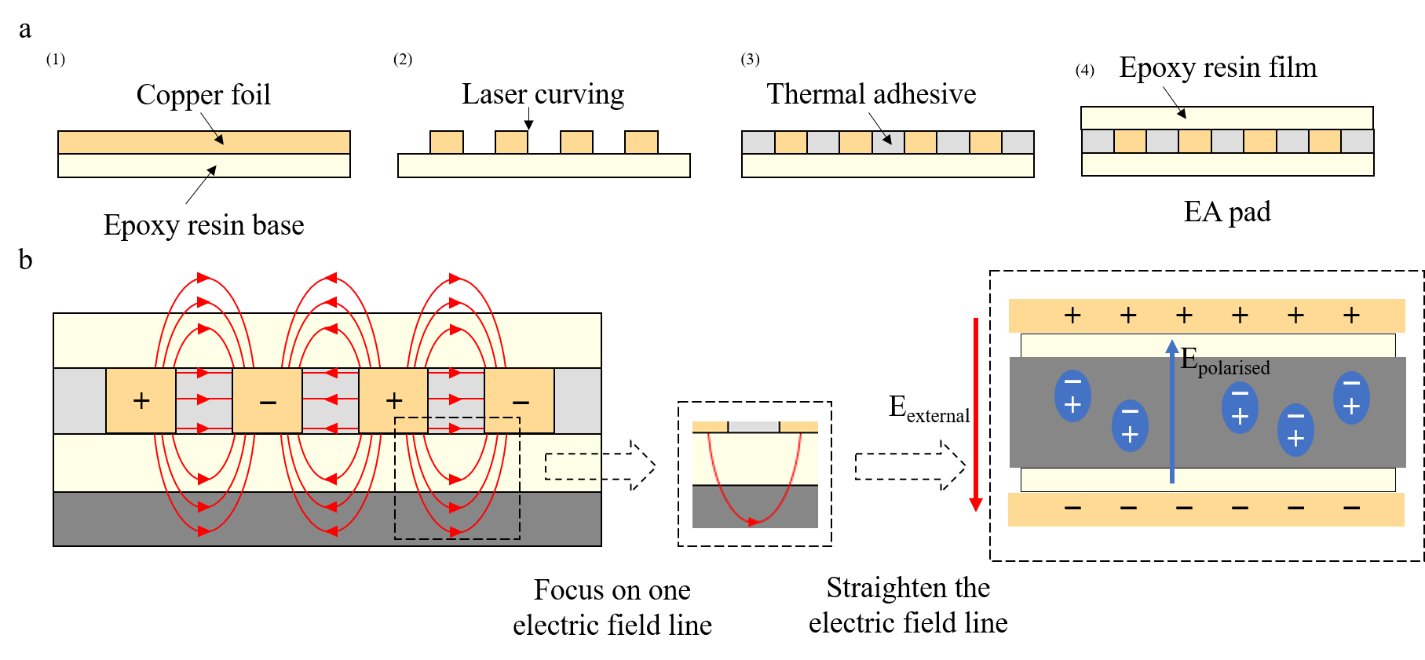
Fig. S1 | Manufacturing and modeling of EA pads. a, The structure and fabrication process of each layer of the EA pad are described in detail. Notably, the copper foil can be substituted with other conductive materials, and the epoxy resin can similarly be replaced with alternative dielectric materials possessing high dielectric constants. b, The distribution of the electric field within the EA pad and substrate under high voltage is illustrated. For clarity, a single electric field line can be isolated, straightened, and analyzed to examine the relationship between the external electric field and the induced polarized electric field.

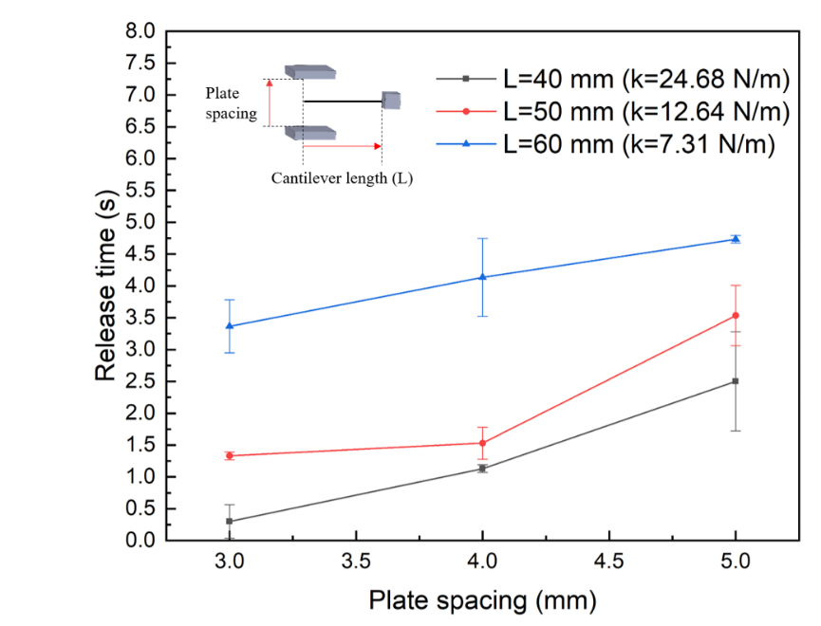
Fig. S2 | Parametric characterization of the impact release time of self-excited pulse modules. The electrode plates and cantilever beams used in the experiments were made of copper foil, with the cantilever beam measuring 0.03 mm in thickness (parallel to the line connecting the electrode plates) and 1 mm in width.
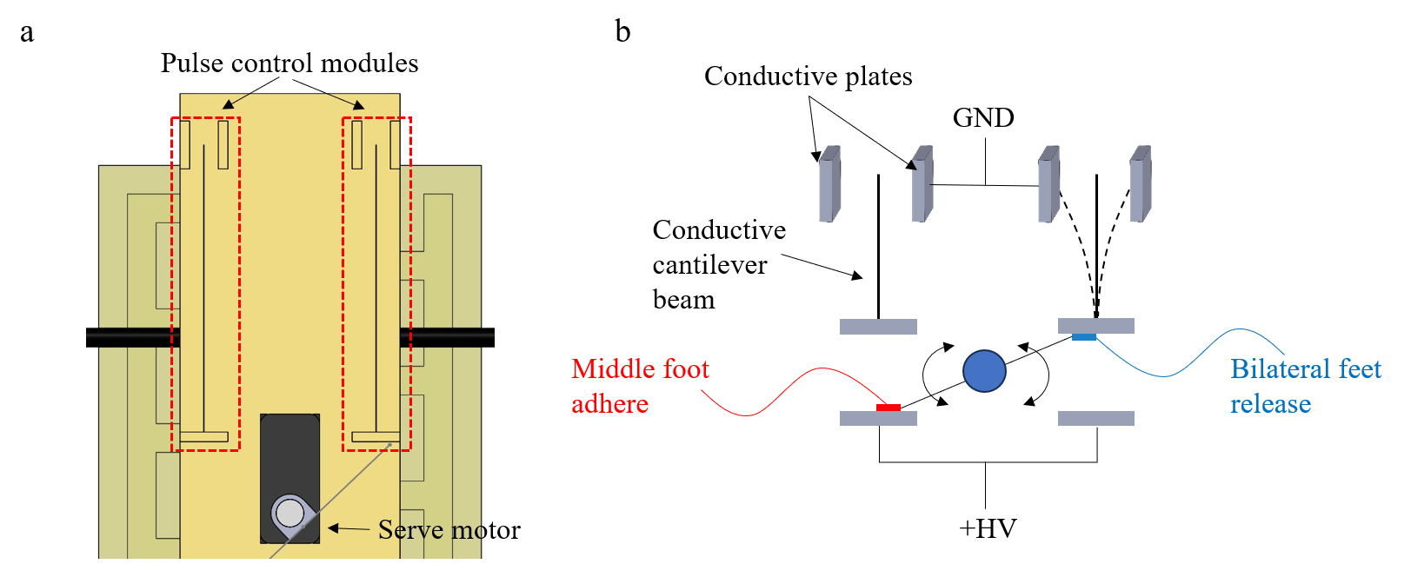
Fig. S3 | Wiring method and operational description of the self-excited pulse modules on the untethered robot. a, A partial top-down view of the 3D structure of the untethered robot, highlighting two self-excited pulse modules and a servo motor equipped with a rod. b, A schematic diagram of the control system of the untethered robot, showing the servo motor positioned such that the EA pad on the middle foot is connected to the high-voltage power supply, while the EA pads on the side feet are connected to the self-excited pulse module.

Video S1. Robotic climbing with different release methods.
This video demonstrates an experimental comparison of robotic climbing on a vertical release paper surface. On the left, the robot with an external self-excited pulse module operates with a stepping cycle of 0.45 seconds, achieving a climbing speed of 4.44 cm/s (approximately 0.45 BL/s). In contrast, the robot on the right utilizes a traditional release method with a stepping cycle of 5.05 seconds. Due to durability issues associated with the traditional release method, the robot on the right gradually exhibits unstable adhesion and eventually falls off the wall. The video is presented at real-time speed (1x).

Video S2. Wall-climbing experiments of untethered robots.
This video presents an experimental demonstration of the untethered robot (Fig. 1a) climbing on vertical walls. The experiments were conducted on three different wall surfaces: the release paper, an interior-painted wall, and an outdoor tiled wall. The robot was controlled via Bluetooth, with the stepping cycle set to 3 seconds. The video is displayed at 2x speed for clarity.

Video S3. Robotic inverted motion on the ceiling.
This video showcases an experimental demonstration of a robot climbing on an inverted indoor surface. The ceiling material is a painted wall, and a gecko specimen, comparable in length to the robot, is attached to the vertical wall for reference. The robot operates with a stepping cycle of 1 second. The video is presented at real-time speed (1x).
Table S1 Parameters of the substrate materials
 | Length | Width | Thickness | Weight
Fabric (conventional) | 125 mm | 125 mm | 0.25 mm | 1.25 g
Wood | 138 mm | 100 mm | 1.1 mm | 2.28 g
Release paper | 118 mm | 113 mm | 3.0 mm | 13.06 g
Fabric (ultra-thin) | 125 mm | 125 mm | 0.1mm | 0.56 g

