Supplemental Information:
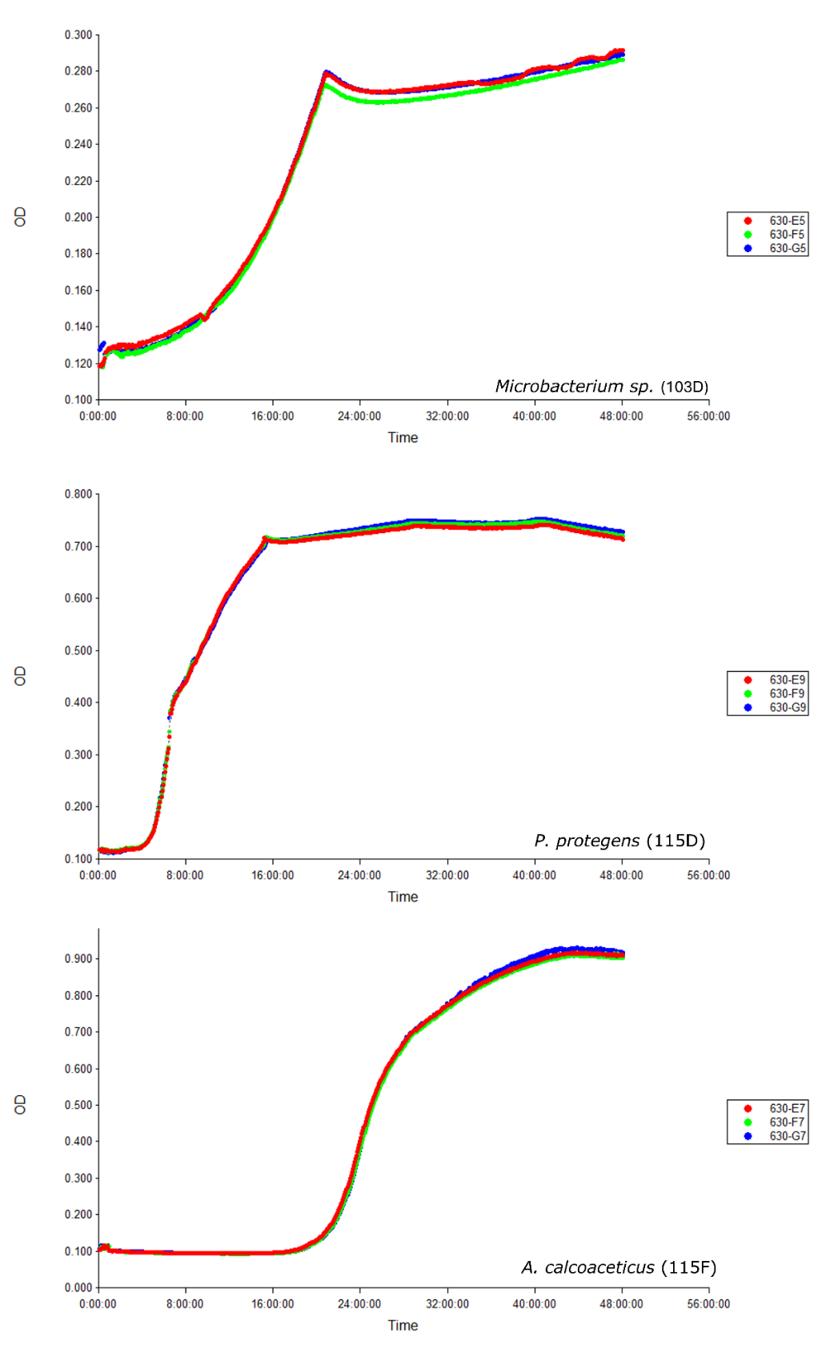
Figure S1: Growth curves of three isolates, Acinetobacter calcoaceticus (115f), Pseudomonas protegens (115d), and Microbacterium sp. (103d), under sole carbon source (malathion) media conditions.

Figure S2. Malathion metabolites detected using GC/MS (chromatograms provided below). Labeled with their CAS ID numbers. Metabolites display patterns of increasing over time and other increasing and decreasing preliminarily supporting the idea of production and subsequent further consumption of metabolites.

103D metabolites

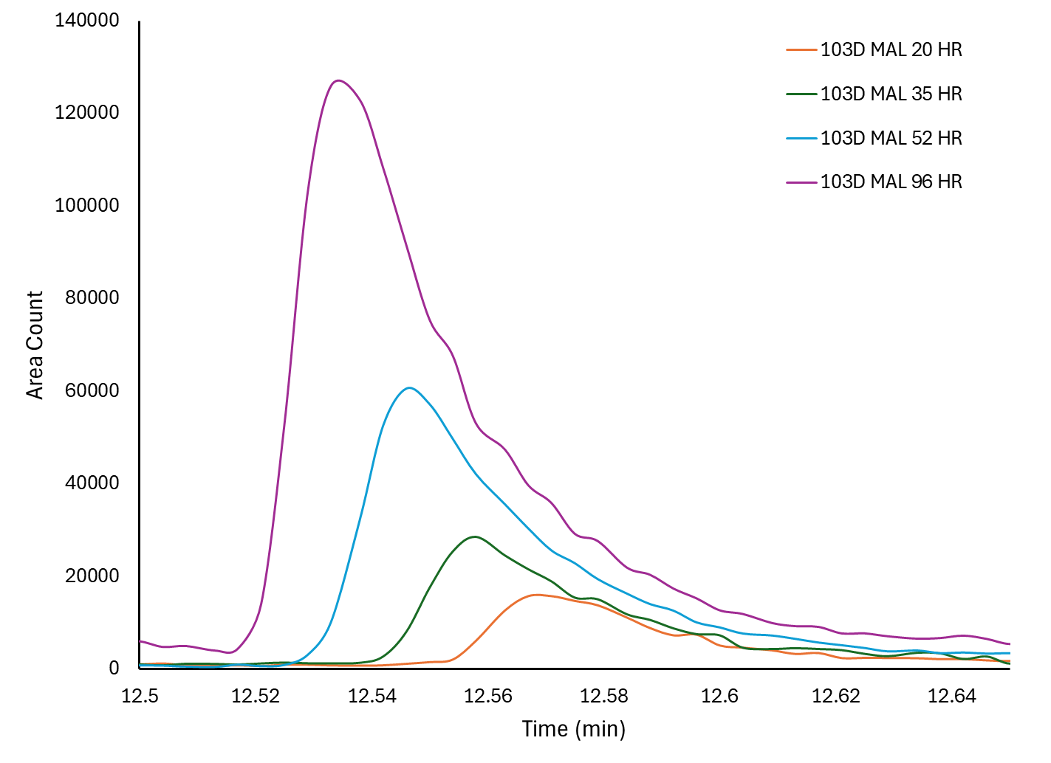
CAS 152-20-5 Increasing over time
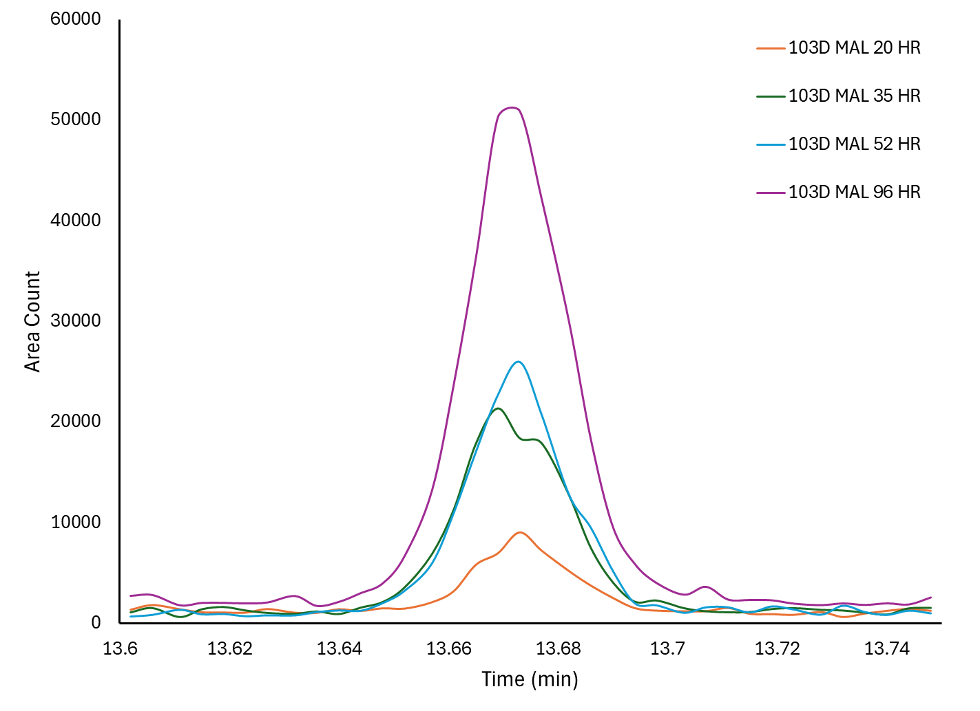
CAS 2953-29-9 Increasing over time

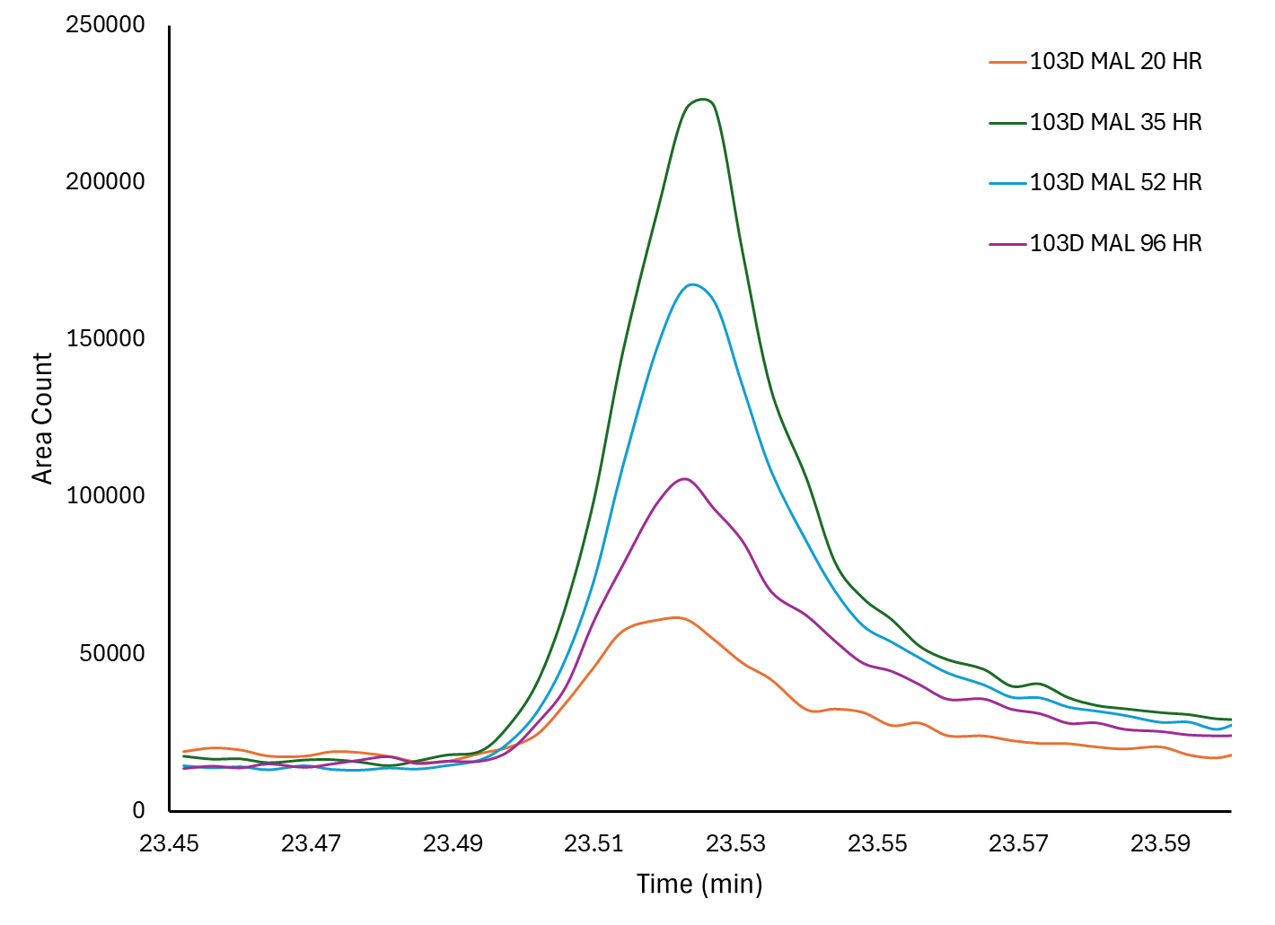
CAS 1190-29-0 Increasing then decreasing

115D metabolites
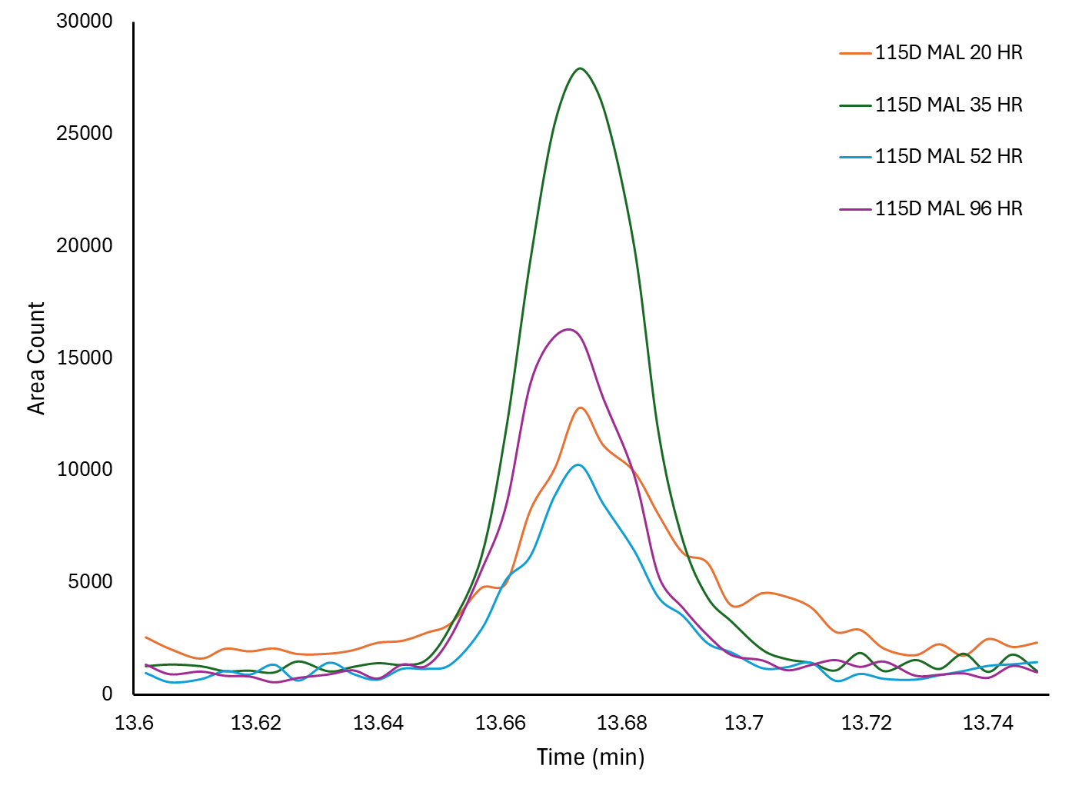
CAS 2953-29-9 Increasing then decreasing

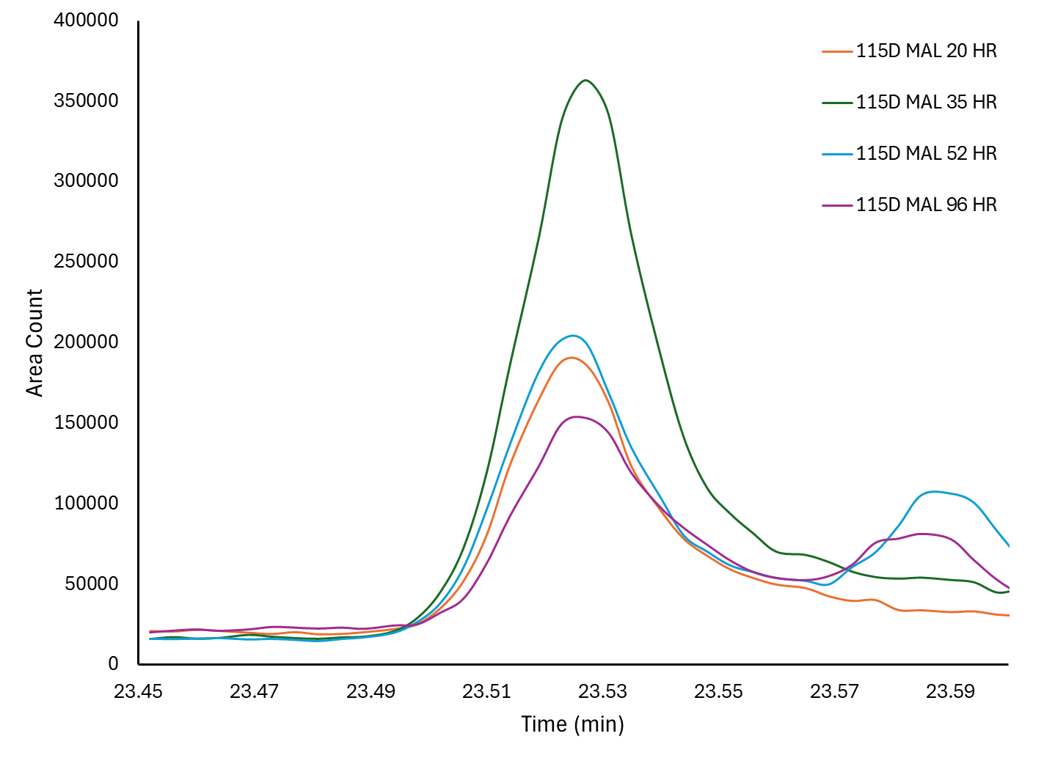
CAS 1190-29-0 Increasing then decreasing

115F Metabolites

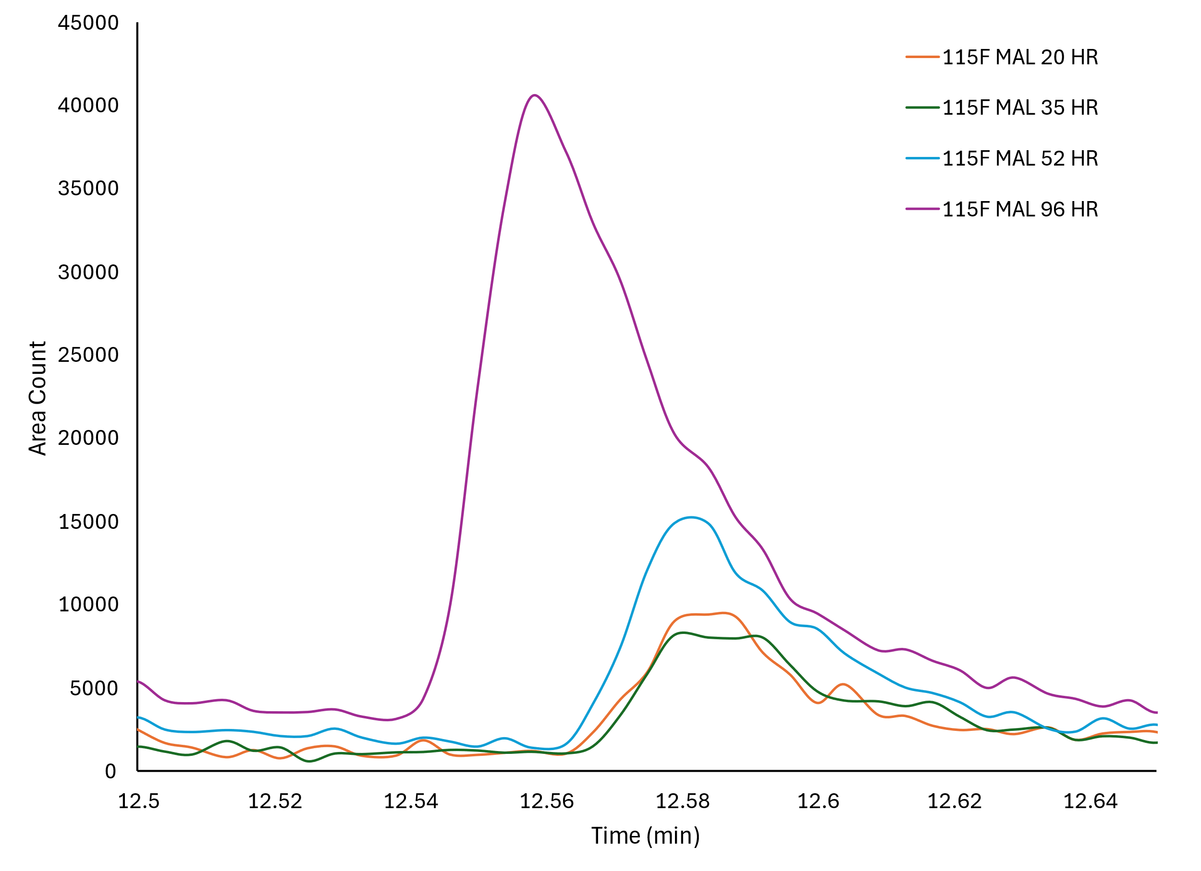
CAS 152-20-5 Increasing over time

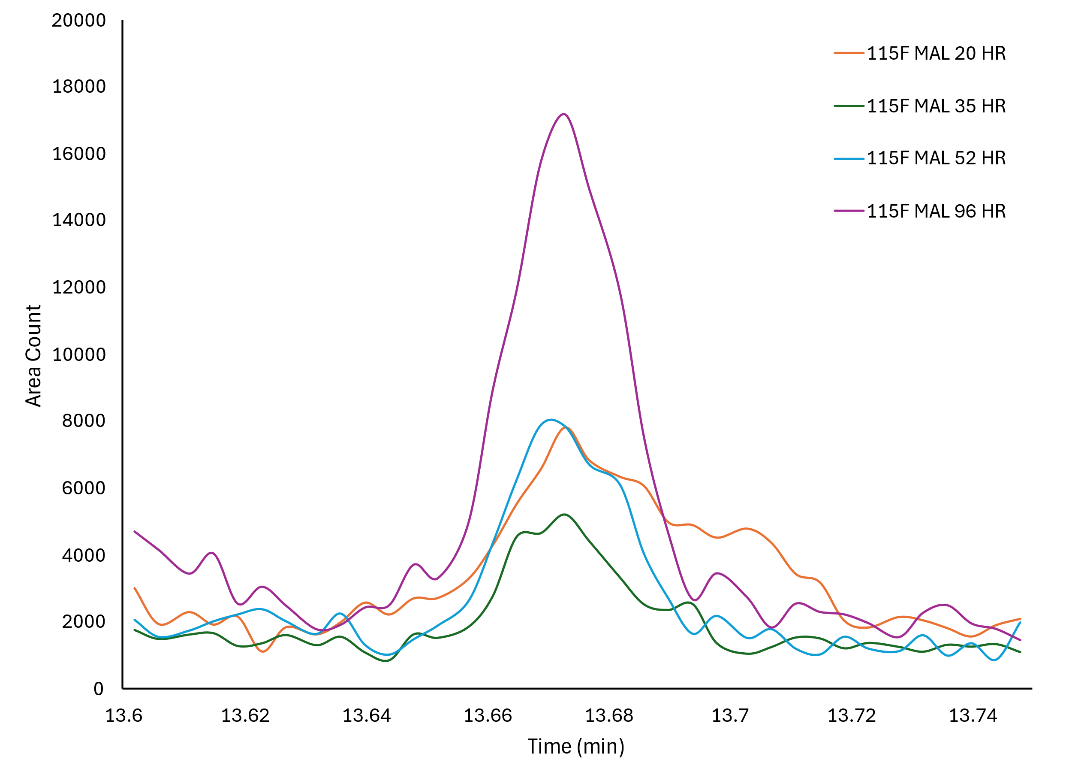
CAS 2953-29-9 Increasing then decreasing

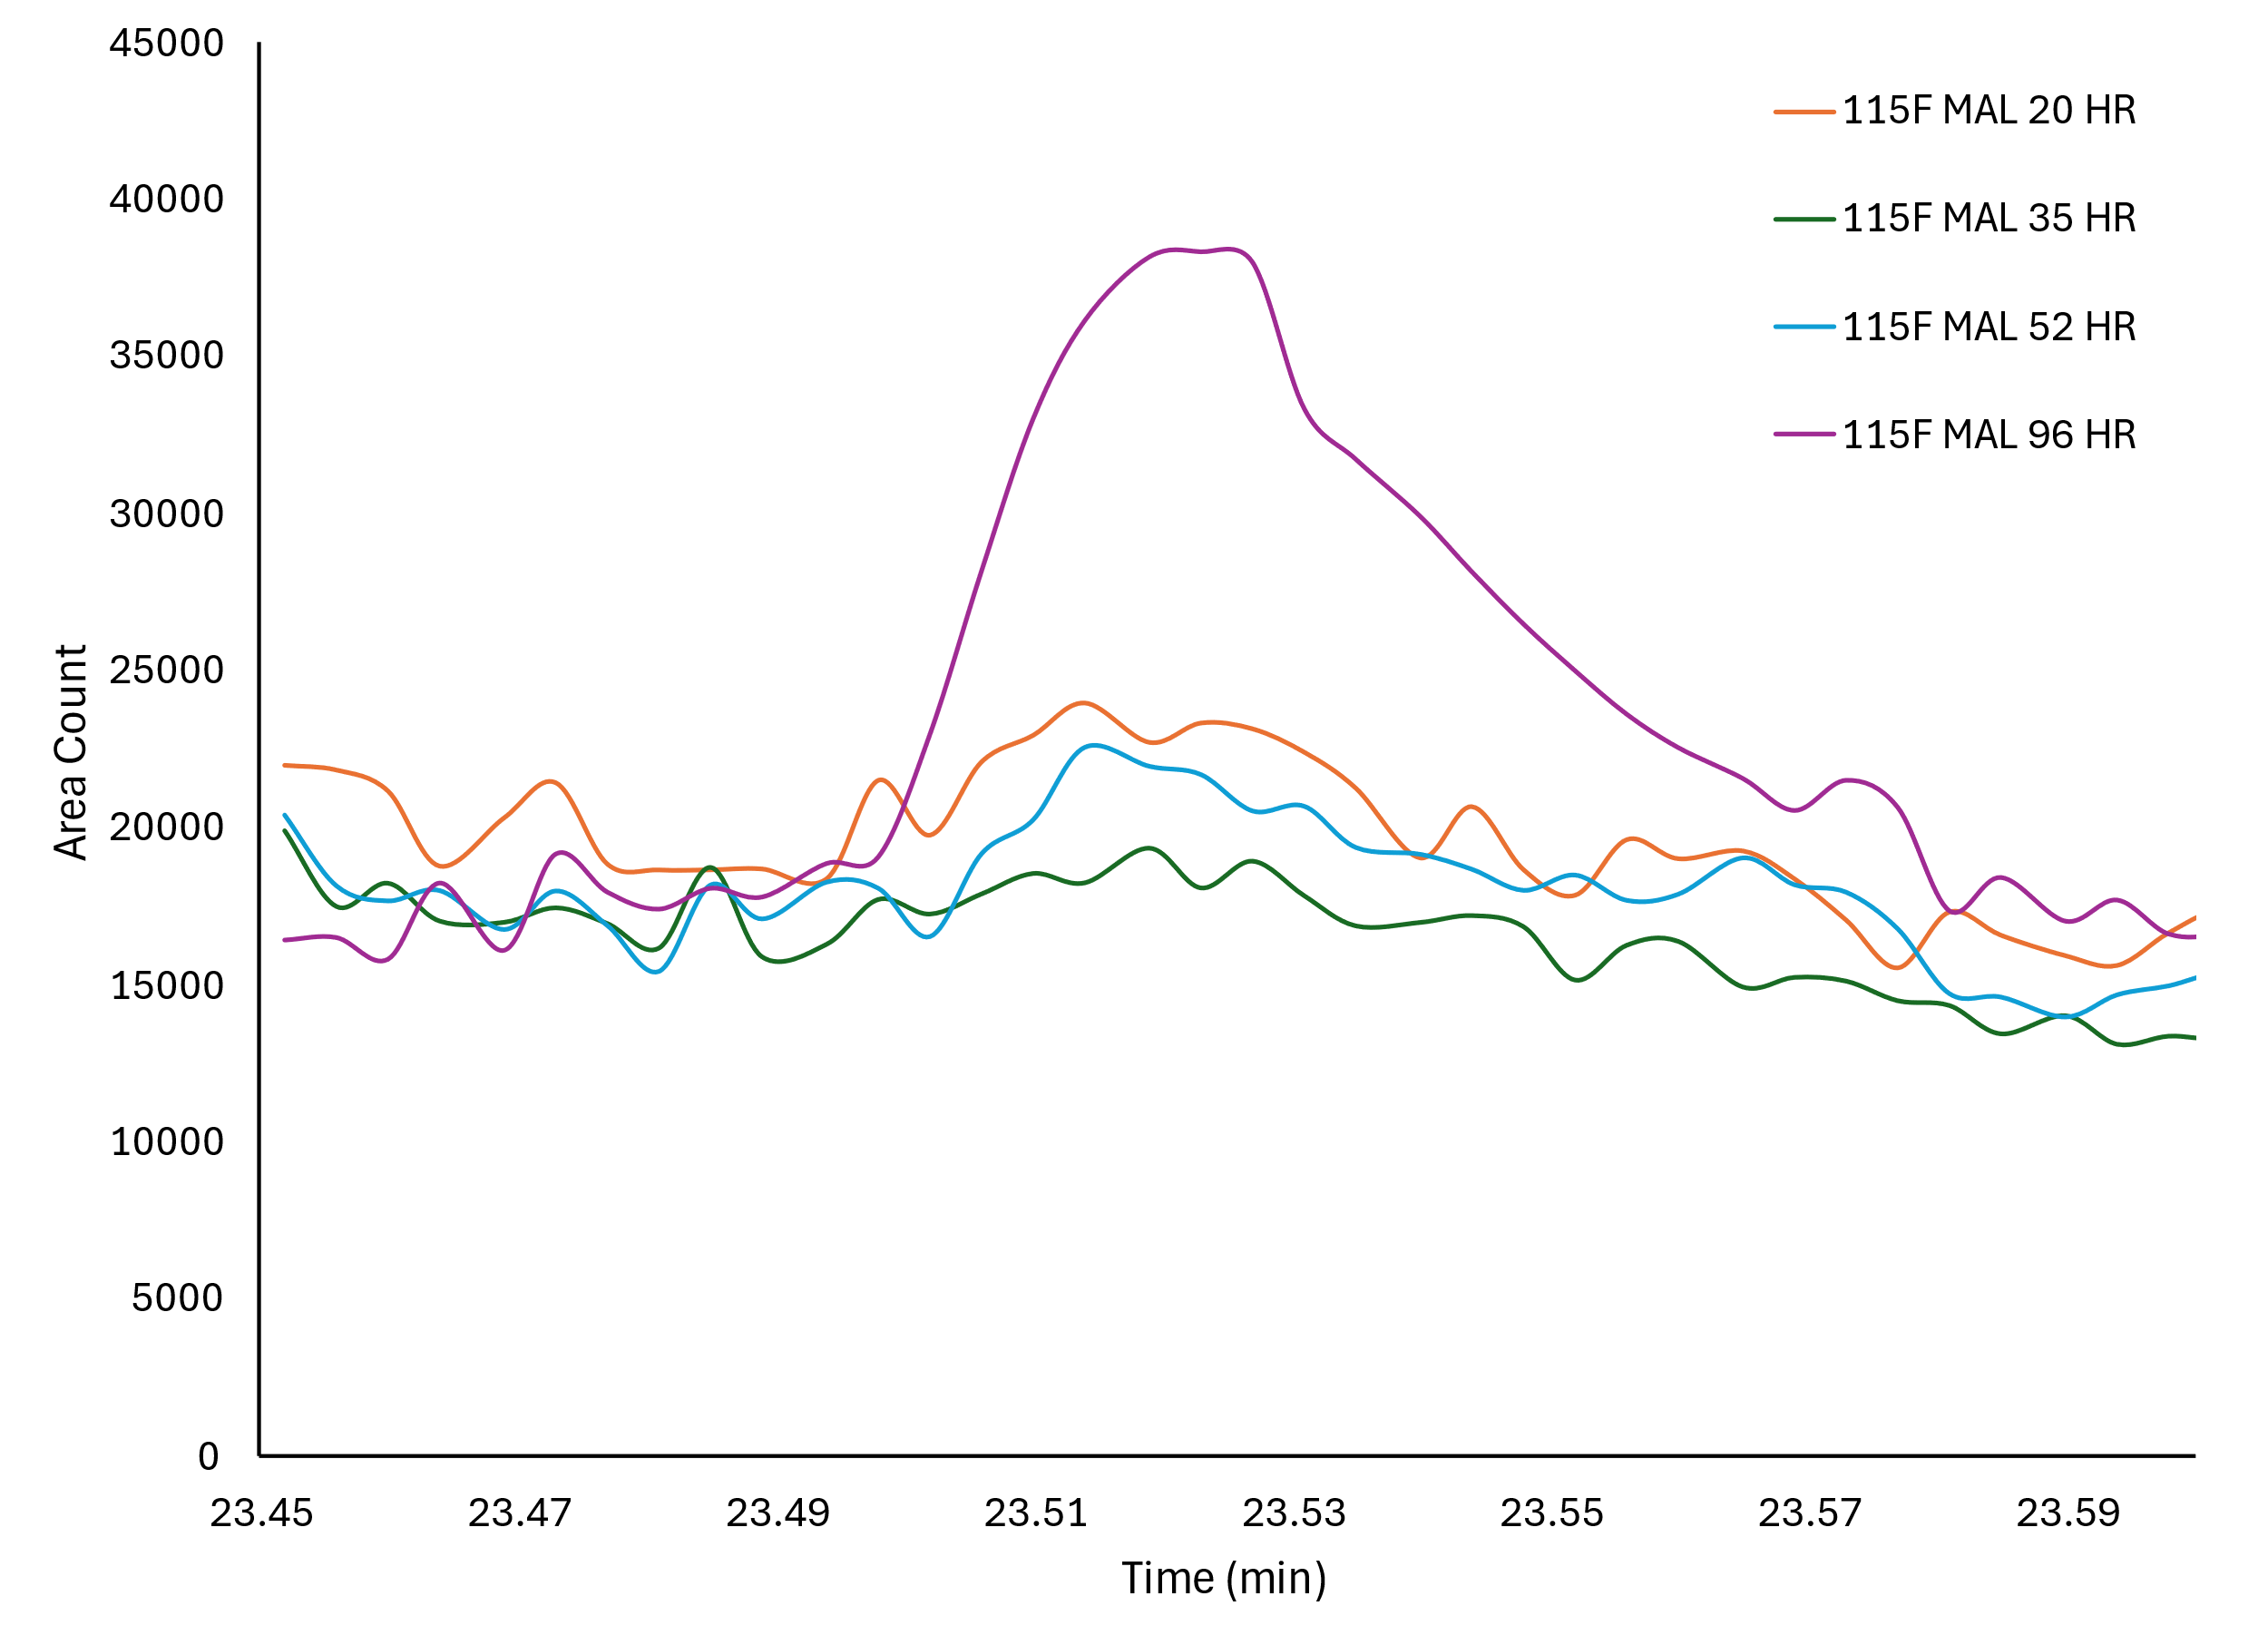
CAS 1190-29-0 Increasing then decreasing

