Supporting Information
NHC-catalyzed Enantioselective Hetero-[10+2] Cycloaddition
Qiupeng Peng, Shi-Jun Li, Bei Zhang, Donghui Guo, Yu Lan* and Jian Wang*

Contents
NMR Spectra 2
HPLC Spectra 64
General Information 94
Procedure for Synthesis of Catalyst F 94
General Procedure for Catalytic Reaction of Indole-2-carbaldehydes with Ketones 95
Characterization Data 95
Gram Scale Synthesis Procedure 110
Synthetic Transformation 111
HRMS of II 111
Kinetic Experiment 112
Control Experiment 112
Crystal Structure of 3e 114
Computational Details 115
Supplementary References 127

NMR Spectra
3a (R)-3-phenyl-3-(trifluoromethyl)-1H,3H-oxazolo[3,4-a]indol-1-one
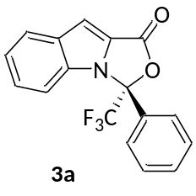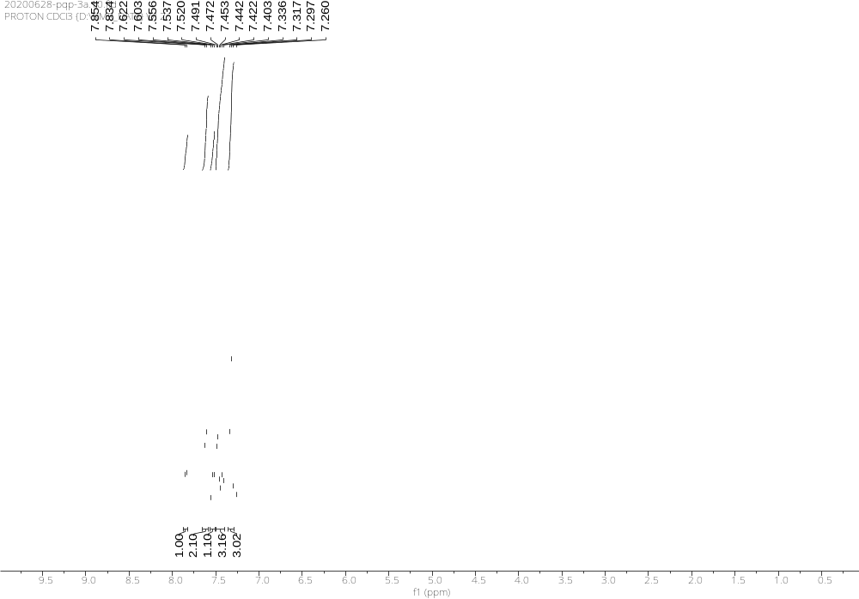
Supplementary Figure 1. ¹H NMR Spectra of 3a
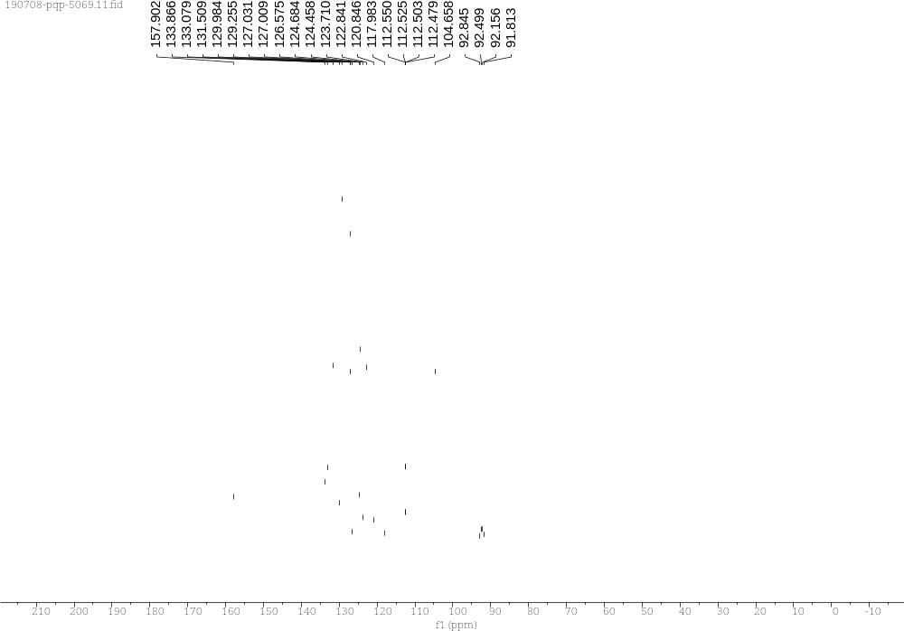
Supplementary Figure 2. ¹³C NMR Spectra of 3a

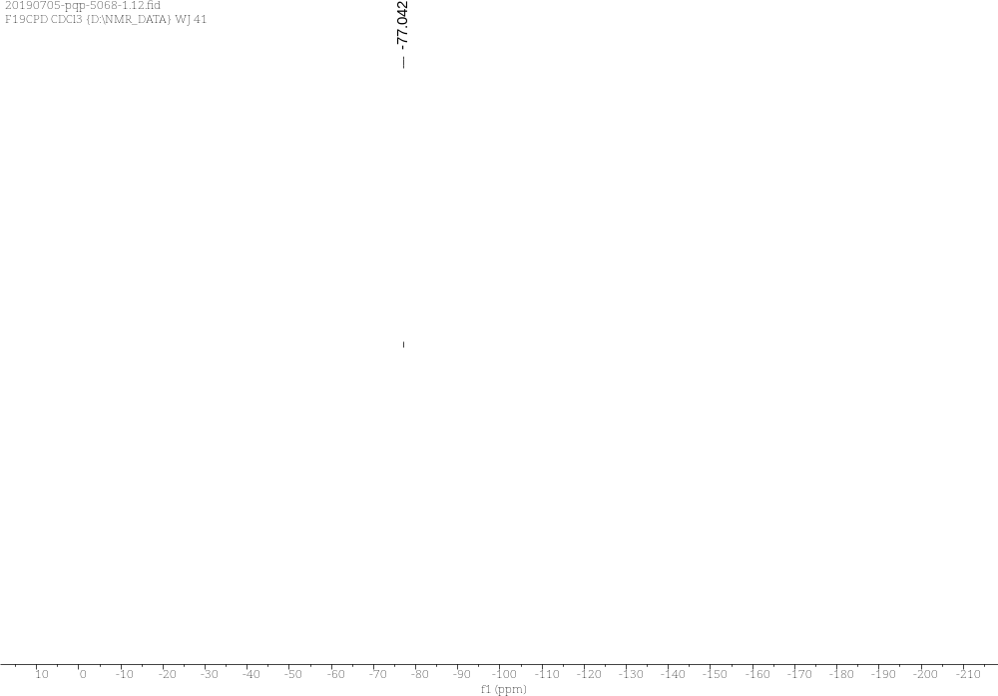
Supplementary Figure 3. ¹⁹F NMR Spectra of 3a

3b (R)-3-(4-fluorophenyl)-3-(trifluoromethyl)-1H,3H-oxazolo[3,4-a]indol-1-one
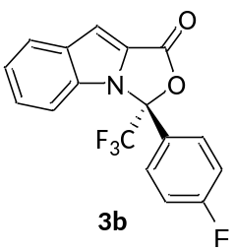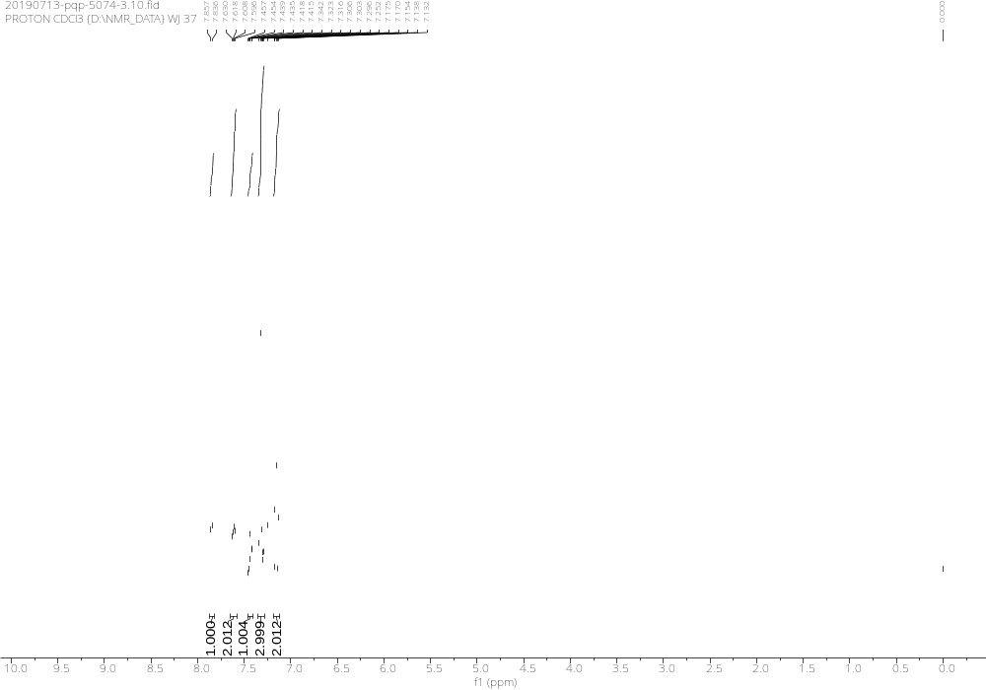
Supplementary Figure 4. ¹H NMR Spectra of 3b
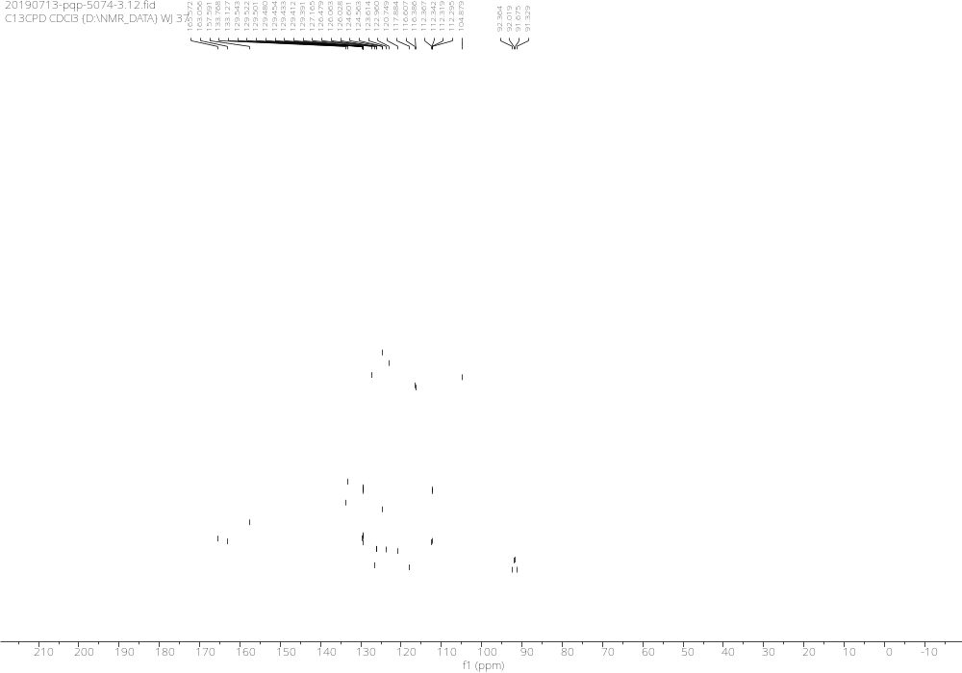
Supplementary Figure 5. ¹³C NMR Spectra of 3b

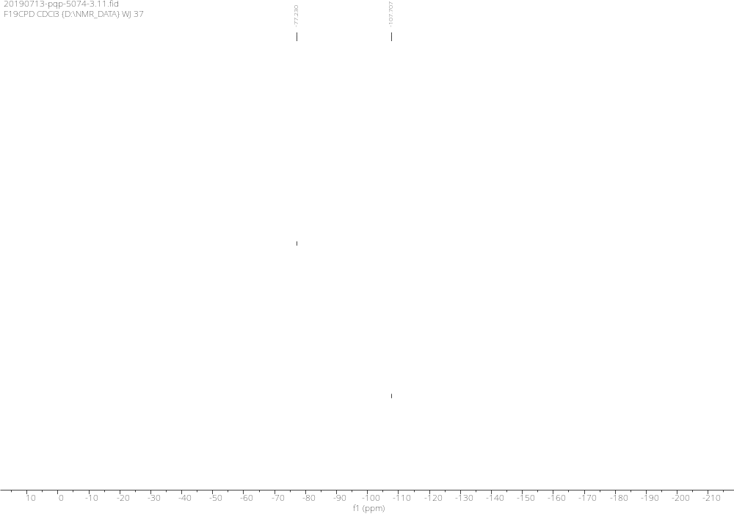
Supplementary Figure 6. ¹⁹F NMR Spectra of 3b

3c (R)-3-(4-chlorophenyl)-3-(trifluoromethyl)-1H,3H-oxazolo[3,4-a]indol-1-one
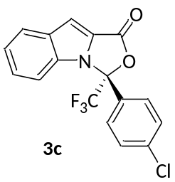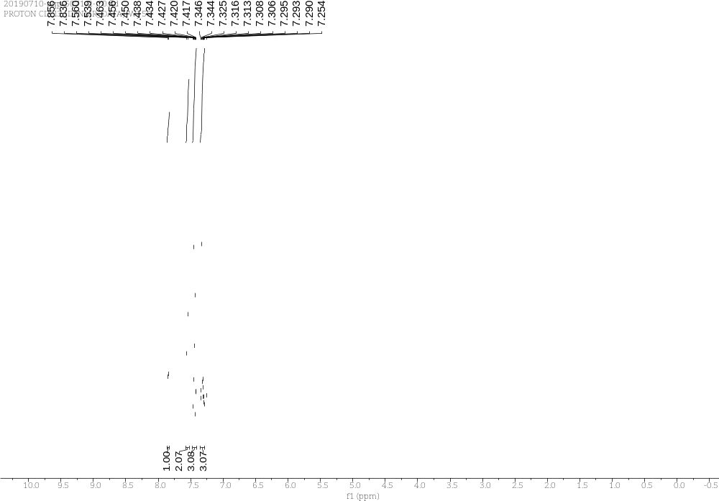
Supplementary Figure 7. ¹H NMR Spectra of 3c

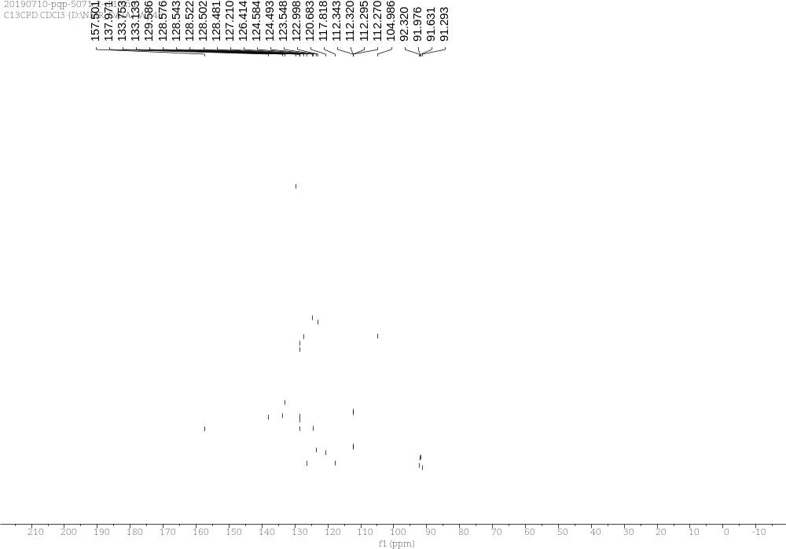
Supplementary Figure 8. ¹³C NMR Spectra of 3c

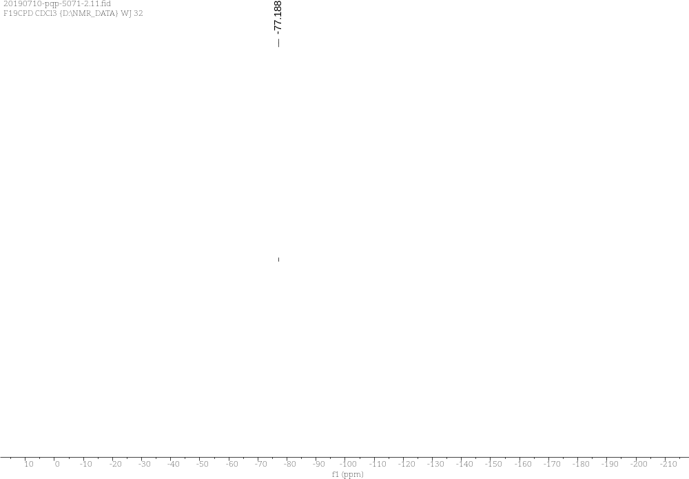
Supplementary Figure 9. ¹⁹F NMR Spectra of 3c

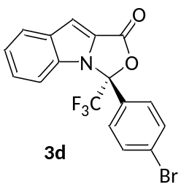3d (R)-3-(4-bromophenyl)-3-(trifluoromethyl)-1H,3H-oxazolo[3,4-a]indol-1-one
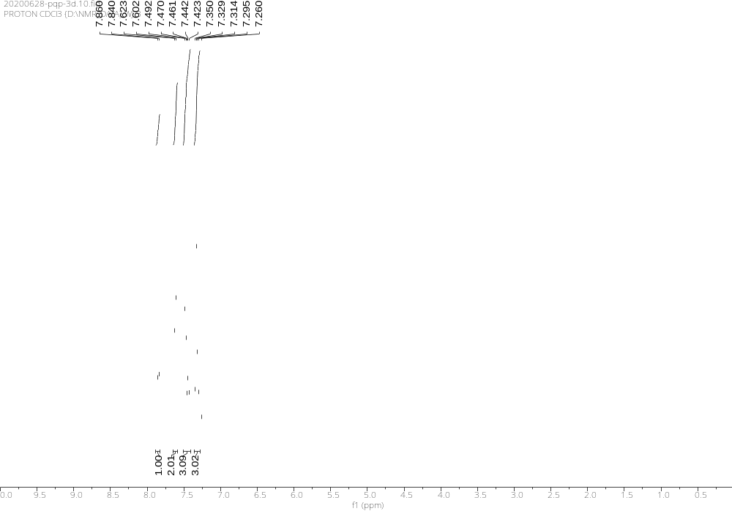
Supplementary Figure 10. ¹H NMR Spectra of 3d
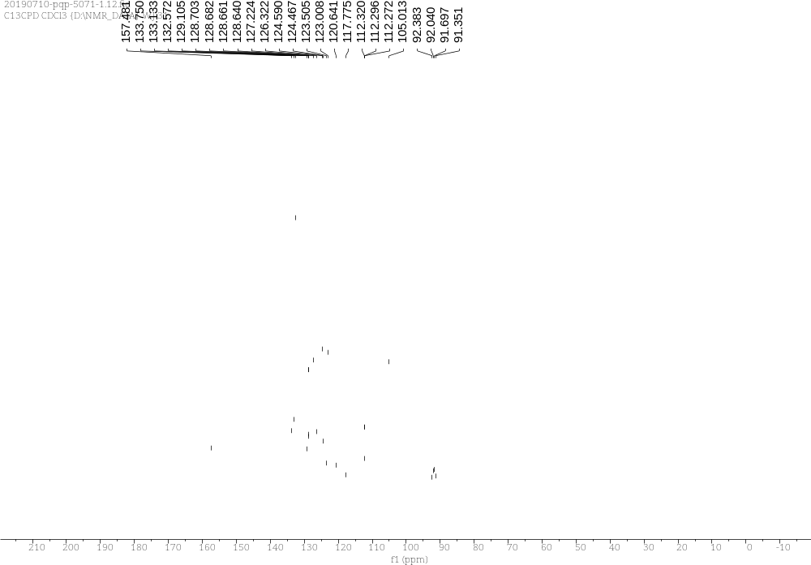
Supplementary Figure 11. ¹³C NMR Spectra of 3d

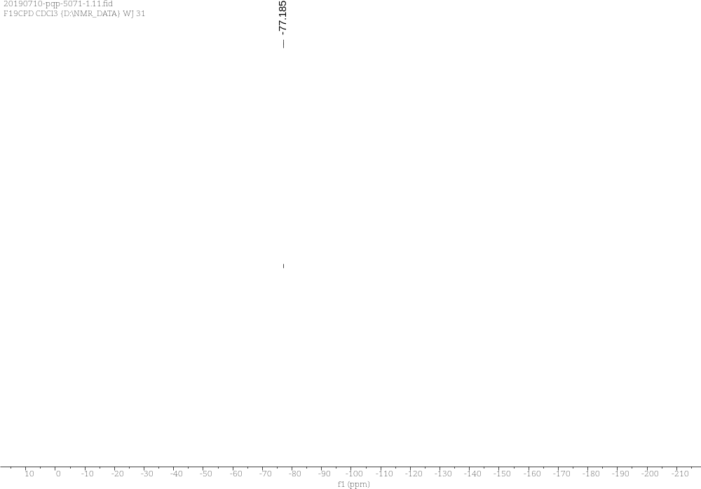
Supplementary Figure 12. ¹⁹F NMR Spectra of 3d

3e (R)-3-(p-tolyl)-3-(trifluoromethyl)-1H,3H-oxazolo[3,4-a]indol-1-one
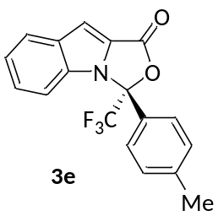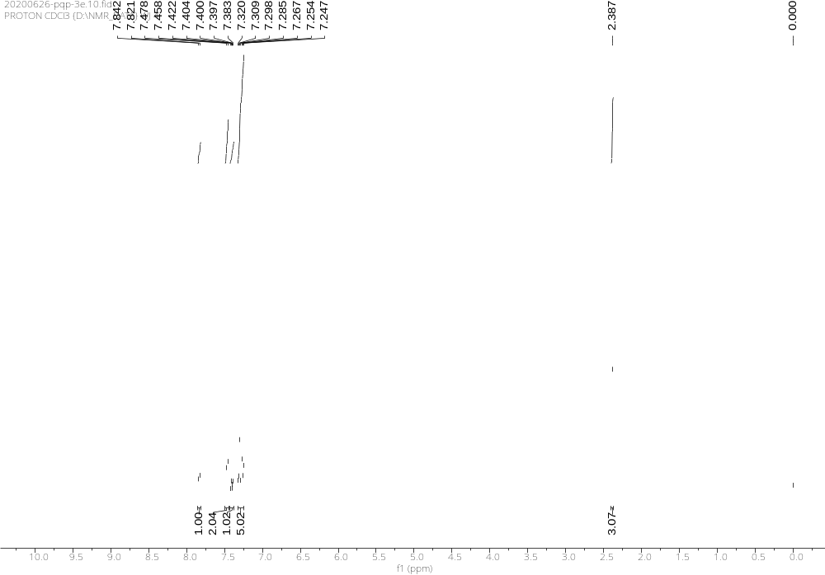
Supplementary Figure 13. ¹H NMR Spectra of 3e
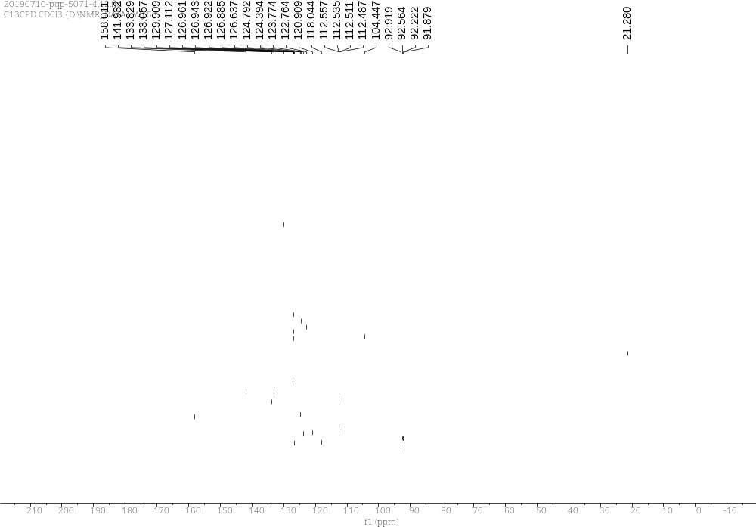
Supplementary Figure 14. ¹³C NMR Spectra of 3e

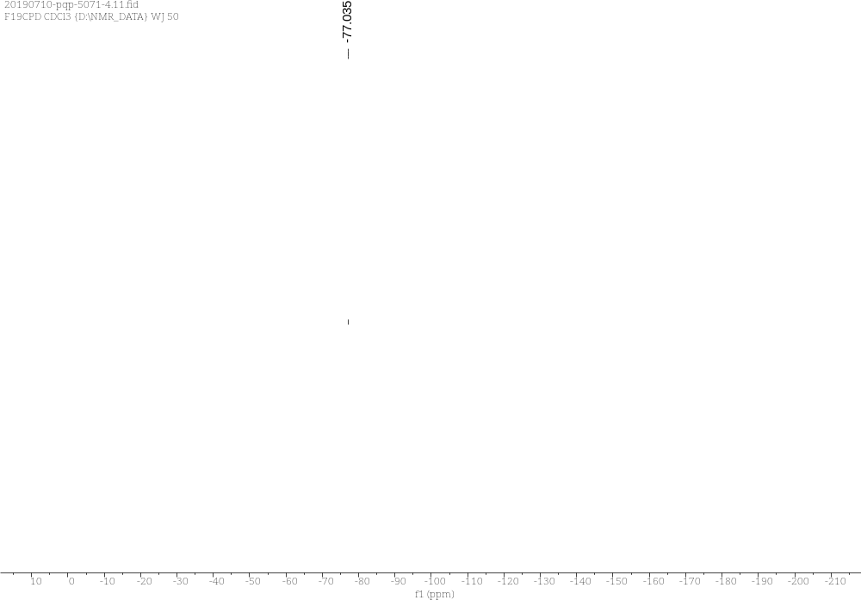
Supplementary Figure 15. ¹⁹F NMR Spectra of 3e

3f (R)-3-(4-methoxyphenyl)-3-(trifluoromethyl)-1H,3H-oxazolo[3,4-a]indol-1-one
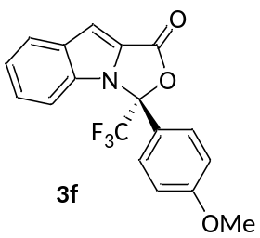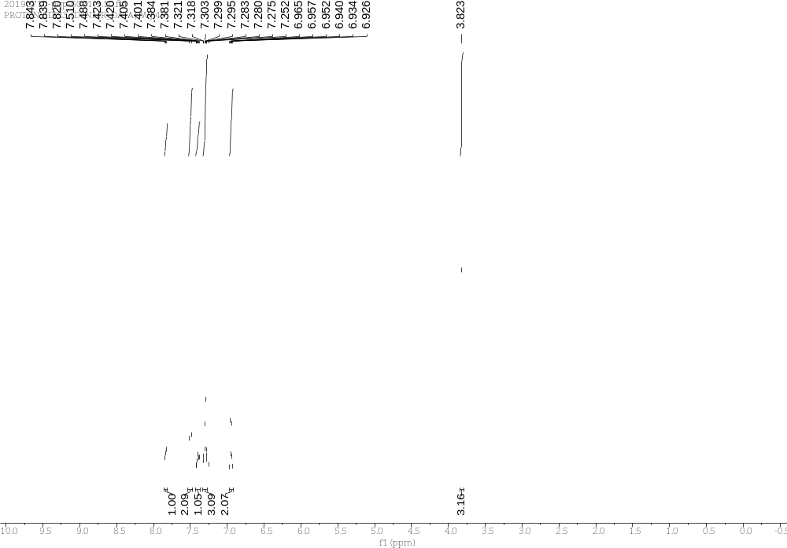
Supplementary Figure 16. ¹H NMR Spectra of 3f
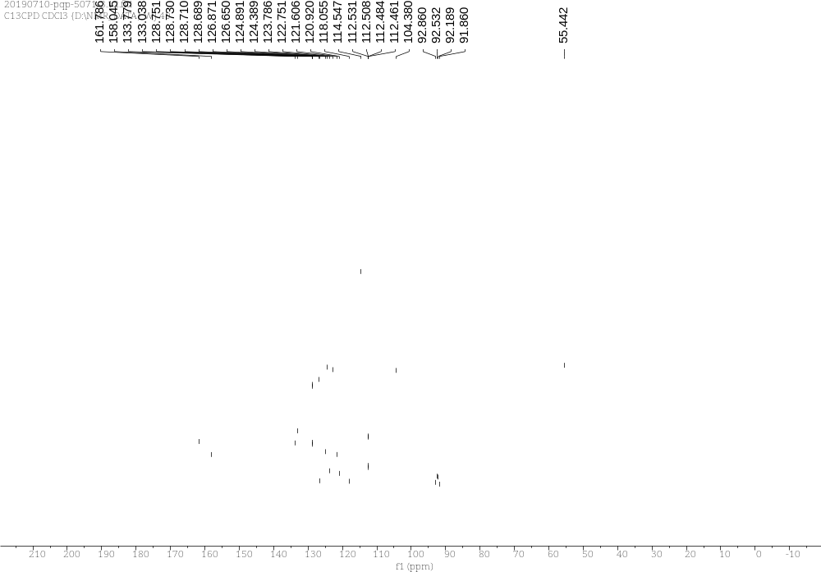
Supplementary Figure 17. ¹³C NMR Spectra of 3f

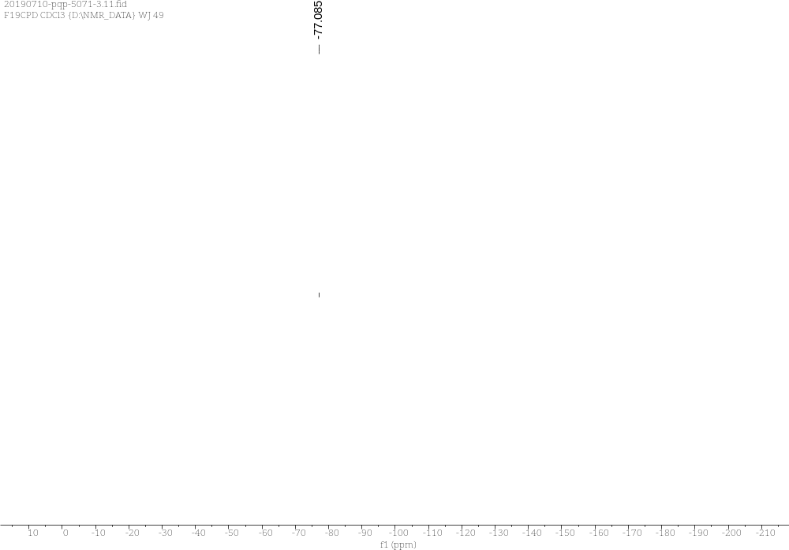
Supplementary Figure 18. ¹⁹F NMR Spectra of 3f

3g (R)-3-([1,1'-biphenyl]-4-yl)-3-(trifluoromethyl)-1H,3H-oxazolo[3,4-a]indol-1-one
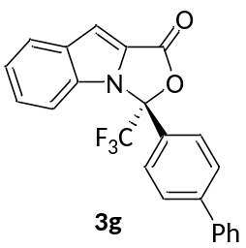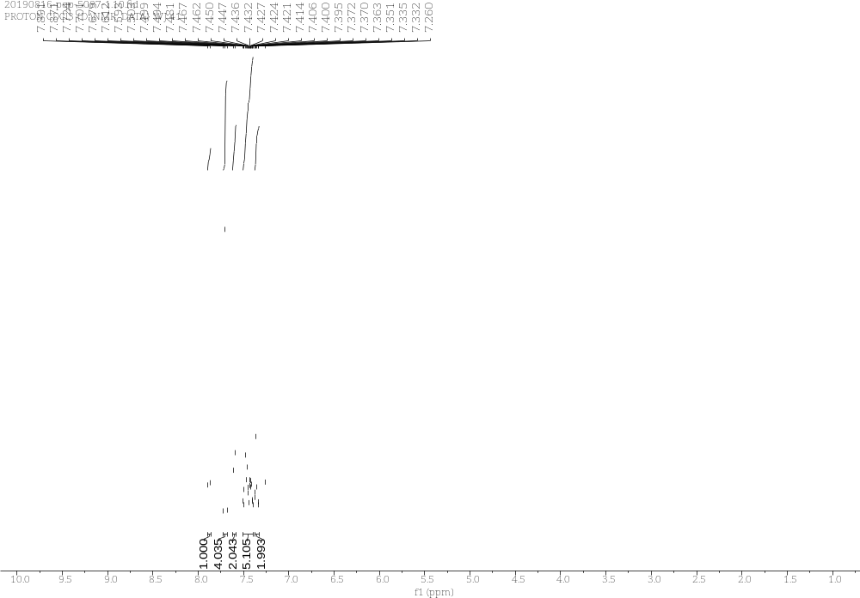
Supplementary Figure 19. ¹H NMR Spectra of 3g
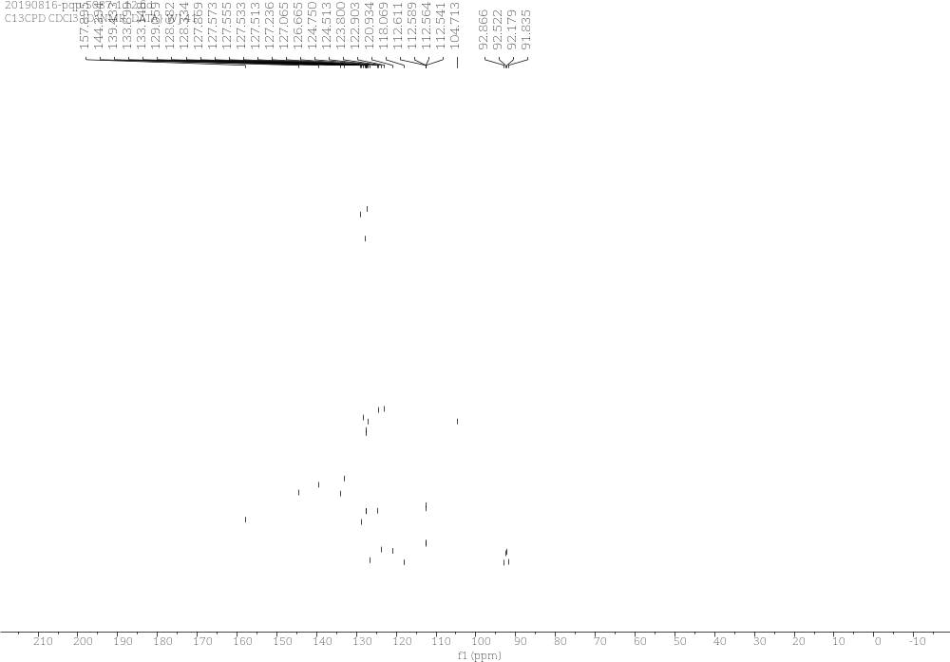
Supplementary Figure 20. ¹³C NMR Spectra of 3g

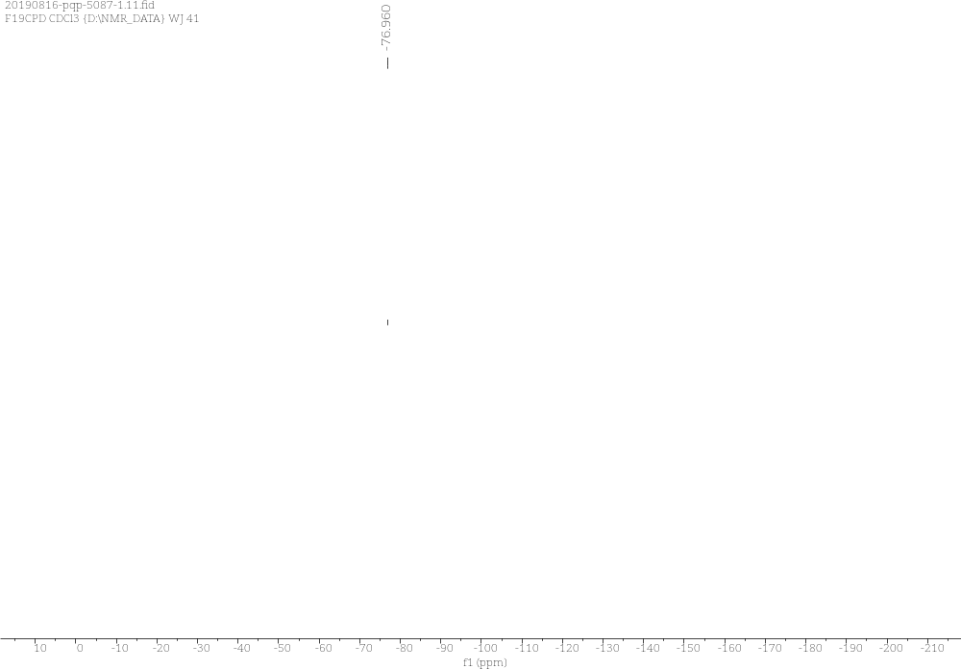
Supplementary Figure 21. ¹⁹F NMR Spectra of 3g

3h (R)-3-(3-fluorophenyl)-3-(trifluoromethyl)-1H,3H-oxazolo[3,4-a]indol-1-one
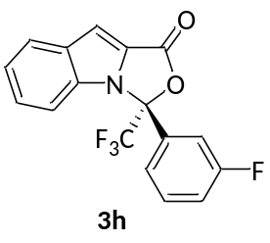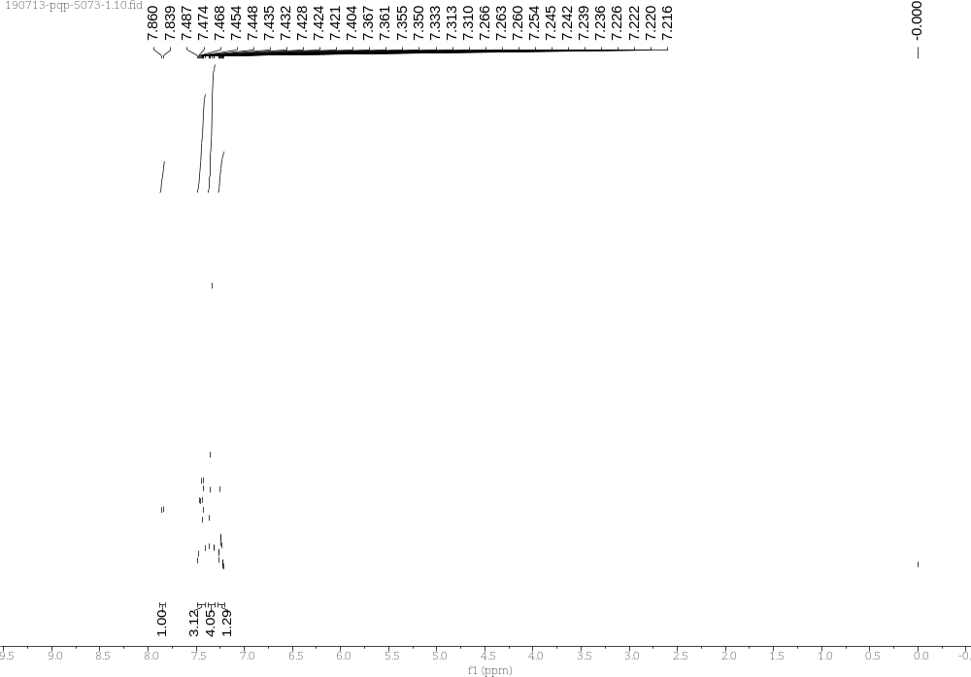
Supplementary Figure 22. ¹H NMR Spectra of 3h
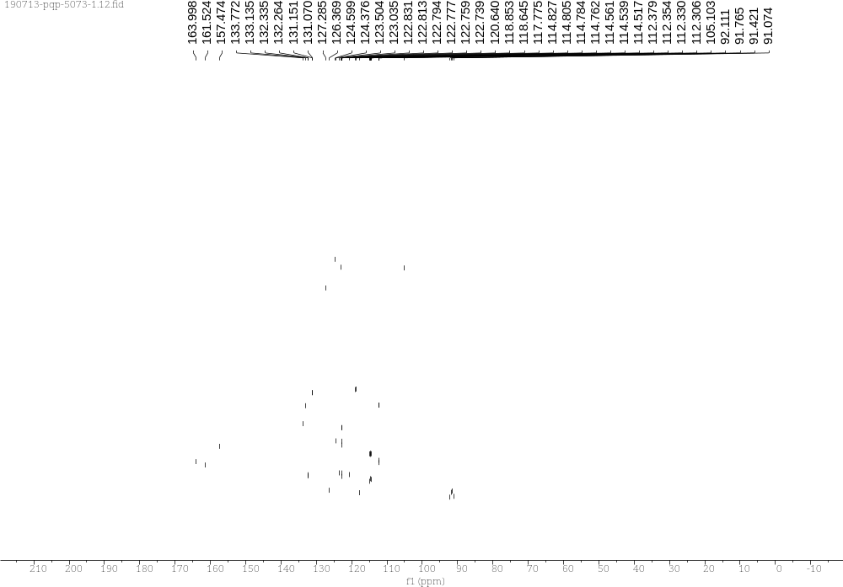
Supplementary Figure 23. ¹³C NMR Spectra of 3h

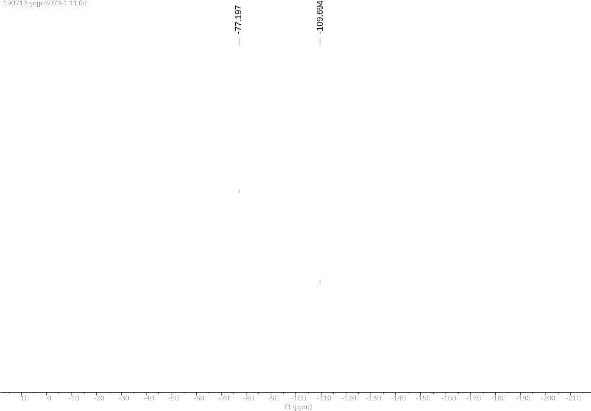
Supplementary Figure 24. ¹⁹F NMR Spectra of 3h

3i (R)-3-(naphthalen-2-yl)-3-(trifluoromethyl)-1H,3H-oxazolo[3,4-a]indol-1-one
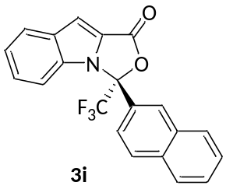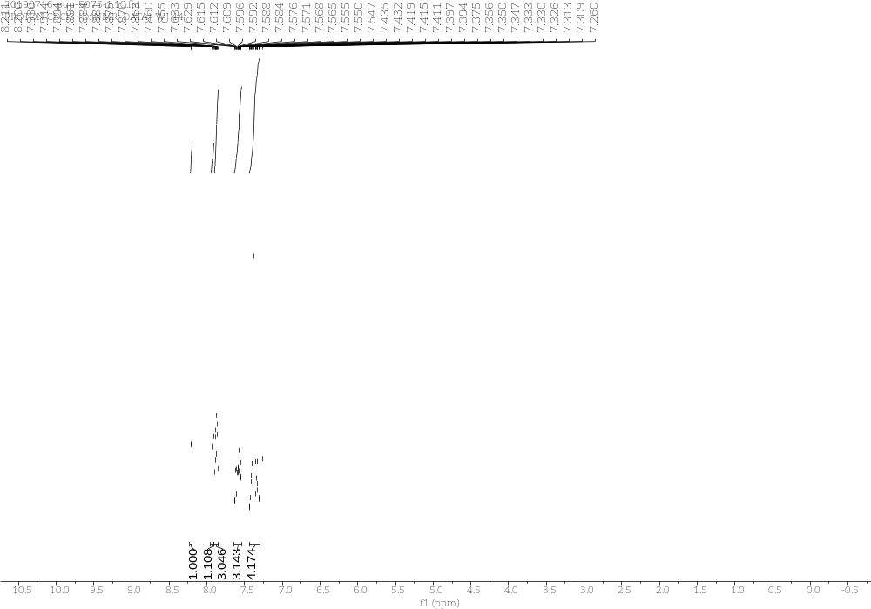
Supplementary Figure 25. ¹H NMR Spectra of 3i
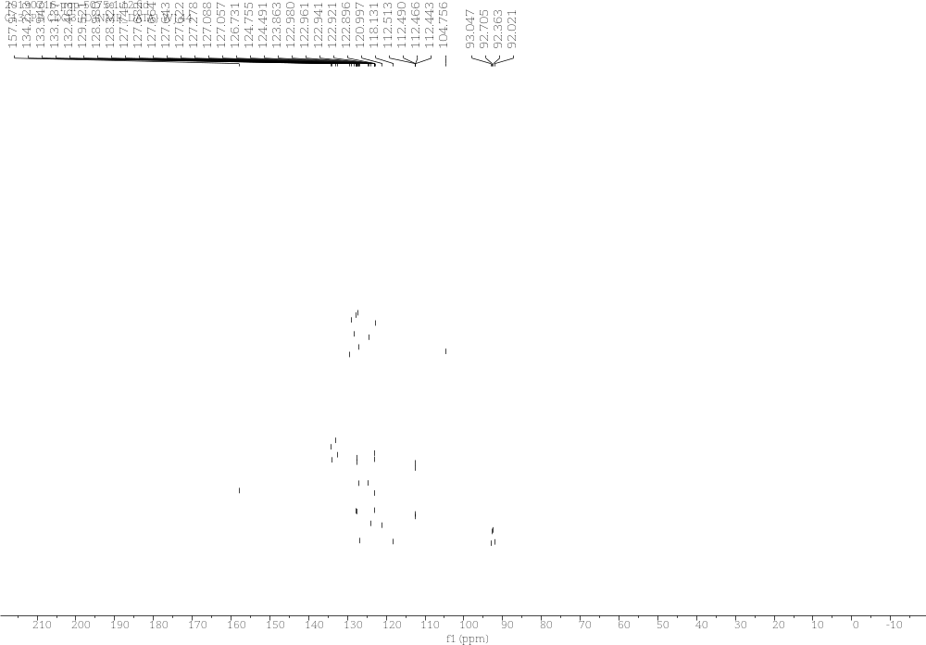
Supplementary Figure 26. ¹³C NMR Spectra of 3i

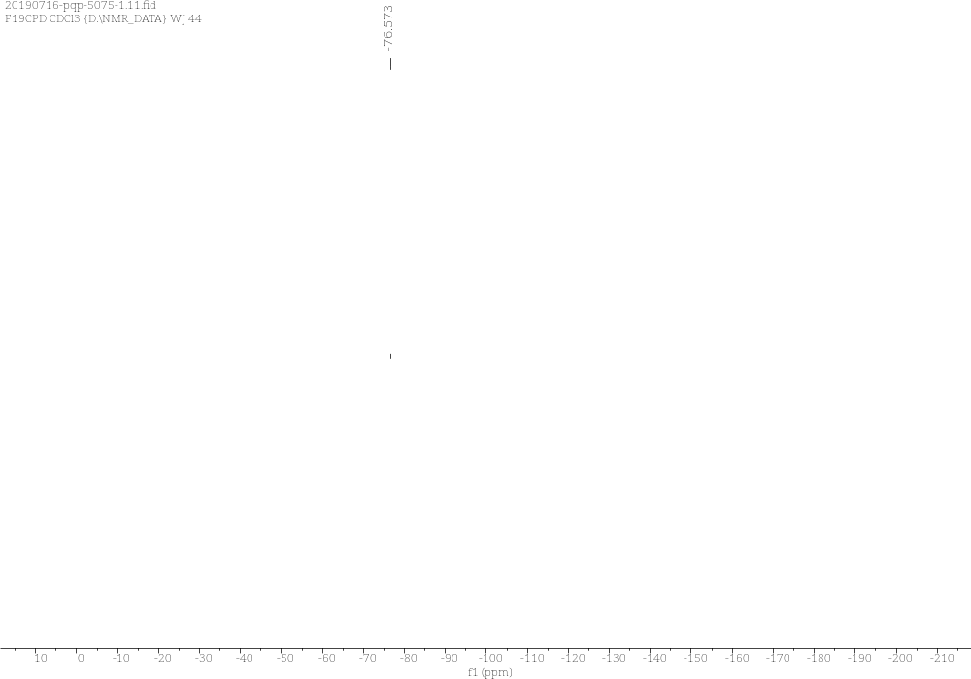
Supplementary Figure 27. ¹⁹F NMR Spectra of 3i

3j (S)-3-(benzo[d]thiazol-2-yl)-3-(trifluoromethyl)-1H,3H-oxazolo[3,4-a]indol-1-one
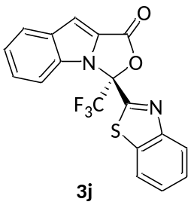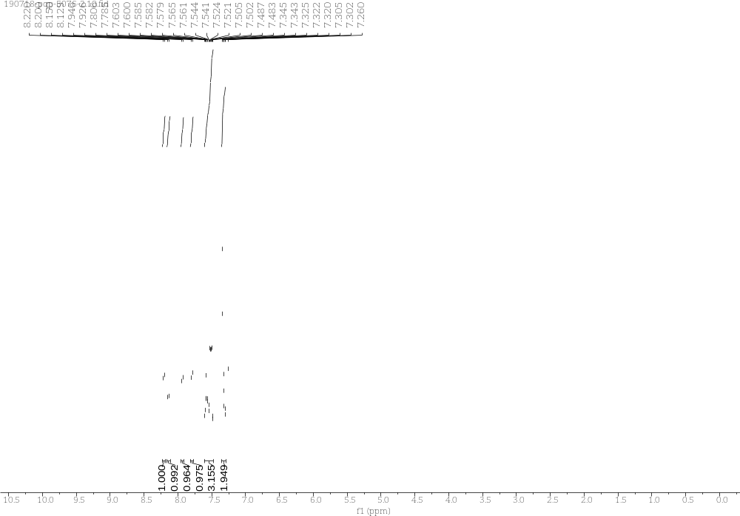
Supplementary Figure 28. ¹H NMR Spectra of 3j
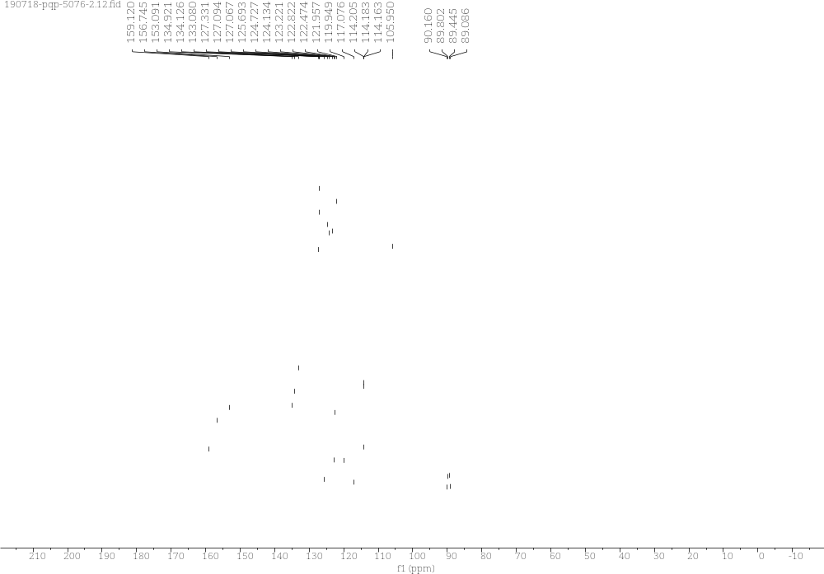
Supplementary Figure 29. ¹³C NMR Spectra of 3j

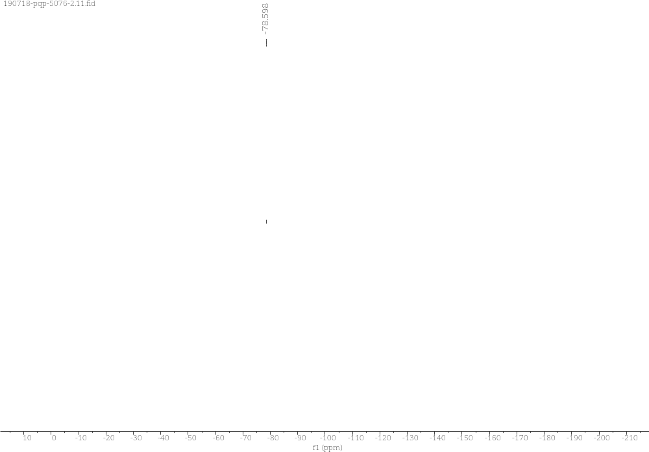
Supplementary Figure 10. ¹⁹F NMR Spectra of 3j

3k (S)-3-(thiophen-2-yl)-3-(trifluoromethyl)-1H,3H-oxazolo[3,4-a]indol-1-one
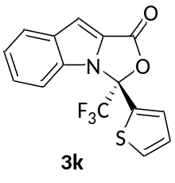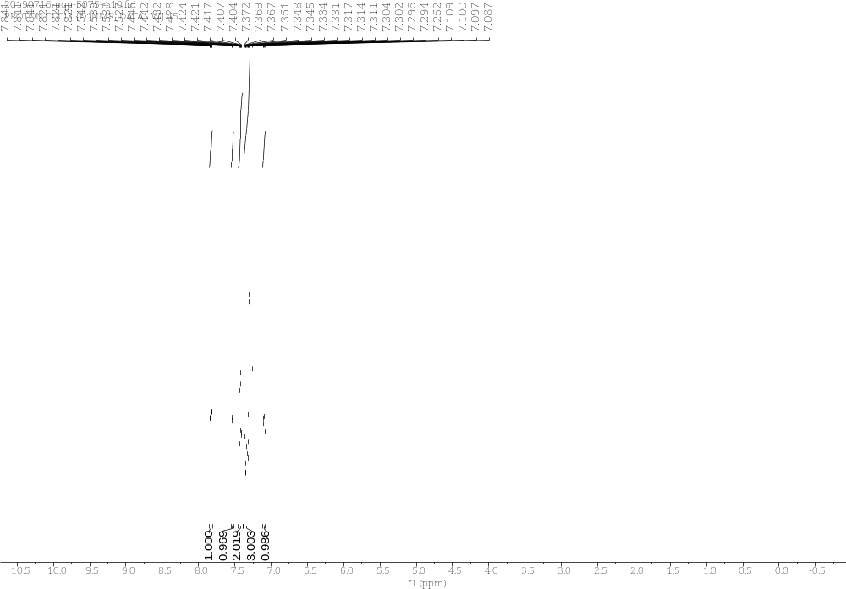
Supplementary Figure 31. ¹H NMR Spectra of 3k
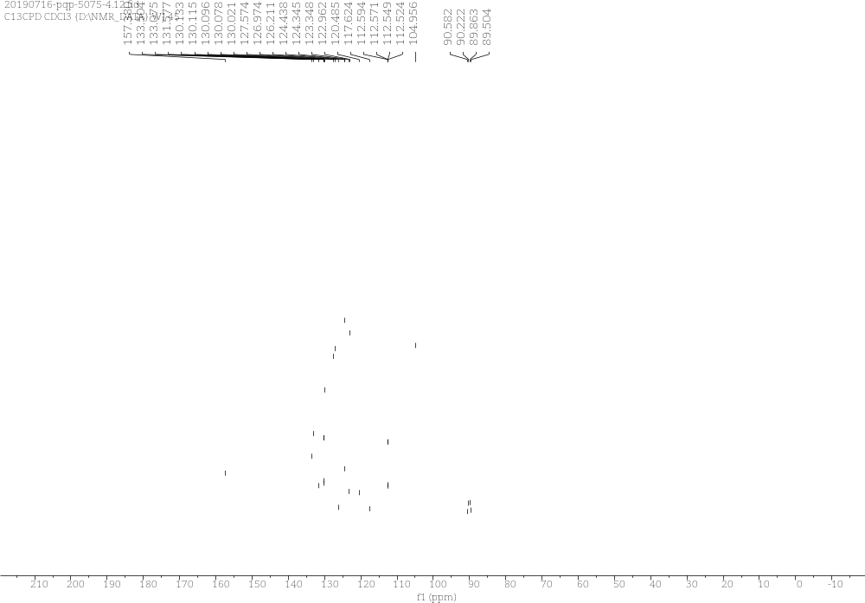
Supplementary Figure 32. ¹³C NMR Spectra of 3k

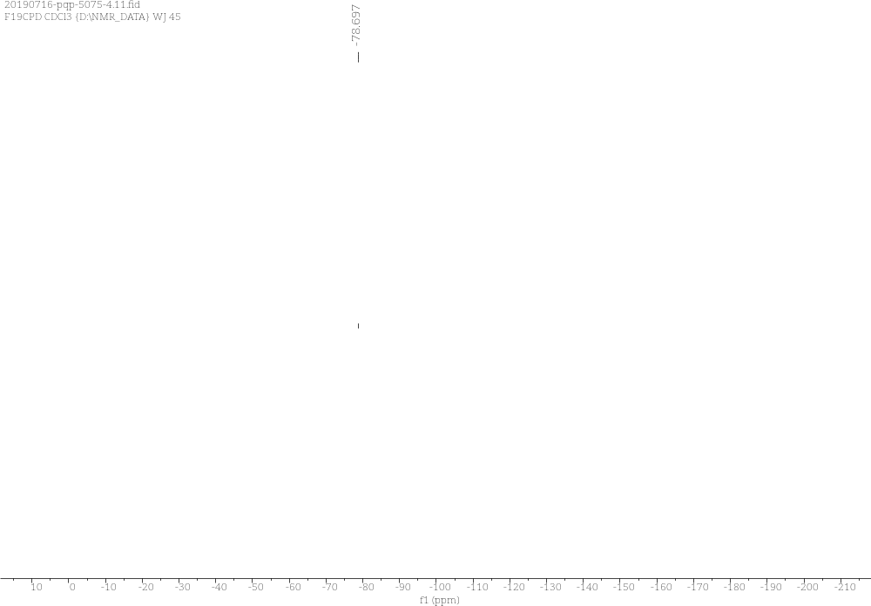
Supplementary Figure 33. ¹³C NMR Spectra of 3k

3l (R)-3-(pyridin-2-yl)-3-(trifluoromethyl)-1H,3H-oxazolo[3,4-a]indol-1-one
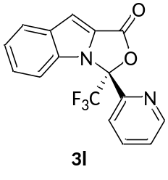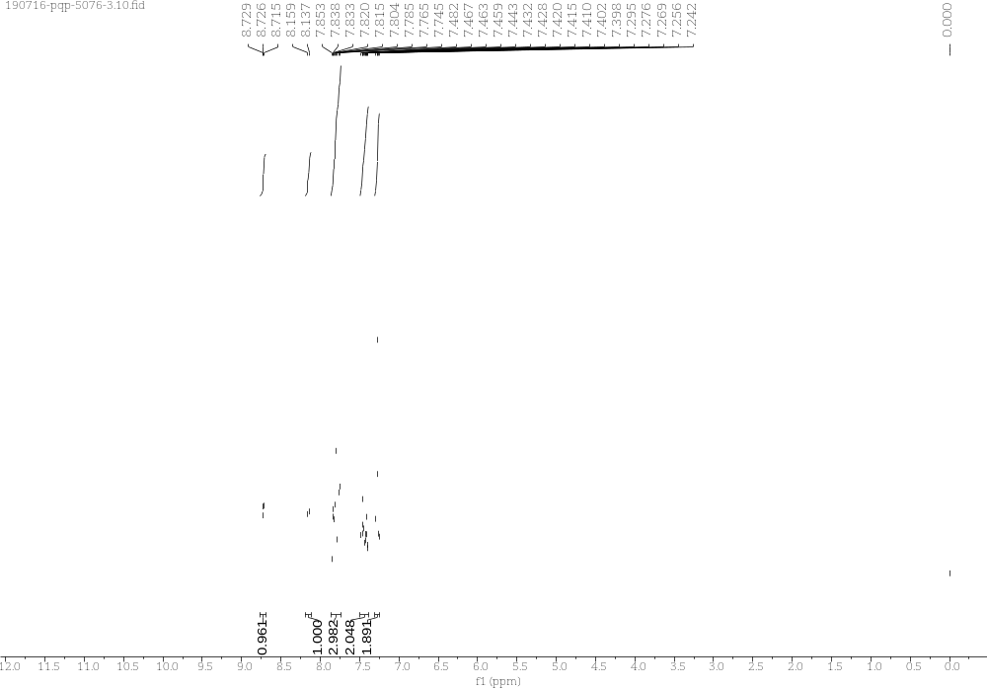
Supplementary Figure 34. ¹H NMR Spectra of 3l
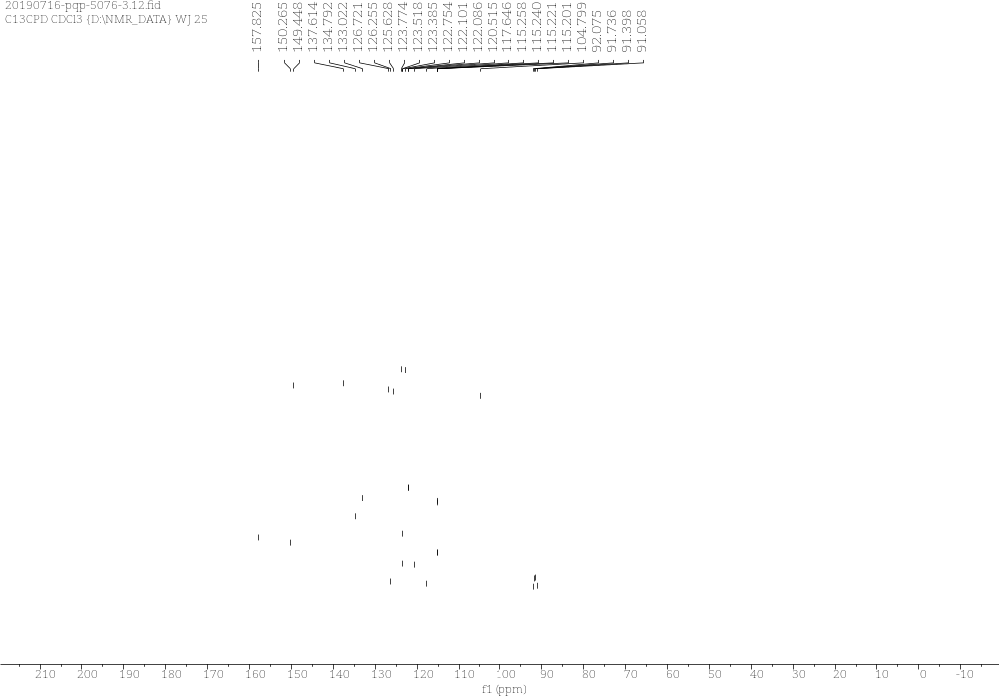
Supplementary Figure 35. ¹³C NMR Spectra of 3l

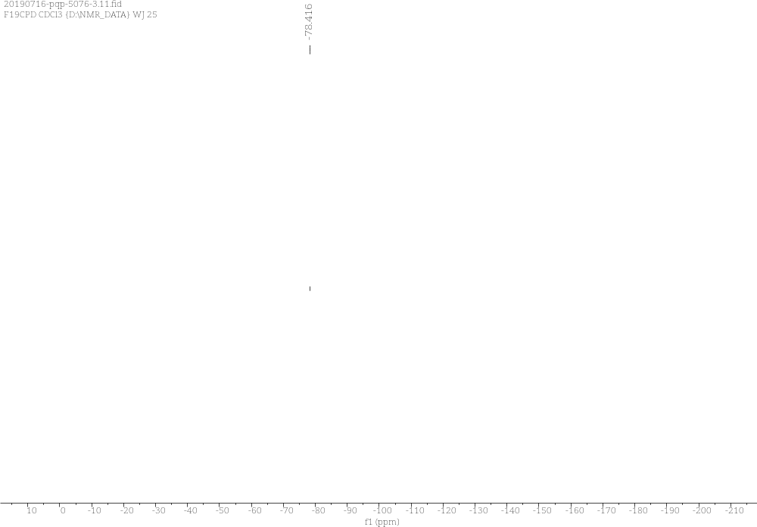
Supplementary Figure 36. ¹⁹F NMR Spectra of 3l

3m (R)-3-(quinolin-6-yl)-3-(trifluoromethyl)-1H,3H-oxazolo[3,4-a]indol-1-one
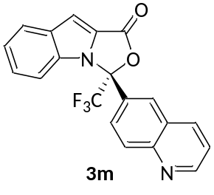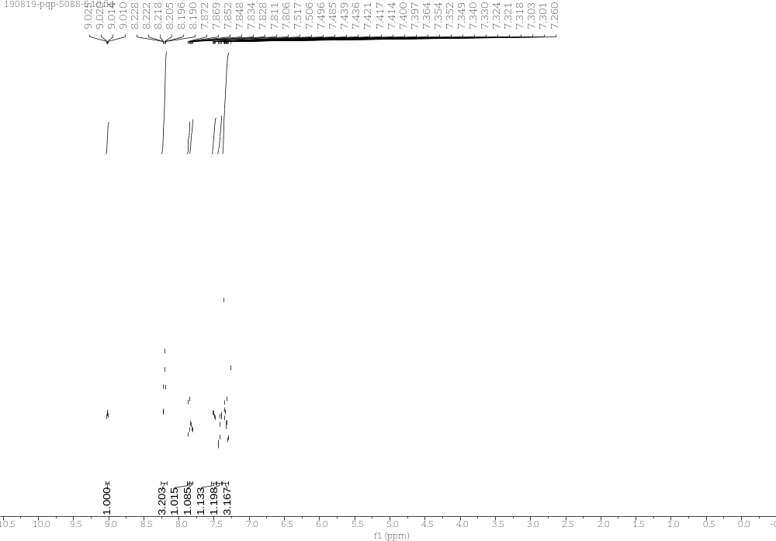
Supplementary Figure 37. ¹H NMR Spectra of 3m
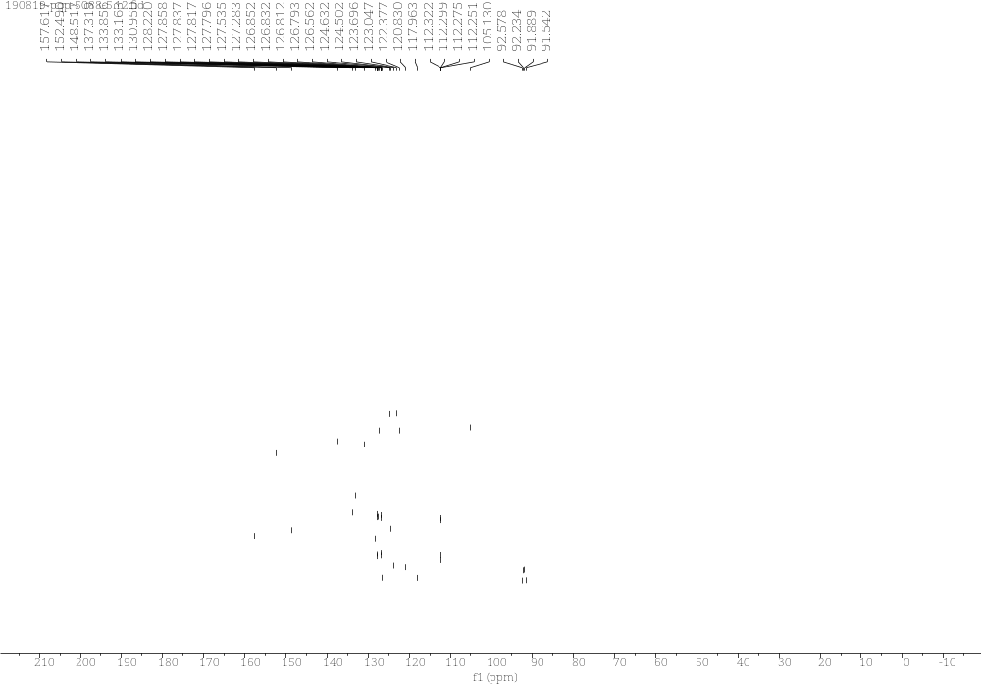
Supplementary Figure 38. ¹³C NMR Spectra of 3m
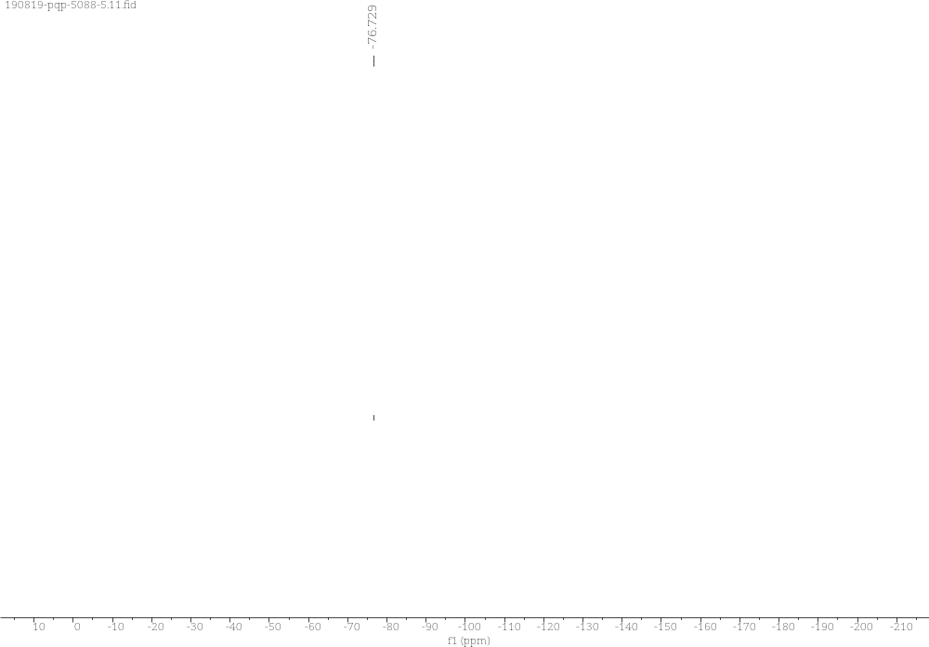
Supplementary Figure 39. ¹⁹F NMR Spectra of 3m

3n (R)-3-(quinolin-3-yl)-3-(trifluoromethyl)-1H,3H-oxazolo[3,4-a]indol-1-one
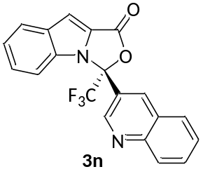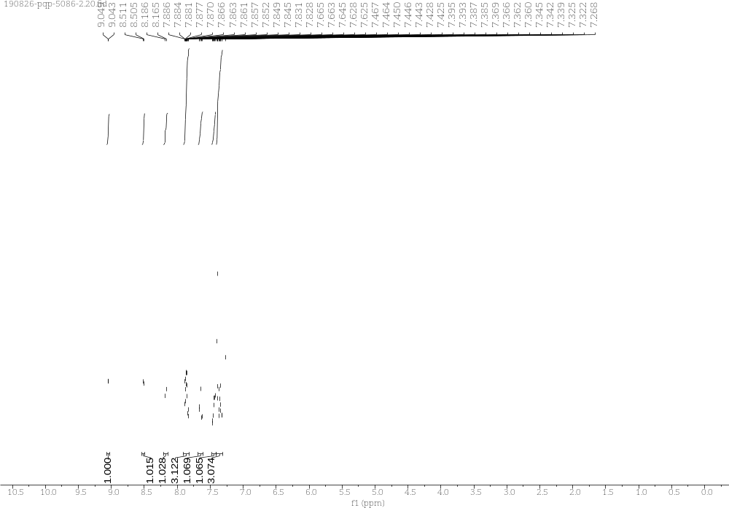
Supplementary Figure 40. ¹H NMR Spectra of 3n
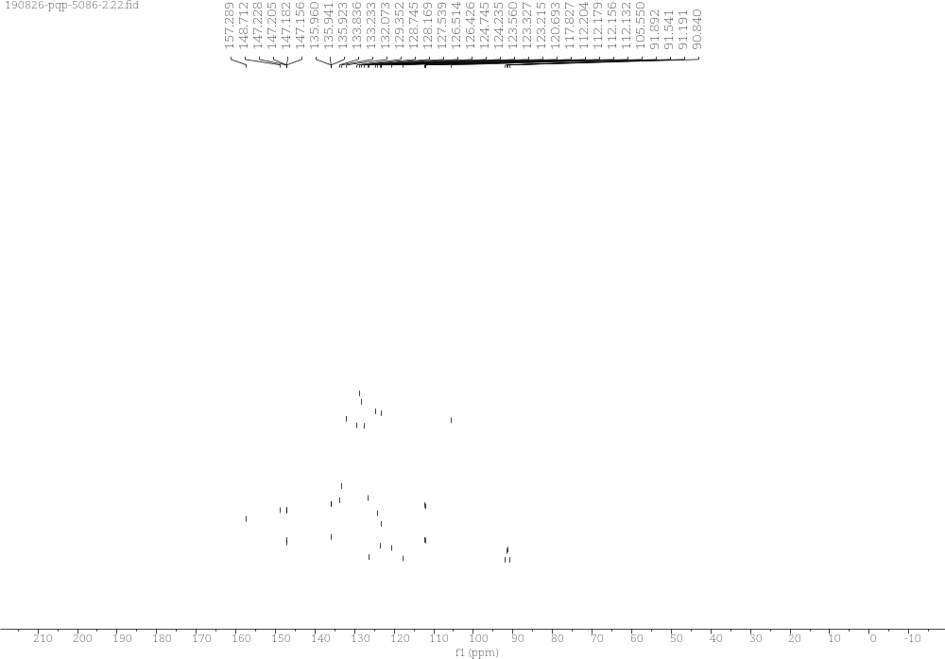
Supplementary Figure 41. ¹³C NMR Spectra of 3n
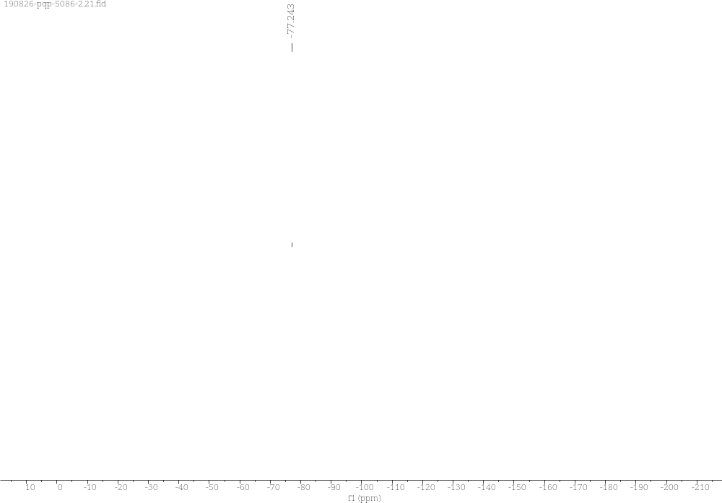
Supplementary Figure 42. ¹⁹F NMR Spectra of 3n

3o (R)-3-ethyl-3-(trifluoromethyl)-1H,3H-oxazolo[3,4-a]indol-1-one
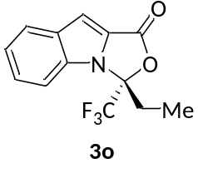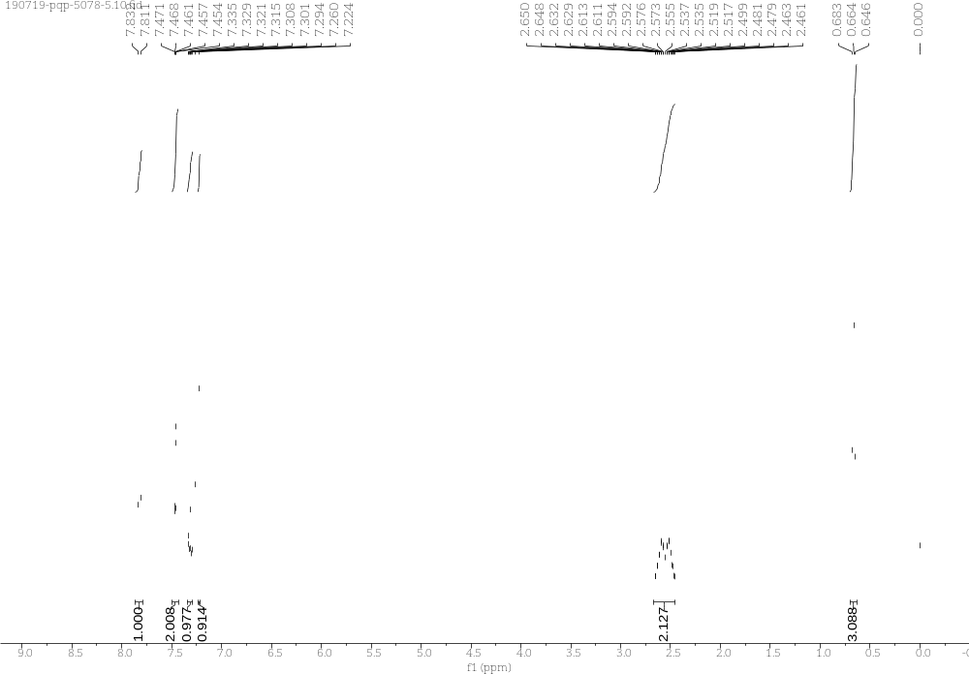
Supplementary Figure 43. ¹H NMR Spectra of 3o
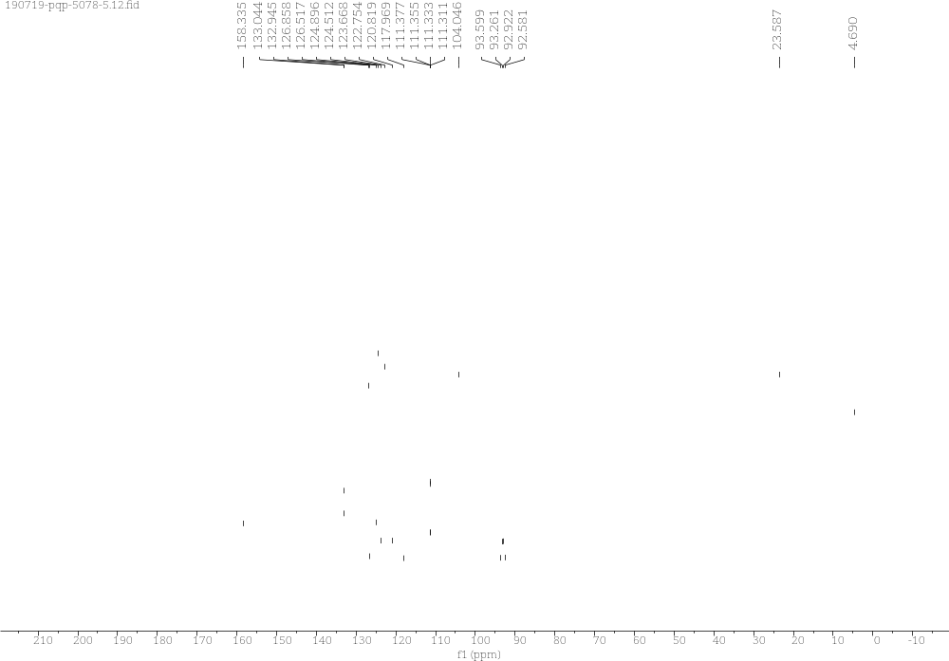
Supplementary Figure 44. ¹³C NMR Spectra of 3o
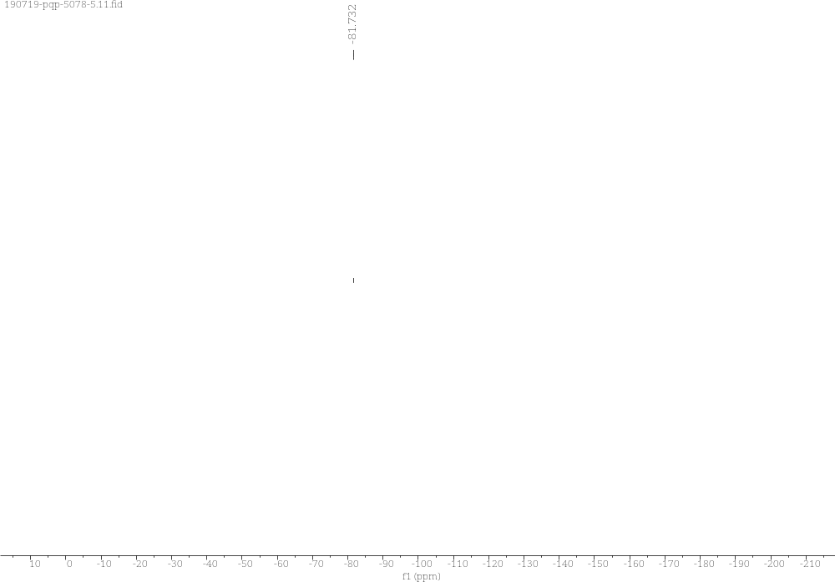
Supplementary Figure 45. ¹⁹F NMR Spectra of 3o

3p (R)-3-benzyl-3-(trifluoromethyl)-1H,3H-oxazolo[3,4-a]indol-1-one
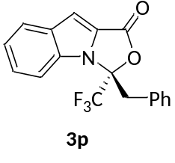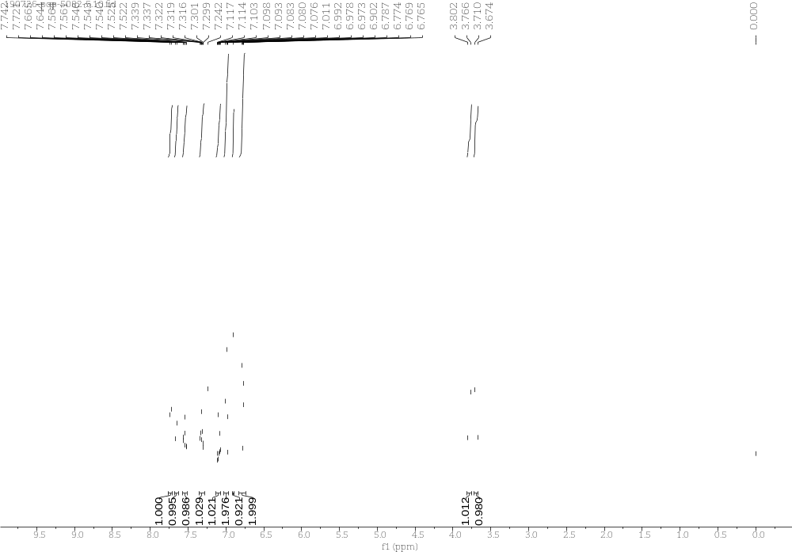
Supplementary Figure 46. ¹H NMR Spectra of 3p
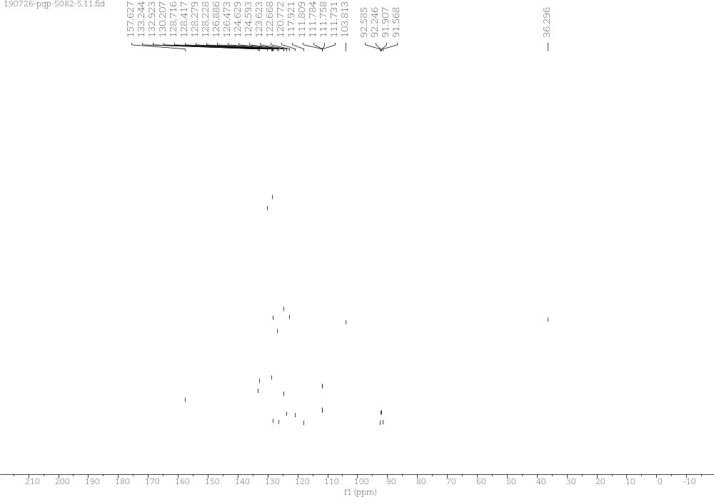
Supplementary Figure 47. ¹³C NMR Spectra of 3p

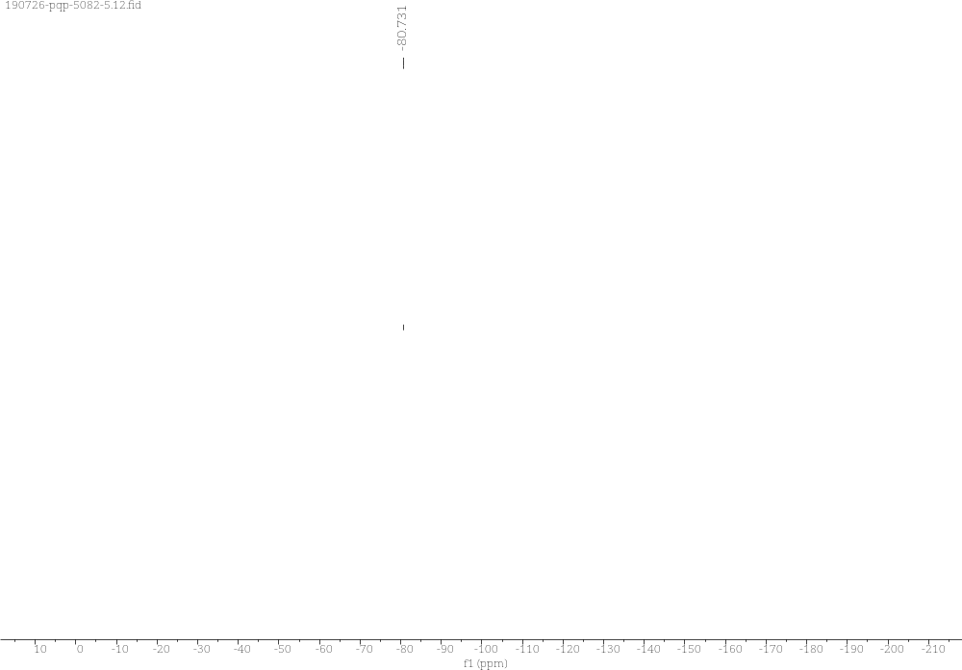
Supplementary Figure 48. ¹⁹F NMR Spectra of 3p

3q (R,E)-3-styryl-3-(trifluoromethyl)-1H,3H-oxazolo[3,4-a]indol-1-one
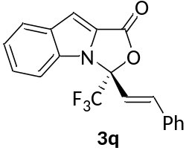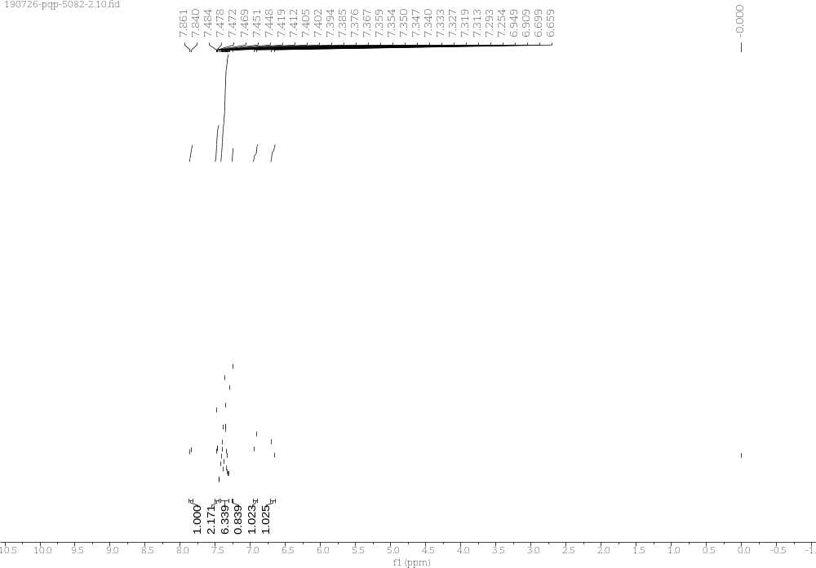
Supplementary Figure 49. ¹H NMR Spectra of 3q
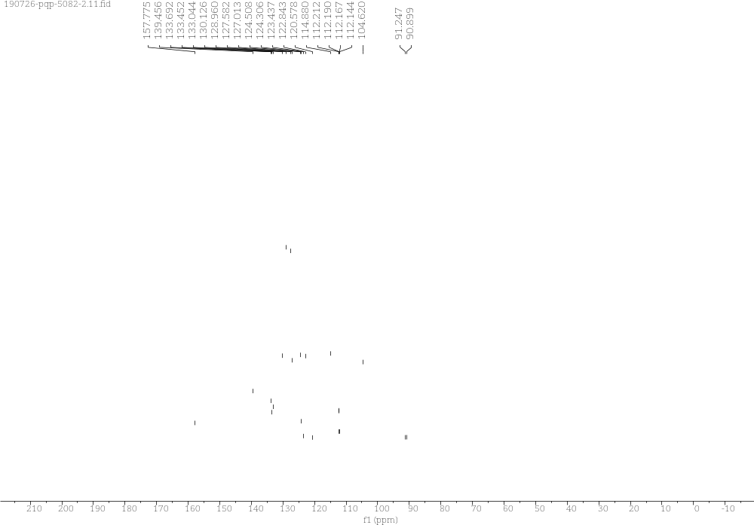
Supplementary Figure 50. ¹³C NMR Spectra of 3q

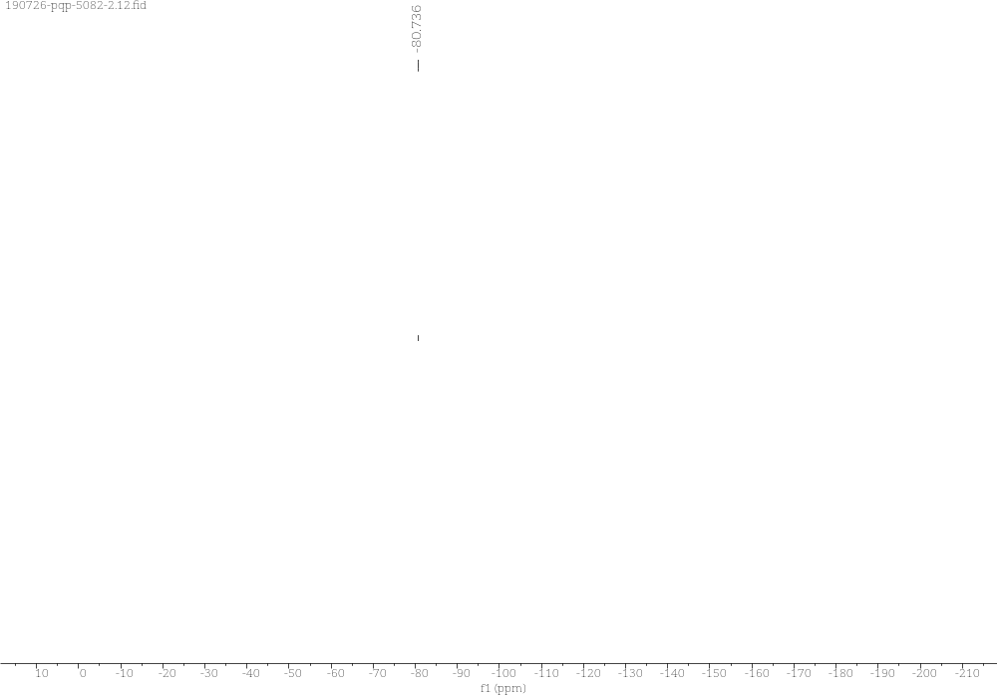
Supplementary Figure 51. ¹⁹F NMR Spectra of 3q

3r (R)-3-(difluoromethyl)-3-phenyl-1H,3H-oxazolo[3,4-a]indol-1-one
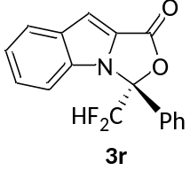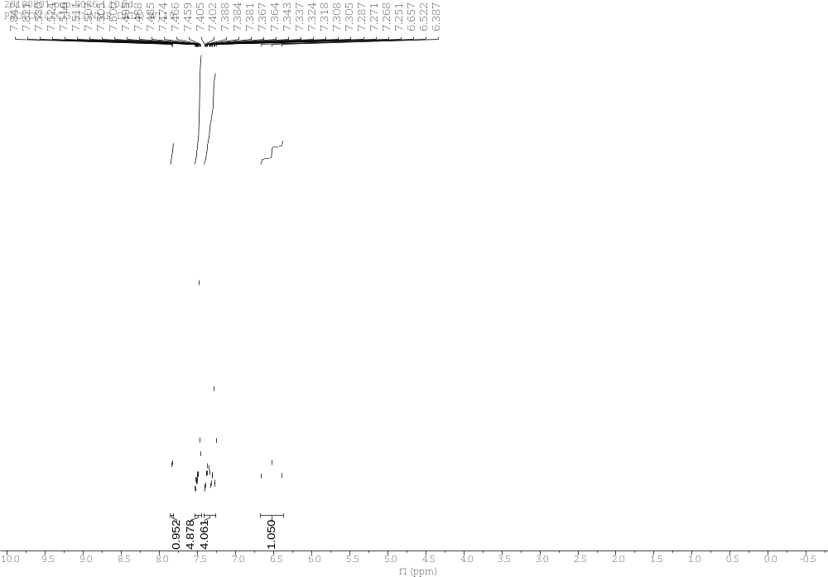
Supplementary Figure 52. ¹H NMR Spectra of 3r
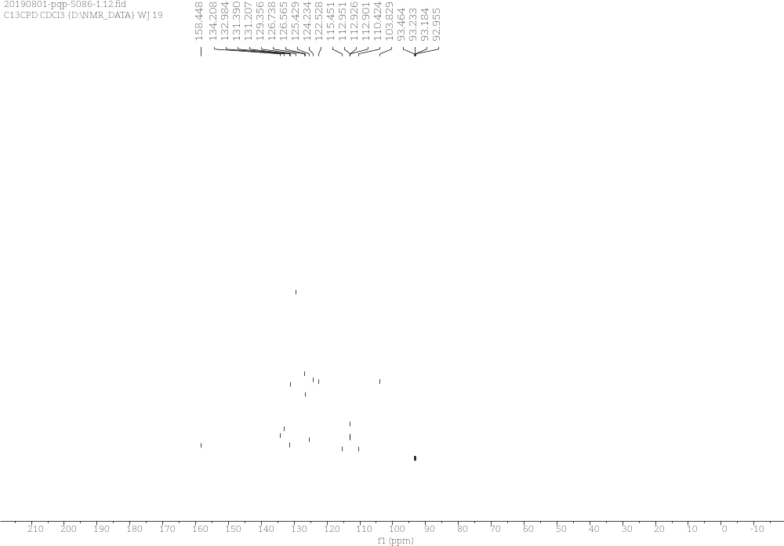
Supplementary Figure 53. ¹³C NMR Spectra of 3r

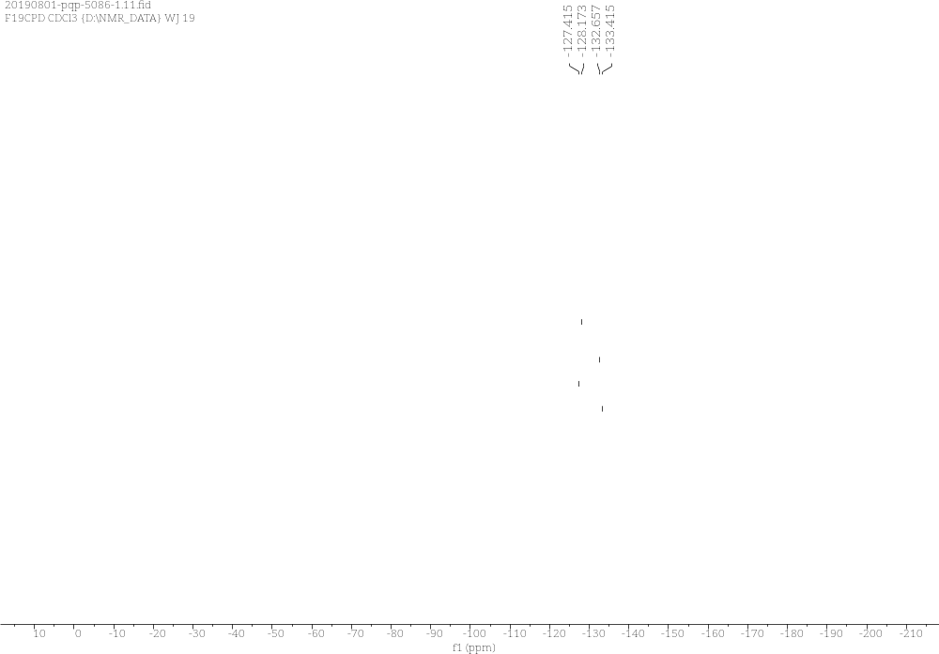
Supplementary Figure 54. ¹⁹C NMR Spectra of 3r

3s (R)-3-(chlorodifluoromethyl)-3-phenyl-1H,3H-oxazolo[3,4-a]indol-1-one
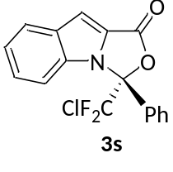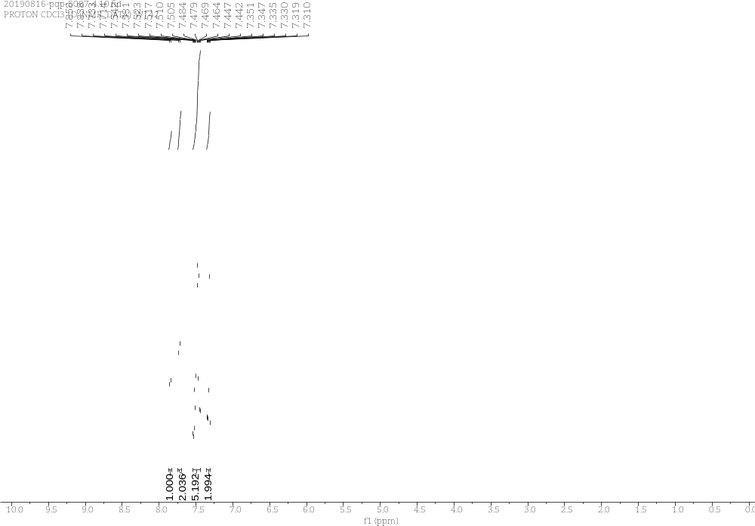
Supplementary Figure 55. ¹H NMR Spectra of 3s
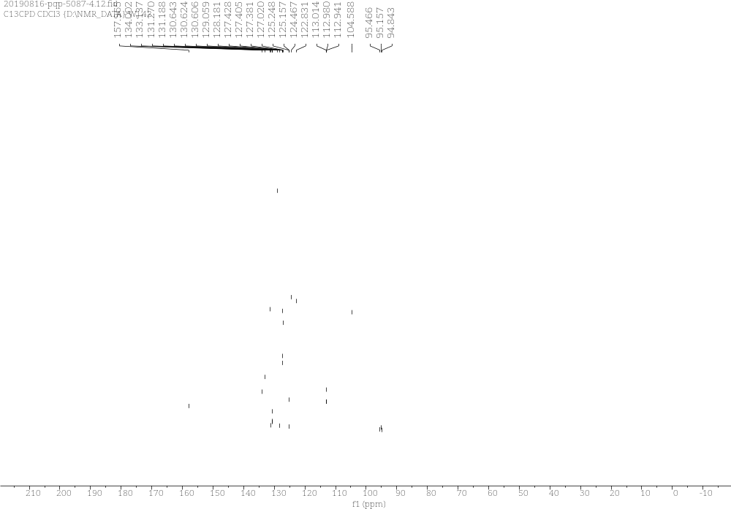
Supplementary Figure 56. ¹³C NMR Spectra of 3s
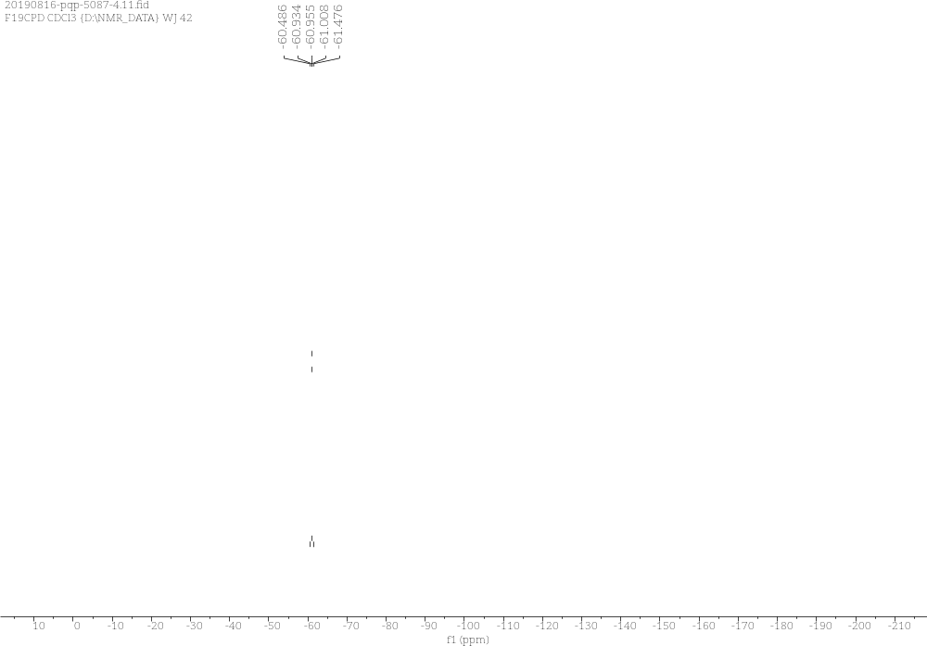
Supplementary Figure 57. ¹³C NMR Spectra of 3s

3t (R)-3-(perfluoroethyl)-3-phenyl-1H,3H-oxazolo[3,4-a]indol-1-one
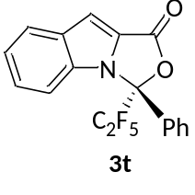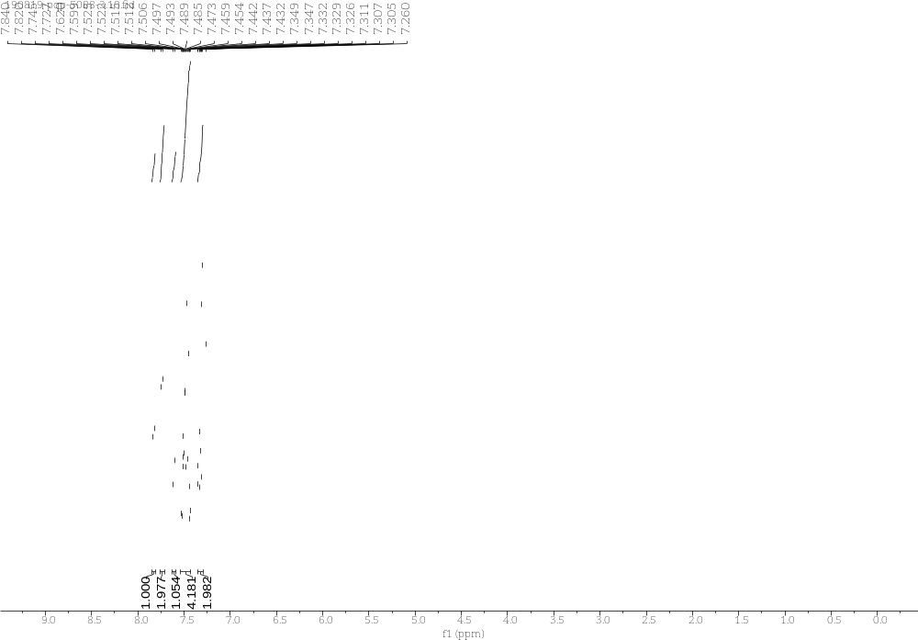
Supplementary Figure 58. ¹H NMR Spectra of 3t
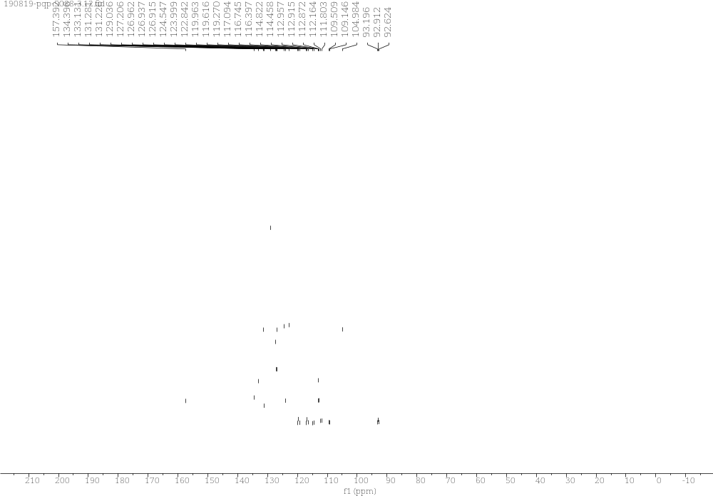
Supplementary Figure 59. ¹³C NMR Spectra of 3t
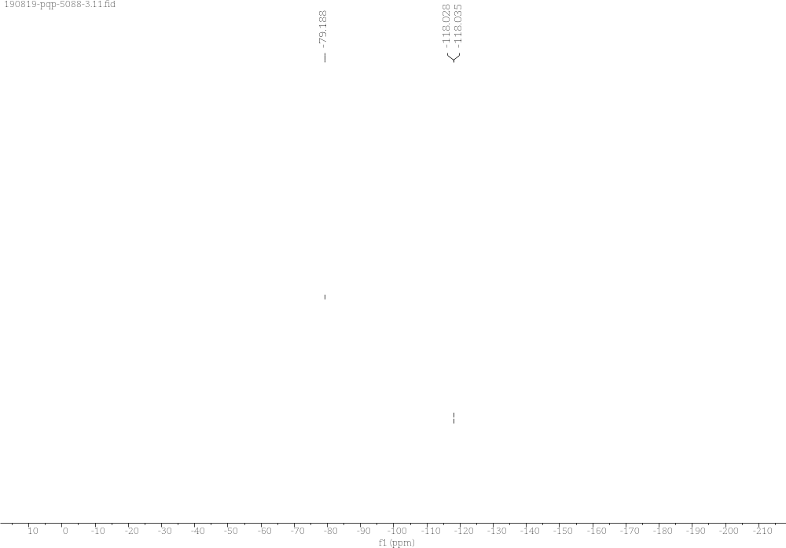
Supplementary Figure 60. ¹⁹F NMR Spectra of 3t

4a (R)-7-fluoro-3-phenyl-3-(trifluoromethyl)-1H,3H-oxazolo[3,4-a]indol-1-one
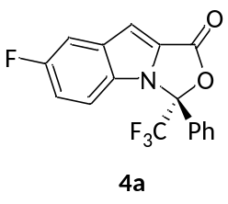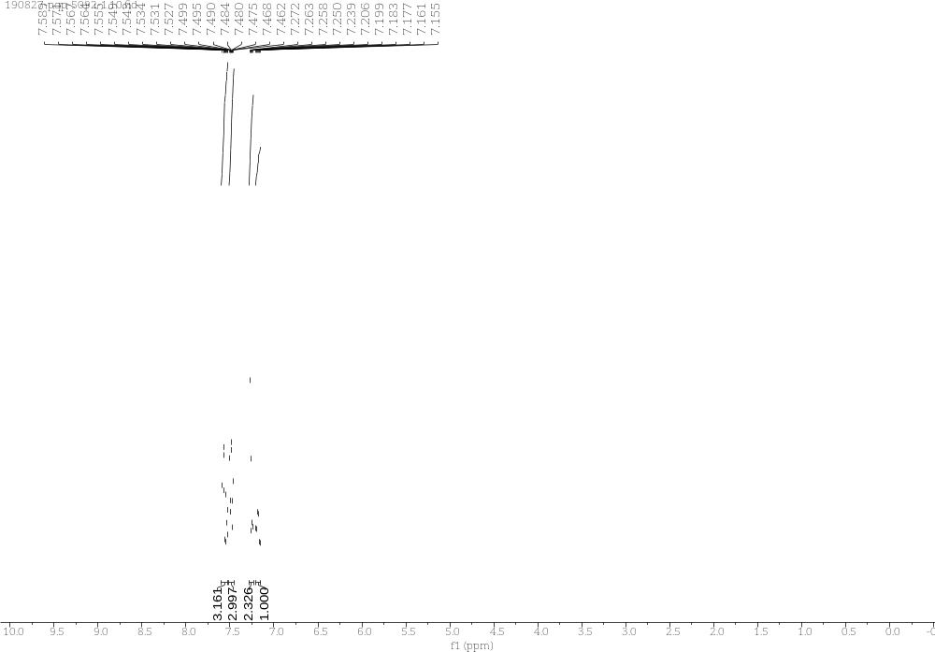
Supplementary Figure 61. ¹H NMR Spectra of 4a
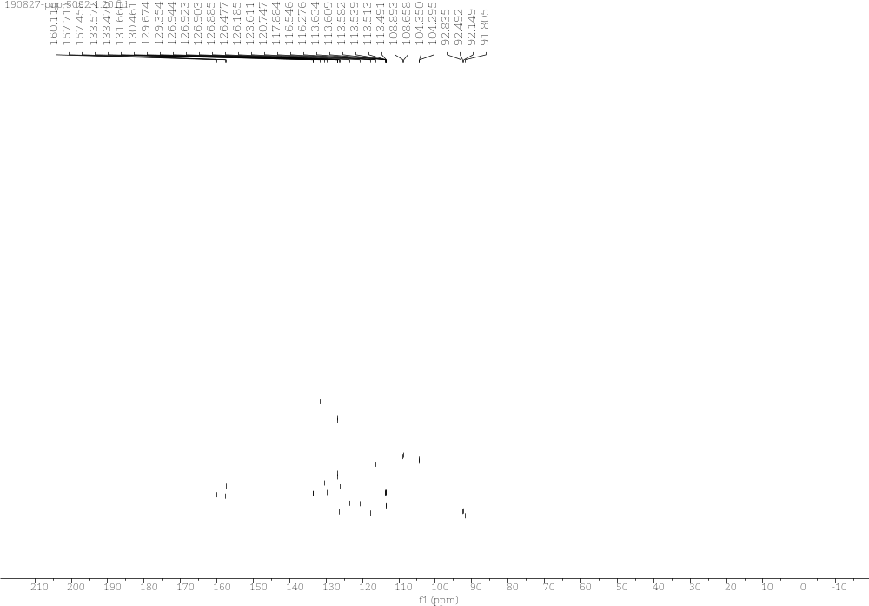
Supplementary Figure 62. ¹³C NMR Spectra of 4a

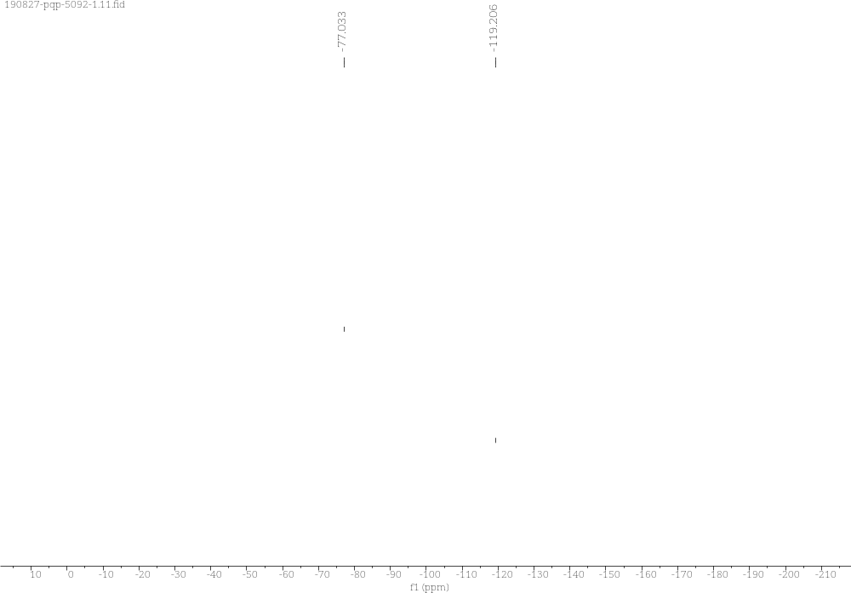
Supplementary Figure 63. ¹⁹F NMR Spectra of 4a

4b (R)-7-chloro-3-phenyl-3-(trifluoromethyl)-1H,3H-oxazolo[3,4-a]indol-1-one
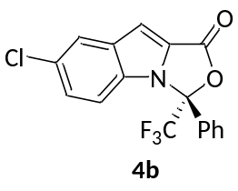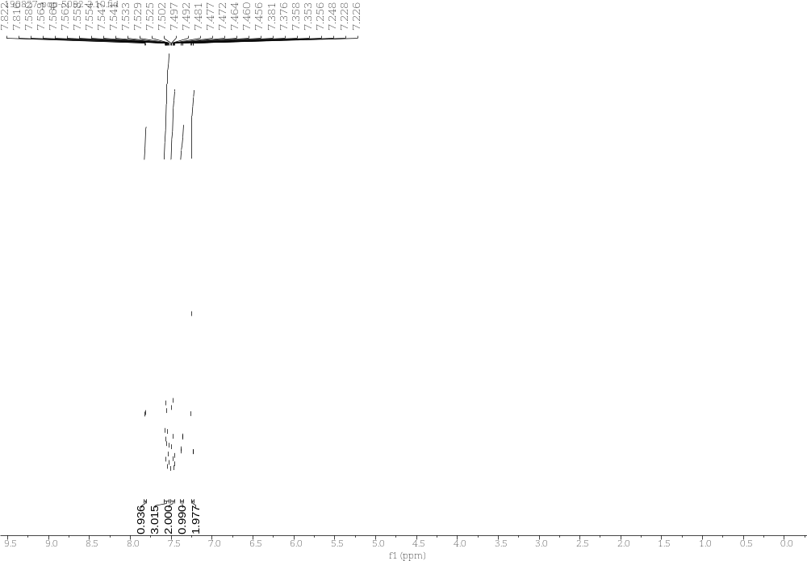
Supplementary Figure 64. ¹H NMR Spectra of 4b
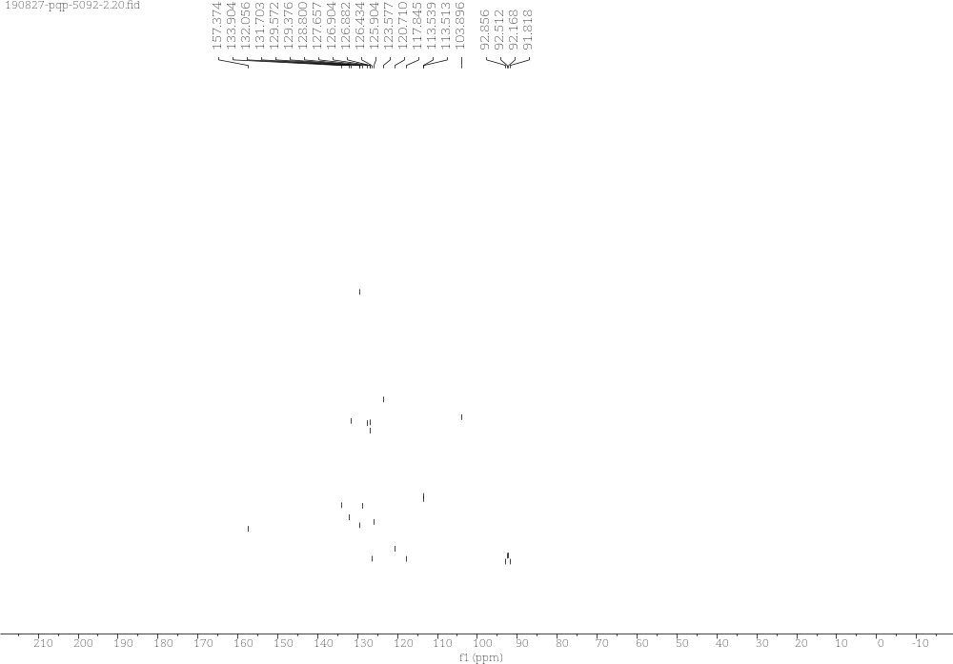
Supplementary Figure 65. ¹³C NMR Spectra of 4b

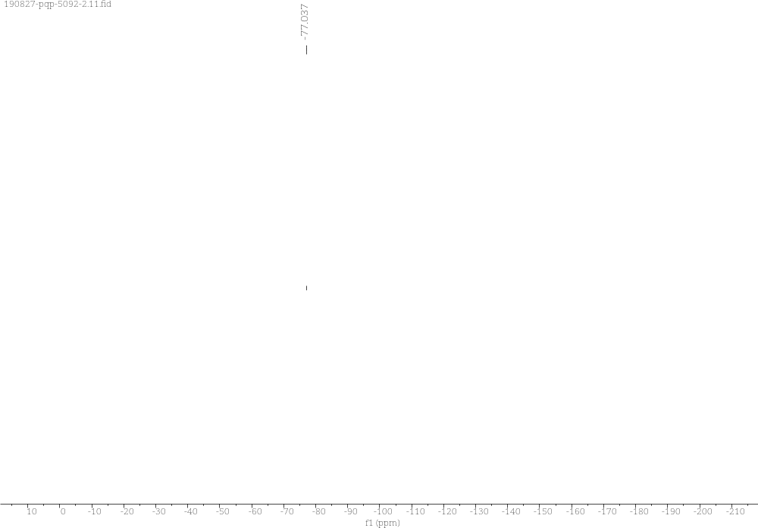
Supplementary Figure 66. ¹⁹F NMR Spectra of 4b

4c (R)-7-methyl-3-phenyl-3-(trifluoromethyl)-1H,3H-oxazolo[3,4-a]indol-1-one
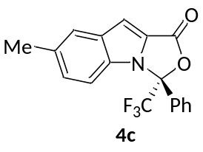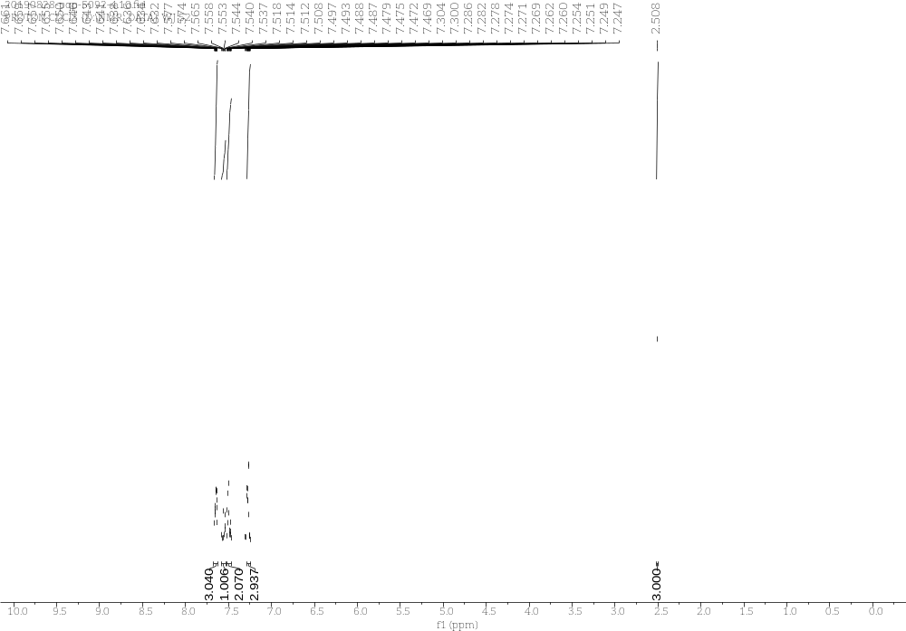
Supplementary Figure 67. ¹H NMR Spectra of 4c
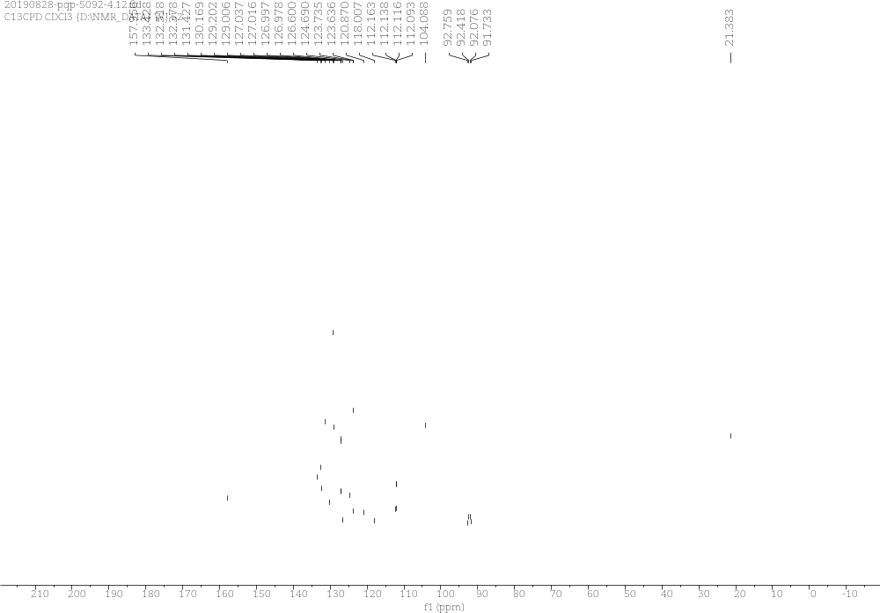
Supplementary Figure 68. ¹³C NMR Spectra of 4c

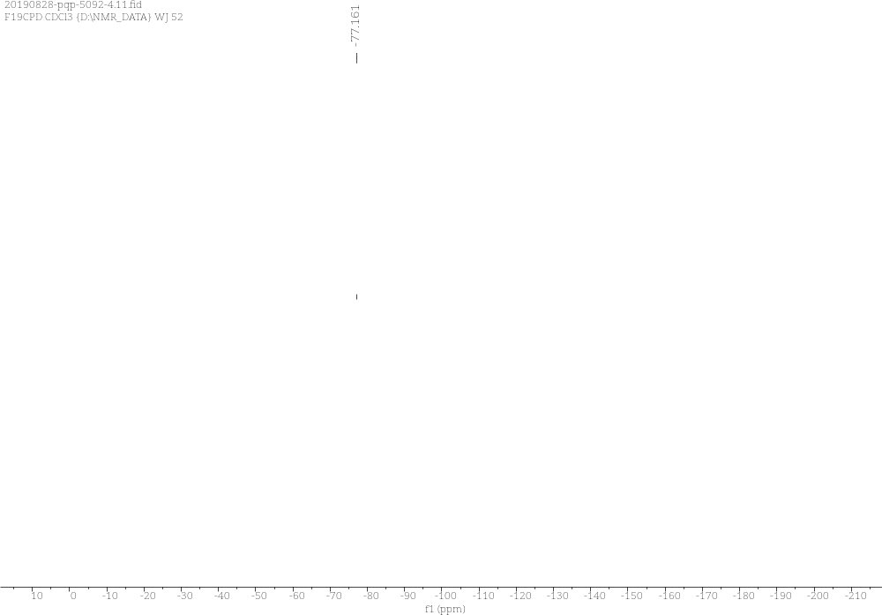
Supplementary Figure 69. ¹⁹F NMR Spectra of 4c

4d (R)-7-methoxy-3-phenyl-3-(trifluoromethyl)-1H,3H-oxazolo[3,4-a]indol-1-one
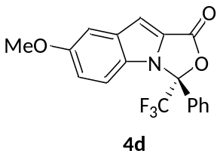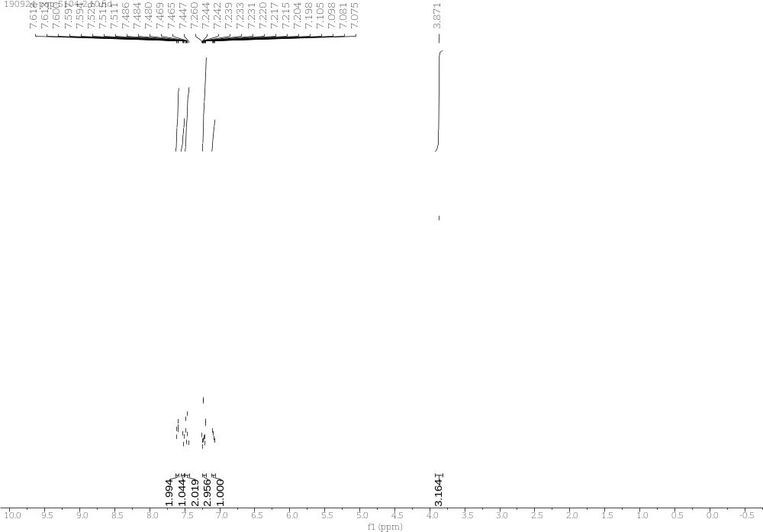
Supplementary Figure 70. ¹H NMR Spectra of 4d
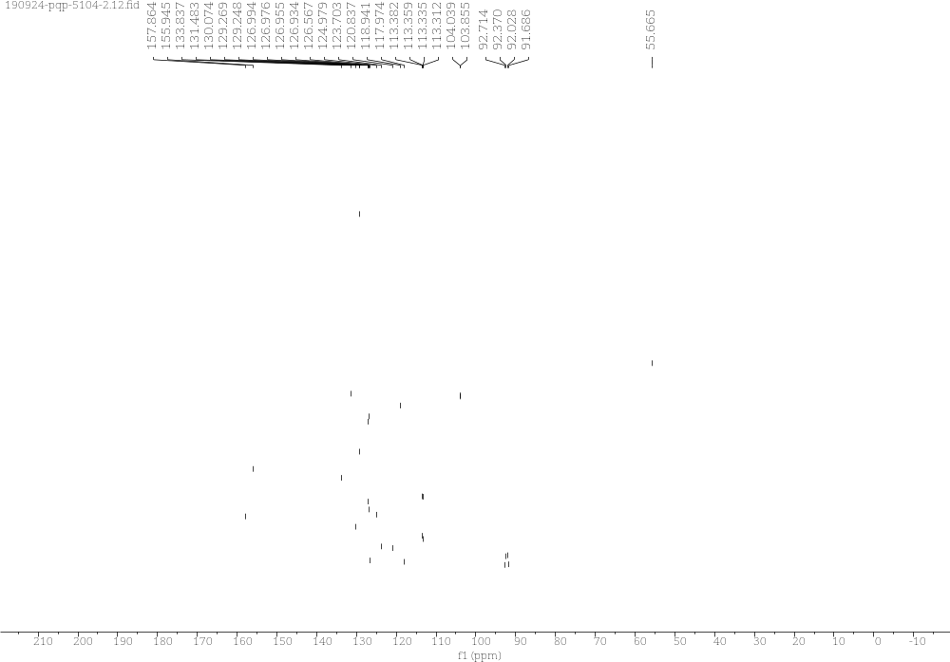
Supplementary Figure 71. ¹³C NMR Spectra of 4d

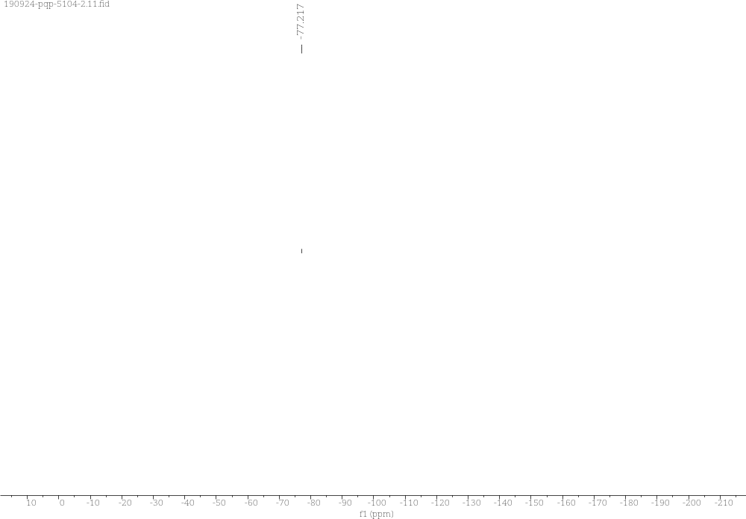
Supplementary Figure 72. ¹⁹F NMR Spectra of 4d

4e (R)-9-methyl-3-phenyl-3-(trifluoromethyl)-1H,3H-oxazolo[3,4-a]indol-1-one
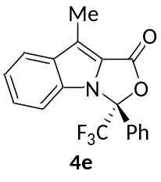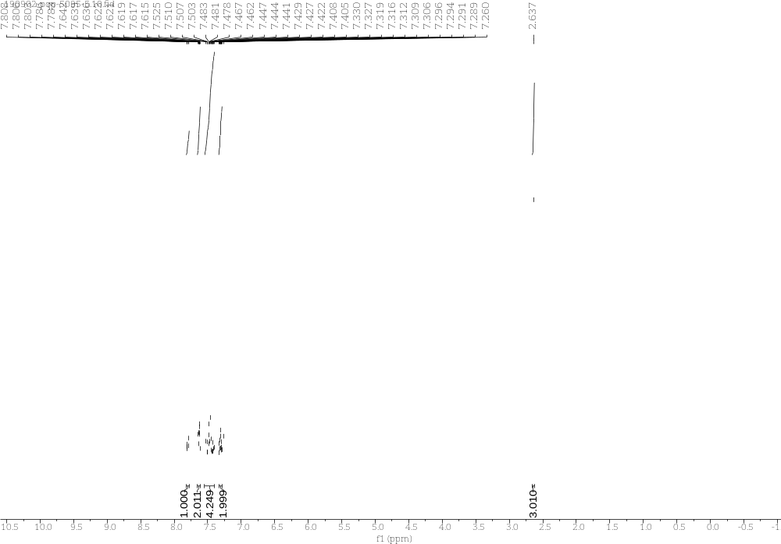
Supplementary Figure 73. ¹H NMR Spectra of 4e
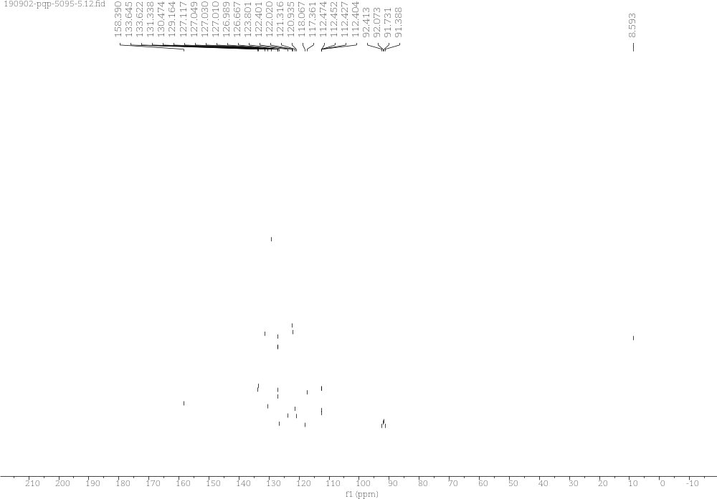
Supplementary Figure 74. ¹³C NMR Spectra of 4e

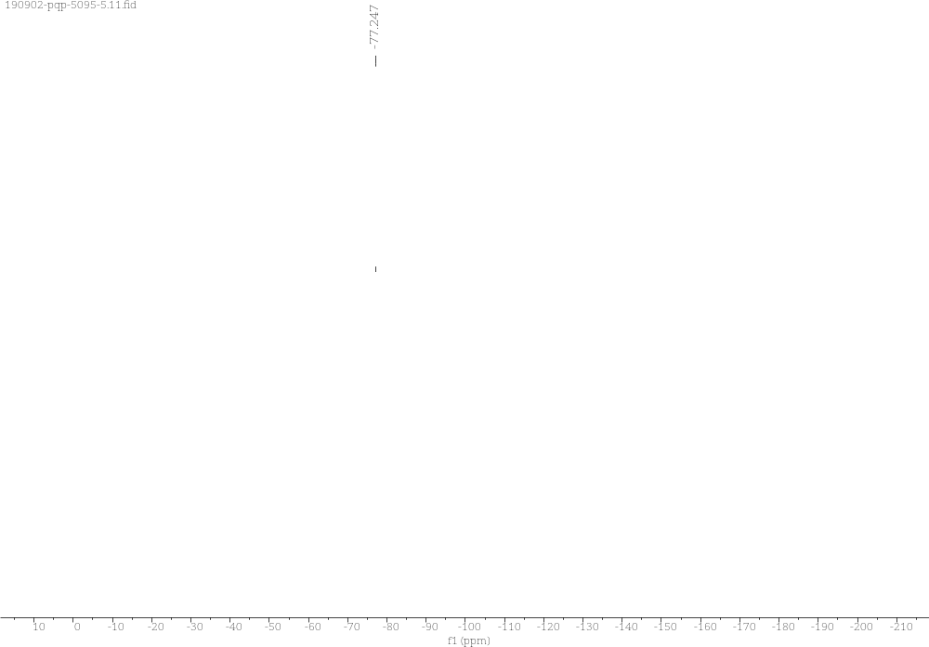
Supplementary Figure 75. ¹⁹F NMR Spectra of 4e

4f (R)-8-methyl-3-phenyl-3-(trifluoromethyl)-1H,3H-oxazolo[3,4-a]indol-1-one
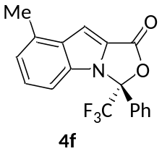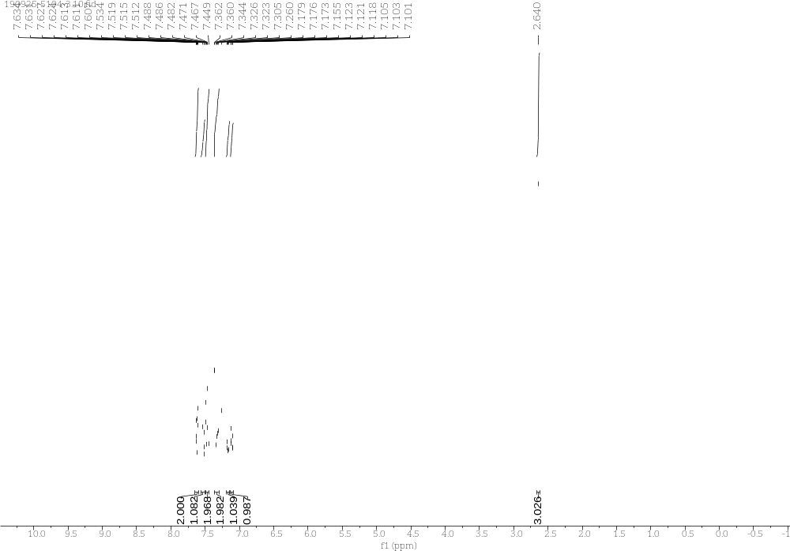
Supplementary Figure 76. ¹H NMR Spectra of 4f
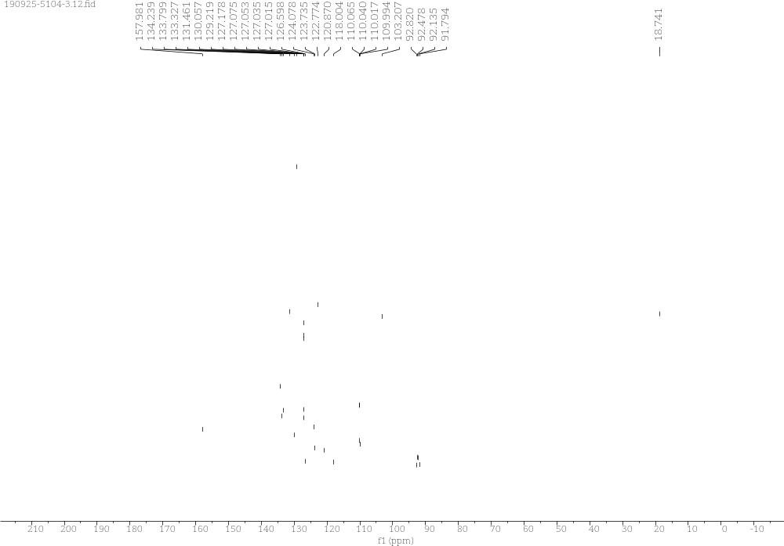
Supplementary Figure 77. ¹³C NMR Spectra of 4f

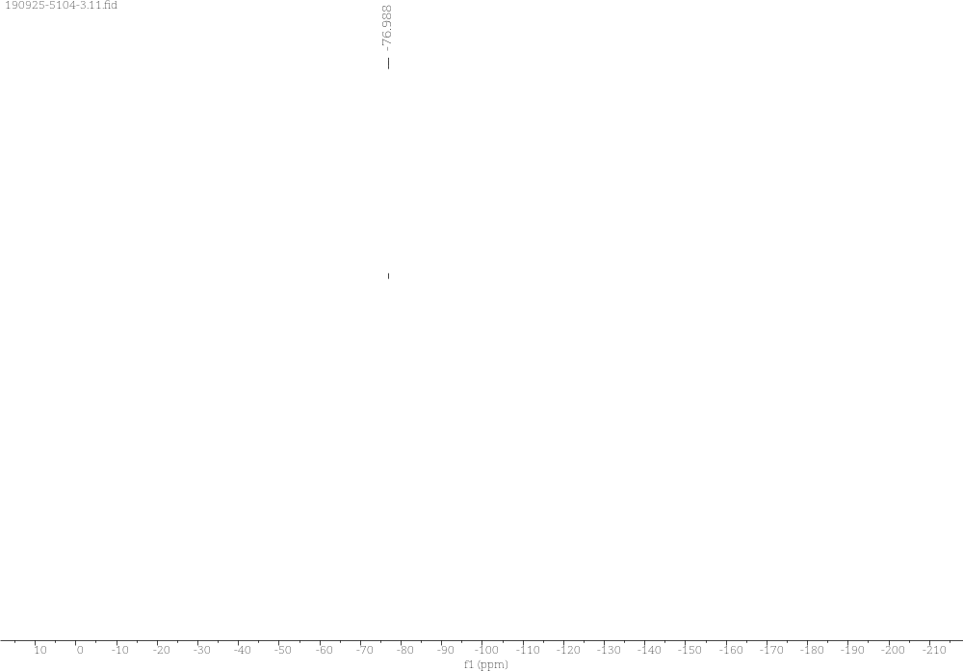
Supplementary Figure 78. ¹⁹F NMR Spectra of 4f

4g (R)-6-methyl-3-phenyl-3-(trifluoromethyl)-1H,3H-oxazolo[3,4-a]indol-1-one
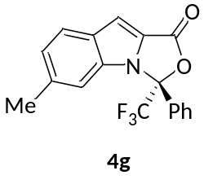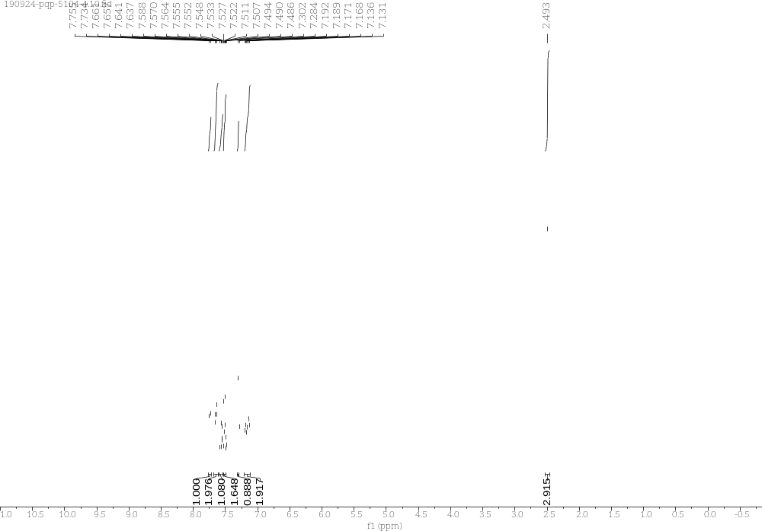
Supplementary Figure 79. ¹H NMR Spectra of 4g
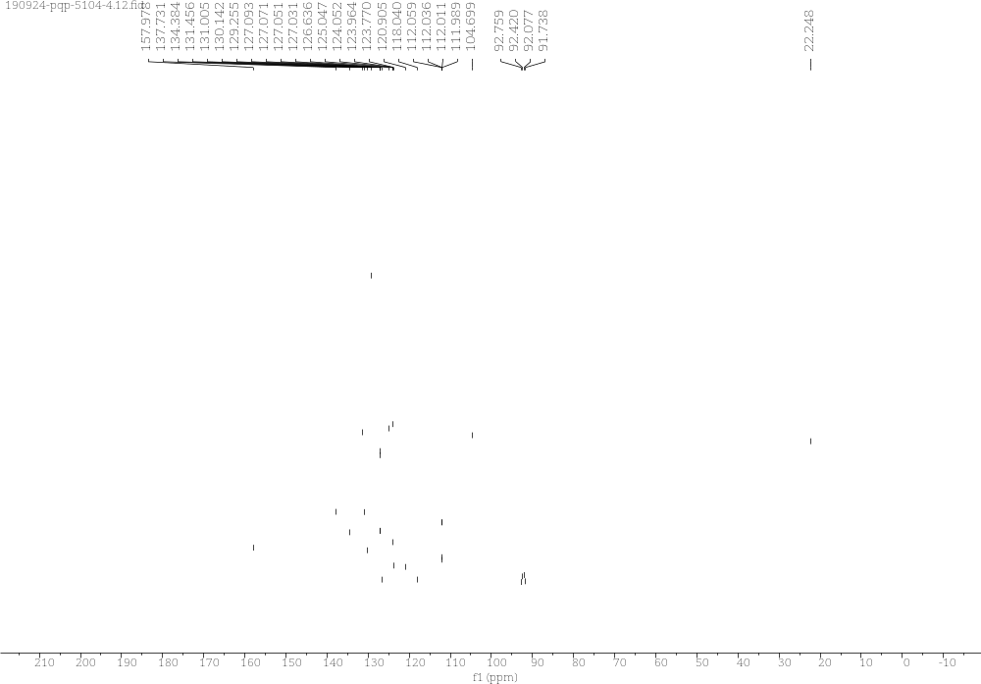
Supplementary Figure 80. ¹³C NMR Spectra of 4g
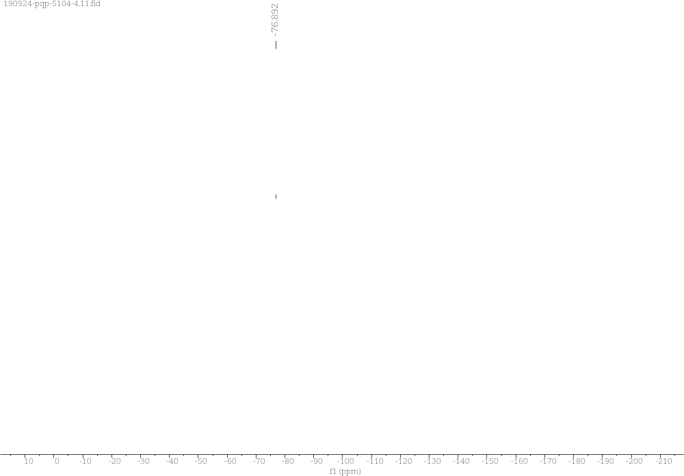
Supplementary Figure 81. ¹⁹F NMR Spectra of 4g

4h (R)-8-phenyl-8-(trifluoromethyl)-8H,10H-benzo[e]oxazolo[3,4-a]indol-10-one
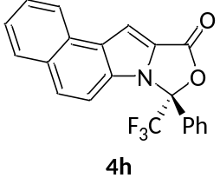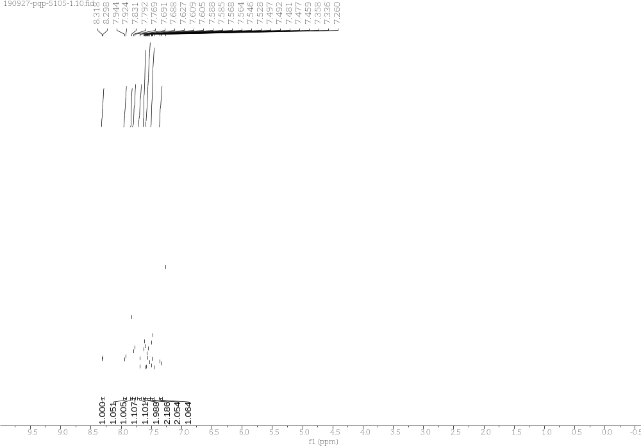
Supplementary Figure 82. ¹H NMR Spectra of 4h
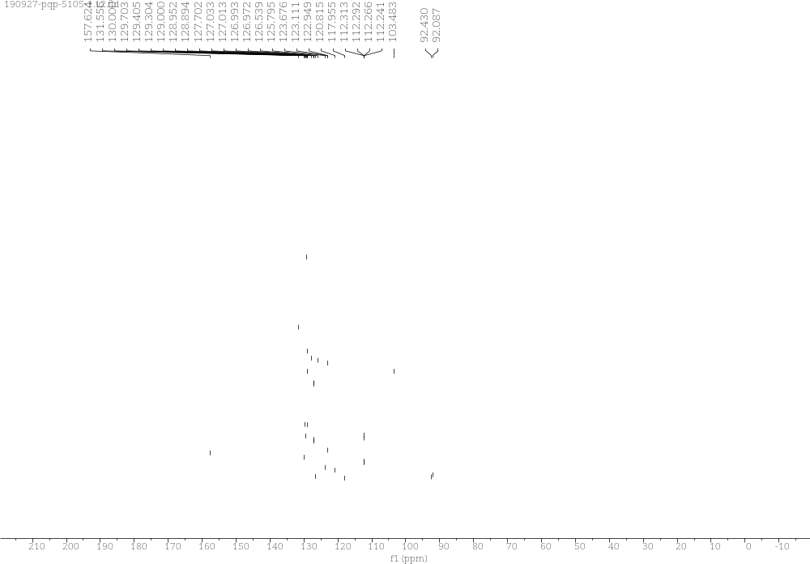
Supplementary Figure 83. ¹³C NMR Spectra of 4h

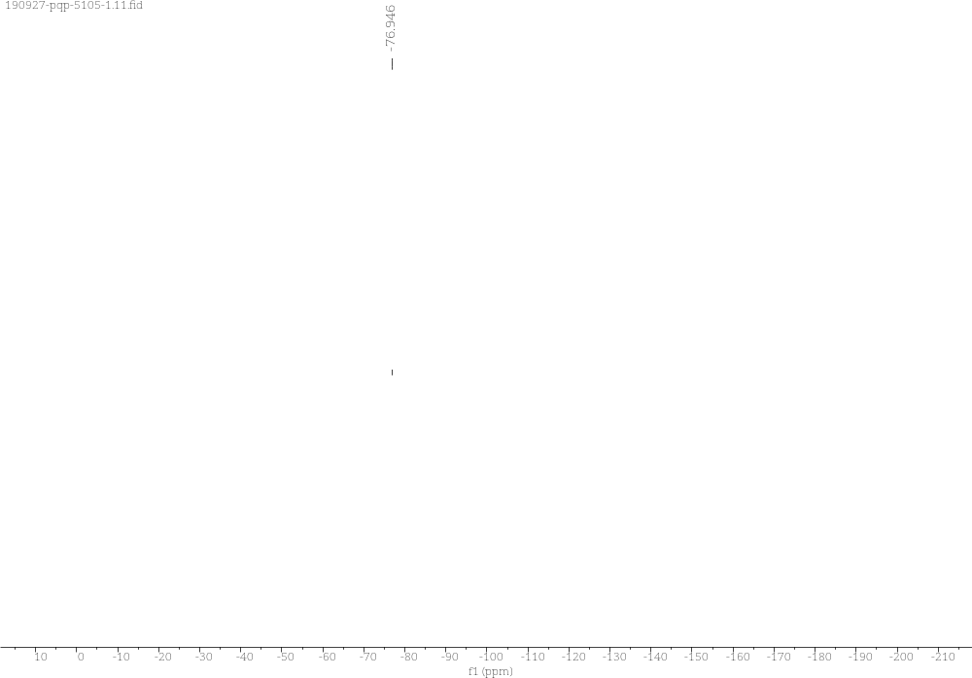
Supplementary Figure 84. ¹⁹F NMR Spectra of 4h

4i (R)-3-methyl-7-phenyl-7-(trifluoromethyl)-7H-oxazolo[3,4-a]pyrrolo[3,2-e]indol-9(3H)-one
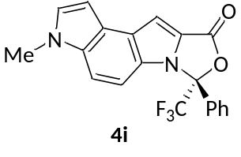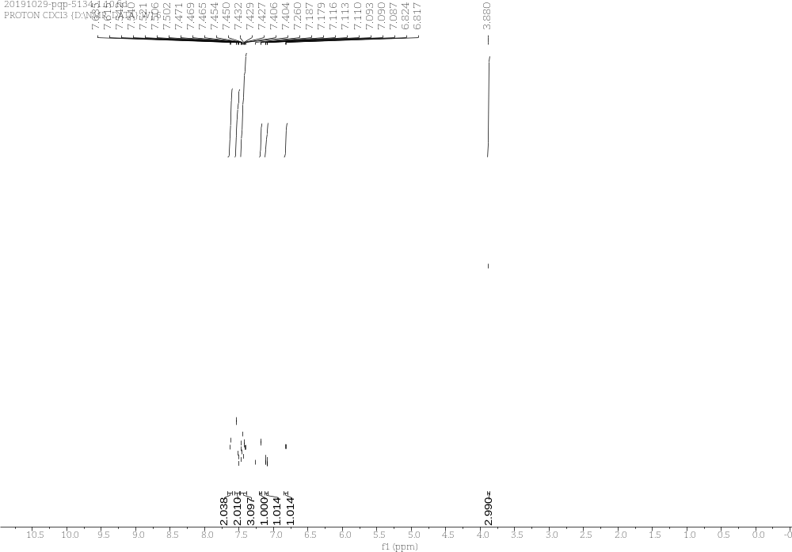
Supplementary Figure 85. ¹H NMR Spectra of 4i
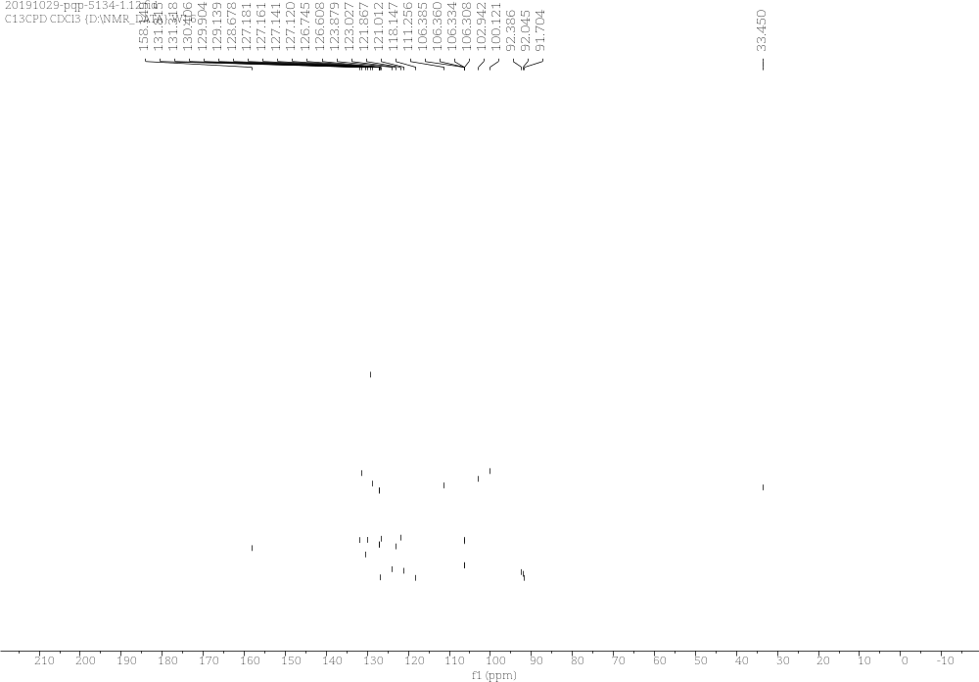
Supplementary Figure 86. ¹³C NMR Spectra of 4i

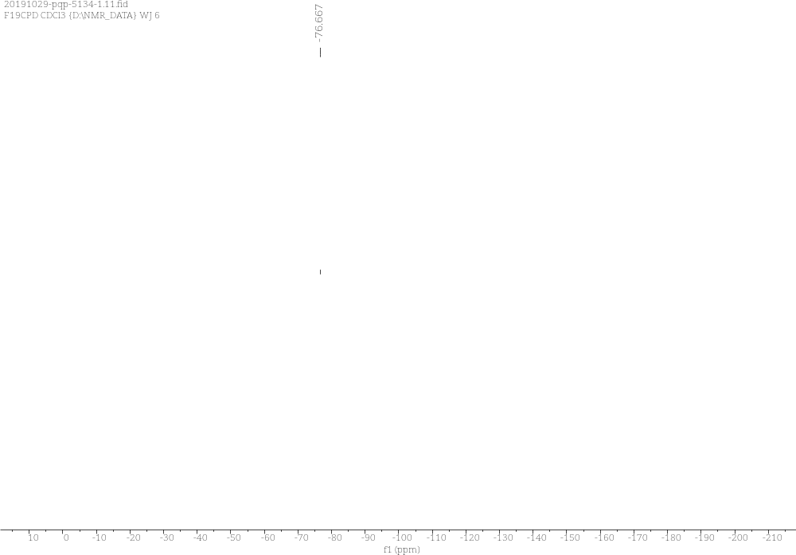
Supplementary Figure 87. ¹⁹F NMR Spectra of 4i

6 (R)-3-(4'-methoxy-[1,1'-biphenyl]-4-yl)-3-(trifluoromethyl)-1H,3H-oxazolo[3,4-a]indol-1-one
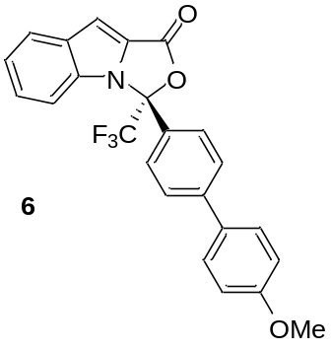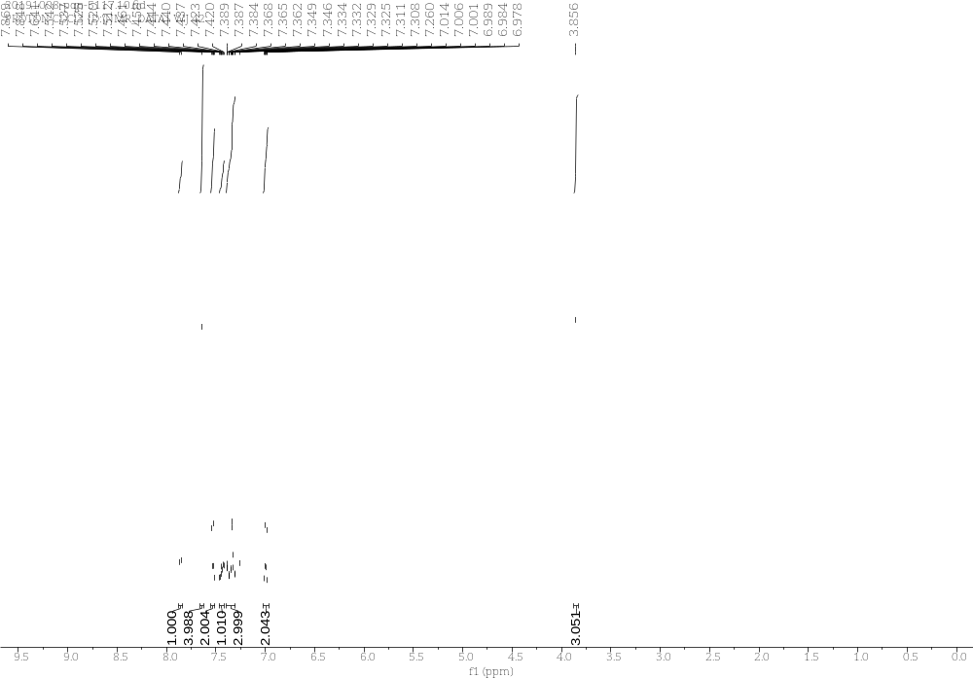
Supplementary Figure 88. ¹H NMR Spectra of 6
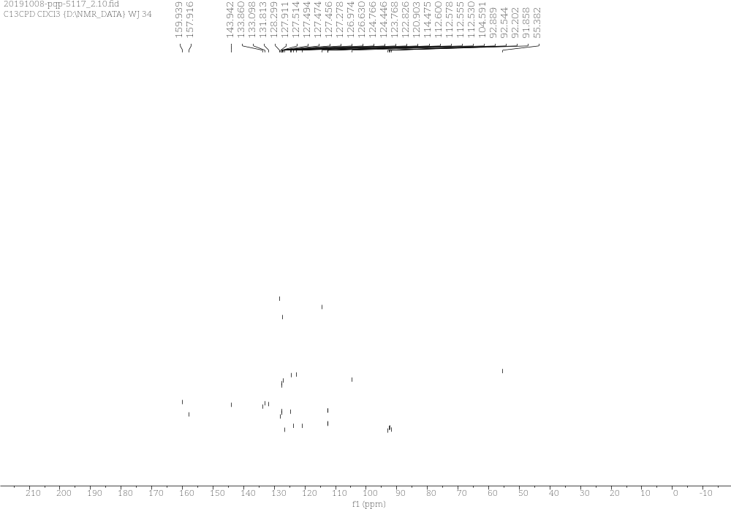
Supplementary Figure 89. ¹³C NMR Spectra of 6
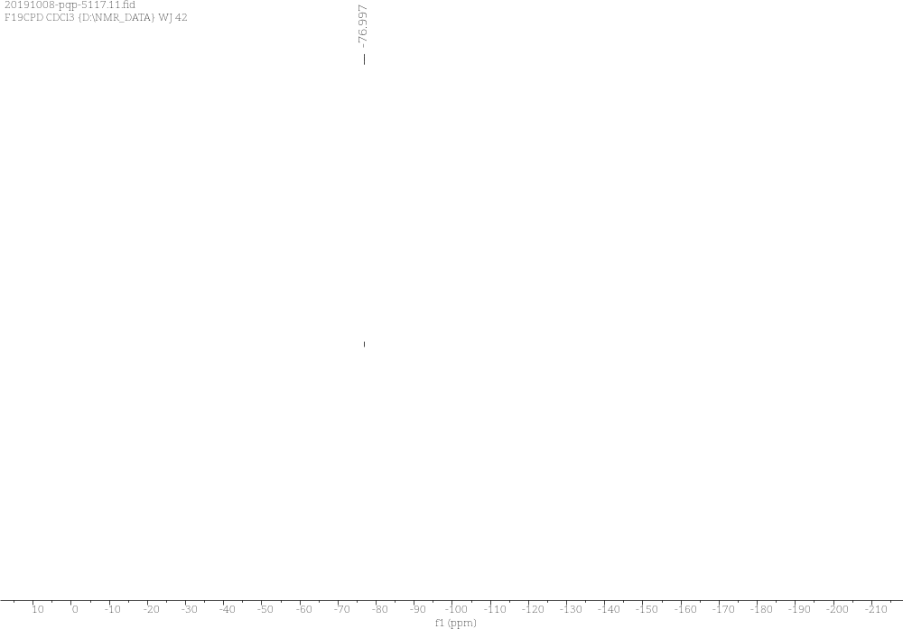
Supplementary Figure 90. ¹⁹F NMR Spectra of 6

F (5aS,10bR)-9-nitro-2-(perfluorophenyl)-5a,10b-dihydro-4H,6H-indeno[2,1-b][1,2,4]triazolo[4,3-d][1,4]oxazin-2-ium tetrafluoroborate

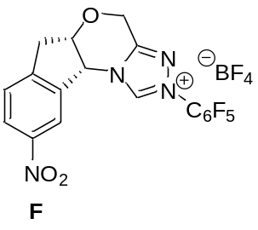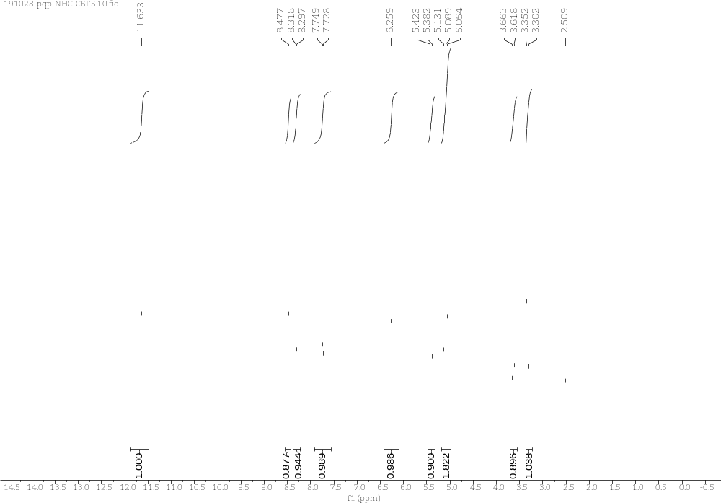
Supplementary Figure 91. ¹H NMR Spectra of F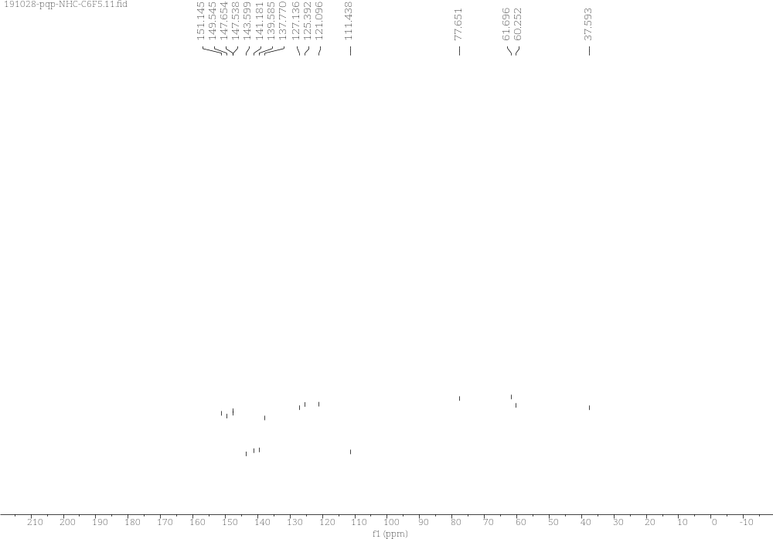
Supplementary Figure 92. ¹³C NMR Spectra of F
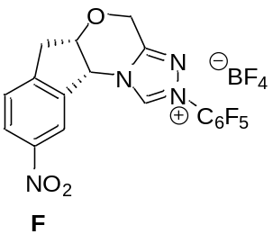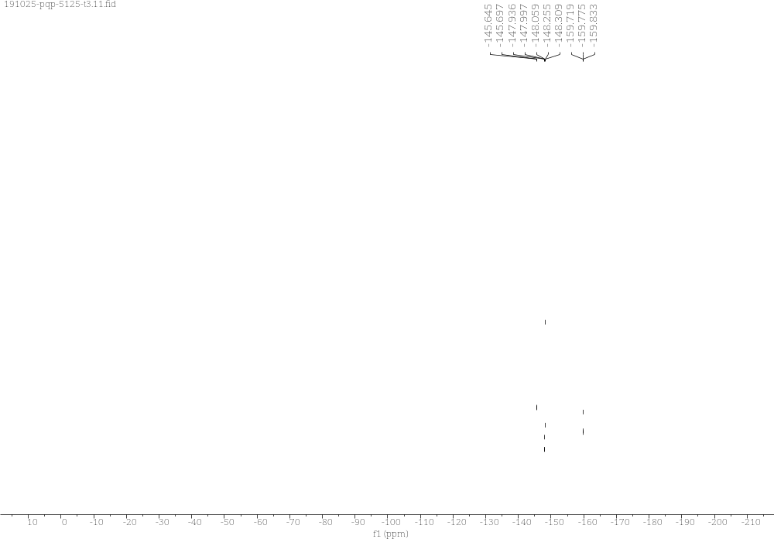
Supplementary Figure 93. ¹⁹F NMR Spectra of F

HPLC Spectra
3a (R)-3-phenyl-3-(trifluoromethyl)-1H,3H-oxazolo[3,4-a]indol-1-one

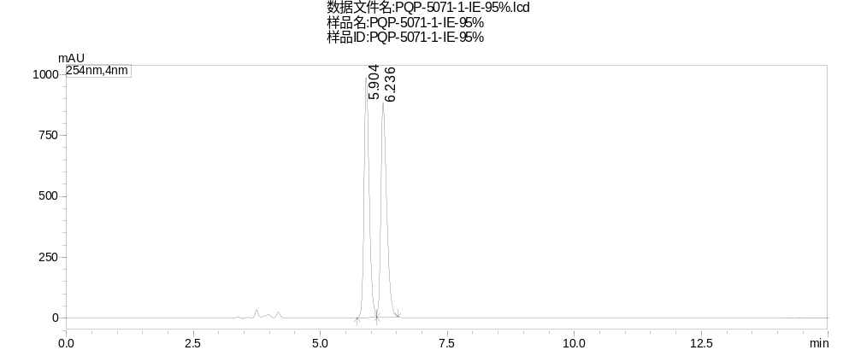
Peak | Ret. Time | Area | Height | Area%
1 | 5.904 | 6983485 | 985666 | 49.956
2 | 6.236 | 6995912 | 880522 | 50.044
Total |  | 13979398 | 1866189 | 100.000
Supplementary Figure 94. HPLC Spectrum of racemic 3a

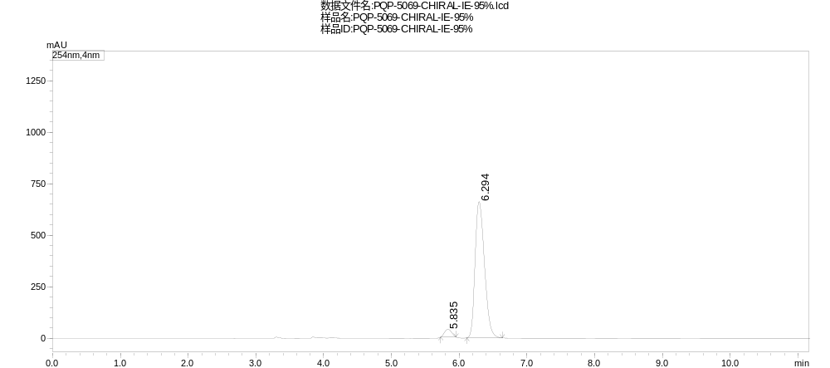
Peak | Ret. Time | Area | Height | Area%
1 | 5.835 | 276982 | 37961 | 4.179
2 | 6.294 | 6350746 | 661113 | 95.821
Total |  | 6627728 | 699074 | 100.000
Supplementary Figure 95. HPLC Spectrum of 3a

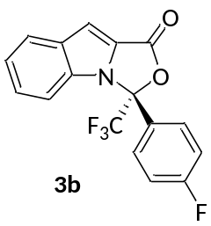
3b (R)-3-(4-fluorophenyl)-3-(trifluoromethyl)-1H,3H-oxazolo[3,4-a]indol-1-one
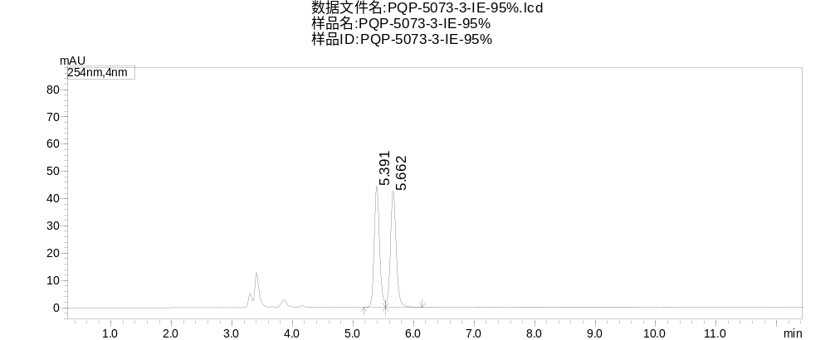
Peak | Ret. Time | Area | Height | Area%
1 | 5.391 | 273968 | 44442 | 49.331
2 | 5.662 | 281396 | 42701 | 50.669
Total |  | 555364 | 87143 | 100.000
Supplementary Figure 96. HPLC Spectrum of racemic 3b

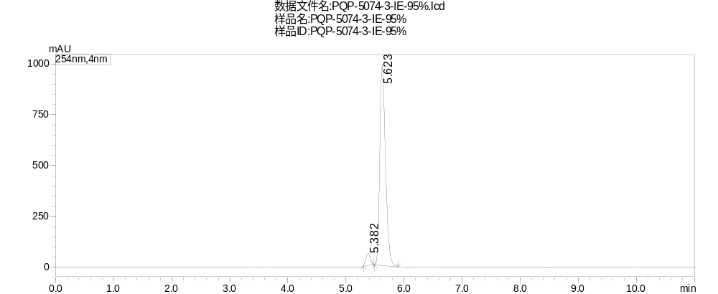
Peak | Ret. Time | Area | Height | Area%
1 | 5.382 | 316864 | 58704 | 4.476
2 | 5.623 | 6762495 | 985309 | 95.524
Total |  | 7079359 | 1044013 | 100.000
Supplementary Figure 97. HPLC Spectrum of 3b

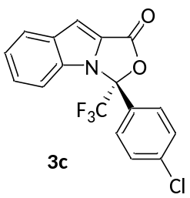
3c (R)-3-(4-chlorophenyl)-3-(trifluoromethyl)-1H,3H-oxazolo[3,4-a]indol-1-one
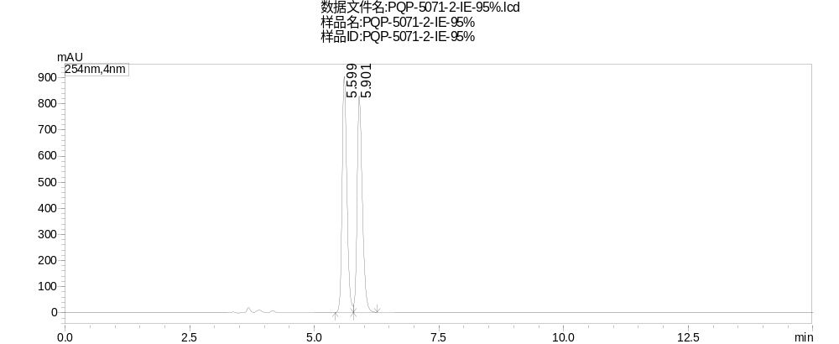
Peak | Ret. Time | Area | Height | Area%
1 | 5.599 | 6015839 | 906077 | 49.788
2 | 5.901 | 6067114 | 830088 | 50.212
Total |  | 12082954 | 1736165 | 100.000
Supplementary Figure 98. HPLC Spectrum of racemic 3c

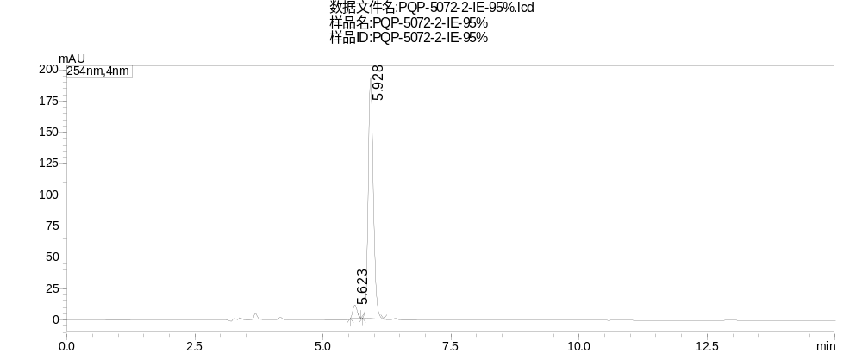
Peak | Ret. Time | Area | Height | Area%
1 | 5.623 | 60988 | 10681 | 4.310
2 | 5.928 | 1353886 | 192200 | 95.690
Total |  | 1414873 | 202881 | 100.000
Supplementary Figure 99. HPLC Spectrum of 3c

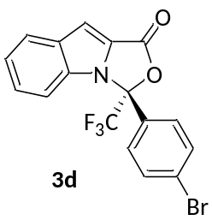
3d (R)-3-(4-bromophenyl)-3-(trifluoromethyl)-1H,3H-oxazolo[3,4-a]indol-1-one
Peak | Ret. Time | Area | Height | Area%
1 | 5.904 | 6983485 | 985666 | 49.956
2 | 6.236 | 6995912 | 880522 | 50.044
Total |  | 13979398 | 1866189 | 100.000
Supplementary Figure 100. HPLC Spectrum of racemic 3d

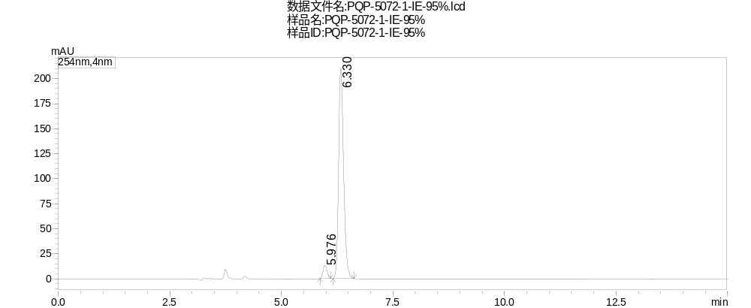
Peak | Ret. Time | Area | Height | Area%
1 | 5.976 | 83862 | 13104 | 4.867
2 | 6.330 | 1639050 | 210150 | 95.133
Total |  | 1722912 | 223253 | 100.000
Supplementary Figure 101. HPLC Spectrum of 3d

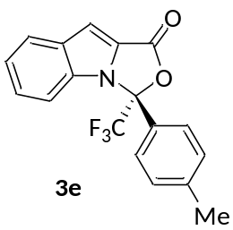
3e (R)-3-(p-tolyl)-3-(trifluoromethyl)-1H,3H-oxazolo[3,4-a]indol-1-one
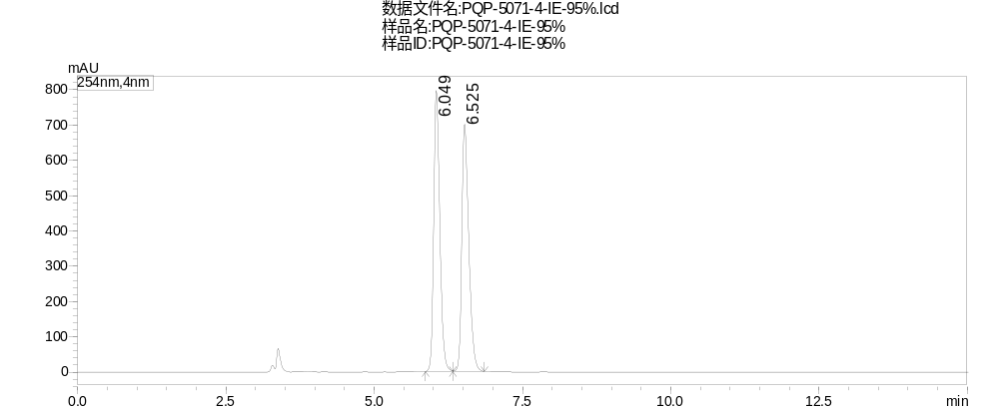
Peak | Ret. Time | Area | Height | Area%
1 | 6.049 | 5726063 | 796923 | 49.947
2 | 6.525 | 5738154 | 700552 | 50.053
Total |  | 11464217 | 1497476 | 100.000
Supplementary Figure 102. HPLC Spectrum of racemic 3e

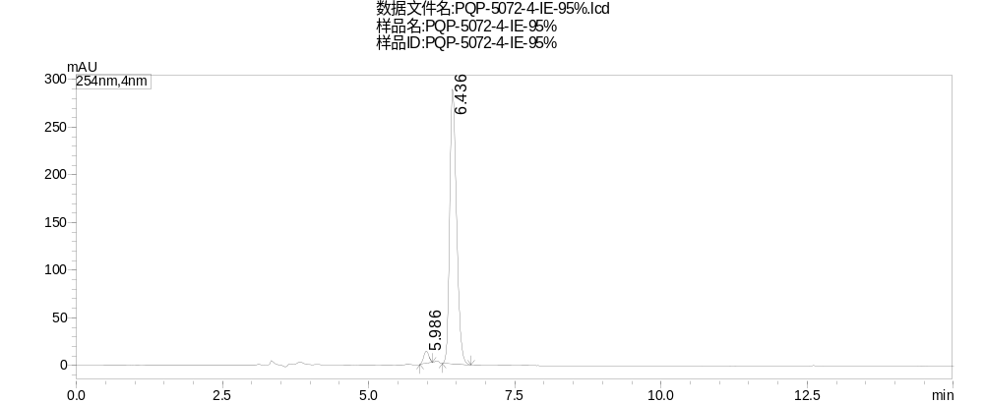
Peak | Ret. Time | Area | Height | Area%
1 | 5.986 | 80613 | 12871 | 3.314
2 | 6.436 | 2352093 | 288340 | 96.686
Total |  | 2432706 | 301211 | 100.000
Supplementary Figure 103. HPLC Spectrum of 3e

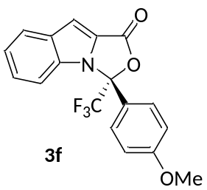
3f (R)-3-(4-methoxyphenyl)-3-(trifluoromethyl)-1H,3H-oxazolo[3,4-a]indol-1-one
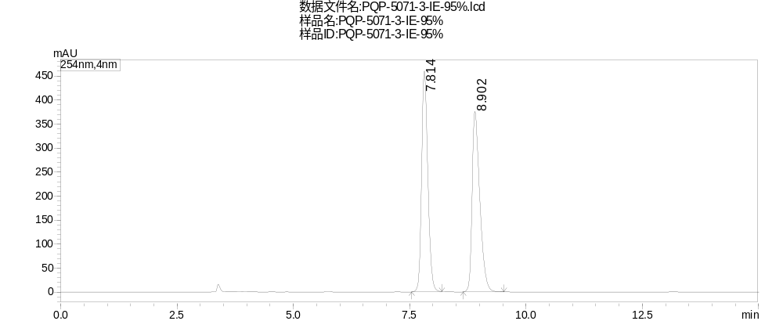
Peak | Ret. Time | Area | Height | Area%
1 | 7.814 | 4282337 | 460142 | 49.822
2 | 8.902 | 4312865 | 375758 | 50.178
Total |  | 8595201 | 835900 | 100.000
Supplementary Figure 104. HPLC Spectrum of racemic 3f

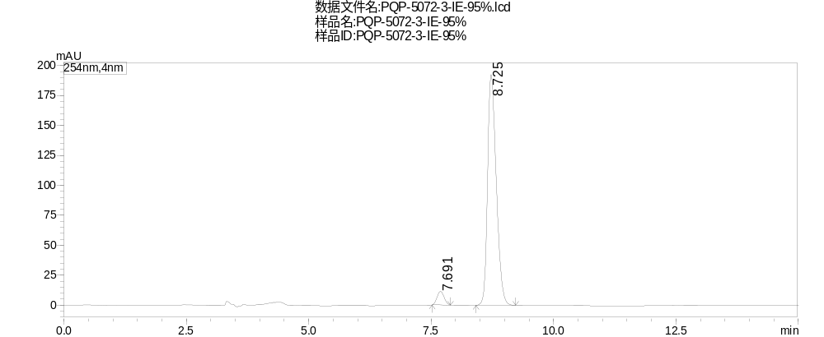
Peak | Ret. Time | Area | Height | Area%
1 | 7.691 | 114266 | 11368 | 4.586
2 | 8.725 | 2377435 | 192573 | 95.414
Total |  | 2491701 | 203942 | 100.000
Supplementary Figure 105. HPLC Spectrum of 3f

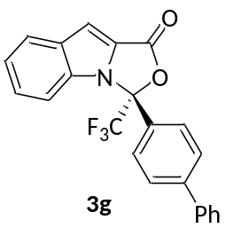
3g (R)-3-([1,1'-biphenyl]-4-yl)-3-(trifluoromethyl)-1H,3H-oxazolo[3,4-a]indol-1-one
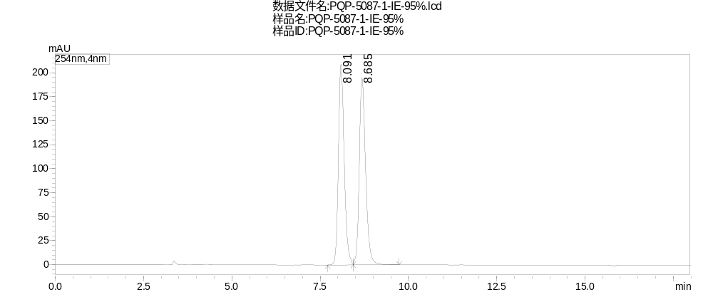
Peak | Ret. Time | Area | Height | Area%
1 | 8.091 | 2405959 | 208797 | 49.658
2 | 8.685 | 2439080 | 194643 | 50.342
Total |  | 4845039 | 403439 | 100.000
Supplementary Figure 106. HPLC Spectrum of racemic 3g

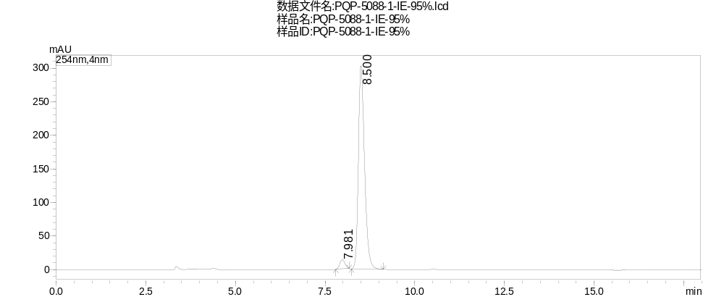
Peak | Ret. Time | Area | Height | Area%
1 | 7.981 | 141872 | 13896 | 3.778
2 | 8.500 | 3613217 | 302585 | 96.222
Total |  | 3755090 | 316481 | 100.000
Supplementary Figure 107. HPLC Spectrum of 3g

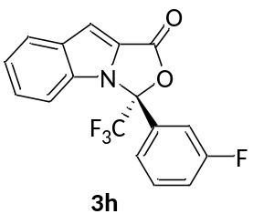
3h (R)-3-(3-fluorophenyl)-3-(trifluoromethyl)-1H,3H-oxazolo[3,4-a]indol-1-one
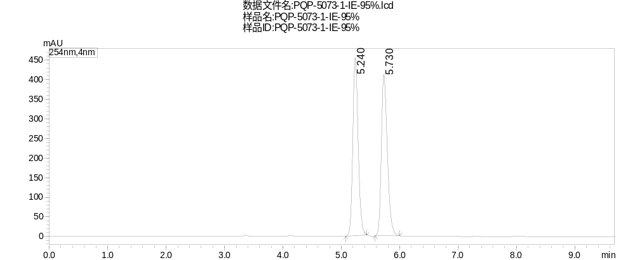
Peak | Ret. Time | Area | Height | Area%
1 | 5.240 | 2899376 | 454977 | 49.713
2 | 5.730 | 2932826 | 411710 | 50.287
Total |  | 5832202 | 866687 | 100.000
Supplementary Figure 108. HPLC Spectrum of racemic 3h

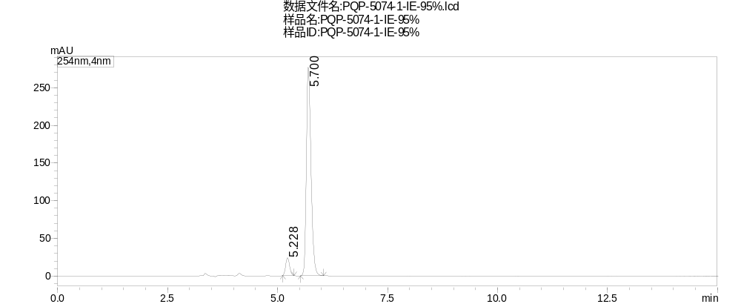
Peak | Ret. Time | Area | Height | Area%
1 | 5.228 | 146891 | 23592 | 6.719
2 | 5.700 | 2039277 | 277021 | 93.281
Total |  | 2186169 | 300613 | 100.000
Supplementary Figure 109. HPLC Spectrum of 3h

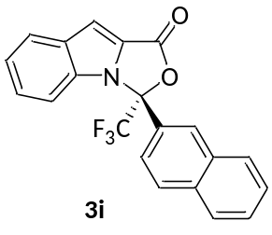
3i (R)-3-(naphthalen-2-yl)-3-(trifluoromethyl)-1H,3H-oxazolo[3,4-a]indol-1-one
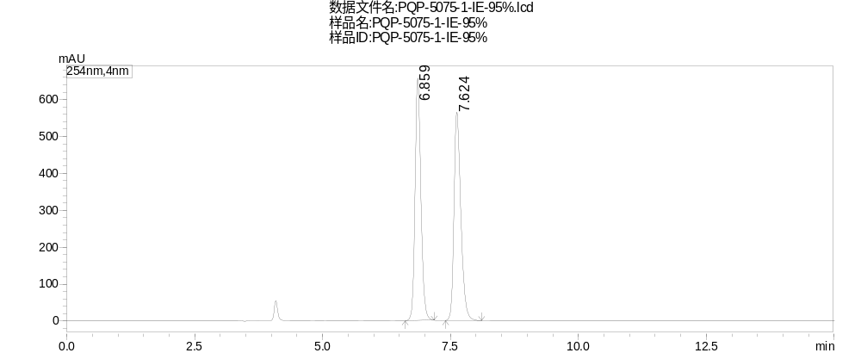
Peak | Ret. Time | Area | Height | Area%
1 | 6.859 | 5231341 | 657273 | 49.886
2 | 7.624 | 5255333 | 565049 | 50.114
Total |  | 10486675 | 1222322 | 100.000
Supplementary Figure 110. HPLC Spectrum of racemic 3i

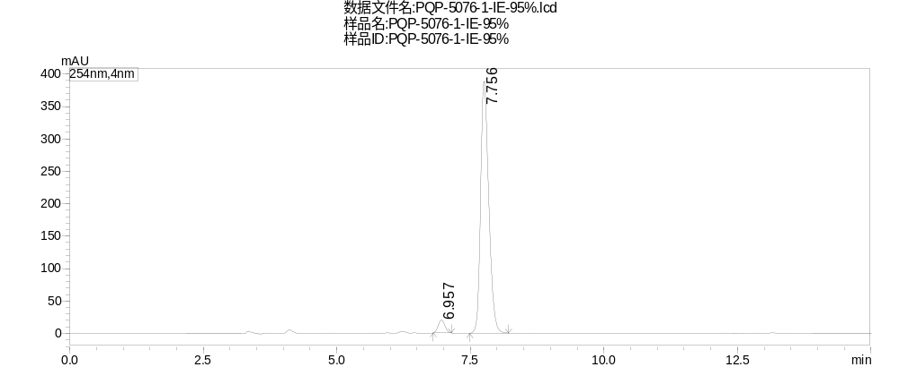
Peak | Ret. Time | Area | Height | Area%
1 | 6.957 | 175362 | 19819 | 4.075
2 | 7.756 | 4127874 | 388884 | 95.925
Total |  | 4303237 | 408704 | 100.000
Supplementary Figure 111. HPLC Spectrum of 3i

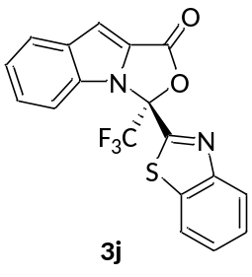
3j (S)-3-(benzo[d]thiazol-2-yl)-3-(trifluoromethyl)-1H,3H-oxazolo[3,4-a]indol-1-one
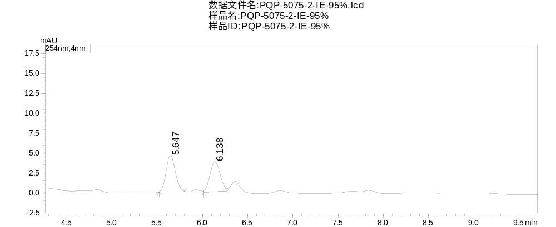
Peak | Ret. Time | Area | Height | Area%
1 | 5.647 | 32048 | 4558 | 51.787
2 | 6.138 | 29836 | 3786 | 48.213
Total |  | 61884 | 8344 | 100.000
Supplementary Figure 112. HPLC Spectrum of racemic 3j

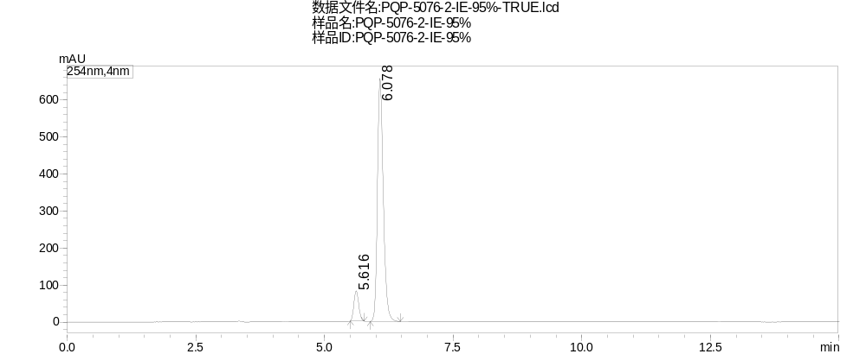
Peak | Ret. Time | Area | Height | Area%
1 | 5.616 | 525811 | 81122 | 9.188
2 | 6.078 | 5196880 | 657343 | 90.812
Total |  | 5722691 | 738465 | 100.000
Supplementary Figure 113. HPLC Spectrum of 3j

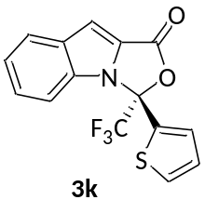
3k (S)-3-(thiophen-2-yl)-3-(trifluoromethyl)-1H,3H-oxazolo[3,4-a]indol-1-one
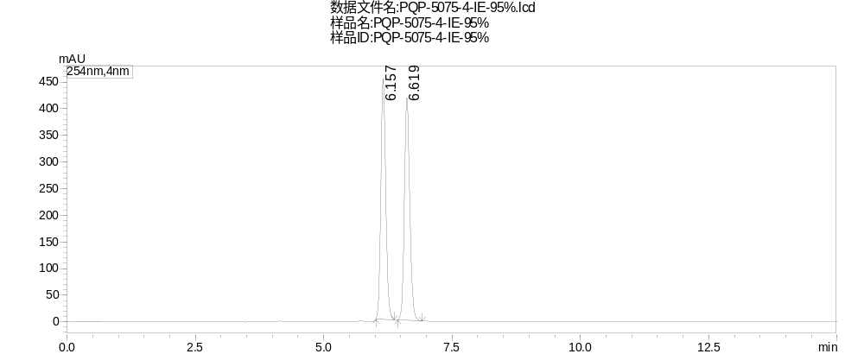
Peak | Ret. Time | Area | Height | Area%
1 | 6.157 | 3022535 | 452680 | 49.699
2 | 6.619 | 3059150 | 417627 | 50.301
Total |  | 6081685 | 870307 | 100.000
Supplementary Figure 114. HPLC Spectrum of racemic 3k

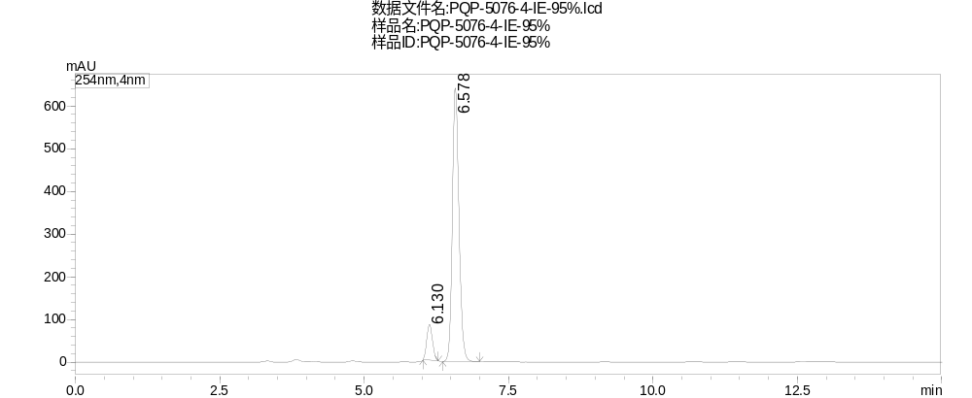
Peak | Ret. Time | Area | Height | Area%
1 | 6.130 | 583347 | 84238 | 10.204
2 | 6.578 | 5133719 | 640994 | 89.796
Total |  | 5717066 | 725232 | 100.000
Supplementary Figure 115. HPLC Spectrum of 3k

3l (R)-3-(pyridin-2-yl)-3-(trifluoromethyl)-1H,3H-oxazolo[3,4-a]indol-1-one
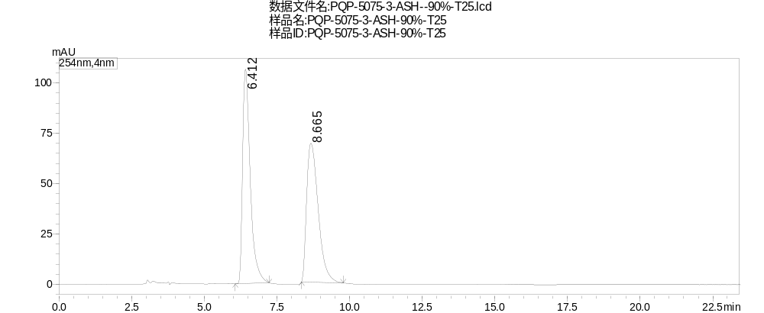
Peak | Ret. Time | Area | Height | Area%
1 | 6.412 | 1953667 | 106504 | 50.589
2 | 8.665 | 1908197 | 68935 | 49.411
Total |  | 3861864 | 175439 | 100.000
Supplementary Figure 116. HPLC Spectrum of racemic 3l

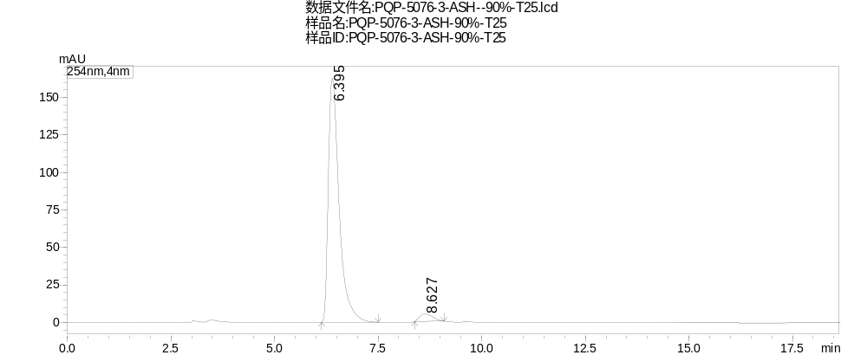
Peak | Ret. Time | Area | Height | Area%
1 | 6.395 | 2958604 | 162459 | 96.370
2 | 8.627 | 111448 | 4936 | 3.630
Total |  | 3070052 | 167394 | 100.000
Supplementary Figure 117. HPLC Spectrum of 3l

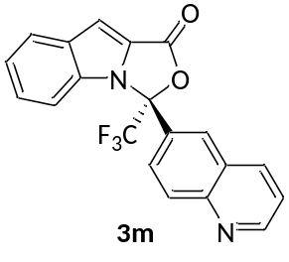
3m (R)-3-(quinolin-6-yl)-3-(trifluoromethyl)-1H,3H-oxazolo[3,4-a]indol-1-one
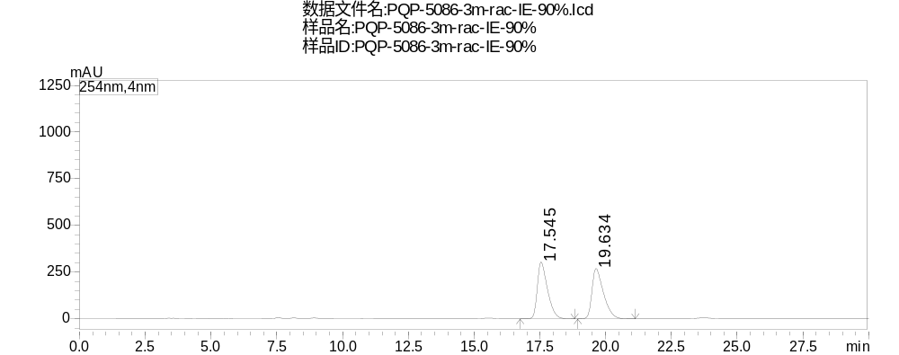
Peak | Ret. Time | Area | Height | Area%
1 | 17.545 | 8237867 | 304910 | 49.928
2 | 19.634 | 8261509 | 269976 | 50.072
Total |  | 16499376 | 574886 | 100.000
Supplementary Figure 118. HPLC Spectrum of racemic 3m

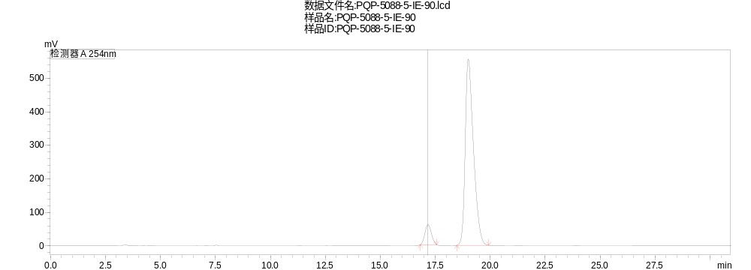
Peak | Ret. Time | Area | Height | Area%
1 | 17.169 | 1198377 | 59667 | 7.625
2 | 19.000 | 14517635 | 555775 | 92.375
Total |  | 15716012 | 615442 | 100.000
Supplementary Figure 119. HPLC Spectrum of 3m

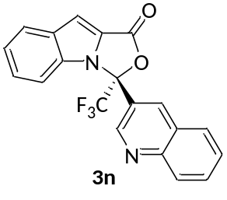
3n (R)-3-(quinolin-3-yl)-3-(trifluoromethyl)-1H,3H-oxazolo[3,4-a]indol-1-one
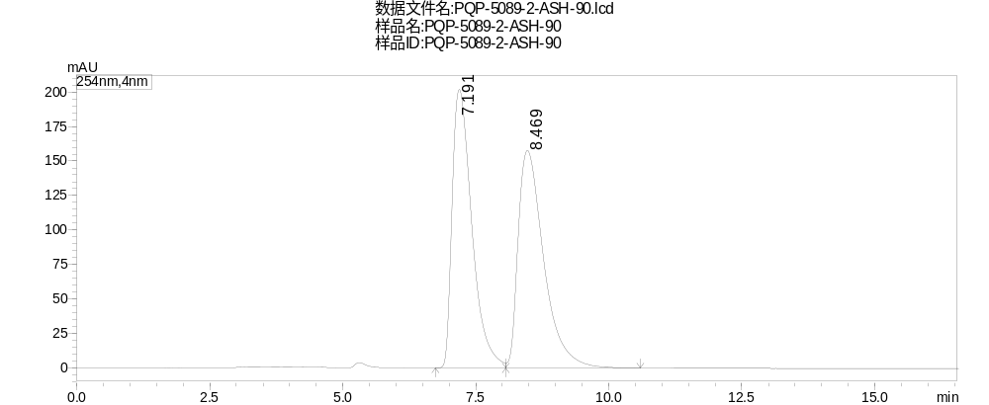
Peak | Ret. Time | Area | Height | Area%
1 | 7.191 | 5213857 | 202132 | 49.669
2 | 8.469 | 5283344 | 157968 | 50.331
Total |  | 10497201 | 360101 | 100.000
Supplementary Figure 120. HPLC Spectrum of racemic 3n
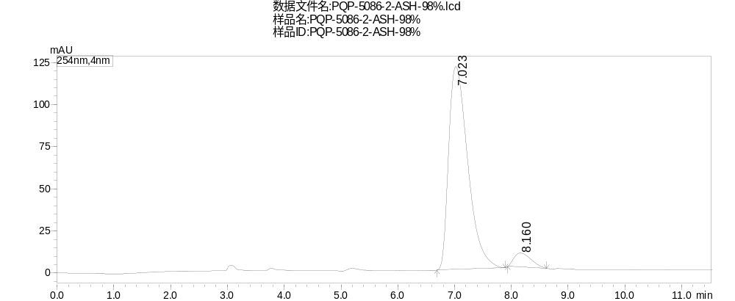
Peak | Ret. Time | Area | Height | Area%
1 | 7.023 | 2831583 | 120486 | 94.197
2 | 8.160 | 174444 | 8349 | 5.803
Total |  | 3006027 | 128835 | 100.000
Supplementary Figure 121. HPLC Spectrum of 3n

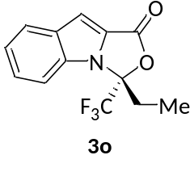
3o (R)-3-ethyl-3-(trifluoromethyl)-1H,3H-oxazolo[3,4-a]indol-1-one

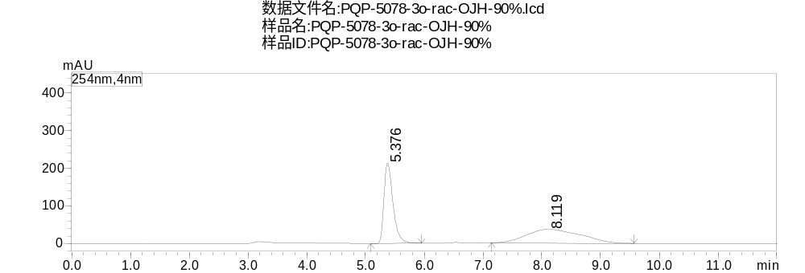
Peak | Ret. Time | Area | Height | Area%
1 | 5.376 | 2284067 | 214189 | 49.432
2 | 8.119 | 2336534 | 36789 | 50.568
Total |  | 4620601 | 250978 | 100.000
Supplementary Figure 122. HPLC Spectrum of racemic 3o

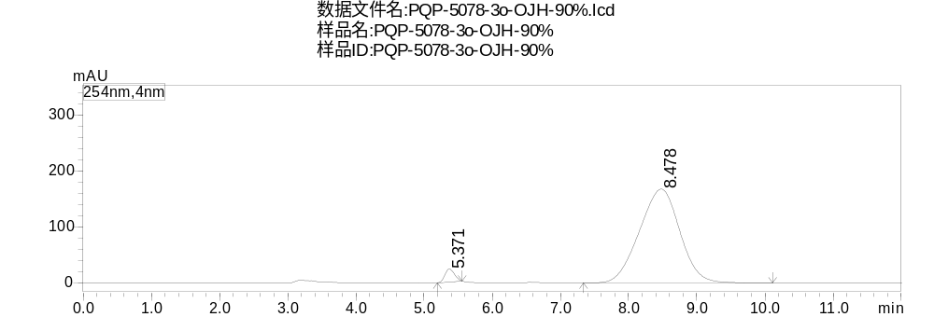
Peak | Ret. Time | Area | Height | Area%
1 | 5.371 | 224980 | 23130 | 3.149
2 | 8.478 | 6918939 | 167722 | 96.851
Total |  | 7143919 | 190853 | 100.000
Supplementary Figure 123. HPLC Spectrum of 3o

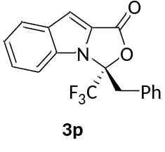
3p (R)-3-benzyl-3-(trifluoromethyl)-1H,3H-oxazolo[3,4-a]indol-1-one
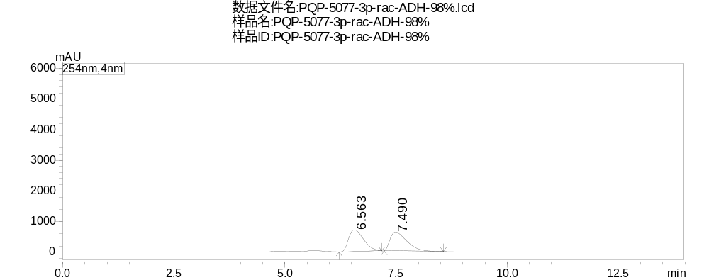
Peak | Ret. Time | Area | Height | Area%
1 | 6.563 | 16704603 | 713387 | 50.953
2 | 7.490 | 16079859 | 614222 | 49.047
Total |  | 32784462 | 1327610 | 100.000
Supplementary Figure 124. HPLC Spectrum of racemic 3p

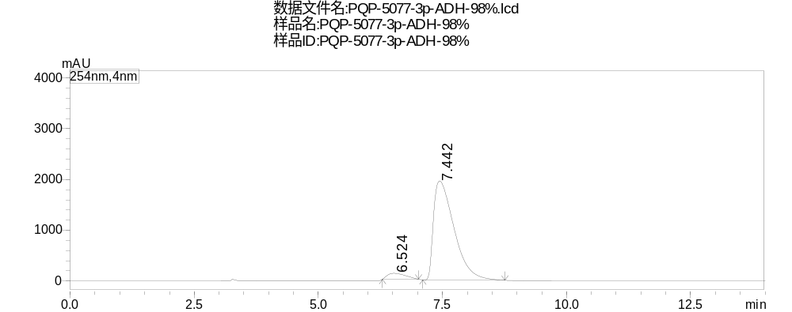
Peak | Ret. Time | Area | Height | Area%
1 | 6.524 | 2955364 | 116253 | 4.996
2 | 7.442 | 56199759 | 1950276 | 95.004
Total |  | 59155124 | 2066529 | 100.000
Supplementary Figure 125. HPLC Spectrum of 3p

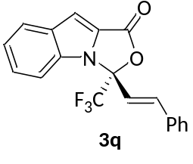
3q (R,E)-3-styryl-3-(trifluoromethyl)-1H,3H-oxazolo[3,4-a]indol-1-one
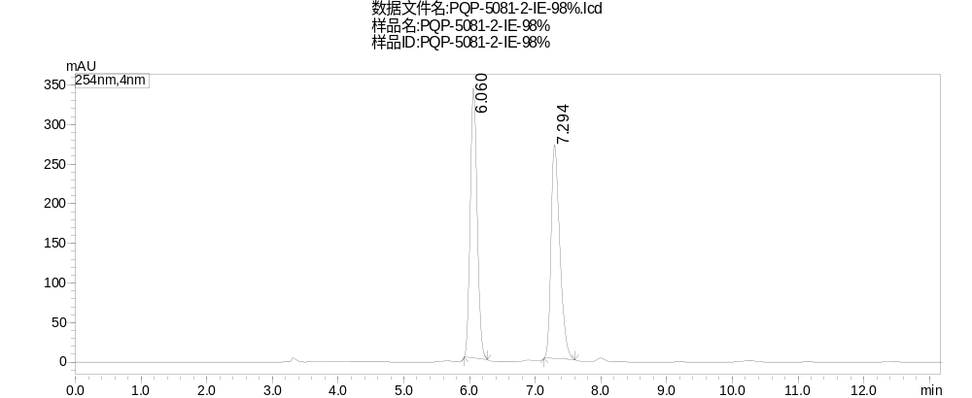
Peak | Ret. Time | Area | Height | Area%
1 | 6.060 | 2513781 | 340991 | 50.022
2 | 7.294 | 2511598 | 270309 | 49.978
Total |  | 5025379 | 611300 | 100.000
Supplementary Figure 126. HPLC Spectrum of racemic 3q

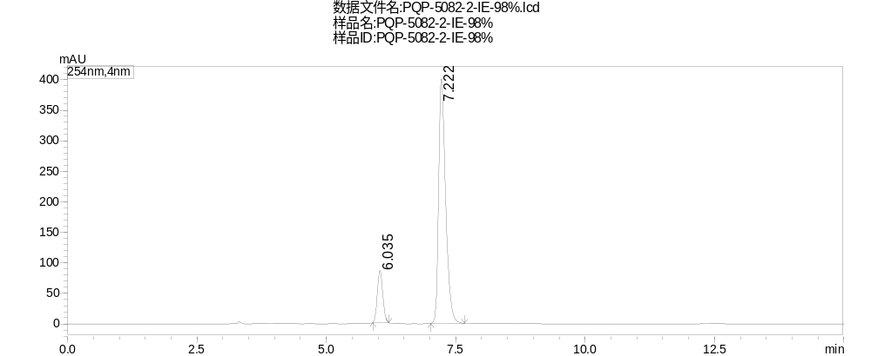
Peak | Ret. Time | Area | Height | Area%
1 | 6.035 | 620544 | 85512 | 14.127
2 | 7.222 | 3771975 | 400869 | 85.873
Total |  | 4392519 | 486381 | 100.000
Supplementary Figure 127. HPLC Spectrum of 3q

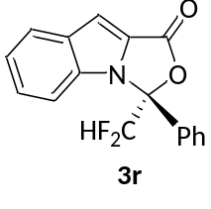
3r (R)-3-(difluoromethyl)-3-phenyl-1H,3H-oxazolo[3,4-a]indol-1-one
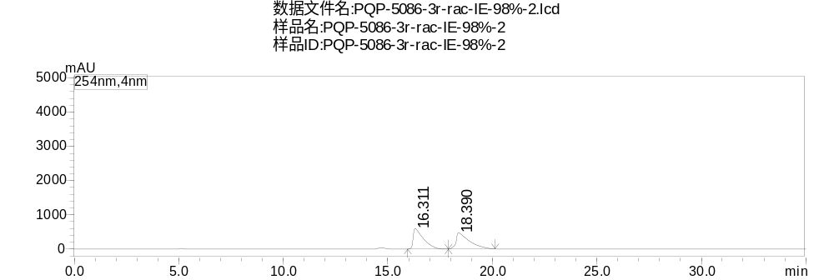
Peak | Ret. Time | Area | Height | Area%
1 | 16.311 | 20373602 | 600415 | 49.330
2 | 18.390 | 20927254 | 474393 | 50.670
Total |  | 41300856 | 1074808 | 100.000
Supplementary Figure 128. HPLC Spectrum of racemic 3r

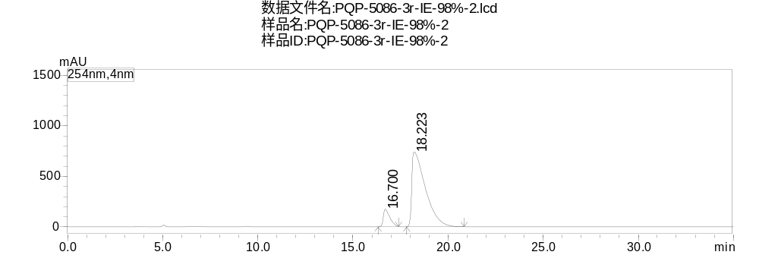
Peak | Ret. Time | Area | Height | Area%
1 | 16.700 | 4102384 | 173350 | 9.984
2 | 18.223 | 36987098 | 740982 | 90.016
Total |  | 41089482 | 914332 | 100.000
Supplementary Figure 129. HPLC Spectrum of racemic 3r

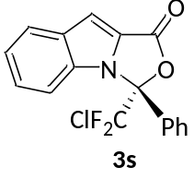
3s (R)-3-(chlorodifluoromethyl)-3-phenyl-1H,3H-oxazolo[3,4-a]indol-1-one
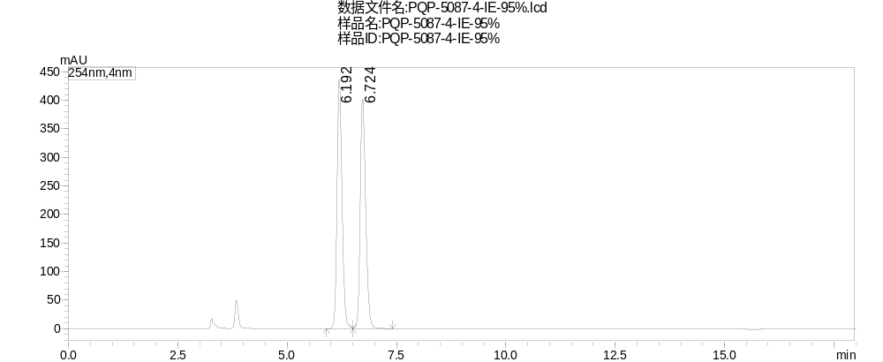
Peak | Ret. Time | Area | Height | Area%
1 | 6.192 | 3482123 | 435569 | 49.775
2 | 6.724 | 3513642 | 402327 | 50.225
Total |  | 6995765 | 837896 | 100.000
Supplementary Figure 130. HPLC Spectrum of racemic 3s

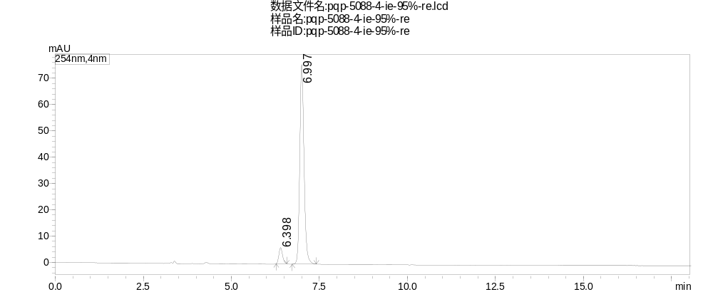
Peak | Ret. Time | Area | Height | Area%
1 | 6.398 | 43790 | 6091 | 6.384
2 | 6.997 | 642189 | 75939 | 93.616
Total |  | 685979 | 82030 | 100.000
Supplementary Figure 131. HPLC Spectrum of 3s

3t (R)-3-(perfluoroethyl)-3-phenyl-1H,3H-oxazolo[3,4-a]indol-1-one

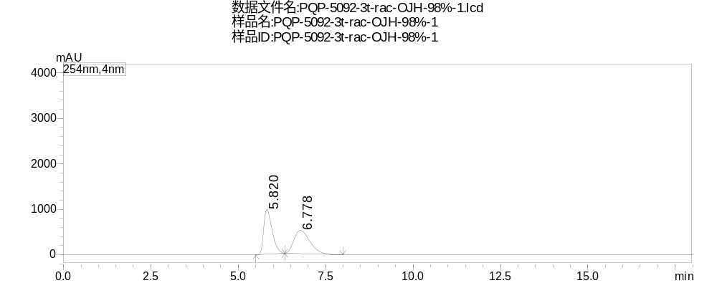
Peak | Ret. Time | Area | Height | Area%
1 | 5.820 | 16478135 | 983813 | 50.498
2 | 6.778 | 16153346 | 511829 | 49.502
Total |  | 32631481 | 1495642 | 100.000
Supplementary Figure 132. HPLC Spectrum of racemic 3t

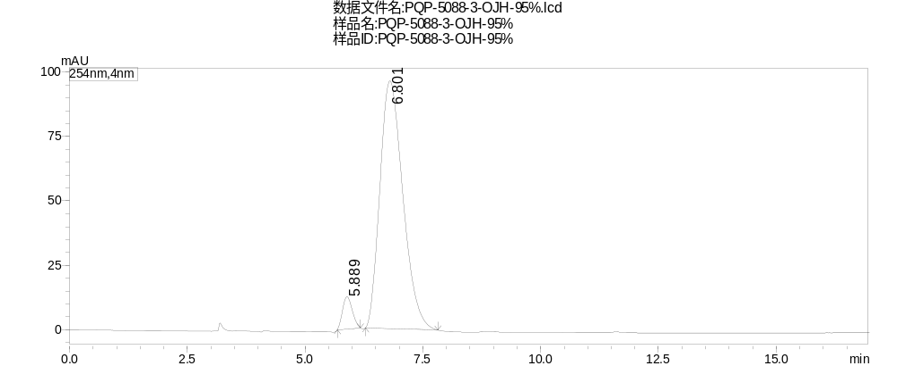
Peak | Ret. Time | Area | Height | Area%
1 | 5.889 | 179614 | 12516 | 5.206
2 | 6.801 | 3270789 | 96120 | 94.794
Total |  | 3450403 | 108636 | 100.000
Supplementary Figure 133. HPLC Spectrum of 3t

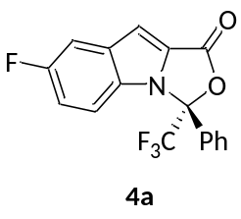
4a (R)-7-fluoro-3-phenyl-3-(trifluoromethyl)-1H,3H-oxazolo[3,4-a]indol-1-one
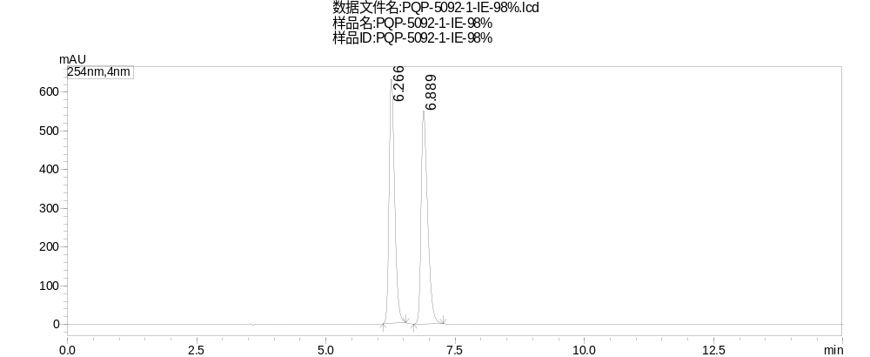
Peak | Ret. Time | Area | Height | Area%
1 | 6.266 | 4725127 | 631845 | 49.648
2 | 6.889 | 4792104 | 551495 | 50.352
Total |  | 9517232 | 1183340 | 100.000
Supplementary Figure 134. HPLC Spectrum of racemic 4a

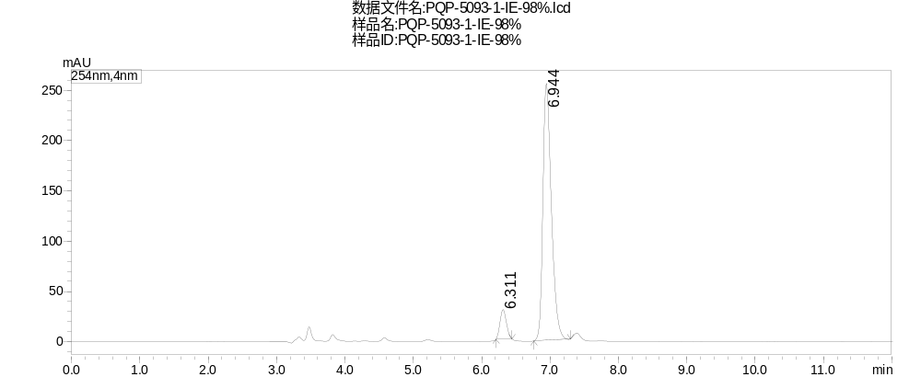
Peak | Ret. Time | Area | Height | Area%
1 | 6.311 | 190274 | 29314 | 7.993
2 | 6.944 | 2190291 | 255526 | 92.007
Total |  | 2380565 | 284840 | 100.000
Supplementary Figure 135. HPLC Spectrum of 4a

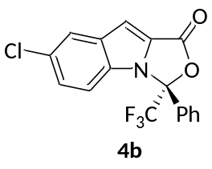
4b (R)-7-chloro-3-phenyl-3-(trifluoromethyl)-1H,3H-oxazolo[3,4-a]indol-1-one
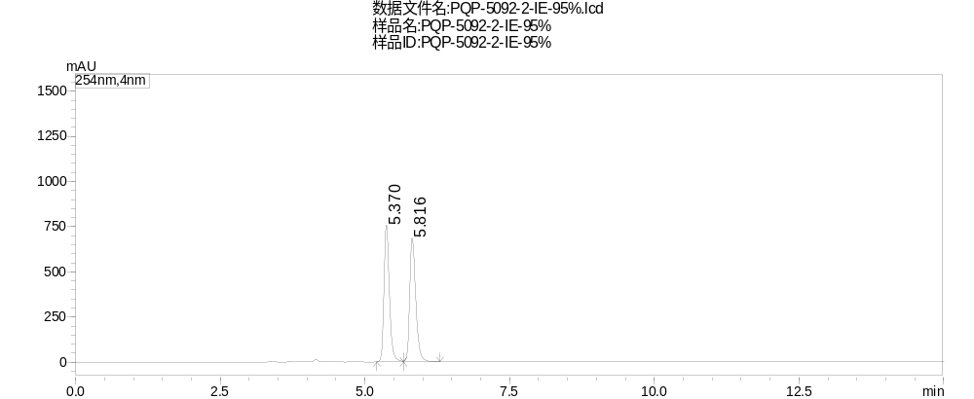
Peak | Ret. Time | Area | Height | Area%
1 | 5.370 | 4930687 | 757504 | 49.684
2 | 5.816 | 4993309 | 686290 | 50.316
Total |  | 9923996 | 1443794 | 100.000
Supplementary Figure 136. HPLC Spectrum of racemic 4b

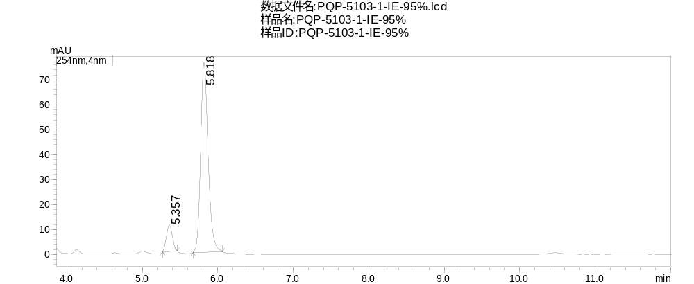
Peak | Ret. Time | Area | Height | Area%
1 | 5.357 | 58405 | 10684 | 9.993
2 | 5.818 | 526066 | 76022 | 90.007
Total |  | 584471 | 86706 | 100.000
Supplementary Figure 137. HPLC Spectrum of 4b

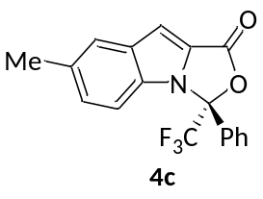
4c (R)-7-methyl-3-phenyl-3-(trifluoromethyl)-1H,3H-oxazolo[3,4-a]indol-1-one
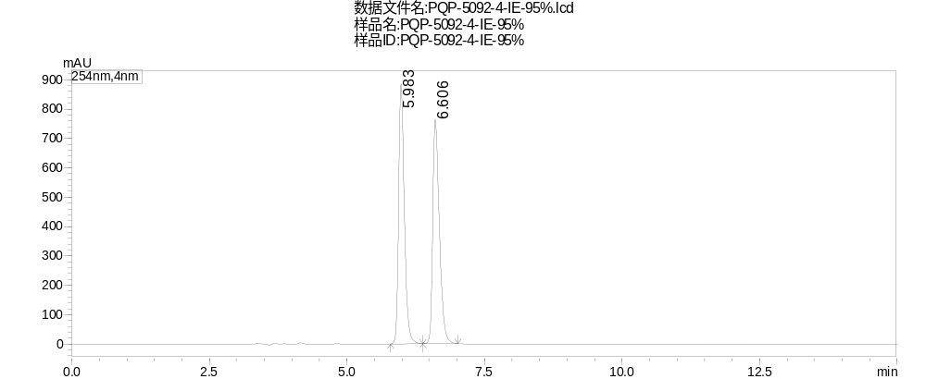
Peak | Ret. Time | Area | Height | Area%
1 | 5.983 | 6421004 | 885762 | 49.965
2 | 6.606 | 6429931 | 764576 | 50.035
Total |  | 12850935 | 1650338 | 100.000
Supplementary Figure 138. HPLC Spectrum of racemic 4c

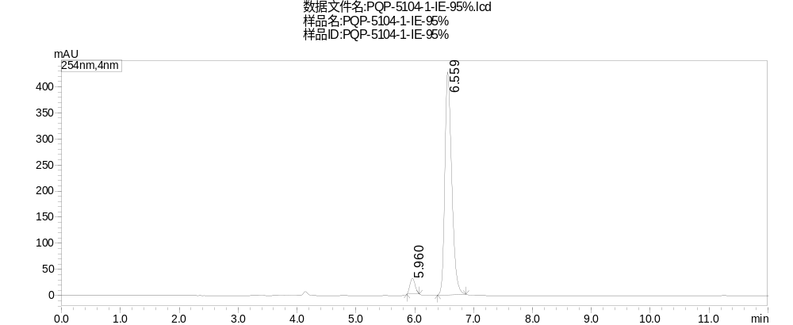
Peak | Ret. Time | Area | Height | Area%
1 | 5.960 | 184812 | 30159 | 5.066
2 | 6.559 | 3463481 | 426818 | 94.934
Total |  | 3648293 | 456977 | 100.000
Supplementary Figure 139. HPLC Spectrum of 4c

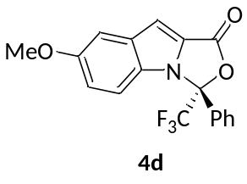
4d (R)-7-methoxy-3-phenyl-3-(trifluoromethyl)-1H,3H-oxazolo[3,4-a]indol-1-one
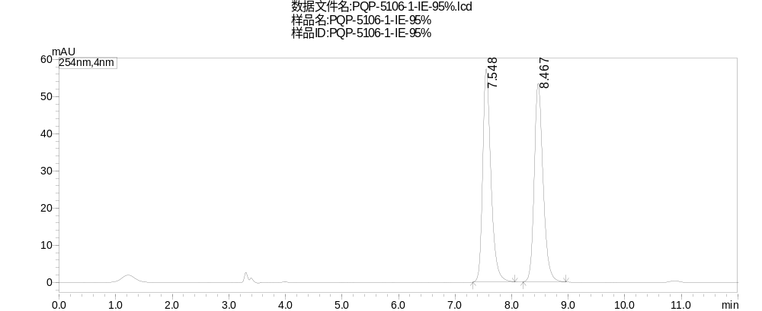

Peak | Ret. Time | Area | Height | Area%
1 | 7.548 | 579014 | 57401 | 49.945
2 | 8.467 | 580286 | 53481 | 50.055
Total |  | 1159300 | 110882 | 100.000
Supplementary Figure 140. HPLC Spectrum of racemic 4d

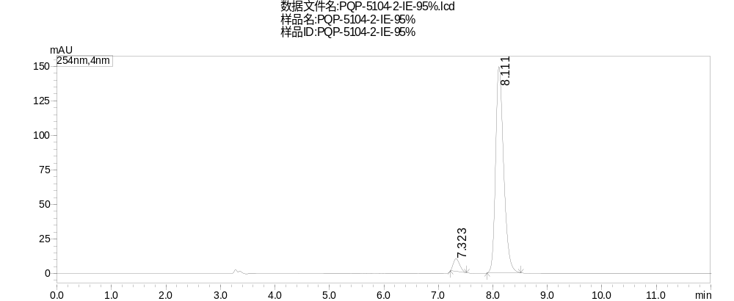
Peak | Ret. Time | Area | Height | Area%
1 | 7.323 | 74565 | 9212 | 4.633
2 | 8.111 | 1534727 | 149364 | 95.367
Total |  | 1609292 | 158576 | 100.000
Supplementary Figure 141. HPLC Spectrum of 4d

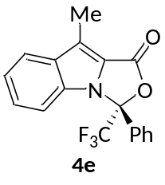
4e (R)-9-methyl-3-phenyl-3-(trifluoromethyl)-1H,3H-oxazolo[3,4-a]indol-1-one
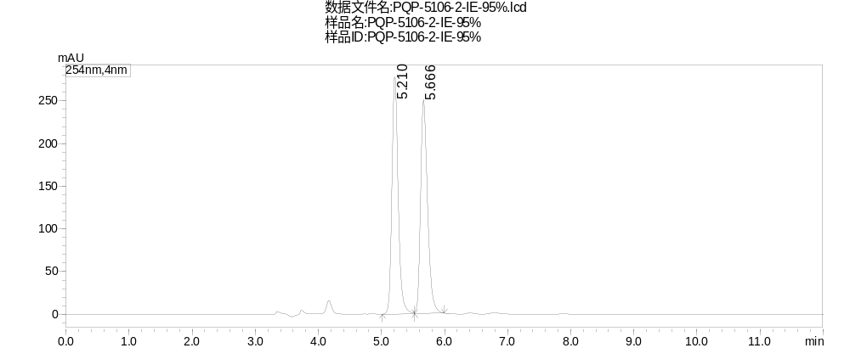
Peak | Ret. Time | Area | Height | Area%
1 | 5.210 | 1920332 | 277746 | 49.959
2 | 5.666 | 1923448 | 250549 | 50.041
Total |  | 3843779 | 528295 | 100.000
Supplementary Figure 142. HPLC Spectrum of racemic 4e

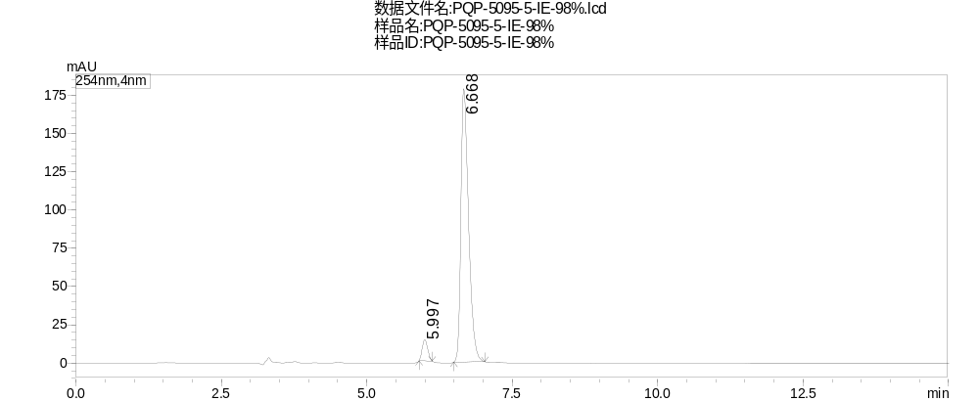
Peak | Ret. Time | Area | Height | Area%
1 | 5.997 | 89862 | 13753 | 5.206
2 | 6.668 | 1636237 | 178659 | 94.794
Total |  | 1726100 | 192412 | 100.000
Supplementary Figure 143. HPLC Spectrum of 4e

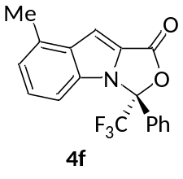
4f (R)-8-methyl-3-phenyl-3-(trifluoromethyl)-1H,3H-oxazolo[3,4-a]indol-1-one
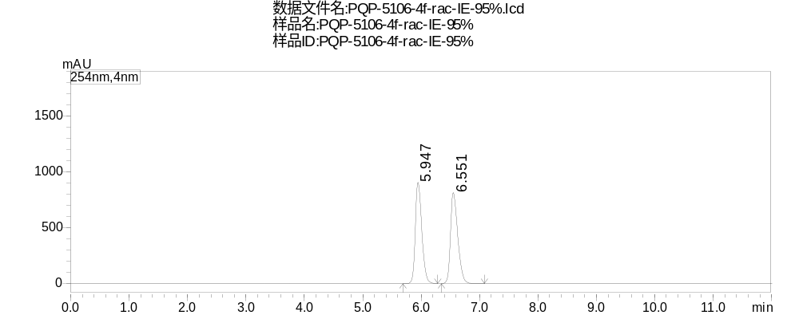
Peak | Ret. Time | Area | Height | Area%
1 | 5.947 | 7018629 | 904721 | 49.836
2 | 6.551 | 7064818 | 815664 | 50.164
Total |  | 14083448 | 1720385 | 100.000
Supplementary Figure 144. HPLC Spectrum of racemic 4f

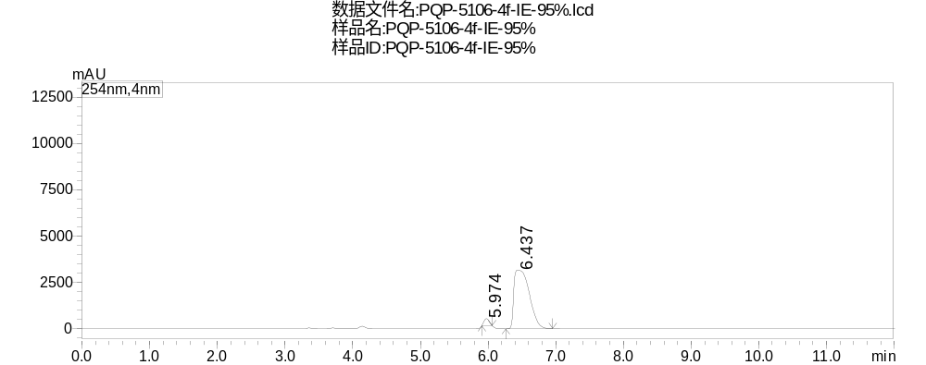
Peak | Ret. Time | Area | Height | Area%
1 | 5.974 | 1958034 | 375832 | 3.772
2 | 6.437 | 49952597 | 3154895 | 96.228
Total |  | 51910631 | 3530727 | 100.000
Supplementary Figure 145. HPLC Spectrum of 4f

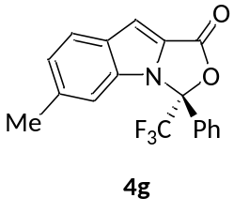
4g (R)-6-methyl-3-phenyl-3-(trifluoromethyl)-1H,3H-oxazolo[3,4-a]indol-1-one

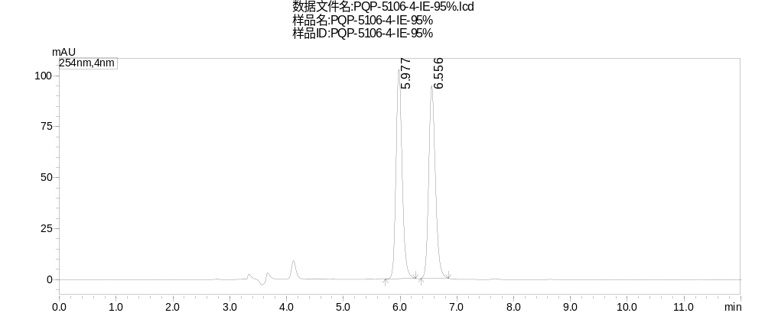
Peak | Ret. Time | Area | Height | Area%
1 | 5.977 | 770735 | 102891 | 49.993
2 | 6.556 | 770936 | 94578 | 50.007
Total |  | 1541671 | 197469 | 100.000
Supplementary Figure 146. HPLC Spectrum of racemic 4g

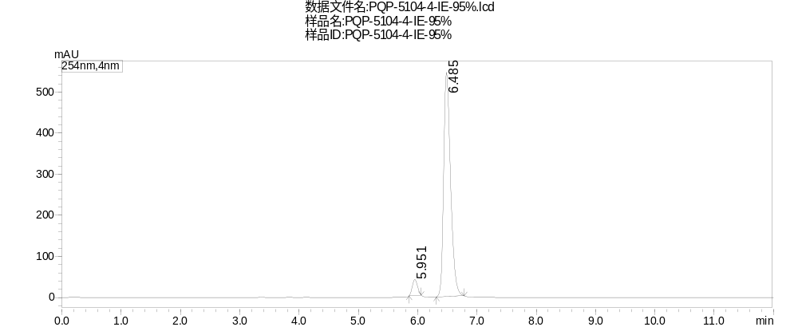

Peak | Ret. Time | Area | Height | Area%
1 | 5.951 | 237347 | 39037 | 5.103
2 | 6.485 | 4414174 | 546091 | 94.897
Total |  | 4651520 | 585128 | 100.000
Supplementary Figure 147. HPLC Spectrum of 4g

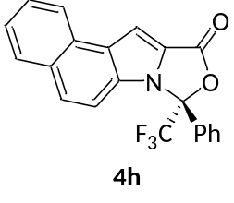
4h (R)-8-phenyl-8-(trifluoromethyl)-8H,10H-benzo[e]oxazolo[3,4-a]indol-10-one
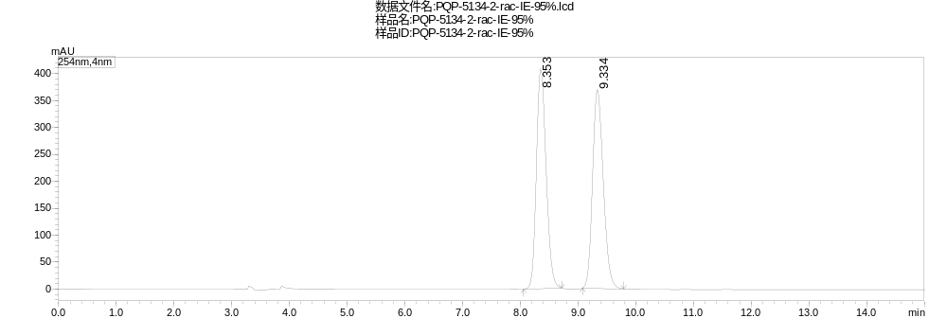
Peak | Ret. Time | Area | Height | Area%
1 | 8.353 | 4776086 | 408420 | 50.114
2 | 9.334 | 4754266 | 368561 | 49.886
Total |  | 9530351 | 776982 | 100.000
Supplementary Figure 148. HPLC Spectrum of racemic 4h

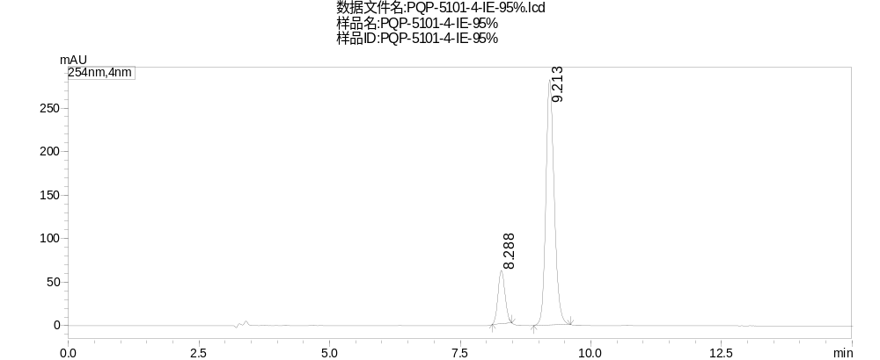
Peak | Ret. Time | Area | Height | Area%
1 | 8.288 | 566900 | 61312 | 15.331
2 | 9.213 | 3130822 | 282030 | 84.669
Total |  | 3697722 | 343341 | 100.000
Supplementary Figure 149. HPLC Spectrum of 4h

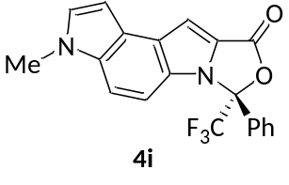
4i (R)-3-methyl-7-phenyl-7-(trifluoromethyl)-7H-oxazolo[3,4-a]pyrrolo[3,2-e]indol-9(3H)-one
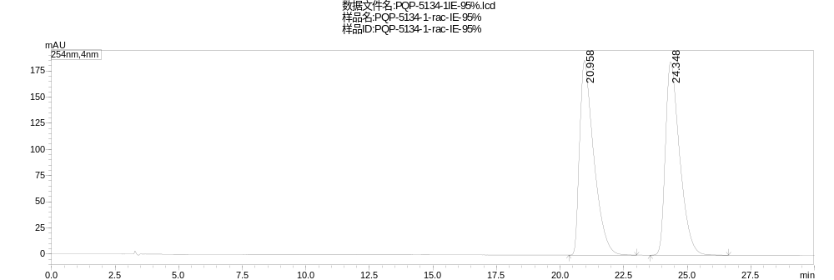
Peak | Ret. Time | Area | Height | Area%
1 | 20.958 | 7197432 | 186035 | 49.994
2 | 24.348 | 7199195 | 184879 | 50.006
Total |  | 14396627 | 370913 | 100.000
Supplementary Figure 150. HPLC Spectrum of racemic 4i

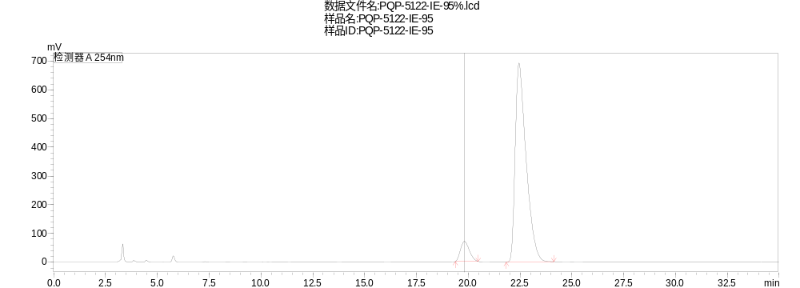
Peak | Ret. Time | Area | Height | Area%
1 | 19.820 | 2081907 | 69956 | 7.599
2 | 22.449 | 25314236 | 692725 | 92.401
Total |  | 27396143 | 762682 | 100.000
Supplementary Figure 151. HPLC Spectrum of 4i

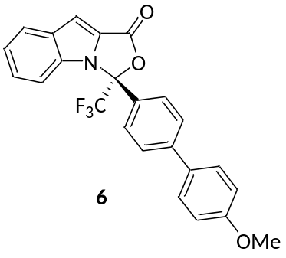
6 (R)-3-(4'-methoxy-[1,1'-biphenyl]-4-yl)-3-(trifluoromethyl)-1H,3H-oxazolo[3,4-a]indol-1-one
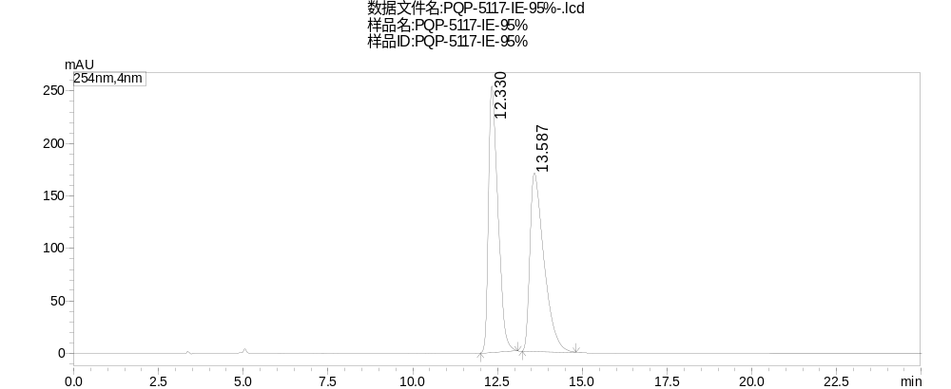
Peak | Ret. Time | Area | Height | Area%
1 | 12.330 | 4924151 | 253883 | 50.079
2 | 13.587 | 4908525 | 170010 | 49.921
Total |  | 9832676 | 423893 | 100.000
Supplementary Figure 152. HPLC Spectrum of racemic 6

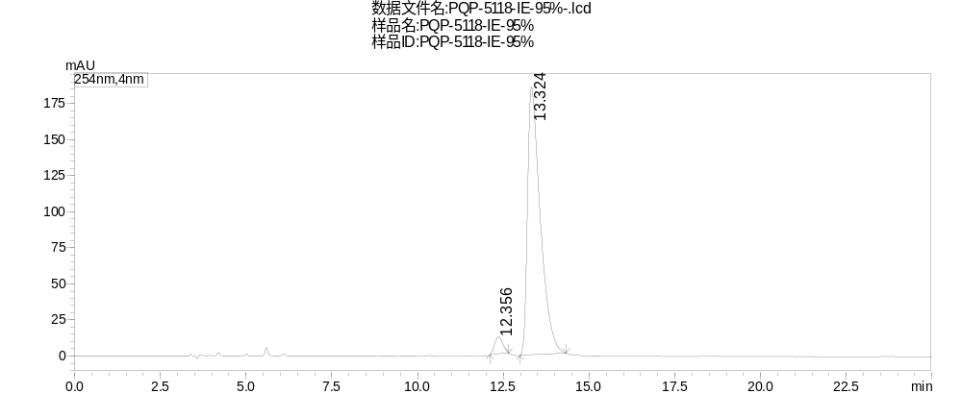
Peak | Ret. Time | Area | Height | Area%
1 | 12.356 | 199902 | 11937 | 3.989
2 | 13.324 | 4811413 | 185593 | 96.011
Total |  | 5011315 | 197530 | 100.000
Supplementary Figure 153. HPLC Spectrum of 6

General Information
Chemicals were purchased from commercial suppliers and used as received. Solvents were dried on alumina columns using a solvent dispensing system. Thin-layer chromatography (TLC) was conducted on plates (GF254) supplied by Yantai Chemicals (China) and visualized using a combination of UV, anisaldehyde, iodine, and potassium permanganate staining. ¹H NMR, ¹³C NMR, ¹⁹F NMR, spectra were recorded on a Bruker ACF400 (400 MHz) spectrometer. Chemical shifts were reported in parts per million (ppm), and the residual solvent peak was used as an internal reference: proton (chloroform δ 7.26, DMSO-d₆ δ 2.50), carbon (chloroform δ 77.16, DMSO-d₆ δ 39.52) or tetramethylsilane (TMS δ 0.00) was used as a reference. Multiplicity was indicated as follows: s (singlet), d (doublet), t (triplet), q (quartet), m (multiplet), dd (doublet of doublet), bs (broad singlet). Coupling constants were reported in Hertz (Hz). All high resolution mass spectra were obtained from the Tsinghua University Mass Spectrometry Facility. Flash chromatography separations were performed on Silica gel (300-400 mesh) supplied by Tsingdao Haiyang Chemicals (China). The enantiomeric excesses of products were determined on a Shimadzu LC-20AT Chiral HPLC. Infrared spectra were recorded on a Perkin Elmer Spectrum two equipped with MIRacleTM single reflection with ZnSe ATR unit. Fluorinated ketones and indole-2-carbaldehydes were prepared by literatures¹⁻⁵ or commercial available.

Procedure for Synthesis of Catalyst F
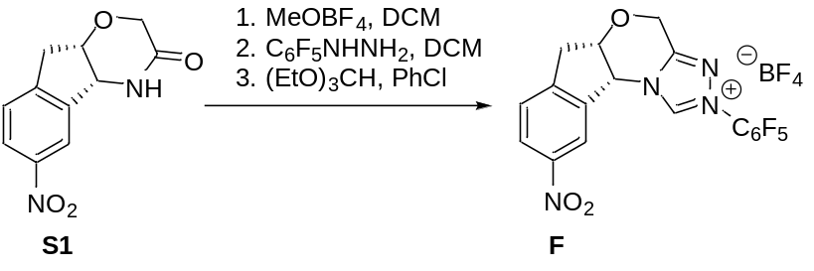
To a solution of S1⁶ (6.0 g, 25.6 mmol) in CH₂Cl₂ (135 mL) was added Me₃OBF₄ (4.17 g, 28.2 mmol), and the mixture was stirred at rt for 24 h. Then, C₆F₅NHNH₂ (5.58 g, 28.2 mmol) was added, and the mixture was stirred for another 36 h. The mixture was concentrated in vacuo, and the residue was dissolved in PhCl (60 mL) followed by the addition of (EtO)₃CH (60 mL). The mixture was heated to 130 ºC for 60 h. The solvent was removed on a rotary evaporator, the crude mixture was purified by column chromatography (DCM: MeOH = 100:1 to 40:1) to give (5aS,10bR)-9-nitro-2-(perfluorophenyl)-5a,10b-dihydro-4H,6H-indeno[2,1-b][1,2,4]triazolo[4,3-d][1,4]oxazin-2-ium tetrafluoroborate F as a white solid, 5.56 g, 42% yield. ¹H NMR (400 MHz, DMSO-d₆) δ 11.63 (s, 1H), 8.48 (s, 1H), 8.31 (d, J = 8.5 Hz, 1H), 7.74 (d, J = 8.4 Hz, 1H), 6.26 (s, 1H), 5.40 (d, J = 16.3 Hz, 1H), 5.07 (d, J = 15.2 Hz, 2H), 3.64 (d, J = 17.9 Hz, 1H), 3.33 (d, J = 19.8 Hz, 1H). ¹³C NMR (100 MHz, DMSO-d₆) δ 151.1, 149.5, 147.7, 147.5, 143.7 (d, J = 13.1 Hz), 141.1 (d, J = 11.7 Hz), 140.0 – 139.2 (m), 137.8, 127.1, 125.4, 121.1, 111.5, 77.7, 61.7, 60.3, 37.6. ¹⁹F NMR (376 MHz, DMSO-d₆) δ -145.67 (d, J = 19.7 Hz), -148.00 (t, J = 23.2 Hz), -148.25, -148.31, -159.78 (t, J = 21.5 Hz). ; HRMS (ESI) exact mass calcd. for C₁₈H₁₀F₅N₄O₃ ([M – BF₄]⁺) requires m/z 425.0668, found m/z 425.0674; [α]²⁵_{D} = -96.2 (c = 1.0, DCM).

General Procedure for Catalytic Reaction of Indole-2-carbaldehydes with Ketones
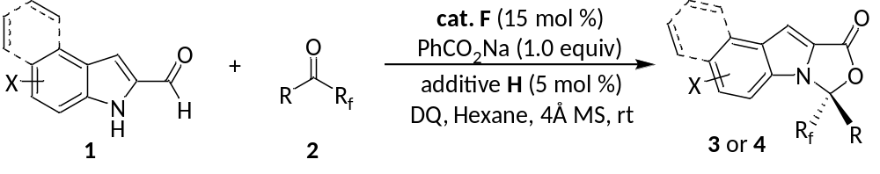
To a flame-dried Schlenk reaction tube equipped with a magnetic stir bar, was added the precatalyst F (15.4 mg, 0.03 mmol), DQ (90.0 mg, 0.22 mmol), additive H (5.0 mg, 0.01 mmol), PhCO₂Na (28.8 mg, 0.20 mmol), 1 (0.20 mmol) and 4Å MS (60 mg). The Schlenk tube was closed with a septum, evacuated and refilled with argon atmosphere. Hexane (2.0 mL) and 2 (0.24 mmol) was added. The mixture was then stirred at 25 °C and monitored by TLC until 1 was consumed. The mixture was concentrated under reduced pressure and purified by column chromatography on silica gel (hexane/EtOAc = 100:1) to afford the desired product 3 or 4.

Characterization Data

3a (R)-3-phenyl-3-(trifluoromethyl)-1H,3H-oxazolo[3,4-a]indol-1-one
Pale yellow oil, 53.9 mg, 85% yield, 48 h; ¹H NMR (400 MHz, Chloroform-d) δ 7.85 (dd, J = 8.0, 1.3 Hz, 1H), 7.62 (d, J = 7.4 Hz, 2H), 7.58 – 7.50 (m, 1H), 7.52 – 7.38 (m, 3H), 7.37 – 7.28 (m, 3H). ¹³C NMR (100 MHz, Chloroform-d) δ 157.9, 133.9, 133.1, 131.5, 130.0, 129.3, 127.0, 127.0, 124.7, 124.5, 122.8, 122.3 (q, J = 288.1 Hz), 112.5 (q, J = 2.4 Hz), 104.7, 92.3 (q, J = 34.6 Hz). ¹⁹F NMR (376 MHz, Chloroform-d) δ -77.04; IR (neat, ATR) 1804, 1787, 1186, 1140, 949, 898, 722, 692 cm⁻¹; HRMS (ESI) exact mass calcd. for C₁₇H₁₁F₃NO₂ ([M + H]⁺) requires m/z 318.0736, found m/z 318.0733; HPLC (Chiralpak IE, i-propanol/hexane = 5/95, flow rate 1.0 mL/min, 25 ºC, λ = 254 nm): t_{R} (major) = 6.3 min, t_{R} (minor) = 5.8 min, ee = 91%; [α]²⁵_{D} = -42.7 (c = 1.0, DCM).

3b (R)-3-(4-fluorophenyl)-3-(trifluoromethyl)-1H,3H-oxazolo[3,4-a]indol-1-one
Pale yellow oil, 55.2 mg, 82% yield, 48 h; ¹H NMR (400 MHz, Chloroform-d) δ 7.85 (d, J = 8.1 Hz, 1H), 7.61 (dd, J = 8.8, 4.9 Hz, 2H), 7.47 – 7.40 (m, 1H), 7.35 – 7.29 (m, 3H), 7.20 – 7.11 (m, 2H). ¹³C NMR (100 MHz, Chloroform-d) δ 164.3 (d, J = 253.1 Hz), 157.6, 133.8, 133.1, 129.5 (dq, J = 9.0, 2.1 Hz), 127.2, 126.0 (d, J = 3.6 Hz), 124.6, 124.6, 123.0, 122.2 (q, J = 288.2 Hz), 116.5 (d, J = 22.2 Hz), 112.3 (q, J = 2.5 Hz), 104.9, 91.8 (q, J = 34.7 Hz). ¹⁹F NMR (376 MHz, Chloroform-d) δ -77.23, -107.71; IR (neat, ATR) 1807, 1257, 1200, 1185, 897, 797,725 cm⁻¹; HRMS (ESI) exact mass calcd. for C₁₇H₁₀F₄NO₂ ([M + H]⁺) requires m/z 336.0642, found m/z 336.0638; HPLC (Chiralpak IE, i-propanol/hexane = 5/95, flow rate 1.0 mL/min, 25 ºC, λ = 254 nm): t_{R} (major) = 5.6 min, t_{R} (minor) = 5.4 min, ee = 91%; [α]²⁵_{D} = -89.4 (c = 1.0, DCM).

3c (R)-3-(4-chlorophenyl)-3-(trifluoromethyl)-1H,3H-oxazolo[3,4-a]indol-1-one
Yellow oil, 56.1 mg, 80% yield, 48 h; ¹H NMR (400 MHz, Chloroform-d) δ 7.85 (d, J = 8.2 Hz, 1H), 7.55 (d, J = 8.5 Hz, 2H), 7.47 – 7.42 (m, 3H), 7.38 – 7.28 (m, 3H). ¹³C NMR (100 MHz, Chloroform-d) δ 157.5, 138.0, 133.8, 133.1, 129.6, 128.5 (q, J = 2.1 Hz), 127.2, 126.4, 124.6, 124.5, 123.0, 122.1 (q, J = 288.2 Hz), 112.3 (q, J = 2.5 Hz), 105.0, 91.8 (q, J = 34.6 Hz). ¹⁹F NMR (376 MHz, Chloroform-d) δ -77.19; IR (neat, ATR) 1803, 1785, 1740, 1373, 1188, 1097, 1008, 941, 837, 739 cm⁻¹; HRMS (ESI) exact mass calcd. for C₁₇H₁₀ClF₃NO₂ ([M + H]⁺) requires m/z 352.0347, found m/z 352.0344; HPLC (Chiralpak IE, i-propanol/hexane = 5/95, flow rate 1.0 mL/min, 25 ºC, λ = 254 nm): t_{R} (major) = 5.9 min, t_{R} (minor) = 5.6 min, ee = 91%; [α]²⁵_{D} = -67.1 (c = 1.0, DCM).

3d (R)-3-(4-bromophenyl)-3-(trifluoromethyl)-1H,3H-oxazolo[3,4-a]indol-1-one
Pale yellow oil, 68.9 mg, 87% yield, 48 h; ¹H NMR (400 MHz, Chloroform-d) δ 7.85 (dd, J = 8.2, 1.3 Hz, 1H), 7.64 – 7.57 (m, 2H), 7.54 – 7.41 (m, 3H), 7.39 – 7.28 (m, 3H). ¹³C NMR (100 MHz, Chloroform-d) δ 157.5, 133.8, 133.1, 132.6, 129.1, 128.7 (q, J = 2.1 Hz), 127.2, 126.3, 124.6, 124.5, 123.0, 122.1 (q, J = 288.2 Hz), 112.3 (q, J = 2.4 Hz), 105.0, 91.9 (q, J = 34.5 Hz). ¹⁹F NMR (376 MHz, Chloroform-d) δ -77.18; IR (neat, ATR) 1808, 1739, 1363, 1185, 1165, 1183, 1003, 941, 814, 739 cm⁻¹; HRMS (ESI) exact mass calcd. for C₁₇H₁₀BrF₃NO₂ ([M + H]⁺) requires m/z 395.9842, found m/z 395.9842; HPLC (Chiralpak IE, i-propanol/hexane = 5/95, flow rate 1.0 mL/min, 25 ºC, λ = 254 nm): t_{R} (major) = 6.3 min, t_{R} (minor) = 6.0 min, ee = 91%; [α]²⁵_{D} = -64.8 (c = 1.0, DCM).

3e (R)-3-(p-tolyl)-3-(trifluoromethyl)-1H,3H-oxazolo[3,4-a]indol-1-one
white solid, 45.7 mg, 69% yield, 72 h; ¹H NMR (400 MHz, Chloroform-d) δ 7.83 (d, J = 7.6 Hz, 1H), 7.47 (d, J = 8.1 Hz, 2H), 7.43 – 7.36 (m, 1H), 7.33 – 7.22 (m, 5H), 2.38 (s, 3H). ¹³C NMR (100 MHz, Chloroform-d) δ 158.0, 141.9, 133.8, 133.1, 129.9, 126.9, 126.9, 126.9, 124.8, 124.4, 122.8, 122.3 (q, J = 288.3 Hz), 112.5 (q, J = 2.3 Hz), 104.4, 92.4 (q, J = 34.4 Hz), 21.3. ¹⁹F NMR (376 MHz, Chloroform-d) δ -77.03; IR (neat, ATR) 1801, 1785, 1376, 1187, 1088, 1007, 941, 897, 731 cm⁻¹; HRMS (ESI) exact mass calcd. for C₁₈H₁₃F₃NO₂ ([M + H]⁺) requires m/z 332.0893, found m/z 332.0895; HPLC (Chiralpak IE, i-propanol/hexane = 5/95, flow rate 1.0 mL/min, 25 ºC, λ = 254 nm): t_{R} (major) = 6.4 min, t_{R} (minor) = 6.0 min, ee = 93%; [α]²⁵_{D} = -136.2 (c = 1.0, DCM).
3f (R)-3-(4-methoxyphenyl)-3-(trifluoromethyl)-1H,3H-oxazolo[3,4-a]indol-1-one
Yellow wax, 53.4 mg, 77% yield, 96 h; ¹H NMR (400 MHz, Chloroform-d) δ 7.83 (d, J = 7.7 Hz, 1H), 7.50 (d, J = 8.7 Hz, 2H), 7.45 – 7.36 (m, 1H), 7.34 – 7.27 (m, 3H), 6.97 – 6.92 (m, 2H), 3.82 (s, 3H). ¹³C NMR (100 MHz, Chloroform-d) δ 161.8, 158.0, 133.8, 133.0, 128.7 (q, J = 2.1 Hz), 126.9, 124.9, 124.4, 122.8, 122.4 (q, J = 288.3 Hz), 121.6, 114.5, 112.5 (q, J = 2.3 Hz), 104.4, 92.4 (q, J = 34.5 Hz), 55.4. ¹⁹F NMR (376 MHz, Chloroform-d) δ -77.08; IR (neat, ATR) 1805, 1612, 1517, 1441, 1177, 1087, 952, 833, 740 cm⁻¹; HRMS (ESI) exact mass calcd. for C₁₈H₁₃F₃NO₃ ([M + H]⁺) requires m/z 348.0842, found m/z 348.0840
; HPLC (Chiralpak IE, i-propanol/hexane = 5/95, flow rate 1.0 mL/min, 25 ºC, λ = 254 nm): t_{R} (major) = 8.7 min, t_{R} (minor) = 7.7 min, ee = 91%; [α]²⁵_{D} = -83.1 (c = 1.0, DCM).
3g (R)-3-([1,1'-biphenyl]-4-yl)-3-(trifluoromethyl)-1H,3H-oxazolo[3,4-a]indol-1-one
Colorless wax, 70.4 mg, 90% yield, 48 h; ¹H NMR (400 MHz, Chloroform-d) δ 7.88 (d, J = 8.2 Hz, 1H), 7.73 – 7.66 (m, 4H), 7.60 (d, J = 7.4 Hz, 2H), 7.51 – 7.39 (m, 5H), 7.38 – 7.32 (m, 2H). ¹³C NMR (100 MHz, Chloroform-d) δ 157.9, 144.4, 139.4, 133.9, 133.1, 129.1, 128.7, 128.3, 127.9, 127.5 (q, J = 2.2 Hz), 127.2, 127.1, 124.8, 124.5, 122.9, 122.4 (q, J = 288.2 Hz), 112.6 (d, J = 2.4 Hz), 104.7, 92.4 (q, J = 34.6 Hz). ¹⁹F NMR (376 MHz, Chloroform-d) δ -76.96; IR (neat, ATR) 1807, 1440, 1343, 1109, 952, 935, 726 cm⁻¹; HRMS (ESI) exact mass calcd. for C₂₃H₁₅F₃NO₂ ([M + H]⁺) requires m/z 394.1049, found m/z 394.1044; HPLC (Chiralpak IE, i-propanol/hexane = 5/95, flow rate 1.0 mL/min, 25 ºC, λ = 254 nm): t_{R} (major) = 8.5 min, t_{R} (minor) = 8.0 min, ee = 93%; [α]²⁵_{D} = -116.0 (c = 1.0, DCM).
3h (R)-3-(3-fluorophenyl)-3-(trifluoromethyl)-1H,3H-oxazolo[3,4-a]indol-1-one
Pale yellow wax, 55.2 mg, 82% yield, 48 h; ¹H NMR (400 MHz, Chloroform-d) δ 7.85 (d, J = 8.1 Hz, 1H), 7.51 – 7.40 (m, 3H), 7.39 – 7.29 (m, 4H), 7.29 – 7.19 (m, 1H). ¹³C NMR (100 MHz, Chloroform-d) δ 162.8 (d, J = 248.9 Hz), 157.5, 133.8, 133.1, 132.3 (d, J = 7.2 Hz), 131.1 (d, J = 8.1 Hz), 127.3, 124.6, 124.4, 123.0, 122.8 (d, J = 1.7 Hz), 122.1 (q, J = 288.2 Hz), 118.7 (d, J = 20.9 Hz), 114.7 (dq, J = 24.6, 2.1 Hz), 112.3 (q, J = 2.5 Hz), 105.1, 91.6 (q, J = 34.8 Hz). ¹⁹F NMR (376 MHz, Chloroform-d) δ -77.20, -109.69; IR (neat, ATR) 1801, 1381, 1233, 1183, 1091, 999, 948, 846, 728 cm⁻¹; HRMS (ESI) exact mass calcd. for C₁₇H₁₀F₄NO₂ ([M + H]⁺) requires m/z 336.0642, found m/z 336.0638; HPLC (Chiralpak IE, i-propanol/hexane = 5/95, flow rate 1.0 mL/min, 25 ºC, λ = 254 nm): t_{R} (major) = 5.7 min, t_{R} (minor) = 5.2 min, ee = 87%; [α]²⁵_{D} = -87.0 (c = 1.0, DCM).

3i (R)-3-(naphthalen-2-yl)-3-(trifluoromethyl)-1H,3H-oxazolo[3,4-a]indol-1-one
Colorless wax, 63.5 mg, 86% yield, 36 h; ¹H NMR (400 MHz, Chloroform-d) δ 8.21 (d, J = 2.0 Hz, 1H), 7.92 (d, J = 8.8 Hz, 1H), 7.90 – 7.85 (m, 3H), 7.65 – 7.53 (m, 3H), 7.46 – 7.31 (m, 4H). ¹³C NMR (100 MHz, Chloroform-d) δ 158.0, 134.2, 133.9, 133.1, 132.5, 129.5, 129.0, 128.3, 127.7, 127.7 (q, J = 2.0 Hz), 127.3, 127.1, 127.1, 124.8, 124.5, 123.0 (q, J = 1.9 Hz), 122.9, 122.4 (q, J = 288.4 Hz), 112.5 (q, J = 2.3 Hz), 104.8, 92.5 (q, J = 34.4 Hz). ¹⁹F NMR (376 MHz, Chloroform-d) δ -76.57; IR (neat, ATR) 1805, 1788, 1375, 1247, 1188, 1010, 955, 900, 844, 733 cm⁻¹; HRMS (ESI) exact mass calcd. for C₂₁H₁₃F₃NO₂ ([M + H]⁺) requires m/z 368.0893, found m/z 368.0898; HPLC (Chiralpak IE, i-propanol/hexane = 5/95, flow rate 1.0 mL/min, 25 ºC, λ = 254 nm): t_{R} (major) = 7.8 min, t_{R} (minor) = 7.0 min, ee = 92%; [α]²⁵_{D} = -68.6 (c = 1.0, DCM).
3j (S)-3-(benzo[d]thiazol-2-yl)-3-(trifluoromethyl)-1H,3H-oxazolo[3,4-a]indol-1-one
Pale yellow wax, 60.4 mg, 81% yield, 48 h; ¹H NMR (400 MHz, Chloroform-d) δ 8.21 (d, J = 8.2 Hz, 1H), 8.14 (d, J = 8.5 Hz, 1H), 7.94 (d, J = 8.0 Hz, 1H), 7.80 (d, J = 8.3 Hz, 1H), 7.62 – 7.47 (m, 3H), 7.39 – 7.29 (m, 2H). ¹³C NMR (100 MHz, Chloroform-d) δ 159.1, 156.7, 153.1, 134.9, 134.1, 133.1, 127.3, 127.1, 127.1, 124.7, 124.1, 123.2, 122.5, 122.0, 121.4 (q, J = 289.0 Hz), 114.2 (d, J = 1.9 Hz), 105.9, 89.6 (q, J = 36.0 Hz). ¹⁹F NMR (376 MHz, Chloroform-d) δ -78.60; IR (neat, ATR) 1804, 1343, 1238, 1179, 1141, 969, 814, 727 cm⁻¹; HRMS (ESI) exact mass calcd. for C₁₈H₁₀F₃N₂O₂S ([M + H]⁺) requires m/z 375.0410, found m/z 375.0412; HPLC (Chiralpak IE, i-propanol/hexane = 5/95, flow rate 1.0 mL/min, 25 ºC, λ = 254 nm): t_{R} (major) = 6.1 min, t_{R} (minor) = 5.6 min, ee = 82%; [α]²⁵_{D} = -65.7 (c = 1.0, DCM).

3k (S)-3-(thiophen-2-yl)-3-(trifluoromethyl)-1H,3H-oxazolo[3,4-a]indol-1-one
Pale yellow wax, 44.3 mg, 69% yield, 48 h; ¹H NMR (400 MHz, Chloroform-d) δ 7.83 (d, J = 8.2 Hz, 1H), 7.53 (dd, J = 5.1, 1.2 Hz, 1H), 7.47 – 7.38 (m, 2H), 7.39 – 7.27 (m, 3H), 7.10 (dd, J = 5.1, 3.8 Hz, 1H). ¹³C NMR (100 MHz, Chloroform-d) δ 157.4, 133.5, 133.1, 131.6, 130.1 (q, J = 1.9 Hz), 130.0, 127.6, 127.0, 124.4, 124.3, 123.0, 121.9 (q, J = 288.0 Hz), 112.6 (q, J = 2.2 Hz), 105.0, 90.0 (q, J = 36.1 Hz). ¹⁹F NMR (376 MHz, Chloroform-d) δ -78.70; IR (neat, ATR) 1800, 1739, 1366, 1259, 1192, 1145, 996, 897, 720 cm⁻¹; HRMS (ESI) exact mass calcd. for C₁₅H₉F₃NO₂S ([M + H]⁺) requires m/z 324.0301, found m/z 324.0300; HPLC (Chiralpak IE, i-propanol/hexane = 5/95, flow rate 1.0 mL/min, 25 ºC, λ = 254 nm): t_{R} (major) = 6.6 min, t_{R} (minor) = 6.1 min, ee = 80%; [α]²⁵_{D} = -120.3 (c = 1.0, DCM).

3l (R)-3-(pyridin-2-yl)-3-(trifluoromethyl)-1H,3H-oxazolo[3,4-a]indol-1-one
Yellow wax, 57.2 mg, 90% yield, 36 h; ¹H NMR (400 MHz, Chloroform-d) δ 8.76 (d, J = 4.8 Hz, 1H), 8.19 (d, J = 8.6 Hz, 1H), 7.96 – 7.76 (m, 3H), 7.58 – 7.40 (m, 2H), 7.37 – 7.29 (m, 2H). ¹³C NMR (100 MHz, Chloroform-d) δ 157.8, 150.3, 149.4, 137.6, 134.8, 133.0, 126.7, 125.6, 123.8, 123.5, 122.8, 122.1 (q, J = 1.5 Hz), 122.0 (q, J = 288.7 Hz), 115.2 (q, J = 1.9 Hz), 104.8, 91.6 (q, J = 34.1 Hz).¹⁹F NMR (376 MHz, Chloroform-d) δ -78.42; IR (neat, ATR) 1808, 1574, 1558, 1439, 1373, 1269, 1103, 953, 895, 743 cm⁻¹; HRMS (ESI) exact mass calcd. for C₁₆H₁₀F₃N₂O₂ ([M + H]⁺) requires m/z 319.0689, found m/z 319.0693; HPLC (Chiralpak ASH, i-propanol/hexane = 5/95, flow rate 1.0 mL/min, 25 ºC, λ = 254 nm): t_{R} (major) = 6.4 min, t_{R} (minor) = 8.6 min, ee = 93%; [α]²⁵_{D} = -115.9 (c = 1.0, DCM).
3m (R)-3-(quinolin-6-yl)-3-(trifluoromethyl)-1H,3H-oxazolo[3,4-a]indol-1-one
Yellow oil, 61.1 mg, 84% yield, 96 h; ¹H NMR (400 MHz, Chloroform-d) δ 9.02 (dd, J = 4.3, 1.7 Hz, 1H), 8.25 – 8.16 (m, 3H), 7.86 (d, J = 8.2 Hz, 1H), 7.82 (dd, J = 9.0, 2.3 Hz, 1H), 7.50 (dd, J = 8.3, 4.3 Hz, 1H), 7.45 – 7.39 (m, 1H), 7.37 – 7.29 (m, 3H). ¹³C NMR (100 MHz, Chloroform-d) δ 157.6, 152.5, 148.5, 137.3, 133.9, 133.2, 131.0, 128.2, 127.8 (q, J = 2.1 Hz), 127.5, 127.3, 126.8 (q, J = 2.0 Hz), 124.6, 124.5, 123.0, 122.4, 122.3 (q, J = 288.4 Hz), 112.3 (q, J = 2.4 Hz), 105.1, 92.1 (q, J = 34.8 Hz). ¹⁹F NMR (376 MHz, Chloroform-d) δ -76.73; IR (neat, ATR) 1805, 1439, 1261, 1238, 1021, 935, 902, 834, 728 cm⁻¹; HRMS (ESI) exact mass calcd. for C₂₀H₁₂F₃N₂O₂ ([M + H]⁺) requires m/z 369.0845, found m/z 369.0844; HPLC (Chiralpak IE, i-propanol/hexane = 10/90, flow rate 1.0 mL/min, 25 ºC, λ = 254 nm): t_{R} (major) = 19.0 min, t_{R} (minor) = 17.2 min, ee = 85%; [α]²⁵_{D} = -88.2 (c = 1.0, DCM).

3n (R)-3-(quinolin-3-yl)-3-(trifluoromethyl)-1H,3H-oxazolo[3,4-a]indol-1-one
Yellow wax, 46.4 mg, 63% yield, 48 h; ¹H NMR (400 MHz, Chloroform-d) δ 9.05 (d, J = 2.4 Hz, 1H), 8.51 (d, J = 2.5 Hz, 1H), 8.18 (d, J = 8.4 Hz, 1H), 7.96 – 7.81 (m, 3H), 7.69 – 7.61 (m, 1H), 7.47 – 7.42 (m, 1H), 7.40 – 7.31 (m, 3H). ¹³C NMR (100 MHz, Chloroform-d) δ 157.3, 148.7, 147.2 (q, J = 2.4 Hz), 136.0 (d, J = 1.9 Hz), 133.8, 133.2, 132.1, 129.4, 128.7, 128.2, 127.5, 126.5, 124.7, 124.2, 123.3, 123.2, 122.1 (q, J = 288.4 Hz), 112.2 (q, J = 2.5 Hz), 105.6, 91.4 (q, J = 35.3 Hz). ¹⁹F NMR (376 MHz, Chloroform-d) δ -77.24; IR (neat, ATR) 1806, 1573, 1495, 1342, 1275, 1181, 1031, 996, 938, 839, 727 cm⁻¹; HRMS (ESI) exact mass calcd. for C₂₀H₁₂F₃N₂O₂ ([M + H]⁺) requires m/z 369.0845, found m/z 369.0845; HPLC (Chiralpak IE, i-propanol/hexane = 5/95, flow rate 1.0 mL/min, 25 ºC, λ = 254 nm): t_{R} (major) = 7.0 min, t_{R} (minor) = 8.2 min, ee = 88%; [α]²⁵_{D} = -147.0 (c = 1.0, DCM).

3o (R)-3-ethyl-3-(trifluoromethyl)-1H,3H-oxazolo[3,4-a]indol-1-one
Pale yellow wax, 45.0 mg, 83% yield, 48 h; ¹H NMR (400 MHz, Chloroform-d) δ 7.82 (d, J = 8.3 Hz, 1H), 7.51 – 7.42 (m, 2H), 7.35 – 7.29 (m, 1H), 7.22 (s, 1H), 2.72 – 2.40 (m, 2H), 0.66 (t, J = 7.3 Hz, 3H). ¹³C NMR (100 MHz, Chloroform-d) δ 158.3, 133.0, 132.9, 126.9, 124.9, 124.5, 122.8, 122.2 (q, J = 286.7 Hz), 111.3 (q, J = 2.2 Hz), 104.0, 93.1 (q, J = 34.1 Hz), 23.6, 4.7; ¹⁹F NMR (376 MHz, Chloroform-d) δ -81.73. IR (neat, ATR) 1790, 1572, 1558, 1366, 1226, 1162, 1078, 987, 805, 727 cm⁻¹; HRMS (ESI) exact mass calcd. for C₁₃H₁₁F₃NO₂ ([M + H]⁺) requires m/z 270.0736, found m/z 270.0734; HPLC (Chiralpak OJH, i-propanol/hexane = 10/90, flow rate 1.0 mL/min, 25 ºC, λ = 254 nm): t_{R} (major) = 8.5 min, t_{R} (minor) = 5.4 min, ee = 94%; [α]²⁵_{D} = -82.0 (c = 1.0, DCM).
3p (R)-3-benzyl-3-(trifluoromethyl)-1H,3H-oxazolo[3,4-a]indol-1-one
Pale yellow wax, 50.6 mg, 76% yield, 48 h; ¹H NMR (400 MHz, Chloroform-d) δ 7.73 (d, J = 8.2 Hz, 1H), 7.65 (d, J = 8.3 Hz, 1H), 7.59 – 7.52 (m, 1H), 7.40 – 7.29 (m, 1H), 7.13 – 7.07 (m, 1H), 6.99 (t, J = 7.6 Hz, 2H), 6.90 (s, 1H), 6.80 – 6.75 (m, 2H), 3.78 (d, J = 14.5 Hz, 1H), 3.69 (d, J = 14.5 Hz, 1H). ¹³C NMR (100 MHz, Chloroform-d) δ 157.6, 133.2, 132.9, 130.2, 128.7, 128.4, 128.2, 126.9, 124.6, 124.6, 122.7, 122.2 (q, J = 286.8 Hz), 111.8 (q, J = 2.6 Hz), 103.8, 92.1 (q, J = 34.1 Hz), 36.3. ¹⁹F NMR (376 MHz, Chloroform-d) δ -80.73; IR (neat, ATR) 2971, 1788, 1379, 1287, 1218, 1069, 999, 950, 817, 728 cm⁻¹; HRMS (ESI) exact mass calcd. for C₁₈H₁₃F₃NO₂ ([M + H]⁺) requires m/z 332.0893, found m/z 332.0891; HPLC (Chiralpak ADH, i-propanol/hexane = 2/98, flow rate 1.0 mL/min, 25 ºC, λ = 254 nm): t_{R} (major) = 7.4 min, t_{R} (minor) = 6.5 min, ee = 90%; [α]²⁵_{D} = -103.5 (c = 1.0, DCM).
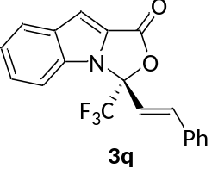
3q (R,E)-3-styryl-3-(trifluoromethyl)-1H,3H-oxazolo[3,4-a]indol-1-one
Pale yellow oil, 50.3 mg, 73% yield, 48 h; ¹H NMR (400 MHz, Chloroform-d) δ 7.85 (d, J = 8.2 Hz, 1H), 7.50 – 7.45 (m, 2H), 7.43 – 7.31 (m, 6H), 7.25 (s, 1H), 6.93 (d, J = 15.9 Hz, 1H), 6.68 (d, J = 15.9 Hz, 1H). ¹³C NMR (100 MHz, Chloroform-d) δ 157.8, 139.5, 133.7, 133.5, 133.0, 130.1, 129.0, 127.6, 127.0, 124.5, 124.3, 122.8, 122.0 (d, J = 287.7 Hz), 114.9, 112.2 (q, J = 2.2 Hz), 104.6, 91.1 (d, J = 35.0 Hz).¹⁹F NMR (376 MHz, Chloroform-d) δ -80.74; IR (neat, ATR) 1797, 1558, 1441, 1342, 1292, 1175, 1125, 1070, 993, 937, 813, 741 cm⁻¹; HRMS (ESI) exact mass calcd. for C₁₉H₁₃F₃NO₂ ([M + H]⁺) requires m/z 344.0893, found m/z 344.0899; HPLC (Chiralpak IE, i-propanol/hexane = 2/98, flow rate 1.0 mL/min, 25 ºC, λ = 254 nm): t_{R} (major) = 7.2 min, t_{R} (minor) = 6.0 min, ee = 72%; [α]²⁵_{D} = -103.5 (c = 1.0, DCM).
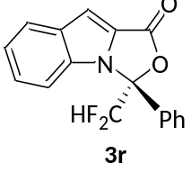
3r (R)-3-(difluoromethyl)-3-phenyl-1H,3H-oxazolo[3,4-a]indol-1-one
Pale yellow wax, 41.3 mg, 69% yield, 48 h; ¹H NMR (400 MHz, Chloroform-d) δ 7.83 (d, J = 8.2 Hz, 1H), 7.55 – 7.44 (m, 5H), 7.43 – 7.25 (m, 4H), 6.52 (t, J = 54.0 Hz, 1H). ¹³C NMR (100 MHz, Chloroform-d) δ 158.4, 134.2, 133.0, 131.4, 131.2, 129.4, 126.7, 126.6, 125.4, 124.2, 122.5, 112.9 (t, J = 252.9 Hz), 112.9 (d, J = 2.5 Hz), 103.8, 93.2 (dd, J = 28.1, 23.1 Hz). ¹⁹F NMR (376 MHz, Chloroform-d) δ -127.79 (d, J = 285.4 Hz), -133.04 (d, J = 285.4 Hz). IR (neat, ATR) 1795, 1725, 1366, 1286, 1075, 983, 911, 738 cm⁻¹; HRMS (ESI) exact mass calcd. for C₁₇H₁₂F₂NO₂ ([M + H]⁺) requires m/z 300.0831, found m/z 300.0830; HPLC (Chiralpak IE, i-propanol/hexane = 2/98, flow rate 1.0 mL/min, 25 ºC, λ = 254 nm): t_{R} (major) = 18.2 min, t_{R} (minor) = 16.7 min, ee = 81%; [α]²⁵_{D} = -55.7 (c = 1.0, DCM).
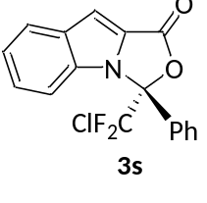
3s (R)-3-(chlorodifluoromethyl)-3-phenyl-1H,3H-oxazolo[3,4-a]indol-1-one
Pale yellow solid, 54.5 mg, 82% yield, 96 h; ¹H NMR (400 MHz, Chloroform-d) δ 7.85 (d, J = 8.2 Hz, 1H), 7.72 (d, J = 7.7 Hz, 2H), 7.55 – 7.43 (m, 5H), 7.36 – 7.30 (m, 2H). ¹³C NMR (100 MHz, Chloroform-d) δ 158.0, 134.0, 133.1, 131.3, 130.6 (t, J = 1.9 Hz), 129.1, 127.4 (t, J = 2.4 Hz), 127.0, 126.7 (t, J = 305.2 Hz), 125.2, 124.5, 122.8, 113.0 (t, J = 3.5 Hz), 104.6, 95.2 (t, J = 31.4 Hz). ¹⁹F NMR (376 MHz, Chloroform-d) δ -60.79 (d, J = 176.1 Hz), -61.24 (d, J = 177.1 Hz); IR (neat, ATR) 1807, 1790, 1739, 1556, 1440, 1371, 1140, 1038, 837, 733 cm⁻¹; HRMS (ESI) exact mass calcd. for C₁₇H₁₁ClF₂NO₂ ([M + H]⁺) requires m/z 334.0441, found m/z 334.0447; HPLC (Chiralpak IE, i-propanol/hexane = 5/95, flow rate 1.0 mL/min, 25 ºC, λ = 254 nm): t_{R} (major) = 7.0 min, t_{R} (minor) = 6.4 min, ee = 87%; [α]²⁵_{D} = -85.7 (c = 1.0, DCM).
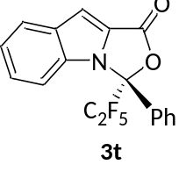
3t (R)-3-(perfluoroethyl)-3-phenyl-1H,3H-oxazolo[3,4-a]indol-1-one
Pale yellow wax, 36.6 mg, 50% yield, 108 h; ¹H NMR (400 MHz, Chloroform-d) δ 7.83 (d, J = 8.2 Hz, 1H), 7.74 (d, J = 7.3 Hz, 2H), 7.61 (d, J = 8.5 Hz, 1H), 7.53 – 7.42 (m, 4H), 7.36 – 7.29 (m, 2H). ¹³C NMR (100 MHz, Chloroform-d) δ 157.4, 134.4, 133.1, 131.3, 131.2, 129.0, 127.2, 126.9 (t, J = 2.4 Hz), 124.5, 124.0, 122.8, 118.2 (dt, J = 289.1, 35.0 Hz), 112.9 (t, J = 4.3 Hz), 112.0 (td, J = 267.4, 36.6 Hz), 105.0, 92.9 (t, J = 28.8 Hz). ¹⁹F NMR (376 MHz, Chloroform-d) δ -79.19, -118.03 (d, J = 2.6 Hz). IR (neat, ATR) 1806, 1336, 1315, 1220, 1163, 1002, 919, 866, 727 cm⁻¹; HRMS (ESI) exact mass calcd. for C₁₈H₁₁F₅NO₂ ([M + H]⁺) requires m/z 368.0704, found m/z 368.0700; HPLC (Chiralpak OJH, i-propanol/hexane = 5/95, flow rate 1.0 mL/min, 25 ºC, λ = 254 nm): t_{R} (major) = 6.8 min, t_{R} (minor) = 5.9 min, ee = 90%; [α]²⁵_{D} = -61.4 (c = 1.0, DCM).
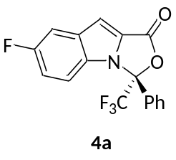
4a (R)-7-fluoro-3-phenyl-3-(trifluoromethyl)-1H,3H-oxazolo[3,4-a]indol-1-one
Pale yellow wax, 45.6 mg, 68% yield, 48 h; ¹H NMR (400 MHz, Chloroform-d) δ 7.60 – 7.53 (m, 3H), 7.51 – 7.45 (m, 3H), 7.28 – 7.23 (m, 2H), 7.18 (td, J = 9.0, 2.5 Hz, 1H). ¹³C NMR (100 MHz, Chloroform-d) δ 158.9 (d, J = 241.3 Hz), 157.5, 133.5 (d, J = 10.3 Hz), 131.7, 130.5, 129.7, 129.4, 126.9 (d, J = 2.0 Hz), 126.2, 122.2 (q, J = 288.2 Hz), 116.4 (d, J = 27.1 Hz), 113.6 (dd, J = 9.6, 2.5 Hz), 108.8 (d, J = 23.7 Hz), 104.3 (d, J = 5.6 Hz), 92.3 (q, J = 34.6 Hz); ¹⁹F NMR (376 MHz, Chloroform-d) δ -77.03, -119.21; IR (neat, ATR) 1811, 1558, 1443, 1379, 1181, 1141, 1010, 949, 863, 808, 722 cm⁻¹; HRMS (ESI) exact mass calcd. for C₁₇H₁₀F₄NO₂ ([M + H]⁺) requires m/z 336.0642, found m/z 336.0643; HPLC (Chiralpak IE, i-propanol/hexane = 2/98, flow rate 1.0 mL/min, 25 ºC, λ = 254 nm): t_{R} (major) = 6.9 min, t_{R} (minor) = 6.3 min, ee = 84%; [α]²⁵_{D} = -100.9 (c = 1.0, DCM).

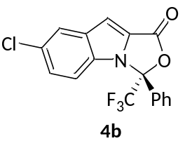
4b (R)-7-chloro-3-phenyl-3-(trifluoromethyl)-1H,3H-oxazolo[3,4-a]indol-1-one
Pale yellow wax, 47.8 mg, 68% yield, 48 h; ¹H NMR (400 MHz, Chloroform-d) δ 7.82 (d, J = 2.1 Hz, 1H), 7.60 – 7.50 (m, 3H), 7.52 – 7.43 (m, 2H), 7.37 (dd, J = 9.0, 2.0 Hz, 1H), 7.24 (d, J = 8.1 Hz, 2H). ¹³C NMR (100 MHz, Chloroform-d) δ 157.4, 133.9, 132.1, 131.7, 129.6, 129.4, 128.8, 127.7, 126.9 (d, J = 2.2 Hz), 125.9, 123.6, 121.1 (q, J = 288.2 Hz), 113.5 (d, J = 2.6 Hz), 103.9, 92.3 (q, J = 34.9 Hz). ¹⁹F NMR (376 MHz, Chloroform-d) δ -77.04; IR (neat, ATR) 1808, 1552, 1454, 1433, 1377, 1273, 1181, 1141, 1065, 1011, 950, 873, 177, 723 cm⁻¹; HRMS (ESI) exact mass calcd. for C₁₇H₁₀ClF₃NO₂ ([M + H]⁺) requires m/z 352.0347, found m/z 352.0345; HPLC (Chiralpak IE, i-propanol/hexane = 5/95, flow rate 1.0 mL/min, 25 ºC, λ = 254 nm): t_{R} (major) = 5.8 min, t_{R} (minor) = 5.4 min, ee = 80%; [α]²⁵_{D} = -50.7 (c = 1.0, DCM).
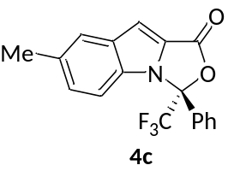
4c (R)-7-methyl-3-phenyl-3-(trifluoromethyl)-1H,3H-oxazolo[3,4-a]indol-1-one
Pale yellow wax, 55.4 mg, 84% yield, 48 h; ¹H NMR (400 MHz, Chloroform-d) δ 7.67 – 7.63 (m, 3H), 7.59 – 7.53 (m, 1H), 7.52 – 7.47 (m, 2H), 7.28 – 7.24 (m, 3H), 2.51 (s, 3H). ¹³C NMR (100 MHz, Chloroform-d) δ 158.0, 133.4, 132.5, 132.4, 131.4, 130.2, 129.2, 129.0, 127.0 (q, J = 2.1 Hz), 124.7, 123.6, 122.3 (q, J = 288.2 Hz), 112.1 (d, J = 2.3 Hz), 104.1, 92.2 (q, J = 34.4 Hz), 21.4. ¹⁹F NMR (376 MHz, Chloroform-d) δ -77.16; IR (neat, ATR) 1805, 1739, 1557, 1455, 1363, 1190, 1083, 997, 948, 883, 797, 727 cm⁻¹; HRMS (ESI) exact mass calcd. for C₁₈H₁₃F₃NO₂ ([M + H]⁺) requires m/z 332.0893, found m/z 332.0895; HPLC (Chiralpak IE, i-propanol/hexane = 5/95, flow rate 1.0 mL/min, 25 ºC, λ = 254 nm): t_{R} (major) = 6.6 min, t_{R} (minor) = 6.0 min, ee = 90%; [α]²⁵_{D} = -52.9 (c = 1.0, DCM).

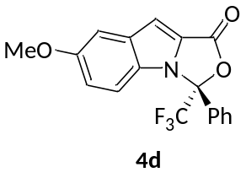
4d (R)-7-methoxy-3-phenyl-3-(trifluoromethyl)-1H,3H-oxazolo[3,4-a]indol-1-one
Pale yellow wax, 62.4 mg, 90% yield, 36 h; ¹H NMR (400 MHz, Chloroform-d) δ 7.61 (d, J = 8.3 Hz, 2H), 7.56 – 7.49 (m, 1H), 7.51 – 7.42 (m, 2H), 7.27 – 7.18 (m, 3H), 7.09 (dd, J = 9.3, 2.5 Hz, 1H), 3.87 (s, 3H). ¹³C NMR (100 MHz, Chloroform-d) δ 157.9, 155.9, 133.8, 131.5, 130.1, 129.3, 129.2, 127.0 (q, J = 2.0 Hz), 125.0, 122.3 (q, J = 288.2 Hz), 118.9, 113.3 (q, J = 2.3 Hz), 104.0, 103.9, 92.2 (q, J = 34.5 Hz), 55.7.¹⁹F NMR (376 MHz, Chloroform-d) δ -77.22; IR (neat, ATR) 1790, 1556, 1540, 1376, 1344, 1259, 1178, 1015, 951, 842, 796, 721 cm⁻¹; HRMS (ESI) exact mass calcd. for C₁₈H₁₃F₃NO₃ ([M + H]⁺) requires m/z 348.0842, found m/z 348.0845; HPLC (Chiralpak IE, i-propanol/hexane = 5/95, flow rate 1.0 mL/min, 25 ºC, λ = 254 nm): t_{R} (major) = 8.1 min, t_{R} (minor) = 7.3 min, ee = 90%; [α]²⁵_{D} = -86.7 (c = 1.0, DCM).
4e (R)-9-methyl-3-phenyl-3-(trifluoromethyl)-1H,3H-oxazolo[3,4-a]indol-1-one
Colorless wax, 48.9 mg, 74% yield, 72 h; ¹H NMR (400 MHz, Chloroform-d) δ 7.83 – 7.76 (m, 1H), 7.63 (d, J = 7.7 Hz, 2H), 7.55 – 7.38 (m, 4H), 7.35 – 7.27 (m, 2H), 2.64 (s, 3H). ¹³C NMR (100 MHz, Chloroform-d) δ 158.4, 133.6, 133.6, 131.3, 130.5, 129.2, 127.1, 127.0 (q, J = 2.0 Hz), 122.4, 122.4 (q, J = 288.4 Hz), 122.0, 121.3, 117.4, 112.4 (q, J = 2.3 Hz), 91.9 (q, J = 34.4 Hz), 8.6. ¹⁹F NMR (376 MHz, Chloroform-d) δ -77.25; IR (neat, ATR) 1789, 1602, 1442, 1329, 1178, 1121, 1054, 981, 948, 898, 720 cm⁻¹; HRMS (ESI) exact mass calcd. for C₁₈H₁₃F₃NO₂ ([M + H]⁺) requires m/z 332.0893, found m/z 332.0898; HPLC (Chiralpak IE, i-propanol/hexane = 2/98, flow rate 1.0 mL/min, 25 ºC, λ = 254 nm): t_{R} (major) = 6.7 min, t_{R} (minor) = 6.0 min, ee = 90%; [α]²⁵_{D} = -102.0 (c = 1.0, DCM).
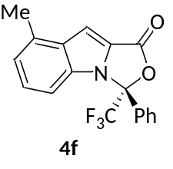
4f (R)-8-methyl-3-phenyl-3-(trifluoromethyl)-1H,3H-oxazolo[3,4-a]indol-1-one
Colorless wax, 49.7 mg, 75% yield, 48 h; ¹H NMR (400 MHz, Chloroform-d) δ 7.62 (d, J = 8.0 Hz, 2H), 7.57 – 7.49 (m, 1H), 7.51 – 7.43 (m, 2H), 7.38 – 7.28 (m, 2H), 7.16 (d, J = 8.6 Hz, 1H), 7.11 (dt, J = 7.1, 1.0 Hz, 1H), 2.64 (s, 3H). ¹³C NMR (100 MHz, Chloroform-d) δ 158.0, 134.2, 133.8, 133.3, 131.5, 130.1, 129.2, 127.2, 127.0 (d, J = 1.9 Hz), 124.1, 122.8, 122.3 (q, J = 288.2 Hz), 110.0 (q, J = 2.4 Hz), 103.2, 92.3 (q, J = 34.4 Hz), 18.7. ¹⁹F NMR (376 MHz, Chloroform-d) δ -76.99; IR (neat, ATR) 1790, 1558, 1453, 1381, 1345, 1241, 1171, 1137, 1050, 947, 901, 777, 722 cm⁻¹; HRMS (ESI) exact mass calcd. for C₁₈H₁₃F₃NO₂ ([M + H]⁺) requires m/z 332.0893, found m/z 332.0894; HPLC (Chiralpak IE, i-propanol/hexane = 5/95, flow rate 1.0 mL/min, 25 ºC, λ = 254 nm): t_{R} (major) = 6.4 min, t_{R} (minor) = 6.0 min, ee = 92%; [α]²⁵_{D} = -46.1 (c = 1.0, DCM).
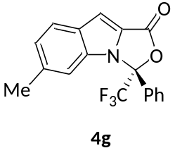
4g (R)-6-methyl-3-phenyl-3-(trifluoromethyl)-1H,3H-oxazolo[3,4-a]indol-1-one
Colorless wax, 52.5 mg, 79% yield, 36 h; ¹H NMR (400 MHz, Chloroform-d) δ 7.74 (d, J = 8.4 Hz, 1H), 7.65 (dd, J = 7.8, 1.6 Hz, 2H), 7.61 – 7.54 (m, 1H), 7.51 (dd, J = 8.3, 6.5 Hz, 2H), 7.30 (s, 1H), 7.21 – 7.11 (m, 2H), 2.49 (s, 3H). ¹³C NMR (100 MHz, Chloroform-d) δ 158.0, 137.7, 134.4, 131.5, 131.0, 130.1, 129.3, 127.1 (q, J = 2.1 Hz), 125.0, 124.1, 124.0, 122.3 (q, J = 288.3 Hz), 112.0 (q, J = 2.3 Hz), 104.7, 92.2 (q, J = 34.1 Hz), 22.2. ¹⁹F NMR (376 MHz, Chloroform-d) δ -76.89; IR (neat, ATR) 1808, 1622, 1553, 1453, 1373, 1336, 1180, 1073, 1012, 948, 892, 826, 722 cm⁻¹; HRMS (ESI) exact mass calcd. for C₁₈H₁₃F₃NO₂ ([M + H]⁺) requires m/z 332.0893, found m/z 332.0896; HPLC (Chiralpak IE, i-propanol/hexane = 5/95, flow rate 1.0 mL/min, 25 ºC, λ = 254 nm): t_{R} (major) = 6.5 min, t_{R} (minor) = 6.0 min, ee = 90%; [α]²⁵_{D} = -162.1 (c = 1.0, DCM).
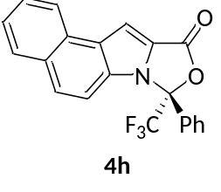
4h (R)-8-phenyl-8-(trifluoromethyl)-8H,10H-benzo[e]oxazolo[3,4-a]indol-10-one
Pale yellow wax, 30.8 mg, 42% yield, 48 h; ¹H NMR (400 MHz, Chloroform-d) δ 8.31 (d, J = 8.1 Hz, 1H), 7.93 (d, J = 8.1 Hz, 1H), 7.83 (s, 1H), 7.78 (d, J = 9.2 Hz, 1H), 7.74 – 7.65 (m, 1H), 7.65 – 7.58 (m, 2H), 7.61 – 7.51 (m, 2H), 7.48 (dd, J = 8.4, 6.6 Hz, 2H), 7.35 (d, J = 9.1 Hz, 1H).
¹³C NMR (100 MHz, Chloroform-d) δ 157.6, 131.6, 130.0, 129.7, 129.4, 129.3, 129.0, 129.0, 128.9, 127.7, 127.0 (q, J = 2.0 Hz), 125.8, 123.1, 122.9, 122.2 (q, J = 287.8 Hz), 112.3 (q, J = 2.3 Hz), 103.5, 92.3 (d, J = 34.5 Hz), miss one carbon. ¹⁹F NMR (376 MHz, Chloroform-d) δ -76.95; IR (neat, ATR) 2964, 1739, 1542, 1445, 1365, 1260, 1016, 949, 798, 720 cm⁻¹; HRMS (ESI) exact mass calcd. for C₂₁H₁₃F₃NO₂ ([M + H]⁺) requires m/z 368.0893, found m/z 368.0893; HPLC (Chiralpak IE, i-propanol/hexane = 5/95, flow rate 1.0 mL/min, 25 ºC, λ = 254 nm): t_{R} (major) = 9.2 min, t_{R} (minor) = 8.3 min, ee = 69%; [α]²⁵_{D} = -92.1 (c = 1.0, DCM).
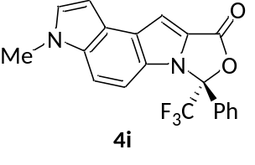
4i (R)-3-methyl-7-phenyl-7-(trifluoromethyl)-7H-oxazolo[3,4-a]pyrrolo[3,2-e]indol-9(3H)-one
White solid, 32.4 mg, 42% yield, 48 h; ¹H NMR (400 MHz, Chloroform-d) δ 7.62 (d, J = 8.0 Hz, 2H), 7.57 – 7.49 (m, 2H), 7.48 – 7.40 (m, 3H), 7.18 (d, J = 3.0 Hz, 1H), 7.12 – 7.06 (m, 1H), 6.82 (d, J = 2.5 Hz, 1H), 3.88 (s, 3H). ¹³C NMR (100 MHz, Chloroform-d) δ 158.1, 131.8, 131.3, 130.4, 129.9, 129.1, 128.7, 127.2 (q, J = 2.0 Hz), 126.6, 123.0, 122.4 (d, J = 288.4 Hz), 121.9, 111.3, 106.3 (q, J = 2.6 Hz), 102.9, 100.1, 92.2 (d, J = 34.3 Hz), 33.4. ¹⁹F NMR (376 MHz, Chloroform-d) δ -76.67; IR (neat, ATR) 1789, 1556, 1496, 1369, 1241, 1187, 1059, 1021, 952, 823, 738 cm⁻¹; HRMS (ESI) exact mass calcd. for C₂₀H₁₄F₃N₂O₂ ([M + H]⁺) requires m/z 371.1002, found m/z 371.1000; HPLC (Chiralpak IE, i-propanol/hexane = 5/95, flow rate 1.0 mL/min, 25 ºC, λ = 254 nm): t_{R} (major) = 22.5 min, t_{R} (minor) = 19.8 min, ee = 85%; [α]²⁵_{D} = -78.1 (c = 1.0, DCM).

Gram Scale Synthesis Procedure
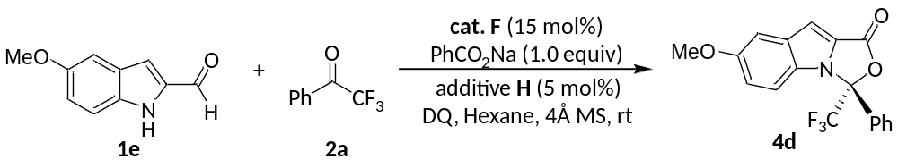
To a flame-dried Schlenk reaction tube equipped with a magnetic stir bar, was added the precatalyst F (308.4 mg, 0.60 mmol), DQ (1.80 g, 4.4 mmol), additive H (100.0 mg, 0.20 mmol), PhCO₂Na (576.0 mg, 4.0 mmol), 1e (700.8 mg, 4.0 mmol) and 4Å M.S. (600 mg). The Schlenk tube was closed with a septum, evacuated and refilled with argon atmosphere. Hexane (33.4 mL), DCM (6.6 mL) and 2a (835.2 mg, 4.8 mmol) was added. The mixture was then stirred at 25 °C and monitored by TLC until 1e was consumed. The mixture was concentrated under reduced pressure and purified by column chromatography on silica gel (hexane/EtOAc = 100:1) to afford the desired product 4d as a pale yellow wax, 1.29 g, 92% yield, 90% ee.

Synthetic Transformation
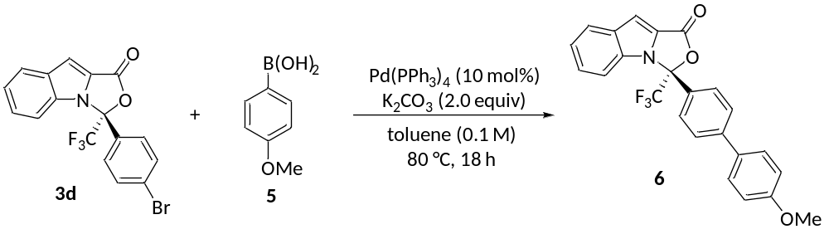
To a flame-dried Schlenk reaction tube equipped with a magnetic stir bar, was added 3d (19.8 mg, 0.05 mmol), (4-methoxyphenyl)boronic acid 5 (15.2 mg, 0.10 mmol), K₂CO₃ (13.8 mg, 0.10 mmol), and Pd(PPh₃)₄ (5.7 mg, 0.005 mmol). The Schlenk tube was closed with a septum, evacuated and refilled with argon atmosphere. Toluene (0.5 mL) was added then the mixture was then stirred at 80 °C for 18 h. The mixture was concentrated under reduced pressure and purified by column chromatography on silica gel (hexane/EtOAc = 100:1) to afford the desired product (R)-3-(4'-methoxy-[1,1'-biphenyl]-4-yl)-3-(trifluoromethyl)-1H,3H-oxazolo[3,4-a]indol-1-one 6 as a yellow wax, 15.1 mg, 71% yield; ¹H NMR (400 MHz, Chloroform-d) δ 7.86 (d, J = 8.3 Hz, 1H), 7.64 (s, 4H), 7.56 – 7.50 (m, 2H), 7.48 – 7.41 (m, 1H), 7.40 – 7.30 (m, 3H), 7.03 – 6.95 (m, 2H), 3.86 (s, 3H). ¹³C NMR (100 MHz, Chloroform-d) δ 159.9, 157.9, 143.9, 133.9, 133.1, 131.8, 128.3, 127.9, 127.5 (q, J = 1.9 Hz), 127.3, 127.0, 124.8, 124.4, 122.8, 122.3 (d, J = 288.2 Hz), 114.5, 112.6 (q, J = 2.4 Hz), 104.6, 92.4 (q, J = 34.7 Hz), 55.4.¹⁹F NMR (376 MHz, Chloroform-d) δ -77.00; HRMS (ESI) exact mass calcd. for C₂₄H₁₇F₃NO₃ ([M + H]⁺) requires m/z 424.1155, found m/z 424.1157; HPLC (Chiralpak IE, i-propanol/hexane = 5/95, flow rate 1.0 mL/min, 25 ºC, λ = 254 nm): t_{R} (major) = 13.3 min, t_{R} (minor) = 12.4 min, ee = 92%; [α]²⁵_{D} = -94.5 (c = 1.0, DCM).

HRMS of II
Supplementary Table 1 HRMS of II
Mass | Calc. Mass | mDa | PPM | DBE | i-FIT | Norm | Conf(%) | Formula
568.1049 | 568.1044 | 0.5 | 0.9 | 20.5 | 678.1 | 2.027 | 13.18 | C₂₇ H₁₅ N₅ O₄ F₅

Kinetic Experiment
To a flame-dried Schlenk reaction tube equipped with a magnetic stir bar, was added the precatalyst F (15.4 mg, 0.03 mmol), DQ (90.0 mg, 0.22 mmol), additive H (5.0 mg, 0.01 mmol), PhCO₂Na (28.8 mg, 0.20 mmol), 1 (0.20 mmol) and 4Å MS (60 mg). The Schlenk tube was closed with a septum, evacuated and refilled with argon atmosphere. Hexane (2.0 mL) and 2 (0.24 mmol) was added. The mixture was then stirred at 25 °C. Yield was determined by ¹⁹F NMR based on the use of benzotrifluoride as internal standard. And the result showed that the electron-rich indole gave more favorable outcomes (a and b) and the electronic-deficient aryl ketone reacted faster (b, c and d).
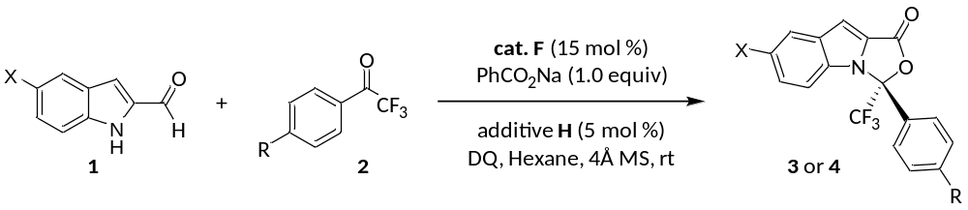

a: X = Me, R = H; b: X = H, R = H; c: X = H, R = Me; d: X = H, R = Cl.
Supplementary Figure 154. Kinetic Experiment

Control Experiment
When the reaction of 1a and 2a (Supplementary Figure 155.a) was performed under the standard conditions without the pre-catalyst F, the desired product 3a or acetal was not formed neither indicating the role of NHC in this [10+2] annulation and the direct N-H addition of initially formed acylazolium then cyclization in a [10+2] pathway is impossible in this case. Further, when the reaction was performed without DQ (Supplementary Figure 155.b), the product 3u was not formed signifying the conjugated pi-electron is indispensable. Additionally, when used N-Me protected aldehyde 1k (Supplementary Figure 155.c), the target product 3v cannot be detected implying the aza-benzofulvene intermediate’s activated site Nitrogen cannot be displaced by Carbon.
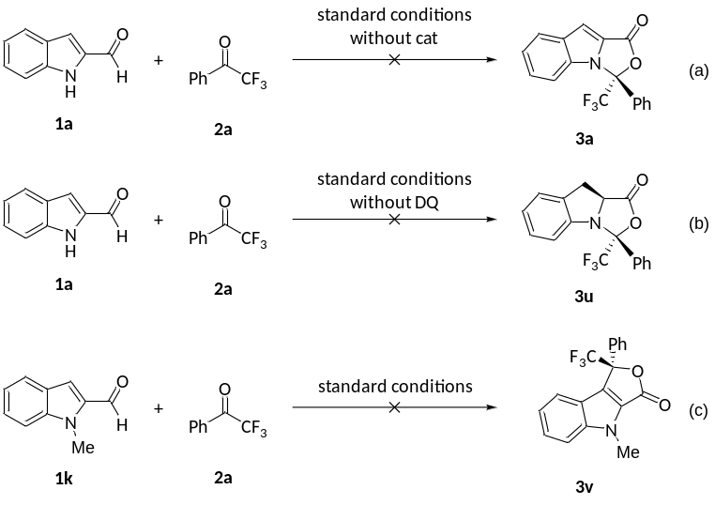
Supplementary Figure 155 Control Experiment

Crystal Structure of 3e
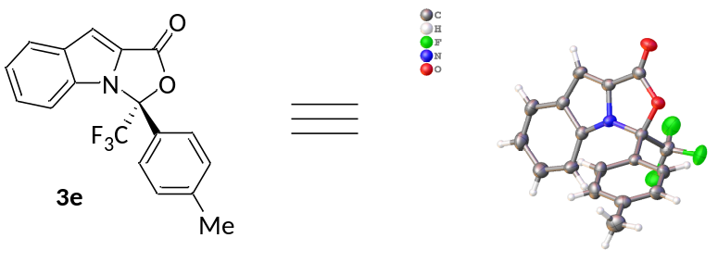
Supplementary Figure 156. Crystal Structure of 3e
Supplementary Table 2 Crystal Structure of 3e
Identification code | 20190718pengqiupeng-2
Empirical formula | C₁₈H₁₂F₃NO₂
Formula weight | 331.29
Temperature/K | 173.00(10)
Crystal system | orthorhombic
Space group | P2₁2₁2₁
a/Å | 10.0743(3)
b/Å | 11.6391(2)
c/Å | 12.9583(3)
α/° | 90
β/° | 90
γ/° | 90
Volume/Å³ | 1519.44(6)
Z | 4
ρ_{calc}g/cm³ | 1.448
μ/mm⁻¹ | 0.119
F(000) | 680.0
Crystal size/mm³ | 0.4 × 0.35 × 0.3
Radiation | MoKα (λ = 0.71073)
2Θ range for data collection/° | 7.002 to 60.87
Index ranges | -13 ≤ h ≤ 14, -16 ≤ k ≤ 16, -17 ≤ l ≤ 18
Reflections collected | 28355
Independent reflections | 4274 [R_{int} = 0.0315, R_{sigma} = 0.0214]
Data/restraints/parameters | 4274/0/218
Goodness-of-fit on F² | 1.034
Final R indexes [I>=2σ (I)] | R₁ = 0.0358, wR₂ = 0.0799
Final R indexes [all data] | R₁ = 0.0449, wR₂ = 0.0846
Largest diff. peak/hole / e Å⁻³ | 0.22/-0.24
Flack parameter | 0.02(17)

Computational Details

All the theoretical calculations in the study were performed using Gaussian16 program package⁷. All the geometries were optimized at the M062X⁸/6-31G(d, p) level, and the solvent effect was utilized the polarizable continuum model using integral equation formalism model (IEFPCM) in hexane solvent.⁹ And the harmonic vibrational frequency calculations were performed at the same level to confirm the local minima and transition state. In addition, intrinsic reaction coordinate (IRC) computations with Hessian-based predictor−corrector integrator (HPC)¹⁰⁻¹² have been used to test some reaction steps to confirm the located transition states as residing on the correct reaction coordinates.

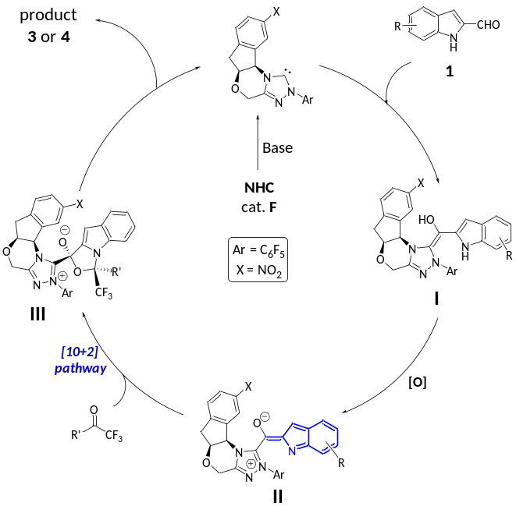

Supplementary Figure 157. The Gibbs free energy barriers and distortion energy in the process. (kcal/mol)

Supplementary Table 3 The free-energy for the corresponding structures
Species | E(au) | Species | E(au)
2 | -476.849491 | II | -2111.045501
TS(II-III)R | -2792.1352 | TS(II-III)S | -2792.127130

Supplementary Table 4 The distortion energy for the TS(II-III)
Species | E(au) | Species | E(au)
2 | -682.3617644 | II | -2110.191031
TS(II-III)R | -2792.567189 | TS(II-III)S | -2792.558481
2 in TS(II-III)R | -682.3453045 | II in TS(II-III)R | -2110.16726
2 in TS(II-III)R | -682.3377994 | II in TS(II-III)R | -2110.171377

The IRC of transition state TS(II)R
In order to find out whether the process from II to III would be concerted, the IRC (intrinsic reaction coordinate) calculation of transition state TS(II)R has been performed. Supplementary Figure 158 clearly shows the C1 of trifluoroacetophenone and N1 of indole would form the covalent bond firstly. Along with the decreasing distance of C1-N1, the bond of oxgen atom O1-C2 gradually formed unitl the intermedaite III generate. Hence, we believe the process should be concerted.
Supplementary Figure 158. IRC calculation of transition state TS(II)R

Supplementary Table 5 The coordinates for the corresponding structures
II
6 -0.216759000 -1.430455000 -0.624863000
6 -0.826181000 -3.248802000 0.415520000
7 -1.278062000 -2.196550000 -0.341765000
7 0.457856000 -3.171144000 0.609136000
6 2.153287000 -1.557046000 -0.020429000
6 2.667424000 -1.052908000 1.168863000
6 2.883117000 -1.460070000 -1.195347000
6 3.924482000 -0.475788000 1.187194000
6 4.144590000 -0.881822000 -1.184633000
6 4.659562000 -0.391640000 0.008495000
7 0.819428000 -2.032393000 -0.049011000
6 -1.768487000 -4.298030000 0.922101000
1 -1.895871000 -4.185497000 2.006093000
1 -1.350078000 -5.287151000 0.729029000
8 -2.995202000 -4.220489000 0.233483000
6 -2.697639000 -1.953140000 -0.713189000
6 -3.547455000 -2.926613000 0.142110000
1 -4.500306000 -3.055944000 -0.376040000
1 -2.779887000 -2.111081000 -1.788809000
6 -3.797171000 -2.175492000 1.469205000
1 -4.732711000 -2.480887000 1.942156000
1 -2.992615000 -2.344831000 2.194839000
6 -3.790245000 -0.736558000 1.022779000
6 -4.303042000 0.375249000 1.682839000
6 -3.180099000 -0.603465000 -0.230045000
6 -4.200807000 1.623711000 1.078623000
1 -4.776844000 0.275747000 2.653550000
6 -3.104217000 0.627967000 -0.869247000
6 -3.614895000 1.718339000 -0.178884000
1 -4.573280000 2.521606000 1.555754000
1 -2.668401000 0.755858000 -1.853008000
7 -3.536972000 3.041322000 -0.818452000
8 -3.090047000 3.095277000 -1.948556000
8 -3.932674000 3.999490000 -0.179951000
6 0.621016000 3.084803000 -0.428561000
6 0.996452000 2.161976000 0.623365000
6 1.618677000 2.643859000 1.810164000
6 1.833893000 3.989405000 1.931161000
6 1.447052000 4.907868000 0.901369000
6 0.855504000 4.477830000 -0.255511000
6 0.079361000 2.298809000 -1.447997000
6 0.157935000 0.978715000 -0.949608000
1 1.917100000 1.939995000 2.582887000
1 2.309212000 4.382089000 2.825260000
1 1.635422000 5.966476000 1.051326000
1 0.569702000 5.182493000 -1.031184000
1 -0.329096000 2.608807000 -2.399721000
7 0.703254000 0.895481000 0.314170000
6 -0.302838000 -0.217611000 -1.548641000
8 -0.862287000 -0.436665000 -2.620896000
9 2.359254000 -1.892324000 -2.336022000
9 4.854616000 -0.797803000 -2.302436000
9 5.862103000 0.161015000 0.024448000
9 4.416022000 0.027625000 2.312955000
9 1.940861000 -1.087419000 2.271686000
1
6 -3.325084000 -0.467486000 0.000091000
6 -2.319425000 -1.430920000 -0.000160000
6 -0.983136000 -1.046536000 -0.000253000
6 -0.656226000 0.314405000 -0.000105000
6 -1.669702000 1.279397000 0.000105000
6 -3.000719000 0.889343000 0.000219000
1 -4.366059000 -0.774662000 0.000174000
1 -2.575671000 -2.484831000 -0.000291000
1 -0.207503000 -1.803658000 -0.000516000
1 -1.388393000 2.327162000 0.000198000
1 -3.786288000 1.637444000 0.000415000
6 0.742660000 0.808336000 -0.000137000
8 1.050836000 1.975770000 -0.000378000
6 1.879540000 -0.238857000 0.000131000
9 1.794272000 -1.025906000 1.082449000
9 3.067693000 0.345753000 0.000354000
9 1.794676000 -1.025815000 -1.082392000
TS3(II-III)R
6 -0.957354000 -1.518492000 0.452820000
6 -1.171819000 -3.034095000 -1.101084000
7 -0.270687000 -2.455350000 -0.230739000
7 -2.361346000 -2.542063000 -0.953816000
6 -3.343685000 -0.841849000 0.400382000
6 -3.925850000 -0.999343000 1.651931000
6 -3.910255000 0.018608000 -0.537761000
6 -5.032724000 -0.236142000 2.000099000
6 -5.019093000 0.773376000 -0.193955000
6 -5.572121000 0.648063000 1.076596000
7 -2.216837000 -1.617649000 0.028363000
6 -0.763129000 -4.005010000 -2.160436000
1 -0.600733000 -3.444108000 -3.091762000
1 -1.562406000 -4.728215000 -2.324364000
8 0.388709000 -4.708997000 -1.771609000
6 1.064993000 -3.102981000 0.013077000
6 1.415378000 -3.893103000 -1.276833000
1 2.220551000 -4.579430000 -1.003986000
1 0.930585000 -3.744401000 0.886581000
6 2.000501000 -2.794847000 -2.196866000
1 2.571932000 -3.203720000 -3.031577000
1 1.212420000 -2.139634000 -2.589586000
6 2.836836000 -2.054698000 -1.183951000
6 4.064775000 -1.428150000 -1.345638000
6 2.282261000 -2.217750000 0.095078000
6 4.756295000 -0.996192000 -0.215022000
1 4.499204000 -1.301267000 -2.331402000
6 2.962726000 -1.821770000 1.231335000
6 4.198133000 -1.209594000 1.037827000
1 5.718869000 -0.505026000 -0.286740000
1 2.583034000 -1.977128000 2.233667000
7 4.943017000 -0.776296000 2.224482000
8 4.364269000 -0.821424000 3.297166000
8 6.089114000 -0.397105000 2.072646000
6 2.591131000 1.366567000 1.500357000
6 2.223047000 1.281722000 0.125208000
6 3.050825000 1.838971000 -0.864592000
6 4.246382000 2.406161000 -0.468310000
6 4.637374000 2.452216000 0.889825000
6 3.815932000 1.948965000 1.877160000
6 1.551019000 0.720765000 2.223486000
6 0.652842000 0.283895000 1.266227000
1 2.770173000 1.797882000 -1.909415000
1 4.910895000 2.822161000 -1.219810000
1 5.594703000 2.889496000 1.153777000
1 4.117170000 1.969064000 2.920763000
1 1.502602000 0.516788000 3.284715000
7 1.026757000 0.614315000 -0.018953000
6 -0.488538000 -0.563543000 1.559093000
8 -1.065462000 -0.658184000 2.622872000
6 -0.449780000 1.427811000 -0.890846000
8 -1.464865000 1.085020000 -0.242696000
6 -0.293588000 0.728723000 -2.256080000
6 -0.029066000 2.879624000 -0.855206000
6 -0.217749000 3.543797000 0.358904000
6 0.508678000 3.568364000 -1.941595000
6 0.151833000 4.874981000 0.493585000
1 -0.649706000 2.991035000 1.187590000
6 0.862307000 4.910023000 -1.808722000
1 0.653927000 3.073018000 -2.895679000
6 0.692356000 5.562870000 -0.592859000
1 0.015819000 5.380047000 1.444596000
1 1.275169000 5.442660000 -2.659672000
1 0.977782000 6.605066000 -0.490332000
9 -1.088373000 1.316319000 -3.161871000
9 -0.673248000 -0.562213000 -2.188392000
9 0.950076000 0.729382000 -2.764927000
9 -3.461771000 -1.898479000 2.504799000
9 -5.596172000 -0.378297000 3.194451000
9 -6.639243000 1.363880000 1.398889000
9 -5.567603000 1.603779000 -1.072483000
9 -3.415629000 0.100392000 -1.758152000
TS3(II-III)S
6 -1.032999000 0.474526000 -1.124489000
6 -1.258009000 2.646483000 -1.148601000
7 -0.360565000 1.617371000 -1.358729000
7 -2.435270000 2.196930000 -0.841497000
6 -3.421708000 0.019019000 -0.645617000
6 -3.979773000 -0.643059000 -1.738096000
6 -4.056724000 -0.040550000 0.592326000
6 -5.093226000 -1.452113000 -1.572639000
6 -5.175717000 -0.843691000 0.758650000
6 -5.686582000 -1.552859000 -0.320879000
7 -2.287294000 0.846602000 -0.856085000
6 -0.860981000 4.084265000 -1.236137000
1 -0.569274000 4.429752000 -0.234267000
1 -1.711994000 4.673923000 -1.578275000
8 0.180618000 4.243002000 -2.168170000
6 0.898567000 1.855294000 -2.151973000
6 1.251745000 3.355714000 -1.979496000
1 1.968858000 3.594330000 -2.768612000
1 0.655999000 1.581523000 -3.180797000
6 1.972838000 3.375262000 -0.615614000
1 2.578475000 4.271137000 -0.465342000
1 1.253521000 3.302647000 0.209257000
6 2.773338000 2.104714000 -0.723658000
6 4.009149000 1.792173000 -0.168251000
6 2.161094000 1.228610000 -1.626914000
6 4.648250000 0.623522000 -0.567718000
1 4.486526000 2.464384000 0.537366000
6 2.797591000 0.081500000 -2.072333000
6 4.042151000 -0.189325000 -1.520384000
1 5.614910000 0.335820000 -0.173489000
1 2.373404000 -0.589390000 -2.809223000
7 4.773883000 -1.371913000 -1.998237000
8 4.248441000 -2.048586000 -2.863734000
8 5.867983000 -1.591280000 -1.513663000
6 2.377550000 -2.780814000 -0.283740000
6 2.343018000 -1.706493000 0.666804000
6 3.408706000 -1.583415000 1.594500000
6 4.446971000 -2.481958000 1.536358000
6 4.477852000 -3.542602000 0.590260000
6 3.455806000 -3.698369000 -0.311100000
6 1.224213000 -2.628504000 -1.071350000
6 0.584324000 -1.486802000 -0.579912000
1 3.427412000 -0.793830000 2.334958000
1 5.273122000 -2.379491000 2.233714000
1 5.326348000 -4.218316000 0.578755000
1 3.477435000 -4.490692000 -1.053403000
1 0.907805000 -3.214268000 -1.923217000
7 1.248006000 -0.910251000 0.480166000
6 -0.593382000 -0.988372000 -1.253736000
8 -1.294619000 -1.640570000 -2.011753000
6 -0.230069000 -0.212536000 1.904804000
8 -1.295568000 -0.457731000 1.347368000
6 0.174357000 -1.238487000 2.979031000
6 0.234529000 1.208615000 2.113983000
6 1.552715000 1.570221000 2.405393000
6 -0.757634000 2.192366000 2.112013000
6 1.863947000 2.886915000 2.727313000
1 2.333849000 0.824004000 2.355006000
6 -0.442628000 3.515808000 2.421468000
1 -1.780137000 1.901648000 1.895765000
6 0.867187000 3.862994000 2.744640000
1 2.890185000 3.153835000 2.961139000
1 -1.227082000 4.266947000 2.438148000
1 1.112118000 4.888046000 3.004766000
9 -0.675660000 -1.078584000 4.011038000
9 1.407818000 -1.071783000 3.471503000
9 0.054262000 -2.486079000 2.544167000
9 -3.480932000 -0.471978000 -2.950002000
9 -3.645926000 0.688086000 1.615422000
9 -5.778098000 -0.908159000 1.938880000
9 -6.761692000 -2.307373000 -0.161444000
9 -5.617154000 -2.090815000 -2.610831000

Supplementary Table 6 The data of IRC of transition state TS(II)R
 | E(a.u.) |  | E(a.u.)
0 | -2792.567189 | 0 | -2792.567189
-0.32676 | -2792.567253 | 0.32676 | -2792.567241
-0.65311 | -2792.567459 | 0.6531 | -2792.567381
-0.97951 | -2792.567802 | 0.97931 | -2792.567584
-1.30598 | -2792.568238 | 1.30581 | -2792.567829
-1.63241 | -2792.568692 | 1.63236 | -2792.568099
-1.95866 | -2792.569092 | 1.95896 | -2792.568383
-2.28441 | -2792.569404 | 2.28558 | -2792.568675
-2.6098 | -2792.569646 | 2.61222 | -2792.568978
-2.93564 | -2792.569849 | 2.93885 | -2792.569287
-3.26194 | -2792.570029 | 3.26548 | -2792.569594
-3.58843 | -2792.570192 | 3.5921 | -2792.569891
-3.9149 | -2792.570341 | 3.9187 | -2792.570169
-4.24072 | -2792.570463 | 4.24527 | -2792.570427
-4.55921 | -2792.570503 | 4.57184 | -2792.570663
-4.8645 | -2792.570487 | 4.89833 | -2792.57088
-5.13646 | -2792.570733 | 5.22472 | -2792.571077
-5.45222 | -2792.570843 | 5.55012 | -2792.571246
-5.77214 | -2792.57093 | 5.87106 | -2792.571392
-6.08551 | -2792.571029 | 6.18803 | -2792.571494
-6.40763 | -2792.571114 | 6.49182 | -2792.571661
-6.72724 | -2792.571198 | 6.80836 | -2792.571796
-7.05105 | -2792.571274 | 7.1258 | -2792.571919
-7.37304 | -2792.571345 | 7.44134 | -2792.572035
-7.69499 | -2792.571408 | 7.7566 | -2792.57213
-8.01308 | -2792.571467 | 8.06553 | -2792.572245
-8.32927 | -2792.57152 | 8.37993 | -2792.57234
-8.64271 | -2792.571572 | 8.68988 | -2792.57244
-8.95615 | -2792.571623 | 9.00135 | -2792.57254
-9.27186 | -2792.57167 | 9.31391 | -2792.572643
-9.58833 | -2792.571715 | 9.62925 | -2792.572746
-9.90683 | -2792.571754 | 9.94792 | -2792.572832
-0.22207 | -2792.571789 | 10.2604 | -2792.572923
-0.53432 | -2792.571815 | 10.57354 | -2792.572985
-0.83887 | -2792.571854 | 10.87629 | -2792.573092
-1.14832 | -2792.571887 | 11.19022 | -2792.573163
-1.45816 | -2792.571915 | 11.49695 | -2792.573258
-1.76667 | -2792.57194 | 11.8115 | -2792.573328
-2.07313 | -2792.571964 | 12.12034 | -2792.573403
-2.37794 | -2792.571992 | 12.43059 | -2792.573469
-2.68925 | -2792.572015 | 12.73729 | -2792.57354
-2.99903 | -2792.572036 | 13.04529 | -2792.573595
-3.30811 | -2792.572054 | 13.34926 | -2792.573665
-3.61352 | -2792.572053 | 13.65653 | -2792.573701
-3.90909 | -2792.572067 | 13.95302 | -2792.573773
-4.20287 | -2792.572082 | 14.25751 | -2792.573745
-4.49496 | -2792.572116 | 14.54122 | -2792.573835
-4.80392 | -2792.572129 | 14.83742 | -2792.573908
-5.10547 | -2792.572145 | 15.14234 | -2792.573951
-5.41327 | -2792.572143 | 15.44491 | -2792.573979
-5.70536 | -2792.572152 | 15.73977 | -2792.573992
-6.00093 | -2792.572157 | 16.03039 | -2792.574014
-6.2936 | -2792.572181 | 16.3178 | -2792.574043
-6.59647 | -2792.57219 | 16.59968 | -2792.574133
-6.88986 | -2792.572204 | 16.91145 | -2792.574137
-7.19411 | -2792.572207 | 17.20036 | -2792.574208
-7.48862 | -2792.572213 | 17.52089 | -2792.574242
-7.7813 | -2792.572218 | 17.8386 | -2792.574262
-8.075 | -2792.572229 | 18.14355 | -2792.574289
-8.37757 | -2792.57222 | 18.4454 | -2792.574288
-8.65471 | -2792.572225 | 18.7376 | -2792.57429
-8.9437 | -2792.572231 | 19.02445 | -2792.574255
-9.23989 | -2792.572241 | 19.29545 | -2792.57432
-9.53156 | -2792.572245 | 19.60238 | -2792.574233
-9.82359 | -2792.572246 | 19.85866 | -2792.574375
-0.11729 | -2792.572235 | 20.17519 | -2792.574268
-0.40472 | -2792.572229 | 20.42359 | -2792.574402
-0.69499 | -2792.572206 | 20.73864 | -2792.574391
-0.97022 | -2792.572215 | 21.02434 | -2792.574421
-1.25476 | -2792.572196 | 21.33221 | -2792.574406
-1.54612 | -2792.572214 | 21.609 | -2792.574443
-1.85239 | -2792.572227 | 21.91721 | -2792.574428
-2.15142 | -2792.572226 | 22.19091 | -2792.574468
-2.4383 | -2792.572237 | 22.50541 | -2792.574435
-2.7307 | -2792.572235 | 22.77219 | -2792.574481
-3.0169 | -2792.572243 | 23.08627 | -2792.574438
-3.30738 | -2792.572243 | 23.33924 | -2792.574493
-3.59138 | -2792.57225 | 23.65727 | -2792.574459
-3.89003 | -2792.572249 | 23.9175 | -2792.574505
-4.18202 | -2792.572258 | 24.23634 | -2792.574488
-4.47875 | -2792.572267
-4.77441 | -2792.572272
-5.06971 | -2792.572275
-5.36855 | -2792.572274
-5.6649 | -2792.572275
-5.96491 | -2792.572272
-6.259 | -2792.572272
-6.55216 | -2792.572269
-6.84264 | -2792.572265
-7.12567 | -2792.572266
-7.41812 | -2792.572267
-7.71812 | -2792.572272
-8.01628 | -2792.572281
-8.316 | -2792.572286
-8.61347 | -2792.57229
-8.9105 | -2792.57229
-9.2043 | -2792.572293
-9.50043 | -2792.5723
-9.8053 | -2792.572305
-0.10397 | -2792.572312
-0.40339 | -2792.572311
-0.69309 | -2792.572312
-0.9882 | -2792.572313
-1.28591 | -2792.572319
-1.59128 | -2792.572323
-1.89341 | -2792.572324
-2.19119 | -2792.572319
-2.48007 | -2792.572323
-2.77049 | -2792.572322
-3.05981 | -2792.57234
-3.37594 | -2792.572343
-3.67379 | -2792.572351
-3.97481 | -2792.572353
-4.27292 | -2792.572356
-4.56915 | -2792.572358
-4.86416 | -2792.572362
-5.16307 | -2792.572367
-5.45964 | -2792.572375
-5.75789 | -2792.572378
-6.05133 | -2792.572378
-6.33894 | -2792.572382
-6.6332 | -2792.572392
-6.94245 | -2792.572401
-7.2462 | -2792.572407
-7.54847 | -2792.572416
-7.85407 | -2792.572422
-8.15621 | -2792.572431
-8.46029 | -2792.572438
-8.76412 | -2792.572442
-9.06125 | -2792.57245
-9.36013 | -2792.572445
-9.6486 | -2792.572457
-9.94022 | -2792.572459
-0.23093 | -2792.572484
-0.54781 | -2792.572485
-0.84671 | -2792.572494
-1.14658 | -2792.572487
-1.4403 | -2792.572478
-1.72701 | -2792.572487
-2.00411 | -2792.572507
-2.3019 | -2792.572522
-2.6041 | -2792.572526
-2.90092 | -2792.572536
-3.19855 | -2792.572537
-3.48847 | -2792.57256
-3.79179 | -2792.572565
-4.08537 | -2792.57259
-4.39758 | -2792.572582
-4.68598 | -2792.572603
-4.99122 | -2792.572591
-5.27459 | -2792.572588
-5.56943 | -2792.572575
-5.85931 | -2792.572512
-6.11882 | -2792.57256
-6.41113 | -2792.57253
-6.69364 | -2792.572595
-6.99178 | -2792.572566
-7.25873 | -2792.57262
-7.56373 | -2792.572562
-7.8322 | -2792.572631
-8.13844 | -2792.572564
-8.39004 | -2792.572639
-8.6965 | -2792.572551
-8.95398 | -2792.572638
-9.25569 | -2792.572575
-9.5128 | -2792.572675
-9.82412 | -2792.572599
-0.08225 | -2792.572685
-0.389 | -2792.572646
-0.64831 | -2792.572689
-0.95302 | -2792.572672
-1.23342 | -2792.572701
-1.53249 | -2792.572696
-1.81253 | -2792.572719
-2.12283 | -2792.572709
-2.40272 | -2792.572733
-2.70777 | -2792.572728
-2.99166 | -2792.572737
-3.28752 | -2792.57273
-3.57182 | -2792.572747
-3.87243 | -2792.572757
-4.17009 | -2792.572758
-4.46278 | -2792.572765
-4.75783 | -2792.572759
-5.04328 | -2792.572778
-5.34643 | -2792.572786
-5.64146 | -2792.572796
-5.93545 | -2792.572803
-6.23027 | -2792.572818
-6.53276 | -2792.572831
-6.83652 | -2792.572847
-7.14051 | -2792.57286
-7.44535 | -2792.572875
-7.74826 | -2792.57289
-8.04999 | -2792.572908
-8.35142 | -2792.572923
-8.64881 | -2792.572943
-8.94866 | -2792.57296
-9.2492 | -2792.572985
-9.55439 | -2792.573001
-9.85427 | -2792.573017

Supplementary References
1 Khodakovskiy, P. V. et al. 2-(Trifluoroacetyl) imidazoles, 2-Trifluoroacetyl-1, 3-thiazoles, and 2-Trifluoroacetyl-1, 3-oxazoles. Synthesis 2008, 948-956 (2008).
2 Bos, M. et al. Catalytic Enantioselective Synthesis of Highly Functionalized Difluoromethylated Cyclopropanes. Angew. Chem. Int. Ed. 56, 13319-13323 (2017).
3 Enders, D., Wang, C. & Raabe, G. Enantioselective synthesis of 3H-pyrrolo [1, 2-a] indole-2-carbaldehydes via an organocatalytic domino aza-Michael/aldol condensation reaction. Synthesis 2009, 4119-4124 (2009).
4 Hong, L., Sun, W., Liu, C., Wang, L. & Wang, R. Asymmetric Organocatalytic N‐Alkylation of Indole‐2‐carbaldehydes with α, β‐Unsaturated Aldehydes: One‐Pot Synthesis of Chiral Pyrrolo [1, 2‐a] indole‐2‐carbaldehydes. Chem. Eur. J. 16, 440-444 (2010).
5 Bonnamour, J. & Bolm, C. Iron (II) triflate as a catalyst for the synthesis of indoles by intramolecular C− H amination. Org. Lett. 13, 2012-2014 (2011).
6 Kuwano, S. et al. Enhanced rate and selectivity by carboxylate salt as a basic cocatalyst in chiral N-Heterocyclic carbene-catalyzed asymmetric acylation of secondary alcohols. J. Am. Chem. Soc. 135, 11485-11488 (2013).
7 Frisch, M. J.; Trucks, G. W.; Schlegel, H. B.; Scuseria, G. E.; Robb, M. A.; Cheeseman, J. R.; Scalmani, G.; Barone, V.; Petersson, G. A.; Nakatsuji, H.; Li, X.; Caricato, M.; Marenich, A. V.; Bloino, J.; Janesko, B. G.; Gomperts, R.; Mennucci, B.; Hratchian, H. P.; Ortiz, J. V.; Izmaylov, A. F.; Sonnenberg, J. L.; Williams-Young, D.; Ding, F.; Lipparini, F.; Egidi, F.; Goings, J.; Peng, B.; Petrone, A.; Henderson, T.; Ranasinghe, D.; Zakrzewski, V. G.; Gao, J.; Rega, N.; Zheng, G.; Liang, W.; Hada, M.; Ehara, M.; Toyota, K.; Fukuda, R.; Hasegawa, J.; Ishida, M.; Nakajima, T.; Honda, Y.; Kitao, O.; Nakai, H.; Vreven, T.; Throssell, K.; Montgomery Jr., J. A.; Peralta, J. E.; Ogliaro, F.; Bearpark, M. J.; Heyd, J. J.; Brothers, E. N.; Kudin, K. N.; Staroverov, V. N.; Keith, T. A.; Kobayashi, R.; Normand, J.; Raghavachari, K.; Rendell, A. P.; Burant, J. C.; Iyengar, S. S.; Tomasi, J.; Cossi, M.; Millam, J. M.; Klene, M.; Adamo, C.; Cammi, R.; Ochterski, J. W.; Martin, R. L.; Morokuma, K.; Farkas, O.; Foresman, J. B.; Fox, D. J. Gaussian16, Gaussian, Inc., Wallingford, CT, 2016.
8 Zhao, Y. & Truhlar, D. G. The M06 suite of density functionals for main group thermochemistry, thermochemical kinetics, noncovalent interactions, excited states, and transition elements: two new functionals and systematic testing of four M06-class functionals and 12 other functionals. Theoretical Chemistry Accounts 120, 215-241 (2008).
9 Furche, F. & Ahlrichs, R. Adiabatic time-dependent density functional methods for excited state properties. J. Chem. Phys.,117, 7433-7447 (2002).
10 Fukui, K. The path of chemical reactions-the IRC approach. Acc. Chem. Res. 14, 363-368 (1981).
11 Hratchian, H. P. & Schlegel, H. B. Accurate reaction paths using a Hessian based predictor–corrector integrator. J. Chem. Phys.,120, 9918-9924 (2004).
12 Hratchian, H. & Schlegel, H. Using Hessian updating to increase the efficiency of a Hessian based predictor-corrector reaction path following method. J. Chem. Phys.,1, 61-69 (2005).

