Extended Data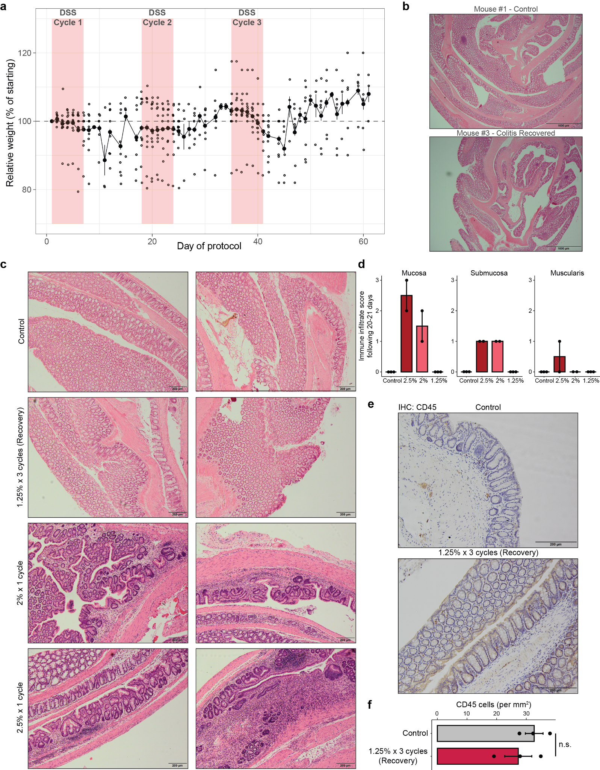
Extended Data Figure 1. Tissue and organismal recovery following colitis. a, Mouse weights, normalized to day 1 weight, through chronic colitis and recovery. Each point represents an animal. b, Colon swiss rolls of mice 21 days following three cycles of 1.25% DSS (Recovery timepoint) and healthy controls. Scale bars 1 mm. c, Representative images of distal colon immune infiltration in healthy controls, 21 days following three cycles of 1.25% DSS, 20 days following one cycle of 2% DSS, and 20 days following one cycle of 2.5% DSS. Scale bars 200 μm. d, Colitis grading of distal colon immune infiltration per Remke et al.⁷⁴ Each point represents tissue from one animal. e, Representative images of CD45 immunohistochemistry in the distal colon 21 days following three cycles of 1.25% DSS. f, Quantification of CD45 cell density in the mucosa and submucosa of the distal colon at 21 days of recovery.
All error bars are s.e.m. (*) p < 0.05, (**) p < 0.01, (***) p < 0.001
⁷⁴
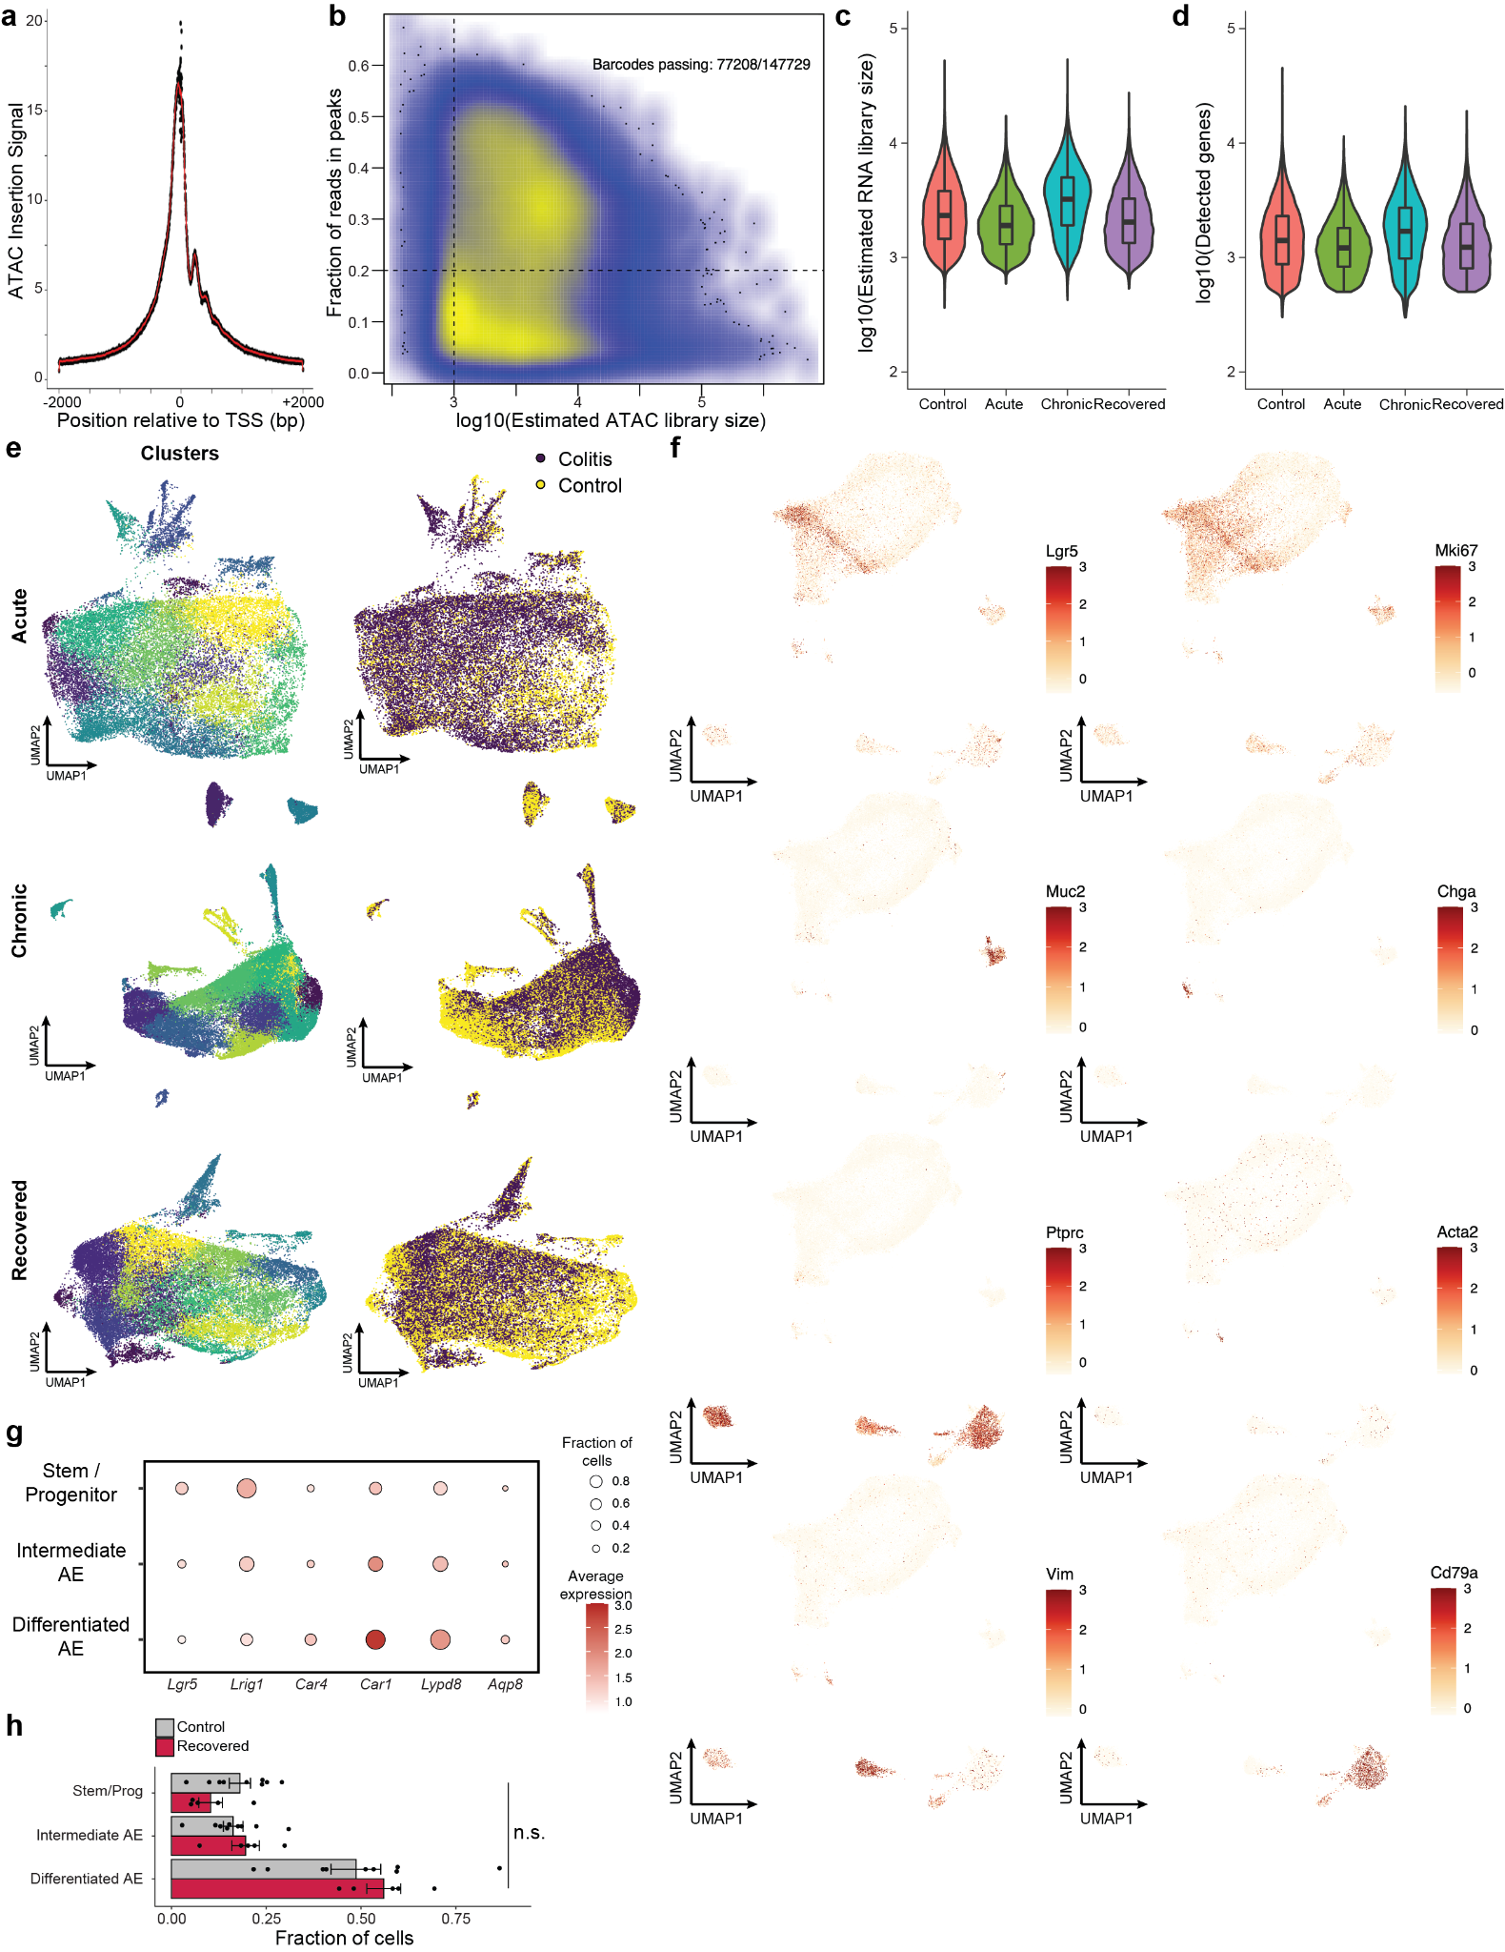
Extended Data Figure 2. Quality control and identification of cell types. a, TSS enrichment of scATAC-seq data. The x-axis represents distance from the center of all transcription start sites and the y-axis shows signal normalized to -2 kb. b, Density plot of library size vs FRIP for all scATAC-seq barcodes. Barcodes passing filter indicate number before matching with scRNA-seq data. c, Estimated library size per cell by sample for scRNA-seq data. d, Number of unique genes detected per cell for scRNA-seq data. e, UMAP embedding of scRNA-seq data per timepoint. Each colitis sample is co-embedded with its corresponding batch controls. Left, cells colored by clusters called. Right, cells colored by sample condition. f, Key marker gene expression shown on scATAC-seq UMAP embedding. Relative expression was computed for each gene independently. g, Marker gene expression for each cell type identified within the absorptive lineage. For each gene, the size of the circle indicates the fraction of cells in which at least one transcript was detected and the color of the circle indicates average expression within the cell type. h, Absorptive epithelial cell type distribution between colitis recovered and control mice. Each circle represents one animal.
All error bars are s.e.m. For box-whisker plots, the center line represents median, the box upper and lower quartiles and the whiskers 1.5 x IQR.

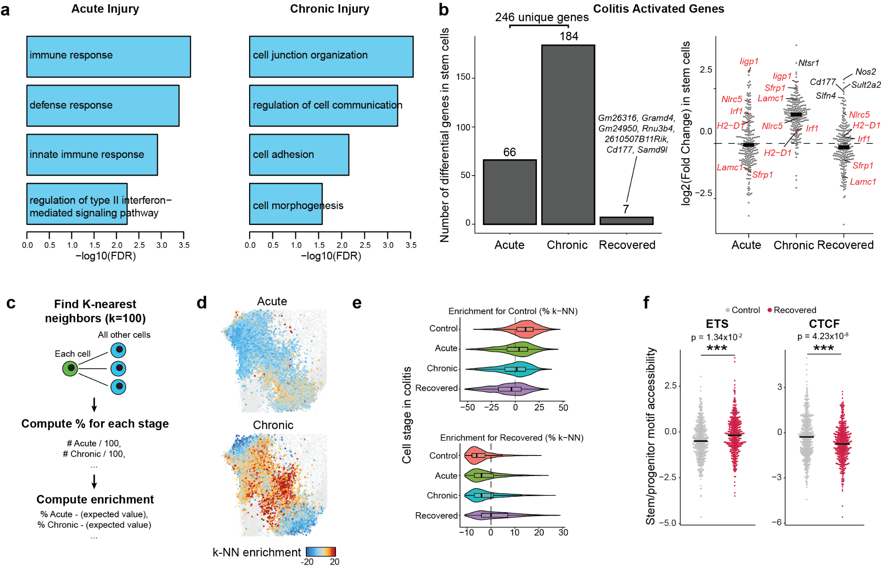
Extended Data Figure 3. Cellular memory following chronic colitis. a, Gene ontology for genes upregulated in stem cells at acute or chronic injury. B, Change in stem cells for all upregulated genes during acute or chronic injury. Left, number of significant genes relative to controls. Right, fold change relative to controls where each point represents a gene. c, Schematic for computing neighborhood enrichment by sample. d, UMAP embedding showing enrichment for each colitis stage in k-NN networks, with each point representing a single cell colored by the enrichment of its k-NN network for a given stage. e, k-NN stage enrichment for all stem cells. The y-axis represents the stage of colitis from which the cell was acquired and the x-axis represents the enrichment of either control or recovered k-NN. f, Single cell motif accessibility for select motif families. Each point represents a single stem cell. For box-whisker plots, the center line represents median, the box upper and lower quartiles and the whiskers 1.5 x IQR.

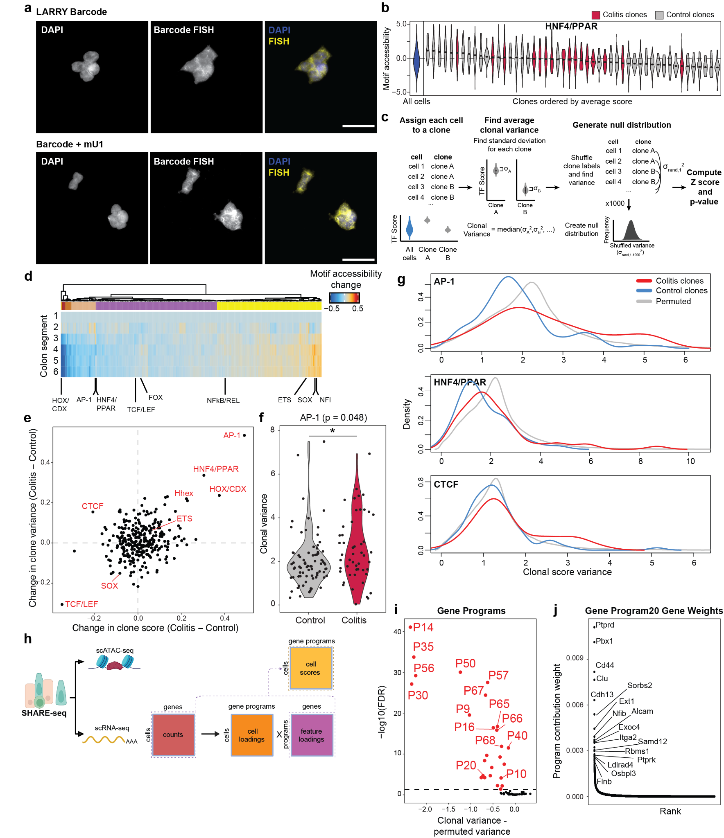
Extended Data Figure 4. Clonal inheritance of epigenetic states. a, Fluorescent in situ hybridization for clonal barcode transcripts in HEK293T cells. Top, cells infected with original LARRY barcode from Weinreb et al.⁴² Bottom, cells infected with LARRY barcode modified by addition of mU1 hairpin sequence. Scale bar 50 μm. b, Distribution of motif accessibility in representative organoid clones for HNF4/PPAR. The y-axis represents motif score and x-axis shows clones ranked by average score. c, Framework for computing clonal variance and identifying clonal features. d, Accessibility of all TF motif families relative to position in the colon. Segment 1 is colon adjacent to cecum and segment 6 is adjacent to rectum. e, Change in clonal signal and variability of TF motif accessibility between control and colitis organoids. The x-axis represents the difference between average motif score across clones and the y-axis the difference between average motif variance across clones. f, Distribution of AP-1 motif score variance in clones. Each point represents a single clone. g, Distribution of motif score variance in clones as compared to random permutation of clonal identity. h, Schematic for deriving gene expression programs. i, Clonal memory of gene programs. j, Individual gene contribution weights to program 20.
(*) p < 0.05, (**) p < 0.01, (***) p < 0.001

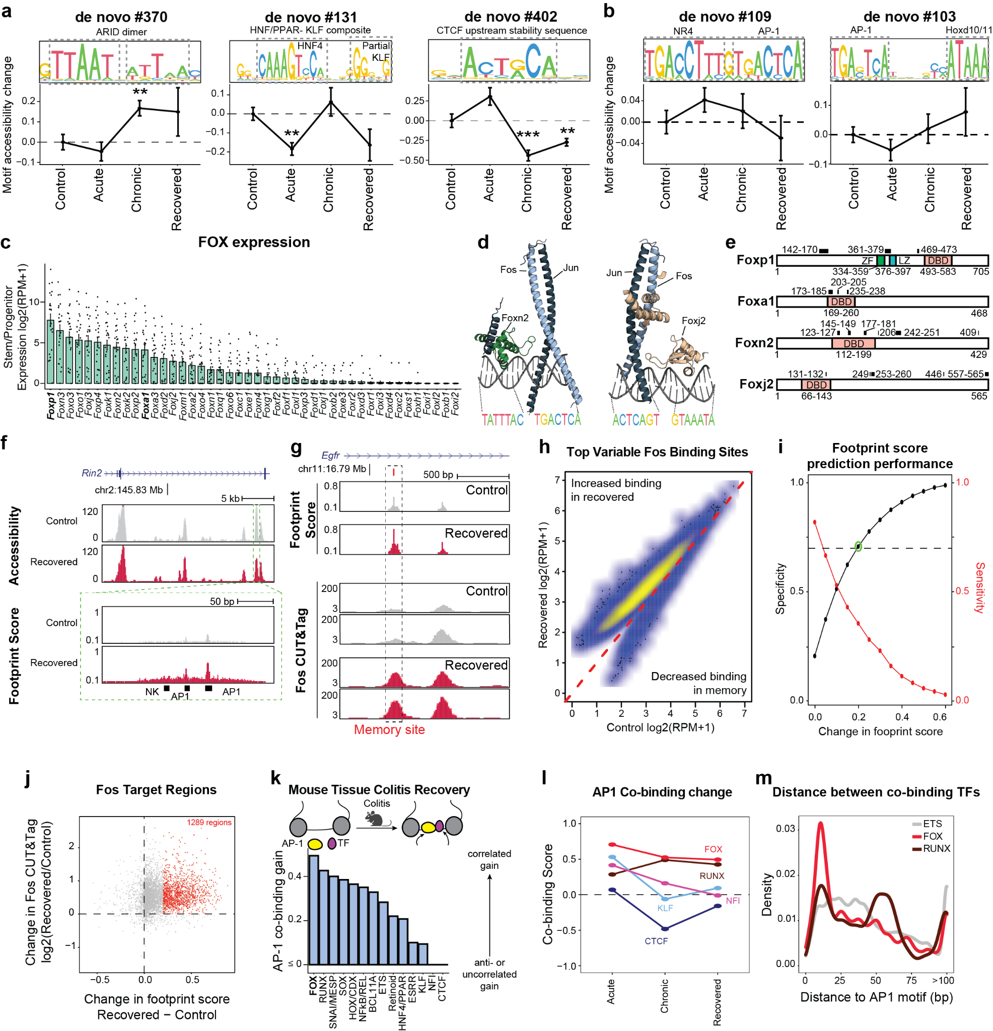Extended Data Figure 5. Transcription factor networks in colitis memory. a, Examples of de novo derived motifs. The y-axis on motif sequences show information content. Line plots show change in motif accessibility in stem cells through colitis progression. Each point represents average accessibility in stem cells across all animals. b, AP-1 compositie motifs. c, Gene expression of FOX family transcription factors in all stem cells in primary tissue. Each point represents RPM value after pseudobulking by mouse. d, AlphaFold predicted structures for Fos-Jun dimer, composite motif and either Foxn2 or Foxj2. e, UniProt domain annotation for Foxa1 and Foxp1 with black boxes indicating regions predicted to interact with AP-1. Numbers indicate amino acid positions. DBD = DNA binding domain, ZF = Zinc finger, LZ = Leucine zipper. f, Genome tracks showing high resolution footprinting in epithelial cells. Horizontal position represents genomic location and vertical height represents either ATAC-seq accessibility (top) or footprint score (bottom). g, Genome tracks of a Fos memory site showing footprint score and respective Fos CUT&Tag. h, Fos CUT&Tag signal in control and recovered tissue at the top 10,000 variable sites following normalization to read depth. i, Differential footprint score performance in predicting CUT&Tag signal. The x-axis represents varying thresholds for difference in AP-1 footprint score andb the y-axis shows sensitivity and specificity for detecting Fos CUT&Tag signal difference between control and recovered tissue. j, Comparison of AP-1 footprint score difference and Fos CUT&Tag signal difference at all identified Fos binding sites. Red points represent sites called as different by footprint score difference of 0.2. k, Co-binding scores with AP-1 factors in primary epithelial tissue following colitis recovery. l, TF family co-binding change across colitis progression. m, Distance from each TF family memory footprint to the nearest AP-1 memory footprint.
All error bars are s.e.m. (*) p < 0.05, (**) p < 0.01, (***) p < 0.001

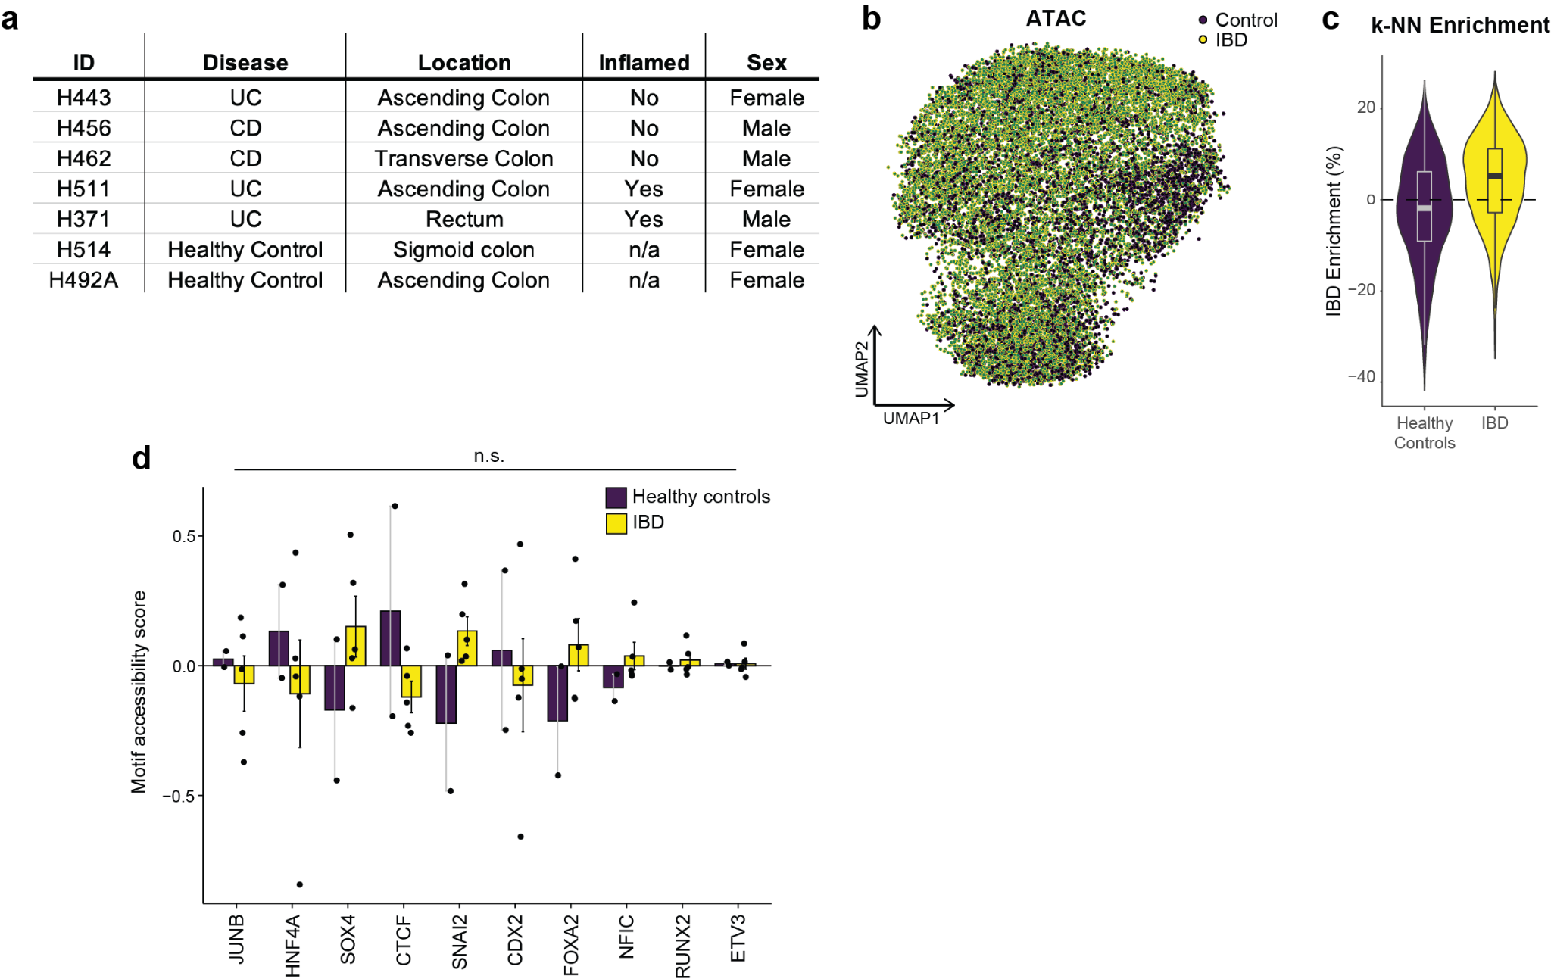Extended Data Figure 6. SHARE-seq in organoids derived from inflammatory bowel disease patients. a, Clinical information for each patient-derived organoid line b, UMAP embedding of scATAC-seq data colored by patient disease state. c, Distribution of k-NN network enrichment for IBD cells. d, Motif memory in patient-derived organoids. Each point represents the average motif score per organoid line.
All error bars are s.e.m. For box-whisker plots, the center line represents median, the box upper and lower quartiles and the whiskers 1.5 x IQR.

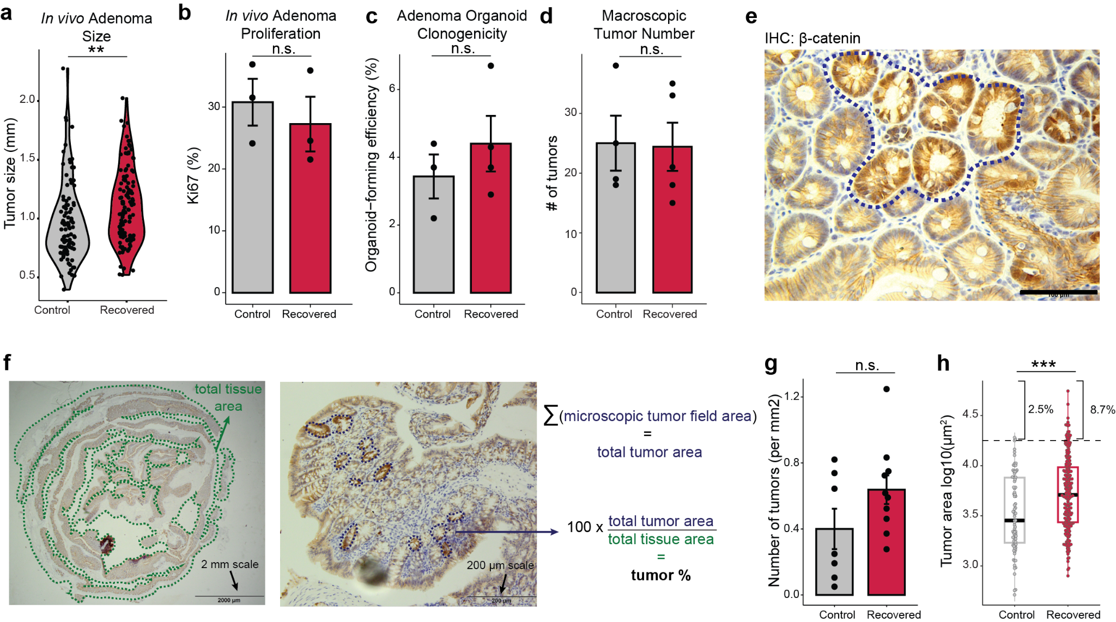
Extended Data Figure 7. Features of adenoma following colitis. a, Distribution of macroscopic adenoma size between control and colitis recovered animals. Each point represents a single tumor. b, Proliferation in adenomas following high dose tamoxifen induction (50 mg/kg x 3). Each point represents a mouse. c, Clonogenicity in adenoma-derived organoid lines. Each point represents an organoid line. d, Visible adenoma number following high dose tamoxifen induction. Each point represents a mouse. e, Representative example of microscopic tumor following low dose tamoxifen induction (10 mg/kg x 1). Scale bar 100 μm. f, Method for computing tumor area. Left, low magnification image used to compute total tissue area. Middle, high magnification image where individual tumors are individually traced. Right, equation for computing percent tumor area. g, Microscopic tumor number normalized to total tissue area. Each point represents a mouse. h, Area of individual tumors. Each point represents a tumor.
All error bars are s.e.m. (*) p < 0.05, (**) p < 0.01, (***) p < 0.001. For box-whisker plots, the center line represents median, the box upper and lower quartiles and the whiskers 1.5 x IQR.

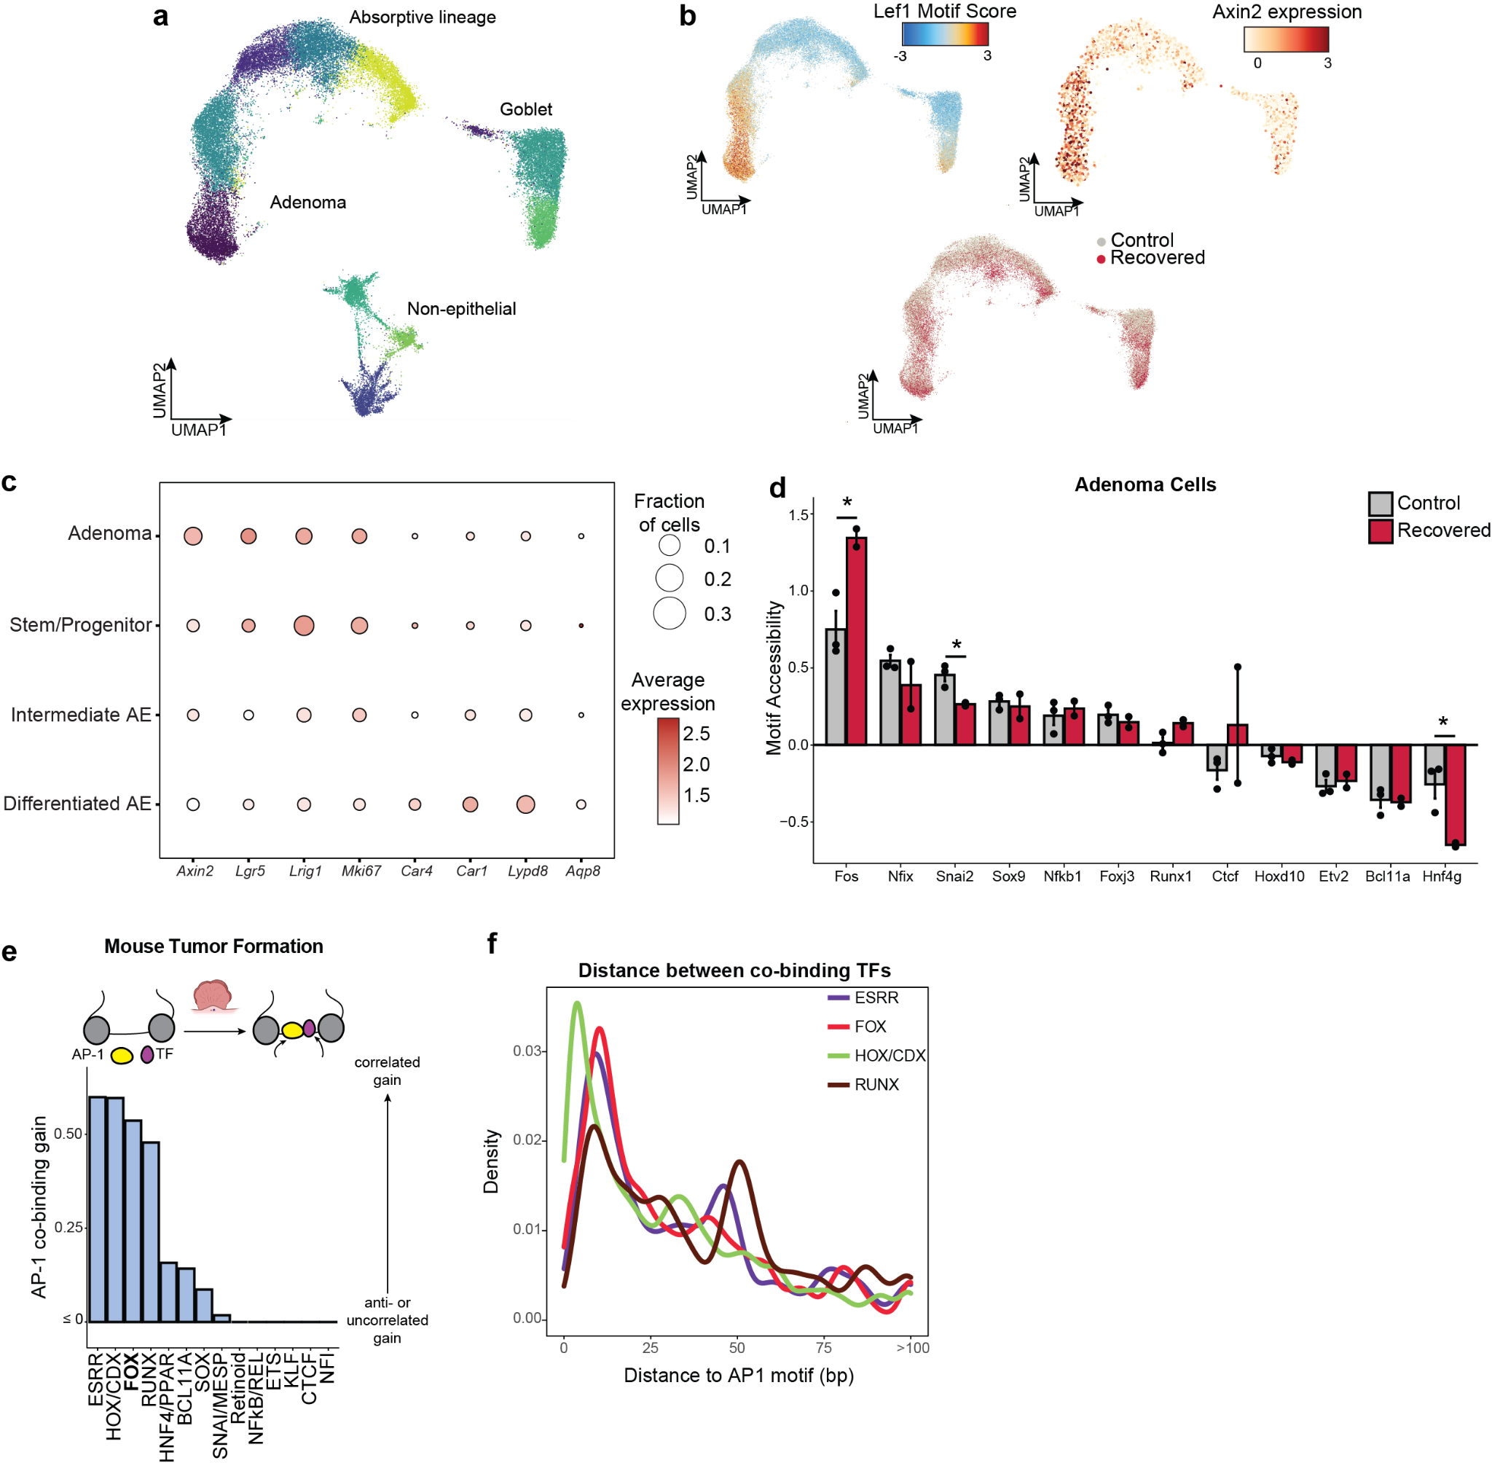
Extended Data Figure 8. SHARE-seq in colitis recovered adenomas. a, UMAP embedding of scATAC-seq data of primary tissue following adenoma induction with cells colored by cluster. b, UMAP embeddings showing Lef1 motif accessibility (top left), Axin2 relative gene expression (top right), and sample condition (bottom). c, Marker gene expression for each epithelial cell type identified. For each gene, the size of the circle indicates the fraction of cells in which at least one transcript was detected and the color indicates average expression within the cell type. d, Transcription factor memory following transformation. Each point represents the average motif score in adenoma cells in an animal. e, Co-binding scores with AP-1 factors in primary adenoma cells. f, Distance from each TF family colitis-associated footprint to the nearest AP-1 colitis-associated footprint in the same regulatory element.
All error bars are s.e.m. (*) p < 0.05, (**) p < 0.01, (***) p < 0.001
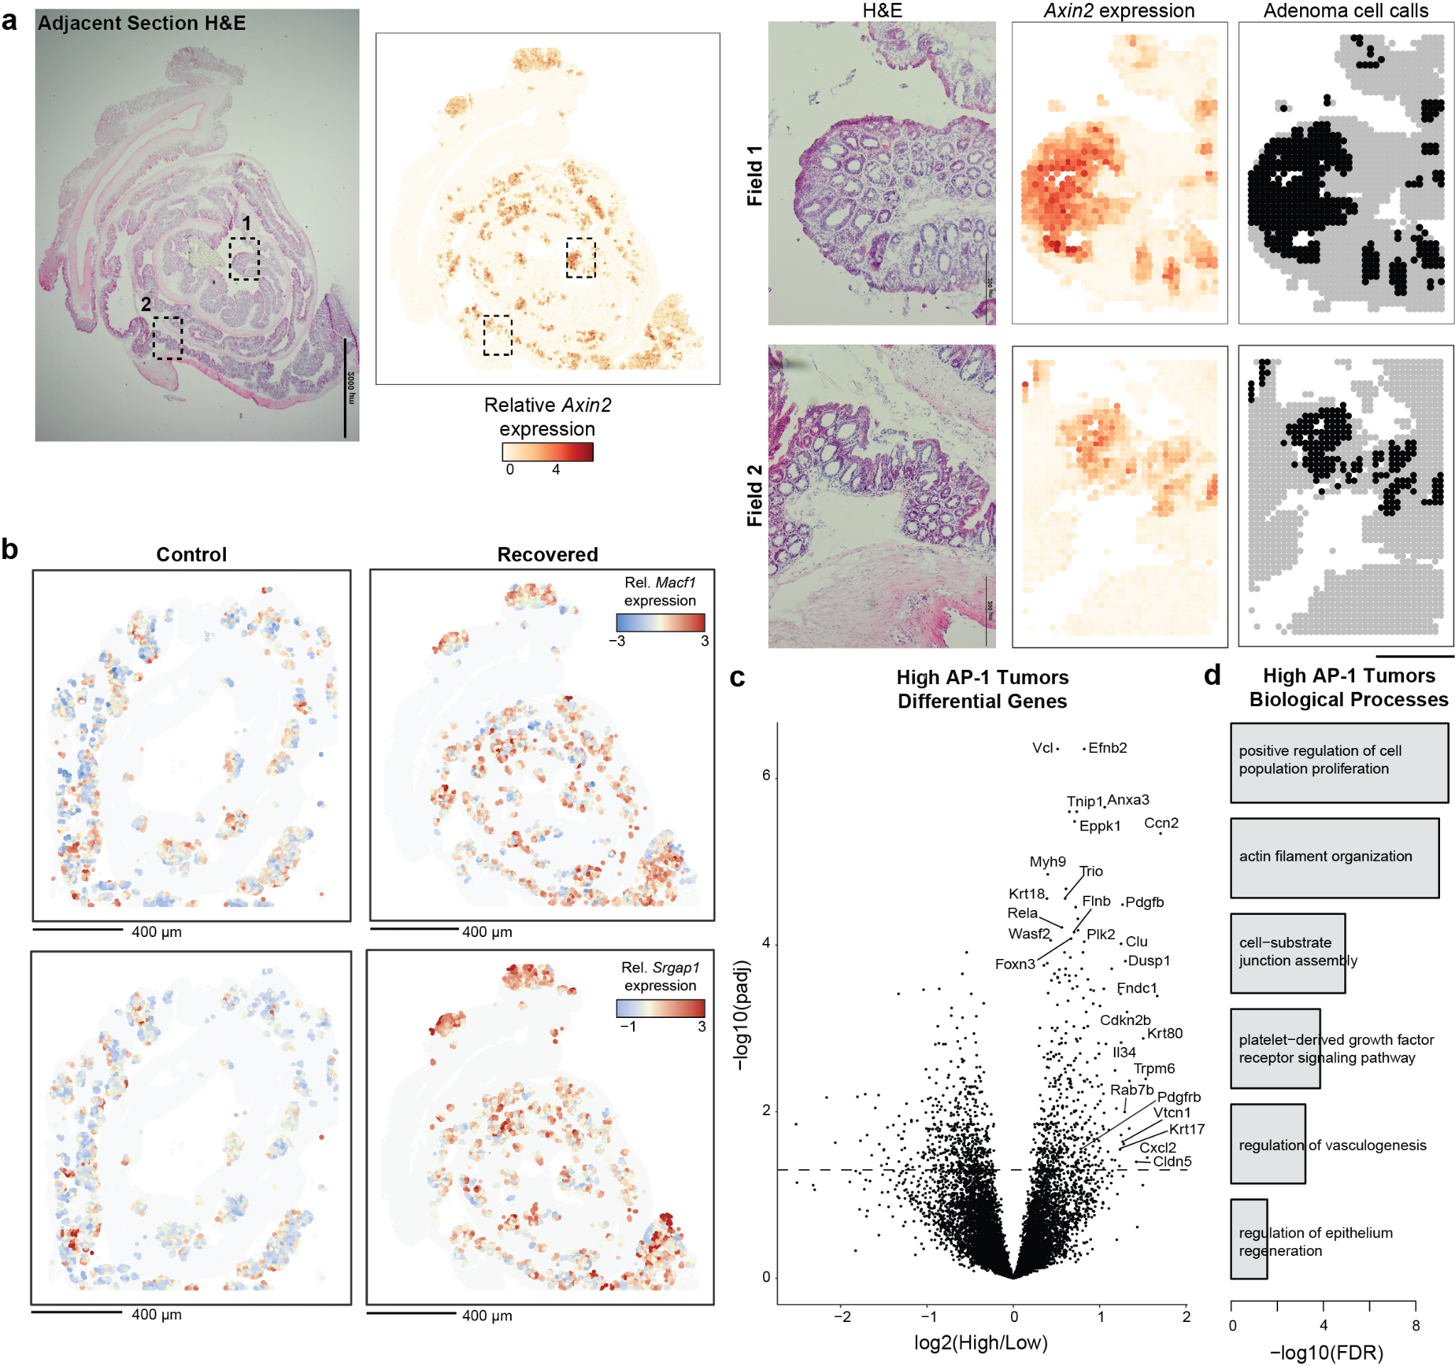
Extended Data Figure 9. Spatial transcriptomics of adenomas. a, Axin2 based tumor cell calls. Left, H&E of adjacent section. Scale bar 2 mm. Middle, spatial expression of Axin2. Right, boxed regions showing alignment of H&E morphology, Axin2 expression and individual tumor cell calls. Scale bar 50 μm. b, Spatial expression of AP-1 associated genes in identified tumor cells. Scale bars 400 μm. c, Differential gene expression between tumors with high AP-1 associated gene expression (score > 3) and tumors with low expression. d, Biological processes associated with genes upregulated in high AP-1 tumors.

