Extended Data Figures

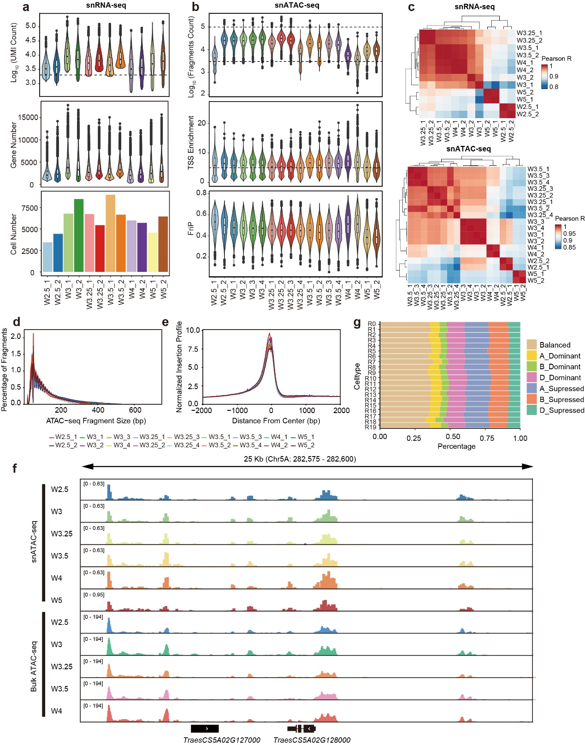

Extended Data Fig. 1 | Data quality assessment of snRNA-seq and snATAC-seq
a Quality metrics of snRNA-seq data, showing the distribution of UMI counts, the number of expressed genes, and the number of cells in each library. The dashed line indicates the filtering criteria.
b Quality metrics of snATAC-seq data, displaying the distribution of UMI count, transcription start site (TSS) enrichment, and fraction of reads in peaks (FriP) for each library. The dashed line indicates the filtering criteria.
c Heatmap of Pearson correlation coefficients for snRNA-seq and snATAC-seq libraries, assessing data consistency.
d Fragment size distributions for each snATAC-seq library, indicating chromatin accessibility patterns.
e Normalized fragment count profiles around TSS for each snATAC-seq library.
f Chromatin accessibility dynamics during wheat inflorescence development, as assessed by snATAC-seq and bulk ATAC-seq data ²⁶.
g Proportion of triads classified by homoeolog expression bias across snRNA-seq cell types. “Balance” denotes similar expression levels across the A, B, and D subgenomes. “A_Dominant” indicates higher gene expression in the A subgenome compared to its B and D homoeologs, while “A_supressed” indicates lower expression in the A subgenome relative to the others.

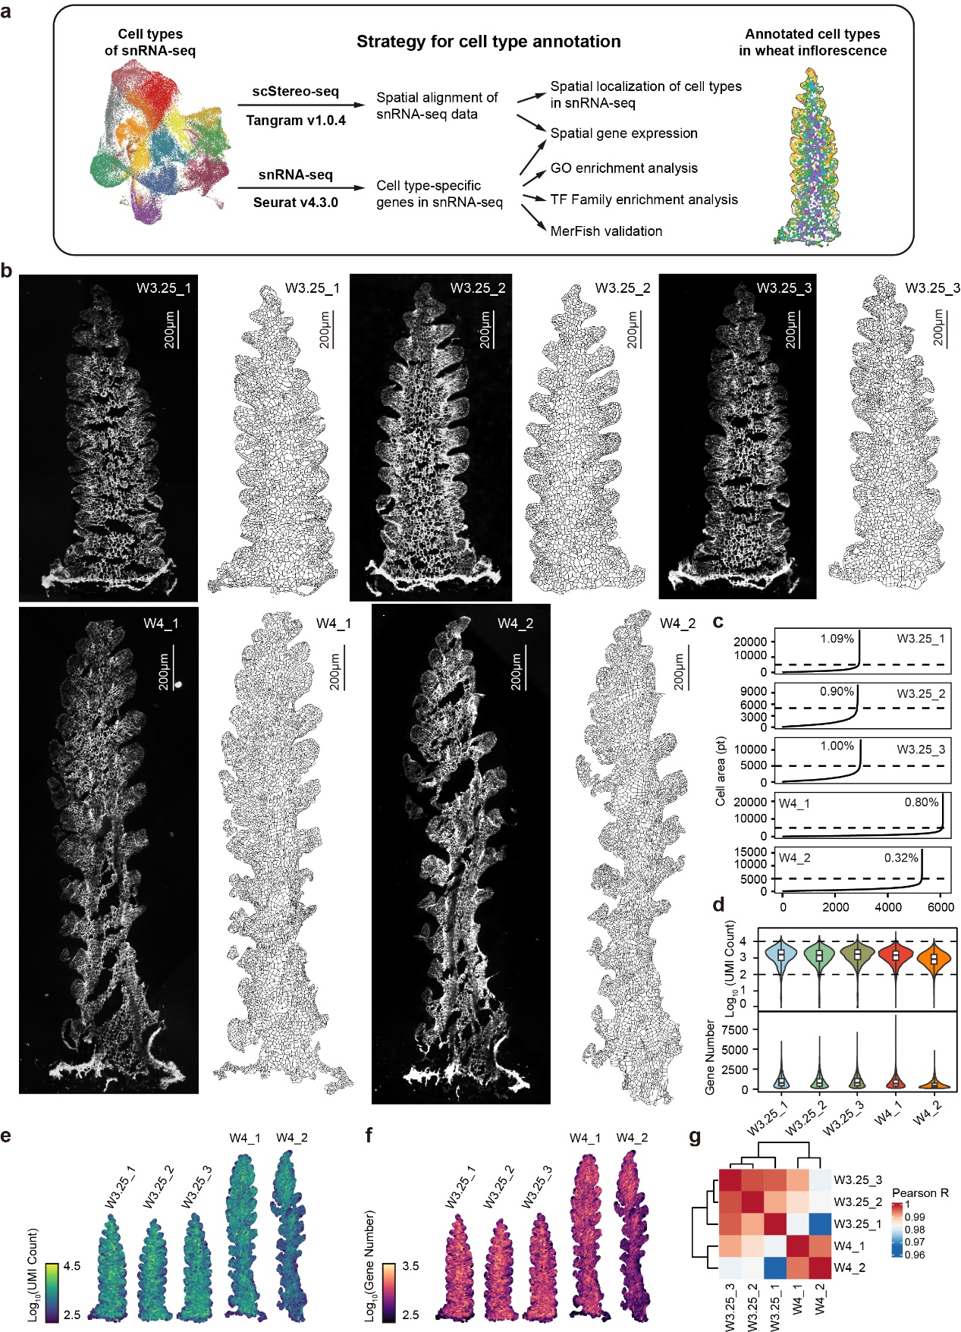

Extended Data Fig. 2 | Data quality assessment of scStereo-seq
a Schematic diagram illustrating the strategy for annotation of cell types classified from snRNA-seq using scStereo-seq in wheat inflorescence.
b Cell wall staining images for each sample analyzed in scStereo-seq.
c Distribution of cell area across samples, with the dashed line indicating the 5,000 pt threshold. The percentage indicates the proportion of cells exceeding this size.
d Distribution of UMI counts and the number of detected genes for each scStereo-seq sample.
e, f Spatial distribution of UMI counts (e) and the number of detected genes (f) across scStereo-seq samples.
g Heatmap showing the Pearson correlation between scStereo-seq samples, assessing data consistency.

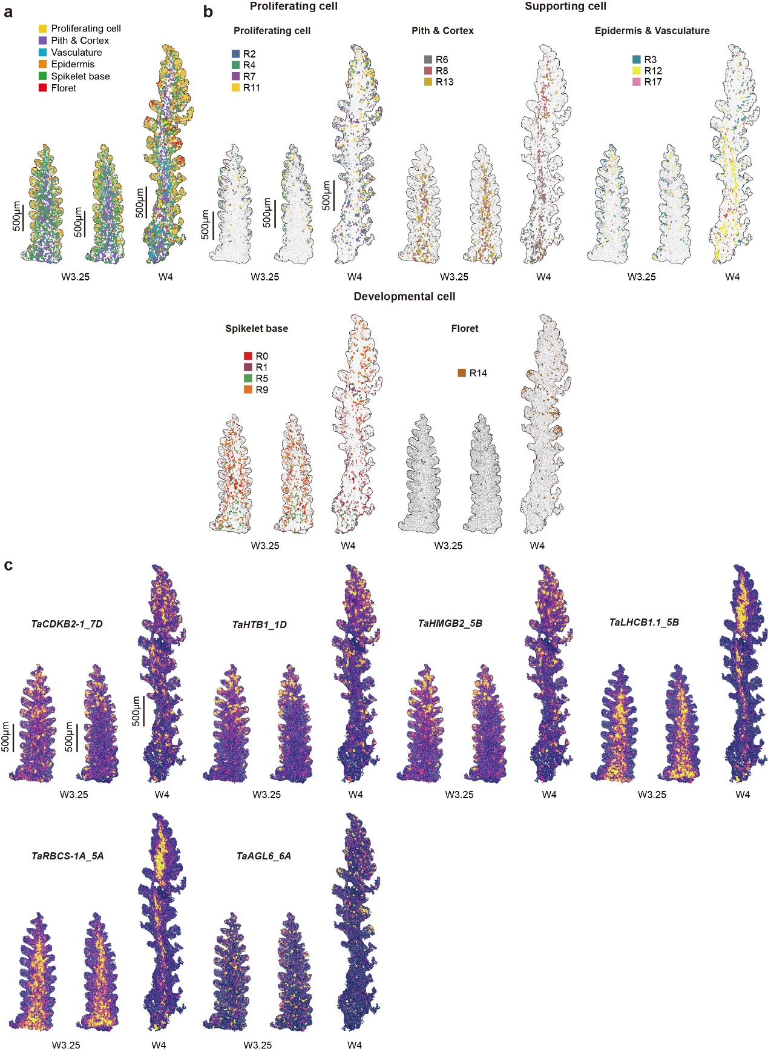

Extended Data Fig. 3 | Spatial distribution of snRNA-seq data mapped onto scStereo-seq data
a Spatial map of cell types in wheat inflorescence.
b Spatial distribution of cell types defined by snRNA-seq, mapped onto scStereo-seq data.
c Spatial expression patterns of cell type-specific genes by mapping the snRNA-seq data onto scStereo-seq data.

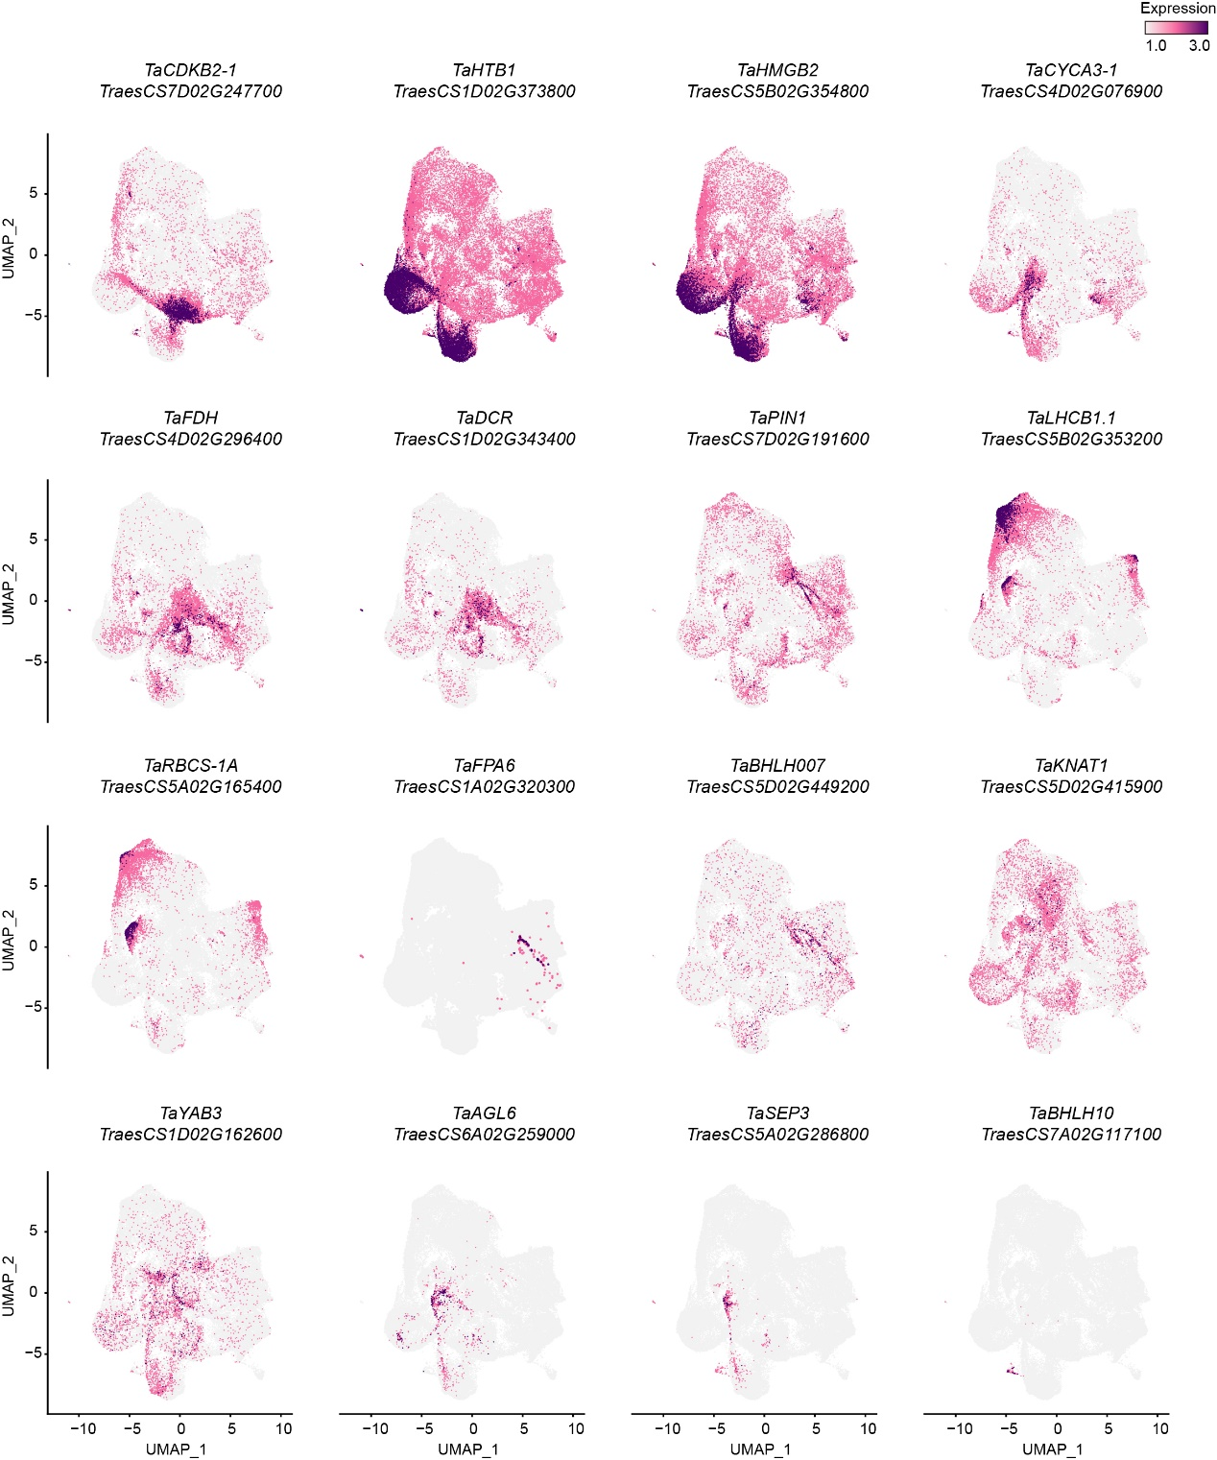

Extended Data Fig. 4 | Expression profiles of cell type-specific genes in snRNA-seq

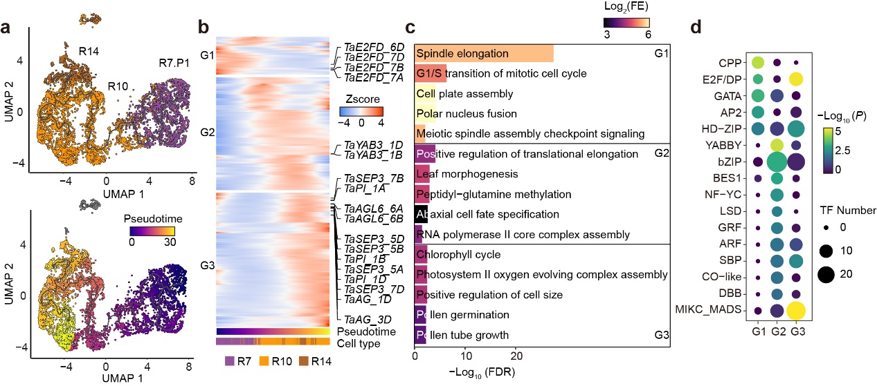

Extended Data Fig. 5 | Trajectory inference for wheat floret formation
a Trajectory inference and pseudotime analysis of cells belonging to R7, R10, and R14 in partition1.
b Heatmap showing the clustering results of genes whose expression changes across pseudotime during floret formation.
c GO enrichment analysis of genes in different clusters during floret formation (two-sided Fisher’s exact test, FDR for multiple testing, FDR < 0.05). FE: fold enrichment.
d TF family enrichment of genes in different clusters during floret formation (two-sided Fisher’s exact test, P < 0.01).

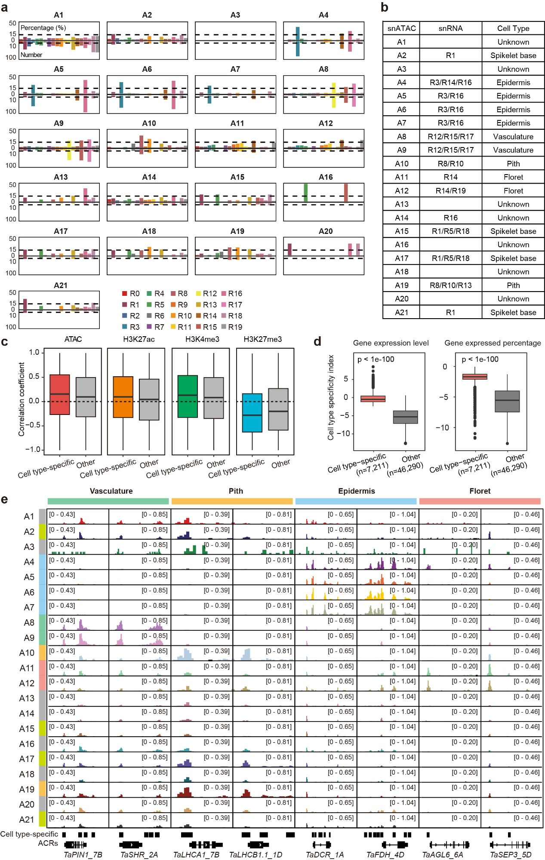

Extended Data Fig. 6 | Correspondence between snRNA-seq and snATAC-seq
a Proportion of cell type-specific genes in snATAC-seq among the cell type-specific genes of each cell type in snRNA-seq. The dashed line represents the thresholds, with gene proportion ≥ 15% and gene counts ≥ 10.
b Correspondence between snATAC-seq and snRNA-seq cell types.
c Pearson correlation coefficient between gene expression and changes in chromatin accessibility, histone modification of snRNA-seq cell type-specific genes, and other genes. Data on gene expression, chromatin accessibility, and histone modification are from published bulk data of wheat spike ²⁶.
d Cell type specificity index defined by gene expression values (left) and the proportion of cells expressing the gene (right) (two-sided Wilcoxon test).
e Chromatin accessibility profiles of several cell type-specific genes across snATAC-seq cell types. Cell type annotations are shown on the left, and the color code is shown in Fig. 3a.

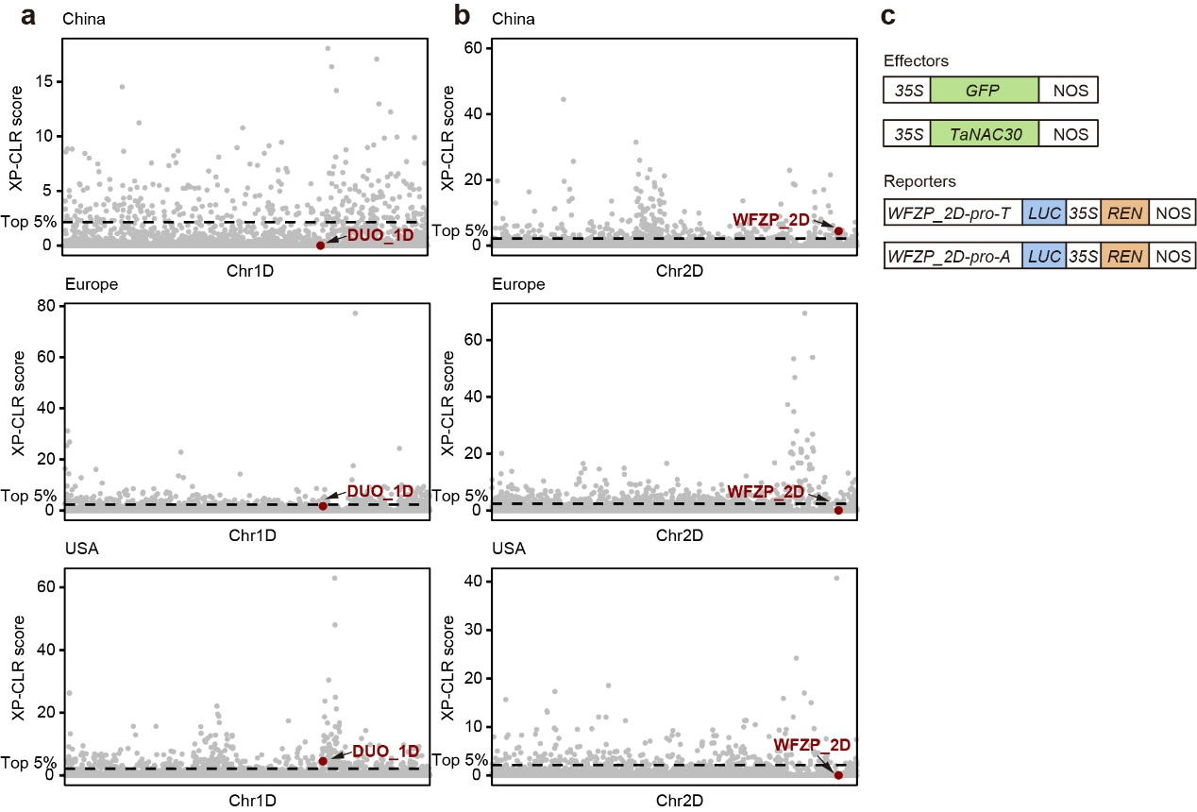

Extended Data Fig. 7 | Profiling of selective regions during modern wheat breeding
a, b Selective regions during wheat breeding processes in China, Europe, and USA on the chromosome 1D (a), and 2D (b). The dashed lines indicate the cutoffs of the top 5% of XP-CLR score.
c Vector designs in the luciferase reporter assays. GFP: green fluorescent protein; NOS: nopaline synthase terminator; REN: renilla luciferase

Supplementary tables

Table S1 Metadata of cells in snRNA-seq.

Table S2 Metadata of cells in snATAC-seq.

Table S3 Cell type-specific genes identified in snRNA-seq.

Table S4 Cell type-specific genes identified in snATAC-seq.

Table S5 Metadata of cells in scStereo-seq.

Table S6 TF family enrichment results of cell type-specific genes in snRNA-seq.

Table S7 GO enrichment results of cell type-specific genes in snRNA-seq.

Table S8 Partition results of cells in snRNA-seq.

Table S9 Differentially expressed genes between R7.P4 and R7.P1.

Table S10 Pseudotime analysis results of cells belonging to R7, R5, and R15 in partition4.

Table S11 Pseudotime analysis results of cells belonging to R7, R10, and R14 in partition1.

Table S12 Clustering analysis results of genes whose expression change across pseudotime of spikelet formation.

Table S13 Clustering analysis results of genes whose expression change across pseudotime of floret formation.

Table S14 Gene expression levels and proportion of cells expressing each gene in snRNA-seq.

Table S15 Chromatin accessibility of genes and proportion of cells with open chromatin in snATAC-seq.

Table S16 The cell type specificity index of all expressed genes.

Table S17 Clustering analysis results of proximal cell type-specific ACRs identified in snATAC-seq.

Table S18 Enrichment of TF binding motifs within cell types-specific ACRs.

Table S19 Cell type-specific TRN for spikelet formation.

Table S20 Cell type-specific TRN for floret formation.

Table S21 Association analysis between sequence variations within cTRN genes and SNS.

Table S22 Annotation of ACRs identified in snATAC-seq.

Table S23 Cell type-specific ACRs identified in snATAC-seq.

Table S24 Reported GWAS loci associated with wheat spike-related traits.

Table S25 Association analysis between sequence variations within cell type-specific ACRs and SNS.

Table S26 Primers used in this study.

