Extended Data Figures and Tables

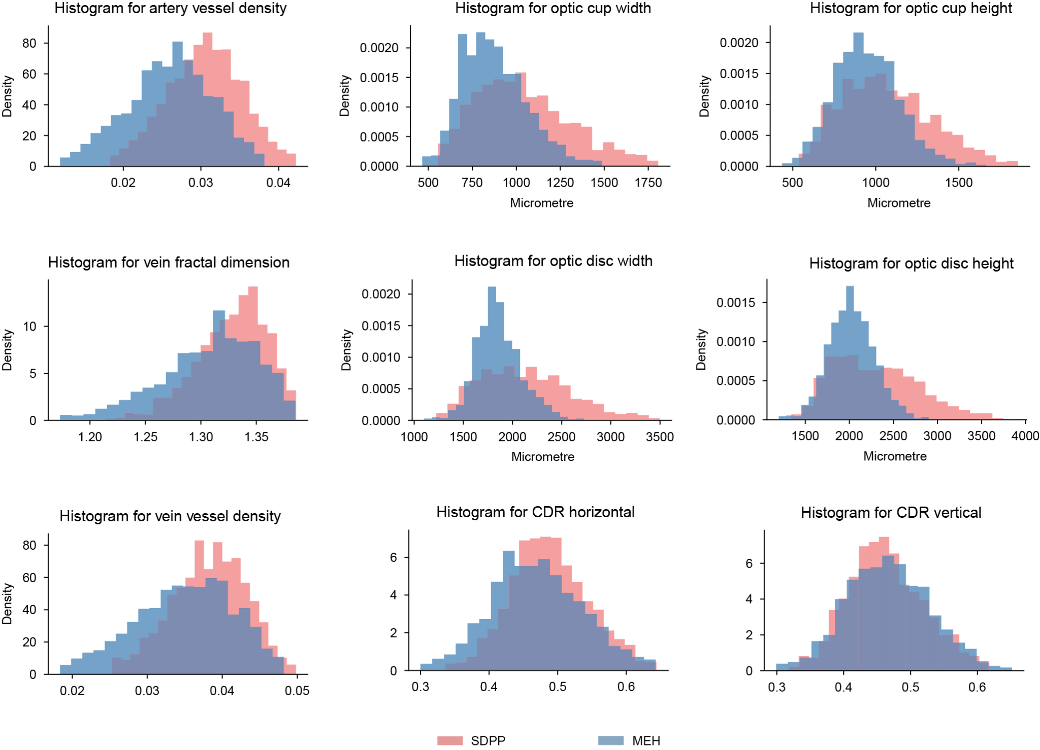
Extended Data Figure 1. Extra clinical meaningful morphological indices of MEH and SDPP data (5000 randomly sampled data points), obtained with AutoMorph. These demonstrate the distinct distribution of data from Moorfields Eye Hospital and SDPP. CDR indicates the optic cup-to-disc ratio. CDR horizontal calculates the ratio of width between the optic cup to the disc while CDR vertical for height ratio.

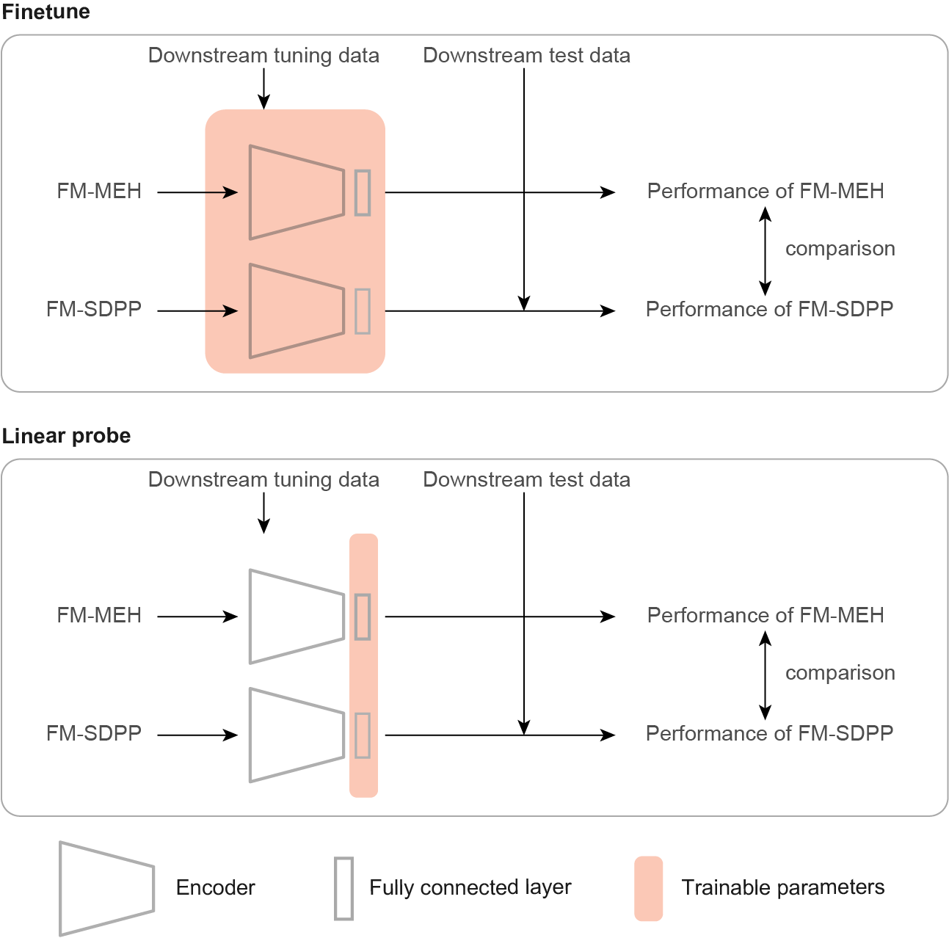
Extended Data Figure 2. Schematic diagram of foundation model adaptations to downstream tasks. Fine-tuning tunes the encoder and fully connected layer using downstream fine-tuning data. Linear probe tunes the fully connected layer only. The performances of FM-MEH and FM-SDPP on downstream test data are compared.

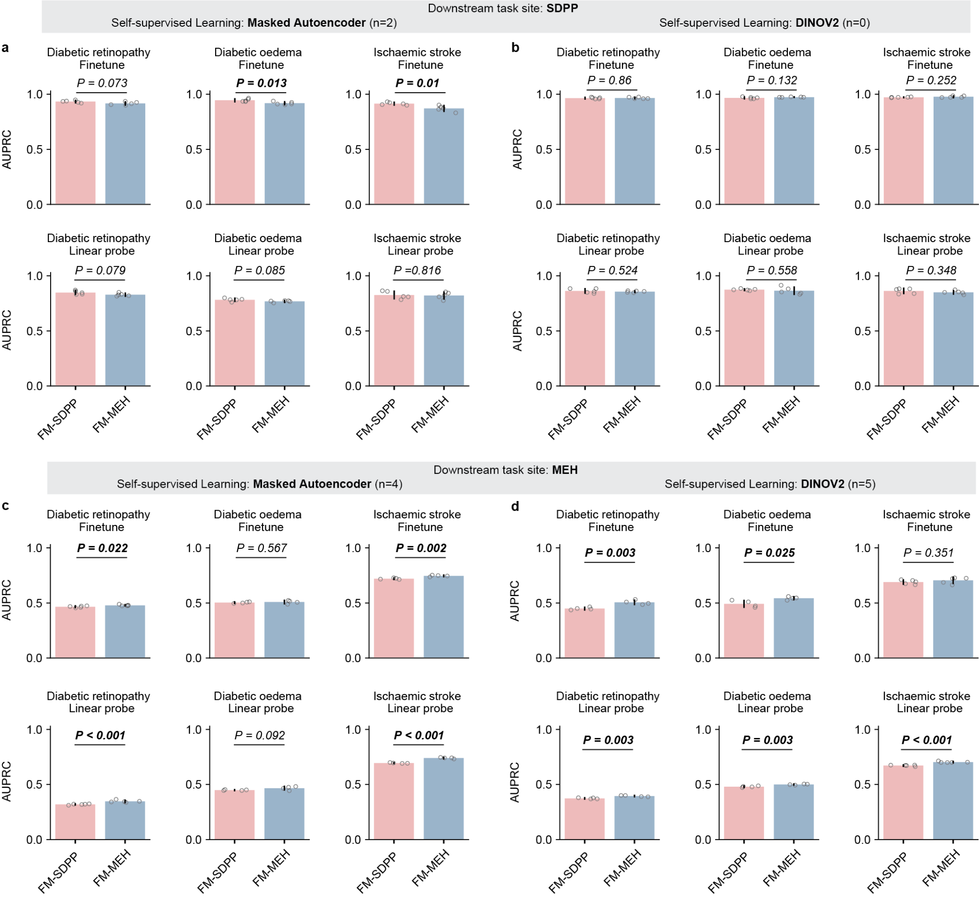
Extended Data Figure 3. AUPRC performance of FM-MEH and FM-SDPP on downstream tasks using data from each site. Subgraphs a and b show the model performance on tasks at the SDPP site, with FMs respectively pre-trained with Masked Autoencoder and DINOV2. Subgraphs c and d present the performance of FMs on tasks at the MEH site. In SDPP downstream tasks, FM-SDPP significantly outperformed FM-MEH on 2 out of 12 evaluations, while FM-MEH achieved superior performance on 9 evaluations when adapted to MEH downstream tasks. For each task, models were fine-tuned with five different random seeds, controlling the shuffling of fine-tuning data, and evaluated on the test set to generate five replicates. The mean AUPRC values are represented by bar centres, with error bars indicating 95% CI. A two-sided t-test was used to assess whether the performance differences between FM-SDPP and FM-MEH were statistically significant, with p-values listed in the figure. Bolded p-values indicate significant differences (p<0.05). n indicates the number of cases showing significant differences.

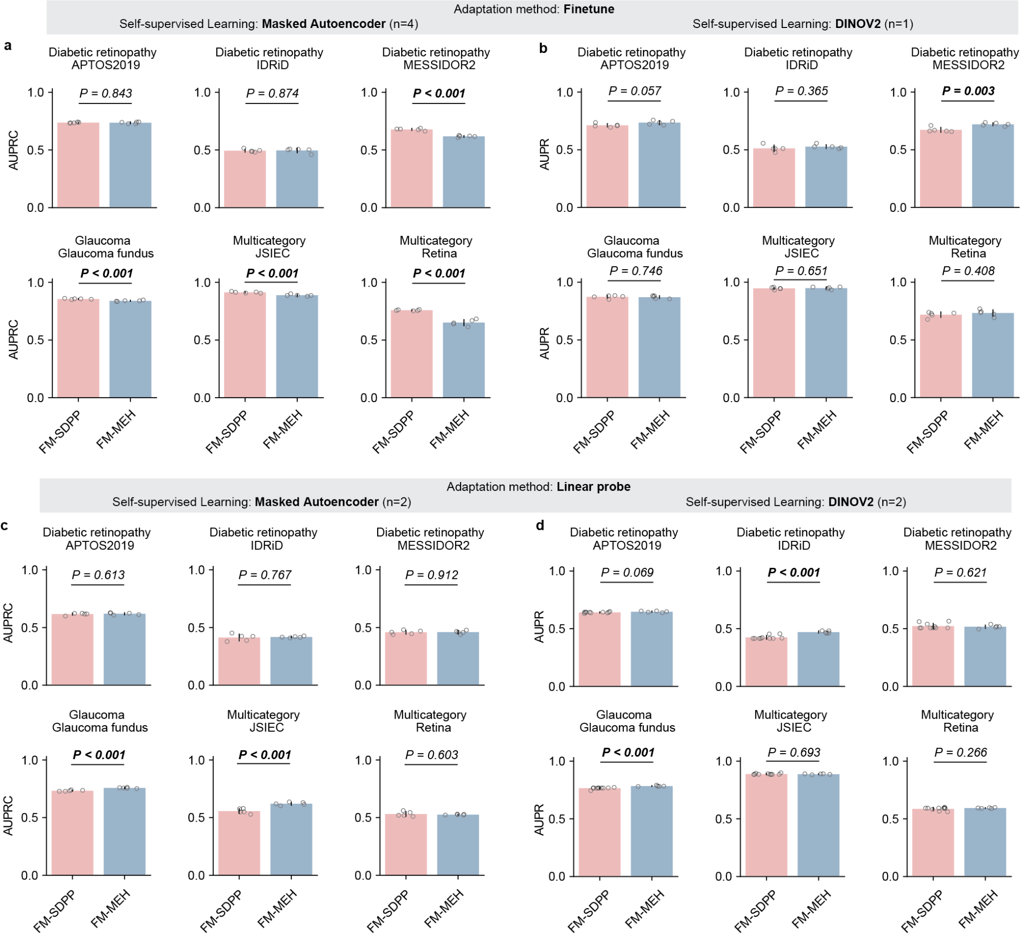
Extended Data Figure 4. AUPRC performance of FM-MEH and FM-SDPP on downstream tasks using publicly available datasets sourced from multiple countries. Subgraphs a and b show the performance of FMs pre-trained respectively with Masked Autoencoder and DINOV2 when fine-tuned to downstream tasks. Subgraphs c and d present the performance of FMs when adapted to downstream tasks with the linear probe. When pre-trained with Masked Autoencoder, FM-SDPP significantly outperformed FM-MEH on four downstream evaluations. When pre-trained with DINOV2, FM-MEH significantly outperformed FM-SDPP on three evaluations. For each task, models were fine-tuned with five different random seeds, controlling the shuffling of fine-tuning data, and evaluated on the test set to generate five replicates. The mean AUROC values are represented by bar centres, with error bars indicating 95% CI. A two-sided t-test was used to assess whether the performance differences between FM-SDPP and FM-MEH were statistically significant, with p-values listed in the figure. Bolded p-values indicate significant differences (p<0.05). n indicates the number of cases showing significant differences.

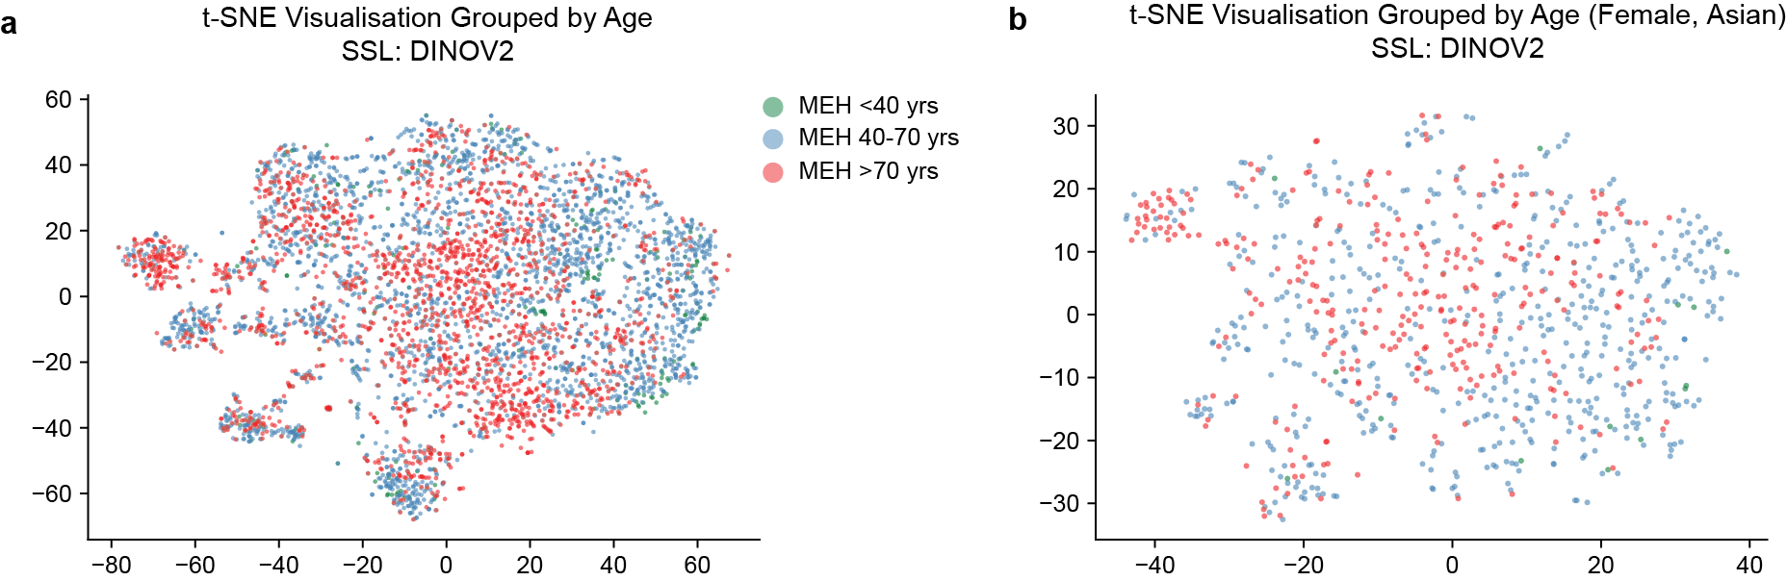
Extended Data Figure 5. Data characteristics of age subgroups. a shows t-SNE visualisation with data features extracted by FM-MEHs pre-trained with DINOV2. b shows t-SNE visualisation after eliminating confounding effects by specifying sex and ethnicity (e.g. Female, Asian or Asian British). The age subgroups still show clear clusterings.

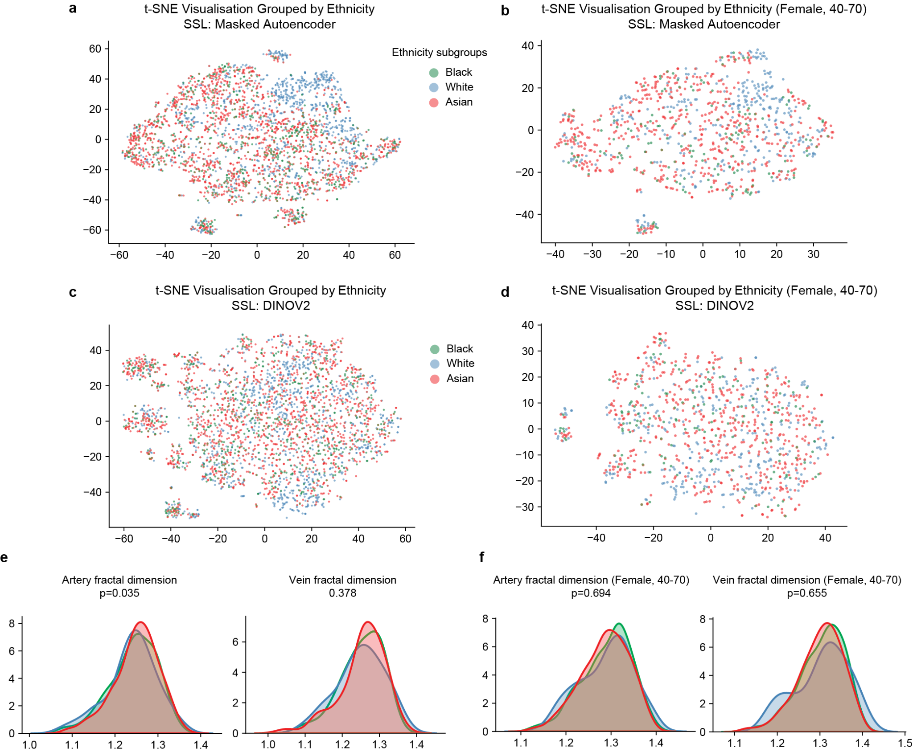
Extended Data Figure 6. Data characteristics of ethnicity subgroups. a and b show t-SNE visualisation with data features extracted by FM-MEHs pre-trained with Masked Autoencoder and DINOV2, respectively. c and d show t-SNE visualisation after eliminating confounding effects by specifying sex and age (e.g. Female, 40-70 years old). The ethnicity subgroups show clusterings only on c. e demonstrates the distribution density of clinically meaningful morphological indices over ethnicity subgroups. f shows the distribution density after specifying sex and age. A Kruskal-Wallis H-test was conducted to assess statistical significance, with p-values listed in the figure. No significant differences have been observed between subgroups in f.

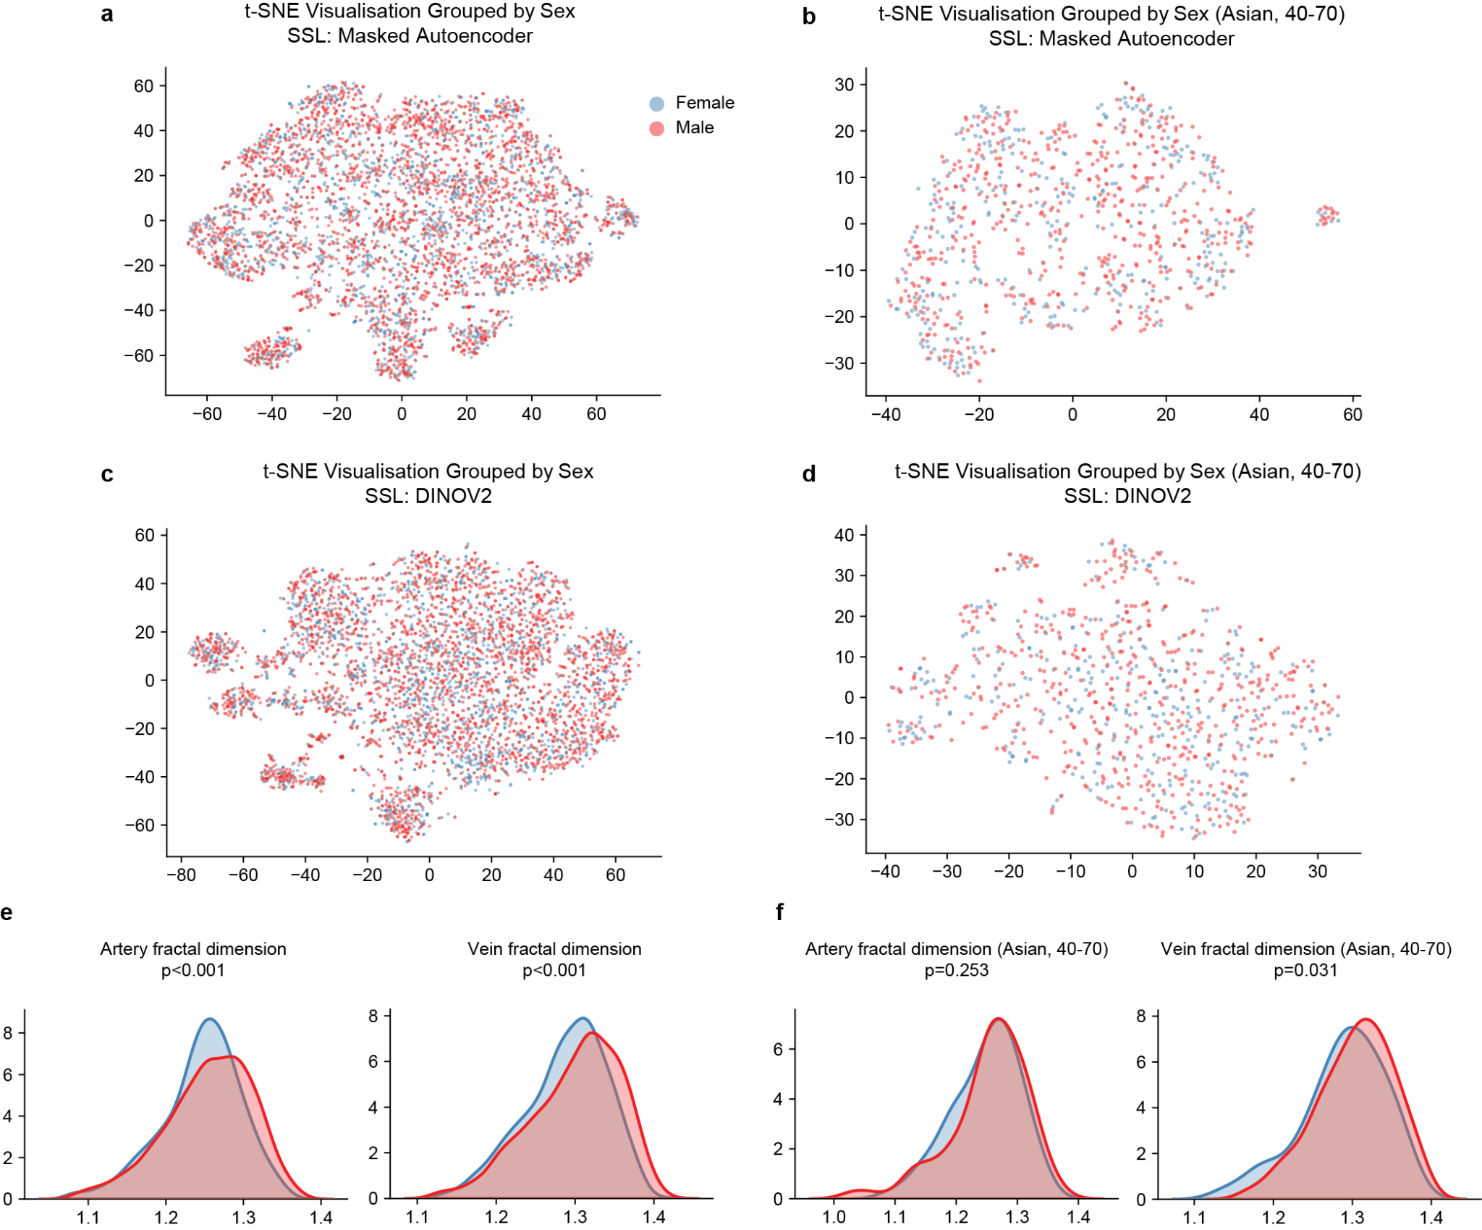
Extended Data Figure 7. Data characteristics of sex subgroups. a and b show t-SNE visualisation with data features extracted by FM-MEHs pre-trained with Masked Autoencoder and DINOV2, respectively. c and d show t-SNE visualisation after eliminating confounding effects by specifying ethnicity and age (e.g. Asian, 40-70 years old). The sex subgroups show no distinct clusterings. e demonstrates the distribution density of clinically meaningful morphological indices over sex subgroups. f shows the distribution density after specifying age and ethnicity. A Kruskal-Wallis H-test was conducted to assess statistical significance, with p-values listed in the figure. Significant differences have been observed in the vein fractal dimension between sex subgroups.

