Reactive Oxygen Species (ROS)-responsive nanoprobe for bioimaging and targeted therapy of osteoarthritis
Chong Shen^{1,2}, Ming Gao^{1,3}, Haimin Chen¹, Yanting Zhan^{1,3}, Qiumei Lan¹, Zhimin Li¹, Wei Xiong¹, Zainen Qin^{1,3*}, Li Zheng^{1,3*}, Jinmin Zhao^{1,3,4,5*}
¹Guangxi Engineering Center in Biomedical Materials for Tissue and Organ Regeneration, The First Affiliated Hospital of Guangxi Medical University, Nanning, 530021, China
²Department of Orthopedics, The Affiliated Hospital of Guilin Medical University, No. 15 Lequn RoadGuilin 541001, Guangxi, China
³Guangxi Collaborative Innovation Center for Biomedicine, The First Affiliated Hospital of Guangxi Medical University, Nanning, 530021, China
⁴Department of Orthopaedics Trauma and Hand Surgery, The First Affiliated Hospital of Guangxi Medical University, Nanning, 530021, China
⁵Guangxi Key Laboratory of Regenerative Medicine, International Joint Laboratory on Regeneration of Bone and Soft Tissue, The First Affiliated Hospital of Guangxi, Medical University, Nanning, 530021, China
Co-Corresponding authors: Zainen Qin, Li Zheng, Jinmin Zhao
E-mail addresses: haiminchen05@163.com (Dr. Haimin Chen), zhengli224@163.com (Prof. Li Zheng), and zhaojinmin@126.com (Prof. Jinmin Zhao),
Chong Shen, Ming Gao, Haimin Chen contributed as first authors.

Materials
3-mercaptopropionic acid (98%), 1-ethyl-3-(3-dimethylaminopropyl) carbodiimide hydrochloride (EDC, 97%), N-hydroxysuccinimide (NHS, 98%), N,N-Dimethylformamide (DMF, 98%), 4-dimethylaminopyridine (DMAP), N, N-Diisopropylethylamine (DIPEA, 98%), ethanolamine, 1,6-hexanediol (HDO), tetrahydrofuran (THF), dichloromethane (DCM), Cy5.5-NHS, BHQ3-NHS and Dexamethasone (DEX, 98%) were purchased from Sigma-Aldrich (China). NH₂-PEG-NH₂ with a molecular weight (MW) of 3400 Da (95%), was purchased from Xi’an Ruixi Biological Technology Co., Ltd. (Xi’an, China). Chondrocyte-affinity peptide (CAP, DWRVIIPPRPSA) was purchased from GL Biochem (Shanghai, China). Potassium superoxide (KO₂) was provided by Alfa Aesar.
Synthesis of thioketal containing monomer (TK).
A mixture of anhydrous 3-mercaptopropionic acid (5.2 g, 49.1 mmol) and anhydrous acetone (5.8 g, 98.2 mmol) was saturated with dry hydrogen chloride and stirred at room temperature for 6 h. After the reaction, the flask was placed in an ice salt bath and rapidly cooled until crystallization was completed (Figure S1). Subsequently, the product was filtered and washed with hexanes and cold water for three times to obtain the crude product, which was then purified via HPLC and verified via ¹HNRM (ADVANCE III HD600 600MHz spectrometer, Bruker, Germany). ¹H NMR (600 MHz, DMSO-d⁶) δ:2.74 (t, 4H), 2.50 (t, 4H), 1.53 (s, 6H).
Synthesis of the BHQ3-OH.
The ethanolamine (4 mg) and BHQ3-NHS ester (2 mg) were dissolved in 200 μL of anhydrous DMF, respectively. Then DIPEA (10 μL) was added to the ethanolamine solution and shaken at room temperature for 10 min. After the reaction, the ethanolamine solution was transferred into BHQ3-NHS ester (2 mg) and was stirred at room temperature for 3 h. Finally, the reaction was terminated by adding 10% TFA to obtain the product BHQ3-OH. The synthesized product (BHQ3-OH) was purified by HPLC and verified by ¹H NRM (Figure S2).
Synthesis of Cy5.5-CAP-PEG-NH₂ and Cy5.5-PEG-NH_{2.}
Firstly, the targeting peptide (CAP) was labeled with Cy5.5 to prepare Cy5.5-CAP. The chondrocyte targeting peptide (CAP, 5 mg) and Cy5.5-NHS ester (2 mg) were separately dissolved in 200 μL of anhydrous DMF, then 10 μL of DIPEA was added, respectively, and shaken at room temperature for 10 min. Then, the solution was mixed and was stirred at room temperature in dark for 3 h. After the reaction, the Cy5.5-CAP (36 mg), EDC (2.3 mg) and NHS (2.18 mg) were dissolved in DMF (3 mL) and stirred at room temperature for 0.5 h, then the mixture was transferred into the NH₂-PEG-NH₂ (100 mg) solution and stirred at room temperature for 48 h. The Cy5.5-CAP-PEG-NH₂ was obtained after dialysis for three days and lyophilization under vacuum. The synthesis route is shown in Figure S3. The ¹HNMR spectrum of Cy5.5-PEG-NH₂is shown in Figure S6.
To obtain Cy5.5-PEG-NH2, a mixture of Cy5.5-NHS ester (5 mg), NH2-PEG-NH2 (50 mg) were dissolved in 1 mL anhydrous DMF. Then, 10 μL of DIPEA was added and the mixture was shaken at room temperature for 24 h. The synthesis route and ¹HNMR spectrum of Cy5.5-PEG-NH₂ is shown in Figure S4 and Figure S7.
Synthesis of Cy5.5-CAP-PEG-TK and Cy5.5-PEG-TK.
Thioketal containing monomer (50 mg, 0.4 mmol), EDC (2.8 mg), and NHS (1.96 mg) are dissolved in 1 mL of DMF and the mixture was stirred for 1 h under a nitrogen atmosphere. The reaction mixture was stirred at room temperature for 0.5 h. After the reaction, the solution was transferred into the Cy5.5-CAP-PEG-NH₂ (50 mg) or Cy5.5-PEG-NH₂ (50 mg) solution, and stirred at room temperature for 48 h. After dialysis for three days, it was lyophilized in vacuo to obtain the product Cy5.5-CAP-PEG-TK or Cy5.5-PEG-TK. The synthesis route is shown in Figure S3 and Figure S4. The ¹HNMR spectrum of Cy5.5-CAP-PEG-TK is shown in Figure S8.
Preparation of the Cy5.5-CAP-PEG-TK-BHQ3 (TKC-PEG), Cy5.5-PEG-TK-BHQ3 (TK-PEG) and Cy5.5-CAP-PEG-BHQ3 (CAP-PEG).
Synthesis of Cy5.5-CAP-PEG-TK-BHQ3 (TKC-PEG): The solution of Cy5.5-CAP-PEG-TK (291.7 mg, 0.66 mmol), triethylamine (TEA, 2 mmol), EDCI (153 mg, 0.8 mmol), hydroxybenzotriazole (HOBT, 108 mg, 0.8 mmol) was added to anhydrous DMF (3 mL) and the mixture was stirred at room temperature for 10 min. Next, the solution of BHQ3-OH (20 mg, 0.133 mmol) in 4 mL of anhydrous DMF was added and the reaction was stirred for 24 h at room temperature. Then, solution was added dropwise into 70 mL stirred deionized water and stirring was continued for 4 h. Next, the solution was loaded into a dialysis bag (MWCO = 3.5 kDa) and dialyzed against deionized water for 48 h. The purified intermediate Cy5.5-CAP-PEG-TK-BHQ3 was lyophilized (188.3 mg, 71.2% yield) and stored at -20 °C for further use (Figure S3). The ¹HNMR spectrum of Cy5.5-CAP-PEG-TK-BHQ3 is shown in Figure S9.
Synthesis of Cy5.5-PEG-TK-BHQ3 (TK-PEG): The reaction bottle is connected to the exhaust gas absorption device. Cy5.5-PEG-TK (100 mg) and thionyl chloride was mixed and stirred at 58-62 °C. The temperature was maintained until the reaction was stopped in the exhaust gas absorption bottle, and the reaction was stopped and distilled under reduced pressure. Thereafter, the BHQ3-OH (20 mg, 0.133 mmol) was dissolved in dichloromethane and stirred in an ice water bath at 0-5 °C. The acid chloride chlorinated Cy5.5-CAP-PEG-TK was dissolved in dichloromethane and added dropwise to the mixed solution at 0-5 ° C for 1 h. The mixture was heated to 20 °C and stirred for 2 h. Finally, the mixture was lyophilized by dialysis to obtain the final product Cy5.5-PEG-TK-BHQ3 (TKC-PEG) (Figure S3). The ¹HNMR spectrum is shown in Figure S10.
Synthesis of Cy5.5-CAP-PEG-BHQ3 (CAP-PEG): The solution of Cy5.5-CAP-PEG-SH (291.7 mg, 0.66 mmol), EDCI (153 mg, 0.8 mmol), hydroxybenzotriazole (HOBT, 108 mg, 0.8 mmol) was added to anhydrous DMF (3 mL) and the mixture was stirred at room temperature for 10 min. Next, the solution of BHQ3-OH (20 mg, 0.133 mmol) in 4 mL of anhydrous DMF was added and the reaction was stirred for 24 h at room temperature. Then, solution was added dropwise into 70 mL stirred deionized water and stirring was continued for 4 h. Next, the solution was loaded into a dialysis bag (MWCO = 3.5 kDa) and dialyzed against deionized water for 48 h. The purified intermediate Cy5.5-CAP-PEG-TK-BHQ3 was lyophilized (188.3 mg, 71.2% yield) and stored at -20 °C for further use (Figure S5). The ¹HNMR spectrum of Cy5.5-CAP-PEG-BHQ3 is shown in Figure S10.
The TK-PEG (Cy5.5-PEG-TK-BHQ3) and CAP-PEG (Cy5.5-CAP-PEG-BHQ3) were synthesized according to the TKC-PEG report. The synthesized product was purified by HPLC and verified by ¹HNRM.
Synthesis of Cy5.5-CAP-PEG-TK-BHQ3@DEX (TKC@DEX), Cy5.5-PEG-TK-BHQ3@DEX (TK@DEX) and Cy5.5-CAP-PEG-BHQ3@DEX (CAP@DEX)
The DEX (10 mg) and TKC-PEG (20 mg) were dissolved in tetrahydrofuran (500 μL), then mixed two and added with water (10 mL) to sonicate for 20 minutes and stir for 0.5 h. The mixture was dialyzed to remove the unloaded drug, and lyophilized to obtain TKC@DEX. The TK@DEX (without CAP) and CAP@DEX (without TK) were synthesized according to above report.

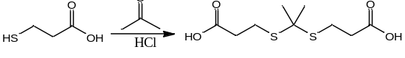
Figure S1. Synthesis route of TK and ¹HNRM spectrum of TK in D₂O.

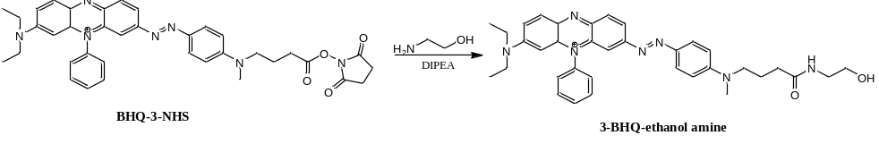
Figure S2. Synthetic pathway toward 3-BHQ-ethanol amine and ¹HNMR spectrum of BHQ3-ethanol amine in CDCl_{3.}

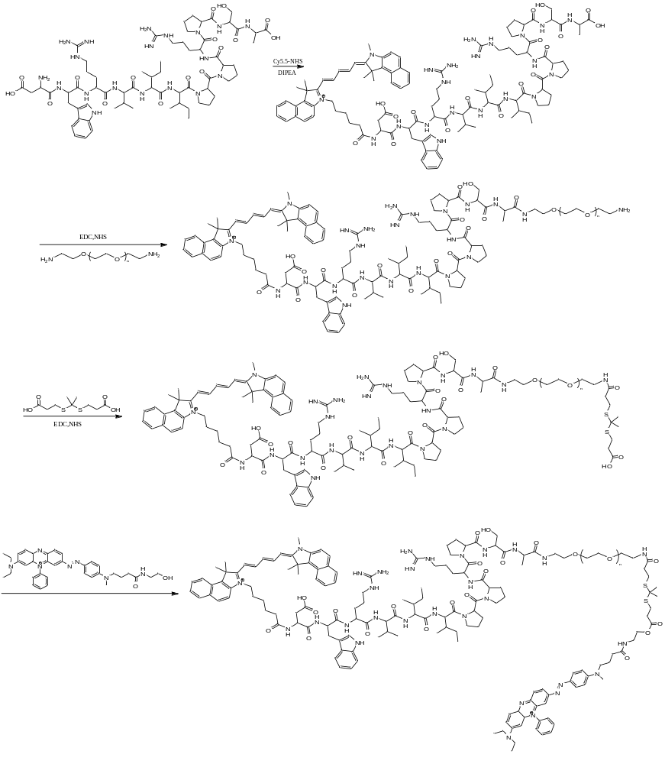
Figure S3. Synthetic pathway toward Cy5.5-CAP-PEG-TK-BHQ3.
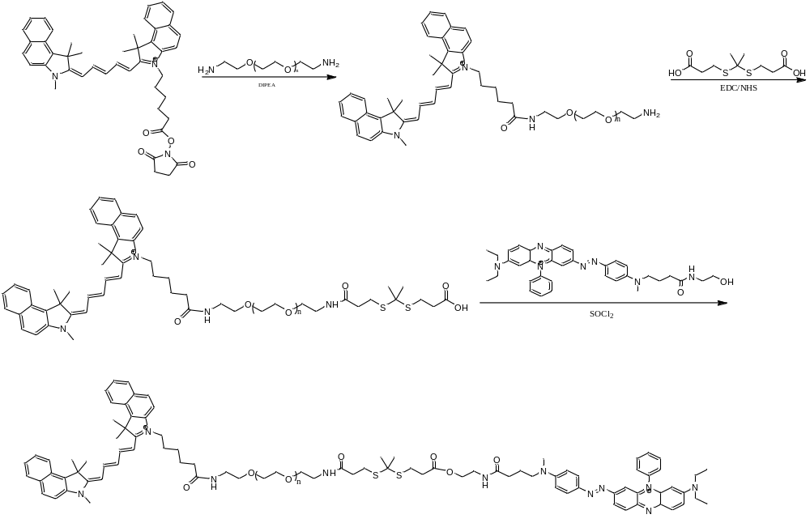

Figure S4. Synthetic pathway toward Cy5.5-PEG-TK-BHQ3.

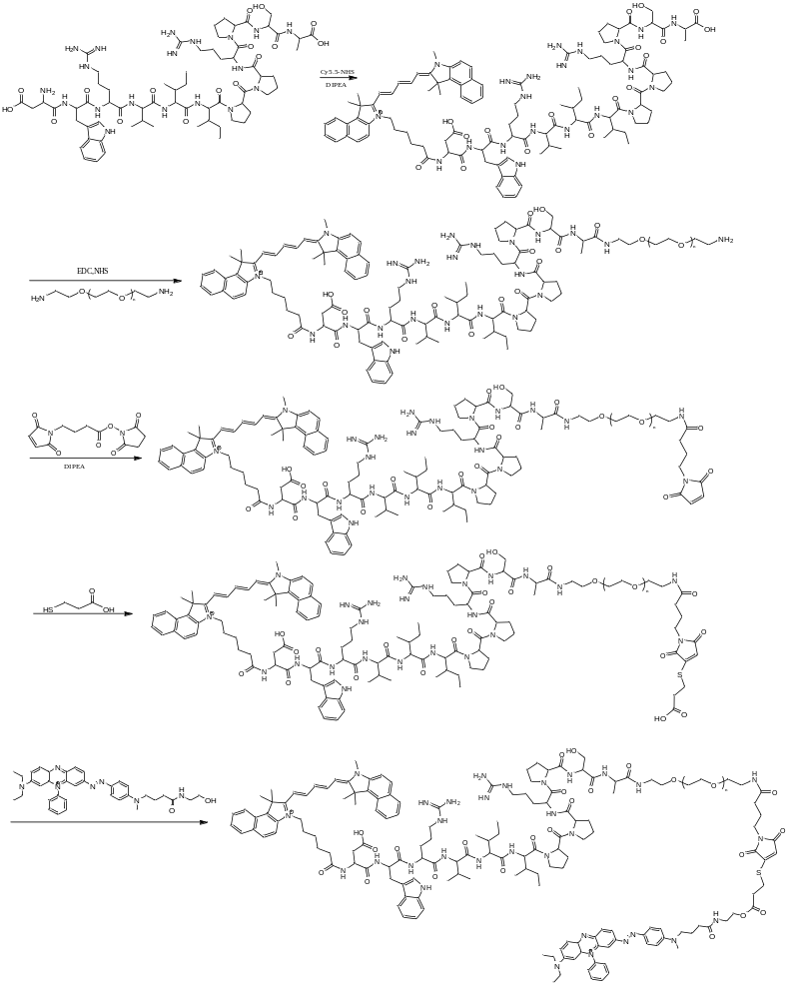
Figure S5. Synthetic pathway toward Cy5.5-CAP-PEG-BHQ3.

Figure S6. ¹HNMR spectrum of Cy5.5-CAP in D₂O.
Figure S7. ¹HNMR spectrum of Cy5.5-CAP-PEG in D₂O.

Figure S8. ¹HNMR spectrum of Cy 5.5-CAP-PEG-TK in D₂O.

Figure S9. ¹HNMR spectrum of Cy5.5-CAP-PEG-TK-BHQ3 in D₂O.
Figure S10. ¹HNMR spectrum of Cy5.5-CAP-PEG-TK-BHQ3, Cy5.5-PEG-TK-BHQ3 and Cy 5.5-CAP-PEG-BHQ3 in D₂O.

