Supporting Information for
Predicting the locations of faults based on morphometric features of alluvial fan and basin using artificial neural networks

Marzieh Mokarram^{1*} Hamid Reza Pourghasemi² John P. Tiefenbacher³
^{1*}Department of Range and Watershed Management, College of Agriculture and Natural Resources of Darab, Shiraz University, Iran, ORCID ID: https://orcid.org/0000-0003-4282-1950. Email: m.mokarram@shirazu.ac.ir
²Department of Natural Resources and Environmental Engineering, College of Agriculture, Shiraz University, Shiraz, Iran, Email: hr.pourghasemi@shirazu.ac.ir
³Department of Geography, Texas State University, San Marcos, TX USA, Email: tief@txstate.edu
*Corresponding author: MarziehMokarram, Tel.: +98-917-8020115; Fax: +987153546476 Address: Darab, Shiraz university, Iran, Postal Code: 71946-84471, Email: m.mokarram@shirazu.ac.ir

Table S1. Morphometric parameters measured in this study.

Symbol | Variable | Symbol | Variable
A_{b} | Basin area (m²) | D_{d} | Drainage density (km⁻¹)
P_{b} | Basin perimeter (m) | Mel | Melton’s number  Mel = ΔH_{b}/(A_{b})0.5
L_{b} | Basin Length (m) | A_{f} | Fan area (m²)
L_{c} | Main channel length (m) | P_{f} | Fan perimeter (m)
H_{min}_b | Basin minimum height (m) | L_{f} | Fan length (m)
H_{max}_b | Basin maximum height (m) | H_{min}_f | Fan minimum height (m)
ΔH_{b} | Basin relief (m)  ΔH_{b}= H_{max_b} − H_{min_b} | ΔH_{f} | Fan relief (m)  ΔH_{f} = H_{max}_f − H_{min}_f
R_{r}b | Basin Relief ratio (m) R_{r}b = ΔH_{b}/L_{b} | R_{r}f | Fan Relief ratio  R_{r}f = ΔH_{f}/L_{f}
β_{b} | Basin mean slope (°) | β_{f} | Fan mean slope (°)
β_{low}_b | Lower basin slope (°) | βupp_f | Upper fan slope (°)
β_{c} | Main channel slope (°) | α | Sweep angle (°)
CC | Cirb  $$v=A_{b}/(\frac{πГ2α}{360})$$  π is equal to 3.14, Г is the radius of the cone and α is the angle between the two margins of the alluvial fan at the junction of the alluvial fan | V_{f} | Fan volume (m³)$$V=(\frac{π×r^{2}×h}{3})×(\frac{s}{360})$$  π is the fan radius in meters, h is the height difference between the apex and the base of the fan in meters, S is the sweeping angle

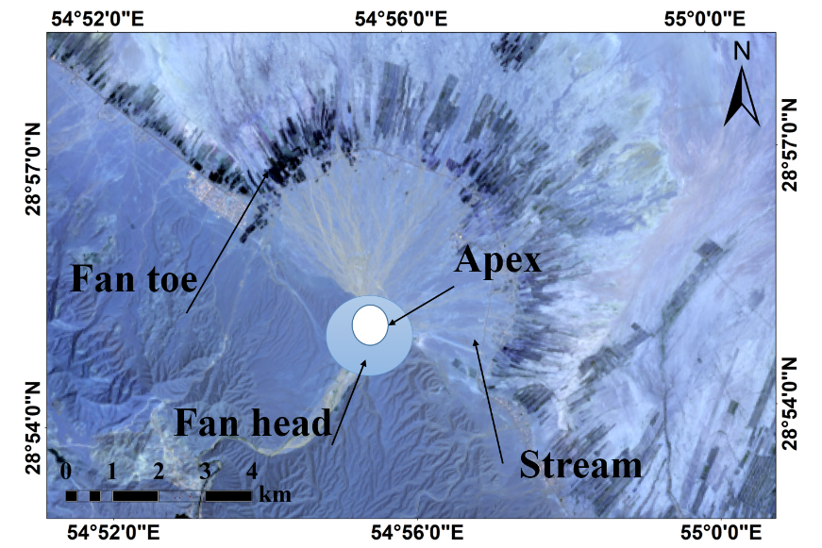
Fig. S1. The structure of an alluvial fan
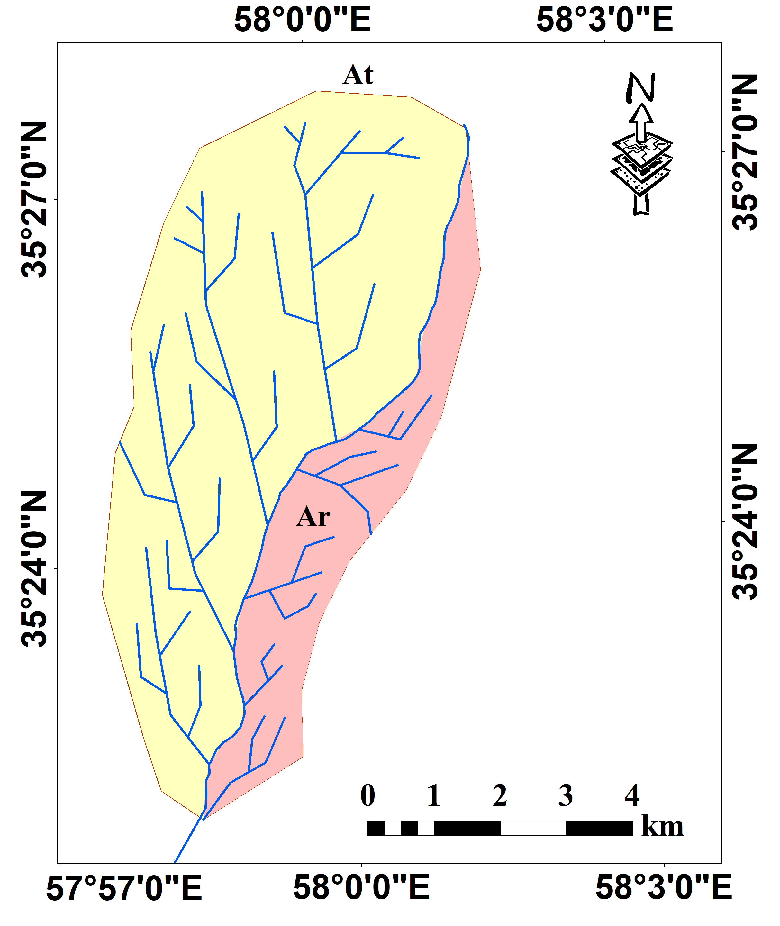
Fig. S2. Parameters Asymmetric (Af) factors
Ar: the area of the right part of the basin in the downstream direction relative to the main river, At: the total area of the drainage basin

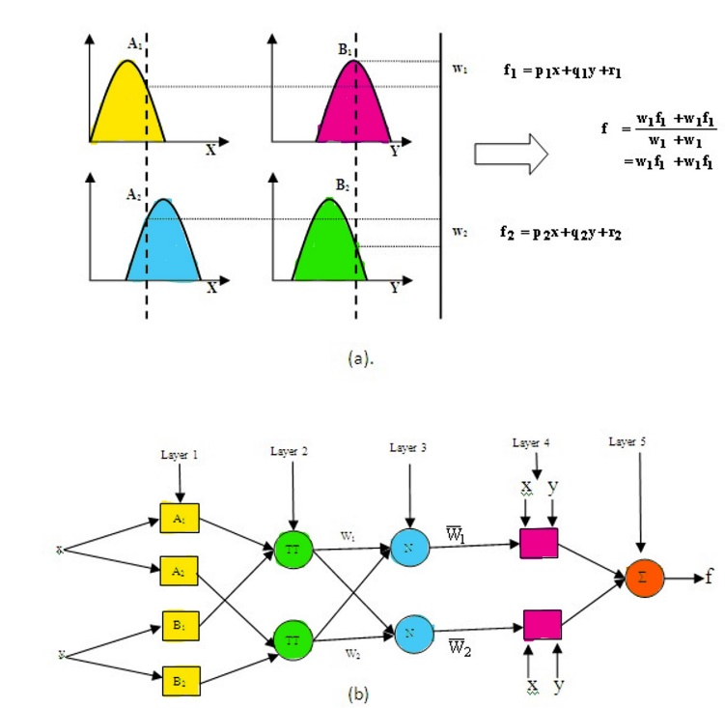
Fig. S3. (a): Fuzzy inference, (b): ANFIS structure (Bisht and Jangid, 2011)
O_{1,i}: the membership grade of a fuzzy set A_{i} (or B_{i})
П: product of all the incoming signals
w_{i}: a normalized firing strength from layer 3
p_{i} , q_{i} , r_{i} : the parameter set of this node
N: normalized firing strengths
Ʃ: overall output

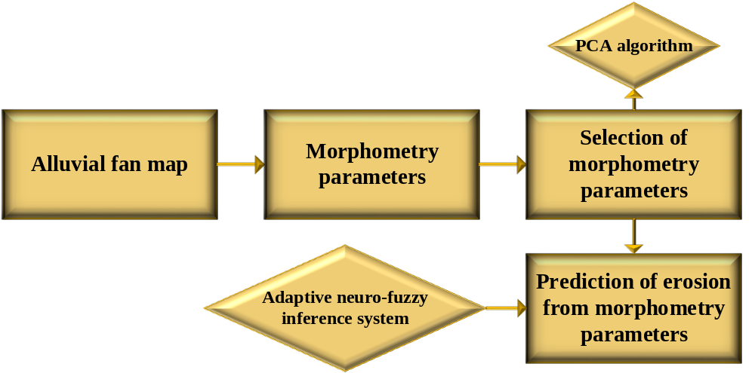
Fig. S4. Flowchart of the steps of implementing the model

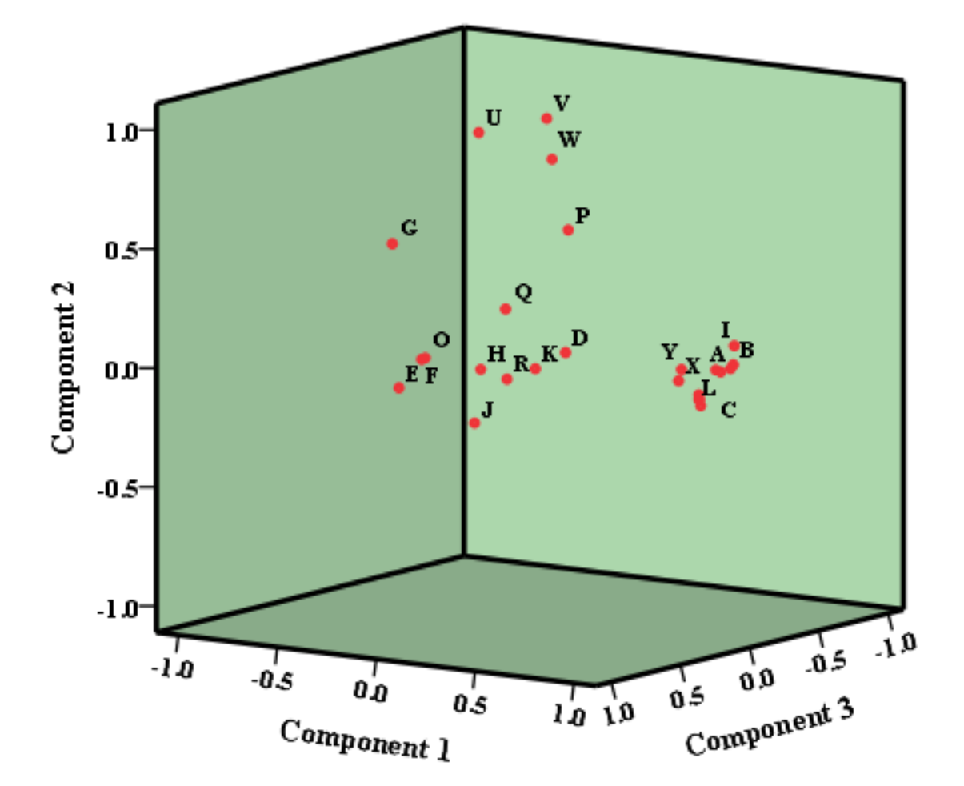
Fig. S5. Distribution of weights for different parameters in the first, second and third principal components.

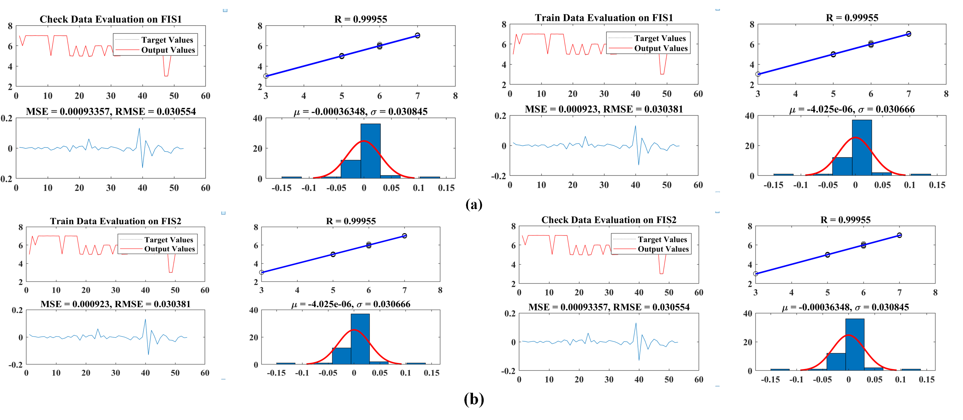
Figure S6. Results of Subtractive method in ANFIS model for (a): radius 0.01 and (b): radius 0.03

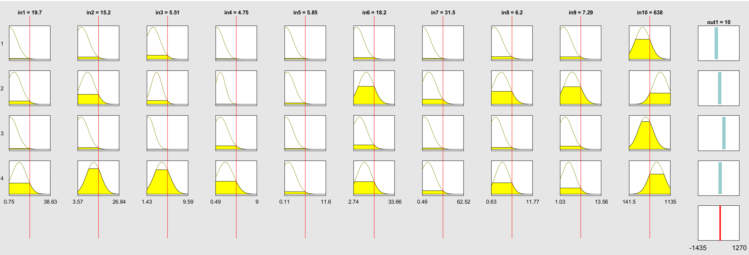
Fig.S7. The rules used in the ANFIS method
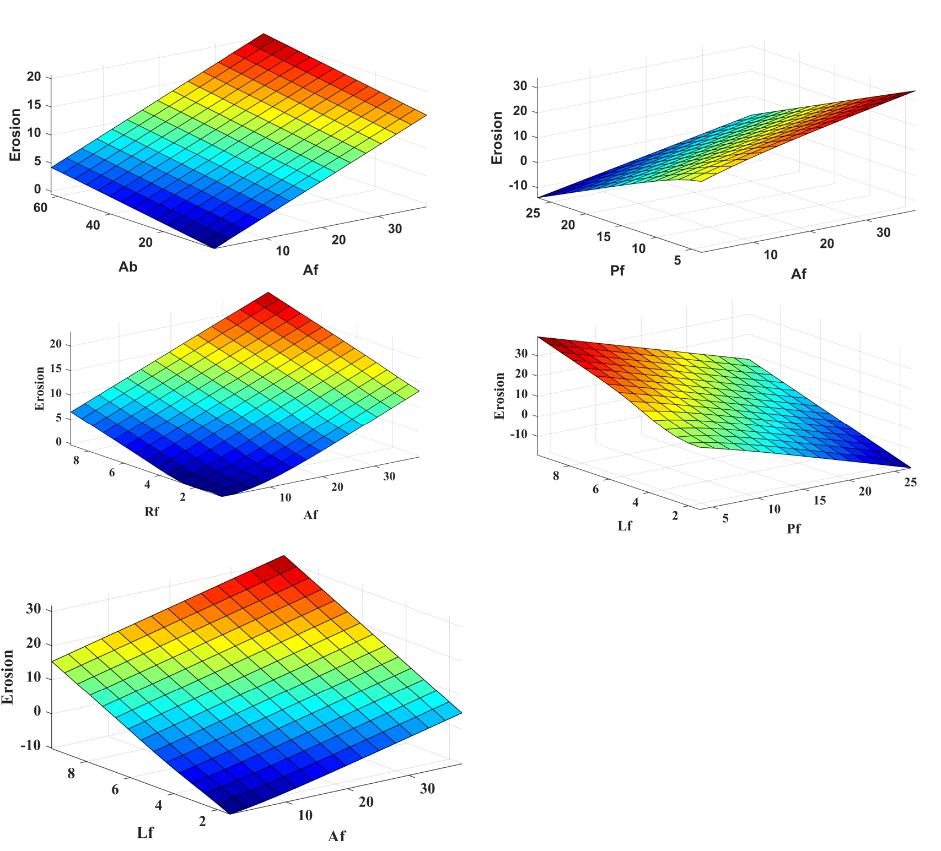
Fig. S8. The relationship between the parameters A_{f}, A_{b}, P_{f}, R_{f}, L_{f}, in three dimensions

