Supplementary Information

Centimeter-scale fullerene-free tin-based perovskite solar cells achieving over 14% efficiency
Tianpeng Li,^{a,#} Feifei He,^{a,#} Tao Shen,^{a,#} Dongsheng Yan,ª Zuoming Jin,ª Bin Li,^{b} Peilin Wang,ª Zhiguo Zhang,ª Zhi Li,^{c} Yu Pu,ª Liangliang Deng,^{d} Lang Qin,ª Wenwu Li,ª Yiqiang Zhan,^{d} Yunqi Liu,ª Yang Wang,^{a,e,}* Jia Liang,^{a,}*
ª Department of Materials Science, State Key Laboratory of Photovoltaic Science and Technology, Fudan University, 220 Handan Road, Shanghai 200433, China
^{b} State Key Laboratory for Modification of Chemical Fibers and Polymer Materials, College of Materials Science and Engineering, Donghua University, Shanghai 201620, China
^{c} Department of Control Science & Engineering, Tongji University, Shanghai 200092, China
^{d} Center of Micro-Nano System, School of Information Science and Technology, Fudan University, 220 Handan Road, Shanghai 200433, China
^{e} State Key Laboratory of Molecular Engineering of Polymers, Fudan University, 2005 Songhu Road, Shanghai 200438, China
# These authors contributed equally to this work.
* E-mail: jialiang@fudan.edu.cn; yangwang@fudan.edu.cn

Contents
Methods 4
Supplementary Fig. 1 11
Supplementary Fig. 2 12
Supplementary Fig. 3 13
Supplementary Fig. 4 14
Supplementary Fig. 5 15
Supplementary Fig. 6 16
Supplementary Fig. 7 17
Supplementary Fig. 8 18
Supplementary Fig. 9 19
Supplementary Fig. 10 20
Supplementary Fig. 11 25
Supplementary Fig. 12 26
Supplementary Fig. 13 27
Supplementary Fig. 14 28
Supplementary Fig. 15 29
Supplementary Fig. 16 30
Supplementary Fig. 17 31
Supplementary Fig. 18 32
Supplementary Fig. 19 33
Supplementary Fig. 20 34
Supplementary Note 1 35
Supplementary Note 2 36
Supplementary Table 1 37
Supplementary Table 2 38
Supplementary Table 3 39
Supplementary Table 4 40
Supplementary Table 5 41
Supplementary Table 6 42
References 43

Methods
Materials.
Phenethylammonium Iodide (PEAI, 97%), Formamidinium Iodide (FAI), Tin iodide (SnI₂, AnhydroBeads, 99.99%), tin fluoride (SnF₂, 99%), dimethyl sulfoxide (DMSO, anhydrous, 99.9%), N, N-dimethylformamide (DMF, anhydrous, 99.8%), chlorobenzene (CB, anhydrous, 99.8%), Bathocuproine (BCP, 96%), isopropanol (IPA, 99.5%) and Tetrahydro-di[1,4]methanonaphthaleno [1,2:2,3,56,60:2,3] [5,6] fullerene-C60 (ICBA, 99%) were purchased from Sigma-Aldrich and used as received with no further purification. 2-(2-Aminoethyl) isothiourea dihydrobromide (AET, 99%) were purchased obtained from Aladdin. Poly (3,4-ethylene dioxythiophene)-poly (styrene sulfonate) (PEDOT:PSS) was purchased from Xi'an Baolaite Optoelectronics Technology Co..

Synthesis Routes of P1, P2 and P3.
Synthesis of 6,6'-((5,6-difluorobenzo[c][1,2,5]thiadiazole-4,7-diyl)bis(thiophene-5,2-diyl))bis(2,5-bis(2-octyldodecyl)-3-(thiophen-2-yl)-2,5-dihydropyrrolo[3,4-c]pyrrole-1,4-dione) (DFB).
DPP (3.0 g, 3.5 mmol), 4,7-dibromobenzo[c][1,2,5]thiadiazole (462 mg, 1.4 mmol), anhydrous Cs₂CO₃ (2.9 g, 8.8 mmol), PivOH (107 mg, 1.1 mmol), Pd₂(dba)₃ (64 mg, 2 mol%), tris(o-methoxyphenyl) phosphine (50 mg, 4 mol%) were successively added into a Schlenk tube. Then, 117 mL anhydrous toluene was added via syringe. The reaction solution was rigorously stirred at 110 ◦C for 1 h under argon atmosphere. Removal of the toluene by rotary evaporator afforded the crude product, which was then purified by chromatogragh column (CC) on silica gel using a mixture of PE and DCM as eluent. The title compund was obtained as a purple solid (1.3 g, 45% yield).
¹H NMR (400 MHz, CDCl₃, δ, ppm): δ 9.14 (d, J = 4.0 Hz, 2H), 8.97 (d, J = 4.0 Hz, 2H), 8.39 (d, J = 4.0 Hz, 2H), 7.57 (d, J = 8.0 Hz, 2H), 7.23 (t, J = 8.0 Hz, 2H), 4.11 (d, J = 8.0 Hz, 4H), 4.01 (d, J = 8.0 Hz, 4H), 2.01 (br s, 2H), 1.93 (br s, 2H), 1.38-1.11 (m, 128H), 0.87-0.77 (m, 24H).
¹³C NMR (100 MHz, CDCl₃, δ, ppm): 161.36, 148.39, 140.51, 139.25, 136.62, 136.22, 136.15, 132.99, 132.04, 130.84, 129.91, 128.62, 46.72, 46.50, 38.69, 38.08, 32.15, 32.12, 31.50, 31.37, 30.49, 30.33, 29.89, 29.61, 26.53, 26.41, 22.91, 14.32.
MALDI-TOF MS (Mw = 1890.98): found m/z = 1891.89 [M+].
Synthesis of 6,6″-(5,5″-(5,6-difluorobenzo[c][1,2,5]thiadiazole-4,7-diyl)bis(thiophene-5,2-diyl))bis(3-(5-bromothiophen-2-yl)-2,5-bis(2-octyldodecyl)pyrrolo[3,4-c]pyrrole-1,4(2H,5H)-dione) (DFB-Br).
To a solution of DPP-dimer (1 mmol) in dichloromethane (50 mL) was added NBS (0.37 g, 2.1mmol) slowly in three portions at 25 ℃. The reaction was stirred overnight at room temperature. Then, the mixture was extracted with dichloromethane and dried with MgSO4. The crude product was further purified by silica gel chromatography using PE: CH2Cl2 as eluent to obtain a dark blue solid. (76%)
¹H NMR (400 MHz, CDCl₃, δ, ppm): δ 9.15 (d, J = 4.0 Hz, 2H), 8.73 (d, J = 4.0 Hz, 2H), 8.37 (d, J = 4.0 Hz, 2H), 7.18 (d, J = 4.0 Hz, 2H), 4.09 (d, J = 4.0 Hz, 4H), 3.93 (d, J = 8.0 Hz, 4H), 2.00 (br s, 2H), 1.91 (br s, 2H), 1.38-1.11 (m, 128H), 0.87-0.77 (m, 24H).
¹³C NMR (100 MHz, CDCl₃, δ, ppm): 160.87, 160.68, 151.33, 151.12, 148.70, 148.50, 147.99, 147.92, 139.14, 138.75, 136.51, 136.26, 135.93, 132.69, 131.80, 131.36, 131.09, 119.16, 111.02, 110.90, 108.50, 107.91, 46.56, 46.36, 38.57, 37.91, 31.98, 31.93, 31.09, 29.83, 29.70, 29.46, 29.40, 26.31, 26.16, 22.73, 14.15.
MALDI-TOF MS (Mw = 2048.77): found m/z = 2049.87 [M+].
Stille polymerization of P1.
DFB-2Br (205mg, 0.1 mmol), 2,5-bis(trimethylstannyl)thiophene (41 mg, 0.1 mmol), Pd₂(dba)₃ (2 mg, 2%), P(o-tol)₃ (2 mg, 6%) were added into a well-dried Schlenk flask. This flask was subjected to pump and purge cycles with N₂ for three times, followed by the addition of 6 mL of chlorobenzene. After stirring for 3 hours at 120°C, the mixture was dropped into 100 mL of methanol. The crude product was filtered and then purified via Soxhlet extraction with methanol, acetone, hexane, and chloroform. The collected chloroform fraction was concentrated, and then precipitated into methanol to obtain a dark solid (85%). GPC (1,2,4-trichlorobenzene, 150 °C): M_{n} = 33.9 KDa, M_{w} = 149.2 KDa, PDI = 4.4; Combustion elemental analysis calculated (Anal.calcd) for C₁₁₈H₁₇₆F₂N₆O₄S₆: C, 71.83, S, 9.75, N, 4.26. Found: C, 71.80, S, 9.12, N, 4.19. ¹H NMR (400 MHz, C₂D₂Cl₄, δ, ppm) : 9.50-9.00 (br), 8.51-8.32 (br), 7.40-7.39 (br), 4.30-4.10 (br), 2.20-2.00 (br), 1.40-1.20 (br), 0.95-0.75 (br)
Stille polymerization of P2.
DFB-2Br (205mg, 0.1 mmol), 3,4-difluorothiophene-2,5-diyl)bis(trimethylstannane (45 mg, 0.1 mmol), Pd₂(dba)₃ (2 mg, 2%), P(o-tol)₃ (2 mg, 6%) were added into a well-dried Schlenk flask. This flask was subjected to pump and purge cycles with N₂ for three times, followed by the addition of 12 mL of chlorobenzene. After stirring for 3 hours at 120°C, the mixture was dropped into 100 mL of methanol. The crude product was filtered and then purified via Soxhlet extraction with methanol and chloroform. The collected chloroform fraction was concentrated, and then precipitated into methanol to obtain a dark solid (90%). GPC (1,2,4-trichlorobenzene, 150 °C): M_{n} = 34.4 KDa, M_{w} = 51.6 KDa, PDI = 1.5; Combustion elemental analysis calculated (Anal.Calcd) for C₁₁₈H₁₇₄F₄N₆O₄S₆: C, 70.54, S, 9.58, N, 4.18. Found: C, 70.49, S, 9.25, N, 4.15. ¹H NMR (400 MHz, C₂D₂Cl₄, δ, ppm) : 9.52-9.05 (br), 8.60-8.35 (br), 7.52-7.10 (br), 4.50-3.95 (br), 2.25-2.10 (br), 1.50-1.19 (br), 0.98-0.77 (br)
Stille polymerization of P3.
DFB-2Br (205mg, 0.1 mmol), 3,3'-difluoro-[2,2'-bithiophene]-5,5'-diyl) bis(trimethylstannane) (53 mg, 0.1 mmol), Pd₂(dba)₃ (2 mg, 2%), P(o-tol)₃ (2 mg, 6%) were added into a well-dried Schlenk flask. This flask was subjected to pump and purge cycles with N₂ for three times, followed by the addition of 8 mL of chlorobenzene. After stirring for 1 hours at 120°C, the mixture was dropped into 100 mL of methanol.
The crude product was filtered and then purified via Soxhlet extraction with methanol, acetone, hexane, and chloroform. The collected chloroform fraction was concentrated, and then precipitated into methanol to obtain a dark solid (87%). GPC (1,2,4-trichlorobenzene, 150 °C): M_{n} = 53.2 KDa, M_{w} =154.3 KDa, PDI = 2.9; Combustion elemental analysis calculated (Anal.Calcd) for C₁₂₂H₁₇₆F₄N₆O₄S.: C, 70.07, S, 10.73, N, 4.02. Found: C, 68.74, S, 10.02, N,3.89. ¹H NMR (400 MHz, C₂D₂Cl₄, δ, ppm) : 9.51-9.08 (br), 8.70-8.39 (br), 7.55-7.15 (br), 4.51-3.98 (br), 2.26-2.11 (br), 1.60-1.25 (br), 0.98-0.80 (br).

Device Fabrication.
Fabrication of HTL Layers.
The patterned ITO glass substrate was continuously cleaned in ultrasonic bath with detergent, deionized water and ethanol for 15 minutes. Then, the ITO glass substrate was dried and cleaned with UV-ozone for 15 minutes. After that, The PEDOT: PSS layer was then deposited on the ITO glass substrate by spin-coating at 5000 rpm for 30 seconds and then annealed at 140°C for 20 minutes.

Fabrication of Perovskite Layers.
The Sn perovskite deposit was prepared in a nitrogen glove box with an oxygen content of 0.1 ppm. Dissolve PEAI (19.9 mg), FAI (123.8mg), SnI₂ (298 mg), SnF₂ (9.4 mg), and AET (11.24 mg) in 1 mL of a mixed solvent of DMF and DMSO (DMSO: DMF=1:4 v/v). Then, Stir the mixture at 65°C for 2 hours to obtain a perovskite precursor solution. Take 85 μL of the perovskite precursor solution and coat it on the surface of the hole transport layer using a drop-coating method. The perovskite precursors were spin-coated on the surfaces of the HTL films at 1000 and 5000 rpm for 10 s and 30 s respectively. During the second stage, 320 μL Chlorobenzene was dropped onto the substrates on the last 22 seconds. Finally, the substrates were annealed at temperature of 60 °C for 5 min and 80 °C for 10 min.

Fabrication of ETL Layers.
The non-fullerene P1, P2, and P3 solution (15mg P1, P2, and P3 in 1 mL chlorobenzene, respectively) was spin coated on the surfaces of the perovskite layers at 1800 rpm for 30 s and then annealed at 70 °C for 10 min. The ICBA solution (20 mg in 1 mL chlorobenzene) was spin coated on the surfaces of the perovskite layers at 2000 rpm for 30 s and then annealed at 70 °C for 10 min. After that, 0.5 mg/mL of BCP saturated isopropyl alcohol solution was spin coated on the ETLs surface at 6000rpm/s for 30s and annealed on a hot plate at 70℃ for 10 minutes. Finally, a 120 nm Ag layer was deposited using the thermal evaporation system.

Fabrication of electron-only devices.
A 120 nm silver film was evaporated on the surface of ITO by thermal evaporation method. After that, The non-fullerene P1, P2, and P3 solution (15 mg P1, P2, and P3 in 1 mL chlorobenzene, respectively) was spin coated on the surfaces of the perovskite layers at 1800 rpm for 30 s and then annealed at 70 °C for 10 min. Finally, a 120 nm Ag layer was deposited using the thermal evaporation system.

Characterizations
¹H NMR (400 MHz) and ¹³C NMR (100 MHz) spectra were measured on a Varian Mercury Plus-400 spectrometer. The splitting patterns were designated as follows: s (singlet); d (doublet); t (triplet); m (multiplet), br (broad). Deuterated chloroform or deuterated 1,1,2,2-tetrachloroethane was used as the solvent. The NMR chemical shifts were reported in ppm (parts per million) relative to the residual solvent peak at 7.26 ppm (chloroform) or 6.00 ppm (1,1,2,2-tetrachloroethane) for the ¹H NMR spectroscopy and 77.6 ppm (chloroform) or 73.8 ppm (1,1,2,2-tetrachloroethane) for the ¹³C NMR spectroscopy. The MALDI−TOF mass spectra were measured by a Bruker autoflex maX MALDI-TOF mass spectrometer. UV-vis-NIR absorption spectra were characterized by PerkinElmer Lambda 750 spectrophotometer. The morphologies of the films (Morphologies of the perovskite) were carried out by a field-emission scanning electron microscope (FESEM) (SU8010, Hitachi). Time-resolved photoluminescence (TRPL) spectra were characterized by a streak camera (Hamamatsu, C6860). The laser source is an amplified titanium/sapphire laser providing 800 nm 35-fs pulses at 2 kHz which is then frequency doubled for 400 nm excitation. Steady-state Photo-Luminescence (PL) spectra were performed using a FLS920 transient optical spectrometer (Edinburgh Instruments). X-ray diffraction pattern data for 2θ values were achieved by a Bruker AXD8 Advance diffractometer with nickel filtered Cu Kα radiation (λ=1.5406 Å). KPFM images of perovskite films was collected using Park NX20. The space-charge-limited current (SCLC) results were acquired using a Keithley 2400 source-meter unit. KPFM images of perovskite films was collected using Park NX20 Bruker. The J–V curves were measured using a Keithley 2400 source-meter unit under AM 1.5 G light illumination at 100 mW cm⁻² (1 sun). (ENLITECH SS-X100R) with forward/reverse scanning modes (rate 0.01 V s⁻¹). Before testing, the light intensity was calibrated using a standard Si reference cell (ENLITECH SRC-2020-KG1-RTD). The active area is 0.04-1 cm². Impedance spectroscopic measurements were recorded by an alternating bias of 50 mV by Zennium-pro (Zahner). The corresponding spectra were fitted by Z-View software. The contact angle images were obtained from JC2000D series contact angle measuring instrument (JC2000D1).

Supplementary Fig. 1 | a-c, ¹H NMR spectra of P1, P2 and P3, respectively.

Supplementary Fig. 2 | a-c, Tauc plots of non-fullerene a, P1, b, P2, and c, P3 ETLs, respectively.

Supplementary Fig. 3 | Calculated ESPs. Calculated electrostatic potentials (ESPs) of a, P1 and b, P2, respectively.

Supplementary Fig. 4 | Strong interaction between non-fullerene ETLs and Sn-based perovskite layers. The electron density distribution of Sn-based perovskites interacting with a, ICBA, b, P1 c, P2 and d, P3 molecules, respectively.

Supplementary Fig. 5 | FTIR spectra. FTIR spectra of c, P1 and the P1-SnI₂ mixture and d, P2 and P2-SnI₂ mixture.

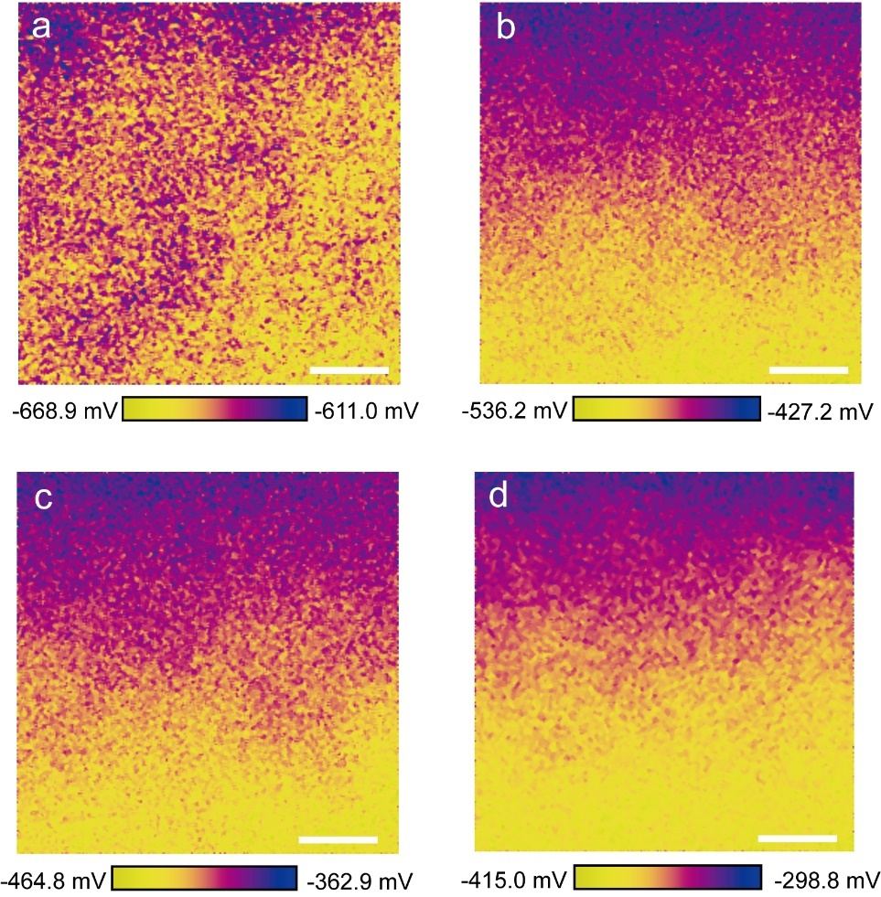

Supplementary Fig. 6 | Surface potential mapping measured by the KPFM method for a, the fullerene-based ICBA ETL and b-d, non-fullerene P1, P2, and P3 ETLs deposited on the Sn-based perovskite film, respectively. The scalebars are 400 nm.

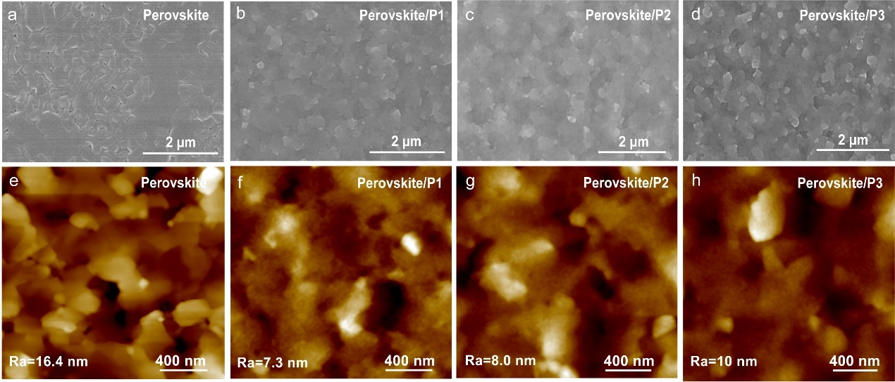

Supplementary Fig. 7 | a-d, the scanning electron microscopy (SEM) images of Sn-based perovskite films without and with the three types of non-fullerene ETLs. e-h, the atomic force microscopy (AFM) images of Sn-based perovskite films without and with the three types of non-fullerene ETLs.

Supplementary Fig. 8 | XRD patterns of the Sn-based perovskite films with and without the three types of non-fullerene ETL.

Supplementary Fig. 9 | Schematic diagram of TPSCs with the structure of ITO/PEDOT:PSS/Sn-based perovskites/ETLs/BCP/Ag, where ETLs include non-fullerene P1, P2, and P3.

Supplementary Fig. 10 | The statistics of photovoltaic parameters of TPSCs (0.04 cm²) with ICBA and non-fullerene ETLs. a, PCE, b, J_{SC}, c, FF, and d, V_{OC}. (13 individual devices for each type TPSC)

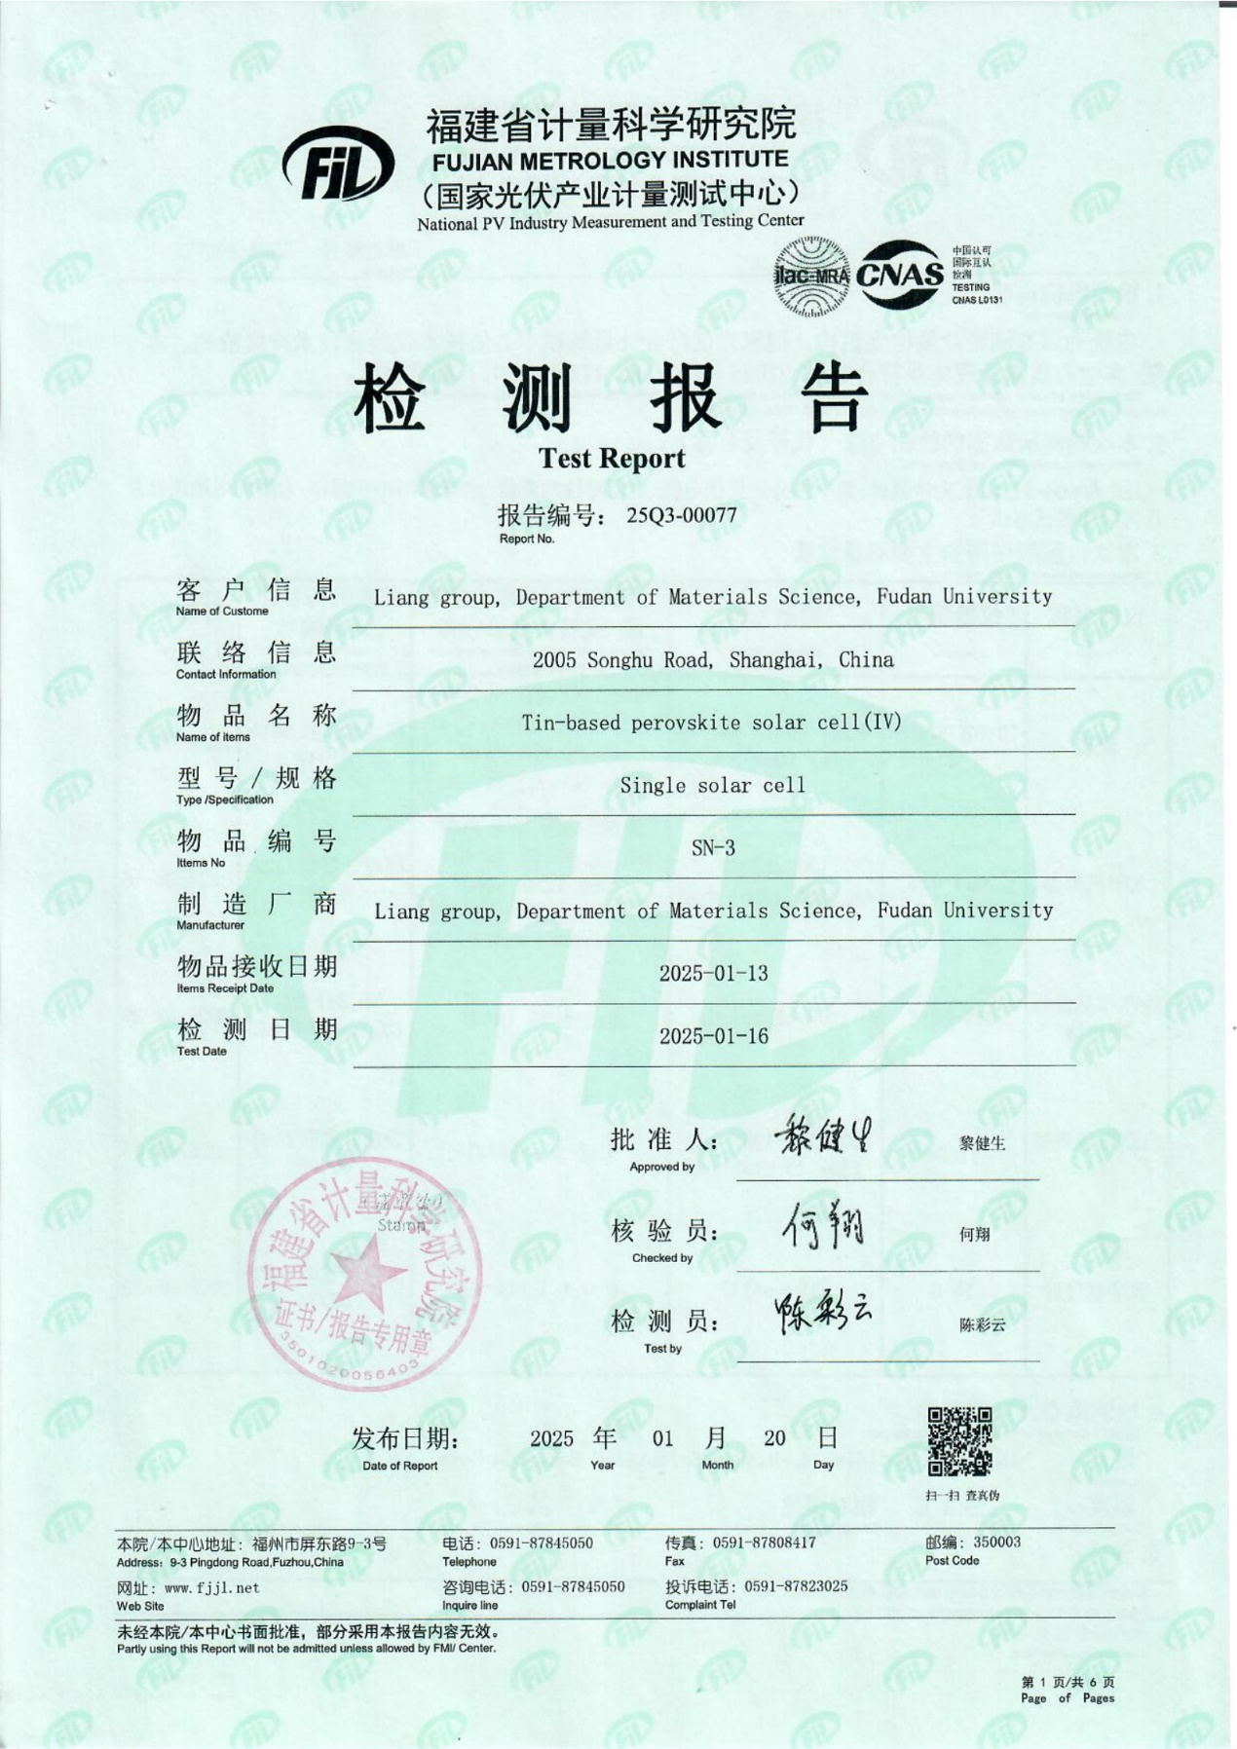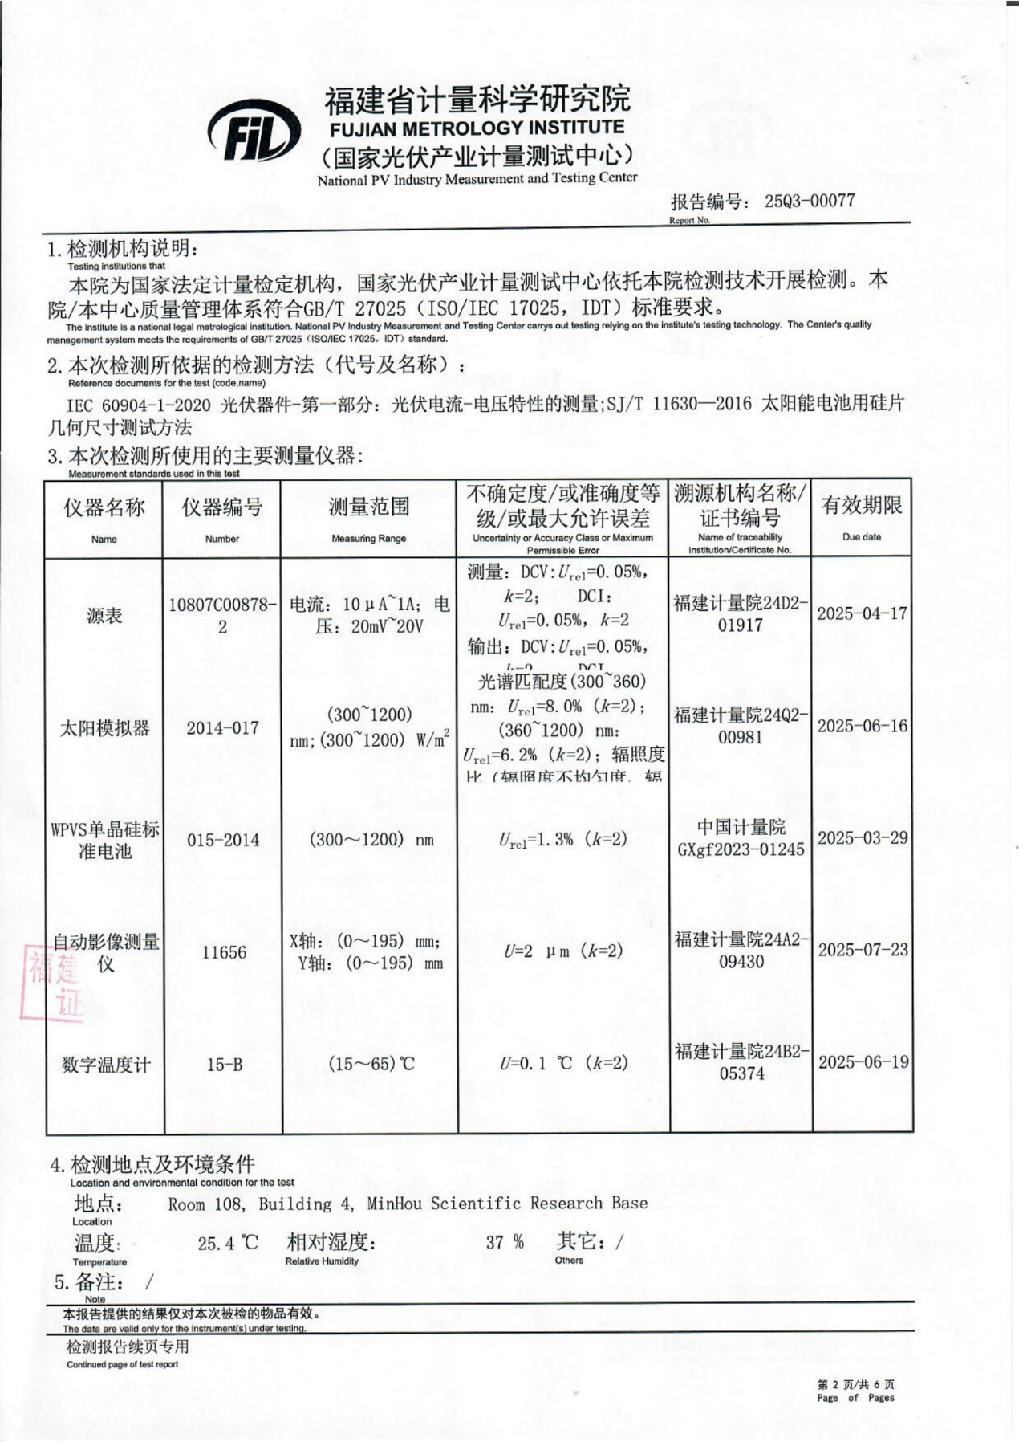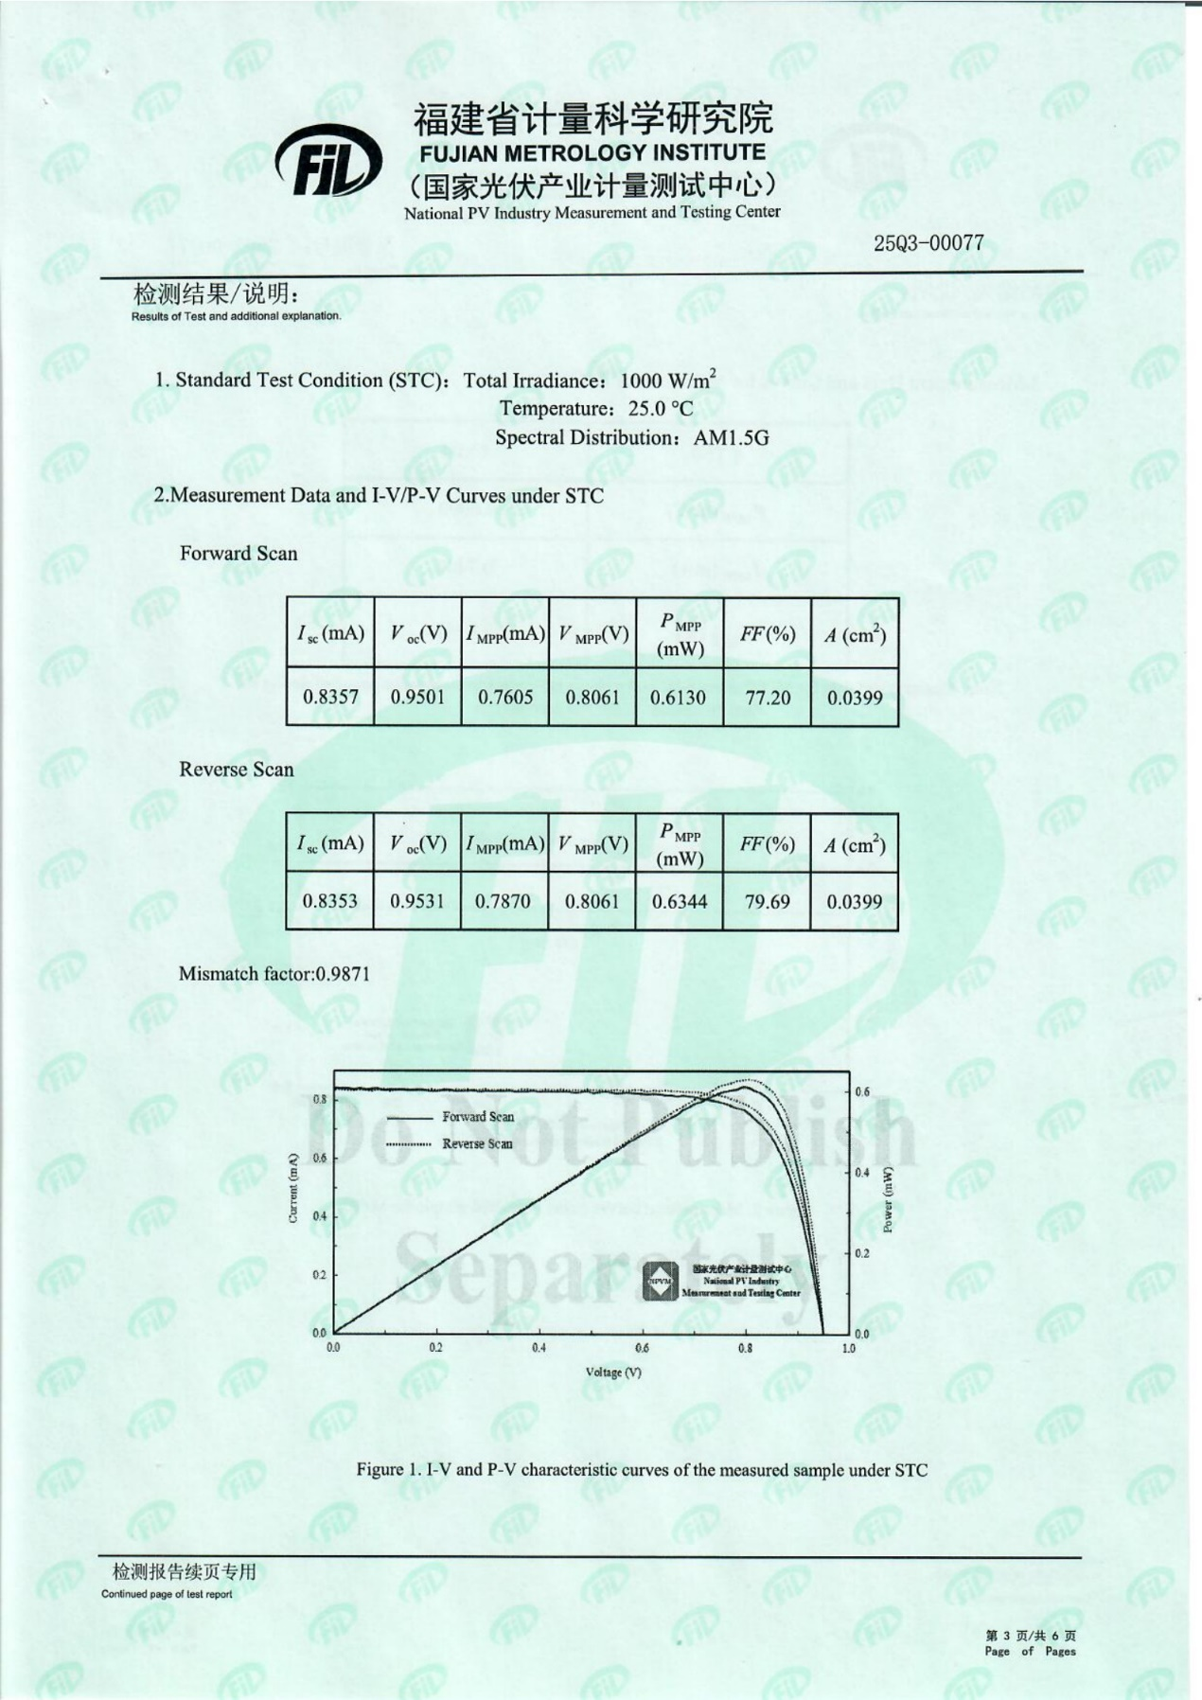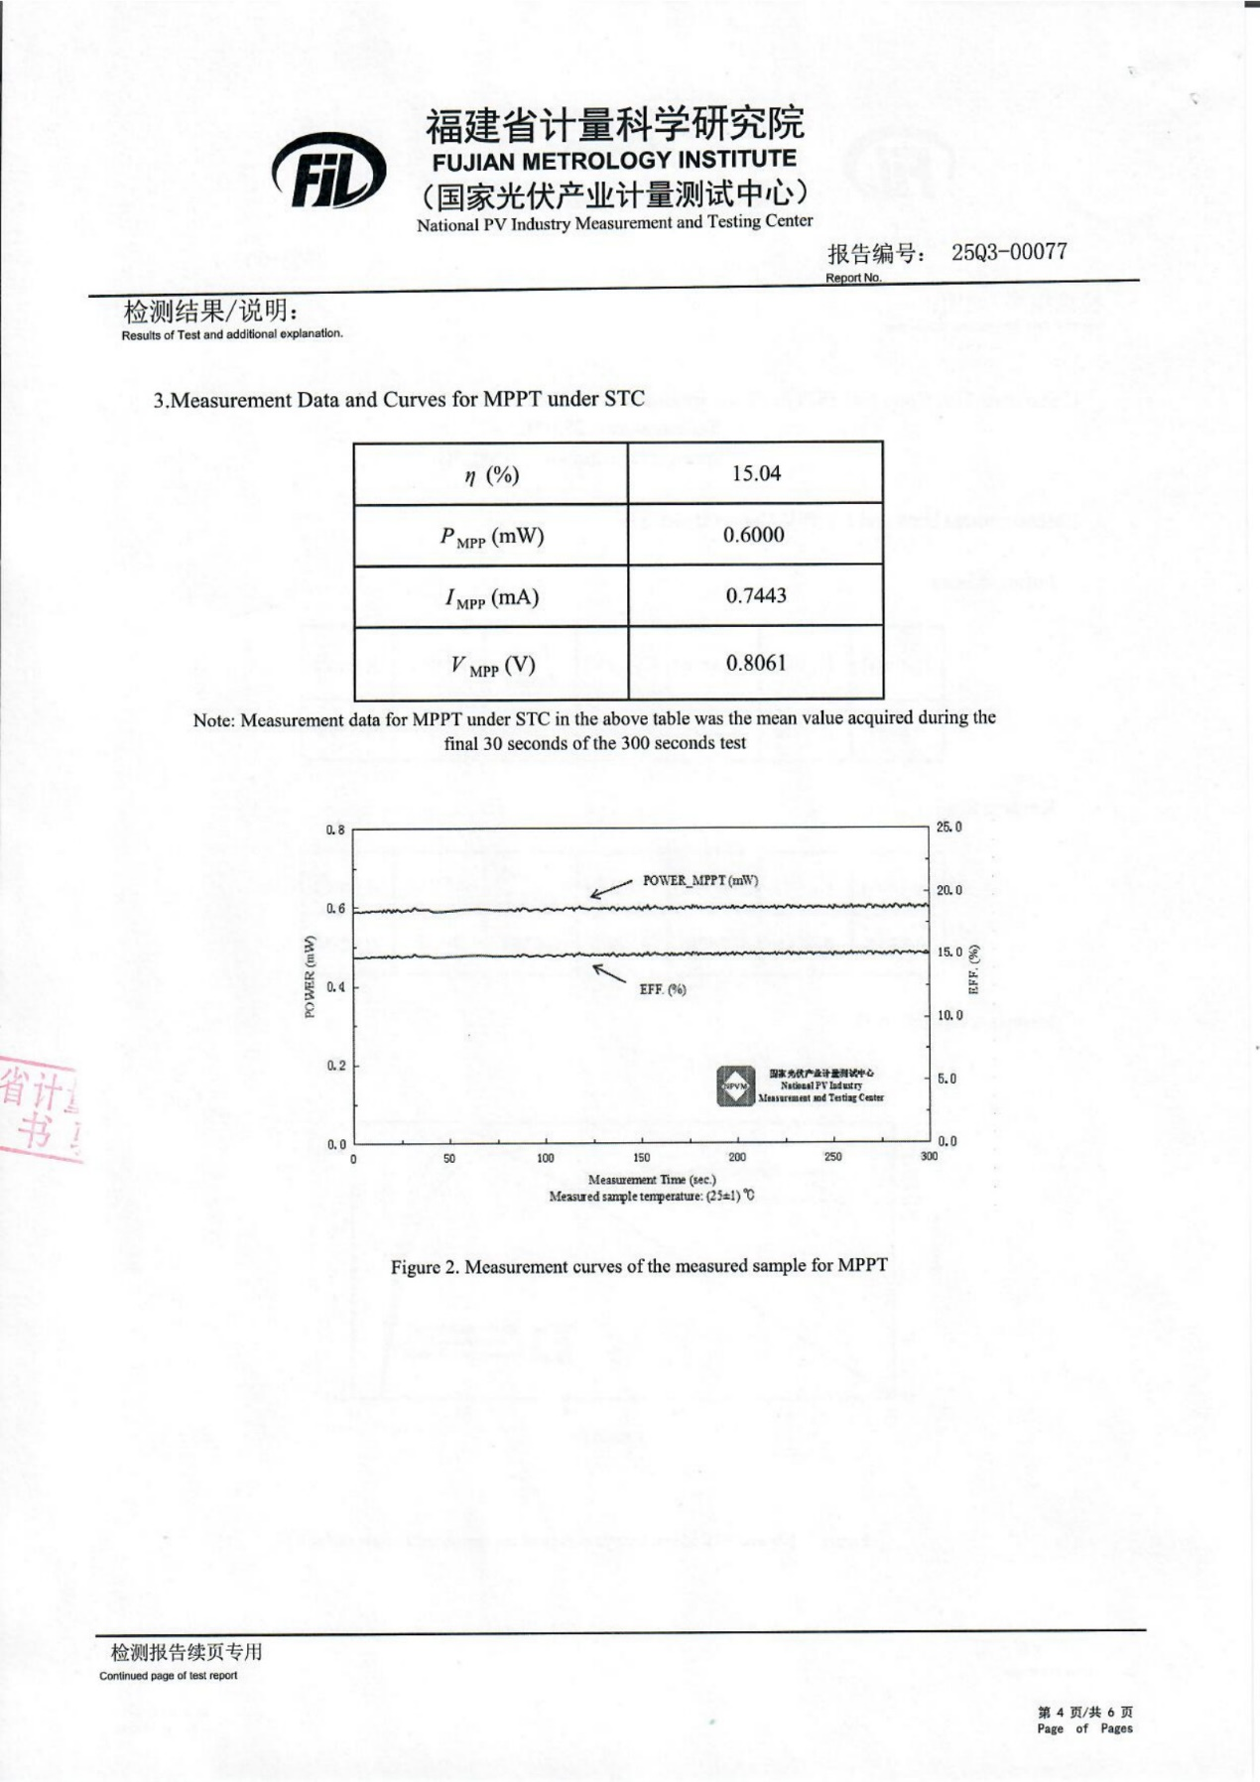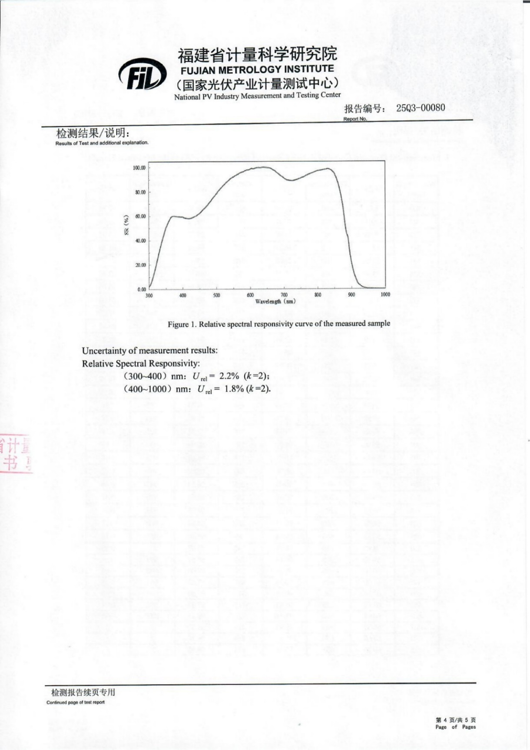

Supplementary Fig. 11 | Photovoltaic performance. Certified performance of the fullerene-free TPSC with the P3 ETL. The certified efficiency is 15.90% under reverse scannign mode with short-circuit current (I_{SC}) = 0.8353 mA, V_{OC} = 0.9531 V, FF = 79.69%, and and Area = 0.0399 cm².

Supplementary Fig. 12 | PL mapping images of perovskite films for distribution on the 0.5 cm x 0.5 cm a, P1 and b, P2 ETLs deposited on the Sn-based perovskite film, respectively.

Supplementary Fig. 13 | IPCE spectra and integrated J_{sc} values of TPSCs with ICBA, P1, P2 and P3 ETLs, respectively

Supplementary Fig. 14 | J-V curves of TPSCs with a, ICBA and b, P3 ETLs measured by the forward and reverse scan modes.

Supplementary Fig. 15 | The statistics of photovoltaic parameters of TPSCs (1 cm²) with ICBA and non-fullerene ETLs. a, PCE, b, J_{SC}, c, FF, and d, V_{OC}. (13 individual devices for each type TPSC).

Supplementary Fig. 16 | EIS spectra of the fullerene-free TPSCs with and without the three types of non-fullerene ETL.

Supplementary Fig. 17 | Dark J-V curves of fullerene-free TPSCs with the three types of non-fullerene ETLs.

Supplementary Fig. 18 | Linear relationships of V_{OC} to light intensities of TPSCs with ICBA, P1, P2 and P3 ETLs, respectively.

Supplementary Fig. 19 | SCLC spectra of electron-only devices structured as FTO/SnO₂/Sn-based perovskites/ETLs/Ag, where ETLs include non-fullerene P1, P2 and P3.

Supplementary Fig. 20 | Water contact angle pictures of ICBA, P1, P2 and P3 ETLs deposited on the Sn-based perovskite film at different time, respectively.

Supplementary Note 1 |. Measurement results of electron mobility of P1, P2 and P3, respectively. We measured the capacitance (C_{p}) and thickness of P1, P2 and P3, respectively, and calculated the relative dielectric constant(ε) with $ε=\frac{C∙L}{ε_{0}∙S}$. Then, its electron mobility is obtained by using Figure 1c and $J_{D}=\frac{9ε_{0}εμV_{b}^{2}}{8L^{3}}$. Here, ε, C_{p}, L, S and $μ$ are the relative dielectric constant, capacitance, thickness, area and electron mobility of P1, P2 and P3, respectively.
Samples | L (um) | C_{P} (F) | ε | μ (cm²∙V⁻¹∙s⁻¹)
P1 | 5.10 | 1.81×10⁻¹¹ | 3.32 | 1.98
P2 | 9.21 | 1.65×10⁻¹¹ | 5.47 | 3.17
P3 | 2.46 | 3.30×10⁻¹¹ | 2.92 | 1.29

Supplementary Note 2 |. Summary of DFT analysis for Sn-based perovskites interacting with ICBA, P1, P2 and P3 molecules.
Number | Molecules | Interaction energy (eV/mol) | Electric transfer (e)
1 | ICBA | -1.25686 | 0.154922
2 | P1 | -2.95251 | 0.349773
3 | P2 | -2.89846 | 0.325995
4 | P3 | -3.21884 | 0.523224

Supplementary Table 1 | The fitted data of TRPL characterization.
Samples | A₁ (%) | τ₁ (ns) | A₂ (%) | τ₂ (ns) | τ_{avg} (ns)
Perovskite | 41.96 | 2.18 | 58.04 | 5.65 | 4.89
Perovskite/P1 | 65.55 | 1.52 | 34.45 | 4.34 | 3.22
Perovskite/P2 | 63.66 | 1.54 | 36.34 | 3.86 | 2.91
Perovskite/P3 | 72.96 | 1.16 | 27.04 | 4.14 | 2.88

Supplementary Table 2 | Photovoltaic parameters of fullerene-based TPSCs (0.04 cm²) with ICBA and fullerene-free TPSCs (0.04 cm²) with non-fullerene ETLs. (13 individual devices for each type TPSC.)
Samples |  | V_{oc} (V) | J_{sc} (mA/cm²) | FF (%) | PCE (%)
ICBA | Best | 0.81 | 18.57 | 78.04 | 11.74
 | Average | 0.79±0.01 | 17.67±1.24 | 75.70±2.38 | 10.54±0.87
P1 | Best | 0.97 | 18.74 | 78.03 | 14.18
 | Average | 0.96±0.01 | 18.54±0.20 | 77.71±0.49 | 13.89±0.26
P2 | Best | 0.99 | 19.25 | 79.20 | 15.09
 | Average | 0.97±0.01 | 19.23±0.22 | 78.20±0.46 | 14.63±0.23
P3 | Best | 0.99 | 19.79 | 81.98 | 16.06
 | Average | 0.98±0.01 | 19.75±0.28 | 80.93±1.01 | 15.63±0.43

Supplementary Table 3 | Photovoltaic parameters of fullerene-based TPSCs (1 cm²) with ICBA and fullerene-free TPSCs (1 cm²) with non-fullerene ETLs. (13 individual devices for each type TPSC.)
Samples |  | V_{oc} (V) | J_{sc} (mA/cm²) | FF (%) | PCE (%)
ICBA | Best | 0.78 | 17.65 | 76.97 | 10.60
 | Average | 0.70±0.06 | 16.36±0.81 | 76.93±2.38 | 8.83±1.03
P1 | Best | 0.92 | 17.91 | 78.19 | 12.88
 | Average | 0.92±0.01 | 17.89±0.45 | 73.61±3.20 | 12.21±0.48
P2 | Best | 0.93 | 18.38 | 78.32 | 13.39
 | Average | 0.93±0.01 | 18.45±0.66 | 74.72±3.53 | 12.89±0.47
P3 | Best | 0.94 | 19.45 | 78.34 | 14.39
 | Average | 0.94±0.01 | 19.45±0.28 | 76.09±2.14 | 13.91±0.32

Supplementary Table 4 | Photovoltaic parameter comparison of existing large-area TPSCs.
ETLs | Active area (cm²) | Voc (V) | Jsc (mA/cm²) | FF (%) | PCE (%) | Year | Ref.*
P3 | 1 | 0.94 | 19.45 | 78.34 | 14.39 | - | This work
C₆₀ | 1.02 | 0.775 | 22.69 | 68.60 | 12.05 | 2023 | 14
C₆₀ | 1 | 0.68 | 19.80 | 66.2 | 8.9 | 2024 | 43
C₆₀ | 1.02 | 0.77 | 19.96 | 65.7 | 10.09 | 2022 | 5
ICBA | 1 | 0.63 | 20.25 | 61.2 | 7.8 | 2021 | 44
C₆₀ | 1 | 0.56 | 17.57 | 72.0 | 7.08 | 2019 | 10
C₆₀ | 1.02 | 0.53 | 19.59 | 61 | 6.33 | 2019 | 45
TiO₂ | 0.39 | 0.47 | 21.68 | 63.15 | 6.49 | 2019 | 46
TiO₂ | 0.39 | 0.45 | 21.87 | 60.12 | 5.88 | 2018 | 47
TiO₂ | 0.39 | 0.35 | 25.02 | 57.40 | 5.09 | 2017 | 48
*The reference numbers in the supplemental information are the same with those in the main text.

Supplementary Table 5 | Related parameters fitted from the equivalent circuit of the EIS spectra measurement.
TPSCs | Rs (Ω) | Rct (Ω) | C (nF) | Rrec (Ω) | CPE (nF)
ICBA | 36.69 | 4290 | 0.5725 | 1267 | 4.003
P3 | 18.92 | 162.8 | 23.28 | 1633 | 0.6406
P2 | 27.59 | 510.6 | 4.041 | 1457 | 0.4733
P1 | 31.9 | 1866 | 0.6682 | 1331 | 0.3432

Supplementary Table 6 | The trap-filled limit voltage and trap-state density relationship of varied different non-fullerene ETLs.
Samples | P1 | P2 | P3
V_{TFL} (V) | 0.81 | 0.71 | 0.60
N_{defects} (x10¹⁵ cm⁻³) | 34.2 | 13.3 | 5.23

References (The reference numbers in the supplemental information are the same with those in the main text.)
5. Liu, X. et al. Lead-Free Perovskite Solar Cells with Over 10% Efficiency and Size 1 cm² Enabled by Solvent–Crystallization Regulation in a Two-Step Deposition Method. ACS Energy Lett. 7, 1, 425–431 (2022).
10. Ran, C. et al. Conjugated Organic Cations Enable Efficient Self-Healing FASnI₃ Solar Cells. Joule. 12, 3072-3087 (2019).
14. Li, B. et al. Suppressing Oxidation at Perovskite–NiO_{x} Interface for Efficient and Stable Tin Perovskite Solar Cells. Adv. Mater., 36, 2309768 (2023).
43. Zhang, Z. et al. Improved Air Stability of Tin Halide Perovskite Solar Cells by an N-Type Active Moisture Barrier. Adv. Funct. Mater. 34, 2306458 (2024).
44. Ye, T. et al. Localized Electron Density Engineering for Stabilized B‑γ CsSnI₃‑Based Perovskite Solar Cells with Efficiencies >10%. ACS Energy Lett. 6, 1480–1489 (2021).
45. Chowdhury, T. et al. Post-Deposition Vapor Annealing Enables Fabrication of 1 cm² Lead-Free Perovskite Solar Cells. Sol. RRL. 3, 1900245 (2019).
46. Vegiraju, S. et al. Benzodithiophene Hole-Transporting Materials for Efficient Tin-Based Perovskite Solar Cells. Adv. Funct. Mater. 2019, 29, 1905393 (2019).
47. Ke, W. et al Dopant-Free Tetrakis-Triphenylamine Hole Transporting Material for
Efficient Tin-Based Perovskite Solar Cells. J. Am. Chem. Soc. 2018, 140, 388–393 (2018).
48. Ke, W. et al. Efficient Lead-Free Solar Cells Based on Hollow {en}MASnI₃ Perovskites. J. Am. Chem. Soc. 139, 14800–14806 (2017).

