Supplementary files
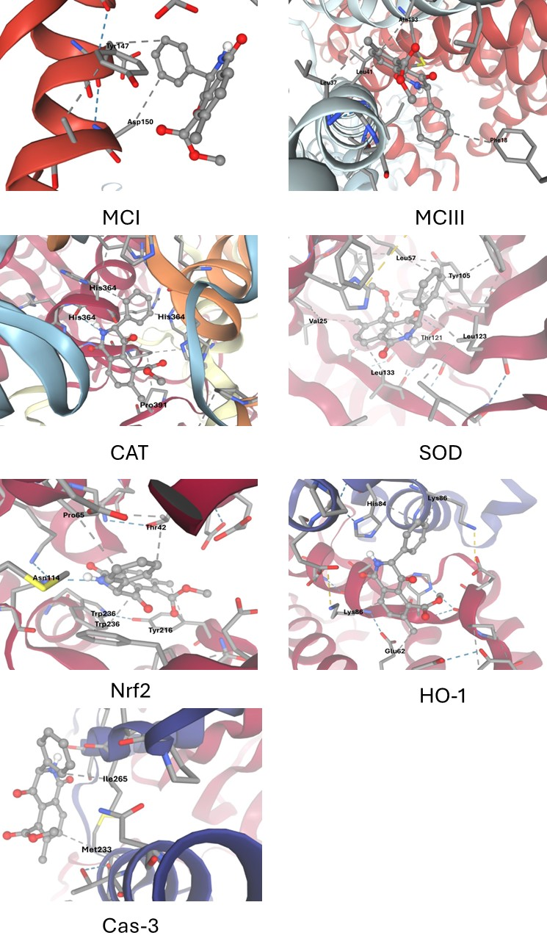
Figure. S1: Molecular docking interaction of OTA with MCI, MCIII, CAT, SOD, Nrf2, HO-1, and Cas-3. The colour coding is used to denote different types of molecular interactions: Blue (Hydrogen bonds): Indicates hydrogen bonding interactions between atoms in the protein and ligand, Gray (Hydrophobic contacts): Denotes nonpolar, hydrophobic interactions between the ligand and protein, Green (π-stacking interactions): Highlights stacking interactions between aromatic rings.
Figure. S1: Molecular docking interaction of OTA with MCI, MCIII, CAT, SOD, Nrf2, HO-1, and Cas-3. The colour coding is used to denote different types of molecular interactions: Blue (Hydrogen bonds): Indicates hydrogen bonding interactions between atoms in the protein and ligand, Gray (Hydrophobic contacts): Denotes nonpolar, hydrophobic interactions between the ligand and protein, Green (π-stacking interactions): Highlights stacking interactions between aromatic rings.

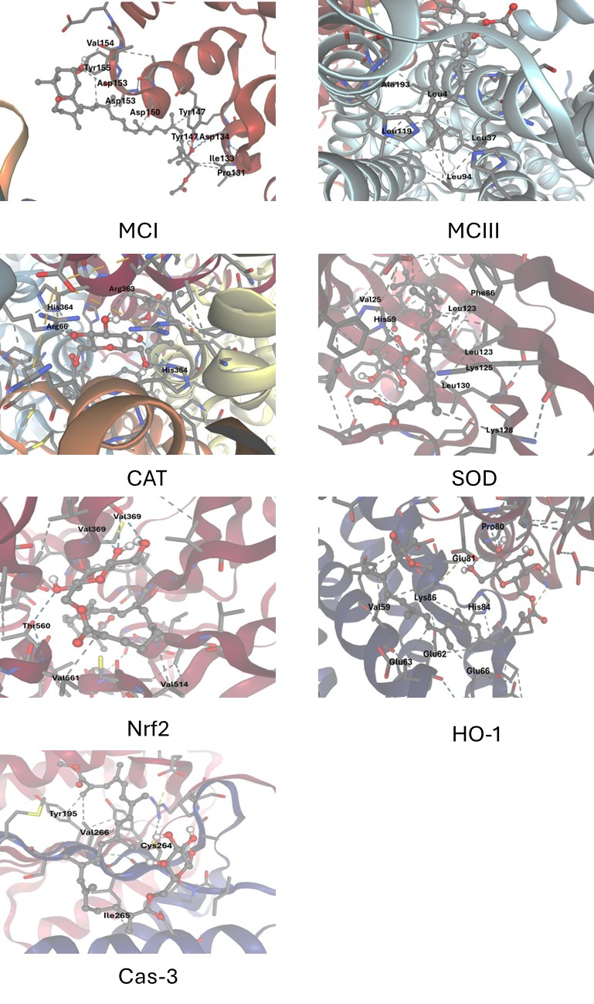
Figure. S2: Molecular docking interaction of FX with MCI, MCIII, CAT, SOD, Nrf2, HO-1, and Cas-3. The colour coding is used to denote different types of molecular interactions: Blue (Hydrogen bonds): Indicates hydrogen bonding interactions between atoms in the protein and ligand, Gray (Hydrophobic contacts): Denotes nonpolar, hydrophobic interactions between the ligand and protein, Green (π-stacking interactions): Highlights stacking interactions between aromatic rings.
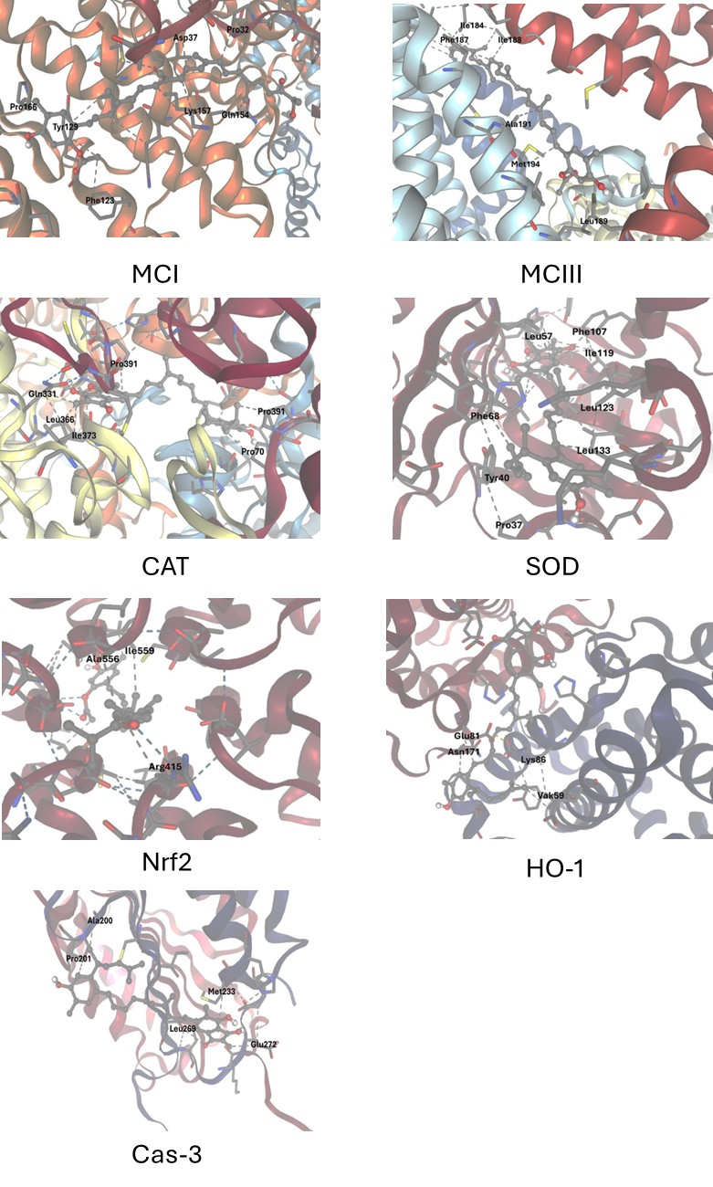

Figure. S3: Molecular docking interaction of FXL with MCI, MCIII, CAT, SOD, Nrf2, HO-1, and Cas-3. The colour coding is used to denote different types of molecular interactions: Blue (Hydrogen bonds): Indicates hydrogen bonding interactions between atoms in the protein and ligand, Gray (Hydrophobic contacts): Denotes nonpolar, hydrophobic interactions between the ligand and protein, Green (π-stacking interactions): Highlights stacking interactions between aromatic rings.

