S. 2. Representative catchments
ID | area_km2 | RepCatch | RepCatch_name | RepCatch_area_km2 | RepCatch_Factor | Relevant to calculation of allocations in:
Murray_usHume_wet | 5063.87 | 401208 | Cudgewa Creek at Berringama (401208) | 356.2 | 18.92 | Murray system
Murray_usHume_dry | 5756.06 | 401013 | Jingellic Creek at Jingellic (401013) | 392 | 16.22 | Murray system
SnowyScheme_SwampyPlainsRiv | 634.65 | 401572 | Tooma River at Tooma Reservoir (401572) | 150.757 | 1.32 | Murray / Snowy system**
Mitta_usDart_wet | 1521.87 | 401210 | Snowy Creek at Below Granite Flat (401210) | 412.9 | 3.64 | Murray system
Mitta_usDart_dry | 1985.83 | 401215 | Morass Creek at Uplands (401215) | 536.7 | 8.80 | Murray system
Kiewa_wet | 858.48 | 401216 | Big River at Jokers Creek (401216) | 358.1 | 1.98
Kiewa_dry | 870.57 | 402204 | Yackandandah Creek at Osbornes Flat (402204) | 280.5 | 3.92
Ovens_wet | 3379.12 | 403233 | Buckland River at Harris Lane (403233) | 457.1 | 5.50
Ovens_dry | 2857.04 | 403221 | Reedy Creek at Woolshed (403221) | 211.5 | 11.90
Broken | 1910.12 | 404207 | Holland Creek at Kelfeera (404207) | 454.7 | 2.44
Goulb_usEild_wet | 2285.96 | 405219 | Goulburn River at Dohertys (405219) | 699.1 | 2.82 | Goulburn system
Goulb_usEild_dry | 1596.23 | 405245 | Ford Creek at Mansfield (405245) | 117.3 | 35.37 | Goulburn system
Goulb_dsEild_wet | 1969.76 | 405209 | Acheron River at Taggerty (405209) | 625.8 | 2.22 | Goulburn system*
Goulb_dsEild_dry | 8814.13 | 405228 | Hughes Creek at Tarcombe Rd (405228) | 480.6 | 12.01 | Goulburn system*
CampLodd_wet | 1978.27 | 407217 | Loddon River at Vaughan D/S Fryers Creek (407217) | 294.7 | 7.10
CampLodd_dry | 4304.48 | 406226 | Mount Ida Creek at Derrinal (406226) | 173 | 17.15
Murray_toMulwala | 2915.66 | 403221 | Reedy Creek at Woolshed (403221) | 211.5 | 2.03
SnowyScheme | 4235.14 | 401572 | Tooma River at Tooma Reservoir (401572) | 150.757 | 11.78 | Snowy system**
Murrumb_usBurrin_wet | 1977.77 | 410088 | Goodradigbee River at Brindabella (No.2&No.3-Cab (410088) | 428.1 | 3.75 | Murrimbidgee System
Murrumb_usBurrin_dry | 9322.95 | 410141 | Micaligo Creek at Michelago (410141) | 190.6 | 107.18 | Murrimbidgee System
Canberra_Cotter | 475.83 | 410730 | Cotter River at Gingera (410730) | 129.2 | 2.00 | Murrimbidgee System
Canberra_Googong | 891.12 | 410734 | Queanbeyan River at Tinderry (410734) | 564.4 | 1.33 | Murrimbidgee System
Murrumb_dsBurrin_wet | 2966.56 | 410038 | Adjungbilly Creek at Darbalara (410038) | 389.2 | 11.20 | Murrimbidgee System*
Murrumb_dsBurrin_dry | 8929.59 | 412029 | Boorowa River at Prossers Crossing (412029) | 1550.6 | 9.34 | Murrimbidgee System*
BillabongCk | 2798.84 | 410091 | Billabong Creek at Walbundrie (410091) | 2636.3 | 0.97 | Murrimbidgee System*
Notes * denotes that an area that is part of a system but downstream of the major reservoir(s) of that system.
** the Snowy system does not itself have allocations, but water released from the Snowy into the Murray and the Murrumbidgee systems affects their allocations

S.2. Rainfall runoff calibration

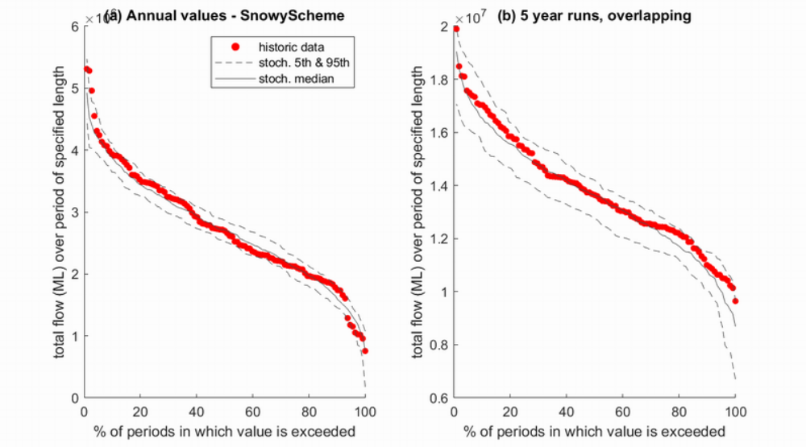

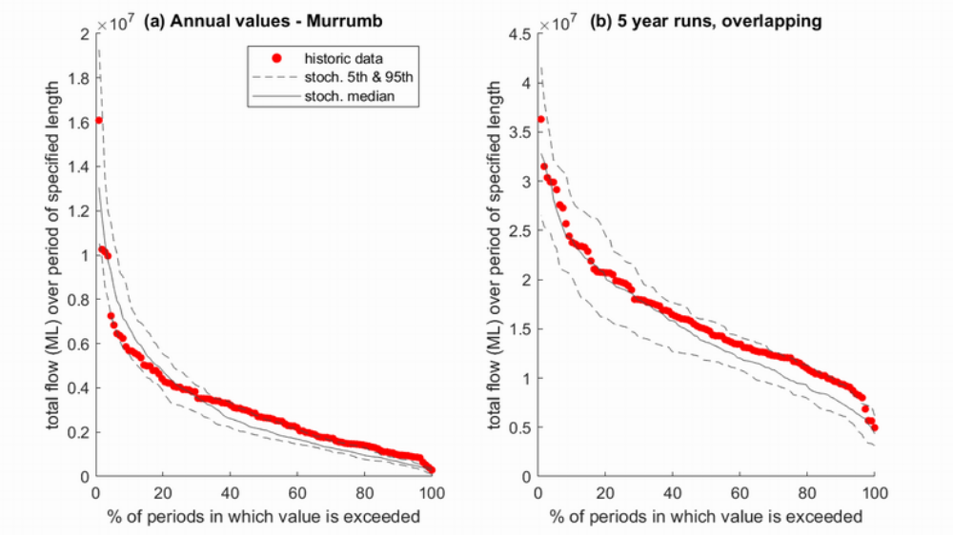

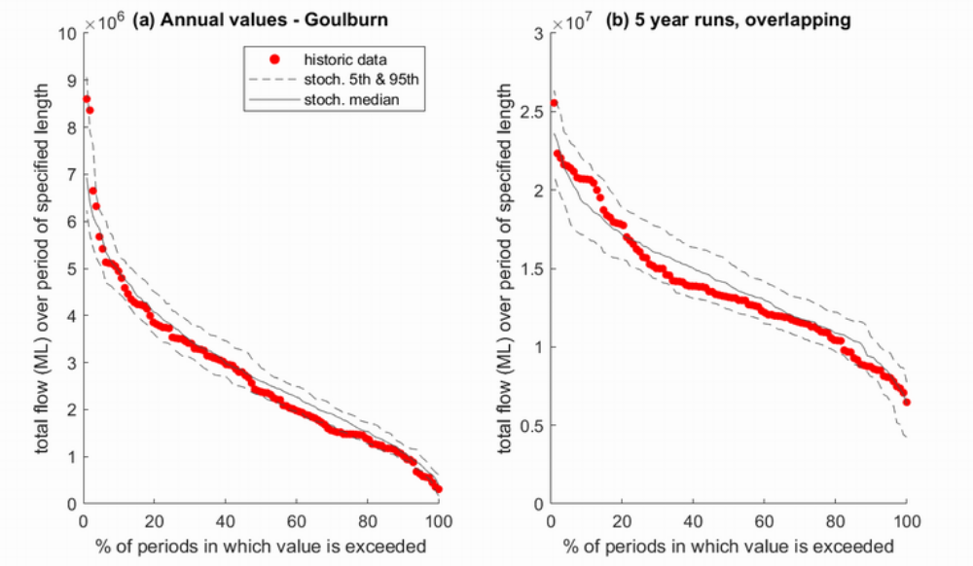

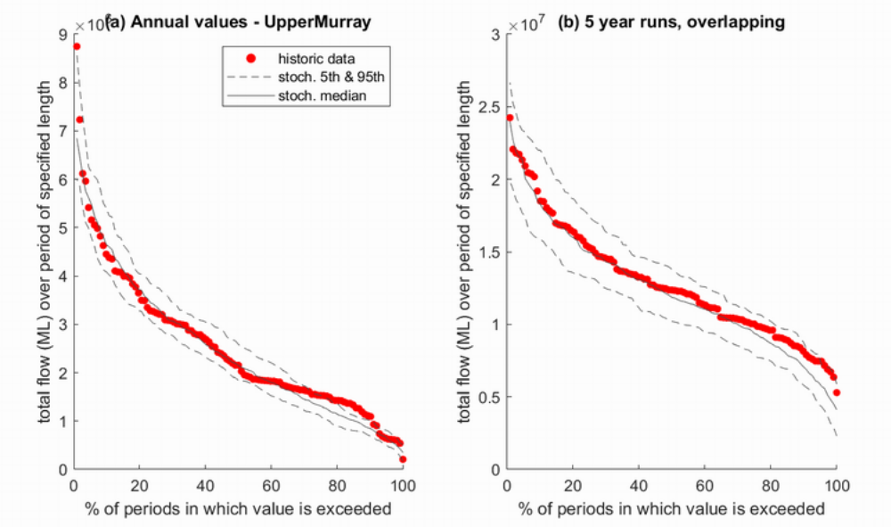

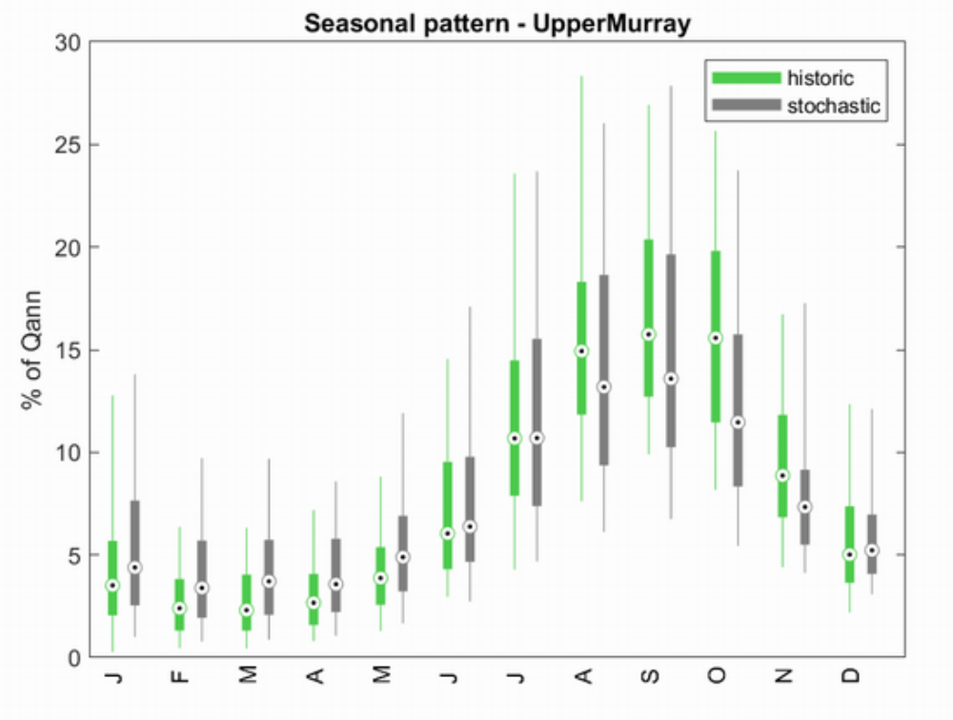

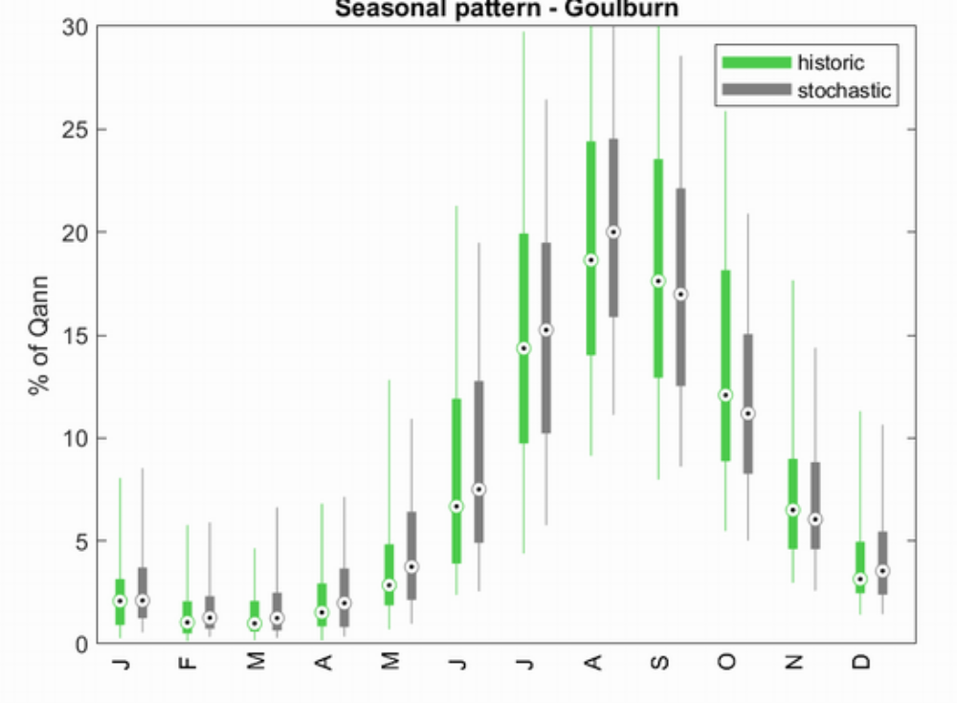

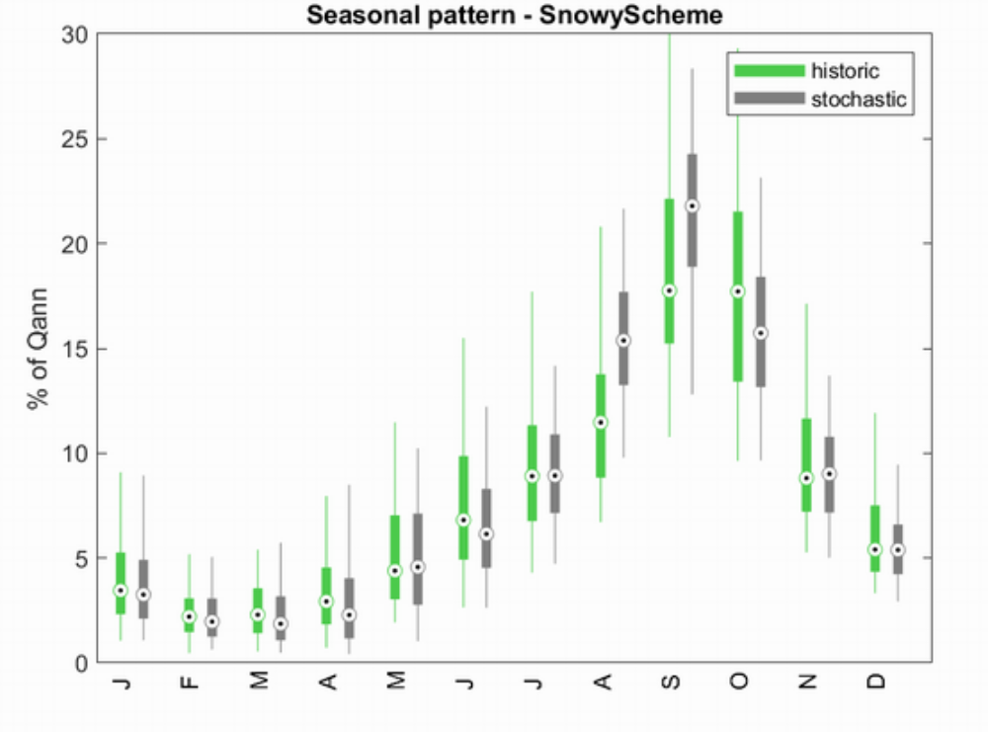

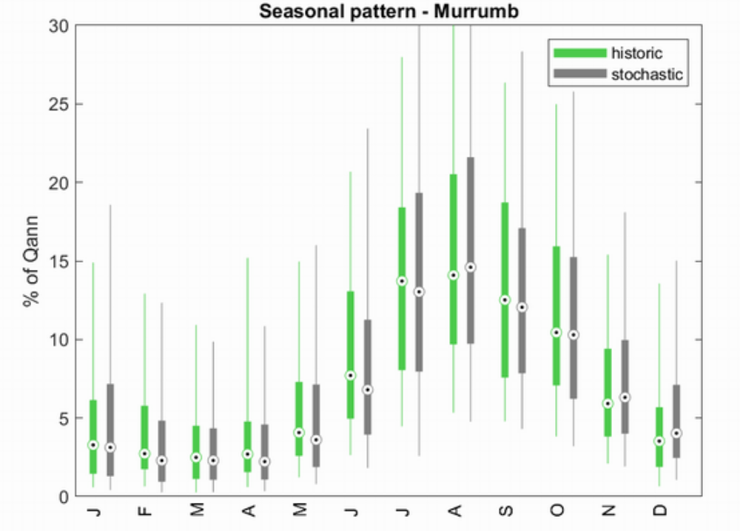
S. 3. Allocation modelling objective function calibration steps
The specific step to calculate the objective function value is outlined as follows.
- Calculate the weights of extreme and non-extreme (i.e., midway) categories
$$w_{e}=\frac{extreme}{extreme+midway}$$
$$w_{m}=\frac{midway}{extreme+midway}=1-w_{e}$$
where $extreme$ is the number of extreme allocations and $midway$ is the number of non-extreme allocations.
- Calculate SI based on the weighted number of successful detections of extreme and non-extreme cases.
$$SI=w_{e}×\left(\frac{hits}{extreme}\right)+w_{m}×(\frac{correct}{midway})$$
where $hits$ is the number of successful detection of extreme allocations and any correct detection of non-extreme allocations will be counted as a $correct$.
- Calculate NNSE based on the prediction accuracy of non-extreme cases.
$$NNSE=\frac{1}{2-NSE}=\frac{1}{1+\frac{\sum{{({Am}_{o}-{Am}_{m})}^{2}}}{\sum{{({Am}_{o}-\overline{{Am}_{o}})}^{2}}}}$$
where ${Am}_{o}$are the observed midway allocations, $\overline{{Am}_{o}}$ is the average of the observed midway allocations, and ${Am}_{m}$are the modelled midway allocations.
- The objective function is defined as
$$Obj= w_{e}×SI+w_{m}×NNSE$$

