Supplemental Materials for
Enzyme-less discrimination of chiral amino acids
with femtoampere-level precision by proton-driven anthrax nanopore
Yan Wang ª, Yunjiao Wang ª, Lebing Wang ^{a, b}, Jing Li ^{a, b}, Zhirui Zhang ª, Shilong Liu ^{a, b}, Liang Wang ^{a*}

ª Chongqing Institute of Green and Intelligent Technology, Chinese Academy of Sciences; Chongqing School, The University of Chinese Academy of Sciences, Chongqing, 400714, China
^{b} School of Optoelectronic Engineering, Chongqing University of Posts and Telecommunications, Chongqing 400065, China

*Corresponding author:
Dr. Liang Wang
Chongqing Institute of Green and Intelligent Technology, Chinese Academy of Sciences; Chongqing School, The University of Chinese Academy of Sciences, Chongqing 400714, China.
Email: wangliang83@cigit.ac.cn;

1. Supplementary Experiments
1.1 Materials and reagents
Four dextrorotary (d-) amino acids (d-isoleucine, d-cysteine, d-glutamine d-methionine) were purchased from Shanghai Yuanye Bio-Technology (China). The other fifteen dextrorotary amino acids and all twenty levorotary amino acids were purchased from Shanghai Sangon Biotech (China). The 0.22 µm filter were purchased from Shanghai Titan Scientific (China). The anthrax protein was ordered from List Biological Laboratories, Inc (Listlabs, US). All other chemicals were procured from Sigma-Aldrich.

1.2 Experimental Procedure
1.2.1. Electrolyte and amino acids stock solution preparation:
1-butyl-3-methylimidazolium chloride ([BMIM]Cl) was dissolved in Milli-Q water (18.2 MΩ cm) to form an electrolyte solution at 0.5 M (pH 5.6) or 1 M (pH 7.6) and, both containing 10mM Tris. Finally, the electrolytes were filtered using a 0.22 µm filter (Shanghai Titan Scientific, China) before use. All the amino acids were dissolved in Milli-Q water (18.2 MΩ cm), to form a stock solution at concentration of 10 mM.
1.2.2. Nanopore detection:
Before constructing the nanopore, a 150 μm hole was created on the Teflon membrane using a universal spark generator universal spark generator (Daedalon, SC-EM-09), and the Teflon membrane was fixed between two customized chambers to construct cis and trans reservoir. A mixture of hexadecane and pentane (Sigma-Aldrich, St. Louis, USA) was applied to make the hole hydrophobic for construction of lipid bilayers (1,2-diphytanoyl-sn-glycero-3-phosphocholine, Avanti Polar Lipids, Alabaster, USA). For the pH - asymmetric electrolyte measurement, 2 mL of 0.5 M [BMIM]Cl, 10 mM Tris, and pH 5.6 electrolyte solution was added to the cis side, and 2 mL of 0.5 M [BMIM]Cl, 10 mM Tris, and pH 7.6 electrolyte solution was added to the trans side. The Ag/AgCl electrodes were used for nanopore recording, with the ground electrode connected to the cis side and the working electrode connected to the trans side, stabilized in an electric-shields. To create a single nanopore, Anthrax virus protein was dissolved in glycerol and buffer (0.5 M [BMIM]Cl 10 mM Tris pH 5.6), and added to the cis side to form a single nanopore channel. The samples were added to the cis chamber for nanopore detection. Ion current recordings were performed using a patch-clamp amplifier (Axopatch 200B, Molecular Devices,Sunnyvale, America) with a Digidata 1550B A/D converter. The signals were filtered at 2 kHz, recorded at a sampling rate of 100 kHz using Clampfit software (Molecular Devices, Sunnyvale, America), and analyzed with OriginLab 2021 (OriginLab Corporation, Northampton,America). All nanopore experiments were conducted at room tempera­ture for at least three times.
2. Supplementary Figures
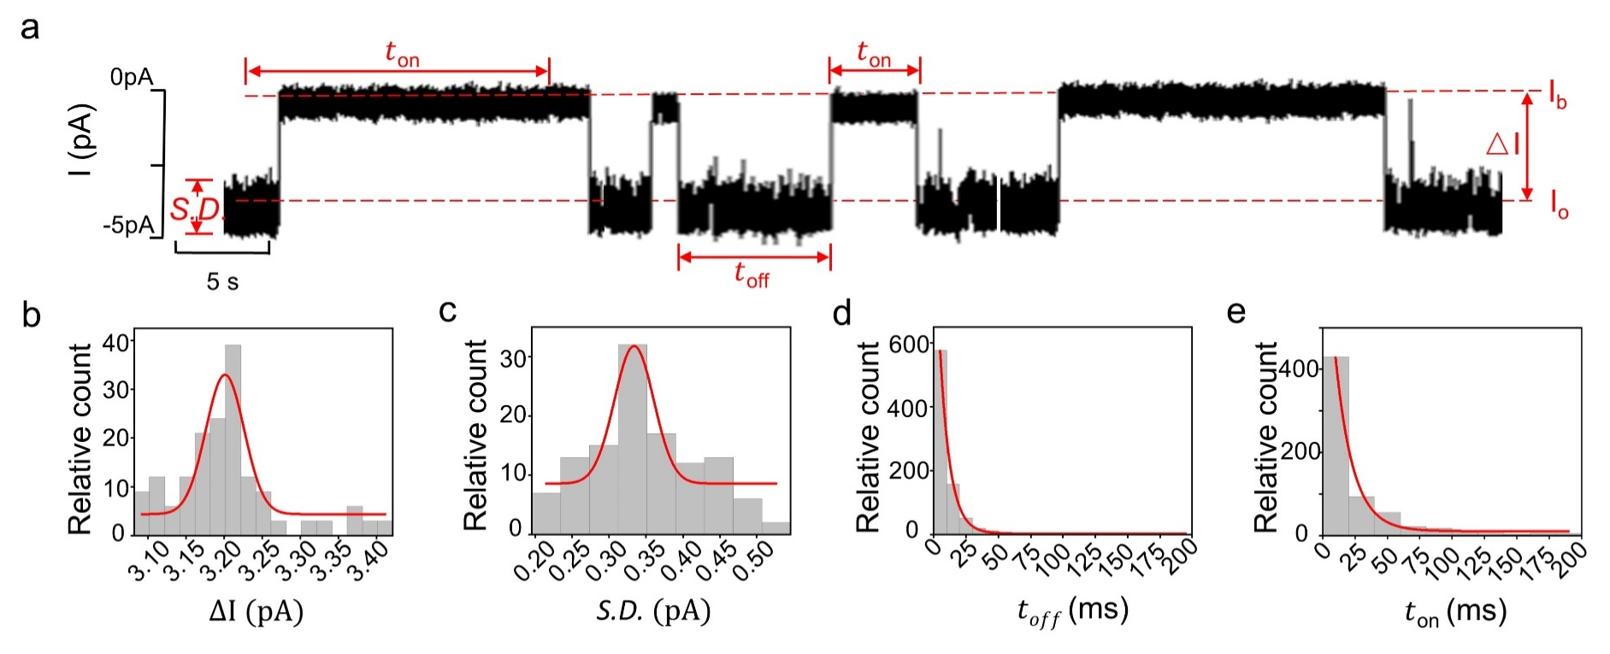
Supplementary Figure 1. The defined current events parameters in nanopore detection. (a) A representative current trace containing of nanopore electrical detection. The trace was acquired with anthrax nanopore and levorotary glutamine was treated as a model analyte. For demonstration, the trace was Butterworth low-pass filtered with a cut-off frequency of 100 Hz. 𝐼_{o} stands for the open-pore current and 𝐼_{b} stands for the current blockage when a single amino acid translocating through the nanopore. ∆𝐼 is defined as ∆𝐼 = 𝐼_{b}−𝐼_{o}. 𝑆. 𝐷. is the standard deviation of the event noise levels. 𝜏_{𝑜𝑓𝑓} represents the dwell time of the current blockages and 𝜏_{𝑜𝑛} represents the inter-event duration between the current blockages. The histogram of ∆𝐼 (b) and 𝑆. 𝐷. (c), Gaussian fittings were performed to obtain the mean ∆𝐼 and the mean 𝑆. 𝐷. (d-e) The histograms of 𝑡_{𝑜𝑓𝑓} (d) and 𝑡_{𝑜𝑛} (e). The mean dwell time (𝜏_{𝑜𝑓𝑓}) and the mean inter-event duration (𝜏_{𝑜𝑛}) were derived from single-exponential fitting following the equation 𝑦 = 𝑎 ∗ exp (−𝑥/𝜏). All parameters were statistically obtained by results from a continually recorded trace as demonstrated in (a).

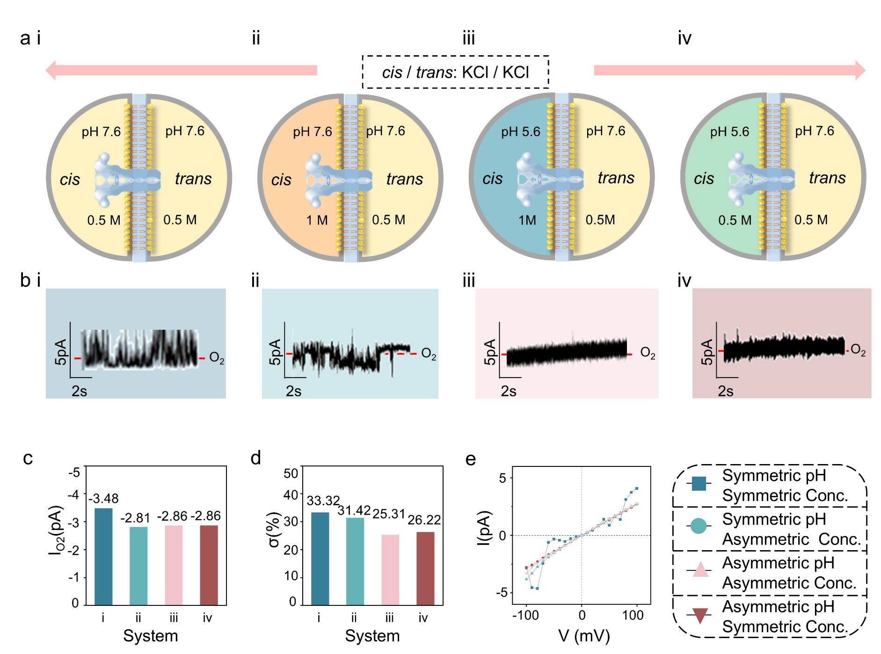
Supplementary Figure 2. Construction of anthrax nanopores in KCl system. (a) Cartoon showing the four KCl electrolyte systems. (i) cis/ trans: 0.5 M / 0.5 M, pH 7.6 / 7.6; (ii) cis/trans:1 M / 0.5 M, pH 7.6 / 7.6; (iii) cis/ trans: 1M / 0.5M, pH 5.6 / 7.6; (iv) cis/trans: 0.5 M / 0.5 M, pH 5.6 / 7.6. (b) Single-channel planar lipid bilayer records (black line) at four different buffer systems under -100 mV, filtered to 100 Hz. (c) Open pore currents Io₂. (d) Discrete constants (σ). (e) I-V curves from -100 mV to 100 mV at 10 mV steps. The statistical data were obtained by at least three independent experiments.

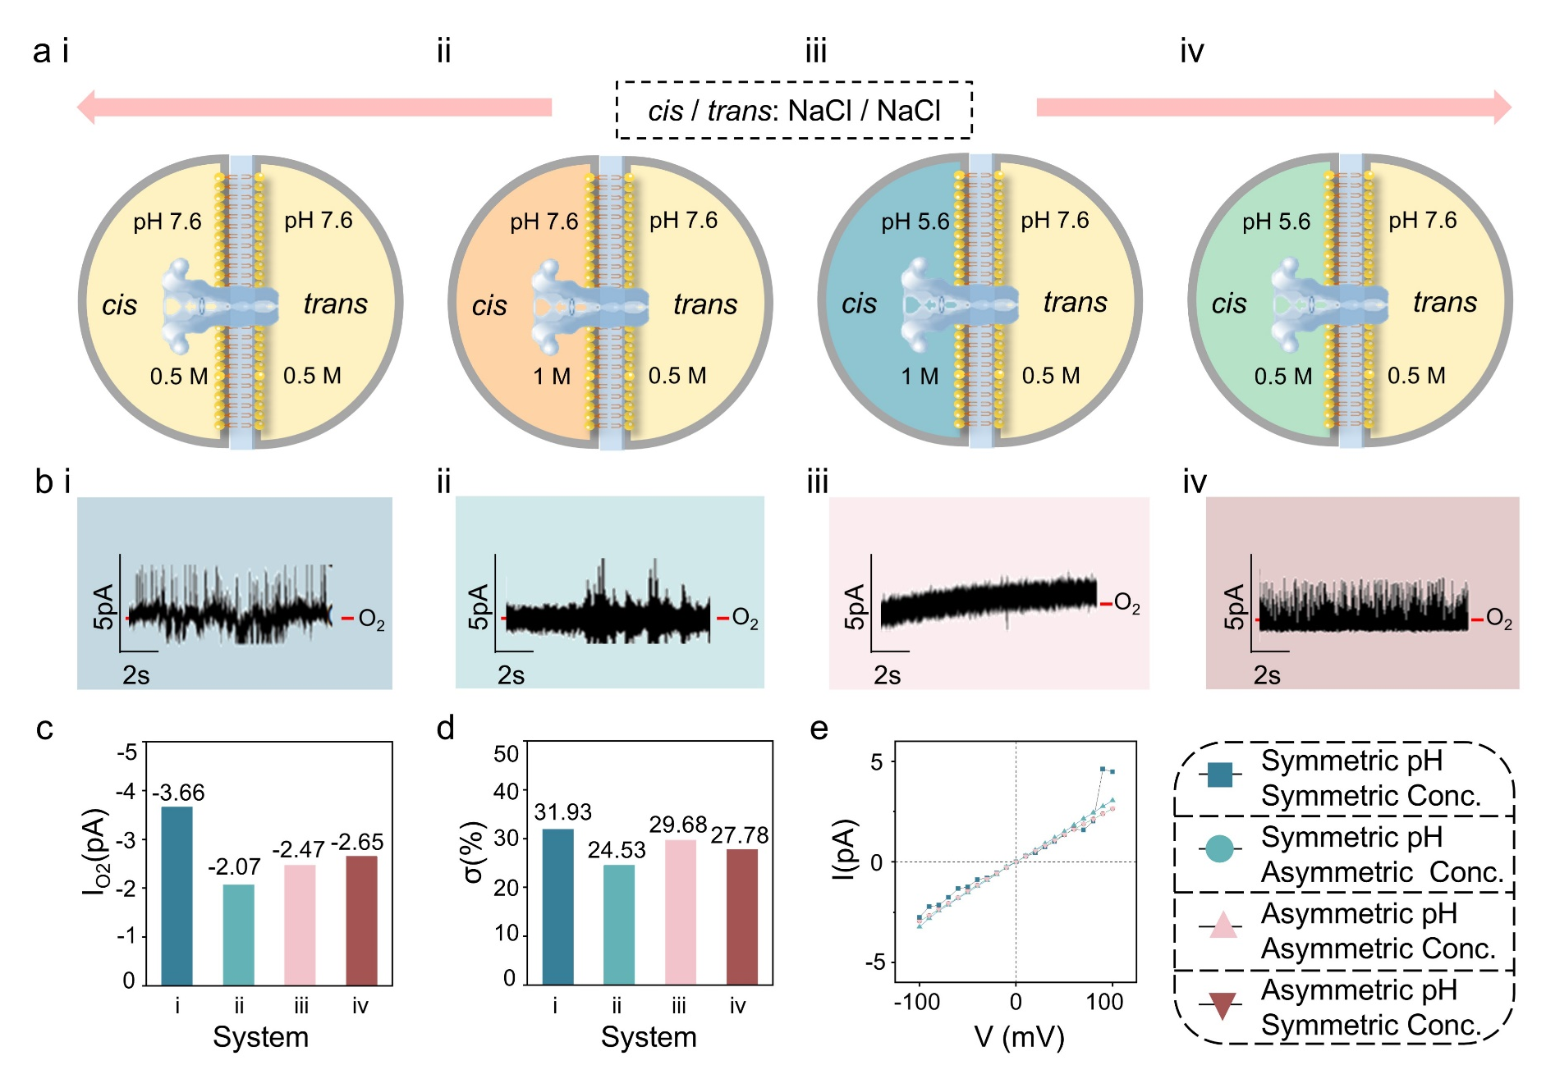
Supplementary Figure 3. Construction of anthrax nanopores in NaCl system. (a) Cartoon showing the four NaCl buffer systems. (i) cis/ trans: 0.5 M / 0.5 M, pH 7.6 / 7.6; (ii) cis/trans:1 M / 0.5 M, pH 7.6 / 7.6; (iii) cis/ trans: 1M / 0.5M, pH 5.6 / 7.6; (iv) cis/trans: 0.5 M / 0.5 M, pH 5.6 / 7.6. (b) Single-channel planar lipid bilayer records (black line) at four different buffer systems under -100 mV, filtered to 100 Hz. (c) Open pore currents Io₂. (d) Discrete constants (σ). (e) I-V curves from -100 mV to 100 mV at 10 mV steps. The statistical data were obtained by at least three independent experiments.

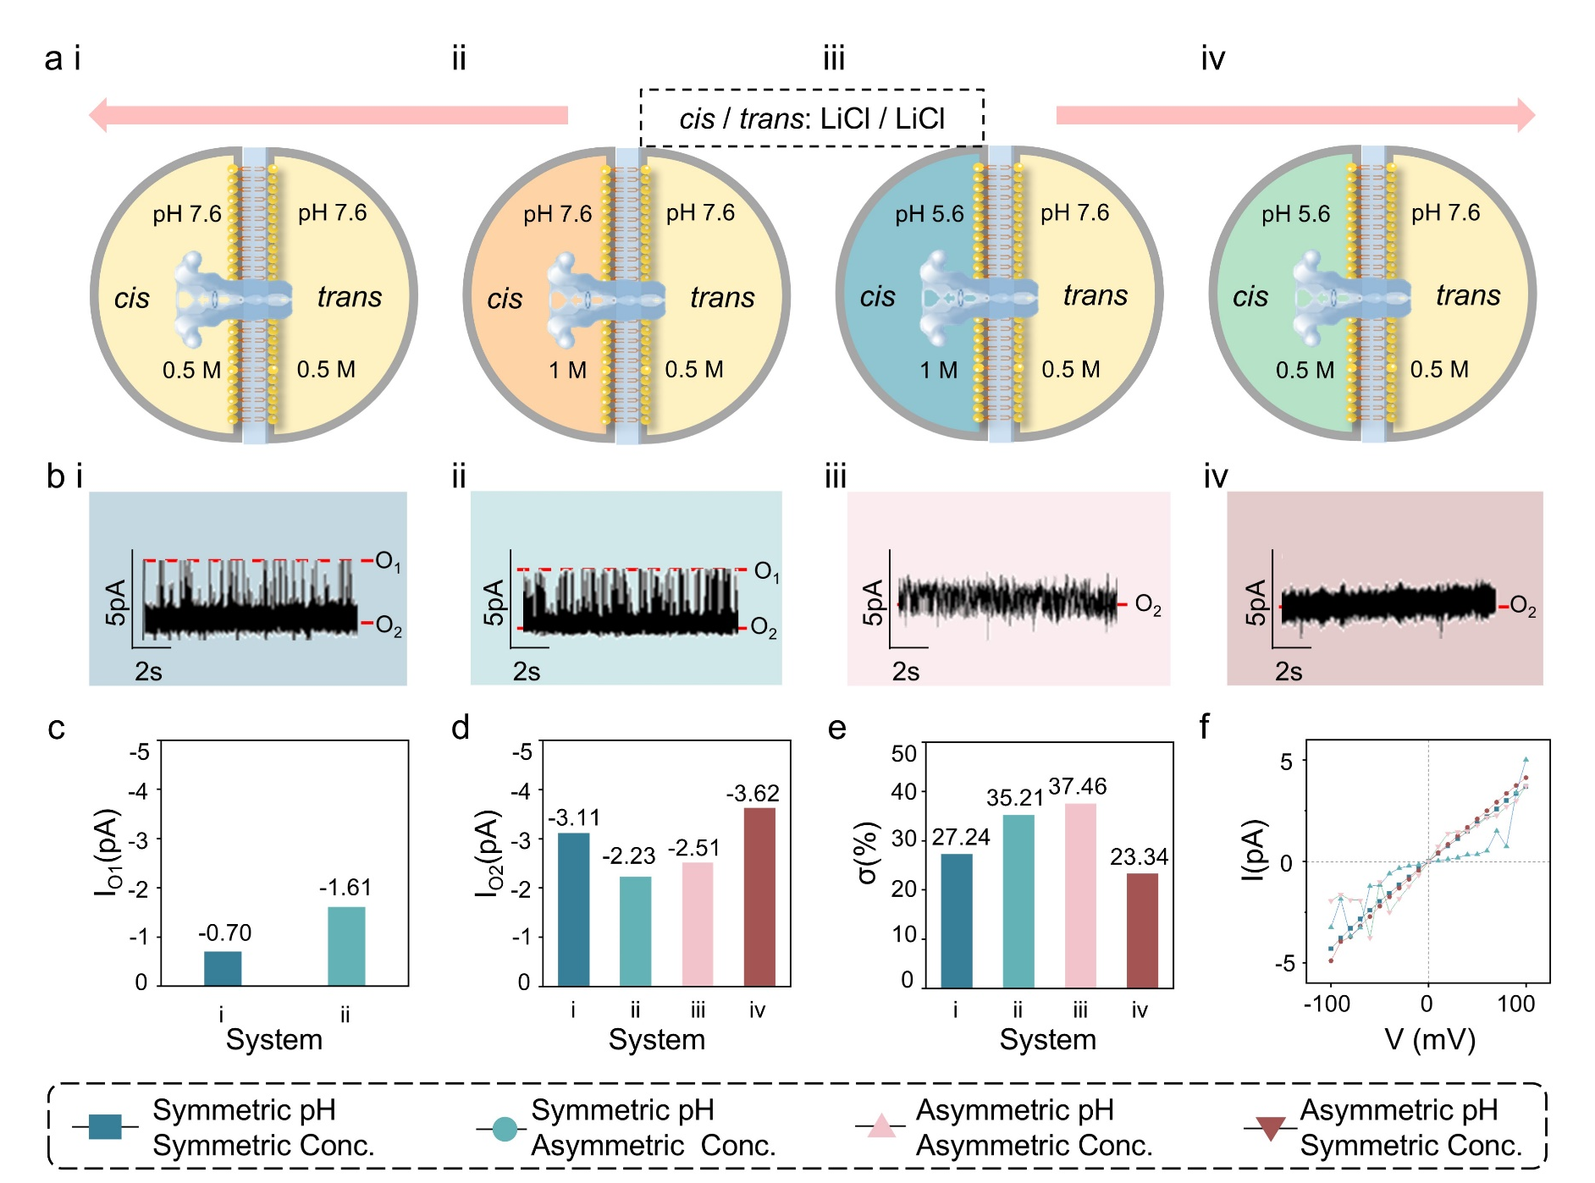
Supplementary Figure 4. Construction of anthrax nanopores in LiCl system. (a) Cartoon showing the four LiCl buffer systems. (i) cis/ trans: 0.5 M / 0.5 M, pH 7.6 / 7.6; (ii) cis/trans:1 M / 0.5 M, pH 7.6 / 7.6; (iii) cis/ trans: 1M / 0.5M, pH 5.6 / 7.6; (iv) cis/trans: 0.5 M / 0.5 M, pH 5.6 / 7.6. (b) Single-channel planar lipid bilayer records (black line) at four different buffer systems under -100 mV, filtered to 100 Hz. (c) Open pore currents Io₂. (d) Discrete constants (σ). (e) I-V curves from -100 mV to 100 mV at 10 mV steps. The statistical data were obtained by at least three independent experiments.

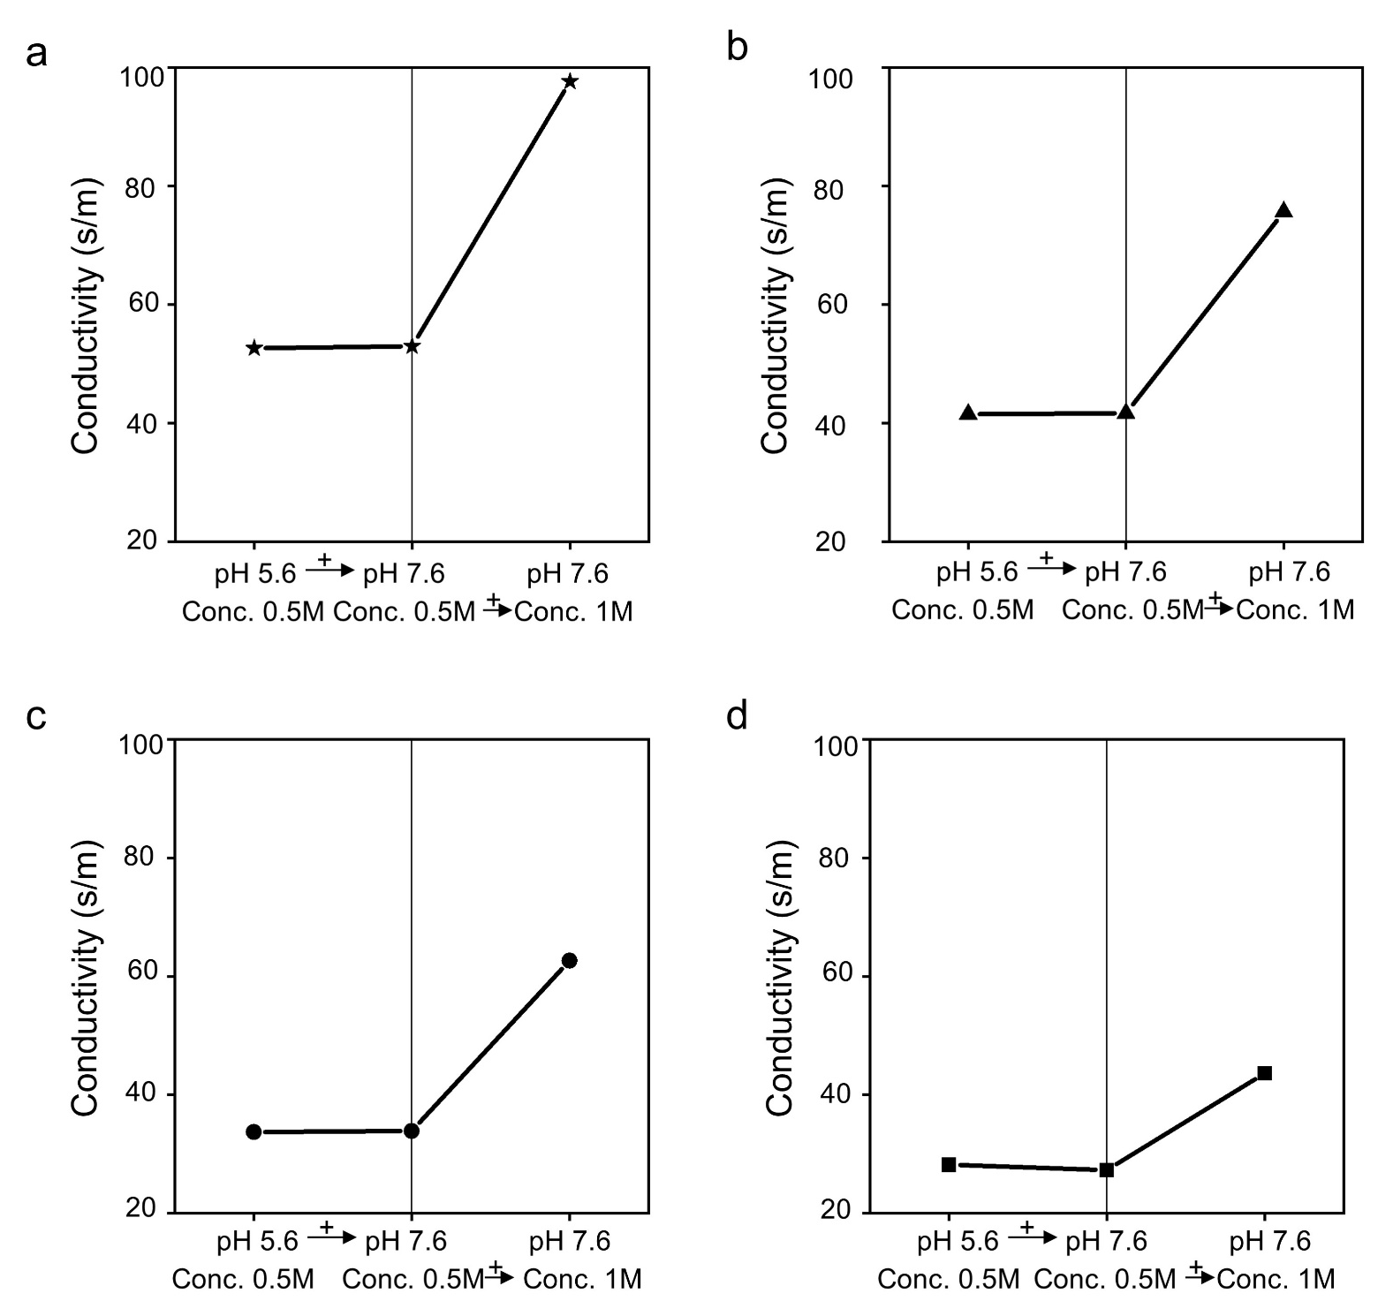Supplementary Figure 5. Electrical conductivity determined under various electrolyte conditions. (a) KCl. (b) NaCl. (c) LiCl. (d) [BMIM]Cl. The statistical data were obtained by at least three independent experiments.

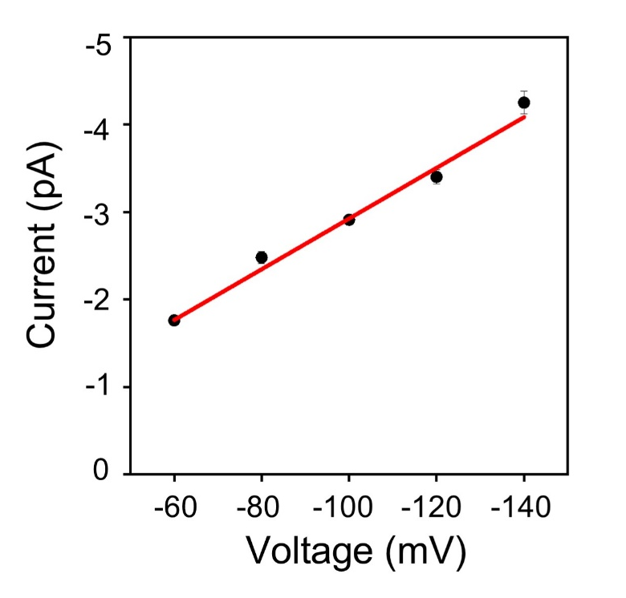
Supplementary Figure 6. Voltage-dependent study on opening pore current. The open current of anthrax nanopore increases with the applied voltage elevated in linear. Conditions: (cis) 0.5 M [BMIM]Cl and 10 mM tris at pH 5.6; (trans) 0.5 M [BMIM]Cl and 10 mM tris at pH 7.6. The statistical data were obtained by at least three independent experiments.

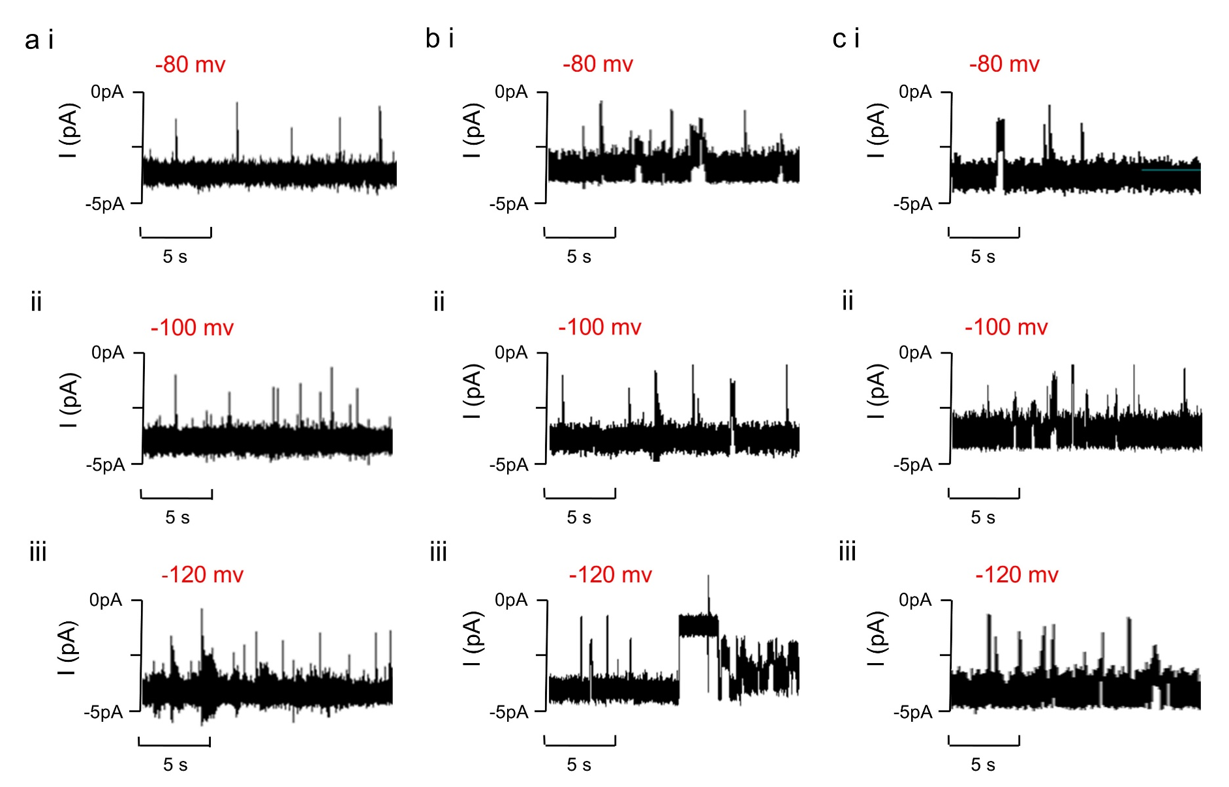
Supplementary Figure 7. Voltage-dependent detection of levorotary arginine, tyrosine, and glutamine. Representative nanopore current traces of three amino acids at (a) -80 mV; (b) -100 mV; (c) -120 mV. (i) Arginine; (ii) Tyrosine; (iii) Glutamine. Conditions: (cis) 0.5 M [BMIM]Cl and 10 mM tris at pH 5.6; (trans) 0.5 M [BMIM]Cl and 10 mM tris at pH 7.6. The statistical data were obtained by at least three independent experiments.

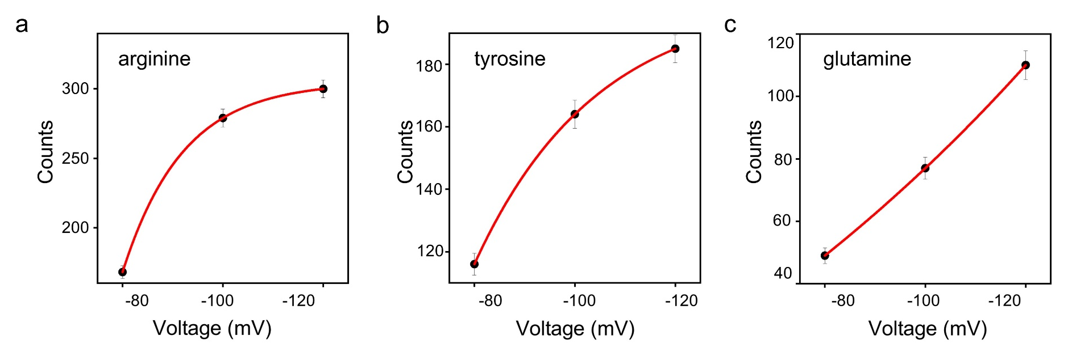
Supplementary Figure 8. Voltage-dependent signal counts of levorotary arginine, tyrosine and glutamine. (a) Arginine; (b) Tyrosine; (c) Glutamine. Conditions: (cis) 0.5 M [BMIM]Cl and 10 mM tris at pH 5.6; (trans) 0.5 M [BMIM]Cl and 10 mM tris at pH 7.6. The applied potential bias ranging -80 ~ -120 mV was used for the detection. The statistical data were obtained by at least three independent experiments.

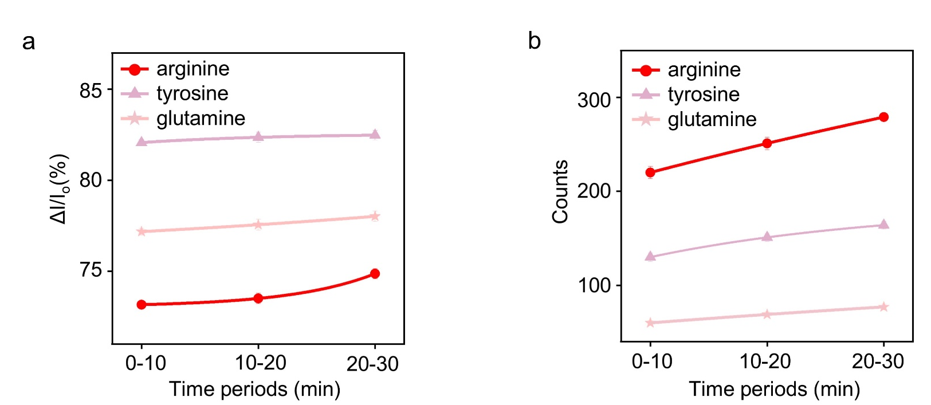
Supplementary Figure 9. Time related ΔI/I_{o} and signal counts of levorotary arginine tyrosine and glutamine detection. (a) Δ I/I_{o}; (b) Signal counts. Conditions: (cis) 0.5 M [BMIM]Cl and 10 mM tris at pH 5.6; (trans) 0.5 M [BMIM]Cl and 10 mM tris at pH 7.6. The applied potential bias of -100 mV was used for the detection. The statistical data were obtained by at least three independent experiments.

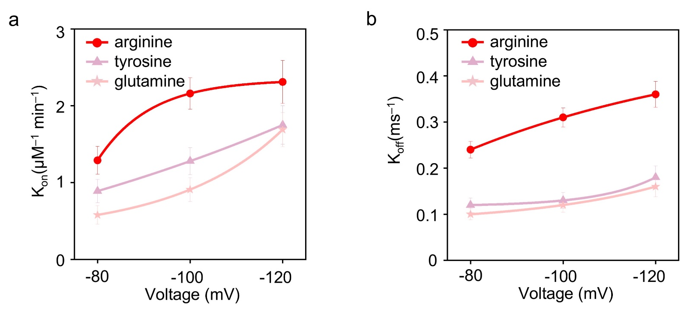
Supplementary Figure 10. The binding kinetics of levorotary arginine tyrosine and glutamine. (a) K_{on}; (b) K_{off}. Conditions: (cis) 0.5 M [BMIM]Cl and 10 mM tris at pH 5.6; (trans) 0.5 M [BMIM]Cl and 10 mM tris at pH 7.6. The applied potential bias ranging -80 ~ -120 mV was used for the detection. The statistical data were obtained by at least three independent experiments.

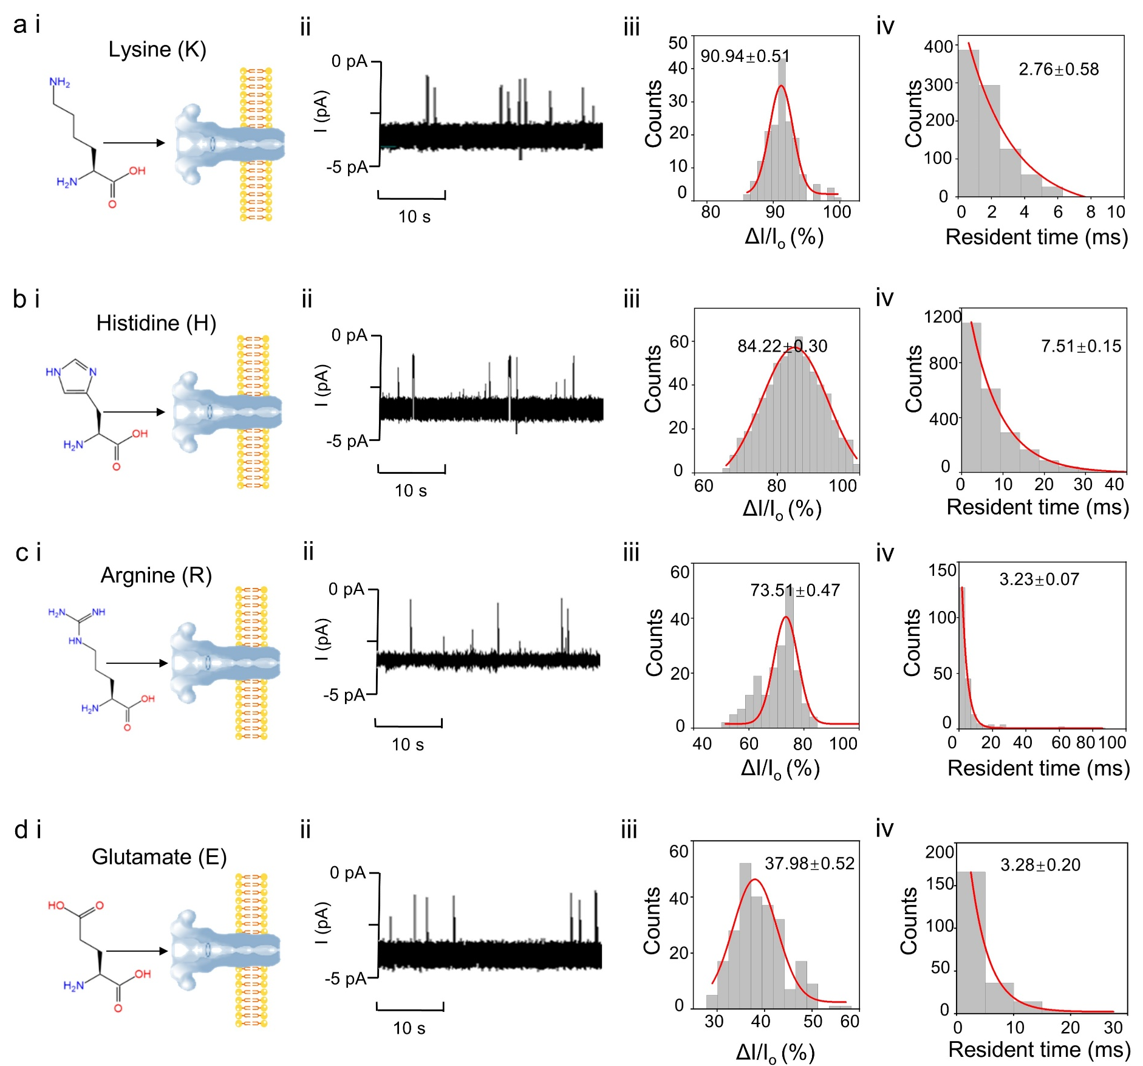
Supplementary Figure 11: Single molecule detection of levorotary charged amino acids. (a) Lysine; (b) Histidine; (c) Arginine; (d) Glutamate. (i) Cartoon of the amino acids detection in anthrax nanopore; (ii) Representative nanopore current traces; (iii) Statistical distribution of ∆I/I_{o}. (iv) Statistical distribution of dwell time. Conditions: (cis) 0.5 M [BMIM]Cl and 10 mM tris at pH 5.6; (trans) 0.5 M [BMIM]Cl and 10 mM tris at pH 7.6. The applied potential bias of -100 mV was used for the detection. The statistical data were obtained by at least three independent experiments.

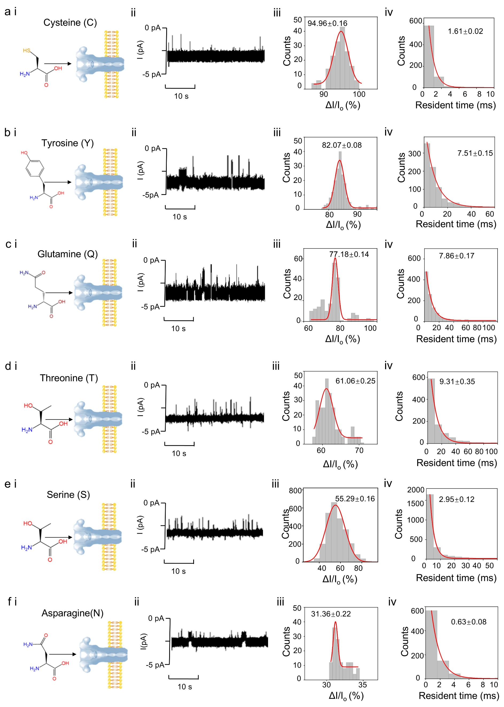
Supplementary Figure 12: Single molecule detection of levorotary polar amino acids. (a) Cysteine; (b) Tyrosine; (c) Glutamine; (d) Threonine; (e) Serine; (f) Asparagine. (i) Cartoon of the amino acids detection in anthrax nanopore; (ii) Representative nanopore current traces; (iii) Statistical distribution of ∆I/I_{o}. (iv) Statistical distribution of dwell time. Conditions: (cis) 0.5 M [BMIM]Cl and 10 mM tris at pH 5.6; (trans) 0.5 M [BMIM]Cl and 10 mM tris at pH 7.6. The applied potential bias of -100 mV was used.

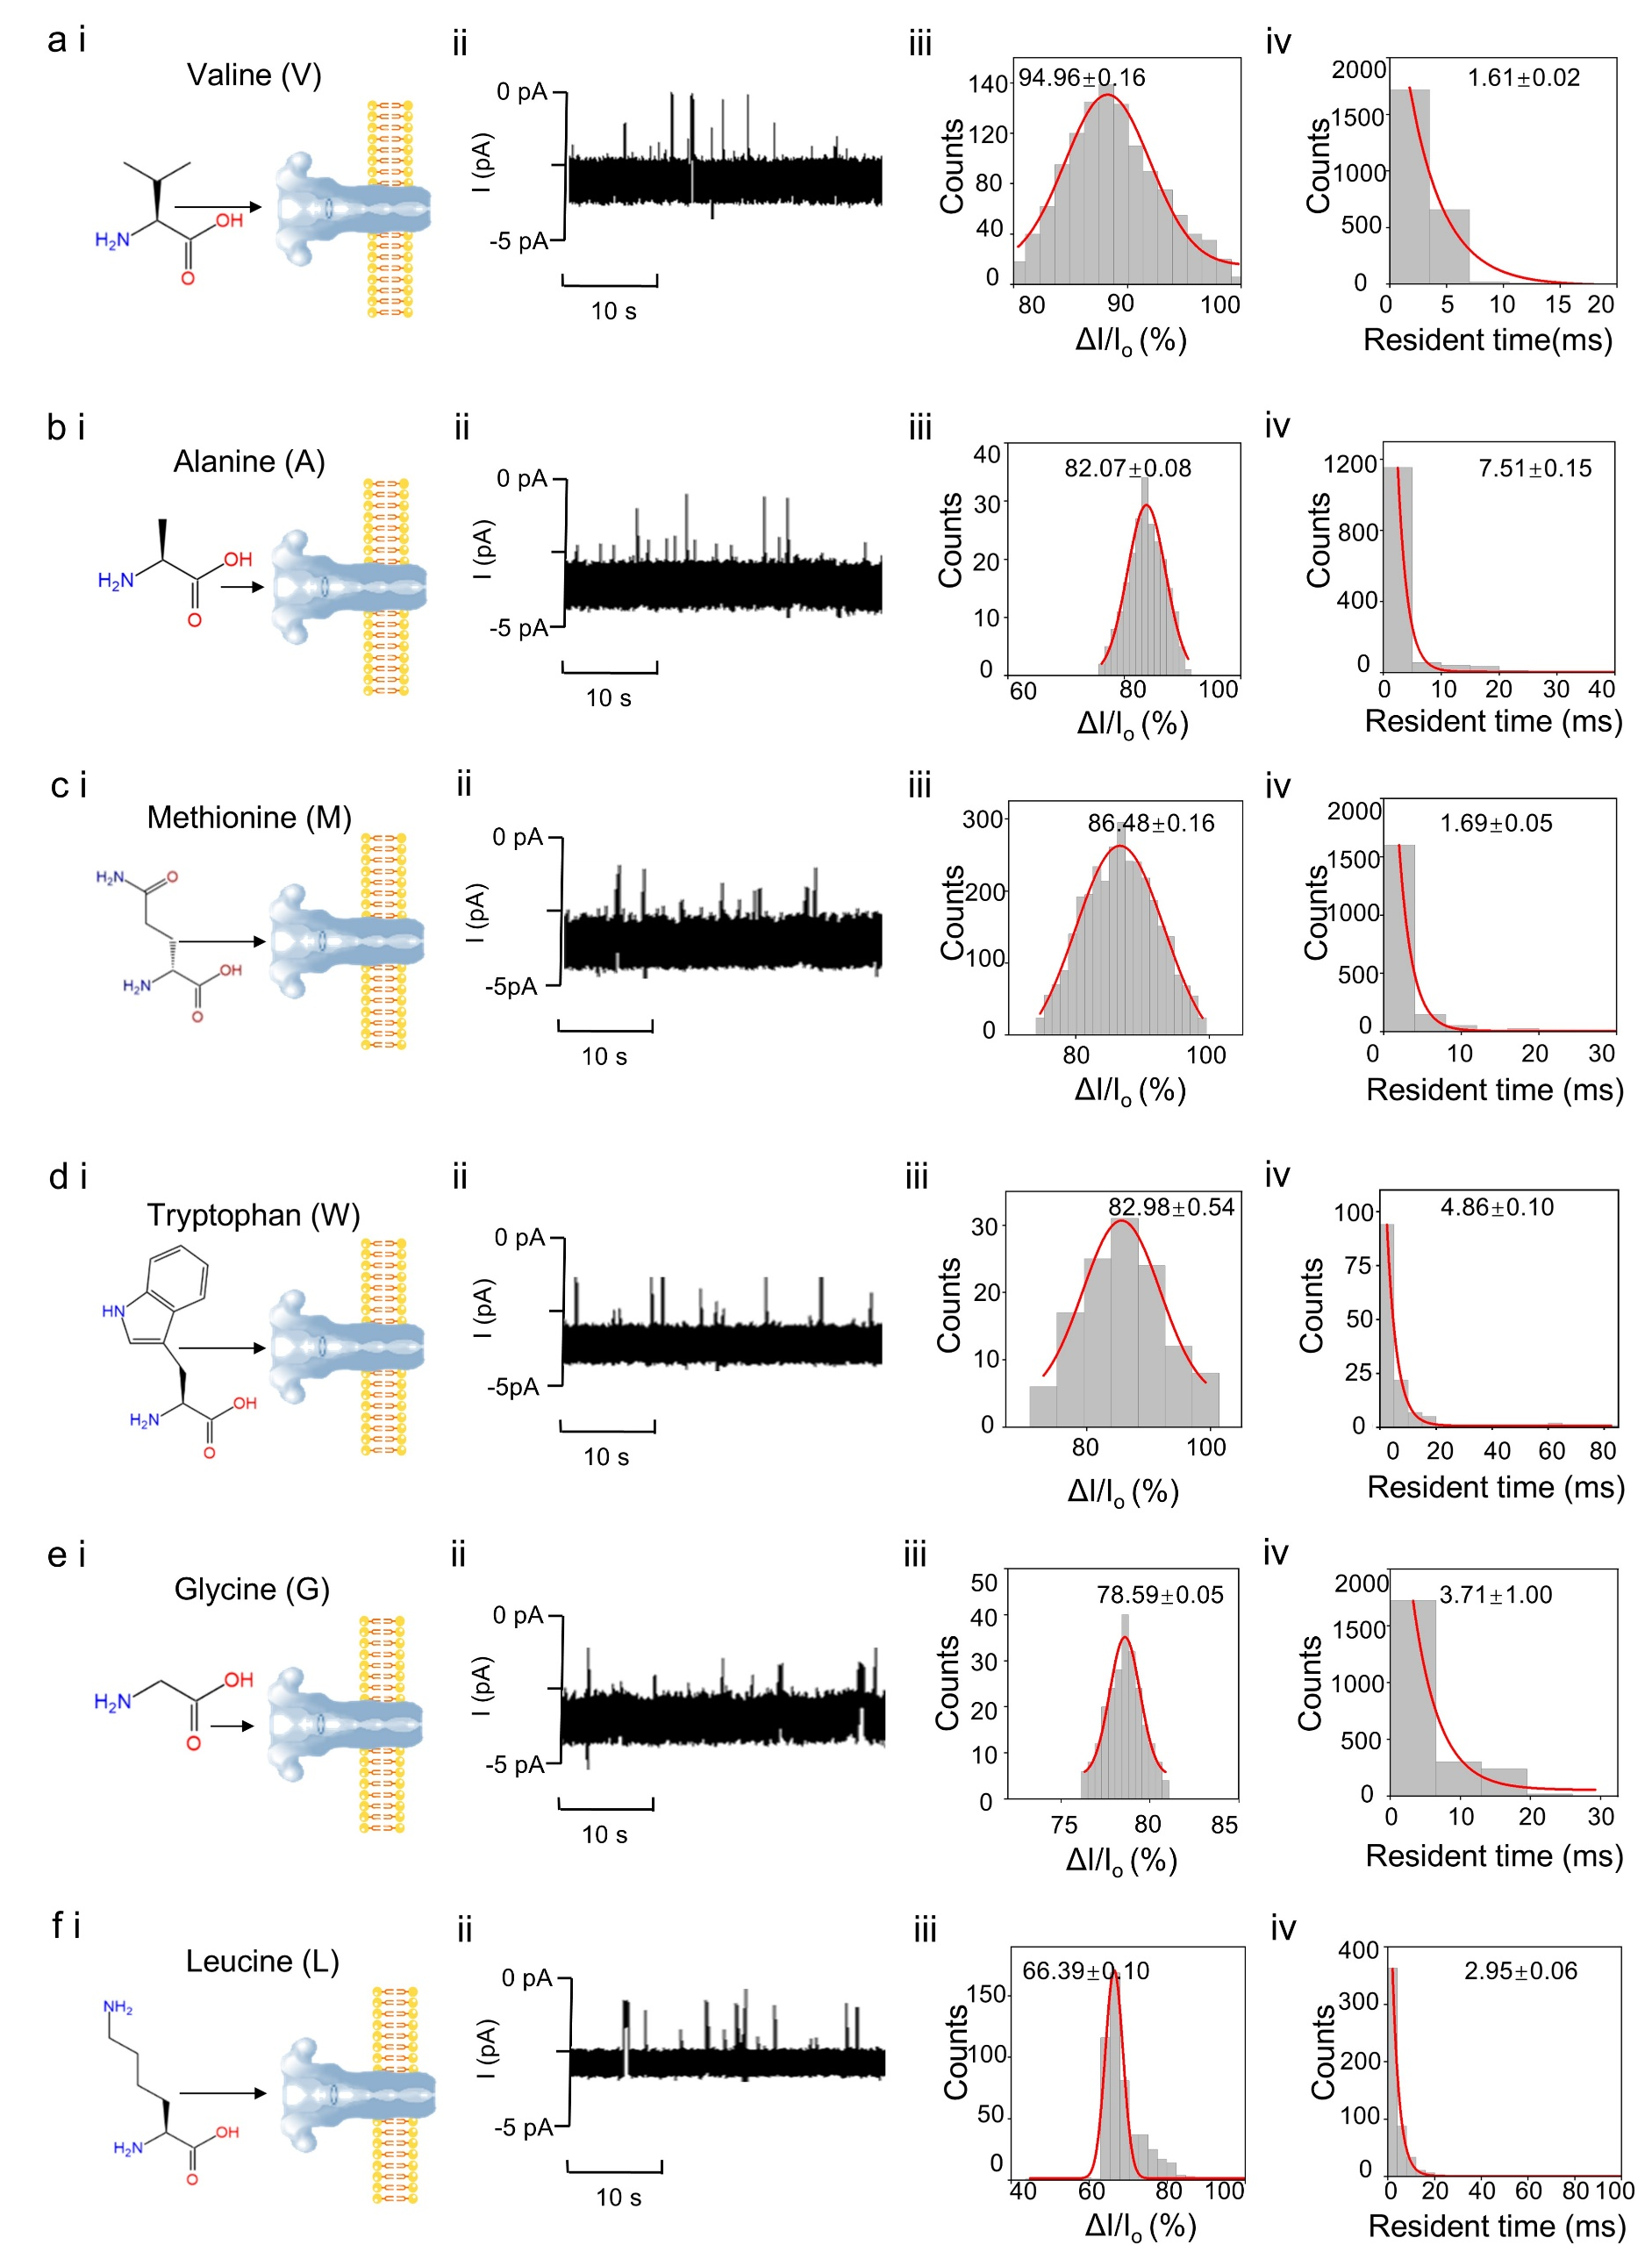

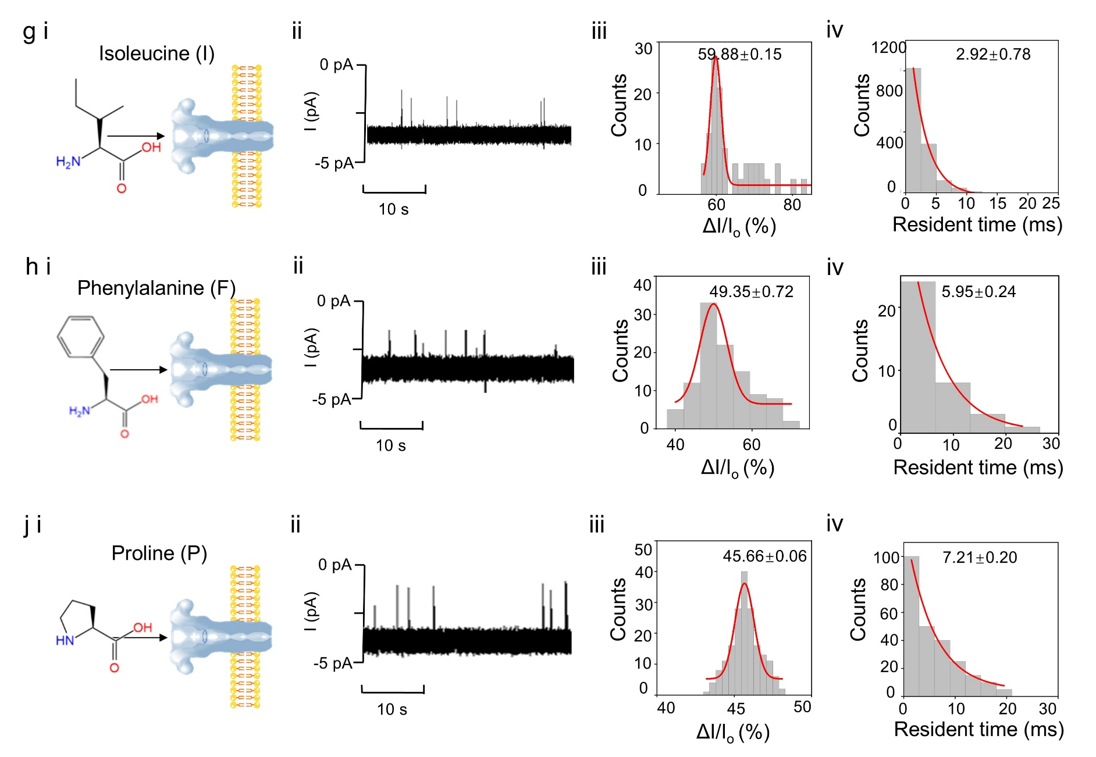
Supplementary Figure 13: Single molecule detection of levorotary non-polar amino acids. (a) Valine; (b) Alanine; (c) Methionine; (d) Tryptophan; (e) Glycine; (f) Leucine. (g) Isoleucine (h) Phenylalanine (j) Proline. (i) Cartoon of the amino acids detection in anthrax nanopore; (ii) Representative nanopore current traces; (iii) Statistical distribution of ∆I/I_{o}. (iv) Statistical distribution of dwell time. Conditions: (cis) 0.5 M [BMIM]Cl and 10 mM tris at pH 5.6; (trans) 0.5 M [BMIM]Cl and 10 mM tris at pH 7.6. The applied potential bias of -100 mV was used. The statistical data were obtained by at least three independent experiments.

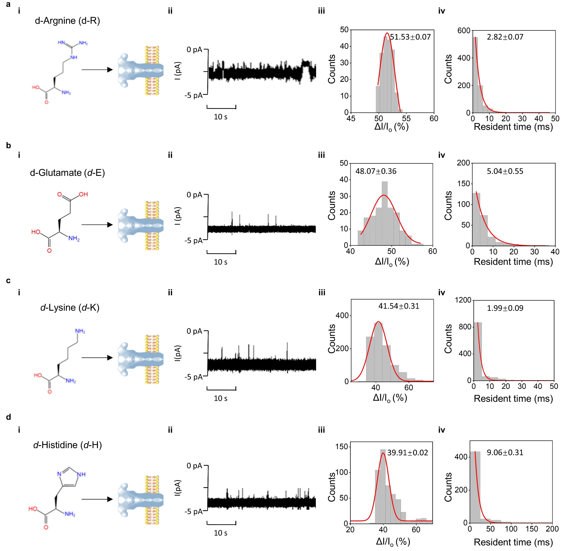
Supplementary Figure 14: Single molecule detection of dextrorotary (d-) charged amino acids. (a) Arginine; (b) Glutamate; (c) Lysine; (d) Histidine. (i) Cartoon of the amino acids detection in anthrax nanopore; (ii) Representative nanopore current traces; (iii) Statistical distribution of ∆I/I_{o}. (iv) Statistical distribution of dwell time. Conditions: (cis) 0.5 M [BMIM]Cl and 10 mM tris at pH 5.6; (trans) 0.5 M [BMIM]Cl and 10 mM tris at pH 7.6. The applied potential bias of -100 mV was used for the detection. The statistical data were obtained by at least three independent experiments.

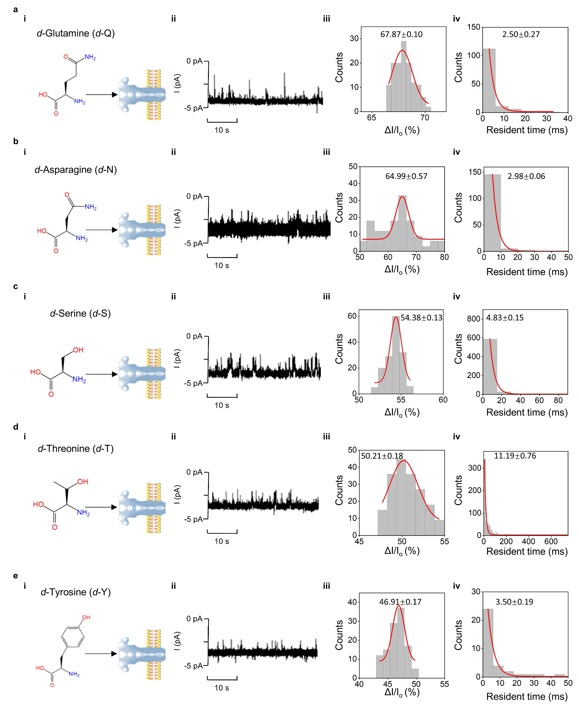
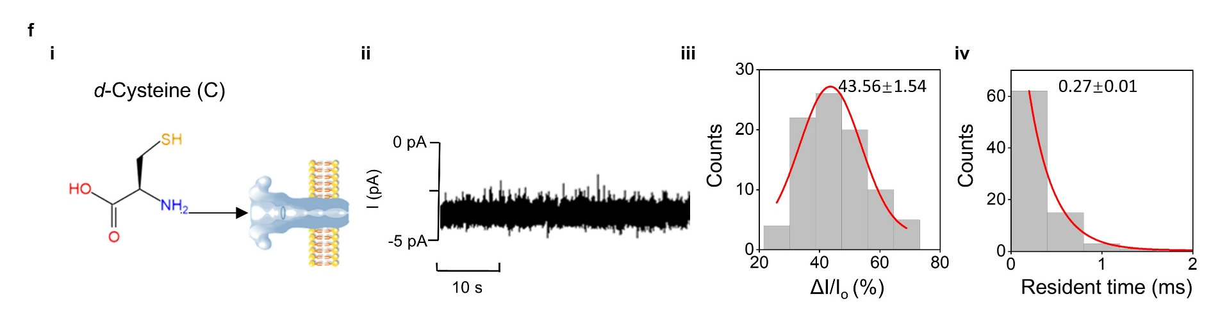
Supplementary Figure 15: Single molecule detection of dextrorotary (d-) polar amino acids. (a) Glutamine; (b) Asparagine; (c) Serine; (d) Threonine; (e) Tyrosine; (f) Cysteine. (i) Cartoon of the amino acids detection in anthrax nanopore; (ii) Representative nanopore current traces; (iii) Statistical distribution of ∆I/I_{o}. (iv) Statistical distribution of dwell time. Conditions: (cis) 0.5 M [BMIM]Cl and 10 mM tris at pH 5.6; (trans) 0.5 M [BMIM]Cl and 10 mM tris at pH 7.6. The applied potential bias of -100 mV was used.

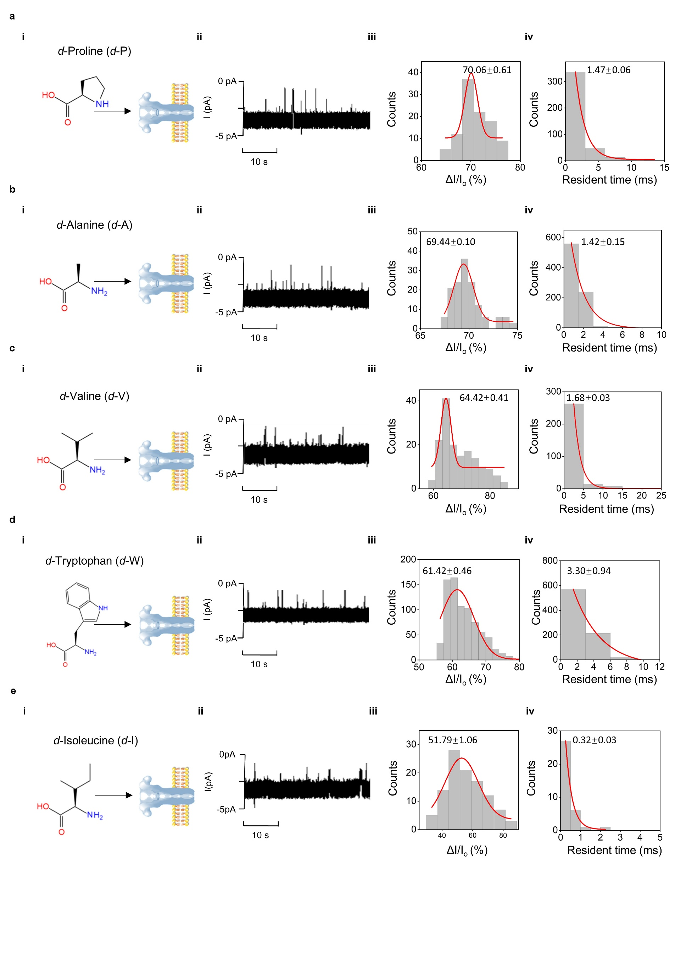
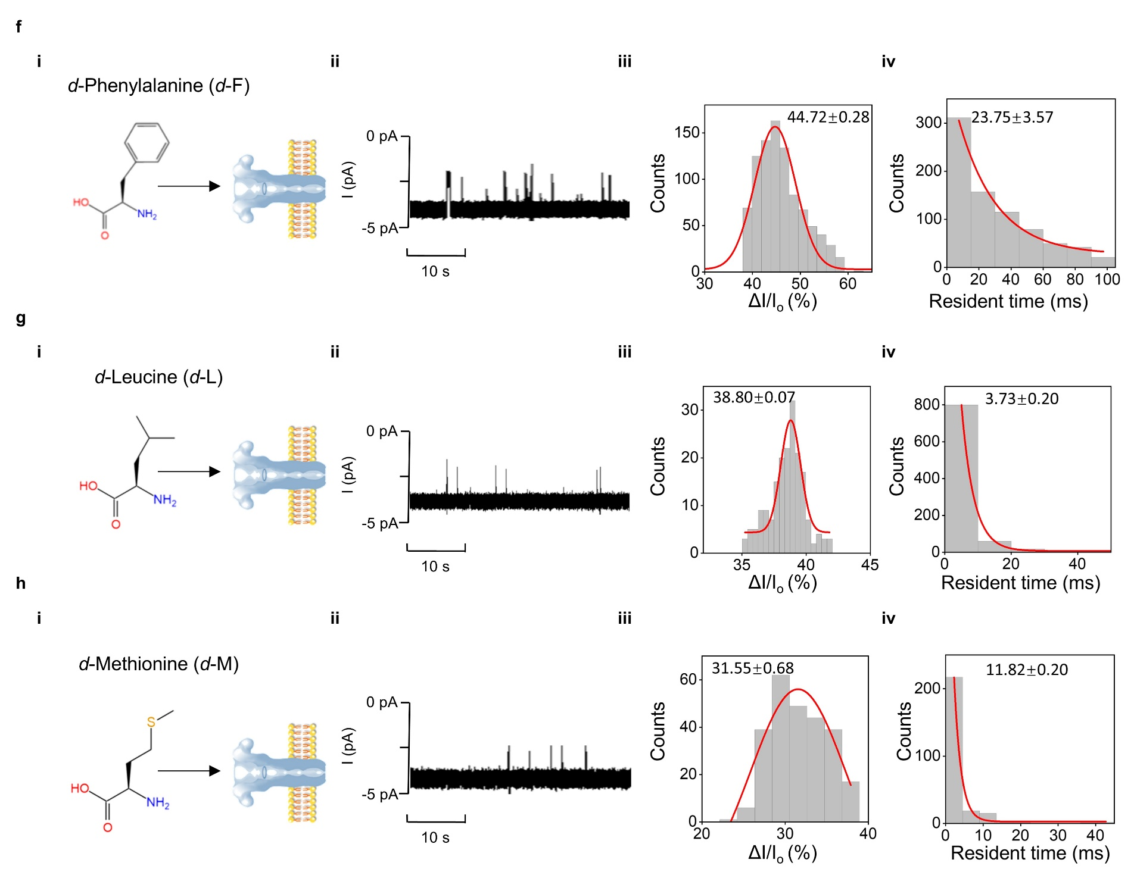
Supplementary Figure 16: Single molecule detection of dextrorotary (d-) non-polar amino acids. (a) Proline; (b) Alanine; (c) Valine; (d) Tryptophan; (e) Isoleucine; (f) Phenylalanine; (h) (g) Leucine; (h) Methionine. (i) Cartoon of the amino acids detection in anthrax nanopore; (ii) Representative nanopore current traces; (iii) Statistical distribution of ∆I/I_{o}. (iv) Statistical distribution of dwell time. Conditions: (cis) 0.5 M [BMIM]Cl and 10 mM tris at pH 5.6; (trans) 0.5 M [BMIM]Cl and 10 mM tris at pH 7.6. The applied potential bias of -100 mV was used. The statistical data were obtained by at least three independent experiments.

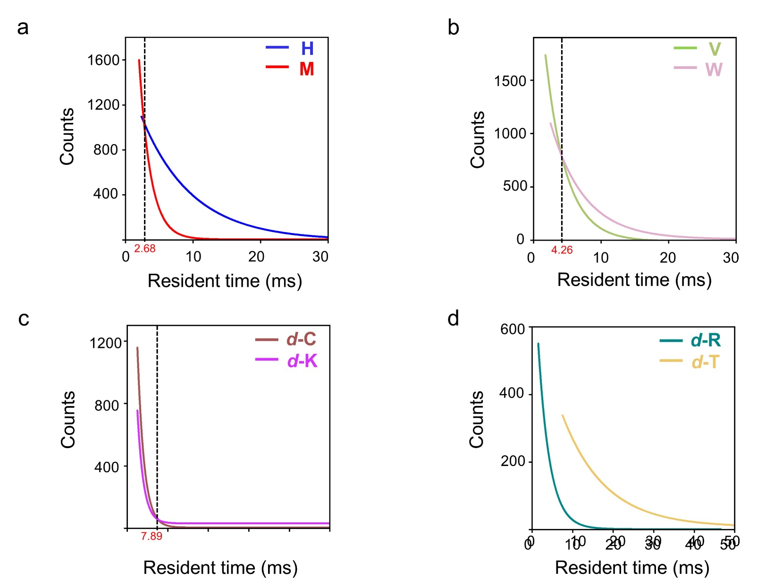
Supplementary Figure 17: Simultaneous detection of mixed amino acids. (a) Determined dwell times for mixed levorotary histidine and levorotary methionine, blue represents histidine, red represents methionine. (b) Determined dwell times for mixed detection of levorotary valine and levorotary tryptophan, green represents valine, purple represents tryptophan. (c) Determined dwell times for mixed for mixed dextrorotary (d-) cysteine and dextrorotary (d-) lysine, brown represents d-cysteine, rose red represents d-lysine. (d) Determined dwell times for mixed dextrorotary (d-) arginine and dextrorotary (d-) threonine, ching represents d-arginine, yellow represents d-threonine. Conditions: (cis) 0.5 M [BMIM]Cl and 10 mM tris at pH 5.6; (trans) 0.5 M [BMIM]Cl and 10 mM tris at pH 7.6. The applied potential bias of -100 mV was used. The statistical data were obtained by at least three independent experiments.

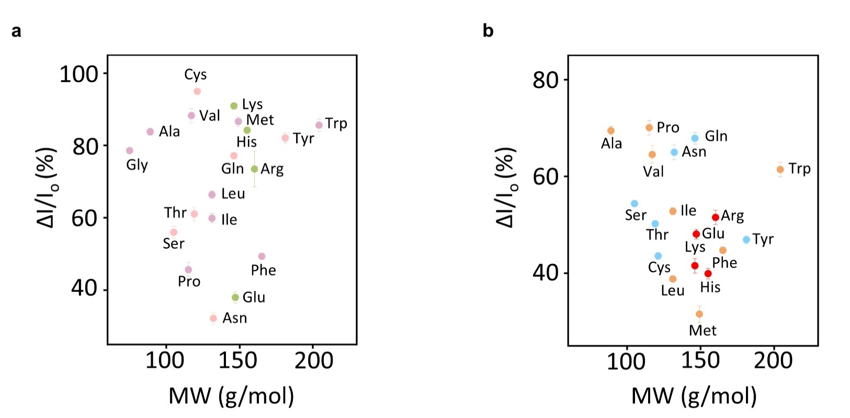
Supplementary Figure 18: Plots of ΔI/I_{o} vs. molecular mass of amino acids. (a) Levorotary amino acids, charged, polar, and non-polar amino acids are represented in green pink and purple, respectively. (b) Dextrorotary amino acids, charged, polar, and non-polar amino acids are represented in red orange and blue, respectively. Conditions: (cis) 0.5 M [BMIM]Cl and 10 mM tris at pH 5.6; (trans) 0.5 M [BMIM]Cl and 10 mM tris at pH 7.6. The applied potential bias of -100 mV was used. The statistical data were obtained by at least three independent experiments.

Supplementary Table.1 Electrical conductivity determiend under various conditions.
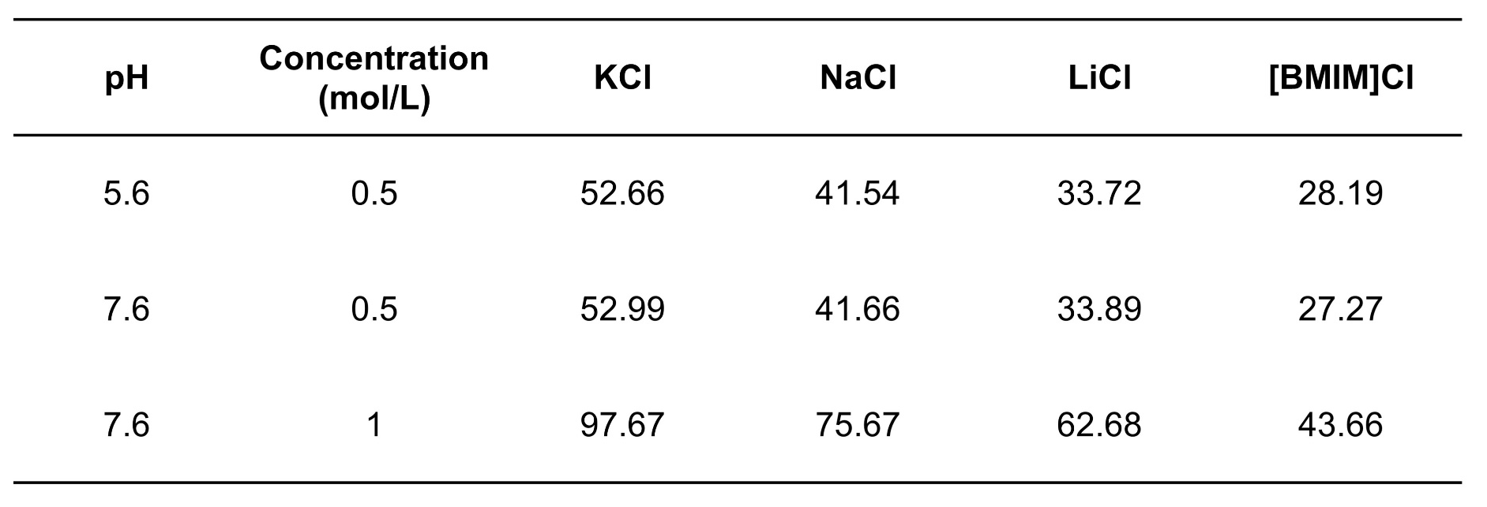

Supplementary Table 2. The isoelectric points, volumes and the molecular weights (MW) of twenty proteinogenic amino acids.
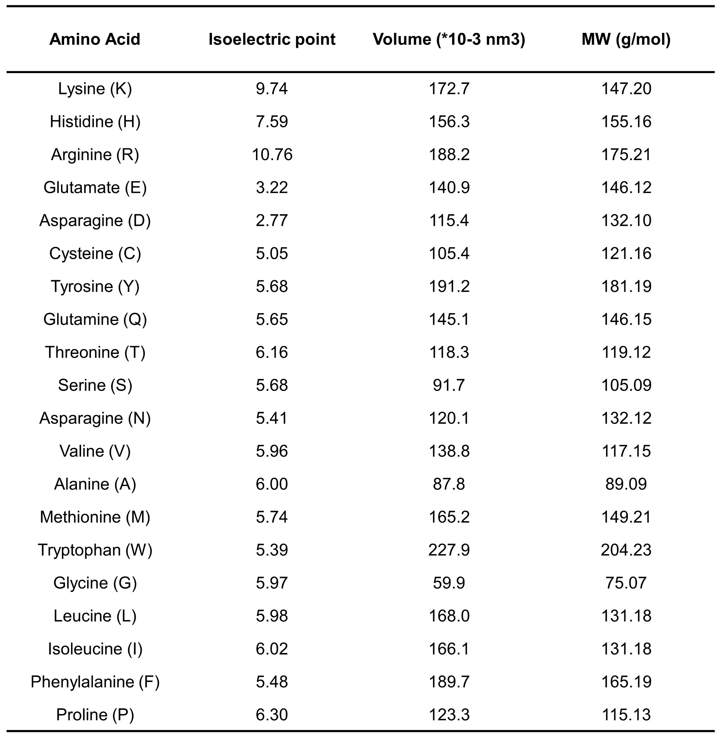

Supplementary Table 3.Opening currents under different voltages
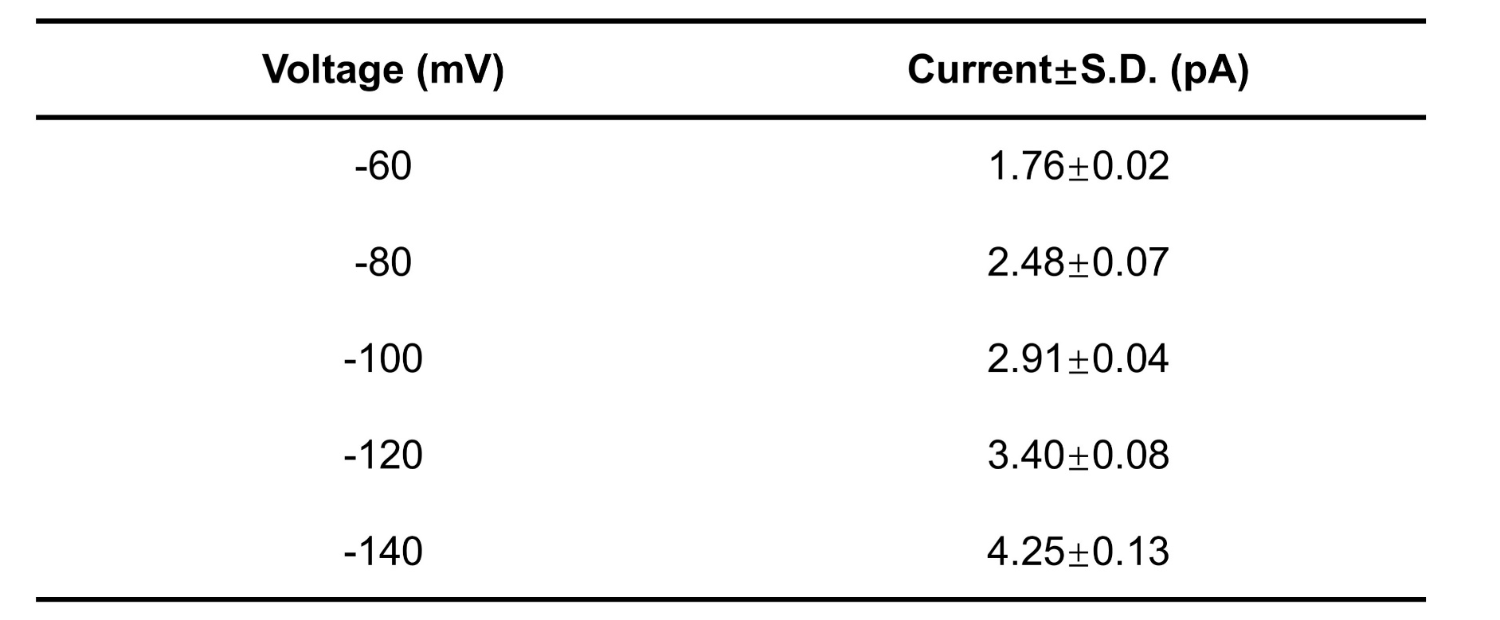
S.D. means standard deviation of event noise levels.

