Supplemental Materials
Efficiently charting the space of mixed vacancy-ordered perovskites by machine-learning encoded atomic-site information
Fan Zhang¹, Li Fu¹, Weiwei Gao^{1*}, Peihong Zhang², Jijun Zhao^{3*}
- Key Laboratory of Material Modification by Laser, Ion and Electron Beams (Dalian University of Technology), Ministry of Education, Dalian 116024, China
- Department of Physics, State University of New York at Buffalo, Buffalo, New York 14260, USA
- Guangdong Basic Research Center of Excellence for Structure and Fundamental Interactions of Matter, Guangdong Provincial Key Laboratory of Quantum Engineering and Quantum Materials, School of Physics, South China Normal University, Guangzhou 510006, China

Fig. S1 DFT and GW band structure for Cs₂MI₆ (M = Pd, Pt, Ti, Sn, Te, Zr and Hf). Since the band structure of Cs₂PdI₆ and Cs₂SnI₆ within PBEsol functional are metallic, here the GW scissor shift are calculated within PBE functional.
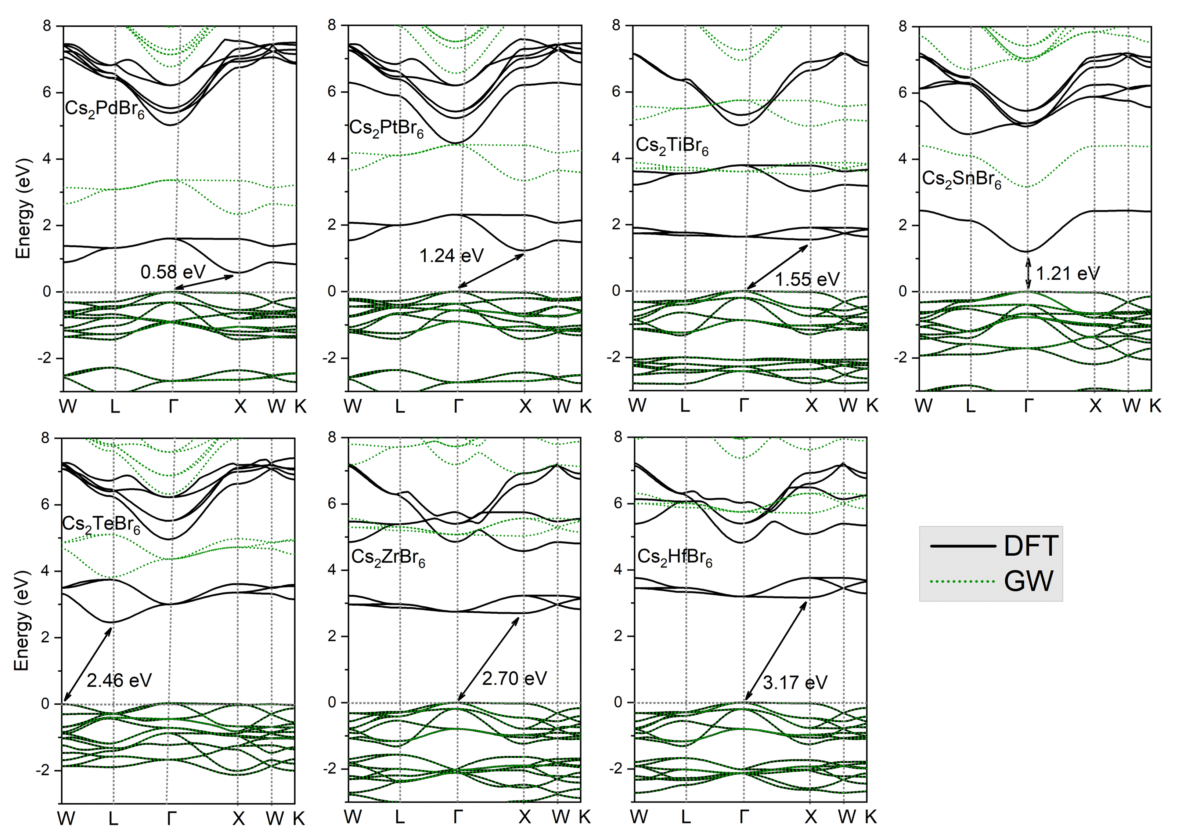
Fig. S2 DFT and GW band structure for Cs₂MBr₆ (M = Pd, Pt, Ti, Sn, Te, Zr and Hf).

Fig. S3 DFT and GW band structure for Cs₂MCl₆ (M = Pd, Pt, Ti, Sn, Te, Zr and Hf).
Fig. S4. Effect of different ratios of element doping at A, M and X sites in A₂MX₆ on the (a) formation energy and (b) bulk modulus.

Fig. S5. RMSE of DFT band gap predictions on a 10% subset of the augmented dataset, with different atomic layers and hidden layer nodes in our GNN model.

TABLE S1. Electron (m_{e}) and hole (m_{h}) effective masses in m₀ unit of pure VODPs Cs₂MX₆.
Cs₂MX₆ | Cl |  | Br |  | I
 | m_{e} (direction) | m_{h} (direction) | m_{e} (direction) | m_{h} (direction) | m_{e} (direction) | m_{h} (direction)
Pd | 0.94 (X→W)  0.81 (X→Γ) | 3.06 (Γ→L) | 0.38 (X→W)  0.41 (X→Γ) | 1.50 (Γ→L) | 0.35 (X→W) 0.44 (X→Γ) | 1.47 (Γ→L)
Pt | 0.56 (X→Γ)  0.71 (X→W) | 3.31 (X→Γ) | 0.41 (X→Γ)  0.43 (X→W) | 1.54 (Γ→L) | 0.36 (X→Γ) 0.29 (X→W) | 1.21 (Γ→L)
Ti | 2.34 (X→W) | 2.84 (Γ→L) | 1.02 (X→W) | 1.48 (Γ→L) | 0.77 (X→W) | 1.19 (Γ→L)
Sn | 0.59 (Γ→X)  0.59 (Γ→L) | 2.95 (Γ→L) | 0.28 (Γ→X)  0.28 (Γ→L) | 1.55 (Γ→L) | 0.24 (Γ→X) 0.24 (Γ→L) | 1.59 (Γ→L)
Te | 0.49 (L→W)  0.88 (L→Γ) | 1.80 (W→L) | 0.53 (L→Γ)  0.28 (L→W) | 1.02 (W→L) | 0.31 (L→Γ) 0.17 (L→W) | 1.02 (Γ→L)
Zr | 1.70 (X→W) | 2.94 (Γ→L) | 0.80 (X→W) | 1.55 (Γ→L) | 0.51 (X→W) | 1.03 (Γ→L)
Hf | 1.36 (X→W) | 3.18 (Γ→L) | 0.75 (X→W) | 1.55 (Γ→L) | 0.64 (X→W) | 1.29 (Γ→L)

