Dear Editors,
We are pleased to submit our systematic review and meta-analysis entitled, “Effects and Moderators of Exercise Training on Erectile Function in Male Adults with Diagnosed Erectile Dysfunction: A Systematic Review and Meta-Analysis,” for consideration in the esteemed Sports Medicine - Open.

We would like to humbly acknowledge that the word count of our manuscript exceeds the standard limit. This was necessary to ensure a comprehensive synthesis of evidence from diverse exercise interventions and subgroup analyses, as well as to address the methodological rigor required for a systematic review and meta-analysis. Given the broad scope of the study, which includes various exercise regimens, patient characteristics, and follow-up durations, we felt it was essential to provide sufficient detail to support our findings and conclusions. These additional details, we believe, enhance the manuscript’s clarity, transparency, and potential to impact clinical practice. We sincerely hope the Editors will consider the importance and value of the additional information in providing robust evidence and actionable insights for healthcare professionals and policymakers. However, we remain open to revising the manuscript further if needed and are willing to collaborate closely with the journal to ensure it adheres to submission requirements.

In this study, we aimed to systematically evaluate the effects of exercise training on erectile dysfunction (ED) in adult men through a comprehensive meta-analysis of randomized controlled trials (RCTs). We examined the moderating effects of different exercise types (e.g., aerobic, traditional Asian exercises like Tai Chi and Wu qinxi), intensity levels, and other factors on the intervention outcomes. Subgroup analyses were conducted to capture the variations in efficacy based on patient characteristics, exercise regimens, and follow-up duration. Our findings highlight that combining exercise with pharmacological treatments yielded the most significant improvement in erectile function, particularly during short-term follow-ups. By synthesizing data from 12 RCTs involving 818 participants, this study provides robust evidence to support the use of exercise training as a therapeutic intervention for ED and offers valuable insights into developing personalized treatment regimens for clinical and practical application.

We believe that our paper is suited for the specific sub-field of exercise science and clinical interventions, as it addresses how different types of exercise training, combined with pharmacological treatments, can influence erectile dysfunction (ED) outcomes in adult men. We also believe that the study and its findings will be of significant interest to the readers of your journal. The highlights of the paper are listed below:
- Conduct a systematic review and meta-analysis of randomized controlled trials (RCTs) investigating the effects of exercise training on erectile dysfunction.
- Examine the moderating effects of exercise type, intensity, patient characteristics, and follow-up duration on intervention outcomes.
- Demonstrate the significant benefits of combining exercise with pharmacological treatments in improving erectile function and propose personalized treatment regimens based on subgroup analysis findings.

We have read and understood your journal's policies, and we confirm that neither the manuscript nor the study violates any of these policies. There are no conflicts of interest to declare.

Sincerely
Haiyang Sun
Department of Physical Education, Sichuan Normal University
Chengdu, Sichuan, China
Email: sunhaiyang.research@gmail.com

Effects and Moderators of Exercise Training on Erectile function in Male Adults with diagnosed erectile dysfunction: A Systematic Review and Meta-Analysis

Short title: Exercise Training and Erectile Dysfunction: A Meta-Analysis

Sports Medicine - Open
Haiyang Sun¹, Yan Zhao¹, Xinyue Liao¹, Francisco B. Ortega^{2,3,4}, Qingguo Chen¹

1. Department of Physical Education, Sichuan Normal University, Chengdu, Sichuan, China
2. Department of Physical Education and Sports, Faculty of Sport Sciences, Sport and Health University Research Institute (iMUDS), University of Granada, Granada, Spain.
3. Faculty of Sport and Health Sciences, University of Jyväskylä, Jyväskylä, Finland.
4. CIBER de Fisiopatología de la Obesidad y Nutrición (CIBEROBN), Instituto de Salud Carlos III, Granada, Spain.
Correspondence to Haiyang Sun; Email: sunhaiyang.research@gmail.com
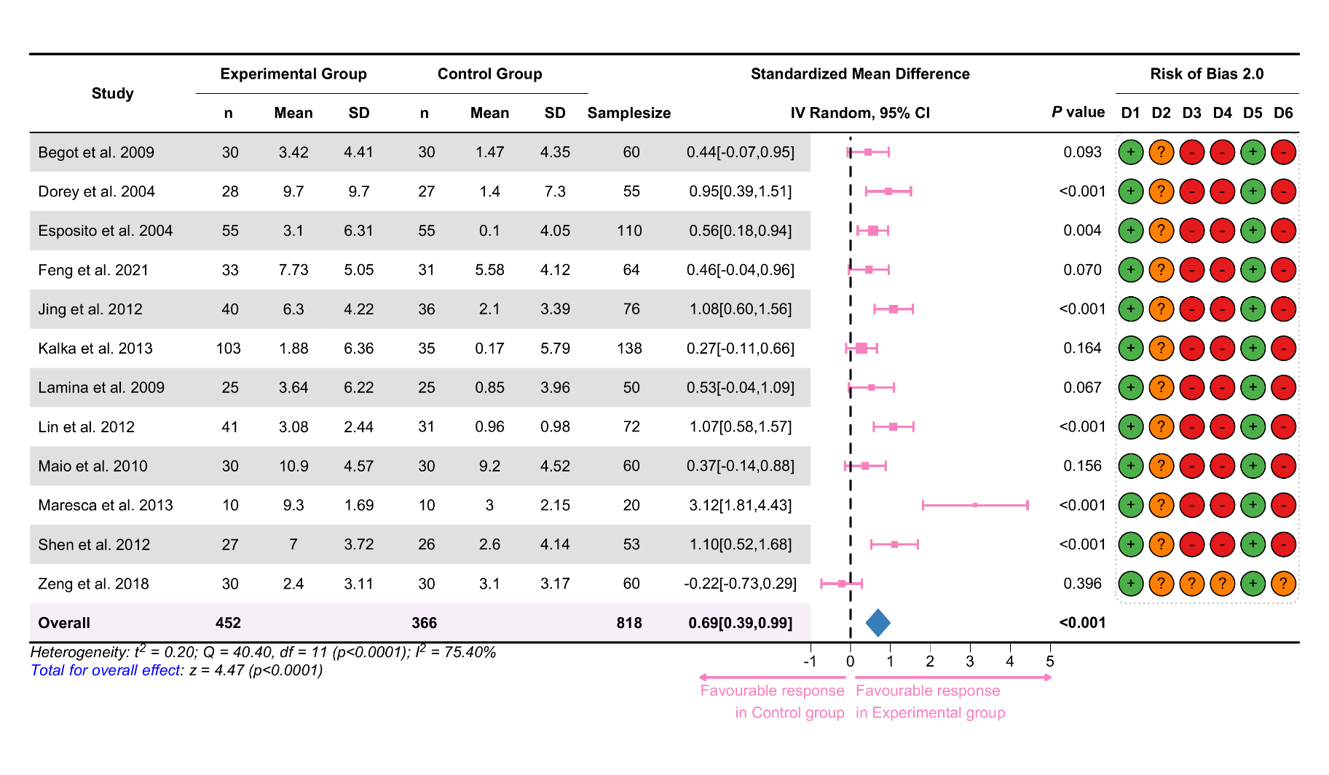
Fig. S1 Forest plot of exercise effects on erectile function in adult males (SMD)

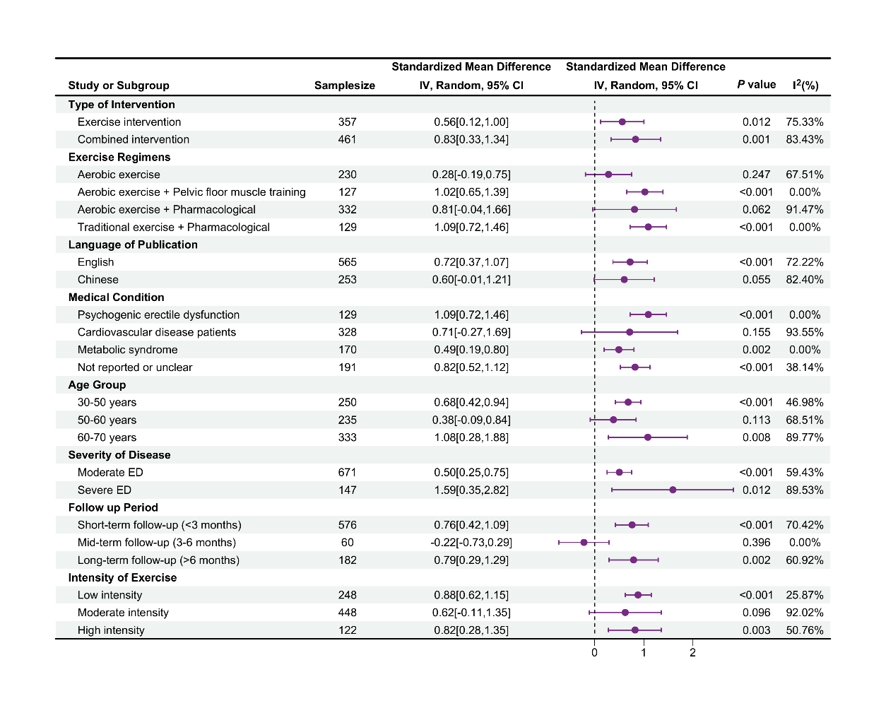
Fig. S2 Subgroup analysis of exercise training effects on erectile function in adult males based on intervention type, regimen, language, medical condition, age group, disease severity, follow-up period, and exercise intensity (SMD)

Section and Topic | Item # | Checklist item | Location where item is reported
TITLE
Title | 1 | Identify the report as a systematic review.
ABSTRACT
Abstract | 2 | See the PRISMA 2020 for Abstracts checklist.
INTRODUCTION
Rationale | 3 | Describe the rationale for the review in the context of existing knowledge.
Objectives | 4 | Provide an explicit statement of the objective(s) or question(s) the review addresses.
METHODS
Eligibility criteria | 5 | Specify the inclusion and exclusion criteria for the review and how studies were grouped for the syntheses.
Information sources | 6 | Specify all databases, registers, websites, organisations, reference lists and other sources searched or consulted to identify studies. Specify the date when each source was last searched or consulted.
Search strategy | 7 | Present the full search strategies for all databases, registers and websites, including any filters and limits used.
Selection process | 8 | Specify the methods used to decide whether a study met the inclusion criteria of the review, including how many reviewers screened each record and each report retrieved, whether they worked independently, and if applicable, details of automation tools used in the process.
Data collection process | 9 | Specify the methods used to collect data from reports, including how many reviewers collected data from each report, whether they worked independently, any processes for obtaining or confirming data from study investigators, and if applicable, details of automation tools used in the process.
Data items | 10a | List and define all outcomes for which data were sought. Specify whether all results that were compatible with each outcome domain in each study were sought (e.g. for all measures, time points, analyses), and if not, the methods used to decide which results to collect.
Data items | 10b | List and define all other variables for which data were sought (e.g. participant and intervention characteristics, funding sources). Describe any assumptions made about any missing or unclear information.
Study risk of bias assessment | 11 | Specify the methods used to assess risk of bias in the included studies, including details of the tool(s) used, how many reviewers assessed each study and whether they worked independently, and if applicable, details of automation tools used in the process.
Effect measures | 12 | Specify for each outcome the effect measure(s) (e.g. risk ratio, mean difference) used in the synthesis or presentation of results.
Synthesis methods | 13a | Describe the processes used to decide which studies were eligible for each synthesis (e.g. tabulating the study intervention characteristics and comparing against the planned groups for each synthesis (item #5)).
Synthesis methods | 13b | Describe any methods required to prepare the data for presentation or synthesis, such as handling of missing summary statistics, or data conversions.
Synthesis methods | 13c | Describe any methods used to tabulate or visually display results of individual studies and syntheses.
Synthesis methods | 13d | Describe any methods used to synthesize results and provide a rationale for the choice(s). If meta-analysis was performed, describe the model(s), method(s) to identify the presence and extent of statistical heterogeneity, and software package(s) used.
Synthesis methods | 13e | Describe any methods used to explore possible causes of heterogeneity among study results (e.g. subgroup analysis, meta-regression).
Synthesis methods | 13f | Describe any sensitivity analyses conducted to assess robustness of the synthesized results.
Reporting bias assessment | 14 | Describe any methods used to assess risk of bias due to missing results in a synthesis (arising from reporting biases).
Certainty assessment | 15 | Describe any methods used to assess certainty (or confidence) in the body of evidence for an outcome.
RESULTS
Study selection | 16a | Describe the results of the search and selection process, from the number of records identified in the search to the number of studies included in the review, ideally using a flow diagram.
Study selection | 16b | Cite studies that might appear to meet the inclusion criteria, but which were excluded, and explain why they were excluded.
Study characteristics | 17 | Cite each included study and present its characteristics.
Risk of bias in studies | 18 | Present assessments of risk of bias for each included study.
Results of individual studies | 19 | For all outcomes, present, for each study: (a) summary statistics for each group (where appropriate) and (b) an effect estimate and its precision (e.g. confidence/credible interval), ideally using structured tables or plots.
Results of syntheses | 20a | For each synthesis, briefly summarise the characteristics and risk of bias among contributing studies.
Results of syntheses | 20b | Present results of all statistical syntheses conducted. If meta-analysis was done, present for each the summary estimate and its precision (e.g. confidence/credible interval) and measures of statistical heterogeneity. If comparing groups, describe the direction of the effect.
Results of syntheses | 20c | Present results of all investigations of possible causes of heterogeneity among study results.
Results of syntheses | 20d | Present results of all sensitivity analyses conducted to assess the robustness of the synthesized results.
Reporting biases | 21 | Present assessments of risk of bias due to missing results (arising from reporting biases) for each synthesis assessed.
Certainty of evidence | 22 | Present assessments of certainty (or confidence) in the body of evidence for each outcome assessed.
DISCUSSION
Discussion | 23a | Provide a general interpretation of the results in the context of other evidence.
Discussion | 23b | Discuss any limitations of the evidence included in the review.
Discussion | 23c | Discuss any limitations of the review processes used.
Discussion | 23d | Discuss implications of the results for practice, policy, and future research.
OTHER INFORMATION
Registration and protocol | 24a | Provide registration information for the review, including register name and registration number, or state that the review was not registered.
Registration and protocol | 24b | Indicate where the review protocol can be accessed, or state that a protocol was not prepared.
Registration and protocol | 24c | Describe and explain any amendments to information provided at registration or in the protocol.
Support | 25 | Describe sources of financial or non-financial support for the review, and the role of the funders or sponsors in the review.
Competing interests | 26 | Declare any competing interests of review authors.
Availability of data, code and other materials | 27 | Report which of the following are publicly available and where they can be found: template data collection forms; data extracted from included studies; data used for all analyses; analytic code; any other materials used in the review.

From: Page MJ, McKenzie JE, Bossuyt PM, Boutron I, Hoffmann TC, Mulrow CD, et al. The PRISMA 2020 statement: an updated guideline for reporting systematic reviews. BMJ 2021;372:n71. doi: 10.1136/bmj.n71. This work is licensed under CC BY 4.0. To view a copy of this license, visit https://creativecommons.org/licenses/by/4.0/

