Remarkable enhancement in the N₂- selectivity of NH₃-SCR over the CeNb₃Fe_{0.3}/TiO₂ catalyst in the presence of chlorobenzene
Peng-chao Zang^{1, 2}, Jun Liu^{1,2,3} *, Xiao-qing Liu^{3,4}, Guo-jie Zhang^{1, 2} *, Jian-jun Chen³, Jun-hua Li³, Yong-fa Zhang^{1, 2}
1 College of Chemistry and Chemical Engineering, Taiyuan University of Technology, Taiyuan 030024, People’s Republic of China
2 State Key Laboratory of Clean and Efficient Coal Utilization, Taiyuan University of Technology, Taiyuan, 030024, Shanxi, P. R. China
3 State Key Joint Laboratory of Environment Simulation and Pollution Control; National Engineering Laboratory for Multi Flue Gas Pollution Control Technology and Equipment, School of Environment, Tsinghua University, Beijing, 100084, PR China
4 School of Environment and Safety Engineering, North University of China, Taiyuan, 030051, Shanxi, PR China.

Corresponding author1：Jun Liu
E-mail: xinzhou98010@126.com

Corresponding author2：Guo-jie Zhang

E-mail: zhgjdoc@126.com

Catalyst characterization
The X-ray diffraction (XRD) patterns were recorded on an X’'Pert diffractometer with Cu Kα radiation (λ = 0.15406 nm). The Raman spectrum of the sample was recorded on a Raman microscope (HORIBA Jobin Yvon LabRAM HR,France), using a 532 nm laser. The nitrogen adsorption-desorption isotherms were measured on a Micromeritics ASAP 2010 surface area and pore sturcture analyzer at -196 °C. The morphology, microstructure and lattice fringes are measured by TEM/HRTEM (JEM-F200, Japan). The X-ray photoelectron spectroscopy (XPS) spectra analysis were recorded on a ESCALAB 250Xi spectrometer using Al Kα X-ray source (1486.6 eV) and a passing energy of 25 eV. The H₂ temperature-programmed reduction (H₂-TPR) measurements were preformed on an Autochem II 2920 instrument (Micromeritics, Aachen, Germany). The NH₃-temperature-programmed desorption (NH₃-TPD) experiment was performed with an Autochem II 2920 instrument (Micromeritics, Aachen, Germany). The in situ diffuse reflectance Fourier transform infrared spectroscopy (DRIFTS) tests were conducted by a Nicolet 6700 FTIR spectrometer. The sample was loaded in the infrared cell and heated to 400 °C for 60 min to remove adsorbed impurities in He flow (30 mL/min). The testing conditions were as follow: NH₃ (1000 mg/L), NO (1000 mg/L), O₂ (5 vol.% if used) with He balance, while the total rate of the feed gas was maintained 30 mL/min.

Fig. S1. N₂ desorption-adsorption isotherm curves of the as-prepared samples.

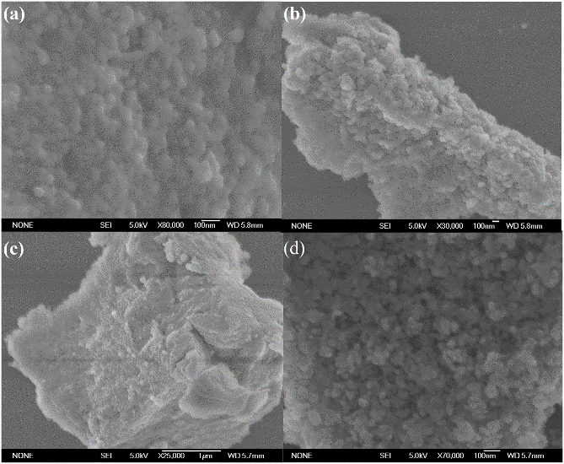
Fig. S2. SEM image of (a) CeNb₃Fe_{0.3} /TiO₂, (b) CeNb₃Fe_{0.6} /TiO₂, (b) CeNb₃Fe /TiO₂, and (d) CeNb₃ /TiO₂.

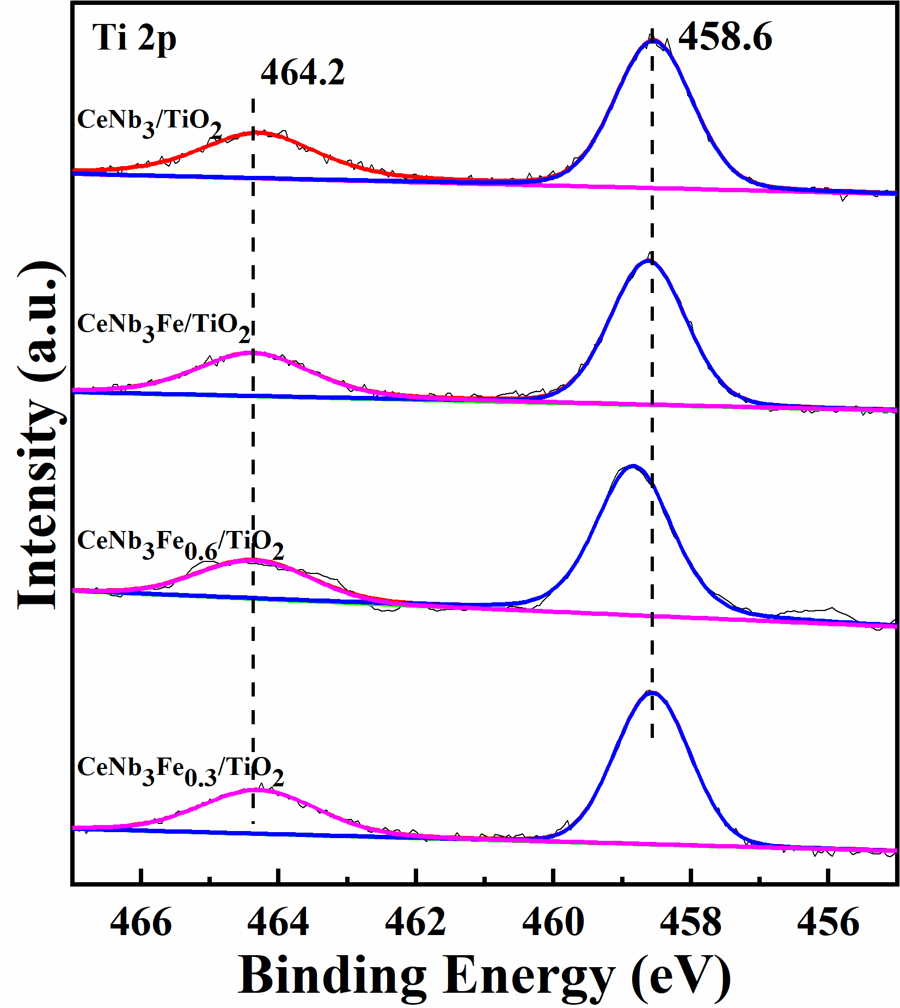
Fig. S3. XPS spectra of Ti 2p of CeNb₃Fe_{x}/TiO₂.

