Supplementary Materials for

Piezo1 is a mechanosensor of soft matrix viscoelasticity

Mariana A. G. Oliva^{1,2}, Giuseppe Ciccone^{1,2}, Gotthold Fläschner², Jiajun Luo¹, Jonah L.Voigt^{1,3,4}, Patrizia Romani⁵, Paul Genever⁶, Oana Dobre¹, Sirio Dupont⁵, Massimo Vassalli¹, Pere Roca-Cusachs^{2,7*}, Manuel Salmeron-Sanchez^{1,2,8*}

Affiliations

¹Centre for the Cellular Microenvironment (CeMi), University of Glasgow, The Advanced Research Centre, Glasgow, UK
²Institute for Bioengineering of Catalonia (IBEC), The Barcelona Institute for Science and Technology (BIST), Barcelona, Spain
³Max Planck Institute for Medical Research, Heidelberg, Germany.
⁴Cellular Biomechanics, Faculty of Engineering, Bayreuth University, Bayreuth, Germany.
⁵Department of Molecular Medicine (DMM), University of Padua, Padua, Italy
⁶Department of Biology, University of York, York, UK.
⁷University of Barcelona, Spain
⁸Institució Catalana de Recerca i Estudis Avançats (ICREA), Barcelona, Spain.

Corresponding authors: proca@ibecbarcelona.eu , msalmeron@ibecbarcelona.eu

This PDF file includes:

Supplementary Figs. S1 to S9
Supplementary Note 1
Tables S1 to S3
Supplementary references

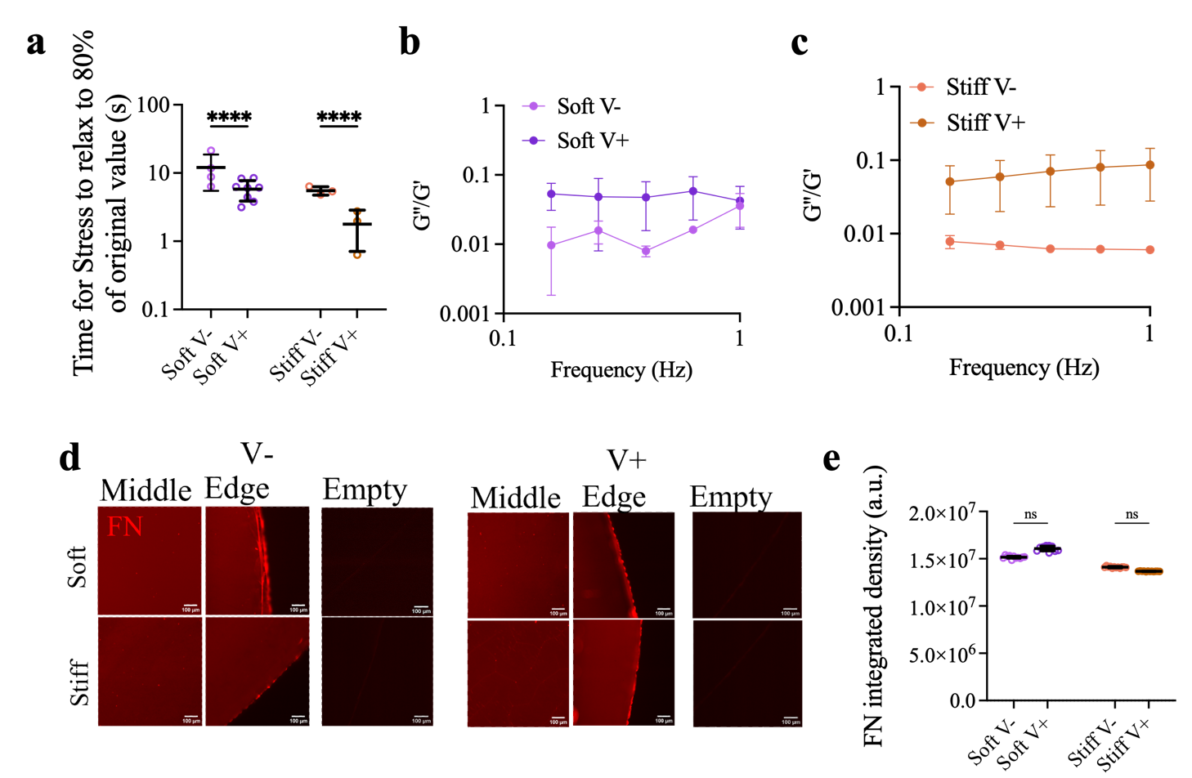

Supplementary Data Fig. 1.
(a) Time for stress relaxation to occur to 80% of original stress value (s) plotted for Soft (grey) and Stiff (orange) hydrogel groups. (n ≥ 61 curves, each dot represents a map of ≥ 4 single nanoindentation curves each) (b) G’’/G’ plot of bulk rheology frequency sweep measurements performed at 0.1% strain for the soft group. (c) G’’/G’ plot of bulk rheology frequency sweep measurements performed at 0.1% strain for the stiff group. Shown as mean ± SD of N = 3 hydrogels. (d) Representative immunofluorescence images of the 10 μg/ml fibronectin coating (red) of the hydrogels, showing the middle and edge of the hydrogel on the glass coverslip. Images of stained non-functionalised hydrogels are also shown in the empty column, for each hydrogel type. Scale bar 100 μm. (e) Quantification of the resulting fibronectin staining intensity (integrated density a.u.) shown as mean ± SD of different areas of n > 3 of each hydrogel N = 3. Statistical analyses were performed using a two-way ANOVA (a) or Kruskal-Walli’s test (e). P values indicating significance, ns > 0.05, **** ≤ 0.0001.

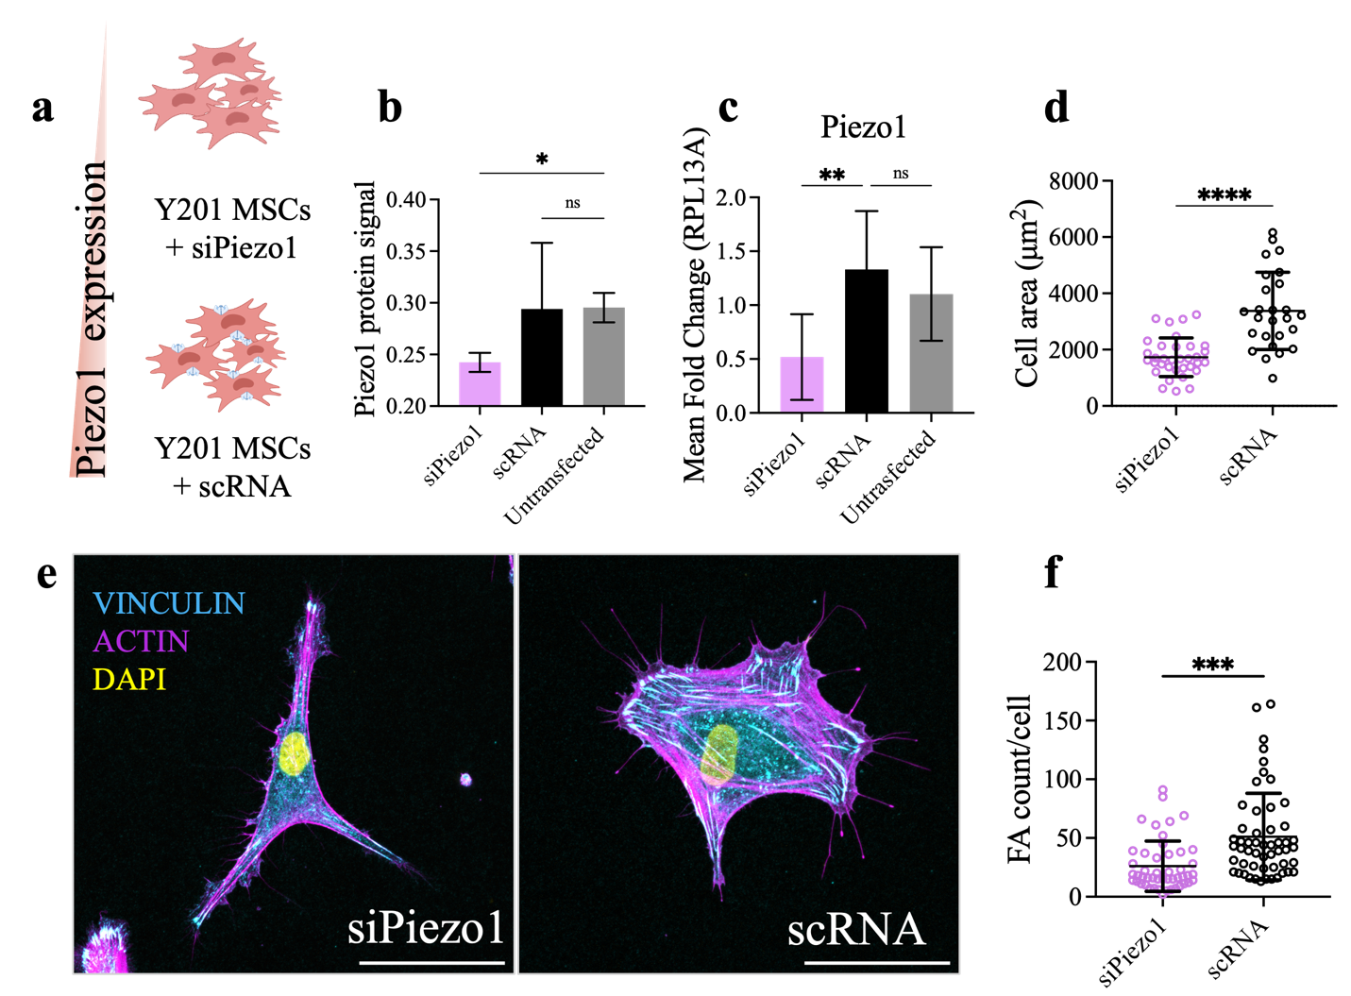

SupplementaryData Fig. 2.
(a) Diagram describing the two treatment conditions: Piezo1 siRNA or scRNA was used on Y201 MSCs prior to performing experiments. (b) Piezo1 protein signal as quantified from in cell western, shown as mean ± SD, N = 2, n ≥ 10,000 cells. (c) Mean fold change of Piezo1 gene expression normalised to RPL13A, shown as mean ± SD, N ≥ 4. (d) Cellular area was quantified after cells were left to adhere for 48h, shown as individual cell values plus mean ± SD, n ≥ 26. (e) Representative images of cells cultured on fibronectin coated coverslips, scale bar 50 µm. (f) Number of focal adhesions per cell plotted as mean ± SD per individual cell, n ≥ 48. Statistical analyses were performed using a one-way ANOVA (b, c) or unpaired t-test (d, f). P values indicating significance, ns > 0.05, *** ≤ 0.001, **** ≤ 0.0001.

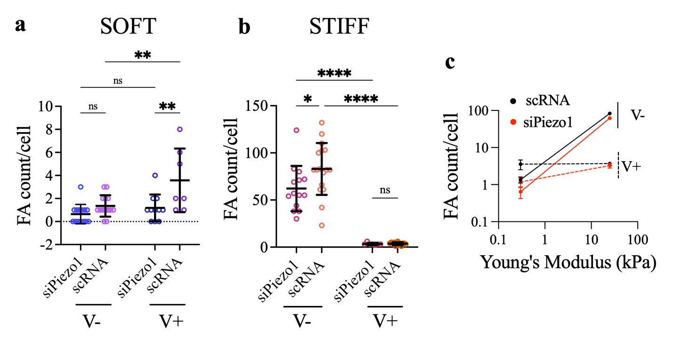

Supplementary Data Fig. 3.
Quantified total focal adhesion per cell (FA count/cell) of the soft (a) and stiff (b) hydrogel groups. Dots represent individual cell measurements, data shown as mean ± SD, n ≥ 7. (c) Summary of average FA count per cell ± SEM plotted as a function of stiffness for all conditions. Statistical analyses were performed using a two-way ANOVA. P values indicating significance, ns > 0.05, * ≤ 0.05, ** ≤ 0.01, *** ≤ 0.001, **** ≤ 0.0001. N ≥ 7

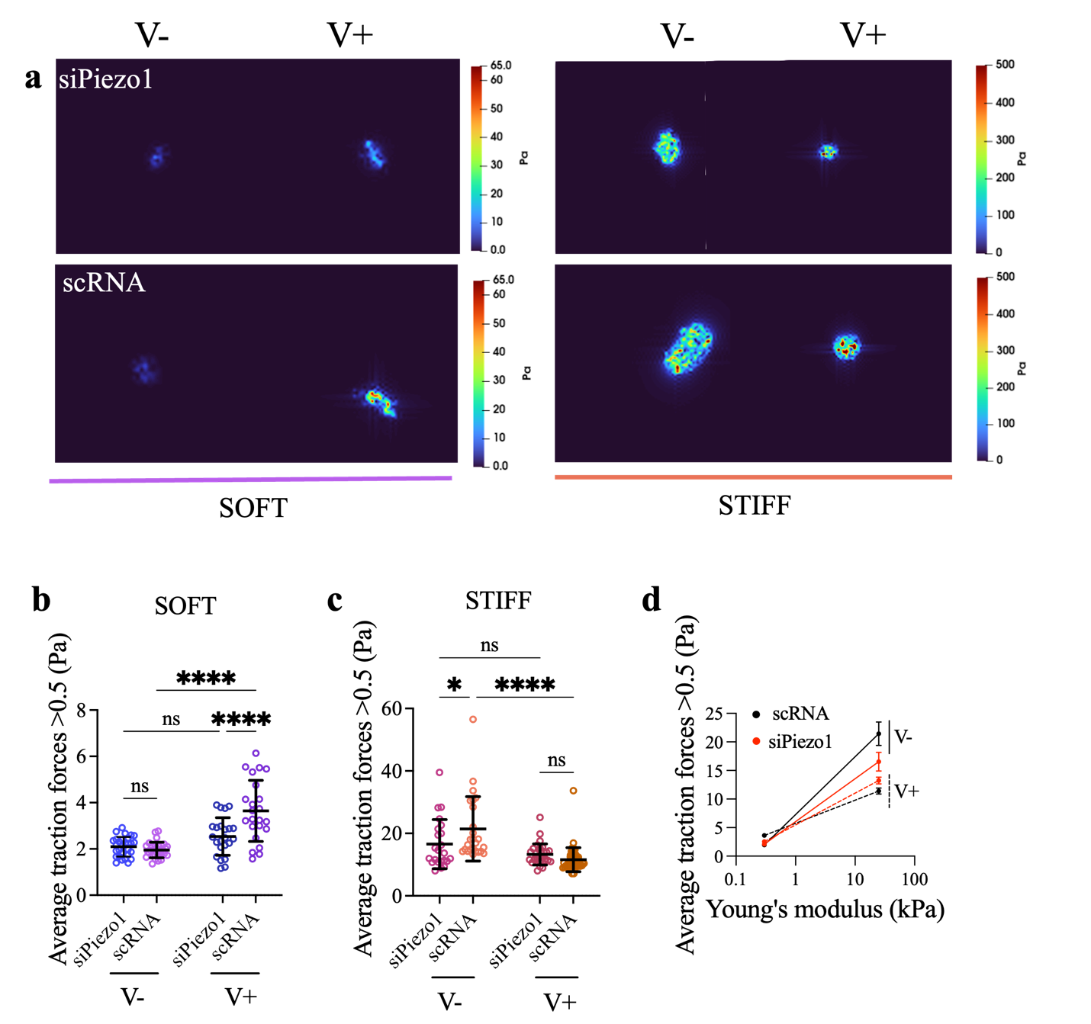

Supplementary Data Fig. 4.
Representative colour maps of traction forces applied by siPiezo1 (top) and scRNA (bottom) cells on soft (left) and stiff (right) hydrogel groups. Average traction forces measured on siPiezo1 and scRNA Y201 cells cultured on the soft (b) and stiff (c) hydrogel groups (n ≥ 22). (l) Summary of average traction forces ± SEM plotted as a function of stiffness for all experimental conditions. Statistical analyses were performed using a two-way ANOVA test. P values indicating significance, ns > 0.05, * ≤ 0.05, *** ≤ 0.001, **** ≤ 0.0001.

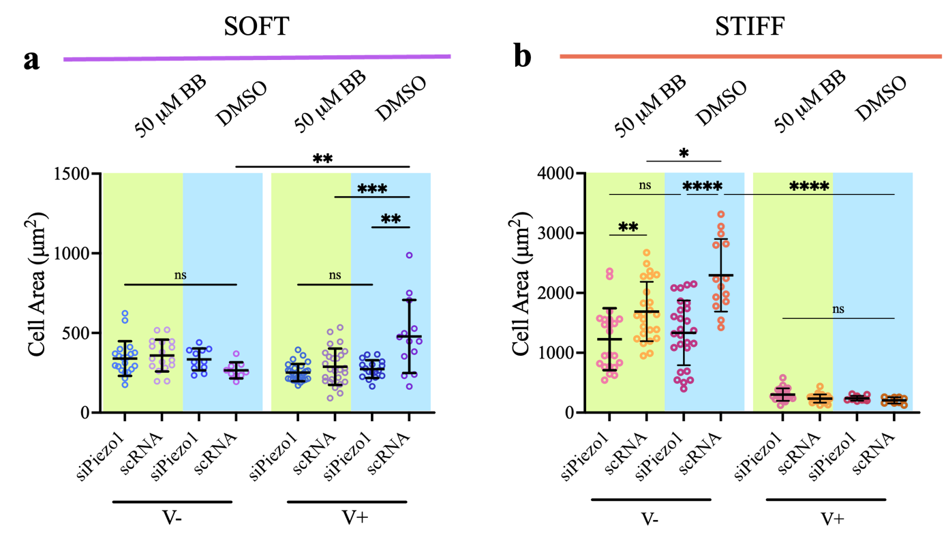
Supplementary Data Fig. 5.
Quantified cell area in cells with Blebbistatin (50 µM BB) treatment or without (DMSO) in the soft (a) and (b) stiff group. Data shown as mean ± SD. Blue and green shaded bars represent blebbistatin and DMSO treatment conditions, respectively. Statistical analyses were performed using a two-way ANOVA test. P values indicating significance, ns > 0.05, * ≤ 0.05, ** ≤ 0.01, *** ≤ 0.001, **** ≤ 0.0001. N ≥ 11.

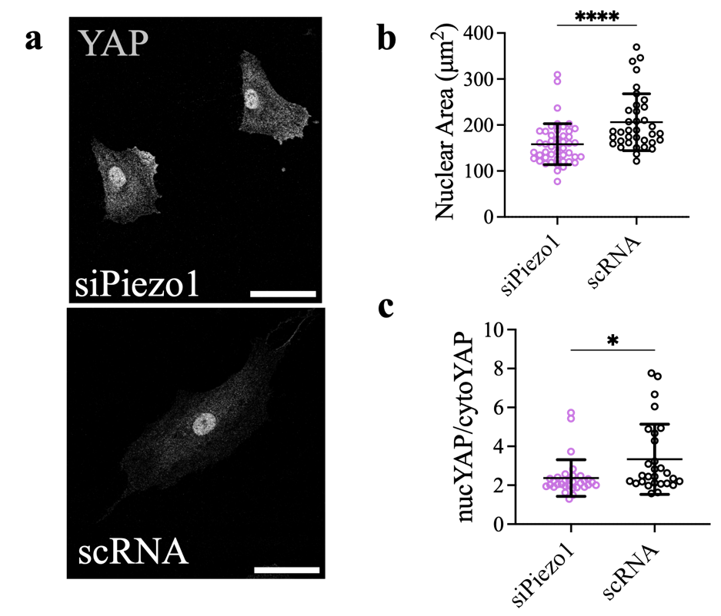
Supplementary Data Fig. 6.
(a) Representative images of YAP in (top to bottom) siPiezo1 and scRNA Y201 MSCs cultured on fibronectin coated glass coverslips for 48h. (b) Quantified nuclear area shown as μm². Dots represent individual cell values and bars represent mean ± SD. (c) Quantified nuclear/cytoplasmic YAP ratio. Dots represent individual cell values and bars is represented as mean ± SD, n ≥ 36. Statistical analyses were performed using an unpaired t-test. P values indicating significance, * ≤ 0.05, **** ≤ 0.0001.

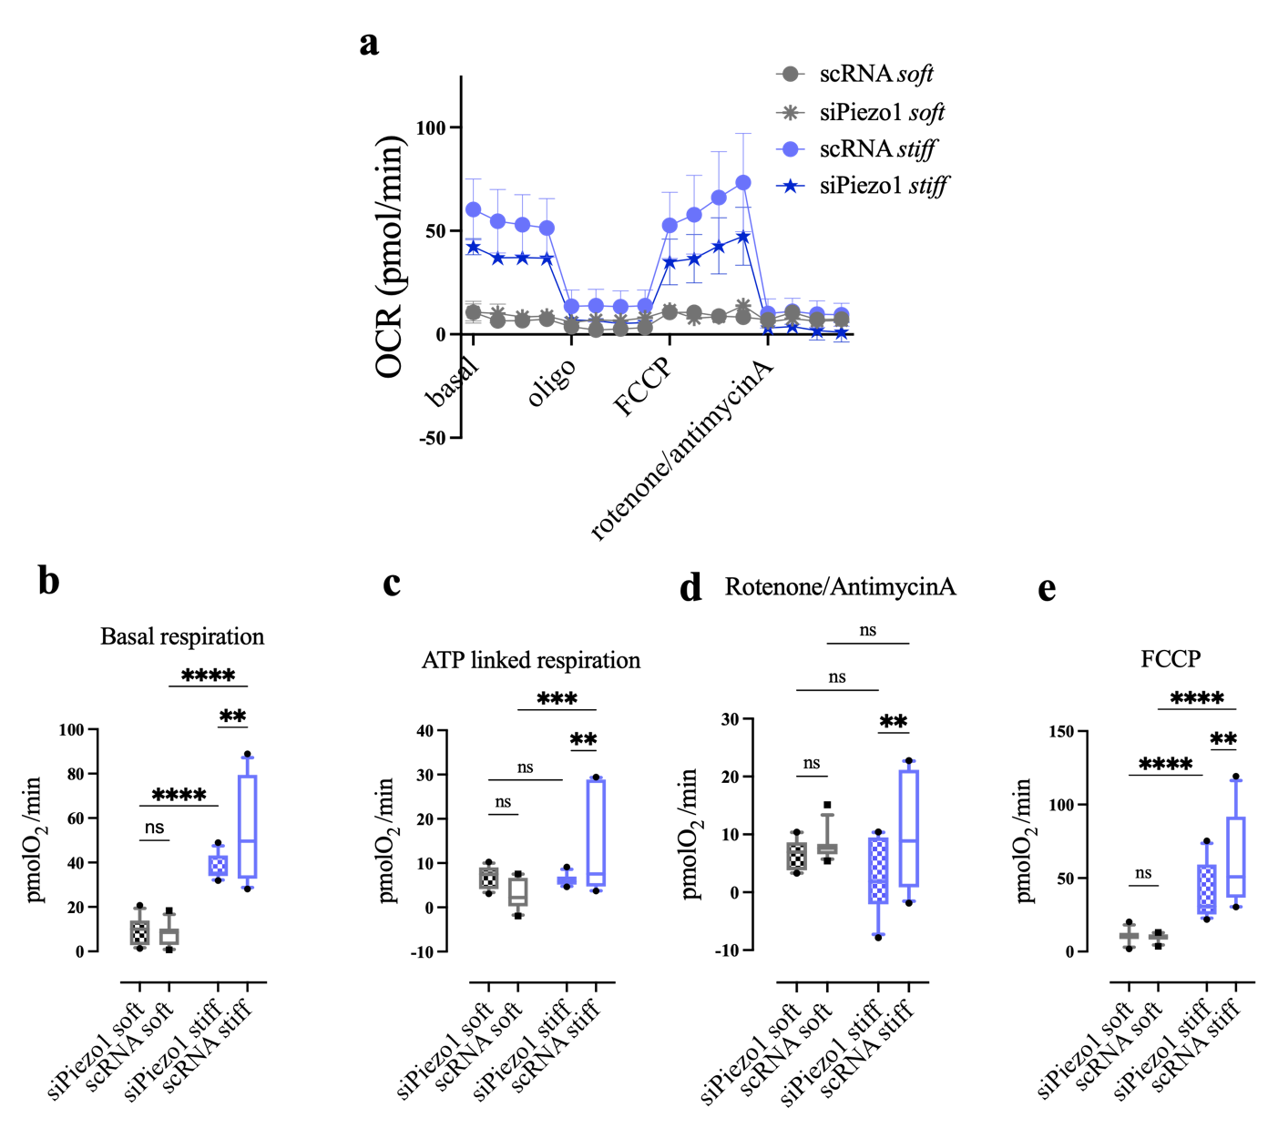
Supplementary Data Fig. 7.
(a) Oxygen Consumption Rate (OCR) profile determined with an extracellular flux analyser of siPiezo1 and scRNA cells cultured as cell monolayers on soft (E ~ 200 Pa) and stiff (E ~ 1GPa) Matrigel coated wells. Oligomycin (oligo, 0.8 μM), FCCP (0.9 μM), rotenone (1 μM) plus antimycin A (1 μM) were used to determine the basal respiration, ATP-coupled respiration, maximal respiratory capacity, and non-mitochondrial oxygen consumption, respectively. Data shown as mean ± SEM and represents two independent experiments (N=2) each with n = 4 technical repeats. (b) Average respiration rates in the basal respiration phase of the OCR measurements. (d) Average respiration rate for the ATP linked respiration phase (after oligomycin addition). (d) Average maximal respiration capacity respiration rates after FCCP treatment. (e) Average non-mitochondrial respiration rates after Rotenone/Antimycin A treatment. Data shown as Box and Whiskers plot with 10-90% whiskers. A two-way ANOVA statistical test followed by a Fisher's Least Significant Difference (LSD) test was performed. P values indicating significance, ns > 0.05, ** ≤ 0.01, *** ≤ 0.001, **** ≤ 0.0001.

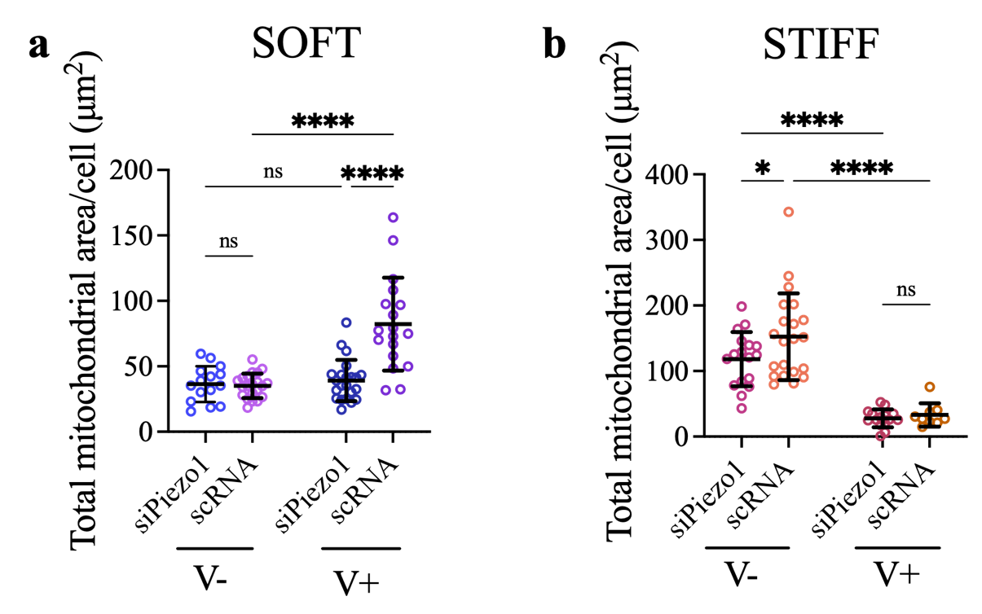
Supplementary Data Fig. 8.
Quantified total mitochondrial area per cell of the soft (a) and stiff (b) hydrogel
groups. All individual points represent averaged mitochondria measurements from individual cells. Data shown as mean ± SD. Statistical analyses were performed using a two-way ANOVA test. P values indicating significance, ns > 0.05, * ≤ 0.05, **** ≤ 0.0001, n ≥ 15.

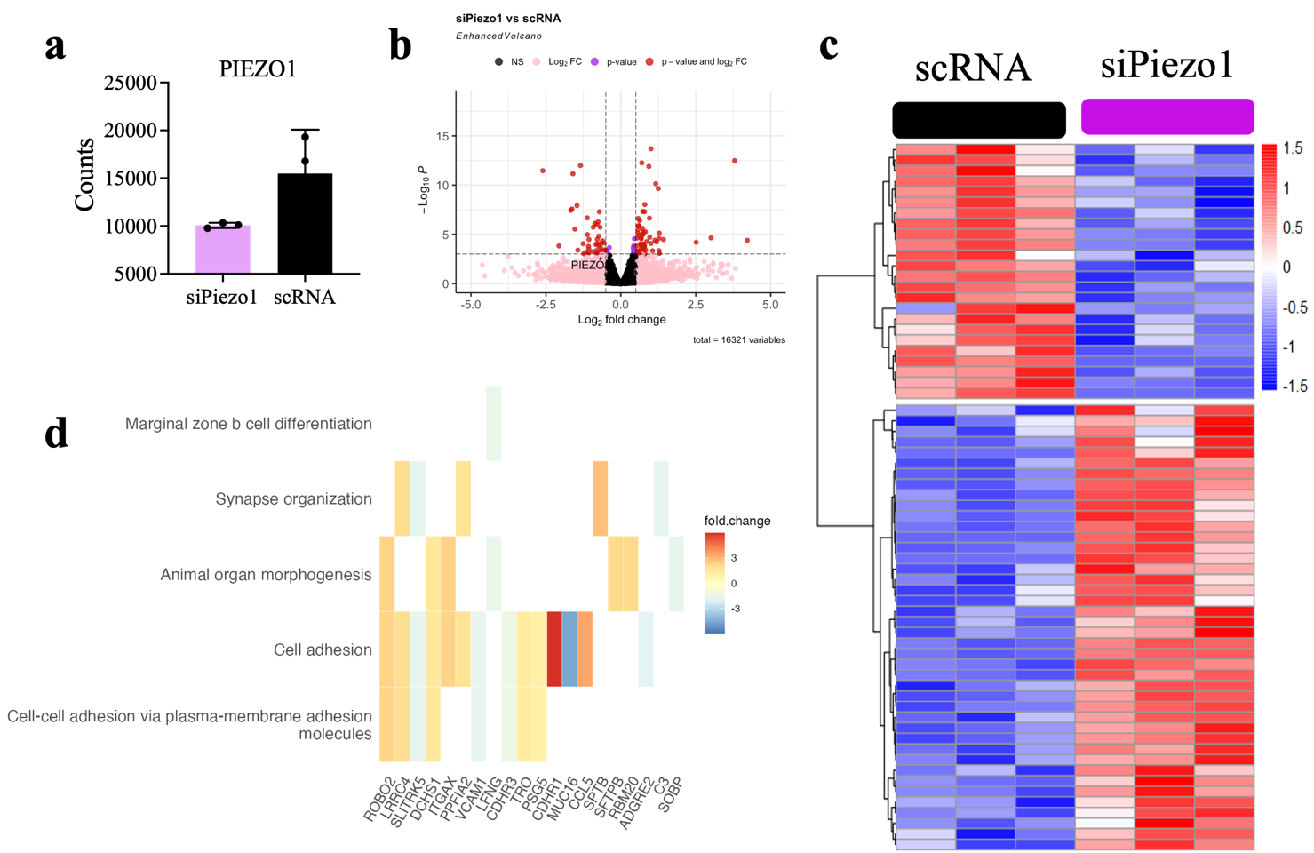

Supplementary Fig. 9. (a) Normalised Piezo1 gene counts RNAseq data from siPiezo1 and scRNA cells. (b) Volcano plot of statistical significance (-Log10P) vs fold change (Log 2 fold change) for siPiezo1 vs scRNA comparison. Each dot represents each individual gene. Piezo1 is highlighted on the table, with a fold change of ~-0.6. A total of 16321 genes were used to create the plot. (c) Heatmap of scRNA and siPiezo1 MSC differentially expressed genes (p < 0.05) (d) Heatmap of enriched results from ORA that encompass the most DE genes in the siPiezo1 vs scRNA comparison.

Supplementary note 1

Computational model implementation and parameters

To implement the computational clutch model for a viscoelastic substrate, we used our previously described model as a reference ^{1,} and incorporated a standard linear solid (SLS) model for the substrate instead of a spring (Fig. 2, e). The SLS model consists of two springs of stiffness $k_{1}$ and $k_{2}$, and a dashpot with viscosity $η$, arranged in series with $k_{2}$. The response of an SLS substrate is characterized by the instantaneous stiffness $k_{0}=k_{1}+k_{2}$, longterm stiffness $k_{∞}=k_{1}$, and the relaxation time constant $τ=η/k_{2}$. With that, the constitutive equation for the substrate is given by:
$$F_{\text{sub}}\left(t\right)+τ\frac{dF_{\text{sub}}\left(t\right)}{dt}=k_{∞}x_{\text{sub}}\left(t\right)+k_{0}τ\frac{dx_{\text{sub}}\left(t\right)}{dt}$$

where $F_{\text{sub}}$ and $x_{\text{sub}}$ are the substrate force and position, respectively.

The Monte Carlo simulation considers a given number of ligands on the substrate n_{l}, to which integrins will bind. When bound, all ligands are connected to the substrate in parallel. The simulation starts with all ligands unbound, in which case the myosin motors are unloaded and move the actin bundle with a constant rearward speed $v_{u}$ towards the cell center. At each time step (5 ms), unbound ligands can bind to the substrate with an association rate $k_{on}$ while bound ligands can dissociate with a rate of $k_{off}$. $k_{on}=k_{ont}d_{int}$, where $k_{ont}$ is the true binding rate characterizing each integrin-ligand bond, and $d_{int}$ is the density of integrins on the cell membrane. After every time step, the substrate position can be determined by applying the force balance between substrate and ligands (clutches) and discretizing the derivates as:
$$x_{sub}\left(t\right)=\frac{\left(1+\frac{τ}{Δt}\right)k_{clutch}\sum_{bound}{x_{clutch,i}\left(t\right)}-\frac{τ}{Δt}F_{sub}\left(t-Δt\right)+\frac{k_{0}τ}{Δt} x_{sub}\left(t-Δt\right)}{k_{∞}+\frac{k_{0}τ}{Δt}+\left(1+\frac{τ}{Δt}\right)k_{clutch}N_{bound}}.$$
Where $x_{clutch,i}(t)$ is the position of each ligand (clutch) and $k_{clutch}$ is clutch stiffness. The total force $F_{\text{sub}}$ is calculated as
$F_{\text{sub}}\left(t\right)=\sum{F_{\text{clutch, }\text{i}} \left(t\right)}$,
where the force on each ligand is given by:
$F_{\text{clutch, }i} \left(t\right)=k_{clutch}\left(x_{clutch, i }\left(t\right)-x_{sub}\left(t\right)\right)$,
The ligand position is continuously updated by the myosin motors, which pull on the ligands at a seed $v$, determined by:
$$v=v_{u}(1-\frac{F_{sub}}{n_{m}F_{m}})$$
Where $n_{m}$ is the total number of myosin motors, and $F_{m}$ is the stall force of a single motor.
Reinforcement was modelled by permitting the clutch to unfold with rate $k_{uf}$, assumed to correspond to talin unfolding ².Once the clutch unfolds, vinculin is allowed to bind at a rate $k_{v,on}$, unless refolding occurs earlier with a rate of $k_{f}$. Upon successful vinculin binding, d_{add} integrins are added to the system. To maintain a stable integrin population over time, integrins also need to be removed, which happens when the clutch unbinds. The amount of integrins is limited by a lower bound d_{int} , corresponding to the start condition.

To capture the influence of the Piezo1, we increased $k_{off}$ by a factor $p_{knock}$ to simulate a Piezo knockdown, thereby reducing the integrin binding affinity ³. Integrin removal was increased by this factor as well.

To model viscoelasticity, we used the experimentally obtained values of $τ$. For $k_{0}$ and $k_{∞}$, we converted experimental values (in units of Pa) to model parameters (in units of N/m) by assuming a given radius of adhesion a, as done previously ¹. Further, we also considered that in experiments, $k_{0}$ between the elastic and viscoelastic case were designed to be equal as measured during nanoindentation experiments (Fig. 1, b). However, the contribution of viscosity to the material's response depends on the strain rate (or equivalently, the loading rate). In experiments, the area on which force is applied is determined by the nanoindenter probe diameter (27.5 µm), whereas the area of integrin adhesions applying force is likely to be smaller. Thus, we can assume that strain rates applied by cells are significantly higher compared to the nanoindenter case. At higher strain rates, the dashpot element in the viscoelastic model resists deformation more strongly, contributing to an increased instantaneous stiffness $k_{0}$. We thus assumed an increase by a factor of 10 and maintained the observed experimental value for $k_{∞}$.

Supplementary tables
Table S1.
Model parameters.
All parameter values, except the cell type specific number of ligands, are of the same order as those employed in previous simulations that considered elasticity rather than viscoelasticity ^{1,2,4}.

Parameter | meaning | Value | Origin
n_{m} | Number of myosin motors | 300 | Adjusted
n_{l} | Number of ligands | 3000 | Adjusted
F_{m} | Myosin motor stall force | 2 pN | ⁵
v_{u} | Unloaded myosin motor velocity | 110 nm/s | ¹
d_{int} | Initial integrin density on the membrane | 100/μm² | Adjusted
k_{ont} | True binding rate | 2.1x10⁻⁵ um²/s | Adjusted, of the order of values reported for αIIBβ3 ⁶
k_{off} | Unbinding rate, scaling factor applied to force curve reported in ⁷ | 0.15 | Adjusted, catch bond dependency from ⁷
$$k_{uf}$$ | Talin unfolding rate | Slip bond | ⁸
$$k_{f}$$ | Talin refolding rate | Slip bond | ⁸
FR | Fraction of force experienced by talin | 0.073 | ²
$$k_{c}$$ | Clutch stiffness | 1nN/nm | ⁹
$$k_{v, on}$$ | Vinculin binding rate | 1x10⁴ | Adjusted
$$τ$$ | Relaxation time of substrates | 2s | As measured
$$k_{∞}/k_{0}$$ | Determines magnitude of substrate relaxation | 0.08 | Adjusted, based on measurement
$$p_{knock}$$ | Fold increase in k_{off} after Piezo knockdown | 1.15 | Adjusted
d_{add} | Integrins added after each reinforcement event | 15/μm² | Adjusted
a | Radius of adhesion | 600 nm | Adjusted

Table S2.
Hydrogel formulations.

Reagent | Soft V- | Soft V+ | Stiff V- | Stiff V+
Aam (%) | 3 | 3 | 15 | 35
BisAam (%) | 0.06 | 0.06 | 0.1 | 0.0124
40% Aam (µl) | 75 | 75 | 375 | 875
2% BisAam (µl) | 30 | 30 | 50 | 6.2
mQ H2O (µl) | 812.5 | / | 565 | 108.8
TEMED 1.5%/100% (µl) | 62.5 (1.5%) | 62.5 (1.5%) | 2.5 (100%) | 2.5 (100%)
APS 5%/10% (µl) | 20 (5%) | 20 (5%) | 7.5 (10%) | 7.5 (10%)
Linear Aam (µl) | / | 812.5 | / | /
Total volume (µl) | 1000 | 1000 | 1000 | 1000

Table S3.
List of antibodies and other reagents used for immunodetection.

Reagent | Provider | Dilution
Alexa Fluor™ 488 Phalloidin | Thermo (A12379) | 1:250
Anti-YAP Antibody (63.7) | Santa Cruz (sc-101199) | 1:100
Anti-Fibronectin antibody | Sigma (F3648) | 1:200
Anti-Vinculin antibody | Sigma (V9264) | 1:400
Anti-TOMM20 | Abcam (ab186735) | 1:200
Anti-Piezo1 | Sigma (AMAB91589) | 1:100
Cy™3 AffiniPure Rabbit Anti-Mouse IgG (H+L) | Jackson ImmunoResearch (315-165-003) | 1:200
Donkey anti-Rabbit IgG (H+L) Alexa Fluor™ 488 | Invitrogen (A-21206) | 1:250
CellTag™ 700 Stain for In-Cell Western™ Assays | Li-Cor (926-41090) | 1:500
IRDye® 800CW Goat anti-Mouse IgG Secondary Antibody | Li-Cor (926-32210) | 1:500

Supplementary references

1. Elosegui-Artola, A. et al. Rigidity sensing and adaptation through regulation of integrin types. Nat Mater 13, 631–637 (2014).
2. Elosegui-Artola, A. et al. Mechanical regulation of a molecular clutch defines force transmission and transduction in response to matrix rigidity. Nat Cell Biol 18, 540–548 (2016).
3. Cheng, D., Wang, J., Yao, M. & Cox, C. D. Joining forces: crosstalk between mechanosensitive PIEZO1 ion channels and integrin-mediated focal adhesions. Biochem Soc Trans (2023) doi:10.1042/BST20230042.
4. Oria, R. et al. Force loading explains spatial sensing of ligands by cells. Nature 552, 219–224 (2017).
5. Molloy, J. E., Burns, J. E., Kendrick-Jones, J., Tregear, R. T. & White, D. C. S. Movement and force produced by a single myosin head. Nature 378, 209–212 (1995).
6. Litvinov, R. I. et al. Resolving Two-dimensional Kinetics of the Integrin αIIbβ3-Fibrinogen Interactions Using Binding-Unbinding Correlation Spectroscopy. Journal of Biological Chemistry 287, 35275–35285 (2012).
7. Kong, F., García, A. J., Mould, A. P., Humphries, M. J. & Zhu, C. Demonstration of catch bonds between an integrin and its ligand. Journal of Cell Biology 185, 1275–1284 (2009).
8. Yao, M. et al. Mechanical activation of vinculin binding to talin locks talin in an unfolded conformation. Sci Rep 4, 4610 (2014).
9. Riveline, D. et al. Focal Contacts as Mechanosensors. J Cell Biol 153, 1175–1186 (2001).

