Supplementary information
Antiparallel stacking of Csu pili drives Acinetobacter baumannii 3D biofilm assembly
Henri Malmi, Natalia Pakharukova, Bindusmita Paul, Minna Tuittila, Irfan Ahmad, Stefan David Knight, Bernt Eric Uhlin, Debnath Ghosal and Anton V. Zavialov
Content:
Supplementary Table 1, page 2
Supplementary Figures 1–12, pages 3-17
Supplementary Notes, pages 18-20
Description of Supplementary Videos, page 21
Supplementary Tables
Supplementary Table 1 | Cryo-EM data collection, refinement Supplementary Table 1 | Cryo-EM data collection, refinement and validation statistics
 | Csu pilus rod segment  (EMDB-)  (PDB) | Csu pilus rod pair  (EMDB-)  (PDB) | Csu pilus rod type 1 stack  (EMDB-)  (PDB) | Csu pilus rod type 2 stack  (EMDB-)  (PDB)
Data collection and processing
Magnification | 81,000 | 105,000 | 105,000 | 105,000
Voltage (kV) | 300 | 300 | 300 | 300
Electron exposure (e–/Å²) | 54.8 | 50 | 59.848 | 59.848
Defocus range (μm) | 0.8–2.5 | 0.8–2.5 | 0.4–1.6 | 0.4–1.6
Pixel size (Å) | 1.08 (collection)  1.0546 (final) | 0.851 (collection)  1.6626 (final) | 0.825 (collection)  0.82313 (final) | 0.825 (collection)  0.82452 (final)
Symmetry imposed | Helical | N/A | N/A | N/A
Helical twist | -153.984 | N/A | N/A | N/A
Helical rise | 27.606 | N/A | N/A | N/A
Initial segment images (no.) | 189,846 | 35,938 | 30,605,819 | 30,605,819
Final segment images (no.) | 50,502 | 12,883 | 504,940 | 687,088
Map resolution (Å) | 3.28 | 8.91 | 7.58 | 4.70
FSC threshold | 0.143 | 0.143 | 0.143 | 0.143
Map resolution range (Å) | 2.3–6.3 | 3.5–31.2 | 3.75–10.45 | 3.46–7.95
Refinement
Initial model used (PDB code) | 7ZL4 | 7ZL4 | 7ZL4 | 7ZL4
Model resolution (Å) | 3.1/3.2/3.6 | 5.7/9.5/24.8 | 6.5/7.7/11.0 | 3.9/4.7/8.5
FSC threshold | 0/0.143/0.5 | 0/0.143/0.5 | 0/0.143/0.5 | 0/0.143/0.5
Map sharpening B factor (Å²) | -105.1 | -150 | -321.8 | -109.3
Model composition
Non-hydrogen atoms | 9,032 | 27,096 | 60,966 | 76,772
Protein residues | 1,240 | 3,720 | 8,370 | 10,540
Ligands | --- | --- | --- | ---
B factors (Å²)
Protein (min/max/mean) | 24.46/134.63/72.51 | 71.51/909.12/304.76 | 267.71/1155.02/668.10 | 99.03/838.77/330.69
Ligand | --- | --- | --- | ---
R.m.s. deviations
Bond lengths (Å) | 0.007 | 0.007 | 0.007 | 0.007
Bond angles (°) | 1.311 | 1.317 | 1.319 | 1.320
Validation
MolProbity score | 1.10 | 1.12 | 1.12 | 1.12
Clashscore | 3.09 | 3.33 | 3.26 | 3.25
Poor rotamers (%) | 0.00 | 0.00 | 0.00 | 0.00
Ramachandran plot
Favored (%) | 98.12 | 98.09 | 98.07 | 98.08
Allowed (%) | 1.88 | 1.91 | 1.93 | 1.92
Disallowed (%) | 0.00 | 0.00 | 0.00 | 0.00

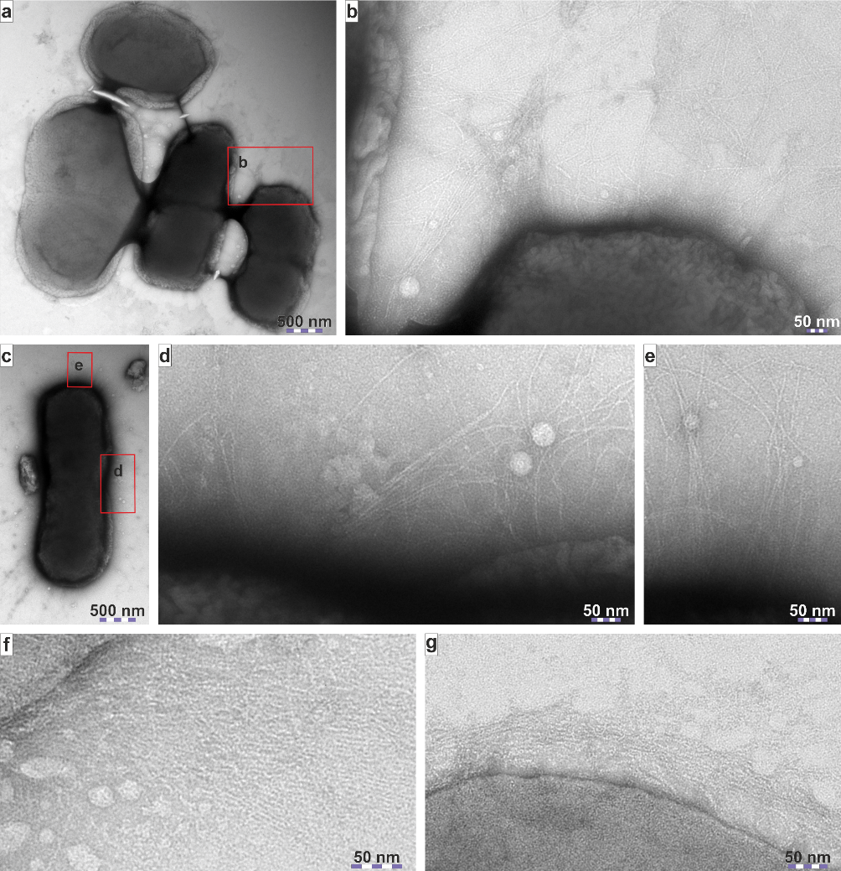
Supplementary Figures
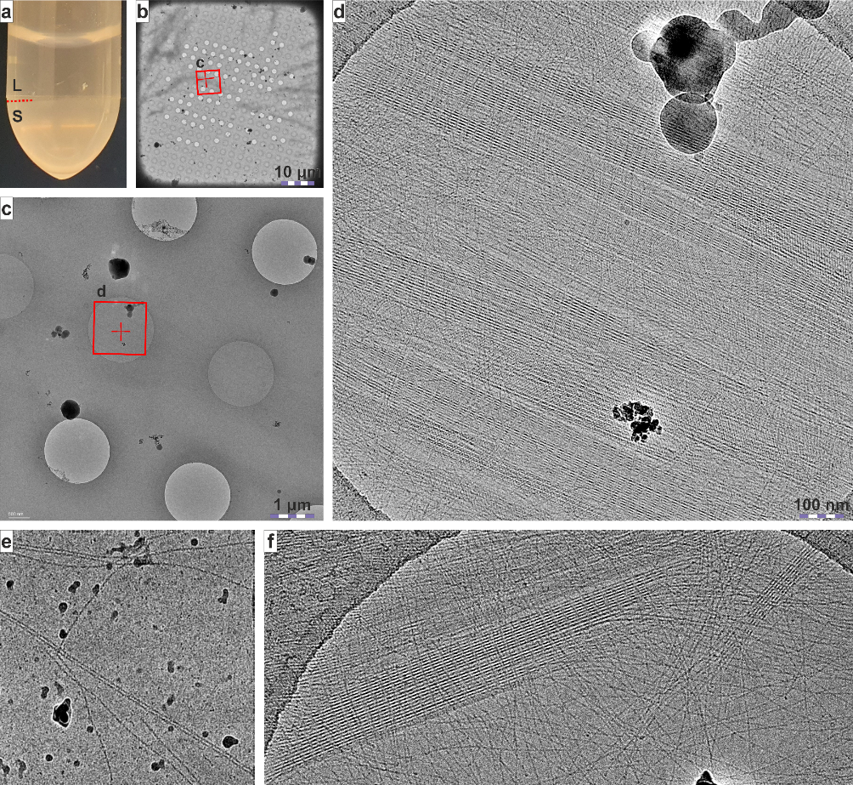
Supplementary Fig. 1 | Csu pilus rod antiparallel binding clumps cells in a process independent from hydrophobic tip fingers-mediated adhesion. a–e, Negative stain TEM images of A. baumannii grown in liquid cultures. In liquid cultures, the Csu pilus stacks form in the gaps between clumped up bacteria (a,b), at cell division septa (c,d) and at the narrow ends of bacterial rods, possibly as remnants of cell divisions (c,e). Csu pilus stacks most likely form as change in outer membrane curvature during cell division positions neighbouring Csu pili antiparallel to each other, and sometimes they keep the bacteria as a clump. f,g, Negative stain TEM images of colony-grown E. coli /pBAD-Csu expressing wild type Csu pili (f) and pili with tip-subunit CsuE mutation IVGIGV→SSGSGS (g)²¹. In the mutant, the hydrophobic residues of the main tip finger in CsuE were substituted by hydrophilic residues rendering it non-adhesive. Both wild-type and mutant Csu pili form stacks in the gaps between cells, indicating that this process is independent of the hydrophobic tip finger-mediated adhesion. Pilus expression was induced with low 0.001‒0.0001 % (w/v) concentrations of L-arabinose to yield native-like numbers of Csu pili.
Supplementary Fig. 2 | Cryo-EM images of Csu pilus stacks and pairs. a, Purified sample of Csu pili stored several months at +4°C has separated into two distinct phases with the upper transparent phase consisting mostly of liquid (L) buffer with only a few Csu pili and the lower opaque phase consisting mostly of Csu pilus stacks (S). b, Grid square-level image of a Cryo-EM grid shows Csu pilus stacks as dark strips atop the grid. The red square indicates the position of the zoomed-in image shown in c. c, Close-up image showing several holes. Csu pilus stacks appear as shadows with sharp outer edges, unidirectional with the dark strips seen in b. The red square indicates the position of the zoomed-in image shown in d. d, Hole-level image shows unidirectional Csu pilus stacks cover the entire hole, with some perpendicular individual Csu pili overlapping with them. e, Csu pili mostly form individual pairs in fresher purified samples, as stack formation in vitro takes time. f, Cryo-EM image of Csu pilus stack fraying into individual pili highlights how the stacks form out of individual Csu pili.
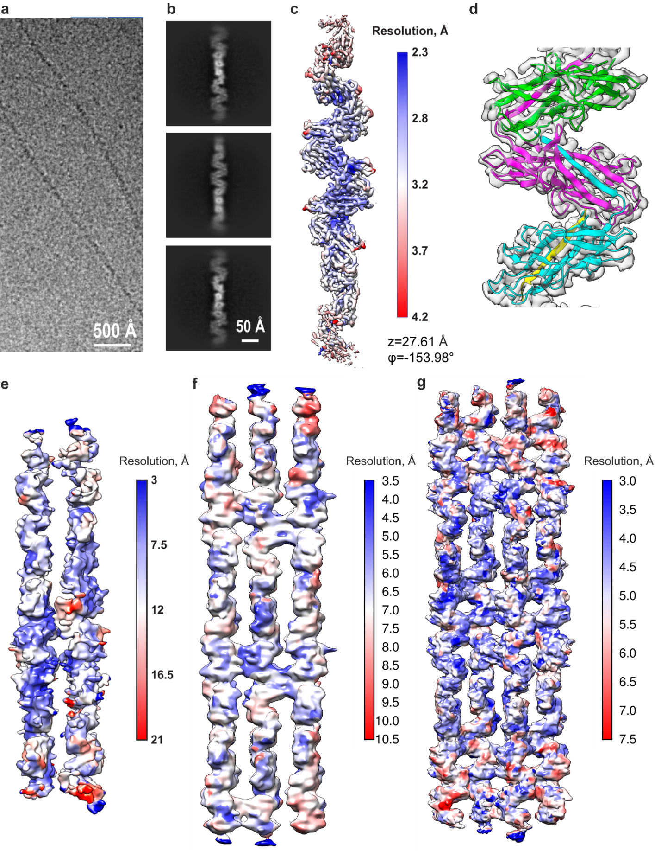
Supplementary Fig. 3 | Local resolution estimations of a single native Csu pilus rod, as well as recombinant Csu pilus pair and types 1 and 2 stacks. a, Cryo-EM micrograph of native Csu pilus. b, Representative 2D classes of native Csu pilus. c,d Cryo-EM map of native Csu pilus colored by local resolution (c) and fitting of a recombinant Csu pilus model (PDB: 7ZL4) into the cryo-EM map (d), which shows the native Csu pilus is morphologically and structurally similar to the recombinant Csu pilus. Map contour level is 0.1. e,f,g Local resolution estimations of recombinant Csu pilus pair at map contour level at 0.4 (e), as well as Csu pilus type 1 (f) and type 2 (g) stacks at contour level 0.06.
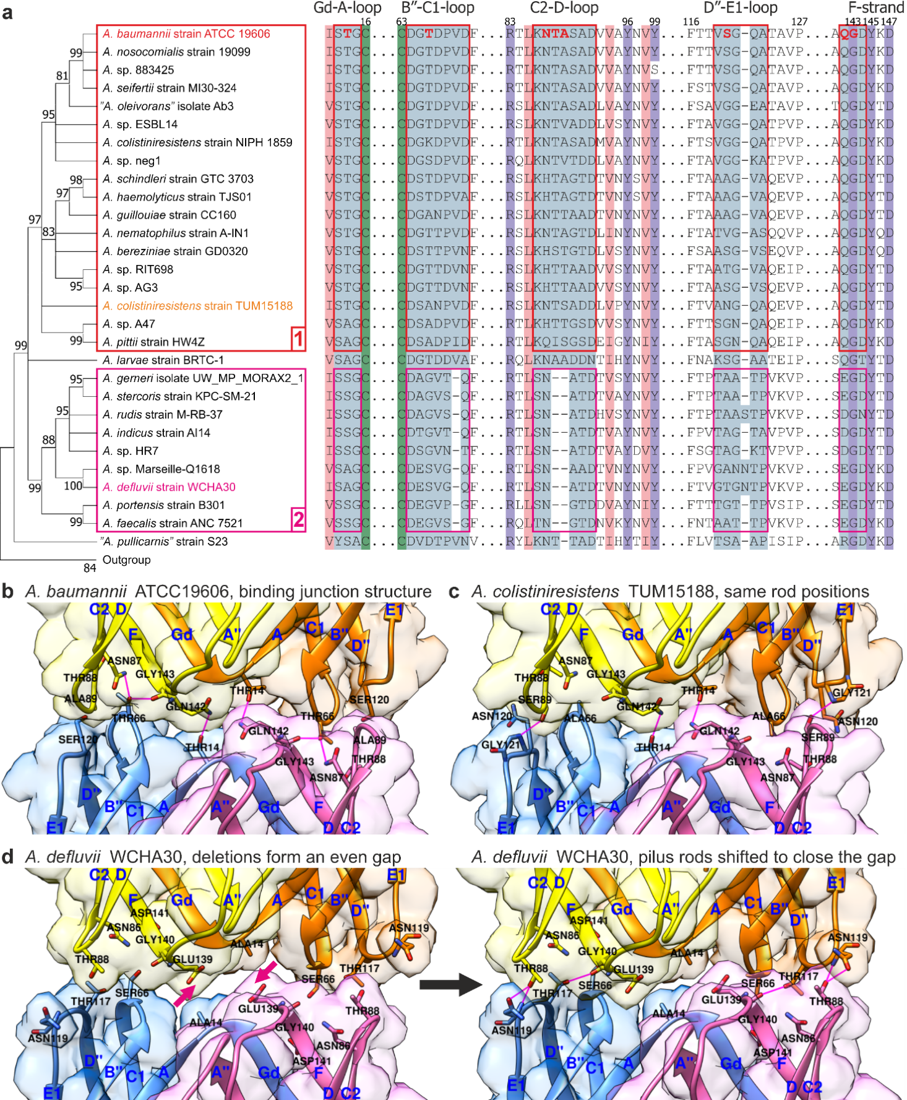
Supplementary Fig. 4 | Modelling binding junctions between rods in Csu pilus stacks from different Acinetobacter species. a, Phylogenetic tree of CsuA/B subunits from different Acinetobacter species (left) and fragments of their sequence alignment (right). The full sequence alignment is in (Supplementary Data Fig. 1). Interactive residues in A. baumannii Csu pilus stacks are in red. Light blue shading indicates regions predicted to mediate the contact between rods. Invariant cysteine residues, highly conserved residues, and conserved hydrophobic positions are highlighted with green, violet, and pink, respectively. The aligned Csu pilus main subunit CsuA/B sequences fall into groups 1 and 2, with CsuA/B from A. larvae and “A. pullicarnis” being the only outliers. Subunits in group 1 differ only through point mutations, whereas group 2 has a consistent single residue deletion in the B′′-C1-loop and a two-residue deletion in the C2-D-loop, both central to the antiparallel binding junction. Group 2 also has a single residue deletion in the E2-F-loop, except A. sp. HR7 has a two-residue insertion (not shown), and three sequences have a single residue insertion in the D′′-E1-loop. The maximum-likelihood phylogenetic tree shows branches supported by over 50 % of the 3000 replicates. b, Binding junction interactions in A. baumannii strain ATCC 19096 according to our cryo-EM structure. c-d, Modelling of the rod-rod junction for A. colistiniresistens strain TUM15188 from group 1 and A. defluvii strain WCHA30 from group 2. Comparing A. baumannii rod-rod junction to a model of A. colistiniresistens, it appears possible to compensate Thr66 changing to Ala66 through Ser89 forming a hydrogen bond with Gly121 and by changing the Thr88 rotamer. AlphaFold and manual modelling of the insertions and deletions in the A. defluvii rod-rod junction model, with rod helical axis positions from A. baumannii Csu pilus stacks, revealed a consistent 2 Å gap between the rod surfaces, indicating surface complementarity. Manually moving the rods closer, as indicated by the pink arrows, led to a tight contact.
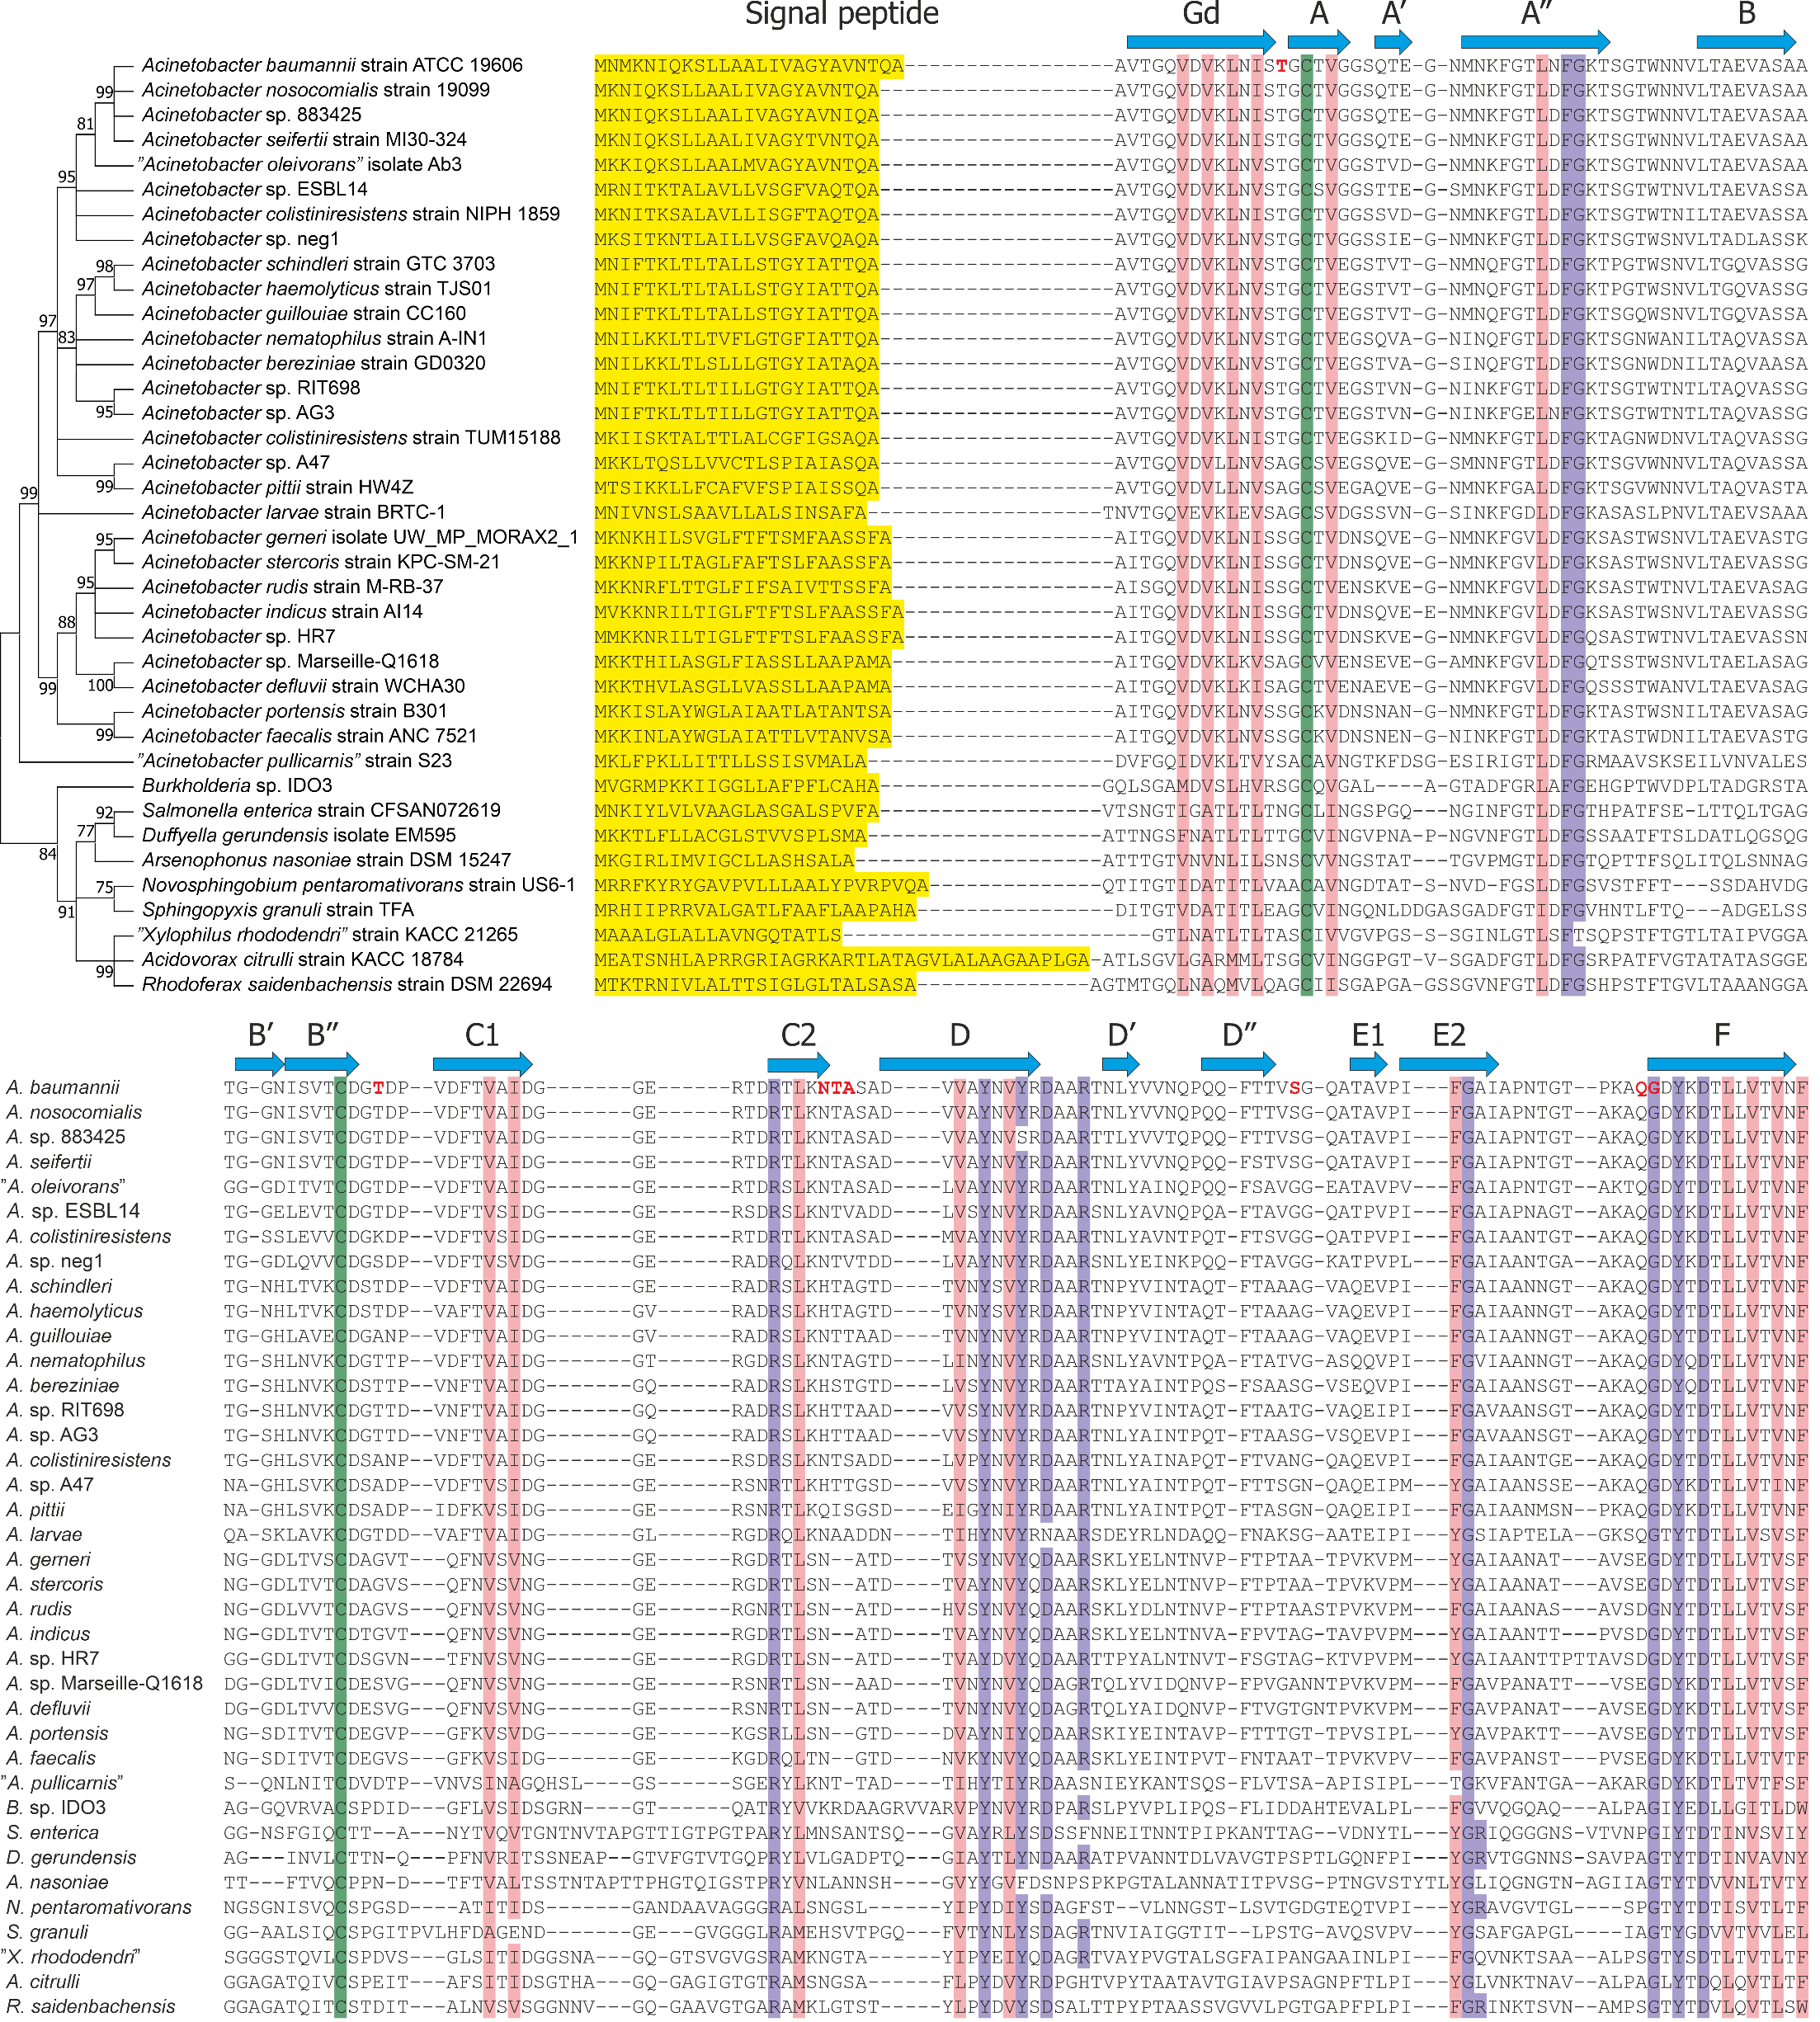
Supplementary Fig. 5 | Sequence alignment of CsuA/B subunits from Acinetobacter species and their close homologues. Maximum likelihood phylogenetic tree showing branches supported by over 50 % of 3000 replicates, and the corresponding alignment of Acinetobacter CsuA/B subunits excluding the signal peptides. The unaligned signal peptides are highlighted with yellow shading. Each outgroup sequence is the first subunit in their respective archaic pilus gene clusters from different genera and predicted to play the role of a polymerizing subunit similar to CsuA/B. Invariant cysteine residues, highly conserved residues, and conserved hydrophobic positions are highlighted by shading in green, violet, and pink, respectively. For CsuA/B from A. baumannii strain ATCC 19096, residues involved in the antiparallel binding junction are in red. Secondary structure elements (β-strands) in A. baumannii CsuA/B are indicated by blue arrows above the sequence.
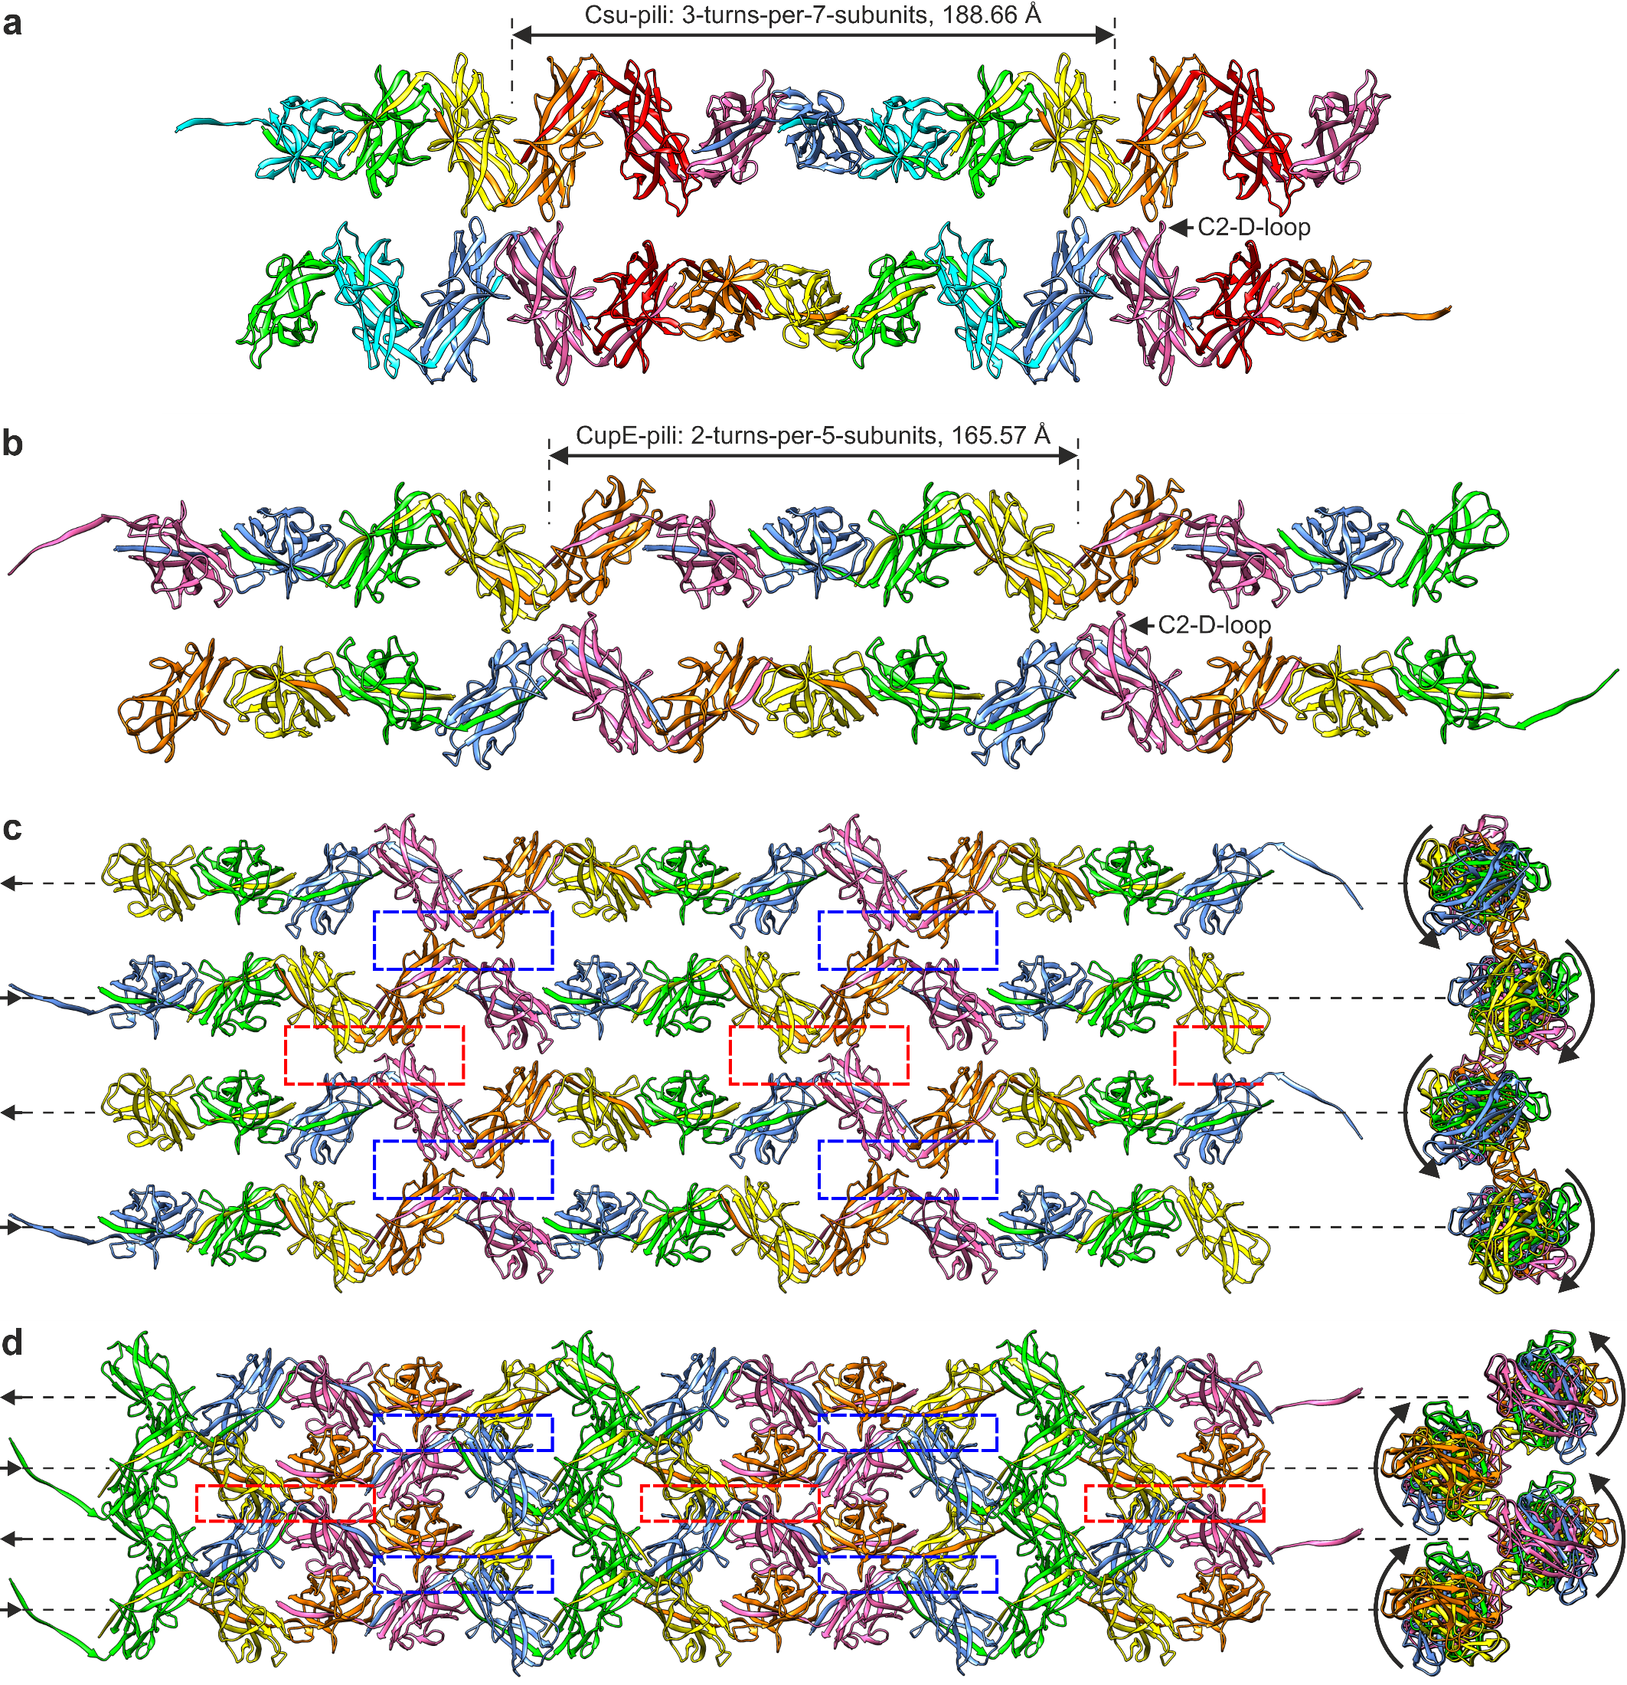
Supplementary Fig. 6 | Csu pilus pair comparison to a predicted CupE pilus pair and stacks. a, Csu pili forming an antiparallel pair have a 3-turns-per-7-subunits repeat around 188.66 Å in length with five subunits linking subsequent binding junctions. b, Helical twist adjusted CupE pilus antiparallel pair based on the CupE pilus rod structure (PDB: 8CIO) and its cryo-EM density map (EMDB: EMD-16683). The cryo-EM map shows an unexplained density extending from CupE C2-D-loop with TTTTSST sequence, which disappears with mutagenesis³⁴. The position of this density indicates it could be part of an antiparallel CupE pilus included in the helical reconstruction rather than being a post-translational modification. CupE pili also form regular mesh-like arrays and CupE pilus rod with -145.33° helical twist³⁴ has only a 1.33° difference from having a 2-turns-per-5-subunits repeat around 165.57 Å in length, with three subunits linking subsequent binding junctions. c,d Predicted CupE pilus type 1 stack (c) and type 2 stack (d) shown from the side and along pilus helical axes. The straight and curved arrows point the direction to the outer membrane and the direction of the rod helical twist, respectively. The red and blue rectangles mark the binding junctions viewed from the opposite directions. The CupE pilus pentagonal cross-section may enable two types of stacks similar to Csu pili, but type 2 stack pili might clash, if the angle between pilus pairs is different, while type 1 stack seems a better match for the observed mess-like arrays³⁴. CupE pilus stacks also seem less able to stretch as type 1 stack has two and type 2 stack has only one stretchable subunit outside the binding junctions in each five-subunit repeat.
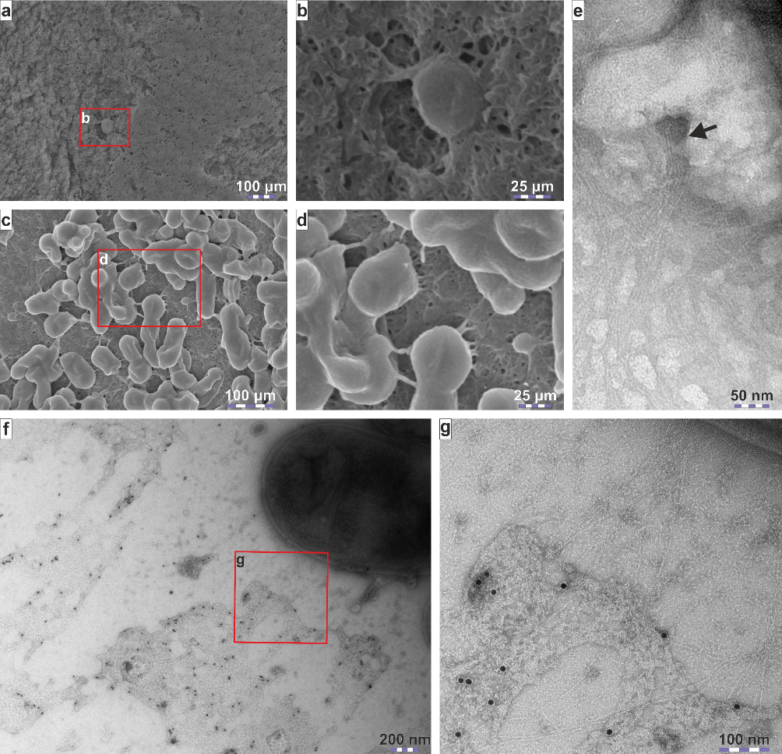
Supplementary Fig. 7 | Csu pilus-mediated 3D biofilm is sealed by PNAG. a-d, SEM images of A. baumannii AB5075 (a, b) and A. baumannii ATCC 19606T (c, d) grown at 30°C for 10 days before samples were fixed and prepared for SEM analysis as described in Methods. Areas indicated by red rectangles in (a) and (c) are shown at a higher magnification in (b) and (d), respectively. e, Negative stain TEM image of bacteria from a suspended A. baumannii strain CCUG 19096T colony showing interactions between Csu stacks and PNAG at a higher resolution. The arrow points at a position, where Csu pilus stack emerges from underneath PNAG. f, Triticum vulgare lectin (WGA) colloidal gold conjugate binds almost exclusively to the amorphous mass surrounding the bacteria from a suspended A. baumannii colony, which indicates the mass contains PNAG. Suspending the mature A. baumannii colony in WGA colloidal gold conjugate solution has dispersed PNAG away from the bacteria. g, Close-up image showing WGA colloidal gold conjugates bound to PNAG near partially stacked Csu pili extending from the bacterial surface.
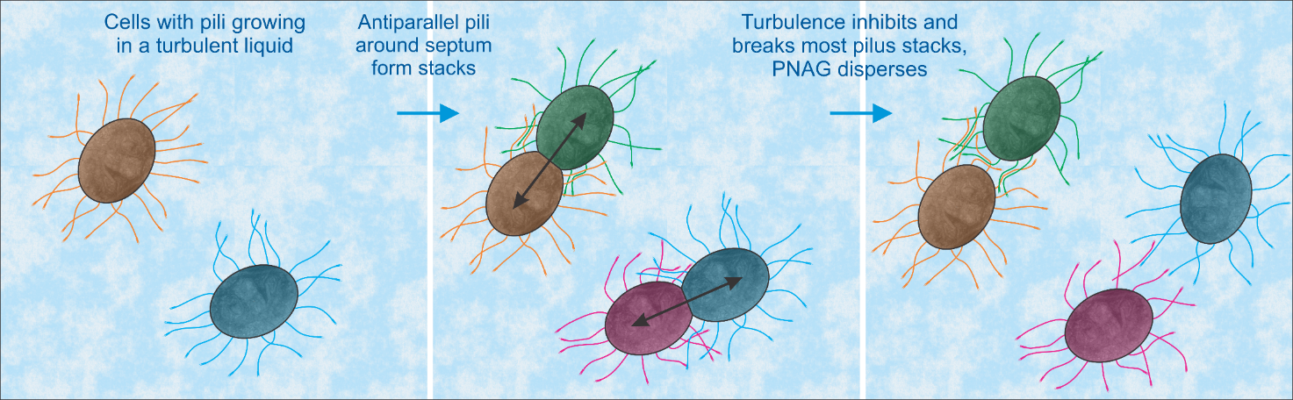
Supplementary Fig. 8| Formation of bacterial aggregates in liquid broth is ineffective. A. baumannii cells growing in a liquid medium are less likely to clump, as turbulence moving both the Csu pili and the cells around inhibits pilus stack formation and breaks the few pairs that form. Limited number of pilus rod antiparallel pairs forming in a turbulent environment usually results in the pairs either breaking or one of the paired pili being pulled off the cell outer membrane. In addition, unlike in a surface biofilm, neighbouring cells are most often absent and therefore unable to stabilize the connection between daughter cells. In these circumstances, PNAG directly exposed to the turbulence disperses before it can link the cells together. If the turbulence is low, then stacks may link the cells, forming a pellicle on the liquid surface.
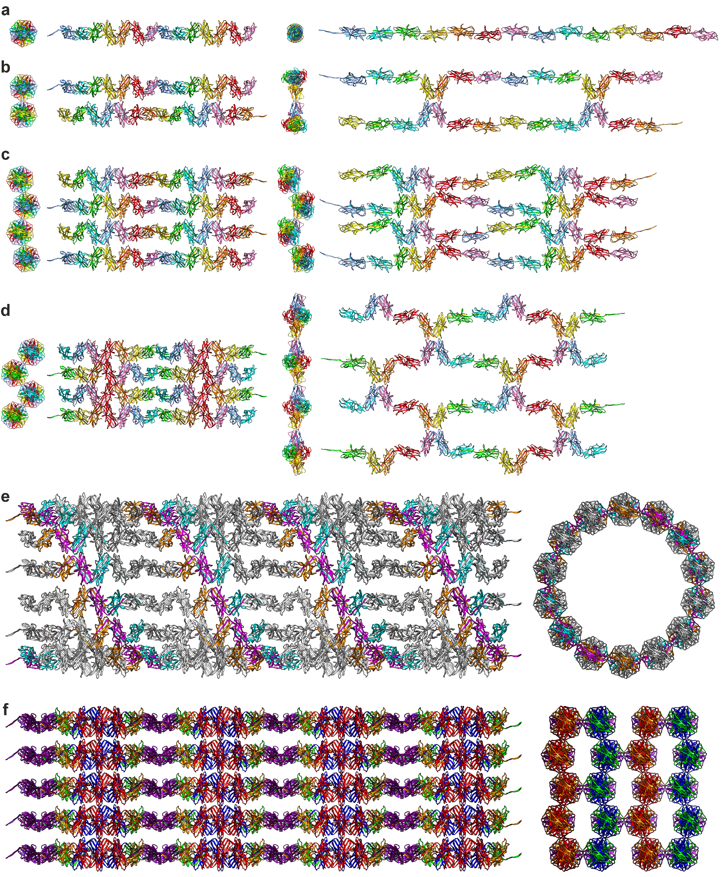
Supplementary Fig. 9 | Modelling the stretching of a single Csu pilus rod, a Csu pilus pair and the two observed types of Csu pilus stacks, and the models of two theoretical 3D stack structures. a, Stretching of a 14 subunit fragment of a Csu pilus rod. The two CsuA/B subunits in each Csu pilus clinch are at a 60° angle to each other along the pilus rod central axis, which allows the rod to extend exactly twice its length, when the clinch structures open²². b, Stretching of a pair of 14 subunit interacting antiparallel Csu pilus rods. Maintaining the interactions would require excluding the two binding junctions from the stretching, but the five subunits linking subsequent binding junctions might still extend. See also Supplementary Video 6. c, Stretching of four antiparallel, 14 subunit fragments forming the Csu pilus type 1 stack. Junctions overlapping by a single subunit in each binding junction band leaves a four-subunit stretchable region between each band, but it also prevents stretching perpendicular to the pilus axes. d, Stretching of four antiparallel, 14 subunit fragments forming the Csu pilus type 2 stack. Lack of overlap between binding junctions leaves two stretchable regions consisting of one or two subunits in each seven-subunit repeat. While this limits stretching along the pilus axes, it enables stretching perpendicular to the pilus axes. This extensive stretching capability of individual pairs (b) and stacks (c,d) is a likely explanation as to why Csu pilus pairs can also wrap into random bundles. e, A theoretical 3D variant of type 1 stack, in which the binding junction position along the rod axes progresses by one subunit with each added Csu pilus, instead of alternating back and forth. This creates a tube of 14 antiparallel Csu pili with two binding junction spirals (orange-magenta-cyan) wrapping around it. In each cross-section of this tube, six out of the 14 subunits belong to a binding junction, so any stretching would likely break the structure. f, Combining stacks 1 and 2 into a uniform 3D stack with type 2 stacks diagonal to the type 1 stacks would require forming a binding junction using the central two subunits (magenta) from each four-subunit stretchable region in type 1 stacks, leaving only two stretchable subunits (orange and green in different layers) in each seven-subunit repeat. These hypothetical 3D stacks are likely bad at stretching and unstable, and we have found no conclusive evidence of their existence.
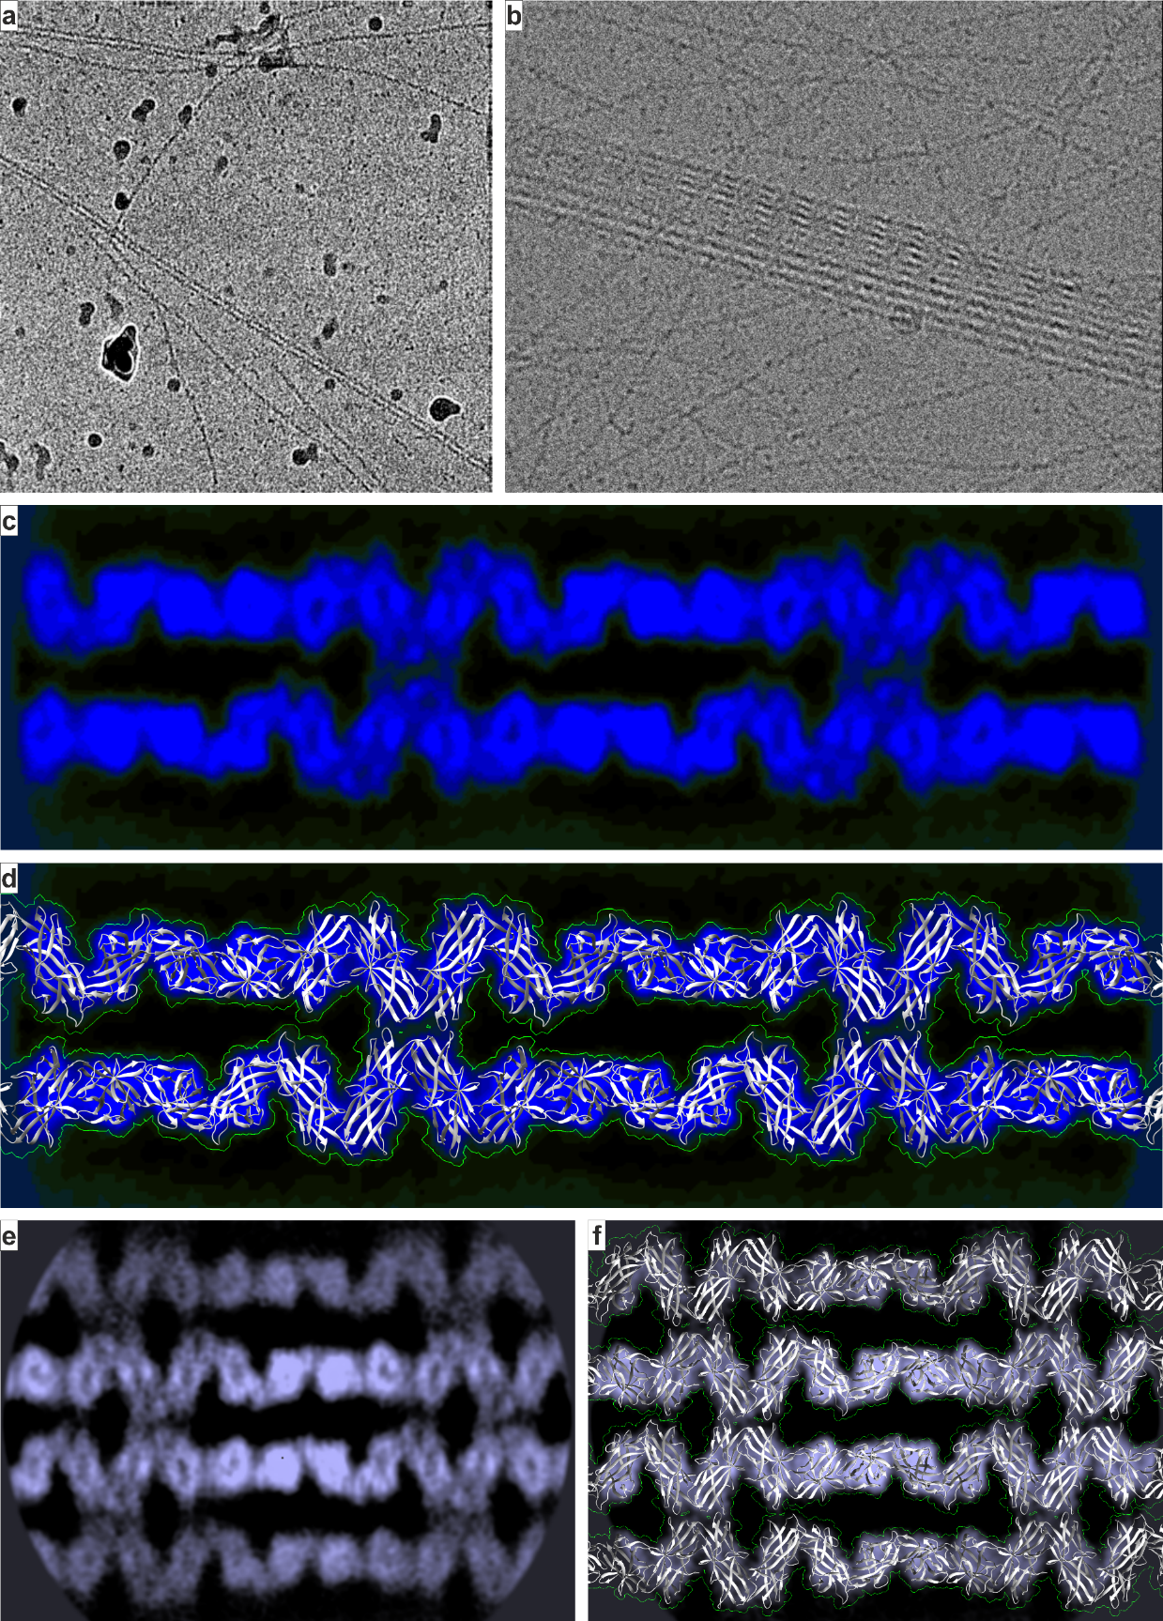
Supplementary Fig. 10 | Models of the Csu pilus doublet and type 1 stack reconstructed based on 2D class averages. a, b, Representative micrographs of pilus pairs (a) and a multi-pilus stack (b). c, The Csu pilus pair cryo-electron microscopy 2D class average used in the overlap analysis. d, Extended version of the Csu pilus pair structure covering the entire Csu pilus pair on the 2D class. The symmetric gap between the Csu pili shows the two pili on the 2D class lay flat against the background. e, 2D class of the Csu pilus stack from an old dataset used for an initial cryo-EM density map. f, Extended version of the Csu pilus type 1 stack structure covers the Csu pilus stack 2D class average without any changes to the angles between Csu pili, which reveals that the stack uses the exact same interactions as the pairs. Description of the modelling procedure is in the Supplementary notes.
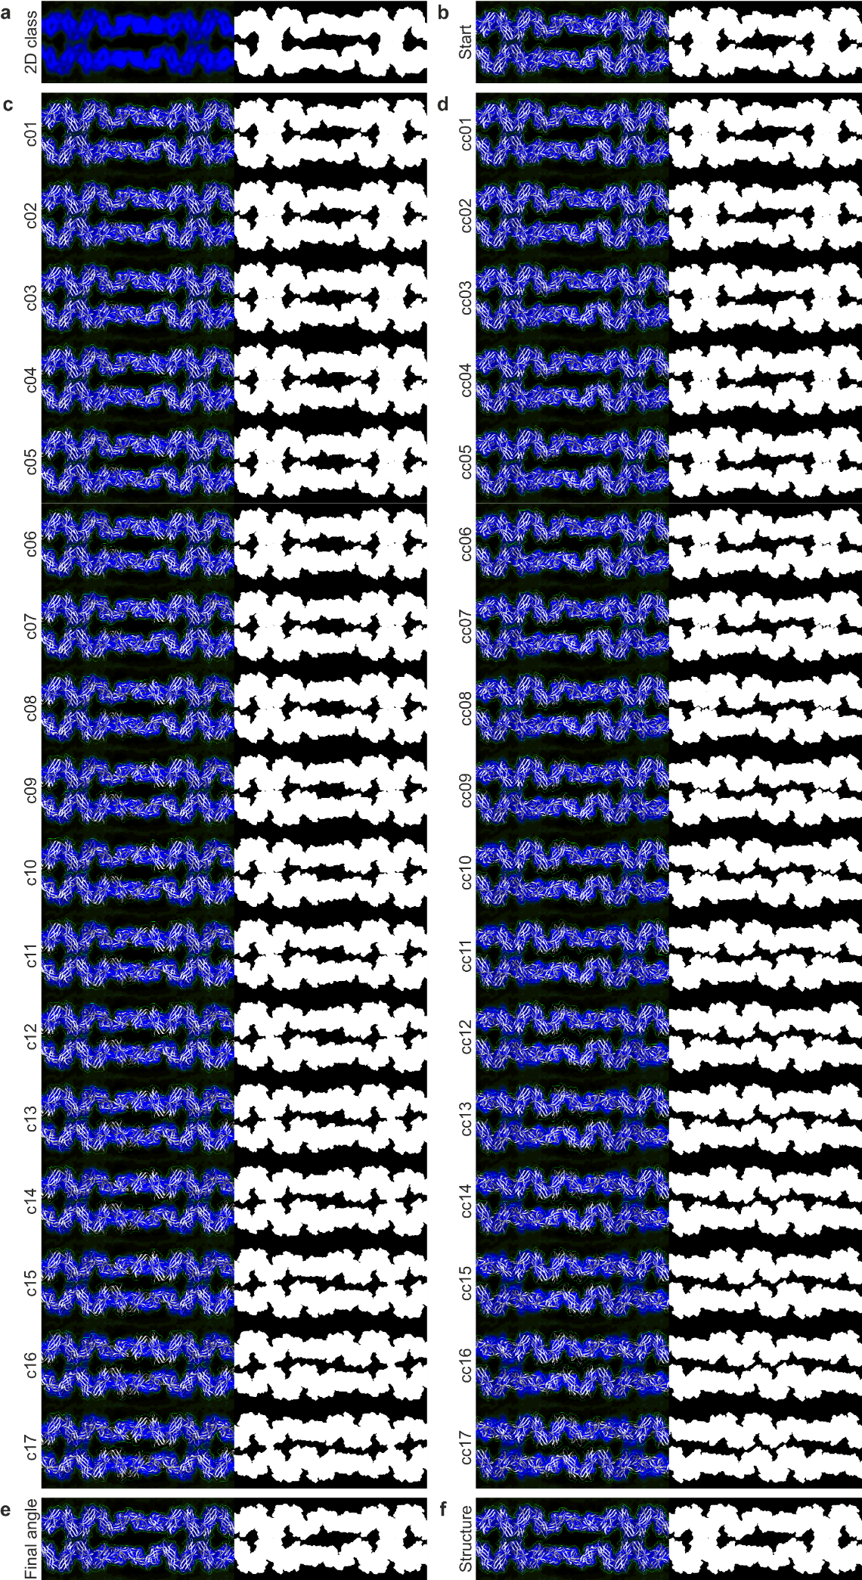
Supplementary Fig. 11 | Csu pilus pair quantitative overlap analysis Part 1. a,b, Quantitative overlap analysis started with a size-adjusted cryo-electron microscopy 2D class (2D-class) and a manual overlap model (Start) consisting of two antiparallel Csu pilus rod models, with their helical twist adjusted precisely to 3-turns-per-7-subunits symmetry, positioned at an equal distance and angle to the 2D class. c,d, The antiparallel Csu pilus rod models are rotated individually around their central axis either clockwise (c01–c17) or counter-clockwise (cc01–cc17) until 51.43° from the manual model. Calculating the difference between each silhouette of a density map simulated from a model and the 2D class silhouette indicates the quality of the overlap through the number of non-overlapping pixels. e–f, The final overlap model (Final angle) with its angle set within the error range of the calculated optimal angle (e) and an extension of the Csu pilus pair structure (Structure) that uses the same angles as the final overlap model (f).

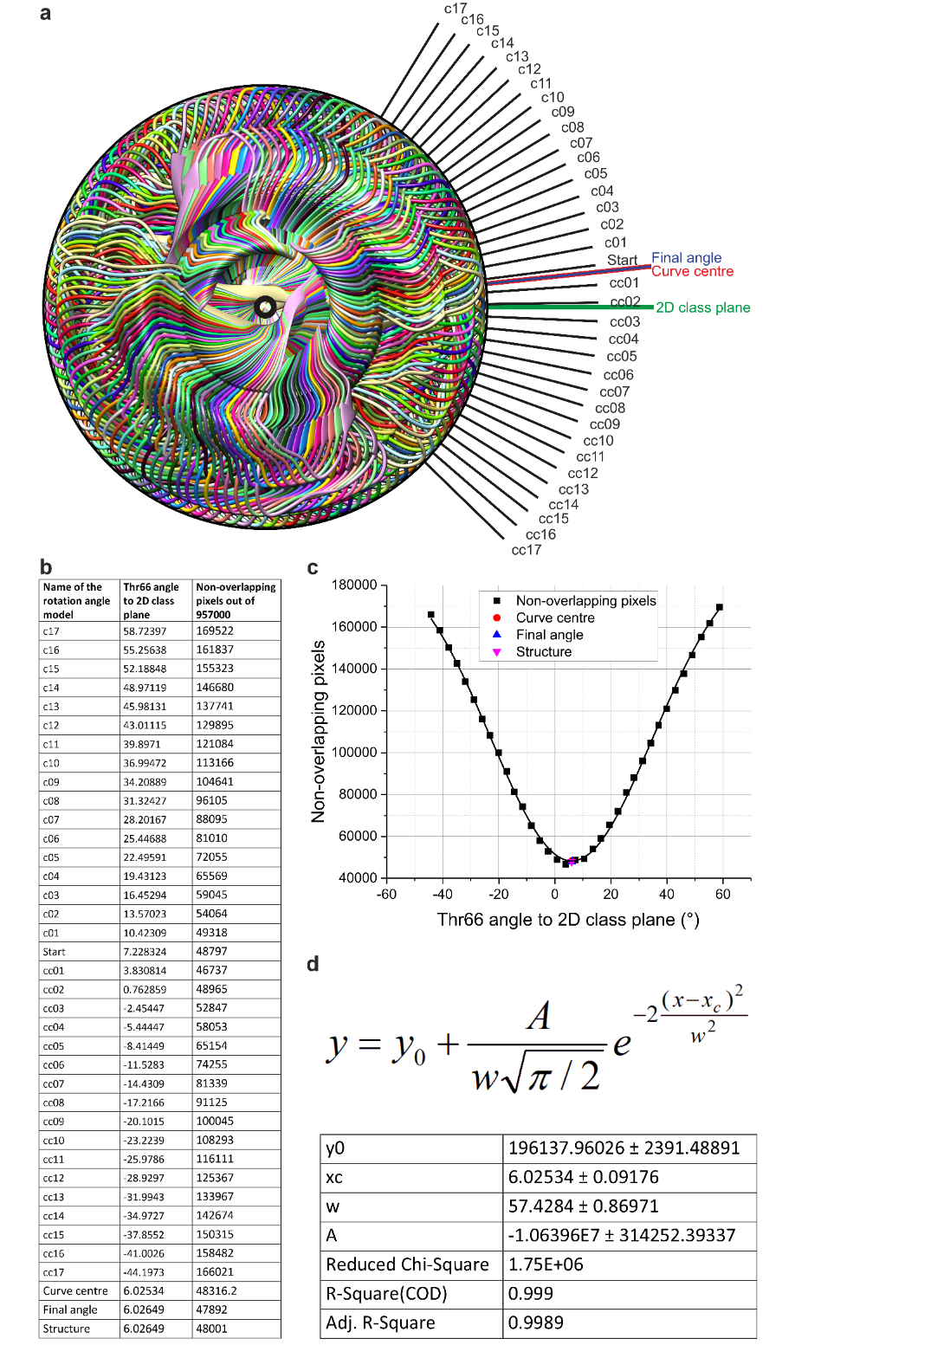
Supplementary Fig. 12 | Csu pilus pair quantitative overlap analysis Part 2. a, End view along the Csu pilus central axis enables accurate adjustment of antiparallel rod pair angles. The angle used for comparison is between the 2D class plane and a line drawn from Thr66 at the antiparallel binding junction to the Csu pilus central axis. b, Full list of Csu pilus antiparallel pair rotation model angles and number of non-overlapping pixels on 957000 pixel images. c, The relation between model angle to 2D class plane and the number of non-overlapping pixels. Curve centre is the calculated lowest point in the fit Gaussian curve, Final angle is the model with its angle adjusted within the error range of the curve centre, and Structure includes the changes caused by antiparallel binding junction adjustments to fit into the type 2 stack density map. d, To avoid bias from local overlap differences caused by rigid surface residues in the simulated model density maps, the final angle is based on Gaussian curve parameters. The parameters indicate that the optimal angle is 6.02534° ± 0.09176° and the 6.02649° angle of the final overlap model fits within this range.
Supplementary notes

Antiparallel binding initial overlap model
Antiparallel Csu pili forming a pair in the cryo-EM 2D classes have identical silhouettes, indicating identical angles and distance to background. The rods show 3-turns-per-7-subunits symmetry and the identical binding sites show internal two-fold symmetry. The -153.984° helical twist of a native single Csu pilus rod structure is only 0.302° off from the 3-turns-per-7-subunits symmetry (-154.286°), so we used that as our starting structure.
We utilized UCSF Chimera package (v.1.15)¹ to adjust the helical twist by first aligning a long Csu pilus rod segment in orthographic projection to orient the central axis perpendicular to the plane of view. We then rotated one of two subsequent subunits in the image plane to adjust the clinch angle, which we evaluated by making 13-subunit rods in Coot (v.8.9.2)². In 3-turns-per-7-subunits symmetry, every eight subunit is directly behind the first, when viewed along the central axis with orthographic projection. Re-adjusting the clinch required shifting Asn44 rotamer slightly and fixing the rotated peptide bond between Thr14 and Gly15.
To overlap two helical twist adjusted 13-subunit models with a 2D class in Chimera, we used orthographic projection to position them horizontally, so that every eighth subunit is directly behind the first in the side view. Since 2D class images open flat against the background, the side view shows, if both models are at an equal distance and angle to the 2D class. Overlap adjustment required moving the 2D class in the background plane, changing its voxel size to 0.4213 Å and adjusting Csu pilus positions by comparing the model secondary structures and simulated density maps to the 2D class.

Csu pili rotation model angles
Creating a series Csu pilus pair models with the two rods rotated equally around their central axes in UCSF Chimera stated with one 13-subunit, helical twist adjusted rod with its axis perpendicular to the plane of view in orthographic projection. Due to its symmetry, if rotated 51.43° in the plane of the screen, the Csu pilus rod overlaps perfectly with itself. We created 17 clockwise and 17 counter-clockwise rotated models extending up to ±51.43° from the initial overlap model and set them in pairs with 51.43° difference. We produced the antiparallel rods in Coot by using the symmetry of the initial overlap model.
Measuring the model rotation angles required a combined image of one rod from every 35 Csu pilus pair rotation models viewed along their central axes in UCSF Chimera. After drawing a circle in CorelDRAW 2021 connecting Thr66s in every model to determine the position of the central axis, we calculated the angle between the 2D class plane and a line drawn from the central axis to the Thr66 of a binding site subunit (Supplementary Fig. 12a). Each model having a pair with 51.43° difference increased the accuracy. We used the same view and image dimensions for later models to calculate their angles as well.

Quantitative overlap analysis
Csu pilus antiparallel pair overlap analysis used 3.4 Å resolution simulated maps of each rotation angle model, made using the UCSF Chimera Fit in Map tool.
We turned each simulated map to a white, level 0.117 surface with brightness set to 10 and transparency to 0. In the Effects section of Viewing, we had silhouettes turned off, and in the Lighting section, we set brightness to 2.0 and contrast to 0.0. These settings showed each density map as a white silhouette with no surface features.
We cropped the image to exclude noise in the 2D class periphery and the model ends. We created separate images of the 2D class and each simulated map using the same view, 1500x638 pixel dimensions and 3x3 pixel Supersampling (Supplementary Fig. 11).
Overlap analysis using Fiji (ImageJ)³ 3D Object Counter v2.0 utilized 16-bit versions of the images. We first deactivated the ‘Show numbers’ in 3D OC Options. Then we adjusted 3D Object Counter v2.0 to use threshold 20 and size filter from 0 to 957000, deactivated ‘Exclude objects on edges’ and set it to show only the Objects map.
Finding the non-overlapping pixels between the 2D class and each model silhouette required using Image Calculator operation ‘Difference’ and Objects map files with one object each. This turns the non-overlapping pixels into a single surface with the image histogram showing their number (Supplementary Fig. 12b). In cases with the silhouette splitting into more than one object in the Objects map, we used 3D Object Counter v2.0 to separate the objects into different images before merging them with Image Calculator operation ‘Difference’.
Scatterplot of non-overlapping pixels versus model rotation angles forms an inverted bell-shaped curve that allowed calculating the optimal Csu pili rotation angle by using Gaussian function from Origin version 2016 (OriginLab Corporation, Northampton, MA, USA) (Supplementary Fig. 12c,d). The 6.02649° angle of the final overlap model is within the standard deviation of the Gaussian function centre (6.02534° ± 0.09176°).

Antiparallel binding site adjustment
In the final overlap model, the central axes of the two Csu pilus rods are 52.39 Å apart, which brings only Thr14, Thr66, Asn87, Thr88, Ala89, Ser120, Gln142 and Gly143 within range to form contacts. Most of these are next to β-sheets or conserved regions important for structural stability, limiting the main chain flexibility. Gln142 and Gly143 form a turn at the start of the F-strand stabilized by Tyr145 from a conserved GXYXD sequence. Tyr145 and Gly142 also help bind the Gd-strand C-terminal anchor Ile12. Similarly, Asn87, Thr88 and Ala89 form the tip of the C2–D-hairpin stabilized by conserved Arg83 and Tyr96, and Asn87 forms stacking interactions with Tyr145. Thr14 belongs to a linker fixed in place by the Gd-strand C-terminal anchor Ile12 as well as Gly15 and Cys16 from the A-stand. Thr66 is part of the more flexible B′′–C1-loop between Cys63 and Asp64 from the B′′-strand and Val69 from the C1-strand. Ser120 belongs to the flexible, outer D–E1-loop between Thr118 and Thr124.
Model overlap with the 2D class is more sensitive to changes in rotation angle than the predicted interactions. Models rotated 7.54° clockwise or 8.48° counter-clockwise have clearly worse overlap than the final angle model, but the residues remain in mostly optimal distance and orientation for binding. Further counter-clockwise rotation forms no extra interactions, but rotating 10.43° clockwise brings Thr41s and Pro139s from either side in range to interact. However, with bad overlap and the 2D class having a low-density area where the Thr41s and Pro139s should connect, the interaction is unlikely.
In the initial binding junction adjustments, we shifted the D–E1-loop slightly in Coot to avoid Ser120 clashing with Ala89, and adjusted the rotamers of Thr14, Thr66 and Gln142. Later, the 4.70 Å resolution of the type 2 stack density map enabled further adjustments to the binding junction B′′–C1-loop (adjusted from Cys63 to Val69) and D–E1-loop (adjusted from Thr118 to Ala123). We used this final version in the binding junctions of all our structures.

Modelling other pili based on the cryo-EM structures
To compare A. baumannii strain ATCC 19096 Csu pilus binding junction structure to Csu pili from other Acinetobacter species, we selected CsuA/B sequences with no mutations affecting Csu pilus clinch angle to represent the two main phylogenetic groups. We modified Csu pilus pair structure in Coot according to the sequence alignment (Supplementary Fig. 5) to create models of the related Csu pili.
CsuA/B from A. colistiniresistens strain TUM15188 differs from A. baumannii CsuA/B only through point mutations, requiring no change in the positions of the two rods. The only main chain difference is in the D′′–E1-loop, allowing Ser89 to form a hydrogen bond with Gly121 and to avoid clashing with Asn120 (Supplementary Fig. 4c).
The other CsuA/B sequence from A. defluvii strain WCHA30 has deletions to B′′–C1-loop and C2–D-loop, and an insertion to D′′–E1-loop. We focused the changes to the main chain orientation to the tips of the affected loops, away from the β-sheets. In the model, Asn119 insertion is at the tip of the D′′–E1-loop, and the B′′–C1-loop resembles the A. baumannii structure, but with a longer β-sheet between the C1- and D′′-strands due to C1-strand lacking Pro68. For the C2–D-loop, we used an AlphaFold model in the UniProt database⁴, and the orientation of Asn86 differs from Asn87 in A. baumannii. With Ala14 and Glu139 replacing Thr14 and Gln142, this leaves an even 2 Å gap across the binding junction, which required shifting the rods closer to connect the complementary surfaces (Supplementary Fig. 4d).
We adjusted Pseudomonas aeruginosa CupE pilus structure (PDB: 8CIO)⁵ with 33.11 Å helical rise and -145.33° helical twist by 1.33° to achieve 2-turns-per-5-subunits symmetry. There was no density map or a 2D class to make an overlap model, but the single CupE pilus rod cryo-EM density map (EMDB: EMB-16683) has an unexplained density linked to a C2–D-loop with TTTTSST sequence, which disappears through mutagenesis⁵. To create the antiparallel binding model (Supplementary Fig. 6b), we placed the edge of an antiparallel CupE pilus inside this unexplained density. We then further extended the pair to produce predicted models of two types of stacks (Supplementary Fig. 6c,d).

Supplementary references

1 Pettersen, E. F., Goddard, T. D., Huang, C. C., Couch, G. S., Greenblatt, D. M., Meng, E. C. & Ferrin, T. E. UCSF Chimera--a visualization system for exploratory research and analysis. J Comput Chem 25, 1605-1612, (2004).
2 Emsley, P., Lohkamp, B., Scott, W. G. & Cowtan, K. Features and development of Coot. Acta Crystallogr D Biol Crystallogr 66, 486-501, (2010).
3 Schindelin, J., Arganda-Carreras, I., Frise, E., Kaynig, V., Longair, M., Pietzsch, T., . . . Cardona, A. Fiji: an open-source platform for biological-image analysis. Nat Methods 9, 676-682, (2012).
4 UniProt, C. UniProt: the Universal Protein Knowledgebase in 2023. Nucleic Acids Res 51, D523-D531, (2023).
5 Bohning, J., Dobbelstein, A. W., Sulkowski, N., Eilers, K., von Kugelgen, A., Tarafder, A. K., . . . Bharat, T. A. M. Architecture of the biofilm-associated archaic Chaperone-Usher pilus CupE from Pseudomonas aeruginosa. PLoS Pathog 19, e1011177, (2023).

Supplementary videos
Video 1 ⎮ Cryo-electron tomography shows flat Csu pilus stacks linking A. baumannii cells. 3D segmentation highlighting the Csu pilus stacks mediating cell-cell contacts. The inner and outer membranes are in cyan and violet.

Video 2 ⎮ The cryo-EM structure of an antiparallel pair of interacting pilus rods. Cartoon representation of the structure of an antiparallel pair of interacting pilus rods. The seven subunits in the helical repeat of the Csu pilus rod all have different colours.

Video 3 ⎮ The cryo-EM structure of the Csu pilus rod type 1 stack. Cartoon representation of the structure of the Csu pilus rod type 1 stack. The seven subunits in the helical repeat of the Csu pilus rod all have different colours.

Video 4 ⎮ The cryo-EM structure of the Csu pilus rod type 2 stack. Cartoon representation of the structure of the Csu pilus rod type 2 stack. The seven subunits in the helical repeat of the Csu pilus rod all have different colours.

Video 5 ⎮ Csu pilus stacks may form around the septum of separating daughter cells. During cell division, the cell membrane grooves inward around the septum, positioning Csu pili around the septum antiparallel to each other, which seems to promote pilus stack formation. Connecting daughter cells by pilus stacks is likely a major step in the formation of a 3D biofilm, allowing the stacks to form simultaneously with bacterial growth.

Video 6 ⎮ Modelling the stretching of a pair of 14-subunit interacting antiparallel Csu pilus rods. Maintaining the pilus-pilus interactions would require excluding the two binding junctions from the stretching, but the five subunits linking subsequent binding junctions might still extend.

