Supplemental Figures

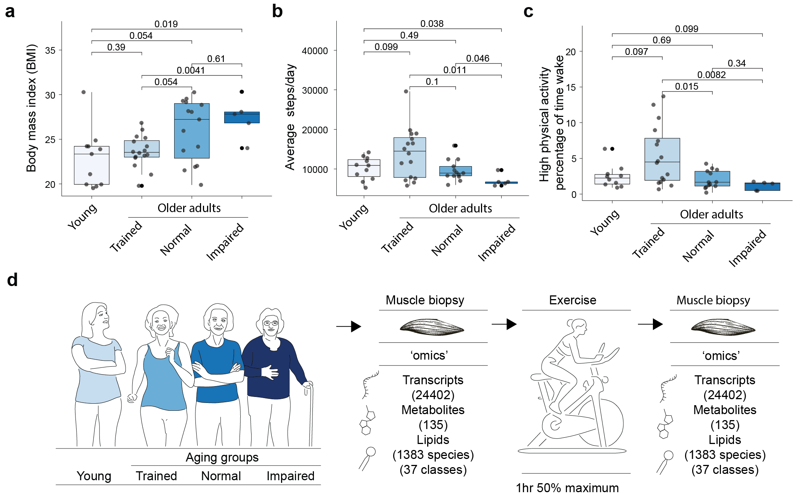
Extended Data Figure 1 | Comparison of specific cohort characteristics. a, Body mass index (BMI) of cohort participants. b, Average steps per day of cohort participants. c, Percentage of time in high physical activity of cohort participants. n=11 young, n=16 trained older adults, n=15 normal older adults, n=5 impaired older adults. Significance was determined using a Kruskal-wallice test. Boxplots: Inner line within the box is the median of the data, the box extends to the upper and lower quartile of the dataset (25% of the data above and below the median), whiskers (dashed lines) represent up to 1.5 times the upper or lower quartiles, circles beyond the whisker represent individual data points outside this range. Source data; see Grevendonk et al. 2021 (PMID: 34362885). d, Schematic of study design with young and older adults of different activity level groups with muscle biopsies collected before and after exercise. Transcriptomics, metabolomics, and lipidomics were performed on the samples.
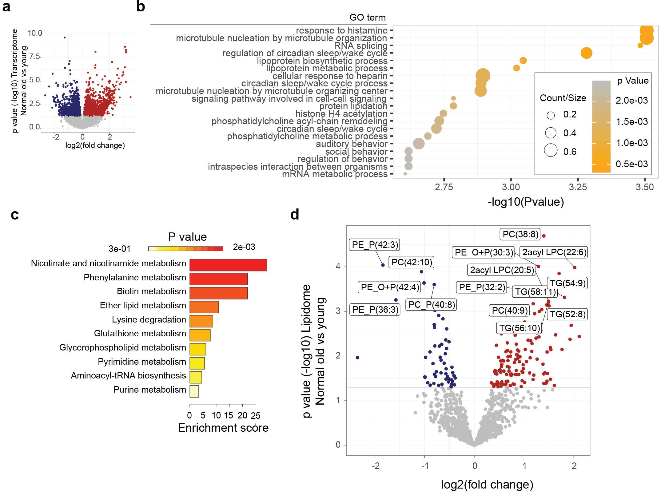
Extended Data Figure 2 | Transcriptome, metabolome, and lipidome in old vs young muscle. a, Volcano plot of fold change (x-axis, log2 scale) versus p-value (y-axis, -log10 scale) for older adults compared to young individuals, illustrating significantly downregulated (blue) or upregulated (red) transcripts with age (comparing young, n=11, and normal older adults, n=15). The horizontal line indicates significance (p<0.05). Significance was determined using an empirical Bayes moderated t-test (two-sided, p values adjusted for multiple comparisons between groups). b, Gene Ontology (GO) term enrichments comparing normal aging to young. Enrichments were calculated using a hypergeometric test comparing upregulated genes (p<0.05, n=1628), relative to the entire transcriptome as background. c, KEGG pathway enrichment for the top most altered metabolites (n=10) with aging using a global test. d, Volcano plot similar to ‘a’ for altered lipids comparing normal aging to young. Top altered lipids (n=15) are highlighted with names. P values were corrected for multiple hypothesis testing (pAdj) using the Benjamini method.

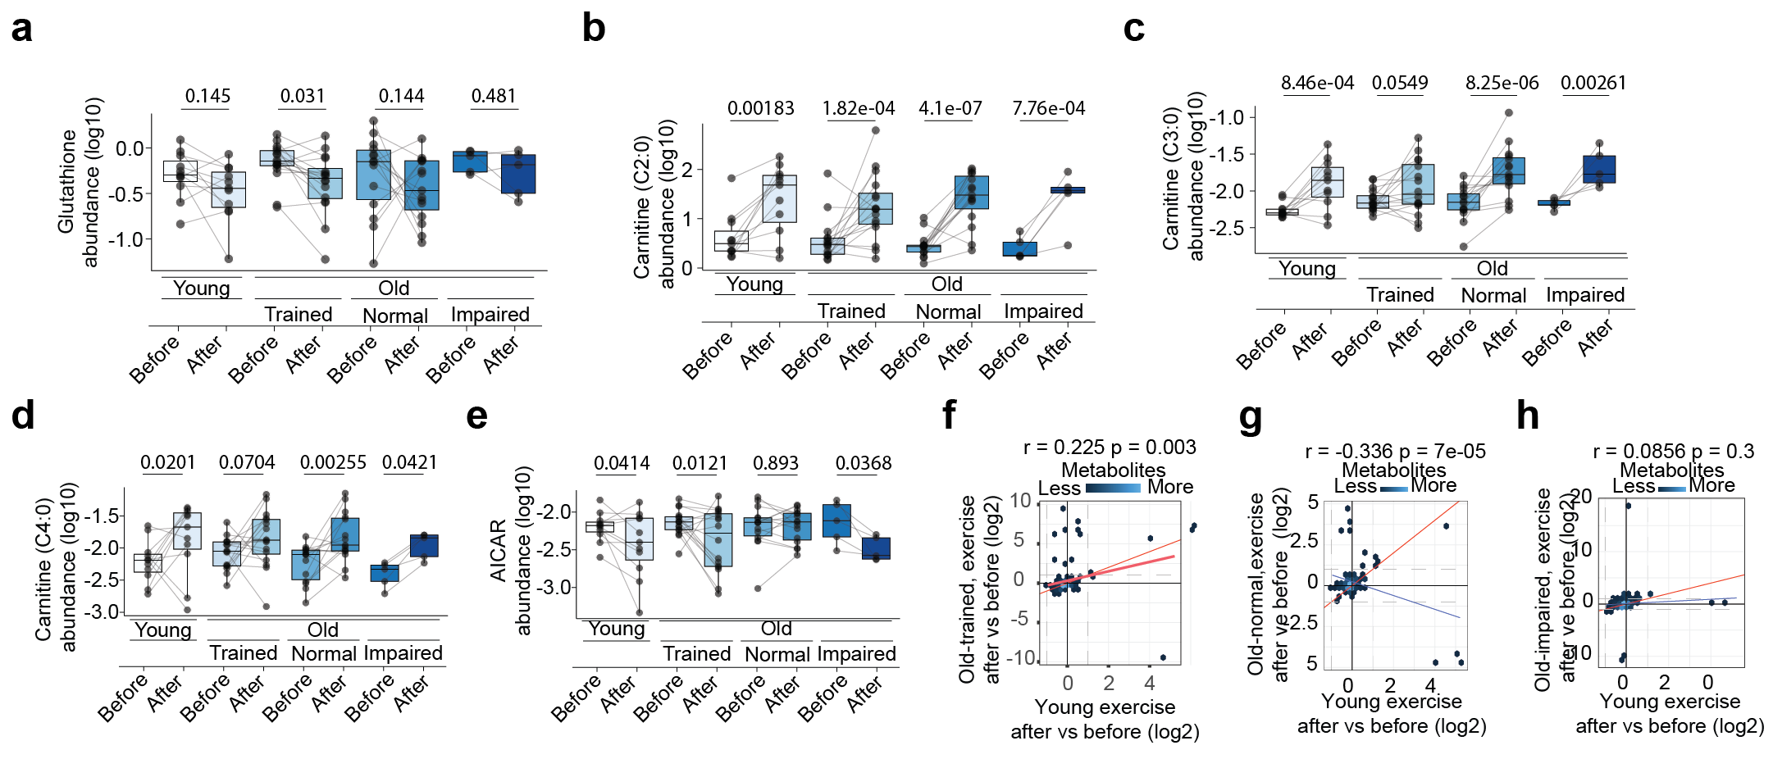
Extended Data Figure 3 | Metabolomics response to exercise. a-e; Boxplots of metabolite responses to exercise, for abundance of a, glutathione, b, acetyl-carnitine (C2:0), c, Propionyl-carnitine (C3:0), d, Butyryl-carnitine (C4:0), e, AICAR. Boxplots: Inner line within the box is the median of the data, the box extends to the upper and lower quartile of the dataset (25% of the data above and below the median), whiskers (dashed lines) represent up to 1.5 times the upper or lower quartiles, circles beyond the whisker represent individual data points outside this range. Significance was determined using an empirical Bayes moderated t-test (two-sided, p values adjusted for multiple comparisons between groups). f-h; Binned hexagonal scatterplots (color indicating point density) comparing log2 fold changes of before-after exercise in young (x-axis) to (y-axis) of: f, trained older adults, g, normal older adults, or h, impaired older adults.

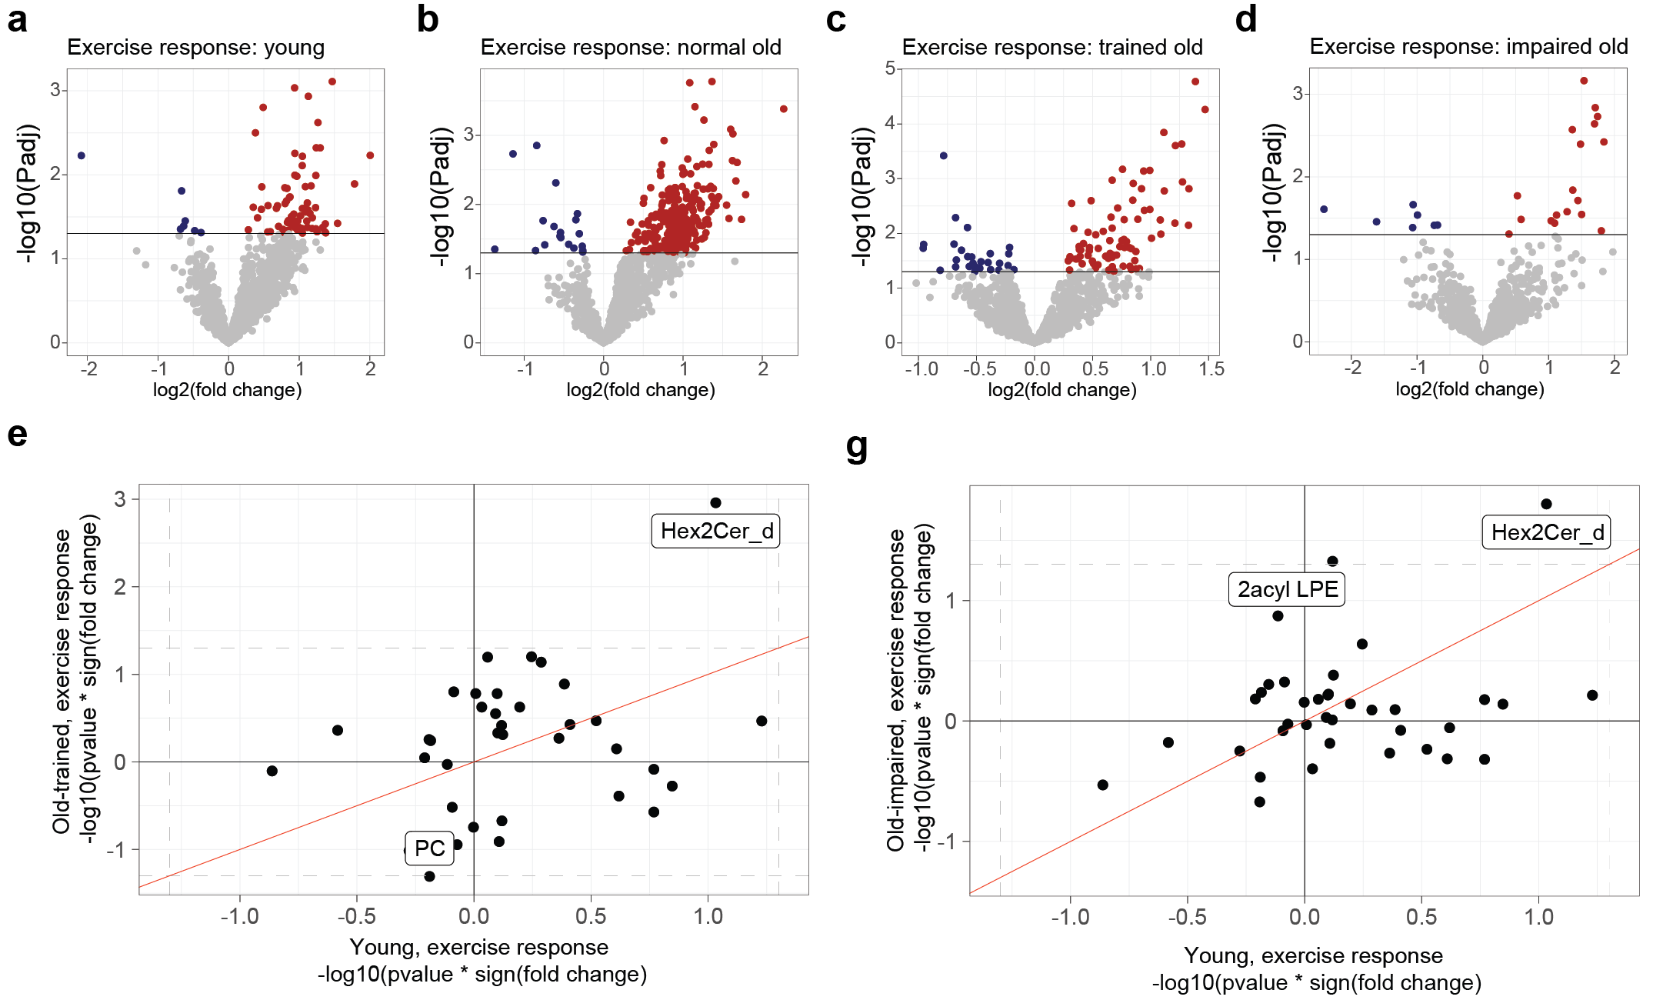
Extended Data Figure 4 | Lipidomic response to exercise. a-d; Volcano plot of fold change (x-axis, log2 scale) versus p-value (y-axis, -log10 scale) for the exercise response of the lipidome for a, young, b, normal older adults, c, trained older adults, and d, impaired older adults, illustrating significantly downregulated (blue) or upregulated (red) transcripts with age. The horizontal line indicates significance (p<0.05). Significance was determined using an empirical Bayes moderated t-test (two-sided, p values adjusted for multiple comparisons between groups). e-f; comparison of the exercise response of the lipidome young adults (x axis) to either e, trained older adults or f, impaired older adults. Red line = 1:1 mark.

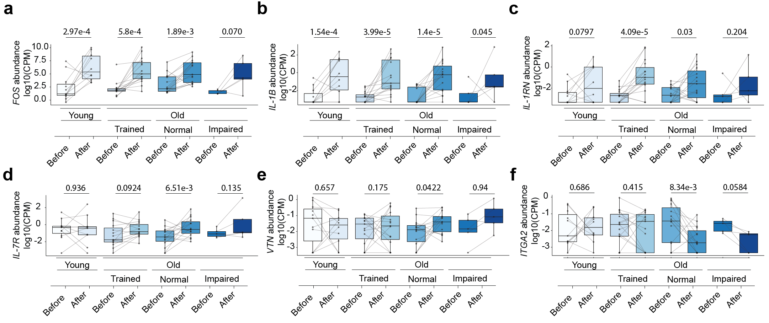
Extended Data Figure 5 | Transcriptional responses to exercise, normal aging. a-f; Boxplots of transcriptional responses to exercise, for a, FOS, b, IL-1B, c, IL-1RN, d, IL-7R, e, VTN, f, ITGA2. Boxplots: Inner line within the box is the median of the data, the box extends to the upper and lower quartile of the dataset (25% of the data above and below the median), whiskers (dashed lines) represent up to 1.5 times the upper or lower quartiles, circles beyond the whisker represent individual data points outside this range. Significance was determined using an empirical Bayes moderated t-test (two-sided, p values adjusted for multiple comparisons between groups).
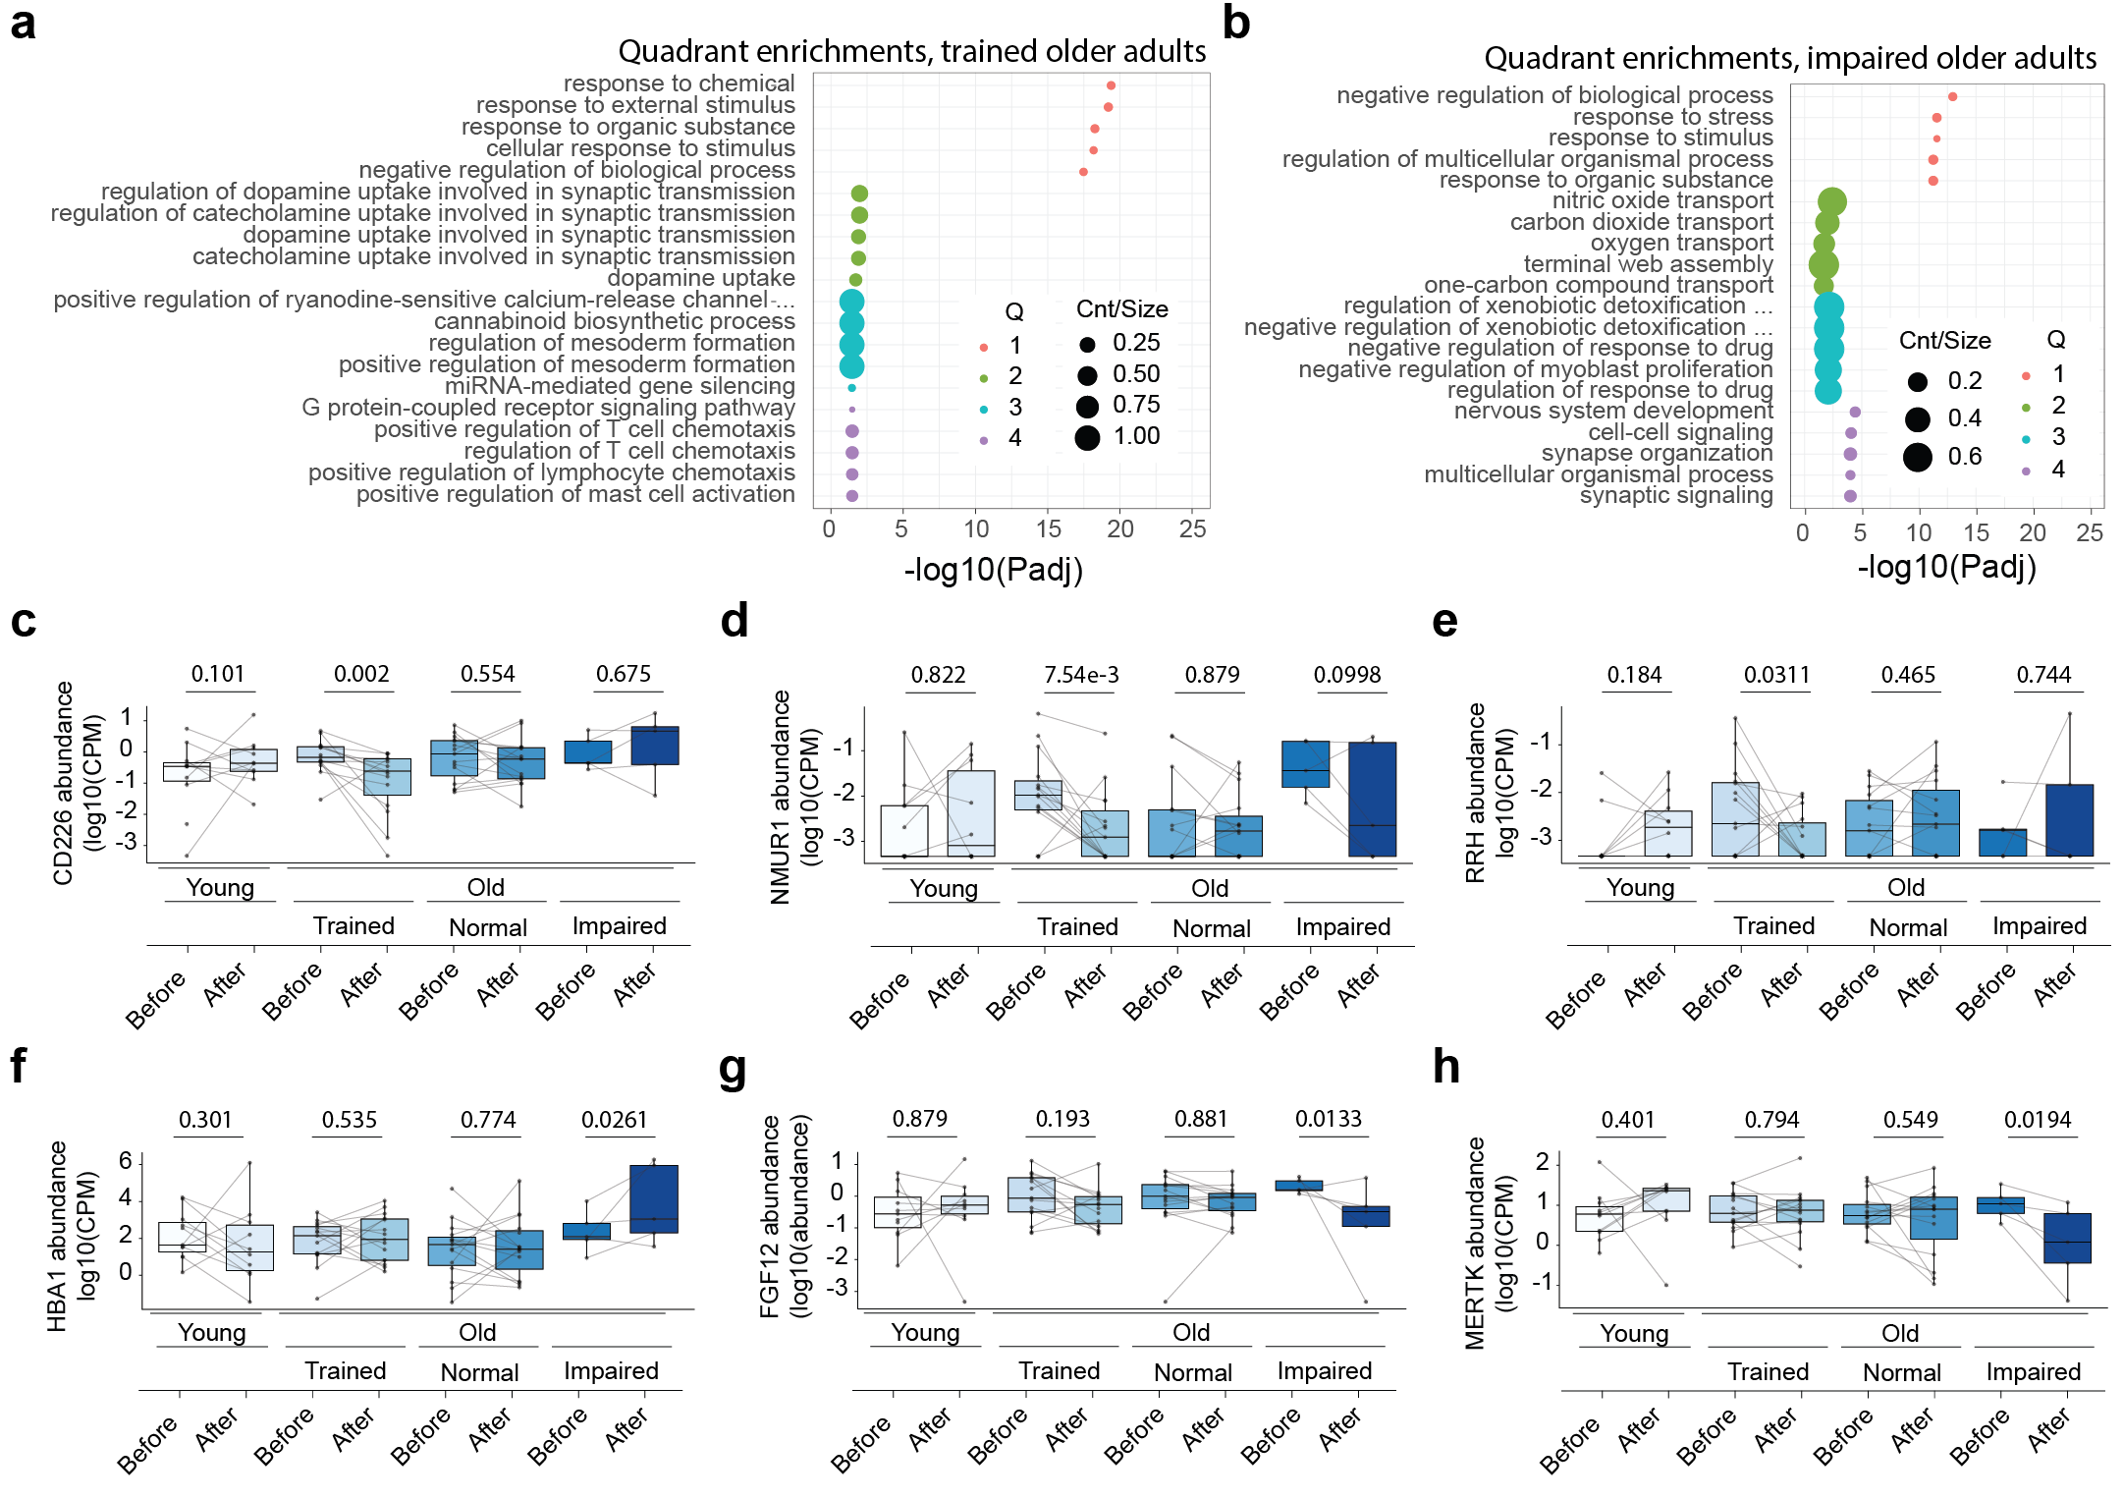
Extended Data Figure 6 | Transcriptome response to exercise, trained and impaired. a-b; Gene Ontology (GO) term enrichments comparing a, trained older adults and b, impaired older adults to young. Enrichments were calculated using a hypergeometric test comparing genes selected from each scatterplot quadrant relative to the entire transcriptome as background. c-h; Boxplots of transcriptional responses to exercise, for c, CD226, d, NMUR1, e, RRH, f, HBA1, g, FGF12, h, MERTK. Boxplots: Inner line within the box is the median of the data, the box extends to the upper and lower quartile of the dataset (25% of the data above and below the median), whiskers (dashed lines) represent up to 1.5 times the upper or lower quartiles, circles beyond the whisker represent individual data points outside this range. Significance was determined using an empirical Bayes moderated t-test (two-sided, p values adjusted for multiple comparisons between groups).

