Additional File 1
Magnetotelluric impedance consisting of six elements

Xiaoli Wan^{1,2}, Hisayoshi Shimizu², Peng Yu¹, Hisashi Utada²

1: School of Ocean and Earth Sciences, Tongji University
2: Earthquake Research Institute, The University of Tokyo

Text S1. Forward calculations for a model with a conductive anomaly in a homogeneous medium

In the main text, we showed results of 3-D numerical modelling concerning the uniqueness of 4- and 6-element impedances and tippers in both Cartesian and spherical coordinate systems. The model setup is illustrated in Figure S1. The study region is a $20°$ times $20°$ square, with a conductive anomaly of 0.1 S/m centered within the region. Outside the study region, model domain for a Cartesian is extended to $40°$ times $40°$ square to avoid influence from the boundary. For a spherical model, calculation grids cover the entire Earth but with coarser grid spacings outside the $40°$ times $40°$ square region. The anomaly has lateral dimensions of 16°times 6°and extends from 4 to 100 km in depth. Outside the anomaly, the model consists of a homogeneous half space. The spherical model consists of a conductive anomaly embedded in a uniform background. A plane-wave source was assumed for Cartesian models, while a dipole source was used for spherical models. EM field components were calculated at all grid points on the surface of the study region, solving the EM induction equations in both Cartesian and spherical coordinate systems for the frequency of ${10}^{-4}$Hz. From these computed field components, we estimated 4-element impedances and tippers in the Cartesian coordinate system, and both 4- and 6-element impedances and tippers in the spherical coordinate system.
Using calculation results, we compared two sets of estimates to examine their amplitude effects. For the Cartesian calculations, the first set was derived from a combination of two orthogonal sources, in which the amplitude of one source was set to unity and that of the other source was varied between ${10}^{-5}$ and ${10}^{5}$. The second set was derived from another combination of two orthogonal sources of unit amplitude. For the spherical calculations, the first set was derived from a combination of three orthogonal sources, in which the amplitude of two sources was set to unity and that of the third source was varied between ${10}^{-5}$ and ${10}^{5}$. The second set was derived from another combination of three orthogonal sources, all with unit amplitude.
The average deviation was calculated for impedances as follows:
$dZ_{avg}^{1-2}=\frac{1}{N}\sum_{n=1}^{N}{\frac{{\left\|Z_{n}^{1}-Z_{n}^{2}\right\|}_{F}}{{\left\|Z_{n}^{2}\right\|}_{F}}}$, (S1)
where ${\left\|∙\right\|}_{F}$ denotes the Frobenius norm. For tippers, the average deviation was computed as:
$dT_{avg}^{1-2}=\frac{1}{N}\sum_{n=1,N}{\frac{{\left\|T_{n}^{1}-T_{n}^{2}\right\|}_{2}}{{\left\|T_{n}^{2}\right\|}_{2}}},$ (S2)
where ${\left\|∙\right\|}_{2}$ denotes the L2-norm. In Equations (S1) and (S2), $N$ represents the total number of grid points in the study region, and the superscripts 1 and 2 correspond to datasets obtained from the respective source combinations.
Note that we compared the impedances and tippers calculated from exactly the same model for the same frequency obtained at the same grid points. The deviations are little influenced by the precision of numerical calculations (${\sim 10}^{-16})$. This means deviations obtained by (S1) and (S2) are essentially attributed to the source amplitude effect.

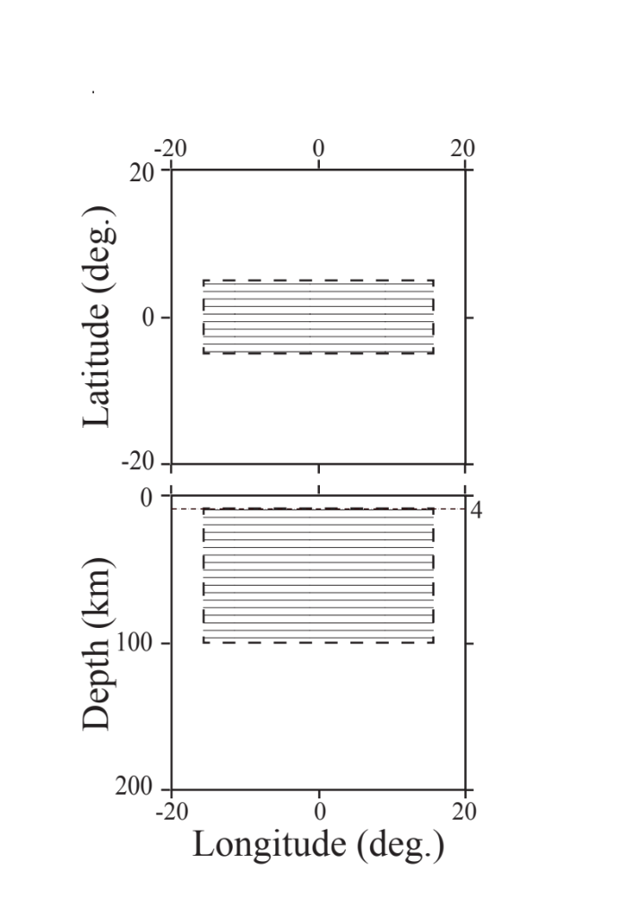
Figure S1. Plan view (top) and side view (bottom) of the conductivity model used for calculating impedance deviations. The model features a polygonal conductive anomaly with a conductivity of 0.1 S/m embedded in a homogeneous half-space with a conductivity of 0.01 S/m. The anomalous body spans a depth range from 4 km to 100 km.

