Supplementary Material for
Diffractive Magic Cube Network with Super-high Capacity Enabled by Mechanical Reconfiguration
Peijie Feng¹, Fubei Liu², Yuanfeng Liu², Mingzhe Chong¹, Zongkun Zhang¹, Qian Zhao³, Jingbo Sun², Ji Zhou², Yunhua Tan¹
¹School of Electronics, Peking University, Beijing, 100871, China
²State Key Laboratory of New Ceramics and Fine Processing, School of Materials Science and Engineering, Tsinghua University,
Beijing 100084, China
³State Key Laboratory of Tribology in Advanced Equipment, Department of Mechanical Engineering, Tsinghua University, Beijing, China
These authors contribute equally: Peijie Feng & Fubei Liu
Correspondence: Yunhua Tan Email: tanggeric@pku.edu.cn & Ji Zhou Email: zhouji@tsinghua.edu.cn& Jingbo Sun Email: jingbosun@mail.tsinghua.edu.cn
Peijie Feng Email: pjf@stu.pku.edu.cn
Fubei Liu Email: lfb23@mails.tsinghua.edu.cn
Yuanfeng Liu Email: lyf_student@126.com
Mingzhe Chong Email: cmz1999@stu.pku.edu.cn
Zongkun Zhang Email: zhangzongkun@163.com
Qian Zhao Email: zhaoqian@tsinghua.edu.cn

The supplementary file includes:
Supplementary Note 1: The hardware scalability of DMCN
Supplementary Note 2: The diverse mechanical combinations of DMCN
Supplementary Note 3: The calculation of the potential number of channels in DMCN and its scalability.
Supplementary Note 4: The relationship between permutation operations and bidirectional transmission.
Supplementary Note 5: Analysis of experimental errors and calibration strategies.
Supplementary Figs. 1-24.

Supplementary Note 1: The hardware scalability of DMCN
The composition of DMCN is remarkably simple, consisting of only three layers of pure phase modulation, resulting in low system complexity. In this article, to facilitate the experimental validation of the theoretical prototype of DMCN, we utilized SLMs and mirrors as the hardware implementation of the system. Alternatively, our DMCN system can achieve phase modulation using isotropic transmissive phase metasurfaces composed of common square or cylindrical meta-atoms, which will significantly reduce the overall system size. Supplementary Fig. 13 and Supplementary Fig. 15 present the 144-channel holographic DMCN and the 108-channel single-focus/multi-focus DMCN implemented by metasurfaces, respectively. Both models utilize meta-atoms with a phase modulation period of 400 nm. The layer width and FOV width of DMCN were set to 300 and 85, respectively. The channel combinations and model training parameters are consistent with those in the main text. The overall dimensions of these two models are only 120 µm × 120 µm × 360 µm. In addition, since metasurfaces can modulate light fields with higher spatial sampling rates, they enhance the equivalent numerical aperture of our system. For the holography functionality, the pixel size of the images is significantly reduced to a subwavelength scale. For the focusing functionality, the FWHM of the focal spot is only 1.4 µm, approximately $3λ$. This is comparable to the focal spot size achieved with a single-layer meta-lens under identical configurations, as shown in Supplementary Fig. 14.
With metasurfaces operating in the terahertz and microwave frequency ranges, our DMCN can be easily implemented in these lower-frequency bands, demonstrating cross-band adaptability. Beyond metasurfaces, our system can also utilize more cost-effective devices, such as phase plates, for implementation. As DMCN leverages mechanical adjustments to coarsely alter the system structure and produce different reconfigurable channels, system capacity can be easily enhanced through combining unique properties of light, such as wavelength and polarization. For instance, the system capacity could be effectively doubled leveraging common orthogonal polarization and wavelength multiplexing metasurfaces.

Supplementary Note 2: The diverse mechanical combinations of DMCN
Mechanical operations provide DMCN with thousands of potential channels for optimization. Due to the limited number of neurons, DMCN can only optimize a subset of these channels. Therefore, there are many other possible combinations to achieve the desired multi-channel functionality. Supplementary Figs. 6–8 demonstrate the results of 144-channel holography achieved by three additional combinations. Combination A uses 3 distance configurations, 3 layer sequences, and 16 rotation angles. Combination B employs 16 distance configurations, 3 layer sequences, and 3 rotation angles. Combination C uses 4 distance configurations, 6 layer sequences, and 6 rotation angles. All these combinations produce holograms of high quality, with PCC values concentrated around 0.98. Supplementary Figs. 9 and 10 show the results of 108-channel single-focus/multi-focus achieved by additional combinations. Combination A uses 2 distance configurations, 6 layer sequences, and 9 rotation angles. Combination B employs 9 distance configurations, 6 layer sequences, and 2 rotation angles. Both combinations achieve high-quality focal spots. Supplementary Figs. 11 and 12 present the results of 60-channel OAM/comb generation achieved by two additional combinations. Combination A uses 1 distance configuration, 6 layer sequences, and 10 rotation angles. Combination B employs 10 distance configurations, 1 layer sequence, and 6 rotation angles. The quality of the OAM and comb generated by Combination B is slightly lower than that of Combination A, indicating that, for complex field modulation, channel crosstalk caused by altering inter-layer distances is more significant. These results demonstrate the high flexibility of DMCN in achieving channel multiplexing, enabling ultra-high system capacity through various mechanical combinations.
Supplementary Note 3: The calculation of the potential number of channels in DMCN and its scalability.
For a three-layer DMCN, The rotation, permutation and translation operations respectively provide 16, 15 and 29 potential channels. A total of 4179 channels can be gernerated through their full combiantions, which is calculated as follows. For the six full permutation cases, they can directly form a Cartesian product with the channels generated by rotation and translation, resulting in $6×16×29=$ 2784 channels. For the six cases involving partial permutation of two layers, only one layer can rotate. However, the two layers can be inserted at different positions to generate $2×29$ distance configurations. Therefore, there are $6×4×2×29=1392$ channels in total. Finally, single-layer cases contain 3 channels.
Furthermore, when the depth of DMCN is increased to five layers, we can roughly estimate the number of potential channels as follows. Rotation operations can now generate $4^{4}=256$ combinations. Assuming the $d_{1}$ and $d_{2}$, $d_{3}$ and $d_{4}$ are respectively equal, and the overall length is divided into 100 segments, translation operations can produce 1176 distance configurations. (i.e., The number of integer solutions to $X≥1,Y≥1,X+Y≤49$). Permutation operations consider only full permutations, yielding $P_{5}^{5}=120$ combinations. Therefore, a five-layer DMCN contains at least $256×1176×120≈36$ million potential channels. This indicates that the potential channel number of DMCN increases factorially with the increase of model depth.

Supplementary Note 4: The relationship between permutation channels and bidirectional transmission.
In this work, we innovatively propose a permutation-based mechanical operation that generates multiplexed channels by altering the order of the phase layers. In fact, this layer-order multiplexing mechanism shares a certain equivalence with the bidirectional transmission multiplexing mechanism. For example, when the layer order is (A, B, C), the system transfer function is expressed as follows:
$$A_{c}=W\left(d_{3}\right)Diag\left(T_{C}\right)W\left(d_{2}\right)Diag\left(T_{B}\right)W\left(d_{1}\right)Diag\left(T_{A}\right)$$
When the layer order is changed to (C, B, A) through permutation operations, the transfer function is expressed as follows:
$$A_{c}=W\left(d_{3}\right)Diag\left(T_{A}\right)W\left(d_{2}\right)Diag\left(T_{B}\right)W\left(d_{1}\right)Diag\left(T_{C}\right)$$
Interestingly, this formula can also be interpreted as the system function when light propagates in reverse through (A, B, C) system. In other words, the layer order (C, B, A) is equivalent to the reverse propagation of light through the layer order (A, B, C). Therefore, our DMCN can also be regarded as a reconfigurable bidirectional transmission device. Light transmitted in opposite directions through the system will produce different multiplexing results in each direction.

Supplementary Note 5: Analysis of experimental errors and calibration strategies.
During the experiments, we thoroughly considered five reasons for errors: (1) lateral alignment, (2) longitudinal alignment, (3) non-ideal planar wavefront of the incident beam, (4) tilted propagation of the laser between the SLM and the reflective mirror, and (5) phase modulation errors of the SLM.
Since our DMCN is composed of three cascaded phase modulation layers, lateral and longitudinal misalignments significantly affect the quality of the optical field in the output FOV region. The double-nested lens phase illustrated in Supplementary Fig. 24a were utilized to minimize these misalignments. It consists of three regions: the circular region with a radius $R_{1}$, where the phase is 0. The red annular region with an outer radius $R_{2}$, representing a lens phase with a focal length $f_{1}$. And the blue region with an outer radius $R_{3}$, representing a lens phase with a focal length $f_{2}$. Two identical cascaded double-nested lens phases form two sets of nested convex lenses, which can transform the incident Gaussian beams or plane waves into two far-field beams. When the two lens phase layers are laterally aligned and their longitudinal distance equals $f_{1}+f_{2}$, the interference pattern of the two far-field beams exhibits an ideal concentric ring distribution. In contrast, misalignment significantly deviates the interference pattern from the ideal distribution. This method leverages the interference effect in the far-field region to enhance the sensitivity of detecting alignment errors. For lateral alignment, we used nested phase with parameters $f_{1}=0.75f_{\text{total }},f_{2}=$ $0.25f_{\text{total }},R_{3}=937.5μm,R_{2}=312.5μm,R_{1}=0μm$. Here, $f_{\text{total }}$ was set as the target distance between two adjacent layers. Supplementary Fig. 24 c shows the interference images for lateral alignment and a misalignment of one pixel ( $Δx=$ $12.5μm$ ), where a one-pixel deviation causes a significant shift in concentricity. Since the movement of SLM simultaneously alters the three laser positions on SLM, making layer-by-layer alignment challenging, we fixed the phase loading position of the previous layer and moved the phase loading position of the subsequent layer during lateral alignment. Due to the limitation of SLM pixel size, this method only ensures lateral alignment errors within $±12.5μm$. To further reduce errors, we added a gradient phase to the nested phase on the previous layer, as shown in Supplementary Fig. 24b. The gradient magnitudes in the $x$ and $y$ directions determine the additional angular deviation of the reflected light, enabling precise control of the laser position on the SLM within one pixel.
For longitudinal alignment, we used phase profiles with parameters $f_{1}=0.6f_{\text{total }},f_{2}=$ $0.4f_{\text{total }},R_{3}=750μm,R_{2}=500μm,R_{1}=250μm$ and $f_{1}=0.6f_{\text{total }},f_{2}=0.4f_{\text{total }},R_{3}=$ $900μm,R_{2}=600μm,R_{1}=300μm$ for aligning layers $1,2$ and 2,3 respectively. Supplementary Fig. 24 e shows the variations in patterns with interlayer distance, where a deviation of $Δz=±1 mm$ causes significant changes. Additionally, we used the phase profile in Supplementary Fig. 24 d for aligning $d_{3}$. This phase combines a focusing annular phase and a gradient phase, where the annular region has an inner radius of $750μ m$, an outer radius of $937.5μ m$, and a focal length of $d_{3}$. The gradient phase focuses the two focal points in the upper and lower regions at the center of the focal plane. When the camera deviates from the focal plane, the focal points expand, and we determined the imaging plane by locating the position with the smallest focal point. By iteratively adjusting the experimental setup using the above strategies, we achieved lateral alignment errors within $±1.25μ m$ and longitudinal alignment errors within $±0.1 mm$.
Due to the limitations of the experimental platform and instrument placement, the laser passes through a series of mirrors and is reflected multiple times before reaching the SLM, resulting in a non-ideal planar wavefront. To mitigate the error caused by the non-ideal incident light, we used a Gaussian beam with a beam waist radius of 1.125 mm and a transmission distance of 3.75 m to train the experimental models. The amplitude and phase distributions of the Gaussian beam are shown in Supplementary Fig. 24 f. To enable modulation in three different regions of the SLM, we used an laser incident angle of approximately ${3.5}^{∘}$. The tilted propagation model in Supplementary Fig. 24 g was established to analyze the effect of tilted incidence on the optical field quality. A horizontal gradient phase corresponding to the ${3.5}^{∘}$ angle was added to the incident field of the first layer, enabling tilted propagation. Zero-padding was applied to the first-layer output field to simulate diffraction over a larger area. The sampling region of the second-layer incident field was determined based on the tilt angle and interlayer distance. By iteratively applying phase modulation, zero-padding, and diffraction propagation, we obtained the output field of the DMCN under tilted propagation. Supplementary Fig. 24 h compares the simulation results for three different DMCN models using the tilted propagation model, demonstrating that tilted propagation slightly reduces optical field quality. Thus, we incorporated the tilted propagation model during training to enhance experimental results.
Finally, we considered the inherent phase errors of the SLM. These errors consist of two aspects: phase coverage and non-linear errors due to phase mapping, and errors caused by surface irregularities of the SLM. For the former, we calibrated the instrument using a fifth-order vortex phase, and the optimal OAM beam is shown in Supplementary Fig. 24 i. The resulting OAM beam still exhibits a non-ideal doughnut shape, indicating that the SLM retains mapping errors even after optimal calibration. For the latter, lacking a correction phase map specific to our SLM under a small 3.5° tilt, we only analyzed the effect of surface irregularity on the optical field quality using a typical calibration phase, as shown in Supplementary Fig. 24 j. In numerical simulations, the three calibration phases in the pink region were added to the three DMCN phase layers to simulate phase differences caused by non-uniform SLM surface heights. The experimental results in the main text show that the generated vortex beam deviates from an ideal doughnut shape, while holograms and focusing perform better. We attribute this to the fact that DMCN generates vortex beams through complex field modulation, making it more sensitive to phase modulation errors. Supplementary Fig. 24 k compares simulation and experimental results. The first three images are from the single-channel vortex beam DMCN model, while the last two images are from the 60-channel vortex beam DMCN model. Simulation results show that these errors not only cause the generated OAM beam to deviate from the ideal doughnut shape but also lead to non-uniform intensity distribution of the ring-shaped OAM beam, with some areas even appearing disconnected. These characteristics are consistent with experimental results, confirming that the poor quality of the experimental OAM beam originates from inherent errors in the SLM instrument. We recommend employing the higher-precision SLM, confining phase modulation to the central regions of three SLMs, or utilizing metasurfaces to effectively mitigate these errors.

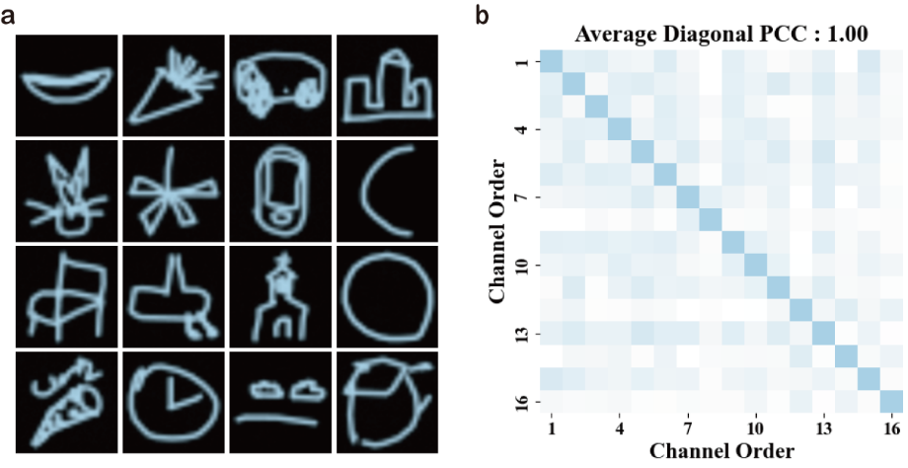
Supplementary Fig. 1. 16-channel holograms implemented by translation operations and their PCC matrix. The DMCN layer width is set to 300, and the FOV width is set to 85. The total longitudinal length is 30 cm, divided into 20 parts, each 1.5 cm. The selected 16 distance configurations are as follows: [(4, 8, 8), (4, 6, 10), (5, 7, 8), (5, 8, 7), (6, 6, 8), (6, 7, 7), (6, 8, 6), (7, 7, 6), (7, 6, 7), (8, 5, 7), (8, 7, 5), (9, 5, 6), (9, 7, 4), (10, 5, 5), (10, 6, 4), (11, 5, 4)].

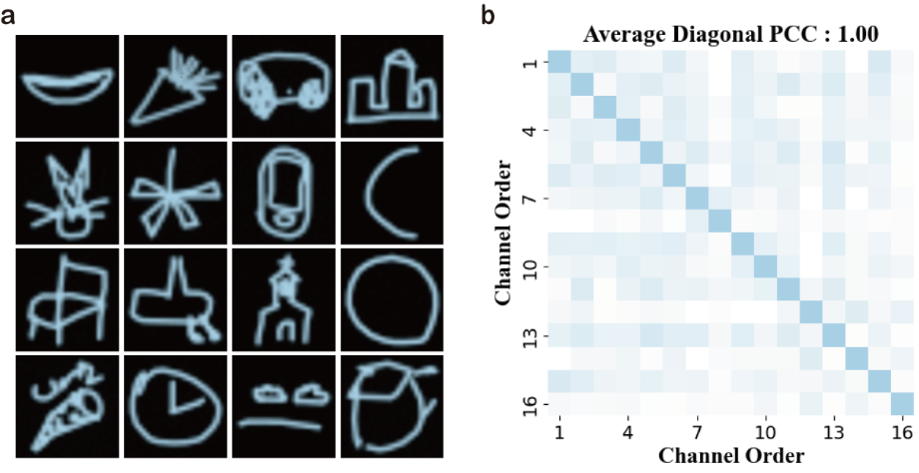
Supplementary Fig. 2. 16-channel holograms implemented by rotation operations and their PCC matrix. The DMCN layer width is set to 300, and the FOV width is set to 85. The layer spacing is (9 cm, 9 cm, 12 cm). The 16 rotation combinations are as follows: [(0°, 0°), (0°, 90°), (0°, 180°), (0°, 270°), (90°, 0°), (90°, 90°), (90°, 180°), (90°, 270°), (180°, 0°), (180°, 90°), (180°, 180°), (180°, 270°), (270°, 0°), (270°, 90°), (270°, 180°), (270°, 270°)].

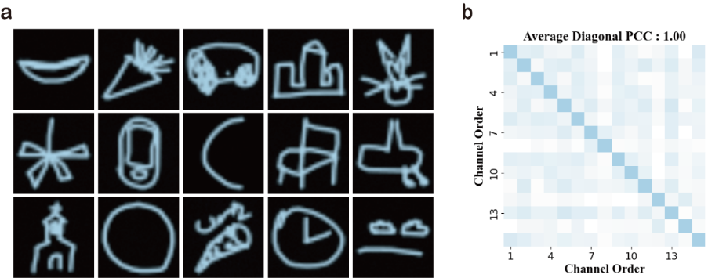
Supplementary Fig. 3. 15-channel holograms implemented by permutation operations and their PCC matrix. The DMCN layer width is set to 300, and the FOV width is set to 85. The layer spacing is (2.7 cm, 2.7 cm, 3.6 cm). The 15 permutation combinations are as follows: [(A, B, C), (A, C, B), (B, A, C), (B, C, A), (C, A, B), (C, B, A), (A, C, X), (B, A, X), (B, C, X), (C, A, X), (C, B, X), (A, B, X), (A, X, X), (B, X, X), (C, X, X)]. Where X indicates that the corresponding layer is empty (air) without the insertion of a phase modulation layer.
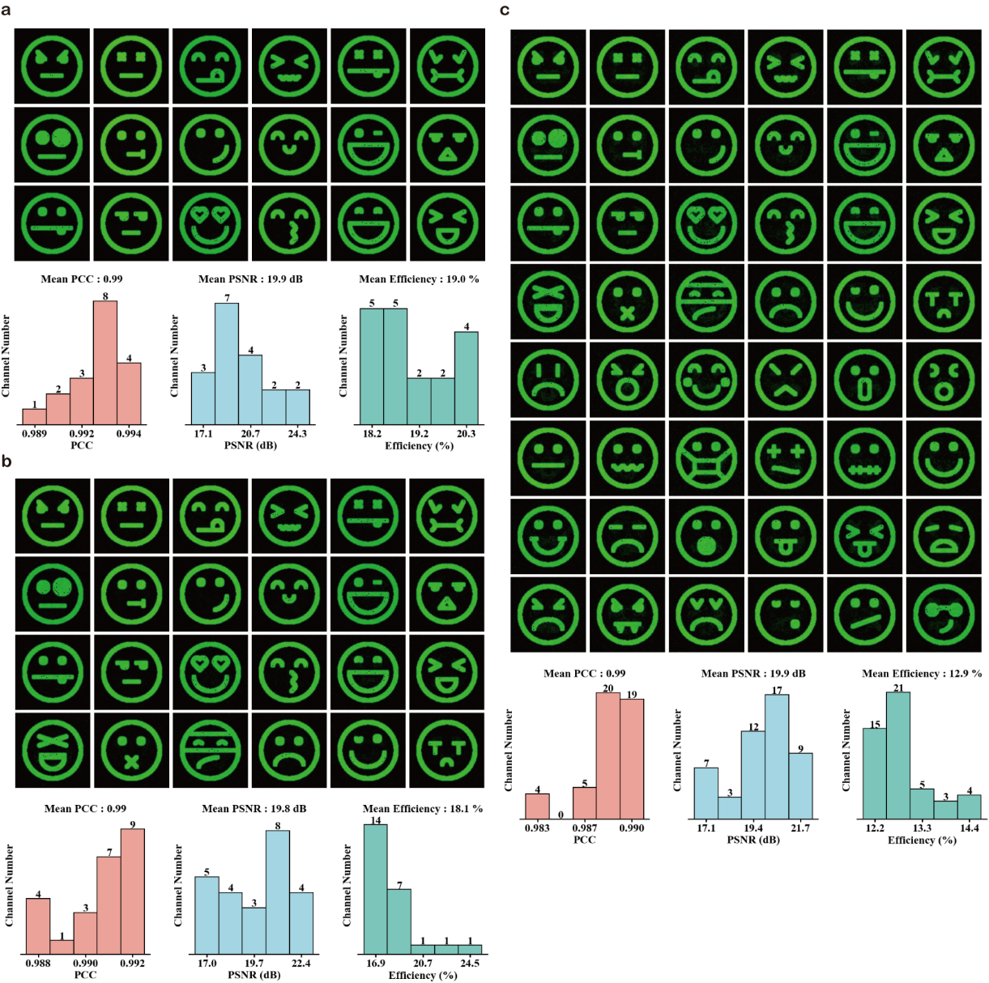
Supplementary Fig. 4. hologram results implemented by combinations of two types of operations. a-c18-, 24-, and 48-channel facial expression holograms with their corresponding metric frequency histograms. These multi-channel holograms are respectively generated by combinations of translation and permutation, rotation and translation, rotation and permutation.

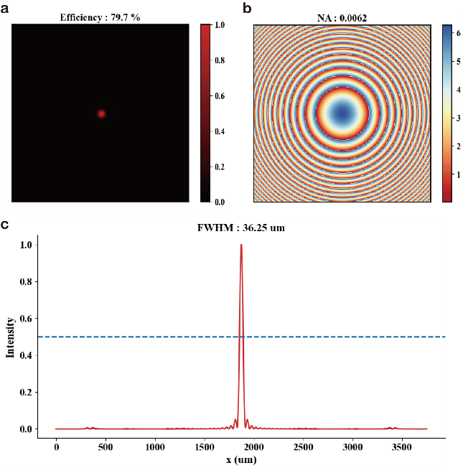
Supplementary Fig. 5. Meta-lens design with a layer width of 300, sampling interval of 12.5 μm, and a focal length of 30 cm. a Focusing result. b Phase profile of the meta-lens. c full width at half maximum (FWHM) of meta-lens.

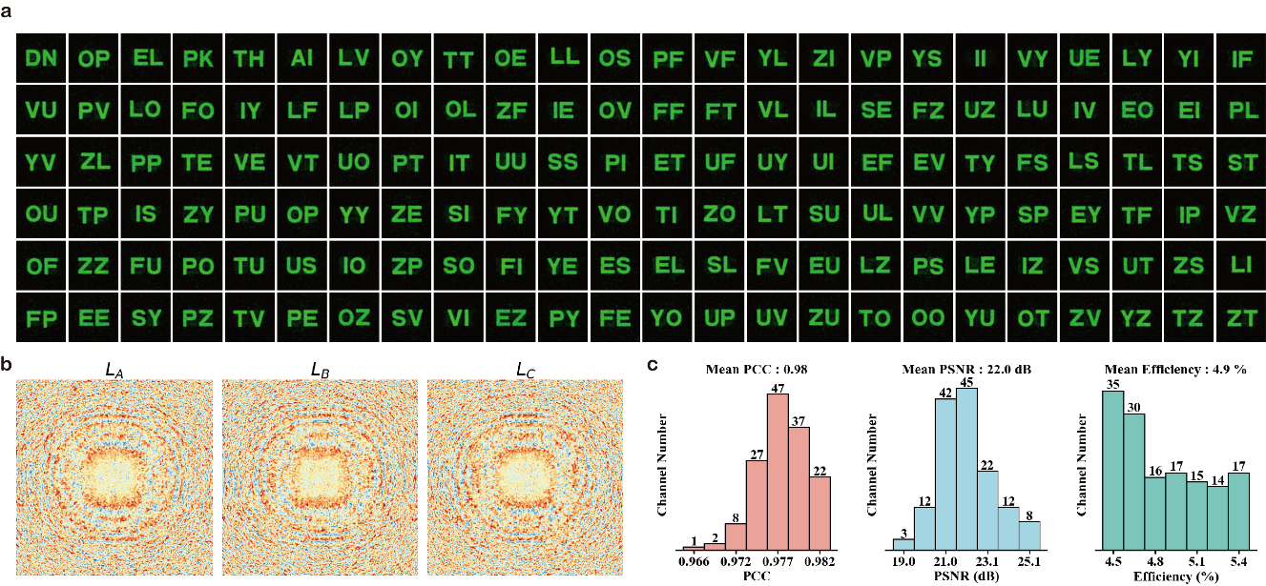
Supplementary Fig. 6. 144-channel holographic results generated by additional combination A. The combination method is: [(13, 13, 34), (14, 14, 32), (15, 15, 30)] × [(A, B, C), (B, C, A), (C, A, B)] × [(0°, 0°), (0°, 90°), (0°, 180°), (0°, 270°), (90°, 0°), (90°, 90°), (90°, 180°), (90°, 270°), (180°, 0°), (180°, 90°), (180°, 180°), (180°, 270°), (270°, 0°), (270°, 90°), (270°, 180°), (270°, 270°)]

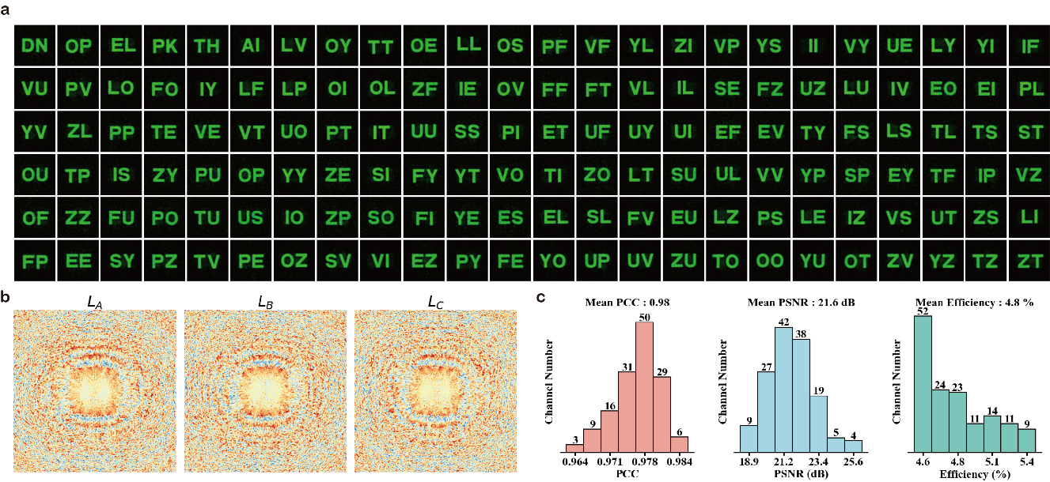
Supplementary Fig. 7. 144-channel holographic results generated by additional combination B. The combination method is: [(13, 13, 34), (14, 14, 32), (15, 15, 30), (16, 16, 28), (17, 17, 26), (18, 18, 24), (19, 19, 22), (20, 20, 20), (21, 21, 18), (22, 22, 16), (23, 23, 14), (24, 24, 12), (12, 12, 36), (11, 11, 38), (10, 10, 40), (9, 9, 42)] × [(A, B, C), (B, C, A), (C, A, B)] × [(0°, 0°), (90°, 0°), (180°, 0°)]

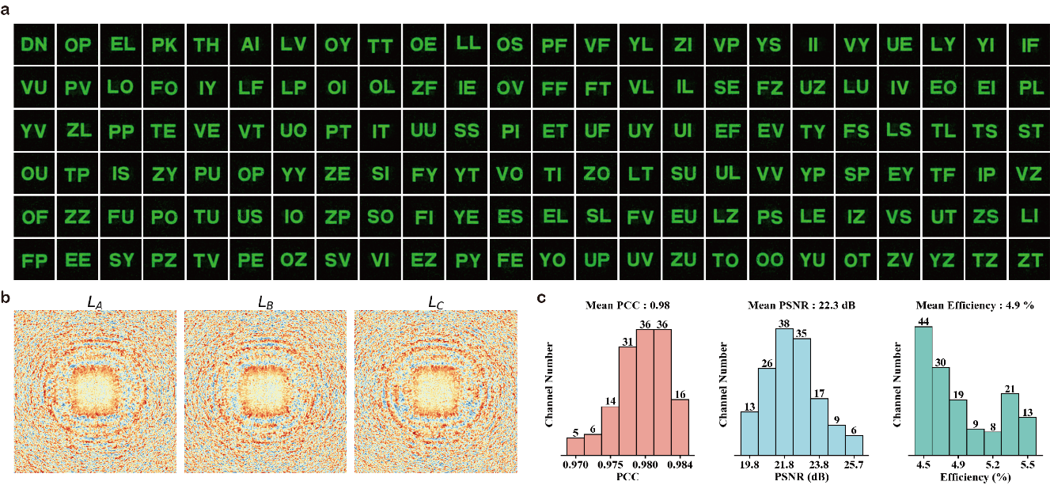
Supplementary Fig. 8. 144-channel holographic results generated by additional combination C. The combination method is: [(13, 13, 34), (14, 14, 32), (15, 15, 30), (12, 12, 36)] × [(A, B, C), (A, C, B), (B, A, C), (B, C, A), (C, A, B), (C, B, A)] × [(0°, 0°), (90°, 0°), (180°, 0°), (270°, 0°), (0°, 90°), (90°, 90°)].

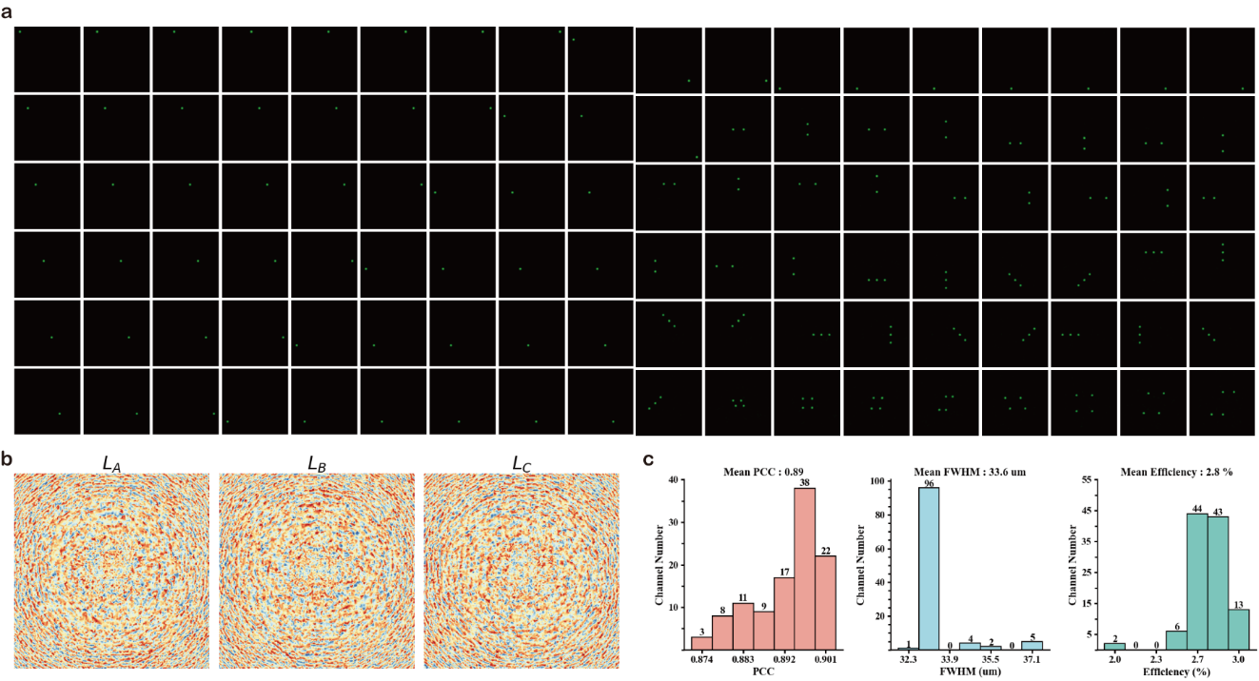
Supplementary Fig. 9. 108-channel single-focus/multi-focus results generated by additional combination A. The combination method is: [(13, 13, 34), (14, 14, 32)] × [(A, B, C), (A, C, B), (B, A, C), (B, C, A), (C, A, B), (C, B, A)] × [(0°, 0°), (90°, 0°), (180°, 0°), (270°, 0°), (0°, 90°), (90°, 90°), (180°, 90°), (270°, 90°), (0°, 180°)]

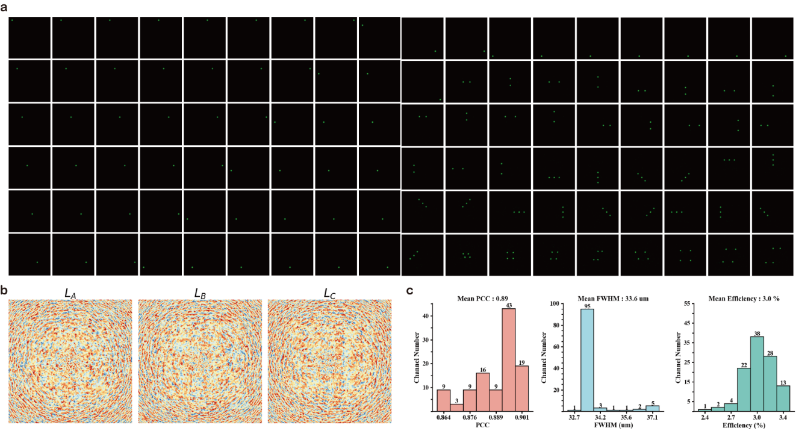
Supplementary Fig. 10. 108-channel single-focus/multi-focus results generated by additional combination B. The combination method is: [(13, 13, 34), (14, 14, 32), (15, 15, 30), (16, 16, 28), (17, 17, 26), (18, 18, 24), (19, 19, 22), (20, 20, 20), (21, 21, 18)] × [(A, B, C), (A, C, B), (B, A, C), (B, C, A), (C, A, B), (C, B, A)] × [(0°, 0°), (90°, 0°)].

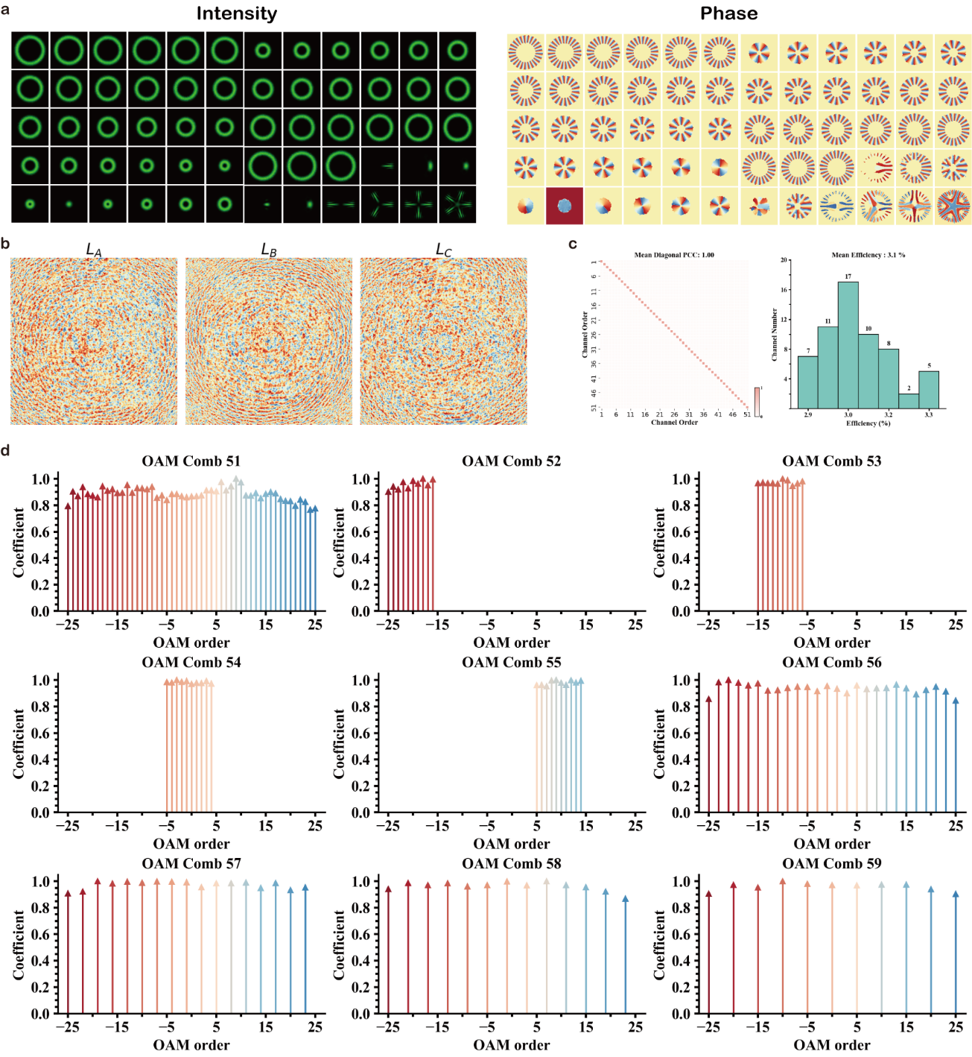
Supplementary Fig. 11. 60-channel OAM beam/comb generation results from the additional combination A. The combination is as follows: [(13, 13, 34)] × [(A, B, C), (A, C, B), (B, A, C), (B, C, A), (C, A, B), (C, B, A)] × [(0°, 0°), (90°, 0°), (180°, 0°), (270°, 0°), (0°, 90°), (90°, 90°), (180°, 90°), (270°, 90°), (0°, 180°), (90°, 180°)]

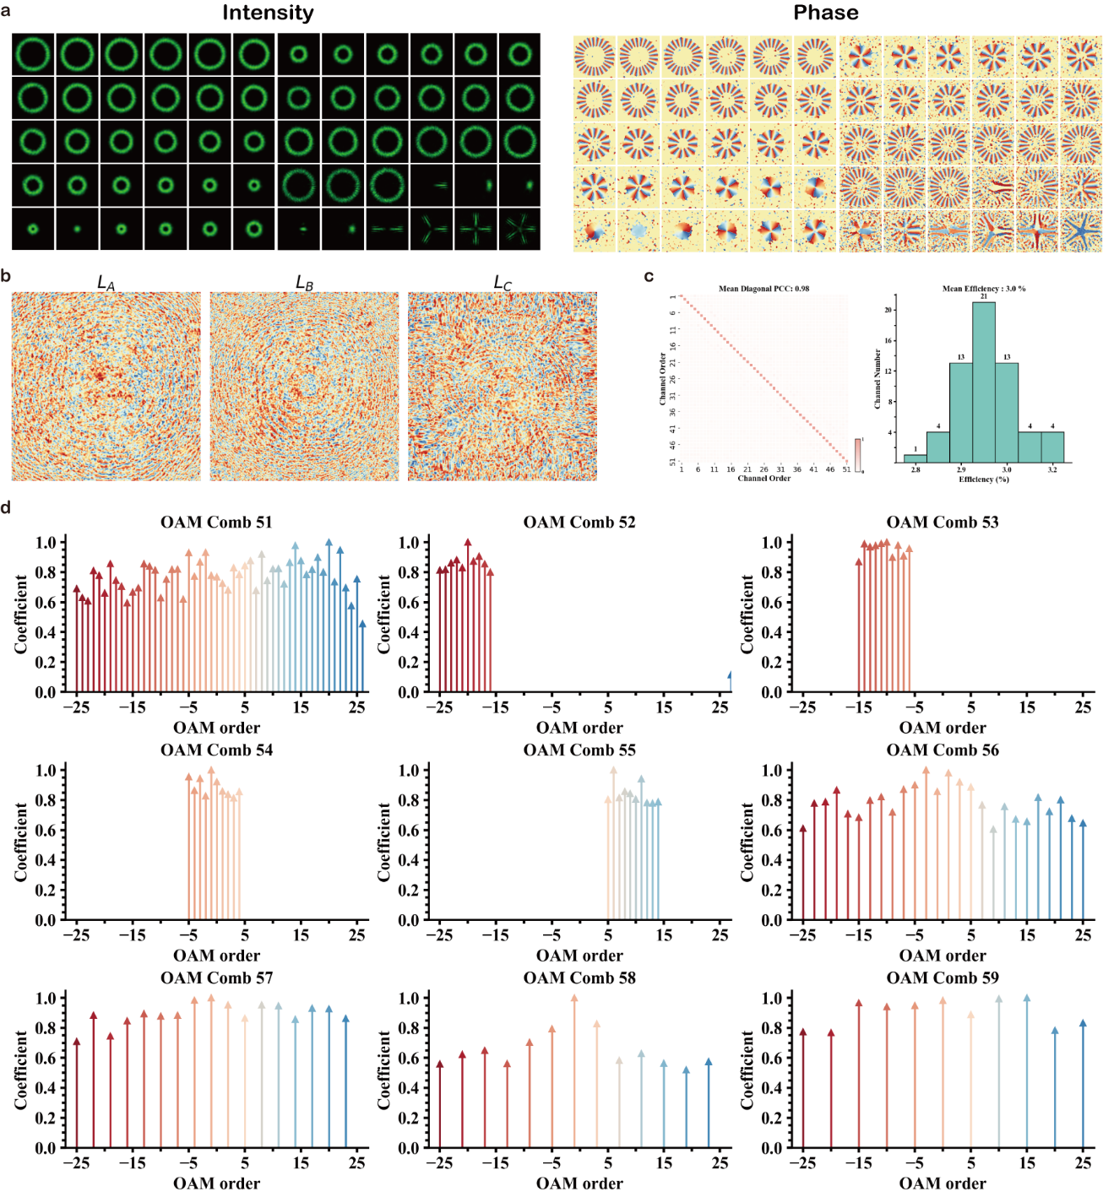
Supplementary Fig. 12. 60-channel OAM beam/comb generation results from the additional combination B. The combination is as follows: [(13, 13, 34), (14, 14, 32), (15, 15, 30), (16, 16, 28), (17, 17, 26), (18, 18, 24), (19, 19, 22), (20, 20, 20), (21, 21, 18), (22, 22, 16)] × [(A, B, C)] × [(0°, 0°), (90°, 0°), (180°, 0°), (270°, 0°), (0°, 90°), (90°, 90°)]

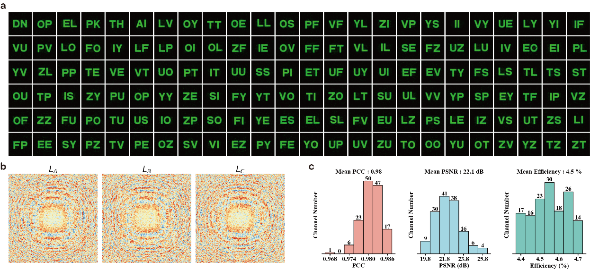
Supplementary Fig. 13. 144-channel holographic results based on the metasurface. The side length of each meta-unit is set to 400 nm, the metasurface width is 300, and the FOV width is 85. The total longitudinal length of the DMCN is 360 µm, divided into 60 segments, each 6 µm. The 144 channels are formed by combining sub-channels from three types of mechanical operations selected in the main text.

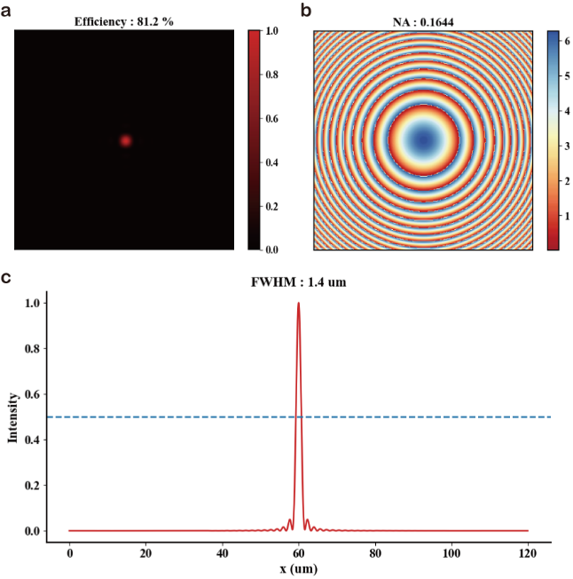
Supplementary Fig. 14. Design of meta-lens. The size of the meta-units is 400 nm, the metasurface width is 300, and the focal length is 360 µm.

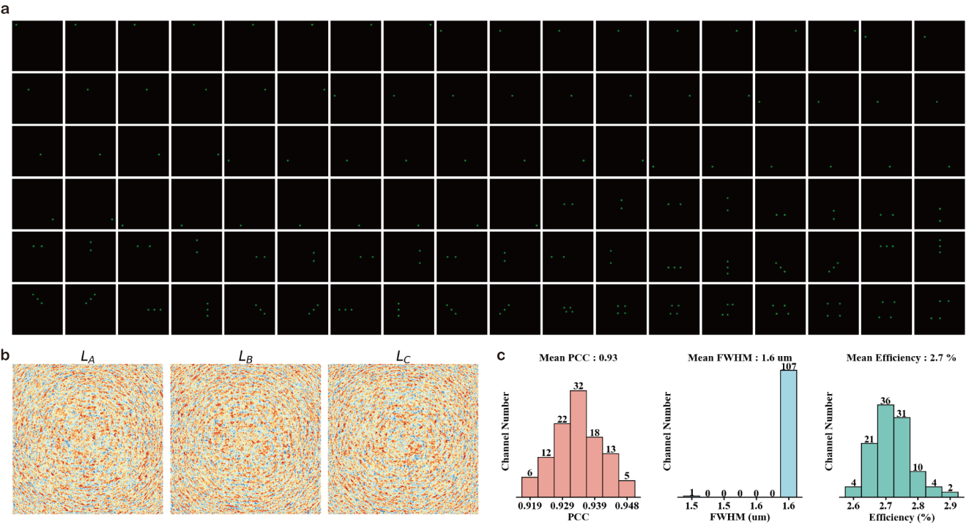
Supplementary Fig. 15 108-channel single-focus/multi-focus based on the metasurface. The metasurface setup is the same as in Supplementary Fig. 13. The 108 channels are the same as those in the main text.

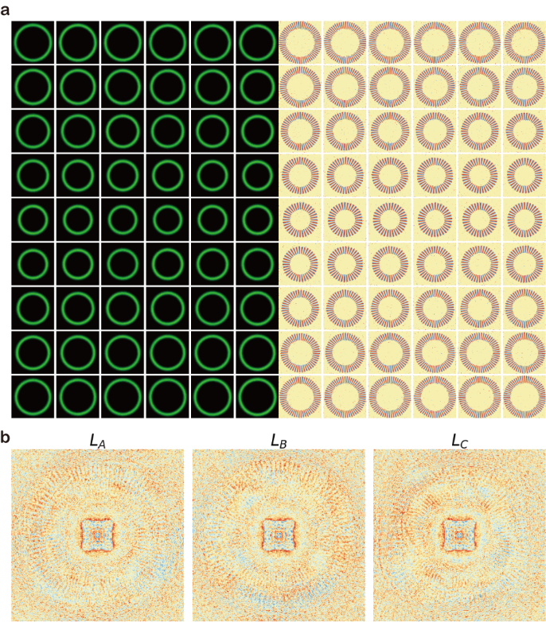
Supplementary Fig. 16. 54-channel high order OAM beam generation. The order range is from -57 to -31 and from 31 to 57. DMCN layer width is 500, and FOV is 85. The first 54 channels from the combination of [(13, 13, 34)] × [(A, B, C), (A, C, B), (B, A, C), (B, C, A), (C, A, B), (C, B, A)] × [(0°, 0°), (90°, 0°), (180°, 0°), (270°, 0°), (0°, 90°), (90°, 90°), (180°, 90°), (270°, 90°), (0°, 180°), (90°, 180°)] are jointly optimized.
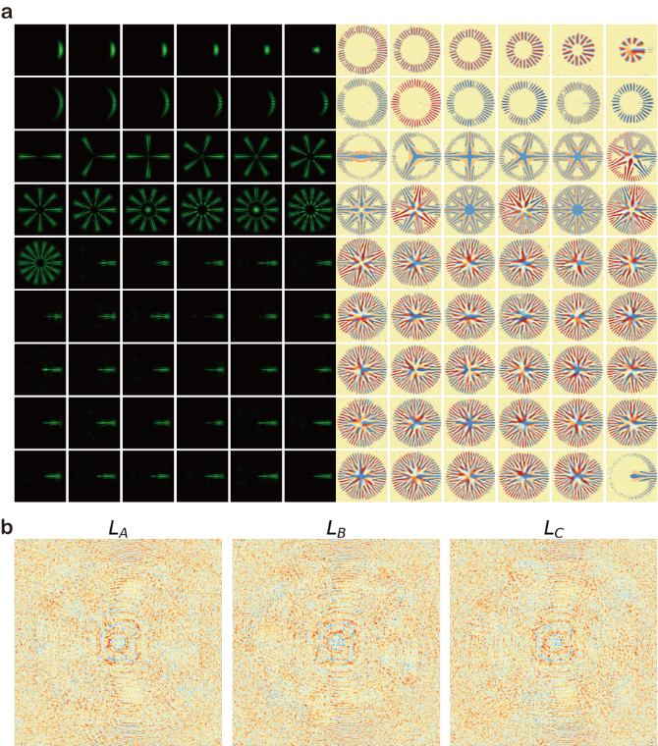
Supplementary Fig. 17. 54-channel high order OAM comb generation. Each channel comb is randomly composed of OAM components ranging from -60 to 60 orders. DMCN layer width is 500, and FOV is 85. The first 54 channels from the combination of [(13, 13, 34)] × [(A, B, C), (A, C, B), (B, A, C), (B, C, A), (C, A, B), (C, B, A)] × [(0°, 0°), (90°, 0°), (180°, 0°), (270°, 0°), (0°, 90°), (90°, 90°), (180°, 90°), (270°, 90°), (0°, 180°), (90°, 180°)] are jointly optimized.
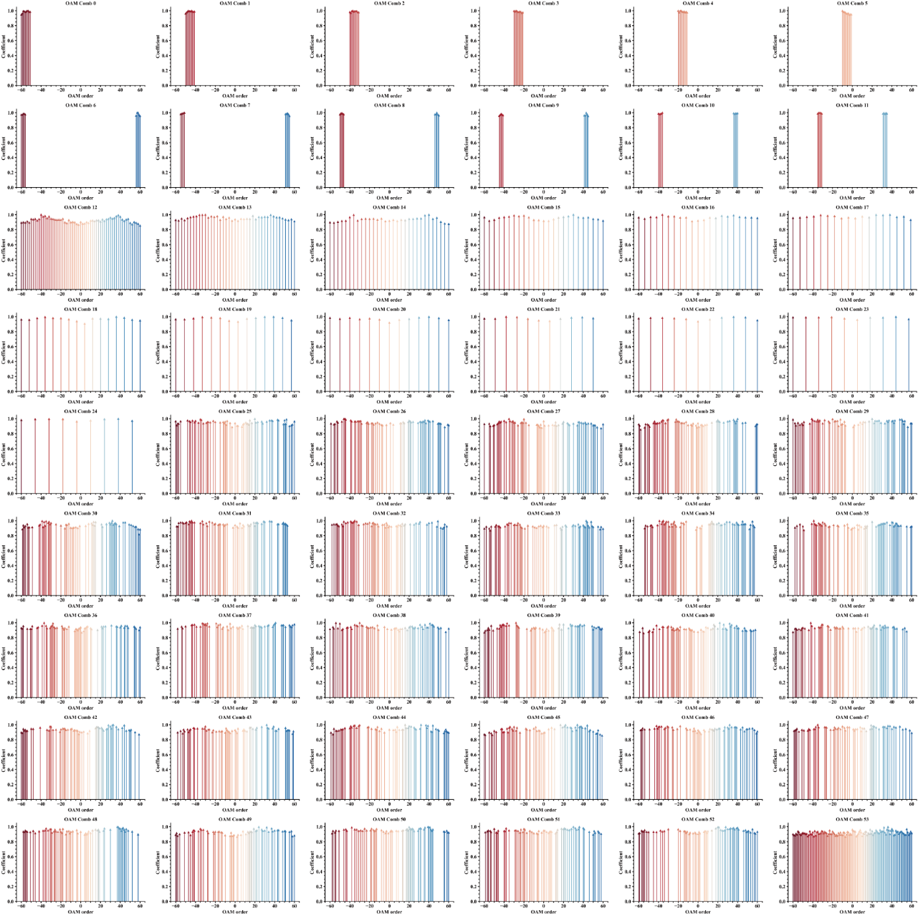
Supplementary Fig. 18. OAM coefficients of 54-Channel high order OAM combs.

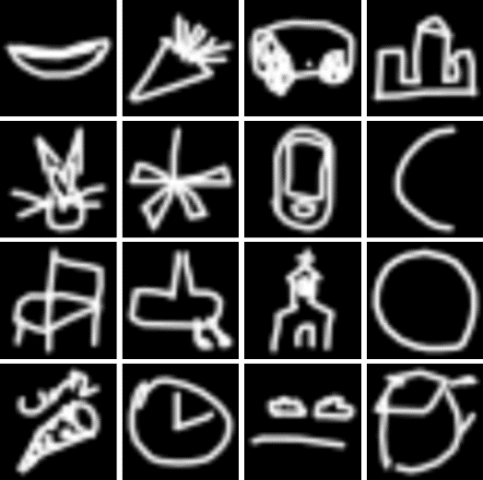
Supplementary Fig. 19. Ground truth of 16 quick draw images.


Supplementary Fig. 20. Ground truth of 48 facial expression images.

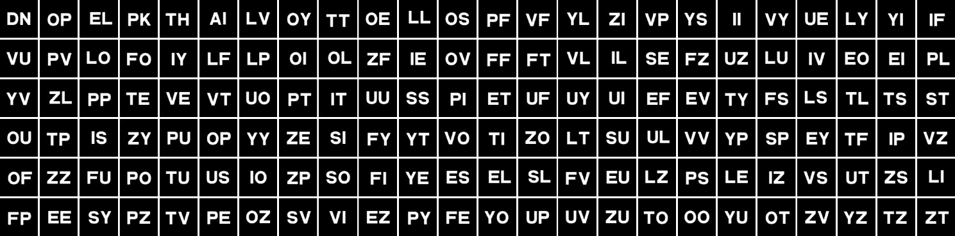
Supplementary Fig. 21. Ground truth of 144 letter images.

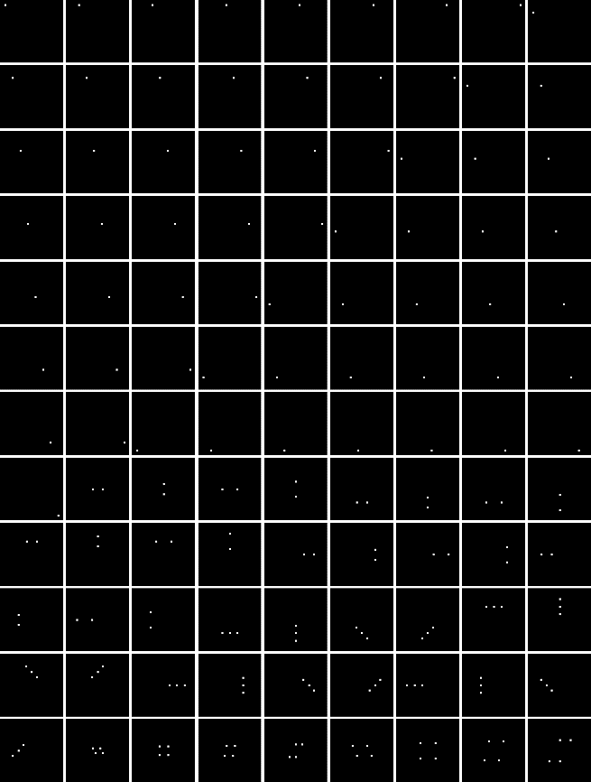
Supplementary Fig. 22. Ground truth of 108 focus patterns.

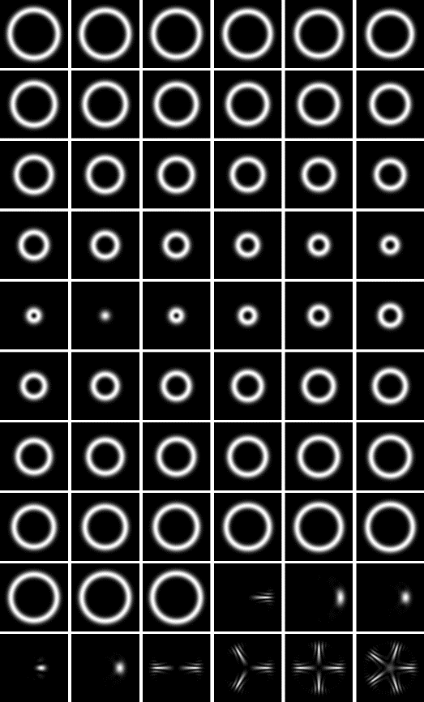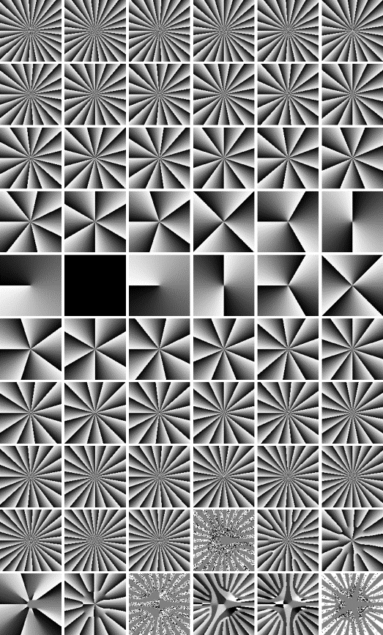
Supplementary Fig. 23. Ground truth of 60 OAM beam/comb fields.
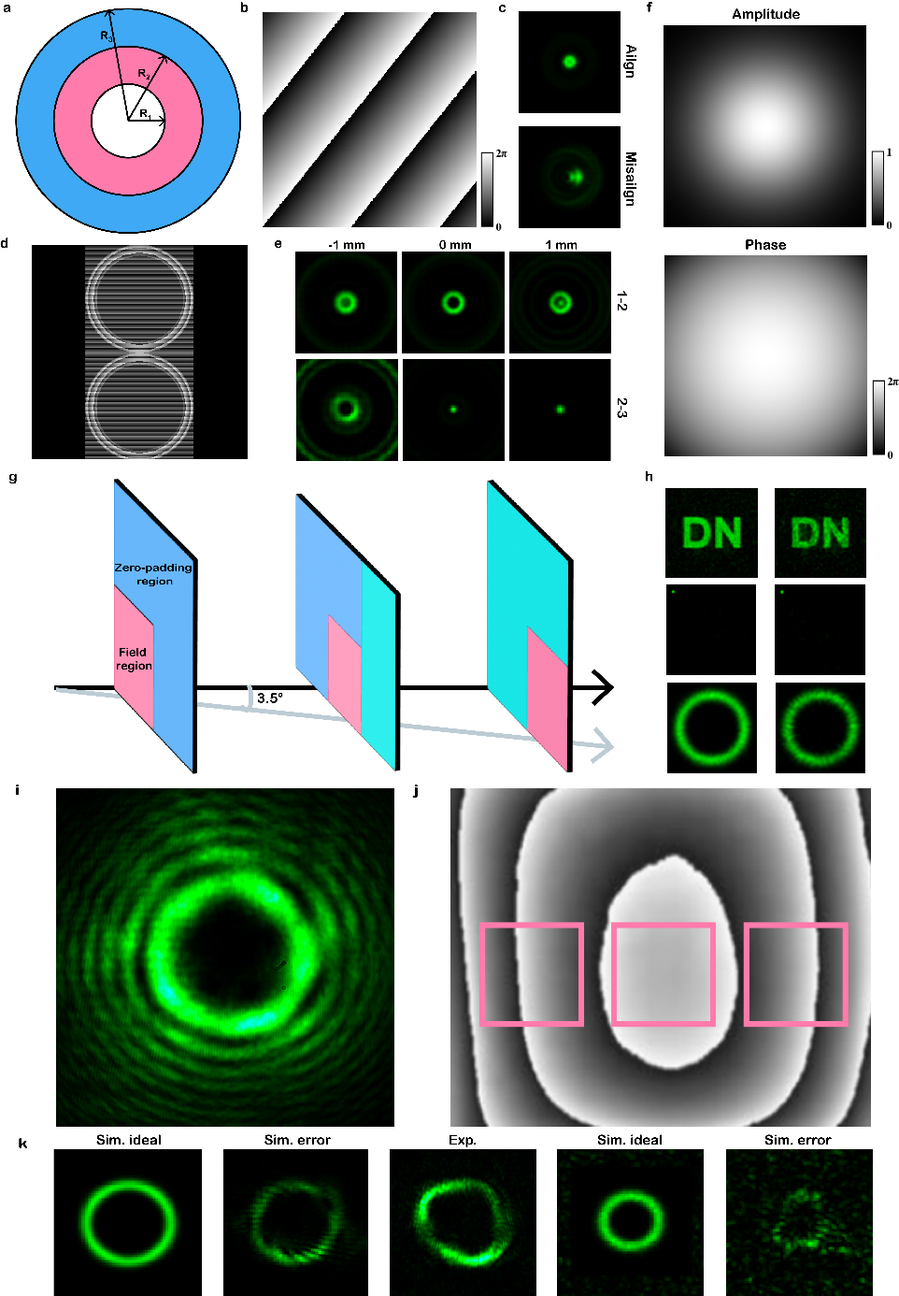
Supplementary Fig. 24 Analysis of experimental errors and calibration methods. a Schematic diagram of double-nested lens phase pattern. The phase in the white region is uniformly zero. The red region represents the lens phase with a focal length of $f_{1}$​, and the blue region represents the lens phase with a focal length of $f_{2}$​. b Schematic diagram of the gradient phase profile. c Typical results of calibrating the lateral alignment of two layers using double-nested lens phases. d Phase profile used for aligning $d_{3}$​. e Results of calibrating the interlayer distance using double-nested lens phases. f Incident Gaussian beam used for training the experimental model. g Schematic diagram of the tilted propagation model. h Error analysis caused by tilted incidence. i OAM beam generated by loading a 5th-order OAM phase onto the first reflection region of the SLM. j Example of additional phase errors caused by the unsmooth surface of the SLM. k Influence of SLM phase errors on OAM generation.

