Supplementary Information
Microstructural evolution and mechanical properties of nano-ATZ ceramics by solid solution precipitation

Yongdong Yu¹, Xudong Liu¹, Yuchen Yuan¹, Wanjun Yu², Hang Yin¹, Zhao Yin¹, Yongting Zheng^{1,*}, Xiaodong He¹

¹ National Key Laboratory of Science and Technology on Advanced Composites in Special Environments, Center for Composite Materials and Structures, Harbin Institute of Technology, Harbin 150080, P. R. China
² School of Environment and Materials Engineering, Yantai University, Yantai 264003, P. R. China

* Corresponding author: zhengyt@hit.edu.cn

Supplementary Figures：

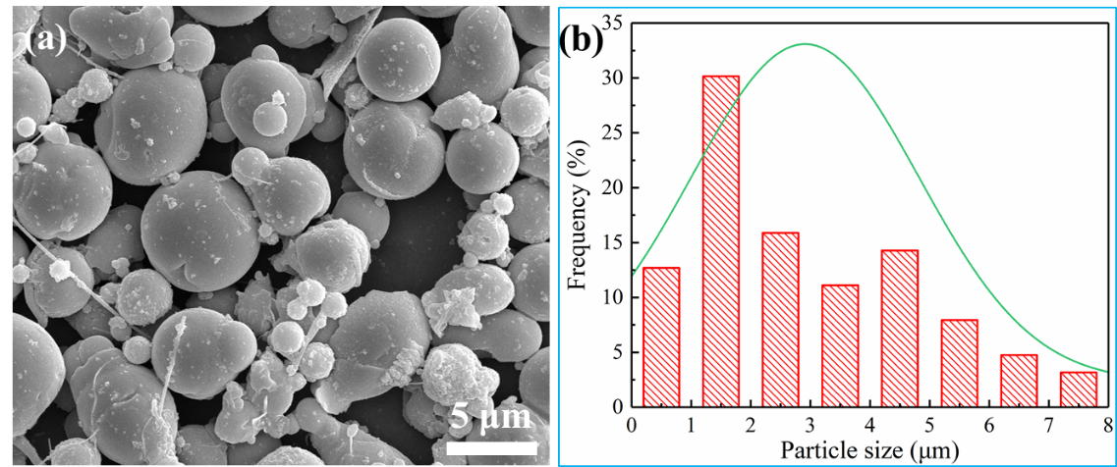
Fig. S1 SEM image of the surface morphology of AZSSP (a) and the size distribution of AZSSP with an average particle size of about 3 μm (b).

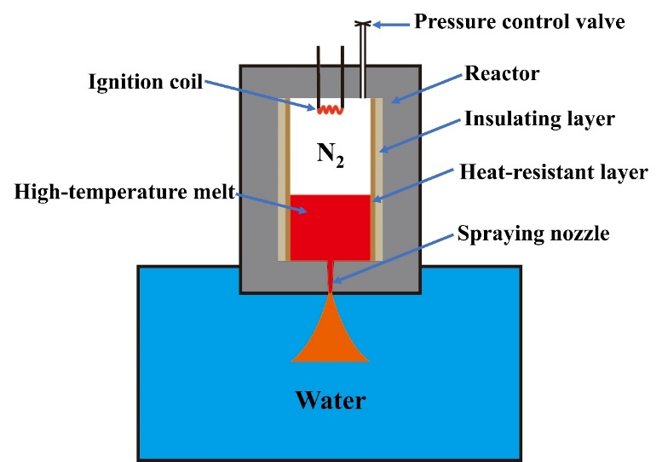
Fig. S2 Schematic diagram of the used apparatus for combustion synthesis assisted rapid water cooling [1].

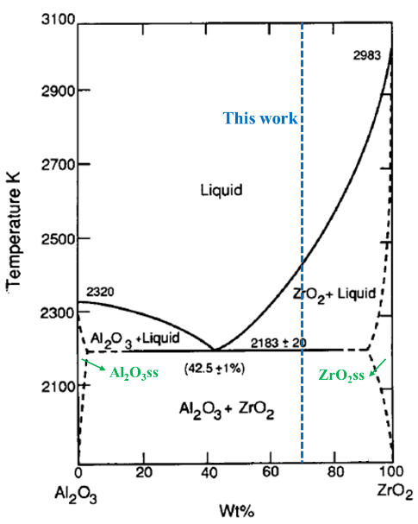
Fig. S3 The phase diagram of Al₂O₃-ZrO₂, the solid solubility of the two phases is extremely small, not exceeding 7 mol% at 1885 ℃ [2]. The blue dotted line represents the composition used in this work.
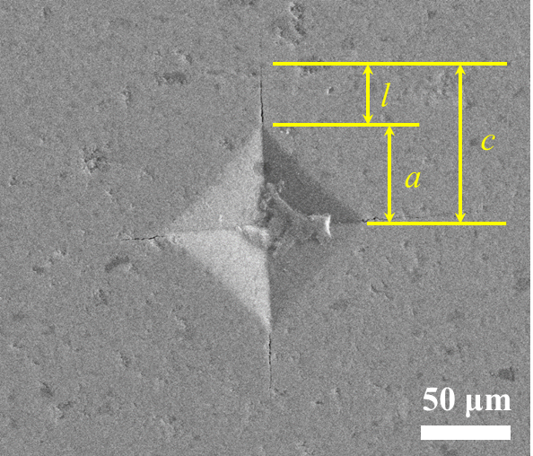
Fig S4 SEM image of Vickers indentation on the polished surface of ATZ-1500. a is the half indentation diagonal length, c is the distance between the center of the indentation and the tip of the crack and l is the crack length.

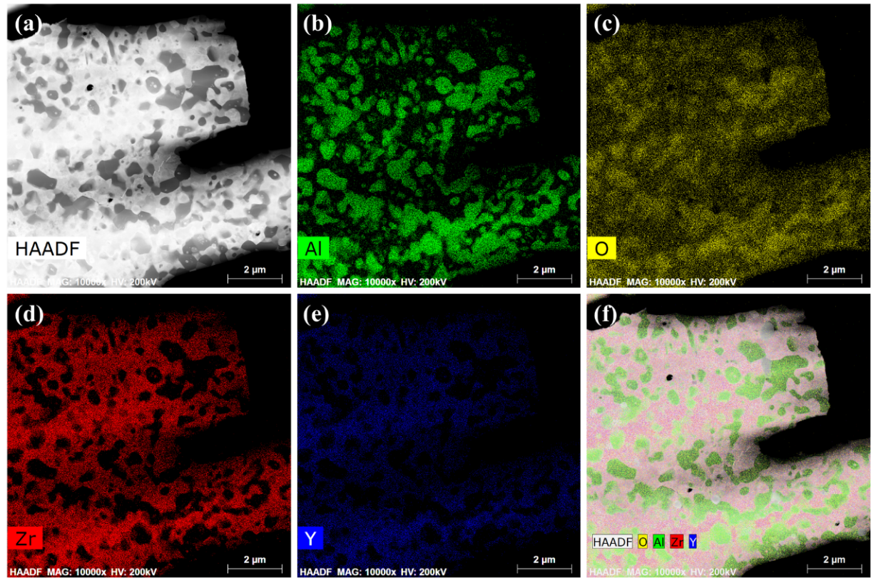
Fig S5 (a): The STEM image of ATZ sintered at 1450 ℃ for 1 hour. (b), (c), (d) and (e): The STEM-EDX elemental mappings show the distribution of Al, O, Zr and Y elements, respectively. (f): A combination of (a), (b), (c), (d) and (e).

Supplementary References：
1 Yu W, Zheng Y, Yu Y, et al. Combustion synthesis assisted water atomization-solid solution precipitation: A new guidance for nano-zta ceramics. J Eur Ceram Soc, 2019, 39: 4313-4321
2 Alper M, Science of ceramics, ed. G. H. Stewart, Academic Press, London, 1967.

