Identifying stable pitting pathways in 316L stainless steel via fractal-inspired PCA-based clustering - Supplementary Information

Leonardo Bertolucci Coelho^{1,2,3,4*}, Thibaut Amand³, Daniel Torres¹, Marjorie Olivier³, Jon Ustarroz^{1,2}
¹ChemSIN – Chemistry of Surfaces, Interfaces and Nanomaterials, Université libre de Bruxelles (ULB), Brussels, Belgium
²Research Group Electrochemical and Surface Engineering (SURF), Vrije Universiteit Brussel, Brussels, Belgium
³University of Mons-UMONS, Faculty of Engineering, Materials Science Department, Place du Parc, 20, 7000 Mons, Belgium
⁴IAlto Ltda, Taió, Santa Catarina, Brazil
*leonardo.bertolucci.coelho@ulb.be

Supplementary Notes 1. Mandelbrot-Zipf modelling – Theoretical background
The concept of power-law distributions, foundational for understanding the dynamics of diverse systems, emerged in the 19th century. Italian economist Vilfredo Pareto first observed that a small proportion of the population held a large portion of the wealth, forming the Pareto distribution - a particular instance of a power-law distribution. Since then, power-law distributions have been identified across a wide array of fields. In the 20th century, linguist George Zipf found a similar pattern in language frequency, where a few words dominate usage while most are rare. Known as Zipf’s law, this pattern highlights the ubiquity of power-law distributions in both natural and social phenomena, from city populations to webpage visits. Such distributions typically reflect complex, scale-invariant systems, characterised by unconstrained growth, extensive value ranges, and intricate network effects [1–7].
While power-law distributions have broad applicability, their direct use in modelling certain aspects of corrosion, such as maximum pit depth evolution, must be approached with caution. Although the maximum pit depth may not follow a power-law distribution strictly, modeling the average pit depth over relatively short time intervals can still produce useful approximations[8].
The Central Limit Theorem (CLT), often suitable for data of similar orders of magnitude, falls short when values span several magnitudes. In these cases, Zipf’s law provides a more appropriate framework, as observed through log-log rank-value plots (Fig. 2(a)). Such plots often appear linear on log-log scales, allowing the slope to be estimated via linear regression and revealing how well the data adhere to Zipf’s law [9]. Among power-law distributions, the Mandelbrot-Zipf distribution extends Zipf’s law by introducing an additional parameter q (Fig. 2(b)), accommodating a plateau at lower ranks and thereby capturing more nuanced distributions. This modification is especially valuable when describing phenomena with complex, multifactorial influences. The Mandelbrot-Zipf distribution captures the typical power-law decay by adjusting for lower-ranked items. It incorporates curvature into the distribution's representation, particularly at its head (region of highest data density).
In the context of corrosion, fractal geometry provides a transformative approach to analyse systems with irregular, non-Euclidean patterns[10–14]. Fractal characteristics, such as self-similarity and scale invariance, distinguish fractal patterns from purely random or chaotic behaviors. Fractal dimensions (FD) quantitatively describe this complexity by quantifying the heterogeneity and self-similarity of objects, making FD a key metric for characterising surface irregularities including corrosion processes[15]). Studies have shown that pit morphology and distribution often exhibit fractal traits[16], demonstrating that localised corrosion damage may follow structured randomness.
Accelerated corrosion tests on materials like 7B04 aluminium alloy, low-carbon steel and stainless steel have revealed an increase in fractal dimension over time, highlighting the fractal nature of pit growth[10,16,17]. Wavelet analysis (WA), which considers different time-scales for pitting stages, complements fractal theory in describing the temporal evolution of corrosion[18]. Similarly, self-similar pit distributions have been identified on corroded aluminium surfaces, reinforcing the view that pitting might be governed by fractal statistics[13,19]. Methods like the box-dimension technique, discrete wavelet transforms, and fractal analyses quantify these attributes, offering a rigorous understanding of pitting complexity[10,20,21].
Integrating fractal geometry with electrochemical techniques enriches our understanding of corrosion processes. For instance, studies involving 304 stainless steel in FeCl₃ solutions show that fractal dimensions can be used to feed predictive models like artificial neural networks, enabling diagnoses of pitting rates and depths under various conditions[17]. However, a single fractal dimension may not fully capture the multifaceted nature of localised attacks. Evidence of multifractal characteristics[12] suggests that a more detailed examination of current distributions under stable corrosion conditions is warranted.
Though fractal approaches to corrosion remain relatively sparse, consensus on the fractal nature of pit dimensions[11] encourages continued exploration. Such insights set the stage for advancing localised corrosion modeling through data-driven strategies that embrace fractal and multifractal concepts.
Clarification of “Rank”: in the Mandelbrot-Zipf approach, “rank” refers to the position of a data point in a sorted list, ordered by its frequency of occurrence. The most common value holds rank 1, while progressively rarer values receive higher ranks. Thus, a low rank corresponds to frequent (common) events, and a high rank corresponds to rare events. Understanding this notation is key to interpreting Mandelbrot distributions, where the tail of the rank-frequency curve often holds critical information about rare occurrences - such as the stable pitting events described in the main manuscript.
For simplicity, the term Mandelbrot-Zipf is often shortened to Mandelbrot in both the main manuscript and these supplementary notes.
Supplementary Notes 2. Anodic branch: Data preparation and histogram analysis
Fig. 3 in the main manuscript presents the populations of polarisation curves obtained at each chloride concentration. Directly comparing histograms of log(j) values from the three different media (Fig. S1) provides useful insights, especially when considered alongside the population plots of polarisation curves (Fig. 3). As the NaCl concentration increases, the distribution of log(j) values across the potential axis broadens, particularly in the pitting region, indicating increased variability in electrochemical activity[22].
Secondly, the first frequency peak, located around log(j) = -2 µA/cm², corresponds to the onset of the passivity region (j_pass indicated in the Fig. S1). Qualitatively, this passivity descriptor exhibits nearly identical distributions regardless of chloride concentration. Thirdly, the second frequency peak, shifting to higher log(j) values with increased chloride content (from ~2 to ~3 µA/cm²), relates to the plateau at the end of the stable pitting region (Fig. 3). This second peak, denoted as the limiting current density (j_lim, as indicated in Fig. S1), is clearly sensitive to testing conditions: higher chloride concentrations lead to a more pronounced and elevated peak. Thus, the anodic process associated with j_lim intensifies with rising [Cl-], which makes sense given that mass transport limitations of dissolving metal cations in occluded pit cavities are expected to be influenced by the chloride concentration[23,24]. The uncompensated ohmic drop may also affect the observed limiting current despite the minimal RE-WE distance, especially as anodic activity intensifies within pits[25,26].
Fig. S1. Histograms of the log(j) value distributions obtained in each polarisation test medium (0.005, 0.01, and 0.05 M NaCl). The j_pass, corresponding to the first peak, indicates the passivity current density. The j_lim, corresponding to the second peak, marks the limiting current conditions at high anodic potentials. The coloured arrow indicates the trend observed for j_lim as chloride concentration increases.
A minor peak (indicated with a question mark in Fig. S1) appears at approximately log(j) = 0.5 µA/cm². Defining the corresponding regions in the polarisation curves (Fig. 3) based solely on histogram analysis is misleading, as multiple potential (E) regions across both the passivity and stable pitting regimes may display log(j) ≈ 0.5 µA/cm². To clarify this, Fig. S2 shows histograms colour-mapped according to the average potential (V). Averaging is necessary since many plotted points represent multiple log(j) counts associated with different E values. Through this approach, the minor peak corresponds to log(j) values of curves that reached high potentials (~0.9 V) without exhibiting stable pitting. This minor peak thus represents a “j_pass-lim” descriptor: a steady-state passivity current density observed in a few curves that do not undergo stable pitting even at elevated potentials. Its distribution appears relatively unaffected by the test media, reflecting a net passivity current governed by surface oxidation rather than chloride concentration.
In theory, one might expect j_pass and j_pass-lim to be identical if passivity remained unchanged regardless of the applied potential. However, Fig. 3 suggests the first and last passivity j values often deviate. Such cases represent samples not transitioning into stable pitting at the end of the test (final anodic overpotential ~1 V). In the context of the weakest link theory, these represent the “strongest links” in the chain[27], i.e. samples least prone to stable pitting due to epistemic uncertainty[28]. Not surprisingly, in the more aggressive 0.05 M NaCl solution, this behaviour occurs less frequently (Fig. S2, red dataset, where the j_pass-lim peak at ~0.5 µA/cm² is nearly undetectable), indicating fewer “strong links” remain under these more severe conditions.
Fig. S2. Histograms of log(j) value distributions with data points colour-mapped to the average potential (V). (a) 0.005 M, (b) 0.01 M, and (c) 0.05 M NaCl. The j_pass-lim denotes the minor peak corresponding to a steady-state passivity current, observed in a few curves not exhibiting stable pitting at high (>0.9 V) overpotentials.
Relying solely on histogram interpretation poses two main drawbacks. Firstly, histogram peaks alone provide limited insight into pitting phenomena. Although histograms effectively highlight common events, they are less capable of revealing tail events - the rare but significant occurrences critical to understanding pitting corrosion. Stable pitting, especially in its metastable forms, often involves such infrequent events[18]. Even though stable pitting was observed in nearly the entire sample population (Fig. 3), the key pitting descriptors (e.g., E_pit) are often sparse[27], emphasising the importance of capturing rare events.
Secondly, while histograms help to identify essential phenomena such as j_pass, j_lim, and j_pass-lim, these distributions cannot be easily fitted with conventional models. The resulting log(j) histograms are complex, arguably bimodal (first and second peaks) with a minor peak and extensive dispersion. Recognising these limitations, we turn to the Mandelbrot-Zipf function for dataset fitting. Its suitability for modelling rare events provides a pathway to circumvent these shortcomings, thus enhancing our capacity to quantitatively analyse and interpret pitting corrosion data.
Supplementary Figure 4
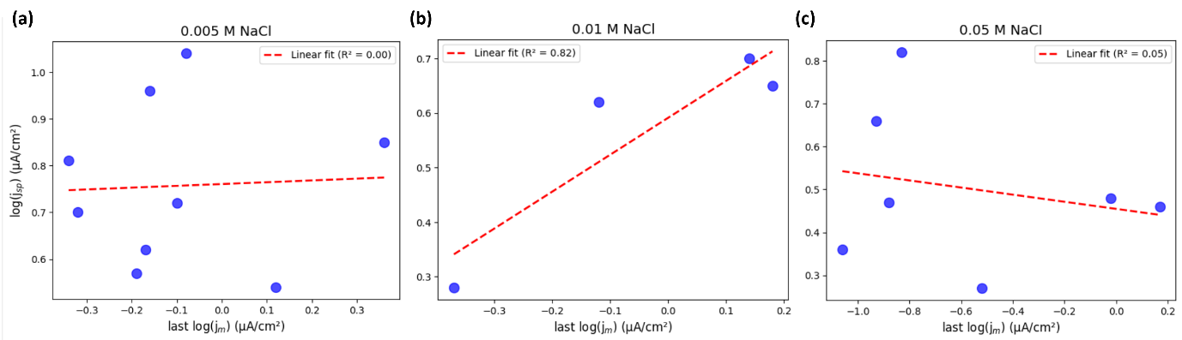
Fig. S3. Correlation plots between the last metastable current density (log(j_m)) and the current density reached at the stable pitting potential (log(j_sp)) for each NaCl concentration: (a) 0.005 M, (b) 0.01 M, and (c) 0.05 M NaCl. The fitted regression lines and corresponding R² values highlight the generally low correlation between these two current density features.
Supplementary Notes 3. Mandelbrot modelling: implementation and qualitative evaluation
The Mandelbrot-Zipf plots for the three datasets are presented in Fig. S4, with data points colour-mapped according to the average log(j) computed for each Frequency-Rank pair. Converting the data from Frequency vs. log(j) plots (Fig. S2 in Supplementary Notes 2) into a Mandelbrot (Frequency vs. Rank) representation provides a more straightforward means of visualisation. Unlike the original histograms, which can be complex and multimodal, the Mandelbrot plots yield relatively smooth curves that are more accessible to fitting and interpretation.
Each Mandelbrot curve exhibits a “bent” shape, transitioning from a plateau region at low ranks (frequent events) to a steep slope at high ranks (rare events). Between these extreme log(j) values lies a range of moderately likely occurrences. The multiplicity bars indicate Frequency-Rank positions corresponding to multiple data points: for example, the highest rank (212) groups all log(j) values that occurred only once. As expected - and verified in all three datasets - this last rank point is associated with the largest number of distinct log(j) values, hence the greatest multiplicity. The size of the bar (in log scale) is proportional to the multiplicity count. When multiplicity is absent (unique rank numbers), the bar is as small as the plotted marker and may not be visible. Similar to previous figures, the colourmaps in Figs. S4 and S5 can represent either average log(j) or average E. The presence of higher multiplicity at 0.05 M NaCl indicates greater diversity of measured log(j) values for increased concentration [22].
Fig. S4. Mandelbrot plots (Rank-Frequency of log(j)) for the populations of polarisation curves obtained at (a) 0.005 M, (b) 0.01 M, and (c) 0.05 M NaCl. Data points are colour-mapped by average log(j). Horizontal bars represent multiplicity, i.e. the number of data points sharing the same Rank/Frequency.

(a)
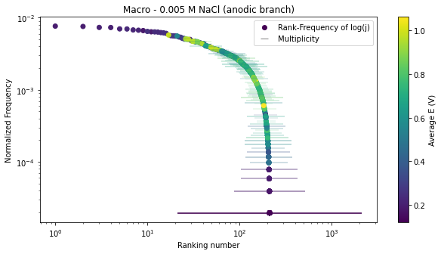
(b) (c)
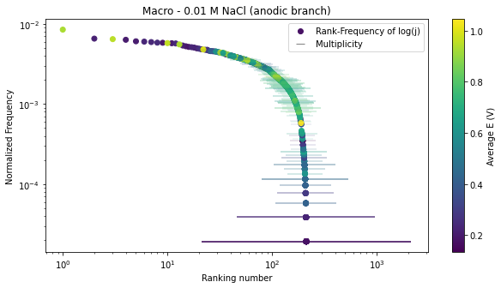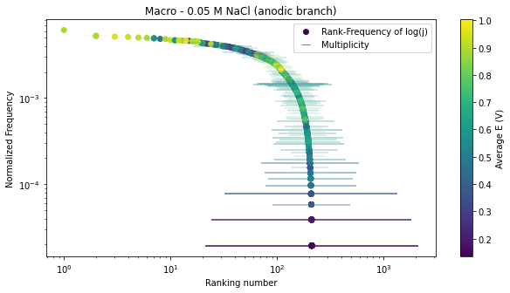
Fig. S5. Mandelbrot plots from the populations of macro-scale polarisation curves obtained at (a) 0.005 M, (b) 0.01 M, and (c) 0.05 M NaCl, now colour-mapped by average E (V). Horizontal bars indicate multiplicity. This figure complements the main text by illustrating how the Mandelbrot transformation facilitates visualising the association between rank and electrochemical parameters.

To further compare the datasets, Fig. S6 displays all three Mandelbrot curves together. For simplicity, no multiplicity bars or colour mapping are included, and the normalised frequency has been numerically adjusted so that the integrated area under each curve equals unity. Interestingly, all three datasets produce the same number of ranks (212), suggesting a certain uniformity under the Mandelbrot framework. In this context, “diversity” refers to the spread of normalised frequency across different ranking regions. Higher [Cl-] concentrations lead to distributions with reduced frequency of very frequent events and relatively higher frequency in moderately occurring/rare events. Thus, the 0.05 M NaCl dataset shows greater “diversity” in the Mandelbrot space, as predicted by the main text (see Fig. S6).
Fig. S6. Comparison of Mandelbrot plots from the populations of polarisation curves at different NaCl concentrations, with normalised frequencies adjusted so that the integrated area under each curve equals one. Coloured arrows indicate observed trends, confirming expectations that higher [Cl-] fosters a more diverse distribution of events.

However, while Mandelbrot modelling makes the data more tractable, classic Mandelbrot-Zipf distributions typically feature a plateau followed by a near-linear decay on a log-log plot. In contrast, our electrochemical data yield more arc-shaped curves (Fig. 2), indicating that the standard Mandelbrot function alone may not fully characterise these distributions. Such curvature may signify transitions between different dynamic regimes, suggesting that the corrosion phenomena we are examining cannot be explained by a single fractal dimension across all scales. In the activity region, the surface is still active (not passivated), and the anodic overpolarisation progressively increases the intensity of the active dissolution. When the passivity domain is reached, the rate of anodic reaction increase is significantly hampered due to the formation of a “stable” (protective) passive film. The distinct regimes could be understood through fractal modelling as a distinct fractal process in which a multi-scale electrochemical response results from the different intensities of overpolarisation imposed on the surface. Similar observations have been made in linguistic corpora studies[2,5], where datasets split into multiple power-law registers distinguish common items from less frequent, more specialised items[29]. Analogously, our data may require a multifractal approach, recognising the complexity and scale-dependence of underlying corrosion processes.
Initial attempts to divide the Mandelbrot plot into three segments - aligned with the activity, passivity, and pitting regimes commonly identified in potentiodynamic polarisation curves -proved challenging. Although fitting curve segments yielded high R² values, they did not neatly correspond to these well-known corrosion regimes. Commonly used for modelling the distribution of city populations, applying Zipf’s law to a set of the entire anodic polarisation branch is like mixing the populations of cities, villages and neighbourhoods: the resulting heterogenous set would potentially lack “coherence”[1]. To address this challenge, we employed data-driven techniques (Principal Component Analysis and clustering) to identify natural segmentations within the Mandelbrot space. It is important to note that no labels (such as E_sp or E_pit) were provided to guide the clustering. The clusters emerged purely from the data’s statistical structure, and only afterward were these clusters associated with stable pitting events. This “divide and conquer” approach ultimately revealed more than three fractal processes, indicating that the anodic branch is governed by multiple overlapping regimes. By acknowledging the necessity for multiple Mandelbrot models within a single dataset, we better capture the multifaceted, multifractal nature of the electrochemical phenomena at play.
These results reinforce the main manuscript’s conclusion that fractal-based modelling, combined with advanced clustering techniques, provides a robust and flexible framework for interpreting complex electrochemical datasets. In doing so, it moves beyond traditional single-curve exemplars or simplistic analytical approaches, paving the way for richer insights into localised corrosion mechanisms and stable pitting pathways.
As introduced in the main manuscript, after applying PCA to the Mandelbrot-transformed polarisation data, a natural segmentation of the datasets emerged. This segmentation highlighted the presence of five distinct clusters, subsequently named “head,” “neck,” “core,” “tail,” and “tail’s tip” for ease of reference. These names reflect the worm-like shape formed in the PCA space and correlate intuitively with distributions commonly described as having a “head” (high concentration of frequent events) and a “tail” (low concentration of rare events). Crucially, the “tail’s tip” cluster is associated with the rarest events - those that correspond to E_sp in the main text.
Fig. S7. PCA-transformed versions of the Mandelbrot curves for the three NaCl concentrations: (a) 0.005 M, (b) 0.01 M, and (c) 0.05 M NaCl. Each curve is segmented into five distinct clusters - head, neck, core, tail, and tail’s tip - highlighting natural discontinuities and structural patterns not easily discernible in the original Mandelbrot plots. The similarity in the clustering outcome across the three datasets emphasizes the robustness of this approach.

To illustrate how PCA-guided clustering translates back into the Mandelbrot domain, Fig. S8 shows the original Mandelbrot curves segmented according to the identified clusters. Each cluster defines a distinct segment of the rank-frequency distribution, capturing its own characteristic range of events and corresponding electrochemical behaviours. The transitions between these clusters are subtle but crucial, representing shifts in the underlying processes governing current distribution and pitting likelihood.
Fig. S8. Mandelbrot curves segmented into the five PCA-defined clusters for (a) 0.005 M, (b) 0.01 M, and (c) 0.05 M NaCl. The boundaries between clusters indicate points of discontinuity in the Mandelbrot curves, reflecting multifractal complexity in the underlying electrochemical processes.

By applying a “divide and conquer” strategy, each cluster (or region) can be modelled separately. As a result, a significantly improved fit can be achieved for each cluster compared to attempting a single fractal model for the entire dataset. The R² values obtained for each segment are generally above 0.9, demonstrating that treating the anodic branch as a composite of multiple fractal regimes yields a more accurate representation of the data. Fig. S9 provides an example of the fitting procedure for the 0.01 M NaCl dataset, where each cluster is fitted individually, leading to a series of high-quality fits that together offer a comprehensive fractal characterisation of the entire system.
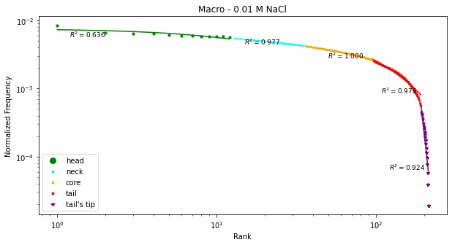
Fig. S9. Example of the multi-region fitting procedure for the clustered Mandelbrot curve of the 0.01 M NaCl macro anodic branch. Each coloured segment corresponds to one of the five clusters (head, neck, core, tail, tail’s tip), and the associated R² values indicate the high goodness of fit achieved for each region. This approach validates the multifractal perspective suggested by the PCA-based segmentation, revealing complex, scale-dependent fractal processes governing the observed electrochemical phenomena.

By projecting the defined clusters back into the original histograms, we gain additional insight into how the five clustered regions, which appear continuous in Mandelbrot space (Fig. S8), relate to the inherently multimodal distributions in the Count vs. log(j) domain (Fig. S10). It is unsurprising that continuity observed in the Frequency vs. Rank representation does not necessarily manifest in the histogram plots, as histograms can exhibit complex, multimodal patterns. Without passing through the PCA-transformed Mandelbrot space, defining the number of clusters or their respective positions directly from these histograms would have been arbitrary.
(a) (b) (c)
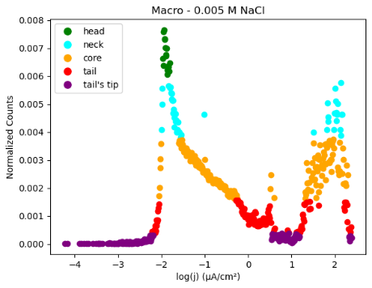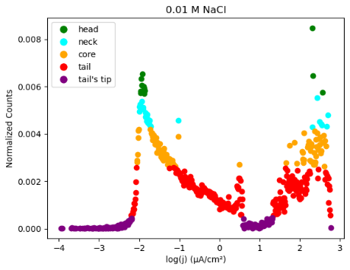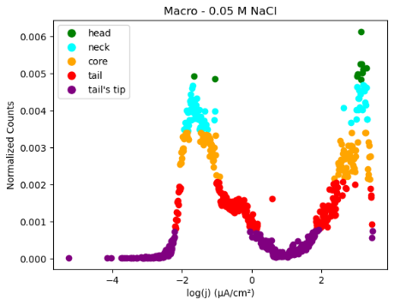
Fig. S10. Histograms of the log(j) populations segmented into the five regions defined by clustering the PCA-transformed Mandelbrot curves: (a) 0.005 M, (b) 0.01 M, and (c) 0.05 M NaCl. Despite the clarity in the Mandelbrot space, direct interpretation from these histograms would be less objective.

Our PCA-based clustering method, rooted in the fractal and multifractal perspective, acknowledges the continuous yet distinct nature of the electrochemical processes. By viewing the data as a series of interrelated fractal regimes, we can represent these five defined regions on the original population plots of polarisation curves. As Fig. S11 shows, the clusters derived from the Mandelbrot domain - which we model independently - are clearly recognisable when mapped back to the log(j)-E space.
Fig. S11. Populations of potentiodynamic polarisation curves segmented into five clusters for (a) 0.005 M, (b) 0.01 M, and (c) 0.05 M NaCl. Each cluster, initially identified in Mandelbrot space via PCA, can be located and interpreted in terms of underlying electrochemical behaviour.

Notably, the “head” region, associated with the most frequent log(j) values, appears in two distinct areas: near the activity/passivity transition and at high overpotentials, where stable pitting currents approach limiting values (j_lim). This highlights the fractal-like complexity - both the onset of passive film formation at lower log(j) scales and the approach to stable pitting growth limits at higher log(j) values can be understood as limiting regimes in a fractal sense [25,26,30,31]. The gradual shift in “head” data from the passivity onset to the stable pitting zone as [Cl-] increases illustrates how achieving a truly passive state (defined as “the region in which the current response is independent on the applied anodic overpotential”[32]) becomes more challenging under more corrosive conditions, consistent with observations related to j_lim (Fig. S1).
The “neck” regions, supporting the “head” clusters, correspond to log(j) values approaching, but not yet reaching, limiting behaviour. In 0.05 M NaCl, a second wave of “neck-head” points emerges at higher overpotentials, illustrating how increased aggressiveness alters the log(j) distribution. This effect manifests as a deterministic-like peak at ~-1 µA/cm² in Fig. S2, reflecting a rapid convergence of log(j) values.
The “core” regions represent well-developed states of both passive film formation (low log(j)) and stable pitting growth (high log(j)). These clusters shrink with increasing [Cl-], as forming a stable passive state becomes more difficult and reaching pitting j_lim becomes easier. Interestingly, some “core” points appear on curves not exhibiting stable pitting, implying that even these “strongest link” curves (see Fig. S1 discussion) can display limited growth at high anodic overpotentials due to the oxide film’s high impedance properties [30,31].
The “tail” and “tail’s tip” clusters mostly capture rare events occurring at both extremes of the log(j) scale. The tail’s tip, representing the rarest events, aligns with conditions close to the open circuit potential (OCP) or near stable pitting initiation. At lower potentials, these rare points reflect the inherent variability in starting surface states across samples. At higher potentials, examining “tail’s tip” points in Fig. S12 (a zoomed-in view of Fig. 3) confirms that they coincide with the transition between metastable and stable pitting, encapsulating the critical E_sp descriptor. This association demonstrates the Mandelbrot-clustering approach’s ability to identify rare events indicative of stable pitting onset, a valuable insight for advanced corrosion monitoring techniques[33,34].
(a)
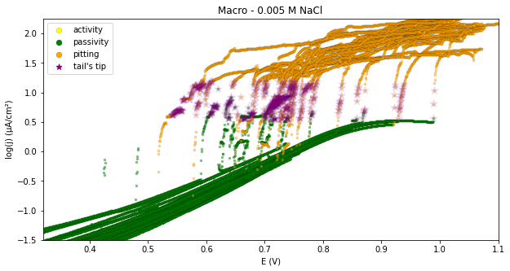
(b) (c)
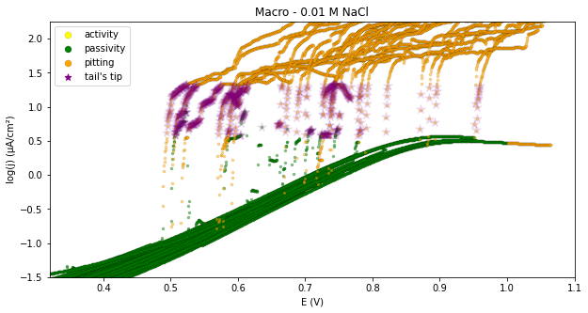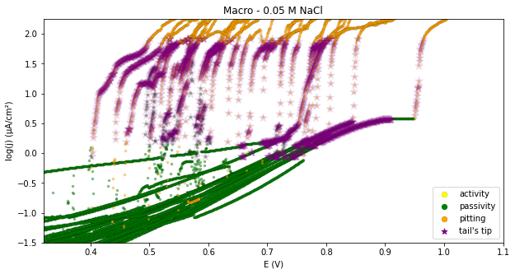
Fig. S12. Zoomed-in version of Fig. 3 (populations of macro potentiodynamic polarisation curves) showing the “tail’s tip” cluster points superimposed on the defined corrosion regimes: (a) 0.005 M, (b) 0.01 M, and (c) 0.05 M NaCl. These rare events occur at the stable pitting onset, reinforcing the link between frequency-based analysis and key corrosion descriptors.

Lastly, the “tail” points are rare but do not represent unlimited scalability. Scalability denotes the extent to which the variable of interest (here, the electrochemical activity) current density log(j) - can increase or amplify without encountering growth limitations, affecting the frequency distribution of the observed events. Instead, they signify log(j) increments already influenced by limiting processes - be it the establishment of a passive state or the onset of stable pitting limitations. Some isolated “tail” or “tail’s tip” points at very high overpotentials can be considered outliers, arising from unique behaviour in a few samples.
By interpreting each cluster as a fractal or multifractal regime, we gain a holistic frequency-based perspective of electrochemical activity. This approach transcends the conventional search for a single deterministic E_pit, encouraging the definition of stable pitting regions (and potentially other corrosion states) in terms of the frequency of log(j) values. Such a viewpoint aligns with the main text’s emphasis on incorporating fractal analysis and data-driven strategies to better understand and predict localised corrosion phenomena.
Supplementary Notes 4 - Classification Metrics: Definitions and Implications
To evaluate the performance of the binary classifier in distinguishing between E_sp and E_pit classes, we employed four key metrics: Accuracy , Precision , Recall , and F1 Score. Below, we provide formal definitions and interpretations of these metrics.
Definitions of Key Terms:
True Positives (TP): Instances correctly identified as belonging to the positive class (E_sp).
True Negatives (TN): Instances correctly identified as belonging to the negative class (E_pit).
False Positives (FP): Instances incorrectly identified as belonging to the positive class (E_sp), when they actually belong to the negative class (E_pit).
False Negatives (FN): Instances incorrectly identified as belonging to the negative class (E_pit), when they actually belong to the positive class (E_sp).
These terms form the foundation for calculating the classification metrics, as shown below:
Accuracy:
Accuracy is the ratio of correctly classified instances (both true positives and true negatives) to the total number of instances. It is calculated as:
$$Accuracy= \frac{TP + TN}{TP + TN + FP + FN​}$$
A high accuracy indicates that the classifier correctly identifies most instances, but it may be misleading in imbalanced datasets where one class is significantly rarer than the other.
Precision:
Precision measures the proportion of true positive predictions out of all positive predictions. It is calculated as:
$$Precision= \frac{TP}{TP + FP​}$$
High precision indicates that the classifier has few false positives, which is crucial when the cost of misclassifying negative instances (e.g., E_pit as E_sp) is high.
Recall (Sensitivity):
Recall measures the proportion of true positives correctly identified out of all actual positives. It is calculated as:
$$Recall= \frac{TP}{TP + FN​}$$
High recall indicates that the classifier effectively identifies most positive instances, which is important when missing positive cases (e.g., failing to detect E_sp) is costly.
F1 Score:
The F1 Score is the harmonic mean of precision and recall, providing a balanced measure of the classifier's performance. It is calculated as:
$$F1 Score=2×\frac{Precision × Recall}{Precision + Recall​​}$$
The F1 Score is particularly useful in imbalanced datasets, as it balances the trade-off between precision and recall.

Supplementary References
[1] M. Cristelli, M. Batty, L. Pietronero, There is more than a power law in Zipf, Sci Rep 2 (2012). https://doi.org/10.1038/srep00812.
[2] R.F. i CANCHO, R. V. SOLÉ, ZIPF’S LAW AND RANDOM TEXTS, Adv Complex Syst 05 (2002) 1–6. https://doi.org/10.1142/S0219525902000468.
[3] O. Fontanelli, P. Miramontes, Y. Yang, G. Cocho, W. Li, Beyond Zipf’s law: The Lavalette rank function and its properties, PLoS One 11 (2016). https://doi.org/10.1371/journal.pone.0163241.
[4] Z.K. Silagadze, Citations and the Zipf – Mandelbrot Law, 1997 (1997) 487–499. https://doi.org/10.48550/arXiv.physics/9901035.
[5] M.A. Montemurro, Beyond the Zipf–Mandelbrot law in quantitative linguistics, Physica A: Statistical Mechanics and Its Applications 300 (2001) 567–578. https://doi.org/10.1016/S0378-4371(01)00355-7.
[6] G. De Marzo, A. Gabrielli, A. Zaccaria, L. Pietronero, Quantifying the unexpected: A scientific approach to Black Swans, Phys Rev Res 4 (2022). https://doi.org/10.1103/PhysRevResearch.4.033079.
[7] J.C. Quiroz, L. Laranjo, C. Tufanaru, A. Baki, D. Rezazadegan, S. Berkovsky, E. Coiera, International Journal of Medical Informatics Empirical analysis of Zipf ’ s law , power law , and lognormal distributions in medical discharge reports, Int J Med Inform 145 (2021) 104324. https://doi.org/10.1016/j.ijmedinf.2020.104324.
[8] R.E. Melchers, Predicting long-term corrosion of metal alloys in physical infrastructure, Npj Mater Degrad 3 (2019) 4. https://doi.org/10.1038/s41529-018-0066-x.
[9] A. Gutierrez, S. Müller, S. Šebek, On asymptotic fairness in voting with greedy sampling, (2021). https://doi.org/https://doi.org/10.48550/arXiv.2101.11269.
[10] A. Jordan, M. Minta, Corrosion analysis, in: Safety, Reliability, Risk and Life-Cycle Performance of Structures and Infrastructures, CRC Press, 2014: pp. 3933–3933. https://doi.org/10.1201/b16387-570.
[11] J.M. Costa, F. Sagués, M. Vilarrasa, Fractal patterns from corrosion pitting, Corros Sci 32 (1991) 665–668. https://doi.org/10.1016/0010-938X(91)90114-5.
[12] R. Reigada, F. Sagués, J.M. Costa, A Monte Carlo simulation of localized corrosion, J Chem Phys 101 (1994) 2329–2337. https://doi.org/10.1063/1.467673.
[13] T. Nagatani, Multifractality of growth probability distribution in diffusion-limited-corrosion pit, Phys Rev A (Coll Park) 45 (1992) R6985–R6988. https://doi.org/10.1103/PhysRevA.45.R6985.
[14] T. Nagatani, Dynamic scaling of pit-size distribution in corrosion patterns, Phys Rev Lett 68 (1992) 1616–1619. https://doi.org/10.1103/PhysRevLett.68.1616.
[15] R.M. Pidaparti, B.S. Aghazadeh, A. Whitfield, A.S. Rao, G.P. Mercier, Classification of corrosion defects in NiAl bronze through image analysis, Corros Sci 52 (2010) 3661–3666. https://doi.org/10.1016/j.corsci.2010.07.017.
[16] Z. Liu, N. Zhang, G. Yan, Pitting Corrosion Morphology Characteristics of 7B04 Aluminum Alloys In Airport Environment Based on Fractal Theory, 166 (2018) 614–618. https://doi.org/10.2991/amcce-18.2018.105.
[17] C. Liang, W. Zhang, Fractal characteristic of pits distribution on 304 stainless steel corroded surface and its application in corrosion diagnosis, Journal Wuhan University of Technology, Materials Science Edition 22 (2007) 389–393. https://doi.org/10.1007/s11595-006-3389-3.
[18] Z. Zhang, X. Wu, Correlated pitting stages of 304 stainless steel with recurrence quantification analysis of electrochemical noise, Materials and Corrosion 70 (2019) 197–205. https://doi.org/10.1002/maco.201810318.
[19] C.H. Liang, W. Zhang, Pitting corrosion mechanisms and characteristics of aluminum in solar heating systems, Journal of the Chinese Chemical Society 53 (2006) 313–318. https://doi.org/10.1002/jccs.200600039.
[20] B.B. Mandelbrot, The fractal geometry of nature, San Francisco, 1982.
[21] C. LEE, D. HO, C. YU, C. WANG, Fractal analysis of temporal variation of air pollutant concentration by box counting, Environmental Modelling & Software 18 (2003) 243–251. https://doi.org/10.1016/S1364-8152(02)00078-6.
[22] L.B. Coelho, D. Torres, M. Bernal, G.M. Paldino, G. Bontempi, J. Ustarroz, Probing the randomness of the local current distributions of 316 L stainless steel corrosion in NaCl solution, Corros Sci 217 (2023) 111104. https://doi.org/10.1016/j.corsci.2023.111104.
[23] B. Li, H. Xing, H. Jing, New diffusive interface model for pitting corrosion, Npj Mater Degrad 7 (2023). https://doi.org/10.1038/s41529-023-00402-0.
[24] K. V. Akpanyung, R.T. Loto, Pitting corrosion evaluation: A review, J Phys Conf Ser 1378 (2019). https://doi.org/10.1088/1742-6596/1378/2/022088.
[25] M.H. Moayed, R.C. Newman, Evolution of current transients and morphology of metastable and stable pitting on stainless steel near the critical pitting temperature, Corros Sci 48 (2006) 1004–1018. https://doi.org/10.1016/j.corsci.2005.03.002.
[26] J. Jun, T. Li, G.S. Frankel, N. Sridhar, Corrosion and repassivation of Super 13Cr stainless steel in artificial 1D pit electrodes at elevated temperature, Corros Sci 173 (2020). https://doi.org/10.1016/j.corsci.2020.108754.
[27] L.B. Coelho, D. Torres, V. Vangrunderbeek, M. Bernal, G.M. Paldino, G. Bontempi, J. Ustarroz, Estimating pitting descriptors of 316 L stainless steel by machine learning and statistical analysis, Npj Mater Degrad 7 (2023) 82. https://doi.org/10.1038/s41529-023-00403-z.
[28] D. Torres, J. Bailly, M. Bernal, L.B. Coelho, J. Ustarroz, Electrochemical nucleation and the role of the surface state: unraveling activity distributions with a cross-system examination and a local electrochemistry approach, Journal of Solid State Electrochemistry (2023). https://doi.org/10.1007/s10008-023-05760-y.
[29] O. Tripp, D. Feitelson, Zipf’s Law Revisited, School of Computer Science and Engineering, The Hebrew University of Jerusalem, Tech. Rep 1-15, 2007.
[30] S.A. Ali Yahia, L. Hamadou, A. Kadri, N. Benbrahim, E.M.M. Sutter, Effect of Anodizing Potential on the Formation and EIS Characteristics of TiO 2 Nanotube Arrays, J Electrochem Soc 159 (2012) K83–K92. https://doi.org/10.1149/2.077204jes.
[31] M.L. Puga, J. Venturini, C.S. ten Caten, C.P. Bergmann, Influencing parameters in the electrochemical anodization of TiO2 nanotubes: Systematic review and meta-analysis, Ceram Int 48 (2022) 19513–19526. https://doi.org/10.1016/j.ceramint.2022.04.059.
[32] R.G. Kelly, J.R. Scully, D. Shoesmith, R.G. Buchheit, Electrochemical Techniques in Corrosion Science and Engineering, 2002. https://doi.org/10.1201/9780203909133.
[33] Z. Li, D. Fu, Y. Li, G. Wang, J. Meng, D. Zhang, Z. Yang, G. Ding, J. Zhao, Application of an electrical resistance sensor-based automated corrosion monitor in the study of atmospheric corrosion, Materials 12 (2019). https://doi.org/10.3390/ma12071065.
[34] Z. Pei, X. Cheng, X. Yang, Q. Li, C. Xia, D. Zhang, X. Li, Understanding environmental impacts on initial atmospheric corrosion based on corrosion monitoring sensors, J Mater Sci Technol 64 (2021) 214–221. https://doi.org/10.1016/j.jmst.2020.01.023.

