Supplementary Data 1. High-throughput design ideas for metal repair tapes.

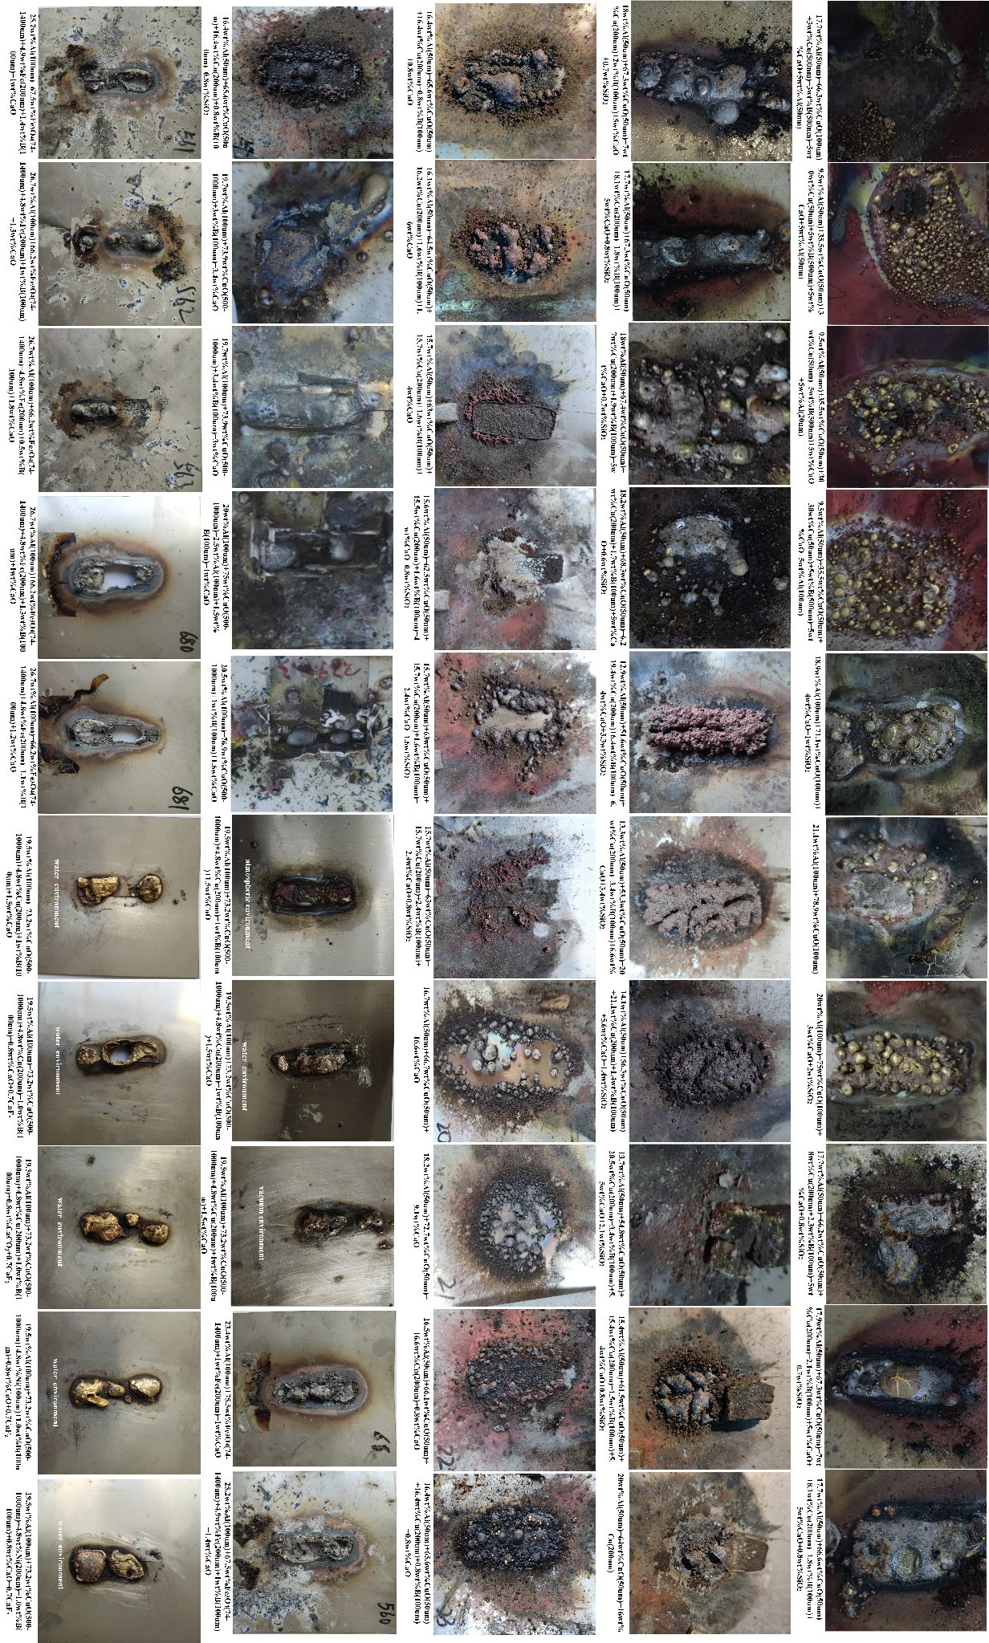
Supplementary Data 2. High-throughput experimental characterization.
Supplementary Data 3. Flowchart of the modification and self-assembly experiments of the initial feedstock.

Supplementary Data4. Microscopic morphology of A. (a-b) High-definition SEM morphology at different magnifications, where spherical aluminium can be observed adhering to the CuO sheet.; (c) EDS mapping of full spectra; (d) (d) Elemental energy spectra and variations, (e) TEM map, (f) Full-spectrum map; (g)C, (h)N,(i)O, (j)Al, (k)Cu, (l)Br of refined spectrum.

Supplementary Data 5. Characterization of properties during the preparation of energy-containing materials. (a-d) XPS

Supplementary Data 6. Physical model diagram of 3DPS. (a) A is formed by modifying and assembling Al with CuO; (b) the top view of A; (c) B is formed by adding CaO, B powder , CaF₂ to A; (d) three-dimensional modeling diagram of B; (e) C is obtained after adding PVB; (f) initial start of the aluminum thermal reaction; (g) entering the violent reaction stage; (h) Slag separating from the metal; (i) the morphology of metal and slag formed by the combustion of C; (j) simulation of the different reaction stages of C;
Supplementary Data 7. SPEDT for the preparation of super alloys

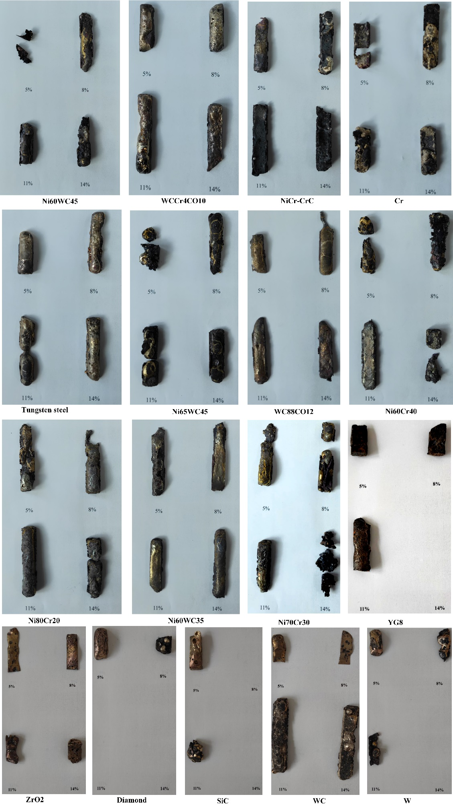
Supplementary Data 8. Morphology of superalloy sample prepared by SPEDT

Supplementary Data 9. Reaction mechanism diagram of 3DPS. (a) 3DPS, (b) ORR excited after energizing ignition, (c) ORR initial reaction, (d) ORR carried out to a degree of intensity, (e) 3DPS completely consumed, (f) Super Cu alloy formed after cooling and solidification
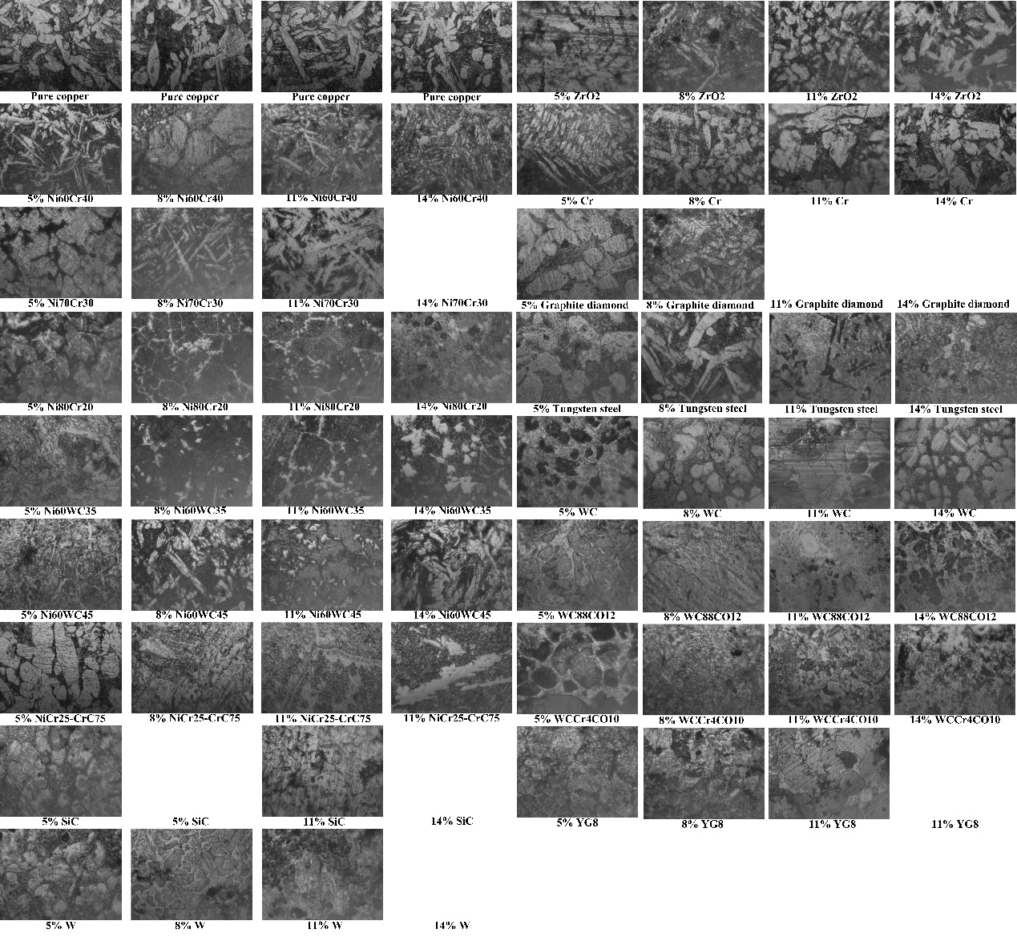
Supplementary Data 10. Microstructure of superalloys prepared by functional powders of different proportions

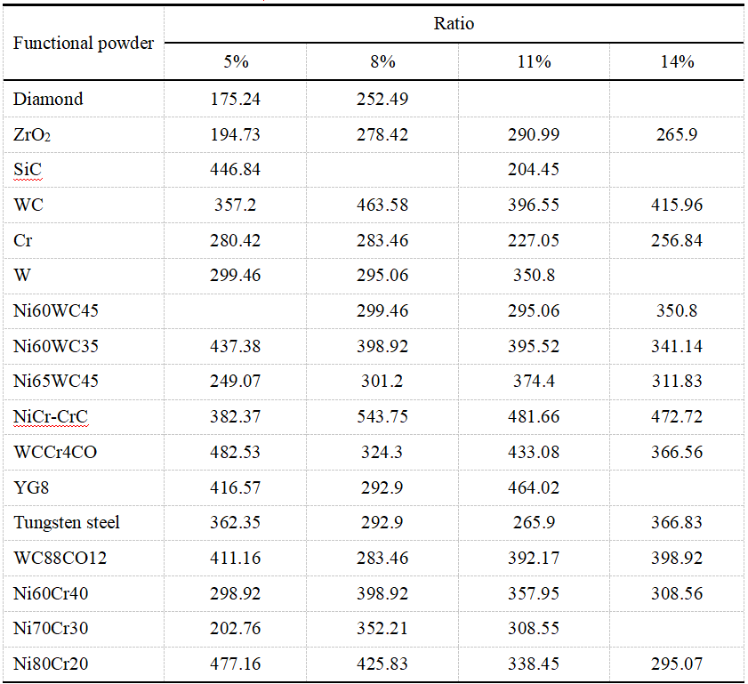
Supplementary Data 11. Microhardness of various functional powders at different proportions
Fig. 12. Scanning data of Ni60WC45/Ni60WC35/Ni70Cr3: (a) three-layer gradient distribution structure, (b) scanning total spectrum, (c) energy spectrum, (d) Cu, (e) Ni, (f) Cr, (g) major atom share at point A, (h) major atom share at point B, (i) major atom share at point C.

