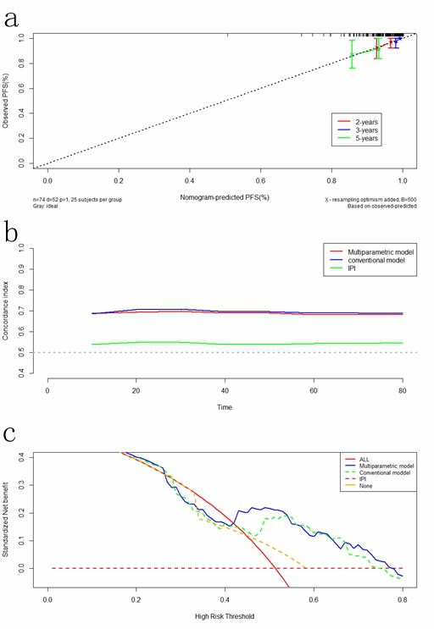
Supplementary Fig1. (a.) Calibration curves of the model for predicting PFS in the validation cohort. (b.) The time-dependent area under the ROC curve of the models for predicting PFS in the validation cohort. (c.) Decision curve analysis of the models for predicting PFS in the validation cohort.
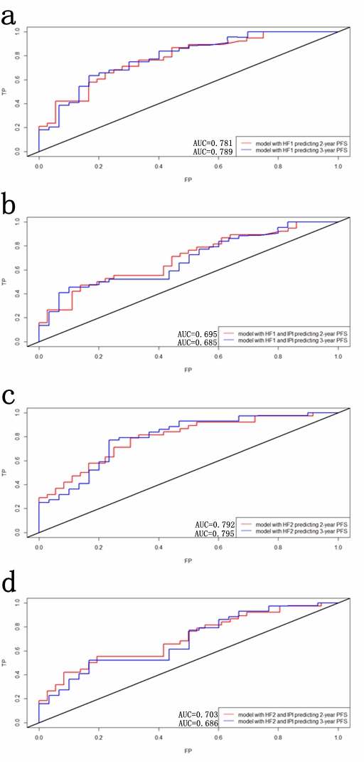
Supplementary Fig2. (a.) The ROC curve of HF1 for predicting 2-PFS and 3-PFS in the validation cohort. (b.) The ROC curve of HF1 and IPI for predicting 2-PFS and 3-PFS in the validation cohort. (c.) The ROC curve of HF2 for predicting 2-PFS and 3-PFS in the validation cohort. (d.) The ROC curve of HF2 and IPI for predicting 2-PFS and 3-PFS in the validation cohort.

