Supplementary Information

Visualization of early and late molecular events associated with the development of Type I Diabetes using NMR spectroscopy

Soumya Swastik Sahoo¹, Shreyada N. Save², Shantanu Madiwale,² Shilpy Sharma^{2,}*, and Jeetender Chugh^{1,}*

¹Department of Chemistry, Indian Institute of Science Education and Research, Dr Homi Bhabha Road, Pashan, Pune 411008

²Department of Biotechnology, Savitribai Phule Pune University, Ganeshkhind Road, Pune 411007

*Address for correspondence
Dr. Jeetender Chugh
Postal address: C-115, Department of Chemistry, Main Building, Indian Institute of Science Education and Research (IISER), Dr. Homi Bhabha Road, Pashan, Pune 411008, India
E-mail: cjeet@iiserpune.ac.in
Phone: +91-20-25908121

Dr. Shilpy Sharma

Postal address: Department of Biotechnology, Savitribai Phule Pune University, Ganeshkhind Road, Pune 411007

E-mail: shilpy.sharma@gmail.com; ssharma@unipune.ac.in

Phone: +91-20-25622228

Figure S1: Representative ¹H NMR spectrum of serum obtained from control C57BL/6 mice. The chemical shifts have been used to assign the metabolites. 1) 2-hydroxybutyrate; 2) 2-hydroxyisovalerate; 3) 3-hydroxybutyrate; 4) Acetate; 5) Alanine; 6) Asparagine; 7) Aspartate; 8) Betaine; 9) Choline; 10) Citrate; 11) Creatine; 12) Cysteine; 13) DSS; 14) Ethanol; 15) Ethanolamine; 16) Formate; 17) Fumarate; 18) Glucose; 19) Glutamate; 20) Glutamine; 21) Glutathione; 22) Glycerol; 23) Glycine; 24) Histamine; 25) Histidine; 26) Imidazole; 27) Isobutyrate; 28) Isoleucine; 29) Lactate; 30) Leucine; 31) Lysine; 32) Mannose; 33) Methanol; 34) Methionine; 35) myo-Inositol; 36) o-Phosphocholine; 37) Phenylalanine; 38) Proline; 39) Pyroglutamate; 40) Pyruvate; 41) Sarcosine; 42) Serine; 43) sn-Glycero-3-phosphocholine; 44) Succinate; 45) Taurine; 46) Threonine; 47) Trimethylamine; 48) Tryptophan; 49) Tyrosine; 50) Uracil; 51) Uridine; 52) Valine. The corresponding chemical shift values for each of the identified metabolites have been listed in Table S1.

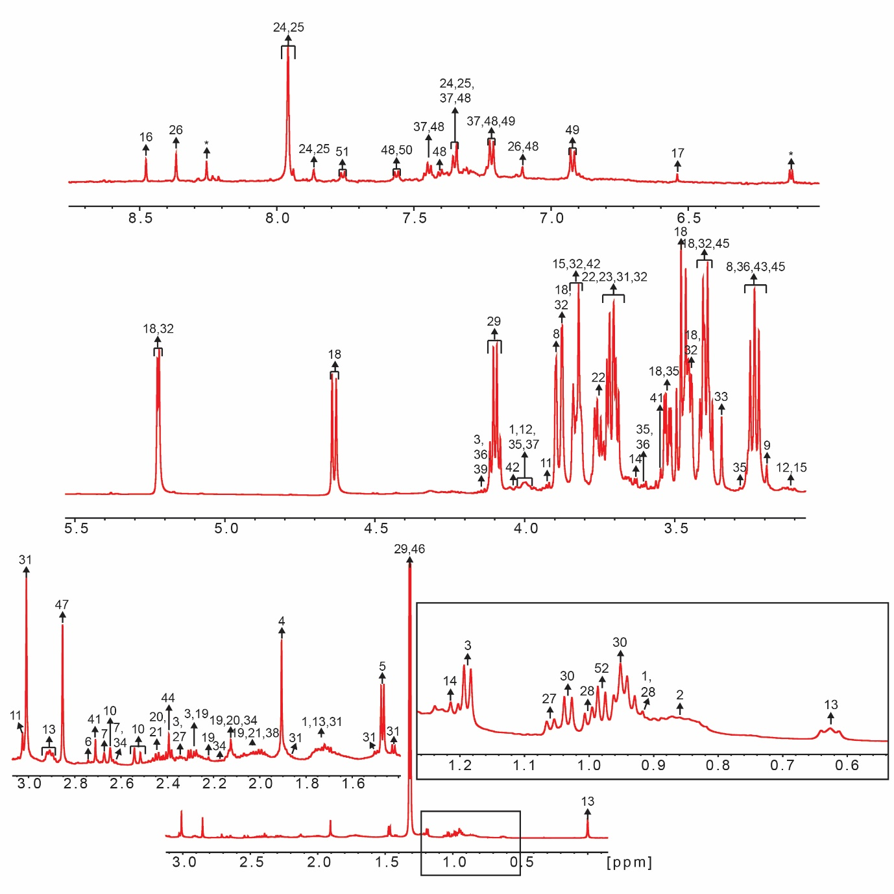

Figure S2: 2D ¹H-¹H TOCSY correlation spectrum of serum obtained from control C57BL/6 mice. The cross-peaks have been depicted for a few representative metabolites.

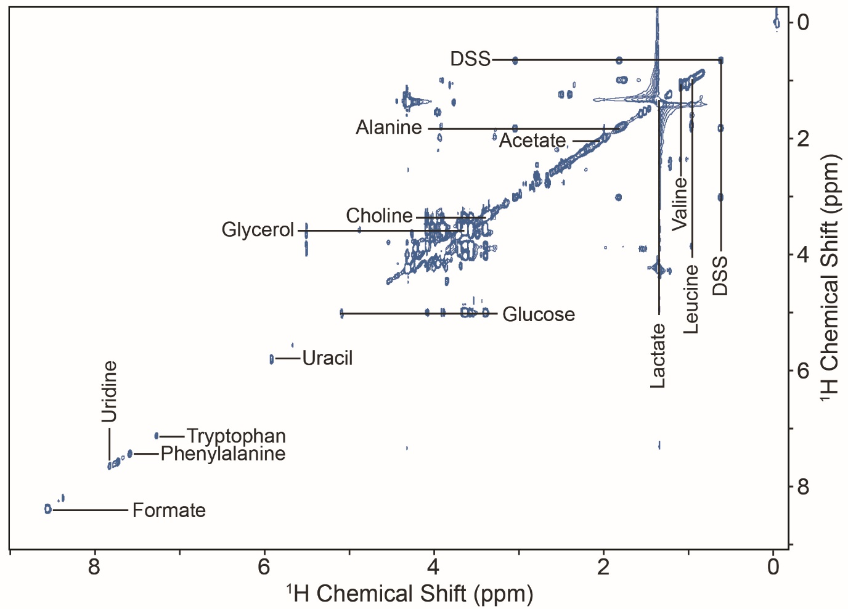

Figure S3: Comparison of the 1D ¹H NMR spectra (1-5 ppm) of serum metabolites obtained from control mice (0 injections; Red); with mice that received 1 STZ injection (Green); 2 STZ injections (Royal blue); 3 STZ injections (Cyan); 4 STZ injections (Purple); and 5 STZ injections (Yellowish brown) A) 15 days, and B) 60 days after the STZ-intervention.

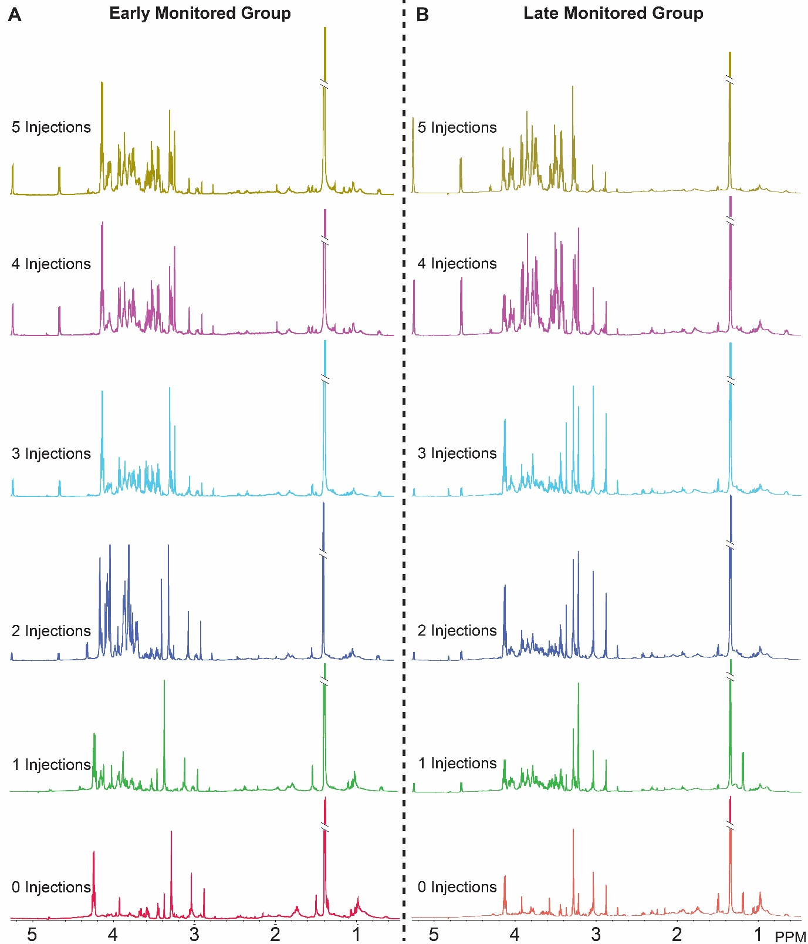

Figure S4: Scores plots generated from the PLS-DA model for the comparison of metabolic profiles obtained from serum samples of control (0I; Red) when compared to mice receiving increasing numbers of STZ injections (Green – 1I, Blue – 2I, Cyan – 3I, Purple – 4I and Yellow – 5I), 15-days (early) (A) and 60-days (late) (B) post-STZ-intervention. Each data point represents an individual sample, and the colored ellipses represent the 95% confidence intervals for each group (N = 8).

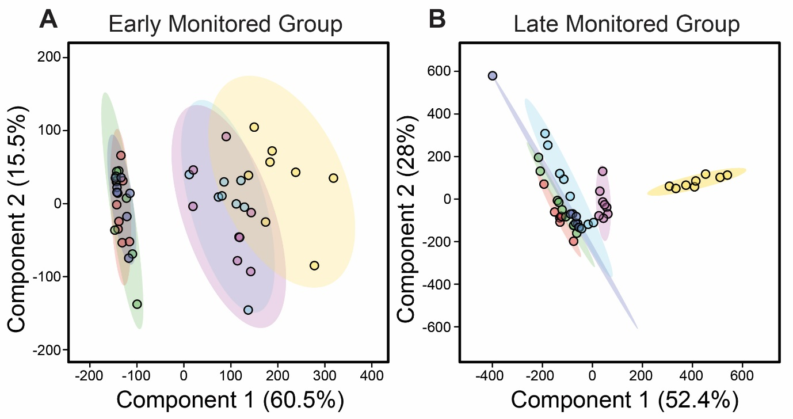

Figure S5: Box-whiskers plots displaying relative normalized concentrations of significantly altered metabolites identified using a cut-off of p-values and FDR values ≤ 0.05. Panels comparing the identified significantly perturbed metabolites while comparing (A) 0I vs 3I, (B) 0I vs. 4I, and (C) 0I vs. 5I mice, monitored for 15-days after STZ-intervention (early time point) have been represented.

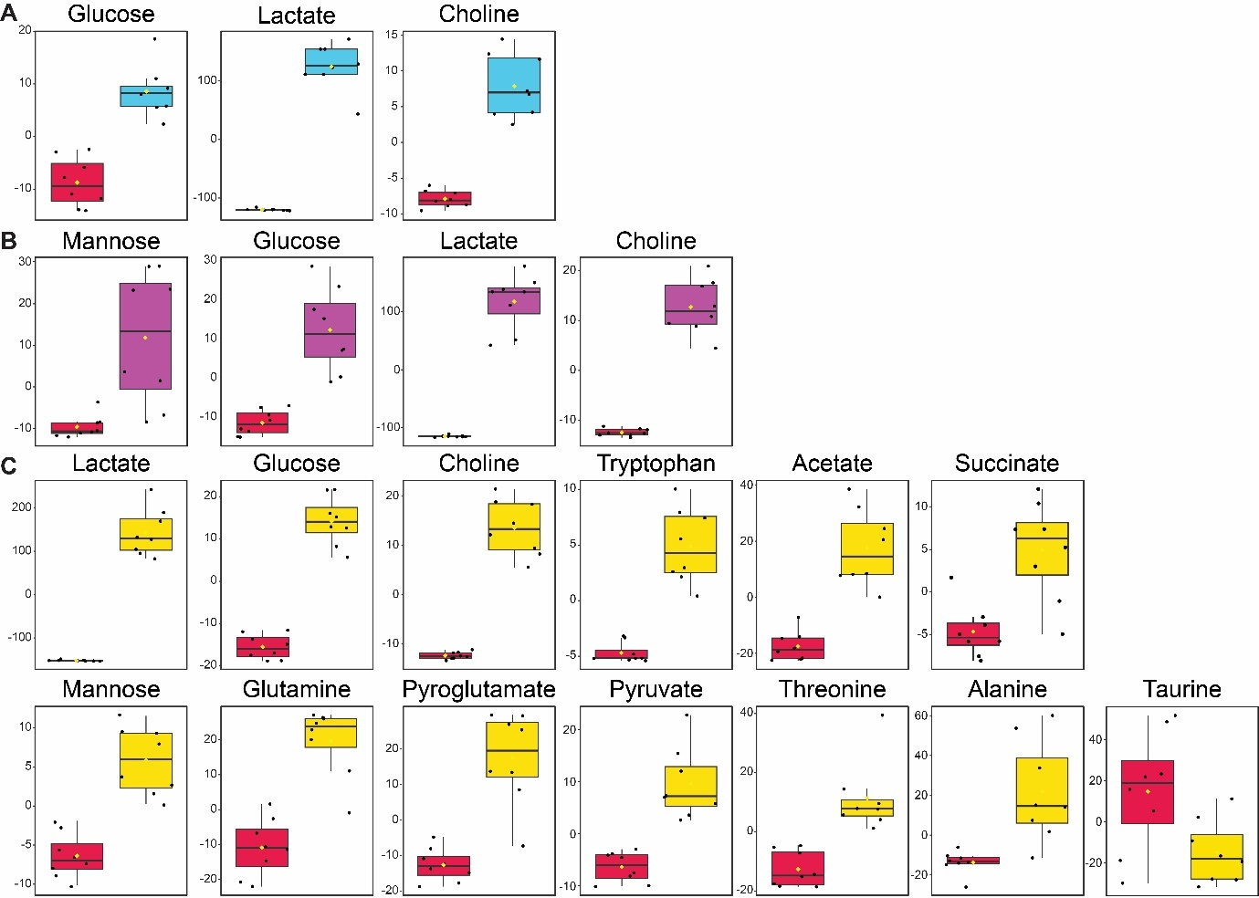

Figure S6: Box-whiskers plots displaying relative normalized concentrations of significantly altered metabolites identified from p-value ≤ 0.05 and FDR ≤ 0.05. Panels comparing significantly perturbed metabolites while comparing (A) 0I vs. 5I, (B) 0I vs. 4I, (C) 0I vs. 3I, and (D) 0I vs. 2I mice, monitored for 60-days (late time-point) after STZ-intervention have been represented.

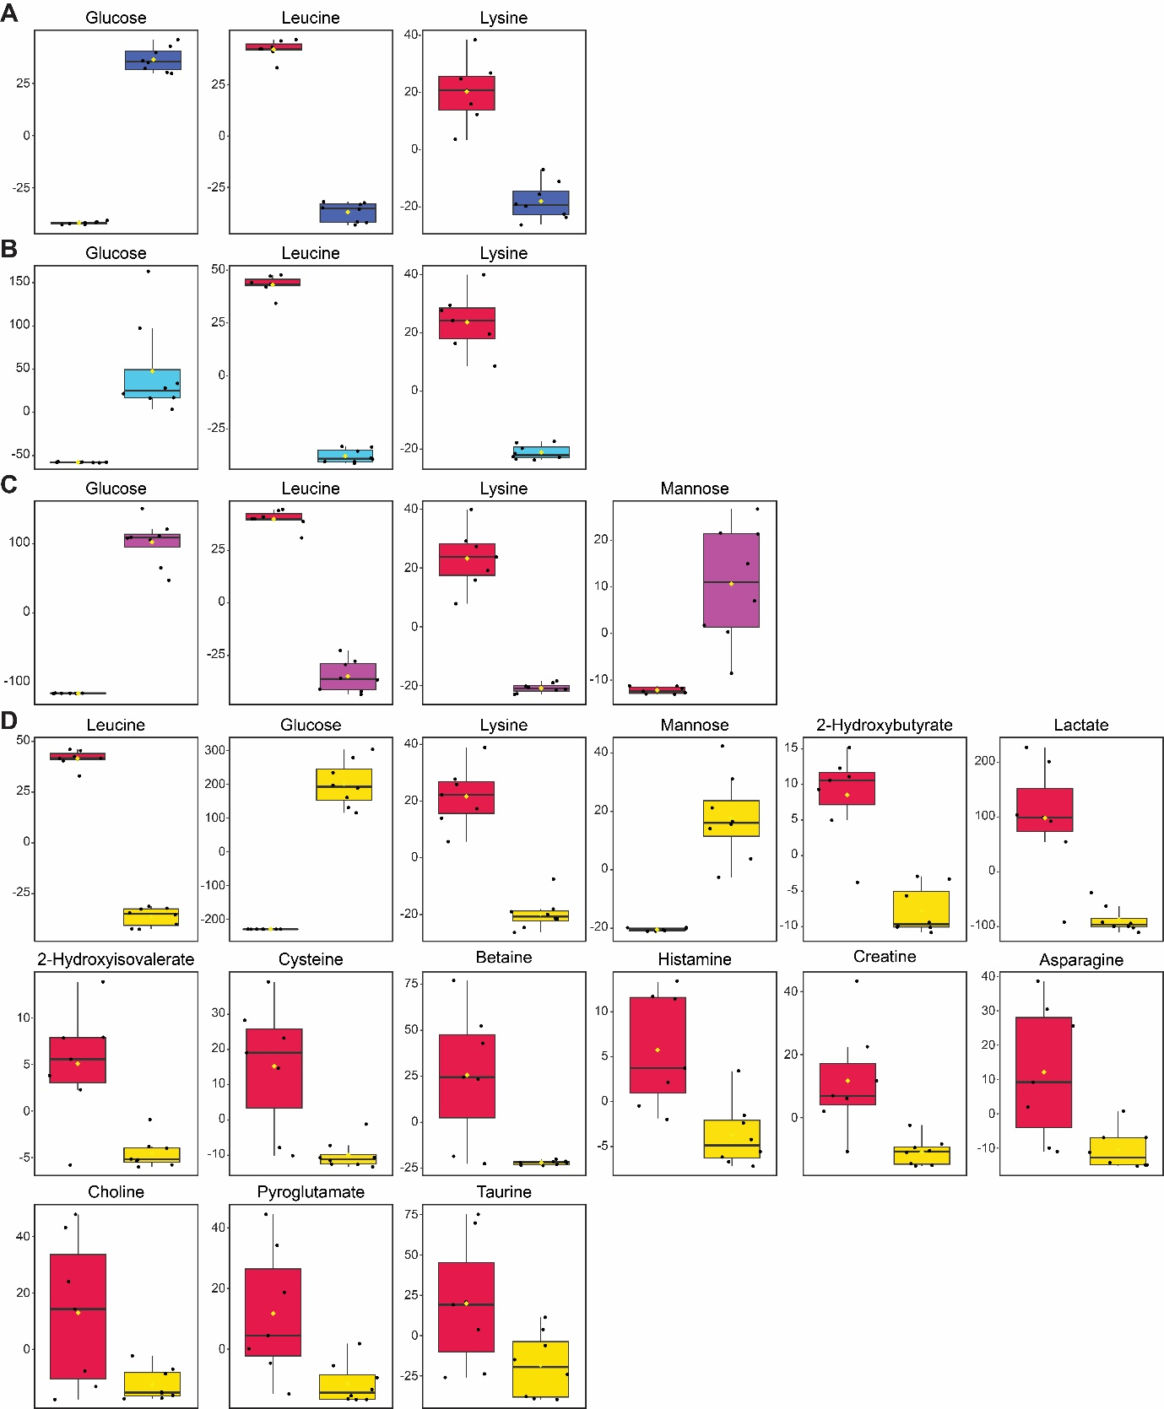

Table S1: Average body weight (in gms) for the mice subgroups used for the early (15-days post-STZ intervention) and late (60-days post-STZ intervention) time points. I: Injection.

15-days | Week 1 | Week 2 | Week 3
Control (0I) | 21 | 21.6 | 21.83
1I | 23.14 | 23.76 | 23.17
2I | 25.05 | 25.02 | 26.17
3I | 23.96 | 23.6 | 24.82
4I | 23.92 | 23.48 | 25.1
5I | 26.28 | 24.85 | 27.3

60-days | Week 1 | Week 2 | Week 3 | Week 4 | Week 5 | Week 6
Control (0I) | 25.08 | 26.46 | 26.98 | 27.76 | 27.48 | 28.92
1I | 25.82 | 26.72 | 25.88 | 26.83 | 25.1 | 26.4
2I | 26.54 | 27.58 | 27. 98 | 28.64 | 29.8 | 29.77
3I | 24 | 23.73 | 25.05 | 25.33 | 25.33 | 26.7
4I | 23.73 | 23.08 | 23.37 | 23.63 | 23.6 | 23.5
5I | 23.77 | 21.97 | 23.03 | 22.7 | 23.05 | 22.88

Table S2: Average feed intake (in gms) and water intake (in ml) for the mice subgroups used for the early (15-days post-STZ intervention) and late (60-days post-STZ intervention) time points. I: Injection.

Feed intake in the 15-days post STZ intervention Group
Control (0I) | 446.4
1I | 440.4
2I | 475.7
3I | 433.4
4I | 455.9
5I | 483.6
60-days post STZ intervention Group
Control (0I) | 1818
1I | 1834.5
2I | 1792
3I | 1799.5
4I | 1885.8
5I | 1858.5

Water intake (in ml) in the 15-days post-STZ Intervention Group
Control (0I) | 460
1I | 490
2I | 490
3I | 450
4I | 480
5I | 460
Water intake (in ml) in the 60-days post-STZ Intervention Group
Control (0I) | 1160
1I | 1130
2I | 1190
3I | 1160
4I | 1110
5I | 1170

Table S3: Blood glucose levels (in mg/dl) for the early time point (15 days) post-STZ intervention as measured by OGTT. I: Injection.

 | Animal no. | 0 min. | 15min. | 30min. | 45min. | 60min. | 90min. | 120min.
Control (0I) | M7 | 118.95 | 224.25 | 159.9 | 124.15 | 134.55 | 111.15 | 117
Control (0I) | M8 | 135.2 | 229.45 | 198.25 | 160.55 | 163.15 | 141.7 | 120.25
Control (0I) | M9 | 118.3 | 255.45 | 234.65 | 148.2 | 159.9 | 146.25 | 126.75
Control (0I) | M30 | 80.6 | 195 | 170.95 | 129.35 | 131.3 | 111.15 | 105.95
Control (0I) | M31 | 114.4 | 201.5 | 178.1 | 135.85 | 139.75 | 109.2 | 115.05
Control (0I) | M32 | 108.55 | 215.15 | 191.75 | 144.95 | 140.4 | 113.1 | 112.45
Control (0I) | M54 | 91.65 | 228.8 | 120.25 | 116.35 | 117.65 | 102.7 | 91
Control (0I) | M55 | 102.05 | 204.75 | 147.55 | 131.95 | 132.6 | 107.9 | 84.5
1I | M16 | 139.1 | 228.15 | 209.3 | 166.4 | 170.95 | 143 | 132.6
1I | M17 | 131.95 | 213.2 | 185.25 | 155.35 | 144.3 | 120.25 | 115.7
1I | M18A | 146.25 | 258.7 | 193.7 | 157.95 | 161.85 | 131.95 | 126.75
1I | M18B | 110.5 | 201.5 | 211.9 | 195 | 166.4 | 135.85 | 129.35
1I | M19 | 130.65 | 265.2 | 263.9 | 178.75 | 185.25 | 143.65 | 161.2
1I | M33 | 155.35 | 187.85 | 214.5 | 190.45 | 184.6 | 144.95 | 131.3
1I | M71 | 109.2 | 211.9 | 155.35 | 139.1 | 138.45 | 111.15 | 94.25
1I | M72 | 105.3 | 215.15 | 190.45 | 177.45 | 176.15 | 135.2 | 118.3
2I | M10 | 130.65 | 215.15 | 257.4 | 210.6 | 167.05 | 111.8 | 108.55
2I | M11 | 117.65 | 203.45 | 223.6 | 199.55 | 152.1 | 111.15 | 106.6
2I | M12 | 87.75 | 219.05 | 212.55 | 153.4 | 133.25 | 110.5 | 97.5
2I | M13 | 113.75 | 230.75 | 241.8 | 221 | 176.8 | 142.35 | 124.8
2I | M14 | 126.75 | 228.8 | 209.95 | 184.6 | 170.3 | 133.25 | 128.05
2I | M31 | 175.5 | 253.5 | 248.3 | 228.15 | 242.45 | 184.6 | 151.45
2I | M67 | 131.3 | 280.8 | 186.55 | 172.25 | 169 | 132.6 | 122.85
2I | M68 | 117.65 | 264.55 | 245.05 | 221 | 206.05 | 170.95 | 128.05
3I | M1 | 135.85 | 235.3 | 244.4 | 204.1 | 189.8 | 139.1 | 113.1
3I | M2 | 171.6 | 320.45 | 328.9 | 283.4 | 252.85 | 200.85 | 157.95
3I | M3 | 163.15 | 310.7 | 343.2 | 300.3 | 243.75 | 224.25 | 202.15
3I | M4 | 195.65 | 293.8 | 344.5 | 364 | 318.5 | 241.15 | 217.75
3I | M5 | 139.75 | 258.7 | 265.85 | 251.55 | 208.65 | 155.35 | 111.15
3I | M29 | 156 | 258.7 | 315.25 | 307.45 | 281.45 | 246.35 | 164.45
3I | M62 | 156.65 | 390 | 373.1 | 321.1 | 316.55 | 241.8 | 176.8
3I | M63 | 167.05 | 321.1 | 349.05 | 319.8 | 305.5 | 254.15 | 189.15
4I | M39 | 297.05 | 390 | 388.7 | 388.05 | 335.4 | 297.05 | 254.8
4I | M40 | 161.2 | 330.85 | 385.45 | 373.75 | 332.15 | 261.3 | 234
4I | M41 | 226.2 | 347.75 | 383.5 | 350.35 | 330.2 | 265.2 | 245.05
4I | M42 | 154.05 | 306.8 | 365.3 | 351 | 337.35 | 338 | 240.5
4I | M43 | 303.55 | 390 | 390 | 390 | 386.75 | 303.55 | 232.7
4I | M27 | 128.05 | 306.8 | 271.7 | 254.8 | 244.4 | 211.9 | 170.95
4I | M58 | 206.05 | 390 | 390 | 380.9 | 372.45 | 314.6 | 253.5
4I | M59 | 166.4 | 390 | 355.55 | 326.95 | 295.1 | 254.8 | 232.7
5I | M20 | 238.55 | 390 | 390 | 390 | 380.9 | 295.75 | 271.7
5I | M21 | 213.85 | 342.55 | 390 | 382.2 | 362.7 | 275.6 | 256.1
5I | M22 | 332.15 | 390 | 390 | 390 | 390 | 390 | 390
5I | M23 | 309.4 | 390 | 390 | 390 | 390 | 390 | 386.75
5I | M24 | 212.55 | 344.5 | 349.7 | 346.45 | 347.75 | 321.75 | 265.85
5I | M25 | 327.6 | 390 | 390 | 390 | 390 | 380.25 | 287.3
5I | M50 | 301.6 | 390 | 390 | 377.65 | 340.6 | 295.75 | 255.45
5I | M51 | 326.95 | 390 | 390 | 390 | 355.55 | 282.1 | 243.75

Table S4: Blood glucose levels (in mg/dl) for the late time point (60 days) post-STZ intervention as measured by OGTT. I: Injection.

 | Animal no. | 0 min. | 15min. | 30min. | 45min. | 60min. | 90min. | 120min.
Control (0I) | M1 | 94.9 | 203.45 | 144.3 | 122.2 | 119.6 | 92.95 | 97.5
Control (0I) | M2 | 95.55 | 179.4 | 132.6 | 118.95 | 126.75 | 96.2 | 83.2
Control (0I) | M3 | 103.35 | 176.8 | 117 | 117.65 | 128.05 | 110.5 | 79.95
Control (0I) | M4 | 108.55 | 207.35 | 129.35 | 123.5 | 137.8 | 120.25 | 87.1
Control (0I) | M5 | 100.1 | 195 | 165.75 | 132.6 | 142.35 | 117.65 | 100.75
Control (0I) | M33 | 111.15 | 197.6 | 172.25 | 98.15 | 104.65 | 88.4 | 87.1
Control (0I) | M56 | 104.65 | 196.95 | 172.25 | 177.45 | 170.3 | 157.3 | 129.35
Control (0I) | M57 | 98.8 | 178.75 | 113.1 | 135.2 | 129.35 | 128.05 | 102.7
1I | M34 | 79.3 | 191.75 | 135.2 | 94.25 | 92.3 | 101.4 | 87.1
1I | M35 | 104 | 209.95 | 167.7 | 109.85 | 117.65 | 105.95 | 96.85
1I | M36 | 115.7 | 218.4 | 163.8 | 106.6 | 105.95 | 105.3 | 102.7
1I | M37 | 88.4 | 190.45 | 130.65 | 92.3 | 115.05 | 102.7 | 100.1
1I | M38 | 71.5 | 221.65 | 112.45 | 82.55 | 112.45 | 99.45 | 74.75
1I | M34 | 115.7 | 244.4 | 207.35 | 143.65 | 150.8 | 125.45 | 135.2
1I | M73 | 117 | 263.25 | 259.35 | 152.75 | 139.75 | 145.6 | 133.25
1I | M74 | 109.85 | 187.85 | 230.75 | 152.1 | 128.05 | 150.15 | 148.85
2I | M15 | 114.4 | 195 | 173.55 | 126.1 | 121.55 | 99.45 | 114.4
2I | M16 | 117 | 174.85 | 157.95 | 131.95 | 131.95 | 103.35 | 111.15
2I | M17 | 104 | 193.7 | 157.95 | 112.45 | 122.2 | 80.6 | 94.25
2I | M49 | 89.05 | 211.9 | 182 | 122.2 | 120.25 | 78 | 77.35
2I | M50 | 118.95 | 220.35 | 229.45 | 177.45 | 162.5 | 104.65 | 109.85
2I | M32 | 135.2 | 308.75 | 273 | 252.2 | 240.5 | 183.3 | 159.9
2I | M69 | 191.75 | 196.95 | 274.95 | 260.65 | 213.85 | 183.95 | 146.25
2I | M70 | 152.1 | 339.95 | 361.4 | 361.4 | 334.75 | 310.05 | 264.55
3I | M6 | 143.65 | 357.5 | 334.1 | 291.85 | 292.5 | 212.55 | 206.05
3I | M7 | 130 | 206.7 | 178.1 | 150.8 | 152.1 | 115.7 | 111.15
3I | M8 | 109.2 | 195.65 | 191.75 | 137.15 | 150.8 | 106.6 | 111.8
3I | M9 | 120.25 | 309.4 | 300.3 | 237.25 | 200.2 | 130.65 | 122.2
3I | M30 | 145.6 | 306.15 | 332.15 | 288.6 | 295.1 | 221 | 167.7
3I | M64 | 213.85 | 263.9 | 254.8 | 202.8 | 182.65 | 153.4 | 125.45
3I | M65 | 236.6 | 390 | 347.75 | 390 | 348.4 | 353.6 | 320.45
3I | M66 | 200.85 | 372.45 | 390 | 337.35 | 338 | 328.25 | 309.4
4I | M44 | 316.55 | 390 | 390 | 359.45 | 352.3 | 302.25 | 267.15
4I | M45 | 222.3 | 390 | 363.35 | 309.4 | 276.25 | 250.25 | 186.55
4I | M46 | 301.6 | 390 | 390 | 390 | 325.65 | 285.35 | 282.75
4I | M47 | 299 | 390 | 390 | 377 | 367.25 | 334.75 | 262.6
4I | M48 | 326.95 | 390 | 390 | 390 | 390 | 363.35 | 308.1
4I | M28 | 170.95 | 338.65 | 390 | 390 | 335.4 | 276.9 | 234
4I | M60 | 282.1 | 390 | 390 | 390 | 372.45 | 377.65 | 312.65
4I | M61 | 221 | 341.25 | 333.45 | 390 | 371.8 | 358.15 | 323.05
5I | M25 | 271.7 | 390 | 387.4 | 340.6 | 299.65 | 251.55 | 267.8
5I | M26 | 297.7 | 390 | 390 | 361.4 | 312.65 | 293.15 | 344.5
5I | M27 | 266.5 | 390 | 390 | 308.1 | 278.85 | 278.2 | 260.65
5I | M28 | 390 | 390 | 390 | 390 | 390 | 369.2 | 390
5I | M29 | 390 | 390 | 390 | 390 | 390 | 383.5 | 386.1
5I | M26 | 150.8 | 390 | 390 | 328.9 | 324.35 | 287.95 | 239.2
5I | M52 | 345.8 | 390 | 390 | 390 | 390 | 390 | 390
5I | M53 | 319.8 | 390 | 390 | 390 | 390 | 390 | 390

Table S5: Blood glucose levels (in mg/dl) for the early time point (15 days) post-STZ intervention as measured by ITT. I: Injection.

 | Animal no. | 0 min. | 15min. | 30min. | 45min. | 60min. | 90min. | 120min.
Control (0I) | M7 | 110.5 | 110.5 | 97.5 | 111.8 | 113.75 | 113.1 | 89.05
Control (0I) | M8 | 108.55 | 65.65 | 76.7 | 91.65 | 79.95 | 90.35 | 120.25
Control (0I) | M9 | 107.25 | 80.6 | 58.5 | 68.9 | 98.15 | 87.1 | 109.85
Control (0I) | M30 | 109.2 | 81.25 | 86.45 | 74.1 | 92.3 | 102.7 | 120.25
Control (0I) | M31 | 103.35 | 93.6 | 77.35 | 60.45 | 57.2 | 65 | 84.5
Control (0I) | M32 | 128.05 | 92.95 | 84.5 | 60.45 | 70.85 | 69.55 | 97.5
Control (0I) | M54 | 76.05 | 105.95 | 94.25 | 117.65 | 119.6 | 94.25 | 93.6
Control (0I) | M55 | 75.4 | 101.4 | 128.7 | 111.8 | 128.7 | 99.45 | 112.45
1I | M16 | 133.9 | 89.7 | 75.4 | 79.95 | 87.75 | 95.55 | 117.65
1I | M17 | 126.75 | 100.75 | 74.75 | 73.45 | 110.5 | 110.5 | 107.25
1I | M18A | 124.15 | 88.4 | 76.05 | 68.25 | 89.05 | 88.4 | 107.9
1I | M18B | 124.15 | 106.6 | 84.5 | 97.5 | 100.75 | 110.5 | 117.65
1I | M19 | 131.3 | 135.85 | 120.25 | 137.15 | 110.5 | 137.8 | 144.3
1I | M33 | 111.8 | 79.95 | 73.45 | 79.3 | 62.4 | 70.2 | 96.2
1I | M71 | 102.7 | 61.75 | 66.95 | 97.5 | 92.3 | 91.65 | 115.7
1I | M72 | 106.6 | 81.25 | 73.45 | 102.7 | 95.55 | 94.9 | 114.4
2I | M10 | 128.05 | 142.35 | 111.15 | 110.5 | 111.15 | 131.3 | 140.4
2I | M11 | 123.5 | 131.3 | 104 | 98.15 | 115.7 | 122.85 | 137.15
2I | M12 | 89.7 | 94.9 | 94.9 | 88.4 | 102.05 | 108.55 | 113.1
2I | M13 | 119.6 | 102.05 | 91 | 85.8 | 94.9 | 116.35 | 127.4
2I | M14 | 133.9 | 112.45 | 86.45 | 83.85 | 104.65 | 103.35 | 119.6
2I | M31 | 135.2 | 81.25 | 72.8 | 55.9 | 72.8 | 68.9 | 91.65
2I | M67 | 113.75 | 83.85 | 62.4 | 57.2 | 65.65 | 91 | 110.5
2I | M68 | 109.2 | 89.05 | 72.8 | 69.55 | 91.65 | 104.65 | 115.05
3I | M1 | 124.15 | 118.3 | 82.55 | 78 | 105.3 | 130 | 102.05
3I | M2 | 142.35 | 149.5 | 100.1 | 115.05 | 126.75 | 139.1 | 150.15
3I | M3 | 135.85 | 180.05 | 108.55 | 113.75 | 137.8 | 162.5 | 161.2
3I | M4 | 146.9 | 151.45 | 87.1 | 107.25 | 115.7 | 173.55 | 183.3
3I | M5 | 112.45 | 135.85 | 98.8 | 100.1 | 110.5 | 141.7 | 156
3I | M29 | 92.95 | 96.2 | 73.45 | 83.85 | 89.05 | 109.85 | 150.8
3I | M62 | 157.3 | 120.25 | 96.85 | 89.05 | 107.25 | 120.25 | 136.5
3I | M63 | 194.35 | 92.95 | 76.7 | 81.25 | 77.35 | 105.3 | 107.9
4I | M39 | 300.95 | 271.7 | 252.2 | 220.35 | 235.95 | 274.95 | 231.4
4I | M40 | 135.2 | 146.25 | 123.5 | 115.05 | 157.3 | 165.1 | 174.2
4I | M41 | 226.2 | 213.85 | 212.55 | 135.2 | 138.45 | 153.4 | 158.6
4I | M42 | 147.55 | 138.45 | 104 | 111.8 | 130 | 141.05 | 130
4I | M43 | 309.4 | 291.85 | 248.3 | 224.25 | 261.3 | 315.9 | 300.3
4I | M27 | 107.25 | 84.5 | 91 | 98.8 | 98.15 | 94.9 | 122.2
4I | M58 | 278.85 | 239.2 | 167.7 | 212.55 | 226.85 | 241.15 | 231.4
4I | M59 | 297.7 | 216.45 | 148.2 | 174.2 | 172.25 | 158.6 | 153.4
5I | M20 | 234 | 222.95 | 195.65 | 177.45 | 172.9 | 208 | 224.25
5I | M21 | 232.7 | 217.75 | 169.65 | 154.05 | 162.5 | 228.8 | 243.75
5I | M22 | 322.4 | 326.3 | 250.25 | 219.05 | 249.6 | 278.85 | 297.7
5I | M23 | 300.3 | 329.55 | 325.65 | 295.75 | 247.65 | 289.9 | 328.25
5I | M24 | 269.1 | 252.2 | 180.7 | 146.25 | 156.65 | 152.1 | 185.9
5I | M25 | 316.55 | 298.35 | 241.8 | 241.15 | 228.8 | 276.25 | 284.05
5I | M50 | 323.7 | 202.8 | 167.7 | 165.1 | 174.2 | 191.75 | 211.25
5I | M51 | 308.75 | 281.45 | 221.65 | 254.15 | 252.85 | 260.65 | 278.85

Table S6: Blood glucose levels (in mg/dl) for the late time point (60 days) post-STZ intervention as measured by ITT. I: Injection.

 | Animal no. | 0 min. | 15min. | 30min. | 45min. | 60min. | 90min. | 120min.
Control (0I) | M1 | 81.9 | 78.65 | 64.35 | 88.4 | 94.25 | 82.55 | 76.7
Control (0I) | M2 | 104.65 | 84.5 | 74.1 | 82.55 | 87.1 | 84.5 | 83.2
Control (0I) | M3 | 106.6 | 91.65 | 73.45 | 78 | 95.55 | 98.15 | 89.7
Control (0I) | M4 | 125.45 | 79.3 | 70.2 | 73.45 | 62.4 | 76.7 | 85.8
Control (0I) | M50 | 117.65 | 78 | 55.9 | 55.25 | 42.25 | 69.55 | 65.65
Control (0I) | M33 | 122.2 | 67.6 | 61.1 | 57.85 | 59.8 | 78 | 86.45
Control (0I) | M56 | 57.85 | 47.45 | 39 | 33.15 | 31.2 | 32.5 | 39
Control (0I) | M57 | 79.95 | 52.65 | 52 | 68.25 | 83.2 | 79.95 | 82.55
1I | M34 | 85.15 | 60.45 | 50.7 | 52.65 | 59.8 | 70.2 | 76.05
1I | M35 | 96.85 | 75.4 | 59.15 | 66.3 | 55.9 | 61.75 | 78
1I | M36 | 85.8 | 64.35 | 61.75 | 65 | 53.95 | 69.55 | 70.85
1I | M37 | 89.7 | 65.65 | 52.65 | 70.85 | 65.65 | 65 | 65.65
1I | M38 | 77.35 | 46.15 | 52.65 | 61.75 | 72.8 | 83.85 | 78
1I | M34 | 95.55 | 76.7 | 72.15 | 68.25 | 66.3 | 68.9 | 74.1
1I | M73 | 95.55 | 89.05 | 58.5 | 67.6 | 65.65 | 70.2 | 80.6
1I | M74 | 91.65 | 108.55 | 82.55 | 85.8 | 90.35 | 87.1 | 88.4
2I | M15 | 108.55 | 62.4 | 61.75 | 61.75 | 59.15 | 52.65 | 100.75
2I | M16 | 124.15 | 85.8 | 73.45 | 67.6 | 61.1 | 69.55 | 103.35
2I | M17 | 108.55 | 76.7 | 59.8 | 65.65 | 56.55 | 68.9 | 66.3
2I | M49 | 85.15 | 51.35 | 49.4 | 54.6 | 56.55 | 79.95 | 72.8
2I | M50 | 109.2 | 115.05 | 84.5 | 94.9 | 97.5 | 88.4 | 89.05
2I | M32 | 116.35 | 81.25 | 79.95 | 76.05 | 77.35 | 87.75 | 81.25
2I | M69 | 135.2 | 148.85 | 123.5 | 101.4 | 88.4 | 81.25 | 65
2I | M70 | 152.1 | 154.7 | 106.6 | 93.6 | 105.3 | 143 | 128.05
3I | M6 | 138.45 | 118.3 | 70.85 | 59.15 | 74.1 | 66.95 | 71.5
3I | M7 | 123.5 | 78.65 | 58.5 | 70.2 | 65 | 100.1 | 83.85
3I | M8 | 117.65 | 77.35 | 61.75 | 48.1 | 104 | 70.85 | 57.85
3I | M9 | 138.45 | 81.9 | 91.65 | 71.5 | 84.5 | 96.85 | 121.55
3I | M30 | 111.8 | 96.2 | 70.85 | 67.6 | 61.75 | 56.55 | 55.9
3I | M64 | 96.2 | 51.35 | 72.15 | 65.65 | 92.95 | 78 | 112.45
3I | M65 | 272.35 | 246.35 | 203.45 | 207.35 | 226.2 | 294.45 | 324.35
3I | M66 | 213.85 | 217.1 | 185.25 | 83.85 | 76.7 | 70.2 | 70.85
4I | M44 | 232.7 | 269.1 | 134.55 | 92.95 | 106.6 | 111.15 | 130.65
4I | M45 | 165.1 | 169 | 90.35 | 91 | 99.45 | 105.95 | 131.3
4I | M46 | 266.5 | 286.65 | 175.5 | 146.9 | 166.4 | 183.3 | 208
4I | M47 | 354.9 | 390 | 390 | 390 | 390 | 382.85 | 330.2
4I | M48 | 331.5 | 349.05 | 266.5 | 165.1 | 159.25 | 163.8 | 183.95
4I | M28 | 165.1 | 174.85 | 99.45 | 87.1 | 79.3 | 96.2 | 96.85
4I | M60 | 291.85 | 247.65 | 229.45 | 167.7 | 161.2 | 213.85 | 216.45
4I | M61 | 227.5 | 217.75 | 161.2 | 121.55 | 107.25 | 148.85 | 199.55
5I | M25 | 288.6 | 321.75 | 207.35 | 169.65 | 139.75 | 156.65 | 185.9
5I | M26 | 280.8 | 326.95 | 243.1 | 147.55 | 123.5 | 120.25 | 136.5
5I | M27 | 264.55 | 209.3 | 108.55 | 96.85 | 79.3 | 90.35 | 85.8
5I | M28 | 322.4 | 384.15 | 377.65 | 354.9 | 323.7 | 286.65 | 286
5I | M29 | 304.85 | 335.4 | 238.55 | 137.15 | 107.25 | 97.5 | 113.1
5I | M26 | 122.2 | 121.55 | 83.2 | 59.15 | 70.2 | 81.25 | 76.05
5I | M52 | 389.35 | 299.65 | 259.35 | 224.25 | 209.95 | 224.25 | 226.2
5I | M53 | 274.95 | 241.8 | 251.55 | 250.25 | 242.45 | 231.4 | 215.8

Table S7: - List of chemical shift assignment of the abundant, aqueous metabolites obtained from the serum of C57BL/6 mice.

S. No. | Metabolite  (PubChem CID Code) | Chemical shift (multiplicity) | Assignment
1 | 2-hydroxybutyrate (440864) | 0.9(t) | C₄H₉
 |  | 1.6(m) | C₂H₃
 |  | 1.7(m) | CH₃
 |  | 4.0(t) | CH₃OH
2 | 2-hydroxyisovalerate (99823) | 0.8(d) | C₄H₉
 |  | 0.96(d) | C₃H₆
3 | 3-hydroxybutyrate (3541112) | 1.2(td) | C₄H₉
 |  | 2.3(q) | C₂H₃
 |  | 2.4(q) | CH₃
 |  | 4.14(t) | CH₃OH
4 | Acetate (175) | 1.90 (s) | CH₃
5 | Alanine (5950) | 3.805 (q) | α-CH
 |  | 1.46 (d) | β-CH₃
6 | Asparagine (6267) | 2.84 (m) | β-CH₂
 |  | 2.94 (m) | β-CH₂
 |  | 3.99 (dd) | α-CH
7 | Aspartate (5960) | 2.66 (dd) | β-CH₂
 |  | 2.79 (dd) | β-CH₂
 |  | 3.916 (dd) | α-CH
8 | Betaine (247) | 3.89 (s) | CH₂
 |  | 3.25 (s) | NCH₃
9 | Choline (305) | 3.2 (s) | N(CH₃)₃
 |  | 3.52 (m) | NCH₂
 |  | 4.06 (m) | OCH₂
10 | Citrate (311) | 2.67 (d) | CH₂
 |  | 2.76 (d) | CH₂
 |  | 2.36 (s) | C₃H₆
11 | Creatine (586) | 3.02 (s) | CH₃
 |  | 3.90 (s) | CH₂
12 | Cysteine (5862) | 3.0(dd) | CH₃
 |  | 3.1(dd) | CH₃
 |  | 4.0(t) | C₂H₃
13 | DSS (74873) | 0 | Si(CH₃)₃
 |  | 0.62 (t) | γ-CH₂
 |  | 1.75 (m) | β-CH₂
 |  | 2.91 (t) | α-CH₂
14 | Ethanol (702) | 1.18 (t) | CH₃
 |  | 3.64 (q) | CH₂
15 | Ethanolamine (700) | 3.81(q) | CH₃
 |  | 3.13(q) | CH₂
16 | Formate (283) | 8.44 (s) | CH
17 | Fumarate (5460307) | 6.50 (s) | CH
18 | Glucose (10954115) | 3.233 (dd) | CHOH
 |  | 3.398 (m) | CHOH
 |  | 3.458 (m) | C₂H₄O
 |  | 3.524 (dd) | CHOH
 |  | 3.728 (m) | CHOH
 |  | 3.824 (m) | CH₂OH
 |  | 3.889 (dd) | CH₂OH
 |  | 4.634 (d) | CHOH
 |  | 5.223 (d) | CHOH
19 | Glutamate (33032) | 2.03 (m) | β-CH₂
 |  | 2.10 (m) | β-CH₂
 |  | 2.34 (m) | γ-CH₂
 |  | 3.75 (dd) | α-CH
20 | Glutamine (5961) | 2.14 (m) | β-CH₂
 |  | 2.459 (m) | γ-CH₂
 |  | 3.76 (t) | α-CH
21 | Glutathione (124886) | 4.56 (q) | C₃H
 |  | 3.78 (m) | C₁₁H
 |  | 2.97 (dd) | C₂H
 |  | 2.54 (m) | C₉H
 |  | 2.15 (m) | C₁₀H
22 | Glycerol (753) | 3.55 (dd) | CH₂
 |  | 3.64 (dd) | CH₂
 |  | 3.77 (dd) | CH₂
23 | Glycine (750) | 3.56 (s) | CH₂
24 | Histamine (774) | 7.89 (s) | CH
 |  | 7.35 (s) | NCH
 |  | 3.3 (t) | CH₂NH₂
 |  | 3.0 (t) | CH₂
25 | Histidine (6274) | 7.894 (s) | C₂H
 |  | 7.22 (s) | C₅H
 |  | 3.98 (dd) | α-CH
 |  | 3.21 (dd) | β-CH₂
 |  | 3.11 (dd) | β-CH₂
26 | Imidazole (795) | 7.98 (s) | α-CH
 |  | 7.28 (s) | β-CH
27 | Isobutyrate (6590) | 2.4 (m) | CH₃
 |  | 1.01 (d) | C₃H₇
28 | Isoleucine (6306) | 0.926 (t) | δ-CH3
 |  | 0.992 (d) | β-CH₃
 |  | 1.248 (m) | γ-CH₂
 |  | 1.457 (m) | γ-CH₂
 |  | 1.968 (m) | β-CH
 |  | 3.661 (d) | α-CH
29 | Lactate (612) | 4.096 (q) | CH
 |  | 1.313 (d) | γ-CH₃
30 | Leucine (6106) | 0.942 (d) | δ-CH₃
 |  | 0.954 (d) | δ-CH₃
 |  | 1.68 (m) | β-CH₂
 |  | 1.70 (m) | γ-CH
 |  | 3.71 (t) | α-CH
31 | Lysine (5962) | 1.44 (m) | ϒ-CH₂
 |  | 1.72 (q) | δ-CH₂
 |  | 1.90 (m) | β-CH₂
 |  | 3.01 (t) | ε-CH₂
 |  | 3.75 (t) | α-CH₂
32 | Mannose (18950) | 5.2 (s) | CHOH
 |  | 3.9 (m) | CH
 |  | 3.8 (m) | CH₂
 |  | 3.7(m) | OCH
 |  | 3.6(m) | CH
 |  | 3.4(m) | CHCH₂OH
33 | Methanol (887) | 3.34 (s) | CH₃
34 | Methionine (6137) | 2.1(s) | CH₃
 |  | 2.6(t) | C₃H₆
 |  | 3.89(t) | C₄H₉
35 | Myo-inositol (892) | 3.27 (t) | C₅H
 |  | 3.54 (dd) | C₁H/C₃H
 |  | 3.62 (dd) | C₄H/C₆H
 |  | 4.05 (t) | C₂H
36 | o-Phosphocholine (1014) | 3.22 (s) | N(CH₃)₃
 |  | 3.58 (m) | NCH₂
 |  | 4.15 (m) | OCH₂
37 | Phenylalanine (6140) | 7.42 (m) | C₃H/C₅H
 |  | 7.36 (m) | C₂H/C₆H
 |  | 7.32 (m) | C₄H
 |  | 3.98 (dd) | α-CH
 |  | 3.27 (m) | β-CH₂
 |  | 3.13 (m) | β-CH₂
38 | Proline (145742) | 4.116 (t) | α-CH
 |  | 3.405 (m) | δ-CH₂
 |  | 3.33 (m) | δ-CH₂
 |  | 2.339 (m) | β-CH₂
 |  | 2.07 (m) | β-CH₂
 |  | 2.01 (m) | γ-CH₂
39 | Pyroglutamate (7405) | 4.17(dd) | CH₃
 |  | 2.50 (m) | C₂H₆
 |  | 2.39 (m) | C₃H₆
 |  | 2.02 (m) | β-CH₃
40 | Pyruvate (107735) | 2.36 (s) | CH₂
41 | Sarcosine (1088) | 2.7 (s) | NHCH₃
 |  | 3.6 (s) | CH₂COOH
42 | Serine (5951) | 4.00 (dd) | CH₃
 |  | 3.94 (dd) | COH₃
 |  | 3.84 (dd) | NCH₃
43 | sn-glycero-3-phosphocholine (657272) | 4.3 (s) | CH₂
 |  | 3.9 (m) | N(CH₃)₃
 |  | 3.64 (dd) | CH₂O
 |  | 3.2 (s) | C₂H₄O
44 | Succinate (160419) | 2.385 (s) | CH
45 | Taurine (1123) | 3.25 (t) | S-CH₂
 |  | 3.42 (t) | N-CH₂
46 | Threonine (6288) | 4.24 (m) | C₂H
 |  | 3.58 (d) | C₃H
 |  | 1.32 (d) | CH₃
47 | Trimethylamine (1146) | 2.9 (s) | N(CH₃)₃
48 | Tryptophan (6305) | 7.6(m) | CH
 |  | 3.84(t) | CH₂
 |  | 3.29(q) | CH₃
49 | Tyrosine (6057) | 7.17 (d) | C₂H/C₆H
 |  | 6.87 (d) | C₃H/C₅H
 |  | 3.93 (dd) | α-CH
 |  | 3.18 (dd) | β-CH₂
 |  | 3.04 (dd) | β-CH₂
50 | Uracil (1174) | 7.53(d) | C₅H
 |  | 5.8 (d) | C₆H
51 | Uridine (6029) | 7.75 (m) | C₁₁H
 |  | 5.89 (d) | C₂H
 |  | 5.88 (d) | C₁₀H
 |  | 4.34 (dd) | C₃H
 |  | 4.22 (dd) | C₄H
 |  | 4.12 (m) | C₅H
 |  | 3.9 (dd) | C₁₄H
 |  | 3.8 (dd) | C₁₄H
52 | Valine (6287) | 0.996 (d) | CH₃
 |  | 1.047 (d) | CH₃
 |  | 2.281 (m) | β-CH
 |  | 3.617 (d) | α-CH

Table S8: List of common metabolic pathways perturbed in the mice given 5 STZ injections, 15- and 60-days post-intervention.

Common Pathways | 15 Days |  | 60 Days
 | P-value | FDR | P-value | FDR
Gluconeogenesis | 2.68E-09 | 2.86E-08 | 3.28E-10 | 2.26E-09
Glycolysis | 2.68E-09 | 2.86E-08 | 3.28E-10 | 2.26E-09
Insulin signalling | 2.68E-09 | 2.86E-08 | 3.28E-10 | 2.26E-09
Glucose-alanine cycle | 3.56E-05 | 0.000127 | 3.29E-10 | 2.26E-09
Galactose metabolism | 0.0003 | 0.000872 | 3.53E-10 | 2.26E-09
Fructose and mannose degradation | 9.83E-06 | 3.93E-05 | 8.60E-06 | 4.59E-05
Cysteine metabolism | 0.001047 | 0.002233 | 0.002543 | 0.01036
Methionine metabolism | 0.00052 | 0.001281 | 0.002914 | 0.01036
Betaine metabolism | 1.38E-07 | 8.83E-07 | 0.003555 | 0.011377
Glutathione metabolism | 0.000465 | 0.001241 | 0.006953 | 0.020226
Glycine, serine and threonine metabolism | 0.002627 | 0.004671 | 0.007679 | 0.020478
Glycerolipid metabolism | 0.078401 | 0.11404 | 0.010702 | 0.024461
Phospholipid biosynthesis | 7.07E-09 | 5.65E-08 | 0.014141 | 0.028283

