Supplementary material

Endozoochorous dispersal by herbivores and omnivores depends on germination conditions
Sorour Karimi, Mahmoud-Reza Hemami, Mostafa Tarkesh Esfahani and Christophe Baltzinger

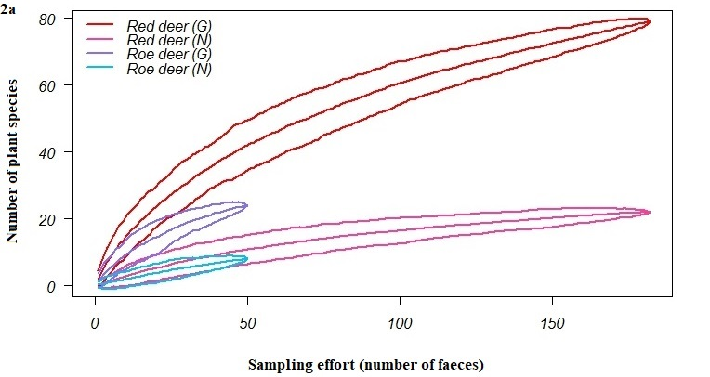
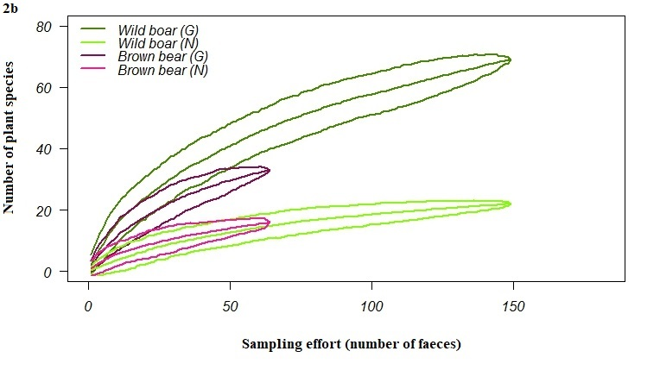

Additional file 2 Species accumulation curves for the plants dispersed by the different animal vectors (total dung mass for red deer: 3640 g; wild boar: 2980 g; brown bear: 1280 g; roe deer: 285.5 g) (a) for herbivores - top panel and (b) omnivores - bottom panel; under greenhouse (G) and natural (N) conditions, based on the Chao 2 estimator with 95% confidence intervals.

