AlloyGPT: End-to-end prediction and design of additively manufacturable alloys using an autoregressive language model
Bo Ni¹, Benjamin Glaser¹, S. Mohadeseh Taheri-Mousavi^{1,2*}
¹ Department of Materials Science and Engineering, Carnegie Mellon University, 5000 Forbes Avenue, Pittsburgh, PA 15213, USA
² Department of Mechanical Engineering, Carnegie Mellon University, 5000 Forbes Avenue, Pittsburgh, PA 15213, USA

*Correspondence: smtaherimousavi@andrew.cmu.edu

SUPPLEMENTARY INFORMATION

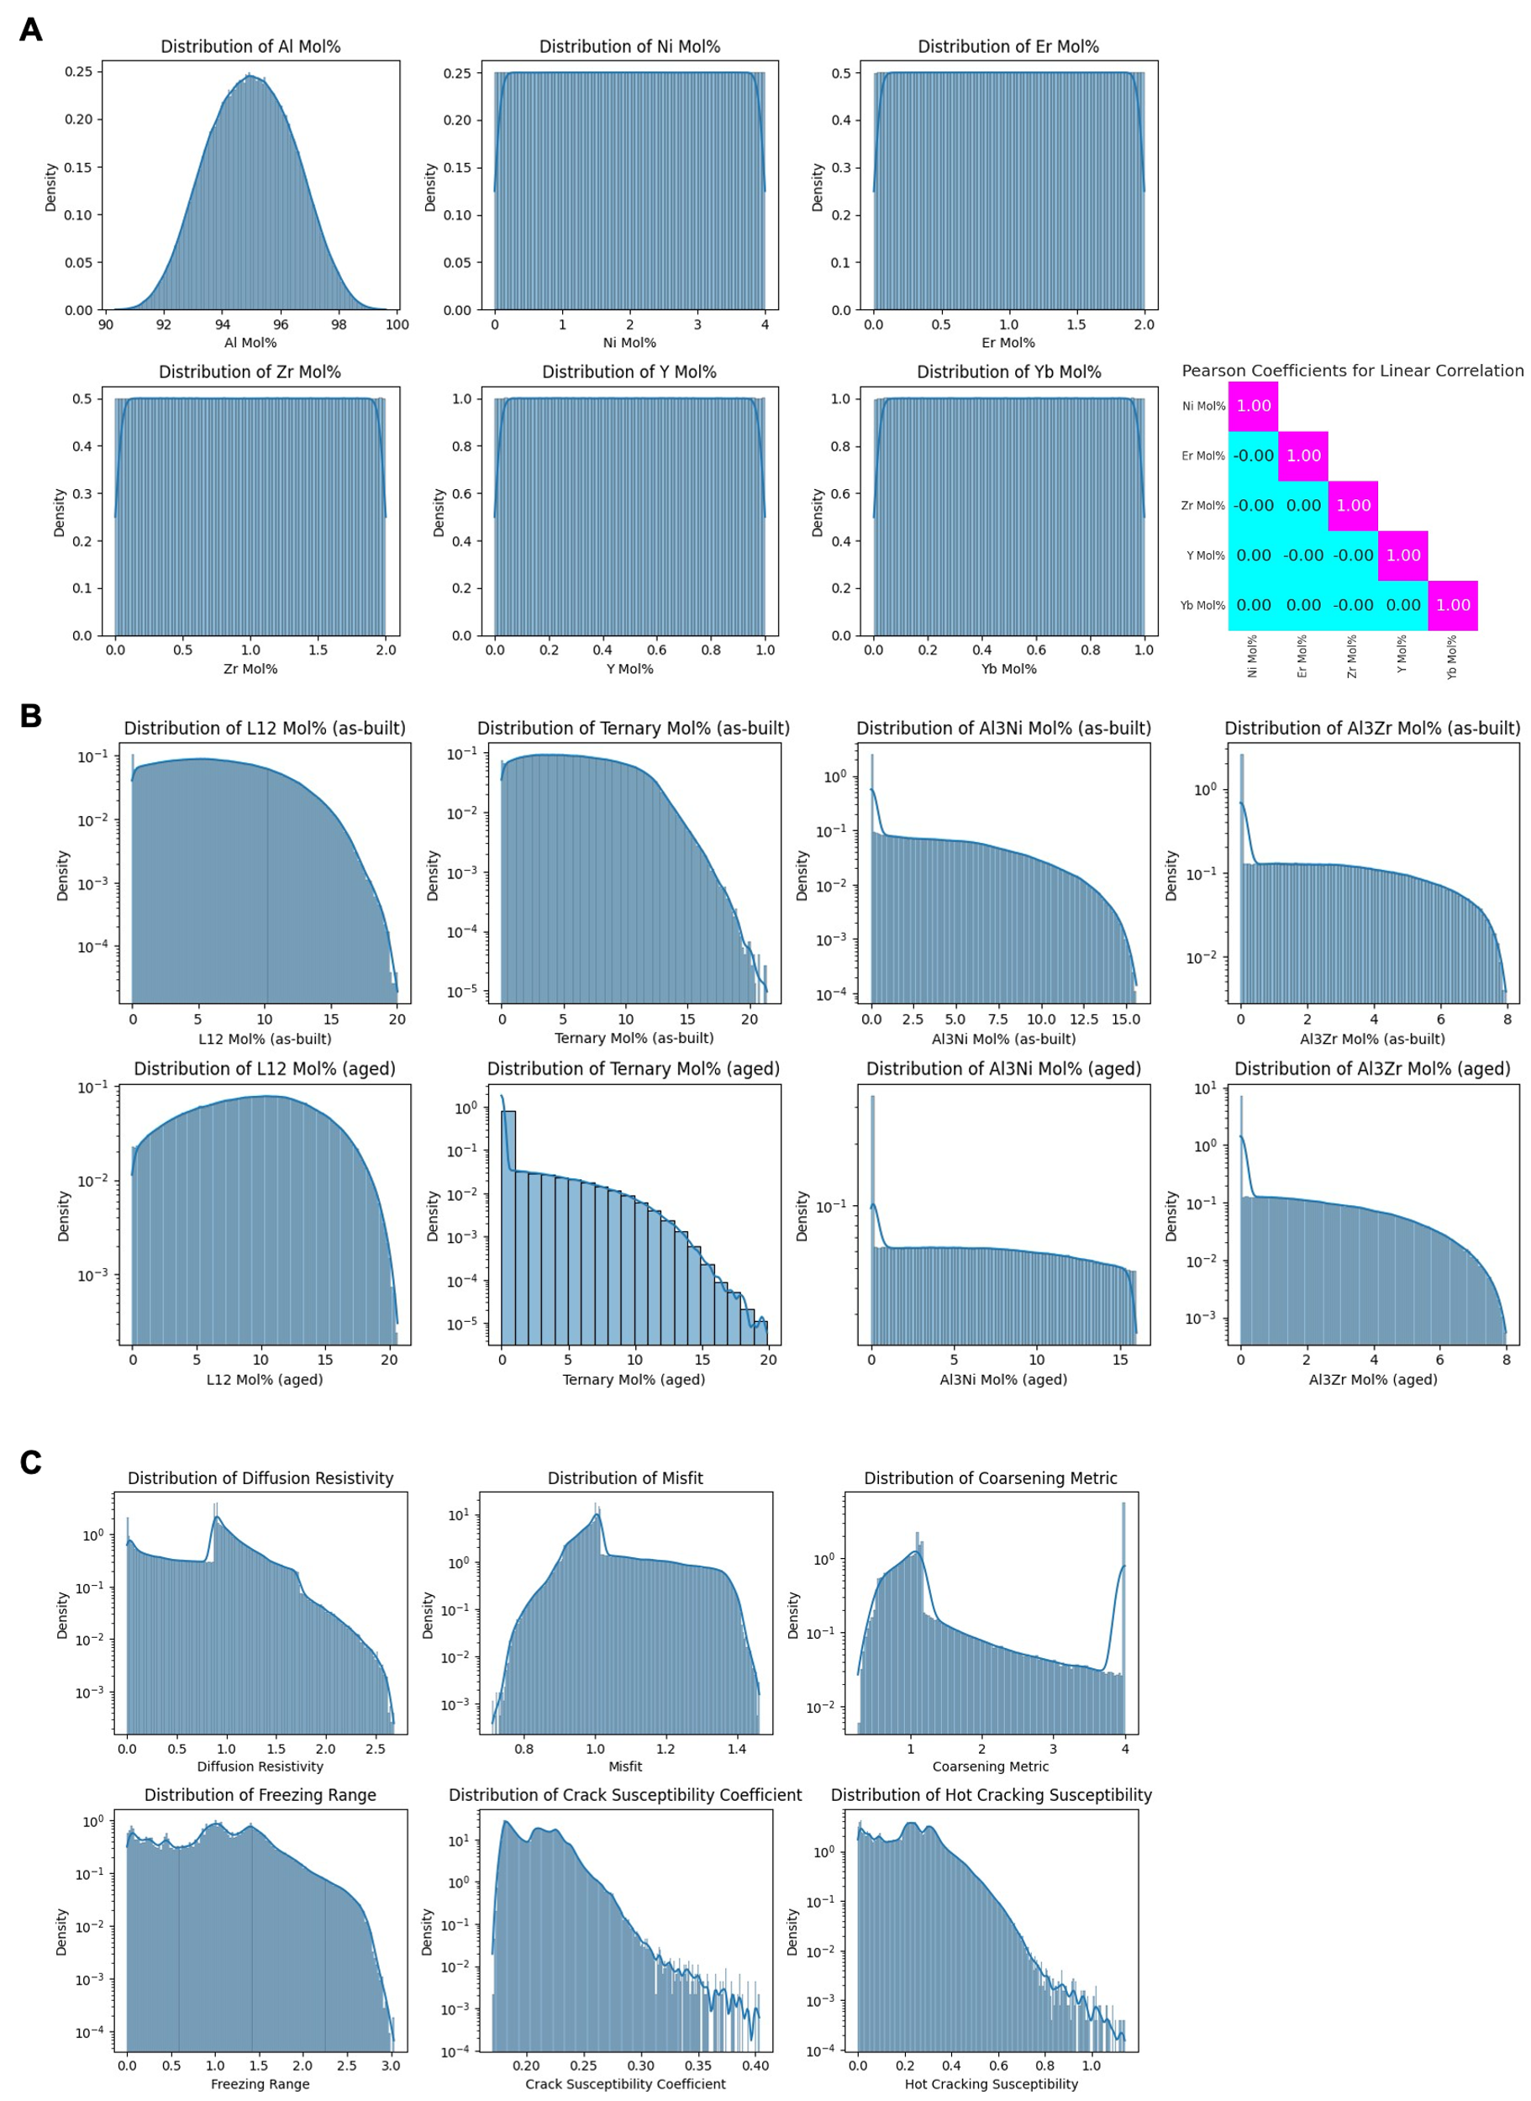
Figure S1. Distributions of the compositions, microstructures and properties collected in the Al-based alloy dataset. (A) Distributions of mol% of Al and the five alloying elements, Ni (0~4%), Er (0~2%), Zr (0~2%), Y (0~1%) and Yb (0~1%). The Pearson coefficients between the alloying elements are zero, indicating the sampled compositions are not correlated. (B) Distributions of four phases, L12, ternary, Al3Zr and Al3Ni, in as-built and aged conditions respectively. (C) Distributions of the properties, including diffusion resistivity, misfit, coarsening rate metric, freezing range, crack susceptibility coefficient (CSC) and hot cracking susceptibility (HCS). The phases and properties are calculated using CALPHAD simulations for 523,599 compositions.
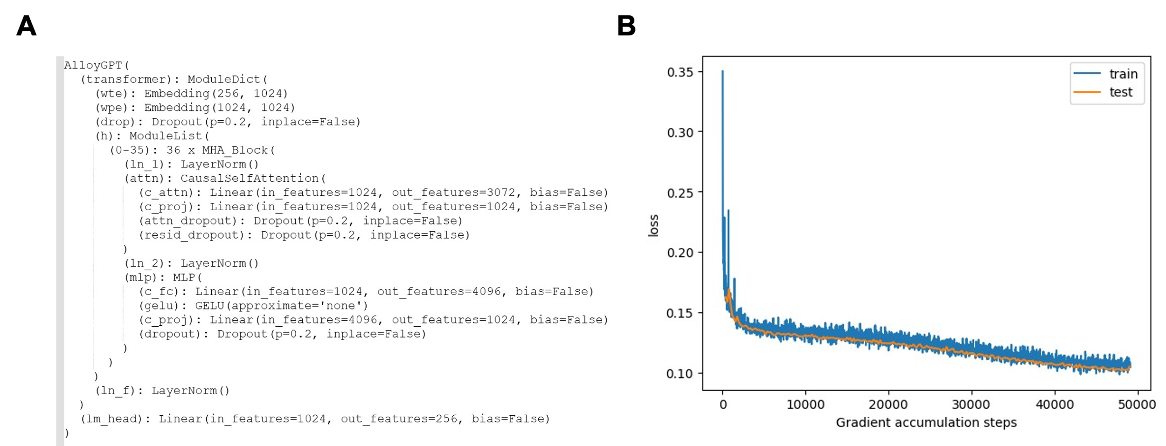
Figure S2. Summary of the architecture (A) and the training history (B) of the AlloyGPT model

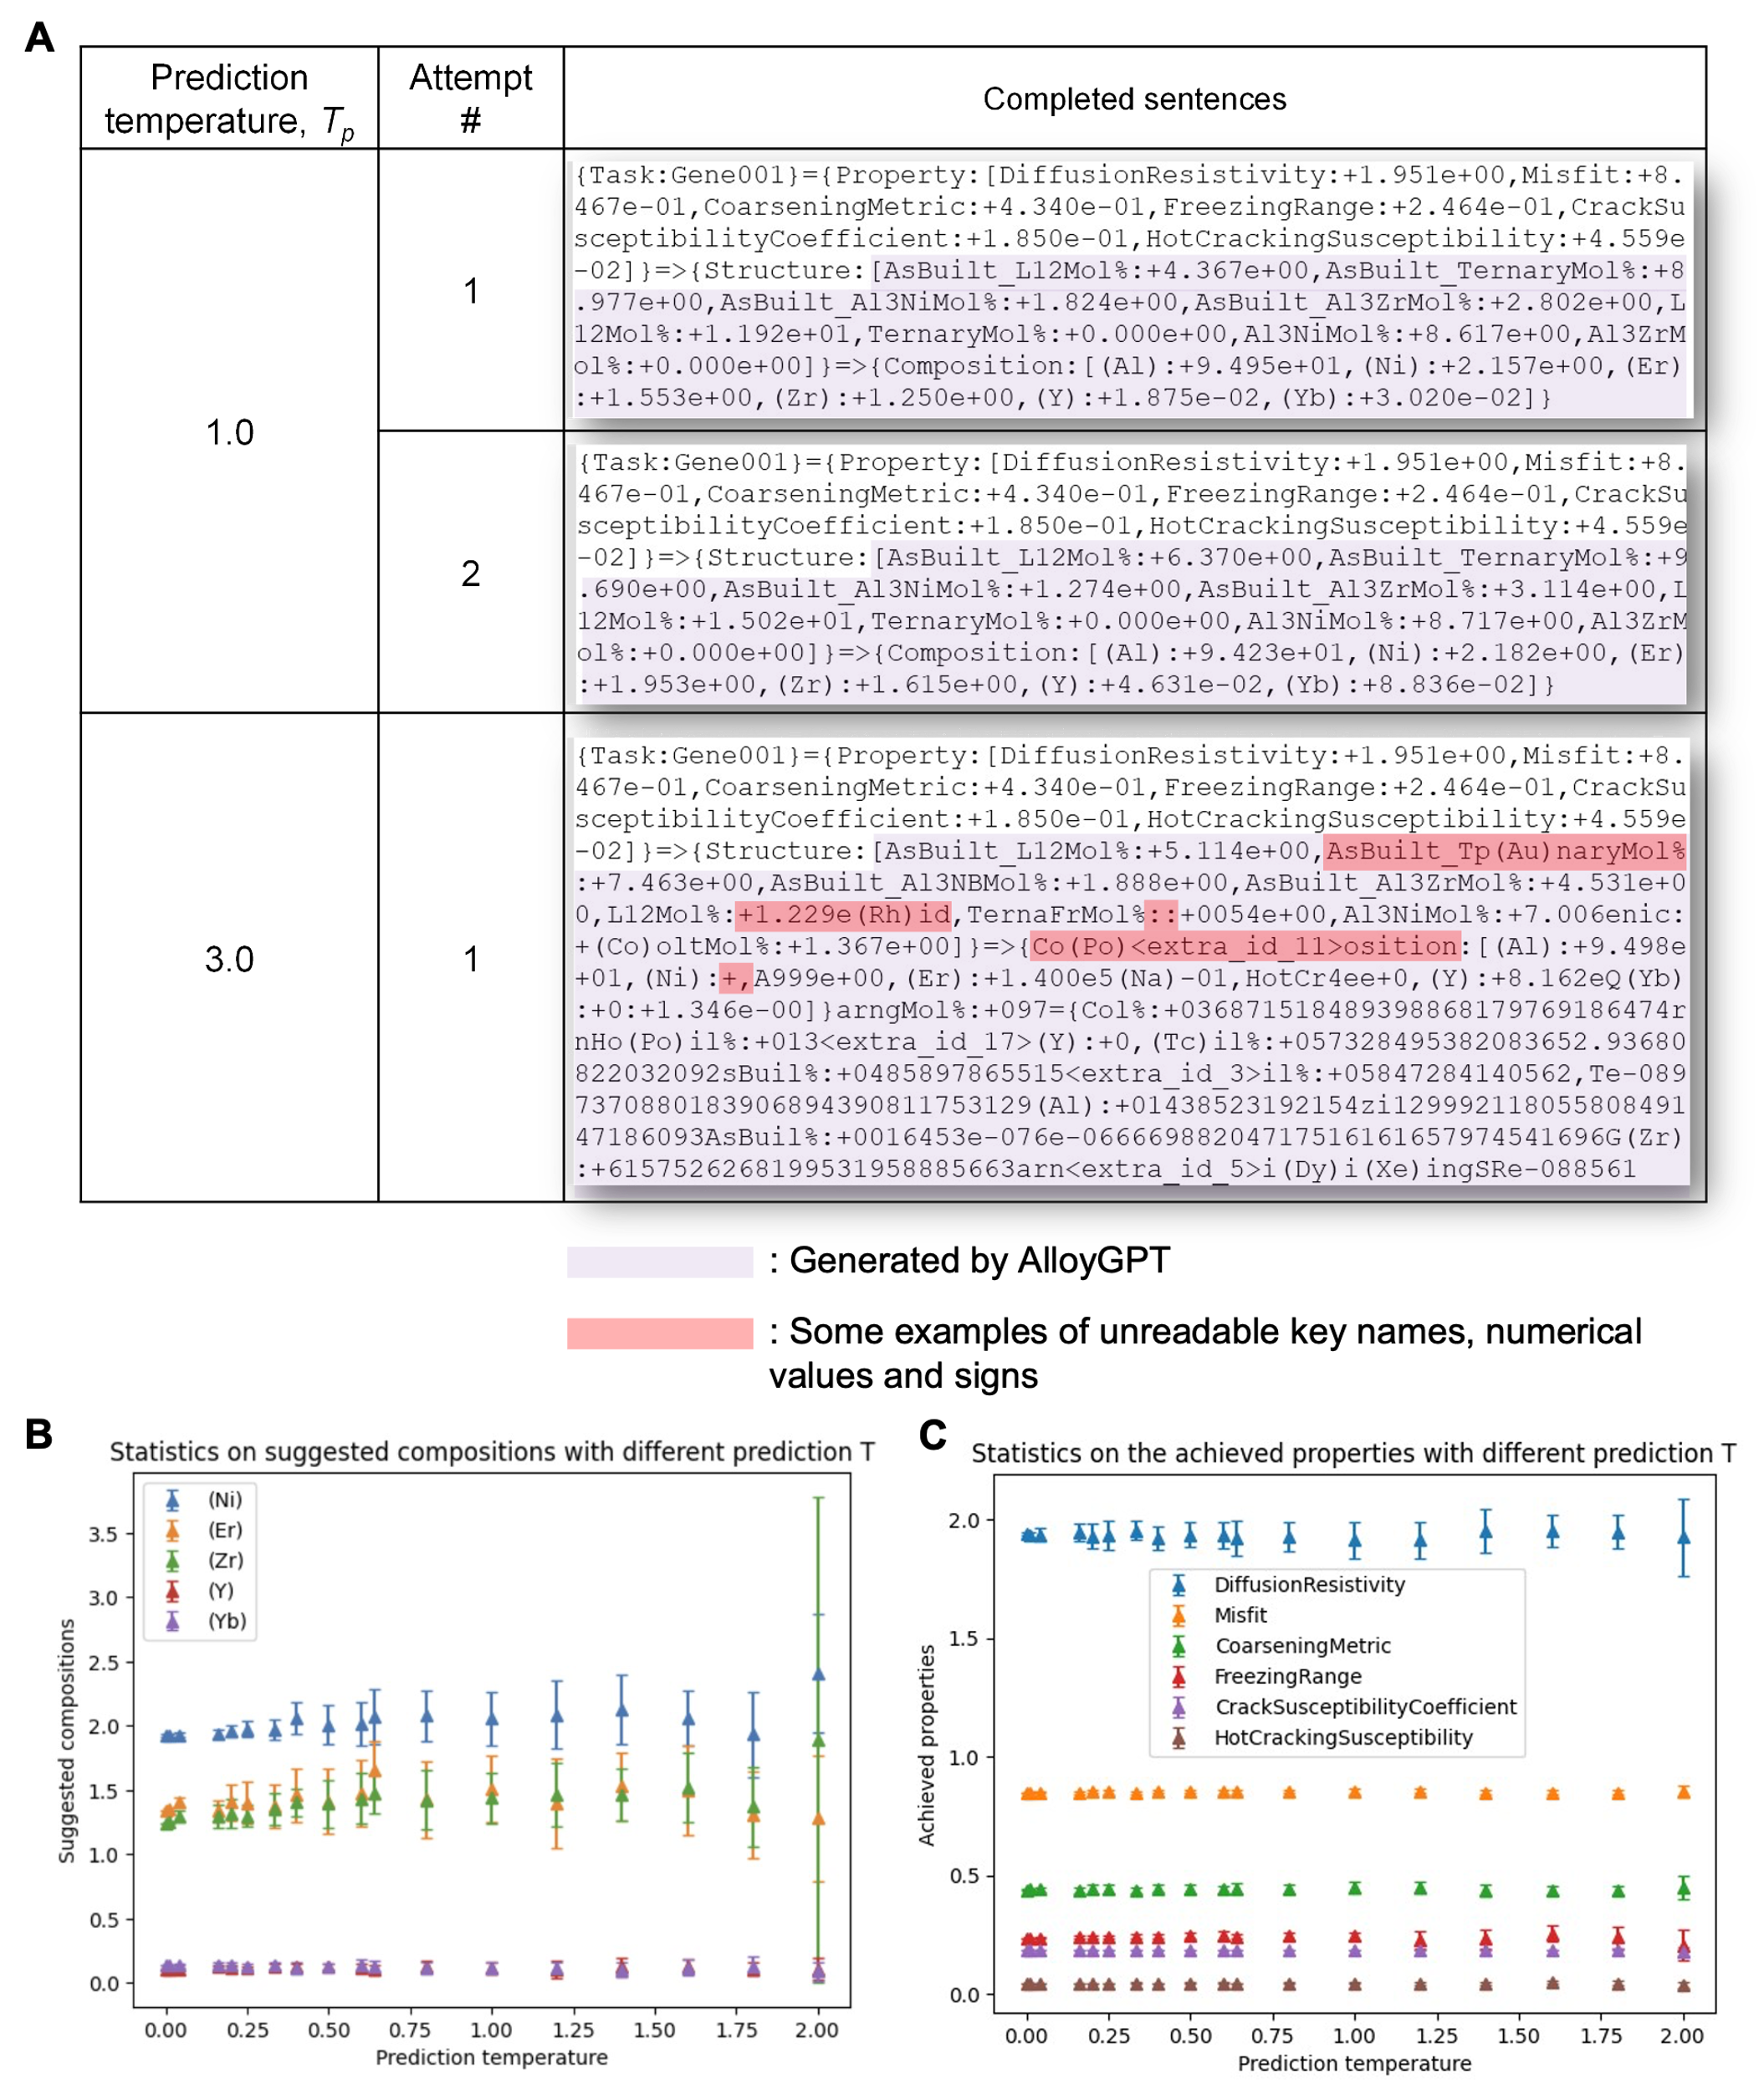
Figure S3. (A) Repeating the same design problem or changing prediction temperature can lead to different results from AlloyGPT. (B) statistics of the suggested alloy compositions with different prediction temperature. (C) statistics of the achieved properties of the compositions designed at different prediction temperature.

R2 values over the test set | C-to-SP predictions | CS-to-P predictions
As-built L1₂ Mol % | 0.997 | --
As-built ternary Mol% | 0.997 | --
As-built Al3Ni Mol% | 0.998 | --
As-built Al3Zr Mol% | 0.997 | --
L1₂ Mol % | 0.998 | --
Ternary Mol% | 0.984 | --
Al3Ni Mol% | 0.997 | --
Al3Zr Mol% | 0.994 | --
Diffusion resistivity | 0.991 | 0.993
Misfit | 0.993 | 0.992
Coarsening metric | 0.992 | 0.995
Freezing range | 0.967 | 0.976
Crack susceptibility coefficient | 0.865 | 0.876
Hot cracking susceptibility | 0.955 | 0.962
Table S1. R2 values of forward prediction tasks (C-to-SP and CS-to-P tasks) by AlloyGPT on the test set as shown in Figure 2D.

