Tree tissues and species traits modulate the microbial methane-cycling communities of the tree phyllosphere
Additional file 1
Marie-Ange Moisan^{1,2}, Vincent Maire^{1,2}, Marie-Josée Morency³, Christine Martineau³
¹Département des Sciences de l’environnement, Université du Québec à Trois-Rivières, 3351 Bd des Forges, Trois-Rivières, QC G8Z 4M3, Canada.
²Centre de Recherche sur les Interactions Bassins Versants - Écosystèmes Aquatiques (RIVE), Université du Québec à Trois-Rivières, 3351 Bd des Forges, Trois-Rivières, QC G8Z 4M3, Canada.
³Canadian Forest Service, Natural Resources Canada, Laurentian Forestry Centre, 1055 Rue du Peps, Québec, QC G1V 4C7, Canada.

Table of content
Table S1. List of methanogen-methanotroph taxa for selection of methane-cycling ASVs and associated reference. 8
Table S2. Results from PERMANOVA testing the effect of flood frequency, tree species, tissue, compartment and block on methane-cycling microbial community composition. 10
Table S3. P-value (holm correction) from ANCOM-BC2 analyses for differentially abundant methanotrophic and methanogenic taxa (genus) between phyllosphere tissues (i.e. leaf, wood and bark). 10
Table S4. P-value and adjusted p-value (Bonferroni correction) from pairwise PERMANOVA for interspecific differences in methane-cycling microbial communities of leaf epiphytes, leaf endophytes, heartwood, sapwood and bark. 11
Table S5. Adjusted p-value (holm correction) from ANCOM-BC2 analyses for differentially abundant methanotrophic and methanogenic taxa (genera) between tree species (Acer saccharinum, Fraxinus nigra, Ulmus americana., Populus spp. and Salix nigra) in leaf epiphytes, leaf endophytes, heartwood, sapwood and bark. 12
Table S6. P-value (non-adjusted) from ANCOM-BC2 analyses for differentially abundant methanotrophic and methanogenic taxa (genera) between tree species (Acer saccharinum, Fraxinus nigra, Ulmus spp., Populus spp. and Salix nigra) in leaf epiphytes, leaf endophytes, heartwood, sapwood and bark. 14
Table S7. Mean trait value for species and statistical results from ANOVA test of species effect. 15
Table S8. Parameters of the linear regression models of methanogens/methanotrophs relative abundance (RA) in leaf epiphytes (models 1.1-1.2), leaf endophytes (model 2), sapwood (models 3.1-3.2), heartwood (models 4.1-4.2) and bark (model 5) according to predictive variables (tree traits, species, block and flood frequency). 16
Table S9. Coefficient table of the MANOVA for the linear regression models 17
Table S10. Relative importance (from relaimpo function) of variables in regression models. 20
Figure S1. Study blocks in the lake St-Pierre floodplain with flooding area. 21
Figure S2. Relative abundance (RA) of methanogenic (a) and methanotrophic (b) genera of sapwood based on 16S rRNA gene sequencing for the tree individuals of species Acer saccharinum (EA), Fraxinus nigra (F), Ulmus americana (O), Populus spp. (P) and Salix nigra (S). 22
Figure S3. Relative abundance (RA) of methanogenic (a) and methanotrophic (b) genera of heartwood based on 16S rRNA gene sequencing for the tree individuals of species Acer saccharinum (EA), Fraxinus nigra (F), Ulmus americana (O), Populus spp. (P) and Salix nigra (S). 23
Figure S4. Relative abundance (RA) of methanogenic (a) and methanotrophic (b) genera of leaf epiphytes based on 16S rRNA gene sequencing for the tree individuals of species Acer saccharinum (EA), Fraxinus nigra (F), Ulmus americana (O), Populus spp. (P) and Salix nigra (S). 24
Figure S5. Relative abundance (RA) of methanotrophic genera of leaf endophytes based on 16S rRNA gene sequencing for the tree individuals of species Acer saccharinum (EA), Fraxinus nigra (F), Ulmus americana (O), Populus spp. (P) and Salix nigra (S). 25
Figure S6. Relative abundance (RA) of methanotrophic genera of bark based on 16S rRNA gene sequencing for the tree individuals of species Acer saccharinum (EA), Fraxinus nigra (F), Ulmus americana (O), Populus spp. (P) and Salix nigra (S). 26
Figure S7. NMDS ordination (Bray-Curtis dissimilarity) of tree microbial communities from 16S rRNA gene sequencing among phyllosphere tissues (bark, leaf and wood) (a) and tree species (b). 27
Figure S8. Relative abundance (RA) of methanogens (a) and methanotrophs (b) between tissues (bark, leaf and wood). 28
Figure S9. Shannon alpha diversity index for methanogenic (a, c) and methanotrophic (b, d) communities between tissues (bark, leaf and wood). 29
Figure S10. Shannon alpha diversity index for methanogenic (a, d, f) and methanotrophic (b, c, e, g, h) communities of leaf epiphytes (a, b), endophytes (c), sapwood (d, e), heartwood (f, g) and bark (h) of the different tree species. 30
Figure S11. Relative abundance (RA) of methanogens (a, d, f) and methanotrophs (b, c, e, g, h) communities of leaf epiphytes (a, b), endophytes (c), sapwood (d, e) heartwood (f, g) and bark (h) of the different tree species. 31
Figure S12. Conditional relationships between the relative abundance (RA) of leaf (epiphyte-epi and endophyte-endo) methanogens-methanotrophs and factors selected in the regression models LM1.1-2 32
Figure S13. Conditional relationships between the relative abundance (RA) of wood (sapwood SW and heartwood HW) methanogens-methanotrophs and factors selected in the regression models LM3.1-4.2 33
Figure S14. Conditional relationship between the relative abundance (RA) of bark methanotrophs and tree species in the regression model LM5. 33
References 34

Table S1. List of methanogen-methanotroph taxa for selection of methane-cycling ASVs and associated reference.
Methanogens | Reference
Methanobacteria | Zhang et al. 2020, Kharitonov et al. 2021
Methanosarcinia | Zhang et al. 2020, Kharitonov et al. 2021
Methanomicrobia | Zhang et al. 2020, Kharitonov et al. 2021
Methanofastidiosa | Zhang et al. 2020, Kharitonov et al. 2021
Methanomassiliicoccales | Zhang et al. 2020, Kharitonov et al. 2021
Methanococcales | Zhang et al. 2020, Kharitonov et al. 2021
Methanopyrales | Zhang et al. 2020, Kharitonov et al. 2021
Methanocellales | Zhang et al. 2020, Kharitonov et al. 2021
Methanotrophs | Reference
Clonothrix | Knief 2015, Ge et al. 2014
Crenothrix | Knief 2015, Ge et al. 2014
Methylacidiphilum | Knief 2015, Ge et al. 2014
Methylacidimicrobium | Knief 2015
Methylobacter | Knief 2015, Ge et al. 2014
Methylocaldum | Knief 2015, Ge et al. 2014
Methylocapsa | Knief 2015, Ge et al. 2014
Methylocella | Knief 2015, Ge et al. 2014
Methylococcus | Knief 2015, Ge et al. 2014
Methylocystis | Knief 2015, Ge et al. 2014
Methyloferula | Knief 2015
Methylogaea | Knief 2015
Methyloglobulus | Knief 2015
Methylohalobius | Knief 2015, Ge et al. 2014
Methylomagnum | Knief 2015
Methylomarinovum | Knief 2015
Methylomarinum | Knief 2015
Methylomicrobium | Knief 2015, Ge et al. 2014
Methylomonas | Knief 2015, Ge et al. 2014
Methyloparacoccus | Knief 2015
Methylosarcina | Knief 2015, Ge et al. 2014
Methylosinus | Knief 2015, Ge et al. 2014
Methylosoma | Knief 2015, Ge et al. 2014
Methylosphaera | Knief 2015, Ge et al. 2014
Methylothermus | Knief 2015, Ge et al. 2014
Methylomirabilis | Knief 2015
Methyloceanibacter | Vekeman et al. 2016
Methylogellaceae | Begmatov 2021
plW-20 | de Groot 2024

Table S2. Results from PERMANOVA testing the effect of flood frequency, tree species, tissue, compartment and block on methane-cycling microbial community composition.
Factors |  | Df | SumOfSqs | F | Significance
Flood frequency |  | 1 | 0.65 | 2.99 | **
Species |  | 4 | 3.52 | 4.04 | ***
Tissue |  | 2 | 29.69 | 68.12 | ***
Compartment |  | 2 | 0.59 | 1.36 | ns
Block |  | 5 | 1.90 | 1.75 | ***
Flood frequency|Block |  | 5 | 1.66 | 1.53 | *
Species: Flood frequency |  | 4 | 0.97 | 1.11 | ns
Species:Compartment |  | 16 | 6.02 | 1.73 | ***
Overall | AIC: -277.8 R²= 0.54
p-value < 0.001: ***; p-value < 0.01: **; p-value < 0.05: *; p-value < 0.1: . ; p-value > 0.1: ns

Table S3. P-value (holm correction) from ANCOM-BC2 analyses for differentially abundant methanotrophic and methanogenic taxa (genus) between phyllosphere tissues (i.e. leaf, wood and bark).
 | Reference: LEAF |  | Reference: BARK
 | Wood | Bark | Leaf | Wood
Methanobacterium | 3.10E-28*** | 1.00 | 1.00 | 5.28E-24***
Methanomassiliicoccus | 1.00 | 1.00 | 1.00 | 0.71
Methylobacterium-Methylorubrum | 8.22E-23*** | 5.64E-09*** | 1.13E-08*** | 1.79E-05***
Methylocella | 1.00 | 3.43E-03** | 3.65E-03** | 0.01*
Methylorosula | 3.37E-08*** | 2.67E-03** | 2.82E-03** | 0.22
p-value < 0.001: ***; p-value < 0.01: **; p-value < 0.05: *; p-value < 0.1: . ; p-value > 0.1: ns
Values in red did not pass the sensitivity analysis of ANCOM-BC2 and likely represent false positives.

Table S4. P-value and adjusted p-value (Bonferroni correction) from pairwise PERMANOVA for interspecific differences in methane-cycling microbial communities of leaf epiphytes, leaf endophytes, heartwood, sapwood and bark.
 | Leaf epiphytes |  | Leaf endophytes |  | Sapwood |  | Heartwood |  | Bark
Tree species | p | p.adj | p | p.adj | p | p.adj | p | p.adj | p | p.adj
Acer vs Fraxinus | 0.006 | 0.060 | 0.026 | 0.260 | 0.501 | 1.000 | 0.436 | 1.000 | 0.001 | 0.010*
Acer vs Ulmus | 0.108 | 1.000 | 0.187 | 1.000 | 0.952 | 1.000 | 0.790 | 1.000 | 0.001 | 0.010*
Acer vs Populus | 0.026 | 0.260 | 0.114 | 1.000 | 0.374 | 1.000 | 0.018 | 0.180 | 0.001 | 0.010*
Acer vs Salix | 0.018 | 0.180 | 0.688 | 1.000 | 0.738 | 1.000 | 0.088 | 0.880 | 0.008 | 0.080
Fraxinus vs Ulmus | 0.009 | 0.090 | 0.002 | 0.020* | 0.405 | 1.000 | 0.169 | 1.000 | 0.030 | 0.300
Fraxinus vs Populus | 0.084 | 0.840 | 0.407 | 1.000 | 0.598 | 1.000 | 0.009 | 0.090 | 0.471 | 1.000
Fraxinus vs Salix | 0.080 | 0.800 | 0.152 | 1.000 | 0.964 | 1.000 | 0.035 | 0.350 | 0.002 | 0.020*
Ulmus vs Populus | 0.024 | 0.240 | 0.004 | 0.040* | 0.053 | 0.530 | 0.098 | 0.980 | 0.005 | 0.050*
Ulmus vs Salix | 0.075 | 0.750 | 0.260 | 1.000 | 0.558 | 1.000 | 0.361 | 1.000 | 0.008 | 0.080
Populus vs Salix | 0.229 | 1.000 | 0.600 | 1.000 | 0.810 | 1.000 | 0.197 | 1.000 | 0.001 | 0.010*
Asterix indicates significant difference (p ≤ 0.05).

Table S5. Adjusted p-value (holm correction) from ANCOM-BC2 analyses for differentially abundant methanotrophic and methanogenic taxa (genera) between tree species (Acer saccharinum, Fraxinus nigra, Ulmus americana., Populus spp. and Salix nigra) in leaf epiphytes, leaf endophytes, heartwood, sapwood and bark.
Epiphytes
 | Reference group: Fraxinus |  |  |  | Reference group: Populus |  |  |  | Reference group: Acer |  |  |  | Reference group: Ulmus
 | Acer | Populus | Salix | Ulmus | Fraxinus | Salix | Ulmus | Acer | Fraxinus | Salix | Ulmus | Populus | Acer | Fraxinus | Salix | Populus
Methanobacterium | 0.67 | 0.84 | 0.38 | 1.00 | 0.90 | 0.15 | 1.00 | 1.00 | 0.69 | 0.16 | 1.00 | 1.00 | 1.00 | 1.00 | 0.56 | 1.00
Methanosarcina | 0.66 | 0.37 | 1.00 | 0.91 | 0.49 | 0.85 | 1.00 | 1.00 | 0.69 | 1.00 | 1.00 | 1.00 | 1.00 | 1.00 | 1.00 | 1.00
Methylobacterium-Methylorubrum | 0.66 | 0.84 | 1.00 | 1.00 | 0.90 | 1.00 | 1.00 | 1.00 | 0.69 | 1.00 | 1.00 | 1.00 | 1.00 | 1.00 | 1.00 | 1.00
Methylocella | 0.24 | 0.37 | 1.00 | 1.00 | 0.49 | 1.00 | 0.18 | 0.01 | 0.26 | 0.02 | 1.00 | 4.40E-03 | 1.00 | 1.00 | 0.48 | 0.15
Methylorosula | 0.65 | 0.37 | 0.85 | 1.00 | 0.49 | 0.15 | 1.00 | 1.00 | 0.69 | 0.15 | 1.00 | 1.00 | 1.00 | 1.00 | 0.48 | 1.00
Crenothrix | 0.66 | 0.37 | 1.00 | 1.00 | 0.49 | 1.00 | 1.00 | 1.00 | 0.69 | 1.00 | 1.00 | 1.00 | 1.00 | 1.00 | 1.00 | 1.00
Endophytes
Methylobacterium-Methylorubrum | 0.01 | 0.25 | 0.24 | 1.00 | 0.35 | 1.00 | 0.46 | 0.86 | 0.01 | 1.00 | 0.47 | 1.00 | 0.37 | 1.00 | 0.47 | 0.68
Methylocella | 0.83 | 1.00 | 0.70 | 1.00 | 1.00 | 1.00 | 0.62 | 0.83 | 0.85 | 1.00 | 0.47 | 1.00 | 0.52 | 1.00 | 0.55 | 1.00
Heartwood
Methanobacterium | 1.00 | 0.86 | 1.00 | 1.00 | 0.62 | 1.00 | 1.00 | 0.59 | 1.00 | 1.00 | 1.00 | 0.81 | 1.00 | 1.00 | 1.00 | 1.00
Methanosarcina | 1.00 | 0.86 | 1.00 | 1.00 | 1.00 | 1.00 | 1.00 | 1.00 | 0.97 | 1.00 | 1.00 | 1.00 | 1.00 | 1.00 | 1.00 | 1.00
Methanomassiliicoccus | 1.00 | 0.44 | 1.00 | 1.00 | 0.20 | 0.82 | 0.25 | 0.22 | 1.00 | 1.00 | 1.00 | 0.24 | 1.00 | 1.00 | 1.00 | 0.54
Candidatus Methanogranum | 1.00 | 0.44 | 1.00 | 1.00 | 1.00 | 0.82 | 1.00 | 0.35 | 1.00 | 1.00 | 1.00 | 0.32 | 1.00 | 1.00 | 1.00 | 0.54
Methylobacterium-Methylorubrum | 1.00 | 0.86 | 1.00 | 1.00 | 1.00 | 1.00 | 1.00 | 1.00 | 1.00 | 1.00 | 1.00 | 1.00 | 1.00 | 1.00 | 1.00 | 1.00
Sapwood
Methanobacterium | 1 | 1 | 1 | 1 | 1 | 1 | 1 | 1 | 1 | 1 | 1 | 1 | 1.00 | 1.00 | 0.72 | 1.00
Methanosarcina | 1 | 1 | 1 | 1 | 1 | 1 | 1 | 1 | 1 | 1 | 1 | 1 | 1.00 | 1.00 | 0.72 | 1.00
Methanomassiliicoccus | 1 | 1 | 1 | 1 | 1 | 1 | 1 | 1 | 1 | 1 | 1 | 1 | 1.00 | 1.00 | 0.72 | 1.00
Methylobacterium-Methylorubrum | 1 | 1 | 1 | 1 | 1 | 1 | 0.920522 | 1 | 1 | 1 | 1 | 1 | 1.00 | 1.00 | 0.72 | 0.91
Heartwood
Methanobacterium | 1.00 | 0.86 | 1.00 | 1.00 | 0.62 | 1.00 | 1.00 | 0.59 | 1.00 | 1.00 | 1.00 | 0.81 | 1.00 | 1.00 | 1.00 | 1.00
Methanosarcina | 1.00 | 0.86 | 1.00 | 1.00 | 1.00 | 1.00 | 1.00 | 1.00 | 0.97 | 1.00 | 1.00 | 1.00 | 1.00 | 1.00 | 1.00 | 1.00
Methanomassiliicoccus | 1.00 | 0.44 | 1.00 | 1.00 | 0.20 | 0.82 | 0.25 | 0.22 | 1.00 | 1.00 | 1.00 | 0.24 | 1.00 | 1.00 | 1.00 | 0.54
Candidatus Methanogranum | 1.00 | 0.44 | 1.00 | 1.00 | 1.00 | 0.82 | 1.00 | 0.35 | 1.00 | 1.00 | 1.00 | 0.32 | 1.00 | 1.00 | 1.00 | 0.54
Methylobacterium-Methylorubrum | 1.00 | 0.86 | 1.00 | 1.00 | 1.00 | 1.00 | 1.00 | 1.00 | 1.00 | 1.00 | 1.00 | 1.00 | 1.00 | 1.00 | 1.00 | 1.00
Bark
Methylobacterium-Methylorubrum | 0.43 | 0.90 | 0.83 | 1.00 | 0.90 | 0.19 | 1.00 | 0.13 | 0.43 | 1.00 | 1.00 | 0.08 | 1.00 | 1.00 | 0.48 | 1.00
Methylocella | 0.35 | 0.90 | 0.83 | 1.00 | 0.90 | 0.72 | 1.00 | 0.06 | 0.35 | 0.05 | 1.00 | 0.05 | 1.00 | 0.20 | 0.05 | 0.04
Methylorosula | 0.96 | 0.90 | 0.83 | 1.00 | 0.90 | 0.65 | 1.00 | 0.49 | 0.96 | 1.00 | 0.62 | 0.54 | 0.82 | 1.00 | 0.48 | 1.00
Values in bold indicate significant difference (p ≤ 0.05). Values in red did not pass the sensitivity analysis of ANCOM-BC2 and likely represent false positives.

Table S6. P-value (non-adjusted) from ANCOM-BC2 analyses for differentially abundant methanotrophic and methanogenic taxa (genera) between tree species (Acer saccharinum, Fraxinus nigra, Ulmus spp., Populus spp. and Salix nigra) in leaf epiphytes, leaf endophytes, heartwood, sapwood and bark.
Epiphytes
 | Reference group: Fraxinus |  |  |  | Reference group: Populus |  |  |  | Reference group: Acer |  |  |  |  | Reference group: Ulmus
 | Acer | Populus | Salix | Ulmus | Fraxinus | Salix | Ulmus | Acer | Fraxinus | Salix | Ulmus | Populus | Acer |  | Fraxinus | Salix | Populus
Methanobacterium | 0.67 | 0.42 | 0.06 | 0.84 | 0.45 | 0.03 | 0.35 | 0.70 | 0.69 | 0.04 | 0.61 | 0.65 | 0.67 |  | 0.88 | 0.14 | 0.34
Methanosarcina | 0.17 | 0.06 | 0.46 | 0.15 | 0.08 | 0.21 | 0.44 | 0.47 | 0.18 | 0.49 | 0.92 | 0.42 | 0.86 |  | 0.17 | 0.46 | 0.43
Methylobacterium-Methylorubrum | 0.26 | 0.78 | 0.80 | 0.54 | 0.84 | 0.86 | 0.55 | 0.38 | 0.26 | 0.38 | 0.54 | 0.33 | 0.44 |  | 0.60 | 0.80 | 0.55
Methylocella | 0.04 | 0.07 | 0.32 | 0.42 | 0.09 | 0.51 | 0.03 | 1.01E-04 | 0.04 | 4.14E-03 | 0.22 | 7.33E-04 | 0.28 |  | 0.41 | 0.08 | 0.03
Methylorosula | 0.13 | 0.07 | 0.17 | 0.42 | 0.09 | 0.02 | 0.22 | 0.64 | 0.14 | 0.03 | 0.41 | 0.59 | 0.47 |  | 0.43 | 0.08 | 0.20
Crenothrix | 0.17 | 0.11 | 1.00 | 0.42 | 0.14 | 1.00 | 0.25 | 0.66 | 0.17 | 1.00 | 0.41 | 0.61 | 0.46 |  | 0.43 | 1.00 | 0.24
Endophytes
Methylobacterium-Methylorubrum | 3.96E-03 | 0.12 | 0.12 | 0.76 | 0.18 | 0.69 | 0.23 | 0.86 | 0.01 | 0.85 | 0.24 | 0.66 | 0.19 |  | 0.78 | 0.24 | 0.34
Methylocella | 0.83 | 1.00 | 0.70 | 0.59 | 1.00 | 0.74 | 0.62 | 0.41 | 0.85 | 0.55 | 0.42 | 1.00 | 0.52 |  | 0.62 | 0.55 | 1.00
Sapwood
Methanobacterium | 0.93 | 0.70 | 0.38 | 0.67 | 0.58 | 0.93 | 0.45 | 0.60 | 0.93 | 0.96 | 0.88 | 0.68 | 0.94 |  | 0.65 | 0.18 | 0.45
Methanosarcina | 1.00 | 0.84 | 0.54 | 0.94 | 1.00 | 0.98 | 0.79 | 0.85 | 1.00 | 0.97 | 0.55 | 0.91 | 0.59 |  | 1.00 | 0.58 | 0.79
Methanomassiliicoccus | 0.62 | 0.70 | 0.78 | 0.92 | 0.58 | 0.55 | 0.86 | 0.40 | 0.62 | 0.86 | 0.77 | 0.45 | 0.82 |  | 0.93 | 0.24 | 0.86
Methylobacterium-Methylorubrum | 0.88 | 0.56 | 0.78 | 0.98 | 0.68 | 0.77 | 0.23 | 0.61 | 0.88 | 0.63 | 0.62 | 0.53 | 0.67 |  | 0.97 | 0.21 | 0.23
Heartwood
Methanobacterium | 0.67 | 0.35 | 0.21 | 0.45 | 0.15 | 0.69 | 0.39 | 0.20 | 0.66 | 0.39 | 0.65 | 0.27 | 0.65 |  | 0.38 | 0.50 | 0.69
Methanosarcina | 0.21 | 0.29 | 0.32 | 1.00 | 0.55 | 0.84 | 1.00 | 0.57 | 0.19 | 0.96 | 1.00 | 0.67 | 1.00 |  | 0.25 | 0.80 | 0.85
Methanomassiliicoccus | 0.92 | 0.09 | 0.97 | 0.91 | 0.04 | 0.20 | 0.05 | 0.04 | 0.91 | 0.90 | 0.95 | 0.05 | 0.93 |  | 0.81 | 0.96 | 0.11
Candidatus Methanogranum | 1.00 | 0.11 | 0.99 | 1.00 | 1.00 | 0.16 | 1.00 | 0.09 | 1.00 | 0.97 | 1.00 | 0.08 | 1.00 |  | 1.00 | 0.88 | 0.11
Methylobacterium-Methylorubrum | 0.57 | 0.58 | 0.99 | 0.61 | 0.91 | 0.49 | 0.76 | 0.66 | 0.56 | 0.60 | 0.90 | 0.79 | 0.89 |  | 0.71 | 0.55 | 0.96
Bark
Methylobacterium-Methylorubrum | 0.22 | 0.30 | 0.34 | 0.73 | 0.30 | 0.06 | 0.53 | 0.06 | 0.22 | 0.79 | 0.76 | 0.04 | 0.68 |  | 0.82 | 0.38 | 0.55
Methylocella | 0.12 | 0.38 | 0.28 | 1.00 | 0.41 | 0.72 | 1.00 | 0.02 | 0.12 | 0.02 | 1.00 | 0.02 | 1.00 |  | 0.07 | 0.02 | 0.01
Methylorosula | 0.96 | 0.68 | 0.47 | 0.69 | 0.71 | 0.32 | 0.99 | 0.49 | 0.96 | 0.68 | 0.21 | 0.54 | 0.27 |  | 0.66 | 0.24 | 1.00
Values in bold indicate significant difference (p ≤ 0.05). Values in red did not pass the sensitivity analysis of ANCOM-BC2 and likely represent false positives.

Table S7. Mean trait value for species and statistical results from ANOVA tests for species effect.
 | Acer | Fraxinus | Populus | Salix | Ulmus | Df | Sum Sq | F | Significance
SW D (g cm⁻³) | 0.56^{ab} | 0.71^{b} | 0.43ª | 0.40ª | 0.68^{b} | 4 | 0.78 | 8.18 | ***
HW D (g cm⁻³) | 0.53^{ab} | 0.62^{bc} | 0.48^{ab} | 0.43ª | 0.70^{c} | 4 | 0.44 | 8.99 | ***
SW H (%) | 29.40^{ab} | 25.12ª | 38.92^{b} | 33.64^{ab} | 35.16^{ab} | 4 | 1306.00 | 4.52 | **
HW H (%) | 36.83^{b} | 24.91ª | 56.18^{d} | 42.24^{cd} | 48.52^{bc} | 4 | 5837.00 | 19.90 | ***
SW pH | 6.66^{ab} | 6.10ª | 6.61^{ab} | 7.00^{b} | 7.04^{b} | 4 | 5.78 | 5.36 | **
HW pH | 6.61^{b} | 4.77ª | 7.70^{c} | 6.42^{b} | 7.45^{bc} | 4 | 54.00 | 17.69 | ***
BK D (g cm⁻³) | 0.65^{b} | 0.38ª | 0.49^{ab} | 0.28ª | 0.33ª | 4 | 0.98 | 9.14 | ***
BK H (%) | 21.18ª | 26.36ª | 23.24ª | 32.79ª | 23.49ª | 4 | 742.00 | 0.94 | ns
BK pH | 5.51ª | 6.12^{bc} | 5.76^{ab} | 6.36^{c} | 6.51^{c} | 4 | 7.30 | 10.69 | ***
Leaf H (%) | 62.35ª | 68.42^{b} | 65.90^{ab} | 66.22^{ab} | 67.01^{ab} | 4 | 241.70 | 2.84 | *
Leaf pH | 4.28ª | 5.75^{c} | 5.51^{bc} | 5.25^{b} | 5.76^{c} | 4 | 17.77 | 99.27 | ***
LMA (g m⁻²) | 5.06E-03ª | 6.58E-03ª | 7.30E-03ª | 5.06E-03ª | 4.81E-03ª | 4 | 5.02E-05 | 2.17 | .
SW= Sapwood, HW= Heartwood, BK= Bark, D= Density, H= Humidity, LMA= Leaf mass per area
Letters in superscript of trait values indicate which species differ significantly according to the post-hoc comparisons.
Significance: p-value < 0.001: ***; p-value < 0.01: **; p-value < 0.05: *; p-value < 0.1: . ; p-value > 0.1: ns

Table S8. Parameters of the linear regression models of methanogens/methanotrophs relative abundance (RA) in leaf epiphytes (models 1.1-1.2), leaf endophytes (model 2), sapwood (models 3.1-3.2), heartwood (models 4.1-4.2) and bark (model 5) according to predictive variables (tree traits, species, block and flood frequency).
ID | Model description | Considered variables | Selected model | n | df | Res. SE | P-value | R2adj | AIC
1.1 | Leaf epiphyte methanogens RA | Flood frequency (HFF/LFF), Block, Species, DBH, LF_H, LF_pH, LMA | Block + Species + DBH +LMA | 48 | 36 | 0.001 | 0.02 | 0.27 | -524.7
1.2 | Leaf epiphyte methanotrophs RA | Flood frequency (HFF/LFF), Block, Species, DBH, LF_H, LF_pH, LMA | LF_pH | 50 | 48 | 0.056 | 0.04 | 0.06 | -141.3
2 | Leaf endophyte methanotrophs RA | Flood frequency (HFF/LFF), Block, Species, DBH, LF_H, LF_pH, LMA | Block + Species + DBH + LF_H + LMA | 32 | 19 | 0.056 | 0.02 | 0.41 | -58.0
3.1 | Sapwood methanogens RA | Flood frequency (HFF/LFF), Block, Species, DBH, SW_H, SW_pH, SW_D | Species + DBH + SW_H | 30 | 23 | 0.089 | 0.10 | 0.22 | -45.2
3.2 | Sapwood methanotrophs RA | Flood frequency (HFF/LFF), Block, Species, DBH, SW_H, SW_pH, SW_D | SW_H | 29 | 27 | 0.006 | 0.13 | 0.03 | -208.9
4.1 | Heartwood methanogens RA | Flood frequency (HFF/LFF), Block, Species, DBH, HW_pH, HW_H, HW_D | Flood frequency (HFF/LFF) + HW_pH + DBH + HW_H | 42 | 37 | 0.074 | 2.77E-05 | 0.45 | -90.8
4.2 | Heartwood methanotrophs RA | Flood frequency (HFF/LFF), Block, Species, DBH, HW_pH, HW_H, HW_D | Block + Species + HW_pH + DBH + HW_H | 41 | 28 | 0.007 | 2.00E-03 | 0.45 | -260.0
5 | Bark methanotrophs RA | Flood frequency (HFF/LFF), Block, Species, DBH, BK_H, BK_pH, BK_D | Species + BK_pH | 49 | 43 | 0.004 | 2.74E-05 | 0.41 | -384.5
HFF= High flood frequency, LFF=Low flood frequency, DBH= Diameter at breast height, LF= Leaf, H= Humidity, LMA= Leaf mass per area, SW= Sapwood, D=Density, HW= Heartwood, BK= Bark

Table S9. Coefficient table of the MANOVA for the linear regression models
LM1.1- Leaf epiphyte methanogens RA
 | Estimate | Std.Error | t | P-value | Significance
(Intercept) | 2.31E-04 | 7.42E-04 | 0.31 | 0.76
Block Dupa | -1.52E-04 | 4.52E-04 | -0.34 | 0.74
Block Maskinonge | 8.39E-05 | 4.56E-04 | 0.18 | 0.85
Block Nicolet | 8.23E-04 | 4.59E-04 | 1.79 | 0.08 | .
Block Pierreville | 7.91E-04 | 4.33E-04 | 1.83 | 0.08 | .
Block Yamachiche | -4.38E-05 | 4.71E-04 | -0.09 | 0.93
Species Fraxinus | -8.22E-04 | 3.62E-04 | -2.27 | 0.03 | *
Species Populus | -3.64E-04 | 3.97E-04 | -0.92 | 0.37
Species Salix | -3.50E-04 | 4.00E-04 | -0.88 | 0.39
Species Ulmus | -1.09E-05 | 4.07E-04 | -0.03 | 0.98
DBH | -2.65E-05 | 1.18E-05 | -2.26 | 0.03 | *
LMA | 0.18 | 0.06 | 3.08 | 3.93E-03 | **
LM1.2-Leaf epiphyte methanotrophs RA
(Intercept) | -0.06 | 0.07 | -0.84 | 0.40
LF_pH | 0.03 | 0.01 | 2.13 | 0.04 | *
LM2-Leaf endophyte methanotrophs RA
(Intercept) | 0.60 | 0.20 | 2.95 | 0.01 | **
Block Dupa | 0.08 | 0.04 | 2.19 | 0.04 | *
Block Maskinonge | -0.01 | 0.04 | -0.31 | 0.76
Block Nicolet | 0.03 | 0.04 | 0.74 | 0.47
Block Pierreville | 0.08 | 0.04 | 1.75 | 0.10 | .
Block Yamachiche | -0.02 | 0.04 | -0.41 | 0.69
Species Fraxinus | 0.12 | 0.04 | 2.83 | 0.01 | *
Species Populus | 0.15 | 0.05 | 2.84 | 0.01 | *
Species Salix | 0.14 | 0.05 | 2.81 | 0.01 | *
Species Ulmus | 0.01 | 0.04 | 0.15 | 0.88
DBH | 0.00 | 1.34E-03 | -2.21 | 0.04 | *
LF_H | -0.01 | 2.77E-03 | -2.37 | 0.03 | *
LMA | -9.62 | 7.33 | -1.31 | 0.20
LM3.1-Sapwood methanogens RA
(Intercept) | 0.13 | 0.07 | 1.78 | 0.09 | .
Species Fraxinus | -0.03 | 0.06 | -0.49 | 0.63
Species Populus | -0.03 | 0.07 | -0.49 | 0.63
Species Salix | -0.02 | 0.07 | -0.29 | 0.77
Species Ulmus | -0.16 | 0.07 | -2.17 | 0.04 | *
DBH | -3.46E-03 | 1.80E-03 | -1.93 | 0.07 | .
SW_H | 3.59E-03 | 2.48E-03 | 1.45 | 0.16
LM3.2-Sapwood methanotrophs RA
(Intercept) | 0.01 | 4.04E-03 | 3.59 | 1.31E-03 | **
SW_H | -2.70E-04 | 1.17E-04 | -2.30 | 0.03 | *
LM4.1-Heartwood methanogens RA
(Intercept) | 0.24 | 0.06 | -3.88 | 4.20E-04 | ***
Flood frequency LFF | 0.03 | 0.02 | -1.40 | 0.17
HW_pH | 0.03 | 0.01 | 2.98 | 0.01 | **
DBH | 1.68E-03 | 7.91E-04 | 2.12 | 0.04 | *
HW_H | 1.86E-03 | 1.13E-03 | 1.65 | 0.11
LM4.2-Heartwood methanotrophs RA
(Intercept) | 0.05 | 0.01 | 3.83 | 6.63E-04 | ***
Block Dupa | 0.01 | 0.00 | -1.10 | 0.28
Block Maskinonge | 0.01 | 4.32E-03 | -1.57 | 0.13
Block Nicolet | 0.01 | 4.73E-03 | -1.84 | 0.08 | .
Block Pierreville | 0.01 | 4.48E-03 | -2.27 | 0.03 | *
Block Yamachiche | 3.92E-03 | 4.39E-03 | 0.89 | 0.38
Species Fraxinus | 2.42E-03 | 4.78E-03 | -0.51 | 0.62
Species Populus | 0.01 | 0.01 | 2.28 | 0.03 | *
Species Salix | 0.01 | 4.74E-03 | 2.36 | 0.03 | *
Species Ulmus | 3.44E-03 | 4.08E-03 | 0.84 | 0.41
HW_pH | -3.04E-03 | 1.68E-03 | -1.81 | 0.08 | .
DBH | 2.11E-04 | 1.09E-04 | 1.93 | 0.06 | .
HW_H | 6.82E-04 | 2.16E-04 | -3.16 | 3.76E-03 | **
LM 5-Bark methanotroph RA
(Intercept) | 0.05 | 0.01 | 5.15 | 6.11E-06 | ***
Species Fraxinus | 4.71E-03 | 2.18E-03 | 2.16 | 0.04 | *
Species Populus | 0.01 | 1.99E-03 | 3.79 | 4.72E-04 | ***
Species Salix | 3.60E-03 | 2.78E-03 | 1.30 | 0.20
Species Ulmus | 0.01 | 2.64E-03 | 2.28 | 0.03 | *
BK_pH | -0.01 | 1.74E-03 | -4.00 | 2.44E-04 | ***
DBH= Diameter at breast height, LF= Leaf, H= Humidity, LMA= Leaf mass per area, SW= Sapwood, HW= Heartwood, LF=Low flood frequency, BK= Bark
Significance: p-value < 0.001: ***; p-value < 0.01: **; p-value < 0.05: *; p-value < 0.1: . ; p-value > 0.1: ns

Table S10. Relative importance (from relaimpo function) of variables in regression models.
LM1.1-Leaf epiphyte methanogens RA
Block | 0.15
Species | 0.10
DBH | 0.06
MLA | 0.12
LM2-Leaf endophyte methanotrophs RA
Block | 0.16
Species | 0.23
DBH | 0.06
Leaf water content | 0.03
LMA | 0.06
LM3.1-Sapwood methanogens RA
Species | 0.17
SW_H | 0.05
DBH | 0.08
LM4.1-Heartwood methanogens RA
Flood frequency | 0.02
HW_H | 0.16
HW_pH | 0.24
DBH | 0.08
LM4.2-Heartwood methanotrophs RA
Block | 0.13
Species | 0.12
HW_H | 0.13
HW_pH | 0.18
DBH | 0.02
LM5-Bark methanotrophs RA
Species | 0.24
BK_pH | 0.24
DBH= Diameter at breast height, LF= Leaf, H= Humidity, LMA= Leaf mass per area, SW= Sapwood, HW= Heartwood, BK= Bark

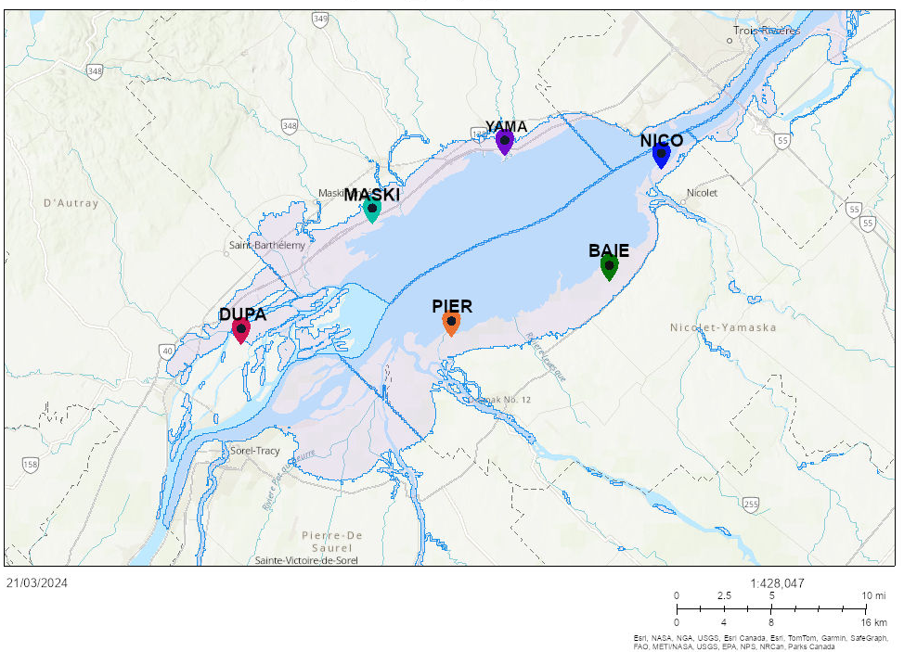Figure S1. Study blocks in the lake St-Pierre floodplain with flooding area represented in pink (Données Québec).

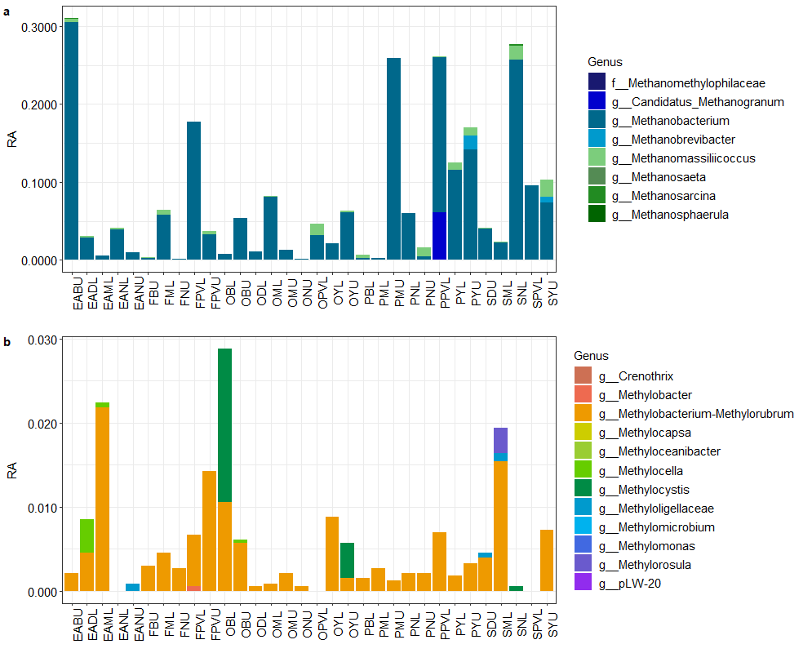Figure S2. Relative abundance (RA) of methanogenic (a) and methanotrophic (b) genera of sapwood based on 16S rRNA gene sequencing for the tree individuals of species Acer saccharinum (EA), Fraxinus nigra (F), Ulmus americana (O), Populus spp. (P) and Salix nigra (S). L= Lowland, U=Upland

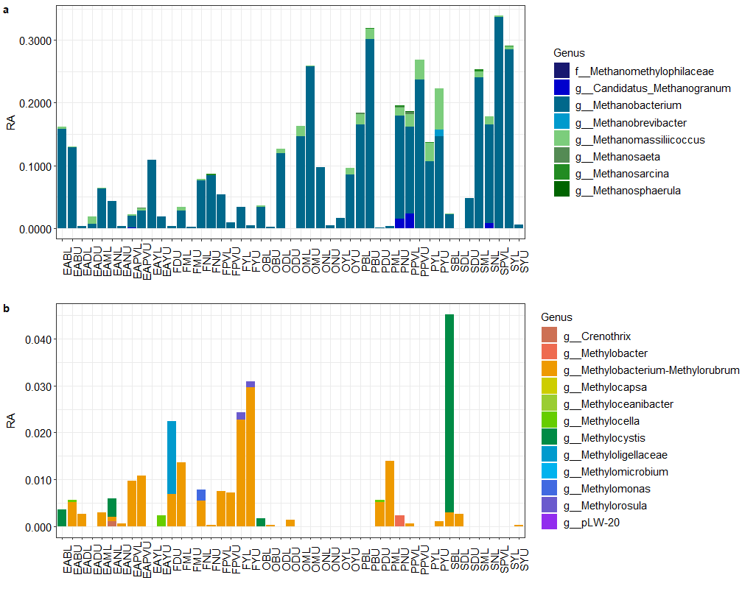Figure S3. Relative abundance (RA) of methanogenic (a) and methanotrophic (b) genera of heartwood based on 16S rRNA gene sequencing for the tree individuals of species Acer saccharinum (EA), Fraxinus nigra (F), Ulmus americana (O), Populus spp. (P) and Salix nigra (S). L= Lowland, U=Upland
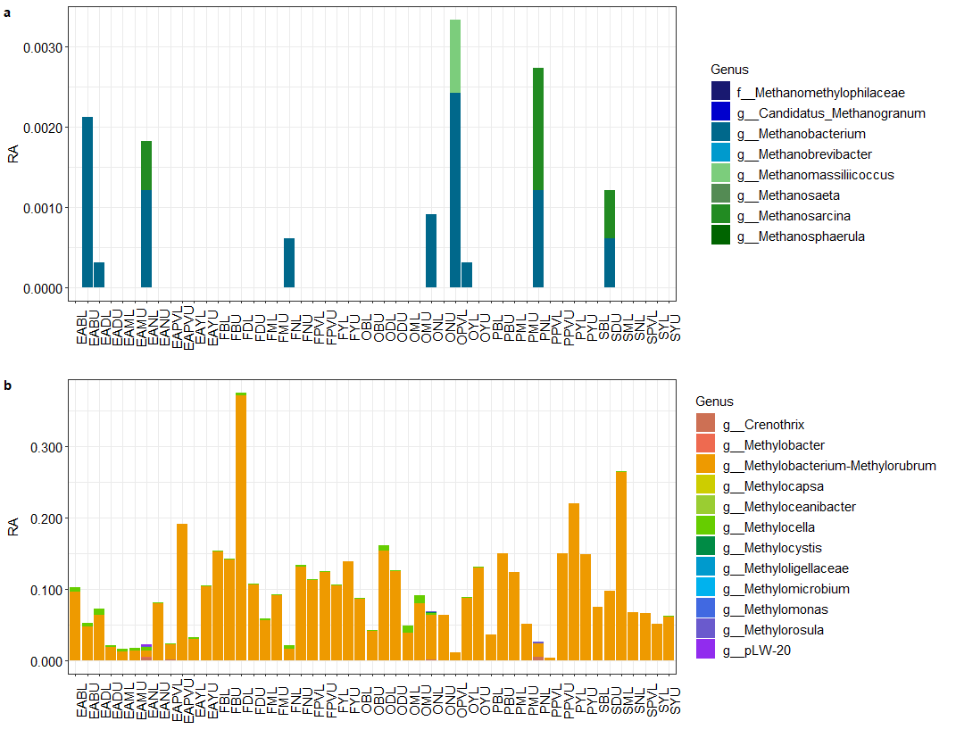

Figure S4. Relative abundance (RA) of methanogenic (a) and methanotrophic (b) genera of leaf epiphytes based on 16S rRNA gene sequencing for the tree individuals of species Acer saccharinum (EA), Fraxinus nigra (F), Ulmus americana (O), Populus spp. (P) and Salix nigra (S). L= Lowland, U=Upland

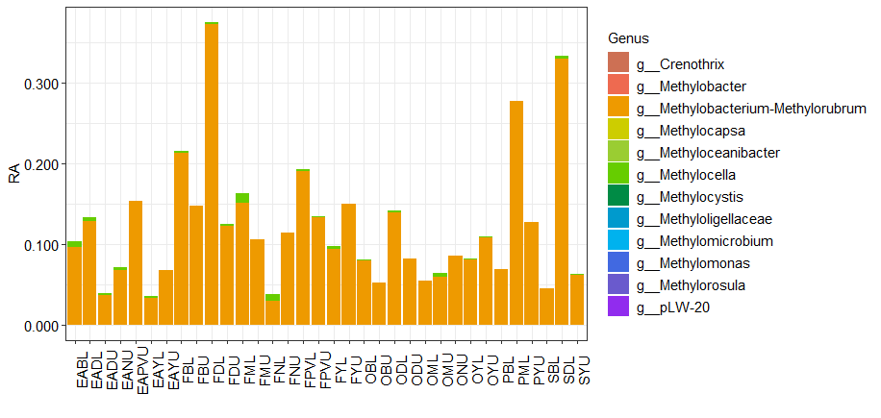Figure S5. Relative abundance (RA) of methanotrophic genera of leaf endophytes based on 16S rRNA gene sequencing for the tree individuals of species Acer saccharinum (EA), Fraxinus nigra (F), Ulmus americana (O), Populus spp. (P) and Salix nigra (S). L= Lowland, U=Upland

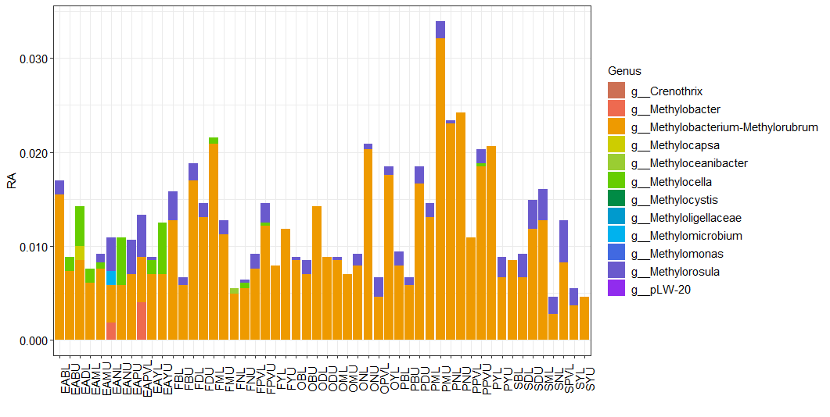

Figure S6. Relative abundance (RA) of methanotrophic genera of bark based on 16S rRNA gene sequencing for the tree individuals of species Acer saccharinum (EA), Fraxinus nigra (F), Ulmus americana (O), Populus spp. (P) and Salix nigra (S). L= Lowland, U=Upland

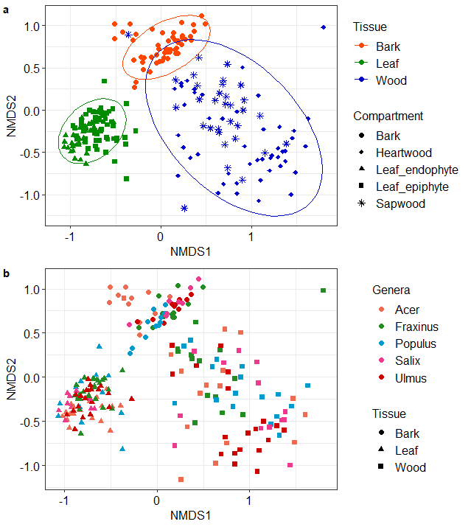

Figure S7. NMDS ordination (Bray-Curtis dissimilarity) of tree microbial communities from 16S rRNA gene sequencing among phyllosphere tissues (bark, leaf and wood) (a) and tree species (b).

c
b

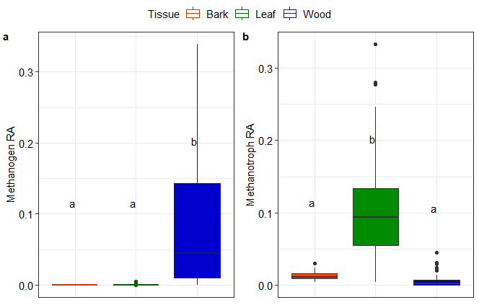

Figure S8. Relative abundance (RA) of methanogens (a) and methanotrophs (b) between tissues (bark, leaf and wood). Letters indicate significantly different groups according to post-hoc comparisons.

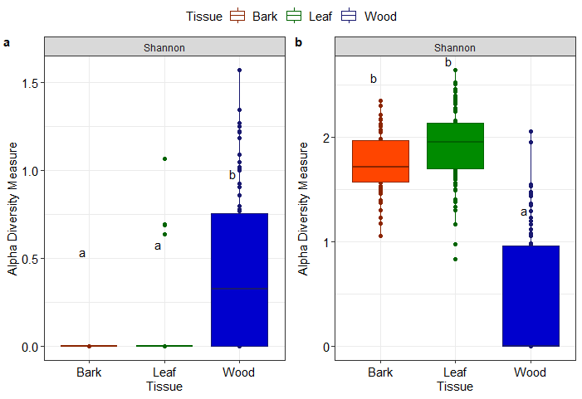

Figure S9. Shannon alpha diversity index for methanogenic (a, c) and methanotrophic (b, d) communities between tissues (bark, leaf and wood). Letters indicate significantly different groups according to post-hoc comparisons.

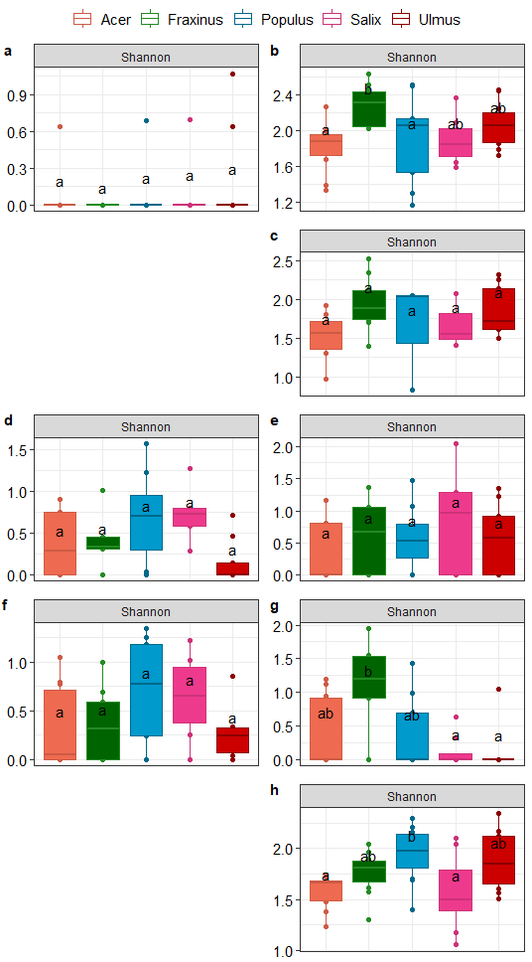

Figure S10. Shannon alpha diversity index for methanogenic (a, d, f) and methanotrophic (b, c, e, g, h) communities of leaf epiphytes (a, b), endophytes (c), sapwood (d, e), heartwood (f, g) and bark (h) of the different tree species. Letters indicate significantly different groups according to post-hoc comparisons.

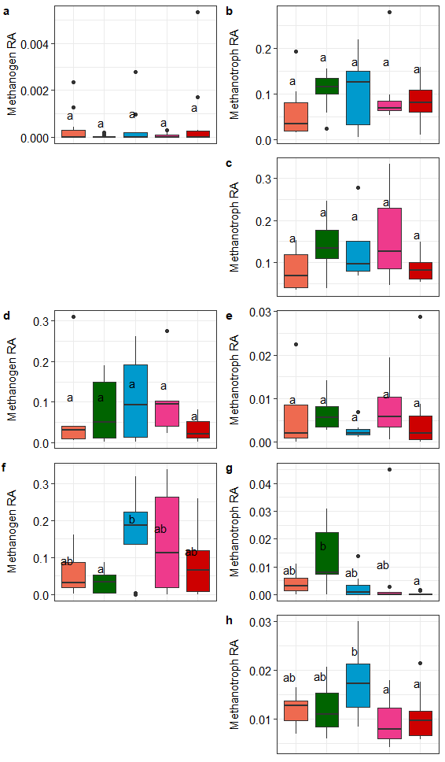

Figure S11. Relative abundance (RA) of methanogens (a, d, f) and methanotrophs (b, c, e, g, h) communities of leaf epiphytes (a, b), endophytes (c), sapwood (d, e) heartwood (f, g) and bark (h) of the different tree species. Letters indicate significantly different groups according to post-hoc comparisons.

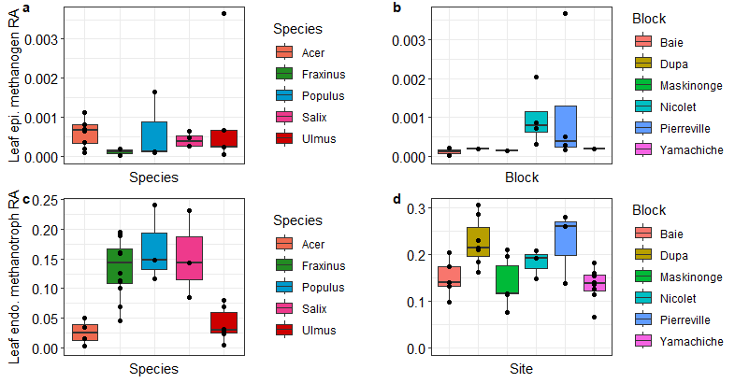

Figure S12. Conditional relationships between the relative abundance (RA) of leaf (epiphyte-epi and endophyte-endo) methanogens-methanotrophs and factors selected in the regression models LM1.1-2

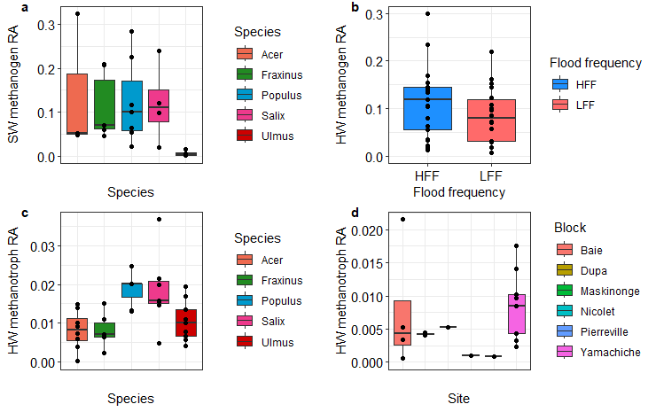

Figure S13. Conditional relationships between the relative abundance (RA) of wood (sapwood SW and heartwood HW) methanogens-methanotrophs and factors selected in the regression models LM3.1-4.2
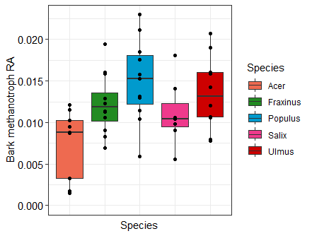

Figure S14. Conditional relationship between the relative abundance (RA) of bark methanotrophs and tree species in the regression model LM5.

References
Begmatov, S. et al. (2021) ‘Microbial Communities Involved in Methane , Sulfur , and Nitrogen Cycling in the Sediments of the Barents Sea’, Microorganisms, 9 (2362). pp. 1–21. doi: 10.3390/ microorganisms9112362.
Ge, X. et al. (2014) ‘Biological conversion of methane to liquid fuels : Status and opportunities’, Biotechnology Advances, 32(8), pp. 1460–1475. doi: 10.1016/j.biotechadv.2014.09.004.
de Groot, T. R. et al. (2024) ‘Tidal and seasonal influence on cold seep activity and methanotroph efficiency in the North Sea’, Communications Earth and Environment, 5(368). doi: 10.1038/s43247-024-01483-8.
Kharitonov, S. et al. (2021) ‘Microbial Communities in Methane Cycle : Modern Molecular Methods Gain Insights into Their Global Ecology Microbial Communities in Methane Cycle : Modern Molecular Methods Gain Insights into Their Global Ecology’, Environments, 8 (16). doi: 10.3390/environments8020016.
Knief, C. (2015) ‘Diversity and habitat preferences of cultivated and uncultivated aerobic methanotrophic bacteria evaluated based on pmoA as molecular marker’, Frontiers in Microbiology, 6(1346). doi: 10.3389/fmicb.2015.01346.
Vekeman, B. et al. (2016) ‘New Methyloceanibacter diversity from North Sea sediments includes methanotroph containing solely the soluble methane monooxygenase’, Environmental Microbiology, 18 (12), pp. 4523–4536. doi: 10.1111/1462-2920.13485.
Zhang, C. J. et al. (2020) ‘Genomic and transcriptomic insights into methanogenesis potential of novel methanogens from mangrove sediments’, Microbiome, 8(1), pp. 1–12. doi: 10.1186/s40168-020-00876-z.

