Supplementary information

Supplementary information S1: XRD and SQUID magnetization of GGG//YIG thin films
  - X-ray diffraction
Figure S1.1. (a) GenX fitting of the x-ray reflectivity (XRR) of the Gd₃Ga₅O₁₂(GGG)//Y₃Fe₅O₁₂(YIG) determine a thickness of 65.4 nm and the roughness of 0.57 nm and (b) The θ-2θ x-ray diffraction (XRD) of the GGG//YIG showed the YIG(444) reflection as a post-peak reflection to the substrate peak of GGG(444). The Laue oscillations in the above XRD scan indicate that the YIG is in a good epitaxy.
  - Magnetization

Figure S1.2. SQUID magnetization loop measured on the YIG(65 nm) show a saturation magnetization of 2.37 μ_{B} at 300 K for in-plane magnetization direction. This value is very close to the early reported YIG values [ H. B. Vasili et al. PRB 2017]. The magnetization loop appears very soft and the coercivity is about ≈ 1 Oe, is a good measure of the quality of the YIG for its magnetic structure.
Supplementary information S2: Crystal field multiplet calculations
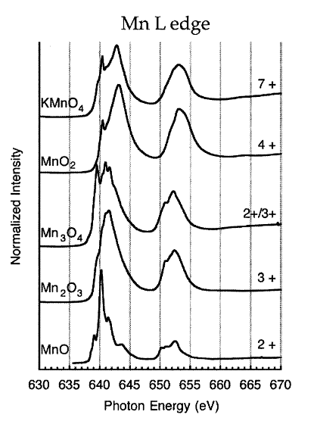
2.1 X-ray absorption spectroscopy (XAS) of Mn-L_{2,3}
- (b)
Figure S2.1. We have calculated the Mn-L_{2,3} XAS by crystal field multiplet simulations using CTM4XAS.¹ The calculated Mn-L XAS spectra for two different 10 Dq values are plotted in (a). The final Slater integrals, F(pd), G(pd), and F(dd) are already have a standard reduction of 80% to their Hartree-Fock values. We have taken the Mn²⁺ electronic configuration and simulated for the C₄ crystal symmetry in two different cases, i.e. (i) 10Dq = 0 eV and (ii) 10Dq = 0.9 eV. The M value was chosen as 9 meV while the D_{t} and D_{s} remain to zero. The spectrum with the crystal field (latter case) is matching to the early reported MnO spectra in (b). The reference XAS spectra [Gilbert et al. J. Phys. Chem. A, 107, 2839 (2003)] for different Mn valences is given in (b).

2.2 X-ray magnetic circular dichroism (XMCD) of Fe-L₃
Figure S2.2. Calculated Fe-L₃ XMCD spectra for O_{h}-Fe³⁺ and T_{d}-Fe³⁺ are plotted on the left-axis while the experimental XMCD data of YIG/PtMn is on the right-axis. In our early publication [H. B. Vasili et al. PRB 2017], we have reported the calculated Fe XMCD by crystal field multiplet simulations on O_{h}-Fe³⁺ and T_{d}-Fe³⁺ sites which were in good agreement with the experimental YIG spectra.
Supplementary information S3: Pt-M₃ XAS and XMCD

Figure S3.1. Pt-M₃ XAS comparison for Pt and PtMn thin films growing on Si substrates in a same batch of the samples growth. The white line of PtMn sample shifts to higher energy than the Pt sample, hinting at slightly excess charging in the PtMn. Inset shows normalized intensities.

Figure S3.2. (a,b) Room temperature data of Pt-M₃ XAS and XMCD of YIG/PtMn(1) with and without C₆₀. No appreciable dichroism was found in any of the sample. (c,d) The Pt white line of PtMn(t) shifts to the lower energies and narrow the peak with interfacing the C₆₀ at room temperature. Pt is being reduced charge after transferring it to the C₆₀. Thickness variation data hinting at the charge transfer is mainly at the interface, as observed in the STEM-EELS data.
Supplementary information S4: Comparison of YIG/PtMn(/C₆₀) to YIG/Pt(/C₆₀)

Figure S4.1. (a) The β-MR of YIG/PtMn(2)(/C₆₀) and YIG/Pt(2)/(/C₆₀) in top and bottom panels, respectively, for applying field of +3 T at 290 K. Despite the PtMn is antiferromagnetic, the bare YIG/PtMn(2) show lower β-MR of YIG/Pt(2). With the C₆₀ on PtMn, the interfacial AMR due to Mn²⁺ spins override the overall magnetoresistance. (b) We removed the Si//PtMn/C₆₀ contribution from the β-MR of YIG/PtMn(2)(/C₆₀), and plotted in top panel. The β-MR of YIG/PtMn(2)(/C₆₀) is above 100% increased than the YIG/PtMn(2). This is very large compared to the YIG/Pt(2)(/C₆₀) data in the lower panel, varies only 30%. This increment is associated to the lowering the Fermi level (E_{F}) of PtMn to 0.2 eV which increases the spin Hall conductivity about 200%, see the main text.

Supplementary information S5: Computational Details

All structures were obtained using spin-polarized DFT-level geometry optimizations performed using Quantum ESPRESSO [Ref.²] using the Perdew-Burke-Ernzerhof (PBE) approximation to the exchange-correlation functional [Ref.³]. Ultrasoft pseudopotential (USPPs) were utilized for both Pt and Mn. The relaxed structure of bulk antiferromagnetic (AFM) PtMn was obtained via a spin-collinear geometry optimization using a plane-wave cutoff of 80 Ry, a 12 $×$ 12 $×$ 12 k-point grid and a Gaussian smearing of 0.01 Ry to aid self-consistency. The convergence threshold was set at 1 $×$ 10⁻⁶ Ry and the mixing ratio was set at 0.4 to further aid self-consistency. The relaxed structure of bulk AFM PtMn had converged lattice parameters of a = 3.98 $Å$ and c/a = 0.99, in close agreement with previously reported results.⁴ Using these bulk relaxed lattice parameters, input structures for the PtMn(111) slab model, both with and without C₆₀, were constructed as the (111) facet is known to be the most stable.⁵ The pristine slab was constructed such that the [111] surface normal is oriented along the Cartesian z-axis and a vacuum of 15 $Å$ is set between periodic images. The pristine slab was left unrelaxed for any further transport calculations. For the PtMn(111)/C₆₀ structure, a relaxation was carried out after placing the C₆₀ molecule on one (111) facet using a reduced cutoff of 30 Ry, a mixing ratio of 0.01 and using a 3×3×1 k-point grid within QuantumESPRESSO. A relaxation of the same input structure was also done using FHI-AIMS [Ref.⁶] (0.1 eV Gaussian broadening, Pulay mixing with mixing factor 0.05, 1 $×$ 10⁻⁴ eV charge density convergence, 1 $×$ 10⁻² eigenvalue convergence, 1 $×$ 10⁻³ total energy convergence, 3$×$3 $×$1 k-point grid and 1 $×$ 10⁻² eV/ $Å$ residual force) for charge density analysis, as reported below, as the atomic-orbital projection analysis within QuantumESPRESSO resulted in a high spilling parameter, indicating the need for more pseudo-atomic wavefunctions for obtaining a complete projection of the system’s eigenstates. Both the relaxed structures were validated to have similar adsorption length for the C₆₀.
Noncollinear DFT-level spin hall conductivity calculations were performed using Quantum ESPRESSO [Ref.²] along with the PAOFLOW package.⁷ Fully relativistic ultrasoft pseudopotential (USPPs) were utilized for both Pt and Mn. The single-point self-consistent calculations were performed using a plane-wave energy cutoff of 40 Ry and plane-wave k-point grid of 6$×$6$×$1 for the pristine PtMn(111) slab model whereas a cutoff of 30 Ry and a k-point grid of 3$×$3$×$1 was used for the PtMn(111)/C₆₀ slab model instead. The tolerance for projectability of bands was set at 0.70. A 25 $×$ 25 $×$ 1 grid size was used for FFT interpolation.
DFT+NEGF calculations are performed with the PBE approximation to the exchange-correlation functional and the on-site approximation to the SOC [Ref.⁸] using the SMEAGOL quantum transport code [Ref.⁹] interfacing with the SIESTA package [Ref.¹⁰]. Core electrons are treated using norm-conserving Troullier-Martins pseudopotentials [Ref.¹¹] generated using the ATOM code [Ref.¹²]. The spd valence electrons for Pt and sd valence electrons for Mn are expanded using the numerical atomic orbital basis set of double-ζ quality. The cutoff radii were tuned to obtain the best match with the plane-wave bandstructure of bulk PtMn computed using Quantum ESPRESSO. All NEGF calculations were performed within the Landauer-Buttiker formalism using a two-terminal device setup with the same material in both the leads and the central region with the lattice parameters obtained from the aforementioned geometry optimizations after bulk PtMn relaxation. Both the zero-bias and finite-bias calculations are performed with a 101$×$1 k-point grid in the transverse Brillouin zone. The equilibrium component of the density matrix is obtained by performing the integration of the lesser Green’s function along a contour in the complex energy plane using a total of 32 points along the semicircle and the imaginary line that form that contour, while we evaluate 16 poles. The integration for the nonequilibrium component is carried out over the real energy axis using 96 energy points. The computed non-equilibrium density matrix is then used within the bond-current scheme [Ref.¹³] to evaluate the spin-currents for the spin-Hall angle evaluation.

Figure S5. PDOS of surface Pt atoms, without (top) and with (bottom) C₆₀ in PtMn(111).

Table S5. Mulliken charges for all atoms obtained after relaxation of the PtMn(111)/C₆₀ structure within FHI-AIMS. Charges are reported by summing over all atoms of the same type within a given surface layer, except for C₆₀ for which the total charge is reported. Surface layer index goes from 1 to 7, with 1 indicating the (111) facet on which C₆₀ was adsorbed and 7 indicating the pristine facet. Note that each surface layer contains 8 formula units of PtMn.
Atom Type | Mulliken Charge (e-) | Surface Layer Index
C₆₀ | -0.294
Pt | -2.804 | 1
Mn | 3.054 | 1
Pt | -2.855 | 2
Mn | 2.836 | 2
Pt | -2.712 | 3
Mn | 2.773 | 3
Pt | -2.758 | 4
Mn | 2.766 | 4
Pt | -2.688 | 5
Mn | 2.772 | 5
Pt | -3.025 | 6
Mn | 2.849 | 6
Pt | -2.951 | 7
Mn | 3.037 | 7

Supplementary information S6: Exchange biasing of YIG/PtMn(/C₆₀) and Co/PtMn(/C₆₀)

6.1 YIG/PtMn(/C₆₀)
Figure S6.1. SQUID magnetization loops of YIG/PtMn(t)(/C₆₀) for t = 1, 2, and 10 nm. The C₆₀ thickness is 15 nm for all the samples. Data in the left, centre, and right panels represent measurements taken at 10 K, 20 K, and 300 K, respectively. While the PtMn(1) at 10 K show an exchange bias (negative shifting in the coercivity), the C₆₀ counteracts and reduces the biasing. This is in line with the magnetoresistance that observed a positive MR for YIG/PtMn(1)/C₆₀ at 10 K although the bare PtMn show negative MR, see the main text. Both findings confirm the emergent magnetic ordering at the PtMn/C₆₀ which is magnetic and competes to the PtMn’s AF strength. The thick PtMn(10) film remain unchanged with the C₆₀, same observed in the MR measurements (read the main text), as the AF strength dominates than the emergent magnetic phase at the PtMn/C₆₀ interface.

6.2 Co/PtMn(/C₆₀)
Figure S6.2. SQUID magnetization loops of Co(5)/PtMn(t)(/C₆₀) for (a) t = 1 nm, (b) t = 2.5 nm, and (c) t = 10 nm, data measured in the temperature range 2-300 K. The C₆₀ thickness is 15 nm for all the samples. While the C₆₀ reduces the exchange biasing (coercivities) in the Co/PtMn films in (a) and (b), the thick PtMn(10) film remain unchanged in (c) for any temperature. (d) The coercivity (H_{c}) values are plotted for all the above samples. While the H_{c} values remain unchanged for t = 10 nm, the thinner PtMn show a decrement in the PtMn/C₆₀ as the emergent magnetic state at PtMn/C₆₀ counteracts the blocking of Co spins underneath.

Overall, the magnetization data of YIG/PtMn(/C₆₀) and Co/PtMn(/C₆₀) show a similar behaviour that an emergent magnetic state at PtMn/C₆₀ (due to canted Mn²⁺- antiferromagnetic spins) lead to tunable blocking of YIG or Co spins underneath which shifts their blocking temperatures. This data supports the results discussed from the spin Hall transport in the temperature range 2-290 K, read the main text for more details.

Supplementary information S7: Thickness-dependent XMCD of YIG/PtMn(t)(/C₆₀)

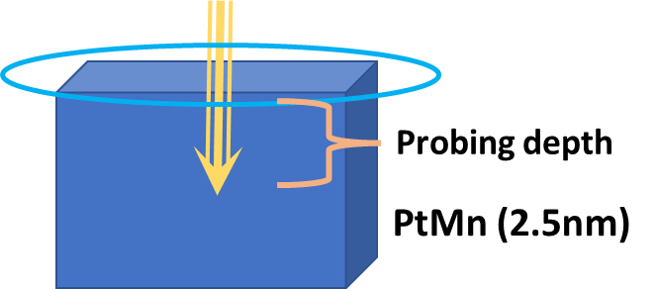
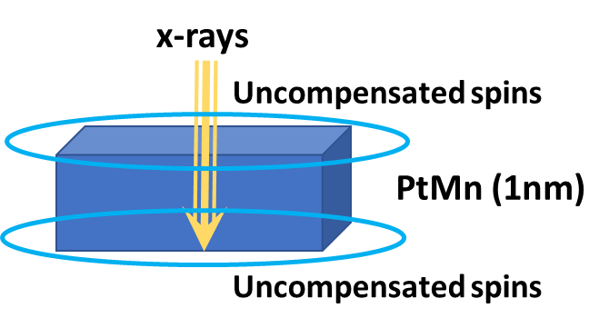
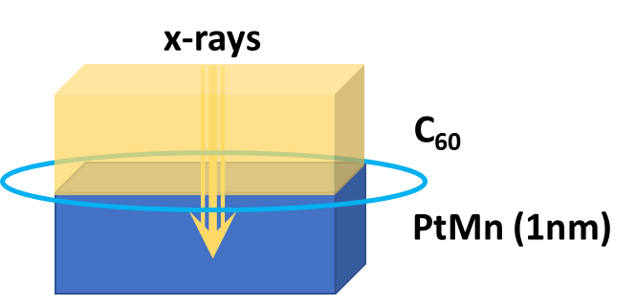
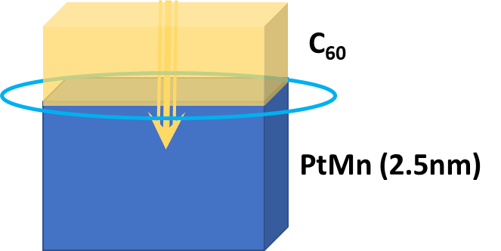
(a)

(b)

Figure S7. (a) Sketch of the PtMn(t) interfaces for t = 1 and 2.5 nm thicknesses. Uncompensated spins from the PtMn interfaces are shown with cyan-coloured oval-shaped circles. The probing depth of x-ray absorption in total electron yield (TEY) mode is limited with the sample thickness. In our samples, YIG(65)/PtMn(t)(/C₆₀(15))/Al(2), the probing depth is sufficient to detect signals from the bottom YIG layer only for t ≤ 2 nm. This allows us to selectively probe the top PtMn/C₆₀ interface.
(b) Mn-L XMCD of YIG/PtMn(1) at 2 K exhibits nearly double the intensity compared to YIG/PtMn(2.5). This difference arises from the fact that x-rays in YIG/PtMn(1) probe uncompensated Mn spins from both the top and bottom interfaces of the PtMn layer, while in YIG/PtMn(2.5), the probing depth is limited only to the top interface. Note that the XMCD signal remains constant for PtMn(t)/C₆₀ samples with t = 1 and 2.5 nm, indicating that the observed XMCD primarily originates from the PtMn/C₆₀ interface where charge transfer leads to the formation of Mn²⁺ state.
Supplementary information S8: Angle-dependent magnetoresistance of YIG/PtMn(/C₆₀)

α-rot
β-rot
γ-rot

n
t
j

Figure S8. Angular dependent magnetoresistance of YIG/PtMn(t)(/C₆₀) for (a) t = 1 nm and (b) t = 2nm in the temperature range 2-290 K. The MR measured in different magnetic field rotations with respect to the current direction (j). The MR (α-rot) is a measure of field rotating in a (j,t)-plane, while the β and γ-rotated MR are for fields rotating in (n,t)- and (n,j)-planes, respectively. In an ideal system, the MR (β-rot) primarily measures the spin Hall magnetoresistance (SHMR), and γ-rotated MR is a measure of the anisotropic magnetoresistance (AMR). The MR (α-rot) = SHMR + AMR. While the YIG/PtMn doesn’t show any significant AMR, the YIG/PtMn(1)/C₆₀ in (a) show a large AMR and diminishes with the increasing PtMn thickness, as in (b).

Supplementary information S9: Unidirectional exchange Magnetoresistance in antiferromagnet/ferromagnet

The spin current density, ${\vec{j}}_{s}^{ (F)}$, at a ferromagnet (F) interface is governed by the spin accumulation (${\vec{μ}}_{s}$) and spin-mixing conductance ($G_{↑↓})$
$e {\vec{j}}_{s}^{ \left(F\right)}\left(\hat{m}\right)= G_{r}\hat{m}×\left(\hat{m}×{\vec{μ}}_{s}\right)+ G_{i}\left(\hat{m}×{\vec{μ}}_{s}\right)$ (1)
where $\hat{m}={\left(m_{x},m_{y},m_{z}\right)}^{T}$is a unit vector along the magnetization The complex spin-mixing conductance, $G_{↑↓}=G_{r}+iG_{i}$, can be decomposed into real and imaginary parts. The real part characterizes the efficiency of spin current transmission across the interface, while the imaginary part represents an effective exchange field acting on the spin accumulation. For a ferromagnetic insulator/antiferromagnet (AF) interface, the ${\vec{j}}_{s}^{ (F)}$ is proportional to the spin transfer torque acting on the ferromagnet,
${\vec{τ}}_{STT}$ = $-\frac{ℏ}{2e}\left[{\vec{j}}_{s}^{ \left(F\right)}\left(\hat{m}\right)+{\vec{j}}_{s}^{ \left(AF\right)}\left(\hat{n}\right)\right]$ (2)
where $\hat{n}={\left(n_{x},n_{y},n_{z}\right)}^{T}$is the Néel vector direction. Considering the $\hat{m}$ and $\hat{n}$ vectors in a perpendicular configuration $\left(m ̂.n ̂=0\right)$, the magnetization vectors can be written as $\hat{m}=\left(\cos{θ, \sin{θ,0}}\right)$ and $\hat{n}=\left(-\sin{θ, \cos{θ,0}}\right)$. The total spin current is the sum of F and AF configurations, and the longitudinal electric current can be expressed as
$\frac{j_{c, long(z)}}{j_{c}^{0}}=1+Θ_{SH}^{2}\frac{\cosh{\frac{2z-t}{2λ_{sd}}}}{\cosh{\frac{t}{2λ_{sd}}}}+Θ_{SH}^{2}\frac{2λ_{sd}G_{r}tanh{\frac{t}{2λ_{sd}}}}{σ+2λ_{sd}G_{r}coth{\frac{t}{λ_{sd}}}}\left[\left(\frac{\sinh{\frac{z-t}{λ_{sd}}}}{\sinh{\frac{t}{λ_{sd}}}}\cos^{2}{θ-}\frac{\sinh{\frac{z}{λ_{sd}}}}{\sinh{\frac{t}{λ_{sd}}}}\sin^{2}{θ}\right)+\left(\frac{\sinh{\frac{z-t}{λ_{sd}}}}{\sinh{\frac{t}{λ_{sd}}}}+\frac{\sinh{\frac{z}{λ_{sd}}}}{\sinh{\frac{t}{λ_{sd}}}}\right)\cos{θ \sin{θ}}\right]$ (3)
$\frac{ρ_{long}}{ρ}=1-Θ_{SH}^{2}\frac{2λ}{t}\tanh{\frac{t}{2λ_{sd}}}+Θ_{SH}^{2}\frac{2{λ_{sd}G}_{r}\tan^{2}h{\frac{t}{2λ_{sd}}}}{σ+2λ_{sd}G_{r}coth{\frac{t}{λ_{sd}}}}\left[{f_{F} cos}^{2}\left({θ-θ}_{m}\right)-{f_{AF} sin}^{2}\left({θ-θ}_{n}\right)+f_{UE}cos\left({θ-θ}_{u}\right)\right]$ (4)

1. Stavitski, E.; de Groot, F. M. F., The CTM4XAS program for EELS and XAS spectral shape analysis of transition metal L edges. Micron 2010, 41 (7), 687-694.
2. Giannozzi, P.; Baroni, S.; Bonini, N.; Calandra, M.; Car, R.; Cavazzoni, C.; Ceresoli, D.; Chiarotti, G. L.; Cococcioni, M.; Dabo, I.; Dal Corso, A.; de Gironcoli, S.; Fabris, S.; Fratesi, G.; Gebauer, R.; Gerstmann, U.; Gougoussis, C.; Kokalj, A.; Lazzeri, M.; Martin-Samos, L.; Marzari, N.; Mauri, F.; Mazzarello, R.; Paolini, S.; Pasquarello, A.; Paulatto, L.; Sbraccia, C.; Scandolo, S.; Sclauzero, G.; Seitsonen, A. P.; Smogunov, A.; Umari, P.; Wentzcovitch, R. M., QUANTUM ESPRESSO: a modular and open-source software project for quantum simulations of materials. Journal of Physics: Condensed Matter 2009, 21 (39), 395502.
3. Perdew, J. P.; Burke, K.; Ernzerhof, M., Generalized Gradient Approximation Made Simple. Physical Review Letters 1996, 77 (18), 3865-3868.
4. Su, Y.; Li, M.; Zhang, J.; Hong, J.; You, L., Voltage-controlled magnetic anisotropy in antiferromagnetic L10-MnPt and MnPd thin films. Journal of Magnetism and Magnetic Materials 2020, 505, 166758.
5. Dannenberg, A.; Gruner, M. E.; Hucht, A.; Entel, P., Surface energies of stoichiometric FePt and CoPt alloys and their implications for nanoparticle morphologies. Physical Review B 2009, 80 (24), 245438.
6. Gavini, V.; Baroni, S.; Blum, V.; Bowler, D. R.; Buccheri, A.; Chelikowsky, J. R.; Das, S.; Dawson, W.; Delugas, P.; Dogan, M.; Draxl, C.; Galli, G.; Genovese, L.; Giannozzi, P.; Giantomassi, M.; Gonze, X.; Govoni, M.; Gygi, F.; Gulans, A.; Herbert, J. M.; Kokott, S.; Kühne, T. D.; Liou, K.-H.; Miyazaki, T.; Motamarri, P.; Nakata, A.; Pask, J. E.; Plessl, C.; Ratcliff, L. E.; Richard, R. M.; Rossi, M.; Schade, R.; Scheffler, M.; Schütt, O.; Suryanarayana, P.; Torrent, M.; Truflandier, L.; Windus, T. L.; Xu, Q.; Yu, V. W. Z.; Perez, D., Roadmap on electronic structure codes in the exascale era. Modelling and Simulation in Materials Science and Engineering 2023, 31 (6), 063301.
7. Buongiorno Nardelli, M.; Cerasoli, F. T.; Costa, M.; Curtarolo, S.; De Gennaro, R.; Fornari, M.; Liyanage, L.; Supka, A. R.; Wang, H., PAOFLOW: A utility to construct and operate on ab initio Hamiltonians from the projections of electronic wavefunctions on atomic orbital bases, including characterization of topological materials. Computational Materials Science 2018, 143, 462-472.
8. Fernández-Seivane, L.; Oliveira, M. A.; Sanvito, S.; Ferrer, J., On-site approximation for spin–orbit coupling in linear combination of atomic orbitals density functional methods. Journal of Physics: Condensed Matter 2006, 18 (34), 7999.
9. Rocha, A. R.; García-Suárez, V. M.; Bailey, S.; Lambert, C.; Ferrer, J.; Sanvito, S., Spin and molecular electronics in atomically generated orbital landscapes. Physical Review B 2006, 73 (8), 085414.
10. José, M. S.; Emilio, A.; Julian, D. G.; Alberto, G.; Javier, J.; Pablo, O.; Daniel, S.-P., The SIESTA method for ab initio order-N materials simulation. Journal of Physics: Condensed Matter 2002, 14 (11), 2745.
11. Troullier, N.; Martins, J. L., Efficient pseudopotentials for plane-wave calculations. Physical Review B 1991, 43 (3), 1993-2006.
12. https://docs.siesta-project.org/projects/atom/en/latest/tutorial/ps-generation/index.html.
13. Droghetti, A.; Rungger, I.; Rubio, A.; Tokatly, I. V., Spin-orbit induced equilibrium spin currents in materials. Physical Review B 2022, 105 (2), 024409.

