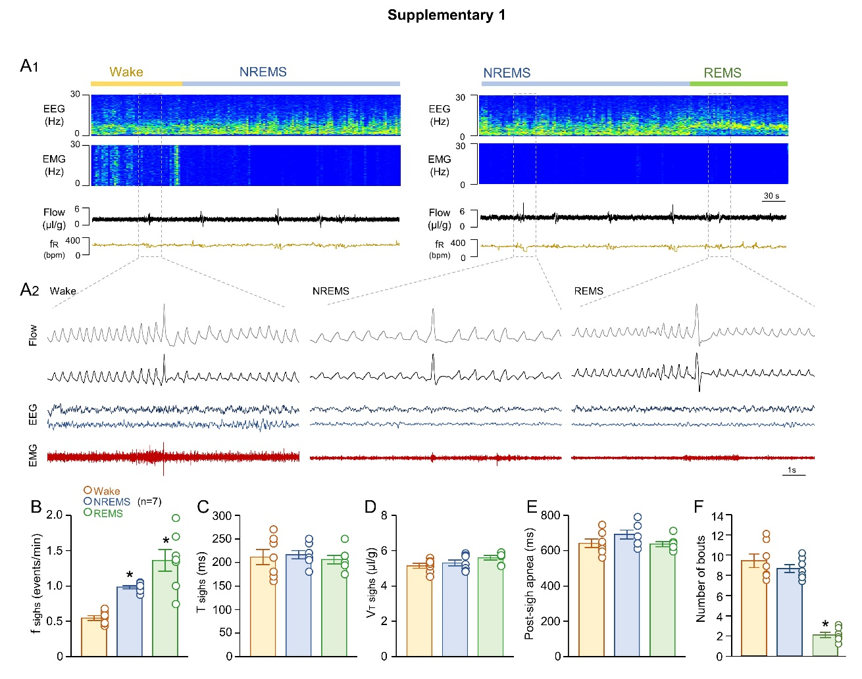
Supplementary figure 1. Characterization of spontaneous arousal with sighs in freely behaving Aldh1l1^{Cre} mice.
A) Representative records of EEG and EMG waves and respiratory flow in freely behaving mice and spontaneous arousal/sigh generation. Variations of B) sigh frequency, C) time of sighing, D) Sigh V_{T}, E) post-sigh apnea duration and F the number of bouts wake, NREMS and REMS. Statistical analysis: One-way ANOVA (*statistically significant from baseline).

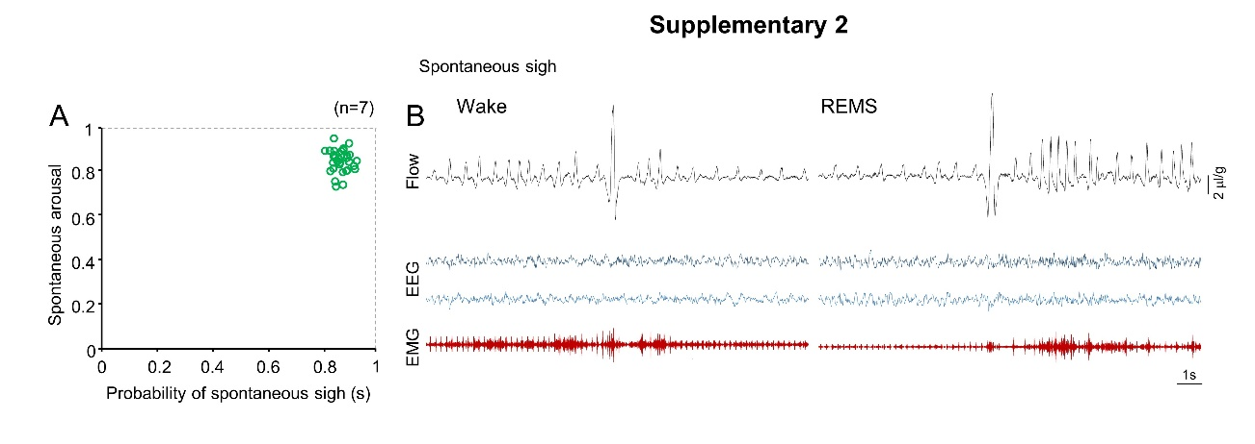
Supplementary figure 2. probability of spontaneous arousal with sighs in freely behaving Aldh1l1^{Cre} mice.
A) Probability of spontaneous arousal and sigh are highly correlated. B) Representative recordings of EEG and EMG waves in freely behaving mice and spontaneous arousal/sigh generation.

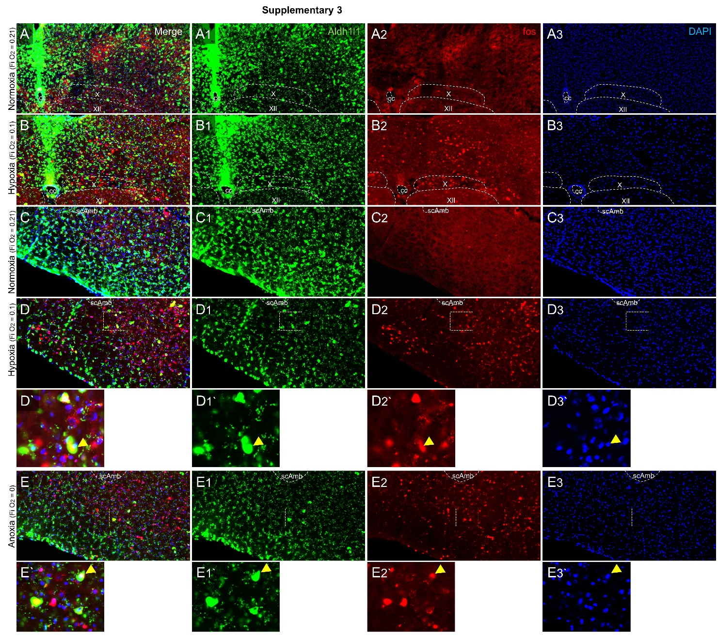
Supplementary figure 3. Hypoxia- or anoxia-induced Aldh1l1 cells-activated in the VRC and NTS.
Representative photomicrographs of A-B) NTS or C-E) VRC demonstrating 1) Aldh1l1 (green), 2) Fos (red) and 3) DAPI expression while the animals were exposed to A/C) Normoxia, B/D) Hypoxia or E) Anoxia (Check protocol for details). Abbreviations: scAmb, nucleus ambiguus pars semi-compact; X, vagus nucleus; XII, hypoglossal nucleus; cc, central canal.

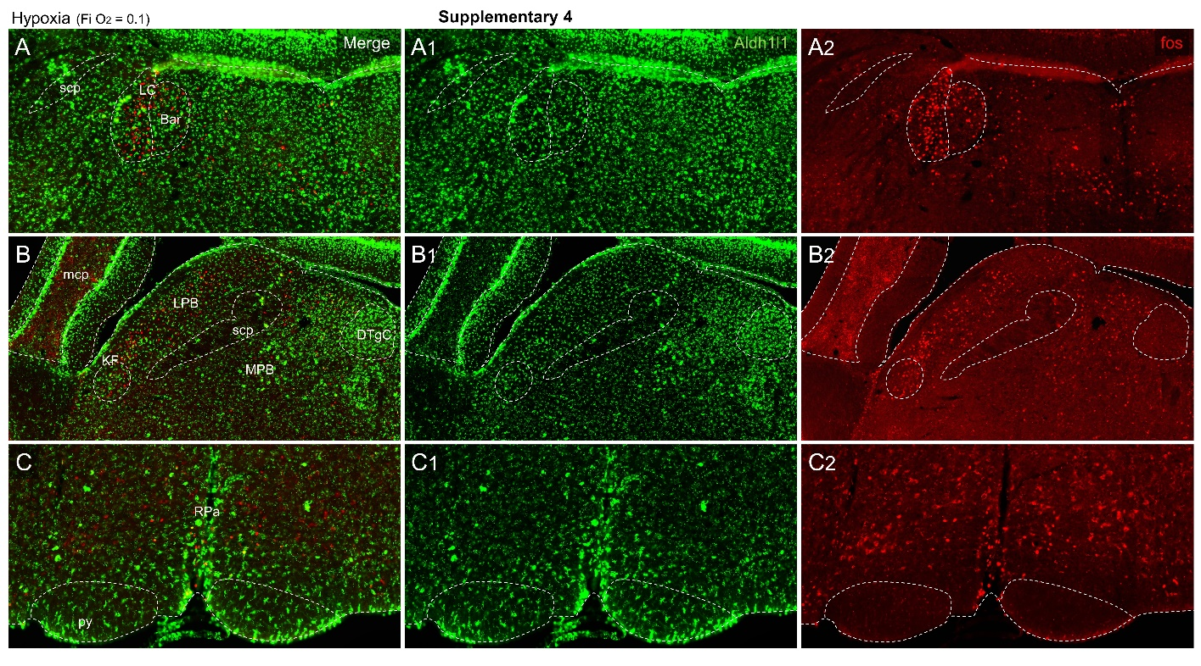
Supplementary figure 4. Hypoxia- or anoxia-induced Aldh1l1 cells- and neurons-activated in the LC, PBN and raphe.
Representative photomicrographs of A) LC, B) PBN/KF and C) Raphe demonstrating 1. Aldh1l1 (green) and 2. c-fos (red) expression while the animals were exposed to hypoxia (Check protocol for details). Abbreviations: KF, Kölliker-fuse nucleus; LPB and PBM, Lateral and medial parabrachial, respectively; scp, superior cerebellar peduncle; DTg, dorsal tegmental nucleus; Bar, Barrington nucleus; LC, Locus coeruleus; py, pyramids.

