Supplementary Information
Charge density waves in pyrochlore crystallite encapsulated by an amorphized matrix
Wenming Qi ^{1,2}, Yang Ding ², Hongliang Dong ², Min Gao ^{1,3}* and Qingyang Hu ²*
¹ Xinjiang Key Laboratory of Solid State Physics and Devices, School of Physics Science and Technology, Xinjiang University, Urumqi, People’s Republic of China
² Center for High Pressure Science and Technology Advanced Research, Shanghai, People’s Republic of China
³ Xinjiang Laboratory of Phase Transitions and Microstructures in Condensed Matter Physics, College of Physical Science and Technology, Yili Normal University, Yining, People’s Republic of China

Content：
S1. Characterizations of starting Lu₂Ti₂O₇ sample
S2. The fitting plot of Lu₂Ti₂O₇ at 16.1 GPa
S3. Color plots of the pressure-dependent Raman spectra of Lu₂Ti₂O₇
S4. Pressure dependence of FWHM in the two modes of Lu₂Ti₂O₇
S5. Pressure dependence of the Raman shift in Lu₂Ti₂O₇
S6. The fitting plots of Lu₂Ti₂O₇ at 39.5 GPa and release to 0.1 GPa
S7. The pressure dependence of frequency in TiO₆ octahedral modes
S8. The fitting plots of Lu₂Ti₂O₇ after release to ambient conditions
S9. Selected SAED patterns in Lu₂Ti₂O₇ thin film
S10. Nanostructure made of amorphized structural matrix

S1. Characterizations of starting Lu₂Ti₂O₇ sample

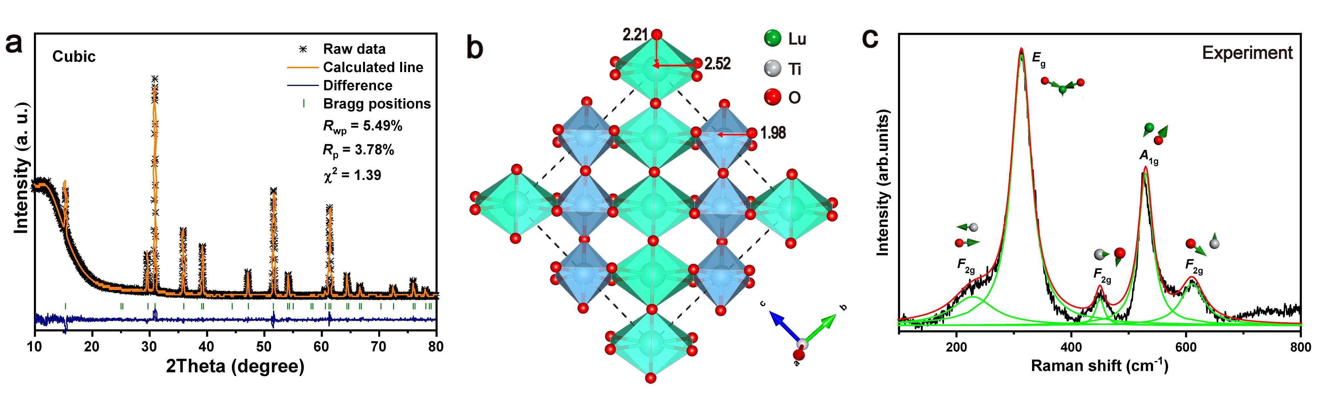
Fig. S1 Characterizations of starting Lu₂Ti₂O₇ sample. (a) Rietveld refinement of XRD patterns collected at ambient conditions. (b) The pyrochlore structure of Lu₂Ti₂O₇. (c) Lorentz fitted for the Raman spectrum of Lu₂Ti₂O₇ at ambient conditions. Inset figures are the bonds vibration diagram of each Raman mode.

S2. The fitting plot of Lu₂Ti₂O₇ at 16.1 GPa
Fig. S2 The fitting Raman spectra of Lu₂Ti₂O₇ at 16.1 GPa.

S3. Color plots of the pressure-dependent Raman spectra of Lu₂Ti₂O₇

Fig. S1 Color plots of the pressure-dependent Raman spectra of Lu₂Ti₂O₇.

S4. Pressure dependence of FWHM in the two modes of Lu₂Ti₂O₇
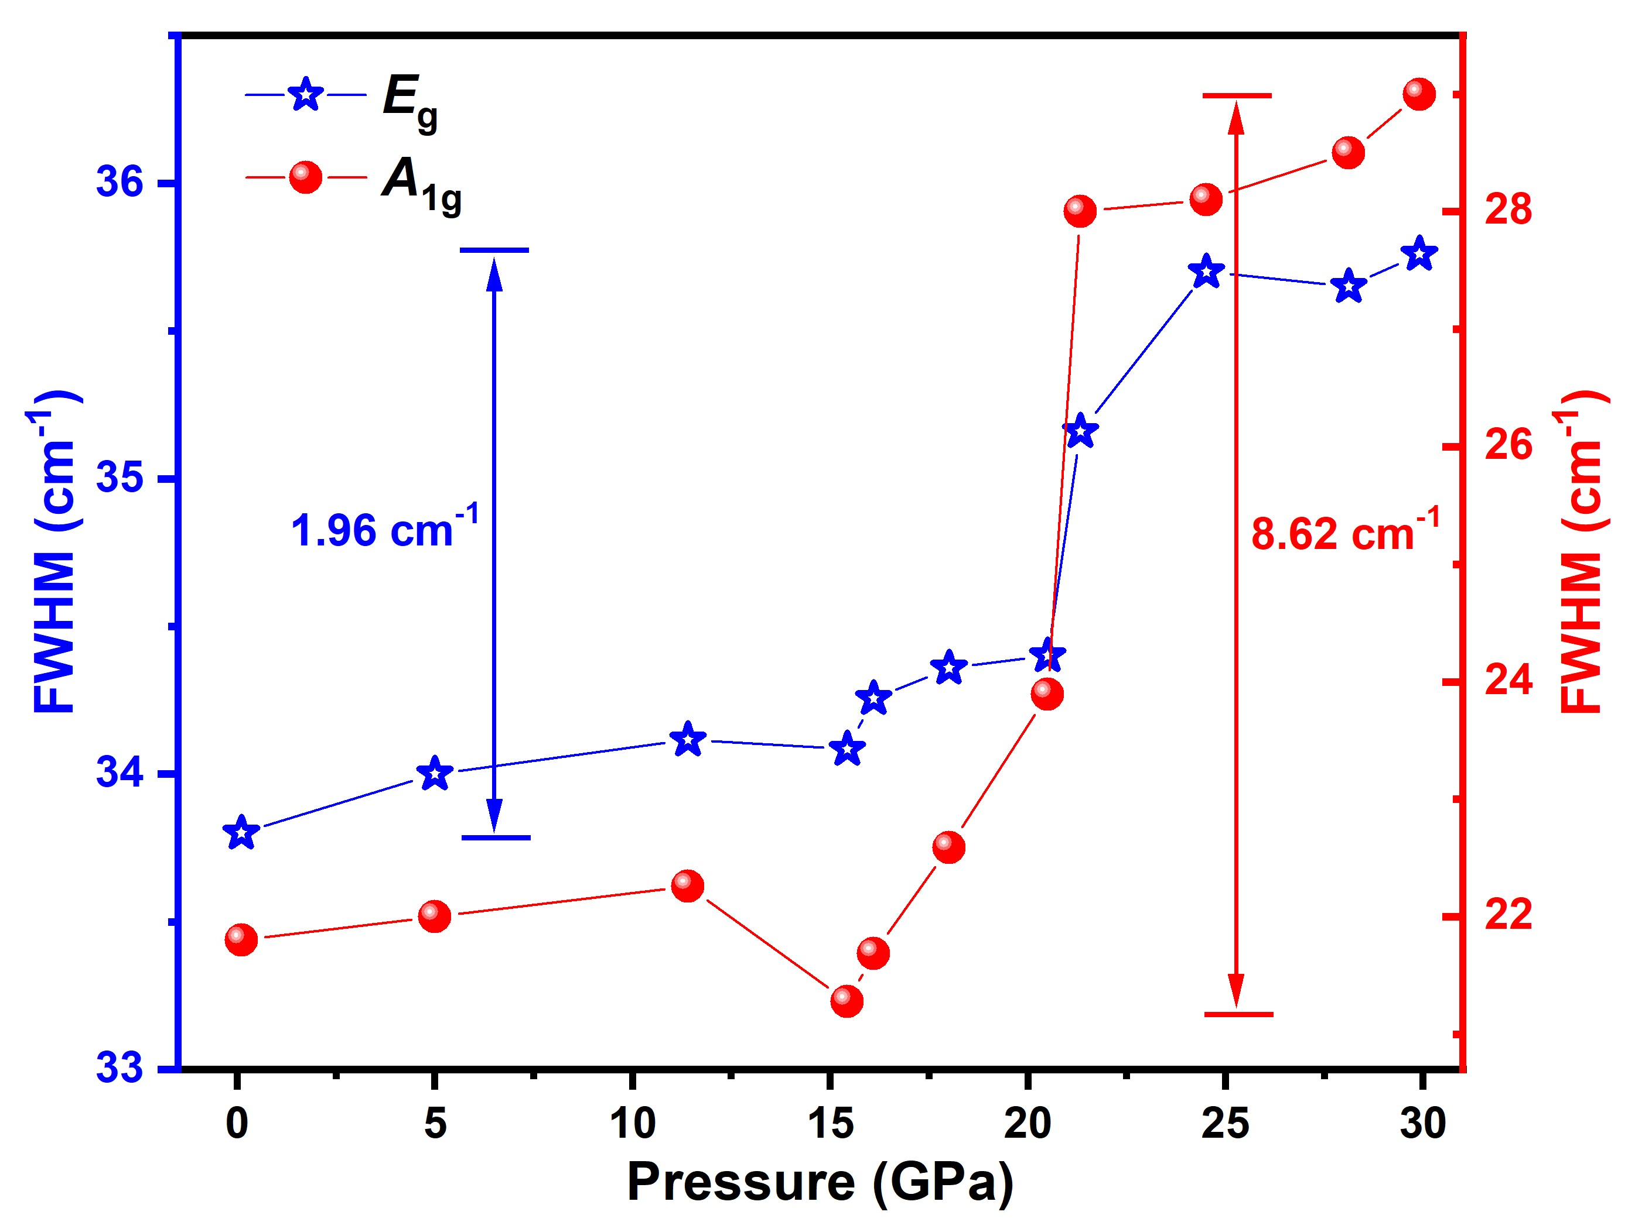
Fig. S4 Pressure dependence of FWHM in the two modes (E_{g} and A_{1g}) of Lu₂Ti₂O₇.

S5. Pressure dependence of the Raman shift in Lu₂Ti₂O₇
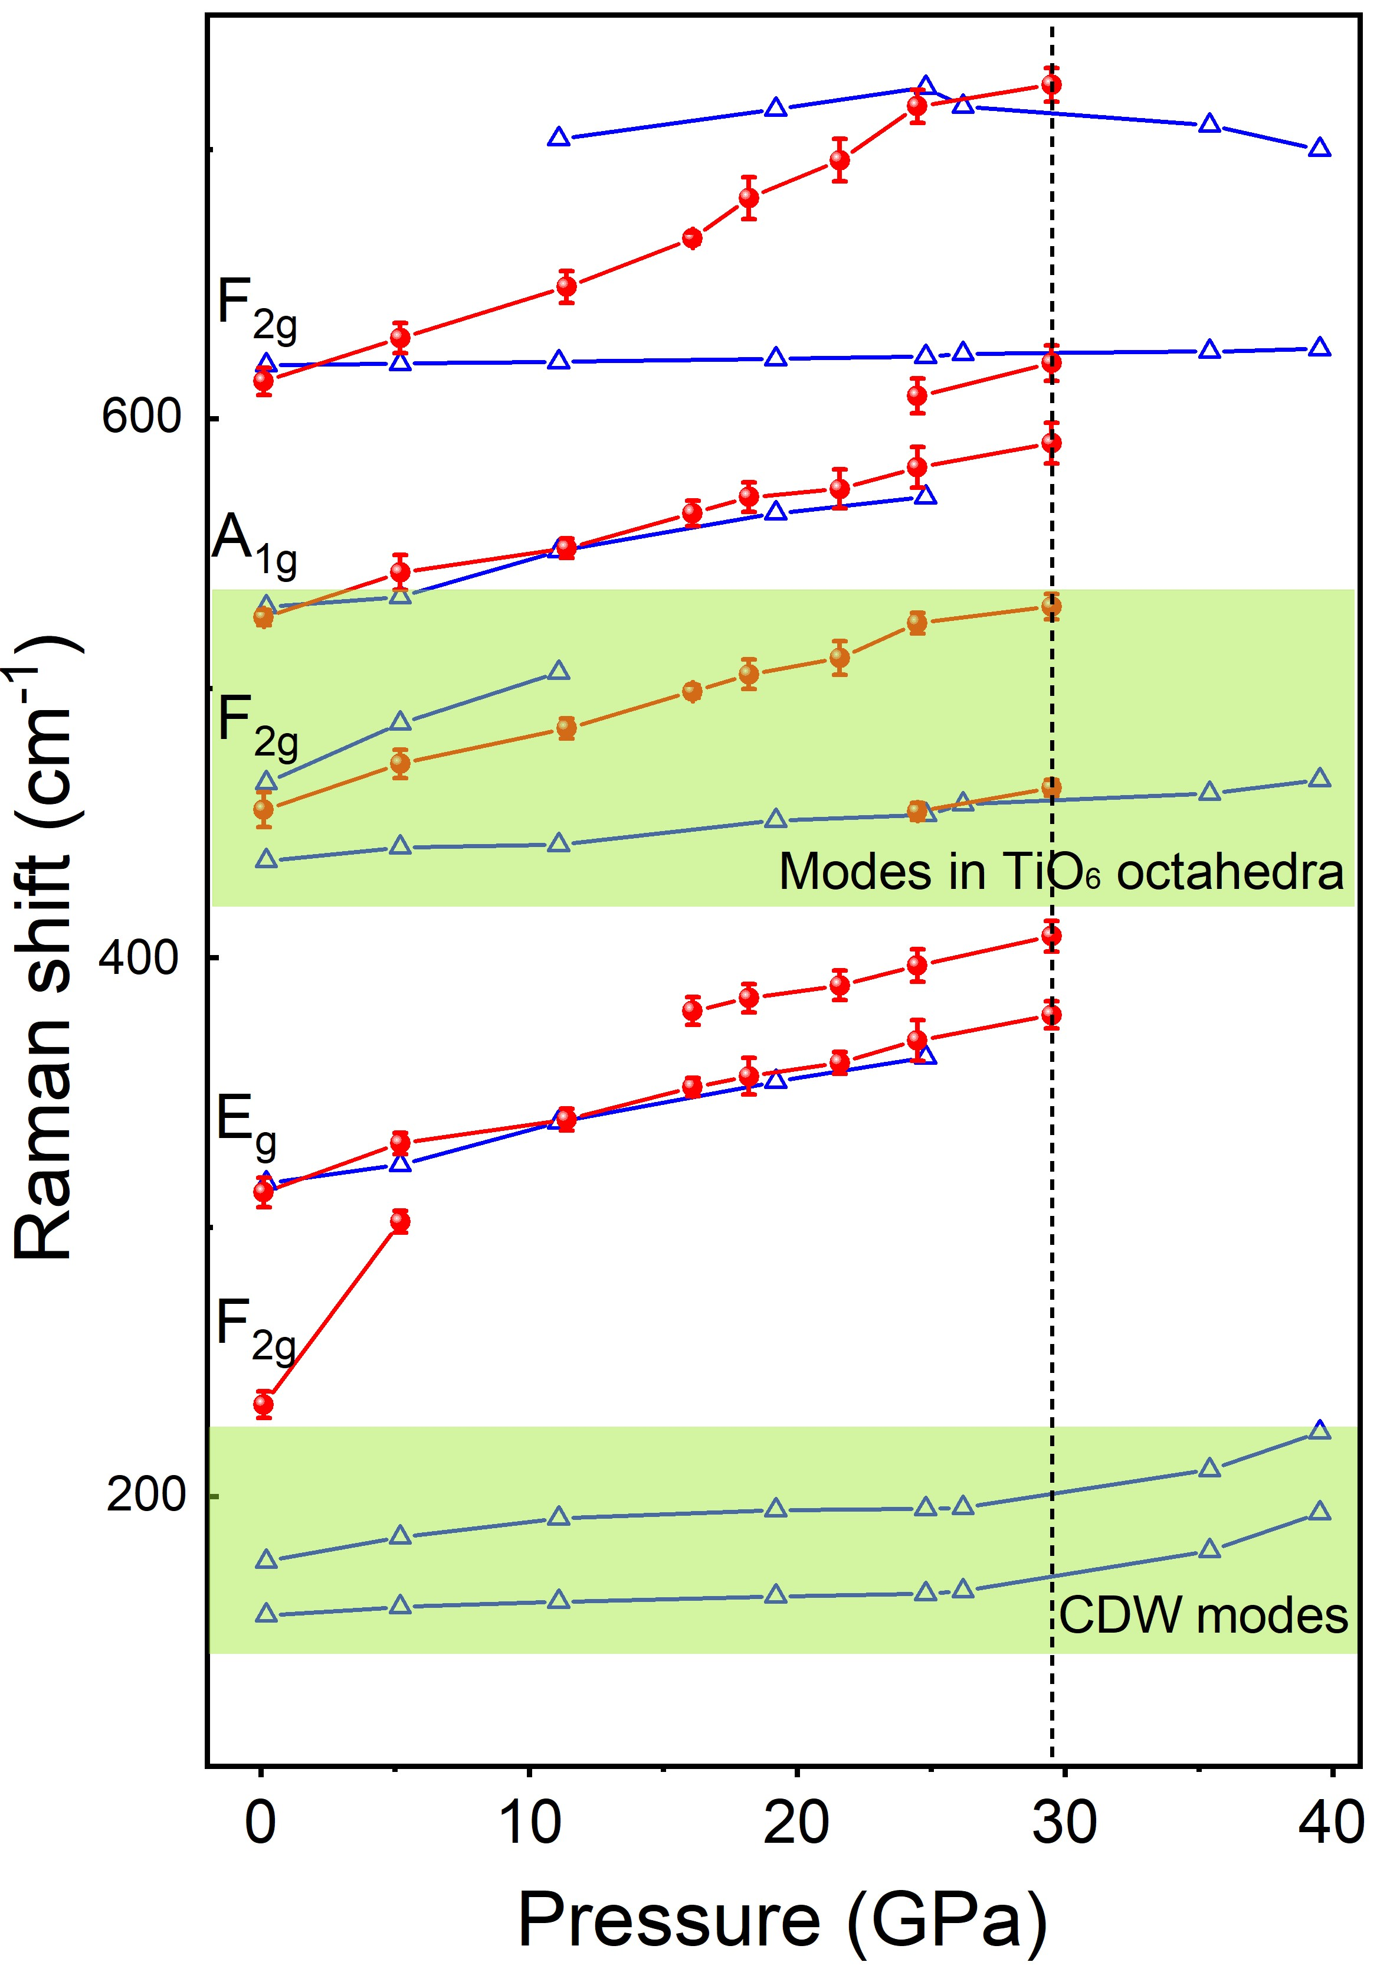
Fig. S5 Pressure dependence of the Raman shift. Dashed line of 29.5 GPa is the onset of structural disordering and transition to the monoclinic phase. red balls, compression; blue triangles, decompression.

S6. The fitting plots of Lu₂Ti₂O₇ at 39.5 GPa and release to 0.1 GPa

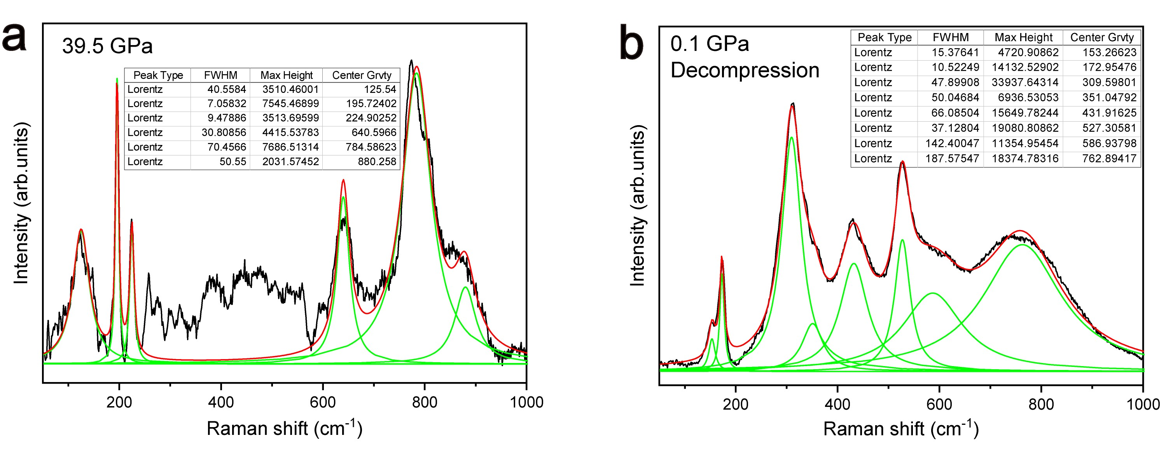
Fig. S6 The fitting Raman spectra of Lu₂Ti₂O₇ at (a) 39.5 GPa and (b) release to 0.1 GPa.

S7. The pressure dependence of frequency in TiO₆ octahedral modes
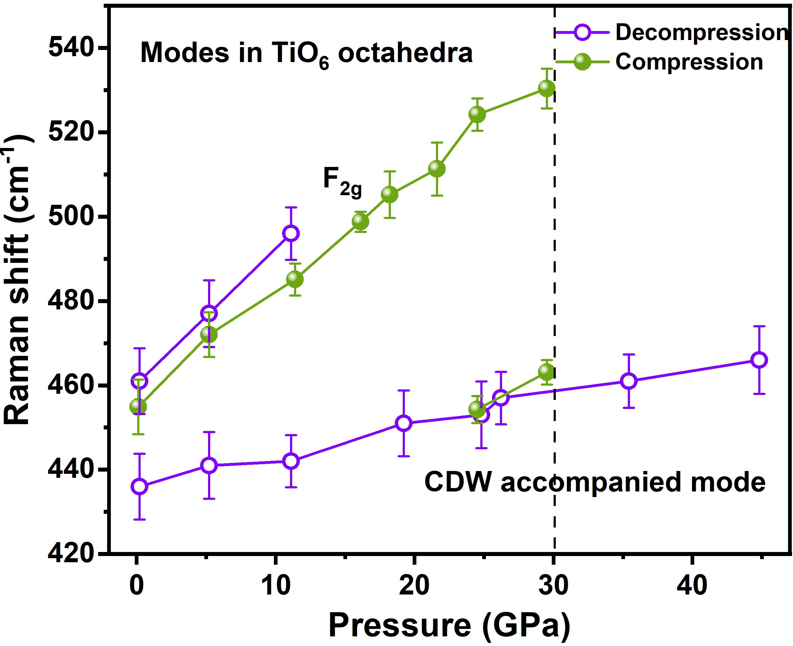
Figure S7 The pressure dependence of frequency in TiO₆ octahedral modes. We are unable to track the reemergence of LTO F_{2g} mode (460 cm^{–1} at 1 atm), suggesting potential topological behavior similar to that in isostructural pyrochlore Gd₂Ti₂O₇ and Tb₂Ti₂O₇.¹⁻³

S8. The fitting plots of Lu₂Ti₂O₇ after release to ambient conditions

Fig. S8 The fitting plots of Lu₂Ti₂O₇ after release to ambient conditions. Wavelength is (a) 532 and (b) 633 nm, respectively. The PTM in (a) is silicone oil and in (b) is neon.

S9. Selected SAED patterns in Lu₂Ti₂O₇ thin film

Fig. S9 Selected SAED patterns in cross-sectional FIB image of the (010) Lu₂Ti₂O₇ thin film.

S10. Nanostructure made of amorphized structural matrix
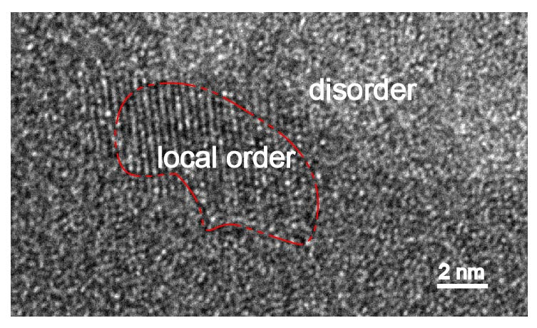
Fig. S10 Nanostructure made of amorphized structural matrix.

References:
1. Mirebeau, I.; Goncharenko, I. N.; Cadavez-Peres, P.; Bramwell, S. T.; Gingras, M. J. P.; Gardner, J. S., Pressure-induced crystallization of a spin liquid. Nature 2002, 420, 54-57.
2. Saha, S.; Muthu, D. V. S.; Pascanut, C.; Dragoe, N.; Suryanarayanan, R.; Dhalenne, G.; Revcolevschi, A.; Karmakar, S.; Sharma, S. M.; Sood, A. K., High-pressure Raman and X-ray study of the spin-frustrated pyrochlore Gd₂Ti₂O₇. Physical Review B 2006, 74 (6).
3. Semeghini, G.; Levine, H.; Keesling, A.; Ebadi, S.; Wang, T. T.; Bluvstein, D.; Verresen, R.; Pichler, H.; Kalinowski, M.; Samajdar, R.; Omran, A.; Sachdev, S.; Vishwanath, A.; Greiner, M.; Vuletic´, V.; Lukin, M. D., Probing topological spin liquids on a programmable quantum simulator. Science 2021, 374, 1242-1247.

