Phosphorus-Doped NiFe Electrodes for Stable Alkaline Seawater Electrolysis at Industrial Current Densities: Facile Synthesis and Mechanistic Insights
Wei Wang*, Zhibo Ren, Peng Liu, Chang Zhang, Tao Wang, Fan Wang, Xupeng Yan, Weiqi Guo, Zhan Wu , Jinyi Wang*
Huaneng Clean Energy Research Institute, Beijing, 102209, China.

* Corresponding Author
Email: w_wang@qny.chng.com.cn; jy_wang@qny.chng.com.cn

Figure

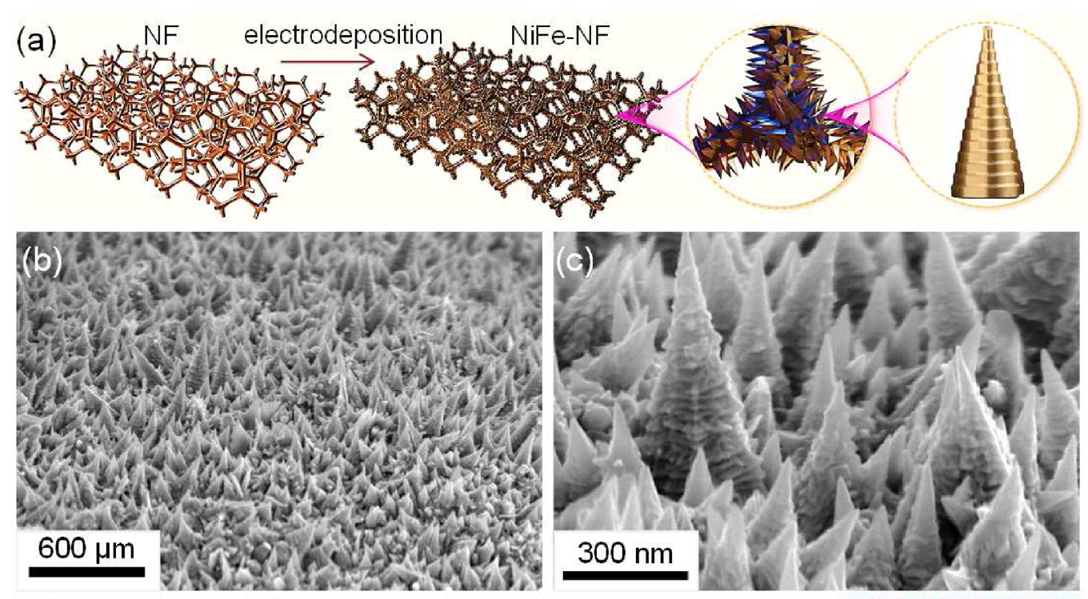
Fig. S1 SEM images of NiFe-NF¹

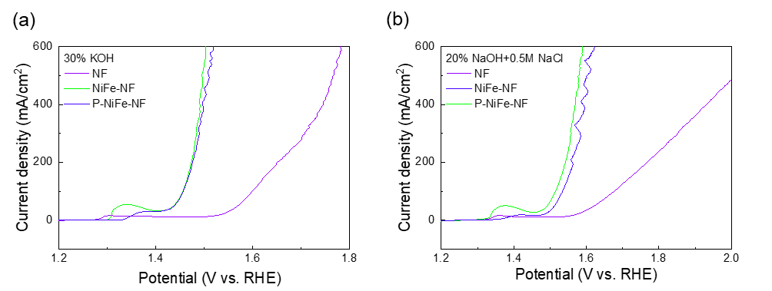
Fig. S2 OER activity of PNiFe NF, NiFe NF and nickel foam (NF) in 30 wt% KOH and 20 wt% NaOH + 0.5 M NaCl electrolyte

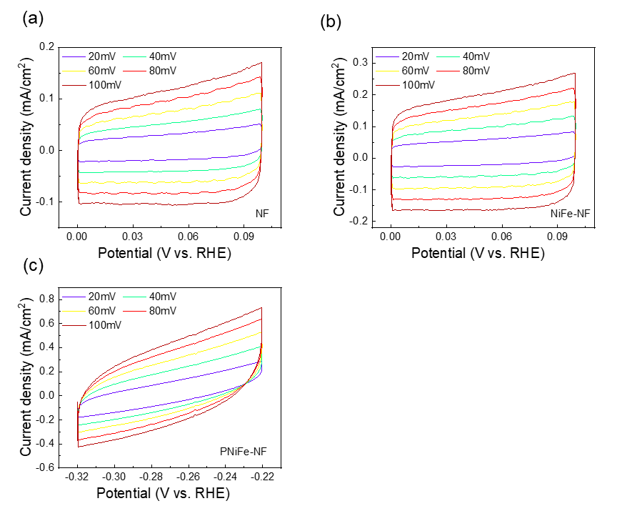
Fig. S3 CV curves at different sweep rates of the electrode in 30 % KOH + 0.5 M NaCl solution: (a)NF, (b)NiFe-NF, (c) PNiFe-NF.

Table

Tab. S1 The electrochemically active surface area of NF, NiFe-NF, and P-NiFe-NF electrodes in 30 % KOH + 0.5 M NaCl solution
ECSA(cm²) | NF | NiFe-NF | P- NiFe-NF
30% KOH+0.5M NaCl | 54.25 | 90.25 | 156.00

Tab. S2 The concentration of ions in natural seawater
Ions | K⁺ | Ca²⁺ | Mg²⁺ | Na⁺ | Cl⁻ | SO₄²⁻
Concentration (mg/L) | 324 | 335 | 1072 | 10117 | 17171 | 2290

References:

1. Liu, P.; Wang, J.; Wang, X.; Liu, L.; Yan, X.; Wang, H.; Lu, Q.; Wang, F.; Ren, Z., A superhydrophilic NiFe electrode for industrial alkaline water electrolysis. Int. J. Hydrog. Energy 2024, 49, 285-294.

