Supplementary Information
Strain-enabled ultra-broadband Ge-based photonic devices for low-cost integration in PICs
Yiding Lin^{1,2,5,†}, Danhao Ma^{3,†}, Rui-Tao Wen^{4,6}, Kwang Hong Lee², Govindo Syaranamual², Lionel C. Kimerling³, Chuan Seng Tan^{1,2} and Jurgen Michel^{2,3,4,*}
¹School of Electrical and Electronic Engineering, Nanyang Technological University, Singapore, Singapore
²Low Energy Electronic Systems (LEES), Singapore-MIT Alliance for Research and Technology, Singapore, Singapore
³Department of Materials Science and Engineering, Massachusetts Institute of Technology, Cambridge, MA, USA
⁴Materials Research Laboratories, Massachusetts Institute of Technology, Cambridge, MA, USA
⁵Currently with Max Planck Institute of Microstructure Physics, Halle (Saale), Germany
⁶Currently with Southern University of Science and Technology, Shenzhen, China
†Equal contribution
*Correspondence to: jmichel@mit.edu

Table of Contents
S1. Ge-OI fabrication 3
S2. Finite element method simulation of Ge mechanical strain in w-Ge-OI and w-Ge-on-SOI structures 3
S3. Determination of Ge longitudinal ($εyy$) strain 5
S4. SiN_{x} stress characterization and optimization 7
S5. Fabrication and supplementary characterization of SiN_{x}-strained w-Ge-OI 9
S6. Key process development 12
I. Effect of top SiN_{x} removal on Ge strain 12
II. Stressor adhesion enhancement to Ge sidewalls 13
S7. Ge strain with respect to SiN_{x} stressor width 14
S8. Fabrication of SiN_{x}-strained w-Ge-OI MSM photodetectors 15
S9. Supplementary characterization of SiN_{x}-strained w-Ge-OI MSM photodetectors 16
I. Ti/Al₂O₃/Ge metal-insulator-semiconductor (MIS) contact 16
II. IQE and dark current conduction mechanism 18
III. Gain mechanism 20
S10. Extraction of Ge effective absorption coefficient from photocurrent spectra 21
S11. Bandgap edge wavelength calculation 22
S12. Fabrication and characterization of tensile SiN_{x}-strained Ge_{0.99}Si_{0.01} EA modulator arrays 23
S13. Optical transmission and ER measurement set-up 24
S14. Ge strain and bandgap extraction from optical transmission spectra using Franz-Keldysh model 24

S1. Ge-OI fabrication
The Ge-OI platform was fabricated via Ge-on-Si epitaxy, direct wafer bonding and layer transfer process. The schematic process flow is shown in Fig. S1. An un-intentionally doped Ge layer was epitaxial grown on a 200-mm Si (100) carrier wafer in a metal-organic chemical vapour deposition (MOCVD) chamber. A SiO₂ layer was then deposited on both the surfaces of Ge and another Si (100) handle wafer by plasma-enhanced chemical vapour deposition (PECVD). Both the SiO₂ surfaces were then treated with oxygen (O₂) plasma for 15 s, followed by rinsing in de-ionized (DI) water and spin-drying, to heavily populate the surfaces with silanol (Si–OH) groups for a stronger bonding. Immediately afterwards, the two wafers were bonded together by contacting the treated SiO₂ surfaces, followed by annealing in N₂ ambient at 300 ^{º}C for 3 hrs to enhance the bonding strength. The bonded pair went through grinding and tetramethylammonium hydroxide (TMAH) etching to remove the Si carrier wafer. The exposed Ge layer was then thinned down to a desired thickness via chemical-mechanical polishing (CMP). Specifically, the residual Ge thickness was ~ 100 and ~ 400 nm, respectively, in the micro-Raman study (Fig. 2) and the metal-semiconductor-metal (MSM) photodetectors (Fig. 3).
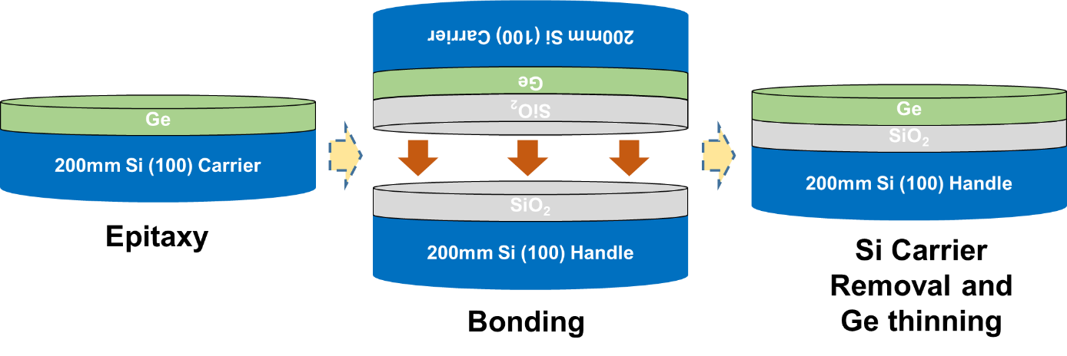
Fig. S1 A schematic of the process flow for Ge-OI fabrication.

S2. Finite element method simulation of Ge mechanical strain in w-Ge-OI and w-Ge-on-SOI structures

The finite element method simulation was constructed by mimicking the practical experimental conditions. This was realized by adopting multiple solid mechanics modules in COMSOL Multiphysics, each corresponding to an experimental process, and solving them in sequence according to the experimental procedures. The stress output from the previous module was imported as the initial stress to the subsequent module, and the output from the last module was converted to the final mechanical strain. All materials are set as linear elastic.
The modelling of SiN_{x}-strained w-Ge-OIs firstly followed the temperature variation during the Ge-OI fabrication discussed in Supplementary S1, consisting of the Ge-on-Si epitaxy by metal-organic chemical vapour deposition (MOCVD) at 600ºC, followed by the direct wafer bonding and post-bonding annealing at 300ºC, and finally cooling down to room temperature (300 K). Subsequently, the Ge-OI was patterned into a shape of waveguide and SiN_{x} stressor was then introduced on its sidewalls with an intrinsic stress, both of which are temperature-independent due to their identical initial and end states at room temperature and the linear elastic setting of materials. Geometrical symmetry was applied penetrating the structure via the y-z and x-z planes (Fig. 1c, d). The stress obtained from the final module was converted to strain via below relations:
$ε_{xx}=\frac{σ_{xx}-v•{(σ}_{yy}+σ_{zz})}{E}$ (S.1)
$ε_{yy}=\frac{σ_{yy}-v•{(σ}_{xx}+σ_{zz})}{E}$ (S.2)
$ε_{zz}=\frac{σ_{zz}-v•{(σ}_{xx}+σ_{yy})}{E}$ (S.3)
where $ε_{xx}$, $ε_{yy}$ and $ε_{zz}$ are the mechanical strain in Ge along the transverse (x-), longitudinal (y-) and vertical (z-) directions, respectively. $σ_{xx}$, $σ_{yy}$ and $σ_{zz}$ are the corresponding mechanical stress values. $v$=0.273 and $E$=103 GPa are the Poisson’s ratio and Young’s modulus of Ge, respectively. Detailed dimensions of the structure can be found in the caption of Fig. 1. The longitudinal dimension of w-Ge-OI is 100 µm. The Yong’s modulus of SiN_{x} in the simulation is 200 GPa.
The strain in Ge_{0.99}Si_{0.01} on SOI structure was modelled in a similar manner by mimicking the sequence of Ge-on-Si growth at 730ºC, cooling down to room temperature, Ge_{0.99}Si_{0.01} waveguide formation and SiN_{x} deposition.

S3. Determination of Ge longitudinal ($ε_{yy}$) strain

The Ge mechanical strain in Ge-OI and w-Ge-OI structures without SiN_{x} stressor was firstly studied using the finite element simulation discussed in S2. Fig. S2a shows the strain profile in Ge-OI. The strain is biaxial and ~0.17% both transversely ($ε_{xx}$) and longitudinally ($ε_{yy}$), which matches well with our earlier high-resolution X-ray diffractometry (HR-XRD) results¹. The accuracy of the model is thus verified. For the w-Ge-OI structure, it can be observed that $ε_{yy}$ (Fig. S2b) reveals a negligible change compared to that in the Ge-OI; while the $ε_{xx}$ (Fig. S2c) exhibits a certain extent of relaxation. The $ε_{xx}$ close to the waveguide sidewall becomes even compressive (~-0.03%). This can be explained by the shrinkage of the contact area to the -OI substrate along the transverse direction, resulting from the waveguide patterning. The reduced contact area relieves the substrate constraint on the w-Ge-OI and thus relaxes its strain. This explanation also fits well to the negligible $ε_{yy}$ change longitudinally, where the w-Ge-OI is still in full contact to the substrate. Therefore, the original in-plane biaxial strain changes to a uniaxial-like longitudinal tensile strain upon the waveguide patterning. Furthermore, the $ε_{yy}$ was found independent of the use of the SiN_{x} stressor from Fig. S2d and e.
The strain profiles in w-Ge-OI were further experimentally investigated by performing micro-Raman measurements (at 785 nm) on a fabricated identical structure. The fabrication process is discussed in S5. Fig. S3a shows an optical microscope image of a fabricated w-Ge-OI with its cross-sectional SEM image shown in the inset. A more detailed information on the micro-Raman measurement can be found in Methods. It can be clearly seen from Fig. S3b that the peak LO phonon frequency of the w-Ge-OI resides in between that of the bulk Ge and Ge-OI, indicating a strain relaxation in w-Ge-OI compared to Ge-OI. This agrees well with the observation from the simulation. To determine the axial strains, one could get the following relation (Eq. S.4) by summing Eqs. S.1 and S.2, since there is no stress along the vertical direction ($σ_{zz}$ = 0):
$ε_{xx}+ε_{yy}=\frac{\left(1-v\right)\left(σ_{xx}+σ_{yy}\right)}{E}$ (S.4)
The term $\left(σ_{xx}+σ_{yy}\right)$ can be deduced from the stress-induced LO phonon frequency splitting relation² below:
$ω_{i}^{2}-ω_{0}^{2}=\left[pS_{12}+q\left(S_{11}+S_{12}\right)\right](σ_{xx}+σ_{yy})$ (S.5)
where $ω_{i}$refers to the peak LO phonon frequency from Ge-OI or w-Ge-OI, and $ω_{0}=$ 300.84 cm⁻¹ corresponds to the peak frequency from bulk Ge. p=$-1.45ω_{0}^{2}$ and q=$-1.95ω_{0}^{2}$ are the phonon deformation potentials. S₁₁ and S₁₂ are the compliance tensors linking between the stress and strain. If we let $ε_{yy}$= 0.17%, $ε_{xx}$~0.04% can be obtained from the following equation by plugging Eq. S.5 into S.4:
$ε_{xx}=\frac{\left(1-ν\right){(ω}_{i}^{2}-ω_{0}^{2})}{2∙E∙\left[pS_{12}+q\left(S_{11}+S_{12}\right)\right]}-ε_{yy}$ (S.6)
The $ε_{xx}$ value reasonably matches with the simulation data (Fig. S2c). Therefore, $ε_{xx}$ relaxation and $ε_{yy}$~0.17% were verified both theoretically and experimentally in w-Ge-OI without stressor. This again validates the accuracy of the finite element simulation and hence the $ε_{yy}$ independence on the use of the SiN_{x} stressor (Fig. S2d and e).
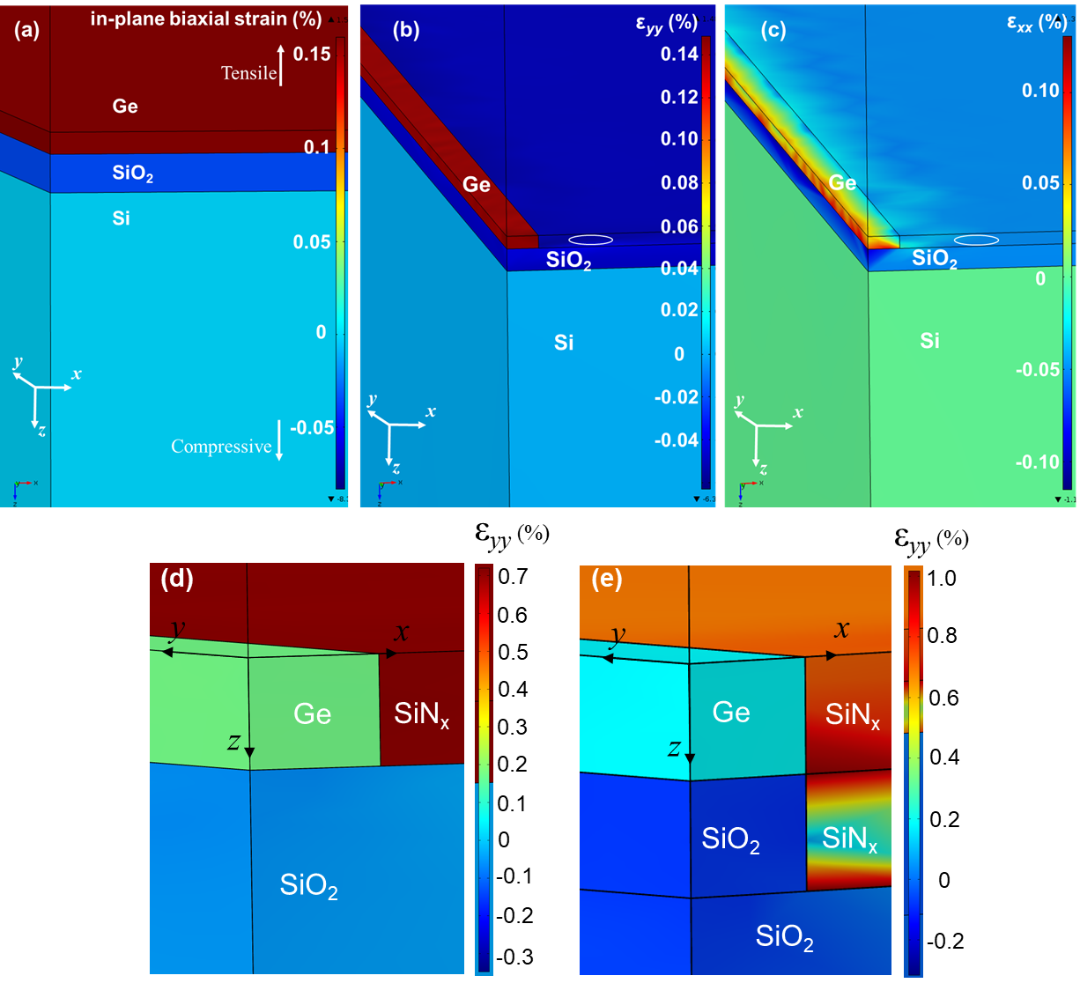
Fig. S2 Simulated Ge mechanical strain profiles of (a) Ge film-OI (in-plane biaxial) and w-Ge-OI along (b) longitudinal ($ε_{yy}$) and (c) transverse ($ε_{xx}$) directions, with (d) un-recessed and (e) recessed SiN_{x} stressor. The Ge thickness and width are 400 nm and 2 µm, respectively, in (a)-(c), and 200 and 500 nm, respectively, in (d) and (e). The strain profiles beyond Ge are artificial due to simulation settings. The circled regions in (b) and (c) are without materials.
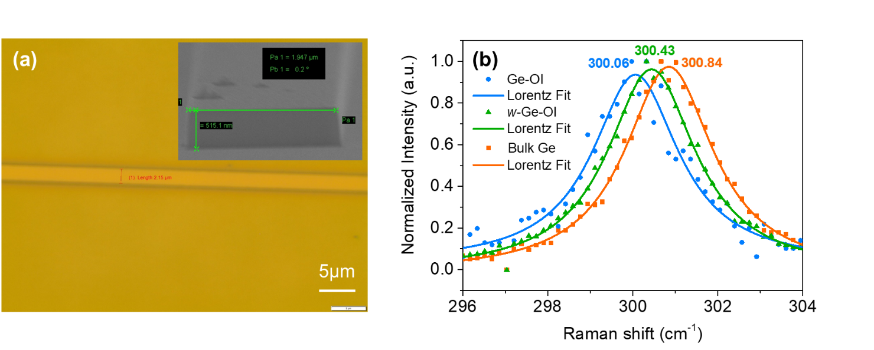
Fig. S3 (a) An optical microscope image of a fabricated w-Ge-OI structure. The inset shows a tilted SEM image of the structure; (b) Micro-Raman spectra of the fabricated w-Ge-OI, with the spectra of bulk Ge and thin film Ge-OI as reference.

S4. SiN_{x} stress characterization and optimization
SiN_{x} films were deposited on 150-mm Si (111) wafers for the characterization of its intrinsic stress. All wafers were RCA-cleaned followed by a diluted HF (1:10) dip before the deposition. No film delamination or crack was observed after deposition. The calculation of the intrinsic stress in SiN_{x} was carried out using the Stoney’s equation³ as below:
$σ=\frac{B{t_{s}}^{2}}{6t_{f}}\left(\frac{1}{r_{a}}-\frac{1}{r_{b}}\right)$ (S.7)
where $B= \frac{E}{1-ν}$is the biaxial modulus of Si. $E$ and $ν$ are the Young’s modulus (~160 GPa) and Poisson’s ratio (~0.27) of Si, respectively. $t_{s}$ and $t_{f}$ are the thickness of the Si wafer and deposited SiN_{x} film, respectively. $r_{a}$ and $r_{b}$ are the radius of curvature for the wafers before and after the SiN_{x} deposition, respectively. The film thickness was measured by a Filmetrics F20 film thickness measurement system, while the wafer curvatures were measured using a KLA-Tencor FLX-2320 stress measurement system.
Multiple deposition parameters can be varied for the SiN_{x} stress optimization, depending on the capability of respective PECVD systems. In general, a high RF frequency (13.56 MHz) benefits a tensile stress and a low frequency (380 kHz) benefits a compressive stress. Table S1 lists the calculated stresses from some films deposited by the Cello Aegis-20 system, along with the respective deposition parameters. Only single RF frequency was applied. The parametric trends agree well with previous studies^{4, 5, 6}. Both highly compressive (~1.04 GPa) and tensile (~750 MPa) films were achieved. Fig. S4 shows the refractive index (n) of the highly-tensile SiN_{x} obtained from the ellipsometry measurement and fitting. It can be inferred that the film is nitrogen-rich due to its lower n (~1.76) than that of stoichiometric Si₃N₄ (n ~2) at ~1,550 nm. The dual-frequency PECVD deposition used for strained Ge_{0.99}Si_{0.01} on SOI EA modulators also follows these trends. An increased ratio of the low-frequency and high-frequency plasma makes the film more compressive and tensile, respectively. A maximum compressive and tensile stresses of ~1 GPa and ~600 MPa, respectively, were achieved in the resulting films.
Table S1 Deposition parameters as well as the resulting SiN_{x} stress by Cello Aegis-20 PECVD. The deposition temperature is at 300 ºC. Negative values indicate compressive stress and positive values tensile stress.
S/N | RF frequency | SiH₄/NH₃ Ratio | RF power (W) | Chamber pressure (mT) | Film thickness (nm) | Stress (MPa)
1 | 380 kHz | 0.2 | 400 | 250 | 406 | -1040
2 | 380 kHz | 0.40 | 400 | 300 | 494 | -792
3 | 380 kHz | 0.36 | 400 | 270 | 1322 | -477
4 | 380 kHz | 0.38 | 200 | 300 | 343 | -216
6 | 13.56 MHz | 0.1 | 100 | 1000 | 183 | 301
7 | 13.56 MHz | 0.025 | 50 | 1500 | 281 | 750
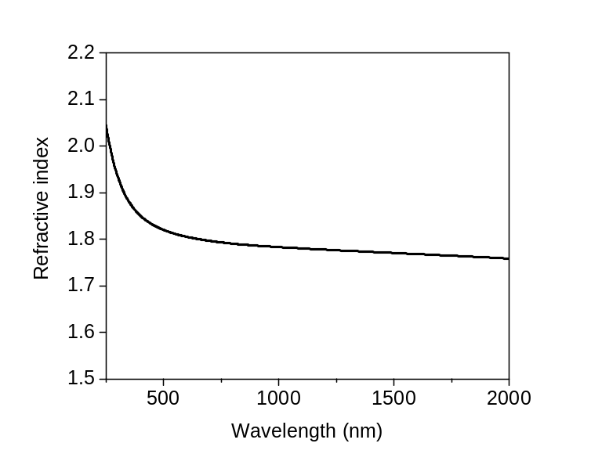
Fig. S4 Refractive index n of PECVD-deposited highly-tensile SiN_{x} in this work, obtained from ellipsometry measurements and fitting.

S5. Fabrication and supplementary characterization of SiN_{x}-strained w-Ge-OI

The process flow for the fabrication of SiN_{x}-strained w-Ge-OIs is shown in the schematics in Fig. S5. First, the as-fabricated Ge-OI (Supplementary S1) was patterned into strip waveguides, using either optical lithography or electron-beam lithography (EBL) depending on their feature sizes, followed by a chlorine (Cl₂)-based RIE. Afterwards, to form the recessed sidewall trenches, carbon tetrafluoride (CF₄)-based gases were used to continue the RIE by ~ 500 nm into the underlying SiO₂, utilizing the same resist hard mask in patterning the w-Ge-OI. This step is termed as self-aligned dry etching (SADE) and makes the process design of recessed SiN_{x} stressor simple. After the resist removal by O₂ plasma ashing, the sample was dipped in buffered oxide etchant (BOE, 6:1) to remove the residual surface oxides and organics. A layer of ~20 nm aluminium oxide (Al₂O₃) was then deposited via atomic layer deposition (ALD) at 250 ºC. This was followed by an O₂ plasma treatment at 100 W for 15 s to enhance the stressor adhesion to w-Ge sidewalls (Supplementary S6. II). SiN_{x} with a tensile stress of ~580 MPa was then deposited by PECVD up to the thickness of w-Ge-OI. The characterization of the SiN_{x} stress is discussed in Supplementary S4. After the deposition, a second EBL patterning was performed, followed by the CF₄-based RIE to remove the SiN_{x} layer at the waveguide top. The purpose for the top SiN_{x} removal is elaborated in Supplementary S6. I. The CF₄-based RIE stopped when the residual SiN_{x} was ~50 nm, after which a sulfur hexafluoride (SF₆)-based RIE was taken over to complete the SiN_{x} removal. The etching was implemented with a low RF power and high chamber pressure to mitigate the ion-bombardment damage to Al₂O₃. The high etching selectivity between the SiN_{x} and Al₂O₃ makes the Al₂O₃ an etch-stop layer to protect the Ge underneath. Finally, the samples were capped with a ~200 nm SiO₂ by PECVD. As a comparison, w-Ge-OIs without using SADE were also prepared, by skipping the step III in Fig. S5.
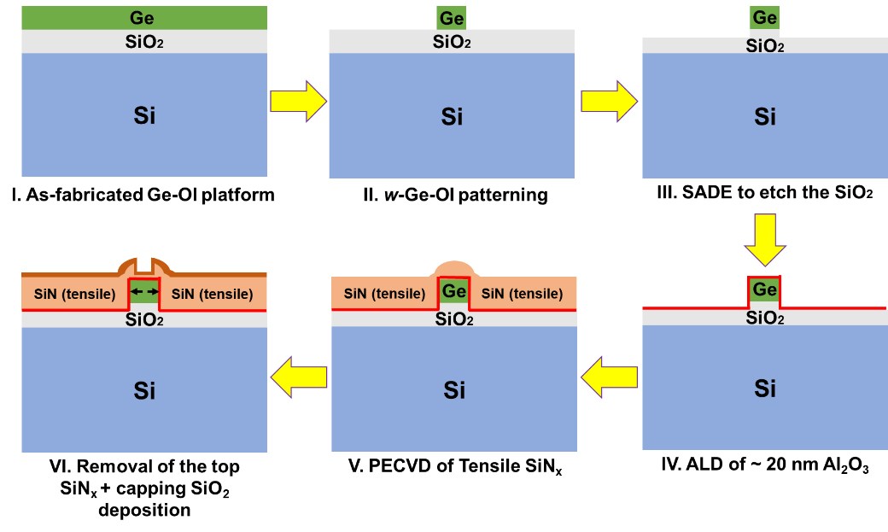
Fig. S5 Process flow schematics for the fabrication of SiN_{x}-strained w-Ge-OI.
Fig. S6 shows the cross-sectional SEM images of the fabricated w-Ge-OIs. Both structures are fabricated with good quality. The Ge layers are ~100 nm thick as expected. Sidewall trenches in (b) are clearly identifiable to accommodate the recessed SiN_{x} stressors and are ~460 nm deep into SiO₂. Interestingly, similar micro-Raman measurements on 2 µm-wide w-Ge-OIs (Fig. S7a) do not exhibit the compressive shoulder as that seen in the 0.5 µm-wide w-Ge-OIs. This makes the accumulation of the compressive strain plausible near both sidewalls of w-Ge-OI, since the incident laser spot is near the waveguide center and its diameter (~1 µm) is smaller than the waveguide width (2 µm). To verify this point, micro-Raman measurements were performed at both the centre and edge of the 2 µm-wide w-Ge-OIs (Fig. S7b top insets). As shown in Fig. S7b top, the structure without the recessed stressor shows distinct LO phonon peaks at the centre and edge, and the strain at the edge is lower. With the use of the recessed stressor, the strain at the edge is enhanced (Fig. S7b bottom). Hence, these results verify that the compressive strain is accumulated at the bottom of the w-Ge-OI close to sidewalls. A qualitative two-dimensional (2-D) strain mapping was thus constructed, by combining and comparing all the measurement results (Fig. S7c). Hence, it can be concluded that, with tensile SiN_{x} stressor, the recessed stressor configuration turns the compressive strain induced by the non-recessed SiN_{x} stressor into tensile near both sidewalls of w-Ge-OI at the bottom, thus improving the tensile strain uniformity in Ge with an enhanced average strain magnitude.
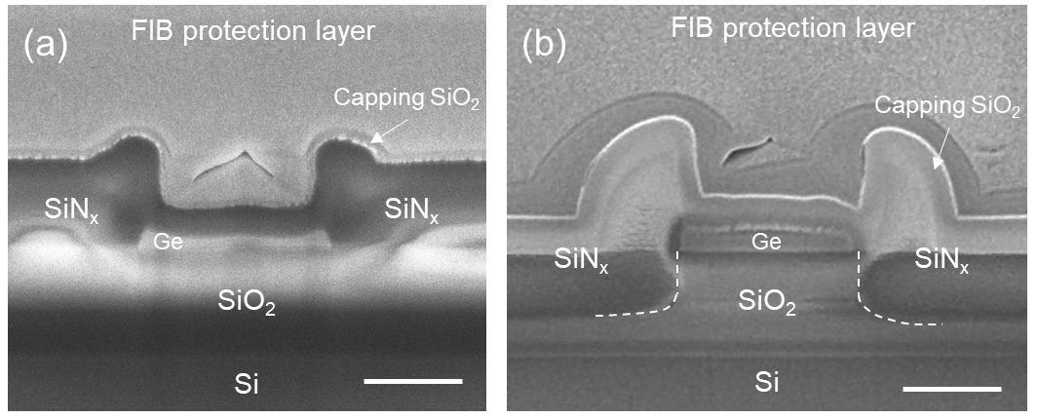
Fig. S6 Cross-sectional SEM images of fabricated w-Ge-OIs (a) without and (b) with the use of the recessed SiN_{x} stressor, prepared by focused-ion beam (FIB) cutting. Scale bar: 500 nm.
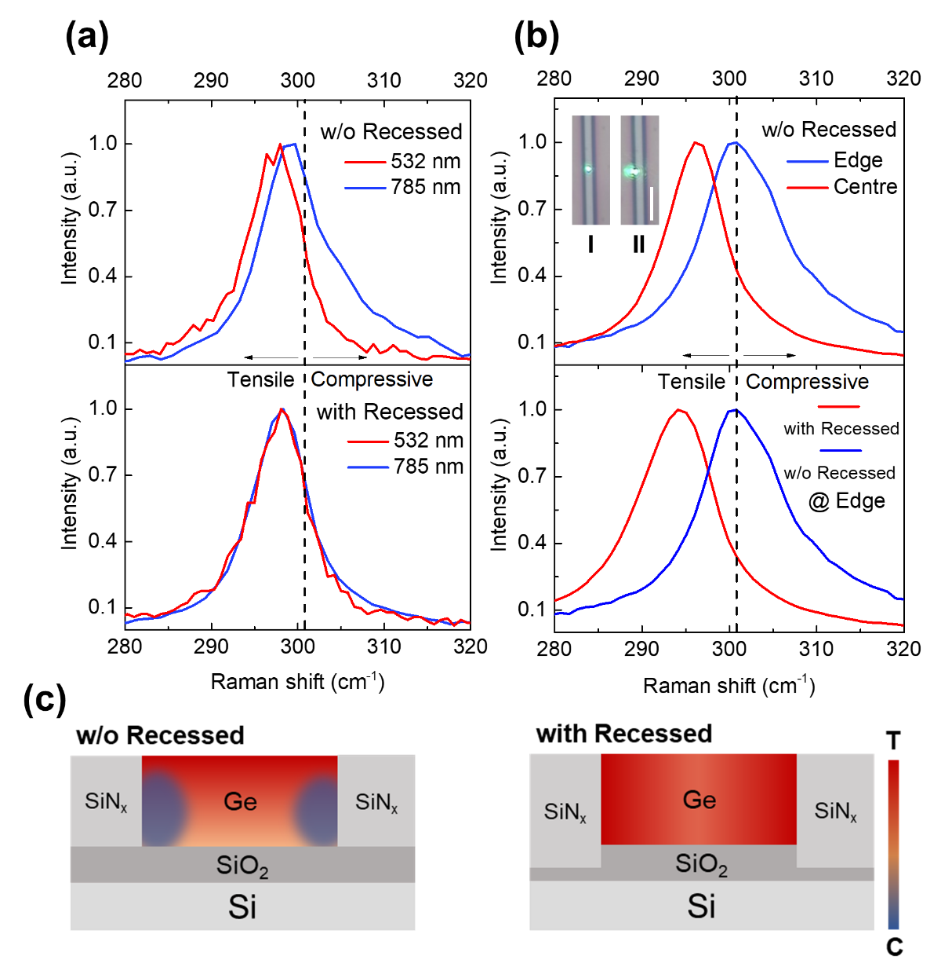
Fig. S7 Micro-Raman spectra of strained w-Ge-OIs with a width of 2 µm at (a) the centre of the waveguides at both 532 and 785 nm and (b) both the centre and edge of the waveguides at 785 nm. The insets in (b) show optical microscope images of the waveguides under the measurement with the incident laser spots at the waveguide (I) centre and (II) edge. Scale bar: 10 µm. For a clear visual effect, the images were captured at the laser wavelength of 532 nm; (c) Schematic strain distribution in Ge without (left) and with (right) the sidewall SiN_{x} stressor recessed, inferred from the micro-Raman results in Fig. 2h, Fig. S7a and b. The colour coded bar indicates the magnitude of strain, where a higher magnitude of tensile (T) and compressive (C) strain correspond to a warmer and colder colour code, respectively.

S6. Key process development

Effect of top SiN_{x} removal on Ge strain

Fig. S8 shows the micro-Raman spectrum at 532 nm of a w-Ge-OI deposited with tensile SiN_{x} without its removal at the waveguide top (step VI in Fig. S5). The waveguide and the SiN_{x} film are both ~400 nm thick, as shown in the insets. A spectrum from bulk Ge is also included as a reference. The Raman peak of the w-Ge-OI is blue-shifted, compared to bulk Ge, indicating a compressive strain at the top of Ge. This is in significant contrast to the red-shift of the spectra for w-Ge-OIs with top SiN_{x} removal (Fig. 2g). This can be easily understood as a material with a tensile stress at the top could induce a compressive strain to the material underneath. Therefore, to maximize the strain in Ge, it is necessary to remove the SiN_{x} at the top of w-Ge-OI.
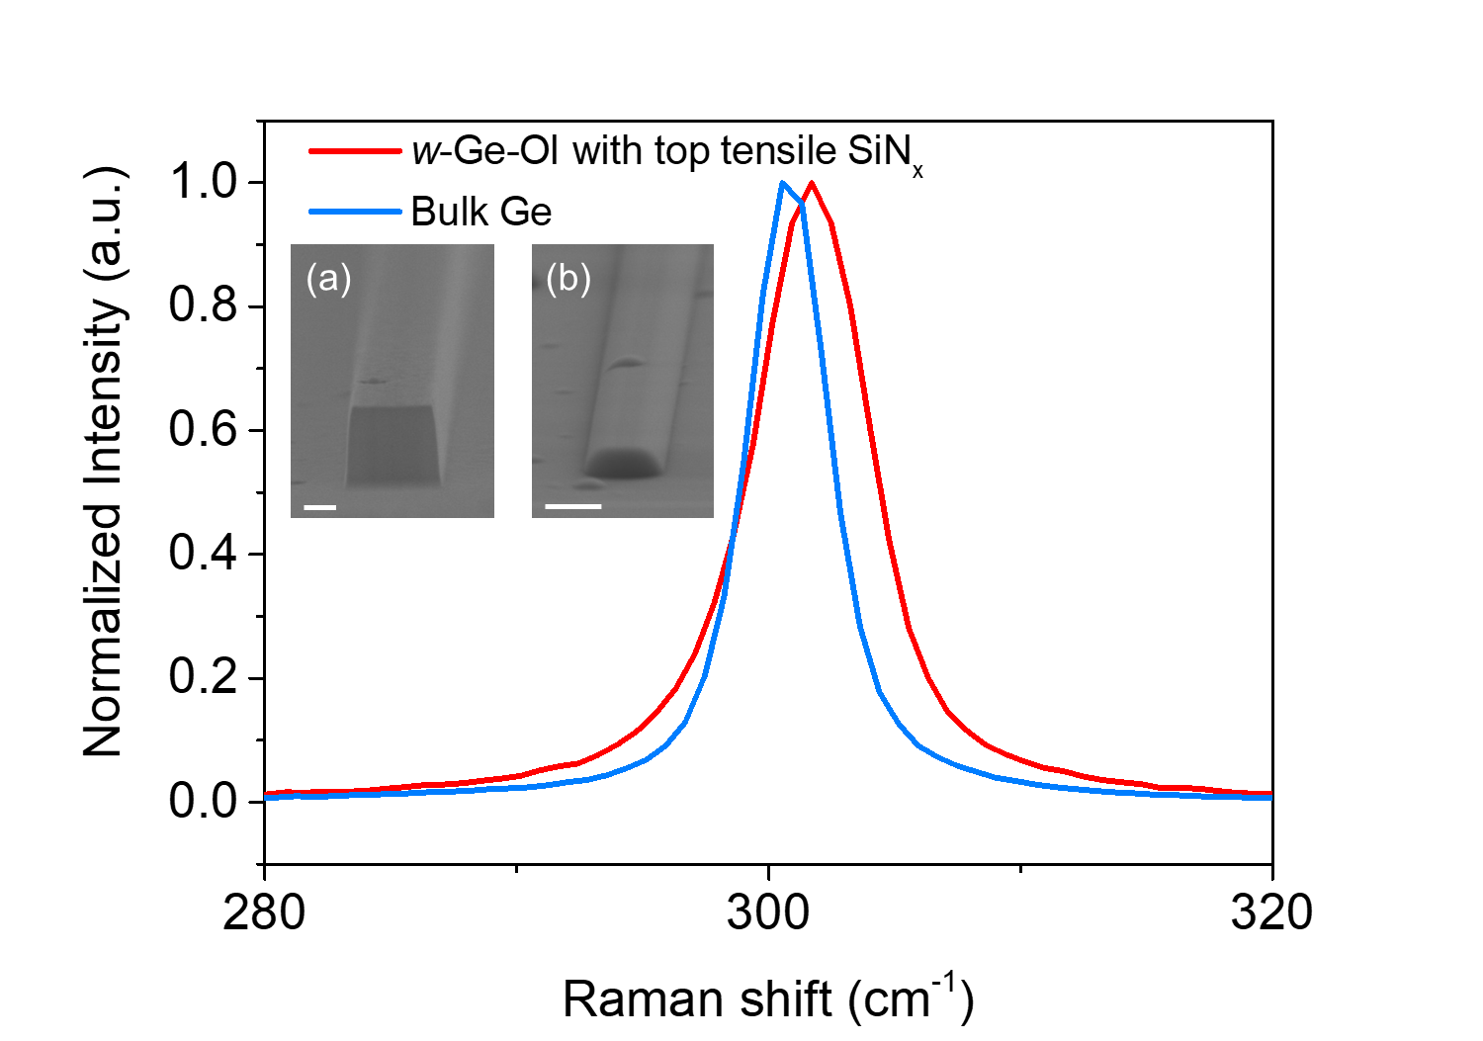
Fig. S8 Micro-Raman spectrum of a w-Ge-OI deposited with tensile SiN_{x} without its removal at the waveguide top. Insets: tilted-angle SEM images of the w-Ge-OI (a) before and (b) after the SiN_{x} deposition. Scale bars: (a) 200 nm and (b) 1 µm. In this study, the stressors are not recessed.

Stressor adhesion enhancement to Ge sidewalls

A common phenomenon following the top SiN_{x} removal, observed from early-batch tensile SiN_{x}-strained w-Ge-OIs, is the gradual detachment of the stressors from the w-Ge-OI sidewalls. The SiN_{x} from these batches was directly deposited on w-Ge-OI after the BOE treatment (as in Supplementary S5), followed by the top SiN_{x} removal. As can be seen from Fig. S9a, the corresponding Ge Raman peak exhibits a blue-shift progressively with time and matches with that of w-Ge-OI without SiN_{x} stressor after 9 days, indicating a gradual relaxation of the tensile strain in Ge. The corresponding tilted SEM image in the inset reveals a complete delamination of the stressor from the waveguide sidewalls, explaining the reason for the strain relaxation. This would result in a reliability limitation to the tensile-strained Ge photodetectors and EA modulators, as only the tensile stress would lead to the delamination. Therefore, as discussed in Supplementary S5, O₂ plasma treatment was adopted before the SiN_{x} deposition to enhance the stressor adhesion, along with the incorporation of the Al₂O₃ interlayer and SiO₂ capping layer. The Al₂O₃ and SiO₂ layers are believed to passivate the Ge from oxidation to form volatile GeO_{x} that could weaken the SiN_{x}/Ge adhesion. The O₂ plasma treatment has been widely used in direct wafer bonding for a higher bonding strength⁷. The treatment increases the number of activated surface groups for the formation of interfacial covalent bonds. It is thus similarly anticipated that the treatment could populate the covalent bond formation between SiN_{x} and Ge. The resulting w-Ge-OI structure, as shown in Fig. S7b, exhibits consistent Raman peaks independent of time. There is no observable tensile strain relaxation even after 2 years. The corresponding tilted SEM image also verifies that the stressor is not delaminated from the sidewalls. Hence, this method can be useful for an improved reliability of tensile SiN_{x}-strained Ge photodetectors and EA modulators.
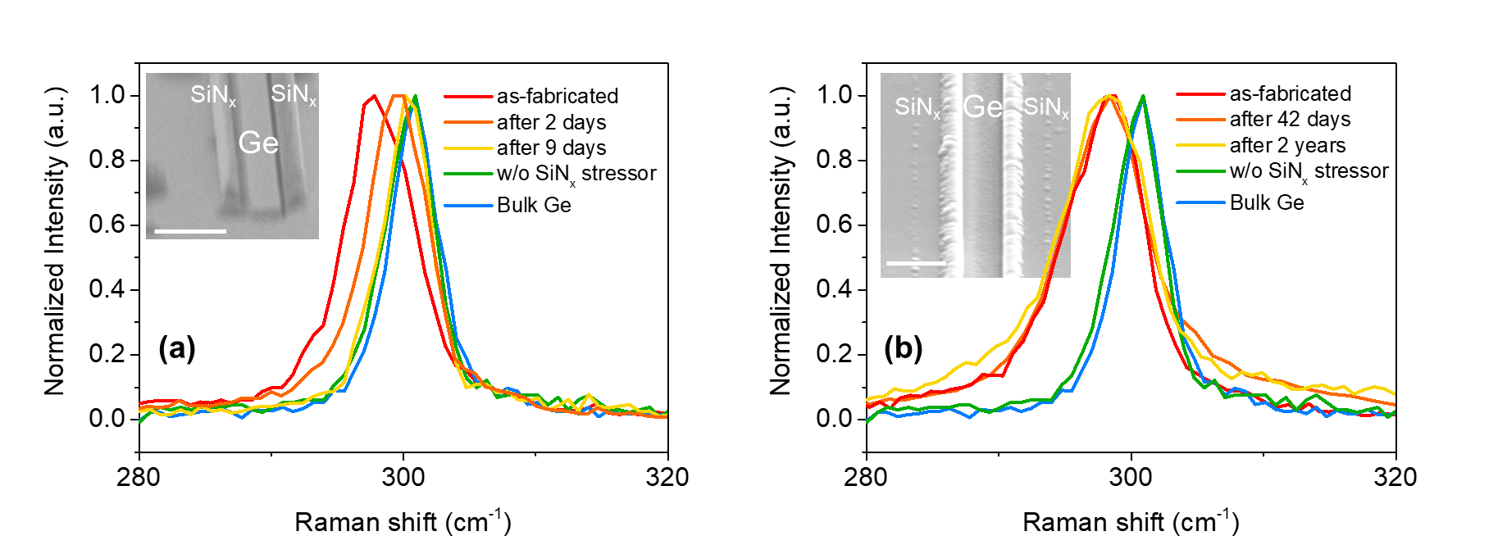
Fig. S9 Micro-Raman spectra of tensile SiN_{x}-strained w-Ge-OIs (a) without and (b) with the use of the O₂ plasma treatment, together with the incorporation of Al₂O₃ interlayer and SiO₂ capping layer, with respect to the time since they were fabricated. The spectra of a w-Ge-OI without SiN_{x} stressor and bulk Ge were included as reference. Insets show tilted SEM images of the corresponding w-Ge-OIs after (a) 9 days and (b) 2 years. Scale bar: 1 µm. In this study, the laser wavelength is 532 nm and the stressors are not recessed.

S7. Ge strain with respect to SiN_{x} stressor width
Form factor has become a key performance indicator for integrated electronic systems, with the continuing downscaling of transistors. A system with a small form factor could facilitate a compact integration with a reduced cost and an improved performance, which also applies to PICs. Fig. S10b shows the micro-Raman spectra of recessed SiN_{x}-strained w-Ge-OIs with respect to the widths (2, 5 and 10 µm) of the respective SiN_{x} stressor at Ge sidewalls. The width for all w-Ge-OIs is 1 µm. A cross-sectional schematic of the structure under test is depicted in Fig. S10a, specifying the stressor width w. The spectra highly overlap at these widths, exhibiting a consistent Ge tensile strain irrespective of the stressor width. It is noteworthy that the width of 10 µm is also the width adopted in the fabrication of all w-Ge-OIs and the corresponding MSM photodetectors in this work. This means that the effect of the SiN_{x} stressor can be sustained very well down to a SiN_{x} width (i.e. w-Ge spacing) of 2 µm, enabling a highly-compact electronic-photonic integration. This result is encouraging especially for the integration of arrays of Ge photodetectors and EA modulators for broadband applications.
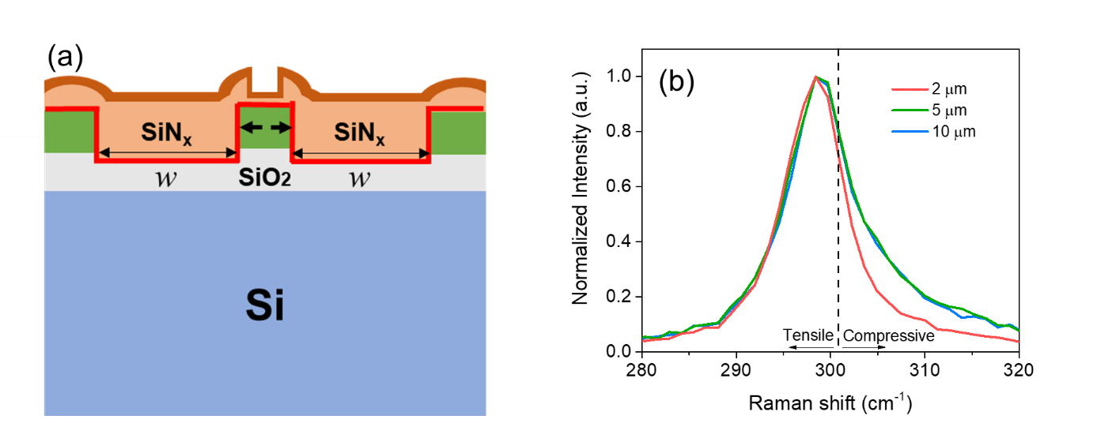
Fig. S10 (a) A cross-sectional schematic of SiN_{x}-strained w-Ge-OI indicating the SiN_{x} stressor width w; (b) The corresponding micro-Raman spectra at the stressor widths of 2, 5 and 10 µm. In this study, the stressors are recessed.

S8. Fabrication of SiN_{x}-strained w-Ge-OI MSM photodetectors
The fabrication of SiN_{x}-strained w-Ge-OI MSM photodetectors follows the process for the SiN_{x}-strained w-Ge-OI fabrication (Fig. S5) at the initial two steps, as shown in Fig. S11. In step III, a second EBL patterning and RIE was performed, instead of a direct SADE in Fig. S5, for the recessed trenches. This is to avoid the over-etching of the resist hard mask by SADE and provide more design flexibility for the trench depth. After a short dip in BOE, a ~1 nm Al₂O₃ was deposited on the sample by ALD for the depinning of the Fermi-level at metal/Ge Schottky contacts. Metal stacks of Ti (bottom layer)/TiN/Al (top layer) were then sputtered sequentially, followed by lift-off, to form and pattern the contacts. Afterwards, as discussed in Supplementary S5, a ~20 nm Al₂O₃ was deposited again by ALD to serve as an etch-stop layer during the subsequent top SiN_{x} removal. Subsequently, surface treatment by O₂ plasma was carried out for a stronger adhesion of the SiN_{x} stressor (Supplementary S6. II). The stressor was then deposited, followed by the top SiN_{x} removal and SiO₂ capping. Finally, the dielectrics covering the probing metal pads were etched away for the ease of device characterization. For comparison, control devices of SiN_{x}-strained w-Ge-OI MSM photodetectors without using the recessed stressor, as well as un-strained w-Ge-OI MSM photodetectors without stressor (used 50-nm SiO₂ as device passivation), were fabricated. The fabrication skips step III for the non-recessed devices, and steps VI, VII and VIII for the un-strained devices.
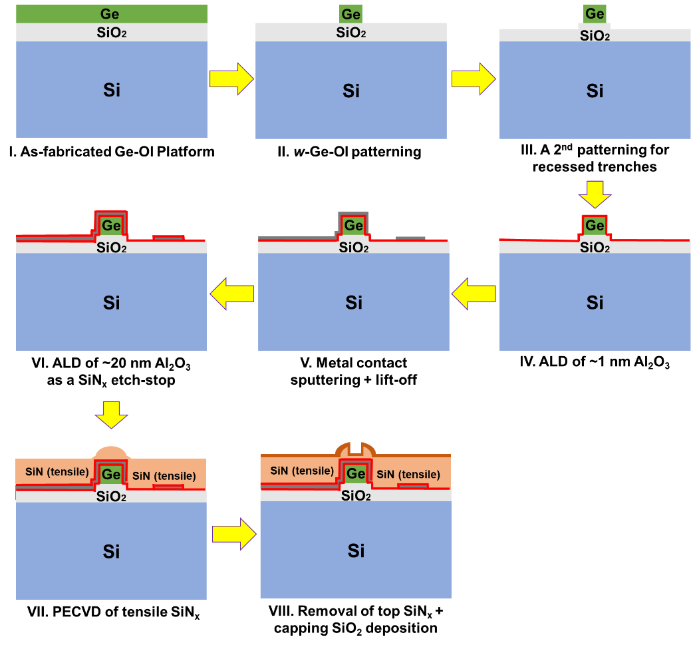
Fig. S11 Process flow schematics for the fabrication of SiN_{x}-strained w-Ge-OI MSM photodetectors.

S9. Supplementary characterization of SiN_{x}-strained w-Ge-OI MSM photodetectors

Ti/Al₂O₃/Ge metal-insulator-semiconductor (MIS) contact
To study the Ti/Al₂O₃/Ge MIS contact, the fabricated w-Ge-OI MSM photodetectors were characterized by temperature-dependent I-V measurements ranging from 293 to 353 K. The Schottky barrier height (ϕ_{B}) of the contact can thus be extracted using the following relation:
$ln\left(\frac{I}{T^{2}}\right){=}-\frac{qϕ_{B}}{k_{B}T}+ln\left(A∙A^{*}\right)$ (S.8)
where $I$ is the dark current, $T$ is the temperature in Kelvin, $k_{B}$ is the Boltzmann constant, $A$ is the diode area and $A^{*}$ is the effective Richardson’s constant. Fig. S12a and b show the plots of $ln\left(I/{T^{2}}\right)$ versus $\left(1/{kT}\right)$ for w-Ge-OI MSM photodetectors without and with the use of the SiN_{x} stressor, respectively, at a bias of 1 V. The slope of the linear fitting indicates the ϕ_{B} of the corresponding MIS contact. The detector without stressor exhibits a ϕ_{B} of ~0.33 eV, which indicates that the Fermi level of Ti has been successfully unpinned from ~0.08 eV above the Ge valence band maximum, where the Fermi level of a direct metal/Ge contact is located. Cross-sectional transmission electron microscopic (TEM) imaging reveals a ~1.3 nm interlayer between Ti and Ge (Fig. S13b), which is further verified as Al₂O₃ via energy-dispersive X-ray (EDX) elemental mapping (Fig. S13a). In contrast, the ϕ_{B} is ~0.12 eV for the SiN_{x}-strained detector. The decrease in ϕ_{B} can be explained by the image dipoles and fixed charge at the MIS interfaces induced by the trap states in SiN_{x}, since it has been reported that interfacial dipoles and charge are liable for the ϕ_{B} lowering of MIS contacts.
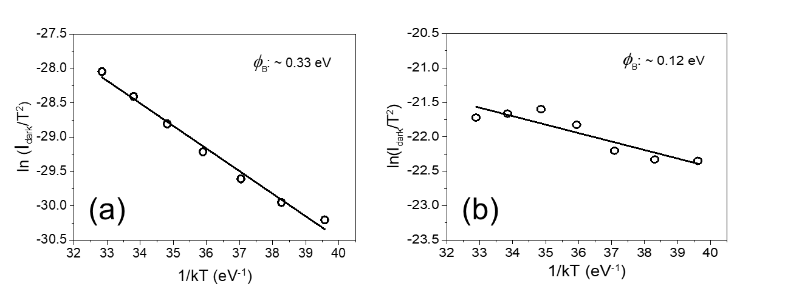
Fig. S12 Schottky barrier height (ϕ_{B}) extraction of the Ti/Al₂O₃/Ge Schottky contact in w-Ge-OI MSM photodetectors (a) without and (b) with the use of the SiN_{x} stressor at 1 V, via temperature-dependent dark current-voltage measurement.
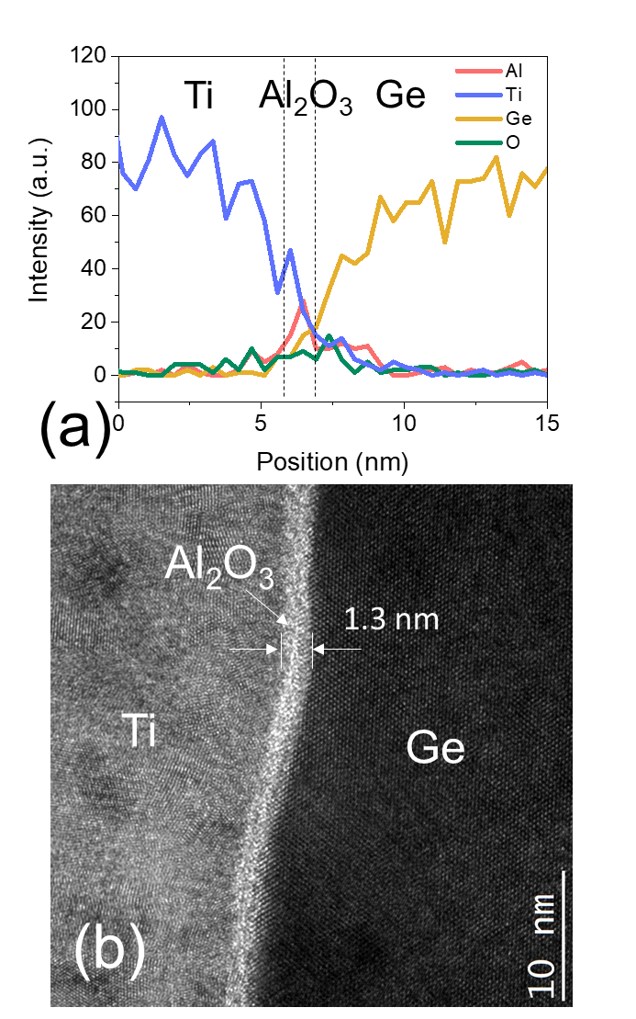
Fig. S13 (a) Elemental mapping profiles at the Ti/Al₂O₃/Ge interface via an EDX line scan, with a cross-sectional TEM image of the interface shown in (b).

IQE and dark current conduction mechanism
Fig. S14 shows the IQE of w-Ge-OI MSM photodetectors as a function of the corresponding voltage bias. The IQE increases with the bias for both devices. However, the photodetector with SiN_{x} stressor exhibits a higher IQE with a faster increasing rate, compared to that without SiN_{x} stressor. This can be attributed to the trap states in SiN_{x} that induces additional interfacial dipoles and fixed charges at the MIS contact, which enhances the electric field across the Al₂O₃ interlayer for a more significant transport of photon-generated carriers. A support to this conclusion comes from the analysis of dark current conduction mechanism of the devices, as shown in Fig. S15, which reveals a dominance of Poole-Frenkel (PF) emission at different bias ranges. The PF emission describes the emission of trapped carriers in the dielectric into current conduction, which typically occurs at a high electric field. It can be expressed by the following equation⁸:
$ln\left(\frac{J}{E}\right)= \frac{\sqrt{\frac{q^{3}}{πε_{r}ε_{0}}}}{k_{B}T}\sqrt{E}-\frac{qϕ_{t}}{k_{B}T}+ln(qN_{c}μ)$ (S.9)
where $q$ is the charge of an electron, $J$ is the dark current density, $E$ is the electric field across the Al₂O₃ interlayer, $ε_{r}$ and $ε_{0}$ are the relative and vacuum permittivity, respectively, $ϕ_{t}$ is the potential barrier of the trap, $N_{c}$ is the density of state in the conduction band and $μ$ is the mobility in the dielectric. It is observed that the photodetectors with and without stressor exhibit a linear fitting from their $ln\left(\frac{J}{E}\right)$-$\sqrt{E}$ plots starting from ~0.26 and ~1.46 V, respectively. The values of relative permittivity $ε_{r}$ of Al₂O₃ (~5.87 and ~8.68, respectively, with and without stressor), extracted from the fitted slopes, match well with that reported in literature^{8, 9, 10}. This verifies the involvement of PF emission in the current conduction of both devices. The earlier onset of PF emission for the SiN_{x}-strained device indicates a higher electric field across the corresponding Al₂O₃ interlayer, which explains its higher IQE (Fig. S14) since the higher electric field could assist the transport of photon-generated carriers through the Al₂O₃ barrier. The higher electric field can be originated from the trap states in the SiN_{x} stressor, as discussed in the main body of this article, which induces interfacial dipoles and fixed charge at the Ti/Al₂O₃/Ge MIS interface. This also explains the reduced Schottky barrier height of the MIS contact with the use of the SiN_{x} stressor (Fig. S12).
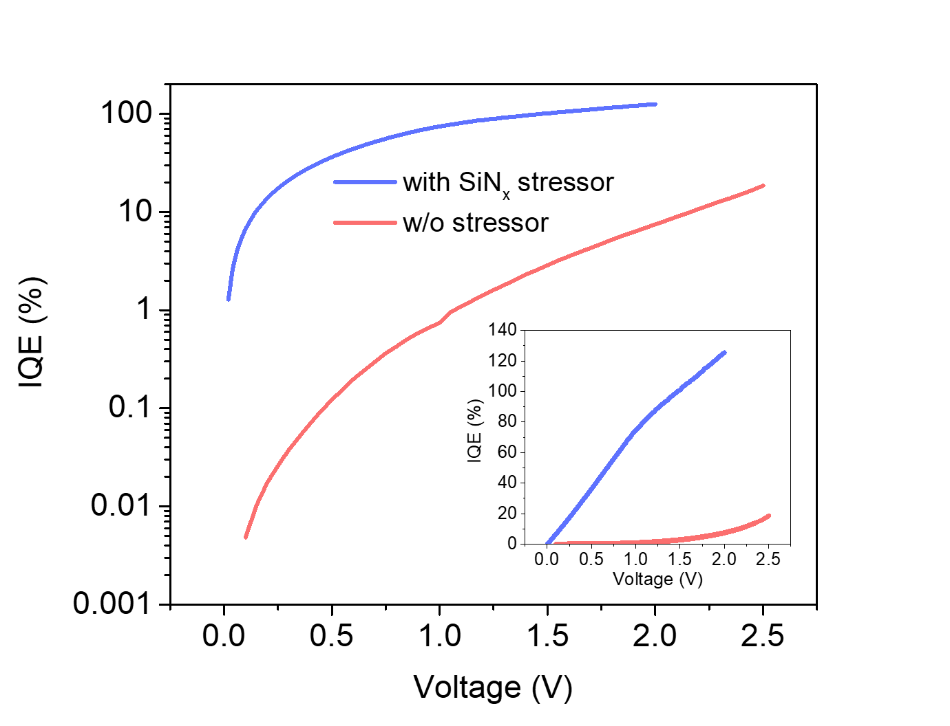
Fig. S14 IQE as a function of voltage bias for w-Ge-OI MSM photodetectors with and without the use of SiN_{x} stressor. Inset shows the plot in linear scale.
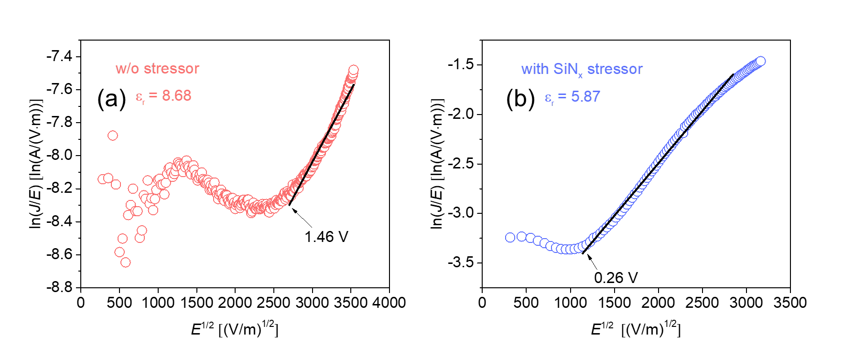
Fig. S15 Poole-Frenkel emission fitting for the dark current (at room temperature) of w-Ge-OI MSM photodetectors (a) without and (b) with the use of the SiN_{x} stressor.

Gain mechanism
Fig. S16 displays Ge electric field profiles in w-Ge-OI MSM photodetectors at different voltage biases (0.3, 1.3, and 2 V). The profiles share a same inter-digitated electrode on-Ge for an easy comparison of the electric field. Both the electrode width and the spacing between electrodes are 1 µm. The thickness of Ge is ~400 nm as that in the fabricated device. It can be found that the electric field has reached ~2×10⁵ V/m at 0.3 V, even at the bottom portion of Ge away from electrodes, where the carriers have reached a saturation drift velocity (6×10⁶ cm/s, ref. 1). Therefore, one can infer that the IQE would also saturate due to the predictable full carrier collection. However, as depicted in Fig. S14, the IQE is far below 100% at this bias and continues to increase with the bias. This discrepancy indicates that the photocurrent transport is hindered by the Al₂O₃ interlayer and this layer does not provide a gain mechanism to the photocurrent. Therefore, the gain is unlikely originated from the interfacial trapped carriers at the MIS interface related to the Al₂O₃ interlayer, which is resulted from the SiN_{x} incorporation and accounts for the Schottky barrier lowering in Fig. S12. Increasing the potential to 1.3 and 2 V results in electric field strength more than 6.3×10⁶ V/m, where avalanche multiplication has been observed¹¹. Hence, the gain can be attributed to the avalanche effect, as the electric field close to electrodes, beyond 1.5 V, has reached the threshold for avalanche multiplication, as shown in Fig. S16.
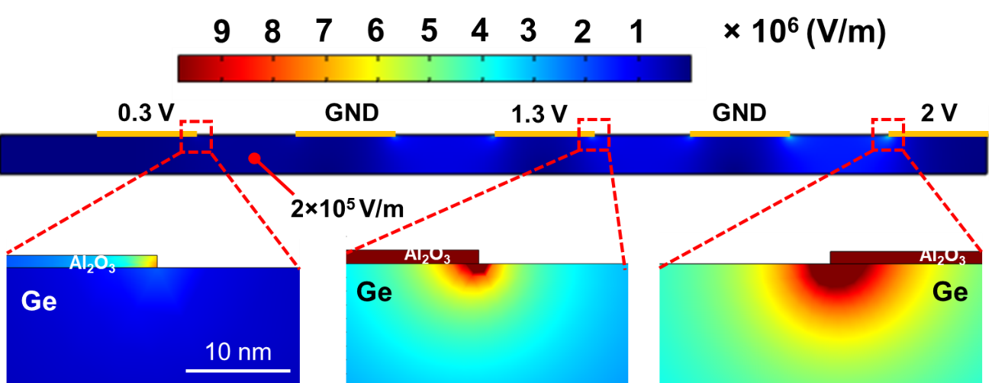
Fig. S16 Electric field simulation of w-Ge-OI inter-digitated MSM photodetector. The respective biases were applied on the 1-nm Al₂O₃ interlayers.

S10. Extraction of Ge effective absorption coefficient from photocurrent spectra
The effective absorption coefficient of SiN_{x}-strained Ge is deduced based on the photocurrent spectra in Fig. 3d (left y-axis). This is because the fabricated devices are with identical illumination and capping material structure at the w-Ge top, irrespective of the use of the (recessed) stressor. The photocurrent $I_{ph}$ for all devices can thus be considered proportional to the light absorption as follows:
$I_{ph}∝ \left(1-e^{-αd}\right)$ (S.10)
where $α$ is the Ge effective absorption coefficient and $d$ is the Ge thickness (~400 nm). Since $αd≪1$, the approximation of $1-e^{-αd}≈αd$ can be satisfied using the Maclaurin series of exponential function. Hence, both $I_{ph}$ and the corresponding device IQE $η∝αd$, as shown below:
$\frac{η_{2}}{η_{1}}=\frac{α_{2}}{α_{1}}=\sqrt{\frac{E_{in}-E_{g2}}{E_{in}-E_{g1}}}$ (S.11)
where $E_{in}$ denotes the incident photon energy and $E_{g}$ the Ge bandgap energy. The relation satisfies for any two (as subscripts 1 and 2) among the three types of fabricated devices. Here, we specifically determine the $α$ at the $E_{in}$ of 1,500 nm using Eq. S.11, where the photocurrent spectra started. The $α$ beyond across the C- and L-band can thus be obtained from the photocurrent spectra based on the $α$ at 1,500 nm. Using $α$=5,096 cm⁻¹ at 1,500 nm for bulk Ge ($E_{g}$~0.801 eV) determined from ellipsometry measurement and fitting, as well as considering the tensile strain-induced $E_{g}$ shrinkage, the $α$ for w-Ge-OI without stressor, with non-recessed and recessed stressor were deduced as 6,021, 7,767 and 8,376 cm⁻¹ at 1,500 nm, respectively. The photocurrent spectra were thus converted to Ge effective absorption coefficient spectra as the right y-axis in Fig. 3d.

S11. Bandgap edge wavelength calculation
Deformation potential theory¹² was used for the Ge bandgap edge wavelength calculation as a function of $ε_{xx}$. The theory analytically describes the correlation between the bandgap of a semiconductor material and its applied mechanical strain. The strain causes a volumetric and lattice symmetry deformation of the material, where the former is termed as hydrostatic deformation (${δE}_{hy}$) and the latter shear deformation (${δE}_{sh}$), as expressed below¹³:
${δE}_{hy}=-a(ε_{xx}+ε_{yy}+ε_{zz})$ (S.12)
${δE}_{sh}=-b(ε_{xx}+ε_{yy}-2ε_{zz})$ (S.13)
where $a$ is defined as hydrostatic deformation potential and $b$ shear deformation potential. $ε_{xx}$, $ε_{yy}$ and $ε_{zz}$ are the axial strain in the material along x, y, and z directions, respectively, induced by the stress along the respective directions. Note that $(ε_{xx}+ε_{yy}+ε_{zz})$ represents the fractional volumetric change of the material.
Considering the coupling with the spin-orbit split-off (SO) band, Ge Γ-valley conduction-band-light-hole bandgap E_{g}^{LH} and conduction-band-heavy-hole bandgap E_{g}^{HH} can be expressed as follows, respectively:
$E_{g}^{LH}=E_{g}-{δE}_{hy}-\frac{1}{4}{δE}_{sh}+\frac{1}{2}∆-\frac{1}{2}\sqrt{∆^{2}+∆∙{δE}_{sh}+\frac{9}{4}{{δE}_{sh}}^{2}}$ (S.14)
$E_{g}^{HH}=E_{g}-{δE}_{hy}+\frac{1}{2}{δE}_{sh}$ (S.15)
where E_{g} is the bandgap of stress-free Ge (0.801 eV) and $∆$is the spin-orbit energy splitting between the degenerated topmost valence band and the SO valence band of Ge. The $∆$, $a$ and $b$ values for Ge used in calculation are 0.289 eV, -8.97 and -1.88, respectively, from the experimental determination by Liu et al.¹⁴. As mentioned, $ε_{xx}$ is the strain variable and $ε_{yy}=$ 0.17% is a constant according to Supplementary S3; $ε_{zz}$ is thus determined from Eqs. S.1 to S.3 based on Poisson effect. The obtained $E_{g}^{LH}$ and $E_{g}^{HH}$values were then converted to bandgap edge wavelengths via $λ=\frac{hc}{E_{g}}$, where $h$ and $c$ are the Planck’s constant and speed of light, respectively.

S12. Fabrication and characterization of tensile SiN_{x}-strained Ge_{0.99}Si_{0.01} EA modulator arrays

The strained modulators array was fabricated in MIT Nano and the Substrate Engineering Lab Cleanroom Facilities. First, boron implantation was performed on Si on 150-mm (100) SOI (250-nm Si on 3-µm SiO₂) wafers. After dopant activation and a standard RCA cleaning, the wafers were immediately loaded into the ultrahigh vacuum chemical vapor deposition (UHV-CVD) system for Ge_{0.99}Si_{0.01} epitaxial growth. The growth comprises of a 40-nm buffer layer grown at 350 ºC, followed by a ~300-nm layer of high material quality at 730 ºC. The wafers were then cyclically-annealed, followed by a poly-Si layer growth on top of the Ge_{0.99}Si_{0.01} layer. Phosphorous was implanted with subsequent thermal annealing for an n-type poly-Si contact layer. Ge_{0.99}Si_{0.01} waveguide-mesa of various widths were patterned using EBL and etched using reactive-ion etching. A SiN_{x} stressor layer was deposited via multi-frequency plasma-enhanced chemical vapor deposition. Finally, trenches were opened for the metal contacts. Multiple modulators with various widths from 400 nm to 4 µm are simultaneously fabricated in the same process flow to achieve the modulator arrays.
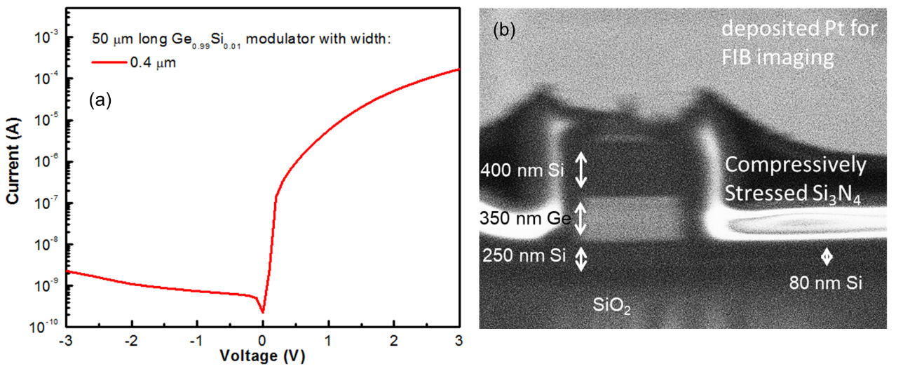
Fig. S17 (a) Dark current-voltage characteristics of a fabricated modulator; (b) A cross-sectional SEM image of a fabricated modulator.

S13. Optical transmission and ER measurement set-up

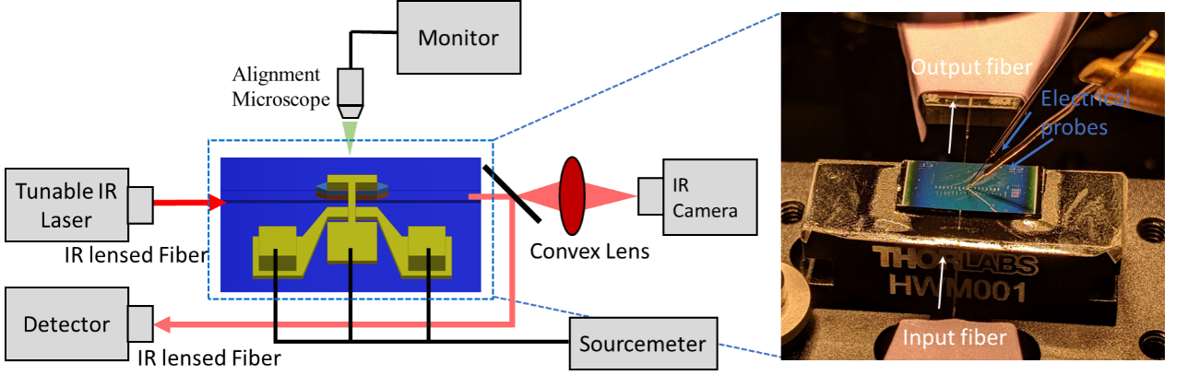
Fig. S18 A schematic of the optical transmission measurement stage (left) with the electrical probe station (right) for the modulator performance characterization.

S14. Ge strain and bandgap extraction from optical transmission spectra using Franz-Keldysh model

Table S2 Extraction of Ge strain (ε_{xx} measured) and bandgap (E_{g} measured) from the optical transmission spectra using the FK model and compare with the simulated ε_{xx} from finite element simulation. ER peak wavelengths are also listed, which are consistent with the corresponding strain and bandgap variation.
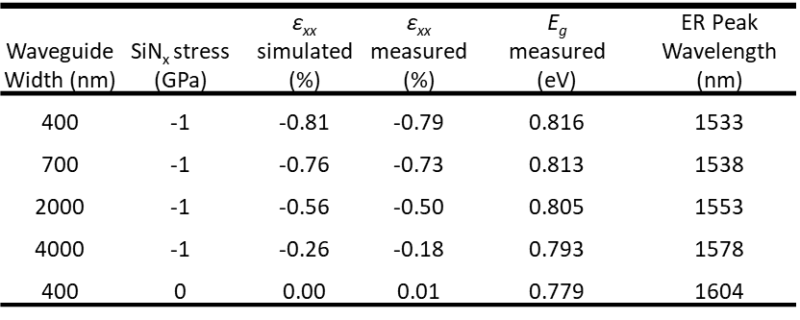

References
1. Lin Y, Lee KH, Bao S, Guo X, Wang H, Michel J, et al. High-efficiency normal-incidence vertical p-i-n photodetectors on a germanium-on-insulator platform. Photonics Research 2017, 5(6): 702-709.
2. Ossikovski R, Picardi G, Ndong G, Chaigneau M. Raman spectroscopy and polarization: Selected case studies. Comptes Rendus Physique 2012, 13(8): 837-852.
3. Stoney GG. The Tension of Metallic Films Deposited by Electrolysis. Proceedings of the Royal Society of London Series A 1909, 82(553): 172.
4. Temple-Boyer P, Rossi C, Saint-Etienne E, Scheid E. Residual stress in low pressure chemical vapor deposition SiNx films deposited from silane and ammonia. Journal of Vacuum Science & Technology A: Vacuum, Surfaces, and Films 1998, 16(4): 2003-2007.
5. Belyansky M, Chace M, Gluschenkov O, Kempisty J, Klymko N, Madan A, et al. Methods of producing plasma enhanced chemical vapor deposition silicon nitride thin films with high compressive and tensile stress. Journal of Vacuum Science & Technology A: Vacuum, Surfaces, and Films 2008, 26(3): 517-521.
6. R. Arghavani LX, H. M’Saad, M. Balseanu, G. Karunasiri, A. Mascarenhas, and S. E. Thompson. A Reliable and Manufacturable Method to Induce a Stress of >1 GPa on a P-Channel MOSFET in High Volume Manufacturing. IEEE Electron Device Letters 2006, 27(2).
7. Lee KH, Bao S, Chong GY, Tan YH, Fitzgerald EA, Tan CS. Fabrication and characterization of germanium-on-insulator through epitaxy, bonding, and layer transfer. Journal of Applied Physics 2014, 116(10): 103506.
8. Spahr H, Montzka S, Reinker J, Hirschberg F, Kowalsky W, Johannes H-H. Conduction mechanisms in thin atomic layer deposited Al2O3 layers. Journal of Applied Physics 2013, 114(18).
9. Yip G, Qiu J, Ng WT, Lu ZH. Effect of metal contacts on the electrical characteristics of Al2O3 dielectric thin films. Applied Physics Letters 2008, 92(12): 122911.
10. Tanner CM, Perng Y-C, Frewin C, Saddow SE, Chang JP. Electrical performance of Al2O3 gate dielectric films deposited by atomic layer deposition on 4H-SiC. Applied Physics Letters 2007, 91(20): 203510.
11. Assefa S, Xia F, Vlasov YA. Reinventing germanium avalanche photodetector for nanophotonic on-chip optical interconnects. Nature 2010, 464(7285): 80-84.
12. Van de Walle CG. Band lineups and deformation potentials in the model-solid theory. Physical Review B 1989, 39(3): 1871-1883.
13. Chuang SL. Physics of photonic devices, vol. 80. John Wiley & Sons, 2012.
14. Liu J, Cannon DD, Wada K, Ishikawa Y, Danielson DT, Jongthammanurak S, et al. Deformation potential constants of biaxially tensile stressed Ge epitaxial films on Si(100). Phys Rev B: Condens Matter Mater Phys 2004, 70: 155309.

