Salpingectomy Simulation
Appendix B:
Materials & Instructions for Assembly

Materials & Cost
- Porcine intestine | Grocery store, Asian food market | $13
- Wire | Galvanized hanging wire is an example; hardware store or Amazon | $2-$12 depending on length purchased
- Circular felt furniture leg pads | Amazon (brands: scotch) or hardware store | $2.79
- Silicone lid for bowls or pots/pans | Amazon | $15-17 for set of 4
- Dishwasher basket for bottle accessories | Amazon (brands: OXO, Munchkin) | $6.99-$11.99
- Monocryl suture, needle driver, scissors | n/a | n/a

A. Preparing the base of the model:

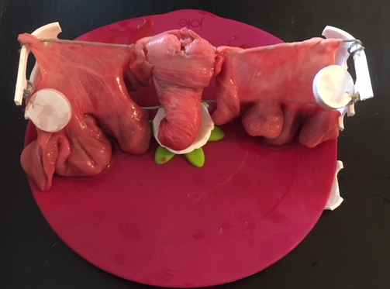
3. String metal wire
2. Place silicone lid at base
1. Trim the basket
- Trim the dishwasher basket using heavy duty scissors to create a base and with pelvic sidewalls, like a frame or cage.
- Place a silicone lid at the center of the basket base, the silicone lid should not be significantly larger than the width of the basket. The baskets are typically 8-9 inches wide.
- String metal wire from one side of the basket to the other, this will create the round ligaments (RL) and a support for the uterus.

B. Preparing the Porcine Intestine – Simulating a Uterus and Fallopian Tubes
This is the large intestine. A section can be utilized to represent the uterus.

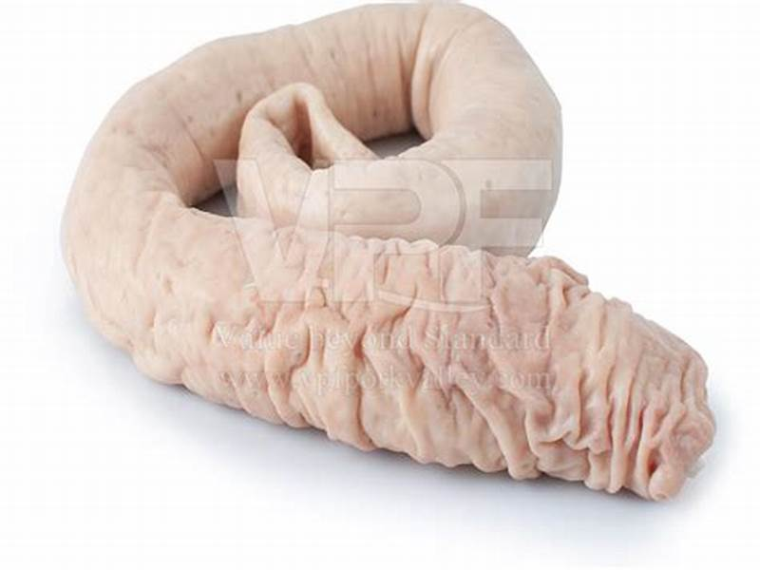

The pig intestine also has a mesentery. The intestine can be divided into 8-9 cm segments to simulate the fallopian tubes (A), and the mesentery will simulate the mesosalpinx (B).

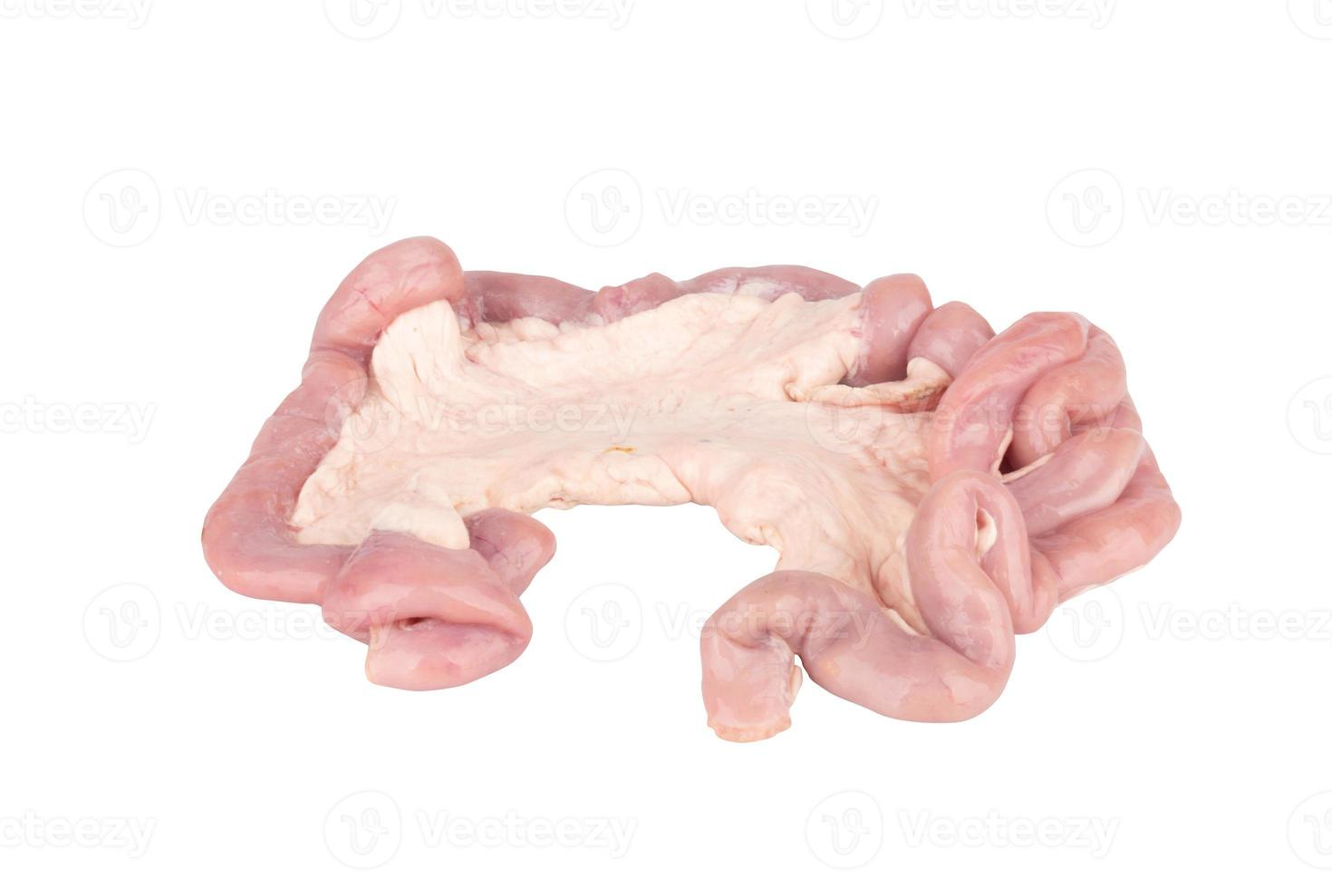
B
A

C. Model Assembly

Round Ligament
UO Ligament
Ovary
Tube
Mesosalpinx
Uterus

- The uterus is sutured to the wire in the midline. The mesosalpinx and tube are draped over the wire and secured with suture to the uterus at the “cornua.” The fallopian tubes should drape down but be secure enough to allow for surgical dissection. The mesosalpinx can be secured around the wire with suture for additional stability.
- An additional metal wire is placed to simulate the utero-ovarian ligament (UO) and can be sutured to the uterus at a point more anterior or closer to the fundus of the uterus than is depicted in this image.
- The felt furniture pad is sutured to the distal end of the fallopian tube and to the lateral attachments of the wire. This pad is intentionally placed close to but not attached to the tube to create a space between the fallopian tube and ovary to allow for safe removal.

D. Final Setup in the Box Trainer

