Supplementary Material for:
Volcanic gas hazards from Kolumbo Volcano, Greece: observations and gas transport modelling
Matteo Cerminara¹ · Peter Baxter² · Augusto Neri¹ · R. Stephen J. Sparks³ · Orlando Vaselli⁴ · Georges Vougioukalakis¹

¹ Istituto Nazionale di Geofisica e Vulcanologia, Sezione di Pisa, Pisa, Italy
² Department of Public Health and Primary Care, University of Cambridge, Cambridge, UK
³ School of Earth Sciences, University of Bristol, Bristol BS8 1RJ, UK
⁴ Department of Earth Sciences, University of Florence, via La Pira, 4, 50121, Florence, Italy
⁵ Dep. of Natural & Technological Hazards, Hellenic Survey of Geology and Mineral Exploration, Athens, Greece
matteo.cerminara@ingv.it
Gas cloud evolution visualization
To visualize the evolution of the portion of the cloud where volcanic gas is present in a significant amount, isosurfaces at constant volcanic gas mass fraction have been extracted from the transient 3D simulations. The threshold value is set to $y_{g}=3.$0 wt.% corresponding to a concentration of $ϵ_{g}=2.2$ vol.% and a dilution factor $Λ≃50$. Figures SM1−SM6 display this isosurface for ID01−ID06, respectively (as in Figs. 2 and 5). The colormap represents the flow height at the selected threshold, with average, when the stationary state is achieved, $h_{2\%}$ reported for each scenario in Table 2. The gravity current reaches a stationary condition in the part of the domain closer than 8 km from the source after a period $t_{s}$ from the emission (Table 2). A video depicting the entire evolution of each scenario is available in supplementary video id01−id06, each corresponding to one of the following figures SM1−SM6.

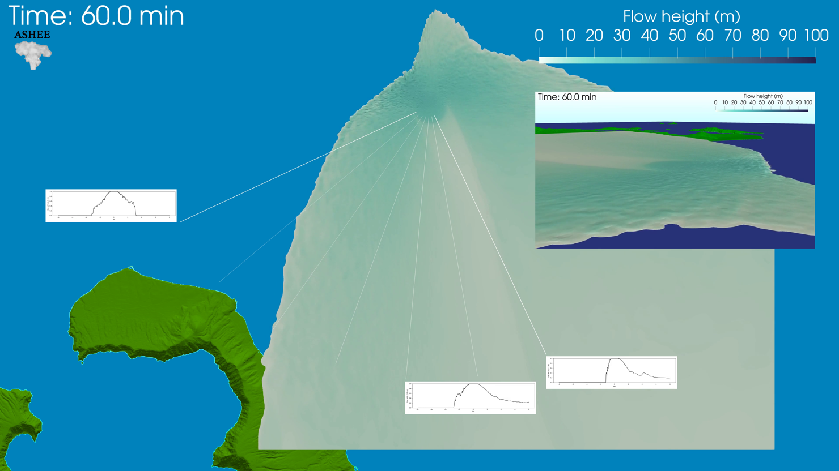
Fig. SM1 Top view of the gravity current described by Simulation ID01 after 1 h of evolution. The isosurface shown corresponds to the threshold gas concentration $ϵ_{g}=2.2$ vol.%. The colormap indicates the height of the isosurface above the sea level. The 7 white lines represent segments from line1 (perpendicular to wind) to line7 (parallel to wind), chosen for measuring gas content at 1.5 m a.s.l. (Fig. 5). The 3 plots at the end of line1, line5, and line7 display the gas mass fraction along those lines, spanning from -8 km to 8 km from the vent, after 1 h of evolution. The inset map provides a side view of the same isosurface.

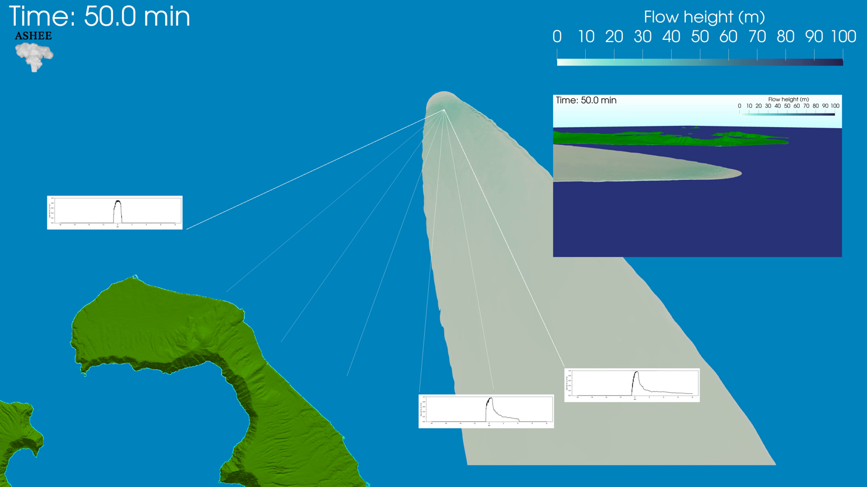
Fig. SM2 Top view of the gravity current described by Simulation ID02 after 50 min of evolution. The isosurface shown corresponds to the threshold gas concentration $ϵ_{g}=2.2$ vol.%. The colormap indicates the height of the isosurface above the sea level. The 7 white lines represent segments from line1 (perpendicular to wind) to line7 (parallel to wind), chosen for measuring gas content at 1.5 m a.s.l. (Fig. 5). The 3 plots at the end of line1, line5, and line7 display the gas mass fraction along those lines, spanning from -8 km to 8 km from the vent, after 50 min of evolution. The inset map provides a side view of the same isosurface.

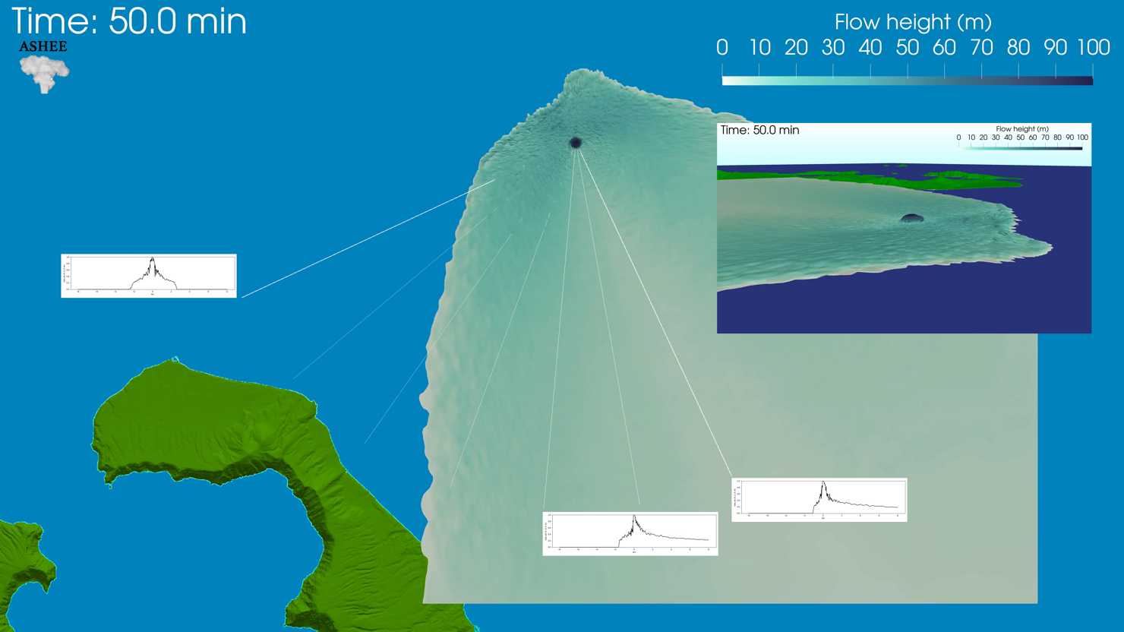
Fig. SM3 Top view of the gravity current described by Simulation ID03 after 50 min of evolution. The isosurface shown corresponds to the threshold gas concentration $ϵ_{g}=2.2$ vol.%. The colormap indicates the height of the isosurface above the sea level. The 7 white lines represent segments from line1 (perpendicular to wind) to line7 (parallel to wind), chosen for measuring gas content at 1.5 m a.s.l. (Fig. 5). The 3 plots at the end of line1, line5, and line7 display the gas mass fraction along those lines, spanning from -8 km to 8 km from the vent, after 50 min of evolution. The inset map provides a side view of the same isosurface.

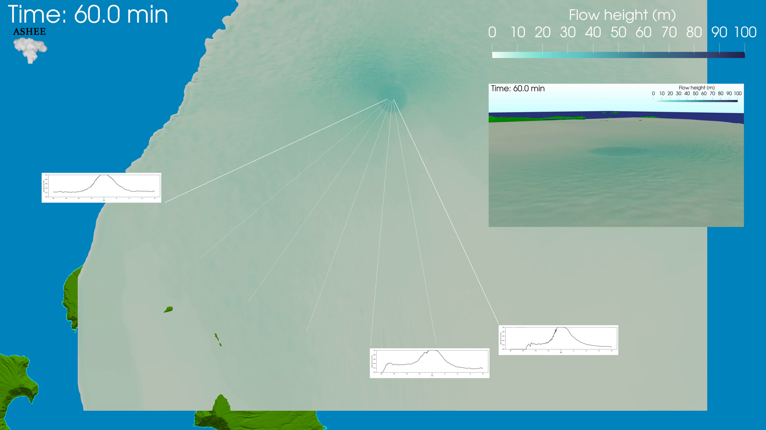
Fig. SM4 Top view of the gravity current described by Simulation ID04 after 1 h of evolution. The isosurface shown corresponds to the threshold gas concentration $ϵ_{g}=2.2$ vol.%. The colormap indicates the height of the isosurface above the sea level. The 7 white lines represent segments from line1 (perpendicular to wind) to line7 (parallel to wind), chosen for measuring gas content at 1.5 m a.s.l. (Fig. 5). The 3 plots at the end of line1, line5, and line7 display the gas mass fraction along those lines, spanning from -8 km to 8 km from the vent, after 1 h of evolution. The inset map provides a side view of the same isosurface.
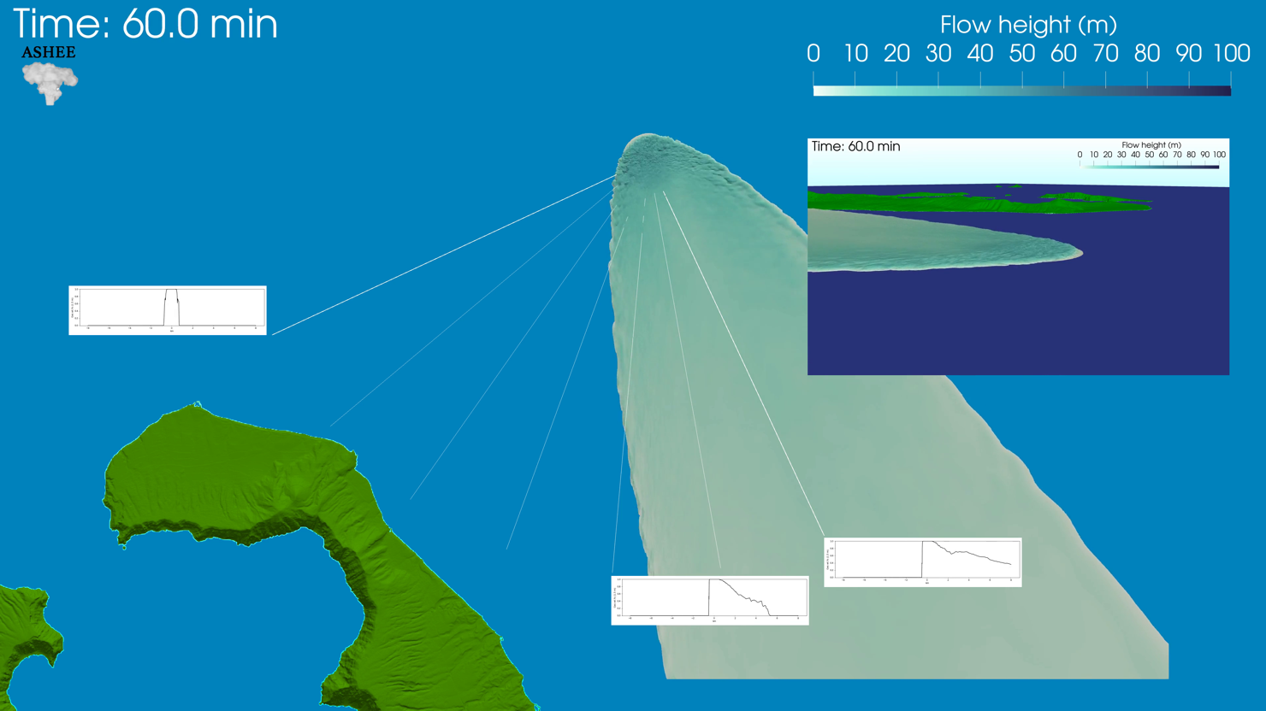
Fig. SM5 Top view of the gravity current described by Simulation ID05 after 1 h of evolution. The isosurface shown corresponds to the threshold gas concentration $ϵ_{g}=2.2$ vol.%. The colormap indicates the height of the isosurface above the sea level. The 7 white lines represent segments from line1 (perpendicular to wind) to line7 (parallel to wind), chosen for measuring gas content at 1.5 m a.s.l. (Fig. 5). The 3 plots at the end of line1, line5, and line7 display the gas mass fraction along those lines, spanning from -8 km to 8 km from the vent, after 1 h of evolution. The inset map provides a side view of the same isosurface.

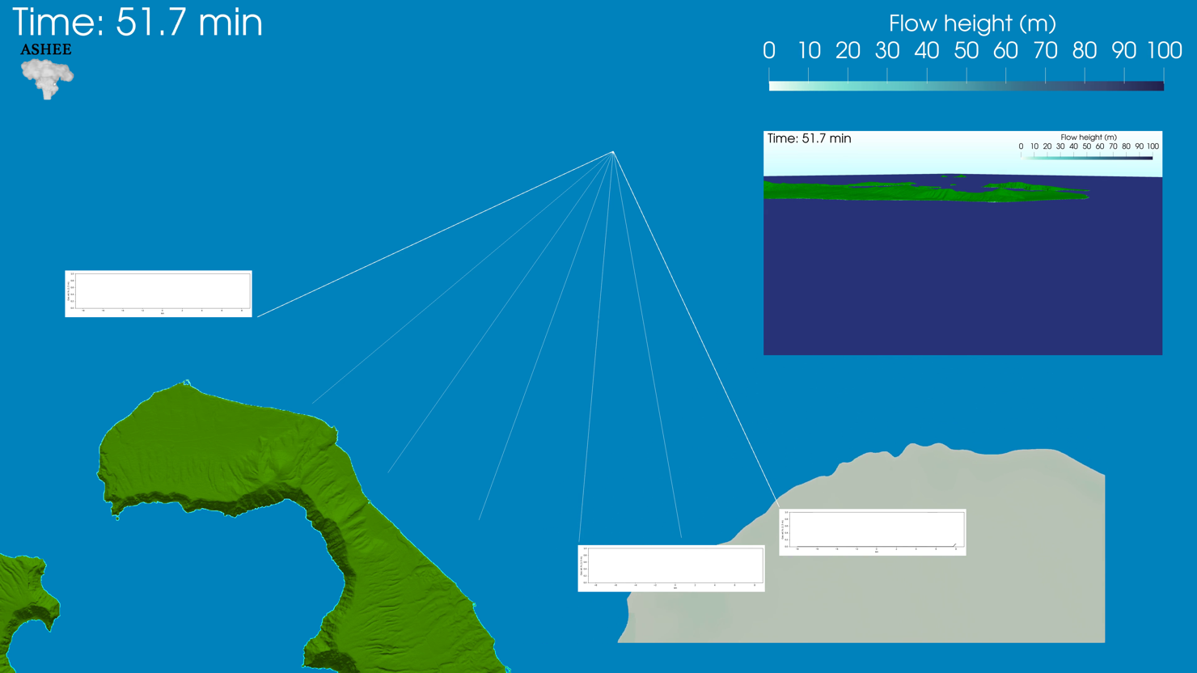
Fig. SM6 Top view of the gravity current described by Simulation ID06 after 52 min of evolution. The isosurface shown corresponds to the threshold gas concentration $ϵ_{g}=2.2$ vol.%. The colormap indicates the height of the isosurface above the sea level. The 7 white lines represent segments from line1 (perpendicular to wind) to line7 (parallel to wind), chosen for measuring gas content at 1.5 m a.s.l. (Fig. 5). The 3 plots at the end of line1, line5, and line7 display the gas mass fraction along those lines, spanning from -8 km to 8 km from the vent, after 52 min of evolution. The inset map provides a side view of the same isosurface.
Profiles along horizontal directions at 1.5 m a.s.l.
Gas mass fractions, flow horizontal and vertical velocity, and horizontal velocity direction have been recorded along 7 directions selected to describe the flow properties, ranging from line1 (perpendicular to wind) to line 7 (parallel to wind), spanning from -8 km to 8 km from the vent at 1.5 m height (Fig. 5). The evolution in time of these profiles is depicted in Figs. SM7−SM12 (cf. Fig. 6). These figures display profiles at 20 s intervals. Although it is impractical to label each profile individually, they are included to enable the reader to visualize their temporal progression and to verify, by examining the black lines, how the stationary condition is achieved along the 7 different directions.

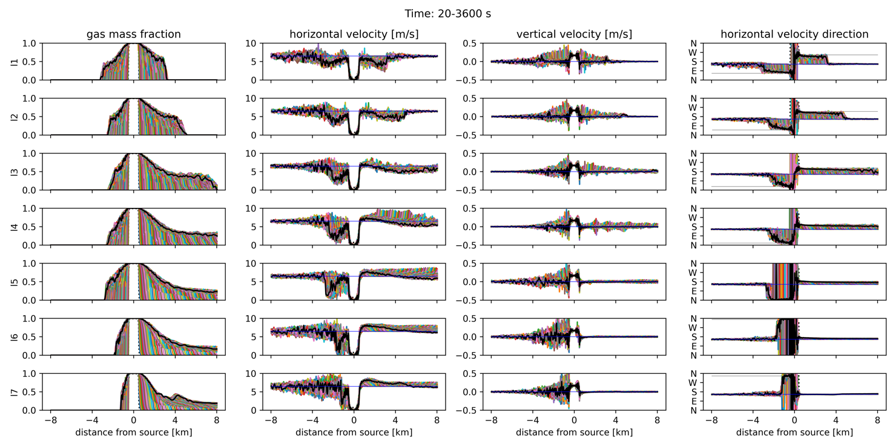
Fig. SM7 Profiles of gas mass fraction, horizontal velocity, vertical velocity, and horizontal velocity direction (columns) are displayed along directions line1 to line7 (rows) for ID01. Positive distance from the source corresponds to the segments shown in Fig. 5. These profiles are presented at intervals of 20 s within the time interval 20-3600 s. The black profiles correspond to the last time, while the thin blue lines represent the atmospheric conditions. In the last column, the horizontal thin grey lines indicate the direction of each line.

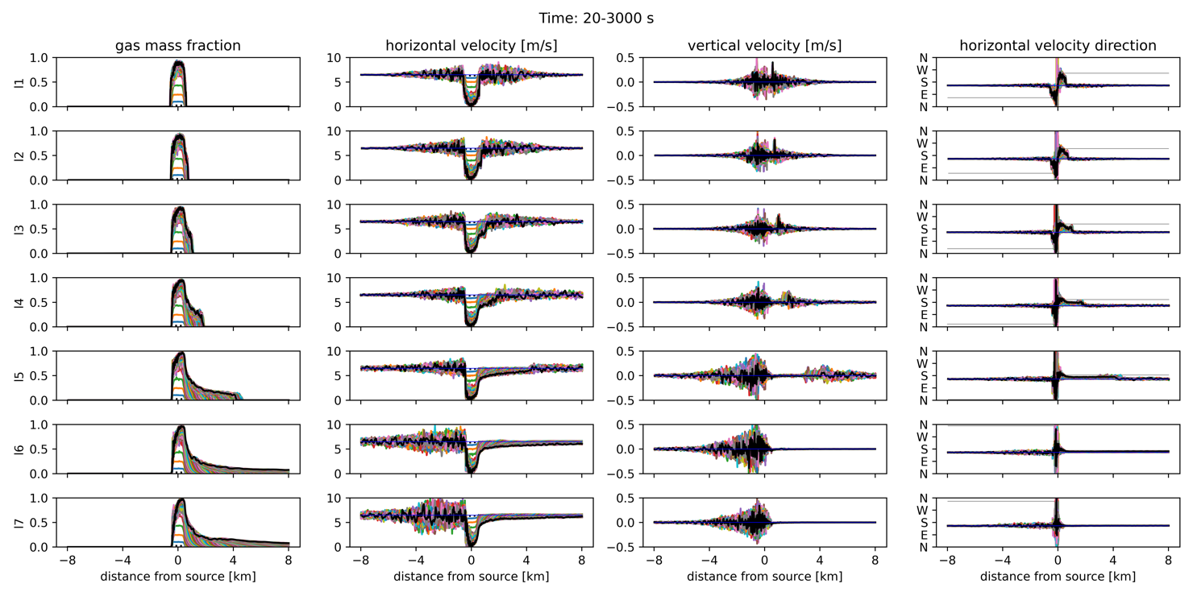
Fig. SM8 Profiles of gas mass fraction, horizontal velocity, vertical velocity, and horizontal velocity direction (columns) are displayed along directions line1 to line7 (rows) for ID02. Positive distance from the source corresponds to the segments shown in Fig. 5. These profiles are presented at intervals of 20 s within the time interval 20-3000 s. The black profiles correspond to the last time, while the thin blue lines represent the atmospheric conditions. In the last column, the horizontal thin grey lines indicate the direction of each line.

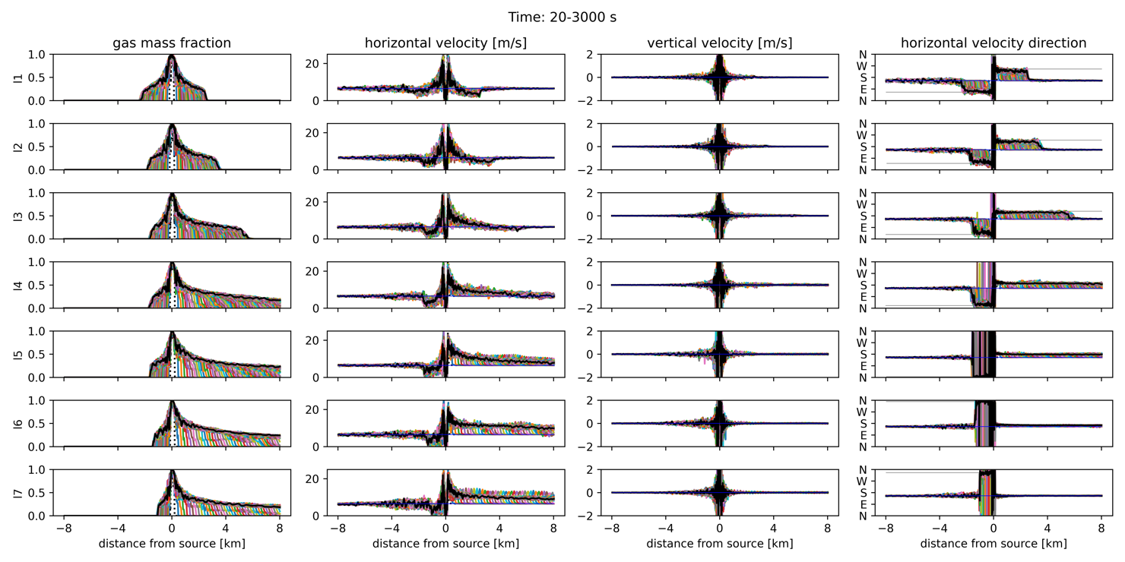
Fig. SM9 Profiles of gas mass fraction, horizontal velocity, vertical velocity, and horizontal velocity direction (columns) are displayed along directions line1 to line7 (rows) for ID03. Positive distance from the source corresponds to the segments shown in Fig. 5. These profiles are presented at intervals of 20 s within the time interval 20-3000 s. The black profiles correspond to the last time, while the thin blue lines represent the atmospheric conditions. In the last column, the horizontal thin grey lines indicate the direction of each line.

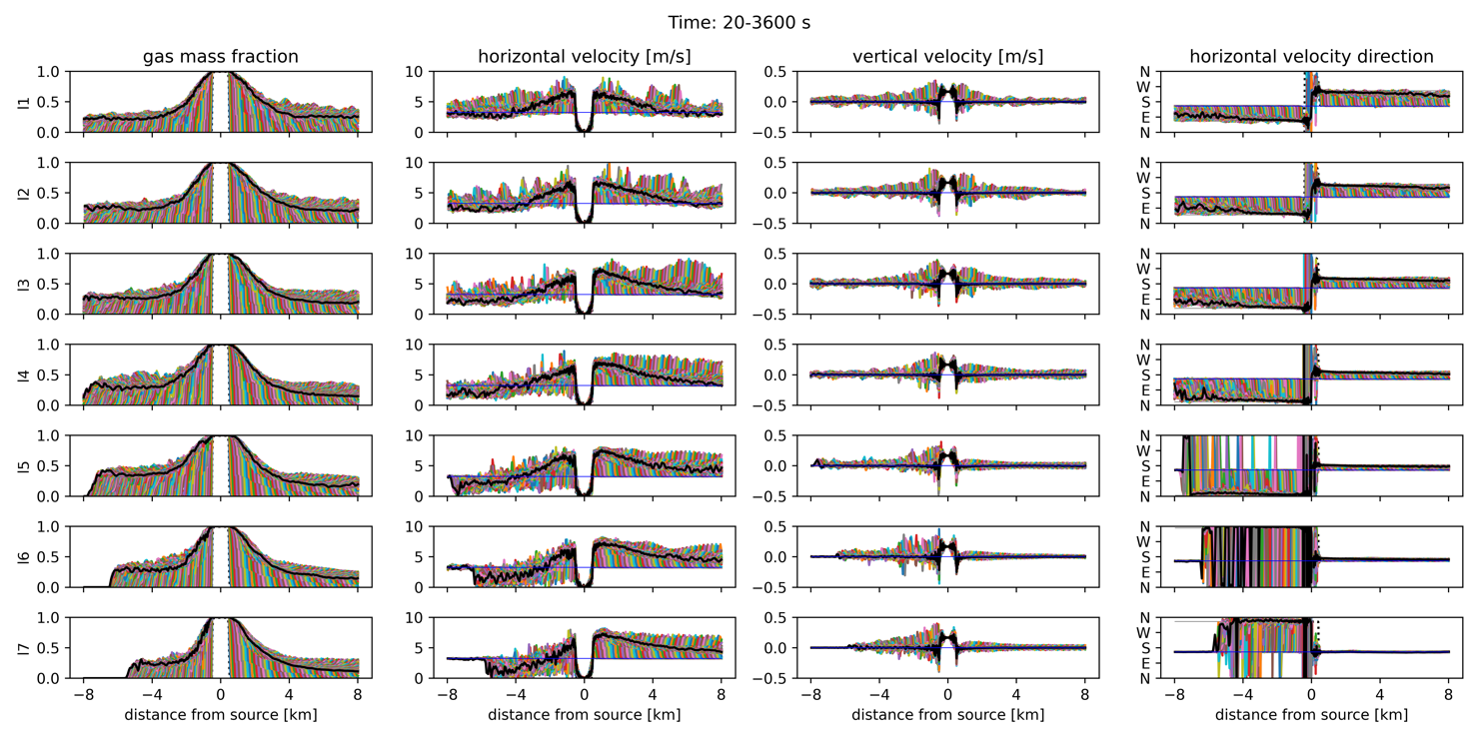
Fig. SM10 Profiles of gas mass fraction, horizontal velocity, vertical velocity, and horizontal velocity direction (columns) are displayed along directions line1 to line7 (rows) for ID04. Positive distance from the source corresponds to the segments shown in Fig. 5. These profiles are presented at intervals of 20 s within the time interval 20-3000 s. The black profiles correspond to the last time, while the thin blue lines represent the atmospheric conditions. In the last column, the horizontal thin grey lines indicate the direction of each line.

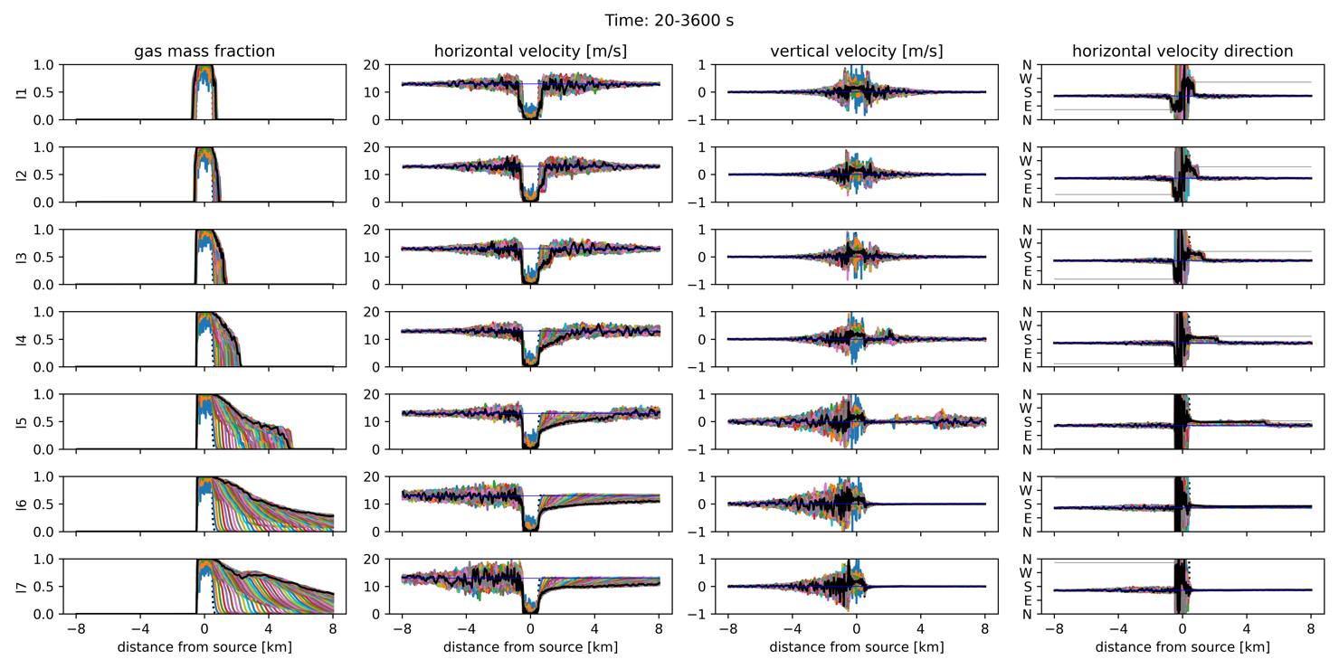
Fig. SM11 Profiles of gas mass fraction, horizontal velocity, vertical velocity, and horizontal velocity direction (columns) are displayed along directions line1 to line7 (rows) for ID05. Positive distance from the source corresponds to the segments shown in Fig. 5. These profiles are presented at intervals of 20 s within the time interval 20-3600 s. The black profiles correspond to the last time, while the thin blue lines represent the atmospheric conditions. In the last column, the horizontal thin grey lines indicate the direction of each line.

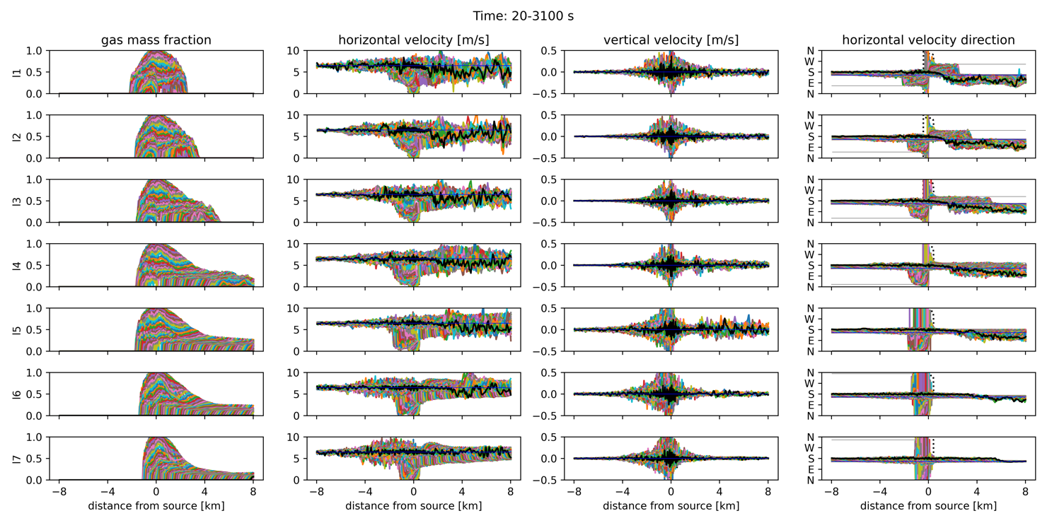
Fig. SM12 Profiles of gas mass fraction, horizontal velocity, vertical velocity, and horizontal velocity direction (columns) are displayed along directions line1 to line7 (rows) for ID06. Positive distance from the source corresponds to the segments shown in Fig. 5. These profiles are presented at intervals of 20 s within the time interval 20-3100 s. The black profiles correspond to the last time, while the thin blue lines represent the atmospheric conditions. In the last column, the horizontal thin grey lines indicate the direction of each line.

Gas concentrations 8 km from the source at 1.5 m a.s.l.
The temporal evolution of gas concentration recorded at 1.5 m a.s.l., +8 km from the source (i.e., at the approximate minimum distance of the Thera coast from Kolumbo), is illustrated in Fig. SM13, along the 7 direction lines displayed in Fig. 5, for all scenarios ID01−ID06 (cf. Fig. 8). The maximum values $(ϵ_{g})_{max}$ and average values in the last 10 min of evolution $(ϵ_{g})_{ave}$ are also reported there.

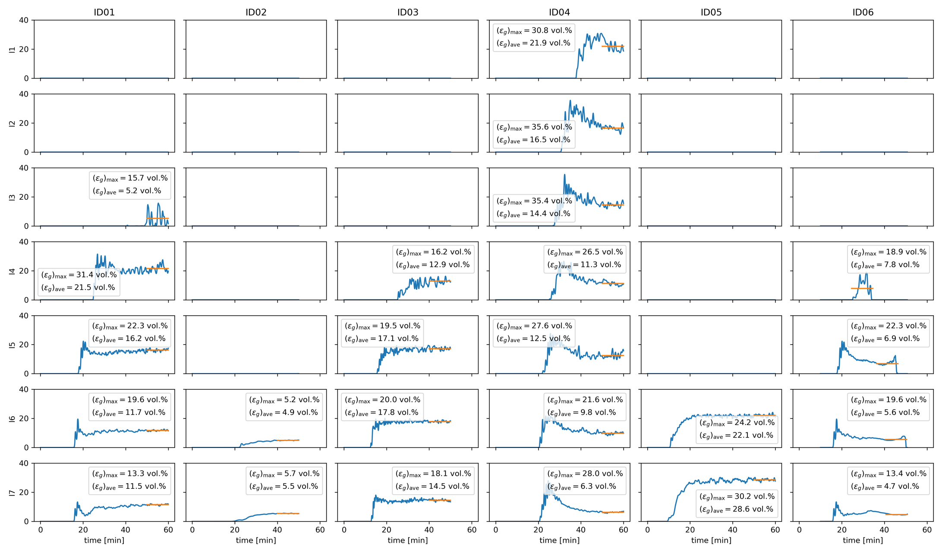

Fig. SM13 Gas concentrations (vol.%) for ID01−ID06 (columns), recorded 1.5 m a.s.l. and +8 km from the source along directions line1−line7 (rows). The panels are empty when the flow does not arrive at 8 km along those directions. The legend reports the maximum values $(ϵ_{g})_{max}$ and the average values in the last 10 min of evolution $(ϵ_{g})_{ave}$ (orange lines).
Gas concentrations and spreading angle across all flow directions
Figure SM14 presents the temporal evolution of gas concentration along a circumference centered above the Kolumbo crater, with a radius of 8 km and at 1.5 m a.s.l., for scenarios ID01−ID06 (cf. Fig. 9). Column a) displays the gas concentration colormap over time and flow direction. Column b) depicts the median of this concentration field over the last 10 min of evolution as a function of the flow direction, with the 25th-75th Intra-Quartile Range (IQR) indicating very small concentration fluctuations along prescribed directions. Conversely, column c) shows the median and IQR calculated over all flow directions as a function of time. The scenarios exhibit a nearly monotonic increase in gas concentration over time, with some amplification effect during the passage of the current head. Column d) displays the evolution of the maximum spreading angle over time. In columns a) and b), the vertical dotted grey lines delineate directions impacting Thira.

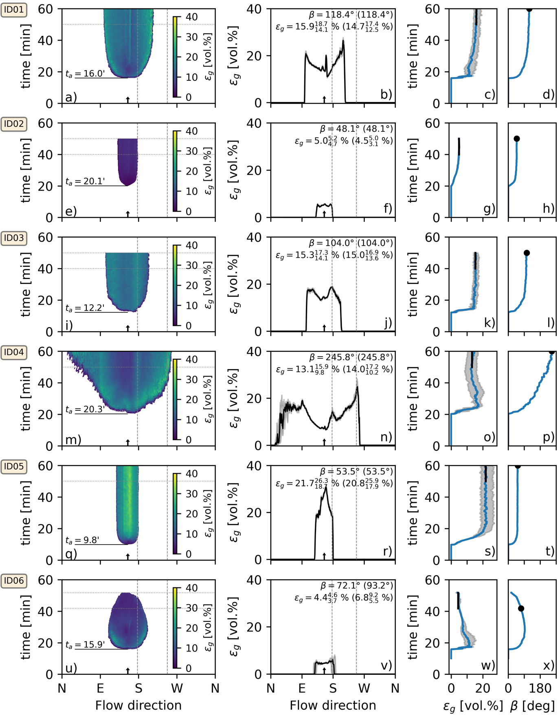
Fig. SM14 Each row of this figure refers to a different scenario, from ID01 to ID06. Column a): gas concentrations along a circumference centered above Kolumbo volcano with radius 8 km at 1.5 m a.s.l. The arrival time is $t_{a}$. Column b): median gas concentration in the last 10 min (horizontal grey dotted lines in panel a) versus flow direction. Column c): median gas concentration where $ϵ_{g}>\left(ϵ_{max}\right)/20$ over time. Column d): maximum flow spreading angle $β$ over time. In columns a) and b), vertical grey dashed lines mark Thera-impacting directions, and the vertical arrows indicate the downwind direction. In columns b) and c), grey shaded areas represent the 25-75 IQR. Gas concentration median (column c, vertical black line), 25-75 IQR, and max spreading angle (column d, black dot) in the last 10 min are annotated in column b. Max spreading angle and 25-50-75 quartiles of gas concentration over the whole 1-hour simulation are also annotated in column b (in brackets).

Comparison between analytical solution and numerical simulations
The following 6 time series have been analyzed and illustrated in Fig. SM15 for scenarios ID01−ID06 (cf. Fig. 10): the maximum width in the direction perpendicular to the wind $2s\left(t\right)$; the downwind distance of the maximum flow width $r_{c}\left(t\right)$; the position of the upwind front of the flow $r_{u}\left(t\right)$; the position of the downwind front of the flow $r_{d}\left(t\right)$; the flow volume $V\left(t\right)$; and the average flow height $h\left(t\right)$. The edges of the gas currents are defined by using 2 gas concentration threshold values i.e. $ϵ_{g}=2$ vol.% and $ϵ_{g}=0.1$vol.%. The most relevant fitting parameters are listed in Table 3.

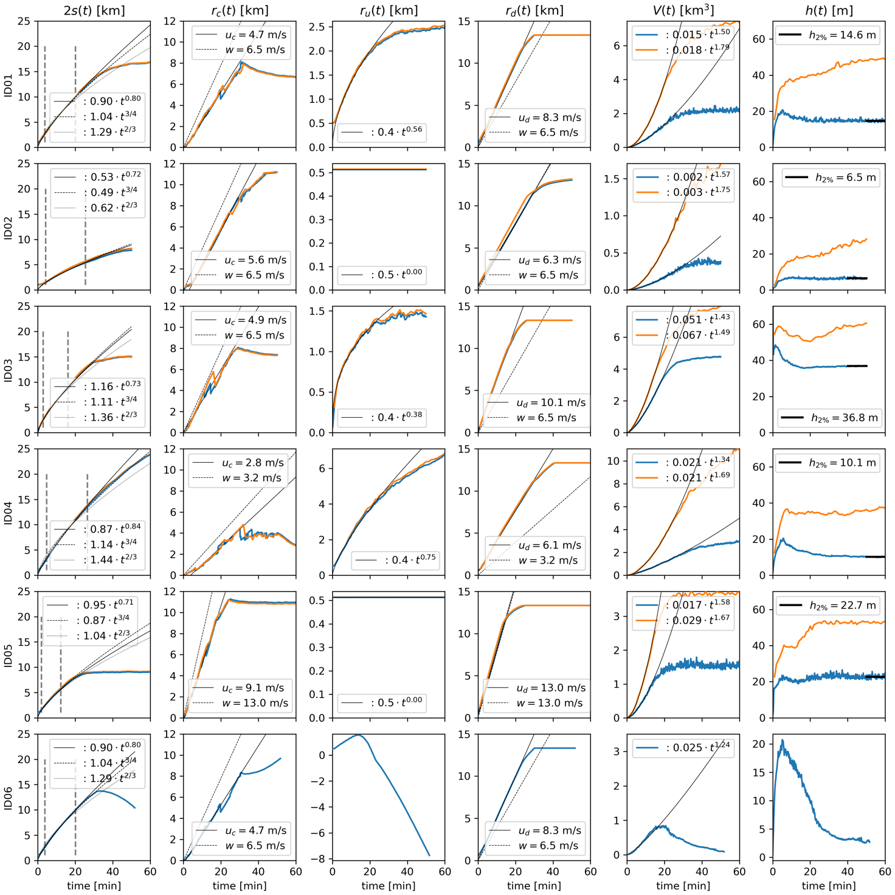
Fig. SM15 Scaling parameters for scenarios ID01−ID06, derived from the edges of the gravity current, marked where $ϵ_{g}=2$ vol.% (blue lines) and where $ϵ_{g}=0.1$ vol.% (orange lines). Columns from a) to f), represent the evolution over time of the following: a) maximum flow width perpendicular to wind; b) downwind position of the maximum flow width; c) upwind front position of the flow; d) downwind front position of the flow; e) flow volume; and f) flow average height. In column a), power-law fits of $2s(t)$ using Eq. (16) are displayed, with both $C$ and $b$ left free to vary (solid line) or with the exponent fixed to $b=3/4$ (dashed) and $b=2/3$ (dotted). Power-law fits are presented for $r_{u}(t)$ and $V(t)$ too. Linear fits are utilised in the $r_{c}(t)$ and $r_{d}(t)$ columns to calculate the corresponding velocities $u_{c}$ and $u_{d}$, respectively, which are depicted in the corresponding panels alongside the wind velocity $w$. The 2 vertical dashed grey lines in column a) identify the time-window used for the fits.

