Journal of Paleolimnology

Supplementary materials for

Varved sediments of Lake Gorzyńskie, western Poland: a new archive of climatic and environmental changes during the Late Glacial and the Holocene in central Europe

Maria Kril¹, Alicja Bonk¹, Maurycy Żarczyński¹, Bernd Zolitschka², Wojciech Tylmann¹
¹Faculty of Oceanography and Geography, University of Gdańsk, Poland
²GEOPOLAR, Institute of Geography, University of Bremen, Germany

Corresponding author: Wojciech Tylmann, wojciech.tylmann@ug.edu.pl, Bażyńskiego 4, PL80309 Gdańsk, Poland

Text S1 Description of varve microfacies. Microfacies numbering is consistent with the Fig. S1:

- C-O subtype A varves (lithozone 2). The annual cycle begins with the deposition of large and fine calcite grains, followed by sparse centric diatoms and chrysophycean cysts. The year ends with a layer of organic matter, forming a brownish, heterogeneous layer.
- C-D subtype A varves (lithozones 1 and 3). The annual cycle begins with centric diatoms and large calcite grains interspersed with numerous quartz. This is followed by a layer rich in centric diatoms and cysts, ending with a deposition of amorphous organic matter and/or littoral diatoms.
- C-D subtype B varves (lithozone 4A). The annual cycle begins with fine-grained, brown-yellowish, rounded grains resembling Mn-Fe-carbonates, followed by idiomorphic calcite grains displaying a clear gradation. The second lamina contains a mix of planktonic and littoral diatoms, along with chrysophycean cysts. Pyrite grains occur occasionally at the end of the year.
- C-D subtype C varves (lithozone 4B). A spring lamina is primarily composed of fine calcite grains with numerous pyrite grains. The second lamina mainly includes planktonic diatoms, along with fine calcite and occasional pyrite grains.
- C-O subtype B varves (lithozone 4B). A spring lamina is densely packed with fine calcite, while the second, organic lamina comprises planktonic diatoms (both centric and pennate), sparse littoral diatoms and pyrite grains, and amorphous organic matter at the end of the year.
- C-O subtype C varves (lithozone 4C). The calcite lamina serves as a marker for the beginning of the year, while the second lamina comprises a mix of diatoms, amorphous organic matter, chrysophycean cysts, and pyrite grains.
- C-D subtype D varves (lithozone 5). The deposition sequence begins with planktonic diatoms, followed by a calcite layer containing abundant quartz grains. The cycle ends with centric and pennate diatoms, and chrysophycean cysts.
- C-D subtype E varves (lithozone 5). The annual cycle begins with a mixed lamina composed of planktonic (centric) diatoms and large idiomorphic calcite grains. The second lamina consists solely of fine calcite, while the third is made up of planktonic diatoms (both centric and pennate) with occasional pyrite and quartz grains.

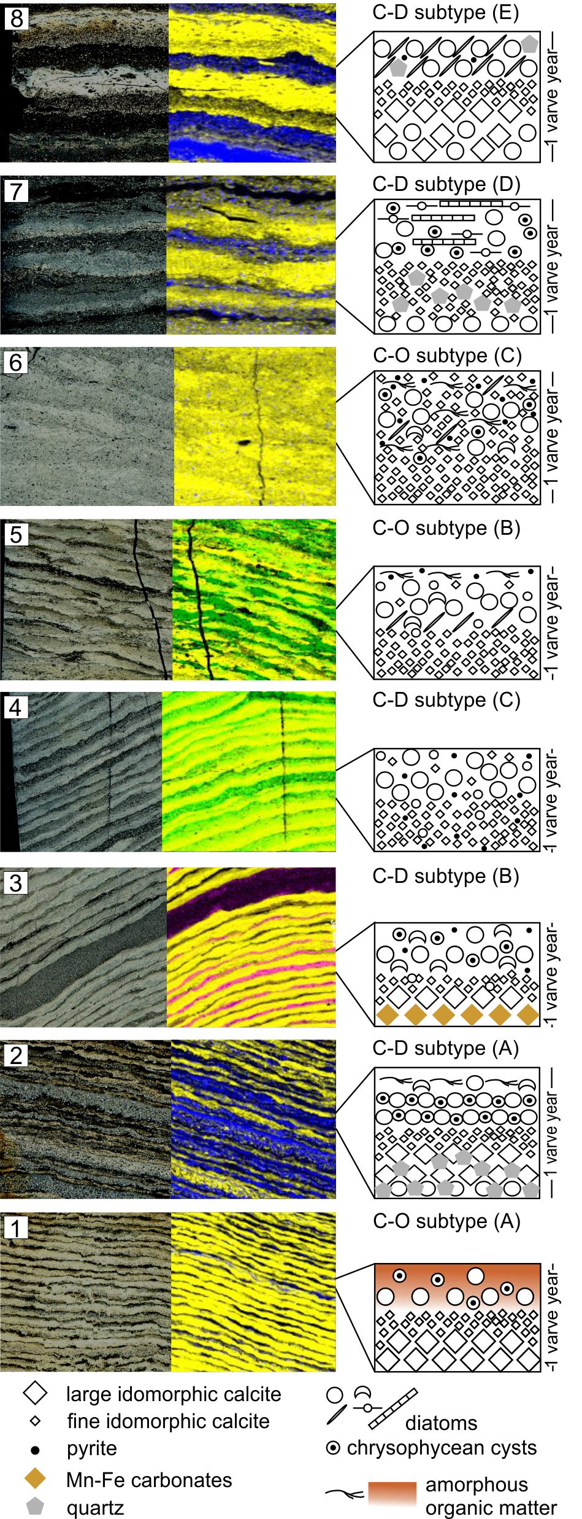
Fig. S1 Varve microfacies subtypes of GOR-20 including polarized light micrographs of thin sections (left), geochemical maps of major element variabilities (calcium – yellow, titanium – blue, silica – green, and manganese – pink) (middle), and schematic varve structure (right). Microfacies numbering is consistent with the description provided in the text

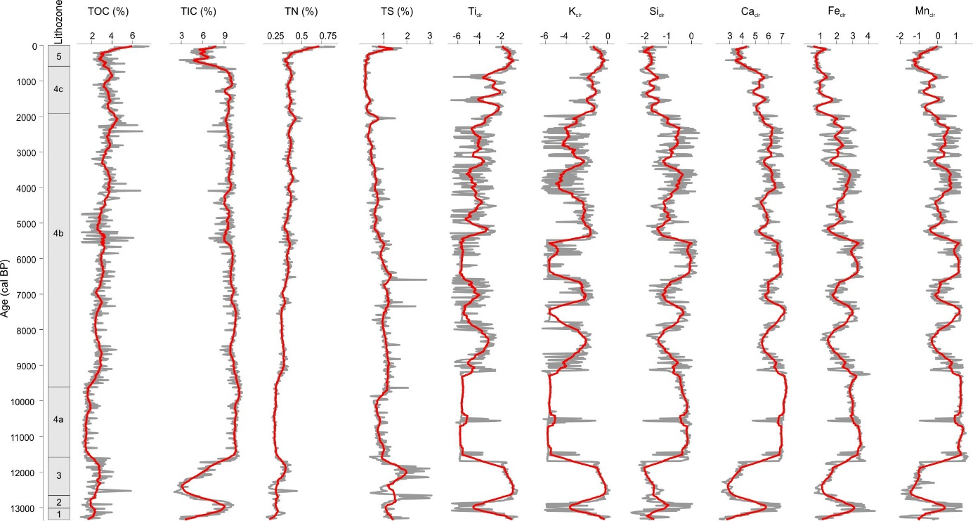
Fig. S2 Composite plot of selected geochemical proxies. All XRF-detected elements are displayed as centered log-ratios (clr), while TOC, TIC, TN and TS values are shown as percentages. Grey lines are the 1 cm resolution data and the red lines are 20-point moving averages

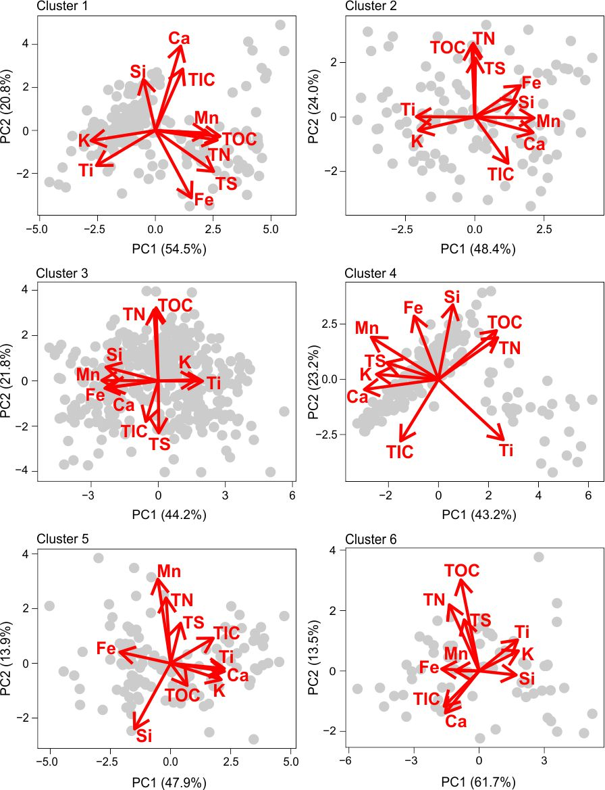
Fig. S3 PCA biplots of geochemical data for individual clusters

Table S1 Results of AMS ¹⁴C dating of terrestrial macrofossils. ¹⁴C BP ages are reported with 1 sigma (68 %) uncertainty while calibrated age ranges are given at a confidence interval of 2 sigma (95.4 %). Dates initially identified as outliers are indicated with an asterisk (*)
Sample ID | Lab. code | Depth (cm) | Material | Age ¹⁴C BP | Age ranges (cal BP)
GOR-20-156* | GdA - 7270 | 155.5 | Sphagnum | 1660 ± 40 | 1468–1620
GOR-20-185* | GdA - 7685 | 184.5 | Betula alba leaf | 2237 ± 36 | 2147–2274
GOR-20-198 | GdA - 7686 | 198.5 | Pinus epiderma | 860 ± 25 | 716–794
GOR-20-325 | GdA - 7327 | 324.5 | Pinus epiderma | 2105 ± 30 | 1993–2147
GOR-20-373 | GdA - 7271 | 372.5 | Pinus epiderma | 2570 ± 30 | 2698–2757
GOR-20-397 | GdA - 7272 | 396.5 | Pinus epiderma | 2825 ± 30 | 2850–3005
GOR-20-446 | GdA - 7328 | 445.5 | Pinus epiderma | 3330 ± 35 | 3457–3640
GOR-20-453 | GdA - 7329 | 452.5 | plant remains | 3460 ± 30 | 3680–3831
GOR-20-483 | GdA - 7687 | 482.5 | Pinus epiderma | 3762 ± 29 | 4076–4236
GOR-20-511 | GdA - 7688 | 510.5 | leaf remains | 4198 ± 31 | 4618–4764
GOR-20-576 | GdA - 7330 | 575.5 | Alnus leaf | 4680 ± 30 | 5318–5474
GOR-20-592 | GdA - 7331 | 591.5 | Pinus epiderma | 4760 ± 30 | 5460–5585
GOR-20-595 | GdA - 7332 | 594.5 | Pinus epiderma | 4935 ± 30 | 5595–5723
GOR-20-709 | GdA - 7689 | 708.5 | Pinus epiderma | 6354 ± 77 | 7156–7428
GOR-20-776 | GdA - 7333 | 775.5 | Pinus epiderma | 8010 ± 35 | 8750–9008
GOR-20-824 | GdA - 7334 | 823.5 | Pinus epiderma | 8560 ± 35 | 9480–9554
GOR-20-882 | GdA - 7335 | 881.5 | Pinus epiderma | 9210 ± 55 | 10242–10510
GOR-20-918 | GdA - 7336 | 917.5 | Pinus epiderma | 9535 ± 35 | 10695–10884
GOR-20-964 | GdA - 7690 | 963.5 | Pinus epiderma | 10140 ± 69 | 11398–11971
GOR-20-1015 | GdA - 7691 | 1014.5 | Betula alba leaf | 10968 ± 84 | 12756–13075
GOR-20-1034 | GdA - 7693 | 1033.5 | Pinus epiderma | 11256 ± 58 | 13088–13248

