Supplementary data

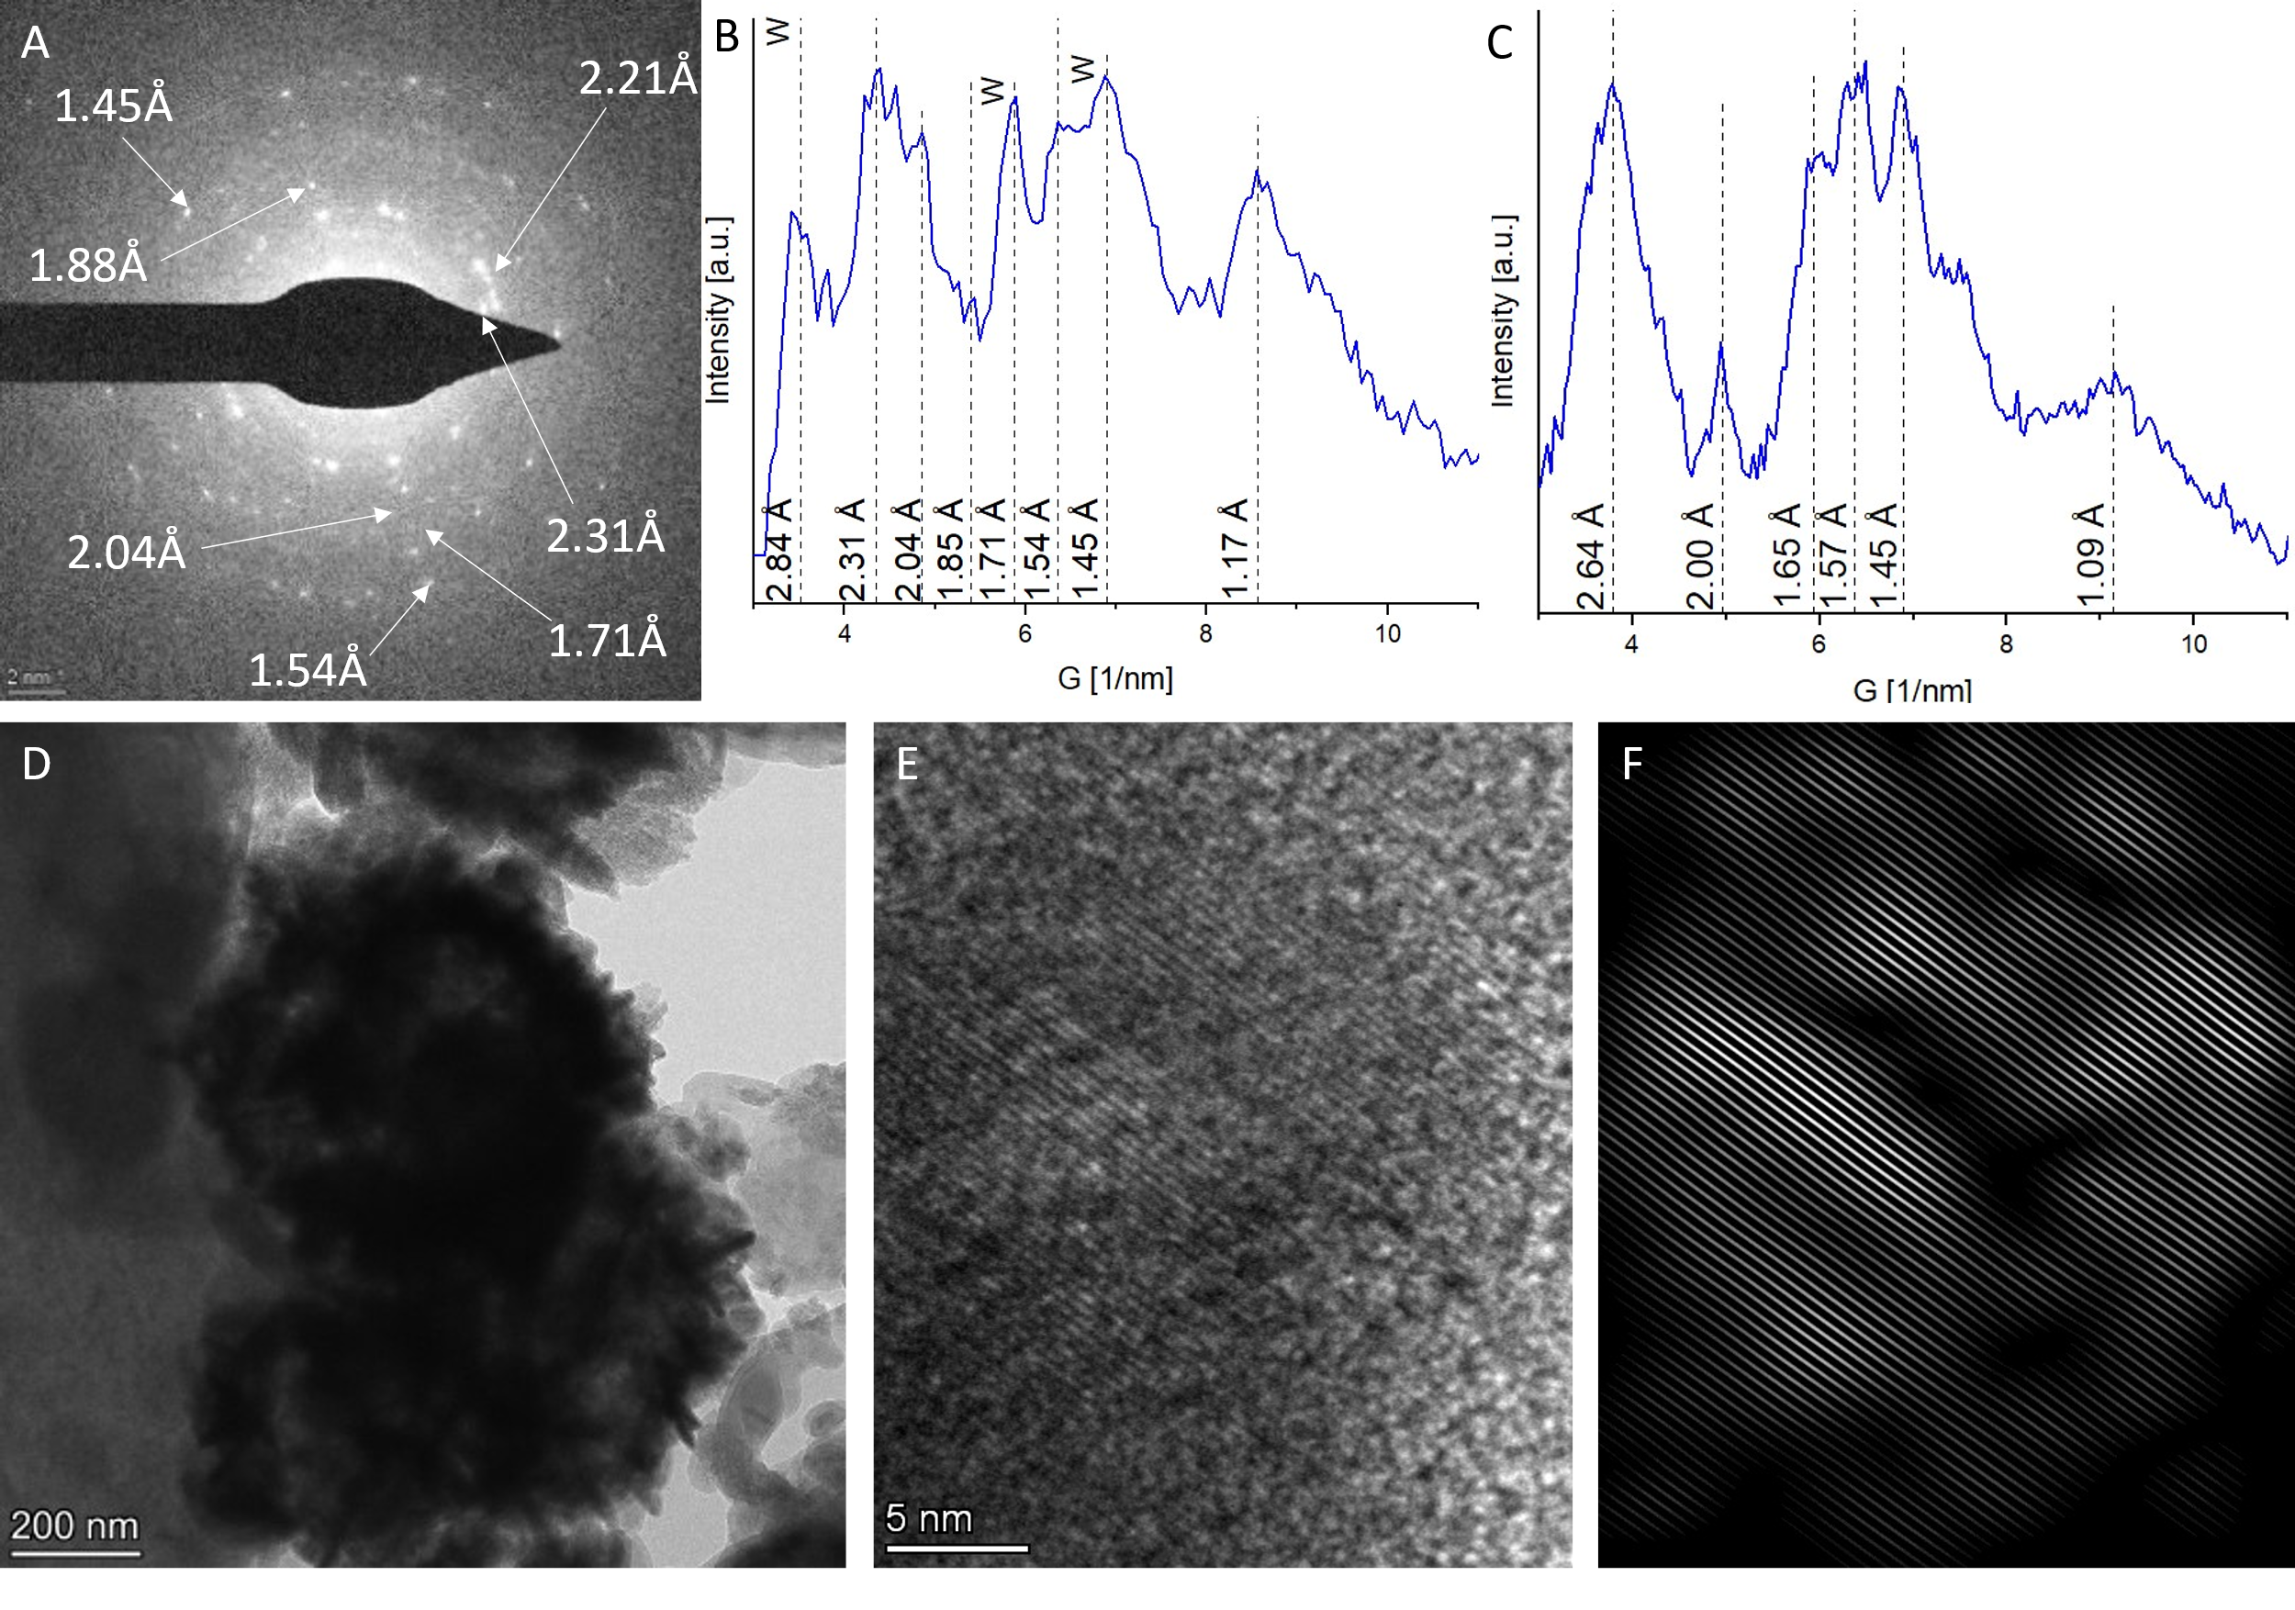
Supplementary Figure 1. STEM results. (A,B) SAED of the acicular Cu-Fe sulfide aggregate from the Fig. 3a and corresponding color profile (note that the letter “w” marks potential peaks of wurtzite, which appear together with the Cu-Fe phase). (C) Color profile for the SAED from the Fig. 3h. (D) Bright-field image of the aggregate from the Fig. 3f. (E-F) Amplified image of the lattice fringes showed in the Fig.3j and the corresponding filtered image.

Supplementary Table 1. Geochemical analyses of the pore water recovered from sediment samples from Filon Centro ICs. Concentration expressed as mg/L.
Element | FC18 (monimolimnion) |  |  |  | FC0 (mixolimnion)
 | Unt (-1cm) | Gly (-1cm) | 4 °C (-1cm) |  | Unt (-1cm) | Gly (-1cm) | 4 °C (-1cm)
SO₄ | 4377 | 6620 | 6984 |  | 5701 | 14101 | 5138
Cu | 34 | b.d. | 444 |  | 14 | b.d. | 16
Fe | 571 | 3504 | 829 |  | 1306 | 6478 | 351

Supplementary Table 2. Distribution of Fe, Cu and S in different fractions obtained by sequential extraction of sediment samples at different depth from Filon Centro 18m and 0m incubation column experiments (untreated, glycerol-amended and 4 °C-stored) after 18 mo (Further incubation setup was described in Ilin et al., 2022). Concentration expressed as ppm.
Element | Step | FC18 (monimolimnion) |  |  |  | FC0 (mixolimnion)
 |  | Unt (-1cm) | Gly (-1cm) | 4 °C (-1cm) |  | Unt (-1cm) | Gly (-1cm)
S | 1 | 703 | 682 | 567 |  | 2064 | 1469
ppm | 2 | 407 | 236 | 327 |  | 2943 | 751
 | 3 | 817 | 55 | 861 |  | 1101 | 76
 | 4 | b.d. | b.d. | b.d. |  | b.d. | b.d.
 | 5 | 334 | 380 | 309 |  | 602 | 307
 | 6 | 8637 | 4708 | 3192 |  | 617 | 1284
Cu | 1 | 4 | 27 | 65 |  | 11 | 31
ppm | 2 | 5 | 31 | 31 |  | b.d. | 10
 | 3 | 11 | 36 | 18 |  | 24 | 30
 | 4 | b.d. | 1 | b.d. |  | 3 | 1
 | 5 | 8 | 28 | 10 |  | 17 | 9
 | 6 | 42 | 122 | 45 |  | 16 | 31
Fe | 1 | 70 | 295 | 84 |  | 775 | 695
ppm | 2 | 151 | 85 | 142 |  | 1704 | 1532
 | 3 | 4286 | 2449 | 3235 |  | 26179 | 4894
 | 4 | 13434 | 9781 | 8461 |  | 6073 | 34520
 | 5 | 40 | 28 | 30 |  | 48.54 | 62.16
 | 6 | 744 | 1188 | 488 |  | 6 | 21

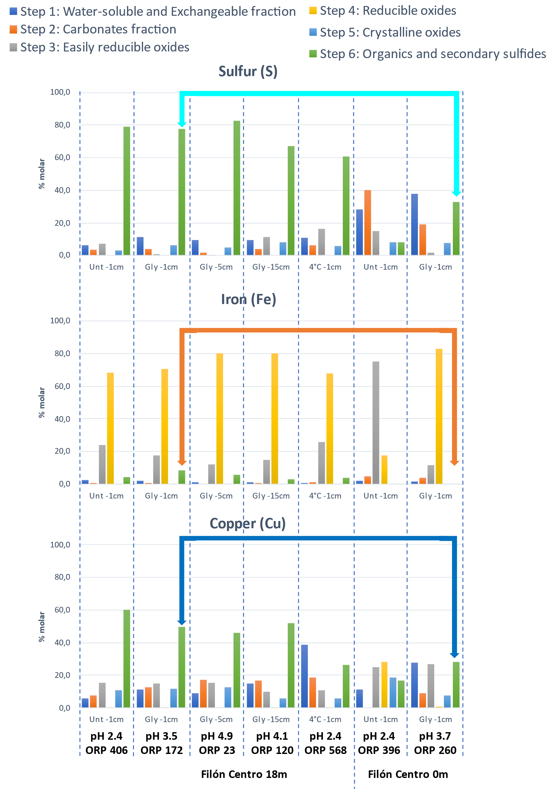
Supplementary Figure 2. Results of the selective dissolution of different sediment layers of the incubation columns after 18 months of incubation following Sequential Extraction protocol showing the distribution of Fe, Cu and S in different fractions expressed in molar percent.

Supplementary Table 3. Parameters used for geochemical modelling. Concentrations provided in mg/L. Temperature was set to a constant 25 °C.
 | Graph A | Graph B | Graph C | Graph D | Graph E | Graph F
Fe(total) | 570
Fe(II) |  | 570 | 570 | 570 | 570 | 570
Cu (total) | 35 |  |  |  |  | 35
Cu(II) |  | variable | 35 | 35 | 35
$$SO_{4}^{2-}$$ | 4400 | 4400 | 4400 | 4400 | 4400 | 4400
H₂S | 10 | 10
S²⁻ |  |  | variable |  | variable
pH | variable | 4.0 |  | 4.0 | 4.0 | 4.0
pe |  |  |  | variable |  | variable

