Early Prediction of Clinical Response to Anti-TNF Treatment using Multi-omics and Machine Learning in Rheumatoid Arthritis

Supplementary Figures

Fig. S1: Study design showing the number of patients used in cross-sectional and longitudinal analysis for RNA-Seq, flow cytometry and protein data analysis

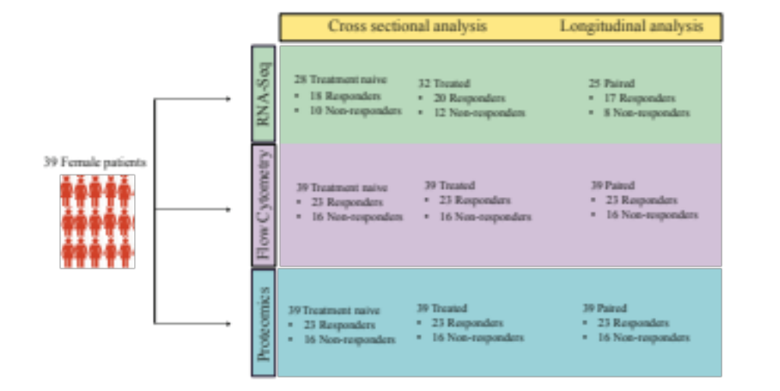

Fig. S1: The study design for the current study using 39 female RA patients

Fig. S2: A) Heat map of normalized differentially expressed genes with deviant sample. The top panel shows responders (brick red) and non-responders (grey). B) The box plots of normalized log₂ expression values with outlier counts before anti-TNF treatment

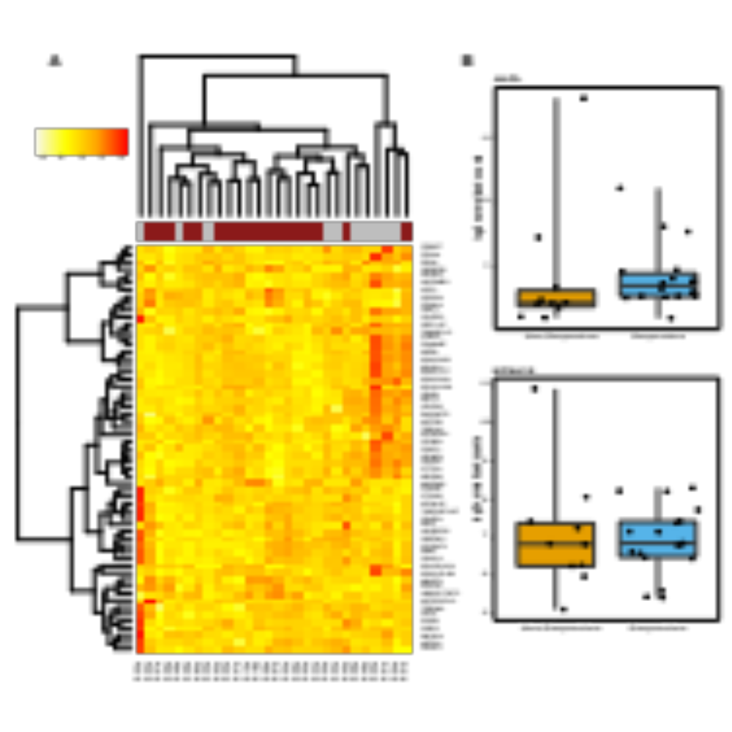

Fig. S2: Expression differences driven by outlier sample

Fig. S3: A) The bar plots represent top 15 enriched upregulated and downregulated pathways before anti-TNF treatment initiation.

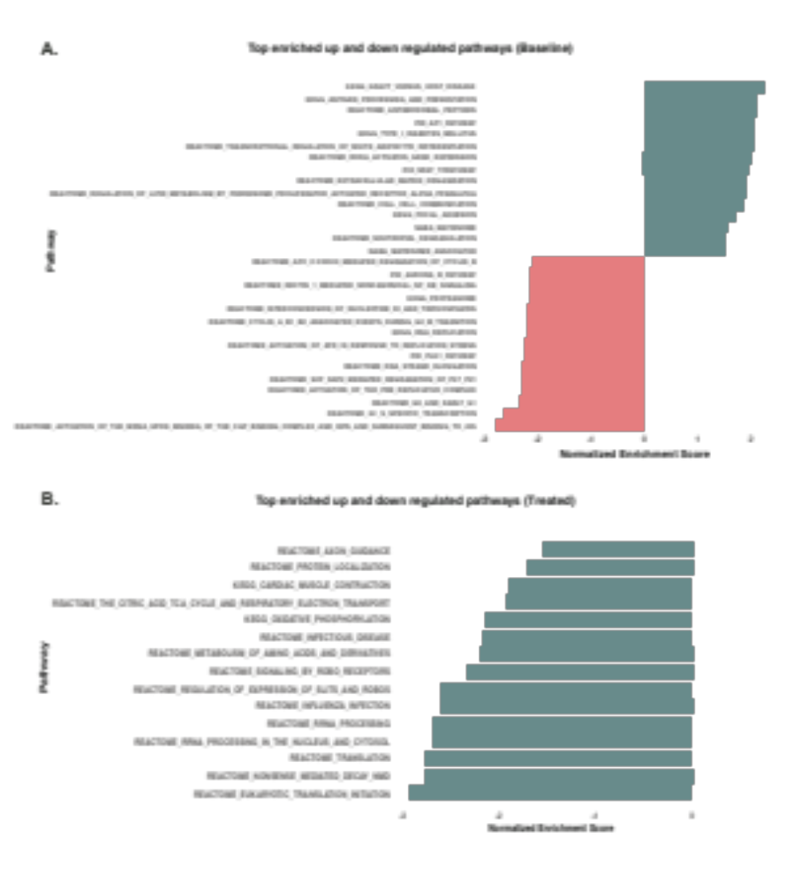

Fig. S3: Most enriched pathways before and after anti-TNF treatment

Fig. S4: The box plots showing the expression levels of genes in non-responders during anti-TNF treatment (comparison between naive and treated RA patient samples). Abbreviations: CXCR2, C-X-C Motif Chemokine Receptor 2; MPO, Myeloperoxidase; MYADM, Myeloid Associated Differentiation Marker; TNFAIP6, TNF Alpha Induced Protein 6; FCGR2B, Fc Fragment of IgG Receptor IIb.

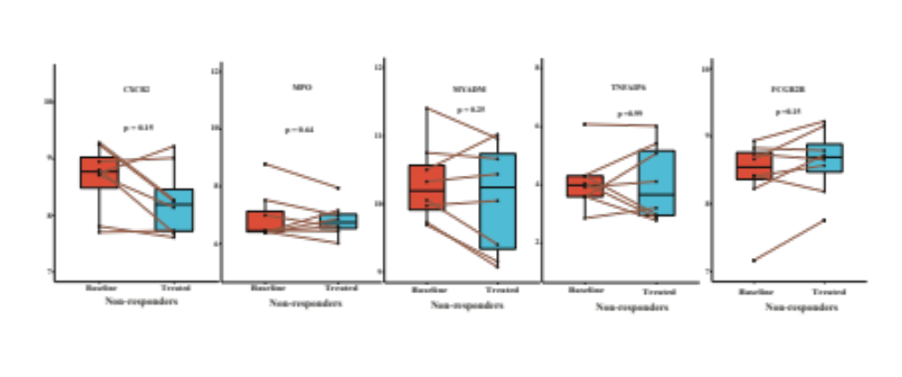

Fig. S4: Gene expression differences in non-responders

