Fig. S1: The study design for the current study using 39 female RA patients

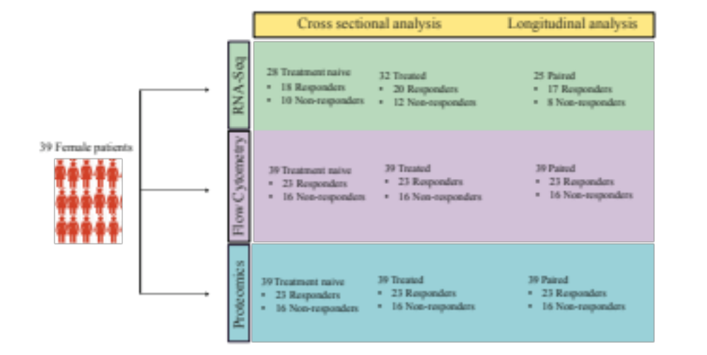

Fig. S1: Study design showing the number of patients used in cross-sectional and longitudinal analysis for RNA-Seq, flow cytometry and protein data analysis

Fig. S2: Expression differences driven by outlier sample
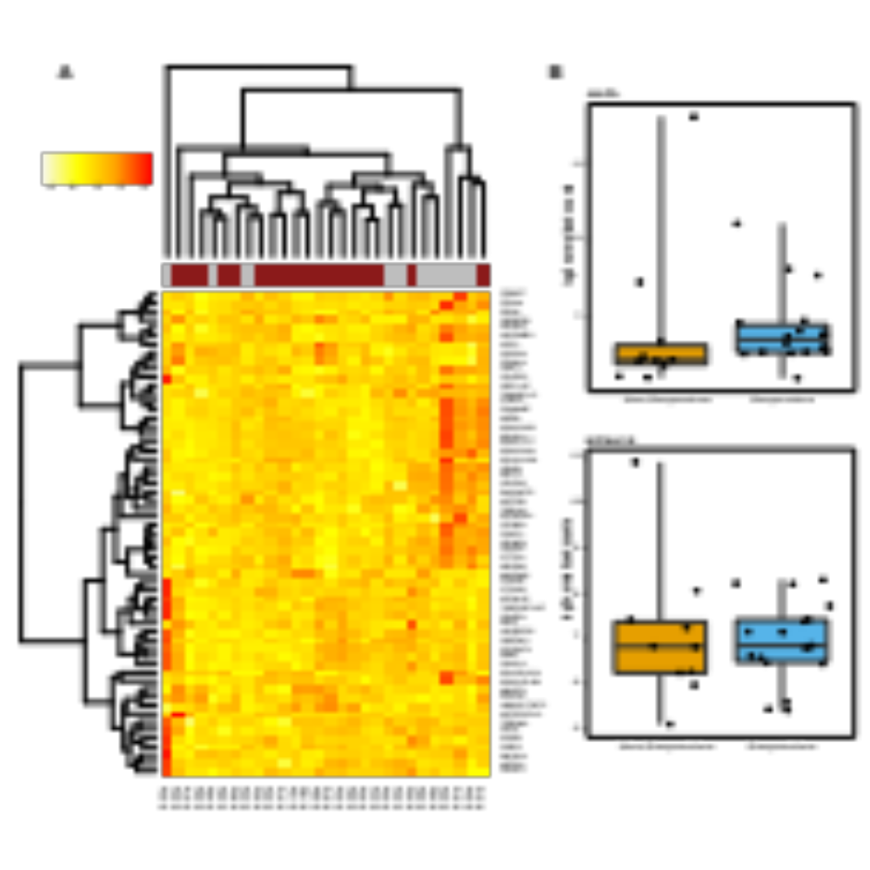

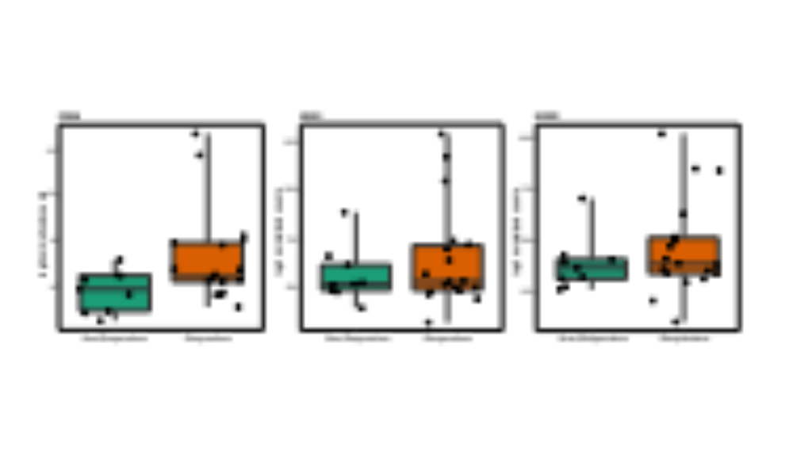

C

Fig. S2: A) Heat map of normalized differentially expressed genes with deviant sample. The top panel shows responders (brick red) and non-responders (grey). B) The box plots of normalized log₂ expression values with outlier counts before anti-TNF treatment. C) The box plot of normalized log₂ expression values of the top differentially expressed genes without outlier sample before anti-TNF treatment.

Fig. S3: Most enriched pathways before and after anti-TNF treatment

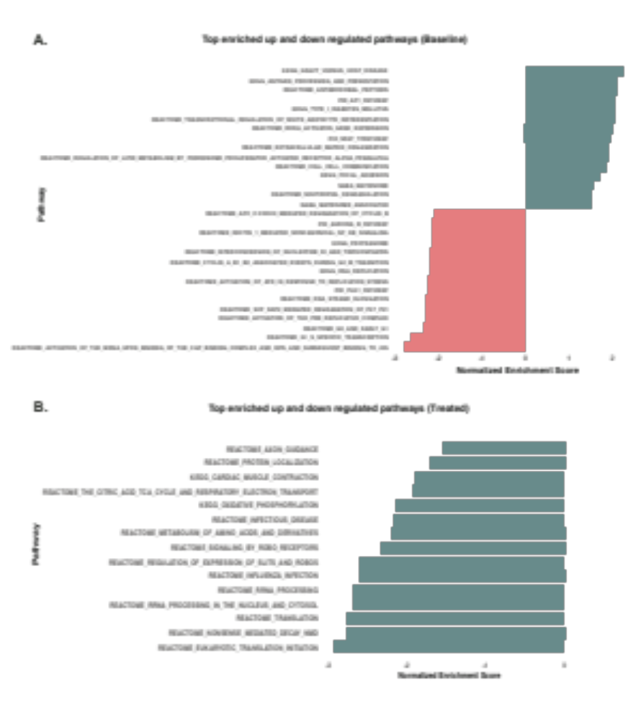

Fig. S3: The bar plots represent top 15 enriched upregulated and downregulated pathways before (A) and after anti-TNF treatment (B). The X-axis represents the normalized enrichment score for each pathway.

Fig. S4: Most significant differentially expressed genes after anti-TNF treatment

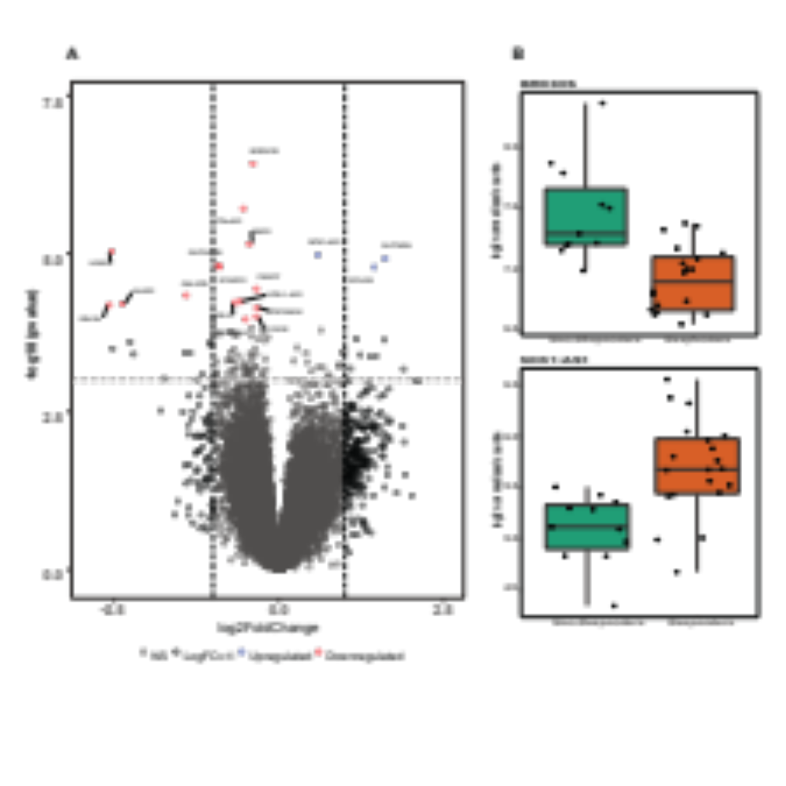
Fig. S4: A) Volcano plot representation of differentially expressed genes between responders and non-responders after treatment. The vertical lines correspond to log₂ fold change of 1 (genes are represented in black) and the horizontal line represents a P-value of 0.001. B) The box plot of normalized log₂ expression values for the differentially expressed genes, BRD3 Opposite Strand (BRD3OS) and NCK1 Antisense RNA 1 (NCK1-AS1) after treatment.

Fig. S5: Gene expression differences in non-responders

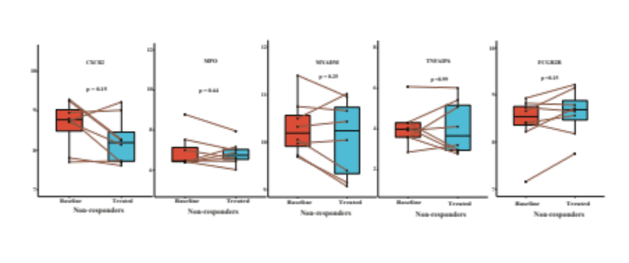
Fig. S5 The box plots showing the expression levels of genes in non-responders during anti-TNF treatment (comparison between naive and treated RA patient samples). Abbreviations: CXCR2, C-X-C Motif Chemokine Receptor 2; MPO, Myeloperoxidase; MYADM, Myeloid Associated Differentiation Marker; TNFAIP6, TNF Alpha Induced Protein 6; FCGR2B, Fc Fragment of IgG Receptor IIb.

