Results from confirmatory factor analysis on independence construct:

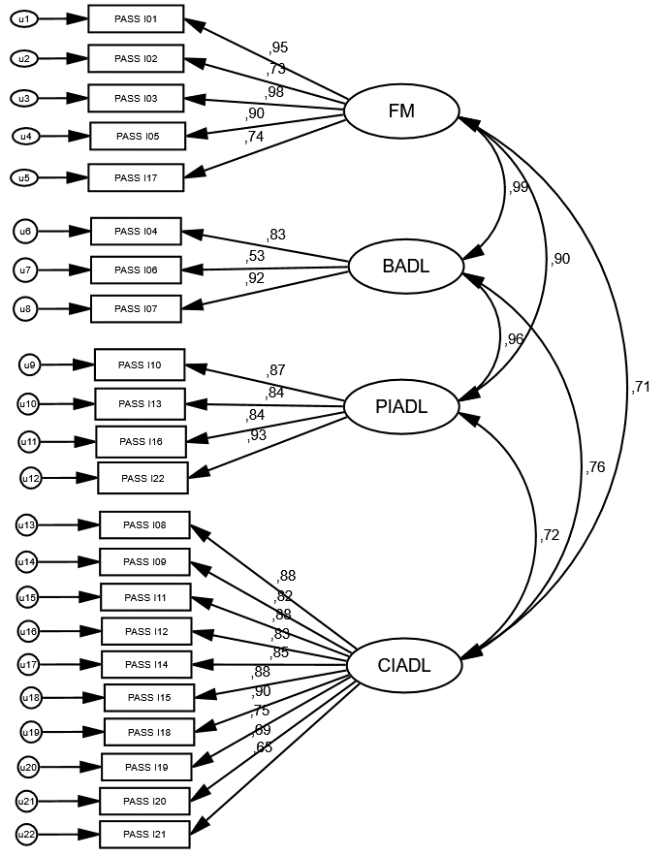

Summary Statistics
χ² | TLI | CFI | RMSEA
p<0.001 | p=0.801 | p=0.825 | p=0.151
χ²: Model Chi-Square; TLI: TuckerLewis Index; CFI: Comparative Fit Index; RMSEA: Root Mean Square Error

Results from confirmatory factor analysis on safety construct:

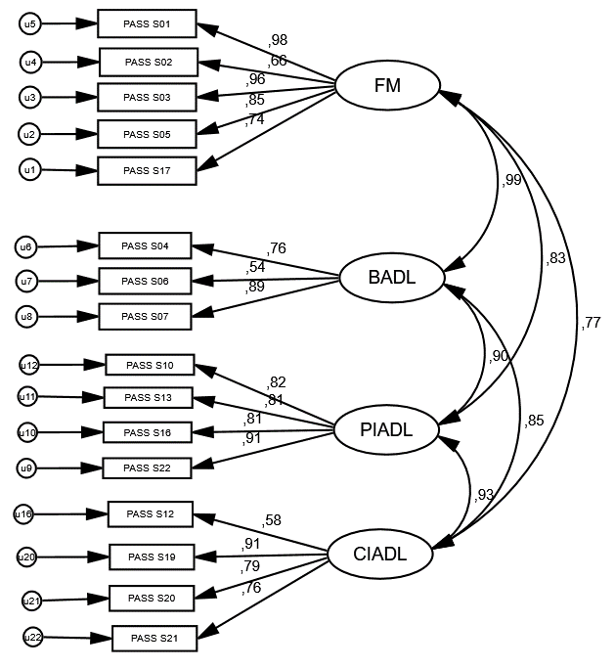

Summary Statistics
χ² | TLI | CFI | RMSEA
p<0.001 | p=0.866 | p=0.890 | p=0.133
χ²: Model Chi-Square; TLI: TuckerLewis Index; CFI: Comparative Fit Index; RMSEA: Root Mean Square Error

Results from confirmatory factor analysis on adequacy construct:

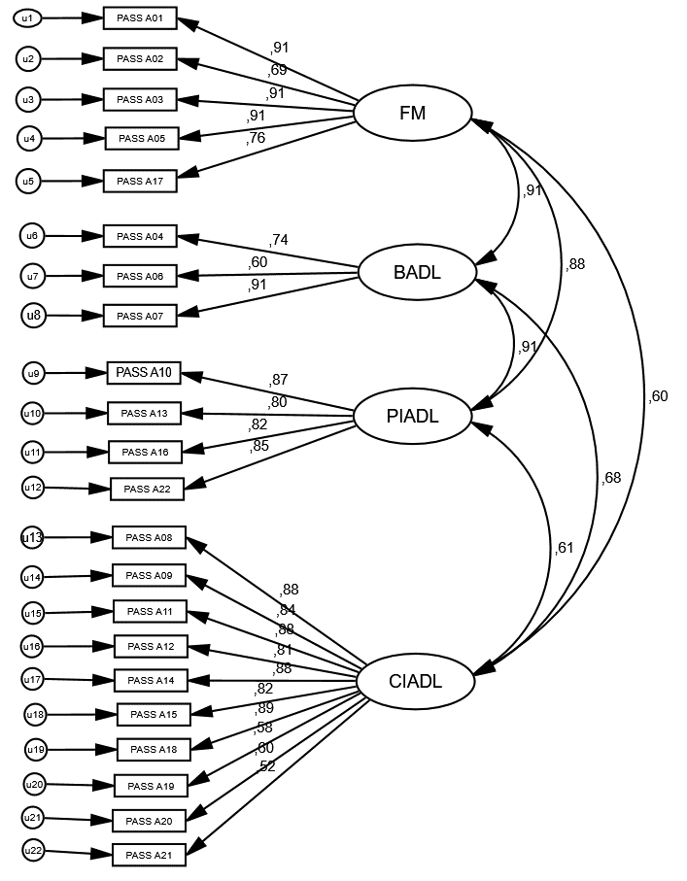

Summary Statistics
χ² | TLI | CFI | RMSEA
p<0.001 | p=0.787 | p=0.813 | p=0.142
χ²: Model Chi-Square; TLI: TuckerLewis Index; CFI: Comparative Fit Index; RMSEA: Root Mean Square Error

