Gas phase acidities of organic acids based on 9H-fluorene scaffold: A DFT Study
Hamid Saeidian,^{*1} Baharak Farzin,² Zohreh Mirjafary²
¹Department of Science, Payame Noor University (PNU), P.O. Box: 19395-4697, Tehran, Iran
² Department of chemistry, Science and Research Branch, Islamic Azad University, Tehran, Iran
Email: Saeidian1980@pnu.ac.ir
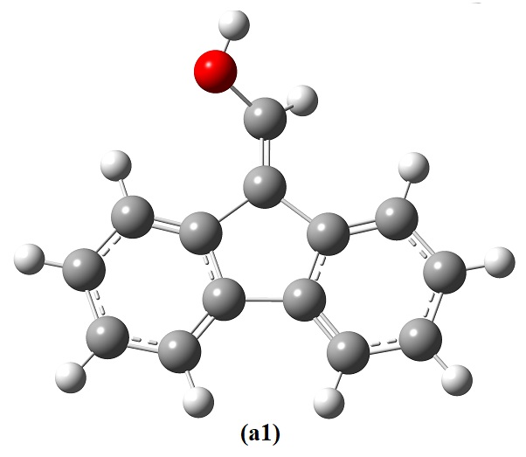
1
%chk=a1.chk
# opt freq=noraman b3lyp/6-31++g(d,p)

1

0 1
C -1.63230578 -3.90962886 0.16485264
C -0.26354532 -3.93632609 -0.20415658
C 0.41267125 -2.73264890 -0.48742220
C -0.28681406 -1.58643248 -0.39281407
C -1.62525095 -1.55824009 -0.03215412
C -2.31623864 -2.67955670 0.24828376
H -2.14624660 -4.82311853 0.38003042
H 0.25569231 -4.86974742 -0.26753586
H 1.44530622 -2.73001142 -0.76770431
H -3.34902582 -2.63839420 0.52497187
C 0.17642160 -0.14243716 -0.63826051
C -1.05704133 0.73507378 -0.37654040
C -1.18179972 2.07317686 -0.45372821
C -2.44220069 2.63026691 -0.15811513
C -3.52201216 1.78605403 0.20478648
C -3.33470876 0.39016995 0.26980592
C -2.11168354 -0.09210662 -0.02187707
H -0.35354920 2.69184154 -0.72969031
H -2.58413568 3.68965997 -0.20751977
H -4.47915011 2.20838805 0.42933251
H -4.13691477 -0.26364996 0.54162394
C 1.41312121 0.27046529 -1.00792612
O 1.96657661 1.46305020 -0.44549536
H 1.97543500 -0.29588063 -1.72063609
H 2.92498600 1.41308772 -0.46905799
Zero-point correction= 0.197825 (Hartree/Particle)
Thermal correction to Energy= 0.208930
Thermal correction to Enthalpy= 0.209874
Thermal correction to Gibbs Free Energy= 0.161009
Sum of electronic and zero-point Energies= -614.575954
Sum of electronic and thermal Energies= -614.564848
Sum of electronic and thermal Enthalpies= -614.563904
Sum of electronic and thermal Free Energies= -614.612769
Fig. s1. The optimized geometry, cartesian coordinates and thermodynamic data for chemical 1.

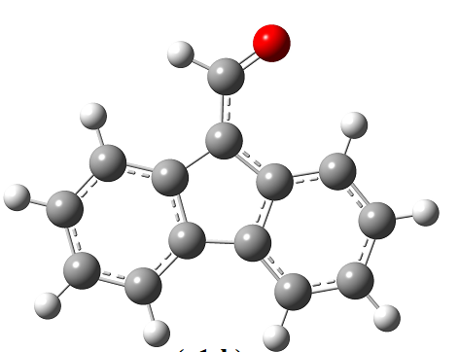
(1+H)
%chk=a1-h.chk
# opt freq=noraman b3lyp/6-31++g(d,p)

(1+H)

-1 1
C -1.63230578 -3.90962886 0.16485264
C -0.26354532 -3.93632609 -0.20415658
C 0.41267125 -2.73264890 -0.48742220
C -0.28681406 -1.58643248 -0.39281407
C -1.62525095 -1.55824009 -0.03215412
C -2.31623864 -2.67955670 0.24828376
H -2.14624660 -4.82311853 0.38003042
H 0.25569231 -4.86974742 -0.26753586
H 1.44530622 -2.73001142 -0.76770431
H -3.34902582 -2.63839420 0.52497187
C 0.17642160 -0.14243716 -0.63826051
C -1.05704133 0.73507378 -0.37654040
C -1.18179972 2.07317686 -0.45372821
C -2.44220069 2.63026691 -0.15811513
C -3.52201216 1.78605403 0.20478648
C -3.33470876 0.39016995 0.26980592
C -2.11168354 -0.09210662 -0.02187707
H -0.35354920 2.69184154 -0.72969031
H -2.58413568 3.68965997 -0.20751977
H -4.47915011 2.20838805 0.42933251
H -4.13691477 -0.26364996 0.54162394
C 1.41312121 0.27046529 -1.00792612
O 1.96657661 1.46305020 -0.44549536
H 1.97543500 -0.29588063 -1.72063609
Zero-point correction= 0.183636 (Hartree/Particle)
Thermal correction to Energy= 0.194373
Thermal correction to Enthalpy= 0.195318
Thermal correction to Gibbs Free Energy= 0.147156
Sum of electronic and zero-point Energies= -614.063130
Sum of electronic and thermal Energies= -614.052393
Sum of electronic and thermal Enthalpies= -614.051449
Sum of electronic and thermal Free Energies= -614.099610
Fig. s2. The optimized geometry, cartesian coordinates and thermodynamic data for chemical (1-H)⁻.
1'

%chk=a1'.chk
# opt freq=noraman b3lyp/6-31++g(d,p)

1'

0 1
C 3.34594248 -1.20858005 -0.11927629
C 3.56325273 0.19604547 -0.09150648
C 2.48260917 1.08364316 0.10407164
C 1.21610869 0.53265909 0.27013297
C 0.99656219 -0.82284118 0.13612434
C 2.03975227 -1.73032314 -0.00714517
H 4.17685312 -1.87352625 -0.23033503
H 4.55297671 0.58316413 -0.21594762
H 2.63388226 2.14252816 0.13198233
H 1.85827505 -2.78431735 -0.03973714
C -0.11360836 1.24184254 0.61005642
C -1.15249181 0.15036467 0.26941909
C -2.52792752 0.27493768 0.10256149
C -3.27433948 -0.90754854 -0.09356729
C -2.62614339 -2.17248049 -0.12107624
C -1.22220103 -2.25680556 -0.00812830
C -0.51756574 -1.06722290 0.13566799
H -3.00466759 1.23246075 0.13028290
H -4.33552418 -0.85144853 -0.21862656
H -3.20560058 -3.06506143 -0.23256005
H -0.71832647 -3.20018333 -0.04051371
C -0.32592781 2.55875780 -0.15952440
O -1.48855837 2.92316321 -0.47427740
H 0.51512010 3.16390852 -0.42660306
H -0.14834546 1.45510802 1.65801213
Zero-point correction= 0.196566 (Hartree/Particle)
Thermal correction to Energy= 0.207730
Thermal correction to Enthalpy= 0.208674
Thermal correction to Gibbs Free Energy= 0.158562
Sum of electronic and zero-point Energies= -614.576336
Sum of electronic and thermal Energies= -614.565172
Sum of electronic and thermal Enthalpies= -614.564228
Sum of electronic and thermal Free Energies= -614.614340
Fig. s3. The optimized geometry, cartesian coordinates and thermodynamic data for chemical 1ˊ.
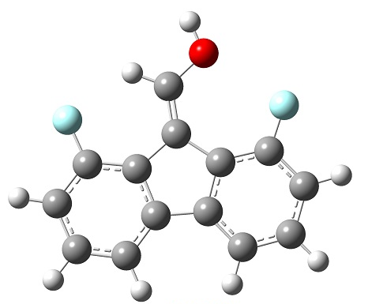

2
%chk=a1 2f.chk
# opt freq=noraman b3lyp/6-31++g(d,p)

2

0 1
C 3.34046800 -1.21071400 0.00013900
C 3.56269200 0.17382200 0.00014500
C 2.48856500 1.06972700 0.00004000
C 1.18506900 0.56893300 -0.00011100
C 0.96210400 -0.83097200 -0.00012400
C 2.03879500 -1.72034300 -0.00002700
H 4.18679100 -1.89145400 0.00025600
H 4.57961600 0.55549900 0.00026700
H 1.87225800 -2.79405700 -0.00004700
C -0.12648800 1.25157800 -0.00011200
C -1.14702100 0.18952200 -0.00026100
C -2.54365800 0.25115500 -0.00006600
C -3.27146400 -0.94421300 0.00019400
C -2.61832300 -2.18438100 0.00019300
C -1.22129000 -2.25325700 -0.00007900
C -0.48639000 -1.06704100 -0.00021600
H -4.35719200 -0.90967300 0.00045400
H -3.20242900 -3.10027600 0.00036700
H -0.72125200 -3.21794800 -0.00035100
C -0.29796400 2.58804900 -0.00007100
O -1.53397100 3.16534200 0.00017900
H 0.54818300 3.27078100 -0.00008400
H -1.45222500 4.12648400 0.00003600
F 2.72804014 2.39831710 0.00006608
F -3.17931001 1.44214050 -0.00030019
Zero-point correction= 0.181596 (Hartree/Particle)
Thermal correction to Energy= 0.194402
Thermal correction to Enthalpy= 0.195346
Thermal correction to Gibbs Free Energy= 0.142276
Sum of electronic and zero-point Energies= -813.069077
Sum of electronic and thermal Energies= -813.056271
Sum of electronic and thermal Enthalpies= -813.055327
Sum of electronic and thermal Free Energies= -813.108397
Fig. s4. The optimized geometry, cartesian coordinates and thermodynamic data for chemical 2.

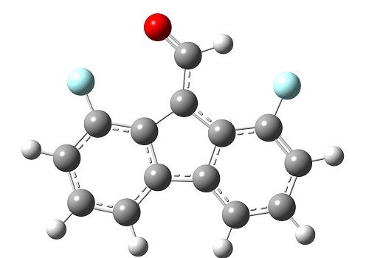
(2+H)

%chk=a1-h 2f.chk
# opt freq=noraman b3lyp/6-31++g(d,p)

(2+H)

-1 1
C 3.28555100 -1.29605300 -0.00003900
C 3.54148400 0.09144400 -0.00014500
C 2.50015300 1.01833200 -0.00012600
C 1.16069400 0.57343700 0.00001400
C 0.90874300 -0.84304800 0.00012600
C 1.96793400 -1.75913300 0.00009300
H 4.11355800 -2.00131000 -0.00007900
H 4.57113000 0.44489100 -0.00023900
H 1.76719700 -2.82944000 0.00015900
C -0.10436100 1.27812900 -0.00006100
C -1.13853500 0.26934300 -0.00007400
C -2.54469100 0.37332900 -0.00019900
C -3.31454700 -0.78924900 -0.00020100
C -2.71410100 -2.06675500 0.00000500
C -1.32278600 -2.18668200 0.00016300
C -0.53059900 -1.03096400 0.00010000
H -4.40049400 -0.71190100 -0.00033300
H -3.33734500 -2.95854300 0.00007100
H -0.86040800 -3.17267300 0.00048700
C -0.27420400 2.68461900 0.00015300
O -1.34779200 3.32830500 0.00018200
H 0.68000700 3.26352500 0.00015700
F 2.78200243 2.33858231 -0.00023153
F -3.11481722 1.59703488 -0.00034956
Zero-point correction= 0.167209 (Hartree/Particle)
Thermal correction to Energy= 0.179855
Thermal correction to Enthalpy= 0.180799
Thermal correction to Gibbs Free Energy= 0.127826
Sum of electronic and zero-point Energies= -812.557826
Sum of electronic and thermal Energies= -812.545181
Sum of electronic and thermal Enthalpies= -812.544236
Sum of electronic and thermal Free Energies= -812.597209
Fig. s5. The optimized geometry, cartesian coordinates and thermodynamic data for chemical (2-H)⁻.
3
%chk=a1 2f'.chk
# opt freq=noraman b3lyp/6-31++g(d,p)

3

0 1
C 3.21292900 -1.76100500 0.00002400
C 3.56587000 -0.40435100 0.00000800
C 2.56259300 0.55542400 -0.00000400
C 1.21251400 0.21886400 0.00000000
C 0.88219800 -1.15908400 0.00001600
C 1.87055600 -2.14638300 0.00002700
H 3.99548700 -2.51326100 0.00003300
H 1.60391400 -3.19869600 0.00003900
C -0.02414600 1.02269300 -0.00001000
C -1.12909200 0.04315400 0.00000000
C -2.52070100 0.14754400 -0.00001000
C -3.34129500 -0.97667100 -0.00000400
C -2.77138700 -2.25457100 0.00001200
C -1.38404000 -2.40918300 0.00002200
C -0.57783700 -1.26986600 0.00001500
H -3.41791100 -3.12670900 0.00001700
H -0.94160900 -3.40045500 0.00003500
C -0.01232900 2.37758100 -0.00002000
O -1.12271700 3.14770200 -0.00000800
H 0.93700800 2.90267900 -0.00002600
H -0.87309000 4.08005100 -0.00006900
H 2.85038844 1.58599364 -0.00001494
H -3.00090942 1.10373429 -0.00002421
F 4.85653179 -0.00850741 0.00000427
F -4.67974517 -0.80045769 -0.00001520
Zero-point correction= 0.181126 (Hartree/Particle)
Thermal correction to Energy= 0.193997
Thermal correction to Enthalpy= 0.194941
Thermal correction to Gibbs Free Energy= 0.141855
Sum of electronic and zero-point Energies= -813.073555
Sum of electronic and thermal Energies= -813.060685
Sum of electronic and thermal Enthalpies= -813.059740
Sum of electronic and thermal Free Energies= -813.112826
Fig. s6. The optimized geometry, cartesian coordinates and thermodynamic data for chemical 3.
(3+H)'
%chk=a1 2f'-h.chk
# opt freq=noraman b3lyp/6-31++g(d,p)

(3+H)'

-1 1
C -3.12656200 -1.60722000 -0.00002200
C -3.53243500 -0.26545100 -0.00000600
C -2.56756900 0.73293100 0.00000600
C -1.20533000 0.44957500 0.00000200
C -0.82122900 -0.91435900 -0.00001400
C -1.77010800 -1.93965900 -0.00002500
H -3.87901700 -2.38958700 -0.00003100
H -1.46240300 -2.98070500 -0.00003700
C -0.00114400 1.30128400 0.00001200
C 1.14136600 0.36583000 0.00000200
C 2.52781100 0.52471400 0.00001200
C 3.39186100 -0.56645500 0.00000600
C 2.87250700 -1.86572200 -0.00001000
C 1.49229000 -2.07462200 -0.00002000
C 0.64202700 -0.96779800 -0.00001300
H 3.55273600 -2.71183400 -0.00001500
H 1.08907400 -3.08248200 -0.00003300
C -0.06608700 2.65466600 0.00002200
O 1.01324600 3.46774000 0.00001000
H -1.03528600 3.14213000 0.00002800
H -2.89555800 1.75142100 0.00001700
H 2.97015100 1.49900100 0.00002700
F -4.83762700 0.07947200 -0.00000200
F 4.72237100 -0.33788700 0.00001800
Zero-point correction= 0.167019 (Hartree/Particle)
Thermal correction to Energy= 0.179579
Thermal correction to Enthalpy= 0.180523
Thermal correction to Gibbs Free Energy= 0.128034
Sum of electronic and zero-point Energies= -812.571518
Sum of electronic and thermal Energies= -812.558959
Sum of electronic and thermal Enthalpies= -812.558015
Sum of electronic and thermal Free Energies= -812.610504
Fig. s7. The optimized geometry, cartesian coordinates and thermodynamic data for chemical (3-H)⁻.

4
%chk=a1 2f''.chk
# opt freq=noraman b3lyp/6-31++g(d,p)
4

0 1
C 3.21292900 -1.76100500 0.00002400
C 3.56587000 -0.40435100 0.00000800
C 2.56259300 0.55542400 -0.00000400
C 1.21251400 0.21886400 0.00000000
C 0.88219800 -1.15908400 0.00001600
C 1.87055600 -2.14638300 0.00002700
H 1.60391400 -3.19869600 0.00003900
C -0.02414600 1.02269300 -0.00001000
C -1.12909200 0.04315400 0.00000000
C -2.52070100 0.14754400 -0.00001000
C -3.34129500 -0.97667100 -0.00000400
C -2.77138700 -2.25457100 0.00001200
C -1.38404000 -2.40918300 0.00002200
C -0.57783700 -1.26986600 0.00001500
H -0.94160900 -3.40045500 0.00003500
C -0.01232900 2.37758100 -0.00002000
O -1.12271700 3.14770200 -0.00000800
H 0.93700800 2.90267900 -0.00002600
H -0.87309000 4.08005100 -0.00006900
H 2.85038844 1.58599364 -0.00001494
H -3.00090942 1.10373429 -0.00002421
F 4.18618015 -2.69657018 0.00003519
F -3.57534228 -3.33907822 0.00001822
H -4.40214069 -0.83700564 -0.00001288
H 4.58883897 -0.09060830 0.00000504
Zero-point correction= 0.181097 (Hartree/Particle)
Thermal correction to Energy= 0.193985
Thermal correction to Enthalpy= 0.194929
Thermal correction to Gibbs Free Energy= 0.141794
Sum of electronic and zero-point Energies= -813.073492
Sum of electronic and thermal Energies= -813.060603
Sum of electronic and thermal Enthalpies= -813.059659
Sum of electronic and thermal Free Energies= -813.112795
Fig. s8. The optimized geometry, cartesian coordinates and thermodynamic data for chemical 4.
(4+H)
%chk=a1 2f''-h.chk
# opt freq=noraman b3lyp/6-31++g(d,p)
(4+H)

-1 1
C -3.15963900 -1.11833500 -0.00001700
C -3.50986300 0.23902300 -0.00000100
C -2.50466600 1.19678700 0.00001100
C -1.15526300 0.85752400 0.00000700
C -0.82770800 -0.52108300 -0.00000900
C -1.81804100 -1.50640100 -0.00002000
H -1.55350700 -2.55924600 -0.00003200
C 0.08300400 1.65887500 0.00001700
C 1.18598600 0.67712500 0.00000700
C 2.57780100 0.77872800 0.00001700
C 3.39614200 -0.34712800 0.00001100
C 2.82367600 -1.62388400 -0.00000500
C 1.43602200 -1.77571800 -0.00001500
C 0.63210300 -0.63478900 -0.00000800
H 0.99160700 -2.76610200 -0.00002800
C 0.07390000 3.01378400 0.00002700
O 1.18582800 3.78167900 0.00001500
H -0.87438300 3.54078200 0.00003300
H -2.79039700 2.22793100 0.00002200
H 3.05992400 1.73395400 0.00003100
F -4.13476200 -2.05195000 -0.00002800
F 3.62545800 -2.71000000 -0.00001100
H 4.45726600 -0.20958800 0.00002000
H -4.53220100 0.55481400 0.00000200
Zero-point correction= 0.166992 (Hartree/Particle)
Thermal correction to Energy= 0.179574
Thermal correction to Enthalpy= 0.180518
Thermal correction to Gibbs Free Energy= 0.127967
Sum of electronic and zero-point Energies= -812.568425
Sum of electronic and thermal Energies= -812.555843
Sum of electronic and thermal Enthalpies= -812.554899
Sum of electronic and thermal Free Energies= -812.607450
Fig. s9. The optimized geometry, cartesian coordinates and thermodynamic data for chemical (4-H)⁻.
5
%chk=a1 2f'''.chk
# opt freq=noraman b3lyp/6-31++g(d,p)
5

0 1
C 3.21292900 -1.76100500 0.00002400
C 3.56587000 -0.40435100 0.00000800
C 2.56259300 0.55542400 -0.00000400
C 1.21251400 0.21886400 0.00000000
C 0.88219800 -1.15908400 0.00001600
C 1.87055600 -2.14638300 0.00002700
C -0.02414600 1.02269300 -0.00001000
C -1.12909200 0.04315400 0.00000000
C -2.52070100 0.14754400 -0.00001000
C -3.34129500 -0.97667100 -0.00000400
C -2.77138700 -2.25457100 0.00001200
C -1.38404000 -2.40918300 0.00002200
C -0.57783700 -1.26986600 0.00001500
C -0.01232900 2.37758100 -0.00002000
O -1.12271700 3.14770200 -0.00000800
H 0.93700800 2.90267900 -0.00002600
H -0.87309000 4.08005100 -0.00006900
H 2.85038844 1.58599364 -0.00001494
H -3.00090942 1.10373429 -0.00002421
H -4.40214069 -0.83700564 -0.00001288
H 4.58883897 -0.09060830 0.00000504
H 3.98432065 -2.50252703 0.00003287
H -3.40859600 -3.11414339 0.00001693
F 1.53896343 -3.45502595 0.00004192
F -0.83381625 -3.64196596 0.0000381
Zero-point correction= 0.181521 (Hartree/Particle)
Thermal correction to Energy= 0.194373
Thermal correction to Enthalpy= 0.195317
Thermal correction to Gibbs Free Energy= 0.142301
Sum of electronic and zero-point Energies= -813.068301
Sum of electronic and thermal Energies= -813.055449
Sum of electronic and thermal Enthalpies= -813.054505
Sum of electronic and thermal Free Energies= -813.107522
Fig. s10. The optimized geometry, cartesian coordinates and thermodynamic data for chemical 5.

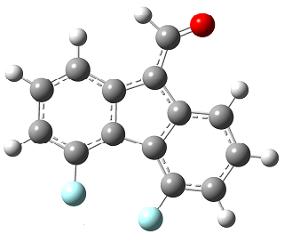
(5+H)

%chk=a1 2f'''-h.chk
# opt freq=noraman b3lyp/6-31++g(d,p)
(5+H)

-1 1
C -3.29625000 0.41219100 -0.00001500
C -3.02857100 1.78820900 0.00000100
C -1.70914600 2.22047200 0.00001300
C -0.63688400 1.33377100 0.00000900
C -0.93416600 -0.05167900 -0.00000700
C -2.25202400 -0.51521000 -0.00001800
C 0.82567000 1.52457900 0.00001900
C 1.39911600 0.16385800 0.00000900
C 2.69930000 -0.34308800 0.00001900
C 2.95379800 -1.71146800 0.00001300
C 1.88781800 -2.61784000 -0.00000300
C 0.56978500 -2.15803000 -0.00001300
C 0.33478900 -0.78224500 -0.00000600
C 1.40024600 2.75165800 0.00002900
O 2.73435400 2.96660700 0.00001700
H 0.77085100 3.63530400 0.00003500
H -1.52356200 3.27425500 0.00002400
H 3.54542000 0.31187800 0.00003300
H 3.97090300 -2.04372900 0.00002200
H -3.81566900 2.51303800 0.00000400
H -4.31226400 0.07660900 -0.00002400
H 2.09123100 -3.66832700 -0.00000800
F -2.51821900 -1.83870600 -0.00003300
F -0.45895500 -3.03221300 -0.00003000
Zero-point correction= 0.167461 (Hartree/Particle)
Thermal correction to Energy= 0.180004
Thermal correction to Enthalpy= 0.180948
Thermal correction to Gibbs Free Energy= 0.128532
Sum of electronic and zero-point Energies= -812.565974
Sum of electronic and thermal Energies= -812.553431
Sum of electronic and thermal Enthalpies= -812.552487
Sum of electronic and thermal Free Energies= -812.604904
Fig. s11. The optimized geometry, cartesian coordinates and thermodynamic data for chemical (5-H)⁻.
6

%chk=a1 2f on one ring'.chk
# opt freq=noraman b3lyp/6-31++g(d,p)
6

0 1
C -2.97749492 -1.37631083 -0.00117262
C -3.30705345 0.00635565 0.00138955
C -2.28905280 0.98382750 0.00336110
C -0.97065831 0.54157755 0.00269688
C -0.64817222 -0.80310204 0.00020555
C -1.62789420 -1.79064176 -0.00178002
C 0.33478470 1.35200097 0.00439553
C 1.46188523 0.30767753 0.00257656
C 2.84039366 0.49060816 0.00310742
C 3.65348777 -0.66293174 0.00104478
C 3.06650377 -1.95746859 -0.00147170
C 1.66268079 -2.10704537 -0.00194277
C 0.88908246 -0.95091601 0.00012952
C 0.46449501 2.70097675 0.00695640
H 3.26929846 1.47088213 0.00501343
H 4.71874984 -0.56235009 0.00137791
H -4.33363219 0.30807725 0.00182731
H -3.75787702 -2.10836383 -0.00265068
H 3.69309675 -2.82480869 -0.00302057
F -1.29945837 -3.10007828 -0.00420240
F -2.58461170 2.30107420 0.00580882
H 1.20937493 -3.07627712 -0.00382625
O -0.69956672 3.53141565 -0.00825838
H 1.43829898 3.14423061 -0.00452485
H -1.48573263 2.98046948 -0.00704239
Zero-point correction= 0.182241 (Hartree/Particle)
Thermal correction to Energy= 0.194736
Thermal correction to Enthalpy= 0.195681
Thermal correction to Gibbs Free Energy= 0.143440
Sum of electronic and zero-point Energies= -813.075652
Sum of electronic and thermal Energies= -813.063157
Sum of electronic and thermal Enthalpies= -813.062213
Sum of electronic and thermal Free Energies= -813.114453
Fig. s12. The optimized geometry, cartesian coordinates and thermodynamic data for chemical 6.

(6+H)
%chk=a1 2f on one ring'-h.chk
# opt freq=noraman b3lyp/6-31++g(d,p)

(6+H)

-1 1
C -2.97749492 -1.37631083 -0.00117262
C -3.30705345 0.00635565 0.00138955
C -2.28905280 0.98382750 0.00336110
C -0.97065831 0.54157755 0.00269688
C -0.64817222 -0.80310204 0.00020555
C -1.62789420 -1.79064176 -0.00178002
C 0.33478470 1.35200097 0.00439553
C 1.46188523 0.30767753 0.00257656
C 2.84039366 0.49060816 0.00310742
C 3.65348777 -0.66293174 0.00104478
C 3.06650377 -1.95746859 -0.00147170
C 1.66268079 -2.10704537 -0.00194277
C 0.88908246 -0.95091601 0.00012952
C 0.46449501 2.70097675 0.00695640
H 3.26929846 1.47088213 0.00501343
H 4.71874984 -0.56235009 0.00137791
H -4.33363219 0.30807725 0.00182731
H -3.75787702 -2.10836383 -0.00265068
H 3.69309675 -2.82480869 -0.00302057
F -1.29945837 -3.10007828 -0.00420240
F -2.58461170 2.30107420 0.00580882
H 1.20937493 -3.07627712 -0.00382625
O -0.69956672 3.53141565 -0.00825838
H 1.43829898 3.14423061 -0.00452485
Zero-point correction= 0.167216 (Hartree/Particle)
Thermal correction to Energy= 0.179864
Thermal correction to Enthalpy= 0.180808
Thermal correction to Gibbs Free Energy= 0.127977
Sum of electronic and zero-point Energies= -812.558897
Sum of electronic and thermal Energies= -812.546250
Sum of electronic and thermal Enthalpies= -812.545306
Sum of electronic and thermal Free Energies= -812.598137
Fig. s13. The optimized geometry, cartesian coordinates and thermodynamic data for chemical (6-H)⁻.
7
1 2f on one ring.chk
# opt freq=noraman b3lyp/6-31++g(d,p)
7

a1 2f on one ring

0 1
C 3.21292900 -1.76100500 0.00002400
C 3.56587000 -0.40435100 0.00000800
C 2.56259300 0.55542400 -0.00000400
C 1.21251400 0.21886400 0.00000000
C 0.88219800 -1.15908400 0.00001600
C 1.87055600 -2.14638300 0.00002700
C -0.02414600 1.02269300 -0.00001000
C -1.12909200 0.04315400 0.00000000
C -2.52070100 0.14754400 -0.00001000
C -3.34129500 -0.97667100 -0.00000400
C -2.77138700 -2.25457100 0.00001200
C -1.38404000 -2.40918300 0.00002200
C -0.57783700 -1.26986600 0.00001500
C -0.01232900 2.37758100 -0.00002000
O -1.12271700 3.14770200 -0.00000800
H 0.93700800 2.90267900 -0.00002600
H -0.87309000 4.08005100 -0.00006900
H -3.00090942 1.10373429 -0.00002421
H -4.40214069 -0.83700564 -0.00001288
H 4.58883897 -0.09060830 0.00000504
H 3.98432065 -2.50252703 0.00003287
H -3.40859600 -3.11414339 0.00001693
F 1.53896343 -3.45502595 0.00004192
F 2.92569940 1.85567542 -0.00001780
H -0.94793673 -3.38627764 0.00003482
Zero-point correction= 0.181754 (Hartree/Particle)
Thermal correction to Energy= 0.194536
Thermal correction to Enthalpy= 0.195481
Thermal correction to Gibbs Free Energy= 0.142787
Sum of electronic and zero-point Energies= -813.072970
Sum of electronic and thermal Energies= -813.060187
Sum of electronic and thermal Enthalpies= -813.059243
Sum of electronic and thermal Free Energies= -813.111936
Fig. s14. The optimized geometry, cartesian coordinates and thermodynamic data for chemical 7.

(7+H)

%chk=a1 2f on one ring-h.chk
# opt freq=noraman b3lyp/6-31++g(d,p)
(7+H)

-1 1
C -2.84796500 -1.52340300 -0.00001900
C -3.24519600 -0.17905000 -0.00000300
C -2.27392500 0.81310300 0.00000900
C -0.91353800 0.52098700 0.00000500
C -0.53822200 -0.84539000 -0.00001100
C -1.49367900 -1.86456300 -0.00002200
C 0.29610300 1.36492900 0.00001500
C 1.43257000 0.42214400 0.00000500
C 2.82000900 0.57210300 0.00001500
C 3.67702000 -0.52460400 0.00000900
C 3.14931600 -1.82050200 -0.00000700
C 1.76778300 -2.02051600 -0.00001700
C 0.92466000 -0.90824400 -0.00001000
C 0.23987100 2.71870200 0.00002500
O 1.32441300 3.52481400 0.00001300
H -0.72617100 3.21239200 0.00003100
H 3.26860900 1.54352300 0.00002900
H 4.73271600 -0.35023300 0.00001800
H -4.27790100 0.10098500 0.00000000
H -3.59463100 -2.28981700 -0.00002800
H 3.81436400 -2.65872000 -0.00001200
F -1.11936000 -3.16163000 -0.00003700
F -2.67946700 2.10075000 0.00002300
H 1.36395000 -3.01138400 -0.00003000
Zero-point correction= 0.167627 (Hartree/Particle)
Thermal correction to Energy= 0.180157
Thermal correction to Enthalpy= 0.181102
Thermal correction to Gibbs Free Energy= 0.128831
Sum of electronic and zero-point Energies= -812.566713
Sum of electronic and thermal Energies= -812.554182
Sum of electronic and thermal Enthalpies= -812.553238
Sum of electronic and thermal Free Energies= -812.605509
Fig. s15. The optimized geometry, cartesian coordinates and thermodynamic data for chemical (7-H)⁻.
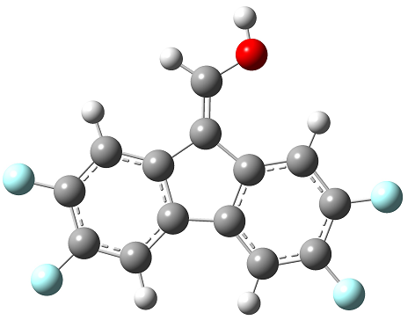
8
%chk=a1 4f.chk
# opt freq=noraman b3lyp/6-31++g(d,p)

3
0 1
C 3.34046800 -1.21071400 0.00013900
C 3.56269200 0.17382200 0.00014500
C 2.48856500 1.06972700 0.00004000
C 1.18506900 0.56893300 -0.00011100
C 0.96210400 -0.83097200 -0.00012400
C 2.03879500 -1.72034300 -0.00002700
H 1.87225800 -2.79405700 -0.00004700
C -0.12648800 1.25157800 -0.00011200
C -1.14702100 0.18952200 -0.00026100
C -2.54365800 0.25115500 -0.00006600
C -3.27146400 -0.94421300 0.00019400
C -2.61832300 -2.18438100 0.00019300
C -1.22129000 -2.25325700 -0.00007900
C -0.48639000 -1.06704100 -0.00021600
H -0.72125200 -3.21794800 -0.00035100
C -0.29796400 2.58804900 -0.00007100
O -1.53397100 3.16534200 0.00017900
H 0.54818300 3.27078100 -0.00008400
H -1.45222500 4.12648400 0.00003600
F 4.82660128 0.64819875 0.00029663
F 4.39240498 -2.05683963 0.00028443
F -4.62078134 -0.90128750 0.00051712
F -3.34422238 -3.32261210 0.00040924
H -3.04747108 1.19512129 -0.00025162
H 2.67837122 2.12275767 0.00006067
Zero-point correction= 0.164647 (Hartree/Particle)
Thermal correction to Energy= 0.179385
Thermal correction to Enthalpy= 0.180329
Thermal correction to Gibbs Free Energy= 0.122937
Sum of electronic and zero-point Energies= -1011.555631
Sum of electronic and thermal Energies= -1011.540893
Sum of electronic and thermal Enthalpies= -1011.539948
Sum of electronic and thermal Free Energies= -1011.597340
Fig. s16. The optimized geometry, cartesian coordinates and thermodynamic data for chemical 8.
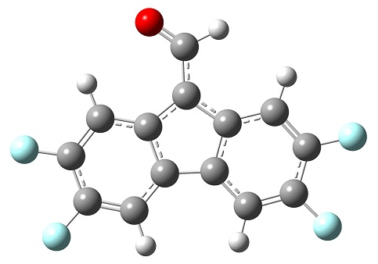
(8+H)

%chk=a1-h 4f.chk
# opt freq=noraman b3lyp/6-31++g(d,p)

(8+H)

-1 1
C 3.28555100 -1.29605300 -0.00003900
C 3.54148400 0.09144400 -0.00014500
C 2.50015300 1.01833200 -0.00012600
C 1.16069400 0.57343700 0.00001400
C 0.90874300 -0.84304800 0.00012600
C 1.96793400 -1.75913300 0.00009300
H 1.76719700 -2.82944000 0.00015900
C -0.10436100 1.27812900 -0.00006100
C -1.13853500 0.26934300 -0.00007400
C -2.54469100 0.37332900 -0.00019900
C -3.31454700 -0.78924900 -0.00020100
C -2.71410100 -2.06675500 0.00000500
C -1.32278600 -2.18668200 0.00016300
C -0.53059900 -1.03096400 0.00010000
H -0.86040800 -3.17267300 0.00048700
C -0.27420400 2.68461900 0.00015300
O -1.34779200 3.32830500 0.00018200
H 0.68000700 3.26352500 0.00015700
F 4.81834905 0.52975398 -0.00026157
F 4.31327978 -2.17142352 -0.00008865
F -4.66113556 -0.69333646 -0.00036468
F -3.48743585 -3.17330514 0.00008689
H 2.72354477 2.06475262 -0.00020964
H -2.99656882 1.34322921 -0.00031833
Zero-point correction= 0.150578 (Hartree/Particle)
Thermal correction to Energy= 0.165062
Thermal correction to Enthalpy= 0.166006
Thermal correction to Gibbs Free Energy= 0.109097
Sum of electronic and zero-point Energies= -1011.060438
Sum of electronic and thermal Energies= -1011.045954
Sum of electronic and thermal Enthalpies= -1011.045010
Sum of electronic and thermal Free Energies= -1011.101919
Fig. s17. The optimized geometry, cartesian coordinates and thermodynamic data for chemical (8-H)⁻.

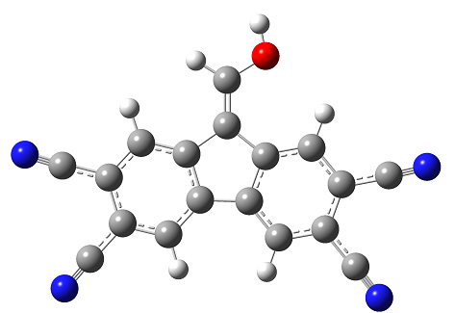
9
%chk=a1 4cn.chk
# opt freq=noraman b3lyp/6-31++g(d,p)

9

0 1
C 3.34046800 -1.21071400 0.00013900
C 3.56269200 0.17382200 0.00014500
C 2.48856500 1.06972700 0.00004000
C 1.18506900 0.56893300 -0.00011100
C 0.96210400 -0.83097200 -0.00012400
C 2.03879500 -1.72034300 -0.00002700
H 1.87225800 -2.79405700 -0.00004700
C -0.12648800 1.25157800 -0.00011200
C -1.14702100 0.18952200 -0.00026100
C -2.54365800 0.25115500 -0.00006600
C -3.27146400 -0.94421300 0.00019400
C -2.61832300 -2.18438100 0.00019300
C -1.22129000 -2.25325700 -0.00007900
C -0.48639000 -1.06704100 -0.00021600
H -0.72125200 -3.21794800 -0.00035100
C -0.29796400 2.58804900 -0.00007100
O -1.53397100 3.16534200 0.00017900
H 0.54818300 3.27078100 -0.00008400
H -1.45222500 4.12648400 0.00003600
H -3.04747108 1.19512129 -0.00025162
H 2.67837122 2.12275767 0.00006067
C 5.00448481 0.71496289 0.00031797
C 4.54045537 -2.17592397 0.00030490
C -3.44638600 -3.48280759 0.00043967
C -4.81068527 -0.89524613 0.00056260
N 6.07796510 1.11786687 0.00044675
N 5.43390050 -2.89456667 0.00042842
N -4.06291654 -4.44954521 0.00062333
N -5.95670547 -0.85878808 0.00083703
Zero-point correction= 0.191441 (Hartree/Particle)
Thermal correction to Energy= 0.210021
Thermal correction to Enthalpy= 0.210965
Thermal correction to Gibbs Free Energy= 0.144270
Sum of electronic and zero-point Energies= -983.547034
Sum of electronic and thermal Energies= -983.528454
Sum of electronic and thermal Enthalpies= -983.527510
Sum of electronic and thermal Free Energies= -983.594206
Fig. s18. The optimized geometry, cartesian coordinates and thermodynamic data for chemical 9.
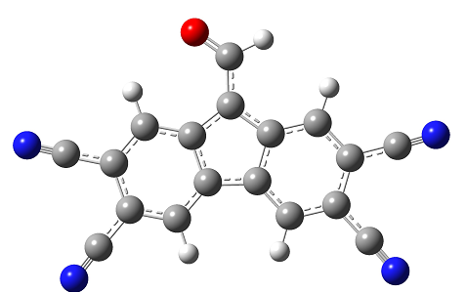
(9+H)

%chk=a1-h 4cn.chk

# opt freq=noraman b3lyp/6-31++g(d,p)

(9+H)

-1 1
C 3.28555100 -1.29605300 -0.00003900
C 3.54148400 0.09144400 -0.00014500
C 2.50015300 1.01833200 -0.00012600
C 1.16069400 0.57343700 0.00001400
C 0.90874300 -0.84304800 0.00012600
C 1.96793400 -1.75913300 0.00009300
H 1.76719700 -2.82944000 0.00015900
C -0.10436100 1.27812900 -0.00006100
C -1.13853500 0.26934300 -0.00007400
C -2.54469100 0.37332900 -0.00019900
C -3.31454700 -0.78924900 -0.00020100
C -2.71410100 -2.06675500 0.00000500
C -1.32278600 -2.18668200 0.00016300
C -0.53059900 -1.03096400 0.00010000
H -0.86040800 -3.17267300 0.00048700
C -0.27420400 2.68461900 0.00015300
O -1.34779200 3.32830500 0.00018200
H 0.68000700 3.26352500 0.00015700
H 2.72354477 2.06475262 -0.00020964
H -2.99656882 1.34322921 -0.00031833
C 4.99805598 0.59144205 -0.00027798
C 4.45792309 -2.29462382 -0.00009564
C -3.59627557 -3.32904182 0.00009842
C -4.85065543 -0.67983766 -0.00038772
N 6.08254003 0.96371333 -0.00037698
N 5.33080740 -3.03810518 -0.00013781
N -4.25309463 -4.26887174 0.00016797
N -5.99435799 -0.59837594 -0.00052674
Zero-point correction= 0.178067 (Hartree/Particle)
Thermal correction to Energy= 0.196297
Thermal correction to Enthalpy= 0.197241
Thermal correction to Gibbs Free Energy= 0.131202
Sum of electronic and zero-point Energies= -983.091310
Sum of electronic and thermal Energies= -983.073080
Sum of electronic and thermal Enthalpies= -983.072136
Sum of electronic and thermal Free Energies= -983.138175
Fig. s19. The optimized geometry, cartesian coordinates and thermodynamic data for chemical (9-H)⁻.
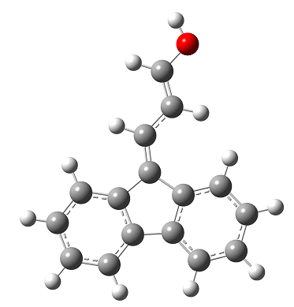
10

%chk=c1.chk
# opt freq=noraman b3lyp/6-31++g(d,p)

10

0 1
C -3.08706332 -2.45245754 1.87348500
C -2.23131729 -3.37053929 1.21378009
C -1.18470761 -2.89578619 0.39795865
C -1.04139547 -1.56260093 0.27912618
C -1.87711232 -0.66326664 0.92337709
C -2.89088257 -1.06550115 1.71327429
H -3.88182829 -2.81226376 2.49299141
H -2.38002887 -4.42317121 1.33523359
H -0.52742930 -3.57103811 -0.10891446
H -3.52580446 -0.35673575 2.20258583
C -0.00686943 -0.76482971 -0.52912531
C -0.34049442 0.71358070 -0.27822585
C 0.26625146 1.81621102 -0.75583260
C -0.24875314 3.06784788 -0.36273917
C -1.36744011 3.13202326 0.50605699
C -1.96407985 1.94429248 0.97629005
C -1.43446193 0.77424234 0.57138530
H 1.10951946 1.74495907 -1.41060143
H 0.20419797 3.96912254 -0.71972562
H -1.75889908 4.08196004 0.80485458
H -2.80882848 1.97164417 1.63245442
C 0.99035405 -1.26093804 -1.30112839
H 1.11850203 -2.31910311 -1.39474875
C 1.93912435 -0.30173115 -2.04366257
C 2.93634594 -0.79783974 -2.81566796
H 1.81097564 0.75643398 -1.95004320
O 3.81734621 0.09285234 -3.50516496
H 4.12404882 -0.32305032 -4.31421283
H 3.06449395 -1.85600484 -2.90928807
Zero-point correction= 0.230893 (Hartree/Particle)
Thermal correction to Energy= 0.244434
Thermal correction to Enthalpy= 0.245378
Thermal correction to Gibbs Free Energy= 0.190246
Sum of electronic and zero-point Energies= -691.952201
Sum of electronic and thermal Energies= -691.938660
Sum of electronic and thermal Enthalpies= -691.937716
Sum of electronic and thermal Free Energies= -691.992848
Fig. s20. The optimized geometry, cartesian coordinates and thermodynamic data for chemical 10.
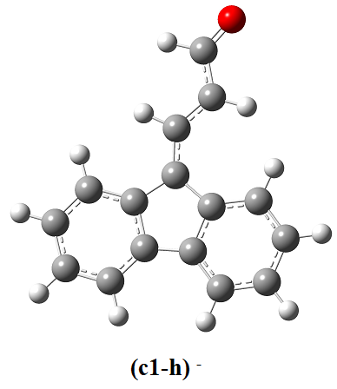
(10+H)
%chk=c1-h.chk
# opt freq=noraman b3lyp/6-31++g(d,p)

(10+H)

-1 1
C -3.08706332 -2.45245754 1.87348500
C -2.23131729 -3.37053929 1.21378009
C -1.18470761 -2.89578619 0.39795865
C -1.04139547 -1.56260093 0.27912618
C -1.87711232 -0.66326664 0.92337709
C -2.89088257 -1.06550115 1.71327429
H -3.88182829 -2.81226376 2.49299141
H -2.38002887 -4.42317121 1.33523359
H -0.52742930 -3.57103811 -0.10891446
H -3.52580446 -0.35673575 2.20258583
C -0.00686943 -0.76482971 -0.52912531
C -0.34049442 0.71358070 -0.27822585
C 0.26625146 1.81621102 -0.75583260
C -0.24875314 3.06784788 -0.36273917
C -1.36744011 3.13202326 0.50605699
C -1.96407985 1.94429248 0.97629005
C -1.43446193 0.77424234 0.57138530
H 1.10951946 1.74495907 -1.41060143
H 0.20419797 3.96912254 -0.71972562
H -1.75889908 4.08196004 0.80485458
H -2.80882848 1.97164417 1.63245442
C 0.99035405 -1.26093804 -1.30112839
H 1.11850203 -2.31910311 -1.39474875
C 1.93912435 -0.30173115 -2.04366257
C 2.93634594 -0.79783974 -2.81566796
H 1.81097564 0.75643398 -1.95004320
O 3.81734621 0.09285234 -3.50516496
H 3.06449395 -1.85600484 -2.90928807
Zero-point correction= 0.217054 (Hartree/Particle)
Thermal correction to Energy= 0.230047
Thermal correction to Enthalpy= 0.230991
Thermal correction to Gibbs Free Energy= 0.177188
Sum of electronic and zero-point Energies= -691.447701
Sum of electronic and thermal Energies= -691.434709
Sum of electronic and thermal Enthalpies= -691.433765
Sum of electronic and thermal Free Energies= -691.487568
Fig. s21. The optimized geometry, cartesian coordinates and thermodynamic data for chemical (10-H)⁻.
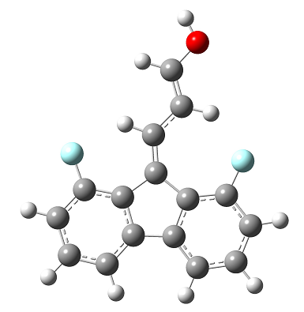
11
%chk=c1 2f.chk
# opt freq=noraman b3lyp/6-31++g(d,p)

11

0 1
C 3.45349500 -2.10124100 0.00021900
C 2.37695200 -3.00017700 -0.00011500
C 1.05813900 -2.53529100 -0.00030300
C 0.81979800 -1.15846000 -0.00019600
C 1.90935700 -0.25492700 0.00012300
C 3.22494300 -0.72194500 0.00034900
H 4.47141000 -2.48015600 0.00038600
H 2.56928900 -4.06925100 -0.00023700
H 4.06204400 -0.02918000 0.00064900
C -0.44722900 -0.39363300 -0.00029200
C -0.05179200 1.03284600 -0.00012700
C -0.79416800 2.21971200 -0.00048500
C -0.12991400 3.45115400 -0.00034000
C 1.26902800 3.51338800 0.00011000
C 2.02570800 2.33805400 0.00033100
C 1.36877200 1.10760100 0.00016800
H -0.71021000 4.36930500 -0.00062300
H 1.76723100 4.47855000 0.00023400
H 3.11119600 2.38606100 0.00058900
C -1.67415100 -0.98688800 -0.00032700
H -1.67581000 -2.07715600 -0.00071300
C -2.98241800 -0.38753300 0.00027400
C -4.10060800 -1.14317700 -0.00004000
H -3.10418400 0.68872000 0.00112700
O -5.34001800 -0.57742700 0.00058200
H -6.02290100 -1.25869400 0.00028700
H -4.06411800 -2.23143800 -0.00085300
F -2.14414808 2.21241070 -0.00117561
F 0.03910857 -3.42077216 -0.00062847
Zero-point correction= 0.215016 (Hartree/Particle)
Thermal correction to Energy= 0.230124
Thermal correction to Enthalpy= 0.231068
Thermal correction to Gibbs Free Energy= 0.172288
Sum of electronic and zero-point Energies= -890.447425
Sum of electronic and thermal Energies= -890.432317
Sum of electronic and thermal Enthalpies= -890.431373
Sum of electronic and thermal Free Energies= -890.490153
Fig. s22. The optimized geometry, cartesian coordinates and thermodynamic data for chemical 11.
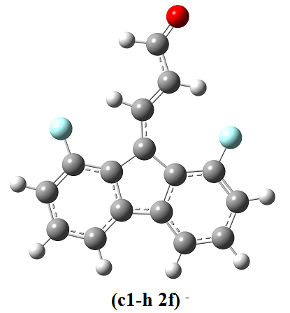
(11+H)
%chk=c1-h 2f.chk
# opt freq=noraman b3lyp/6-31++g(d,p)

(11+H)

-1 1
C 3.29861700 -2.25074200 0.00013500
C 2.16331000 -3.08696300 -0.00001600
C 0.87546300 -2.55296300 -0.00013400
C 0.69568200 -1.15575500 -0.00010500
C 1.85413700 -0.31314700 0.00004800
C 3.14129700 -0.86311900 0.00016700
H 4.29421900 -2.68791600 0.00022600
H 2.29496800 -4.16710200 -0.00004000
H 4.01634000 -0.21556300 0.00028300
C -0.50408600 -0.33390800 -0.00020900
C -0.04621900 1.04449100 -0.00010400
C -0.73052500 2.27720400 -0.00013600
C -0.01133500 3.47277000 -0.00001700
C 1.39677100 3.47874600 0.00013500
C 2.09658900 2.27028700 0.00016700
C 1.39077100 1.06244600 0.00004900
H -0.55029100 4.41790700 -0.00004400
H 1.93601000 4.42309600 0.00022700
H 3.18516100 2.26992700 0.00028300
C -1.80522000 -0.86092700 -0.00038100
H -1.84505200 -1.95369100 -0.00044200
C -3.05671100 -0.25518000 -0.00050100
C -4.24425100 -1.04785400 0.00040000
H -3.18722600 0.82141600 -0.00125000
O -5.42211200 -0.64501400 0.00039100
H -4.05655100 -2.15000200 0.00115700
F -2.07987029 2.31924279 -0.00028422
F -0.18961029 -3.38249231 -0.00027675
Zero-point correction= 0.200945 (Hartree/Particle)
Thermal correction to Energy= 0.215710
Thermal correction to Enthalpy= 0.216654
Thermal correction to Gibbs Free Energy= 0.158484
Sum of electronic and zero-point Energies= -889.944518
Sum of electronic and thermal Energies= -889.929754
Sum of electronic and thermal Enthalpies= -889.928809
Sum of electronic and thermal Free Energies= -889.986979
Fig. s23. The optimized geometry, cartesian coordinates and thermodynamic data for chemical (11-H)⁻.

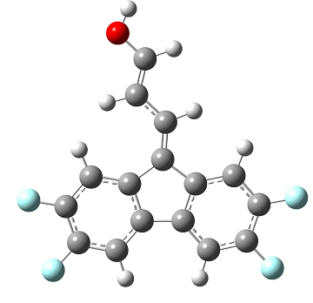
12
%chk=c1 4f.chk
# opt freq=noraman b3lyp/6-31++g(d,p)

12

0 1
C 3.45349500 -2.10124100 0.00021900
C 2.37695200 -3.00017700 -0.00011500
C 1.05813900 -2.53529100 -0.00030300
C 0.81979800 -1.15846000 -0.00019600
C 1.90935700 -0.25492700 0.00012300
C 3.22494300 -0.72194500 0.00034900
H 4.06204400 -0.02918000 0.00064900
C -0.44722900 -0.39363300 -0.00029200
C -0.05179200 1.03284600 -0.00012700
C -0.79416800 2.21971200 -0.00048500
C -0.12991400 3.45115400 -0.00034000
C 1.26902800 3.51338800 0.00011000
C 2.02570800 2.33805400 0.00033100
C 1.36877200 1.10760100 0.00016800
H 3.11119600 2.38606100 0.00058900
C -1.67415100 -0.98688800 -0.00032700
H -1.67581000 -2.07715600 -0.00071300
C -2.98241800 -0.38753300 0.00027400
C -4.10060800 -1.14317700 -0.00004000
H -3.10418400 0.68872000 0.00112700
O -5.34001800 -0.57742700 0.00058200
H -6.02290100 -1.25869400 0.00028700
H -4.06411800 -2.23143800 -0.00085300
F -0.85116979 4.59233320 -0.00069174
F 1.88824979 4.71299808 0.00026412
F 2.61599259 -4.32884535 -0.00026662
F 4.71868113 -2.57220174 0.00042657
H 0.25046303 -3.23711681 -0.00056097
H -1.86415221 2.21392504 -0.00103237
Zero-point correction= 0.197777 (Hartree/Particle)
Thermal correction to Energy= 0.214942
Thermal correction to Enthalpy= 0.215886
Thermal correction to Gibbs Free Energy= 0.152308
Sum of electronic and zero-point Energies= -1088.931864
Sum of electronic and thermal Energies= -1088.914699
Sum of electronic and thermal Enthalpies= -1088.913755
Sum of electronic and thermal Free Energies= -1088.977333
Fig. s24. The optimized geometry, cartesian coordinates and thermodynamic data for chemical 12.

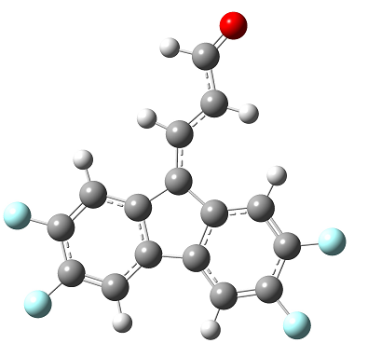
(12+H)
%chk=c1-h 4f.chk
# opt freq=noraman b3lyp/6-31++g(d,p)

(12+H)

-1 1
C 3.29861700 -2.25074200 0.00013500
C 2.16331000 -3.08696300 -0.00001600
C 0.87546300 -2.55296300 -0.00013400
C 0.69568200 -1.15575500 -0.00010500
C 1.85413700 -0.31314700 0.00004800
C 3.14129700 -0.86311900 0.00016700
H 4.01634000 -0.21556300 0.00028300
C -0.50408600 -0.33390800 -0.00020900
C -0.04621900 1.04449100 -0.00010400
C -0.73052500 2.27720400 -0.00013600
C -0.01133500 3.47277000 -0.00001700
C 1.39677100 3.47874600 0.00013500
C 2.09658900 2.27028700 0.00016700
C 1.39077100 1.06244600 0.00004900
H 3.18516100 2.26992700 0.00028300
C -1.80522000 -0.86092700 -0.00038100
H -1.84505200 -1.95369100 -0.00044200
C -3.05671100 -0.25518000 -0.00050100
C -4.24425100 -1.04785400 0.00040000
H -3.18722600 0.82141600 -0.00125000
O -5.42211200 -0.64501400 0.00039100
H -4.05655100 -2.15000200 0.00115700
H 0.03129380 -3.21044178 -0.00024714
H -1.80000608 2.31052363 -0.00025348
F -0.68007254 4.64549763 -0.00005050
F 2.06619396 4.65108251 0.00024921
F 4.53469967 -2.79351231 0.00024798
F 2.32665239 -4.42704481 -0.00004578
Zero-point correction= 0.183904 (Hartree/Particle)
Thermal correction to Energy= 0.200680
Thermal correction to Enthalpy= 0.201624
Thermal correction to Gibbs Free Energy= 0.138987
Sum of electronic and zero-point Energies= -1088.441753
Sum of electronic and thermal Energies= -1088.424978
Sum of electronic and thermal Enthalpies= -1088.424033
Sum of electronic and thermal Free Energies= -1088.486670
Fig. s25. The optimized geometry, cartesian coordinates and thermodynamic data for chemical (12-H)⁻.

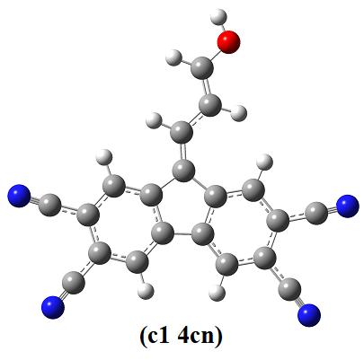
13
%chk=c1 4cn.chk
# opt freq=noraman b3lyp/6-31++g(d,p)

13

0 1
C 3.45349500 -2.10124100 0.00021900
C 2.37695200 -3.00017700 -0.00011500
C 1.05813900 -2.53529100 -0.00030300
C 0.81979800 -1.15846000 -0.00019600
C 1.90935700 -0.25492700 0.00012300
C 3.22494300 -0.72194500 0.00034900
H 4.06204400 -0.02918000 0.00064900
C -0.44722900 -0.39363300 -0.00029200
C -0.05179200 1.03284600 -0.00012700
C -0.79416800 2.21971200 -0.00048500
C -0.12991400 3.45115400 -0.00034000
C 1.26902800 3.51338800 0.00011000
C 2.02570800 2.33805400 0.00033100
C 1.36877200 1.10760100 0.00016800
H 3.11119600 2.38606100 0.00058900
C -1.67415100 -0.98688800 -0.00032700
H -1.67581000 -2.07715600 -0.00071300
C -2.98241800 -0.38753300 0.00027400
C -4.10060800 -1.14317700 -0.00004000
H -3.10418400 0.68872000 0.00112700
O -5.34001800 -0.57742700 0.00058200
H -6.02290100 -1.25869400 0.00028700
H -4.06411800 -2.23143800 -0.00085300
H 0.25046303 -3.23711681 -0.00056097
H -1.86415221 2.21392504 -0.00103237
C -0.95267986 4.75294360 -0.00074124
C 1.97539952 4.88183209 0.00028581
C 4.89674436 -2.63848510 0.00045578
C 2.64963534 -4.51584311 -0.00028796
N -1.56526645 5.72218514 -0.00103999
N 2.50132523 5.90070092 0.00041671
N 5.97130911 -3.03848776 0.00063208
N 2.85266048 -5.64432543 -0.00041674
Zero-point correction= 0.224676 (Hartree/Particle)
Thermal correction to Energy= 0.245650
Thermal correction to Enthalpy= 0.246595
Thermal correction to Gibbs Free Energy= 0.173807
Sum of electronic and zero-point Energies= -1060.924327
Sum of electronic and thermal Energies= -1060.903353
Sum of electronic and thermal Enthalpies= -1060.902409
Sum of electronic and thermal Free Energies= -1060.975196
Fig. s26. The optimized geometry, cartesian coordinates and thermodynamic data for chemical 13.

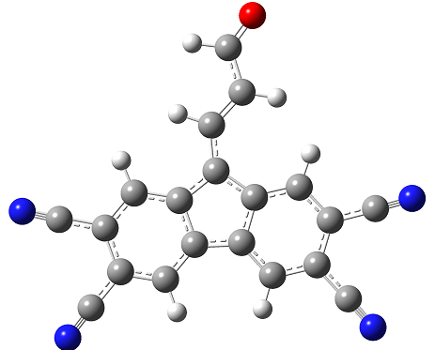
(13+H)
%chk=c1-h 4cn.chk
# opt freq=noraman b3lyp/6-31++g(d,p)

(13+H)

-1 1
C 3.29861700 -2.25074200 0.00013500
C 2.16331000 -3.08696300 -0.00001600
C 0.87546300 -2.55296300 -0.00013400
C 0.69568200 -1.15575500 -0.00010500
C 1.85413700 -0.31314700 0.00004800
C 3.14129700 -0.86311900 0.00016700
H 4.01634000 -0.21556300 0.00028300
C -0.50408600 -0.33390800 -0.00020900
C -0.04621900 1.04449100 -0.00010400
C -0.73052500 2.27720400 -0.00013600
C -0.01133500 3.47277000 -0.00001700
C 1.39677100 3.47874600 0.00013500
C 2.09658900 2.27028700 0.00016700
C 1.39077100 1.06244600 0.00004900
H 3.18516100 2.26992700 0.00028300
C -1.80522000 -0.86092700 -0.00038100
H -1.84505200 -1.95369100 -0.00044200
C -3.05671100 -0.25518000 -0.00050100
C -4.24425100 -1.04785400 0.00040000
H -3.18722600 0.82141600 -0.00125000
O -5.42211200 -0.64501400 0.00039100
H -4.05655100 -2.15000200 0.00115700
H 0.03129380 -3.21044178 -0.00024714
H -1.80000608 2.31052363 -0.00025348
C -0.77419116 4.81054819 -0.00005521
C 2.16040904 4.81607802 0.00026528
C 4.70866686 -2.86990221 0.00026388
C 2.34964132 -4.61564892 -0.00004997
N -1.34217224 5.80658486 -0.00008367
N 2.72897228 5.81178249 0.00036229
N 2.48837346 -5.75382507 -0.00007526
N 5.75851308 -3.33089513 0.00035984
Zero-point correction= 0.211292 (Hartree/Particle)
Thermal correction to Energy= 0.231876
Thermal correction to Enthalpy= 0.232820
Thermal correction to Gibbs Free Energy= 0.160804
Sum of electronic and zero-point Energies= -1060.468402
Sum of electronic and thermal Energies= -1060.447818
Sum of electronic and thermal Enthalpies= -1060.446874
Sum of electronic and thermal Free Energies= -1060.518890
Fig. s27. The optimized geometry, cartesian coordinates and thermodynamic data for chemical (13-H)⁻.

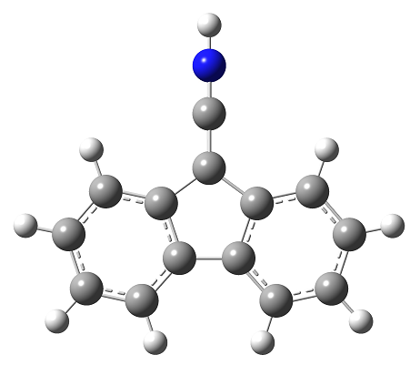
14
%chk=b1.chk
# opt freq=noraman b3lyp/6-31++g(d,p)

14

0 1
C -1.63230578 -3.90962886 0.16485264
C -0.26354532 -3.93632609 -0.20415658
C 0.41267125 -2.73264890 -0.48742220
C -0.28681406 -1.58643248 -0.39281407
C -1.62525095 -1.55824009 -0.03215412
C -2.31623864 -2.67955670 0.24828376
H -2.14624660 -4.82311853 0.38003042
H 0.25569231 -4.86974742 -0.26753586
H 1.44530622 -2.73001142 -0.76770431
H -3.34902582 -2.63839420 0.52497187
C 0.17642160 -0.14243716 -0.63826051
C -1.05704133 0.73507378 -0.37654040
C -1.18179972 2.07317686 -0.45372821
C -2.44220069 2.63026691 -0.15811513
C -3.52201216 1.78605403 0.20478648
C -3.33470876 0.39016995 0.26980592
C -2.11168354 -0.09210662 -0.02187707
H -0.35354920 2.69184154 -0.72969031
H -2.58413568 3.68965997 -0.20751977
H -4.47915011 2.20838805 0.42933251
H -4.13691477 -0.26364996 0.54162394
C 1.41312121 0.27046529 -1.00792612
N 2.59360595 0.66460319 -1.36078871
H 3.32258074 -0.00500616 -1.50298219
Zero-point correction= 0.184222 (Hartree/Particle)
Thermal correction to Energy= 0.195060
Thermal correction to Enthalpy= 0.196004
Thermal correction to Gibbs Free Energy= 0.147433
Sum of electronic and zero-point Energies= -593.471185
Sum of electronic and thermal Energies= -593.460347
Sum of electronic and thermal Enthalpies= -593.459403
Sum of electronic and thermal Free Energies= -593.507973
Fig. s28. The optimized geometry, cartesian coordinates and thermodynamic data for chemical 14.
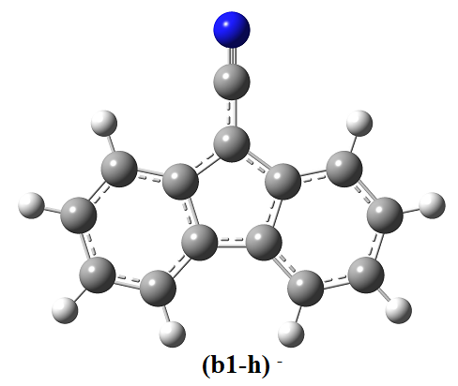
(14+H)
%chk=b1-h.chk
# opt freq=noraman b3lyp/6-31++g(d,p)

(14+H)

-1 1
C -1.63230578 -3.90962886 0.16485264
C -0.26354532 -3.93632609 -0.20415658
C 0.41267125 -2.73264890 -0.48742220
C -0.28681406 -1.58643248 -0.39281407
C -1.62525095 -1.55824009 -0.03215412
C -2.31623864 -2.67955670 0.24828376
H -2.14624660 -4.82311853 0.38003042
H 0.25569231 -4.86974742 -0.26753586
H 1.44530622 -2.73001142 -0.76770431
H -3.34902582 -2.63839420 0.52497187
C 0.17642160 -0.14243716 -0.63826051
C -1.05704133 0.73507378 -0.37654040
C -1.18179972 2.07317686 -0.45372821
C -2.44220069 2.63026691 -0.15811513
C -3.52201216 1.78605403 0.20478648
C -3.33470876 0.39016995 0.26980592
C -2.11168354 -0.09210662 -0.02187707
H -0.35354920 2.69184154 -0.72969031
H -2.58413568 3.68965997 -0.20751977
H -4.47915011 2.20838805 0.42933251
H -4.13691477 -0.26364996 0.54162394
C 1.41312121 0.27046529 -1.00792612
N 2.59360595 0.66460319 -1.36078871
Zero-point correction= 0.172935 (Hartree/Particle)
Thermal correction to Energy= 0.183521
Thermal correction to Enthalpy= 0.184465
Thermal correction to Gibbs Free Energy= 0.136495
Sum of electronic and zero-point Energies= -592.990652
Sum of electronic and thermal Energies= -592.980066
Sum of electronic and thermal Enthalpies= -592.979122
Sum of electronic and thermal Free Energies= -593.027093
Fig. s29. The optimized geometry, cartesian coordinates and thermodynamic data for chemical (14-H)⁻.
14'
%chk=b1'.chk
# opt freq=noraman b3lyp/6-31++g(d,p)
14'

0 1
C -2.94292367 -0.28847843 -1.64490284
C -2.87582679 1.11368929 -1.38097623
C -1.72168209 1.67588809 -0.79869498
C -0.66613799 0.81924041 -0.50445568
C -0.77592662 -0.54731080 -0.64951647
C -1.87840632 -1.13676908 -1.26216084
H -3.80556345 -0.70201359 -2.13099353
H -3.70354520 1.74618898 -1.62900086
H -1.65614573 2.72849257 -0.59977894
H -1.92057273 -2.19370467 -1.43204971
C 0.74170500 1.18338640 -0.00512975
C 1.27297006 -0.19005436 0.47527106
C 2.37707768 -0.46741662 1.26695375
C 2.71273873 -1.81863219 1.48629345
C 1.93388371 -2.85476634 0.89613114
C 0.77977577 -2.54151357 0.13919429
C 0.46014459 -1.19591364 -0.00889321
H 2.96214398 0.31722556 1.69099636
H 3.56246765 -2.06083633 2.09706953
H 2.22311896 -3.87654952 1.03073697
H 0.17122190 -3.30776699 -0.29844369
C 0.71519168 2.27119272 1.09391107
N 0.69032469 3.08199848 1.92253540
H 1.33684870 1.53194483 -0.82366250
Zero-point correction= 0.186490 (Hartree/Particle)
Thermal correction to Energy= 0.197260
Thermal correction to Enthalpy= 0.198204
Thermal correction to Gibbs Free Energy= 0.149584
Sum of electronic and zero-point Energies= -593.505423
Sum of electronic and thermal Energies= -593.494653
Sum of electronic and thermal Enthalpies= -593.493709
Sum of electronic and thermal Free Energies= -593.542329
Fig. s30. The optimized geometry, cartesian coordinates and thermodynamic data for chemical 14ˊ.

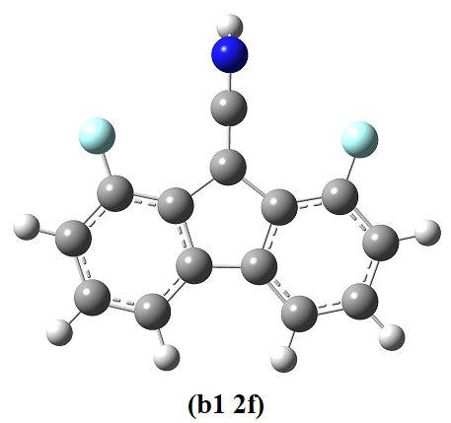
15
%chk=b1 2f.chk
# opt freq=noraman b3lyp/6-31++g(d,p)

15

0 1
C -3.02380700 -1.69423500 0.00077300
C -3.46383200 -0.36023100 0.00033500
C -2.55008600 0.69582900 -0.00049100
C -1.18226300 0.40409200 -0.00087700
C -0.73090600 -0.94465700 -0.00037700
C -1.65965700 -1.99090400 0.00045700
H -3.75173200 -2.50028900 0.00145500
H -4.52891200 -0.14622500 0.00056800
H -1.32548900 -3.02499800 0.00099300
C 0.00038500 1.27225800 -0.00233600
C 1.18222300 0.40269300 -0.00088100
C 2.55034800 0.69285200 -0.00049000
C 3.46286700 -0.36429600 0.00033600
C 3.02132500 -1.69778300 0.00077100
C 1.65681800 -1.99285300 0.00045100
C 0.72930500 -0.94552000 -0.00038500
H 4.52819400 -0.15150400 0.00057000
H 3.74833000 -2.50466500 0.00145500
H 1.32142300 -3.02654900 0.00099700
C 0.00211500 2.61191900 -0.00216400
N 0.00457800 3.79769300 0.00289500
H 0.00565600 4.79139000 0.00495100
F -2.98941453 1.97234381 -0.00111816
F 2.99119441 1.96884340 -0.00110723
Zero-point correction= 0.169378 (Hartree/Particle)
Thermal correction to Energy= 0.181937
Thermal correction to Enthalpy= 0.182882
Thermal correction to Gibbs Free Energy= 0.130373
Sum of electronic and zero-point Energies= -791.983410
Sum of electronic and thermal Energies= -791.970850
Sum of electronic and thermal Enthalpies= -791.969906
Sum of electronic and thermal Free Energies= -792.022415
Fig. s31. The optimized geometry, cartesian coordinates and thermodynamic data for chemical 15.
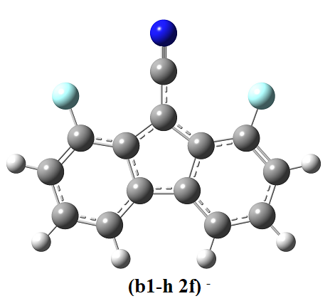
(15+H)
%chk=b1-h 2f.chk
# opt freq=noraman b3lyp/6-31++g(d,p)

(15+H)

-1 1
C -3.02964400 -1.65509800 0.00000000
C -3.45660100 -0.30772500 0.00000100
C -2.53996600 0.73997800 0.00000100
C -1.15793500 0.45449100 0.00000000
C -0.72334900 -0.91913600 -0.00000100
C -1.66665300 -1.95599500 -0.00000100
H -3.76501600 -2.45639200 0.00000000
H -4.52221400 -0.08566800 0.00000200
H -1.33915400 -2.99453500 -0.00000100
C -0.00000200 1.30423600 -0.00000100
C 1.15793500 0.45449700 0.00000000
C 2.53996500 0.73999000 0.00000100
C 3.45660400 -0.30770800 0.00000100
C 3.02965500 -1.65508400 0.00000000
C 1.66666400 -1.95598700 -0.00000100
C 0.72335500 -0.91913300 -0.00000100
H 4.52221600 -0.08564700 0.00000200
H 3.76503000 -2.45637400 0.00000000
H 1.33917100 -2.99452800 -0.00000100
C -0.00000500 2.70719600 -0.00000500
N -0.00002500 3.88310800 0.00000100
F 2.96561254 2.02113175 0.00000224
F -2.96561987 2.02111764 0.00000224
Zero-point correction= 0.156548 (Hartree/Particle)
Thermal correction to Energy= 0.168971
Thermal correction to Enthalpy= 0.169915
Thermal correction to Gibbs Free Energy= 0.117681
Sum of electronic and zero-point Energies= -791.489065
Sum of electronic and thermal Energies= -791.476642
Sum of electronic and thermal Enthalpies= -791.475698
Sum of electronic and thermal Free Energies= -791.527933
Fig. s32. The optimized geometry, cartesian coordinates and thermodynamic data for chemical (15-H)⁻.
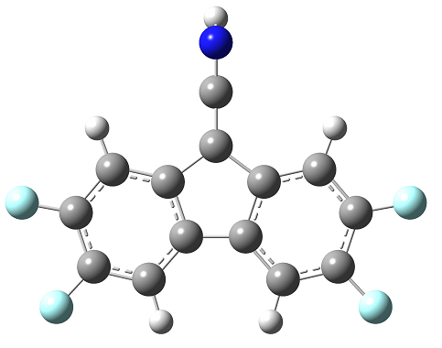
16
%chk=b1 4f.chk
# opt freq=noraman b3lyp/6-31++g(d,p)

16

0 1
C -3.02380700 -1.69423500 0.00077300
C -3.46383200 -0.36023100 0.00033500
C -2.55008600 0.69582900 -0.00049100
C -1.18226300 0.40409200 -0.00087700
C -0.73090600 -0.94465700 -0.00037700
C -1.65965700 -1.99090400 0.00045700
H -1.32548900 -3.02499800 0.00099300
C 0.00038500 1.27225800 -0.00233600
C 1.18222300 0.40269300 -0.00088100
C 2.55034800 0.69285200 -0.00049000
C 3.46286700 -0.36429600 0.00033600
C 3.02132500 -1.69778300 0.00077100
C 1.65681800 -1.99285300 0.00045100
C 0.72930500 -0.94552000 -0.00038500
H 1.32142300 -3.02654900 0.00099700
C 0.00211500 2.61191900 -0.00216400
N 0.00457800 3.79769300 0.00289500
H 0.00565600 4.79139000 0.00495100
F 4.78671618 -0.09986591 0.00062678
F 3.92498415 -2.70072837 0.00162120
F -4.78737877 -0.09429140 0.00062454
F -3.92860854 -2.69614989 0.00162072
H 2.89975960 1.70419333 -0.00097921
H -2.89829454 1.70758518 -0.00098808
Zero-point correction= 0.152614 (Hartree/Particle)
Thermal correction to Energy= 0.167034
Thermal correction to Enthalpy= 0.167978
Thermal correction to Gibbs Free Energy= 0.110948
Sum of electronic and zero-point Energies= -990.465490
Sum of electronic and thermal Energies= -990.451071
Sum of electronic and thermal Enthalpies= -990.450127
Sum of electronic and thermal Free Energies= -990.507156
Fig. s33. The optimized geometry, cartesian coordinates and thermodynamic data for chemical 16.

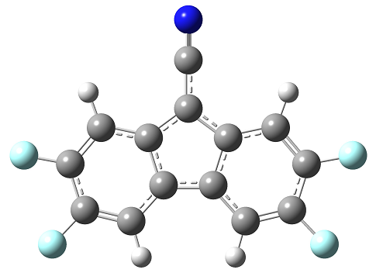
(16+H)
%chk=b1-h 4f.chk
# opt freq=noraman b3lyp/6-31++g(d,p)

(16+H)

-1 1
C -3.02964400 -1.65509800 0.00000000
C -3.45660100 -0.30772500 0.00000100
C -2.53996600 0.73997800 0.00000100
C -1.15793500 0.45449100 0.00000000
C -0.72334900 -0.91913600 -0.00000100
C -1.66665300 -1.95599500 -0.00000100
H -1.33915400 -2.99453500 -0.00000100
C -0.00000200 1.30423600 -0.00000100
C 1.15793500 0.45449700 0.00000000
C 2.53996500 0.73999000 0.00000100
C 3.45660400 -0.30770800 0.00000100
C 3.02965500 -1.65508400 0.00000000
C 1.66666400 -1.95598700 -0.00000100
C 0.72335500 -0.91913300 -0.00000100
H 1.33917100 -2.99452800 -0.00000100
C -0.00000500 2.70719600 -0.00000500
N -0.00002500 3.88310800 0.00000100
H 2.87733009 1.75541346 0.00000198
H -2.87733610 1.75539979 0.00000198
F 4.77821308 -0.03230022 0.00000224
F 3.94246261 -2.64971070 0.00000000
F -4.77821112 -0.03232222 0.00000224
F -3.94244711 -2.64972882 0.00000000
Zero-point correction= 0.139895 (Hartree/Particle)
Thermal correction to Energy= 0.154236
Thermal correction to Enthalpy= 0.155180
Thermal correction to Gibbs Free Energy= 0.098417
Sum of electronic and zero-point Energies= -989.986407
Sum of electronic and thermal Energies= -989.972067
Sum of electronic and thermal Enthalpies= -989.971123
Sum of electronic and thermal Free Energies= -990.027885
Fig. s34. The optimized geometry, cartesian coordinates and thermodynamic data for chemical (16-H)⁻.
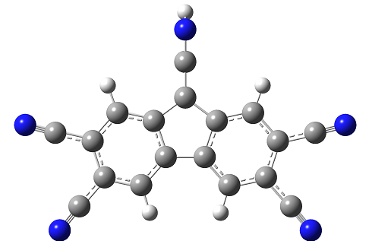
17
%chk=b1 4cn.chk
# opt freq=noraman b3lyp/6-31++g(d,p)

17

0 1
C -3.02380700 -1.69423500 0.00077300
C -3.46383200 -0.36023100 0.00033500
C -2.55008600 0.69582900 -0.00049100
C -1.18226300 0.40409200 -0.00087700
C -0.73090600 -0.94465700 -0.00037700
C -1.65965700 -1.99090400 0.00045700
H -1.32548900 -3.02499800 0.00099300
C 0.00038500 1.27225800 -0.00233600
C 1.18222300 0.40269300 -0.00088100
C 2.55034800 0.69285200 -0.00049000
C 3.46286700 -0.36429600 0.00033600
C 3.02132500 -1.69778300 0.00077100
C 1.65681800 -1.99285300 0.00045100
C 0.72930500 -0.94552000 -0.00038500
H 1.32142300 -3.02654900 0.00099700
C 0.00211500 2.61191900 -0.00216400
N 0.00457800 3.79769300 0.00289500
H 0.00565600 4.79139000 0.00495100
H 2.89975960 1.70419333 -0.00097921
H -2.89829454 1.70758518 -0.00098808
C 4.97303569 -0.06264982 0.00066770
C 4.05216581 -2.84188365 0.00174086
C -4.05595098 -2.83716014 0.00174003
C -4.97365572 -0.05686286 0.00066529
N 6.09742493 0.16193947 0.00091467
N 4.81967365 -3.69371858 0.00246296
N -6.09778811 0.16900850 0.00091121
N -4.82442909 -3.68811985 0.00246003
Zero-point correction= 0.179076 (Hartree/Particle)
Thermal correction to Energy= 0.197428
Thermal correction to Enthalpy= 0.198372
Thermal correction to Gibbs Free Energy= 0.131862
Sum of electronic and zero-point Energies= -962.456209
Sum of electronic and thermal Energies= -962.437857
Sum of electronic and thermal Enthalpies= -962.436913
Sum of electronic and thermal Free Energies= -962.503423
Fig. s35. The optimized geometry, cartesian coordinates and thermodynamic data for chemical 17.
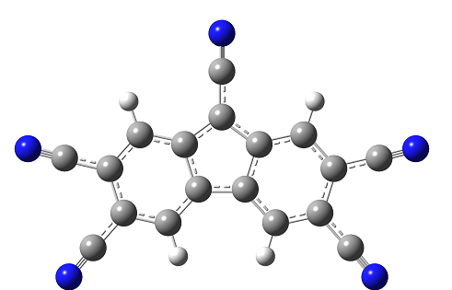
(17+H)
%chk=b1-h 4cngjf.chk
# opt freq=noraman b3lyp/6-31++g(d,p)

(17+H)

-1 1
C -3.02964400 -1.65509800 0.00000000
C -3.45660100 -0.30772500 0.00000100
C -2.53996600 0.73997800 0.00000100
C -1.15793500 0.45449100 0.00000000
C -0.72334900 -0.91913600 -0.00000100
C -1.66665300 -1.95599500 -0.00000100
H -1.33915400 -2.99453500 -0.00000100
C -0.00000200 1.30423600 -0.00000100
C 1.15793500 0.45449700 0.00000000
C 2.53996500 0.73999000 0.00000100
C 3.45660400 -0.30770800 0.00000100
C 3.02965500 -1.65508400 0.00000000
C 1.66666400 -1.95598700 -0.00000100
C 0.72335500 -0.91913300 -0.00000100
H 1.33917100 -2.99452800 -0.00000100
C -0.00000500 2.70719600 -0.00000500
N -0.00002500 3.88310800 0.00000100
H 2.87733009 1.75541346 0.00000198
H -2.87733610 1.75539979 0.00000198
C 4.96421732 0.00646087 0.00000241
C 4.07093183 -2.78969520 0.00000000
C -4.07091570 -2.78971390 0.00000000
C -4.96421551 0.00643817 0.00000241
N 6.08670396 0.24037388 0.00000347
N 4.84620976 -3.63446481 0.00000000
N -4.84618981 -3.63448702 0.00000000
N -6.08670304 0.24034693 0.00000347
Zero-point correction= 0.167347 (Hartree/Particle)
Thermal correction to Energy= 0.185399
Thermal correction to Enthalpy= 0.186343
Thermal correction to Gibbs Free Energy= 0.120551
Sum of electronic and zero-point Energies= -962.017993
Sum of electronic and thermal Energies= -961.999941
Sum of electronic and thermal Enthalpies= -961.998997
Sum of electronic and thermal Free Energies= -962.064789
Fig. s36. The optimized geometry, cartesian coordinates and thermodynamic data for chemical (17-H)⁻.

%chk=a1 H2SO4.chk
# opt freq=noraman b3lyp/6-31++g(d,p)
18

0 1
C 3.40056702 -1.35081063 0.07393060
C 3.66986780 0.04464981 0.05049252
C 2.61052140 0.97668914 0.02102506
C 1.31261577 0.47752453 0.01601608
C 1.04873399 -0.87968383 0.03878877
C 2.07027638 -1.82344662 0.06805692
H 4.21189593 -2.04805526 0.09618643
H 4.68234084 0.39073653 0.05522061
H 2.79929371 2.02975439 0.00317549
H 1.85520391 -2.87146335 0.08551380
C -0.02664484 1.23018603 -0.01317629
C -1.10735301 0.13795634 -0.00453176
C -2.49240896 0.26064979 -0.02230383
C -3.25469141 -0.92699908 -0.00830062
C -2.61218741 -2.19451579 0.02287847
C -1.20328788 -2.28279071 0.04026030
C -0.48057391 -1.09427515 0.02580356
H -2.96337138 1.22114153 -0.04575712
H -4.32324563 -0.87292047 -0.02123849
H -3.20056025 -3.08816550 0.03324988
H -0.70842741 -3.23119020 0.06374412
O -1.85981958 3.08483899 -0.06875450
H -2.00068580 4.00006267 -0.32197848
O 0.37519290 3.36571644 1.12390905
O 0.40133818 3.32128626 -1.22109049
H 1.33050570 3.32232172 1.03968103
S -0.24155658 2.76368046 -0.04462711
Zero-point correction= 0.200466 (Hartree/Particle)
Thermal correction to Energy= 0.214534
Thermal correction to Enthalpy= 0.215478
Thermal correction to Gibbs Free Energy= 0.159434
Sum of electronic and zero-point Energies= -1125.004375
Sum of electronic and thermal Energies= -1124.990307
Sum of electronic and thermal Enthalpies= -1124.989363
Sum of electronic and thermal Free Energies= -1125.045407
Fig. s37. The optimized geometry, cartesian coordinates and thermodynamic data for chemical 18.
(18+H)
%chk=a1 H2SO4-h.chk
# opt freq=noraman b3lyp/6-31++g(d,p)

(18+H)
-1 1
C 3.58049700 -1.48129900 0.01105000
C 2.63336100 -2.54114200 0.01806400
C 1.24968200 -2.26327100 0.01799900
C 0.86021200 -0.92835100 0.01088500
C 1.78019500 0.10400200 0.00405800
C 3.15028900 -0.13669400 0.00392700
H 4.62703000 -1.70416300 0.01116900
H 2.97163600 -3.55624800 0.02342700
H 0.52618000 -3.05157100 0.02323800
H 3.85383400 0.66946800 -0.00138700
C -0.55039200 -0.31911900 0.00898300
C -0.33632400 1.20241600 0.00016300
C -1.27342300 2.22982600 -0.00461000
C -0.79043400 3.55588700 -0.01261900
C 0.60753600 3.81289200 -0.01559200
C 1.53170100 2.74565800 -0.01057600
C 1.02404000 1.45054700 -0.00271800
H -2.32312600 2.02241800 -0.00229200
H -1.48110800 4.37311100 -0.01648000
H 0.96199800 4.82245600 -0.02167500
H 2.58626600 2.92672900 -0.01274300
O -3.13720000 0.01521600 0.00991200
O -1.98174300 -1.93641400 -1.15313400
O -1.97919000 -1.92317700 1.19239300
H -1.37019000 -2.66974300 -1.05398200
S -1.90083800 -1.07743500 0.01473200
Zero-point correction= 0.188608 (Hartree/Particle)
Thermal correction to Energy= 0.202077
Thermal correction to Enthalpy= 0.203021
Thermal correction to Gibbs Free Energy= 0.148281
Sum of electronic and zero-point Energies= -1124.540905
Sum of electronic and thermal Energies= -1124.527437
Sum of electronic and thermal Enthalpies= -1124.526492
Sum of electronic and thermal Free Energies= -1124.581232
Fig. s38. The optimized geometry, cartesian coordinates and thermodynamic data for chemical (18-H)⁻.
18'
%chk=a1H2SO4'.chk
# opt freq=noraman b3lyp/6-31++g(d,p)

18'
0 1
C 3.14654463 -2.11195075 -0.35823284
C 2.01726059 -2.95734597 -0.18204846
C 0.76149702 -2.41142737 0.16276646
C 0.67924512 -1.03220372 0.32433412
C 1.75144293 -0.20880505 0.04854079
C 3.01366126 -0.71177823 -0.24492839
H 4.10148253 -2.53942811 -0.58241293
H 2.12040165 -4.01489462 -0.30795628
H -0.09478983 -3.03751213 0.30309001
H 3.85111018 -0.06129176 -0.38792024
C -0.51727077 -0.18081993 0.80357301
C -0.08163746 1.24272593 0.39136514
C -0.84791581 2.40048583 0.30454993
C -0.17893380 3.60895983 0.01142836
C 1.22838477 3.62307173 -0.18924986
C 1.96595056 2.42072629 -0.15262885
C 1.26508518 1.24533478 0.09138716
H -1.90592266 2.37751492 0.46264429
H -0.73451415 4.52089360 -0.05644848
H 1.73036544 4.54987144 -0.37352605
H 3.02352915 2.41305666 -0.31501333
O -3.13779218 0.21493846 0.58381787
O -1.99067461 -0.60396178 -1.56054742
O -2.37687497 -2.06009470 0.51678380
H -1.29718797 -1.18964765 -1.87303475
S -2.07617971 -0.68164900 0.10545185
H -0.59262379 -0.23742794 1.86941421
Zero-point correction= 0.202232 (Hartree/Particle)
Thermal correction to Energy= 0.215757
Thermal correction to Enthalpy= 0.216701
Thermal correction to Gibbs Free Energy= 0.161755
Sum of electronic and zero-point Energies= -1125.061869
Sum of electronic and thermal Energies= -1125.048345
Sum of electronic and thermal Enthalpies= -1125.047401
Sum of electronic and thermal Free Energies= -1125.102346
Fig. s39. The optimized geometry, cartesian coordinates and thermodynamic data for chemical 18ˊ.

(18+H)'

%chk=a1H2SO4'-h.chk
# opt freq=noraman b3lyp/6-31++g(d,p)
(18+H)'

-1 1
C 3.14654463 -2.11195075 -0.35823284
C 2.01726059 -2.95734597 -0.18204846
C 0.76149702 -2.41142737 0.16276646
C 0.67924512 -1.03220372 0.32433412
C 1.75144293 -0.20880505 0.04854079
C 3.01366126 -0.71177823 -0.24492839
H 4.10148253 -2.53942811 -0.58241293
H 2.12040165 -4.01489462 -0.30795628
H -0.09478983 -3.03751213 0.30309001
H 3.85111018 -0.06129176 -0.38792024
C -0.51727077 -0.18081993 0.80357301
C -0.08163746 1.24272593 0.39136514
C -0.84791581 2.40048583 0.30454993
C -0.17893380 3.60895983 0.01142836
C 1.22838477 3.62307173 -0.18924986
C 1.96595056 2.42072629 -0.15262885
C 1.26508518 1.24533478 0.09138716
H -1.90592266 2.37751492 0.46264429
H -0.73451415 4.52089360 -0.05644848
H 1.73036544 4.54987144 -0.37352605
H 3.02352915 2.41305666 -0.31501333
O -3.13779218 0.21493846 0.58381787
O -1.99067461 -0.60396178 -1.56054742
O -2.37687497 -2.06009470 0.51678380
S -2.07617971 -0.68164900 0.10545185
H -0.59262379 -0.23742794 1.86941421
Zero-point correction= 0.190122 (Hartree/Particle)
Thermal correction to Energy= 0.203010
Thermal correction to Enthalpy= 0.203954
Thermal correction to Gibbs Free Energy= 0.150130
Sum of electronic and zero-point Energies= -1124.564724
Sum of electronic and thermal Energies= -1124.551836
Sum of electronic and thermal Enthalpies= -1124.550892
Sum of electronic and thermal Free Energies= -1124.604716
Fig. s40. The optimized geometry, cartesian coordinates and thermodynamic data for chemical (18-H)⁻.

%chk=a1 FSO2H.chk
# opt freq=noraman b3lyp/6-31++g(d,p)

0 1
C 3.34046800 -1.21071400 0.00013900
C 3.56269200 0.17382200 0.00014500
C 2.48856500 1.06972700 0.00004000
C 1.18506900 0.56893300 -0.00011100
C 0.96210400 -0.83097200 -0.00012400
C 2.03879500 -1.72034300 -0.00002700
H 4.18679100 -1.89145400 0.00025600
H 4.57961600 0.55549900 0.00026700
H 2.68138700 2.13948900 0.00006100
H 1.87225800 -2.79405700 -0.00004700
C -0.12648800 1.25157800 -0.00011200
C -1.14702100 0.18952200 -0.00026100
C -2.54365800 0.25115500 -0.00006600
C -3.27146400 -0.94421300 0.00019400
C -2.61832300 -2.18438100 0.00019300
C -1.22129000 -2.25325700 -0.00007900
C -0.48639000 -1.06704100 -0.00021600
H -3.05393800 1.20723800 -0.00025400
H -4.35719200 -0.90967300 0.00045400
H -3.20242900 -3.10027600 0.00036700
H -0.72125200 -3.21794800 -0.00035100
O -1.53397100 3.16534200 0.00017900
H -1.45222500 4.12648400 0.00003600
S -0.29796400 2.58804900 -0.00007100
O 0.40680845 3.10251434 1.18244554
F 0.46403678 3.14467583 -1.27976682
Zero-point correction= 0.188856 (Hartree/Particle)
Thermal correction to Energy= 0.202462
Thermal correction to Enthalpy= 0.203406
Thermal correction to Gibbs Free Energy= 0.148517
Sum of electronic and zero-point Energies= -1149.038263
Sum of electronic and thermal Energies= -1149.024656
Sum of electronic and thermal Enthalpies= -1149.023712
Sum of electronic and thermal Free Energies= -1149.078601
Fig. s41. The optimized geometry, cartesian coordinates and thermodynamic data for chemical 19.
(19+H)
%chk=a1 FSO2H-h.chk
# opt freq=noraman b3lyp/6-31++g(d,p)

-1 1
C -0.51333200 3.76746000 0.00440100
C 0.85779900 3.47311400 -0.02075000
C 1.30607700 2.14928500 -0.03653500
C 0.36659500 1.11692700 -0.02605900
C -1.02009100 1.41270200 -0.00086900
C -1.45832300 2.73913300 0.01423000
H -0.84185000 4.80263300 0.01581200
H 1.58168300 4.28260000 -0.02892800
H 2.37153100 1.94081600 -0.05765600
H -2.51935200 2.97176000 0.03330800
C 0.53052300 -0.35458300 -0.03753900
C -0.83690700 -0.91954500 -0.01647800
C -1.29207300 -2.24273500 -0.01617000
C -2.66977700 -2.48319200 0.00385600
C -3.58623100 -1.42307500 0.02366900
C -3.13887600 -0.09913000 0.02368700
C -1.76579900 0.15353300 0.00369300
H -0.59314900 -3.07161100 -0.03142800
H -3.03333300 -3.50672700 0.00397600
H -4.65190400 -1.63239100 0.03914500
H -3.85348300 0.71903900 0.03939300
O 1.75765800 -2.46660400 -0.01842300
S 1.79734300 -1.03739400 -0.06120000
O 2.67527700 -0.66595500 -1.19177600
F 2.66641800 -0.63594800 1.23686800
Zero-point correction= 0.177003 (Hartree/Particle)
Thermal correction to Energy= 0.189954
Thermal correction to Enthalpy= 0.190898
Thermal correction to Gibbs Free Energy= 0.137178
Sum of electronic and zero-point Energies= -1148.582888
Sum of electronic and thermal Energies= -1148.569937
Sum of electronic and thermal Enthalpies= -1148.568992
Sum of electronic and thermal Free Energies= -1148.622713
Fig. s42. The optimized geometry, cartesian coordinates and thermodynamic data for chemical (19-H)⁻.
%chk=a1 CF3SO2H.chk
# opt freq=noraman b3lyp/6-31++g(d,p)
20

0 1
C 3.40411560 -1.34995356 0.06704919
C 3.66959339 0.04630608 0.04800515
C 2.60769861 0.97552814 0.02142698
C 1.31116536 0.47282832 0.01480250
C 1.05100180 -0.88516262 0.03330351
C 2.07512485 -1.82621090 0.05964376
H 4.21735082 -2.04503969 0.08714294
H 4.68111444 0.39514832 0.05385948
H 2.79358595 2.02915749 0.00689581
H 1.86292355 -2.87486243 0.07380485
C -0.03015133 1.22190657 -0.01206543
C -1.10786376 0.12669898 -0.00688327
C -2.49325025 0.24565331 -0.02430957
C -3.25227684 -0.94411731 -0.01406226
C -2.60630388 -2.20996102 0.01315574
C -1.19716823 -2.29443052 0.03030424
C -0.47771227 -1.10390029 0.01959935
H -2.96684147 1.20492036 -0.04475806
H -4.32097488 -0.89292553 -0.02686609
H -3.19222677 -3.10524723 0.02070239
H -0.69971221 -3.24153999 0.05082598
O -1.88905965 3.10029554 -0.06255371
H -2.02487218 4.05049677 -0.07906552
S -0.25175200 2.77231823 -0.03900702
O 0.35124756 3.37423112 1.15841378
C 0.51122192 3.45552377 -1.49485760
F 1.83479400 3.19039229 -1.47582295
F 0.32023580 4.79174424 -1.51807713
F -0.04270405 2.90259630 -2.59482906
Zero-point correction= 0.200472 (Hartree/Particle)
Thermal correction to Energy= 0.217127
Thermal correction to Enthalpy= 0.218071
Thermal correction to Gibbs Free Energy= 0.155402
Sum of electronic and zero-point Energies= -1386.808804
Sum of electronic and thermal Energies= -1386.792149
Sum of electronic and thermal Enthalpies= -1386.791205
Sum of electronic and thermal Free Energies= -1386.853873
Fig. s43. The optimized geometry, cartesian coordinates and thermodynamic data for chemical 20.

(20+H)
%chk=a1 CF3SO2H-h.chk
# opt freq=noraman b3lyp/6-31++g(d,p)
(20+H)

-1 1
C -1.95360600 3.58070300 0.01724100
C -0.55582200 3.63296300 -0.23544300
C 0.19190500 2.44318100 -0.36623300
C -0.48831100 1.23700000 -0.23902200
C -1.84807400 1.18423300 0.00679500
C -2.61287500 2.33845100 0.14079800
H -2.51014200 4.48938700 0.11450600
H -0.06731900 4.58052000 -0.32709600
H 1.24455600 2.46833600 -0.55647700
H -3.66456000 2.28653000 0.33095900
C 0.04294700 -0.20192000 -0.32981900
C -1.18158000 -1.10255100 -0.10538600
C -1.26997300 -2.49017300 -0.08443100
C -2.53955600 -3.06148600 0.14696000
C -3.67612900 -2.23224100 0.34929000
C -3.55067900 -0.82633000 0.32157500
C -2.28618800 -0.29425400 0.09124600
H -0.40632100 -3.10283000 -0.23823700
H -2.64722100 -4.12580100 0.17023600
H -4.63364800 -2.67674500 0.52385300
H -4.39898400 -0.19190900 0.47253400
O 1.59683800 -2.32260100 -0.60289700
S 1.51895900 -0.65443700 -0.59482100
O 1.96379000 -0.13696300 -1.89638500
C 2.57445100 -0.01739000 0.68912200
F 2.51149500 1.33112500 0.69565000
F 3.84655000 -0.40739200 0.46073000
F 2.16582100 -0.49275100 1.88476100
Zero-point correction= 0.188701 (Hartree/Particle)
Thermal correction to Energy= 0.204692
Thermal correction to Enthalpy= 0.205636
Thermal correction to Gibbs Free Energy= 0.144335
Sum of electronic and zero-point Energies= -1386.355696
Sum of electronic and thermal Energies= -1386.339706
Sum of electronic and thermal Enthalpies= -1386.338761
Sum of electronic and thermal Free Energies= -1386.400062
Fig. s44. The optimized geometry, cartesian coordinates and thermodynamic data for chemical (20-H)⁻.
%chk=a1 H3PO4.chk
# opt freq=noraman b3lyp/6-31++g(d,p)
21

0 1
C 3.40056702 -1.35081063 0.07393060
C 3.66986780 0.04464981 0.05049252
C 2.61052140 0.97668914 0.02102506
C 1.31261577 0.47752453 0.01601608
C 1.04873399 -0.87968383 0.03878877
C 2.07027638 -1.82344662 0.06805692
H 4.21189593 -2.04805526 0.09618643
H 4.68234084 0.39073653 0.05522061
H 2.79929371 2.02975439 0.00317549
H 1.85520391 -2.87146335 0.08551380
C -0.02664484 1.23018603 -0.01317629
C -1.10735301 0.13795634 -0.00453176
C -2.49240896 0.26064979 -0.02230383
C -3.25469141 -0.92699908 -0.00830062
C -2.61218741 -2.19451579 0.02287847
C -1.20328788 -2.28279071 0.04026030
C -0.48057391 -1.09427515 0.02580356
H -2.96337138 1.22114153 -0.04575712
H -4.32324563 -0.87292047 -0.02123849
H -3.20056025 -3.08816550 0.03324988
H -0.70842741 -3.23119020 0.06374412
O -1.85981958 3.08483899 -0.06875450
H -2.00068580 4.00006267 -0.32197848
O 0.37519290 3.36571644 1.12390905
O 0.40133818 3.32128626 -1.22109049
P -0.24155658 2.76368046 -0.04462711
H 1.35456678 3.27253720 -1.11823738
H 1.33050570 3.32232172 1.03968103
Zero-point correction= 0.211180 (Hartree/Particle)
Thermal correction to Energy= 0.225883
Thermal correction to Enthalpy= 0.226827
Thermal correction to Gibbs Free Energy= 0.169507
Sum of electronic and zero-point Energies= -1068.916663
Sum of electronic and thermal Energies= -1068.901960
Sum of electronic and thermal Enthalpies= -1068.901016
Sum of electronic and thermal Free Energies= -1068.958336
Fig. s45. The optimized geometry, cartesian coordinates and thermodynamic data for chemical 21.

(21+H)
%chk=a1 H3PO4-h.chk
# opt freq=noraman b3lyp/6-31++g(d,p)

a1 H3PO4-h

-1 1
C -3.06338900 -2.35867500 -0.00445200
C -1.87064000 -3.13180500 -0.00248800
C -0.60892600 -2.49946700 0.00001600
C -0.58463800 -1.10908600 0.00047000
C -1.74395400 -0.35532900 -0.00143900
C -3.00235000 -0.94822600 -0.00392500
H -4.01433100 -2.84918900 -0.00634100
H -1.92973600 -4.20017200 -0.00291100
H 0.29658800 -3.06950200 0.00151000
H -3.89331300 -0.35570500 -0.00539000
C 0.61581400 -0.14998200 0.00295400
C 0.00872400 1.26154600 0.00225000
C 0.64228200 2.49942900 0.00376900
C -0.17277900 3.65158000 0.00260900
C -1.58909700 3.53149500 -0.00002600
C -2.19969100 2.25859900 -0.00151800
C -1.36897600 1.14280100 -0.00031400
H 1.70956000 2.57567700 0.00574700
H 0.27838100 4.62181400 0.00372100
H -2.19684100 4.41214600 -0.00088600
H -3.26472600 2.15566100 -0.00350600
O 3.02335000 0.85356400 0.00766700
H 3.93029900 0.64162900 -0.22498600
O 2.41732900 -1.32772700 1.17870300
O 2.42163500 -1.32704400 -1.16685900
P 2.11826300 -0.52604200 0.00560300
H 2.01654500 -2.19269400 -1.07657500
Zero-point correction= 0.198673 (Hartree/Particle)
Thermal correction to Energy= 0.213060
Thermal correction to Enthalpy= 0.214004
Thermal correction to Gibbs Free Energy= 0.157122
Sum of electronic and zero-point Energies= -1068.434381
Sum of electronic and thermal Energies= -1068.419994
Sum of electronic and thermal Enthalpies= -1068.419050
Sum of electronic and thermal Free Energies= -1068.475932
Fig. s46. The optimized geometry, cartesian coordinates and thermodynamic data for chemical (21-H)⁻.
%chk=a1 HCLO4.chk
# opt freq=noraman b3lyp/6-31++g(d,p)
22

0 1
C 3.40056702 -1.35081063 0.07393060
C 3.66986780 0.04464981 0.05049252
C 2.61052140 0.97668914 0.02102506
C 1.31261577 0.47752453 0.01601608
C 1.04873399 -0.87968383 0.03878877
C 2.07027638 -1.82344662 0.06805692
H 4.21189593 -2.04805526 0.09618643
H 4.68234084 0.39073653 0.05522061
H 2.79929371 2.02975439 0.00317549
H 1.85520391 -2.87146335 0.08551380
C -0.02664484 1.23018603 -0.01317629
C -1.10735301 0.13795634 -0.00453176
C -2.49240896 0.26064979 -0.02230383
C -3.25469141 -0.92699908 -0.00830062
C -2.61218741 -2.19451579 0.02287847
C -1.20328788 -2.28279071 0.04026030
C -0.48057391 -1.09427515 0.02580356
H -2.96337138 1.22114153 -0.04575712
H -4.32324563 -0.87292047 -0.02123849
H -3.20056025 -3.08816550 0.03324988
H -0.70842741 -3.23119020 0.06374412
O -1.85981958 3.08483899 -0.06875450
H -2.00068580 4.00006267 -0.32197848
O 0.37519290 3.36571644 1.12390905
Cl -0.24155658 2.76368046 -0.04462711
O 0.40133818 3.32128626 -1.22109049
Zero-point correction= 0.186770 (Hartree/Particle)
Thermal correction to Energy= 0.201003
Thermal correction to Enthalpy= 0.201948
Thermal correction to Gibbs Free Energy= 0.145580
Sum of electronic and zero-point Energies= -1186.150376
Sum of electronic and thermal Energies= -1186.136143
Sum of electronic and thermal Enthalpies= -1186.135199
Sum of electronic and thermal Free Energies= -1186.191566
Fig. s47. The optimized geometry, cartesian coordinates and thermodynamic data for chemical 22.

(22+H)
%chk=a1 HCLO4-h.chk
# opt freq=noraman b3lyp/6-31++g(d,p)

(22+H)

-1 1
C -3.68832100 -1.21539700 -0.00439900
C -2.82496000 -2.34454900 -0.00243800
C -1.42409200 -2.17324600 0.00003300
C -0.93373600 -0.87197700 0.00045800
C -1.77212500 0.22768900 -0.00144800
C -3.15660700 0.09241500 -0.00390200
H -4.74882500 -1.35762300 -0.00626300
H -3.23982800 -3.33084800 -0.00283800
H -0.76295600 -3.01455200 0.00152500
H -3.79647900 0.95000500 -0.00536600
C 0.51930300 -0.37233400 0.00290300
C 0.42215000 1.16113600 0.00218000
C 1.43503000 2.11393200 0.00366300
C 1.05480400 3.47305200 0.00249200
C -0.31943300 3.83616000 -0.00011900
C -1.32246000 2.84266800 -0.00157400
C -0.91526900 1.51252200 -0.00036000
H 2.46581000 1.82689500 0.00562300
H 1.80591600 4.23510900 0.00357600
H -0.59569700 4.86988000 -0.00098700
H -2.36010100 3.10381500 -0.00354400
O 3.12409400 -0.23668900 0.00755800
O 1.81997300 -2.08721200 1.17864900
Cl 1.80784000 -1.23166300 0.00553600
O 1.82420800 -2.08804900 -1.16691400
Zero-point correction= 0.176067 (Hartree/Particle)
Thermal correction to Energy= 0.188212
Thermal correction to Enthalpy= 0.189156
Thermal correction to Gibbs Free Energy= 0.137649
Sum of electronic and zero-point Energies= -1185.663753
Sum of electronic and thermal Energies= -1185.651608
Sum of electronic and thermal Enthalpies= -1185.650664
Sum of electronic and thermal Free Energies= -1185.702171
Fig. s48. The optimized geometry, cartesian coordinates and thermodynamic data for chemical (22-H)⁻.
%chk=a1 HNO3.chk
# opt freq=noraman b3lyp/6-31++g(d,p)
23

0 1
C 3.40411560 -1.34995356 0.06704919
C 3.66959339 0.04630608 0.04800515
C 2.60769861 0.97552814 0.02142698
C 1.31116536 0.47282832 0.01480250
C 1.05100180 -0.88516262 0.03330351
C 2.07512485 -1.82621090 0.05964376
H 4.21735082 -2.04503969 0.08714294
H 4.68111444 0.39514832 0.05385948
H 2.79358595 2.02915749 0.00689581
H 1.86292355 -2.87486243 0.07380485
C -0.03015133 1.22190657 -0.01206543
C -1.10786376 0.12669898 -0.00688327
C -2.49325025 0.24565331 -0.02430957
C -3.25227684 -0.94411731 -0.01406226
C -2.60630388 -2.20996102 0.01315574
C -1.19716823 -2.29443052 0.03030424
C -0.47771227 -1.10390029 0.01959935
H -2.96684147 1.20492036 -0.04475806
H -4.32097488 -0.89292553 -0.02686609
H -3.19222677 -3.10524723 0.02070239
H -0.69971221 -3.24153999 0.05082598
O -1.88905965 3.10029554 -0.06255371
H -2.02487218 4.05049677 -0.07906552
O 0.35124756 3.37423112 1.15841378
N -0.25175200 2.77231823 -0.03900702
Zero-point correction= 0.190125 (Hartree/Particle)
Thermal correction to Energy= 0.201889
Thermal correction to Enthalpy= 0.202833
Thermal correction to Gibbs Free Energy= 0.152422
Sum of electronic and zero-point Energies= -705.768362
Sum of electronic and thermal Energies= -705.756599
Sum of electronic and thermal Enthalpies= -705.755655
Sum of electronic and thermal Free Energies= -705.806066
Fig. s49. The optimized geometry, cartesian coordinates and thermodynamic data for chemical 23.
(23+H)

%chk=a1 HNO3-h.chk
# opt freq=noraman b3lyp/6-31++g(d,p)

(23+H)

-1 1
C 3.38051900 -1.40636600 0.00031500
C 3.59248100 -0.01336000 -0.09945300
C 2.50367500 0.87324600 -0.15348600
C 1.22316000 0.32564100 -0.10693200
C 1.01106100 -1.04781100 -0.00895900
C 2.07617500 -1.93748100 0.04745500
H 4.22799100 -2.07049800 0.04161800
H 4.59771900 0.37225700 -0.13260400
H 2.65146400 1.93743300 -0.22597300
H 1.91243800 -2.99941600 0.12417500
C -0.11203700 1.00241300 -0.14034500
C -1.14812400 -0.08147100 -0.06694200
C -2.54081400 -0.00153200 -0.06947400
C -3.26261500 -1.20455500 0.02237100
C -2.59057900 -2.44322400 0.11094700
C -1.18277900 -2.50208700 0.11007500
C -0.48414900 -1.30554400 0.01888800
H -3.04125600 0.94796700 -0.13849500
H -4.33956200 -1.18162900 0.02416500
H -3.16200300 -3.35423200 0.17927500
H -0.66745500 -3.44574200 0.17729800
O -1.90801000 2.74229800 -0.26317900
O 0.31276500 3.17605300 0.77385000
N -0.31868500 2.45716200 -0.25075100
Zero-point correction= 0.177238 (Hartree/Particle)
Thermal correction to Energy= 0.188444
Thermal correction to Enthalpy= 0.189388
Thermal correction to Gibbs Free Energy= 0.139953
Sum of electronic and zero-point Energies= -705.263600
Sum of electronic and thermal Energies= -705.252394
Sum of electronic and thermal Enthalpies= -705.251450
Sum of electronic and thermal Free Energies= -705.300885
Fig. s50. The optimized geometry, cartesian coordinates and thermodynamic data for chemical (23-H)⁻.

