Figure S1: Trends in research publication

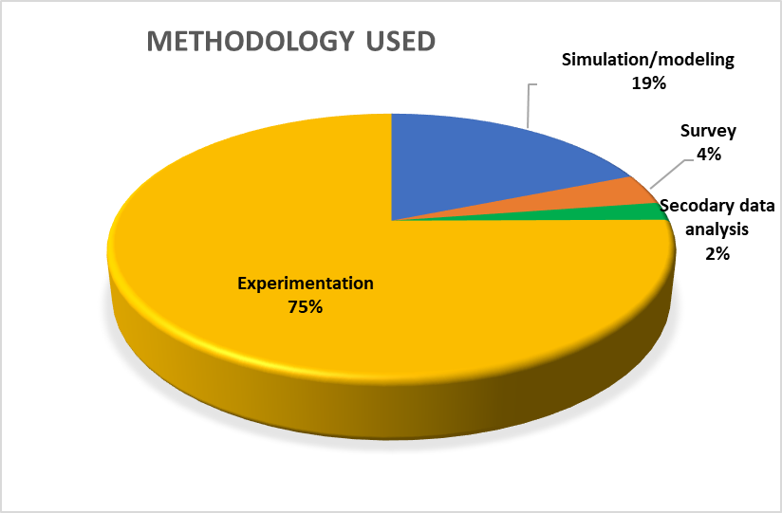
Figure S2: Contribution by types of studies

Figure S3: Trends in methodology followed in research publication

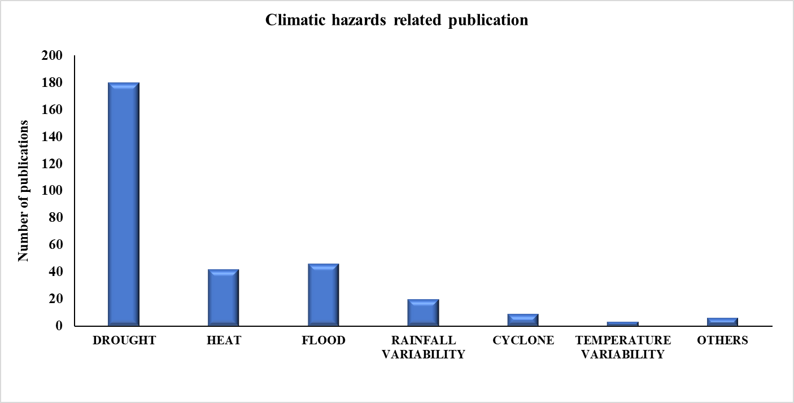
Figure S4: Various climatic hazards related publications
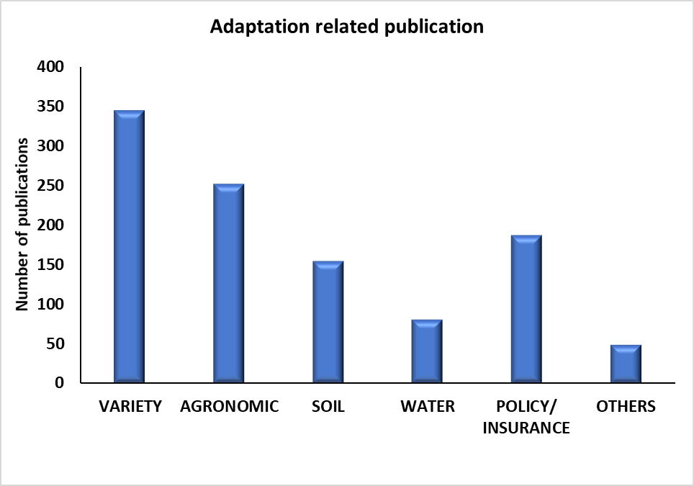

Figure S4: Publications related to different adaptation technologies to deal with climatic hazards

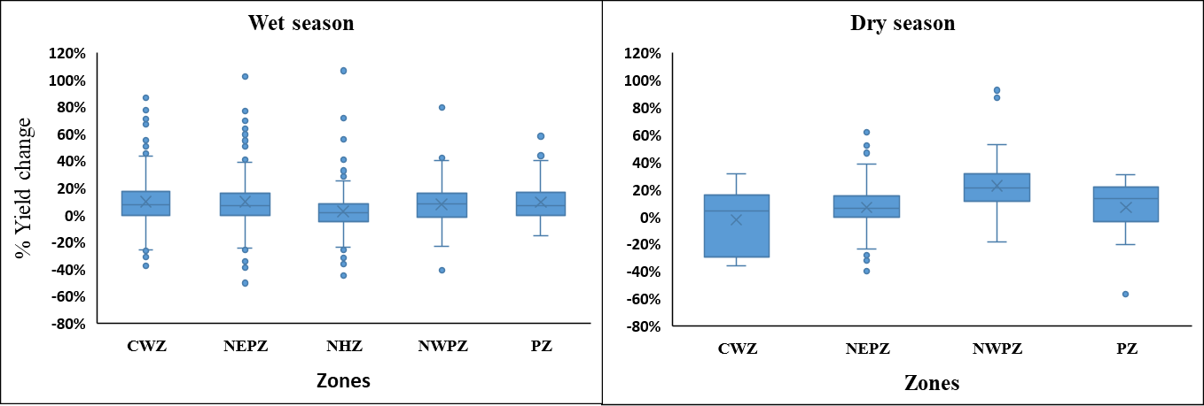

Figure S5: Yield change (%age) in different seasons and agro-climatic zones with adaptation options

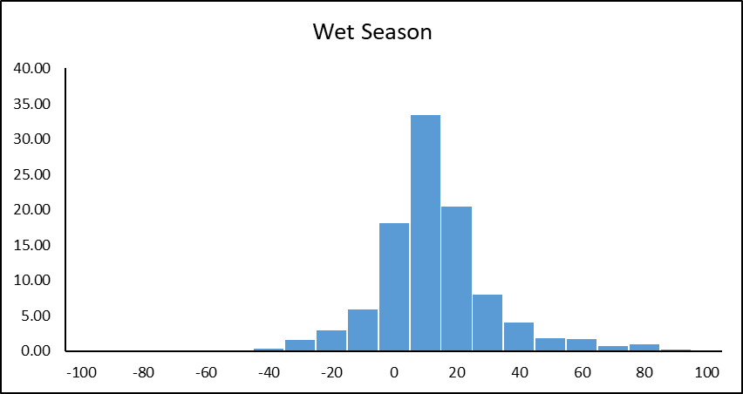
Figure S6: Distribution of relative yield change in maize under different adaptation options in wet season
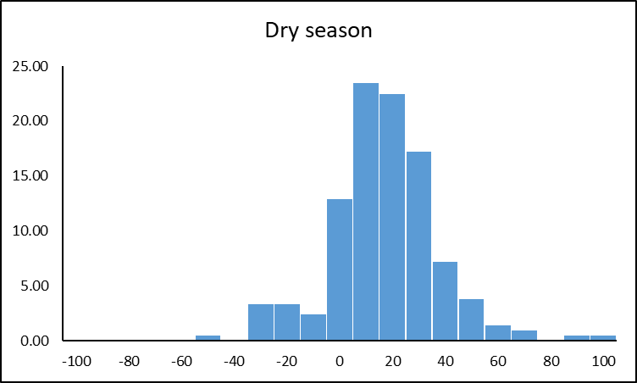
Figure S7: Distribution of relative yield change in maize under different adaptation options in dry season
Table1: Statistics of distribution of relative yield change in maize under different adaptation options in wet and dry seasons
Variables | Wet season | Dry season
Min | -50.38 | -56.54
Max | 106.54 | 92.36
Mean | 8.23 | 12.14
Q1 | -1.72 | 2.08
Median | 6.40 | 12.40
Q3 | 15.18 | 2.01
Kurtosis | 5.55 | 1.77
Skewness | 2.22 | 1.60

