Supplementary Table 1. Annual rate of change of age-standardized rates in prevalence, deaths, YLLs, YLDs, and DALYs for ACM between 1990 and 2021 in China and Global level.
Measure | China |  | Global
Measure | 1990 | 2021 | 1990 | 2021
Prevalence | 0.52(0.43, 0.62) | 1.56(1.24, 1.92) | 7.94(6.72, 9.38) | 6.16(5.14, 7.39)
Deaths | 0.05(0.02, 0.12) | 0.10(0.02, 0.15) | 1.18(1.11, 1.24) | 0.74(0.65, 0.81)
DALYs | 1.80(0.67, 4.14) | 3.43(0.67, 5.41) | 35.87(33.47,37.95) | 25.34(22.39, 27.46)
YLDs | 0.05(0.03, 0.07) | 0.14(0.09, 0.21) | 0.69(0.47, 0.96) | 0.54(0.36, 0.75)
YLLs | 1.76(0.62, 4.09) | 3.29(0.53, 5.31) | 35.18(32.75,37.28) | 24.81(21.86, 26.88)
DALYs = disability-adjusted life-years, YLDs = years lived with disability, YLLs = years of life lost.

Supplementary Table 2. Age, period and cohort effects of ACM prevalence and mortality rate in China
Factors | ACM prevalence |  |  |  | ACM mortality
Factors | Coefficient | RR | 95%CI |  | Coefficient | RR | 95%CI
Factors | Coefficient | RR | Lower | Upper | Coefficient | RR | Lower | Upper
Age
15-19 | -2.73 | 0.07 | 0.06 | 0.07 | -1.56 | 0.21 | 0.18 | 0.25
20-24 | -2.14 | 0.12 | 0.11 | 0.13 | -1.12 | 0.33 | 0.29 | 0.37
25-29 | -2.00 | 0.14 | 0.13 | 0.15 | -0.57 | 0.57 | 0.51 | 0.63
30-34 | -1.54 | 0.22 | 0.20 | 0.23 | 0.09 | 1.09 | 0.99 | 1.20
35-39 | -0.92 | 0.40 | 0.38 | 0.43 | 0.68 | 1.97 | 1.80 | 2.15
40-44 | -0.28 | 0.76 | 0.71 | 0.80 | 1.10 | 2.99 | 2.76 | 3.24
45-49 | 0.21 | 1.23 | 1.17 | 1.30 | 1.38 | 3.96 | 3.68 | 4.27
50-54 | 0.40 | 1.49 | 1.41 | 1.57 | 1.66 | 5.25 | 4.89 | 5.63
55-59 | 0.17 | 1.19 | 1.13 | 1.26 | 1.77 | 5.88 | 5.48 | 6.30
60-64 | 0.46 | 1.59 | 1.50 | 1.67 | 1.73 | 5.65 | 5.26 | 6.07
65-69 | 1.05 | 2.86 | 2.72 | 3.01 | 1.87 | 6.52 | 6.04 | 7.04
70-74 | 1.23 | 3.42 | 3.22 | 3.62 | 1.90 | 6.71 | 6.12 | 7.36
75-79 | 1.41 | 4.11 | 3.80 | 4.44 | 1.91 | 6.78 | 6.01 | 7.64
80-84 | 1.28 | 3.59 | 3.24 | 3.99 | 2.11 | 8.21 | 7.07 | 9.54
85-89 | 1.59 | 4.93 | 4.28 | 5.67 | 2.39 | 10.92 | 8.91 | 13.39
90-94 | 1.93 | 6.86 | 5.47 | 8.60 | 3.06 | 21.24 | 15.99 | 28.22
95-99 | 2.23 | 9.33 | 5.91 | 14.72 | 3.91 | 49.73 | 31.85 | 77.63
Period
1994 | -0.61 | 0.54 | 0.52 | 0.57 | -0.22 | 0.81 | 0.75 | 0.86
1999 | -0.47 | 0.62 | 0.60 | 0.65 | -0.11 | 0.89 | 0.84 | 0.95
2004 | 0.00 | 1.00 | 1.00 | 1.00 | 0.00 | 1.00 | 1.00 | 1.00
2009 | 0.21 | 1.24 | 1.19 | 1.28 | 0.29 | 1.34 | 1.27 | 1.42
2014 | 0.34 | 1.41 | 1.36 | 1.47 | 0.39 | 1.48 | 1.40 | 1.57
2019 | 0.31 | 1.36 | 1.30 | 1.43 | 0.33 | 1.39 | 1.30 | 1.48
Cohort
1895-1899 | -0.95 | 0.39 | 0.04 | 4.10 | -0.89 | 0.41 | 0.04 | 4.37
1900-1904 | -0.95 | 0.39 | 0.16 | 0.92 | -0.82 | 0.44 | 0.16 | 1.23
1905-1909 | -0.97 | 0.38 | 0.25 | 0.58 | -0.76 | 0.47 | 0.27 | 0.83
1910-1914 | -0.95 | 0.39 | 0.30 | 0.50 | -0.66 | 0.52 | 0.36 | 0.73
1915-1919 | -0.87 | 0.42 | 0.36 | 0.49 | -0.59 | 0.55 | 0.44 | 0.71
1920-1924 | -0.77 | 0.47 | 0.41 | 0.52 | -0.52 | 0.60 | 0.50 | 0.71
1925-1929 | -0.68 | 0.51 | 0.46 | 0.55 | -0.40 | 0.67 | 0.59 | 0.77
1930-1934 | -0.57 | 0.57 | 0.52 | 0.61 | -0.31 | 0.74 | 0.66 | 0.82

1935-1939 | -0.43 | 0.65 | 0.61 | 0.69 | -0.23 |  | 0.80 | 0.72 | 0.87
1940-1944 | -0.24 | 0.79 | 0.74 | 0.84 | -0.12 |  | 0.89 | 0.81 | 0.96
1945-1949 | 0.00 | 1.00 | 1.00 | 1.00 | 0.00 |  | 1.00 | 1.00 | 1.00
1950-1954 | 0.26 | 1.29 | 1.23 | 1.36 | 0.14 |  | 1.15 | 1.07 | 1.24
1955-1959 | 0.54 | 1.72 | 1.63 | 1.82 | 0.29 | 1.33 |  | 1.24 | 1.43
1960-1964 | 0.84 | 2.33 | 2.20 | 2.46 | 0.47 | 1.61 |  | 1.49 | 1.73
1965-1969 | 1.12 | 3.06 | 2.89 | 3.23 | 0.68 | 1.98 |  | 1.84 | 2.14
1970-1974 | 1.40 | 4.06 | 3.82 | 4.31 | 0.81 | 2.25 |  | 2.07 | 2.45
1975-1979 | 1.65 | 5.22 | 4.88 | 5.59 | 1.00 | 2.73 |  | 2.48 | 3.00
1980-1984 | 1.88 | 6.55 | 6.08 | 7.05 | 1.18 | 3.24 |  | 2.91 | 3.61
1985-1989 | 2.09 | 8.09 | 7.47 | 8.76 | 1.29 | 3.62 |  | 3.20 | 4.09
1990-1994 | 2.34 | 10.35 | 9.45 | 11.34 | 1.34 | 3.82 |  | 3.27 | 4.46
1995-1999 | 2.59 | 13.36 | 11.98 | 14.90 | 1.46 | 4.31 |  | 3.47 | 5.35
2000-2004 | 2.81 | 16.60 | 14.24 | 19.35 | 1.45 | 4.26 |  | 3.01 | 6.02
P value
NetDrift ＝ 0 | <0.001 |  |  |  | <0.001
All Local Drifts＝NetDrift | <0.001 |  |  |  | 0.001
All Age Deviations＝ 0 | <0.001 |  |  |  | <0.001
All Period Deviations=0 | <0.001 |  |  |  | <0.001
All Chort Deviations＝ 0 | <0.001 |  |  |  | 0.002

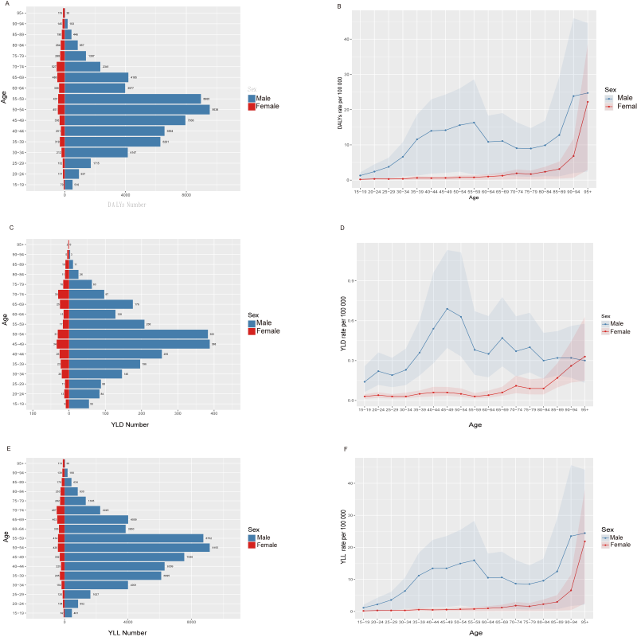
Supplementary Figure 1
Age-specific numbers and age-standardized DALYs, YLD, YLL rates of ACM in China, 2021. (A) Age-specific DALYs number. (B) Age-standardized DALYs rate. (C) Age-specific YLD number. (D) Age-standardized YLD rate. (E) Age-specific YLL number. (F) Age-standardized YLL rate.

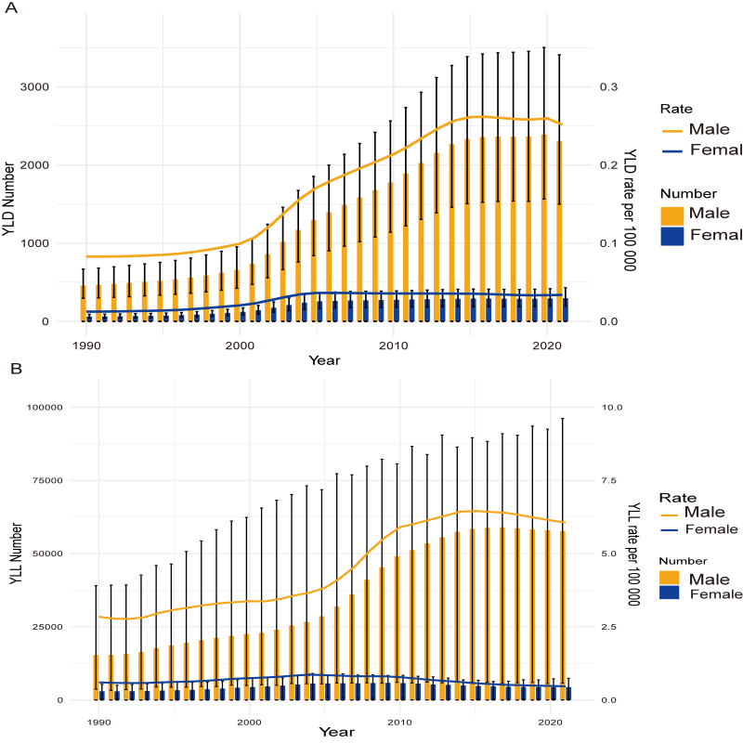

Supplementary Figure 2
Trends in the all-age cases and age-standardized YLD, YLL rates of ACM by sex from 1990 to 2021. (A) YLD number and rate. (B) YLL number and rate.

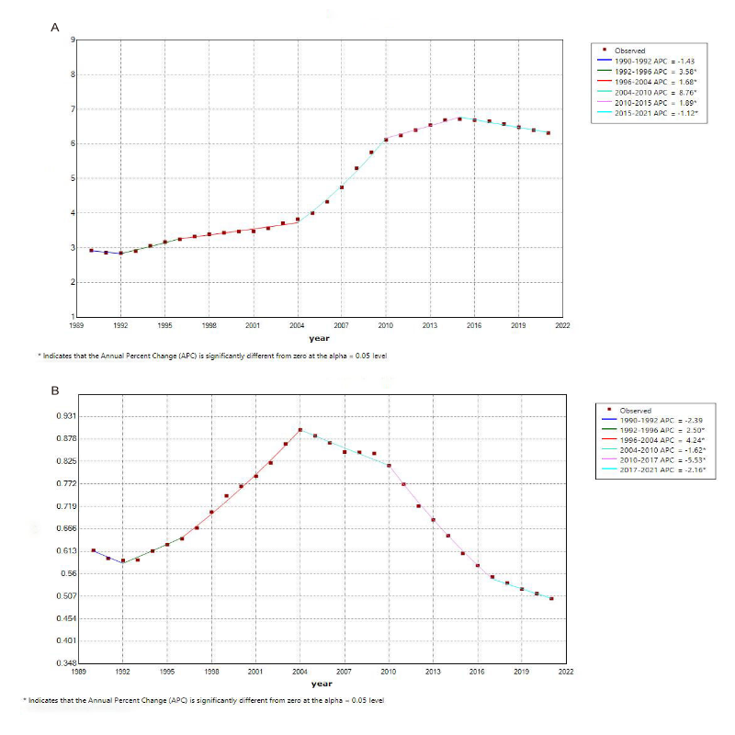Supplementary Figure 3
Joinpoint regression analysis of the sex-specific age-standardized DALYs rate for ACM in China from 1990 to 2021. (A) Age-standardized DALYs rate for males. (B) Age-standardized DALYs rate for females.

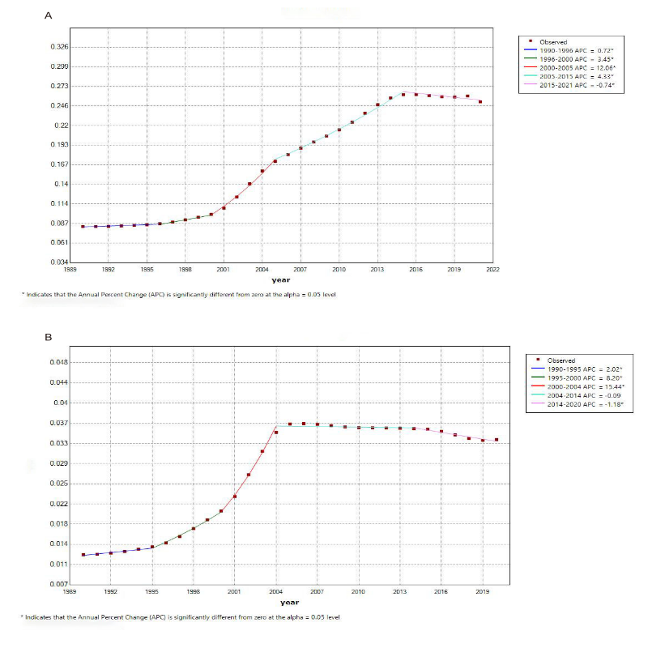
Supplementary Figure 4
Joinpoint regression analysis of the sex-specific age-standardized YLD rate for ACM in China from 1990 to 2021. (A) Age-standardized YLD rate for males. (B) Age-standardized YLD rate for females.

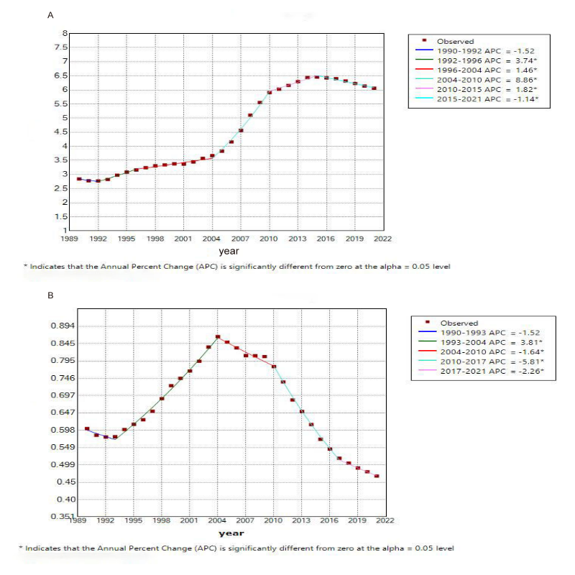
Supplementary Figure 5
Joinpoint regression analysis of the sex-specific age-standardized YLLrate for ACM in China from 1990 to 2021. (A) Age-standardized YLL rate for males. (B) Age-standardized YLL rate for females.

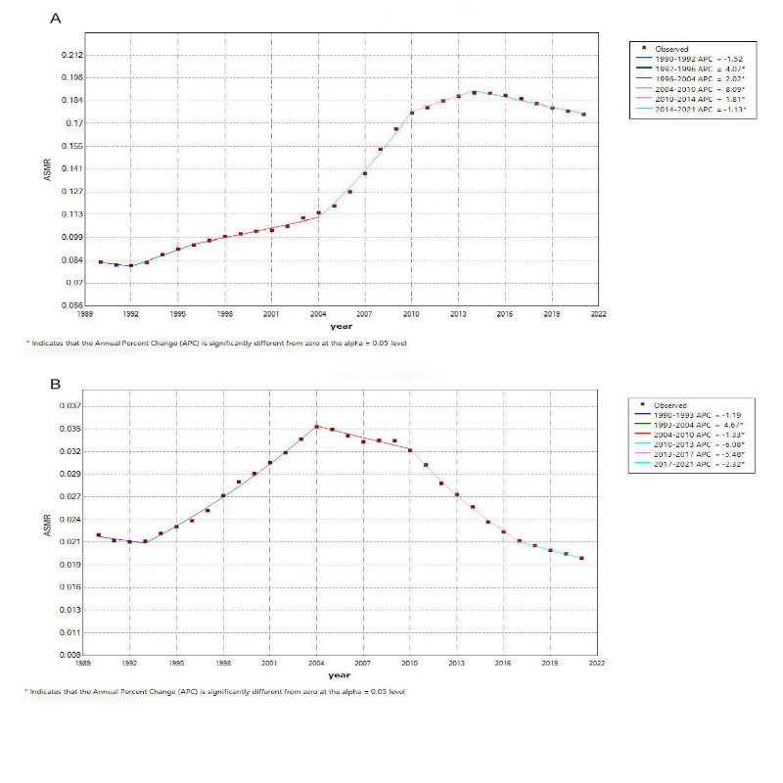
Supplementary Figure 6
Joinpoint regression analysis of the sex-specific age-standardized mortality rate for ACM in China from 1990 to 2021. (A) Age-standardized mortality rate for males. (B) Age-standardized mortality rate for females.

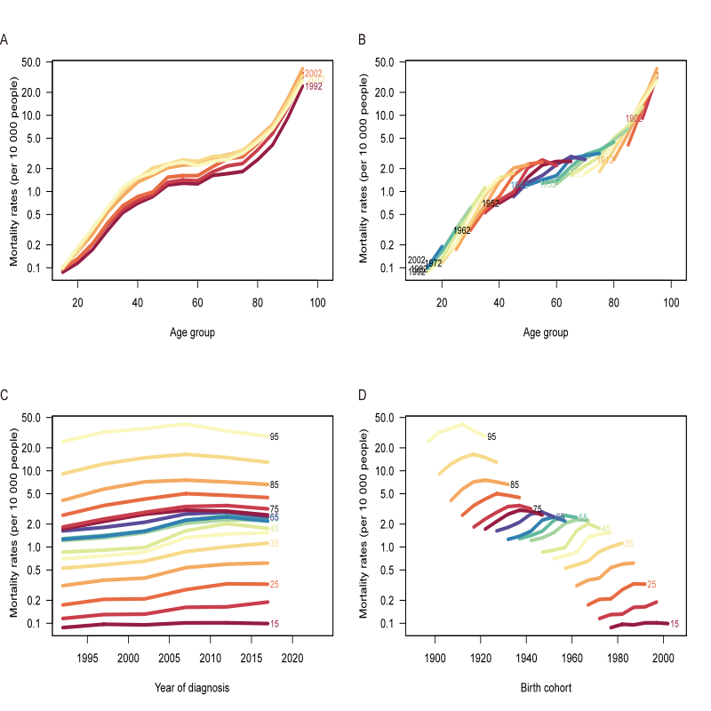
Supplementary Figure 7
Mortality rates of ACM in China. (A) The age-specific mortality rates of ACM according to time periods; each line connects the age-specific mortality for a 5-year period. (B) The age-specific mortality rates of ACM according to birth cohorts; each line connects the age-specific mortality for a 5-year cohort. (C) The period-specific mortality rates of ACM according to age group; each line connects the birth cohort-specific mortality for a 5-year age group. (D) The birth
cohort-specific mortality rates of ACM according to age groups; each line connects the birth cohort-specific mortality for a 5-year age group.

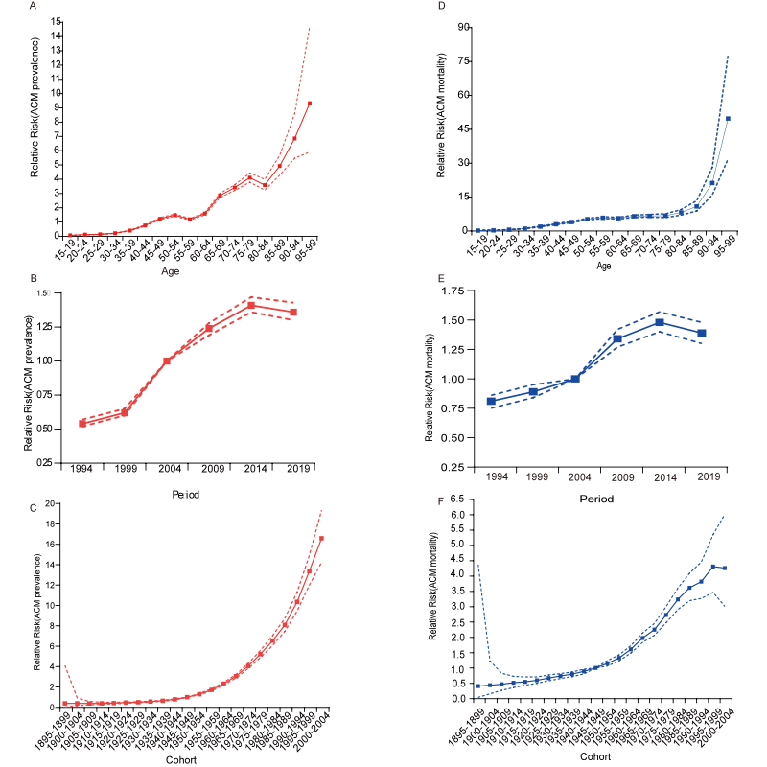

Supplementary Figure 8
Age, period and cohort effects on ACM prevalence and mortality rate in China during 1990–2021. (A–C) The red dot line represents the 95% CI of age, period and cohort effects for ACM prevalence; (D–F) the blue dot line represents the 95% CI of age, period and cohort effects for ACM mortality rate.

