Supporting information

Recovery of Au(III) from electronic waste using solid phase extraction based on a magetic nanobiocomposite, OCBS@Fe₃O₄@UiO-66-SH

Parisa Poormoghadam¹, Soleiman Bahar^{1*}, Yunes Naghdi¹

¹Department of Chemistry, Faculty of Science, University of Kurdistan, P.O. Box 416 Sanandaj, I.R. IRAN

*Corresponding author at University of Kurdistan, Department of Chemistry, Sanandaj, Iran.
Tel.: +98 8733664600;
Fax: +98 8733664600;
E-mail address: s.bahar@uok.ac.ir

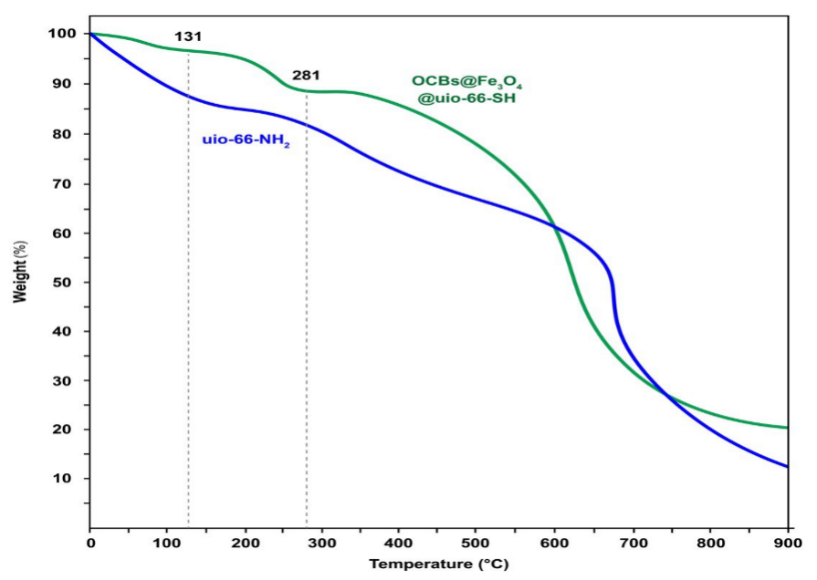
Fig. S1 TGA plots of UiO-66-NH₂ and OCBs@Fe₃O₄@UiO-66-SH

Table S1 Comparison of adsorption capacity of adsorbents reported for Au(III) adsorption in the literature with the adsorption capacity of our adsorbent
Adsorbents | Adsorption capacity (mg/g) | Adsorption  conditions | Eq time | Ref.
N-containing polymer (Zn based-MOP) | 1073 | pH 3.23, 25 ◦C | 350 min at  279 mg/L | [1]
Metal-organic polymer  (Cu-based-MOP) | 1317 | pH 4.48, 25 ◦C | 400 min at  53 mg/L | [2]
2,5-TP (Zn-MOF) | 1253 | pH 7, 25 ◦C | 16 h at 300 mg/L | [3]
S,N-rich MOF¹ | 1891  3680 | pH 2.57, 25 ◦C  pH 2.57, 55 ◦C | 8 min at 9.6 mg/L  180 min at 93 mg/L | [4]
CoFe₂O₄@S–CoWO₄ | 1049 | pH 3, 25 ◦C | 10 h at 100 mg/L | [5]
M-Cu- BDC- NH₂ ² | 1184 | pH 3, 25 ◦C | 5 min at100 mg/L | [6]
DB18C6-HCP³ | 1667 | pH = 11, 25 ◦C | 40 min | [7]
OCBS@Fe₃O₄@UiO-66-SH | 1587 | adsorbent dose = 10 mg; solution volume= 30 mL, pH= 6 at 50 $℃$ | 40 min | present work
¹ Cr-based MOF with adenine and 4,4′-thiodiphenol as organic ligands
² BDC-NH₂: 2-amino-1,4-benzenedicarboxylic acid
³ Cross-linked dibenzo-18-crown-6 (DB18C6) and dibenzo-24-crown-8 (DB24C8)

Adsorption equilibrium isotherms
Different models are available to describe the adsorption process, including the Langmuir isotherm, which assumes that only one layer is formed on the adsorbent surface and no further adsorption occurs after the formation of this layer. Furthermore, this model assumes that the adsorbed molecules do not move across the surface and that the adsorption occurs on a homogeneous surface with a finite number of identical sites with constant adsorption energy [8–10]. The Langmuir isotherm is presented as following equation:
$$\frac{1}{q_{e}}=\frac{1}{q_{m} K_{L }C_{e}}+\frac{1}{q_{m}}$$ | (1)
Symbols q_{m} (mg/g), K_{L} (L/mg), C_{e} (mg/L), and q_{e} (mg/g) represent the maximum adsorption capacity, Langmuir constant, equilibrium concentration, and adsorbed solute quantity, respectively [11]. The graph’s slope and intercept can help calculate q_{m} and K_{L} by plotting 1/q_{e} against 1/C_{e} and analyzing the outcomes.
Freundlich adsorption isotherm is another model for adsorption, in which it is assumed that the surface is heterogeneous and there are sites with different energies (exponential distribution). Its linear form is expressed as [12]:
$$\log{q_{e}}=\log{K_{F}}+\frac{1}{n}\log{C_{e}}$$ | (2)
In this regard, K_{F} is the Freundlich constant and shows the maximum amount of material that can be adsorbed on the unit mass of the adsorbent. Freundlich exponent (n) shows the intensity of the absorption process, values higher than 1 indicate strong absorption, and n between 0 and 1 indicates weak absorption. At n > 1, the absorption increases rapidly with increasing adsorbent concentration, suggesting the presence of pores or gaps in the adsorbent surface that can accommodate several adsorbent molecules [9, 13, 14].
The Temkin isotherm is another mathematical model that takes into account the interactions between adsorbate molecules. According to this model, the heat of adsorption decreases linearly with increasing surface coverage due to adsorbate-adsorbate interactions decreasing the adsorption energy [10, 15]. Its linear form is denoted as:
$q_{e}=B\ln{A}+B\ln{C_{e}}$ | (3)
In this equation, B (in J/mol) is the heat of absorption, A (L/g) is the Tamkin isotherm constant, which is related to the maximum adsorption capacity and C_{e} is the equailibrium concentration [16]. Fig. S2 illustrates the linear plots of the Langmuir, Freundlich, and Temkin isotherm theories for describing the Au(III) adsorption onto the OCBS@Fe₃O₄@UiO-66-SH adsorbent and Table S2 presents the mentioned model parameters.
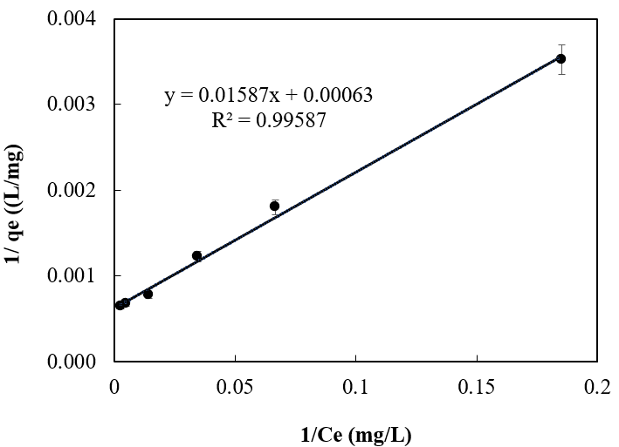  (a) | 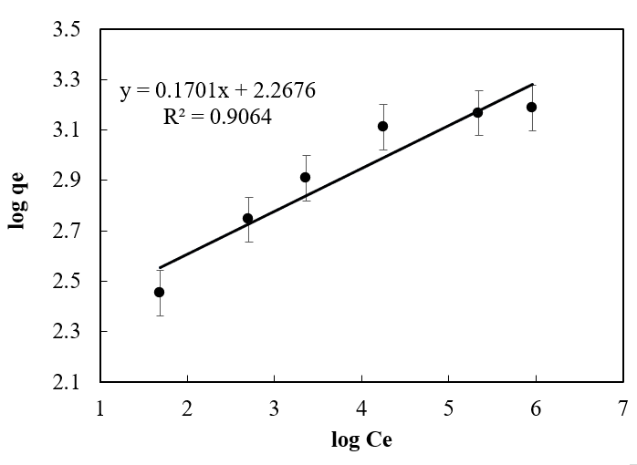  (b)
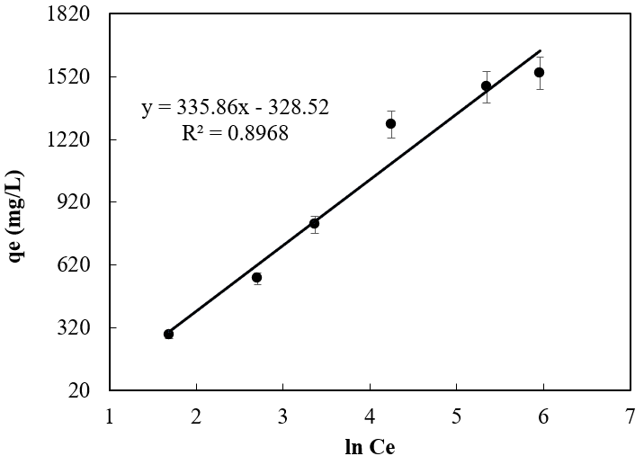
(c)
Fig. S2 Linear plots of isotherm models of (a) Langmuir (b) Freundlich, and (c) Temkin for Au(III) adsorption onto OCBS@Fe₃O₄@UiO-66-SH adsorbent.

Table S2 The parameters of the Langmuir, Freundlich, and Temkin isotherms for the Au(III) adsorption onto the OCBS@Fe₃O₄@UiO-66-SH adsorbent
Model | Parameter | Value
Langmuir | q_{m} (mg.g) | 1587.30
Langmuir | K_{L} (L/mg) | 0.0252
Langmuir | R² | 0.9959
Freundlich | K_{F} (mg/g. L^{1/n} mg^{-1/n}) | 164.21
Freundlich | n | 5.534
Freundlich | R² | 0.9064
Temkin | A (J/mol) | 0.3760
Temkin | B (L/mg) | 335.86
Temkin | R² | 0.8968

In the Langmuir model, a q_{m} value of 0.1587 mg Au(III) per gram of adsorbent was obtained, showing a small difference (3%) between the theoretical and experimental value for q_{m} (1536 mg/g). This slight difference confirms that the model describes the experimental conditions well. Using the Langmuir model, K_{L} was calculated to be 0.0252 L/mg, which is small and indicates a weak association between the adsorbent and adsorbed molecules. The correlation coefficient (R² = 0.9959) shows excellent correlation with the experimental data.
In the Freundlich equation, the value of K_{F} (164.21 mg/g. L^{1/n} mg^{-1/n}) shows that this adsorbent has a high capacity to adsorb the desired substance. The value of n (5.534) expresses the adsorption process’s strength and the adsorbent’s high tendency to adsorb Au(III) ions. The results of the Freundlich model show that the absorption process is robust [17]. Compared to the Langmuir model, its R² score of 0.9064 indicates that it is less capable of explaining experimental data.
For Temkin model, A = 0.3760 J/mol value expresses this system’s maximum adsorption energy and the value of B = 335.86 L/mg indicates the heat of adsorption [18]. The experimental results align with the Temkin isotherm model with an R² value of 0.8968.
Upon comparing models, it is evident that the Langmuir model, boasting the highest R² value, is the most suitable for interpreting the experimental data. The evidence suggests that a monolayer adsorption mechanism accurately explains the adsorption process, with minimal interactions among the adsorbed molecules.
Adsorption kinetic study
Blanchard et al. pioneered the pseudo-second-order (PSO) kinetic model in 1984, commonly used alongside the pseudo-first-order (PFO) model to describe adsorption kinetics, with Coleman et al. later endorsing it [19]. In 1956, this model was considered suitable for predicting time-dependent heavy metal adsroption by clinoptilolite [20]. PFO implies a clear correlation between the site occupancy percentage and the quantity of empty binding sites. The PSO model assumes the number of sites available and the adsorption rate are closely linked [21]. PFO and PSO modesl have the following mathematical expressions:
$$\log{(}q_{e}-q_{t})=log⁡ (q_{e})-k_{1}t$$ | (4)
$$\frac{t}{q_{t}}=\frac{1}{k_{2}q_{e}^{2}}+\frac{t}{q_{e}}$$ | (5)
The equilibrium adsorption capacity is shown by q_{e} (mg/g) in the PFO model, while the rate constant is represented by k₁ (min⁻¹). In this case, q_{e} is the equilibrium adsorption capacity, k₂ is the rate constant (g/mg.min), and q_{t} is the adsorption quantity at time t (in mg/g).
The intraparticle diffusion (ID) model is used to describe the adsorption process in cases where the diffusion of the adsorbate into the pores of the adsorbent is the rate-limiting step of the adsorption process. In other words, it is applied when the rate of movement of the analyte within the pores is much slower than the rate of its adsorption onto the surface of the adsorbent [21]. The model is represented as:
$$q_{t}=k_{i}t^{0.5}+C$$ | (6)
The C is a constant related to the thickness of the boundary layer in this formula, the more pronounced the impact of the boundary layer. The expression q_{t} gives the absorption at time t, while k_{I} (mg/g.min^{0.5}) expresses the intraparticle diffusion rate constant [22, 23]. Fig. S3 and Table S3 provide diagrams of PFO, PSO, and ID kinetic models for Au(III) adsorption on OCBS@Fe₃O₄@UiO-66-SH adsorbent and their determined values.
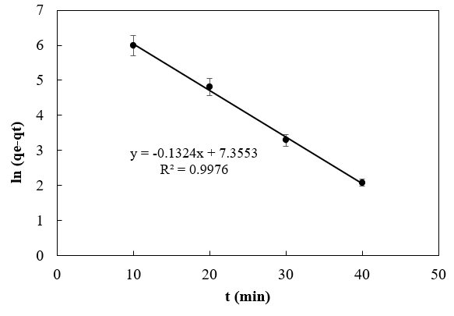  (a) | 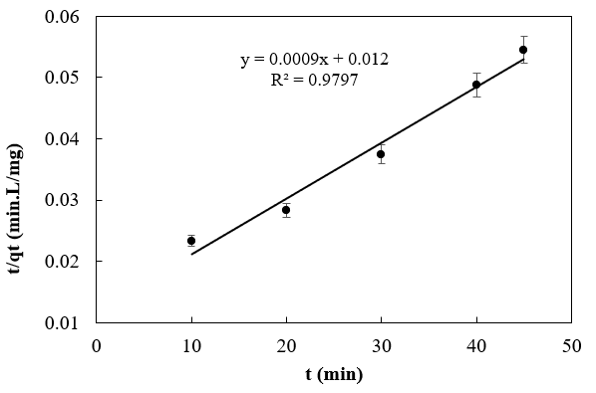  (b)
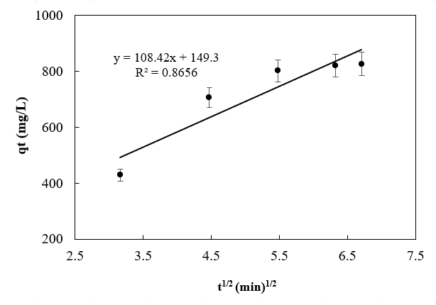
(c)
Fig. S3 Plots of (a) PFO, (b) PSO kinetic models, and (c) ID model for Au(III) adsorption onto OCBS@Fe₃O₄@UiO-66-SH adsorbent.

Table S3 PFO, PDO, and ID kinetic models for Au(III) adsorption onto OCBS@Fe₃O₄@UiO-66-SH adsorbent
Model | Parameter | Value
PFO | k₁ (min⁻¹) | 0.1324
PFO | q_{e} (mg/g) | 1564.5
PFO | R² | 0.9976
PSO | k₂ (g/mg.min) | 0.0009
PSO | q_{e} (mg/g) | 1111.1
PSO | R² | 0.9797
ID | C | 149.3
ID | k_{I} (mg/g.min^{0.5}) | 108.42
ID | R² | 0.8656

The PFO model possesses a robust correlation with the results of experiments, as evidenced by its high R² of 0.9976. The model’s calculated q_{e}, 1564.5 mg/g, is close to the experimental value (1587 mg/g) and shows only 1% difference. A model that so accurately represents adsorption kinetics has demonstrated that the time spent occupying an adsorption site is directly correlated with the number of available unoccupied sites. The adsorption process progresses reasonably quickly, reflected by the rate constant (k₁) of 0.1324 min⁻¹. The adsorbent has a high affinity for the active sites [24, 25]. The kinetic model also shows a high PSO’ R² of 0.9797, lower than the PFO model. Also, the calculated q_{e} (1111.1 mg/g) significantly deviates from the experimental q_{e} (1587 mg/g). This idea justifies the claim that other elements influencing the absorption process include particle penetration and adsorbent surface renewal [26–28]. The PFO model, show casing a rate constant of 0.1324 min⁻¹, effectively depicts our adsorption kinetics, outperforming the PSO model with a rate constant of 0.0009 g/mg.min.
Conversely, the ID model has the lowest R² (0.8656), which indicates a low fit with the experimental data compared to other models. This low correlation demonstrates that the intraparticle diffusion model may not adequately describe adsorption kinetics. It refers to the movement of adsorbent molecules through the pores of the adsorbent material and is usually not the only factor influencing the adsorption rate [29].
The strong correlation between the calculated and observed q_{e} values and the good R² value suggests that the adsorbent molecules’ interaction with surface sites is consistent with the core tenets of the PFO model.

Thermodynamic Parameters
The surface adsorption process’s thermodynamic properties reveal the process’s order and direction. The Gibbs free energy of adsorption (ΔG°) indicates the spontaneity of the adsorption process at constant temperature and pressure. When ΔG° is negative (ΔG° < 0), the adsorption process is spontaneous, meaning it will occur without any external energy input. Conversely, when ΔG° is positive (ΔG° > 0), the adsorption process is non-spontaneous and requires energy input to proceed [30]. The adsorption enthalpy (ΔH°) represents the energy change in the surface adsorbed system. When ΔH° is positive and has a large magnitude, it indicates a strong attraction between the adsorbate and adsorbent. The adsorption exothermic is the opposite. The entropy of adsorption (ΔS°) needs to show us what order or disorder changed when the adsorbent molecules were adsorbed on the surface. In cases where ΔG° is negative, a positive ΔS° indicates that after the adsorption of adsorbate molecules on the surface, there is sufficient disorder for their distribution on the surface, and this contributes to the spontaneity of the adsorption process [31, 32]. In adsorption studies, the change in Gibbs energy ΔG° is calculated as:
$${∆G}^{°}=-RT lnK_{d}$$ | (7)
in which
$$\ln{K_{d}}=-\frac{∆H^{°}}{R}\frac{1}{T}+\frac{∆S^{°}}{R}$$ | (8)
In which, $K_{d}$ is distribution constant defined as [33–35]:
$$K_{d}=\frac{C_{ad}}{C_{e}}$$ | (9)
In this equation, C_{e} and C_{ad} represent the equilibrium concentration of the solute in the solution and the concentration of the adsorbed solute at equilibrium, R (8.314 J/mol.K) is gas constant, T is absolute temperature (in kelvins), ΔH° represents energy changes, and ΔS° represents entropy changes. Equation 10 may be used to calculate the values of ΔH° and ΔS° by examining the slope and intercept of the graph that plots the equilibrium constant's natural logarithm (ln K_{d}) versus temperature reciprocal (1/T). Exploring Au(III) adsorption at different temperatures reveals intriguing thermodynamic insights in Table S4 and Fig. S4, where lnK_{d} is plotted against 1/T for analysis.
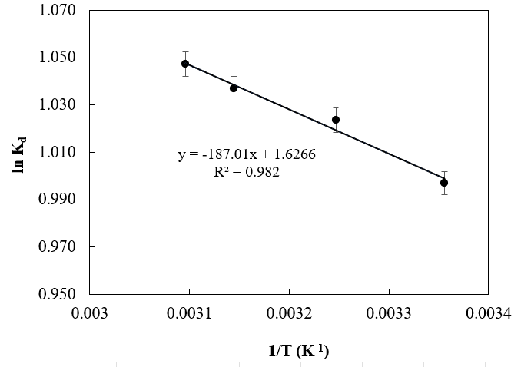
Fig. S4 The plot of ln (K_{d}) vs. 1/T.

Table S4 Adsorption thermodynamic parameters
T (K) | K_{d} | ΔG°  (kJ/mol) | ΔH°  (kJ/mol) | ΔS°  (J/mol.K)
298 | 2.71 | -2.48 | 1.55 | 13.52
308 | 2.78 | -2.61
318 | 2.82 | -2.75
323 | 2.85 | -2.81

The adsorption enthalpy value (ΔH° = 1.55 kJ/mol) is positive, and this indicates the endothermicity of the surface adsorption process [36]. The spontaneous adsorption process is evidenced by the negative ΔG° values recorded within the temperature range of 298 K to 323 K. Increasing temperature leads to more negative ΔG° values, indicating that higher temperatures facilitate more favorable adsorption by providing enough energy for molecules to overcome activation barriers and adhere to the adsorbent surface, aligning with the process’s endothermic nature [37]. Moreover, positive ΔS° (13.52 J/mol·K) indicates the distribution of molecules on the adsorbent surface after the surface adsorption process [38]

References
1. Zhou S, Xu W, Hu C, et al (2020) Fast and effective recovery of Au (III) from aqueous solution by a N-containing polymer. Chemosphere 260:127615. https://doi.org/10.1016/j.chemosphere.2020.127615.
2. Xu W, Mo X, Zhou S, et al (2019) Highly efficient and selective recovery of Au (III) by a new metal-organic polymer. J Hazard Mater 380:120844. https://doi.org/10.1016/j.jhazmat.2019.120844.
3. Hu C, Xu W, Li H, et al (2019) Highly efficient adsorption of Au (III) from water by a novel metal–organic framework constructed with sulfur-containing ligands and Zn (II). Ind Eng Chem Res 58:17972–17979. https://doi.org/10.1021/acs.iecr.9b03433.
4. Wang B, Ma Y, Xu W, Tang K (2023) A novel S, N-rich MOF for efficient recovery of Au (III): Performance and mechanism. J Hazard Mater 451:131051. https://doi.org/10.1016/j.jhazmat.2023.131051.
5. Zhao M, Zhang Y, Yang R, et al (2023) Construction of magnetic S‐doped CoWO₄ composite for efficient and selective recovery of gold from wastewater via adsorption–reduction pathway. Small Struct 4:2300039. https://doi.org/10.1002/sstr.202300039.
6. Xiang Y, Cheng C-Y, Liu M-H, et al (2024) Efficient recovery of gold using Macroporous Metal-Organic framework prepared by the’MOF in MOF’method. Sep Purif Technol 335:126131. https://doi.org/10.1016/j.seppur.2023.126131.
7. Kong H-Y, Wang T-X, Tao Y, et al (2022) Crown ether-based hypercrosslinked porous polymers for gold adsorption. Sep Purif Technol 290:120805. https://doi.org/10.1016/j.seppur.2022.120805.
8. Ayanda OS, Fatoki OS, Adekola FA, Ximba BJ (2013) Kinetics and equilibrium models for the sorption of tributyltin to nZnO, activated carbon and nZnO/activated carbon composite in artificial seawater. Mar Pollut Bull 72:222-230. https://doi.org/10.1016/j.marpolbul.2013.04.001.
9. Kumar KV, Sivanesan S (2006) Isotherm parameters for basic dyes onto activated carbon: Comparison of linear and non-linear method. J Hazard Mater 129:147-150. https://doi.org/10.1016/j.jhazmat.2005.08.022.
10. Dada AO, Ojediran JO, Olalekan AP (2013) Sorption of Pb²⁺ from aqueous solution unto modified rice husk: Isotherms studies. Adv Phys Chem 2013:842425. https://doi.org/10.1155/2013/842425.
11. Shikuku VO, Kowenje CO, Kengara FO (2018) Errors in parameters estimation using linearized adsorption isotherms: Sulfadimethoxine adsorption onto kaolinite clay. Chem Sci Int J 23:1-6. 10.9734/CSJI/2018/44087.
12. Vanaamudan A, Pathan N, Pamidimukkala P (2014) Adsorption of Reactive Blue 21 from aqueous solutions onto clay, activated clay, and modified clay. Desalin Water Treat 52:1589-1599. https://doi.org/10.1080/19443994.2013.789405.
13. Agarwal AK, Kadu MS, Pandhurnekar CP, Muthreja IL (2016) Brunauer-Emmett-Teller (B.E.T.), langmuir and freundlich isotherm studies for the adsorption of Nickel ions onto coal fly ash. Asian J Water, Environ Pollut 13:49-53. 10.3233/AJW-160016.
14. Fouad MR, Aly MI, El-Aswad AF, Badawy MEI (2024) Effect of particles size on adsorption isotherm of chlorantraniliprole, dinotefuran, bispyribac-sodium, and metribuzin into sandy loam soil. Curr Chem Lett 13:61-72. 10.5267/j.ccl.2023.8.009.
15. Dada AO, Adekola FA, Odebunmi EO (2017) Kinetics, mechanism, isotherm and thermodynamic studies of liquid phase adsorption of Pb²⁺ onto wood activated carbon supported zerovalent iron (WAC-ZVI) nanocomposite . Cogent Chem 3:1351653. https://doi.org/10.1080/23312009.2017.1351653.
16. Habeeb OA, Kanthasamy R, Ali GAM, et al (2017) Kinetic, isotherm and equilibrium study of adsorption of hydrogen sulfide from wastewater using modified eggshells. IIUM Eng J 18:13-25. https://doi.org/10.31436/iiumej.v18i1.689.
17. Zhang J, Deng R jian, Ren B zhi, et al (2019) Preparation of a novel Fe₃O₄/HCO composite adsorbent and the mechanism for the removal of antimony (III) from aqueous solution. Sci Rep 9:13021. https://doi.org/10.1038/s41598-019-49679-9.
18. Kalam S, Abu-Khamsin SA, Kamal MS, Patil S (2021) Surfactant adsorption isotherms: A Review. ACS Omega 6:32342-32348. https://doi.org/10.1021/acsomega.1c04661.
19. Blanchard G, Maunaye M, Martin G (1984) Removal of heavy metals from waters by means of natural zeolites. Water Res 18:1501-1507. https://doi.org/10.1016/0043-1354(84)90124-6.
20. Coleman NT, Mcclung AC, Moore DP (1956) Formation constants for Cu(II)-peat complexes [8]. Science 123:330-331. 10.1126/science.123.3191.330.
21. Tadepalli S, Murthy KSR, Sahu O (2023) Interparticle diffusion and thermodynamic modeling studies for the removal of heavy metals using mixed adsorbents in industrial effluents. Environ Qual Manag 32:375-388. https://doi.org/10.1002/tqem.21927.
22. Wang J, Guo X (2022) Rethinking of the intraparticle diffusion adsorption kinetics model: Interpretation, solving methods and applications. Chemosphere 309:136732. https://doi.org/10.1016/j.chemosphere.2022.136732.
23. Silva LMS, Muñoz-Peña MJ, Domínguez-Vargas JR, et al (2021) Kinetic and equilibrium adsorption parameters estimation based on a heterogeneous intraparticle diffusion model. Surfaces and Interfaces 22:100791. https://doi.org/10.1016/j.surfin.2020.100791.
24. Rudzinski W, Plazinski W (2006) Kinetics of solute adsorption at solid/solution interfaces: A theoretical development of the empirical pseudo-first and pseudo-second order kinetic rate equations, based on applying the statistical rate theory of interfacial transport. J Phys Chem B 110:16514-16525. https://doi.org/10.1021/jp061779n.
25. Rudzinski W, Plazinski W (2007) Studies of the kinetics of solute adsorption at solid/solution interfaces: On the possibility of distinguishing between the diffusional and the surface reaction kinetic models by studying the pseudo-first-order kinetics. J Phys Chem C 111:15100-15110. https://doi.org/10.1021/jp073249c.
26. Alakhras F, Ouerfelli N, Al-Mazaideh G, et al (2019) Optimal pseudo-average order kinetic model for correlating the removal of nickel ions by adsorption on nanobentonite. Arab J Sci Eng 44:159-168. https://doi.org/10.1007/s13369-018-3304-1.
27. Mohammadi A, Karimi AA (2017) Methylene blue removal using surface-modified TiO₂ nanoparticles: A comparative study on adsorption and photocatalytic degradation. J Water Environ Nanotechnol J Water Environ Nanotechnol 2:118-128. https://doi.org/10.22090/jwent.2017.02.007.
28. Musah M, Azeh Y, Mathew J, et al (2022) Adsorption kinetics and isotherm models: A Review. Caliphate J Sci Technol 4:20-26. https://dx.doi.org/10.4314/cajost.v4i1.3.
29. Ghaedi M, Moazzen HR, Purkait MK (2016) Kinetic and isotherm study of Sudan black B removal. Toxicol Ind Health 32:1891-1901. https://doi.org/10.1177/0748233715592.
30. Din MI, Hussain Z, Mirza ML, et al (2014) Adsorption optimization of lead (II) using Saccharum Bengalense as a non-conventional low cost Biosorbent: Isotherm and thermodynamics modeling. Int J Phytoremediation 16:889-908. https://doi.org/10.1080/15226514.2013.803025.
31. Dada AO, Adekola FA, Odebunmi EO, et al (2021) Two–three parameters isotherm modeling, kinetics with statistical validity, desorption and thermodynamic studies of adsorption of Cu(II) ions onto zerovalent iron nanoparticles. Sci Rep 11:16454. https://doi.org/10.1038/s41598-021-95090-8.
32. Mahmoud ME, Amira MF, Seleim SM, Mohamed AK (2017) Adsorption isotherm models, kinetics study, and thermodynamic parameters of Ni(II) and Zn(II) removal from water using the LbL technique. J Chem Eng Data 62:839-850. https://doi.org/10.1021/acs.jced.6b00865.
33. Salman M, Athar M, Farooq U (2015) Biosorption of heavy metals from aqueous solutions using indigenous and modified lignocellulosic materials. Rev. Environ. Sci. Biotechnol. 14:211-228. https://doi.org/10.1007/s11157-015-9362-x.
34. Yu L, Luo YM (2014) The adsorption mechanism of anionic and cationic dyes by Jerusalem artichoke stalk-based mesoporous activated carbon. J Environ Chem Eng 2:220-229. https://doi.org/10.1016/j.jece.2013.12.016.
35. Guo L, Li G, Liu J, et al (2013) Adsorptive decolorization of methylene blue by crosslinked porous starch. Carbohydr Polym 93:374-379. https://doi.org/10.1016/j.carbpol.2012.12.019.
36. Lu L, Na C (2022) Gibbsian interpretation of Langmuir, Freundlich and Temkin isotherms for adsorption in solution. Philos Mag Lett 102:239-253. https://doi.org/10.1080/09500839.2022.2084571.
37. Ferhat D, Nibou D, Elhadj M, Amokrane S (2019) Adsorption of Ni²⁺ ions onto NaX and NaY zeolites: Equilibrium, kinetics, intra crystalline diffusion and thermodynamic studies. Iran J Chem Chem Eng 38:63-81.
38. Chakraborty S, Mukherjee A, Das S, et al (2021) Study on isotherm, kinetics, and thermodynamics of adsorption of crystal violet dye by calcium oxide modified fly ash. Environ Eng Res 26:190372-190380.

