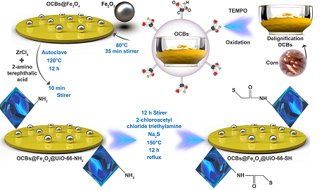
Scheme 1. Preparation steps of OCBs, OCBs-Fe₃O₄, OCBS@Fe₃O₄@UiO-66-NH₂ and OCBS@Fe₃O₄@UiO-66-SH nanocomposites.

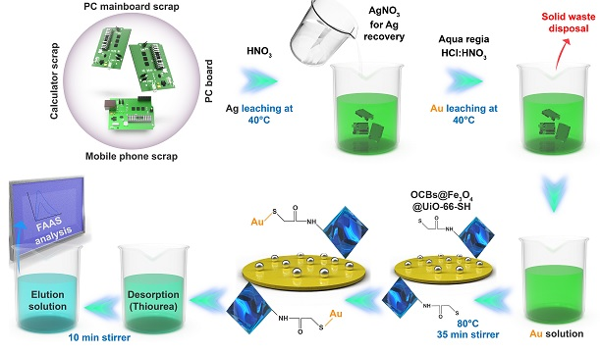
Scheme 2. Extraction and recovery of Au(III) from electronic waste by nanocomposite OCBS@Fe₃O₄@UiO-66-SH.

