Supplementary Information for the paper:
Hidden colour signals as key drivers in the evolution of anti-predator coloration and defensive behaviours in snakes

Table S1. Frequency of each color strategy among the analyzed 251 species.
Color strategy | Cry | Hidden | Con | Polymorphic
 |  |  |  | Cry/Hidden | Cry/Con | Hidden/Con | Cry/Hidden/Con
Number of species | 87 | 51 | 101 | 3 | 1 | 5 | 3

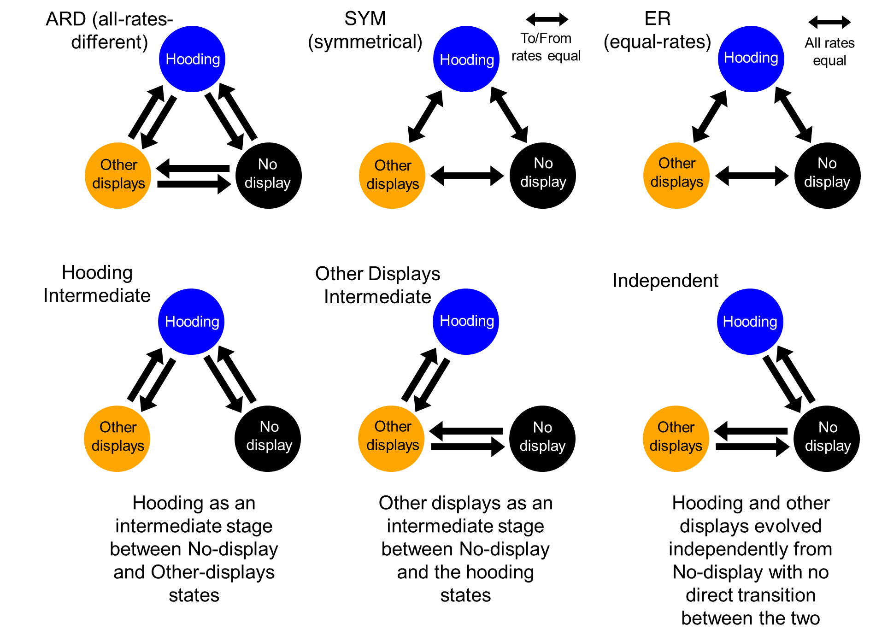
Figure S1. The models we fitted to examine the transitional patterns among the behavioral traits.

Table S2. Full transition matrix of the ER model. Grey cells are those estimated for polymorphic states that only a few species exist.
To  From | Cry | Hidden | Con | Cry  /Hidden | Cry  /Con | Hidden  /Con | Cry  /Hidden  /Con
Cry |  | 0.0019 | 0.0019 | 0.0159 | 0.102 | 0 | 0.301
Hidden | 0.0019 |  | 0.0019 | 0.034 | 0 | 0.022 | 0
Con | 0.0019 | 0.0019 |  | 0 | 0 | 248.09 | 0
Cry  /Hidden | 0.496 | 0.715 | 0 |  | 0 | 0 | 0
Cry  /Con | 8.563 | 0 | 0.237 | 0 |  | 0 | 0
Hidden  /Con | 0 | 0.313 | 5011.68 | 0 | 0 |  | 0
Cry  /Hidden  /Con | 8.510 | 0.0009 | 0.190 | 0 | 0 | 0

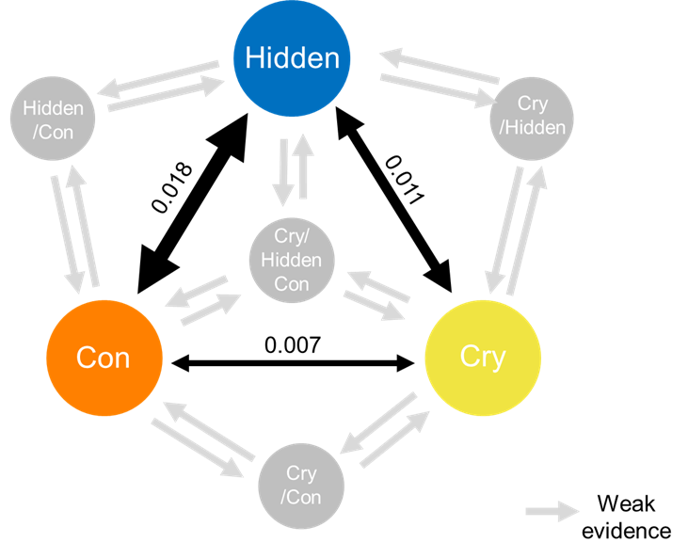
Figure S2. The transition rates estimated in SYM model (the second-best model).

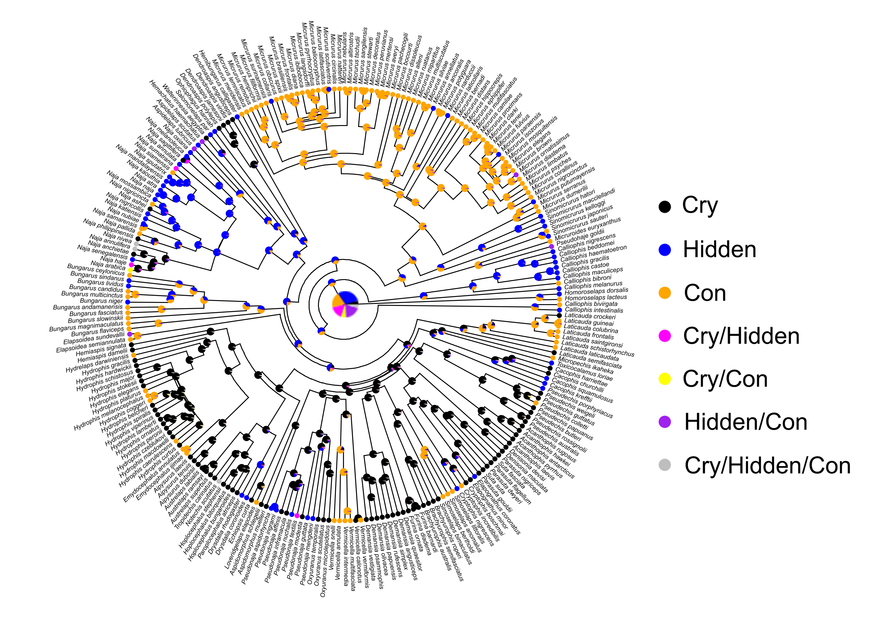
Figure S3. The results of marginal ancestral character reconstruction using the color dataset. Here the ancestral state was estimated as a matrix of marginal probabilities for each node.
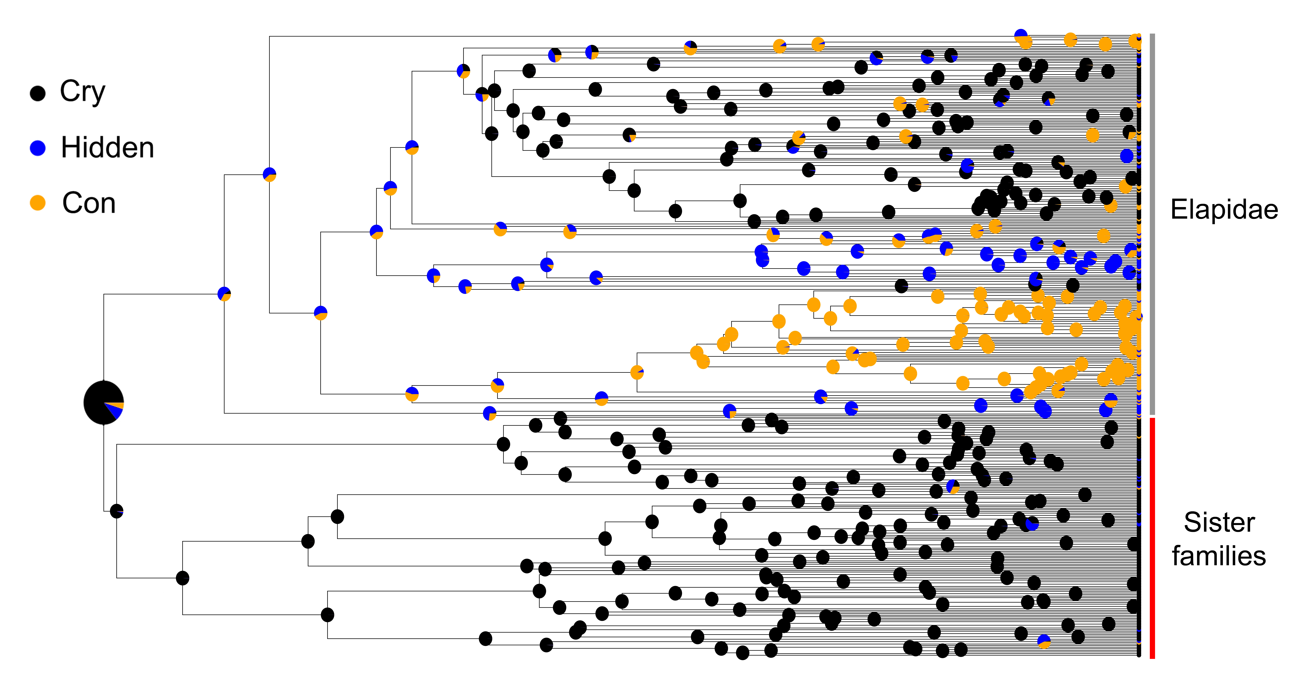
Figure S4. The results of marginal ancestral character reconstruction using the family Elapidae and its sister families are presented. Polymorphic species, all of which evolved near the tip of the phylogeny and are present only in the family Elapidae, were excluded from this analysis for providing simpler results. However, including the polymorphic species does not change the ancestral state of the common ancestor between Elapidae and its sister clades.

Table S3. The support of competing models when species with any disagreement in classification were excluded from the analyses. The ER model remained the best-supported model. The transition rates and ancestral character reconstruction results almost exactly mirrored the main results (Fig. S5).
Model | Log likelihood | Number of parameters | AICc | AIC weight
ARD | -222.8 | 24 | 493.7 | 0.02
SYM | -223.7 | 21 | 489.4 | 0.17
ER | -224.3 | 19 | 486.6 | 0.69
Intermediate | -224.4 | 22 | 492.9 | 0.03
Cost-offset | -224.4 | 22 | 492.7 | 0.03
Secondary | -223.9 | 22 | 491.8 | 0.15

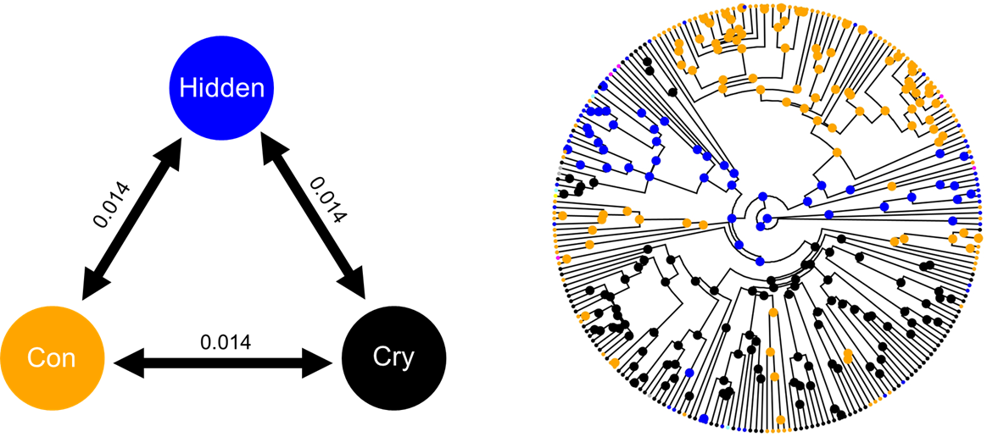
Figure S5. The estimated transition rates and ancestral character reconstruction results of the best-supported model when species with any disagreement in classification were excluded.

Table S4. The support of competing models when polymorphic species were excluded from the analyses. ER and SYM models were best supported with the same ancestral character reconstruction results which almost exactly corresponds to the main results (Fig. S6).
Model | Log likelihood | Number of parameters | AICc | AIC weight
ARD | -182.6 | 6 | 377.2 | 0.27
SYM | -185.3 | 3 | 376.5 | 0.37
ER | -187.3 | 1 | 376.7 | 0.35
Intermediate | -193.6 | 4 | 395.2 | 0.00
Cost-offset | -196.7 | 4 | 401.5 | 0.00
Secondary | -215.6 | 4 | 439.2 | 0.00

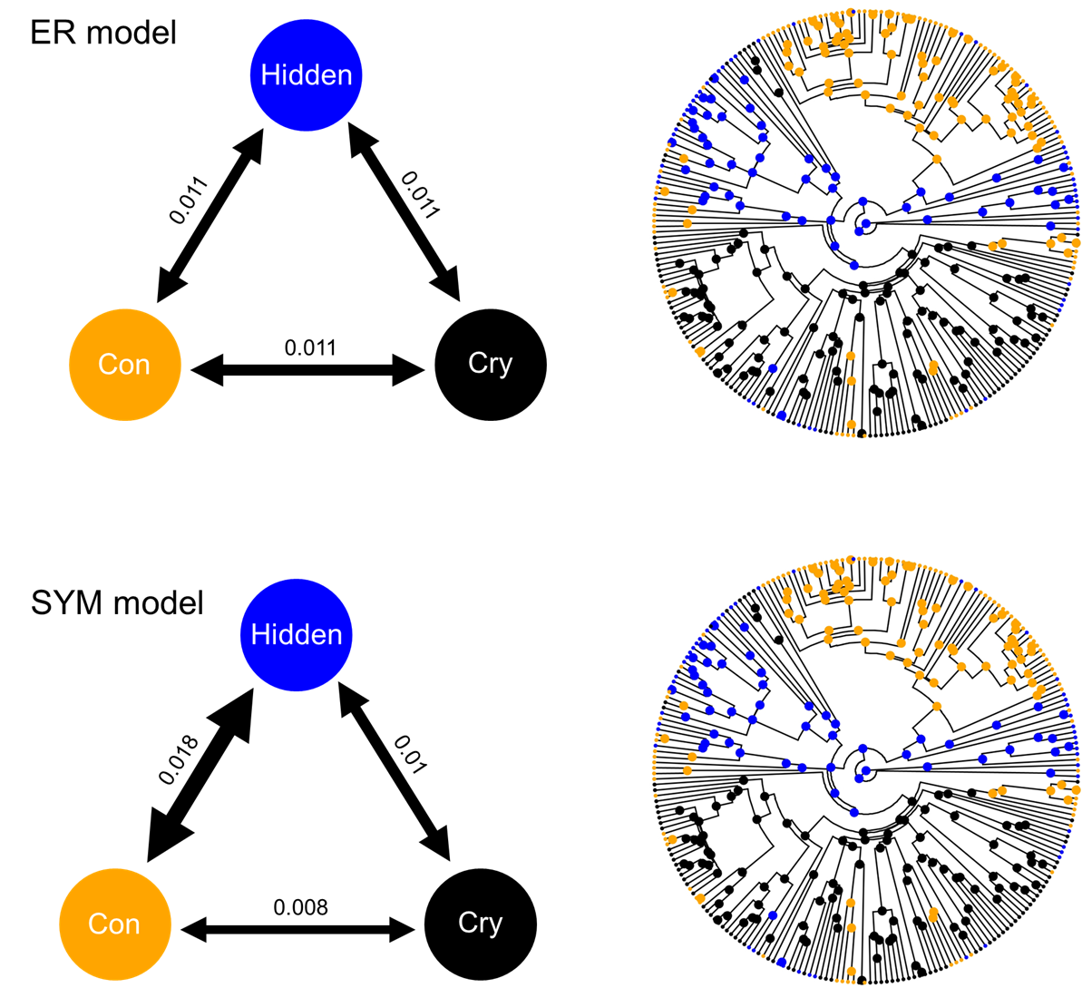

Figure S6. The estimated transition rates and ancestral character reconstruction results of the two best-supported models when polymorphic species were excluded.
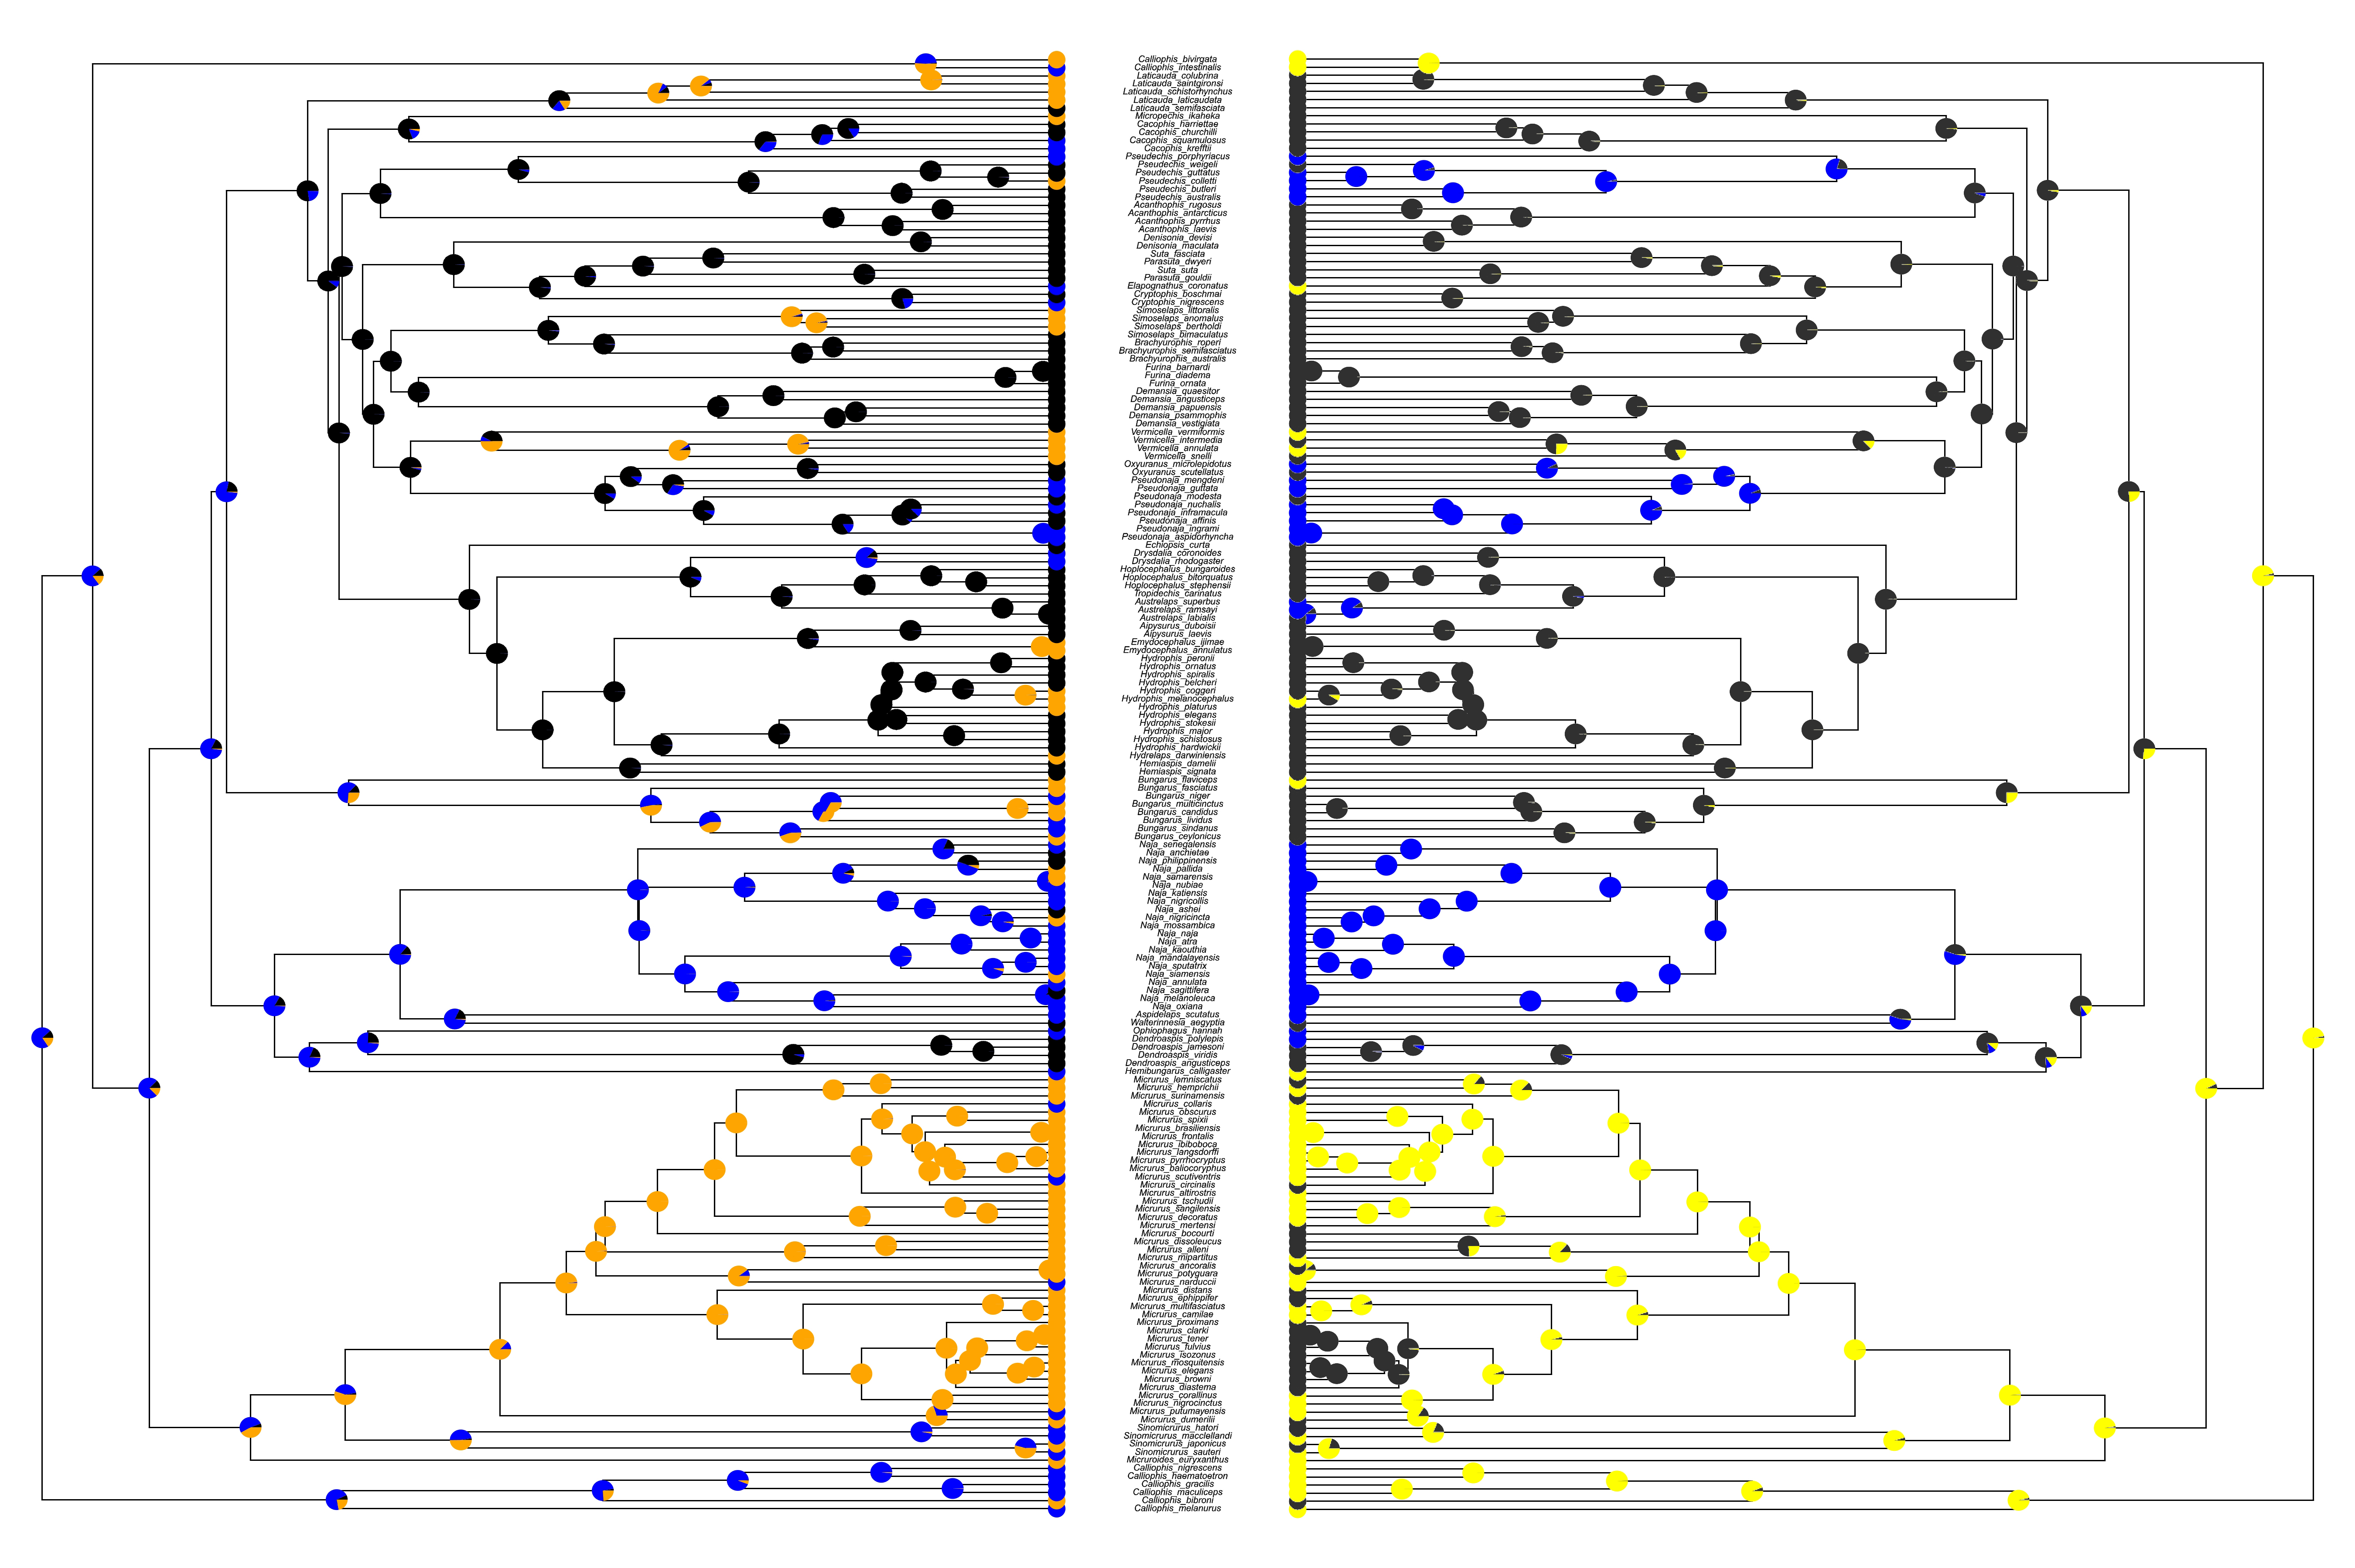
Figure S5. The results of marginal ancestral character reconstruction using the colour+behaviour dataset.

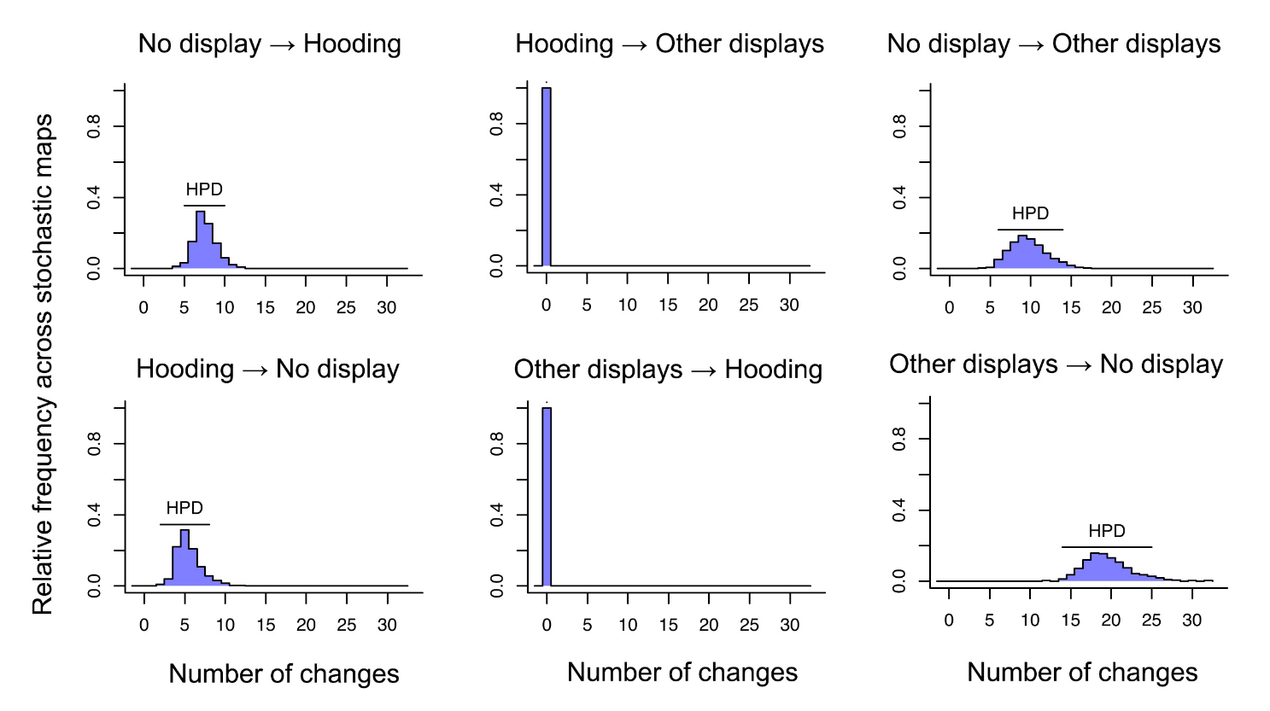
Figure S6. The results of stochastic character mapping for defensive behaviours. The distribution of number of changes between traits aligns well with the transition rate result; there had been no shift between hooding and other defensive displays and these two defensive behaviours evolve independently from each other.

Table S5. Species names and author credits of images that were used to generate Figure 3. All images were either under a CC-BY license or public domain images.
Species | Authors | Source
Micrurus lemniscatus | Ricardo J. Sawaya | Wikimedia commons
Micrurus altirostris | Tomás Carranza Perales | Wikimedia commons
Micrurus dissoleucus | Iván S. Arenas V. | Wikimedia commons
Micrurus narduccii | Ferhat Gundogdu | Wikimedia commons
Micrurus tener | LA Dawson | Wikimedia commons
Micrurus browni | Ruth Percino Daniel | Wikimedia commons
Micrurus corallinus | Paulo Marcelo Adamek | Wikimedia commons
Sinomicrurus sauteri | 向高世 | Wikimedia commons
Calliophis nigrescens | Rushikesh lohar | Wikimedia commons
Homoroselaps lacteus | Oliver Angus | Wikimedia commons
Laticauda colubrina | Jens Petersen | Wikimedia commons
Pseudechis guttatus | Max Tibby | Wikimedia commons
Pseudechis australis | Max Tibby | Wikimedia commons
Suta suta | Max Tibby | Wikimedia commons
Cryptophis nigrescens | Scott Warner | Wikimedia commons
Brachyurophis australis | Max Tibby | Wikimedia commons
Demansia psammophis | Mark_Green_13 | Wikimedia commons
Vermicella annulata | Will Brown | Wikimedia commons
Pseudonaja textilis | Xyxyzyz | Wikimedia commons
Hoplocephalus bungaroides | Alan | Wikimedia commons
Emydocephalus ijimae | Lu i-chi | Wikimedia commons
Hydrophis lamberti | Franco Colnago | Wikimedia commons
Elapsoidea sundevallii | Marius Burger | Wikimedia commons
Bungarus fasciatus | 灯管儿 | Wikimedia commons
Naja philippinensis | MorphinESTP | Wikimedia commons
Naja naja | Raju Kasambe | Wikimedia commons
Naja oxiana | Ali Khani | Wikimedia commons
Ophiophagus hannah | TimVickers | Wikimedia commons

Table S6. Image sources used for color classification.
Species | Image sources 1 | Image sources 2 | Image sources 3 | Image sources 4
Acanthophis antarcticus | https://www.shannonwild.com/image/I00009R7kT4N9dYA | https://reptile-database.reptarium.cz/species?genus=Acanthophis&species=antarcticus
Acanthophis cryptamydros | https://www.researchgate.net/figure/Acanthophis-cryptamydros-sp-nov-holotype-WAM-R174083-showing-dorsal-and-ventral_fig6_281288432 |  | https://reptile-database.reptarium.cz/species?genus=Acanthophis&species=cryptamydros
Acanthophis hawkei | https://www.mindenpictures.com/stock-photo-barkly-death-adder-acanthophis-hawkei-aged-11-months-captive-bred-naturephotography-image90813293.html | https://reptile-database.reptarium.cz/species?genus=Acanthophis&species=hawkei
Acanthophis laevis | https://venomland.forumotion.com/t710-acanthophis-laevis | https://www.flickr.com/photos/midlandsreptiles/28954445393 | https://inaturalist.ca/taxa/35052-Acanthophis-laevis
Acanthophis pyrrhus | https://inaturalist.ca/taxa/35056-Acanthophis-pyrrhus/browse_photos | https://inaturalist.ca/taxa/35056-Acanthophis-pyrrhus/browse_photos | https://inaturalist.ca/taxa/35056-Acanthophis-pyrrhus/browse_photos
Acanthophis rugosus | https://www.youtube.com/watch?v=J0e0kmrs_AM | https://reptile-database.reptarium.cz/species?genus=Acanthophis&species=rugosus | https://reptile-database.reptarium.cz/species?genus=Acanthophis&species=rugosus
Aipysurus duboisii | https://inaturalist.ca/taxa/35263-Aipysurus-duboisii/browse_photos | https://inaturalist.ca/taxa/35263-Aipysurus-duboisii/browse_photos | https://inaturalist.ca/taxa/35263-Aipysurus-duboisii/browse_photos | https://inaturalist.ca/taxa/35263-Aipysurus-duboisii/browse_photos
Aipysurus laevis | https://www.inaturalist.org/taxa/35260-Aipysurus-laevis | https://oceana.org/marine-life/olive-sea-snake/ | https://www.naturepl.com/stock-photo-two-olive-brown-sea-snakes-aipysurus-laevis-interacting-venomous-image01505478.html | http://www.ourwildlife.com.au/elapids/194-broad-headed-snake-hoplocephalus-bungaroides
Aipysurus pooleorum | https://www.inaturalist.org/taxa/539231-Aipysurus-pooleorum/browse_photos | https://www.inaturalist.org/taxa/539231-Aipysurus-pooleorum/browse_photos
Aipysurus tenuis | https://reeflifesurvey.com/species/aipysurus-tenuis/
Antaioserpens albiceps | https://www.flickr.com/photos/shaneblackfnq/38713907885 | https://www.flickr.com/photos/elliotbudd/37331164970 | http://treatment.plazi.org/id/03A81A62FF96FFC8FF6564BAFC61F246
Aspidelaps lubricus | https://www.inaturalist.org/taxa/30464-Aspidelaps-lubricus/browse_photos | https://www.flickr.com/photos/cowyeow/4530250215
Aspidelaps scutatus | https://inaturalist.ca/taxa/30461-Aspidelaps-scutatus | https://www.tyroneping.co.za/snakes-southern-africa/aspidelaps-scutatus-fulafula-eastern-shield-nose-snake/ | http://www.the-eis.com/atlas/?q=mammal-description&taxon_meaning_id=2967 | https://www.pinterest.com/pin/326511041710389416/
Aspidomorphus muelleri | https://www.inaturalist.org/taxa/35075-Aspidomorphus-muelleri/browse_photos |  | http://www.toxinology.com/fusebox.cfm?fuseaction=main.snakes.display&id=SN0622
Aspidomorphus schlegelii | https://www.inaturalist.org/observations/128436674 | https://reptile-database.reptarium.cz/species?genus=Aspidomorphus&species=muelleri
Austrelaps labialis | https://www.mindenpictures.com/stock-photo-adelaide-pygmy-copperhead-snake-austrelaps-labialis-strike-pose-south-naturephotography-image90185869.html |  | https://reptile-database.reptarium.cz/species?genus=Austrelaps&species=labialis
Austrelaps ramsayi | https://www.flickr.com/photos/23031163@N03/41620667665 | https://reptile-database.reptarium.cz/species?genus=Austrelaps&species=ramsayi | https://www.flickr.com/photos/58349528@N02/28351753504 | https://collections.museumsvictoria.com.au/species/8786
Austrelaps superbus | https://www.natureinstock.com/search/preview/lowland-copperhead-austrelaps-superbus-male-snake-basking-donnybrook/0_12566979.html | https://www.projectnoah.org/spottings/2001976002 | https://www.flickr.com/photos/126237772@N07/29519598664 | https://collections.museumsvictoria.com.au/species/8787
Brachyurophis australis | https://apps.des.qld.gov.au/species-search/details/?id=460 |  | https://calphotos.berkeley.edu/cgi/img_query?enlarge=0000+0000+1211+0469
Brachyurophis campbelli | https://www.inaturalist.org/taxa/558846-Brachyurophis-campbelli/browse_photos | https://www.inaturalist.org/taxa/558846-Brachyurophis-campbelli/browse_photos
Brachyurophis roperi | https://twitter.com/alanadelaive/status/1043344010251649025
Brachyurophis semifasciatus | https://www.flickr.com/photos/jasminevink/46262298224 | https://reptile-database.reptarium.cz/species?genus=Brachyurophis&species=semifasciatus | https://www.mindenpictures.com/stock-photo-southern-shovel-nosed-sake-brachyurophis-semifasciatus-coastal-sand-naturephotography-image90729724.html
Bungarus andamanensis | https://www.inaturalist.org/taxa/30453-Bungarus-andamanensis/browse_photos
Bungarus candidus | https://en.wikipedia.org/wiki/Bungarus_candidus |  | https://a-z-animals.com/animals/malayan-krait/
Bungarus ceylonicus | https://reptile-database.reptarium.cz/species?genus=Bungarus&species=ceylonicus
Bungarus fasciatus | https://www.monaconatureencyclopedia.com/bungarus-fasciatus/?lang=en |  | https://www.thainationalparks.com/species/bungarus-fasciatus
Bungarus flaviceps | https://reptile-database.reptarium.cz/species?genus=Bungarus&species=flaviceps |  | https://exotic-venom.tumblr.com/post/174446031371/bungarus-flaviceps-identification
Bungarus lividus | https://www.researchgate.net/figure/Lesser-Black-Krait-Bungarus-lividus-Ventral-side-of-the-same-snake-showing-the-light_fig18_235758972 | https://inaturalist.ca/taxa/30445-Bungarus-lividus/browse_photos | https://inaturalist.ca/taxa/30445-Bungarus-lividus/browse_photos
Bungarus magnimaculatus | https://inaturalist.ca/taxa/96226-Bungarus-magnimaculatus/browse_photos | https://inaturalist.ca/taxa/96226-Bungarus-magnimaculatus/browse_photos
Bungarus multicinctus | https://www.hongkongsnakeid.com/many-banded-krait |  | https://reptile-database.reptarium.cz/species?genus=Bungarus&species=multicinctus
Bungarus niger | https://reptile-database.reptarium.cz/species?genus=Bungarus&species=niger | https://www.flickr.com/photos/64374409@N05/27839208173 | https://www.inaturalist.org/taxa/30441-Bungarus-niger
Bungarus sindanus | https://en.wikipedia.org/wiki/Bungarus_sindanus | https://reptile-database.reptarium.cz/species?genus=bungarus&species=sindanus
Bungarus slowinskii | https://www.inaturalist.org/taxa/96227-Bungarus-slowinskii/browse_photos
Bungarus suzhenae | https://news.mongabay.com/2021/04/deadly-new-snake-named-after-mythical-chinese-goddess-of-healing/ |  | https://en.wikipedia.org/wiki/Bungarus_suzhenae
Bungarus walli | https://www.inaturalist.org/taxa/558848-Bungarus-walli/browse_photos | https://www.inaturalist.org/taxa/558848-Bungarus-walli/browse_photos
Cacophis churchilli | https://www.flickr.com/photos/shaneblackfnq/31461577466
Cacophis harriettae | https://www.flickr.com/photos/angusmcnab/13964479753 | https://reptile-database.reptarium.cz/species?genus=Cacophis&species=harriettae | https://www.inaturalist.org/taxa/35049-Cacophis-harriettae | https://www.inaturalist.org/taxa/35049-Cacophis-harriettae
Cacophis krefftii | https://southeastsnakecatcher.com.au/dwarf-crowned-snake/ | https://reptile-database.reptarium.cz/species?genus=Cacophis&species=krefftii | https://apps.des.qld.gov.au/species-search/details/?id=502 | https://inaturalist.ca/taxa/35047-Cacophis-krefftii
Cacophis squamulosus | https://www.flickr.com/photos/smacdonald/2096606014 | https://reptile-database.reptarium.cz/species?genus=Cacophis&species=squamulosus | https://www.australiawidefirstaid.com.au/resources/golden-crowned-snake
Calliophis beddomei | https://indiabiodiversity.org/species/show/257463 | https://en.wikipedia.org/wiki/Beddome%27s_coral_snake
Calliophis bibroni | https://en.wikipedia.org/wiki/Calliophis_bibroni |  | https://indiabiodiversity.org/species/show/257458
Calliophis bilineatus | https://palawanwildfrontier.blogspot.com/2020/02/two-lined-coral-snake.html | https://reptile-database.reptarium.cz/species?genus=Calliophis&species=bilineatus&search_param=%28%28search%3D%27snakes%27%29%29
Calliophis bivirgatus | https://inaturalist.ca/taxa/558849-Calliophis-bivirgatus |  | https://www.hongkongsnakeid.com/malayan-blue-coral-snake
Calliophis castoe | https://www.researchgate.net/figure/Calliophis-castoe-venter-of-subadult-female-paratype-BNHS-3474-313-mm-TL-from-Ambe_fig2_260086305 | https://www.researchgate.net/figure/Calliophis-castoe-dorsum-of-live-adult-male-specimen-not-collected-from-Dicholi-Goa_fig1_260086305 | https://indiabiodiversity.org/observation/show/17035373
Calliophis gracilis | https://www.flickr.com/photos/59583171@N07/14035330449 |  | https://uk.inaturalist.org/taxa/30424-Calliophis-gracilis
Calliophis haematoetron | https://reptile-database.reptarium.cz/species?genus=Calliophis&species=haematoetron |  | https://inaturalist.ca/taxa/96465-Calliophis-haematoetron/browse_photos
Calliophis intestinalis | https://photos.chienclee.com/image/I00009WMwRIE2k7A |  | https://www.flickr.com/photos/artour_a/4712108294
Calliophis maculiceps | https://www.researchgate.net/figure/Live-adult-male-Calliophis-maculiceps-KUZ-R-74136-from-Yommalath-District-Khammouane_fig1_339768240 |  |  | https://www.thainationalparks.com/species/calliophis-maculiceps
Calliophis melanurus | https://inaturalist.ca/taxa/68529-Calliophis-melanurus |  | https://inaturalist.ca/taxa/68529-Calliophis-melanurus
Calliophis nigrescens | https://reptile-database.reptarium.cz/species?genus=calliophis&species=nigrescens | https://reptile-database.reptarium.cz/species?genus=calliophis&species=nigrescens
Calliophis nigrotaeniatus | https://ones-habitat.hatenablog.com/entry/2019/01/14/020736 | https://ones-habitat.hatenablog.com/entry/2019/01/14/020736 | https://www.flickr.com/photos/55114263@N00/49328426418 | https://reptile-database.reptarium.cz/species?genus=Calliophis&species=nigrotaeniatus&search_param=%28%29
Cryptophis boschmai | https://www.inaturalist.org/taxa/318660-Cryptophis-boschmai/browse_photos | https://www.inaturalist.org/taxa/318660-Cryptophis-boschmai/browse_photos | https://www.inaturalist.org/taxa/318660-Cryptophis-boschmai/browse_photos | https://www.inaturalist.org/taxa/318660-Cryptophis-boschmai/browse_photos
Cryptophis incredibilis | https://bie.ala.org.au/species/https://biodiversity.org.au/afd/taxa/e9458bef-eb45-4070-aac4-d12962232081
Cryptophis nigrescens | https://arod.com.au/arod/reptilia/Squamata/Elapidae/Cryptophis/nigrescens | https://bendofislands.wordpress.com/flora-and-fauna/reptiles/small-eyed-snake/ | https://www.flickr.com/photos/141679113@N08/50780862741 | https://www.inaturalist.org/taxa/35134-Cryptophis-nigrescens
Demansia angusticeps | https://www.flickr.com/photos/shaneblackfnq/31237712660 |  | https://www.flickr.com/photos/stephenmahony/13071309794 | https://uk.inaturalist.org/taxa/99174-Demansia-angusticeps
Demansia olivacea | https://www.flickr.com/photos/reptileshots/17451513423 |  | https://www.inaturalist.org/taxa/35040-Demansia-olivacea
Demansia papuensis | https://uk.inaturalist.org/taxa/99176-Demansia-papuensis/browse_photos | https://uk.inaturalist.org/taxa/99176-Demansia-papuensis/browse_photos | https://uk.inaturalist.org/taxa/99176-Demansia-papuensis/browse_photos | https://uk.inaturalist.org/taxa/99176-Demansia-papuensis/browse_photos
Demansia psammophis | https://en.wikipedia.org/wiki/Yellow-faced_whipsnake | https://australian.museum/learn/animals/reptiles/yellow-faced-whip-snake/ | https://inaturalist.ca/taxa/35034-Demansia-psammophis/browse_photos | https://inaturalist.ca/taxa/35034-Demansia-psammophis/browse_photos
Demansia quaesitor | https://vimeo.com/90274019 | https://reptile-database.reptarium.cz/species?genus=Demansia&species=quaesitor | https://apps.des.qld.gov.au/species-search/details/?id=31914
Demansia reticulata | https://vertebrate-zoology.arphahub.com/article/89647/zoom/fig/15/ | https://vertebrate-zoology.arphahub.com/article/89647/zoom/fig/15/ | https://inaturalist.ca/taxa/539606-Demansia-reticulata/browse_photos | https://inaturalist.ca/taxa/539606-Demansia-reticulata/browse_photos
Demansia rufescens | https://uk.inaturalist.org/taxa/35032-Demansia-rufescens/browse_photos | https://uk.inaturalist.org/taxa/35032-Demansia-rufescens/browse_photos
Demansia simplex | https://www.flickr.com/photos/reptileshots/8269183692 | https://reptile-database.reptarium.cz/species?genus=Demansia&species=simplex
Demansia vestigiata | https://inaturalist.ca/taxa/35041-Demansia-vestigiata/browse_photos | https://inaturalist.ca/taxa/35041-Demansia-vestigiata/browse_photos | https://inaturalist.ca/taxa/35041-Demansia-vestigiata/browse_photos | https://inaturalist.ca/taxa/35041-Demansia-vestigiata/browse_photos
Dendroaspis angusticeps | https://www.tyroneping.co.za/snakes-southern-africa/dendroaspis-angusticeps-eastern-green-mamba/ | https://reptile-database.reptarium.cz/species?genus=Dendroaspis&species=angusticeps | https://www.tyroneping.co.za/snakes-southern-africa/dendroaspis-angusticeps-eastern-green-mamba/
Dendroaspis jamesoni | http://www.toxinology.com/fusebox.cfm?fuseaction=main.snakes.display&id=SN0169 | https://en.wikipedia.org/wiki/Jameson%27s_mamba#/media/File:Dendroaspis_jamesoni_kaimosae_IMG_5053.jpg | https://www.sciencephoto.com/media/380030/view/jameson-s-mamba | https://www.pinterest.com/pin/calphotos-dendroaspis-jamesoni-jamesons-blacktailed-mamba--228065168600563816/
Dendroaspis polylepis | https://www.sanbi.org/animal-of-the-week/black-mamba/ | https://www.sanbi.org/animal-of-the-week/black-mamba/ | https://www.alamy.com/presenter-nigel-marven-holding-black-mamba-dendroaspis-polylepis-with-its-mouth-wide-open-hooked-over-a-sticksouth-africa-october-image357487844.html
Dendroaspis viridis | https://www.shutterstock.com/sv/image-photo/western-green-mamba-dendroaspis-viridis-known-743943472 | https://www.biolib.cz/en/image/id181867/ | https://en.wikipedia.org/wiki/Western_green_mamba | https://www.flickr.com/photos/guenterleitenbauer/29249899046
Denisonia devisi | https://www.dreamstime.com/mud-adder-de-vis-banded-snake-image202514292 | https://www.inaturalist.org/taxa/35029-Denisonia-devisi/browse_photos
Denisonia maculata | https://www.keystonefauna.com.au/2016/06/20/so-tell-me-about-the-yakka-skink-and-the-ornamental-snake/ | https://reptile-database.reptarium.cz/species?genus=Denisonia&species=maculata | https://www.inaturalist.org/taxa/35028-Denisonia-maculata/browse_photos
Drysdalia coronoides | https://scontent-ord5-2.xx.fbcdn.net/v/t31.18172-8/10452865_982460151804284_7611055778878358644_o.jpg?stp=cp0_dst-jpg_e15_fr_q65&_nc_cat=102&ccb=1-7&_nc_sid=2d5d41&_nc_ohc=zttZ8JgacqoAX_t1-bt&_nc_ht=scontent-ord5-2.xx&oh=00_AfA3U0OXyTReVZ2WMFgrCSngcMxFX7gaeflS8WpJ3Hso5g&oe=647F8F73 |  | https://reptile-database.reptarium.cz/species?genus=Drysdalia&species=coronoides | https://canberra.naturemapr.org/species/4506
Drysdalia rhodogaster | https://exotic-venom.tumblr.com/post/160795215673/drysdalia-rhodogaster-mustard-bellied-snake/amp |  | https://www.inaturalist.org/taxa/35273-Drysdalia-rhodogaster/browse_photos | https://www.inaturalist.org/taxa/35273-Drysdalia-rhodogaster/browse_photos
Echiopsis curta | https://www.lochmantransparencies.com/products/australian-wildlife/bardick-4/ | https://calphotos.berkeley.edu/cgi/img_query?enlarge=0000+0000+0407+1883 | http://snakeslove.blogspot.com/2012/04/bardick-snake-echiopsis-curta.html | https://www.google.com/url?sa=i&url=https%3A%2F%2Freptile-database.reptarium.cz%2Fspecies%3Fgenus%3DEchiopsis%26species%3Dcurta&psig=AOvVaw0ZwqshCkR6S9_9aNuM9teV&ust=1684081064864000&source=images&cd=vfe&ved=0CBAQjhxqFwoTCJCW_orZ8v4CFQAAAAAdAAAAABAS
Elapognathus coronatus | https://en.wikipedia.org/wiki/Crowned_snake#/media/File:Elapognathuscoronatus-euankettle.jpg
Elapognathus minor | https://www.flickr.com/photos/27897324@N07/7667754464/in/photostream/ | https://arod.com.au/arod/index.php?q=author%3D%22Günther%22+yearDescribed%3D1863 | https://reptile-database.reptarium.cz/species?genus=Elapognathus&species=minor
Elapsoidea semiannulata | https://typhlonectes.tumblr.com/post/633609945651249152/elapsoidea-semiannulata-half-banded-african
Elapsoidea sundevallii | https://en.wikipedia.org/wiki/Elapsoidea_sundevallii | https://reptile-database.reptarium.cz/species?genus=Elapsoidea&species=sundevallii
Emydocephalus annulatus | https://reptile-database.reptarium.cz/species?genus=Emydocephalus&species=annulatus |  | https://en.wikipedia.org/wiki/Emydocephalus_annulatus
Emydocephalus ijimae | https://www.flickr.com/photos/okinawaphotos/6180470709 |  | https://www.reeflex.net/tiere/9055_Emydocephalus_annulatus.htm | https://eol.org/pages/46559567
Emydocephalus orarius | https://reptile-database.reptarium.cz/species?genus=Emydocephalus&species=orarius
Furina barnardi | https://www.flickr.com/photos/21331380@N02/5696368364/ | https://reptile-database.reptarium.cz/species?genus=Furina&species=barnardi&search_param=%28%29 | https://www.agefotostock.com/age/en/Stock-Images/furina-barnardi.html | https://uk.inaturalist.org/taxa/35251-Furina-barnardi
Furina diadema | https://uk.inaturalist.org/taxa/35249-Furina-diadema/browse_photos | https://calphotos.berkeley.edu/cgi/img_query?enlarge=0000+0000+1211+1336 | https://uk.inaturalist.org/taxa/35249-Furina-diadema/browse_photos | https://uk.inaturalist.org/taxa/35249-Furina-diadema/browse_photos
Furina ornata | https://www.inaturalist.org/taxa/35247-Furina-ornata/browse_photos |  | https://www.mindenpictures.com/stock-photo-moon-snake-furina-ornata-defensive-display-australia-naturephotography-image00510701.html | https://reptile-database.reptarium.cz/species?genus=Furina&species=ornata
Hemachatus haemachatus | https://www.worldlifeexpectancy.com/reptile-life-expectancy-ringneck-spitting-cobra | https://www.inaturalist.org/taxa/30652-Hemachatus-haemachatus/browse_photos
Hemiaspis damelii | https://www.inaturalist.org/taxa/35244-Hemiaspis-damelii/browse_photos | https://www.inaturalist.org/taxa/35244-Hemiaspis-damelii/browse_photos | https://calphotos.berkeley.edu/cgi/img_query?enlarge=0000+0000+0512+0431
Hemiaspis signata | https://www.researchgate.net/figure/Black-bellied-Swamp-Snake-Hemiaspis-signata-found-as-roadkill-Photo-Oatley-Flora-and_fig1_329718528 | https://reptile-database.reptarium.cz/species?genus=Hemiaspis&species=signata | https://uk.inaturalist.org/taxa/35245-Hemiaspis-signata
Hemibungarus calligaster | https://reptile-database.reptarium.cz/species?genus=Hemibungarus&species=calligaster
Hemibungarus mcclungi | https://animalsoftanay.home.blog/2019/11/26/barred-coral-snake/ |  | https://reptile-database.reptarium.cz/species?genus=Hemibungarus&species=calligaster
Homoroselaps dorsalis | https://www.africansnakebiteinstitute.com/snake/striped-harlequin-snake/ | https://www.inaturalist.org/taxa/116524-Homoroselaps-dorsalis/browse_photos | https://www.inaturalist.org/taxa/116524-Homoroselaps-dorsalis/browse_photos | https://www.inaturalist.org/taxa/116524-Homoroselaps-dorsalis/browse_photos
Homoroselaps lacteus | https://en.wikipedia.org/wiki/Homoroselaps_lacteus |  | https://www.tyroneping.co.za/snakes-southern-africa/homoroselaps-lacteus-spotted-harlequin-snake/
Hoplocephalus bitorquatus | https://bioone.org/journals/australian-journal-of-zoology/volume-65/issue-6/ZO18009/Population-ecology-of-a-cryptic-arboreal-snake-Hoplocephalus-bitorquatus/10.1071/ZO18009.short | https://reptile-database.reptarium.cz/species?genus=Hoplocephalus&species=bitorquatus | https://eol.org/pages/963551 | https://www.flickr.com/photos/21331380@N02/6686714939/
Hoplocephalus bungaroides | https://reptile-database.reptarium.cz/species?genus=Hoplocephalus&species=bungaroides | http://animal.memozee.com/view.php?tid=3&did=19870 | http://www.ourwildlife.com.au/elapids/194-broad-headed-snake-hoplocephalus-bungaroides | https://en.wikipedia.org/wiki/Broad-headed_snake
Hoplocephalus stephensii | https://reptile-database.reptarium.cz/species?genus=Hoplocephalus&species=stephensii |  | http://www.snakecatchers.com.au/stephens-banded.php
Hydrelaps darwiniensis | https://www.flickr.com/photos/reptileshots/7423066324
Hydrophis belcheri | https://en.wikipedia.org/wiki/Hydrophis_belcheri#/media/File:Hydrophis_belcheri_-_journal.pone.0027373.g005.png
Hydrophis caerulescens | https://indiabiodiversity.org/species/show/227389 |  | https://reptile-database.reptarium.cz/species?genus=Hydrophis&species=caerulescens
Hydrophis coggeri | https://inaturalist.ca/taxa/104140-Hydrophis-coggeri |  | https://inaturalist.ca/taxa/104140-Hydrophis-coggeri
Hydrophis curtus | https://www.inaturalist.org/taxa/200386-Hydrophis-curtus/browse_photos |  | https://www.inaturalist.org/taxa/200386-Hydrophis-curtus/browse_photos
Hydrophis czeblukovi | https://reptile-database.reptarium.cz/species?genus=Hydrophis&species=czeblukovi
Hydrophis elegans | https://www.flickr.com/photos/fins72/37184091302 |  | https://reptile-database.reptarium.cz/species?genus=Hydrophis&species=elegans
Hydrophis gracilis | https://www.inaturalist.org/taxa/121089-Hydrophis-gracilis/browse_photos
Hydrophis hardwickii | https://www.reptilefact.com/hardwickes-sea-snake.html
Hydrophis lamberti | https://inaturalist.ca/taxa/97546-Hydrophis-lamberti/browse_photos |  | https://inaturalist.ca/taxa/97546-Hydrophis-lamberti/browse_photos
Hydrophis macdowelli | https://www.inaturalist.org/taxa/35215-Hydrophis-macdowelli/browse_photos |  | https://www.inaturalist.org/taxa/35215-Hydrophis-macdowelli/browse_photos
Hydrophis major | https://ausargenomics.com/reference-genomes/hydrophis-genome/
Hydrophis melanocephalus | https://www.flickr.com/photos/okinawaphotos/26951312491 | https://guatemala.inaturalist.org/taxa/35216-Hydrophis-melanocephalus | https://en.wikipedia.org/wiki/Hydrophis_melanocephalus | https://shiny-ace.com/zukan2-e/yuurinmoku-e/kurogashiraumihebi-e.html
Hydrophis ocellatus | https://reptile-database.reptarium.cz/species?genus=Hydrophis&species=ocellatus |  | http://reptilesofaustralia.com/snakes/marine/Hydrophis_ornatus.html
Hydrophis ornatus | https://www.inaturalist.org/taxa/35204-Hydrophis-ornatus/browse_photos |  | https://www.inaturalist.org/taxa/35204-Hydrophis-ornatus/browse_photos
Hydrophis peronii | https://inaturalist.ca/taxa/200394-Hydrophis-peronii
Hydrophis platurus | https://eol.org/pages/37135449 |  | https://www.inaturalist.org/taxa/35164-Hydrophis-platurus
Hydrophis schistosus | https://inaturalist.ca/taxa/318698-Hydrophis-schistosus/browse_photos | https://inaturalist.ca/taxa/318698-Hydrophis-schistosus/browse_photos | https://inaturalist.ca/taxa/318698-Hydrophis-schistosus/browse_photos | https://inaturalist.ca/taxa/318698-Hydrophis-schistosus/browse_photos
Hydrophis spiralis | https://inaturalist.ca/taxa/35211-Hydrophis-spiralis/browse_photos | https://inaturalist.ca/taxa/35211-Hydrophis-spiralis/browse_photos | https://inaturalist.ca/taxa/35211-Hydrophis-spiralis/browse_photos | https://inaturalist.ca/taxa/35211-Hydrophis-spiralis/browse_photos
Hydrophis stokesii | https://www.flickr.com/photos/angusmcnab/48604007161 | https://www.facebook.com/marinebiodiversityhub/photos/a.1554420491529027/1930719500565789/?type=3
Hydrophis viperinus | https://reptile-database.reptarium.cz/species?genus=Hydrophis&species=viperinus |  | https://www.inaturalist.org/taxa/318699-Hydrophis-viperinus
Laticauda colubrina | https://reptile-database.reptarium.cz/species?genus=Laticauda&species=colubrina | https://www.thainationalparks.com/species/laticauda-colubrina
Laticauda crockeri | https://inaturalist.ca/taxa/35242-Laticauda-crockeri/browse_photos | https://inaturalist.ca/taxa/35242-Laticauda-crockeri/browse_photos
Laticauda frontalis | https://novataxa.blogspot.com/2016/09/2006-laticauda-saintgironsi.html?m=1 |  | https://novataxa.blogspot.com/2016/09/2006-laticauda-saintgironsi.html?m=1
Laticauda guineai | https://www.flickr.com/photos/midlandsreptiles/47826945332
Laticauda laticaudata | https://inaturalist.ca/taxa/35239-Laticauda-laticaudata |  | https://en.wikipedia.org/wiki/Blue-lipped_sea_krait
Laticauda saintgironsi | https://reptile-database.reptarium.cz/species?genus=Laticauda&species=saintgironsi |  | https://inaturalist.ca/taxa/68342-Laticauda-saintgironsi
Laticauda schistorhyncha | https://www.inaturalist.org/taxa/717870-Laticauda-schistorhyncha/browse_photos |  | https://www.inaturalist.org/taxa/717870-Laticauda-schistorhyncha/browse_photos
Laticauda semifasciata | https://www.snakesoftaiwan.com/laticauda-semifasciata.html
Loveridgelaps elapoides | https://inaturalist.ca/taxa/35192-Loveridgelaps-elapoides
Micropechis ikaheca | https://uk.inaturalist.org/taxa/35186-Micropechis/browse_photos |  | https://uk.inaturalist.org/taxa/35186-Micropechis/browse_photos
Micruroides euryxanthus | https://reptile-database.reptarium.cz/species?genus=Micruroides&species=euryxanthus |  | https://www.inaturalist.org/taxa/30630-Micruroides-euryxanthus
Micrurus alleni | https://reptile-database.reptarium.cz/species?genus=Micrurus&species=alleni |  | https://icp.ucr.ac.cr/en/information-and-materials/venomous-snakes-costa-rica/micrurus-alleni
Micrurus altirostris | https://reptile-database.reptarium.cz/species?genus=Micrurus&species=altirostris |  | https://inaturalist.ca/taxa/105866-Micrurus-altirostris
Micrurus ancoralis | https://reptile-database.reptarium.cz/species?genus=Micrurus&species=ancoralis | https://www.mashpilodge.com/blog/coral-snake/
Micrurus annellatus | https://reptile-database.reptarium.cz/species?genus=Micrurus&species=annellatus | https://www.inaturalist.org/taxa/30607-Micrurus-annellatus
Micrurus averyi | https://www.google.com/search?q=Micrurus+averyi&tbm=isch&ved=2ahUKEwiux8jy9-H-AhWGI2IAHZMpBzMQ2-cCegQIABAA&oq=Micrurus+averyi&gs_lcp=CgNpbWcQAzIFCAAQgAQ6BAgAEB5Q6gRYnQhgqQloAHAAeACAATmIAXGSAQEymAEAoAEBqgELZ3dzLXdpei1pbWewAQDAAQE&sclient=img&ei=3e5WZO7kOYbHiLMPk9OcmAM&bih=754&biw=1370&client=safari#imgrc=Brc0WyFjy3nZ9M
Micrurus baliocoryphus | https://en.wikipedia.org/wiki/Micrurus_baliocoryphus#/media/File:Mucrurus_sp.jpg |  | https://www.inaturalist.org/taxa/30566-Micrurus-baliocoryphus/browse_photos
Micrurus bernadi | https://en.wikipedia.org/wiki/Micrurus_browni |  | https://guatemala.inaturalist.org/taxa/30606-Micrurus-bernadi
Micrurus bocourti | https://www.reptilesofecuador.com/micrurus_bocourti_photos.html |  | https://www.inaturalist.org/taxa/30603-Micrurus-bocourti
Micrurus boicora | https://reptile-database.reptarium.cz/species?genus=Micrurus&species=boicora | https://conexaoplaneta.com.br/blog/tag/micrurus-boicora/
Micrurus brasiliensis | https://reptile-database.reptarium.cz/species?genus=Micrurus&species=brasiliensis | https://inaturalist.ca/taxa/30565-Micrurus-brasiliensis
Micrurus browni | https://reptile-database.reptarium.cz/species?genus=Micrurus&species=browni |  | https://www.inaturalist.org/taxa/30600-Micrurus-browni/browse_photos
Micrurus camilae | https://inaturalist.ca/taxa/30619-Micrurus-camilae |  | https://inaturalist.ca/taxa/30619-Micrurus-camilae
Micrurus carvalhoi | https://www.youtube.com/watch?v=HhGdyVk8XmE
Micrurus circinalis | https://www.flickr.com/photos/nclarkii/5054554293 | https://inaturalist.ca/taxa/30524-Micrurus-circinalis
Micrurus clarki | https://reptile-database.reptarium.cz/species?genus=Micrurus&species=clarki |  | https://icp.ucr.ac.cr/en/information-and-materials/venomous-snakes-costa-rica/micrurus-clarki
Micrurus collaris | https://www.bio-scene.org/media/micrurus-collaris-1 |  | https://www.bio-scene.org/article/fiche-micrurus-collaris
Micrurus corallinus | https://reptile-database.reptarium.cz/species?genus=Micrurus&species=corallinus |  | https://en.wikipedia.org/wiki/Micrurus_corallinus
Micrurus decoratus | https://www.flickr.com/photos/sickilla/7015498465 |  | https://reptile-database.reptarium.cz/species?genus=Micrurus&species=decoratus
Micrurus diana | https://uk.inaturalist.org/taxa/30590-Micrurus-diana/browse_photos
Micrurus diastema | https://reptile-database.reptarium.cz/species?genus=Micrurus&species=diastema |  | https://en.wikipedia.org/wiki/Micrurus_diastema
Micrurus dissoleucus | https://reptile-database.reptarium.cz/species?genus=Micrurus&species=dissoleucus |  | https://inaturalist.ca/taxa/30583-Micrurus-dissoleucus
Micrurus distans | https://inaturalist.ca/taxa/30578-Micrurus-distans |  | https://csvcoll.org/portal/taxa/index.php?taxauthid=1&taxon=585944&clid=23
Micrurus diutius | https://herpetologytt.blogspot.com/2016/08/trinidad-ribbon-coral-snake-micrurus.html |  | https://www.inaturalist.org/taxa/1223343-Micrurus-diutius
Micrurus dumerilii | https://reptile-database.reptarium.cz/species?genus=Micrurus&species=dumerilii |  | https://www.inaturalist.org/taxa/115846-Micrurus-dumerilii-antioquiensis
Micrurus elegans | https://calphotos.berkeley.edu/cgi/img_query?enlarge=0000+0000+1114+0944 | https://www.inaturalist.org/taxa/30573-Micrurus-elegans/browse_photos
Micrurus ephippifer | https://www.inaturalist.org/taxa/30570-Micrurus-ephippifer |  | https://www.inaturalist.org/taxa/30570-Micrurus-ephippifer
Micrurus filiformis | https://reptile-database.reptarium.cz/species?genus=Micrurus&species=filiformis |  | https://inaturalist.ca/taxa/30568-Micrurus-filiformis
Micrurus frontalis | https://reptile-database.reptarium.cz/species?genus=Micrurus&species=frontalis |  | https://reptile-database.reptarium.cz/species?genus=Micrurus&species=frontalis
Micrurus frontifasciatus | https://www.naturepl.com/stock-photo-coral-snake-micrurus-frontifasciatus-andes-semi-desert-at-3300-metres-image01038700.html |  | https://eol.org/pages/1055840
Micrurus fulvius | https://inaturalist.ca/taxa/73867-Micrurus-fulvius |  | https://inaturalist.ca/taxa/73867-Micrurus-fulvius
Micrurus helleri | http://www.wildherps.com/species/M.lemniscatus.html |  | http://www.wildherps.com/species/M.lemniscatus.html
Micrurus hemprichii | https://reptile-database.reptarium.cz/species?genus=Micrurus&species=hemprichii |  | https://inaturalist.ca/taxa/30560-Micrurus-hemprichii
Micrurus hippocrepis | https://www.inaturalist.org/taxa/30559-Micrurus-hippocrepis
Micrurus ibiboboca | https://reptile-database.reptarium.cz/species?genus=Micrurus&species=ibiboboca |  | https://inaturalist.ca/taxa/105868-Micrurus-ibiboboca
Micrurus isozonus | https://reptile-database.reptarium.cz/species?genus=Micrurus&species=isozonus |  | https://www.flickr.com/photos/faunacolombianacom/3812183063
Micrurus langsdorffi | https://reptile-database.reptarium.cz/species?genus=Micrurus&species=langsdorffi |  | https://www.flickr.com/photos/kevinmessenger/12128732963
Micrurus laticollaris | https://www.inaturalist.org/taxa/30558-Micrurus-laticollaris-maculirostris |  | https://www.flickr.com/photos/lizard_skin/28866007923
Micrurus latifasciatus | https://inaturalist.ca/taxa/30554-Micrurus-latifasciatus
Micrurus lemniscatus | https://www.inaturalist.org/taxa/30498-Micrurus-lemniscatus |  | http://www.wildherps.com/species/M.lemniscatus.html
Micrurus limbatus | https://uk.inaturalist.org/taxa/30550-Micrurus-limbatus/browse_photos |  | https://uk.inaturalist.org/taxa/30550-Micrurus-limbatus/browse_photos
Micrurus meridensis | https://reptile-database.reptarium.cz/species?genus=Micrurus&species=meridensis
Micrurus mertensi | https://www.reptilesofecuador.com/micrurus_mertensi.html |  | https://inaturalist.ca/taxa/30548-Micrurus-mertensi
Micrurus mipartitus | https://en.wikipedia.org/wiki/Micrurus_mipartitus |  | https://icp.ucr.ac.cr/en/information-and-materials/venomous-snakes-costa-rica/micrurus-mipartitus
Micrurus mosquitensis | https://reptile-database.reptarium.cz/species?genus=Micrurus&species=mosquitensis |  | https://reptile-database.reptarium.cz/species?genus=Micrurus&species=mosquitensis
Micrurus multifasciatus | http://www.wildherps.com/species/M.multifasciatus.html | https://reptile-database.reptarium.cz/species?genus=Micrurus&species=multifasciatus
Micrurus multiscutatus | https://reptile-database.reptarium.cz/species?genus=Micrurus&species=multiscutatus |  | https://www.reptilesofecuador.com/micrurus_multiscutatus_photos.html
Micrurus narduccii | https://reptile-database.reptarium.cz/species?genus=Micrurus&species=narduccii | https://reptile-database.reptarium.cz/species?genus=Micrurus&species=narduccii | https://www.google.com/url?sa=i&url=https%3A%2F%2Fwww.flickr.com%2Fphotos%2Fkwray%2F16699535422&psig=AOvVaw1OFs35p_eeR2ZVCBf3FnB9&ust=1683509309022000&source=images&cd=vfe&ved=0CBAQjhxqFwoTCJjE4ZSH4v4CFQAAAAAdAAAAABAM | https://uk.inaturalist.org/taxa/30617-Micrurus-narduccii
Micrurus nattereri | https://inaturalist.ca/taxa/146289-Micrurus-nattereri |  | https://inaturalist.ca/taxa/146289-Micrurus-nattereri
Micrurus nebularis | https://inaturalist.ca/taxa/30542-Micrurus-nebularis |  | https://inaturalist.ca/taxa/30542-Micrurus-nebularis
Micrurus nigrocinctus | https://www.inaturalist.org/taxa/30531-Micrurus-nigrocinctus |  | https://en.wikipedia.org/wiki/Micrurus_nigrocinctus
Micrurus obscurus | https://reptile-database.reptarium.cz/species?genus=Micrurus&species=obscurus |  | https://www.inaturalist.org/taxa/146290-Micrurus-obscurus/browse_photos
Micrurus ornatissimus | https://www.projectnoah.org/spottings/517716002 | https://www.reptilesofecuador.com/micrurus_ornatissimus_photos.html
Micrurus pachecogili | https://www.naturalista.mx/taxa/30530-Micrurus-pachecogili/browse_photos
Micrurus paraensis | https://www.researchgate.net/figure/Micrurus-paraensis-MPEG-20867-340-mm-SVL-from-Melgaco-state-of-Para-Brazil-Dorsal_fig2_330966764
Micrurus peruvianus | https://reptile-database.reptarium.cz/species?genus=Micrurus&species=peruvianus |  | https://www.alamy.com/the-peruvian-coral-snake-micrurus-peruvianus-is-a-highly-secretive-but-venomous-inhabitant-of-the-jungle-image177815711.html
Micrurus potyguara | https://biofaces.com/specie/2197/micrurus-potyguara |  | https://biofaces.com/specie/2197/micrurus-potyguara
Micrurus proximans | https://reptile-database.reptarium.cz/species?genus=Micrurus&species=proximans |  | https://inaturalist.ca/taxa/30529-Micrurus-proximans
Micrurus psyches | https://www.sciencephoto.com/media/106773/view/carib-coral-snake
Micrurus putumayensis | https://www.sciencephoto.com/media/1139871/view/sooty-coral-snake |  | https://inaturalist.ca/taxa/105871-Micrurus-putumayensis/browse_photos | https://inaturalist.ca/taxa/105871-Micrurus-putumayensis/browse_photos
Micrurus pyrrhocryptus | https://reptile-database.reptarium.cz/species?genus=Micrurus&species=tricolor |  | https://inaturalist.ca/taxa/105872-Micrurus-pyrrhocryptus
Micrurus remotus | https://reptile-database.reptarium.cz/species?genus=Micrurus&species=remotus |  | https://www.inaturalist.org/taxa/30493
Micrurus ruatanus | https://en.wikipedia.org/wiki/Roatan_coral_snake |  | https://reptile-database.reptarium.cz/species?genus=Micrurus&species=ruatanus
Micrurus sangilensis | https://inaturalist.ca/taxa/30521-Micrurus-sangilensis |  | https://inaturalist.ca/taxa/30521-Micrurus-sangilensis
Micrurus scutiventris | https://reptile-database.reptarium.cz/species?genus=Micrurus&species=scutiventris | https://reptile-database.reptarium.cz/species?genus=Micrurus&species=scutiventris
Micrurus serranus | https://commons.wikimedia.org/wiki/File:Micrurus_serranus_1.jpg |  | https://www.inaturalist.org/taxa/105873-Micrurus-serranus
Micrurus silviae | https://www.researchgate.net/figure/Photograph-of-the-holotype-of-Micrurus-silviae-CRUPF-1488_fig1_333850685
Micrurus spixii | https://reptile-database.reptarium.cz/species?genus=Micrurus&species=spixii |  | https://uk.inaturalist.org/taxa/30517-Micrurus-spixii
Micrurus stewarti | https://reptile-database.reptarium.cz/species?genus=Micrurus&species=stewarti |  | https://www.flickr.com/photos/primevalnature/9716356496
Micrurus surinamensis | https://reptile-database.reptarium.cz/species?genus=Micrurus&species=surinamensis |  | https://en.wikipedia.org/wiki/Aquatic_coral_snake
Micrurus tener | https://www.inaturalist.org/taxa/30494-Micrurus-tener |  | https://reptile-database.reptarium.cz/species?genus=Micrurus&species=tener
Micrurus tikuna | https://reptile-database.reptarium.cz/species?genus=Micrurus&species=tikuna |  | https://inaturalist.ca/taxa/539989-Micrurus-tikuna
Micrurus tricolor | https://reptile-database.reptarium.cz/species?genus=Micrurus&species=tricolor |  | https://reptile-database.reptarium.cz/species?genus=Micrurus&species=tricolor
Micrurus tschudii | https://reptile-database.reptarium.cz/species?genus=Micrurus&species=tschudii | https://www.flickr.com/photos/kz_yb/24394391598 | https://venomland.forumotion.com/t7124-micrurus-tschudii-feeding
Naja anchietae | https://www.tyroneping.co.za/snakes-southern-africa/naja-anchietae-anchietas-cobra/ |  | https://www.tyroneping.co.za/snakes-southern-africa/naja-anchietae-anchietas-cobra/
Naja annulata | https://inaturalist.ca/taxa/30456-Naja-annulata/browse_photos |  | https://reptile-database.reptarium.cz/species?genus=Naja&species=annulata | https://vk.com/wall-51398671_136?lang=en
Naja annulifera | https://exotic-venom.tumblr.com/post/122883478396/naja-annulifera-snouted-cobra-banded-egyptian | https://www.flickr.com/photos/tyroneping/6009803666 | https://calphotos.berkeley.edu/cgi/img_query?enlarge=0000+0000+0211+0366
Naja arabica | https://www.youtube.com/watch?v=cVCDE_aeGes | https://www.youtube.com/shorts/Wo8t9dfD5uw
Naja ashei | https://www.nbcnews.com/id/wbna22148537 | http://novataxa.blogspot.com/2019/04/2007-naja-ashei.html
Naja atra | https://www.snakesoftaiwan.com/naja-atra.html | https://www.hongkongsnakeid.com/chinese-cobra | https://www.naturepl.com/stock-photo-chinese-cobra-naja-atra-in-threat-stance-shek-pik-southwestern-coast-nature-image01608542.html | https://reptile-database.reptarium.cz/species?genus=Naja&species=atra
Naja fuxi | https://passport.weibo.com/visitor/visitor?entry=miniblog&a=enter&url=https%3A%2F%2Fweibo.com%2F1914242474%2FMjOwciVXS%3Ffrom%3Dpage_1005056518988728_profile%26wvr%3D6%26mod%3Dweibotime&domain=weibo.com&ua=Mozilla%2F5.0%20%28Macintosh%3B%20Intel%20Mac%20OS%20X%2010_12_6%29%20AppleWebKit%2F605.1.15%20%28KHTML%2C%20like%20Gecko%29%20Version%2F12.1.2%20Safari%2F605.1.15&_rand=1683381191421&sudaref= | https://www.youtube.com/watch?v=DJPhGX5JXnc | https://baike.baidu.com/item/西南眼镜蛇/62538614 | http://novataxa.blogspot.com/2022/12/naja.html
Naja guineensis | https://guatemala.inaturalist.org/taxa/797731-Naja-guineensis/browse_photos |  | https://guatemala.inaturalist.org/taxa/797731-Naja-guineensis/browse_photos
Naja haje | https://reptile-database.reptarium.cz/species?genus=Naja&species=haje | https://reptile-database.reptarium.cz/species?genus=Naja&species=haje
Naja kaouthia | https://www.flickr.com/photos/hghjim/8739324310 |  | https://stock.adobe.com/ca/images/snake-siamese-cobra-naja-kaouthia-on-the-green-grass/227080791
Naja katiensis | https://www.inaturalist.org/taxa/30490-Naja-katiensis/browse_photos | https://www.inaturalist.org/taxa/30490-Naja-katiensis/browse_photos | https://www.tumblr.com/exotic-venom/124709763268/naja-katiensis-mali-cobra-mainly-terrestrial
Naja mandalayensis | https://inaturalist.ca/taxa/30491-Naja-mandalayensis/browse_photos | https://inaturalist.ca/taxa/30491-Naja-mandalayensis/browse_photos
Naja melanoleuca | https://reptile-database.reptarium.cz/species?genus=Naja&species=melanoleuca |  | https://news.mongabay.com/2018/08/africas-biggest-cobra-is-five-species-not-one-study-finds/
Naja mossambica | https://www.flickr.com/photos/hghjim/8742070613 |  | https://reptile-database.reptarium.cz/species?genus=Naja&species=mossambica
Naja naja | https://en.wikipedia.org/wiki/Naja |  | https://animalia.bio/indian-cobra
Naja nana | https://reptile-database.reptarium.cz/species?genus=Naja&species=nana |  | https://dickiesworlddotcodotuk.wordpress.com/2020/05/20/new-species-of-semi-aquatic-cobra-described-from-the-democratic-republic-of-the-congo/ | http://www.reptiles4all.com/media/a634af6c-44b2-4bb2-bdd1-f3fc0b2f560e-congo-dwarf-water-cobra-naja-nana
Naja nigricincta | https://calphotos.berkeley.edu/cgi/img_query?enlarge=0000+0000+0315+2288 |  | https://calphotos.berkeley.edu/cgi/img_query?enlarge=0000+0000+0315+2287
Naja nigricollis | http://animal.memozee.com/view.php?tid=2&did=42262 |  | https://www.reddit.com/r/snakes/comments/wro3cb/not_happy_about_the_move_my_buddy_sent_me_this/
Naja nivea | https://creatures-of-the-world.fandom.com/wiki/Cape_Cobra | https://nextgenherpetologist.co.za/2017/04/23/cape-cobra-naja-nivea/ | https://stock.adobe.com/au/images/cape-cobra-naja-nivea/260209165
Naja nubiae | https://www.flickr.com/photos/hghjim/8746568547 |  | https://www.reddit.com/r/VenomousKeepers/comments/db03sl/naja_nubiae_in_new_enclosure/ | https://www.flickr.com/photos/hghjim/8746568719
Naja oxiana | https://thesnakeguide.com/caspian-cobra/ |  | https://calphotos.berkeley.edu/cgi/img_query?enlarge=0000+0000+0511+1572
Naja pallida | https://dangerousanimals.fandom.com/wiki/Red_Spitting_Cobra | https://ferrebeekeeper.wordpress.com/2011/10/13/the-red-spitting-cobra/
Naja philippinensis | https://calphotos.berkeley.edu/cgi/img_query?enlarge=0000+0000+0106+0929 |  | https://owlcation.com/stem/The-Philippine-Cobra
Naja sagittifera | https://en.wikipedia.org/wiki/Andaman_cobra |  | https://reptile-database.reptarium.cz/species?genus=Naja&species=sagittifera
Naja samarensis | https://www.reptilefact.com/southern-philippine-cobra.html |  | https://www.flickr.com/photos/hghjim/8232891620
Naja savannula | https://www.inaturalist.org/taxa/797732-Naja-savannula/browse_photos | https://www.inaturalist.org/taxa/797732-Naja-savannula/browse_photos | https://www.inaturalist.org/taxa/797732-Naja-savannula/browse_photos | https://www.inaturalist.org/taxa/797732-Naja-savannula/browse_photos
Naja senegalensis | https://www.researchgate.net/figure/Adult-specimen-of-Naja-senegalensis-from-near-Bamako-Mali-photographed-at-the-house-of_fig8_228655725 | https://www.jeroenverhoeff.com/2006/12/01/senegal-and-gambia-2006-trip-report/olympus-digital-camera-58/
Naja siamensis | https://www.flickr.com/photos/hghjim/2965344640 | https://www.pinterest.ca/pin/indochinese-cobra-naja-siamensis--5911043232523254/ | https://www.en.siam-info.de/venomous_animals/snakes/naja.html | https://www.reddit.com/r/snakes/comments/d5g8hh/naja_siamensis_indochinese_spitting_cobra_this/
Naja sputatrix | https://en.wikipedia.org/wiki/Javan_spitting_cobra |  | https://inaturalist.ca/taxa/30482-Naja-sputatrix
Naja subfulva | https://www.researchgate.net/figure/Naja-Boulengerina-subfulva-Variation-in-colour-and-pattern-Top-left-specimen-from_fig8_326736093 |  | https://www.tyroneping.co.za/snakes-southern-africa/naja-subfulva-eastern-forest-cobra/
Naja sumatrana | https://en.wikipedia.org/wiki/Equatorial_spitting_cobra | https://inaturalist.ca/taxa/106451-Naja-sumatrana
Neelaps bimaculatus | https://inaturalist.ca/taxa/1250098-Neelaps-bimaculatus/browse_photos |  | https://inaturalist.ca/taxa/1250098-Neelaps-bimaculatus/browse_photos
Neelaps calonotos | https://inaturalist.ca/taxa/318362-Neelaps | https://reptile-database.reptarium.cz/species?genus=Neelaps&species=calonotos&search_param=%28%29 | https://museum.wa.gov.au/explore/articles/meet-black-striped-snake
Notechis scutatus | https://www.shutterstock.com/search/notechis | https://www.pinterest.com/pin/411727590926234021/ | https://www.flickr.com/photos/jason_sulda/33074503391
Ophiophagus hannah | https://indiabiodiversity.org/species/show/238894 |  | https://en.wikipedia.org/wiki/King_cobra#/media/File:12_-_The_Mystical_King_Cobra_and_Coffee_Forests.jpg
Oxyuranus microlepidotus | https://reptile-database.reptarium.cz/species?genus=Oxyuranus&species=microlepidotus | https://australian.museum/learn/animals/reptiles/inland-taipan/ | https://www.shutterstock.com/search/taipan | http://repfocus.dk/natureswindow/Reptilia/Oxyuranus_microlepidotus.html
Oxyuranus scutellatus | https://stock.adobe.com/ca/images/coastal-taipan-oxyuranus-scutellatus/44477986 | https://www.google.com/url?sa=i&url=https%3A%2F%2Fearth-and-space-news.blogspot.com%2F2014%2F07%2Fcoastal-taipan-natural-history.html&psig=AOvVaw1eaMYG0GEzmtnhhXehTHZ4&ust=1683504405234000&source=images&cd=vfe&ved=0CBAQjhxqFwoTCIjc3O304f4CFQAAAAAdAAAAABAJ | http://coolcompanions.com.au/blog/coastal-taipan-2 | http://animal.memozee.com/view.php?tid=3&did=20387
Oxyuranus temporalis | https://www.vetlexicon.com/treat/equis/illustration/central-ranges-taipan-%28oxyuranus-temporalis%29 | https://reptile-database.reptarium.cz/species?genus=Oxyuranus&species=temporalis | https://reptile-database.reptarium.cz/species?genus=Oxyuranus&species=temporalis
Paroplocephalus atriceps | https://bie.ala.org.au/species/Paroplocephalus+atriceps | https://reptile-database.reptarium.cz/species?genus=Paroplocephalus&species=atriceps | https://www.flickr.com/photos/27897324@N07/15448506953 | https://www.mja.com.au/journal/2013/199/11/paroplocephalus-envenoming-previously-unrecognised-highly-venomous-snake
Pseudechis australis | http://www.reptilesofaustralia.com/snakes/elapids/paustralis.htm#.ZFZhoi0ZO8U | https://www.zoochat.com/community/media/king-brown-snake-pseudechis-australis.513538/ | https://depositphotos.com/stock-photos/pseudechis-australis.html | https://reptile-database.reptarium.cz/species?genus=Pseudechis&species=australis
Pseudechis butleri | https://www.inaturalist.org/taxa/35157-Pseudechis-butleri/browse_photos |  | https://reptile-database.reptarium.cz/species?genus=Pseudechis&species=butleri
Pseudechis colletti | https://www.shannonwild.com/image/I0000HJcD_7rPXMw | https://www.natureinstock.com/search/preview/colletts-snake-pseudechis-colletti-juvenile-in-threat-posture-queensland/0_12029551.html
Pseudechis guttatus | https://www.youtube.com/watch?v=L2uRyKdiPk8
Pseudechis papuanus | https://www.flickr.com/photos/103027574@N04/10177232376
Pseudechis porphyriacus | https://commons.wikimedia.org/wiki/File:Red-bellied_Black_Snake_%28Pseudechis_porphyriacus%29_%288397137495%29.jpg | https://biomedicalsciences.unimelb.edu.au/departments/department-of-biochemistry-and-pharmacology/engage/avru/discover/snakes/black-snakes-pseudechis | https://www.flickr.com/photos/96574168@N02/14704478180 | https://www.terraristik.com/tb/buy-and-sell/pseudechis-porphyriacus-for-sale/a939742/
Pseudechis rossignolii | https://www.inaturalist.org/taxa/35161-Pseudechis-australis/browse_photos | https://www.inaturalist.org/taxa/35161-Pseudechis-australis/browse_photos
Pseudechis weigeli | https://www.alamy.com/pygmy-mulga-snake-pseudechis-weigeli-mitchell-plateau-np-kimberley-western-australia-dangerous-venomous-species-image357505130.html |  | https://www.flickr.com/photos/jasminevink/16161363457
Pseudohaje goldii | https://inaturalist.ca/taxa/111014-Pseudohaje-goldii/browse_photos | https://www.reptilefact.com/golds-tree-cobra.html
Pseudonaja affinis | https://thlpp.tumblr.com/post/120198595816/dugite-pseudonaja-affinis-by-chris-hay-via |  | https://reptile-database.reptarium.cz/species?genus=Pseudonaja&species=affinis
Pseudonaja aspidorhyncha | https://www.flickr.com/photos/dan_lynch/5917808663 | https://calphotos.berkeley.edu/cgi/img_query?enlarge=0000+0000+0312+0213 | https://arod.com.au/arod/reptilia/Squamata/Elapidae/Pseudonaja/aspidorhyncha | https://www.flickr.com/photos/gazs_pics/42490840060
Pseudonaja guttata | https://www.natureinstock.com/search/preview/speckled-brownsnake-pseudonaja-guttata-male-raising-head-and-flicking-tongue/0_12558343.html |  | https://www.flickr.com/photos/reptileshots/13533914173
Pseudonaja inframacula | https://www.inaturalist.org/taxa/111068-Pseudonaja-inframacula |  | https://www.flickr.com/photos/126237772@N07/32004456900
Pseudonaja ingrami | https://www.flickr.com/photos/shaneblackfnq/19988953086 | https://www.flickr.com/photos/shaneblackfnq/15027494935 | https://www.inaturalist.org/taxa/35145-Pseudonaja-ingrami/browse_photos | https://arod.com.au/arod/index.php?scaleCounting=true&analScale=divided&midBody=17&ventral=200&subCaudal=&subCaudalType=Divided&scaleState=Qld&action=Search
Pseudonaja mengdeni | https://www.flickr.com/photos/27897324@N07/8499576082 | https://www.flickr.com/photos/euprepiosaur/7218819042 | https://biomedicalsciences.unimelb.edu.au/departments/department-of-biochemistry-and-pharmacology/engage/avru/discover/snakes/common-brown-snake
Pseudonaja modesta | https://www.inaturalist.org/taxa/35144-Pseudonaja-modesta/browse_photos | https://reptile-database.reptarium.cz/species?genus=Pseudonaja&species=modesta | http://www.toxinology.com/fusebox.cfm?fuseaction=main.snakes.display&id=SN0531 | https://reptile-database.reptarium.cz/species?genus=Pseudonaja&species=modesta
Pseudonaja nuchalis | https://inaturalist.ca/taxa/35143-Pseudonaja-nuchalis/browse_photos | https://inaturalist.ca/taxa/35143-Pseudonaja-nuchalis/browse_photos | https://inaturalist.ca/taxa/35143-Pseudonaja-nuchalis/browse_photos
Pseudonaja textilis | https://www.instagram.com/p/Cd3jC52MeMv/ | https://www.britannica.com/animal/brown-snake
Salomonelaps par | https://www.inaturalist.org/taxa/35132-Salomonelaps-par | https://www.inaturalist.org/taxa/35132-Salomonelaps-par
Simoselaps anomalus | https://reptile-database.reptarium.cz/species?genus=Simoselaps&species=anomalus |  | https://www.flickr.com/photos/euprepiosaur/46469532374
Simoselaps bertholdi | https://reptile-database.reptarium.cz/species?genus=Simoselaps&species=bertholdi |  | https://www.flickr.com/photos/cowyeow/16132592273
Simoselaps littoralis | https://reptile-database.reptarium.cz/species?genus=Simoselaps&species=littoralis
Sinomicrurus annularis | https://www.pinterest.ca/pin/mcclellands-coral-snake-sinomicrurus-annularis--13159023881276446/ | https://www.flickr.com/photos/cowyeow/38010915866
Sinomicrurus hatori | https://www.youtube.com/watch?v=-ym5NfoVZGQ | https://calphotos.berkeley.edu/cgi/img_query?enlarge=0000+0000+1117+1833 | https://snakesoftaiwan.com/sinomicrurus-hatori.html
Sinomicrurus japonicus | http://okinawanaturephotography.com/tag/hyan-coral-snake-sinomicrurus-japonicus-japonicus-by-shawn-miller/ | http://okinawanaturephotography.com/tag/hyan-coral-snake-sinomicrurus-japonicus-japonicus-by-shawn-miller/ | https://www.inaturalist.org/taxa/30648-Sinomicrurus-japonicus/browse_photos
Sinomicrurus kelloggi | https://www.facebook.com/amphibian.reptile.conservation.org/photos/a.401066603242076/1263592473656147/?type=3 |  | https://www.flickr.com/photos/cowyeow/31959452373
Sinomicrurus macclellandi | http://indiansnakes.org/snakedetails/macclelland’s%20coral%20snake
Sinomicrurus sauteri | https://reptile-database.reptarium.cz/species?genus=Sinomicrurus&species=sauteri | https://reptile-database.reptarium.cz/species?genus=Sinomicrurus&species=sauteri
Sinomicrurus swinhoei | https://reptile-database.reptarium.cz/species?genus=Sinomicrurus&species=swinhoei&search_param=%28%28taxon%3D%27snake%27%29%29 | https://reptile-database.reptarium.cz/species?genus=Sinomicrurus&species=swinhoei&search_param=%28%28taxon%3D%27snake%27%29%29 | https://www.google.com/url?sa=i&url=https%3A%2F%2Fwww.snakesoftaiwan.com%2Fsinomicrurus-macclellandi-swinhoei.html&psig=AOvVaw2ilPGm984YwK41WmJjYebT&ust=1684027880328000&source=images&cd=vfe&ved=0CBAQjhxqFwoTCNDkvfGS8f4CFQAAAAAdAAAAABAP
Suta dwyeri | https://www.flickr.com/photos/126237772@N07/27926462478 | https://israel.inaturalist.org/taxa/1127947-Suta-dwyeri | https://reptile-database.reptarium.cz/species?genus=Suta&species=dwyeri
Suta fasciata | https://m.facebook.com/MickFullertonWildlife/videos/773062787041833/?_rdr | https://calphotos.berkeley.edu/cgi/img_query?enlarge=0000+0000+0612+1518 | http://members.iinet.net.au/~bush/rosens.html
Suta flagellum | https://inaturalist.ca/taxa/1127948-Suta-flagellum/browse_photos | https://inaturalist.ca/taxa/1127948-Suta-flagellum/browse_photos | https://inaturalist.ca/taxa/1127948-Suta-flagellum/browse_photos
Suta gouldii | https://www.flickr.com/photos/reptileshots/14706674640 |  | https://reptile-database.reptarium.cz/species?genus=Suta&species=gouldii
Suta nigriceps | https://www.inaturalist.org/taxa/1127951-Suta-nigriceps/browse_photos | https://www.inaturalist.org/taxa/1127951-Suta-nigriceps/browse_photos | https://www.inaturalist.org/taxa/1127951-Suta-nigriceps/browse_photos
Suta suta | https://commons.wikimedia.org/wiki/File:Suta_suta_1_-_Christopher_Watson.jpg |  | https://reptile-database.reptarium.cz/species?genus=Suta&species=suta
Toxicocalamus atratus | https://www.ecologyasia.com/verts/snakes-png/black-forest-snake.htm
Toxicocalamus loriae | https://vertebrate-zoology.arphahub.com/article/89647/zoom/fig/15/ | https://vertebrate-zoology.arphahub.com/article/89647/zoom/fig/15/ | https://vertebrate-zoology.arphahub.com/article/89647/zoom/fig/15/ | https://vertebrate-zoology.arphahub.com/article/89647/zoom/fig/15/
Tropidechis carinatus | https://www.shutterstock.com/search/tropidechis-carinatus | https://australian.museum/learn/animals/reptiles/rough-scaled-snake/ | https://kids.britannica.com/students/article/Rough-scaled-snake/313294
Vermicella annulata | https://reptile-database.reptarium.cz/species?genus=Vermicella&species=annulata |  | https://www.google.com/url?sa=i&url=https%3A%2F%2Fwww.flickr.com%2Fphotos%2Fjono-dashper%2F51172545007&psig=AOvVaw1GSR-JfCiDEu07Sk4LvaGI&ust=1683475026047000&source=images&cd=vfe&ved=0CBAQjhxqFwoTCMDyv6uH4f4CFQAAAAAdAAAAABAI
Vermicella intermedia | https://reptile-database.reptarium.cz/species?genus=Vermicella&species=intermedia
Vermicella multifasciata | https://bie.ala.org.au/species/https://biodiversity.org.au/afd/taxa/0f9c65c4-c923-4fa3-ba81-166c8b25ca0a |  | https://www.agefotostock.com/age/en/details-photo/northern-bandy-bandy-vermicella-multifasciata-specialist-feeder-on-blind-snakes-humpty-doo-northern-territory-australia/UIG-961-22-jcw00039
Vermicella parscauda | https://calphotos.berkeley.edu/cgi/img_query?enlarge=0000+0000+0119+3001 |  | https://www.researchgate.net/figure/Dorsal-and-head-view-of-Vermicella-parscauda-sp-nov-holotype-QM-J95678-Male-collected_fig1_326414078
Vermicella snelli | https://reptile-database.reptarium.cz/species?genus=Vermicella&species=snelli |  | https://arod.com.au/arod/index.php?q=photographerID%3D32
Vermicella vermiformis | https://megadiverse.tumblr.com/post/119347657827/worm-like-bandy-bandy-vermicella-vermiformis-by |  | https://inaturalist.ca/taxa/35070-Vermicella-vermiformis
Walterinnesia aegyptia | https://reptile-database.reptarium.cz/species?genus=Walterinnesia&species=aegyptia |  | https://www.alamy.com/stock-photo/walterinnesia-aegyptia.html

Table S7. Video sources used for the presence of defensive behaviors
Species | video URL
Acanthops antarcticus | https://www.youtube.com/watch?v=XQ4shUO8Jqw
Acanthophs antarcticus | https://www.youtube.com/watch?v=L1bNaIPxjt4
Acanthophis antarcticus | https://www.youtube.com/watch?v=wFM6DuyQyIc
Acanthophis antarcticus | https://www.youtube.com/watch?v=wU3ek876aXc
Acanthophis antarcticus | https://www.youtube.com/watch?v=Y0UDKQuTJ5s
Acanthophis pyrrhus | https://www.youtube.com/shorts/X63Kxzm4TBg
Acanthophis rugosus | https://www.youtube.com/watch?v=J0e0kmrs_AM
Acanthophis wellsi | https://www.youtube.com/watch?v=ldLmjCzsVmc
Aipysurus eydouxii | https://www.youtube.com/watch?v=bT6yiWb0Uko
Aipysurus laevis | https://www.youtube.com/shorts/RRTPdz40vUs
Aipysurus laevis | https://www.youtube.com/watch?v=8eTtciy0fok
Aipysurus laevis | https://www.youtube.com/shorts/ozVFxS7-Epc
Aipysurus laevis | https://www.youtube.com/shorts/c4zstWePztU
Aipysurus laevis | https://www.youtube.com/watch?v=puTp-t4HB-c
Antaioserpens albiceps | https://www.youtube.com/watch?v=Cy6HNE5zWNs
Aspidelaps lubricus | https://www.youtube.com/watch?v=Yp1fhdkfTaA
Aspidelaps lubricus | https://www.youtube.com/watch?v=4am1b-LZEEE
Aspidelaps lubricus | https://www.youtube.com/watch?v=QwNUpbHb7rM
Aspidelaps lubricus | https://www.youtube.com/watch?v=tgDAhqdZ350
Aspidelaps lubricus | https://www.youtube.com/shorts/CQWCahErQA4
Aspidelaps scutatus | https://www.youtube.com/shorts/P0nf0eBoA_8
Aspidelaps scutatus | https://www.youtube.com/shorts/PD3gQt1tKdA
Aspidelaps scutatus | https://www.youtube.com/watch?v=rYrQDCll9IY
Aspidelaps scutatus | https://www.youtube.com/watch?v=VScCiYslXgw
Aspidelaps scutatus | https://www.youtube.com/watch?v=-L7pz8u3Dbo
Austrelaps labialis | https://www.youtube.com/watch?v=zO8DDpe76BI
Austrelaps labialis | https://www.youtube.com/watch?v=X9jt2M43crc
Austrelaps ramsayi | https://www.youtube.com/shorts/y3mlIAGjuAY
Austrelaps ramsayi | https://www.youtube.com/watch?v=EDRBwjbYyYE
Austrelaps superbus | https://www.youtube.com/watch?v=fs-gixDZKTg
Austrelaps superbus | https://www.youtube.com/watch?v=bxifKdSIhfE
Austrelaps superbus | https://www.youtube.com/watch?v=usjIe0akPmU
Austrelaps superbus | https://www.youtube.com/watch?v=51Fy-njursI
Austrelaps superbus | https://www.youtube.com/watch?v=qyv9IHlUYxA
Brachyurophis australis | https://www.youtube.com/watch?v=-qqz1wqtYe8
Brachyurophis australis | https://www.youtube.com/watch?v=QPvvrR81TIU
Brachyurophis australis | https://www.youtube.com/watch?v=CfyDZhf5Ykg
Brachyurophis australis | https://www.youtube.com/watch?v=jW-ol22MvSs
Brachyurophis roperi | https://twitter.com/alanadelaive/status/1135838696509362181
Bungarus caeruleus | https://www.facebook.com/100063868113646/videos/today-while-digging-a-grave-a-common-krait-bungarus-caeruleus-snake-came-out-of-/741070853281859/
Bungarus caeruleus | https://www.youtube.com/watch?v=9cqRFTbbRuY
Bungarus caeruleus | https://www.youtube.com/watch?v=I8eEzc_g5Ls
Bungarus ceylonicus | https://www.youtube.com/watch?v=syoQ8d8Wink
Bungarus ceylonicus | https://www.youtube.com/watch?v=I8eEzc_g5Ls
Bungarus ceylonicus | https://www.youtube.com/watch?v=i1q7Xly_wCk
Bungarus ceylonicus | https://www.youtube.com/watch?v=wURpo1oXI7Y
Bungarus ceylonicus | https://www.youtube.com/watch?v=JtLPOWDZM4U
Bungarus fasciatus | https://www.youtube.com/watch?v=tYG-SzhvTyk
Bungarus fasciatus | https://www.youtube.com/watch?v=U4RUIW9wqG0
Bungarus fasciatus | https://www.youtube.com/watch?v=1ps29Bur4ns
Bungarus fasciatus | https://www.youtube.com/shorts/gGvatJYmLAg
Bungarus fasciatus | https://www.youtube.com/watch?v=uVj2WaT-muM
Bungarus flaviceps | https://www.youtube.com/watch?v=ptmyItml1Ss
Bungarus flaviceps | https://www.youtube.com/watch?v=5mleGVZgnYE
Bungarus flaviceps | https://www.youtube.com/watch?v=qUzFBTnPbTo
Bungarus flaviceps | https://www.youtube.com/watch?v=hl7-loTYPD4
Bungarus lividus | https://www.youtube.com/watch?v=YdmRYYSXxaA
Bungarus lividus | https://www.youtube.com/shorts/BAf0Li-kGWk
Bungarus lividus | https://www.youtube.com/shorts/YQLfT6XRVhY
Bungarus lividus | https://www.youtube.com/watch?v=4vkIp4N3rhw
Bungarus lividus | https://www.youtube.com/watch?v=ScpCoa92ww0
Bungarus multicinctus | https://www.youtube.com/watch?v=hggn0Udep7Q
Bungarus multicinctus | https://www.youtube.com/watch?v=-_MJnpaBi9Y
Bungarus niger | https://www.youtube.com/results?search_query=Bungarus+niger
Bungarus niger | https://www.youtube.com/shorts/VHihD4l0rtg
Bungarus niger | https://www.youtube.com/shorts/LOR_lulcITA
Bungarus niger | https://www.facebook.com/100063098091300/videos/rescue-and-release-of-highly-venomous-snake/1224940041683640/
Bungarus walli | https://www.youtube.com/watch?v=e56xrwTLnYw
Bungarus walli | https://www.youtube.com/shorts/T9nhpXFifdw
Bungarus walli | https://www.youtube.com/watch?v=Hb_r9FOlOX8
Cacophis harriettae | https://www.youtube.com/watch?v=6wgsuo88-AA
Cacophis harriettae | https://www.youtube.com/watch?v=5weEeUSgTY0&list=PL0V4WLGAv8PJfK09zHyLVF_tRNjslZ2qZ
Cacophis harriettae | https://www.youtube.com/watch?v=Kae-ROBDS6A&list=PL0V4WLGAv8PJfK09zHyLVF_tRNjslZ2qZ&index=4
Cacophis harriettae | https://www.youtube.com/watch?v=-zP3Avsqosc&list=PL0V4WLGAv8PJfK09zHyLVF_tRNjslZ2qZ&index=6
Cacophis harriettae | https://www.youtube.com/watch?v=FPdxqoJYOtk&list=PL0V4WLGAv8PJfK09zHyLVF_tRNjslZ2qZ&index=8
Cacophis krefftii | https://www.youtube.com/watch?v=FY6x7sAmBkQ
Cacophis krefftii | https://www.youtube.com/watch?v=9D59t7ATbVQ
Cacophis squamulosus | https://www.youtube.com/watch?v=6dOM5teQ_E4
Cacophis squamulosus | https://www.youtube.com/watch?v=XyMEvCssGGA
Cacophis squamulosus | https://www.youtube.com/shorts/4dC2xGLB7Iw
Cacophis squamulosus | https://www.youtube.com/shorts/K2CDULbK-cg
Calliophis bibroni | https://www.youtube.com/shorts/8s9afaGH07Y
Calliophis bibroni | https://www.youtube.com/watch?v=6JwtOuwZeBU
Calliophis bivirgatus | https://www.youtube.com/watch?v=xMyCm5wlaGE
Calliophis bivirgatus | https://www.youtube.com/watch?v=7g9h1aF1OtU
Calliophis bivirgatus | https://www.youtube.com/watch?v=6BGJ9QNlEzo
Calliophis bivirgatus | https://www.youtube.com/watch?v=XjjsZCrPX8U
Calliophis bivirgatus | https://www.youtube.com/watch?v=2bPzRwixJj8
Calliophis intestinalis | https://www.youtube.com/watch?v=sBIQ5qxwJxE
Calliophis intestinalis | https://www.youtube.com/watch?v=TOVqTwFJYtM
Calliophis intestinalis | https://www.youtube.com/watch?v=z5nz_JQzDrc
Calliophis intestinalis | https://www.youtube.com/watch?v=FwGMvDphMoY
Calliophis intestinalis | https://www.youtube.com/shorts/2ZOEcAcE1_s
Calliophis maculiceps | https://www.youtube.com/watch?v=rXW5544K6pE
Calliophis melanurus | https://www.youtube.com/watch?v=5oAkmy5FRwQ
Calliophis melanurus | https://www.youtube.com/watch?v=t4OsbTW5qsk
Calliophis melanurus | https://www.youtube.com/watch?v=iV9no5y1umo
Calliophis melanurus | https://www.youtube.com/watch?v=YZOeVrnIIjA
Calliophis melanurus | https://www.youtube.com/watch?v=LpsazjaeBvg
Cryptophis nigrescens | https://www.youtube.com/watch?v=Lrm41DQXAj8
Cryptophis nigrescens | https://www.youtube.com/shorts/zWfp4pYG35A
Cryptophis nigrescens | https://www.youtube.com/watch?v=ZRI-Fkm9KKc
Cryptophis nigrescens | https://www.youtube.com/watch?v=qpmz65lBAT0
Demansia papuensis | https://m.facebook.com/discoverycoastsnakecatchers/videos/i-got-to-remove-and-relocate-a-papuan-whip-snake-demansia-papuensis-at-work-up-i/371779933658893/?locale=he_IL
Demansia psammophis | https://www.youtube.com/results?search_query=Demansia+psammophis
Demansia psammophis | https://www.youtube.com/shorts/oTuV0avnubU
Demansia psammophis | https://www.youtube.com/shorts/WyrXA65fTtk
Demansia psammophis | https://www.youtube.com/watch?v=JLwgQBdmVlU
Demansia psammophis | https://www.youtube.com/watch?v=Ndtl5Vx4NnQ
Demansia quaesitor | https://vimeo.com/90274019
Demansia reticulata | https://www.youtube.com/watch?v=m9lhsnh1pmU
Demansia reticulata | https://www.youtube.com/watch?v=3MTsHvgMQW0
Demansia reticulata | https://ms-my.facebook.com/WesternReptileRemoval/videos/copper-tail-whip-snake-demansia-reticulata-cupreiceps-release-pilbara-region-wa-/3240851366199118/
Demansia torquata | https://www.youtube.com/watch?v=xDzRbAUR7Uw
Demansia vestigiata | https://www.youtube.com/watch?v=sIXAOigYGfo
Demansia vestigiata | https://www.youtube.com/watch?v=qxgi5kS3w5c
Dendroaspis angusticeps | https://www.youtube.com/watch?v=uJB2tZzz5x4
Dendroaspis angusticeps | https://www.youtube.com/watch?v=TjZki5MCtsI
Dendroaspis angusticeps | https://www.youtube.com/watch?v=az_1AohpwLU
Dendroaspis angusticeps | https://www.youtube.com/watch?v=rTOHvCNcaqU
Dendroaspis angusticeps | https://www.youtube.com/watch?v=rmZ1HExZahU
Dendroaspis jamesoni | https://www.youtube.com/watch?v=SPg8nbAq2kg
Dendroaspis jamesoni | https://www.youtube.com/watch?v=MlGXcjcV8Cg
Dendroaspis jamesoni | https://www.youtube.com/shorts/KqYBrQ5wOYU
Dendroaspis polylepis | https://www.youtube.com/watch?v=KRVgNhWNZgQ
Dendroaspis polylepis | https://www.youtube.com/shorts/KbBcPc24oUc
Dendroaspis polylepis | https://www.youtube.com/watch?v=svLCryez4x0
Dendroaspis polylepis | https://www.youtube.com/watch?v=RtNoLUh-cBs
Dendroaspis polylepis | https://www.youtube.com/watch?v=LZW8xzr-JTQ
Dendroaspis viridis | https://www.youtube.com/shorts/6uZBSd8Vwn4
Denisonia maculata | https://www.youtube.com/watch?v=hpS1u9QQjG8
Drysdalia coronoides | https://www.youtube.com/watch?v=QptdjCK-5R0
Drysdalia coronoides | https://www.youtube.com/watch?v=SjMwIggCxQs
Drysdalia coronoides | https://www.youtube.com/watch?v=jidMbKkh04s
Drysdalia coronoides | https://www.youtube.com/watch?v=iZoKMovBzsw
Drysdalia coronoides | https://www.youtube.com/watch?v=ZxATRxQywgM
Drysdalia rhodogaster | https://www.youtube.com/watch?v=4EP45i1_AYg
Drysdalia rhodogaster | https://www.youtube.com/watch?v=9N9eCrVTxOE
Echiopsis curta | https://www.youtube.com/watch?v=pW0OjDtcDUA
Echiopsis curta | https://m.facebook.com/lifeofsiboy/videos/2875373699412865/
Elapsoidea sundevallii | https://www.youtube.com/watch?v=uwOvmLMOWQ0
Elapsoidea sundevallii | https://www.youtube.com/watch?v=XGxm_bsR5aI
Emydocephalus ijimae | https://www.youtube.com/watch?v=dVWjcQWioMU
Furina diadema | https://www.youtube.com/watch?v=4fDE2STUU-k
Furina diadema | https://www.youtube.com/watch?v=JP7Q3Q00wCo
Furina ornata | https://www.youtube.com/watch?v=rAHvqr8CmPw
Hemachatus haemachatus | https://www.youtube.com/watch?v=D8fo59vsOZU
Hemachatus haemachatus | https://www.youtube.com/watch?v=H_ugRBEsW1U
Hemachatus haemachatus | https://www.youtube.com/watch?v=uI2cLBvbtW8
Hemachatus haemachatus | https://www.youtube.com/shorts/LNn4zESzM04
Hemachatus haemachatus | https://www.youtube.com/watch?v=yXndw9BR2-g
Hemiaspis damelii | https://news.csu.edu.au/latest-news/charles-sturt-study-into-rare-animal-sighting-in-murrumbidgee-wetlands
Hemiaspis signata | https://www.youtube.com/watch?v=x-eNfeZKMoc
Hemiaspis signata | https://www.youtube.com/watch?v=jNym2ITO5zk
Hemiaspis signata | https://www.youtube.com/shorts/c0Th6NWT_RM
Hemiaspis signata | https://www.youtube.com/watch?v=0HtvQ1bM4jY
Hemiaspis signata | https://www.youtube.com/watch?v=HVMDyWC1864
Hemibungarus calligaster | https://www.youtube.com/watch?v=HFmNkyT9asA
Hemibungarus calligaster | https://www.youtube.com/watch?v=jp3b9KzfHLs
Hemibungarus calligaster | https://www.youtube.com/watch?v=83apa-mYr60
Hemibungarus calligaster | https://www.youtube.com/watch?v=Ro2MV0IY4gA
Hemibungarus calligaster | https://www.youtube.com/shorts/VokoZJGGaVY
Homoroselaps lacteus | https://www.youtube.com/watch?v=t6HD452izLo
Homoroselaps lacteus | https://www.youtube.com/shorts/KZQ9_MYbiOk
Homoroselaps lacteus | https://www.youtube.com/watch?v=JXgx9lhkjzI
Homoroselaps lacteus | https://www.youtube.com/watch?v=14BMd-_kKXA
Homoroselaps lacteus | https://www.youtube.com/watch?v=kJmToTa3r1k
Hoplocephalus stephensii | https://www.youtube.com/watch?v=HRhgYeL76qw
Hoplocephalus stephensii | https://www.youtube.com/watch?v=-s7d8dGbJU8
Hoplocephalus stephensii | https://www.youtube.com/watch?v=_Au18Fer6N8
Hydrophis belcheri | https://www.youtube.com/watch?v=EhL0kdC6nsA
Hydrophis brookii | https://www.youtube.com/watch?v=I0CmPExGjA0
Hydrophis cyanocinctus | https://www.youtube.com/watch?v=Ze5giICN_hI
Hydrophis cyanocinctus | https://www.youtube.com/watch?v=hN-87dq2pJY
Hydrophis elegans | https://www.youtube.com/watch?v=ZtD9DvgKNYE
Hydrophis elegans | https://www.youtube.com/watch?v=2OwVWQEA4H4
Hydrophis elegans | https://www.youtube.com/watch?v=EXYevKfx0VI
Hydrophis elegans | https://www.youtube.com/watch?v=xjnACECD-jE
Hydrophis hardwickii | https://www.youtube.com/watch?v=vIQ6eqN9T9A
Hydrophis major | https://www.scienceinpublic.com.au/media-releases/citizen-science-project-in-new-caledonia
Hydrophis peronii | https://m.facebook.com/AustralianSeabirdRescueInc/videos/success-story-thanks-to-bluebaydivers-volunteers-phil-and-carolyn-had-the-pleasu/3007162009408754/?_se_imp=0JyKnUu1CpvLhJRU6
Hydrophis platurus | https://www.youtube.com/watch?v=_Ee6ba8Jh30
Hydrophis platurus | https://www.youtube.com/shorts/8NkKjRneoX0
Hydrophis platurus | https://www.youtube.com/watch?v=QzBqjiF8RC8
Hydrophis platurus | https://www.youtube.com/watch?v=ElR8D-aiezM
Hydrophis platurus | https://www.youtube.com/watch?v=3lr7H7wm2tU
Hydrophis stokesii | https://www.facebook.com/ArcticFreediver/videos/stokes-sea-snake-with-the-longest-fangs-of-marine-snakes-which-is-even-capable-t/1333965806958304/
Laticauda colubrina | https://www.youtube.com/watch?v=djnnZrr1YKU
Laticauda colubrina | https://www.youtube.com/watch?v=IgD0dslQDsk
Laticauda colubrina | https://www.youtube.com/watch?v=emtnnXUekmY
Laticauda colubrina | https://www.youtube.com/watch?v=xq9XKp6C_Ys
Laticauda laticaudata | https://www.youtube.com/watch?v=UWCgkRMJuVs
Laticauda laticaudata | https://www.youtube.com/watch?v=mzcKwg8O4a8
Laticauda saintgironsi | https://www.youtube.com/watch?v=WXMx-0D8nbc
Laticauda schistorhyncha | https://www.youtube.com/watch?v=EdwleQtueEo
Laticauda schistorhyncha | https://www.youtube.com/watch?v=50DSD8qvwSc
Laticauda schistorhyncha | https://www.youtube.com/watch?v=Q7pkazXvUG4
Laticauda semifasciata | https://www.youtube.com/watch?v=n1OCqT7iQKs
Laticauda semifasciata | https://www.youtube.com/watch?v=A2qBcY_Vg7Q
Micropechis ikaheca | https://www.youtube.com/watch?v=Yguh_gFbToc
Micropechis ikaheca | https://www.youtube.com/shorts/lNb4kcuc8fo
Micropechis ikaheca | https://www.youtube.com/shorts/lNb4kcuc8fo
Micruroides euryxanthus | https://www.youtube.com/watch?v=3Uuw8D7VIoc
Micruroides euryxanthus | https://www.youtube.com/watch?v=4NTkj70Kfok
Micruroides euryxanthus | https://www.youtube.com/watch?v=5-H2_Jr3lGM
Micruroides euryxanthus | https://www.youtube.com/watch?v=2wWK4i9vU3E
Micruroides euryxanthus | https://www.youtube.com/watch?v=p5bp2ignWlU
Micrurus alleni | https://www.youtube.com/watch?v=6OIzGi835-o
Micrurus alleni | https://www.youtube.com/watch?v=6rlg_KDCz6s
Micrurus altirostris | https://www.youtube.com/watch?v=nu3JzDYtlAQ
Micrurus altirostris | https://www.youtube.com/shorts/lbs_gOXh_o4
Micrurus altirostris | https://www.youtube.com/watch?v=tOq_h2qXe3k
Micrurus altirostris | https://www.youtube.com/watch?v=dKF5a1RNt9Q
Micrurus altirostris | https://www.youtube.com/shorts/xZZpVg_FYks
Micrurus carvalhoi | https://www.youtube.com/watch?v=HhGdyVk8XmE
Micrurus circinalis | https://www.youtube.com/watch?v=Q5NpcKDj26s
Micrurus corallinus | https://www.youtube.com/shorts/kU9Ro4td3Ts
Micrurus corallinus | https://www.youtube.com/watch?v=1Ob5UX-jXx0
Micrurus corallinus | https://www.youtube.com/shorts/W39Mqc-sRAo
Micrurus corallinus | https://www.youtube.com/watch?v=iHAIZ8QxKpw
Micrurus corallinus | https://www.youtube.com/watch?v=zkk4Y6rzMHU
Micrurus diastema | https://www.youtube.com/watch?v=TIWe4at0CCY
Micrurus diastema | https://www.youtube.com/watch?v=748shZuObIs
Micrurus diastema | https://www.youtube.com/watch?v=Hq19i-kBaFw
Micrurus dissoleucus | https://www.youtube.com/watch?v=yseiTsQZtbY
Micrurus dissoleucus | https://www.youtube.com/shorts/S3Z4n96EPlI
Micrurus distans | https://www.youtube.com/watch?v=K8L-rBVzN1I
Micrurus fulvius | https://www.youtube.com/shorts/wxY4ecqD2l8
Micrurus fulvius | https://www.youtube.com/shorts/N0pLETSPYXA
Micrurus fulvius | https://www.youtube.com/watch?v=AZdBjV-dZyE
Micrurus fulvius | https://www.youtube.com/shorts/VCKDKt3_K-8
Micrurus fulvius | https://www.youtube.com/shorts/ctcKTcuKExo
Micrurus helleri | https://www.youtube.com/watch?v=NLmEKr450OU
Micrurus ibiboboca | https://www.youtube.com/watch?v=7TRqV51vRw4
Micrurus ibiboboca | https://www.youtube.com/shorts/7ox3mcp2gLY
Micrurus ibiboboca | https://www.youtube.com/watch?v=XoPq8OFVxyo
Micrurus ibiboboca | https://www.youtube.com/watch?v=wPaZgJoK9XA
Micrurus ibiboboca | https://www.youtube.com/watch?v=Kqb2mLUMlmk
Micrurus isozonus | https://www.youtube.com/watch?v=D1uRum0MbEw
Micrurus lemniscatus | https://www.youtube.com/watch?v=oHhZbNuKTLs
Micrurus mertensi | https://www.youtube.com/watch?v=_7Y9vN3LZtc
Micrurus mipartitus | https://www.youtube.com/watch?v=8Be22eu8INY
Micrurus mipartitus | https://www.youtube.com/watch?v=_bP5t3VvxDU
Micrurus mipartitus | https://www.youtube.com/watch?v=BTU_ibou3qY
Micrurus mipartitus | https://www.youtube.com/watch?v=ExuQjHZrG1Q
Micrurus mipartitus | https://www.youtube.com/watch?v=L2X1DgO4zJ8
Micrurus mosquitensis | https://www.youtube.com/watch?v=ODSexlZ2khA
Micrurus mosquitensis | https://www.youtube.com/watch?v=fSQ81dDYIYA
Micrurus nigrocinctus | https://www.youtube.com/watch?v=AgwF2Uo4Wmw
Micrurus nigrocinctus | https://www.youtube.com/watch?v=AnGS8pzVKCU
Micrurus nigrocinctus | https://www.youtube.com/watch?v=EEO5hVWn-S8
Micrurus nigrocinctus | https://www.youtube.com/shorts/A26sVFnO9Kw
Micrurus sangilensis | https://www.facebook.com/CorporacionAutonomaDeSantanderCAS/videos/una-serpiente-identificada-como-micrurus-sangilensis-o-coral-sangile%C3%B1a-fue-halla/803507604364051/
Micrurus surinamensis | https://www.youtube.com/watch?v=rj5OTnirM7g
Micrurus surinamensis | https://www.youtube.com/watch?v=_ex_SDPuzzo
Micrurus surinamensis | https://www.youtube.com/watch?v=giMtQe7HMck
Micrurus surinamensis | https://www.youtube.com/watch?v=5Wv0ZcHUjjw
Micrurus surinamensis | https://www.youtube.com/shorts/0-SYGCaaolg
Micrurus tener | https://www.youtube.com/watch?v=ztwHUgwdZx0
Micrurus tener | https://www.youtube.com/shorts/P5gjgZJORJY
Micrurus tener | https://www.youtube.com/watch?v=4-ii8dvX7Mc
Micrurus tener | https://www.youtube.com/shorts/SR8qiEDqrDo
Micrurus tener | https://www.youtube.com/watch?v=eTRmjkFwKBE
Naja anchietae | https://www.youtube.com/watch?v=c0B7gBjViHw
Naja anchietae | https://www.youtube.com/shorts/sJL_irsy5NE
Naja anchietae | https://www.youtube.com/watch?v=tDGdTMRR9bo
Naja anchietae | https://www.youtube.com/watch?v=-vtOsBY1dDI
Naja anchietae | https://www.youtube.com/watch?v=MZ0IuGaY5Mo
Naja annulata | https://www.youtube.com/shorts/DJOSI5eyA-0
Naja annulifera | https://www.youtube.com/watch?v=QjMBjjVBeO4
Naja annulifera | https://www.youtube.com/shorts/0EgoFw-wccM
Naja annulifera | https://www.youtube.com/watch?v=pktl20Ds81w
Naja annulifera | https://www.youtube.com/watch?v=rcfXIogijmQ
Naja annulifera | https://www.youtube.com/watch?v=k5TqRaor-0E
Naja arabica | https://www.youtube.com/shorts/njotRU5XhWk
Naja arabica | https://www.youtube.com/shorts/FUUDTNvwrf8
Naja arabica | https://www.youtube.com/shorts/mUBpSyWb1Po
Naja arabica | https://www.youtube.com/shorts/ccIh3-YHOGM
Naja arabica | https://www.youtube.com/shorts/_7t4eMWmakk
Naja ashei | https://www.youtube.com/watch?v=9qvm3TGArJU
Naja ashei | https://www.youtube.com/watch?v=l4K-2MLF2Fk
Naja atra | https://www.youtube.com/watch?v=c7r_UqDgJN0
Naja atra | https://www.youtube.com/watch?v=XIb5Fu5KLas
Naja atra | https://www.youtube.com/watch?v=3ti_JrT3nK0
Naja atra | https://www.youtube.com/shorts/Ki2FTLadNdY
Naja atra | https://www.youtube.com/watch?v=v3U-Nk21r7o
Naja guineensis | https://www.youtube.com/shorts/5OKf-jeq7tM
Naja haje | https://www.youtube.com/watch?v=5u1_pBITRy0
Naja haje | https://www.youtube.com/watch?v=VGy2WzZFm0I
Naja haje | https://www.youtube.com/shorts/hcqdJta1D_w
Naja haje | https://www.youtube.com/watch?v=-GiFTb4W4NY
Naja haje | https://www.youtube.com/watch?v=1EP_0BTuRhc
Naja kaouthia | https://www.youtube.com/watch?v=JSmOq-Dv5iY
Naja kaouthia | https://www.youtube.com/watch?v=Smof86LKlLM
Naja kaouthia | https://www.youtube.com/shorts/w3wgZdRV8gs
Naja kaouthia | https://www.youtube.com/watch?v=sCkzKkpDG4k
Naja kaouthia | https://www.youtube.com/shorts/0v9htkURxg8
Naja melanoleuca | https://www.youtube.com/watch?v=x1j_4CMiZJ4
Naja melanoleuca | https://www.youtube.com/watch?v=swqJnEYkZoo
Naja melanoleuca | https://www.youtube.com/watch?v=RMDK7hPAB5o
Naja melanoleuca | https://www.youtube.com/watch?v=oJkzW_HG_8w
Naja mossambica | https://www.youtube.com/watch?v=WxjxE1UOJ4A
Naja mossambica | https://www.youtube.com/watch?v=Tb5GwzYdC9M
Naja mossambica | https://www.youtube.com/watch?v=1sMEiyLnG0A
Naja mossambica | https://www.youtube.com/watch?v=PqXHx9-e5ug
Naja mossambica | https://www.youtube.com/shorts/KcfWM7i7bpU
Naja naja | https://www.youtube.com/watch?v=rqScF2_sqKY
Naja naja | https://www.youtube.com/watch?v=FAtt1B62grw
Naja naja | https://www.youtube.com/watch?v=ygH8dYF2x8M
Naja naja | https://www.youtube.com/shorts/bSe32rGnUv0
Naja naja | https://www.youtube.com/shorts/5TwfkUv3jI0
Naja nigricincta | https://www.youtube.com/watch?v=fsk5tz3gKNw
Naja nigricincta | https://www.youtube.com/shorts/qs5dPkSow8M
Naja nigricincta | https://www.youtube.com/shorts/_ty4AAgR7vA
Naja nigricincta | https://www.youtube.com/watch?v=J1rSTLHODaI
Naja nigricincta | https://www.youtube.com/shorts/oGnsg6UoOIA
Naja nigricollis | https://www.youtube.com/watch?v=4LZoCEa3TmM
Naja nigricollis | https://www.youtube.com/shorts/uo5Iymp4Y9Y
Naja nigricollis | https://www.youtube.com/watch?v=odN5zAmAqUU
Naja nigricollis | https://www.youtube.com/shorts/_scFEUHbHe0
Naja nigricollis | https://www.youtube.com/shorts/bqMfqJ3GlD4
Naja nivea | https://www.youtube.com/watch?v=1hyJToBJ3cg
Naja nivea | https://www.youtube.com/watch?v=Qi7AJbJVpsE
Naja nivea | https://www.youtube.com/watch?v=RWyOh2r_DLQ
Naja nivea | https://www.youtube.com/watch?v=cQziJOzX7SU
Naja nivea | https://www.youtube.com/shorts/JB4Y1zA4YmA
Naja nubiae | https://www.youtube.com/watch?v=Of6bRY1EFxs
Naja nubiae | https://www.youtube.com/watch?v=bFj5nDOSD3U
Naja oxiana | https://www.youtube.com/watch?v=lTY7Ka_7TJI
Naja oxiana | https://www.youtube.com/shorts/v_fp3s_ccB0
Naja oxiana | https://www.youtube.com/shorts/N0Dpxf9d628
Naja oxiana | https://www.youtube.com/watch?v=M3S5KSjUn0s
Naja pallida | https://www.youtube.com/watch?v=xfxADhl7gbw
Naja pallida | https://www.youtube.com/watch?v=WUBfI_UAVq0
Naja pallida | https://www.youtube.com/shorts/fQzXu4Sx_Bc
Naja pallida | https://www.youtube.com/shorts/ExcwxWPDw1w
Naja pallida | https://www.youtube.com/watch?v=iUftPkYSN1U
Naja philippinensis | https://www.youtube.com/shorts/2K_jfEKYyBI
Naja philippinensis | https://www.youtube.com/shorts/2-4nflt0IFY
Naja philippinensis | https://www.youtube.com/watch?v=33YWH2P-KhE
Naja philippinensis | https://www.youtube.com/shorts/DN0xd4yi5Kk
Naja samarensis | https://www.youtube.com/shorts/aqBf4wE3qrw
Naja samarensis | https://www.youtube.com/watch?v=LTlInN-9TwI
Naja samarensis | https://www.youtube.com/watch?v=PlnekPpORd0
Naja samarensis | https://www.youtube.com/watch?v=_L-gkk2sMt8
Naja samarensis | https://www.youtube.com/watch?v=zkE9Pts54Ss
Naja senegalensis | https://www.youtube.com/shorts/etAR98zV_WI
Naja siamensis | https://www.youtube.com/watch?v=w2DwK0FA_3Y
Naja siamensis | https://www.youtube.com/watch?v=b2dTCOWLKCE
Naja siamensis | https://www.youtube.com/watch?v=GcheeB8rxD8
Naja siamensis | https://www.youtube.com/watch?v=QwHPUXPOYiw
Naja siamensis | https://www.youtube.com/watch?v=ttJ3wpxomGg
Naja sputatrix | https://www.youtube.com/watch?v=j_tDMHGD0nA
Naja sputatrix | https://www.youtube.com/watch?v=7oDrpffRBaY
Naja sputatrix | https://www.youtube.com/shorts/V8UIyXX9fNw
Naja sputatrix | https://www.youtube.com/shorts/g2BXbRDUVn8
Naja sputatrix | https://www.youtube.com/watch?v=q9yyCbzASuQ
Naja subfulva | https://www.youtube.com/shorts/eBtxvSpU_AU
Naja subfulva | https://www.youtube.com/watch?v=XQJsDLtKOFU
Naja subfulva | https://www.youtube.com/watch?v=BbZ74GT_PFc
Naja subfulva | https://www.youtube.com/results?search_query=Naja+subfulva
Naja subfulva | https://www.youtube.com/watch?v=COZSQdHSOoA
Naja sumatrana | https://www.youtube.com/watch?v=9Nrb8ne13iA
Naja sumatrana | https://www.youtube.com/watch?v=ADwgDTb44Nw
Naja sumatrana | https://www.youtube.com/shorts/qkbU1kxCP1c
Naja sumatrana | https://www.youtube.com/shorts/LQq_6R6m94E
Naja sumatrana | https://www.youtube.com/shorts/R9yJ7UVFgZg
Neelaps bimaculatus | https://www.tiktok.com/@thesnakespot/video/7189605555227446530
Notechis scutatus | https://www.youtube.com/watch?v=1crMh34v4f8
Notechis scutatus | https://www.youtube.com/shorts/Clm1_kbEASQ
Notechis scutatus | https://www.youtube.com/watch?v=PAzS_kmE6d0
Notechis scutatus | https://www.youtube.com/watch?v=v-87IyMyZGE
Notechis scutatus | https://www.youtube.com/shorts/ZH-GHmGG5q4
Ophiophagus hannah | https://www.youtube.com/watch?v=mX6izlS_Gjk
Ophiophagus hannah | https://www.youtube.com/watch?v=5pQZZwt5rx4
Ophiophagus hannah | https://www.youtube.com/watch?v=VxWJUlftcNc
Ophiophagus hannah | https://www.youtube.com/shorts/jJI4EBAB40A
Ophiophagus hannah | https://www.youtube.com/shorts/WFN6J1n-s7c
Oxyuranus microlepidotus | https://www.youtube.com/watch?v=HXh0rLQPK5g
Oxyuranus microlepidotus | https://www.youtube.com/shorts/UBb0SzVUSbE
Oxyuranus microlepidotus | https://www.youtube.com/shorts/lZLqS9AacMk
Oxyuranus scutellatus | https://www.youtube.com/watch?v=XrYWSHaGxNc
Oxyuranus scutellatus | https://www.youtube.com/watch?v=ctc3rl4UyY0
Oxyuranus scutellatus | https://www.youtube.com/watch?v=ZUQbShr8AVs
Oxyuranus scutellatus | https://www.youtube.com/watch?v=FoegDb2M18Y
Pseudechis australis | https://www.youtube.com/watch?v=Of2NHg1dvpw
Pseudechis australis | https://www.youtube.com/watch?v=8phqmmrbrxU
Pseudechis australis | https://www.youtube.com/watch?v=8phqmmrbrxU
Pseudechis australis | https://www.youtube.com/watch?v=yX0mA6ogZOA
Pseudechis australis | https://www.youtube.com/watch?v=xCnEBB7Pqf8
Pseudechis colletti | https://www.youtube.com/watch?v=96msAqsyBic
Pseudechis colletti | https://www.youtube.com/watch?v=V6iVifCv6ss
Pseudechis colletti | https://www.youtube.com/watch?v=rRy5TN1iqw4
Pseudechis guttatus | https://www.youtube.com/watch?v=L2uRyKdiPk8
Pseudechis porphyriacus | https://www.youtube.com/watch?v=-tz6OfMlr58
Pseudechis porphyriacus | https://www.youtube.com/shorts/NmXxohH5li0
Pseudechis porphyriacus | https://www.youtube.com/watch?v=1kC4LkGnZec
Pseudechis porphyriacus | https://www.youtube.com/shorts/k2ZXxA4_3LE
Pseudechis porphyriacus | https://www.youtube.com/watch?v=bKzTn-6kUAQ
Pseudonaja affinis | https://www.youtube.com/watch?v=7SI31QRoKP8
Pseudonaja affinis | https://www.youtube.com/watch?v=uHYWOze5xA4
Pseudonaja affinis | https://www.youtube.com/shorts/u4XR2VvCA-g
Pseudonaja affinis | https://www.youtube.com/watch?v=4WXCJDrydWc
Pseudonaja affinis | https://www.youtube.com/watch?v=uaZw81lpr8w
Pseudonaja aspidorhyncha | https://www.youtube.com/watch?v=EzL32nuMgeI
Pseudonaja guttata | https://www.youtube.com/watch?v=q_v1n3RO4BE
Pseudonaja ingrami | https://www.youtube.com/watch?v=RZ5MLOtScI0
Pseudonaja mengdeni | https://www.youtube.com/watch?v=INNzP6lRLuY
Pseudonaja mengdeni | https://www.youtube.com/watch?v=h2-Ty78pnI0
Pseudonaja mengdeni | https://www.youtube.com/shorts/PnhW4nbEU3w
Pseudonaja mengdeni | https://www.youtube.com/watch?v=3jI3yWHd81k
Pseudonaja mengdeni | https://www.youtube.com/watch?v=eH_cH5wmyDE
Pseudonaja modesta | https://m.facebook.com/elapidreptileremoval/videos/ringed-brown-snake-pseudonaja-modestavenomous-specie/127891338489865/
Pseudonaja modesta | https://ms-my.facebook.com/WesternReptileRemoval/videos/ringed-brown-snake-pseudonaja-modesta-release-venom-rating-potentially-dangerous/807442993562296/
Pseudonaja nuchalis | https://www.youtube.com/watch?v=Ez8MB331xkI
Pseudonaja textilis | https://www.youtube.com/watch?v=FCszL7UHm98
Pseudonaja textilis | https://www.youtube.com/shorts/hgZA3vgQTzA
Pseudonaja textilis | https://www.youtube.com/shorts/nRDonFGzePk
Pseudonaja textilis | https://www.youtube.com/watch?v=YAxwX1LBns8
Pseudonaja textilis | https://www.youtube.com/shorts/TcCoDqQwS3Y
Simoselaps anomalus | https://www.youtube.com/watch?v=QP5JIzzP_5g
Simoselaps anomalus | https://www.youtube.com/watch?v=Cv7va29kn38
Simoselaps bertholdi | https://www.facebook.com/natural.area.wa/videos/jans-banded-snake-simoselaps-bertholdi-a-burrowing-snake-small-rather-stout-snak/510434286988550/
Simoselaps bertholdi | https://www.facebook.com/AWConservancy/videos/this-delightful-jans-banded-snaked-simoselaps-bertholdi-was-found-during-biodive/830622577859198/
Sinomicrurus hatori | https://www.youtube.com/watch?v=-ym5NfoVZGQ
Sinomicrurus japonicus | https://www.youtube.com/watch?v=asLIgecLhRk
Sinomicrurus japonicus | https://www.youtube.com/watch?v=3omWURM9PrA
Sinomicrurus japonicus | https://www.youtube.com/watch?v=Iq8RZMGvS4k
Sinomicrurus japonicus | https://www.youtube.com/shorts/ukx4vmCiTZQ
Sinomicrurus japonicus | https://www.youtube.com/shorts/DpCrGEhE4Tg
Sinomicrurus macclellandi | https://www.youtube.com/watch?v=MPm0T4zP-cs
Sinomicrurus macclellandi | https://www.youtube.com/watch?v=MAHa0QUprTM
Sinomicrurus macclellandi | https://www.youtube.com/watch?v=SP6s1MLEczQ
Suta dwyeri | https://www.youtube.com/watch?v=2Y4WqcvlGhY
Suta fasciata | https://m.facebook.com/MickFullertonWildlife/videos/773062787041833/?_rdr
Suta fasciata | https://www.tiktok.com/@mick_fullerton_wildlife/video/7108960428864146690
Suta gouldii | https://www.youtube.com/shorts/_2v40Ees0vI
Suta gouldii | https://www.youtube.com/watch?v=DmMYVWPtUHk
Suta gouldii | https://www.youtube.com/watch?v=Bk8HpXbyX-M
Suta punctata | https://www.youtube.com/watch?v=8g4d_uACFo4
Tropidechis carinatus | https://www.youtube.com/watch?v=-AghsglGlhY
Tropidechis carinatus | https://www.youtube.com/watch?v=tE2BJmfFNuA
Tropidechis carinatus | https://www.youtube.com/shorts/rQ58oWBpIoI
Tropidechis carinatus | https://www.youtube.com/watch?v=-6wcqhQCUog
Tropidechis carinatus | https://www.youtube.com/watch?v=q9f5RaGOo0U
Vermicella annulata | https://www.youtube.com/watch?v=Q8U2MnJjJ3Y
Vermicella annulata | https://www.youtube.com/watch?v=j1Z6O-sICa0
Vermicella annulata | https://www.youtube.com/shorts/F23Hd81cefo
Vermicella annulata | https://www.youtube.com/watch?v=Z8yINYGXwD0
Vermicella annulata | https://www.youtube.com/watch?v=PoeOFFp29S4
Vermicella snelli | https://www.youtube.com/watch?v=kyxsaZJ4ooI
Walterinnesia aegyptia | https://www.youtube.com/shorts/VmoC5ldzvjk
Walterinnesia aegyptia | https://www.youtube.com/watch?v=ERkL1wHFmGI
Walterinnesia morgani | https://www.youtube.com/watch?v=cMQwpdrHJlo

Table S8. Image sources used for photo-based behavioral data acquisition.
Species | Main image source | Example of behavioral display if present
Acanthophis antarcticus | https://www.inaturalist.org/
Acanthophis hawkei | https://www.inaturalist.org/
Acanthophis laevis | https://www.inaturalist.org/
Acanthophis pyrrhus | https://www.inaturalist.org/
Acanthophis rugosus | https://www.inaturalist.org/
Aipysurus duboisii | https://www.inaturalist.org/
Aipysurus laevis | https://www.inaturalist.org/
Aipysurus tenuis | https://www.inaturalist.org/
Aspidelaps lubricus | https://www.inaturalist.org/ | https://www.inaturalist.org/observations/52578125
Aspidelaps scutatus | https://www.inaturalist.org/ | https://www.inaturalist.org/observations/60593812
Aspidomorphs muelleri | https://www.inaturalist.org/
Aspidomorphs schlegelii | https://www.inaturalist.org/
Austrelaps labialis | https://www.inaturalist.org/
Austrelaps ramsayi | https://www.inaturalist.org/ | https://www.inaturalist.org/observations/25030152
Austrelaps superbus | https://www.inaturalist.org/ | https://inaturalist.ca/observations/196818974
Brachyurophisaustralis | https://www.inaturalist.org/
Brachyurophisroperi | https://www.inaturalist.org/
Brachyurophissemifasciatus | https://www.inaturalist.org/
Bungarus andamanensis | https://www.inaturalist.org/
Bungarus candidus | https://www.inaturalist.org/
Bungarus ceylonicus | https://www.inaturalist.org/
Bungarus fasciatus | https://www.inaturalist.org/
Bungarus flaviceps | https://www.inaturalist.org/ | https://uk.inaturalist.org/observations/195575726
Bungarus lividus | https://www.inaturalist.org/
Bungarus magnimaculas | https://www.inaturalist.org/
Bungarus multicinctus | https://www.inaturalist.org/
Bungarus niger | https://www.inaturalist.org/
Bungarus sindanus | https://www.inaturalist.org/
Bungarus slowinskii | https://www.inaturalist.org/
Cacophis churchilli | https://www.inaturalist.org/
Cacophis harriettae | https://www.inaturalist.org/
Cacophis krefftii | https://www.inaturalist.org/
Cacophis squamulosus | https://www.inaturalist.org/
Calliophis beddomei | https://www.inaturalist.org/
Calliophis bibroni | https://www.inaturalist.org/
Calliophis bivirgata | https://www.inaturalist.org/
Calliophis castoe | https://www.inaturalist.org/
Calliophis gracilis | https://www.inaturalist.org/ | https://uk.inaturalist.org/taxa/30424-Calliophis-gracilis/browse_photos
Calliophis haematoetron | https://www.inaturalist.org/ | https://reptile-database.reptarium.cz/species?genus=Calliophis&species=haematoetron
Calliophis intestinalis | https://www.inaturalist.org/ | https://inaturalist.ca/observations/105264203
Calliophis maculiceps | https://www.inaturalist.org/ | https://www.inaturalist.org/taxa/30413-Calliophis-maculiceps/browse_photos
Calliophis melanurus | https://www.inaturalist.org/ | https://www.inaturalist.org/taxa/68529-Calliophis-melanurus/browse_photos
Calliophis nigrescens | https://www.inaturalist.org/ | https://www.inaturalist.org/observations/205064923
Cryptophis boschmai | https://www.inaturalist.org/
Cryptophis incredibilis | https://www.inaturalist.org/
Cryptophis nigrescens | https://www.inaturalist.org/
Demansia angusticeps | https://www.inaturalist.org/
Demansia olivacea | https://www.inaturalist.org/
Demansia papuensis | https://www.inaturalist.org/
Demansia psammophis | https://www.inaturalist.org/
Demansia quaesitor | https://www.inaturalist.org/
Demansia rufescens | https://www.inaturalist.org/
Demansia simplex | https://www.inaturalist.org/
Demansia vestigiata | https://www.inaturalist.org/
Dendroaspis angusticeps | https://www.inaturalist.org/
Dendroaspis jamesoni | https://www.inaturalist.org/
Dendroaspis polylepis | https://www.inaturalist.org/ | https://www.inaturalist.org/observations/147129856
Dendroaspis viridis | https://www.inaturalist.org/
Denisonia devisi | https://www.inaturalist.org/
Denisonia maculata | https://www.inaturalist.org/
Drysdalia coronoides | https://www.inaturalist.org/
Drysdalia rhodogaster | https://www.inaturalist.org/
Echiopsis curta | https://www.inaturalist.org/
Elapognathus coronatus | https://www.inaturalist.org/
Elapognathusminor | https://www.inaturalist.org/
Elapsoidea semiannulata | https://www.inaturalist.org/
Elapsoidea sundevallii | https://www.inaturalist.org/
Emydocephals annulatus | https://www.inaturalist.org/
Emydocephals ijimae | https://www.inaturalist.org/
Furina barnardi | https://www.inaturalist.org/
Furina diadema | https://www.inaturalist.org/
Furina ornata | https://www.inaturalist.org/
Hemachatus haemachatus | https://www.inaturalist.org/ | https://uk.inaturalist.org/observations/9392146
Hemiaspis damelii | https://www.inaturalist.org/
Hemiaspis signata | https://www.inaturalist.org/
Hemibungarus calligaster | https://www.inaturalist.org/ | https://www.inaturalist.org/taxa/73818-Hemibungarus-calligaster
Hoplocephalus bungaroides | https://www.inaturalist.org/
Hoplocephalusbitorquatus | https://www.inaturalist.org/
Hoplocephalusstephensii | https://www.inaturalist.org/
Hydrelaps darwiniensis | https://www.inaturalist.org/
Hydrophis belcheri | https://www.inaturalist.org/
Hydrophis caerulescens | https://www.inaturalist.org/
Hydrophis coggeri | https://www.inaturalist.org/
Hydrophis curtus | https://www.inaturalist.org/
Hydrophis czeblukovi | https://www.inaturalist.org/
Hydrophis elegans | https://www.inaturalist.org/
Hydrophis gracilis | https://www.inaturalist.org/
Hydrophis hardwickii | https://www.inaturalist.org/
Hydrophis lamberti | https://www.inaturalist.org/
Hydrophis macdowelli | https://www.inaturalist.org/
Hydrophis major | https://www.inaturalist.org/
Hydrophis melanocephalus | https://www.inaturalist.org/ | https://www.inaturalist.org/taxa/35216-Hydrophis-melanocephalus
Hydrophis ornatus | https://www.inaturalist.org/
Hydrophis peronii | https://www.inaturalist.org/
Hydrophis platurus | https://www.inaturalist.org/
Hydrophis schistosus | https://www.inaturalist.org/
Hydrophis spiralis | https://www.inaturalist.org/
Hydrophis stokesii | https://www.inaturalist.org/
Hydrophis viperinus | https://www.inaturalist.org/
Laticauda colubrina | https://www.inaturalist.org/
Laticauda crockeri | https://www.inaturalist.org/
Laticauda frontalis | https://www.inaturalist.org/
Laticauda guineai | https://www.inaturalist.org/
Laticauda laticaudata | https://www.inaturalist.org/
Laticauda saintgironsi | https://www.inaturalist.org/
Laticauda schistorhynchs | https://www.inaturalist.org/
Laticauda semifasciata | https://www.inaturalist.org/
Loveridgelapselapoides | https://www.inaturalist.org/
Micropechis ikaheka | https://www.inaturalist.org/
Micruroides euryxanthus | https://www.inaturalist.org/ | https://www.inaturalist.org/observations/19445743
Micrurus alleni | https://www.inaturalist.org/
Micrurus altirostris | https://www.inaturalist.org/ | https://www.inaturalist.org/photos/62785
Micrurus ancoralis | https://www.inaturalist.org/
Micrurus annellatus | https://www.inaturalist.org/
Micrurus averyi | https://www.inaturalist.org/
Micrurus baliocoryphus | https://www.inaturalist.org/ | https://www.inaturalist.org/observations/37248805
Micrurus bernadi | https://www.inaturalist.org/
Micrurus bocourti | https://www.inaturalist.org/
Micrurus brasiliensis | https://www.inaturalist.org/ | https://www.inaturalist.org/taxa/30565-Micrurus-brasiliensis
Micrurus browni | https://www.inaturalist.org/
Micrurus camilae | https://www.inaturalist.org/ | https://www.inaturalist.org/observations/95118968
Micrurus circinalis | https://www.inaturalist.org/
Micrurus clarki | https://www.inaturalist.org/
Micrurus collaris | https://www.inaturalist.org/ | https://www.bio-scene.org/media/micrurus-collaris-1
Micrurus corallinus | https://www.inaturalist.org/ | https://www.inaturalist.org/observations/56930958
Micrurus decoratus | https://www.inaturalist.org/ | https://www.inaturalist.org/taxa/30589-Micrurus-decoratus
Micrurus diana | https://www.inaturalist.org/
Micrurus diastema | https://www.inaturalist.org/
Micrurus dissoleucus | https://www.inaturalist.org/
Micrurus distans | https://www.inaturalist.org/
Micrurus dumerilii | https://www.inaturalist.org/
Micrurus elegans | https://www.inaturalist.org/
Micrurus ephippifer | https://www.inaturalist.org/
Micrurus filiformis | https://www.inaturalist.org/
Micrurus frontalis | https://www.inaturalist.org/ | https://www.inaturalist.org/observations/41081150
Micrurus fulvius | https://www.inaturalist.org/
Micrurus hemprichii | https://www.inaturalist.org/ | https://www.inaturalist.org/observations/199120762
Micrurus hippocrepis | https://www.inaturalist.org/
Micrurus ibiboboca | https://www.inaturalist.org/ | https://www.inaturalist.org/observations/198526177
Micrurus isozonus | https://www.inaturalist.org/
Micrurus langsdorffi | https://www.inaturalist.org/ | https://www.inaturalist.org/observations/119423805
Micrurus laticollaris | https://www.inaturalist.org/
Micrurus latifasciatus | https://www.inaturalist.org/
Micrurus lemniscatus | https://www.inaturalist.org/
Micrurus limbatus | https://www.inaturalist.org/
Micrurus meridensis | https://www.inaturalist.org/
Micrurus mertensi | https://www.inaturalist.org/
Micrurus mipartitus | https://www.inaturalist.org/ | https://inaturalist.ca/observations/48881761
Micrurus mosquitensis | https://www.inaturalist.org/
Micrurus multifasciatus | https://www.inaturalist.org/ | https://www.inaturalist.org/taxa/30543-Micrurus-multifasciatus
Micrurus multiscutatus | https://www.inaturalist.org/
Micrurus narduccii | https://www.inaturalist.org/ | https://www.inaturalist.org/observations/42286407
Micrurus nattereri | https://www.inaturalist.org/
Micrurus nebularis | https://www.inaturalist.org/
Micrurus nigrocinctus | https://www.inaturalist.org/ | https://www.inaturalist.org/observations/196681445
Micrurus obscurus | https://www.inaturalist.org/ | https://uk.inaturalist.org/taxa/146290-Micrurus-obscurus
Micrurus ornatissimus | https://www.inaturalist.org/ | https://uk.inaturalist.org/observations/65285762
Micrurus pachecogili | https://www.inaturalist.org/
Micrurus paraensis | https://www.inaturalist.org/
Micrurus peruvianus | https://www.inaturalist.org/
Micrurus potyguara | https://www.inaturalist.org/ | https://www.inaturalist.org/observations/180853336
Micrurus proximans | https://www.inaturalist.org/
Micrurus psyches | https://www.inaturalist.org/
Micrurus putumayensis | https://www.inaturalist.org/ | https://www.inaturalist.org/observations/150826011
Micrurus pyrrhocryptus | https://www.inaturalist.org/ | https://www.inaturalist.org/observations/40126554
Micrurus remotus | https://www.inaturalist.org/
Micrurus ruatanus | https://www.inaturalist.org/
Micrurus sangilensis | https://www.inaturalist.org/ | https://www.inaturalist.org/observations/145931406
Micrurus scutiventris | https://www.inaturalist.org/ | https://www.inaturalist.org/observations/186673584
Micrurus serranus | https://www.inaturalist.org/
Micrurus silviae | https://www.inaturalist.org/
Micrurus spixii | https://www.inaturalist.org/ | https://www.inaturalist.org/observations/148779709
Micrurus stewarti | https://www.inaturalist.org/
Micrurus surinamensis | https://www.inaturalist.org/
Micrurus tener | https://www.inaturalist.org/
Micrurus tschudii | https://www.inaturalist.org/ | https://inaturalist.ca/observations/80520707
Naja anchietae | https://www.inaturalist.org/ | https://inaturalist.ca/observations/21741953
Naja annulata | https://www.inaturalist.org/
Naja annulifera | https://www.inaturalist.org/ | https://inaturalist.ca/observations/148881144
Naja arabica | https://www.inaturalist.org/ | https://inaturalist.ca/observations/132022310
Naja ashei | https://www.inaturalist.org/ | https://inaturalist.ca/observations/123503222
Naja atra | https://www.inaturalist.org/ | https://www.inaturalist.org/observations/26298366
Naja haje | https://www.inaturalist.org/ | https://www.inaturalist.org/observations/9439019
Naja kaouthia | https://www.inaturalist.org/ | https://www.inaturalist.org/observations/170108742
Naja katiensis | https://www.inaturalist.org/ | https://reptile-database.reptarium.cz/species?genus=Naja&species=katiensis
Naja mandalayensis | https://www.inaturalist.org/ | https://www.inaturalist.org/observations/140250236
Naja melanoleuca | https://www.inaturalist.org/ | https://www.inaturalist.org/observations/91839783
Naja mossambica | https://www.inaturalist.org/ | https://www.inaturalist.org/observations/151826747
Naja naja | https://www.inaturalist.org/ | https://www.inaturalist.org/observations/21469845
Naja nigricincta | https://www.inaturalist.org/ | https://www.inaturalist.org/observations/33842350
Naja nigricollis | https://www.inaturalist.org/ | https://www.inaturalist.org/observations/25612654
Naja nivea | https://www.inaturalist.org/ | https://www.inaturalist.org/observations/23102399
Naja nubiae | https://www.inaturalist.org/ | https://uk.inaturalist.org/taxa/106448-Naja-nubiae
Naja oxiana | https://www.inaturalist.org/ | https://www.inaturalist.org/observations/392258
Naja pallida | https://www.inaturalist.org/ | https://www.inaturalist.org/observations/115596237
Naja philippinensis | https://www.inaturalist.org/ | https://www.inaturalist.org/observations/65676493
Naja sagittifera | https://www.inaturalist.org/ | https://inaturalist.ca/observations/194432445
Naja samarensis | https://www.inaturalist.org/ | https://www.inaturalist.org/observations/163475268
Naja senegalensis | https://www.inaturalist.org/
Naja siamensis | https://www.inaturalist.org/ | https://www.inaturalist.org/observations/14311106
Naja sputatrix | https://www.inaturalist.org/ | https://www.inaturalist.org/observations/36740255
Naja sumatrana | https://www.inaturalist.org/ | https://www.inaturalist.org/observations/27181983
Notechis scutatus | https://www.inaturalist.org/ | https://inaturalist.ca/observations/47816490
Ophiophagus hannah | https://www.inaturalist.org/ | https://www.inaturalist.org/observations/100499731
Oxyuranus microlepidotus | https://www.inaturalist.org/ | https://www.inaturalist.org/observations/198112714
Oxyuranus scutellatus | https://www.inaturalist.org/
Oxyuranus temporalis | https://www.inaturalist.org/
Parasuta dwyeri | https://www.inaturalist.org/
Parasuta flagellum | https://www.inaturalist.org/
Parasuta gouldii | https://www.inaturalist.org/
Parasuta nigriceps | https://www.inaturalist.org/
Paroplocephalus atriceps | https://www.inaturalist.org/
Pseudechis australis | https://www.inaturalist.org/ | https://www.inaturalist.org/observations/18055588
Pseudechis butleri | https://www.inaturalist.org/ | https://www.inaturalist.org/observations/16448943
Pseudechis colletti | https://www.inaturalist.org/ | https://uk.inaturalist.org/observations/188521033
Pseudechis guttatus | https://www.inaturalist.org/ | https://www.inaturalist.org/observations/154925594
Pseudechis papuanus | https://www.inaturalist.org/
Pseudechis porphyriacus | https://www.inaturalist.org/ | https://www.inaturalist.org/observations/61389546
Pseudechis rossignolii | https://www.inaturalist.org/
Pseudechis weigeli | https://www.inaturalist.org/
Pseudohaje goldii | https://www.inaturalist.org/
Pseudonaja affinis | https://www.inaturalist.org/ | https://inaturalist.ca/observations/34733775
Pseudonaja aspidorhyncha | https://www.inaturalist.org/ | https://www.inaturalist.org/observations/197052388
Pseudonaja guttata | https://www.inaturalist.org/ | https://www.inaturalist.org/observations/55878754
Pseudonaja inframacula | https://www.inaturalist.org/ | https://www.inaturalist.org/observations/75128147
Pseudonaja ingrami | https://www.inaturalist.org/ | https://inaturalist.nz/observations/193443397
Pseudonaja mengdeni | https://www.inaturalist.org/ | https://www.inaturalist.org/observations/52138875
Pseudonaja modesta | https://www.inaturalist.org/
Pseudonaja nuchalis | https://www.inaturalist.org/ | https://www.inaturalist.org/observations/68722825
Pseudonaja textilis | https://www.inaturalist.org/ | https://www.inaturalist.org/observations/7629423
Salomonelaps par | https://www.inaturalist.org/
Simoselaps anomalus | https://www.inaturalist.org/
Simoselaps bertholdi | https://www.inaturalist.org/
Simoselaps bimaculatus | https://www.inaturalist.org/
Simoselaps littoralis | https://www.inaturalist.org/
Sinomicrurus hatori | https://www.inaturalist.org/
Sinomicrurus japonicus | https://www.inaturalist.org/
Sinomicrurus kellogg | https://www.inaturalist.org/
Sinomicrurus macclellandi | https://www.inaturalist.org/ | https://www.inaturalist.org/observations/51575268
Sinomicrurus sauteri | https://www.inaturalist.org/ | https://uk.inaturalist.org/observations/152479329
Suta fasciata | https://www.inaturalist.org/
Suta suta | https://www.inaturalist.org/
Toxicocalamus loriae | https://www.inaturalist.org/
Tropidechis carinatus | https://www.inaturalist.org/
Vermicella annulata | https://www.inaturalist.org/ | https://www.inaturalist.org/observations/150362446
Vermicella calonotus | https://www.inaturalist.org/
Vermicella intermedia | https://www.inaturalist.org/
Vermicella multifasciata | https://www.inaturalist.org/
Vermicella snelli | https://www.inaturalist.org/
Vermicella vermiformis | https://www.inaturalist.org/ | https://inaturalist.ca/observations/7959445
Walterinnesia aegyptia | https://www.inaturalist.org/

