Supplementary Figure 1. Flowchart of individuals enrolled in BREATHE.

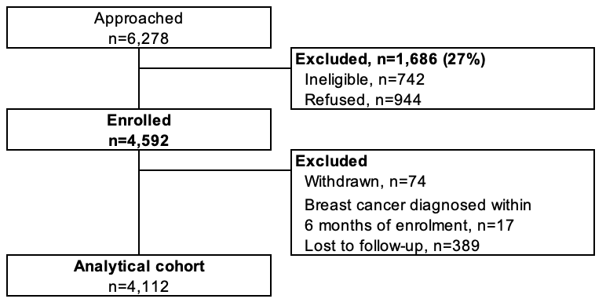

Supplementary Figure 2. Changes in perceived risk (enrolment and during follow-up) by predicted risk (facet label: below average, average, above average) and age group.
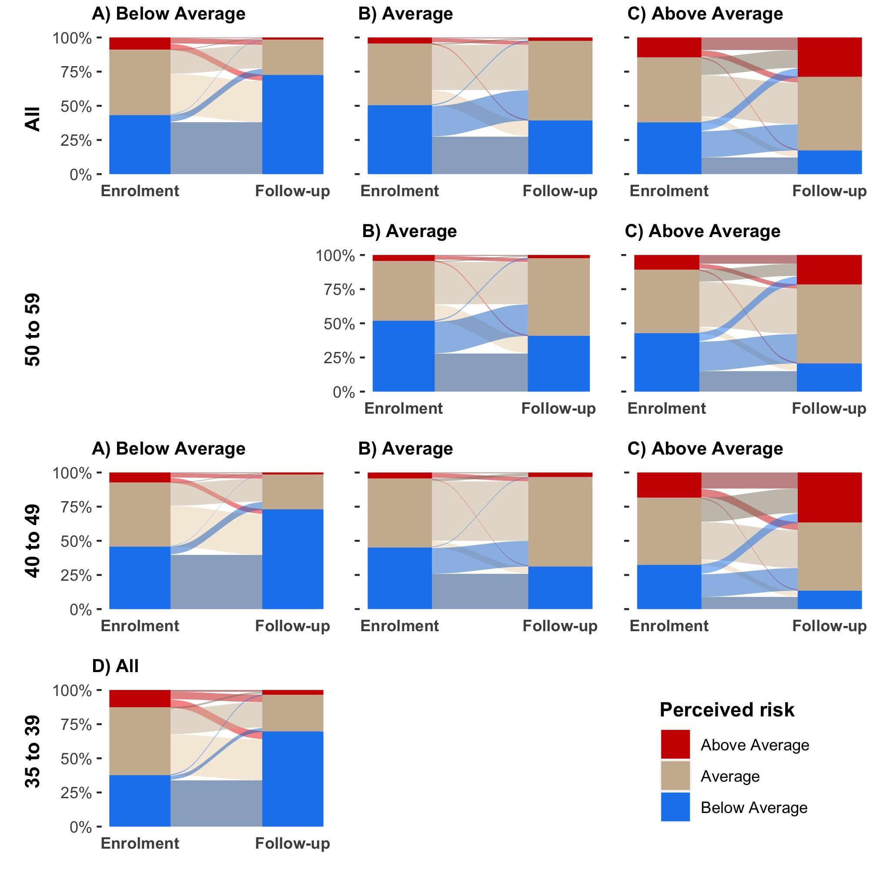

Supplementary Figure 3. Hypothetical scenarios using the best fit model for each age group. The ordinal model to predict the woman's perceived risk after risk assessment (y-axis) included perceived risk at enrolment (panel) predicted risk (x-axis), ethnicity, and menopausal status.
- Age 35 to 39
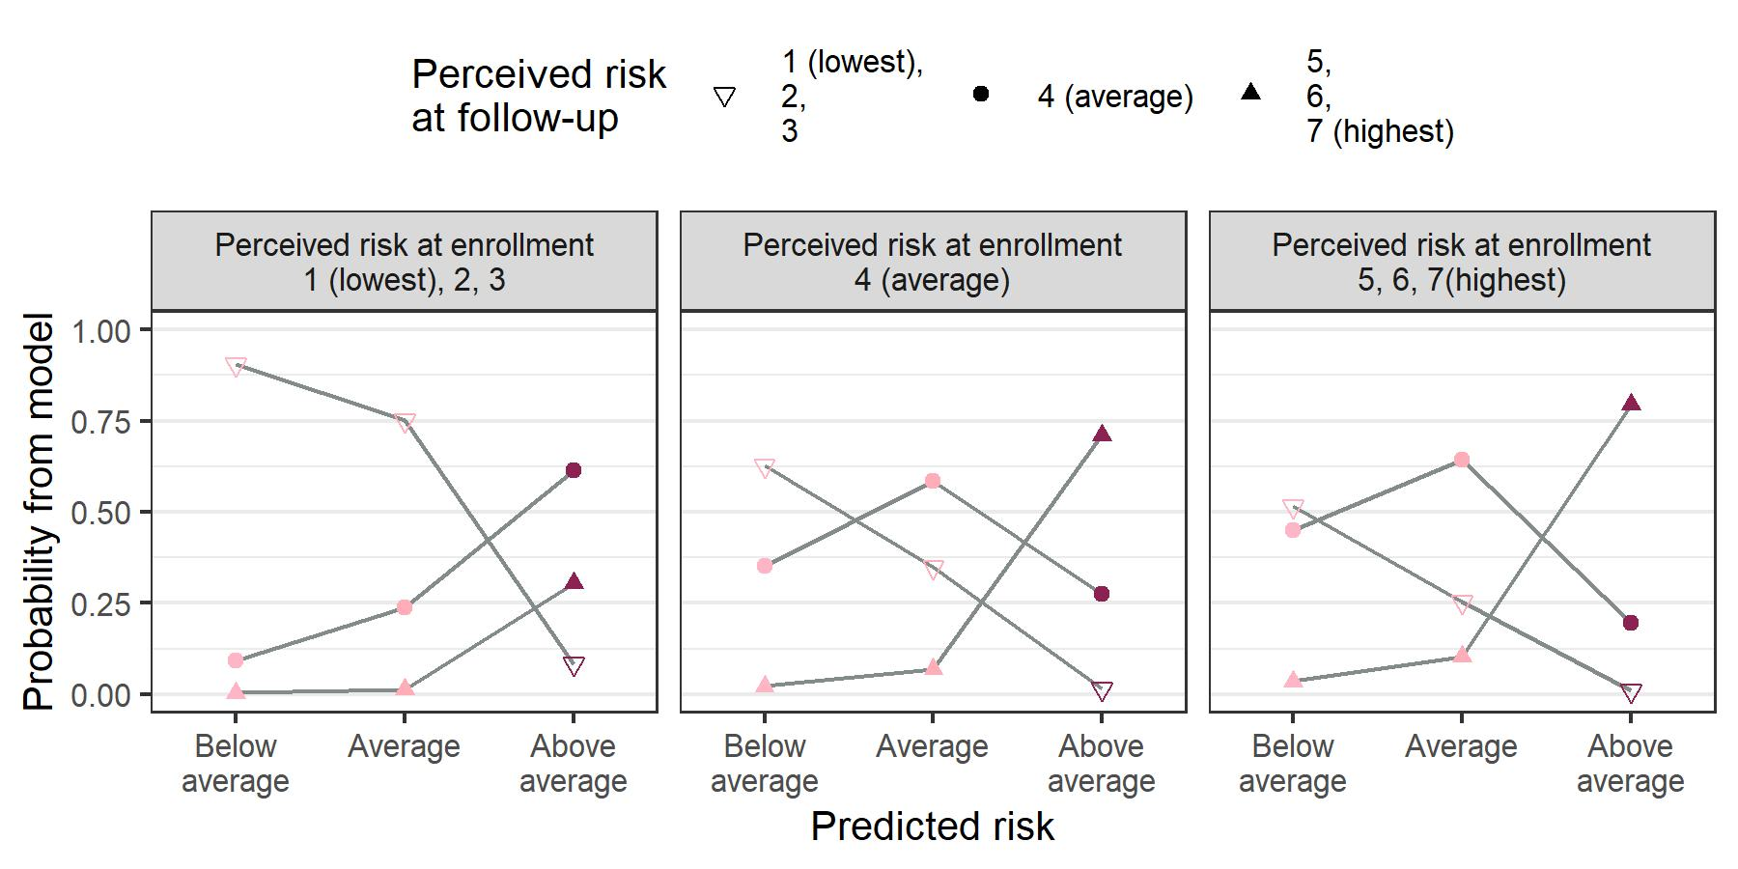
- Age 40 to 49
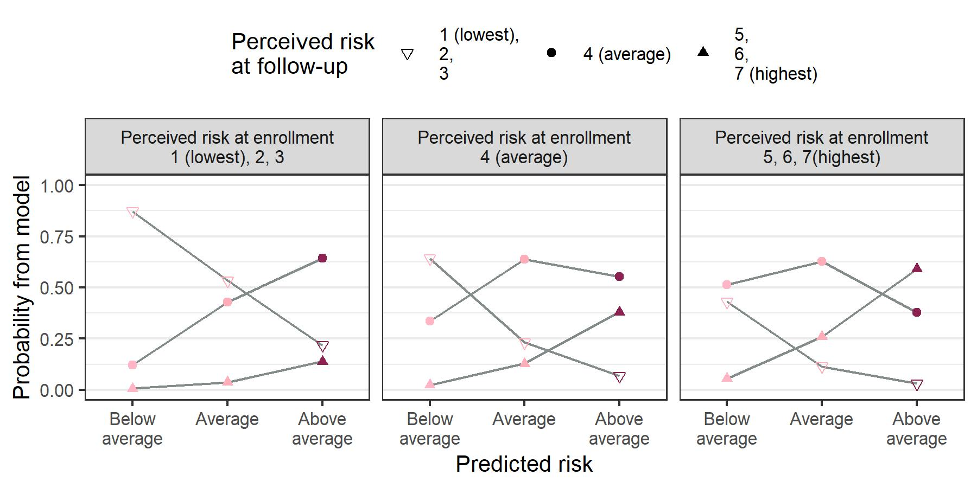
- Age 50 to 59, Chinese pre-menopausal woman
