Supporting Information
Molecular Mechanism of Staphylococcus xylosus Resistance against
Tylosin and Florfenicol
Xin Liu^{1, 2, #}, Shu Li^{3, #}, Wenqiang Cui³, Yonghui Zhou², Mo Chen¹, Qianwei Qu¹, Ruixiang Che⁴, Lu Li⁵, Horst Vogel^{3, 6*}, Shuguang Yuan^{3, *}, Yanhua Li^{1, *}
1 College of Veterinary Medicine, Northeast Agricultural University, Harbin, Heilongjiang 150030, China
2 College of Basic Medicine, Guiyang University of Chinese Medicine, Guiyang, Guizhou 550025, China
3 The Research Center for Computer-aided Drug Discovery, Shenzhen Institutes of Advanced Technology, Chinese Academy of Sciences, Shenzhen 518055, China
4 College of Animal Science and Veterinary Medicine, Heilongjiang Bayi Agricultural University, Daqing 163319, China
5 College of Life Sciences, Northeast Agricultural University, Harbin, Heilongjiang 150030, China
6 Institute of Chemical Science and Engineering (ISIC), Ecole Polytechnique Fédérale de Lausanne (EPFL), Lausanne, Switzerland.
# These authors contributed equally to this work.
* Corresponding authors:
Email: horst.vogel@epfl.ch (Horst Vogel), shuguang.yuan@siat.ac.cn (Shuguang Yuan), liyanhua@neau.edu.cn (Yanhua Li).

mutations

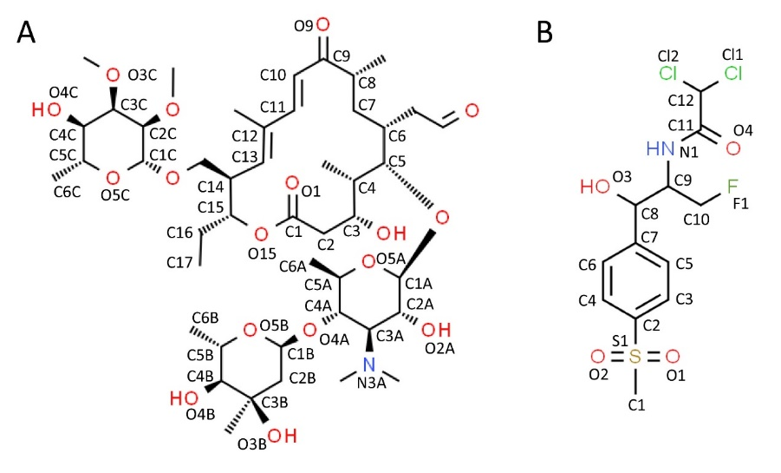
Figure S1. Chemical structures of the tylosin (A) and florfenicol (B).

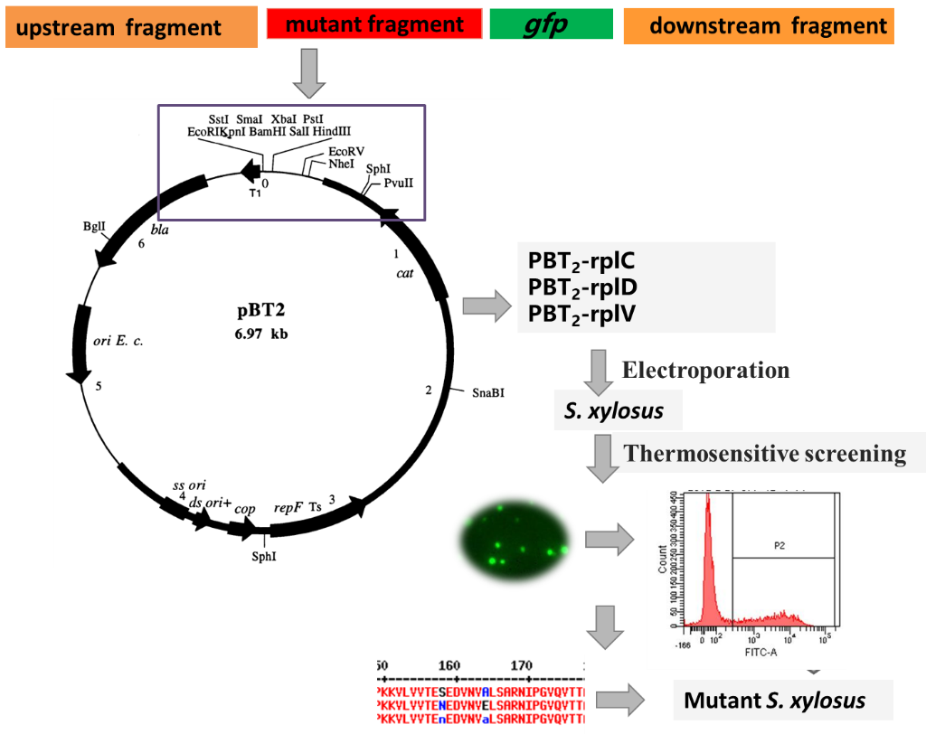
Figure S2. The construction of mutant strains.

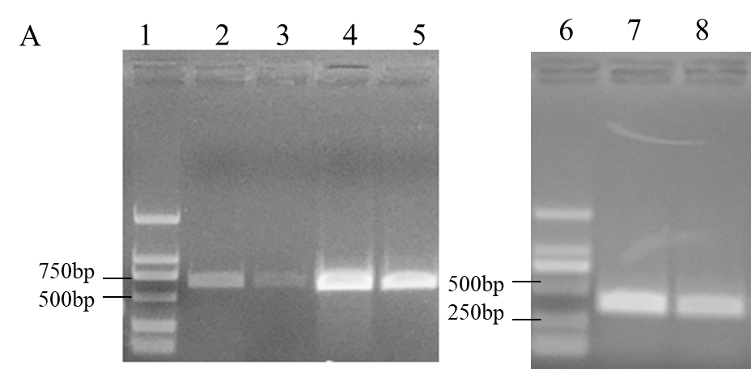
Figure S3. PCR amplification results of rplC, rplD, rplV and 23S rRNA in S. xylosus and R-tylosin S. xylosus. In figure, 1 stands for DL200 DNA maker, 2 stands for PCR amplification results of rplC in S. xylosus, 3 stands for PCR amplification results of rplC in R-Tylosin S. xylosus, 4 stands for PCR amplification results of rplD in S. xylosus, 5 stands for PCR amplification results of rplC in R-Tylosin S. xylosus, 6 stands for DL200 DNA maker, 7 stands for PCR amplification results of rplV in S. xylosus, 8 stands for PCR amplification results of rplV in R-Tylosin S. xylosus.

4A
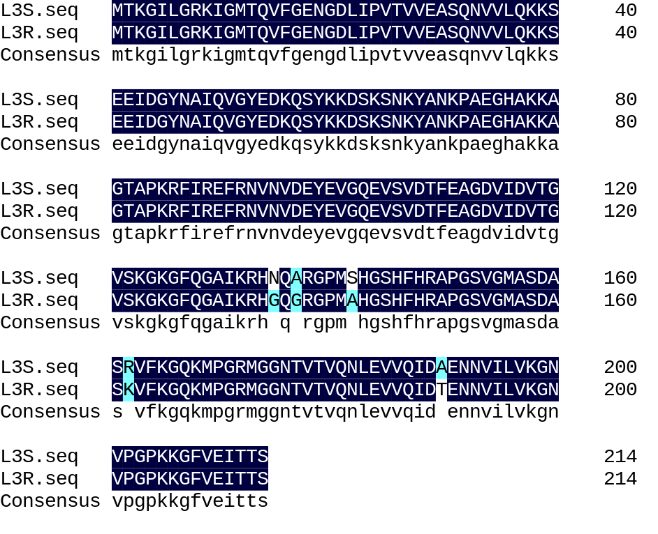
4B
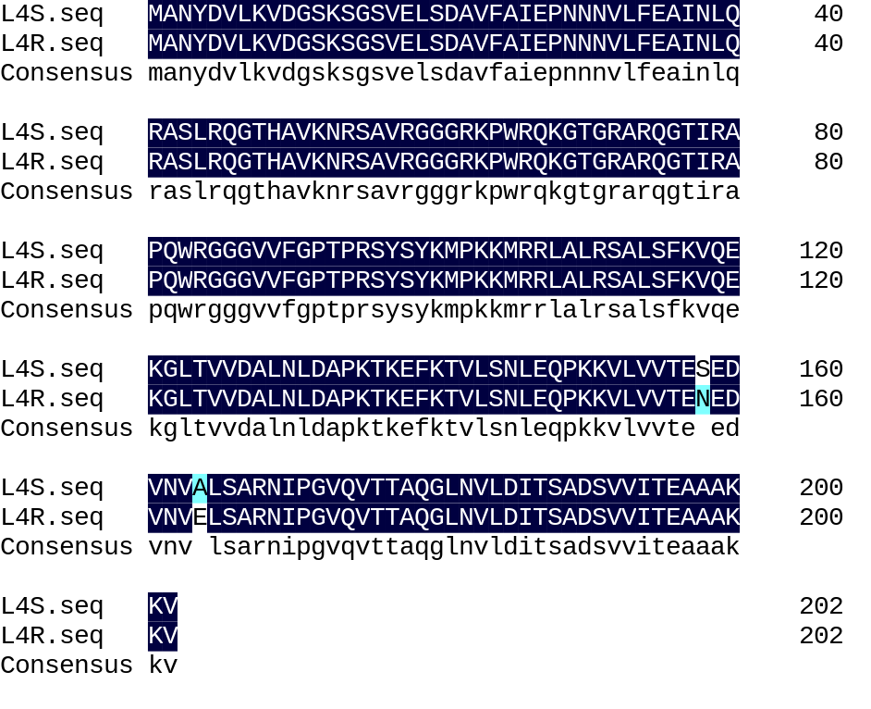
4C
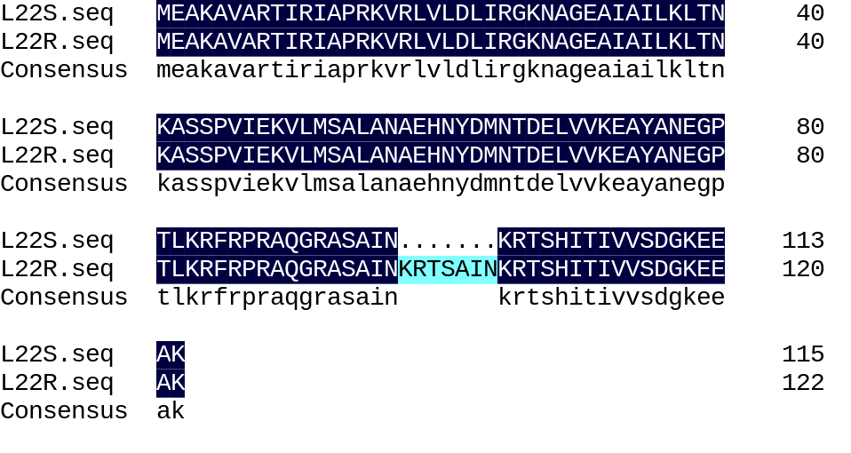
Figure S4. Mutations of ribosomal proteins L3, L4 and L22 in S. xylosus and R-tylosin S. xylosus. Sequencing and blast were used to explore the mutations of ribosomal proteins L3, L4 and L22 in S. xylosus and R-tylosin S. xylosus. (A) Amino acid sequence comparison of ribosomal protein L3 in S. xylosus and R-tylosin S. xylosus. (B) Amino acid sequence comparison of ribosomal protein L4 in S. xylosu sand R-tylosin S. xylosus. (C) Amino acid sequence comparison of ribosomal protein L22 in S. xylosus and R-tylosin S. xylosus.

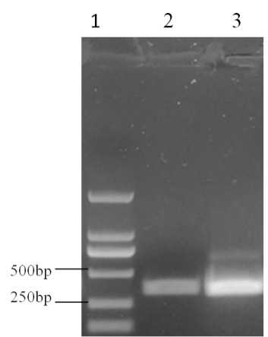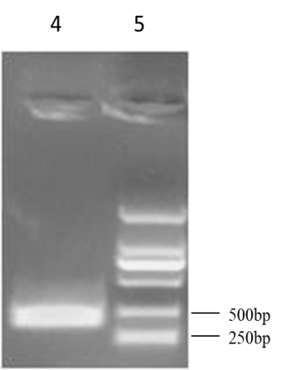
Figure S5. PCR identification f S. xylosus L3 (rplC) mutant strain, S. xylosus L4 (rplD) mutant strain and S. xylosus L22 (rplV) mutant strain. 1 stands for DL2000 DNA marker; 2 stands for rplC mutant fragment; 3 stands for rplD mutant fragment;4 stands for rplV mutant fragment; 5 stands for DL2000 DNA marker.

6A
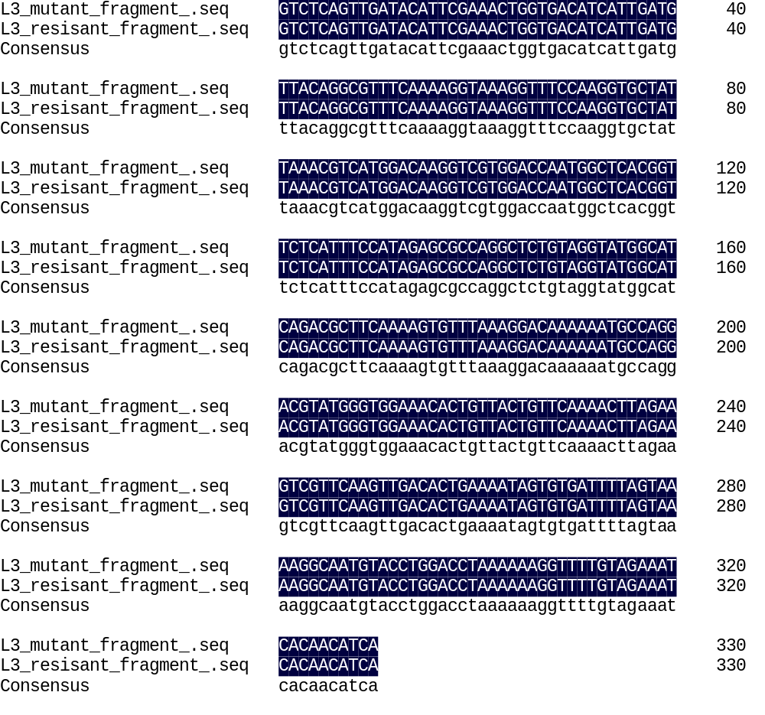
6B
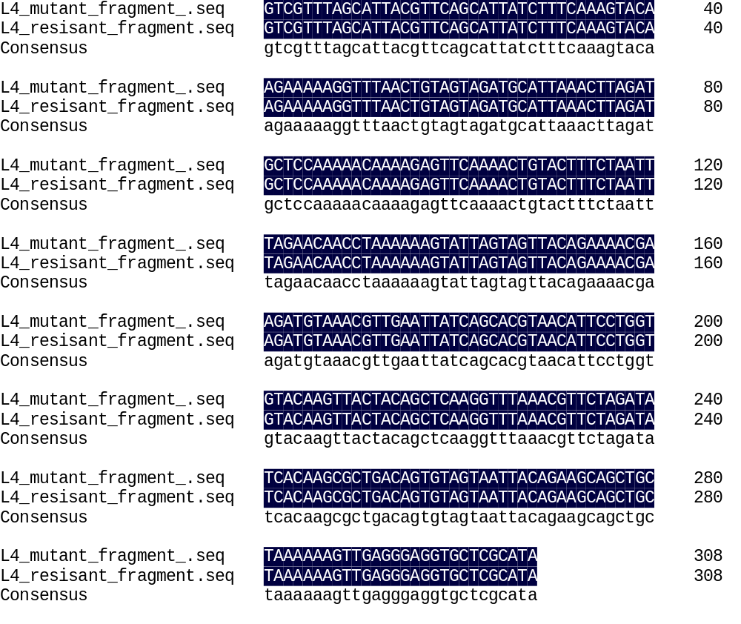
6C
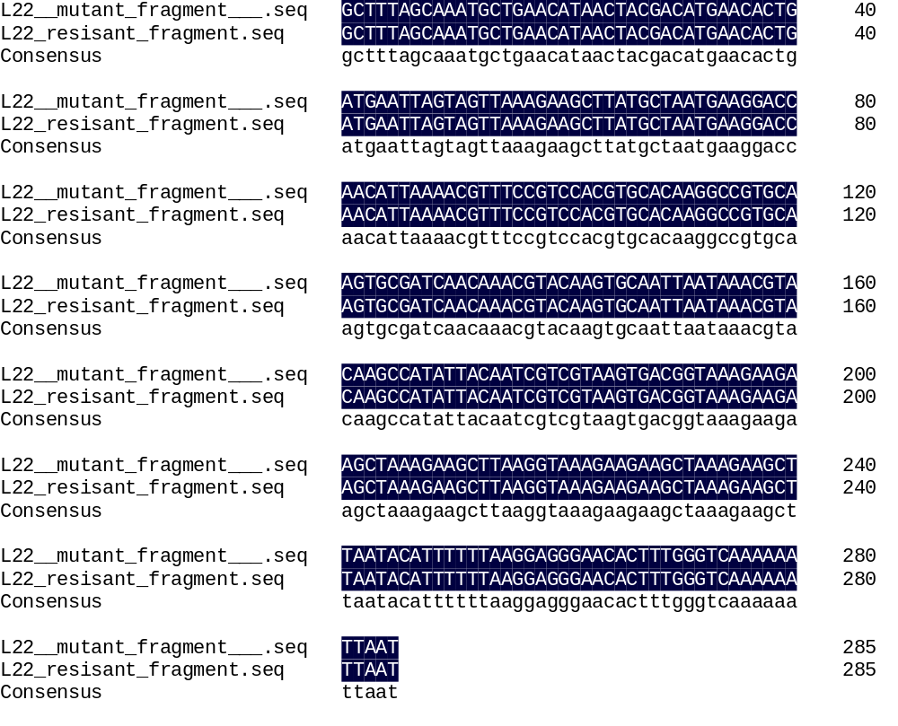
Figure S6. Comparison of sequencing results of mutant fragments in S. xylosus and Tylosin-resistant S. xylosus. (A) Comparison of sequencing results of mutant ribosomal protein L3 fragment. (B) Comparison of sequencing results of mutant ribosomal protein L4 fragment. (C) Comparison of sequencing results of mutant ribosomal protein L22 fragment.

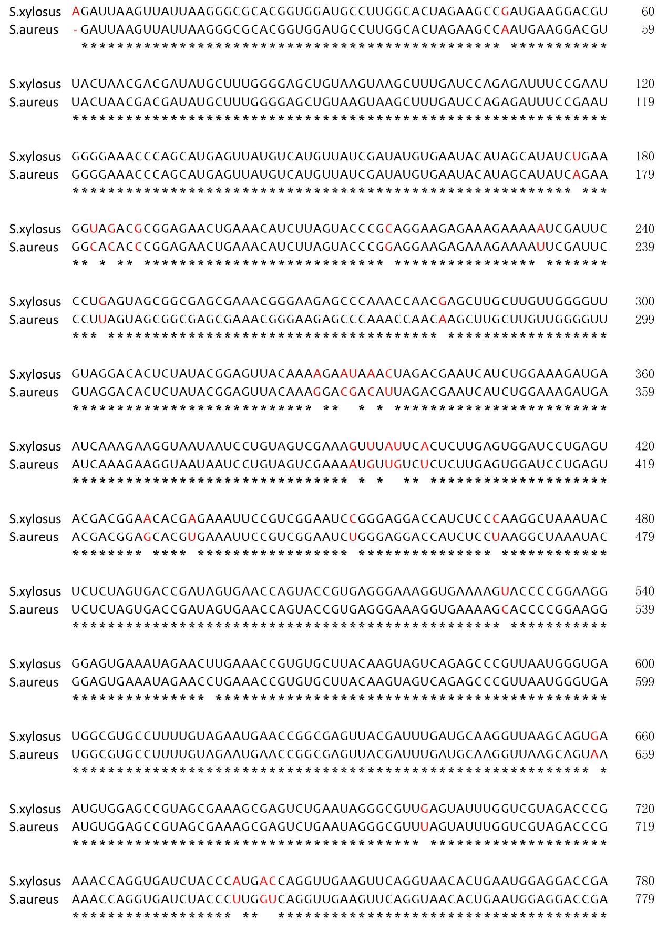
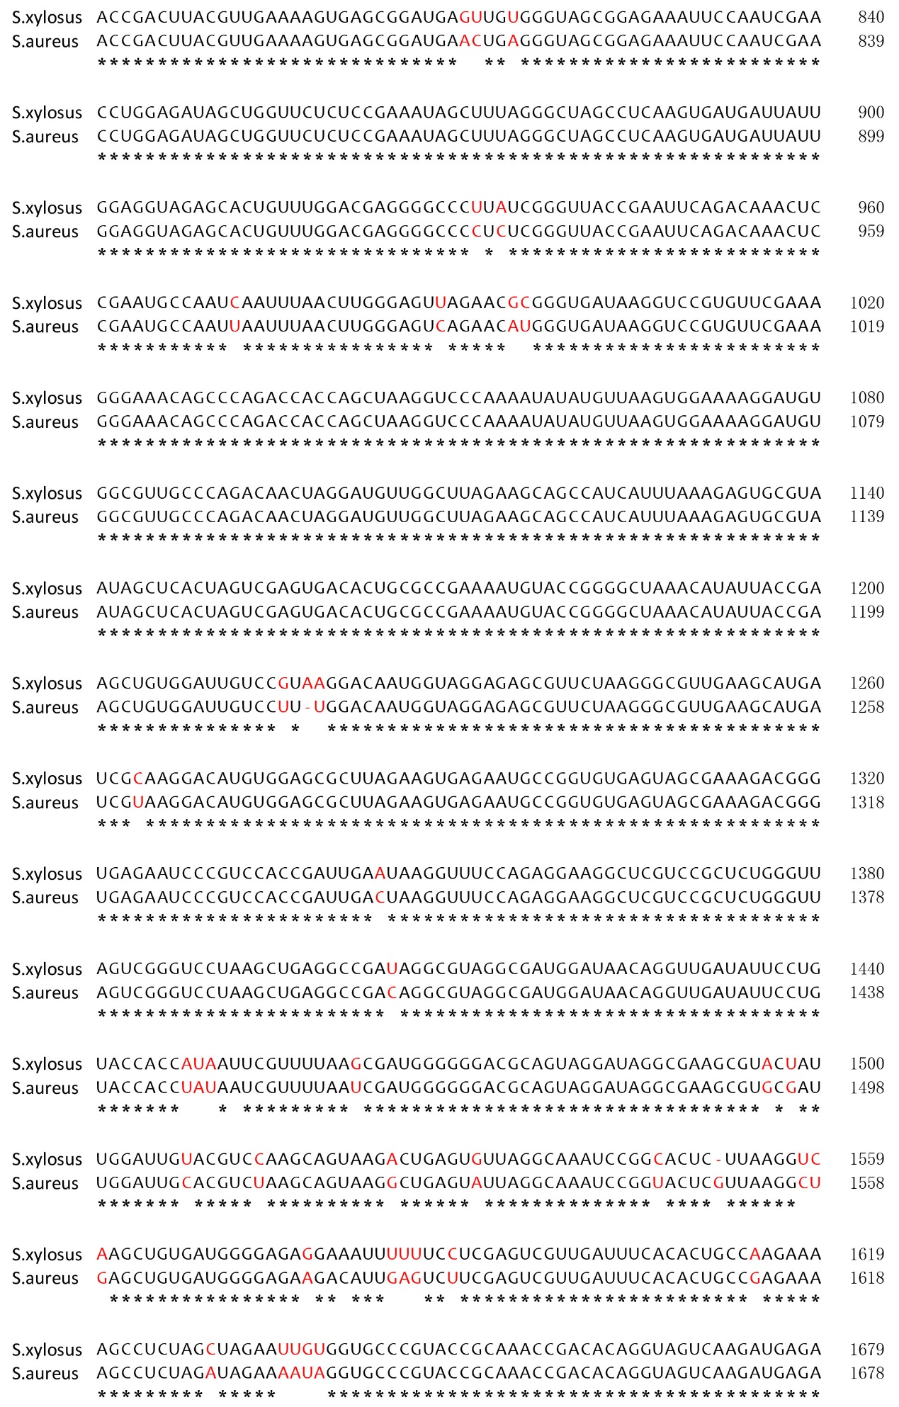
Figure S7. Continue
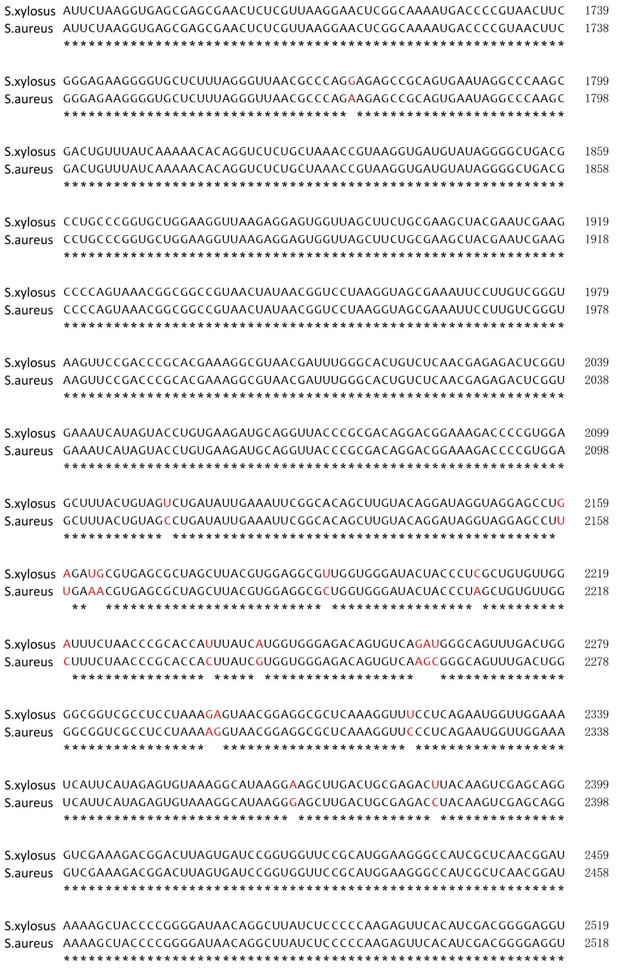
Figure S7. Continue

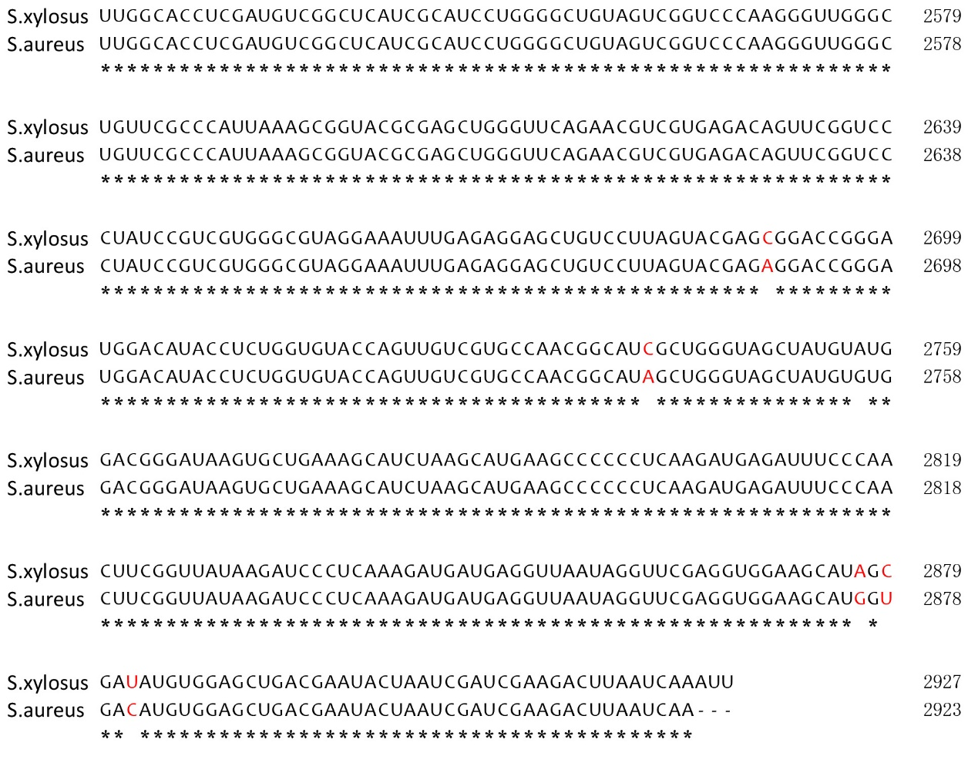
Figure S7. The sequence alignment of 23S rRNA between S. xylosus and S. aureus. The different bases were shown in red.

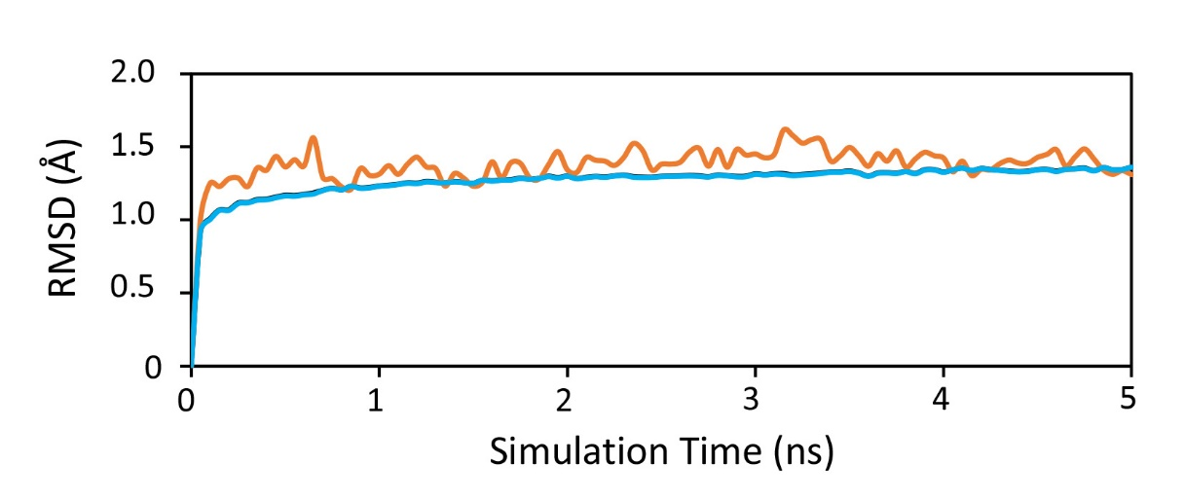
Figure S8. RMSD of 23S rRNA (cyan) and L22 (orange) along 5 ns MD simulation.

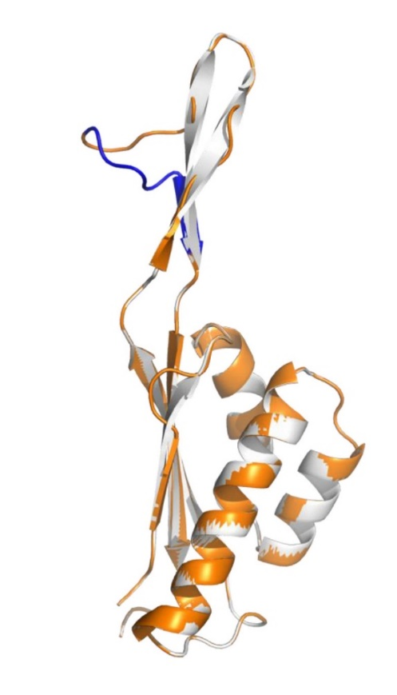
Figure S9. Structural difference in L22 (white) and L22 97KRTSAIN98 insertion mutant (orange). The segment of 97KRTSAIN98 insertion is shown in blue.

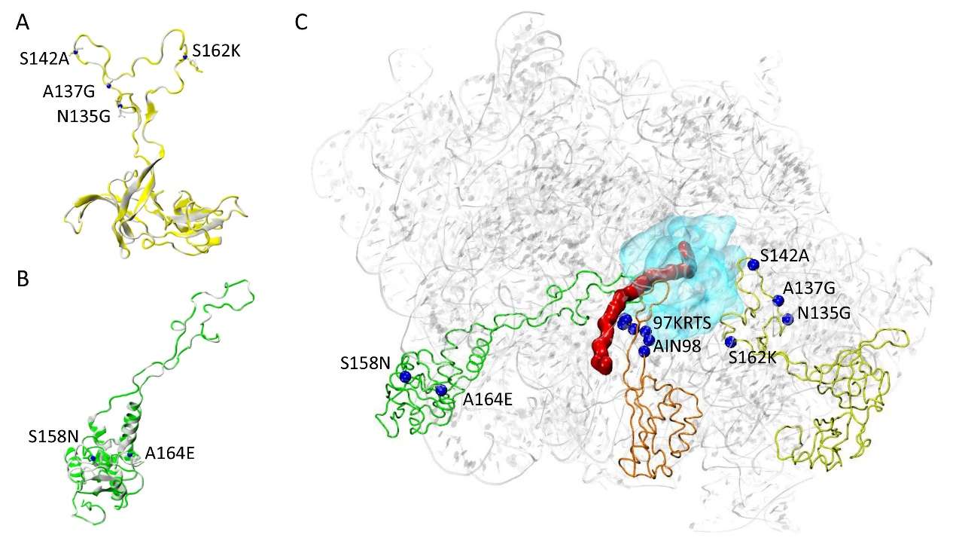
Figure S10. The role of mutations in L3 and L4. (A) Structural difference in L3 (white) and L3 mutant (N135G, A137G, S142A and R162K) (yellow). (B) Structural difference in L4 (white) and L4 mutant (S158N and A164E) (green). (C) The structure of ribosome is composed with the 23S rRNA and the homology models of L3 mutant, L4 mutant and L22 mutant. The 23S rRNA is shown in gray, the antibiotic binding site is shown in cyan, the mutant amino acids are marked in blue. The theoretical nascent polypeptide chain is shown in red.

Table S1 Plasmids used in our study
Name | function
gfp- T | Used to clone gfp gene
rplC- T | Used to clone rplC mutant fragment
rplD –T | Used to clone rplD mutant fragment
rplV –T | Used to clone rplV mutant fragment
23s rRNA-3-T | Used to clone 23s rRNA-3 mutant fragment
23s rRNA-4-T | Used to clone 23s rRNA-4 mutant fragment
23s rRNA-5-T | Used to clone 23s rRNA-5 mutant fragment
pClone007-rplC | Used to construct the shuttle plasmid PBT₂-rplC
pClone007-rplD | Used to construct the shuttle plasmid PBT₂-rplD
pClone007-rplV | Used to construct the shuttle plasmid PBT₂-rplV

Table S2 Strains used in our study
System | Strains
1 | S. xylosus
2 | Tylosin-resistant S. xylosus
3 | L3 (rplC) mutant s.xylosus (N135G、A137G、S142A and R162K)
4 | L4 (rplD) mutant s.xylosus (S158N and A164E)
5 | L22 (rplV) mutant s.xylosus (97KRTSAIN98 insertion)

Table S3 Primers of ribosomal genes
Oligonucleotide name | Sequence (5’ to 3’) a
rplC F | ATGACCAAAGGAATCTTAGGAAGAAAAA
rplC R | TTATTTATTACCTTTGATTGATGTTGTG
rplD F | ATGGCTAATTATGATGTATTAAAAGTAG
rplD R | TTATCCGAGCACCTCCTCAACTTTTTTA
rplV F | AAAGCGGTTGCTAAAACAATAAGAATCG
rplVR | GCTTCTTTAGCTTCTTCTTTACCGTCAC

Table S4 Primers of shuttle plasims
Oligonucleotide name | Sequence (5’ to 3’) a
rplC-1 F | TGCACTGCAGTGCA ACTAAAAGAGTAGTGCGAATTGCA
rplC-1 R | GTATCAACTGAGACTTCTTGACCTACTTCGTATTCATCAA
rplC-2 F | GTCTCAGTTGATACATTCGAAACTG
rplC-2 R | TTTACTCATTTATTTATTACCTTTGATTGATGTTGTGATT
rplC-3 F | AGGTAATAAATAAATGAGTAAAGGAGAAGAACTTTTCACT
rplC-3 F | CTTTCGTATTATATTATTTGTATAGTTCATCCATGCCATG
rplC-4 F | TATACAAATAATATAATACGAAAGGAGGAATTGCATAATG
rplC-4 R | TACGACGACCATTAGTAATTGGCCGCGGATCCGCG
rplD-1 F | TGCACTGCACTGCAAAATTAGGAGGTGGACTTTCGATG
rplD-1 R | TAATGCTAAACGACGCATTTTCTTAGGCATTTTGTATGAG
rplD-2 F | GTCGTTTAGCATTACGTTCAGC
rplD-2 R | AAGTTCTTCTCCTTTACTCATTTATGCGAGCACCTCCCTC
rplD-3 F | GGTGCTCGCATAAATGAGTAAAGGAGAAGAACTTTTCACT
rplD-3 R | TCTCTTGCTTCCATTATTTGTATAGTTCATCCATGCCATG
rplD-4 F | ATGAACTATACAAATAATGGAAGCAAGAGACGTTCTTAAG
rplD-4 R | GCGTAGGTTTACCCCAAGGTCGCGGATCCGCG
rplV-1 F | TGCACTGCAGTGCATTTATGCTGATGGTGAAAAACGC
rplV-1 R | TTTGCTAAAGCGGACATTAATAATTTTTCAACTACTGGTG
rplV-2 F | GCTTTAGCAAATGCTGAACATAACTA
Note: Primers including the indicated restriction site (underlined)

Table S5 Primers used for real-time PCR of drug resistant proteins
Oligonucleotide name | Sequence (5’ to 3’) a
rplW F | TGGAAGCAAGAGACGTTCTTAAGCG
rplW R | TAGCACGAGTATCAACGTCGAATGTG
infB F | AGCAGGTGGTATTACACAGCATATCG
infB R | GCGTGGCCTGGCGTATCAAG
ldh F | GAACCACGCTGCACCTTATGG
ldh R | GCGCCAGCAGTAATTACAACTATGTC
aldA-1 F | GTGACCGCAGGCATCGTTCC
aldA-1 R | CTGCTGGTATTGTTGACTCACGAATG
katA F | GAGAGGTGATTCCAGAACGACGTATG
katA R | ATCCACGAATATCACGCTCTGCATC
trxA F | CAACTTGGTGTGGCCCTTGT
trxA R | ACAACTTTATCTACTGGTTCGCCA
gros F | AGAGCAAACAACAAAGAGCGG
gros R | GCCCTGCACCTACTGCAATTA
cl F | GGCAGCGTTAATCGTGGTGA
cl R | CTAGCACACTGACTGCGACG
16S rRNA F | CGGGCAATTTGTTTAGCA
16S rRNA R | ATTAGGTGGAGCAGGTCA

