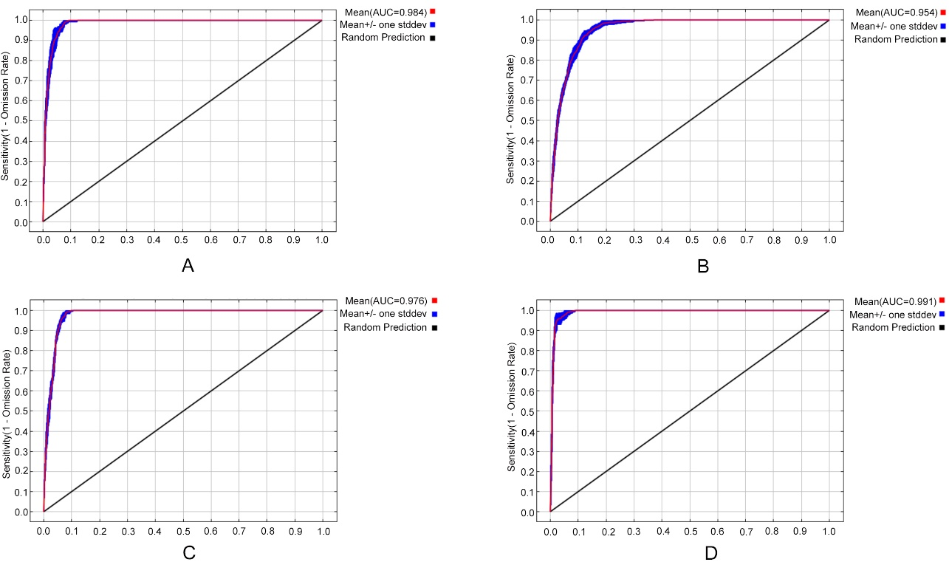
Fig. S1 AUC curve of ecological distribution
Table S1 The variable importance of key environmental factors of Prunus armeniaca L.var.ansu Maxim.
Variable | Percent contribution (%) |  | Permutation importance (%)
Bio 12 |  | 45.1 |  | 33.3
Bio 14 |  | 19.7 |  | 15.9
Bio 6 |  | 16.5 |  | 24.2
Bio 10 |  | 9.3 |  | 1.3
Bio 5 |  | 5.2 |  | 16.1
Bio 3 |  | 2.6 |  | 3
Bio 2 |  | 1.6 |  | 6.2
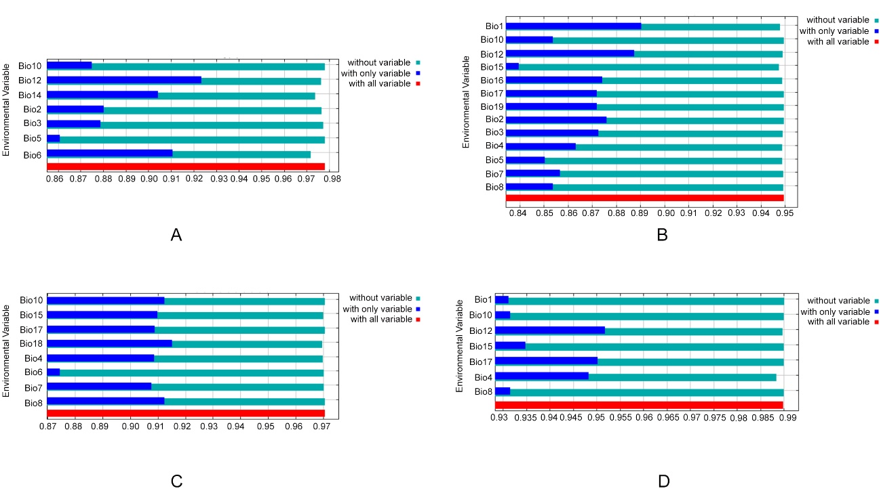
Fig. S2 Jackknife results of habitat distribution prediction
Table S2 The variable importance of key environmental factors of Prunus armeniaca L.
Variable | Percent contribution (%) |  | Permutation importance (%)
Bio 17 |  | 35.6 |  | 6
Bio 5 |  | 20.1 |  | 16.2
Bio 10 |  | 13.7 |  | 6.8
Bio 1 |  | 11.6 |  | 28.7
Bio 4 |  | 5.7 |  | 10.1
Bio 12 |  | 5 |  | 4
Bio 7 |  | 3.4 |  | 0.6
Bio 15 |  | 2 |  | 6.1
Bio 19 |  | 0.9 |  | 1.3
Bio 3 |  | 0.7 |  | 5.1
Bio 2 |  | 0.7 |  | 2.8
Bio 16 |  | 0.4 |  | 7.5
Bio 8 |  | 0.3 |  | 4.9
Table S3 The variable importance of key environmental factors of Prunus sibirica L.
Variable | Percent contribution (%) |  | Permutation importance (%)
Bio 18 |  | 36.9 |  | 19.4
Bio 4 |  | 36.1 |  | 7.7
Bio 15 |  | 13.2 |  | 35.5
Bio 10 |  | 6.4 |  | 14.3
Bio 6 |  | 4.8 |  | 7.1
Bio 17 |  | 1.2 |  | 6.2
Bio 7 |  | 0.8 |  | 5.7
Bio 8 |  | 0.6 |  | 4.2
Table S4 The variable importance of key environmental factors of Prunus mandshurica (Maxim.) Koehne.
Variable | Percent contribution (%) |  | Permutation importance (%)
Bio 4 |  | 43.2 |  | 3.9
Bio 12 |  | 27.6 |  | 4.3
Bio 17 |  | 17.8 |  | 11.8
Bio 1 |  | 8.3 |  | 43.1
Bio 10 |  | 1.6 |  | 23.7
Bio 15 |  | 1.4 |  | 5.7
Bio 8 |  | 0.3 |  | 7.6
Table S5 Areas of suitable habitat for Prunus armeniaca L. var. ansu Maxim. based on current and future climate conditions.
Prunus armeniaca L. var. ansu Maxim. | Highly suitable area/×10⁶ km² |  | Moderately suitable area/×10⁶ km² |  | Poorly suitable area/×10⁶ km² |  | Suitable area  /×10⁶ km²
Current |  | 0.209 |  | 0.456 |  | 0.525 |  | 1.190
RCP2.6-2050s |  | 0.180 |  | 0.470 |  | 0.577 |  | 1.227
RCP2.6-2070s |  | 0.207 |  | 0.490 |  | 0.534 |  | 1.231
RCP4.5-2050s |  | 0.133 |  | 0.461 |  | 0.570 |  | 1.164
RCP4.5-2070s |  | 0.166 |  | 0.408 |  | 0.526 |  | 1.100
RCP8.5-2050s |  | 0.182 |  | 0.481 |  | 0.572 |  | 1.235
RCP8.5-2070s |  | 0.218 |  | 0.449 |  | 0.511 |  | 1.178
Table S6 Areas of suitable habitat for Prunus armeniaca L. based on current and future climate conditions.
Prunus armeniaca L. | Highly suitable area/×10⁶ km² |  | Moderately suitable area/×10⁶ km² |  | Poorly suitable area/×10⁶ km² |  | Suitable area  /×10⁶ km²
Current |  | 0.446 |  | 0.9276 |  | 1.408 |  | 2.7816
RCP2.6-2050s |  | 0.4045 |  | 0.7613 |  | 1.283 |  | 2.4488
RCP2.6-2070s |  | 0.413 |  | 0.747 |  | 1.3508 |  | 2.5108
RCP4.5-2050s |  | 0.425 |  | 0.717 |  | 1.306 |  | 2.448
RCP4.5-2070s |  | 0.4123 |  | 0.772 |  | 1.4138 |  | 2.5981
RCP8.5-2050s |  | 0.404 |  | 0.761 |  | 1.283 |  | 2.448
RCP8.5-2070s |  | 0.3943 |  | 0.7964 |  | 1.3317 |  | 2.5224
Table S7 Areas of suitable habitat for Prunus sibirica L. based on current and future climate conditions.
Prunus sibirica L. | Highly suitable area/×10⁶ km² |  | Moderately suitable area/×10⁶ km² |  | Poorly suitable area/×10⁶ km² |  | Suitable area  /×10⁶ km²
Current |  | 0.138 |  | 0.670 |  | 0.890 |  | 1.698
RCP2.6-2050s |  | 0.185 |  | 0.627 |  | 0.771 |  | 1.583
RCP2.6-2070s |  | 0.197 |  | 0.539 |  | 0.683 |  | 1.419
RCP4.5-2050s |  | 0.186 |  | 0.650 |  | 0.745 |  | 1.581
RCP4.5-2070s |  | 0.197 |  | 0.552 |  | 0.815 |  | 1.564
RCP8.5-2050s |  | 0.192 |  | 0.574 |  | 0.770 |  | 1.536
RCP8.5-2070s |  | 0.243 |  | 0.591 |  | 0.876 |  | 1.710
Table S8 Areas of suitable habitat for Prunus mandshurica (Maxim.) Koehne based on current and future climate conditions.
Prunus mandshurica (Maxim.) Koehne | Highly suitable area/×10⁶ km² |  | Moderately suitable area/×10⁶ km² |  | Poorly suitable area/×10⁶ km² |  | Suitable area  /×10⁶ km²
Current |  | 0.109 |  | 0.167 |  | 0.152 |  | 0.428
RCP2.6-2050s |  | 0.118 |  | 0.170 |  | 0.171 |  | 0.459
RCP2.6-2070s |  | 0.099 |  | 0.182 |  | 0.185 |  | 0.466
RCP4.5-2050s |  | 0.118 |  | 0.177 |  | 0.170 |  | 0.465
RCP4.5-2070s |  | 0.113 |  | 0.185 |  | 0.155 |  | 0.453
RCP8.5-2050s |  | 0.120 |  | 0.173 |  | 0.160 |  | 0.453
RCP8.5-2070s |  | 0.136 |  | 0.162 |  | 0.156 |  | 0.454
Fig. S3 The regression model linking amygdalin content to environmental factors
