Effect of an Early Lactate Measurement on In-hospital Mortality among Adults with Hypotension and Hyperlactatemia: an observational study on two cohorts

Additional Methods
Data extraction
Data was extracted from the MIMIC and eICU using structured query language (SQL). Baseline characteristics within the first 24 h after ICU admission were collected: age, gender, weight, ICU type, source of admission, time of ICU admission, admission type, ethnicity, severity at admission measured by Sequential Organ Failure Assessment (SOFA) score, Overall Anxiety Severity and Impairment Scale (OASIS) score and Prognostic Score (Simplified Acute Physiology Score II (SAPS II) in MIMIC and Acute Physiology and Chronic Health Evaluation (APACHE) IV in eICU), comorbidity score (using Elixhauser comorbidity score in MIMIC), use of mechanical ventilation, use of renal replacement therapy (RRT), and administration of vasopressors. Vital signs including mean arterial pressure (MAP), heart rate, temperature (°C) and respiratory rate were also extracted. Laboratory variables of white blood cell (WBC) count, hemoglobin, platelet count, lactate, pH, partial pressure of oxygen (PO₂), partial pressure of carbon dioxide (PCO₂) and PaO₂/FiO₂ were measured during the first 24 h of ICU stay. If a variable was recorded more than once in the first 24 h, we used the value related to the greatest severity of illness.
Admission diagnoses based on the recorded ICD-9 codes for the MIMIC and APACHE IV diagnosis system for the eICU were documented. Comorbidities including congestive heart failure (CHF), chronic renal disease, liver disease, chronic obstructive pulmonary disease (COPD), stroke, and malignant tumor were also collected for analysis.
Statistical analysis
Multivariate regression was selected to characterize the relationship between timely lactate measurement and in-hospital mortality. Baseline variables that were considered clinically relevant or that showed a univariate relationship with the outcome (p < 0.10) were entered into a multivariate logistic regression model as covariates, including age, gender, weight, admission period, severity scores, ICU type, use of mechanical ventilation, use of RRT, use of vasopressors, comorbidities, MAP, vital signs and initial lactate level, time of ICU admission.
PSM and IPTW were also used for adjusting the covariates to ensure the robustness of our findings. PSM is employed to solve the problem of imbalance of covariates between groups. A multivariate logistic regression model was used to estimate the patient’s propensity scores for timely lactate measurement in our study. Using the estimated propensity scores as weights, a logistic regression was performed on the weighted cohort which generated through the IPTW model. The standardized mean differences (SMDs) were calculated to evaluate the effectiveness of the PSM and IPTW.
CMA is a method for separating the total effect of a treatment into direct and indirect effects. The indirect effect on the outcome is mediated via a mediator. The analysis reports consist of the average causal mediation effect (ACME), average direct effect (ADE), and total effect. In our study, we used the timely lactate measurement as the treatment and the interventions mentioned above as mediator variables.

Table S1: Additional baseline characteristics of the included patients in two cohorts
 | MIMIC-III  (n=4257) | eICU  (n=5721)
Source of admission, n (%)
Ward or step-down unit | 647/4257 (15.2) | 908/5721 (15.9)
Office or operating room | 897/4257 (21.1) | 673/5721 (11.8)
Emergency | 1800/4257 (42.3) | 3015/5721 (52.7)
Transferred from other hospital | 908/4257 (21.3) | 1102/5721 (19.2)
Other | 5/4257 (0.1) | 23/5721 (0.4)
Ethnicity, n (%)
Blacks | 288/4257 (6.8) | 731/5721 (12.8)
Hispanic | 153/4257 (3.6) | 174/5721 (3)
White | 2997/4257 (70.4) | 4382/5721 (76.6)
Other | 819/4257 (19.2) | 434/5721 (7.6)
Initial diagnosis, n (%)
Sepsis | 2107/4257 (49.5) | 1890/5721 (33)
Cardiovascular disease | 890/4257 (20.9) | 944/5721 (16.5)
Other respiratory condition | 289/4257 (6.8) | 961/5721 (16.8)
Renal condition | 76/4257 (1.8) | 81/5721 (1.4)
Trauma | 142/4257 (3.3) | 337/5721 (5.9)
Others | 753/4257 (17.7) | 1508/5721 (26.4)
Laboratory values
Maximum WBC (*10⁹/L) | 15.3 (11.2-20.7) | 16.6(11.5-23.1)
Minimum Hemoglobin (g/dl) | 9.1 (7.7-10.7) | 10.1(8.2-11.9)
Minimum Platelet (*10⁹/L) | 149 (100-212) | 150 (95-212)
Minimum pH | 7.37(7.32-7.4) | 7.25 (7.15-7.34)
Minimum PaO2 (mmHg) | 74.3(60.1-102.3) | 65 (52.4-82)
Maximum PaCO2 (mmHg) | 38.8(35-42.5) | 30(26-35)
Minimum PaO2/FiO2 (mmHg) | 121.2(80.5-301.9) | 131(75-216)
Time from hospital admission to ICU admission (h) | 0.07(0.02-11.1) | 3.43 (0.98-10.15)
WBC: White Blood Cell;
Table S2: Characteristics of the hospitals included in the two databases
 | MIMIC | eICU | eICU
 | Number of Hospitals  (n = 1) | Number of Hospitals  (n = 171) | Number of Patients  (n = 5721)
Hospital size
< 100 beds | 0 / 1 (0%) | 34/146 (23.3%) | 181/5254 (3.4%)
100 – 249 beds | 0 / 1 (0%) | 56/146 (38.4%) | 840/5254 (16%)
250 – 499 beds | 0 / 1 (0%) | 33/146 (22.6%) | 1457/5254 (27.8%)
≥ 500 beds | 1 / 1 (100%) | 23/146 (17.7%) | 2776/5254 (52.8%)
Teaching hospital | 1 / 1 (100%) | 18/171 (10.5%) | 2191/5721 (38.3%)
Hospital region
Midwest | 0 / 1 (0.0) | 58/154 (37.7%) | 1733/5411 (32%)
Northeast | 0 / 1 (0.0) | 12/154 (7.8%) | 674/5411/5411 (12.5%)
South | 1 / 1 (100.0) | 47/154 (30.5%) | 1870/5411 (34.5%)
West | 0 / 1 (0.0) | 37/154 (24%) | 1134/5411 (21%)
North | 0 / 1 (0.0) | 0/154 (0%) | 0/5411 (%)

Table S3: Demographic data and comparisons between the original cohort and matched cohort in MIMIC
Covariate | Original cohort |  |  | Matched cohort
Covariate | Lacby1 | No Lacby1 | SMD | Lacby1 | No Lacby1 | SMD
N | 1189 | 3068 |  | 1187 | 1187
Age | 68 (54-78) | 68 (56-79) | 0.057 | 68 (54-78) | 67 (55-78) | 0.045
Male | 699 (58.8%) | 1712 (55.8%) | 0.052 | 697 (58.7%) | 702 (59.1%) | 0.009
Weight (kg) | 79.8 (67.5-92.9) | 78.6 (66-93) | 0.040 | 79.8 (67.4-92.9) | 80 (67.4-95) | 0.035
Service unit (MICU %) | 314 (26.4%) | 943 (30.7%) | 0.115 | 312 (26.2%) | 331 (27.9%) | 0.036
Admission period, n (%) |  |  | 0.076 |  |  | 0.029
Before 2008 | 665 (55.9%) | 1753 (57.1%) |  | 664 (55.8%) | 665 (56%)
2008-2012 | 524 (44.1%) | 1315 (42.9%) |  | 523 (44.2%) | 522 (44%)
Severity of illness
SOFA score | 7 (5-9) | 6 (4-9) | 0.135 | 7 (5-9) | 7 (4-10) | 0.015
SAPS II score | 44 (35-55) | 44 (34-54) | 0.077 | 43 (35-55) | 44 (34-54) | 0.023
OASIS score | 37 (32-43) | 37 (32-43) | 0.076 | 37 (32-43) | 37 (32-43) | 0.018
Elixhauser comorbidity score | 5 (0-11) | 5 (0-11) | 0.005 | 5 (0-11) | 5 (0-11) | 0.037
Mechanical ventilation (1st 24 h) | 1018 (85.6%) | 2350 (76.6%) | 0.232 | 1016 (85.6%) | 998 (84.1%) | 0.042
Vasopressor (1st 24 h) | 796 (66.9%) | 1902 (62%) | 0.103 | 795 (66.9%) | 804 (667.7%) | 0.016
Comorbidities, n (%)
CHF | 164 (13.8%) | 472 (15.4%) | 0.046 | 164 (13.8%) | 181 (15.2%) | 0.041
Chronic renal disease | 152 (12.8%) | 380 (12.4%) | 0.012 | 152 (12.8%) | 158 (13.3%) | 0.015
Liver disease | 97 (8.2%) | 270 (8.8%) | 0.022 | 96 (8.1%) | 104 (8.8%) | 0.024
COPD | 207 (17.4%) | 469 (15.3%) | 0.057 | 207 (17.4%) | 219 (18.4%) | 0.026
Stroke | 30 (2.5%) | 98 (3.2%) | 0.040 | 30 (2.5%) | 28 (2.4%) | 0.011
Malignancy | 54 (4.5%) | 135 (4.4%) | 0.007 | 54 (4.5%) | 58 (4.9%) | 0.016
Vital signs
Minimum MAP (mmHg) | 55 (48-60) | 54 (47-60) | 0.067 | 55 (48-60) | 55 (48-60) | 0.034
Maximum Heart rate (bpm) | 112 (97-126) | 108 (94-123) | 0.125 | 111 (97-126) | 110 (90-127) | 0.001
Maximum Temperature (℃) | 37.7 (37.2-38.3) | 37.7 (37.1-38.2) | 0.100 | 37.7 (37.2-38.3) | 37.7 (37.1-38.2) | 0.002
Maximum Respiratory rate (bpm) | 27 (24-32) | 28 (24-32) | 0.001 | 27 (24-32) | 28 (24-32) | 0.030
Initial lactate level (mmol/L) | 3.4 (2.6-5) | 3 (2.5-4.2) | 0.227 | 3.4 (2.6-4.9) | 3.3 (2.5-4.9) | 0.016
Time of ICU admission, n (%) |  |  | 0.074 |  |  | 0.036
0:00 - 8:00 | 520 (43.7%) | 1381 (45%) |  | 519 (43.7%) | 498 (42%)
8:00 -16:00 | 408 (34.3%) | 1082 (35.3%) |  | 407 (34.3%) | 418 (35.2%)
16:00 -24:00 | 261 (22%) | 605 (19.7%) |  | 261 (22%) | 271 (22.8%)
MICU: Medical Intensive Care Unit; SOFA: Sequential Organ Failure Assessment; SAPS II: Simplified Acute Physiology Score II; OASIS: Overall Anxiety Severity and Impairment Scale; CHF: Congestive Heart Failure; COPD: Chronic Obstructive Pulmonary Disease; MAP: Mean Arterial Pressure; ICU: Intensive Care Unit.

Table S4: Demographic data and comparisons between the original cohort and matched cohort in eICU
Covariate | Original cohort |  |  | Matched cohort
Covariate | Lacby1 | No Lacby1 | SMD | Lacby1 | No Lacby1 | SMD
N | 1650 | 4071 |  | 1642 | 1642
Age | 63 (53-74) | 65 (54-76) | 0.112 | 64 (52-74) | 63 (53-74) | 0.001
Male | 964 (58.4%) | 2206 (54.2) | 0.085 | 960 (58.5%) | 929 (57.9%) | 0.038
Weight (kg) | 80.8 (67.6-98.7) | 80 (66-97.5) | 0.020 | 80.6 (67.7-97.9) | 80.7 (67.7-98.5) | 0.003
Service unit (MICU %) | 1069 (64.8%) | 2869 (70.5%) | 0.122 | 1069 (65.1%) | 1058 (64.4%) | 0.014
Admission period, n (%) |  |  | 0.055 |  |  | 0.018
2014 | 707 (42.8%) | 1856 (45.6%) |  | 707 (43.1%) | 691 (41.1%)
2015 | 943 (57.2%) | 2215 (54.4%) |  | 935 (56.9%) | 951 (57.9%)
Severity of illness
SOFA score | 8 (6-11) | 5 (5-11) | 0.041 | 8 (6-11) | 8(6-11) | 0.014
APACHE IV score | 83 (65-108) | 83 (65-105) | 0.032 | 84 (66-108) | 84 (66-108) | 0.023
OASIS score | 45 (36-52) | 44 (35-52) | 0.046 | 45 (36-52) | 45 (36-52) | 0.005
Mechanical ventilation (1st 24 h) | 1022 (61.9%) | 2082 (51.1%) | 0.219 | 1014 (61.8%) | 1020 (62.1%) | 0.008
Vasopressor (1st 24 h) | 859 (52.1%) | 1936 (47.6%) | 0.090 | 852 (51.9%) | 881 (53.7%) | 0.035
Comorbidities, n (%)
CHF | 196 (11.9%) | 481 (11.8%) | 0.002 | 195 (11.9%) | 196 (11.9%) | 0.002
Chronic renal disease | 179 (10.8%) | 536 (13.2%) | 0.071 | 179 (10.9%) | 184 (11.2%) | 0.010
Liver disease | 94 (5.7%) | 238 (5.8%) | 0.006 | 94 (5.7%) | 98 (6.0%) | 0.010
COPD | 223 (13.5%) | 593 (14.6%) | 0.030 | 222 (13.5%) | 211 (12.9%) | 0.020
Stroke | 113 (6.8%) | 330 (8.1%) | 0.048 | 113 (6.9%) | 105 (6.4%) | 0.020
Malignancy | 223 (13.5%) | 330 (8.1%) | 0.048 | 223 (13.6%) | 211 (12.9%) | 0.022
Vital signs
Minimum MAP (mmHg) | 66 (57.3-73) | 63.7 (55.3-71.3) | 0.159 | 65 (56-71.7) | 65.3 (56.7-72) | 0.066
Maximum Heart rate (bpm) | 129 (113-145) | 129 (114-145) | 0.035 | 129 (114-145) | 129 (114-145) | 0.004
Maximum Temperature (℃) | 38 (37.5-38.8) | 38.1 (37.5-38.8) | 0.023 | 38.1 (37.5-38.8) | 38.1 (37.5-38.8) | 0.001
Maximum Respiratory rate (bpm) | 35 (29-42) | 35 (30-42) | 0.079 | 35 (30-42) | 35 (29-42) | 0.025
Initial lactate level (mmol/L) | 3.6 (2.7-5.6) | 3.3 (2.5-5.1) | 0.133 | 3.5 (2.6-5.7) | 3.6 (2.6-5.7) | 0.022
Time of ICU admission, n (%) |  |  | 0.029 |  |  | 0.018
0:00 - 8:00 | 369 (22.4%) | 865 (21.2%) |  | 335 (21.6%) | 367 (22.4%)
8:00 -16:00 | 642 (38.9%) | 1586 (39%) |  | 640 (39%) | 636 (38.7%)
16:00 -24:00 | 639 (38.7%) | 1620 (39.8%) |  | 647 (39.4%) | 639 (38.9%)
MICU: Medical Intensive Care Unit; SOFA: Sequential Organ Failure Assessment; SAPS II: Simplified Acute Physiology Score II; OASIS: Overall Anxiety Severity and Impairment Scale; CHF: Congestive Heart Failure; COPD: Chronic Obstructive Pulmonary Disease; MAP: Mean Arterial Pressure; ICU: Intensive Care Unit.

Table S5: Univariate models assessing impact of timely lactate measurement and other important factors on in-hospital mortality
 | MIMIC–III |  | eICU
 | Odds Ratio  (95% CI) | p value | Odds Ratioª  (95% CI) | p value
Timely lactate measurement* | 0.83 (0.71-0.98) | 0.027 | 0.82 (0.72-0.93) | <0.001
Age | 1 (1-1) | <0.001 | 1 (1-1.01) | <0.001
Gender (Male) | 0.91 (0.79-1.05) | 0.192 | 0.93 (0.83-1.04) | 0.223
Weight | 1 (0.99-1) | <0.001 | 1 (0.99-1) | 0.627
Admission period ( 2008-2012) | 0.78 (0.67-0.89) | <0.001 | --- | ---
Admission period ( 2015) | --- | --- | 0.85 (0.76-0.96) | 0.007
Service Unit (MICU) | 2.11 (1.83-2.43) | <0.001 | 1.01 (0.89-1.14) | 0.871
SOFA | 1.17 (1.15-1.19) | <0.001 | 1.21 (1.19-1.23) | <0.001
OASIS | 1.08 (1.07-1.09) | <0.001 | 1.06 (1.06-1.07) | <0.001
SAPS II score | 1.05 (1.05-1.06) | <0.001 | --- | ---
Elixhauser comorbidity score | 1.07 (1.06-1.08) | <0.001 | --- | ---
APACHE IV score | --- | --- | 1.03 (1.02-1.03) | <0.001
Mechanical ventilation (1st 24 h) | 0.82 (0.69-0.96) | 0.016 | 1.7 (1.51-1.91) | <0.001
Vasopressor (1st 24 h) | 1.06 (0.92-1.23) | 0.415 | 2.05 (1.83-2.3) | <0.001
CHF | 1.81 (1.52-2.16) | <0.001 | 1.19 (1-1.41) | 0.046
Chronic renal disease | 1.38 (1.13-1.67) | 0.001 | 1.31 (1.11-1.54) | 0.002
Liver disease | 2.14 (1.72-2.65) | <0.001 | 1.62 (1.29-2.03) | <0.001
COPD | 0.83 (0.68-1.01) | 0.059 | 1.05 (0.89-1.24) | 0.54
Stroke | 0.67 (0.43-1.06) | 0.086 | 1.24 (1.01-1.52) | 0.04
Malignancy | 2.65 (1.99-3.53) | <0.001 | 1.54 (1.32-1.79) | <0.001
Minimum MAP | 0.98 (0.97-0.98) | <0.001 | 0.96 (0.95-0.96) | <0.001
Maximum Heart rate | 1.01 (1.01-1.02) | <0.001 | 1.01 (1.01-1.01) | <0.001
Maximum Temperature | 0.86 (0.79-0.93) | <0.001 | 1.04 (0.98-1.11) | 0.169
Maximum Respiratory rate | 1.04 (1.03-1.05) | <0.001 | 1.01 (1.01-1.02) | <0.001
Initial lactate level | 1.19 (1.16-1.23) | <0.001 | 1.14 (1.11-1.16) | <0.001
Time of ICU admission
0:00 - 8:00 | Reference |  | Reference
8:00 -16:00 | 2.28 (1.95-2.68) | <0.001 | 0.99 (0.85-1.16) | 0.916
16:00 -24:00 | 1.81 (1.5-2.19) | <0.001 | 1.02 (0.88-1.19) | 0.781
ª Calculated in a mixed-effect model with centers as random effects
* Timely lactate measurement refers to an initial lactate level measured within 1 hour after ICU admission.
MICU: Medical Intensive Care Unit; SOFA: Sequential Organ Failure Assessment; SAPS II: Simplified Acute Physiology Score II; OASIS: Overall Anxiety Severity and Impairment Scale; APACHE IV: Acute Physiology and Chronic Health Evaluation IV; CHF: Congestive Heart Failure; COPD: Chronic Obstructive Pulmonary Disease; MAP: Mean Arterial Pressure; ICU: Intensive Care Unit.

Table S6: Full multivariable model assessing impact of timely lactate measurement on in-hospital mortality
 | MIMIC–III |  | eICU
 | Odds Ratio  (95% CI) | p value | Odds Ratioª  (95% CI) | p value
Timely lactate measurement* | 0.70 (0.58-0.85) | <0.001 | 0.75 (0.64-0.88) | <0.001
Age | 1 (1-1) | 0.196 | 0.99 (0.99-1) | 0.323
Gender (Male) | 0.99 (0.83-1.17) | 0.878 | 0.96 (0.83-1.10) | 0.582
Weight | 1 (0.99-1.00) | 0.055 | 1 (1-1) | 0.419
Admission period ( 2008-2012) | 0.72 (0.60-0.86) | <0.001 | --- | ---
Admission period ( 2015) | --- | --- | 0.83 (0.72-0.95) | 0.007
Service Unit (MICU) | 1.05 (0.87-1.26) | 0.629 | 0.97 (0.84-1.13) | 0.719
SOFA | 1.05 (1.02-1.09) | 0.004 | 1.07 (1.05-1.10) | <0.001
OASIS | 1.03 (1.02-1.05) | <0.001 | 1.05 (1.04-1.07) | <0.001
SAPS II score | 1.02 (1.02-1.03) | <0.001 | --- | ---
Elixhauser comorbidity score | 1.04 (1.02-1.06) | <0.001 | --- | ---
APACHE IV score | --- | --- | 1.01 (1-1.01) | <0.001
Mechanical ventilation (1st 24 h) | 0.67 (0.52-0.84) | 0.001 | 0.77 (0.64-0.93) | 0.007
Vasopressor (1st 24 h) | 0.86 (0.71-1.05) | 0.143 | 1.42 (1.24-1.64) | <0.001
CHF | 0.84 (0.65-1.08) | 0.168 | 1.17 (0.95-1.45) | 0.190
Chronic renal disease | 0.88 (0.68-1.14) | 0.335 | 1.07 (0.87-1.31) | 0.646
Liver disease | 1.05 (0.74-1.48) | 0.784 | 1.23 (0.93-1.64) | 0.153
COPD | 0.77 (0.61-0.97) | 0.025 | 1.12 (0.92-1.37) | 0.256
Stroke | 0.69 (0.40-1.14) | 0.159 | 1.13 (0.89-1.46) | 0.399
Malignancy | 1.26 (0.84-1.88) | 0.267 | 1.69 (1.40-2.04) | <0.001
Minimum MAP | 0.99 (0.99-1.00) | 0.053 | 0.97 (0.97-0.98) | <0.001
Maximum Heart rate | 1 (1-1.01) | 0.239 | 1 (1-1) | 0.107
Maximum Temperature | 0.92 (0.84-1.01) | 0.097 | 0.91 (0.84-0.99) | 0.024
Maximum Respiratory rate | 1.01 (0.99-1.02) | 0.309 | 0.98 (0.97-0.99) | <0.001
Initial lactate level | 1.13 (1.10-.1.17) | <0.001 | 1.05 (1.02-1.07) | <0.001
Time of ICU admission
0:00 - 8:00 | Reference |  | Reference
8:00 -16:00 | 1.70 (1.41-2.05) | <0.001 | 0.99 (0.82-1.19) | 0.895
16:00 -24:00 | 1.32 (1.05-1.65) | <0.001 | 1.05 (0.88-1.26) | 0.558
ª Calculated in a mixed-effect model with centers as random effects
* Timely lactate measurement refers to an initial lactate level measured within 1 hour after ICU admission.
MICU: Medical Intensive Care Unit; SOFA: Sequential Organ Failure Assessment; SAPS II: Simplified Acute Physiology Score II; OASIS: Overall Anxiety Severity and Impairment Scale; APACHE IV: Acute Physiology and Chronic Health Evaluation IV; CHF: Congestive Heart Failure; COPD: Chronic Obstructive Pulmonary Disease; MAP: Mean Arterial Pressure; ICU: Intensive Care Unit.

Table S7: Percentage of missing data in the variables of interest
 | MIMIC-III  (n=4257) | eICU  (n=5721)
Age (years) | 0 (0) | 0 (0)
Male | 0 (0) | 0 (0)
Weight (kg) | 273 (6.4%) | 62 (1.1%)
Service unit (MICU %) | 0 (0) | 0 (0)
Source of admission | 0 (0) | 0 (0)
Admission period | 0 (0) | 0 (0)
Ethnicity | 0 (0) | 0 (0)
Initial diagnosis | 0 (0) | 0 (0)
Severity of illness
SOFA score | 0 (0) | 0 (0)
SAPS II score | 0 (0) | –
OASIS score | 0 (0) | 0 (0)
APACHE IV score | – | 357 (6.2%)
Elixhauser comorbidity score | 0 (0) | –
Interventions
Mechanical ventilation (1st 24 h) | 0 (0) | 0 (0)
Vasopressor (1st 24 h) | 0 (0) | 0 (0)
Comorbidities
CHF | 0 (0) | 0 (0)
Chronic renal disease | 0 (0) | 0 (0)
Liver disease | 0 (0) | 0 (0)
COPD | 0 (0) | 0 (0)
Stroke | 0 (0) | 0 (0)
Malignancy | 0 (0) | 0 (0)
Vital signs
Minimum SBP (mmHg) | 0 (0) | 183 (3.2%)
Minimum DBP (mmHg) | 0 (0) | 183 (3.2%)
Minimum MAP (mmHg) | 0 (0) | 183 (3.2%)
Maximum Heart rate (bpm) | 0 (0) | 146 (2.5%)
Maximum Temperature (℃) | 296 (6.9%) | 94 (1.6%)
Maximum Respiratory rate (bpm) | 0 (0) | 200 (3.5%)
Laboratory values
Maximum WBC (*10⁹/L) | 15 (0.35%) | 41 (0.7%)
Minimum Hemoglobin (g/dl) | 0 (0) | 30 (0.5%)
Minimum Platelet (*10⁹/L) | 0 (0) | 52 (0.9%)
Minimum pH | 530 (12.4%) | 1003 (17.5%)
Minimum PaO2 (mmHg) | 530 (12.4%) | 945 (16.5%)
Maximum PaCO2 (mmHg) | 530 (12.4%) | 1002 (17.5%)
Minimum PaO2/FiO2 (mmHg)
Initial lactate level (mmol/L) | 0 (0) | 0 (0)
Time to initial lactate level measurement (hours) | 0 (0) | 0 (0)
Time from hospital admission to ICU admission (hours) | 0 (0) | 0 (0)
Time of ICU admission
0:00 - 8:00 | 0 (0) | 0 (0)
8:00 -16:00 | 0 (0) | 0 (0)
16:00 -24:00 | 0 (0) | 0 (0)
MICU: Medical Intensive Care Unit; SOFA: Sequential Organ Failure Assessment; SAPS II: Simplified Acute Physiology Score II; OASIS: Overall Anxiety Severity and Impairment Scale; APACHE IV: Acute Physiology and Chronic Health Evaluation IV; CHF: Congestive Heart Failure; COPD: Chronic Obstructive Pulmonary Disease; SBP: Systolic Blood Pressure; DBP: Diastolic Blood Pressure; MAP: Mean Arterial Pressure; WBC: White Blood Cell; ICU: Intensive Care Unit.

Table S8: Full multivariable model assessing impact of timely lactate measurement on in-hospital mortality after multiple imputation
 | MIMIC–III |  | eICU
 | Odds Ratio  (95% CI) | p value | Odds Ratio ª  (95% CI) | p value
Timely lactate measurement* | 0.73 (0.61-0.87) | 0.001 | 0.74 (0.64-0.86) | <0.001
Age | 1 (1-1) | 0.336 | 1 (1-1) | 0.831
Gender (Male) | 1 (0.85-1.17) | 0.976 | 0.97 (0.85-1.11) | 0.671
Weight | 1 (0.99-1) | 0.205 | 1 (1-1) | 0.505
Admission period ( 2008-2012) | 0.72 (0.61-0.85) | <0.001 | --- | ---
Admission period ( 2015) | --- | --- | 0.82 (0.72-0.93) | 0.002
Service Unit (MICU) | 1.07 (0.89-1.28) | 0.471 | 0.96 (0.84-1.11) | 0.609
SOFA | 1.03 (1-1.07) | 0.040 | 1.07 (1.04-1.09) | <0.001
SPAS II | 1.03 (1.02-1.04) | <0.001 | --- | ---
OASIS | 1.03 (1.02-1.05) | <0.001 | 1.04 (1.03-1.05) | <0.001
Elixhauser comorbidity score | 1.04 (1.03-1.06) | <0.001 | --- | ---
APACHE IV score | --- | --- | 1.01 (1-1.02) | <0.001
Mechanical ventilation (1st 24 h) | 0.7 (0.56-0.88) | 0.002 | 0.87 (0.73-1.03) | 0.104
Vasopressor (1st 24 h) | 0.87 (0.73-1.05) | 0.157 | 1.53 (1.34-1.75) | <0.001
CHF | 0.86 (0.68-1.10) | 0.228 | 1.16 (0.95-1.41) | 0.154
Chronic renal disease | 0.84 (0.66-1.07) | 0.154 | 1.02 (0.84-1.23) | 0.869
Liver disease | 1.03 (0.74-1.42) | 0.872 | 1.22 (0.94-1.59) | 0.136
COPD | 0.75 (0.60-0.93) | 0.011 | 1.15 (0.96-1.39) | 0.122
Stroke | 0.56 (0.33-0.91) | 0.025 | 1.09 (0.87-1.38) | 0.429
Malignancy | 1.17 (0.79-1.71) | 0.437 | 1.67 (1.41-1.99) | <0.001
Minimum MAP | 0.99 (0.99-1) | 0.069 | 0.97 (0.97-0.98) | <0.001
Maximum Heart rate | 1 (1-1.01) | 0.242 | 1 (1-1) | 0.074
Maximum Temperature | 0.91 (0.83-1) | 0.043 | 0.91 (0.85-0.98) | 0.018
Maximum Respiratory rate | 1.01 (0.99-1.02) | 0.286 | 0.98 (0.97-0.99) | <0.001
Initial lactate level | 1.13 (1.09-1.17) | <0.001 | 1.06 (1.03-1.08) | <0.001
Time of ICU admission
0:00 - 8:00 | Reference |  | Reference
8:00 -16:00 | 1.77 (1.48-2.12) | <0.001 | 1 (0.85-1.19) | 0.949
16:00 -24:00 | 1.40 (1.13-1.73) | <0.001 | 1.07 (0.91-1.27) | 0.409
ª Calculated in a mixed-effect model with centers as random effects
* Timely lactate measurement refers to an initial lactate level measured within 1 hour after ICU admission.
MICU: Medical Intensive Care Unit; SOFA: Sequential Organ Failure Assessment; SAPS II: Simplified Acute Physiology Score II; OASIS: Overall Anxiety Severity and Impairment Scale; APACHE IV: Acute Physiology and Chronic Health Evaluation IV; CHF: Congestive Heart Failure; COPD: Chronic Obstructive Pulmonary Disease; MAP: Mean Arterial Pressure; ICU: Intensive Care Unit.

Table S9: Mediation effects of therapeutic interventions in matched cohorts
 | Total effect  (Hazard) | ACME  (Hazard) | P-value  (for ACME)
MIMIC-III
Time to initial IVF | -0.036 | -0.00244 | <0.001
Time to initial any vasopressor | -0.025 | 0 | 0.76
eICU
Time to initial IVF | -0.020 | -0.0025 | 0.44
Time to initial any vasopressor | -0.083 | 0.0019 | 0.08

Figure S1：Study flowchart in MIMIC-III

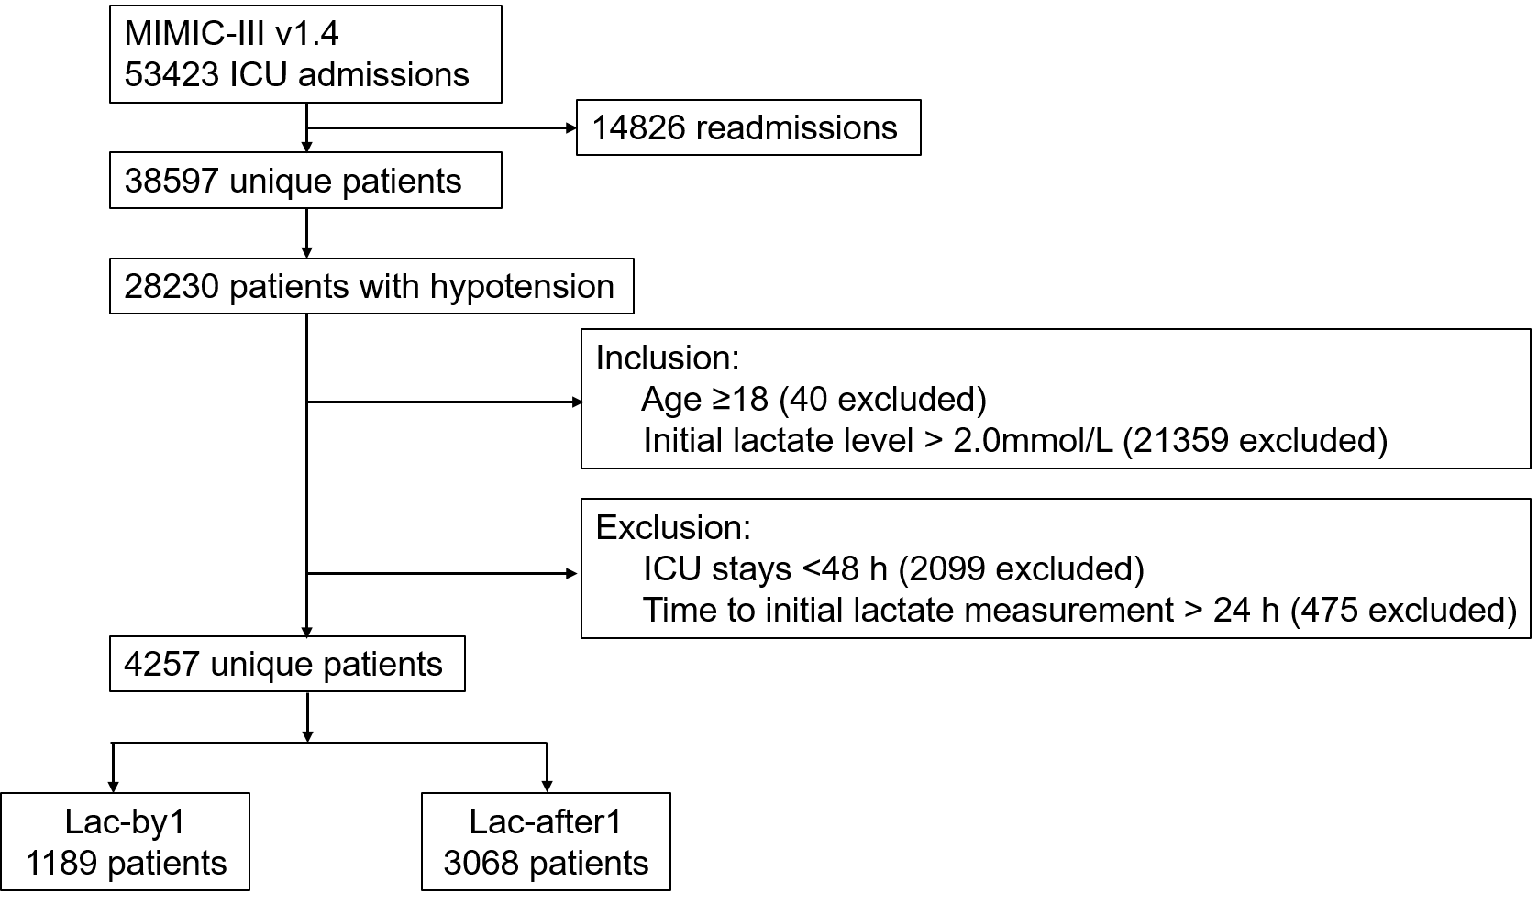
Figure S2：Study flowchart in eICU

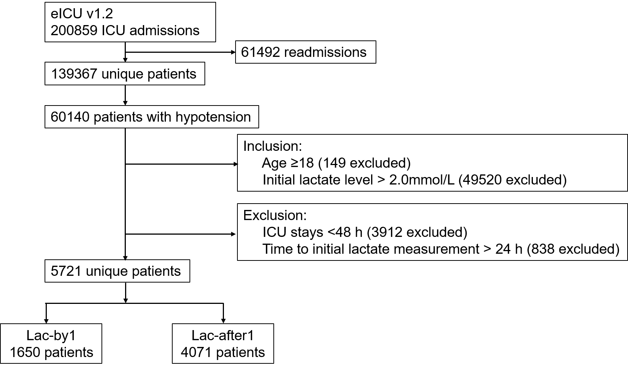
Figure S3：Distribution of time to initial lactate level measurements in MIMIC-III and eICU

Figure S4: Standardized mean difference (SMD) of variables before and after propensity score matching and weighting in MIMIC-III.

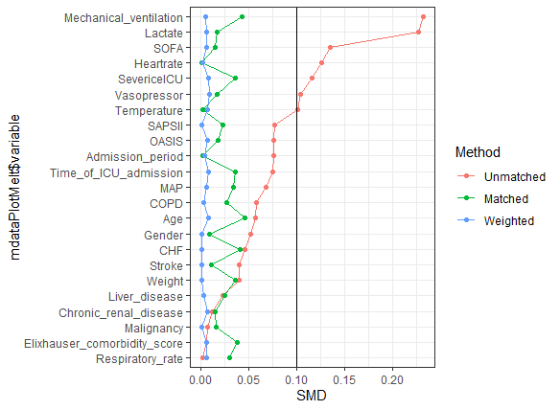
Figure S5: Standardized mean difference (SMD) of variables before and after propensity score matching and weighting in eICU.

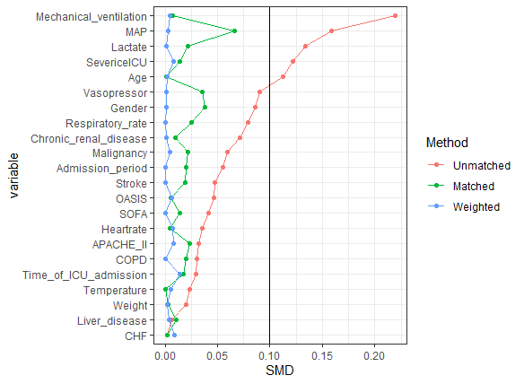

Figure S6: Subgroup analyses of the association between timely lactate measurement and in-hospital mortality in the MIMIC (6A) and eICU (6B)
